Supplemental Material 1: Analysis of Synchronous Spontaneous Otoacoustic Emissions

The presence of synchronous spontaneous otoacoustic emissions (SSOAEs) was investigated using methods adapted from Mertes and Goodman (2016). SSOAEs were obtained from the transient-evoked otoacoustic emission (TEOAE) screening procedure described in the Methods (the short duration of the middle ear muscle reflex measurement did not allow for sufficient signal averaging to detect SSOAEs). SSOAEs were analyzed in the time window from 34 to 44 ms (relative to the location of the stimulus peak) because this window would not contain TEOAEs (Sisto and Moleti 2007). Waveforms were band pass filtered from 1000 to 4000 Hz using a Hann-window-based finite impulse response filter with a filter order of 128. The first and last 1-ms were ramped on and off with a raised-cosine ramp. Artifact rejection and comuptatuion of the root-mean-square signal and noise floor amplitudes were performed as described in the Methods. SSOAEs were considered present if the signal-to-noise ratio exceeded 6 dB.
Results revealed that 34 of 44 participants (77.27%) had present SSOAEs. This prevalence is consistent with that reported by Sisto et al. (2001), but differs from other reports (Jedrzejczak et al. 2008; Mertes and Goodman 2016; Lewis 2018). These discrepancies may be due to a combination of differences in stimuli, analysis, and participant characteristics. Of the 34 participants with present SSOAEs, the mean amplitude ±1 SD was 3.579 ± 5.773 dB SPL (range = −5.505 to 16.590 dB SPL).
The potential influence of SSOAEs on the middle ear muscle reflex (MEMR) results was examined through the scatter plot shown in Figure 1. Ear-canal stimulus amplitude differences are plotted against SSOAE amplitude. The SSOAE amplitude is shown for participants with present SSOAEs as well as absent SSOAEs to look for any qualitative differences between the two groups. Visual inspection revealed no apparent relationship between the size of the difference in ear-canal stimulus amplitude and the SSOAE amplitude. This observation was confirmed by lack of a significant correlation, r(42) = −0.129, p = 0.403. Participants with absent SSOAEs showed a smaller range of difference values compared to those with present SSOAEs, but this may be due to the smaller number of participants with absent SSOAEs. The participant with the largest difference value (0.237 dB) that fell outside the 95% critical difference had an SSOAE amplitude that was on the lower end of the distribution of SSOAE amplitudes (−1.738 dB SPL, below the 25th percentile), suggesting that SSOAEs did not contribute appreciably to the difference in ear-canal stimulus amplitude. Conversely, the other participant with a difference value (−0.073 dB) falling outside the 95% cirtical difference had an SSOAE amplitude that was on the higher end of the distribution of SSOAE amplitudes (11.130 dB SPL, above the 75th percentile). This could suggest an influence of SSOAEs on the measured difference in ear-canal stimulus amplitude in this participant, although it is of note that other participants with SSOAEs of a similar amplitude did not exceed the 95% critical difference.
One factor we cannot account for in this analysis is the amount of medial olivocochlear reflex (MOCR) inhibition of the SSOAE (recall that the TEOAE screening data were analyzed for SSOAEs, which did not include a contralateral elicitor). If a large-amplitude SSOAE was sufficiently inhibited by the MOCR and was out of phase with the stimulus, this interaction could exhibit as a change in ear-canal stimulus amplitude even if there were no MEMR activation. The following equation illsturates the potential impact of SSOAEs. Equation 1 computes the difference value that would result from an interaction of the stimulus amplitude and an SSOAE that is inhibited by the MOCR:
$δ_{stim}=20 \log_{10}\left[(A_{stim}+\left(A_{ssoae}×A_{moc}\right)) / (A_{stim}+ A_{ssoae})\right]$ (1),
where $δ_{stim}$ is the estimated change in ear-canal stimulus amplitude in dB, $A_{stim}$ is the RMS amplitude of the ear-canal stimulus in Pascals, $A_{ssoae}$ is the RMS amplitude of the SSOAE in Pascals, and $A_{moc}$ is the amplitude of MOCR inhibition of the SSOAE in linear units. For the aforementioned participant with a difference value of −0.073 dB and an SSOAE amplitude of 11.130 dB SPL, if we use an $A_{stim}$ of 55 dB SPL and a reasonable value of $A_{moc}$ of 0.707 (3 dB inhibition), the resulting $δ_{stim}$ is −0.016 dB. This value is smaller than the participant’s actual difference value, and $δ_{stim}$ did not exceed the 95% critical difference. This suggests a lack of effect of SSOAEs on the results for this participant. Conversely, for the participant with the largest SSOAE amplitude (16.590 dB SPL), if we again use an $A_{moc}$ of 0.707, $δ_{stim}$ is −0.030 which exceeds the participant’s actual difference value of −0.024 dB but does not exceed the 95% critical difference. In this participant, it could suggest that the value of $A_{moc}$ overestimated the actual MOCR effect and/or that the inhibited SSOAE is not completely out of phase with the stimulus waveform.
Because no measurement of MOCR inhibition of the SSOAEs was obtained in the current study, these estimated effects of SSOAEs remain speculative. It appears that very large-amplitude SSOAEs may potentially impact the measured change in ear-canal stimulus amplitude, but only if the size of MOCR inhibition is substantially large. Further work is needed, but we recommend that future work include the analysis of SSOAEs and the MOCR effect on SSOAEs when developing critical differences.
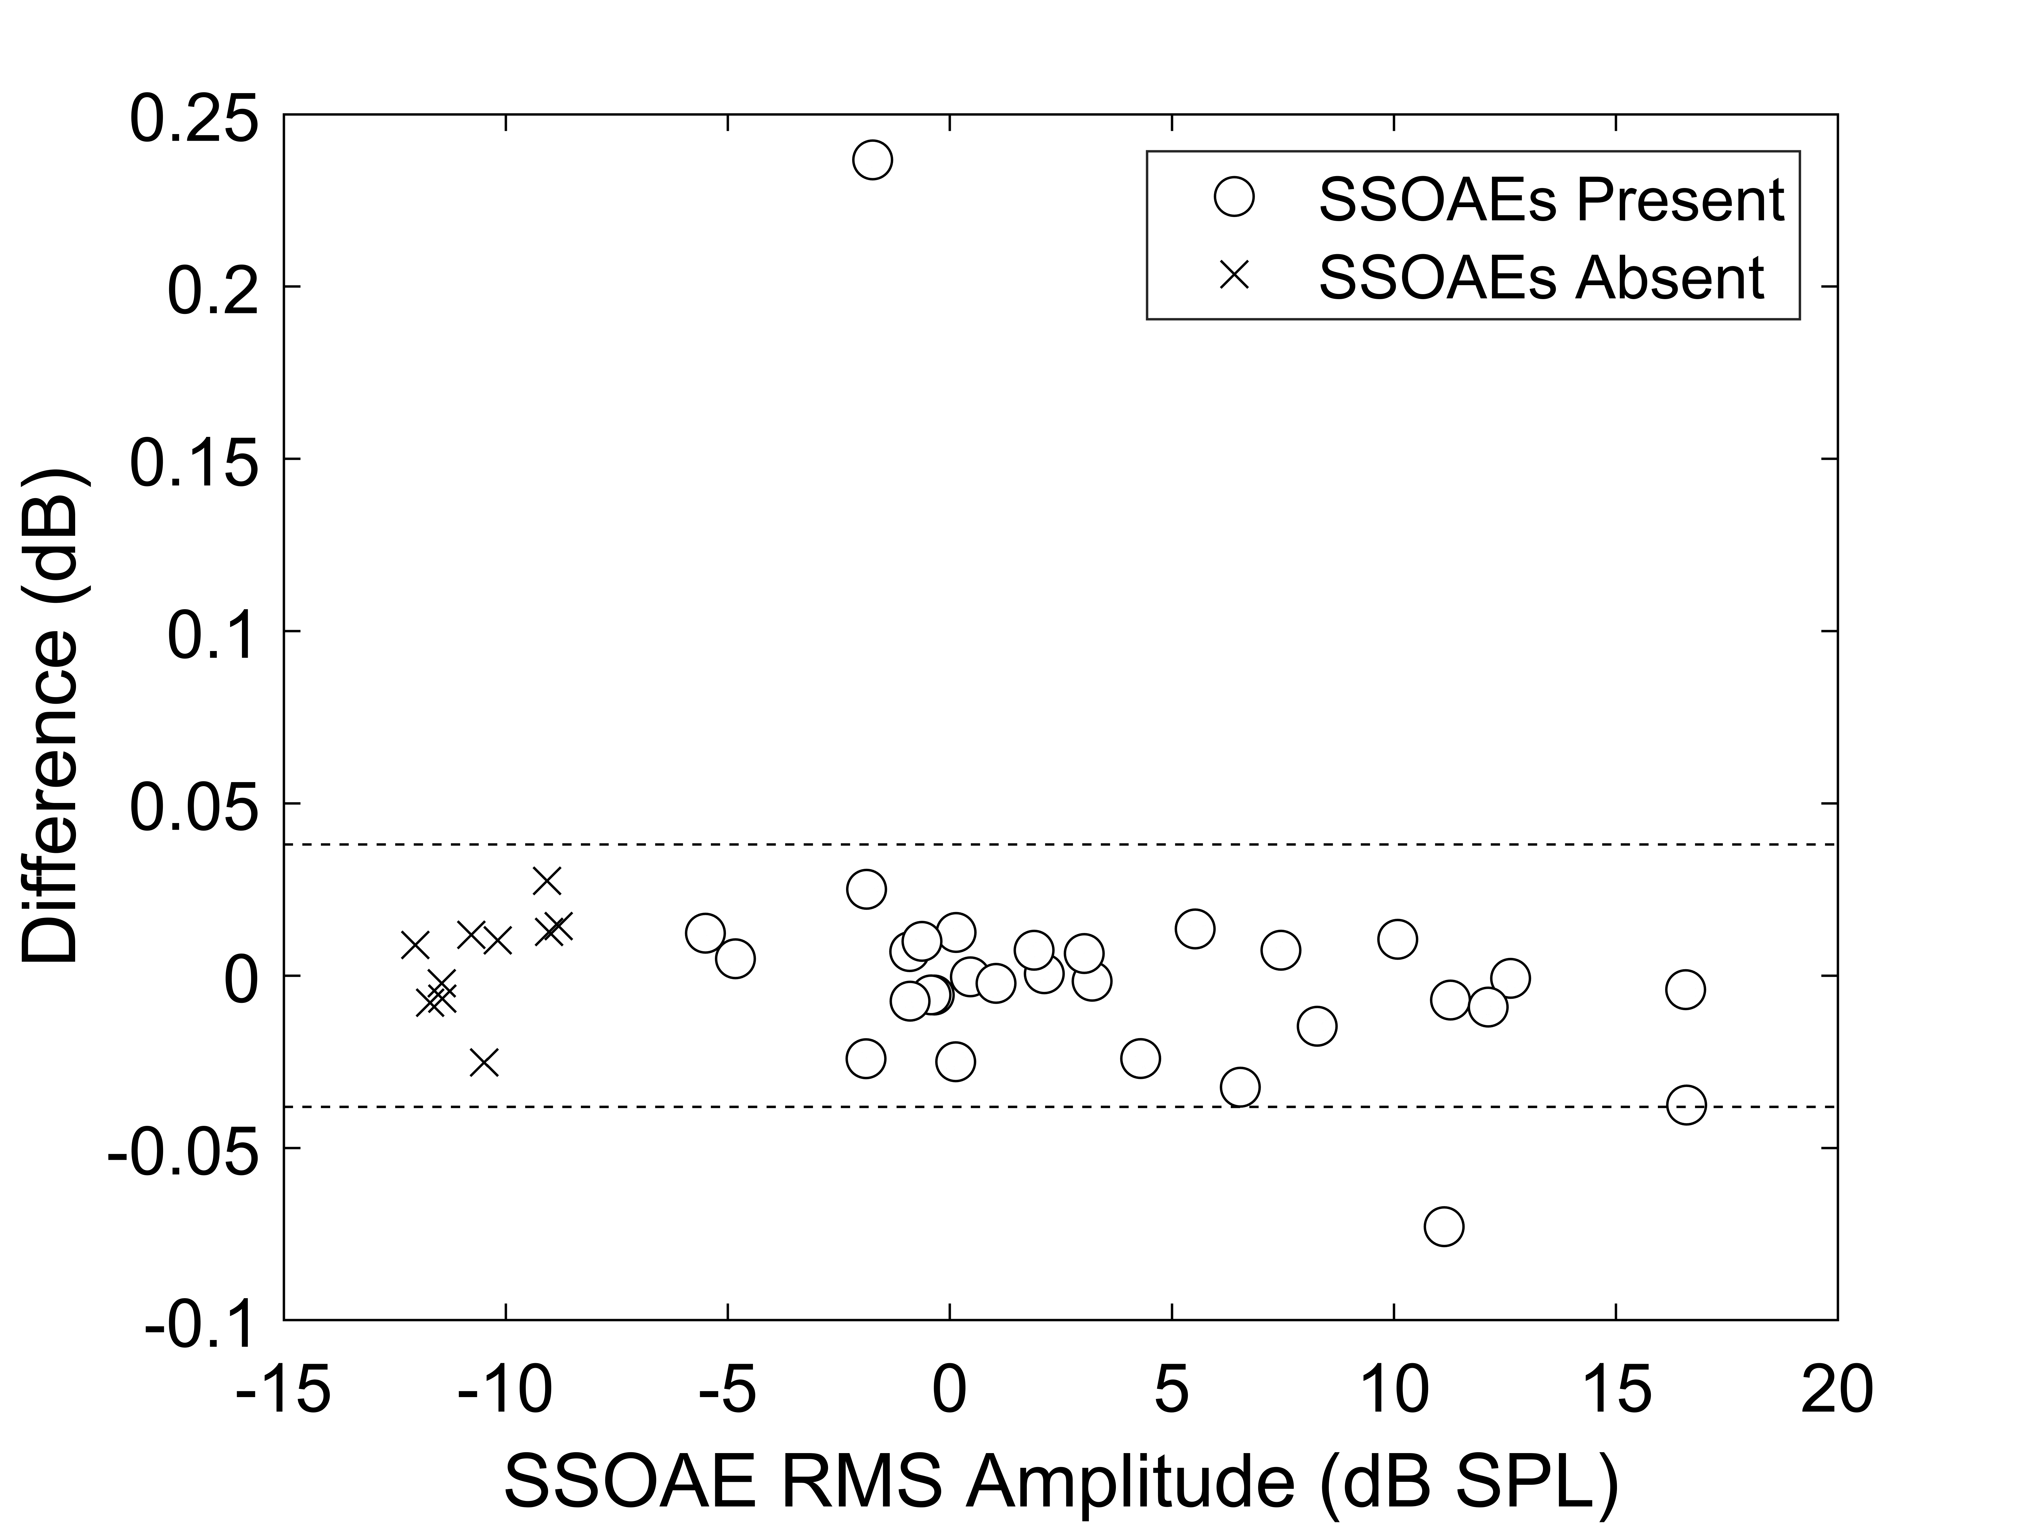
Figure 1. Differences in ear-canal stimulus amplitude (no elicitor 1 versus elicitor 1) as a function of SSOAE amplitude. Open circles represent participants with present SSOAEs and x symbols represent participants with absent SSOAEs. The dashed horizontal lines represent the 95% critical difference.

References
Jedrzejczak, W. W., K. J. Blinowska, K. Kochanek, and H. Skarzynski. 2008. “Synchronized Spontaneous Otoacoustic Emissions Analyzed in a Time-Frequency Domain.” The Journal of the Acoustical Society of America 124 (6):3720–3729. doi:10.1121/1.2999556.
Lewis, J. D. 2018. “Synchronized Spontaneous Otoacoustic Emissions Provide a Signal-to-Noise Ratio Advantage in Medial-Olivocochlear Reflex Assays.” Journal of the Association for Research in Otolaryngology 19 (1):53–65. doi:10.1007/s10162-017-0645-5.
Mertes, I. B., and S. S. Goodman. 2016. “Within- and Across-Subject Variability of Repeated Measurements of Medial Olivocochlear-Induced Changes in Transient-Evoked Otoacoustic Emissions.” Ear and Hearing 37 (2):e72–e84. doi:10.1097/AUD.0000000000000244.
Sisto, R., and A. Moleti. 2007. “Transient Evoked Otoacoustic Emission Latency and Cochlear Tuning at Different Stimulus Levels.” The Journal of the Acoustical Society of America 122 (4):2183–2190. doi:10.1121/1.2769981.
Sisto, R., A. Moleti, and M. Lucertini. 2001. “Spontaneous Otoacoustic Emissions and Relaxation Dynamics of Long Decay Time OAEs in Audiometrically Normal and Impaired Subjects.” The Journal of the Acoustical Society of America 109 (2):638–647. doi:10.1121/1.1336502.

