**Supplementary Material**

**Table 6a.Characterization of 33 Genomic-SSR makers in wheat.**

|  |  |  |  |  |  |
| --- | --- | --- | --- | --- | --- |
| **Primers Name** | **Chromosome location** | **TA** | **Allele Size (bp)** | **Polymorphic Allele** | **PIC** |
| barc5 | 2A | 52 | 400-270 | 3 | 0.665 |
| barc11 | 2D | 52 | 210-170 | 2 | 0.92 |
| barc13 | 2B | 52 | 150 | 1 | 0 |
| barc15 | 2A | 52 | 105 | 1 | 0 |
| barc45 | 3A, 2B | 52 | 200 | 1 | 0 |
| barc59 | 5B, 2D | 52 | 220 | 1 | 0 |
| barc60 | 4B, 1B | 52 | 230-120 | 2 | 0.512346 |
| barc61 | 1B | 52 | 1300 | 1 | 0 |
| barc63 | 7B | 52 | 210-200 | 2 | 0.165289 |
| barc65 | 7B | 52 | 120 | 1 | 0 |
| Barc80 | 1B | 52 | 110-100 | 2 | 0.497041 |
| barc81 | 1B | 52 | 200 | 1 | 0 |
| barc101 | 2B, 3B, 6B | 52 | 160-110 | 2 | 0.48 |
| barc117 | 5A | 52 | 270-260 | 2 | 0.32 |
| barc118 | 6A, 4D | 52 | 160 | 1 | 0 |
| barc120 | 7B | 52 | 600-220 | 2 | 0.570637 |
| barc122 | 2A, 5B | 52 | 150 | 1 | 0 |
| barc124 | 2A | 52 | 100 | 1 | 0 |
| barc125 | 2B | 52 | 130 | 1 | 0 |
| barc127 | 7A, 6B | 52 | 250-110 | 2 | 0.655612 |
| barc128 | 2B | 52 | 210 | 1 | 0 |
| barc135 | 4A | 52 | 210-200 | 2 | 0.444444 |
| barc141 | 5A | 52 | 220 | 1 | 0 |
| barc144 | 5D, 5A | 52 | 250 | 1 | 0 |
| barc204 | 6A | 52 | 120 | 1 | 0 |
| barc210 | 1D, 2B | 52 | 200 | 1 | 0 |
| barc217 | 4D | 52 | 100 | 1 | 0 |
| barc321 | 3A | 52 | 230 | 1 | 0 |
| barc322 | 5D | 52 | 110 | 1 | 0 |
| barc323 | 3D | 52 | 110 | 1 | 0 |
| barc350 | -- | 52 | 110 | 1 | 0 |
| barc343 | 4A | 52 | 180 | 1 | 0 |
| barc349 | 2B | 52 | 230-110 | 2 | 0.493827 |
| Total | --- | --- | --- | 45 | 6.218023 |
| Mean | --- | --- | --- | 1.363636 | 0.203389394 |
| Maximal | --- | --- | --- | 3.00 | 0.92 |
| Minimal | --- | --- | --- | 1.00 | 0.00 |

**Table 6b.Characterization of 31 polymorphic EST- SSR makers in wheat (*Triticumaestivum*).**

|  |  |  |  |  |  |  |
| --- | --- | --- | --- | --- | --- | --- |
| **Primers name and location** | **Accession No.** | **SSR motif** | **TA** | **Size (bp)** | **Polymorphic Allele** | **PIC** |
| xcwem3-1A | BG607867 | (AC)7 | 55 | 100 | 1 | 0 |
| xcwem5-1D | BG274942 | (TGC)8 | 55 | 126 | 1 | 0 |
| xcwem6-1B | BF483588 | (AG)12 | 55 | 165 | 1 | 0 |
| xcwem7-6A | BE500104 | (T)10 | 55 | 110 | 1 | 0 |
| xcwem9-1D,1A,3A | BE443007 | (CAGG)5 | 55 | 200-350 | 3 | 0.656 |
| xcwem10-1D | BF483804 | (A)11 | 50 | 70 | 1 | 0 |
| xcwem11-4A | BG314086 | (ACT)5 | 60 | 100-90 | 2 | 0.1653 |
| xcwem13-5A | BE399363 | (GCT)5 | 55 | 110 | 1 | 0 |
| xcwem14-2B | BE636802 | (CTT)6 | 55 | 120 | 1 | 0 |
| xcwem15-2B | BF146045 | (CAG)5 | 60 | 110 | 1 | 0 |
| xcwem17-3D | BE495462 | (GCG)6 | 55 | 130 | 1 | 0 |
| xcwem19-3A | BE585734 | (GCA)5-(CAG)6 | 50 | 150 | 1 | 0 |
| xcwem22-3B,3D | BF484536 | (AGC)6 | 55 | 140-160 | 1 | 0 |
| xcwem32-1A | BE606965 | (TGC)8 | 55 | 140 | 1 | 0 |
| xcwem34-4B | BE495116 | (AAG)5 | 50 | 90 | 1 | 0 |
| xcwem37-5D | BE446061 | (GAT)5 | 55 | 160 | 1 | 0 |
| xcwem38-4B | BF485412 | (AG)6 | 60 | 130 | 1 | 0 |
| xcwem39-3B | BF478437 | (AGG)5 | 55 | 167 | 1 | 0 |
| xcwem40-5B,5A | BE403549 | (TCT)6 | 55 | 105-135 | 1 | 0 |
| xcwem42-5D | BE444720 | (CGG)5 | 55 | 120 | 1 | 0 |
| xcwem43-5D | BE443021 | (CATG)5 | 55 | 120 | 1 | 0 |
| xcwem44-5B | BE404135 | (GAA)9 | 60 | 70 | 1 | 0 |
| xcwem45-5B | BE517676 | (TGC)6 | 55 | 220 | 1 | 0 |
| xcwem46-1D,7A | BE500430 | (TCC)5 | 50 | 90-170 | 1 | 0 |
| xcwem47-6D | BE426787 | (AGG)5 | 55 | 160 | 1 | 0 |
| xcwem49-6A | BE445201 | (GCC)6 | 55 | 120 | 1 | 0 |
| xcwem50-6A | BF483695 | (CTG)5 | 50 | 70 | 1 | 0 |
| xcwem51-6D | BE405680 | (CCAT)6 | 55 | 105 | 1 | 0 |
| xcwem527B | BE399084 | (GCAAAC)5 | 55 | 130 | 1 | 0 |
| xcwem53-4B | BF484868 | (TGC)8 | 55 | 480 | 1 | 0 |
| xcwem54-7A,1B,2B | BE517937 | (CCG)5 | 55 | 650-200 | 5 | 0.7422 |
| Total | --- | --- | --- | --- | 38 | 2.72 |
| Mean | --- | --- | --- | --- | 1.2 | 0.08 |
| Maximal | --- | --- | --- | --- | 5 | 0.7422 |
| Minimal | --- | --- | --- | --- | 1 | 0 |

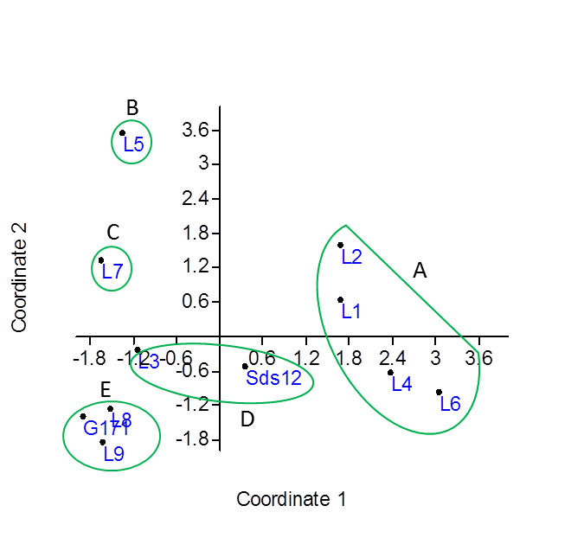

**Figure 2.Principal coordinate analysis (PCA) of the eleven wheat genotypes with 33 SSRs and 31 EST-SSR combinations.**

I

II



**Figure 3. Unweighted pair group method with arithmetic average (UPGMA) dendrogram for eleven wheat genotypes based on the allelic data of 33 SSRs.**



**A**

**B**

**C**

**D**

**Figure 4. Principal component analysis (PCA) of the 11 wheat genotyped with 33 polymorphic SSRs.**

**Figure 5. Unweighted pair group method arithmetic average (UPGMA) dendrogram for eleven wheat genotypes based on the allelic data of 31 EST-SSR.**



A

**C**

B

D

**Figure 6. Principal coordinate analysis (PCA) of the eleven wheat genotypes with 31 polymorphic EST-SSR markers.**