Supplementary Material

Table 2- Data from rainfall of region of Itupararanga Reservoir
Points | Dry Season | Wet Season | Coordinate | Period | Source
Una | 38,95 | 179,98 | Ibiuna | 1939-2017 | DAEE
Sorocabuçu | 34,0 | 188,5 | Ibiuna | 1996-2011 | CIIAGRO
Sorocamirim | 25,8 | 202,4 | São Roque | 2000-2013 | CIIAGRO
Sorocaba | 61.25 | 151.3 | Sorocaba | 2016-2018 | DAEE
Piedade | 75.5 | 120.6 | Piedade | 2016-2018 | DAEE
Mairinque | 92.9 | 175.35 | Mairinque | 2016-2018 | DAEE
Mairinque II | 77.15 | 239.1 | Mairinque II | 2016-2018 | DAEE

Table 3 - Data set of variables that compose the indices. S: Dry period
Points | DO | Temp | pH | Cond | Turb | TDS | TR | Total Coliforms | TC | BOD | Chl-a | TP | TN | Surfac
Una | 6.600 | 21.000 | 6.600 | 93.000 | 25.600 | 40.000 | 0.014 | 1601.000 | 1601.000 | 1.033 | 0.0014500 | 0.204 | 8.400 | 0.050
Sb | 6.800 | 21.700 | 5.930 | 51.000 | 77.000 | 33.000 | 0.013 | 1601.000 | 350.000 | 0.933 | 0.0010550 | 0.192 | 3.800 | 0.100
Sm | 7.930 | 22.800 | 6.520 | 98.000 | 18.800 | 64.000 | 0.011 | 920.000 | 79.000 | 0.783 | 0.0015500 | 0.197 | 5.400 | 0.075
Res-1 | 5.770 | 27.600 | 8.380 | 82.000 | 22.900 | 53.000 | 0.012 | 130.000 | 17.000 | 2.585 | 0.0213800 | 0.044 | 0.688 | 0.110
Res-2 | 6.160 | 27.300 | 8.100 | 77.000 | 16.900 | 50.000 | 0.010 | 7.800 | 2.000 | 1.060 | 0.0127000 | 0.024 | 0.403 | 0.105
Res-3 | 5.860 | 27.300 | 7.400 | 74.000 | 17.600 | 48.000 | 0.010 | 2.000 | 1.790 | 0.380 | 0.0136300 | 0.019 | 0.364 | 0.085
Res-4 | 8.000 | 26.500 | 7.300 | 72.000 | 13.300 | 47.000 | 0.011 | 11.000 | 1.790 | 0.845 | 0.0104200 | 0.019 | 0.622 | 0.200
Res-5 | 6.700 | 23.500 | 7.340 | 72.000 | 16.100 | 47.000 | 0.009 | 49.000 | 4.500 | 0.100 | 0.0082900 | 0.019 | 0.745 | 0.260
Res-6 | 6.590 | 23.900 | 7.040 | 74.000 | 19.600 | 47.000 | 0.009 | 11.000 | 2.000 | 0.400 | 0.0106900 | 0.017 | 0.416 | 0.100
Res-7 | 10.900 | 23.300 | 6.860 | 76.000 | 13.000 | 48.000 | 0.007 | 11.000 | 4.000 | 0.450 | 0.0082900 | 0.017 | 0.166 | 0.280
Una-s | 7.200 | 14.210 | 6.700 | 206.000 | 9.700 | 134.000 | 0.007 | 2200.000 | 2200.000 | 1.600 | 0.001 | 0.230 | 1.300 | 0.080
Sb-S | 7.800 | 15.000 | 6.600 | 49.000 | 10.500 | 32.000 | 0.038 | 3500.000 | 540.000 | 1.000 | 0.001 | 0.219 | 0.600 | 0.090
Sm-S | 7.300 | 15.200 | 6.900 | 106.000 | 11.700 | 69.000 | 0.002 | 3500.000 | 920.000 | 0.367 | 0.000 | 0.080 | 1.500 | 0.045
Res-1-S | 6.710 | 18.000 | 8.300 | 207.000 | 9.500 | 52.000 | 0.004 | 130.000 | 23.000 | 1.687 | 0.009 | 0.744 | 1.350 | 0.085
Res-2-S | 7.270 | 19.210 | 7.900 | 69.000 | 8.500 | 45.000 | 0.005 | 6.800 | 4.000 | 0.723 | 0.009 | 0.186 | 0.500 | 0.090
Res-3-S | 6.320 | 18.030 | 7.700 | 62.000 | 11.200 | 40.000 | 0.005 | 4.500 | 4.500 | 1.490 | 0.008 | 0.134 | 0.500 | 0.080
Res-4-S | 7.010 | 19.700 | 7.630 | 66.000 | 7.500 | 43.000 | 0.004 | 7.800 | 1.790 | 1.940 | 0.009 | 0.091 | 0.300 | 0.090
Res-5-S | 6.630 | 18.500 | 7.680 | 67.000 | 8.500 | 44.000 | 0.004 | 1.790 | 1.790 | 1.837 | 0.008 | 0.075 | 0.300 | 0.090
Res-6-S | 5.530 | 18.200 | 7.800 | 67.000 | 8.200 | 44.000 | 0.001 | 2.000 | 2.000 | 1.750 | 0.008 | 0.130 | 0.300 | 0.070
Res-7-S | 7.320 | 18.400 | 6.400 | 73.000 | 7.700 | 46.000 | 0.004 | 1.790 | 1.790 | 2.143 | 0.010 | 0.068 | 0.300 | 0.090
Soro-S | 7.850 | 17.900 | 7.400 | 79.000 | 4.500 | 51.000 | 0.001 | 170.000 | 79.000 | 1.383 | 0.001 | 0.044 | 0.250 | 0.115

Figure 10 - PCA with data set which compose the indices standardized with global mean to remove the seasonality effect.
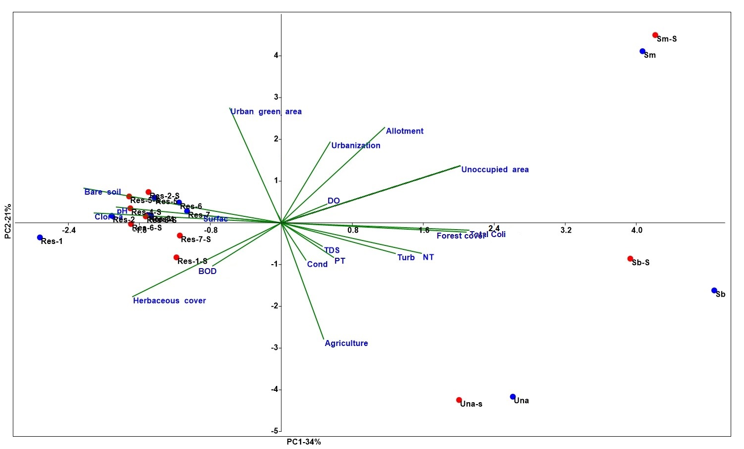

Figure 11 - Cluster analysis with indexes data
