Degradation of Organophosphorus Flame Retardant Tri(chloro-propyl)phosphate (TCPP) by (001) Crystal Plane of TiO₂ Photocatalysts
Huan He^{[+]1}, Xiaohan Wang^{[+]1}, Chen Cheng^{2,3}, Shaogui Yang^{1*},Xiaomen Wang³, Qing Liu³, Yong Wang^{4*}, Zunyao Wang³，Limin Zhang¹, Cheng Sun³
¹ School of Environment, Nanjing Normal University, Nanjing, Jiangsu 210023, P.R. China
² School of Chemistry and Life Science, Chengdu Normal University，Chengdu 611130, China
³ State Key Laboratory of Pollution Control and Resources Reuse, School of the Environment, Nanjing University, Nanjing, Jiangsu 210023, P.R. China
⁴School of Environment, Northeast Normal University, Changchun, Jilin 130024, P.R. China
^{[+]} These authors contributed equally to this work.

* Corresponding author:
- mail: yangsg@njnu.edu.cn (S.G. Yang) , wangy833@nenu.edu.cn

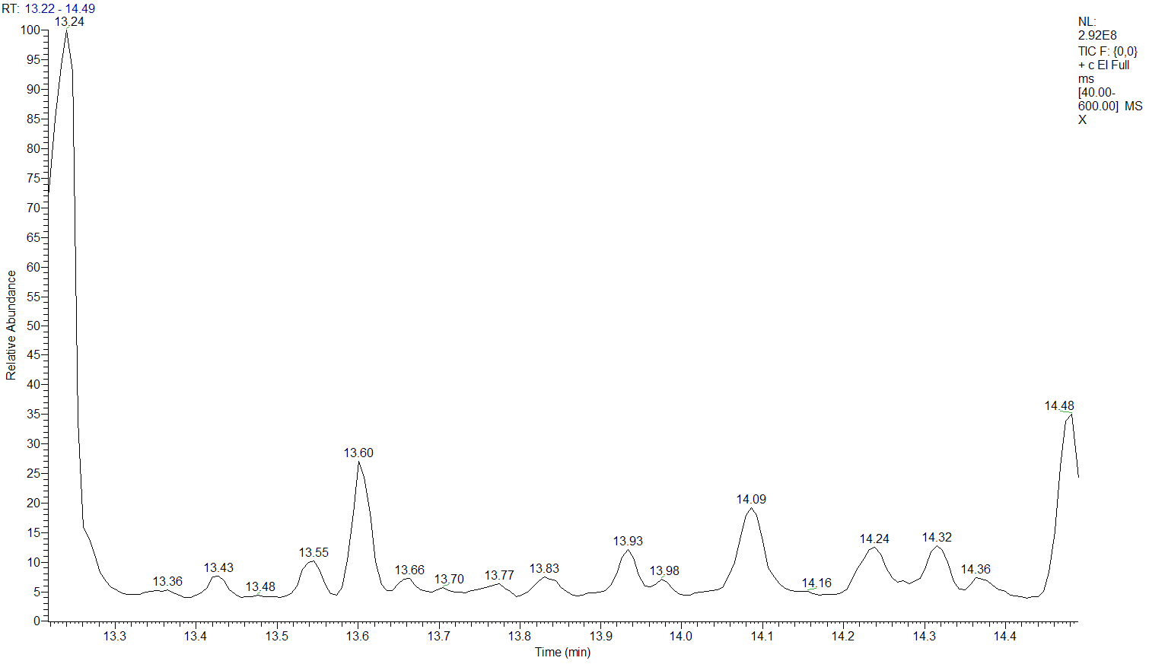
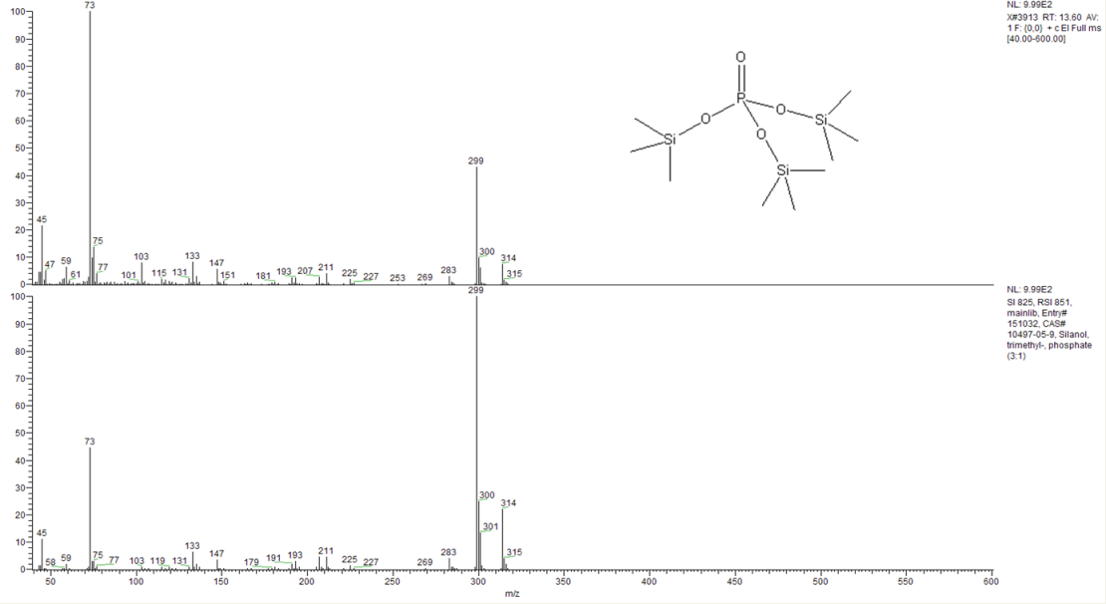
Fig.S1. Chromatogram and Mass spectra of PO₃⁴⁻ comparing with the standard spectrum

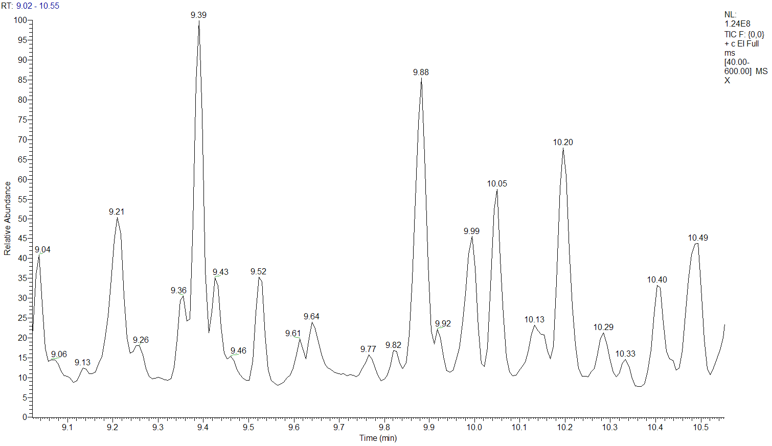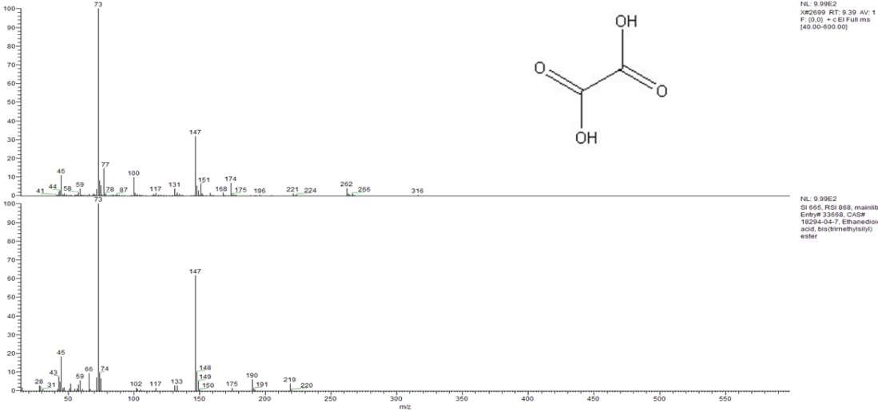
Fig.S2. Chromatogram and Mass spectra of （COOH）₂ comparing with the standard spectrum

