Supporting information

Text S1. Rice cultivation on nitrogen-deficient agar plates with Azoarcus sp. KH32C
Azoarcus sp. strain KH32C was cultivated on DNB-NS agar plates at 26°C in anaerobic conditions for 1 week. Escherichia coli K-12 strain MG1655 was cultivated on LB agar plates at 30°C for 1 week. Strains KH32C and MG1655 were suspended in 0.5 mM calcium chloride (OD₆₆₀ = 0.8). Hulled rice seeds (Oriza sativa L. cv. Nipponbare) were immersed in a mixture of sodium hypochlorite, sodium hydroxide, and surfactant for surface sterilization. After washing with sterilized distilled water, the surface-sterilized seeds were immersed in the cell suspensions of strain KH32C or strain MG1655 for 1.5 min. The rice seeds were germinated on nitrogen-deficient agar plates (0.5 mM calcium chloride and 7.5 g Agar Type A plant cell culture tested [Sigma-Aldrich, MO, USA] per a liter), and cultivated at 30°C with a 14 h/10 h light/dark photoperiod. After 12 days, the fresh weight of seed-removed rice seedlings was measured. To assess the effect of strain KH32C on rice plant growth, heteroscedastic t-test was carried out between KH32C inoculation and MG1655 inoculation conditions.
PCR amplification was performed to detect strain KH32C from rice root. DNA was extracted from rice roots at 4 days after KH32C or MG1655 inoculation. Specific primer sets for the nos Z gene in strain KH32C, del-NosZ-F/del-NosZ-R, was used for PCR amplification (Gao et al. 2017).

Table S1. Sampling date of rice plants and rice root-associated soil. Eg, early growth stage; Pf, panicle formation stage; Fh, full heading stage; Hv, harvesting stage. The numbers in parenthesis show the number of days after transplantation.

 | Nipponbare |  | Takanari |  | IR64
 | KH32C | Control | KH32C | Control | KH32C | Control
PF4 in 2015
Eg | June 23rd (25) |  | June 23rd (25) |  | June 23rd (25)
Pf | July 14th (46) |  | July 14th (46) |  | July 14th (46)
Hv | Oct. 10th (134) |  | Oct. 5th (129) |  | Oct. 5th (129)
PF2 in 2017
Eg | June 20th (24) |  | June 20th (24) |  | June 20th (24)
Pf | July 11th (45) |  | July 11th |  | July 11th
Fh | Aug. 25th (90) |  | Aug. 18th (83) | Aug. 21st (86) | Aug. 25th (90) | Aug. 21st (86)
Hv | Oct. 12th (139) |  | Oct. 9th (135) |  | Oct. 12th (139)

Table S2. Yield of rice.

(g/m²) | KH32C | Control
PF4
Nipponbare | 773.0±57.2 | 724.4±6.0
Takanari | 787.9±17.1 | 714.4±125.3
IR64 | 683.4±1.9 | 747.0±42.8
PF2
Nipponbare | 409.1±23.0 | 471.1±52.3
Takanari | 786.6±89.0 | 840.5±23.7
IR64 | 572.7±60.3 | 523.9±36.4
Mean±SE

Table S3. The number of high-quality sequences and OTUs obtained by meta-amplicon sequencing analysis of Nipponbare root-associated soil. Eg, early growth stage; Pf, panicle formation stage; Hv, harvesting stage.

 | KH32C |  |  | Control |  |  | Total
 | Eg | Pf | Hv | Eg | Pf | Hv
High-quality sequence | 11,930 | 9,428 | 31,368 | 15,583 | 8,960 | 14,242 | 91,511
OTU | 4,002 | 3,146 | 7,696 | 4,784 | 3,048 | 5,016 | 14,064

Table S4. The diversity of bacterial community in root-associated soil of Nipponbare in PF4. Eg, early growth stage; Pf, panicle formation stage; Hv, harvesting stage.

 | KH32C |  |  | Control
 | Eg | Pf | Hv | Eg | Pf | Hv
Shannon index | 7.42 | 7.36 | 7.62 | 7.48 | 7.32 | 7.67
ACE | 11503 | 7879 | 13020 | 11752 | 8354 | 13407
Evenness | 0.91 | 0.92 | 0.93 | 0.92 | 0.91 | 0.93

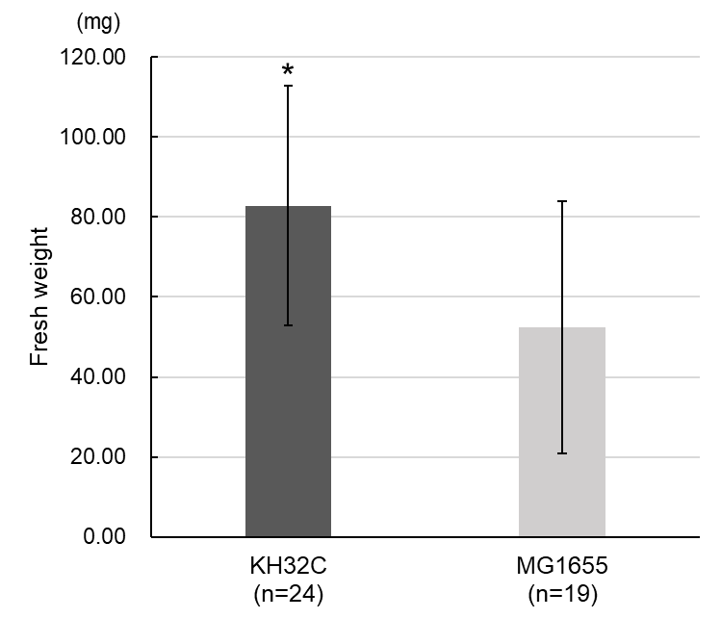

Figure S1. Fresh weight of seed-removed rice seedlings grown on nitrogen-deficient agar plates. Error bars mean SD. *, Significant high at p-value <0.01 by heteroscedastic t-test.

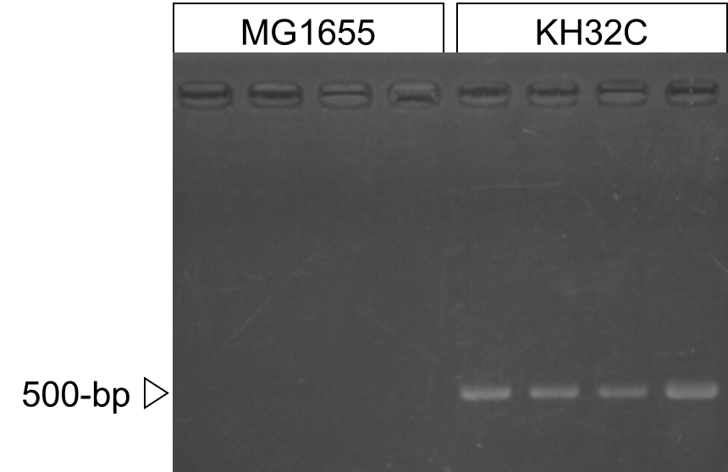

Figure S2. Agarose gel electrophoretic patterns of PCR amplification of rice root grown on nitrogen-deficient agar plates.

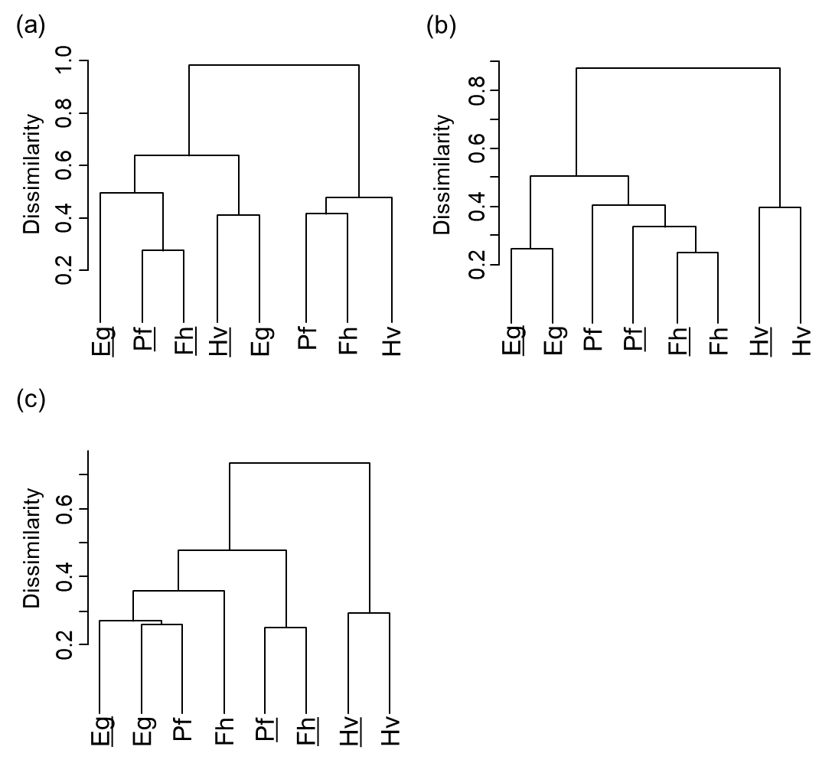

Figure S3. Cluster analysis of the bacterial community in rice root-associated soil in each cultivar based on terminal restriction fragments profile in PF2. (a) Nipponbare, (b) Takanari, (c) IR64. Eg, early growth stage; Pf, panicle formation stage; Fh, full heading stage; Hv, harvesting stage. Underlines indicate KH32C inoculation.

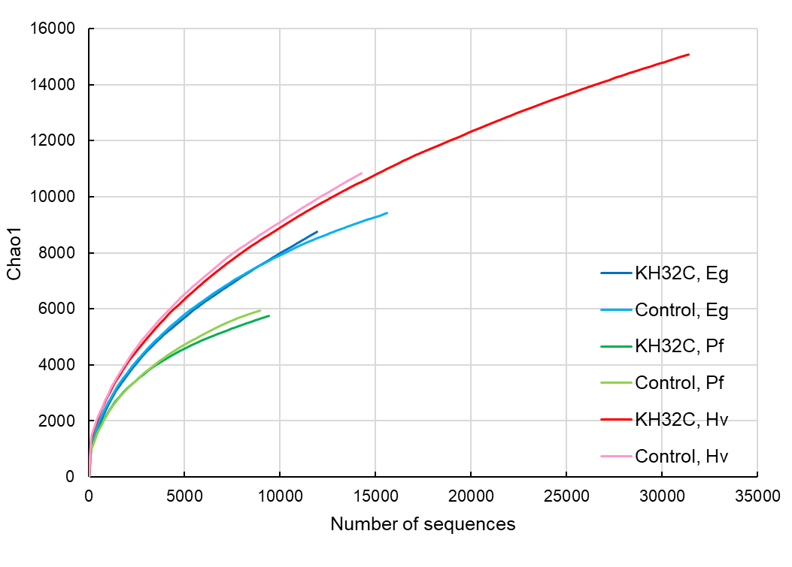
Figure S4. Rarefaction curve calculated using the chao1 estimator of the Nipponbare root-associated soil bacterial community. Eg, early growth stage; Pf, panicle formation stage; Hv, harvesting stage.

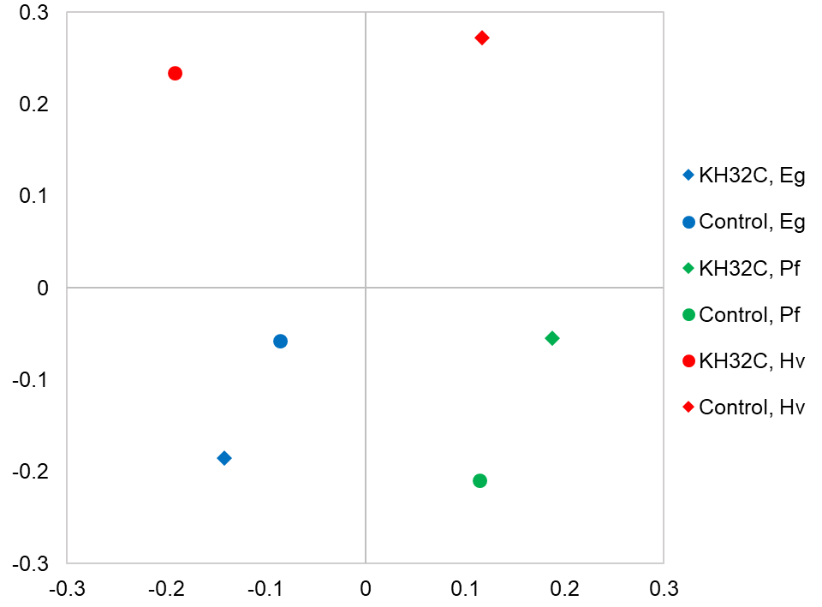

Figure S5. Non-metric multidimensional scaling plot of the Nipponbare root-associated soil bacterial community. Eg, early growth stage; Pf, panicle formation stage; Hv, harvesting stage.

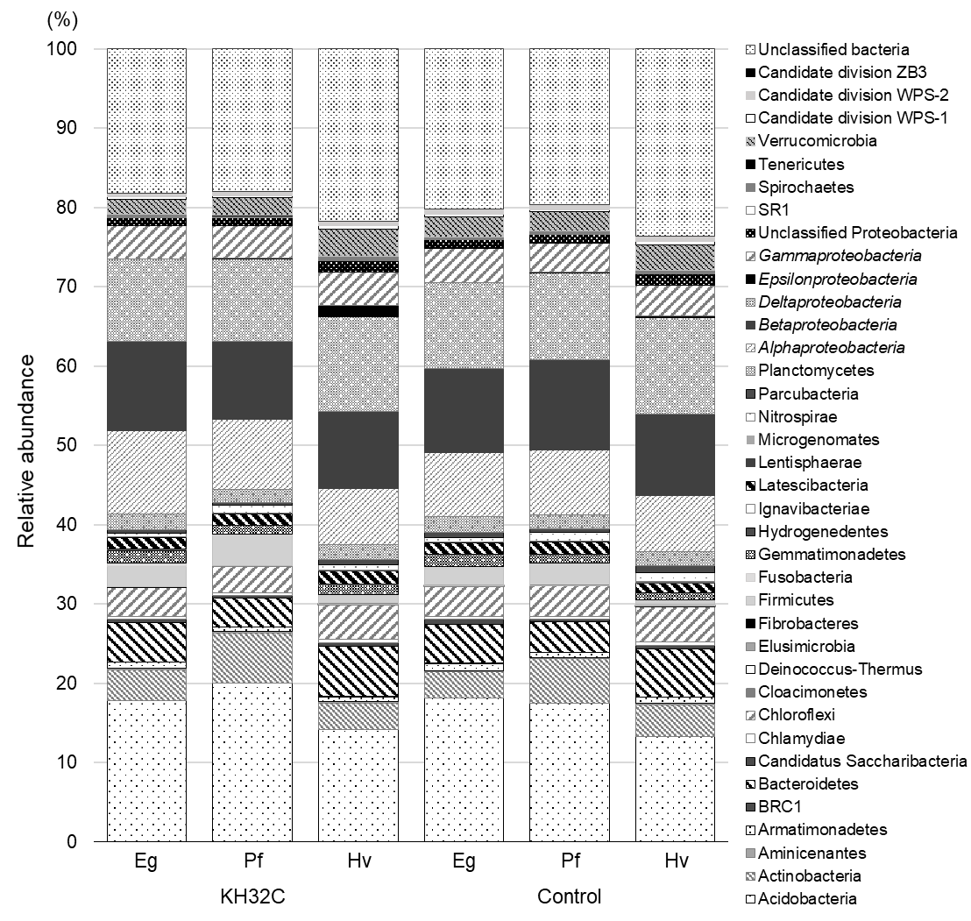

Figure S6. Bacterial community structure at the phylum level in root-associated soil of Nipponbare in PF4. Proteobacteria are shown at a class level. Eg, early growth stage; Pf, panicle formation stage; Hv, harvesting stage.

Reference

Gao N, Shen W, Camargo E, Shiratori Y, Nishizawa T, Isobe K, He X, Senoo K 2017: Nitrous oxide (N₂O)-reducing denitrifier-inoculated organic fertilizer mitigates N₂O emissions from agricultural soils. Biol. Fertil. Soils, 53,885-898. 10.1007/s00374-017-1231-z

