Pyridinium Salts of Dithiophosphoric Acids on the Basis of Nicotinic acids and Their Isomers, 3-Hydroxypyridine and 3-Pyridinemethanol

Ilyas S. Nizamov^{1, 2*}, Ramazan Z. Salikhov², Ildus D. Timushev², Yevgeniy N. Nikitin², Ilnar D. Nizamov¹, Vladimir Yu. Yakimov¹, Marina P. Shulaeva³, Oscar K. Pozdeev³, Elvira S. Batyeva², Rafael A. Cherkasov¹, nd Anna S. Ponomareva⁴
¹A.M. Butlerov Chemical Institute, Kazan Federal University, Kazan, Russia
²A.E. Arbuzov Institute of Organic and Physical Chemistry, Federal Research Center, Kazan Scientific Center, Russian Academy of Sciences, Kazan, Russia
³Department of Microbiology, Kazan State Medical Academy, Kazan, Russia
⁴D.N. Pryanishnikov All-Russian Scientific Research Institute of Agrochemistry, Moscow, Russia
Email : isnizamov@mail.ru
Table S 1. The Antimicrobial Activity of Compounds 6a and 6bª

Compound | Zone of inhibition, mm
 | E.  coli | B.  cereus | Ps.  aeruginosa | S.  aureus | Candida  albicans
6a | 7 | 11 | 7 | 10 | 13
6b | - | 11 | 12 | 7 | 21
Slayt (1%)¹⁷ | 10 | 12 | 12 | 19 | 14
ªIn 1% concentrations in DMSO.

Table S 2. FTIR Data of the Products Obtained
Prod. | ν_{max}, cm⁻¹
3a | KBr: 3412 s vbr (H–O), 3080 vw, 3052 vw (=С-Н_{Ar}), 2951 vs, 2878 m [ν_{as,s}(СН₃, СН₂)], 2750 w (NH⁺), 1717 m (О=С–О), 1629 m, 1597 m, 1526 m (С=С_{Ar}), 1466 m [δ_{as}(СН₃)], 1399 m [δ_{s}(СН₃)], 1012 s [(P)O–C], 945 m (О–С, ОС–С), 661 m (P=S), 561 m (P–S).
3b | KBr: 3444 s vbr (H–O), 2984 s, 2952 vs, 2879 s [ν_{as,s}(СН₃, СН₂)], 2750 w (NH⁺), 1712 m (О=С–О), 1638 w, 1617 w, 1562 w (С=С_{Ar}), 1454 m [δ_{as}(СН₃)], 1388 m, 1368 m {δ_{s}[(CH₃)₂C_{gem.}]}, 1055 s, 1031 s, 1021 s [(P)O–C], 992 s, 978 s (О–С, ОС–С), 674 m (P=S), 537 m (P–S).
3c | KBr: 3444 m vbr (H–O), 2951 vs, 2978 s [ν_{as,s}(СН₃, СН₂)], 2707 w (NH⁺), 1730 m (О=С–О), 1658 m, 1603 m, 1526 m (С=С_{Ar}), 1455 m [δ_{as}(СН₃)], 1387 m, 1368 m {δ_{s}[(CH₃)₂C_{gem.}]}, 1053 s, 1032 s [(P)O–C], 992 s, 978 s (О–С, ОС–С), 672 m (P=S), 561 m (P–S).
6a | Film: 3331 s vbr (H–O), 3068 w (=С-Н_{Ar}), 2961 vs, 2975 vs [ν_{as,s}(СН₃, СН₂)], 2694 w (NH⁺), 1620 m, 1556 s (С=С_{Ar}), 1474 s [δ_{as}(СН₃)], 1398 m, 1367 m {δ_{s}[(CH₃)₂C_{gem.}]}, 1048 vs [(P)O–C], 995 vs (О–С, ОС–С), 694 s (P=S), 546 m (P–S).
6b | Film: 3347 s vbr (H–O), 3057 w (=С-Н_{Ar}), 2960 vs, 2974 vs [ν_{as,s}(СН₃, СН₂)], 2714 w (NH⁺), 1630 m, 1610 m, 1550 s (С=С_{Ar}), 1470 s [δ_{as}(СН₃)], 1397 m, 1367 m {δ_{s}[(CH₃)₂C_{gem.}]}, 1048 vs [(P)O–C], 994 vs (О–С, ОС–С), 694 vs (P=S), 546 m (P–S).

Table S 3. ¹H NMR data for compounds prepared
Comp. | ppm
3a | Acetone-d₆: 0.83 s (6Н, С⁸Н₃), 0.87 s [12Н, (С^{9,10}Н₃)₂С], 1.25 m (4Н, С⁵Н₂), 1.70 m (4Н, С⁶Н₂), 2.20 m (4Н, С³Н₂), 2.33 m (2Н, С⁴Н), 4.82 m (2Н, POC²H), 7.78 m (1H, C^{5’}H), 8.56 d (1H, C^{4’}H, ³J_{HH} = 7.9 Hz), 8.96 d (1H, C^{6’}H, ³J_{HH} = 4.1 Hz), 9.29 s (1H, C^{2’}H) ppm.
3b | Acetone-d₆: 0.84 s (6Н, С⁸Н₃), 0.88 s [12Н, (С^{9,10}Н₃)₂С], 1.25 m (4Н, С⁵Н₂), 1.71 m (4Н, С⁶Н₂), 2.20 m (4Н, С³Н₂), 2.36 m (2Н, С⁴Н), 4.83 m (2Н, POC²H), 8.17 d (1H, C^{3’}H, 1H, C^{5’}H, ³J_{НН} = 4.8 Hz), 9.30 m (1H, C^{4’}H, 1H, C^{6’}H) ppm.
3c | Acetone-d₆: 0.84 s (6Н, С⁸Н₃), 0.88 s [12Н, (С^{9,10}Н₃)₂С], 1.20 m (4Н, С⁵Н₂), 1.70 m (4Н, С⁶Н₂), 2.20 m (4Н, С³Н₂), 2.37 m (2Н, С⁴Н), 4.84 m (2Н, POC²H), 7.73 m (1H, C^{5’}H), 8.12 m (1H, C^{4’}H), 8.20 m (1H, C^{3’}H), 8.75 m (1H, C^{6’}H).
6a | СD₃OD: 1.05 s [6Н, (С^{7,8}Н₃)₂С], 3.93 d (2H, С⁴H₂OP, 2H, С⁶H₂OP, ³J_{PН} = 15.9 Hz), 7.76 m (1H, C^{4’}H), 7.78 m (1H, C^{5’}H), 8.33 m (1H, C^{2’}H), 8.34 m (1H, C^{6’}H).
6b | Acetone-d₆: 0.99 s [6Н, (С^{7,8}Н₃)₂С], 3.93 d (2H, С⁴H₂OP, 2H, С⁶H₂OP, ³J_{PН} = 15.5 Hz), 4.96 s (C^{7’}H₂O), 7.03 m (1H, OH), 8.05 d (1H, C^{5’}H, ³J_{HН} = 7.9 Hz), 8.06 d (1H, C^{5’}H, ³J_{HН} = 7.9 Hz), 8.54 d (1H, C^{4’}H, ³J_{HН} = 8.0 Hz), 8.95 d (1H, C^{6’}H, ³J_{HН} = 5.2 Hz), 9.01 s (1H, C^{2’}H).

Table S 4. ¹³С{¹H} NMR data for compounds prepared
Comp. | Acetone-d₆, ppm
3a | 18.0 s (C⁸Н₃), 23.2 s (C⁹Н₃), 24.8 s (С¹⁰Н₃), 31.0 s (С⁵Н₂), 31.9 s (С⁶Н₂), 33.0 s (С³Н₂), 33.3 s (С³Н₂), 43.9 s (С⁴Н), 50.1 s (С⁷), 50.4 s (С¹), 88.4 d (РОС²H, ²J_{СР} = 7.4 Hz), 129.8 s (C^{5’}H), 132.1 s (C^{3’}), 144.6 s (C^{4’}H), 153.0 s (C^{6’}H), 154.1 s (C^{2’}H), 156.5 s (C^{7’}=O).
3b | 12.8 s (C⁸Н₃), 18.1 s (C⁹Н₃), 19.6 s (С¹⁰Н₃), 25.8 s (С⁵Н₂), 28.1 s (С⁶Н₂), 38.7 s (С³Н₂), 45.2 s (С⁴Н), 47.5 s (С⁷), 49.1 s (С¹), 84.0 d (РОС²H, ²J_{СР} = 7.7 Hz), 124.2 s (C^{3’}H, C^{5’}H), 140.8 s (C^{4’}), 148.2 s (C^{2’}H, C^{6’}H), 164.7 s (C^{7’}=O).
3c | 12.8 s (C⁸Н₃), 18.1 s (C⁹Н₃), 19.6 s (С¹⁰Н₃), 25.8 s (С⁵Н₂), 28.1 s (С⁶Н₂), 38.7 s (С³Н₂), 45.2 s (С⁴Н), 47.5 s (С⁷), 49.1 s (С¹), 84.4 d (РОС²H, ²J_{СР} = 7.9 Hz), 124.0 s (С^{3’}H), 127.7 s (С^{5’}H), 138.4 s (С^{4’}H), 147.1 s (С^{2’}), 148.7 s (С^{6’}H), 164.4 s (C^{7’}=O).
6b | 18.0 s (С⁷Н₃), 21.4 s (С⁸Н₃), 32.11 s (C⁵), 32.15 s (C⁵), 60.4 s (C^{7’}H₂O), 74.04 s (С⁴H₂OP), 74.11 s (С⁶H₂OP), 126.2 s (C^{5’}H), 141.2 s (C^{4’}H), 141.8 s (C^{3’}), 142.0 s (C^{2’}H), 142.3 s (C^{6’}H).

Table S 5. ³¹Р{¹H} NMR data for compounds prepared
Comp. | ppm
3a | Benzene: 111.0
3b | Ethanol: 105.9
3c | Ethanol: 109.8
6a | Ethanol: 110.4
6b | Ethanol: 111.2

Table S 6. Analytical data for compounds prepared
Comp.
3a | Calculated (%) for C₂₆H₄₀NO₄PS₂: C, 59.40; H, 7.67; N, 2.66; P, 5.89; S, 12.20. Found (%): C, 59.15; H, 7.57; N, 2.34; P, 5.56; S, 12.56.
3b | Calculated (%) for C₂₆H₄₀NO₄PS₂: C, 59.40; H, 7.67; N, 2.66; P, 5.89; S, 12.20. Found (%): C, 59.15; H, 7.57; N, 2.34; P, 5.56; S, 12.56.
3c | Calculated (%) for C₂₆H₄₀NO₄PS₂: C, 59.40; H, 7.67; N, 2.66; P, 5.89; S, 12.20. Found (%): C, 59.73; H, 7.85; N, 2.43; P, 6.10; S, 12.45.
6a | Calculated (%) for C₁₀H₁₆NO₃PS₂: C, 40.94; H, 5.50; N, 4.77; P, 10.56; S, 21.86. Found (%): C, 41.23; H, 5.23; N, 4.44; P, 10.32; S, 22.13.
6b | Calculated (%) for C₁₁H₁₈NO₃PS₂: C, 42.98; H, 5.90; N, 4.56; P, 10.08; S, 20.86. Found (%): C, 43.23; H, 6.23; N, 4.34; P, 9.75; S, 21.16.

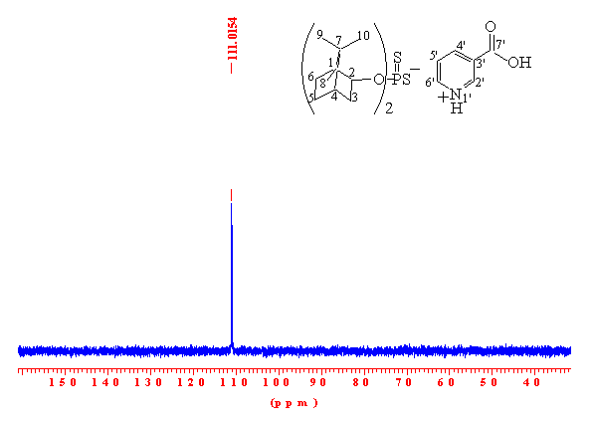
Figure S 1. ³¹Р{¹H} NMR of salt 3a in benzene.
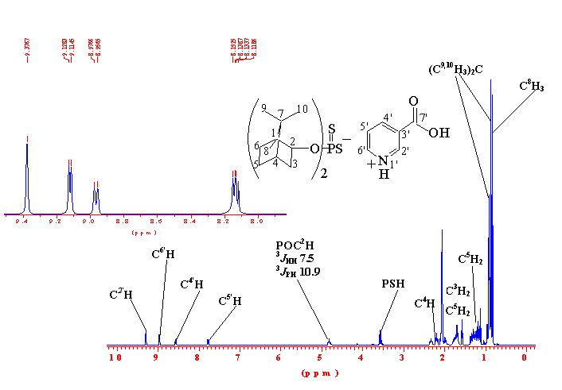
Figure S 2. ¹H NMR of salt 3a in acetone-d₆.

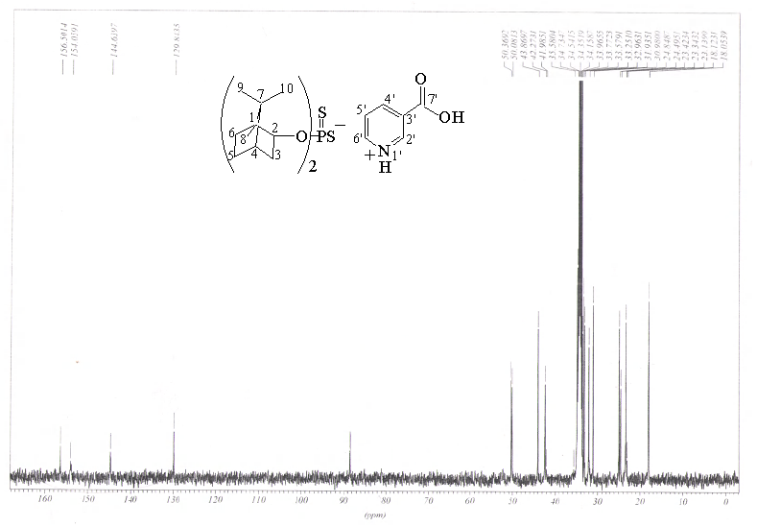

Figure S 3. ¹³С{¹H} NMR of salt 3a in acetone-d₆.
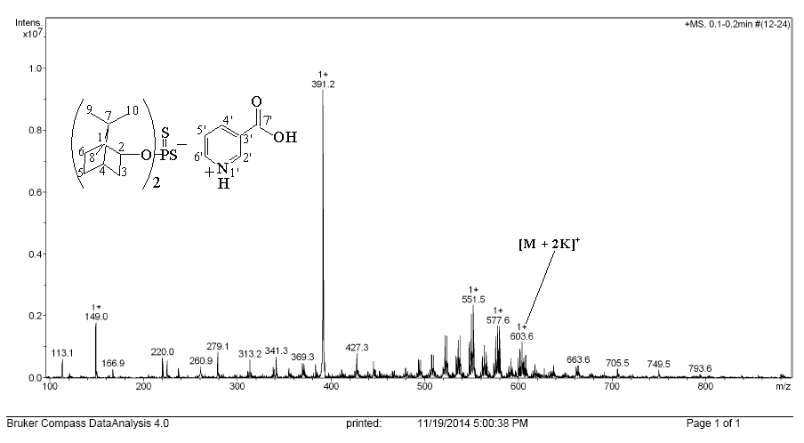

Figure S 4. The mass-spectrum of ESI of 3a (acetone) (calculated M 525.7).
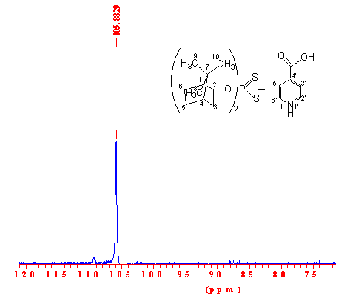
Figure S 5. ³¹Р{¹H} NMR of salt 3b in ethanol.
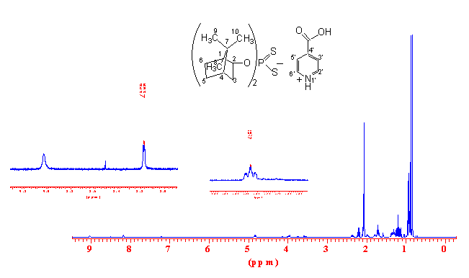

Figure S 6. ¹H NMR of salt 3b in acetone-d₆.

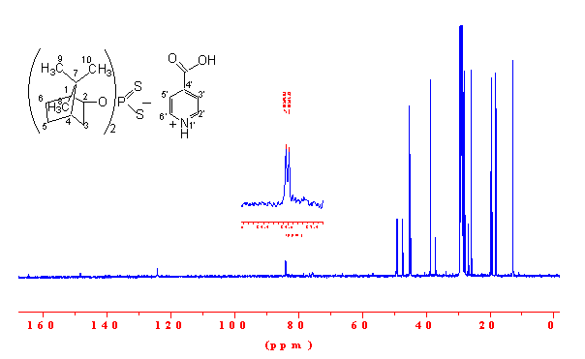

Figure S 7. ¹³С{¹H} NMR of salt 3b in acetone-d₆.

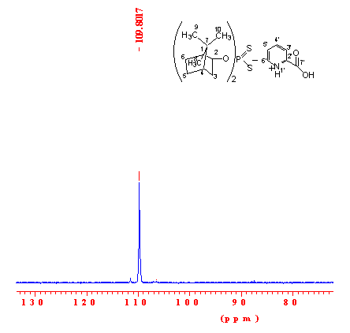
Figure S 8. ³¹Р{¹H} NMR of salt 3с in ethanol.

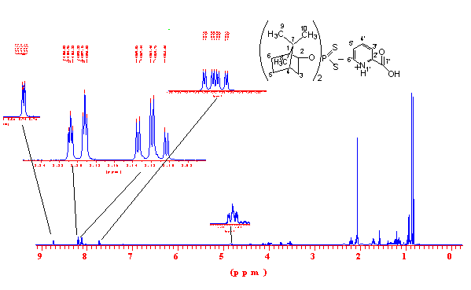

Figure S 9. ¹H NMR of salt 3c in acetone-d₆.

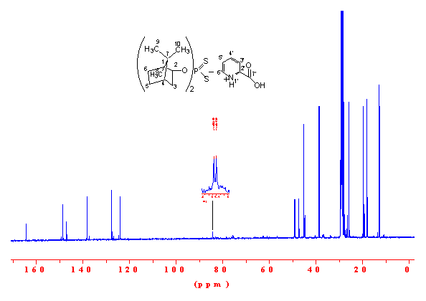
Figure S 10. ¹³С{¹H} NMR of salt 3c in acetone-d₆.
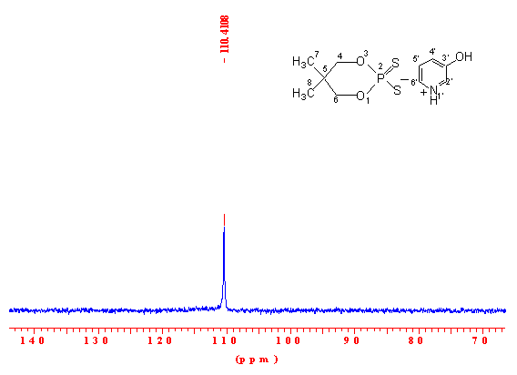
Figure S 11. ³¹Р{¹H} NMR of salt 6a in ethanol.

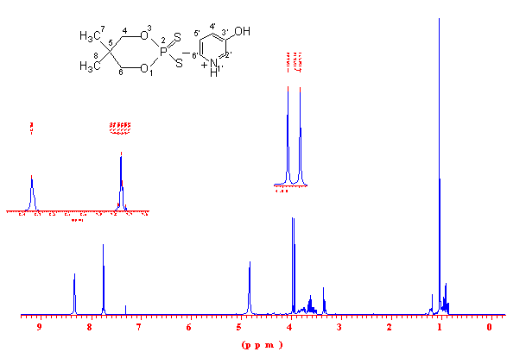

Figure S 12. ¹H NMR of salt 6a in СD₃OD.

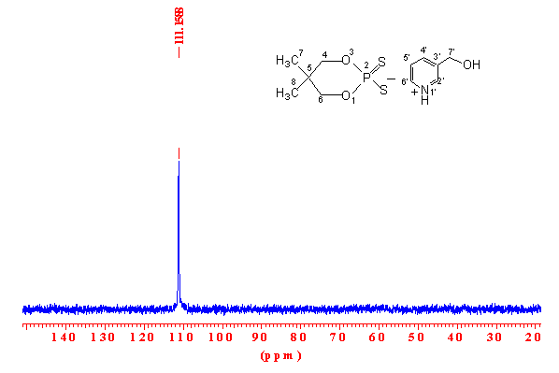
Figure S 13. ³¹Р{¹H} NMR of salt 6b in ethanol.

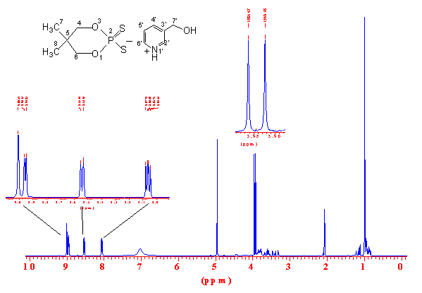

Figure S 14. ¹H NMR of salt 6b in acetone-d₆.

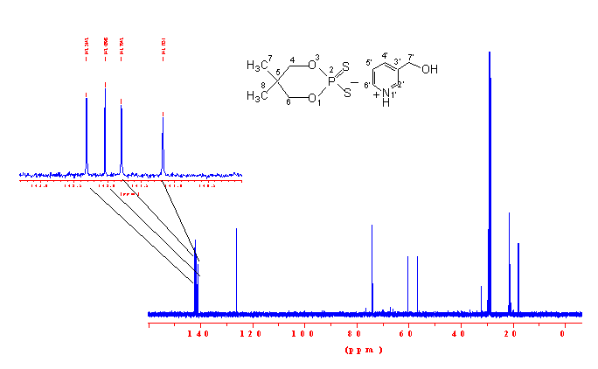

Figure S 15. ¹³С{¹H} NMR of salt 6b in acetone-d₆.

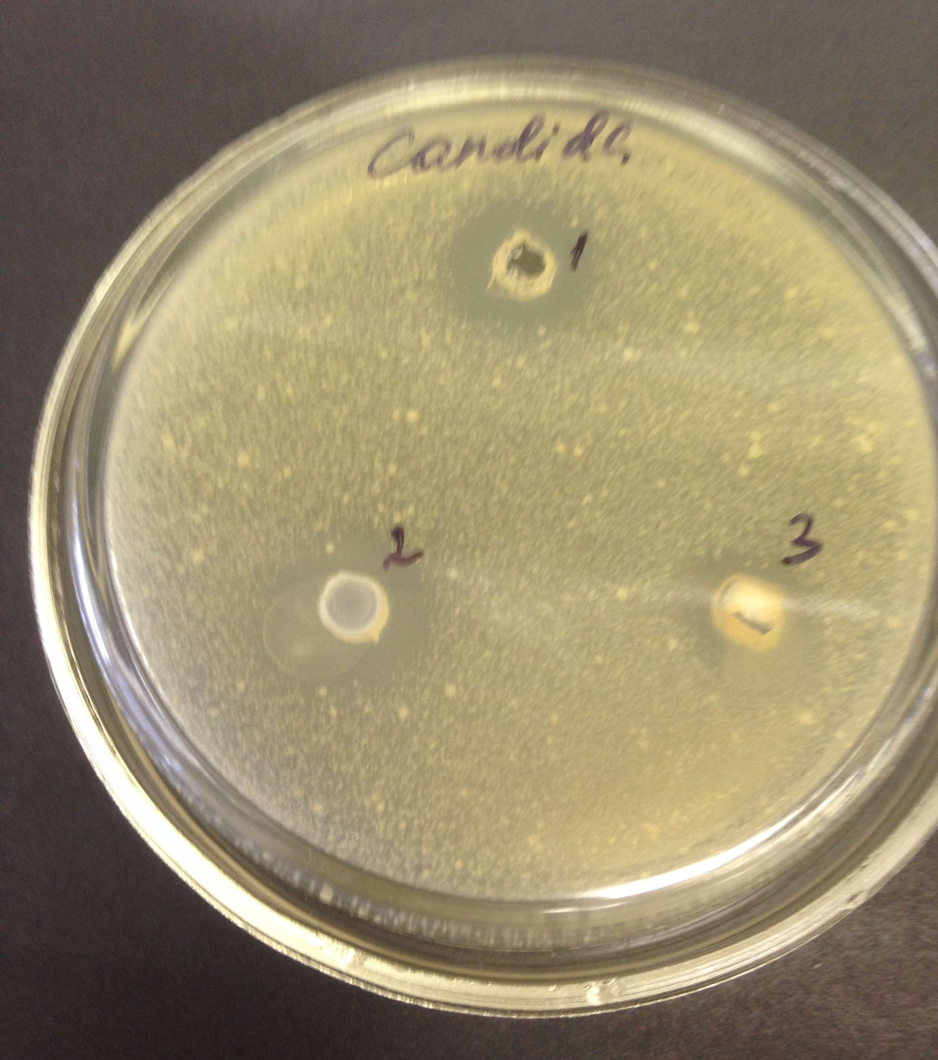

Figure S 16. Antifungal activity of compound 6b against Candida albicans (indicated as 2)

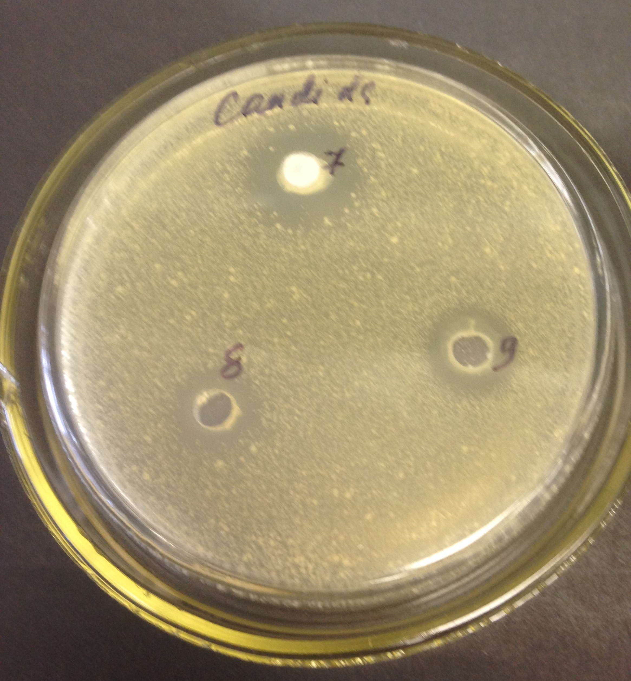

Figure S 17. Antifungal activity of compound 6a against Candida albicans (indicated as 7)

