# Supplementary Material

# Binuclear ruthenium(II) complexes of 4,4’-azopyridine bridging ligand as anticancer agents: Synthesis, characterization, and *in vitro* cytotoxicity studies

PRIYANKA KHANVILKAR, RAMADEVI PULIPAKA, KAVITA SHIRSATH, RANJITSINH DEVKAR and DEBJANI CHAKRABORTY*

**Figure S1.** ESI mass spectra of the complexes indicating their molecular ion peak.

1. **C1**

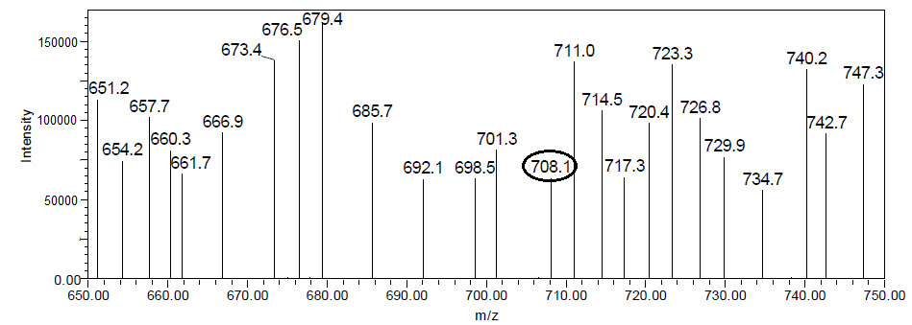

1. **C2**

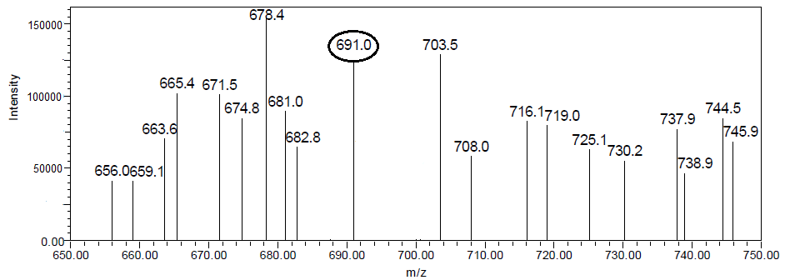

1. **C3**

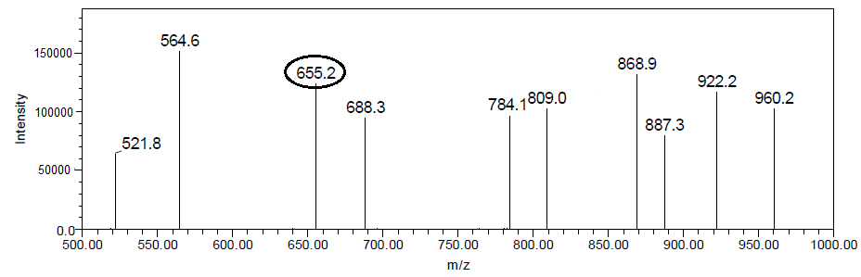

1. **C4**

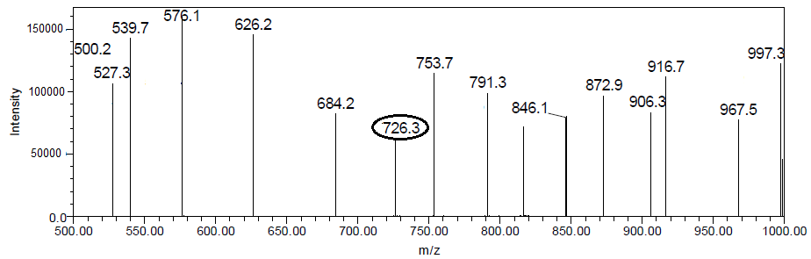

**Figure S2** IR spectra of the complexes.

1. **C1**

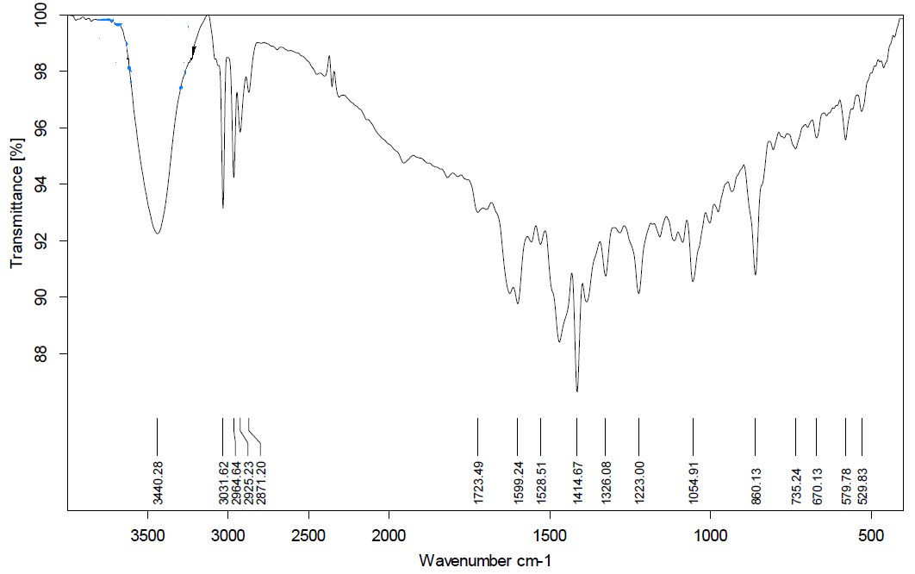

1. **C2**

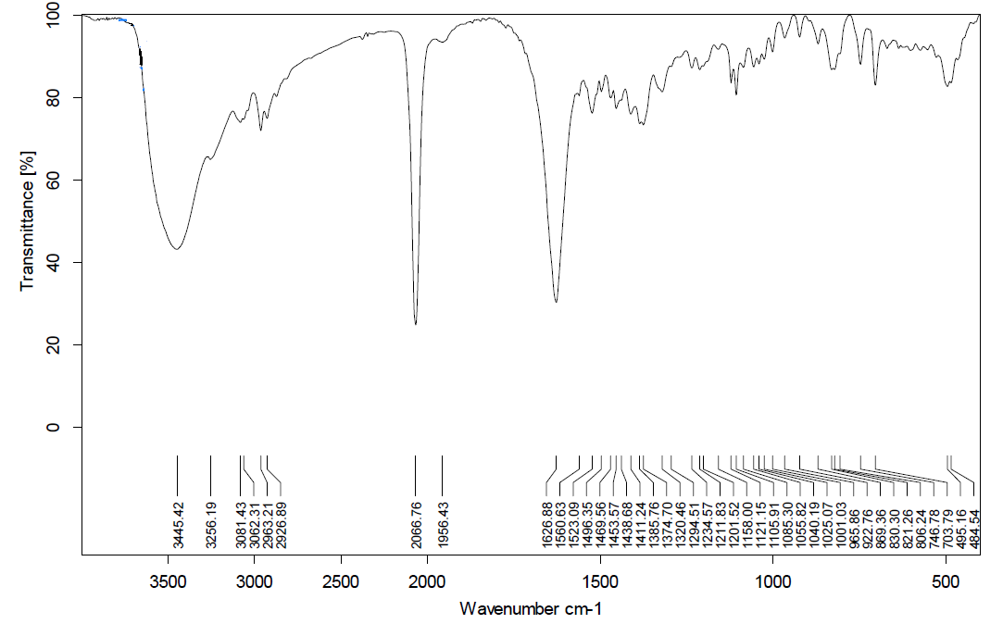

1. **C3**

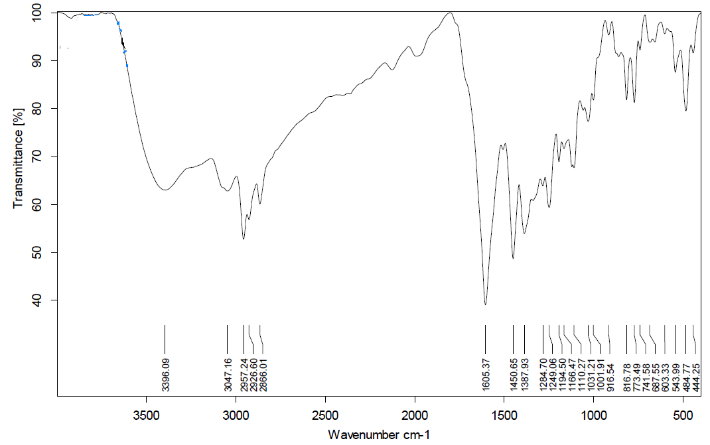

1. **C4**

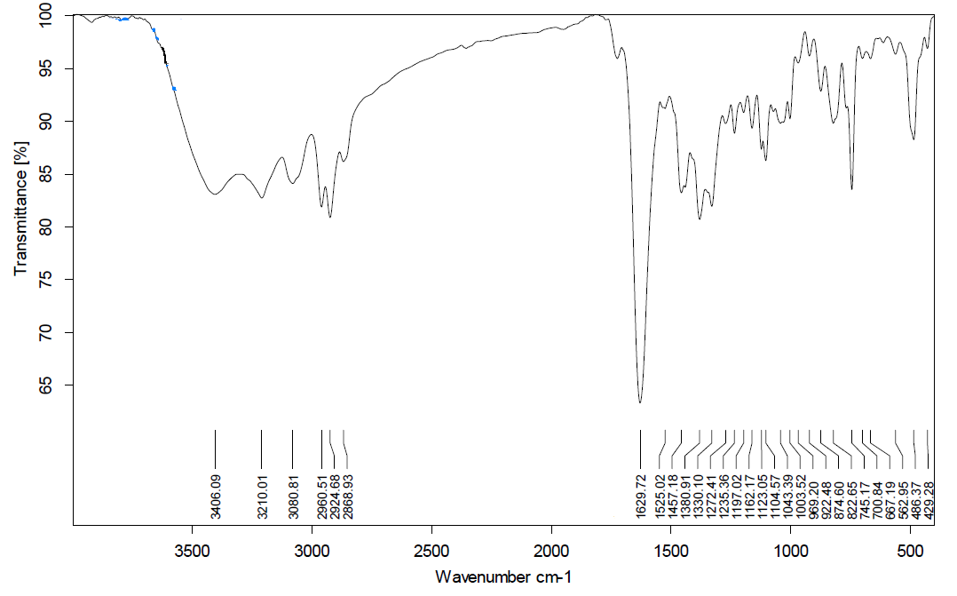

**Figure S3.** 1H NMR spectra of the complexes.

1. **C1**

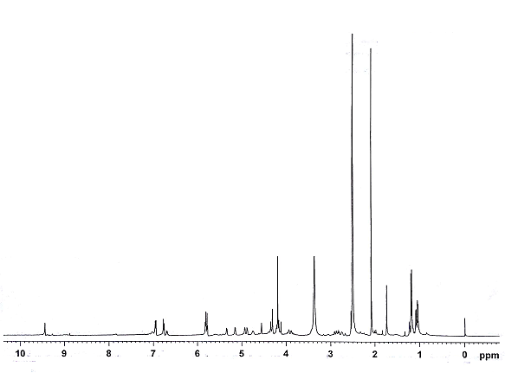

1. **C2**

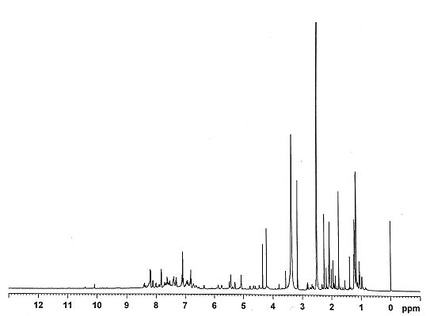

1. **C3**

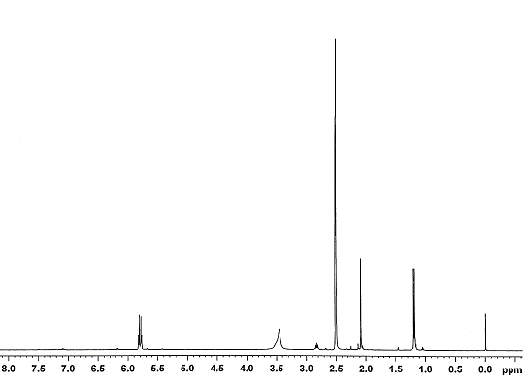

1. **C4**

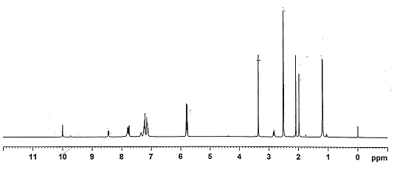

**Figure S4.** UV absorption spectra of complexes at increasing concentrations of CT-DNA, the arrow shows decrease in intensity upon increasing concentrations of DNA.

1. **C2**

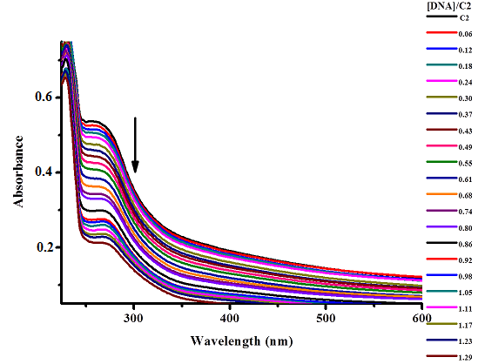

1. **C3**

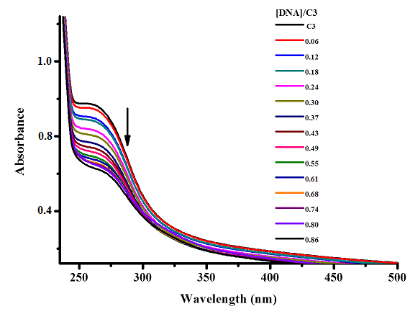

1. **C4**

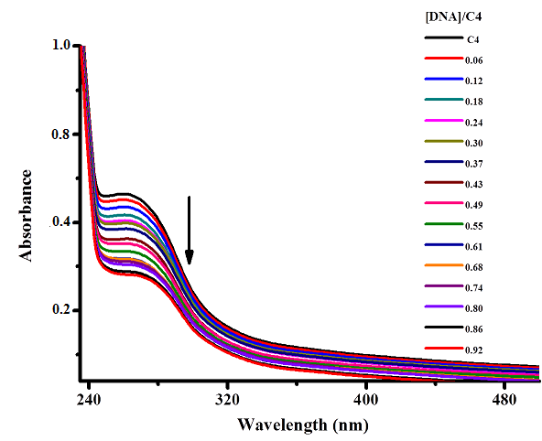

**Figure S5.** Plot of [DNA]/(εA -εf) versus [DNA] for **C1-C4**. The slope to intercept ratio gave Kb values.

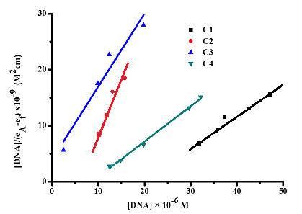

**Figure S6.** Fluorescence emission spectra of DNA-EB complex at increasing concentrations of complexes, the arrow shows decrease in intensity upon increasing concentration of the complex.

1. **C2**

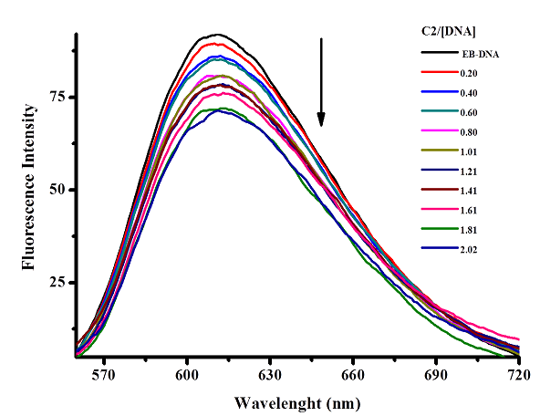

1. **C3**

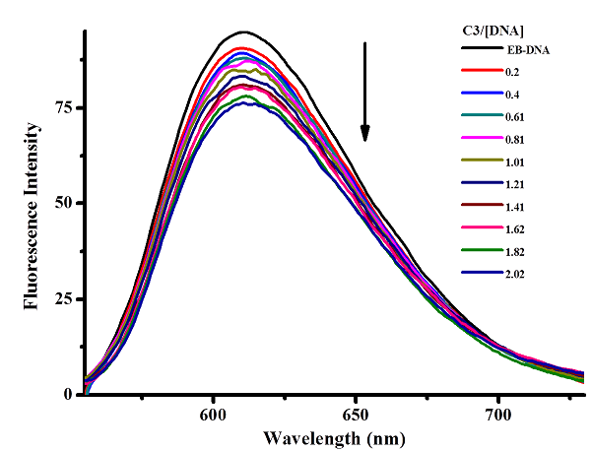

1. **C4**

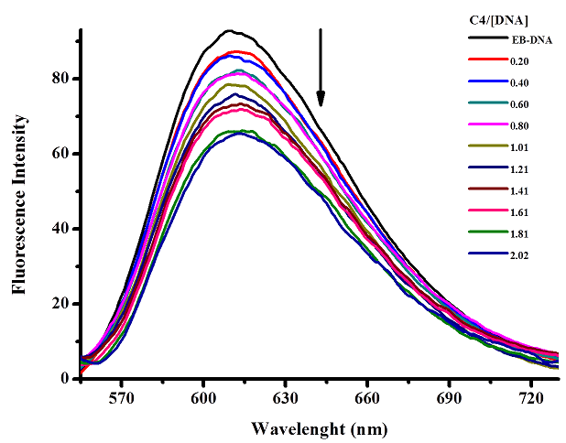

**Figure S7.** Stern-Volmer quenching plot Io/I versus [Q] of DNA-EB for **C1-C4**.

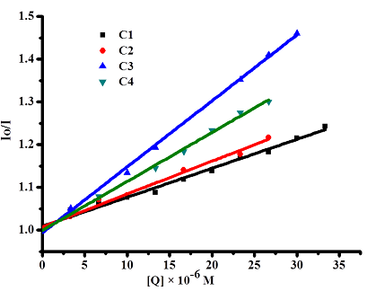

**Figure S8.** Fluorescence emission spectra of BSA at increasing concentrations of complexes, the arrow shows decrease in intensity upon increasing concentration of the complex.

1. **C2**

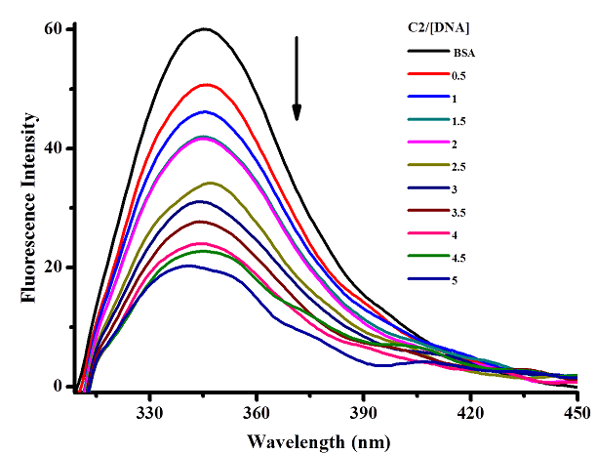

1. **C3**

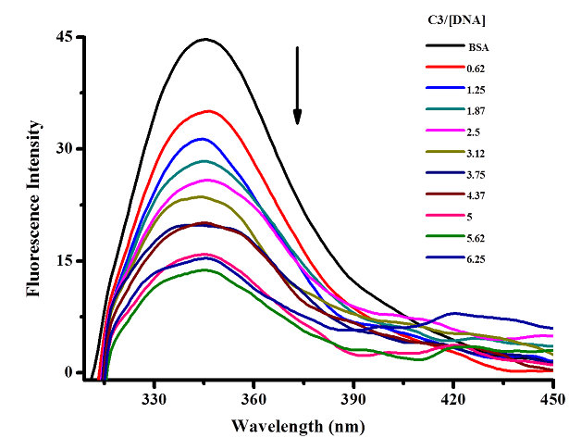

1. **C4**

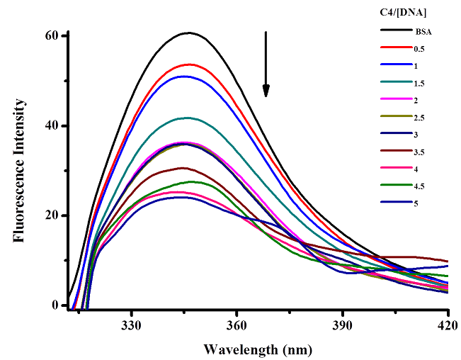

**Figure S9.** Stern-Volmer quenching plot Io/I versus [Q] of BSA for **C1-C4**.

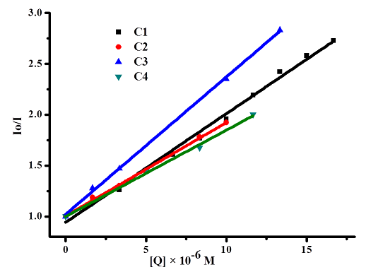

**Figure S10.** Double logarithmic plot from the quenching of BSA fluorescence by **C1-C4** to determine the binding constant Ka and number of binding sites n.

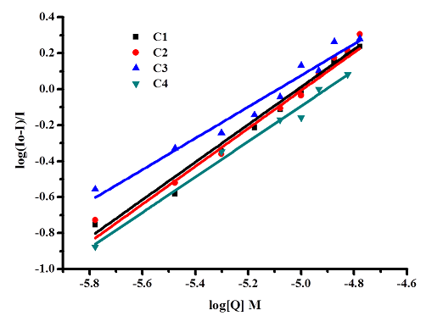

**Figure S11**. % Cell viability of complexes **C1-C4** towards HeLa human cervical cancer cell lines. Each point is the mean ± standard error obtained from three independent experiments.

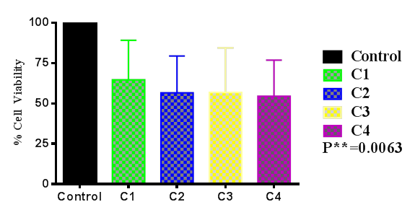

Table S1. Crystallographic data for [Ru(η6-p-cymene)(Fc-phe)Cl].

|  |  |
| --- | --- |
| Empirical formula | C30H34ClFeNO2Ru |
| Molecular weight | 632.95 |
| Crystal system | Orthorhombic |
| Space group | P*212121* |
| a (Å) | 6.8729(7) |
| b (Å) | 10.7444(8) |
| c (Å) | 35.938(3) |
| α (°) | 90 |
| β (°) | 90 |
| γ (°) | 90 |
| V (Å3), Z | 2653.9(4), 4 |
| λ (Å) | 0.71073 |
| Size | 0.25 × 0.17 × 0.12 |
| T (K) | 293 |
| Dcalcd (g/cm3) | 1.584 |
| μ (mm-1) | 1.245 |
| GOF on F2 | 1.030 |
| Final R indices I > 2σ(I) | 0.0493 |
| R indices (all data) | 0.0915 |
| Reflection collection | 17441 |
| Independent reflections | 6133 (Rint = 0.0503; Rsigma = 0.0631 |
| Absorption coefficient | 1.245 |
| F(000) | 1292 |
| Θ range (°) | 3.81-26.05 |
| Index range | -8 < h < 8  -14 < k < 14  -48 < h < 48 |
| Absorption correction | MULTI-SCAN |
| Data / Restraints / Parameters | 6133 / 0 / 328 |