Scalable synthesis of multi-substituted aryl-phosphonates: exploring the limits of isoretical expansion and the synthesis of new triazene-based phosphonates
Derek Barbeeª and Andrew R. Barron^{a,b,c*}
ªDepartment of Materials Science and Nanoengineering, Rice University, Houston, Texas 77005, USA
^{b}Department of Chemistry, Rice University, Houston, Texas 77005, USA
^{c}Energy Safety Research Institute, Swansea University, Bay Campus, Swansea, SA1 8EN, Wales, UK
Email: arb@rice.edu
Supplemental Materials
IR data
1,3,5-Tris(4-bromophenyl)benzene (TBPB, 3a). FTIR (cm⁻¹): 3045, 1591, 1493, 1648, 1589, 1488, 1440, 1365, 1257, 1238, 1200, 1064, 1005, 942, 869, 805, 690.
Tris(4’-bromo-[1,1’-biphenyl]-4-yl)-1,3,5-benzene (TBBPB) (5a). FTIR (cm⁻¹): 3017, 1601, 1491, 1443, 1194, 1005, 857, 802, 720.
(E)-1,3-bis(4’-bromo-[1,1’-biphenyl]-4-yl)but-2-en-1-one (DBBPE) (6a). FTIR (cm⁻¹): 3094, 3081, 1642, 1590, 1455, 1365, 1311, 1252, 1176, 1047, 1010, 981, 912, 857, 803, 739.
1,3,5-tris(4-bromo-2-methylphenyl)triazine (8a). FTIR (cm⁻¹): 3005, 2945, 2371, 2347, 1593, 1559, 1517, 1430, 1389, 1342, 1253, 1195, 1150, 1084, 1027, 866, 805.
4,4’-bis(diisopropyl phosphonate) biphenyl (1b). FTIR (cm⁻¹): 2973, 2944, 2891, 2355, 2340, 1596, 1384, 1249, 1167, 1139, 1096, 961, 876, 813, 764, 748, 700.
Diisopropyl (E)-(4’-(4-(4’-(diisopropoxyphosphoryl)-[1,1’-biphenyl]-4-yl)-4-oxobut-2-en-2-yl)-[1,1’-biphenyl]-4-yl)phosphonate (6b). FTIR (cm⁻¹): 2991, 2937, 2883, 1638, 1583, 1409, 1362, 1225, 1155, 1107, 1081, 963, 867, 809, 741, 679.
Hexaisopropyl((1,3,5-triazine-2,4,6-triyl)tris(([1,1’-biphenyl]-4’-4-diyl)))tris(phosphonate) (7b). FTIR (cm⁻¹): 2988, 2941, 2873, 1500, 1361, 1243, 1175, 1138, 1096, 1058, 968, 882, 804, 775, 694.
1,3,5-tris(diisopropyl 2-methylphenyl-4-phosphonato)triazine (8b). FTIR (cm⁻¹): 3015, 2959, 2892, 2209, 1520, 1465, 1396, 1250, 1177, 1148, 1103, 963, 905, 842, 789, 708.
Biphenyl-4,4’-di(phosphonic acid) (1c). FTIR (cm⁻¹): 3500-2000, 2365, 2343, 1594, 1130, 1117, 1000, 93, 809, 705. CHN analysis calcd. (%): C 45.86, H 3.82; found: C 45.14, H 3.80.
3,3’,5,5’-Tetra(phosphoric acid)-1,1’-biphenyl (2c). FTIR (cm⁻¹): 3750-3350, 3008, 2953, 2903, 1428, 1345, 1211, 1141, 1103, 1063, 965, 850, 795, 717, 656. CHNS analysis calcd. (%): C 30.38, H 2.95; found C 30.47, H 2.92.
1,3,5-Benzene-tri-p-phenylphosphonic acid (3c). FTIR (cm⁻¹): 3500-2000, 2357, 2325, 1204, 1111, 1055, 99, 937, 795, 730, 681. CHNS analysis calcd (%): C 22.64, H 2.83; found: C 22.30, H 2.84.
1,3,5-Tris(phenyl-4-phosphonic acid)benzene (BBTPA) (4c). FTIR (cm⁻¹): 3600-2000, 2375, 2339, 1590, 1133, 1051, 982, 919, 815, 721, 686.
((1,3,5-triazine-2,4,6-triyl)tris(3-methylbenzene-4,1,-diyl))tris(phosphonic acid) (MBTTPA) (8c). FTIR (cm⁻¹): 3700-2000, 2988, 2939, 1560, 1503, 1375, 1341, 1141, 1099, 977, 883, 807, 793, 681.

Computational data
Table S 1: Selected calculated structural parameters for R(CH₃)C=C(H)C(O)R intermediate using RB3LYP method and 6-31G** basis set.
R | O=C (Å) | C=C (Å) | O…Me (Å) | O=C-C (°) | C-C=C (°) | C=C-C (°) | Σ(X-C-C) (°)
Ph | 1.26293 | 1.3659 | 2.81671 | 122.03680 | 125.88735 | 123.34808 | 371.27223
Bi-phenyl | 1.26346 | 1.36566 | 2.85974 | 122.26606 | 126.43491 | 123.52476 | 372.22573

Table S 2: Calculated total energy (Hartree) for optimized structures using RB3LYP method and 6-31G** basis set.ª
R | RC(O)CH₃ | R(CH₃)C=C(O)R | C₆H₃R₃
Ph | -384.814612 | -693.210538 | -925.24701
Bi-phenyl | -615.827943 | -1155.237226 | -1618.255426
ª Energy for H₂O = -76.401391 Hartree.

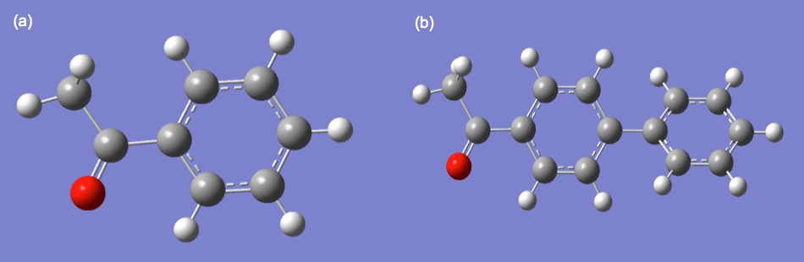
Figure S 1: Calculated structures of (a) PhC(O)CH₃ and (b) (biphen)C(O)CH₃. Calculations of all structures was carried out at the RB3LYP level with the 6-31G** basis set

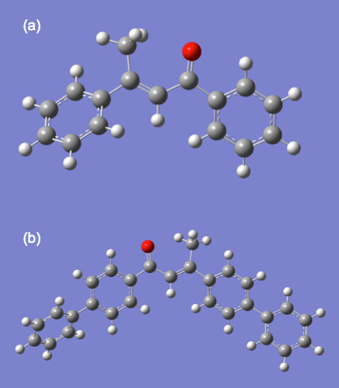
Figure S 2. Calculated structures of (a) Ph(CH₃)C=C(H)C(O)Ph and (b) (biphen)(CH₃)C=C(H)C(O)(biphen). Calculations of all structures was carried out at the RB3LYP level with the 6-31G** basis set.

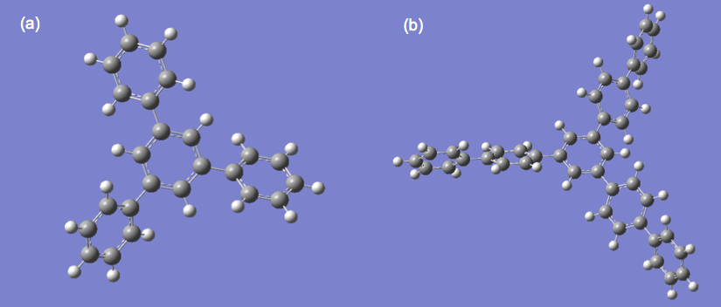
Figure S 3: Calculated structures of (a) C₆H₃Ph and (b) C₆H₃(biphen). Calculations of all structures was carried out at the RB3LYP level with the 6-31G** basis set.

Table S 3: Calculated total energy (Hartree) for optimized structures using RB3LYP method and 6-31G** basis set.
Entry | R | R-C≡N | N₃C₃R₃
1 | Ph | -324.423785 | -973.337598
2 | Bi-phenyl | -555.437023 | -1666.377571

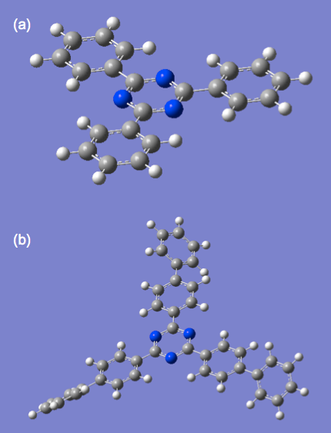
Figure S 4: Calculated structures of (a) C₃N₃Ph and (b) C₃N₃(biphen). Calculations of all structures was carried out at the RB3LYP level with the 6-31G** basis set.

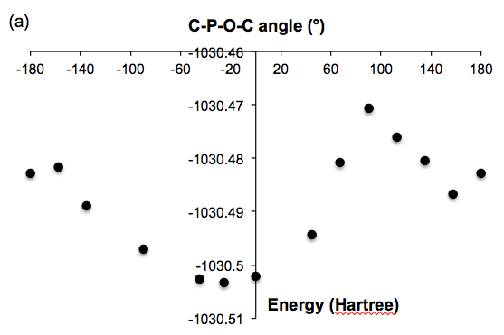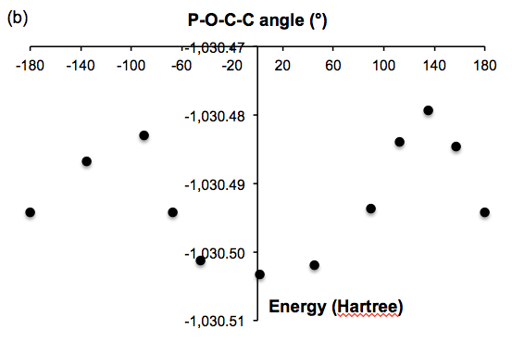
Figure S 5: Plot of calculated total energy (Hartree) of C₆H₅P(O)(O^{i}Pr)₂ as a function of the (a) C-P-O-C and (b) C-C-P=O torsional angle.

