**Supplementary material**

**Synthesis of nucleotide analogues, EFdA, EdA and EdAP, and the effect of EdAP on hepatitis B virus replication**

Mai Kamata,1 Toshifumi Takeuchi,1 Ei Hayashi,1 Kazane Nishioka,1,2 Mizuki Oshima,1,2 Masashi Iwamoto,1,2 Kota Nishiuchi,1 Shogo Kamo,1 Shusuke Tomoshige,1 Koichi Watashi,1,2 Shinji Kamisuki,3 Hiroshi Ohrui,4 Fumio Sugawara,1 Kouji Kuramochi1,*

1*Department of Applied Biological Science, Tokyo University of Science, Chiba, Japan*

2*Department of Virology II, National Institute of Infectious Diseases, Tokyo 162-8640, Japan.*

3*School of Veterinary Medicine, Azabu University, 1-17-71 Fuchinobe, Chuo-ku, Sagamihara, Kanagawa 252-5201, Japan.*

4*Yokohama University of Pharmacy, 601 Matano-cho, Totsuka-ku, Yokohama 245-0066, Japan.*

*Corresponding author. Tel: +81-4-7124-1501 (ext. 3400); E-mail address: kuramoch@rs.tus.ac.jp

Index

**Figure S1**. 1H NMR spectrum (400 MHz, methanol-*d*4) of EFdA (**1**). S3

**Figure S2**. 13C NMR spectrum (100 MHz, methanol-*d*4) of EFdA (**1**). 　 S4

**Figure S3**. 1H NMR spectrum (400 MHz, methanol-*d*4) of EdA (**2**). 　　 　　 S5

**Figure S4**. 13C NMR spectrum (100 MHz, methanol-*d*4) of EdA (**2**). 　　 S6

**Figure S5.** 1H NMR spectrum (400 MHz, DMSO-*d*6) of EdA (**2**). S7

**Figure S6**. 1H NMR spectrum (400 MHz, methanol-*d*4) of EdAP (**3**). 　　 S8

**Figure S7**. 13C NMR spectrum (100 MHz, methanol-*d*4) of EdAP (**3**). 　　 S9

**Figure S8.** 1H NMR spectrum (400 MHz, chloroform-*d*) of compound **21**. S10

**Figure S9.** 13C NMR spectrum (100 MHz, chloroform-*d*) of compound **21**. S11

**Figure S10.** A magnified view of HMBC spectrum of compound **21**. S12

**Figure S11**. 1H NMR spectrum (400 MHz, chloroform-*d*) of compound **25**. S13

**Figure S12.** 13C NMR spectrum (100 MHz, chloroform-*d*) of compound **25**. S14

**Figure S13**. 1H NMR spectrum (400 MHz, chloroform-*d*) of compound **26**. S15

**Figure S14.** 13C NMR spectrum (100 MHz, chloroform-*d*) of compound **26**. S16

**Figure S15.** 1H NMR spectrum (400 MHz, chloroform-*d*) of compound **27**. S17

**Figure S16.** 13C NMR spectrum (100 MHz, chloroform-*d*) of compound **27**. S18

**Figure S17.** 1H NMR spectrum (400 MHz, chloroform-*d*) of compound **28**. S19

**Figure S18.** 13C NMR spectrum (100 MHz, chloroform-*d*) of compound **28**. S20

**Figure S19.** 1H NMR spectrum (400 MHz, chloroform-*d*) of compound **29**. S21

**Figure S20.** 13C NMR spectrum (100 MHz, chloroform-*d*) of compound **29**. S22

**Figure S21.** Effect of EdA on the replication of HBV. 　　　　S23

**Figure S1.** 1H NMR spectrum (400 MHz, methanol-*d*4) of EFdA (**1**).

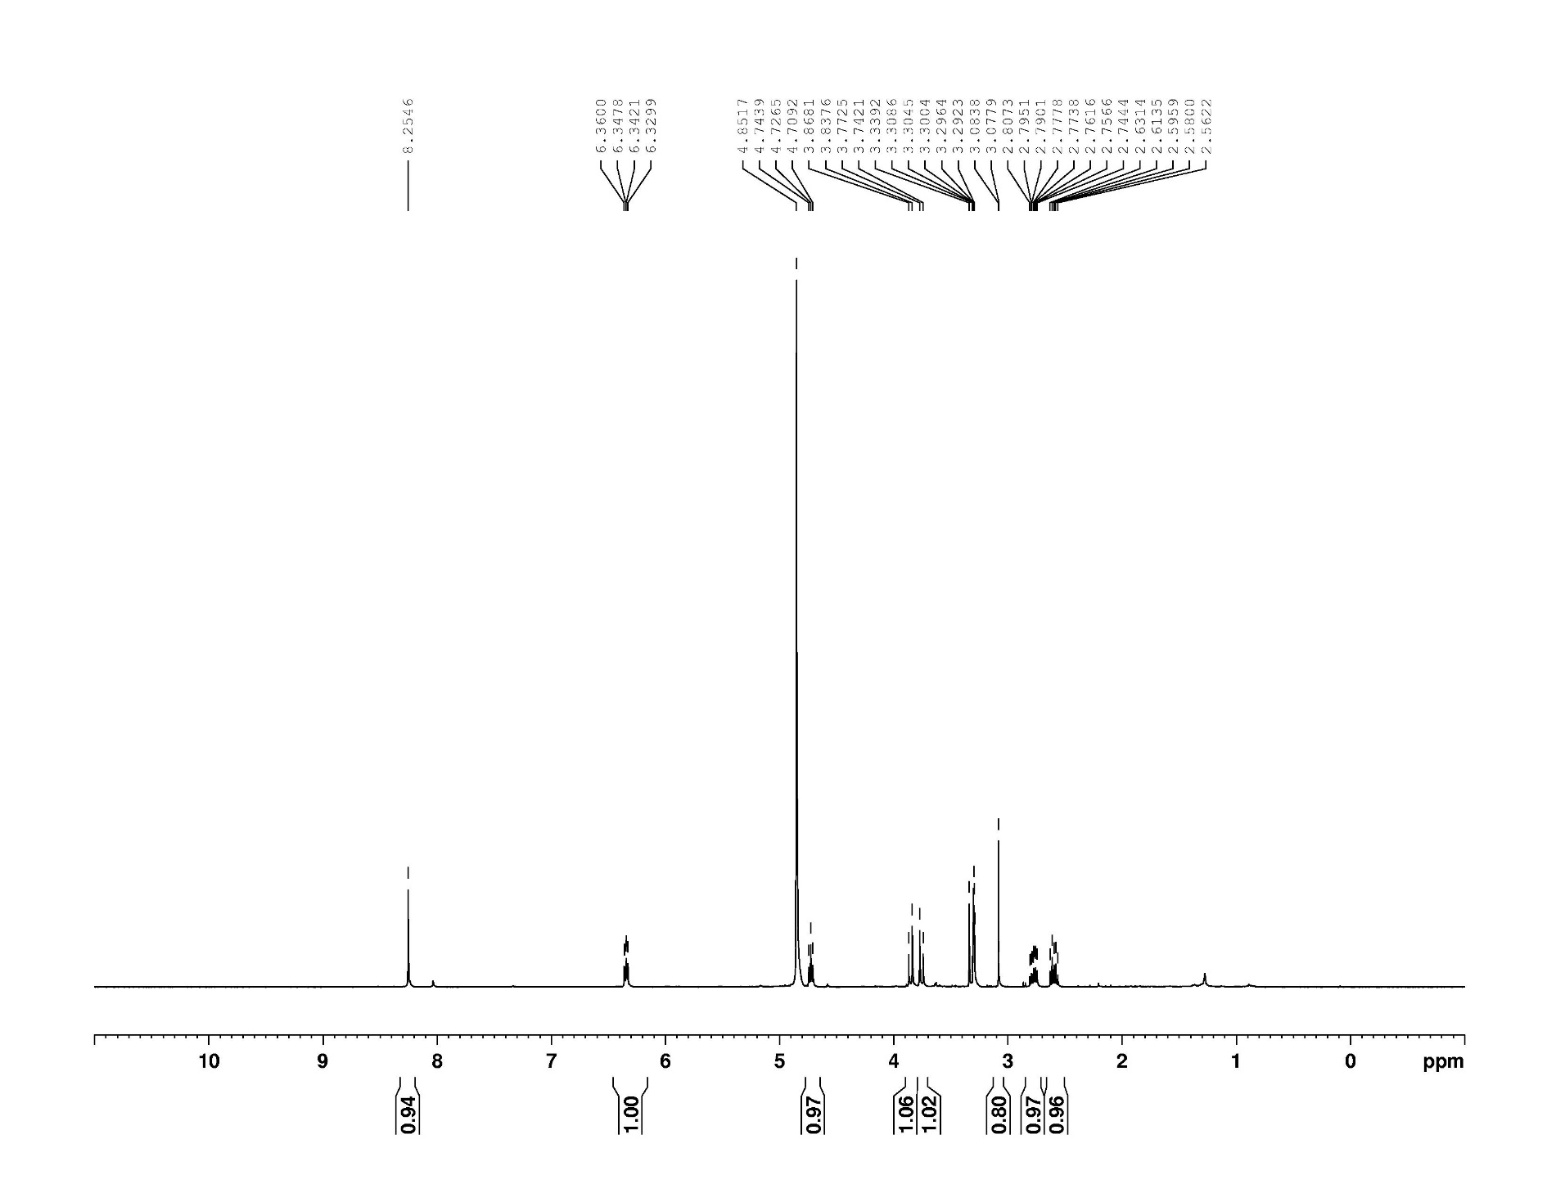

**Figure S2.** 13C NMR spectrum (100 MHz, methanol-*d*4) of EFdA (**1**).

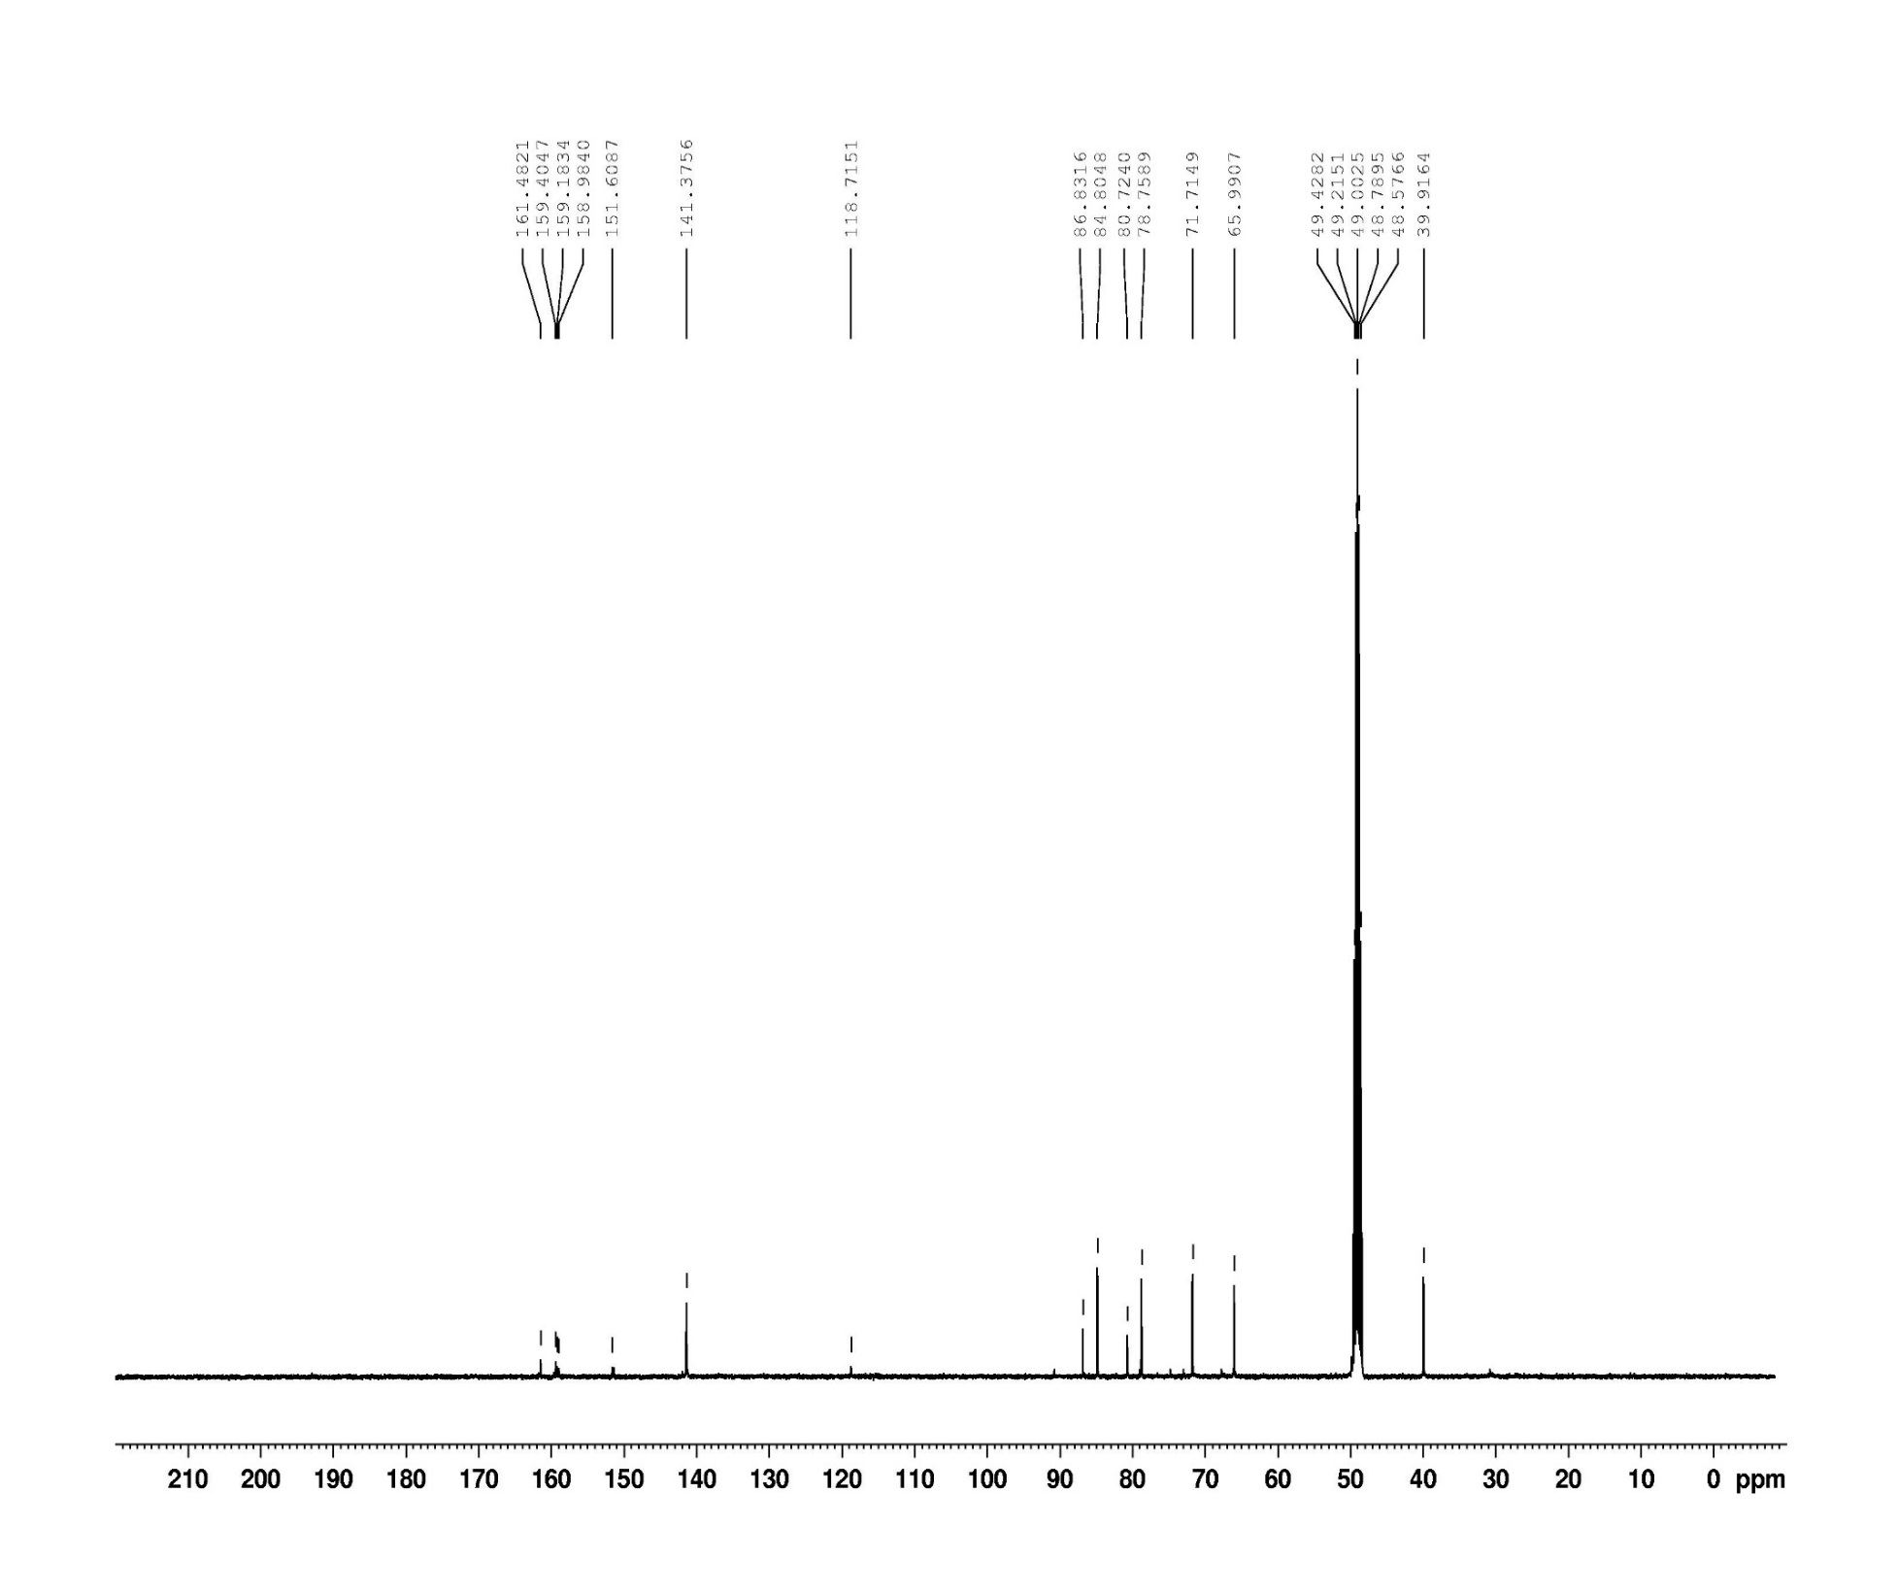

**Figure S3.** 1H NMR spectrum (400 MHz, methanol-*d*4) of EdA (**2**).

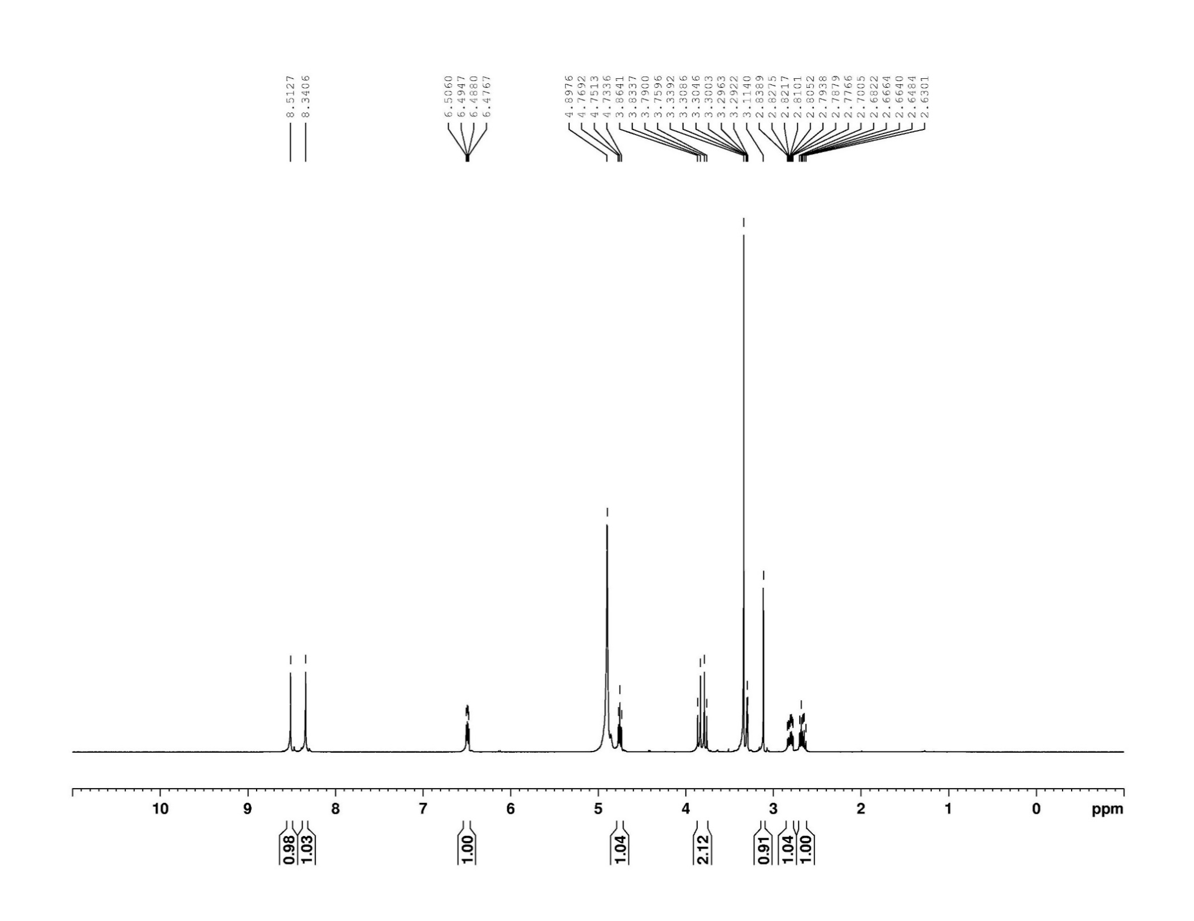

**Figure S4.** 13C NMR spectrum (100 MHz, methanol-*d*4) of EdA (**2**).

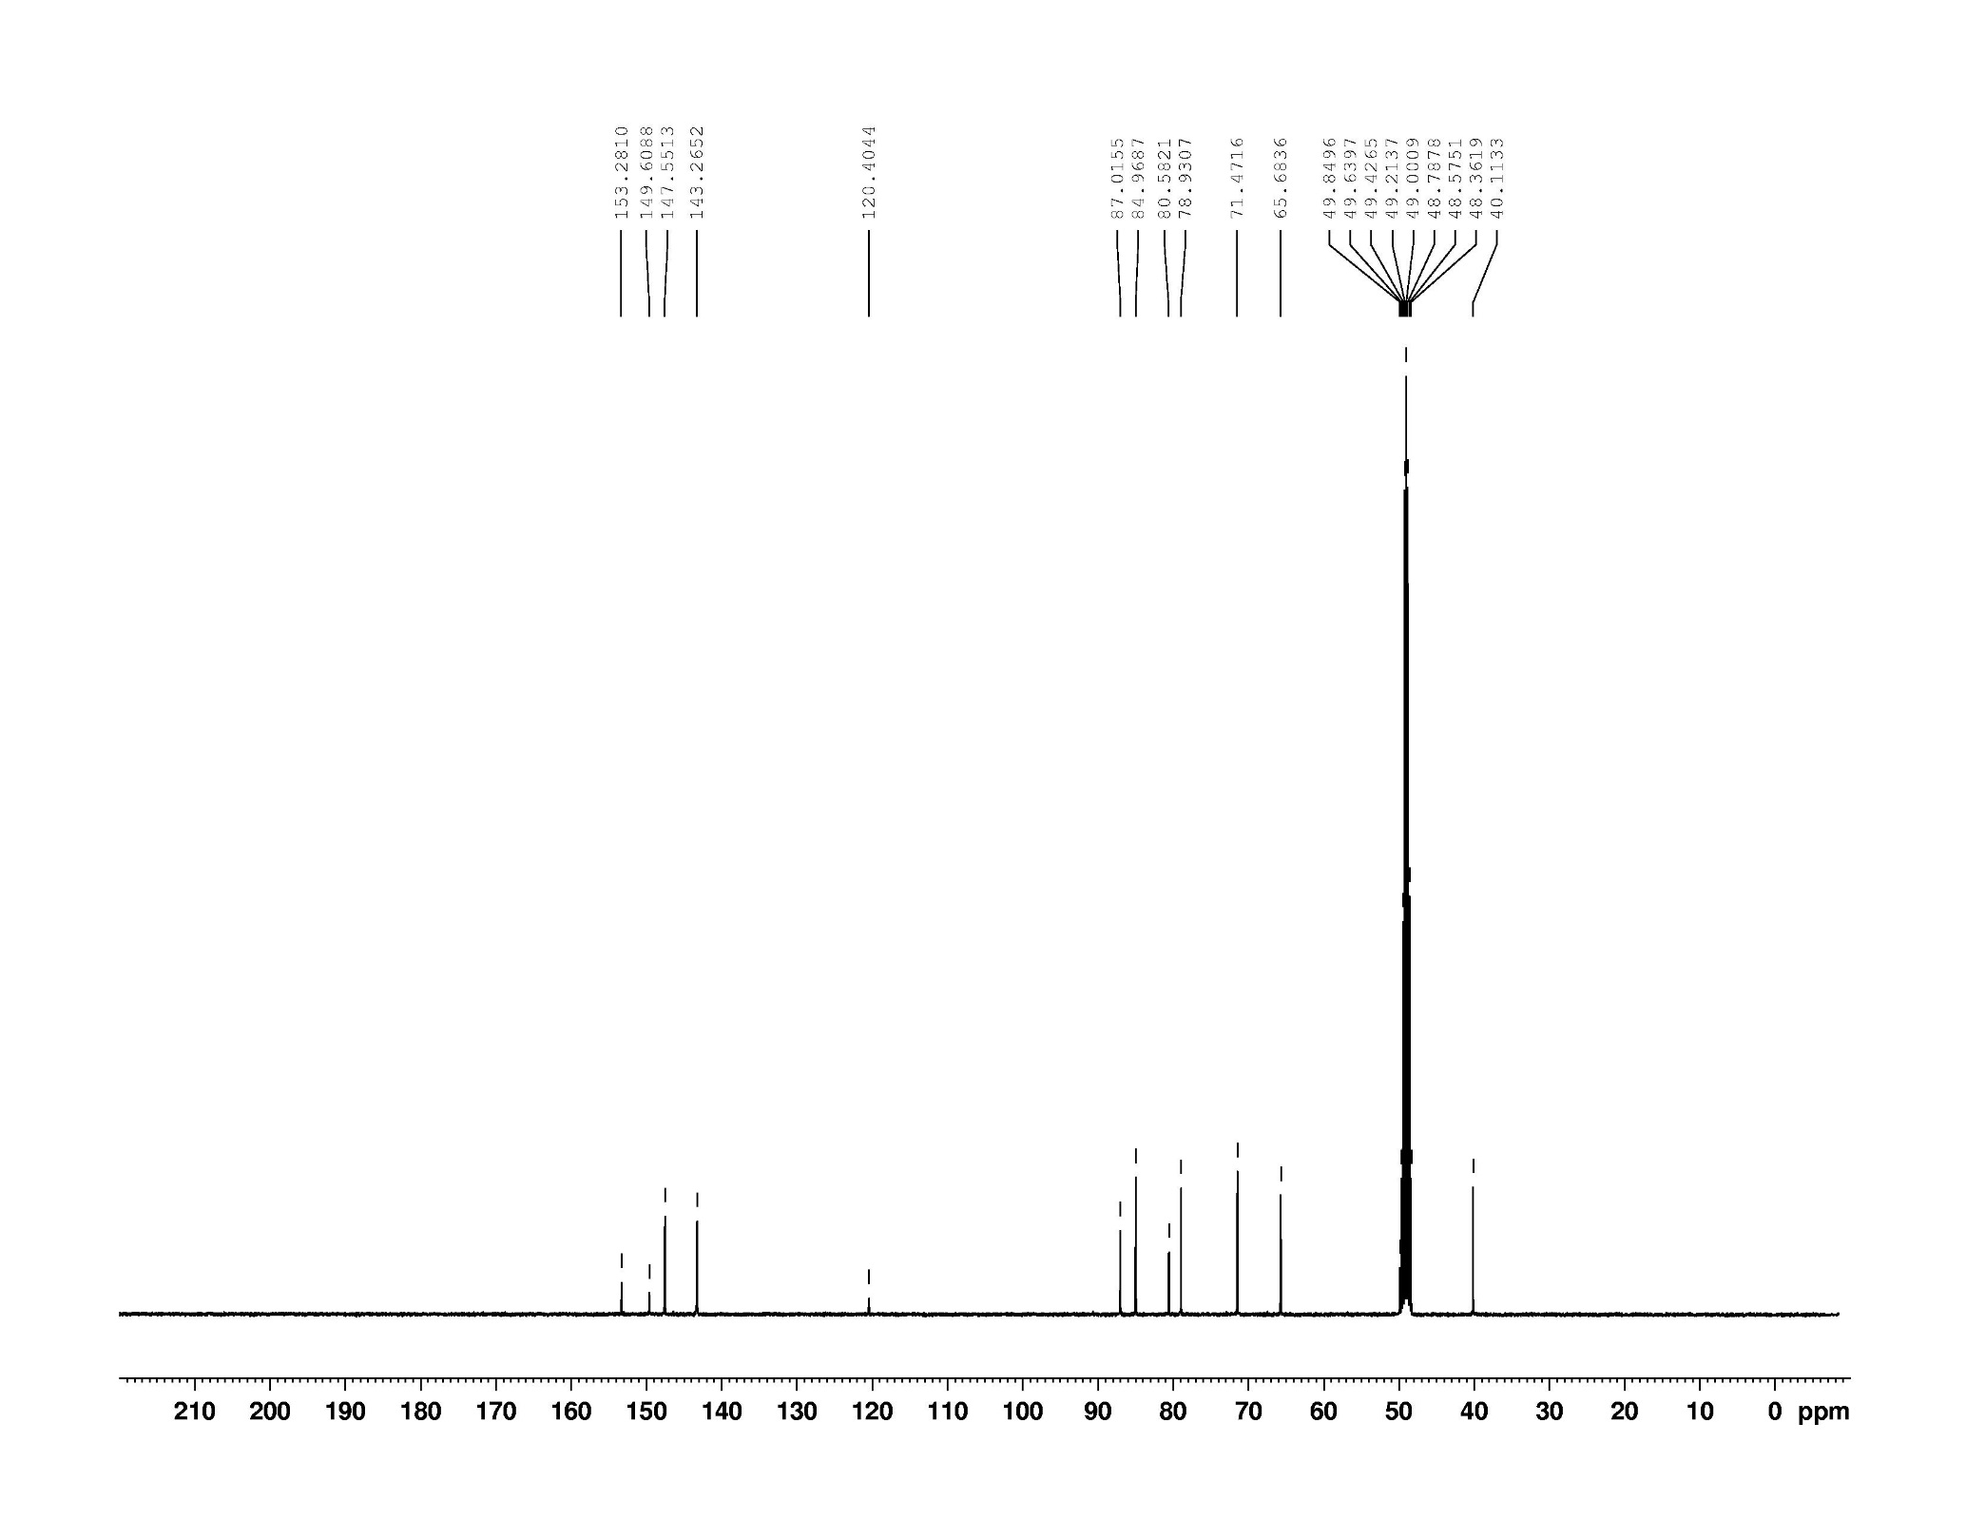

**Figure S5.** 1H NMR spectrum (400 MHz, DMSO-*d*6) of EdA (**2**).

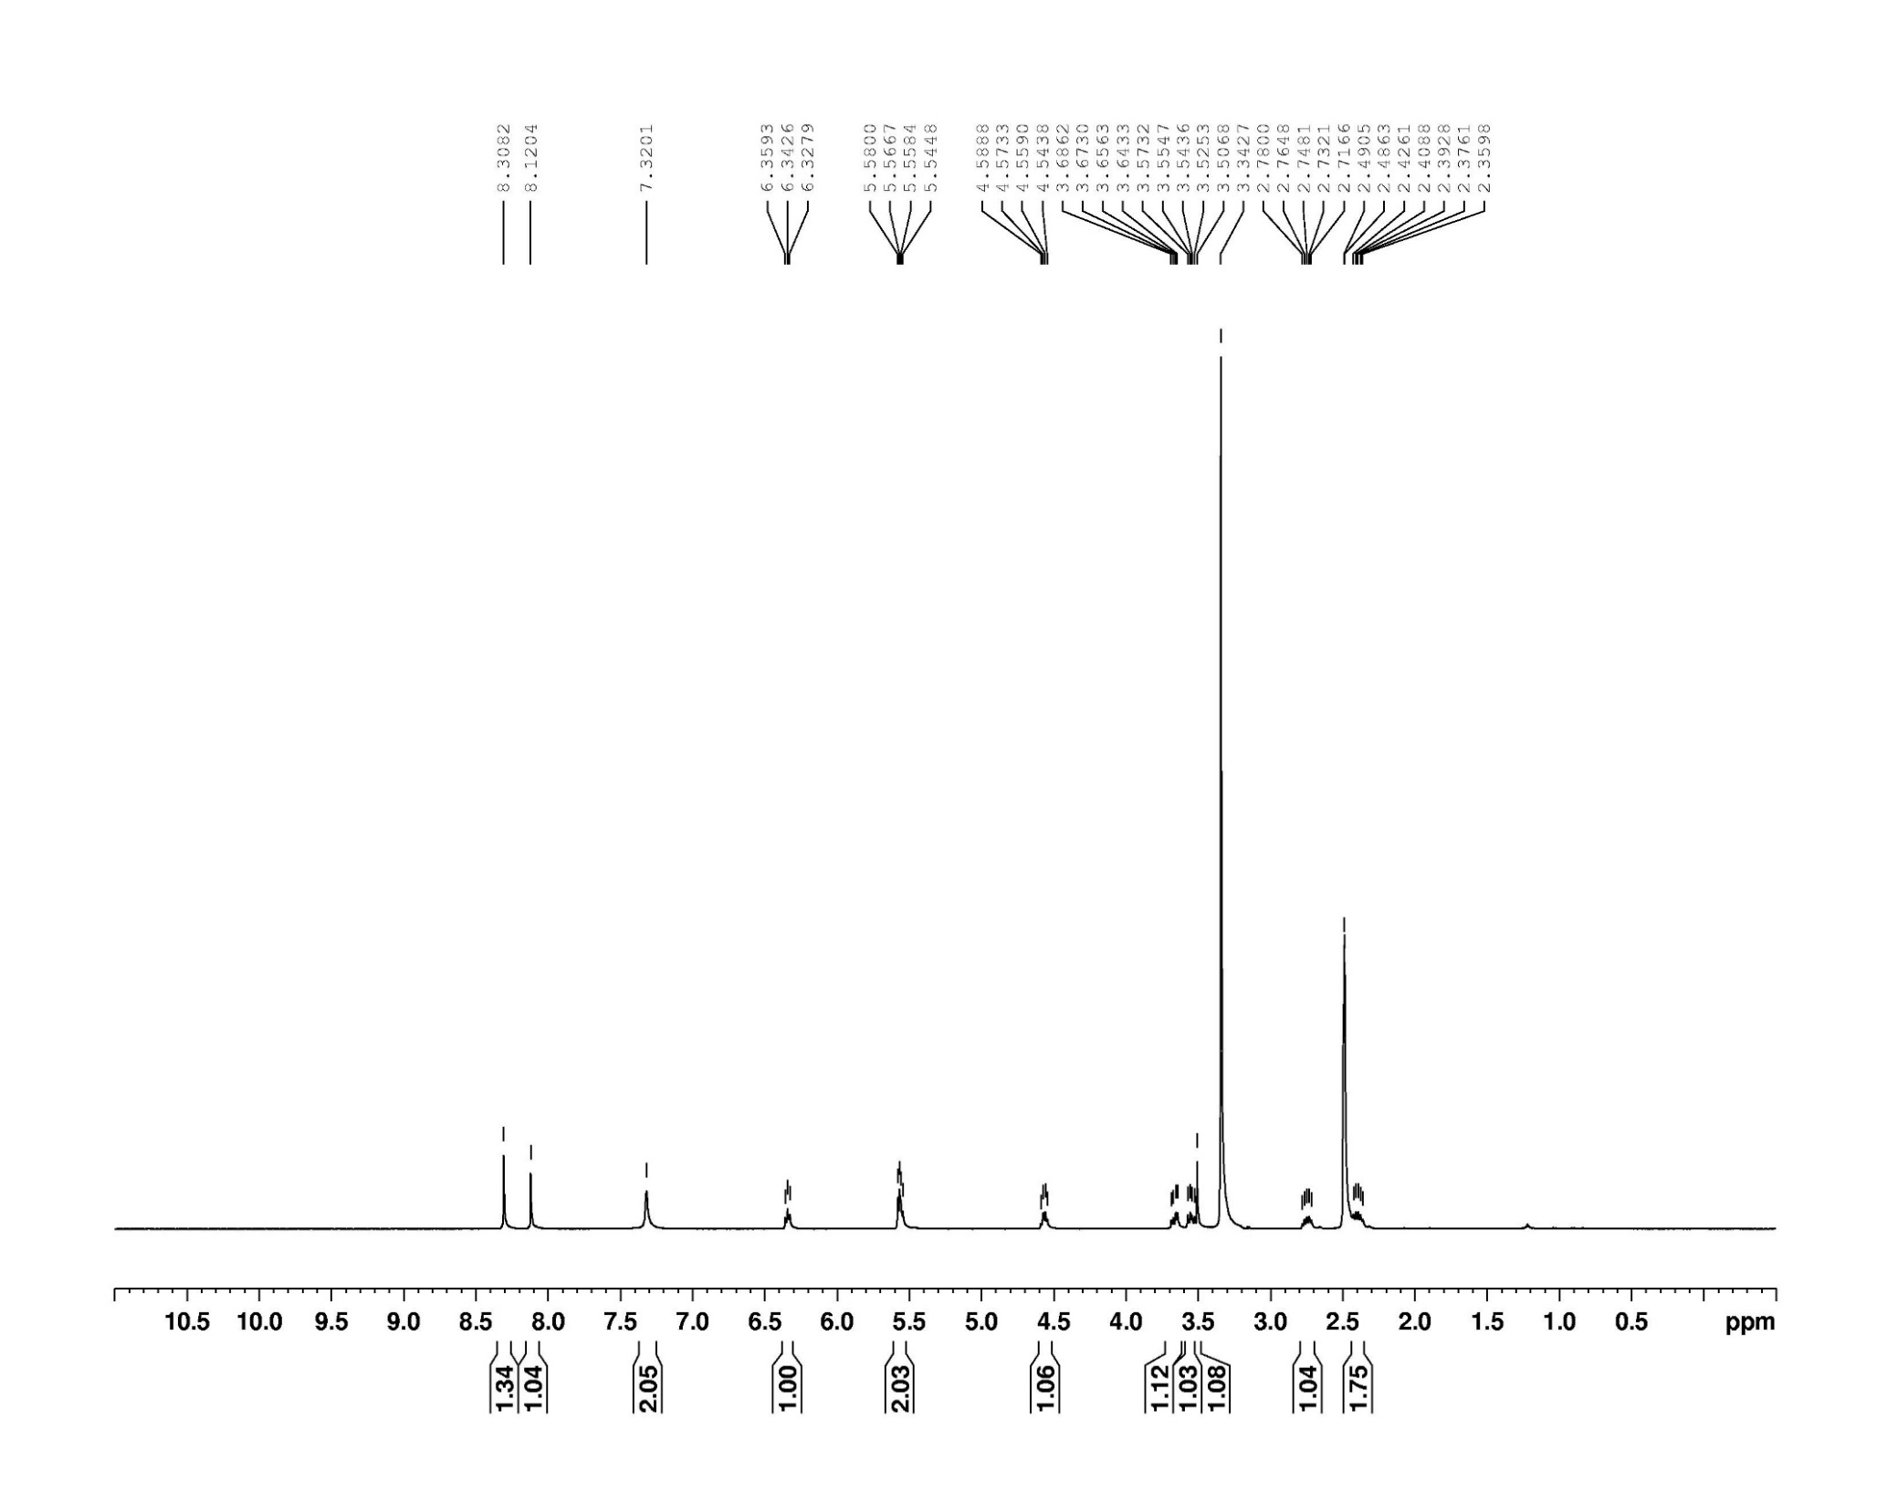

**Figure S6**. 1H NMR spectrum (400 MHz, methanol-*d*4) of EdAP (**3**).

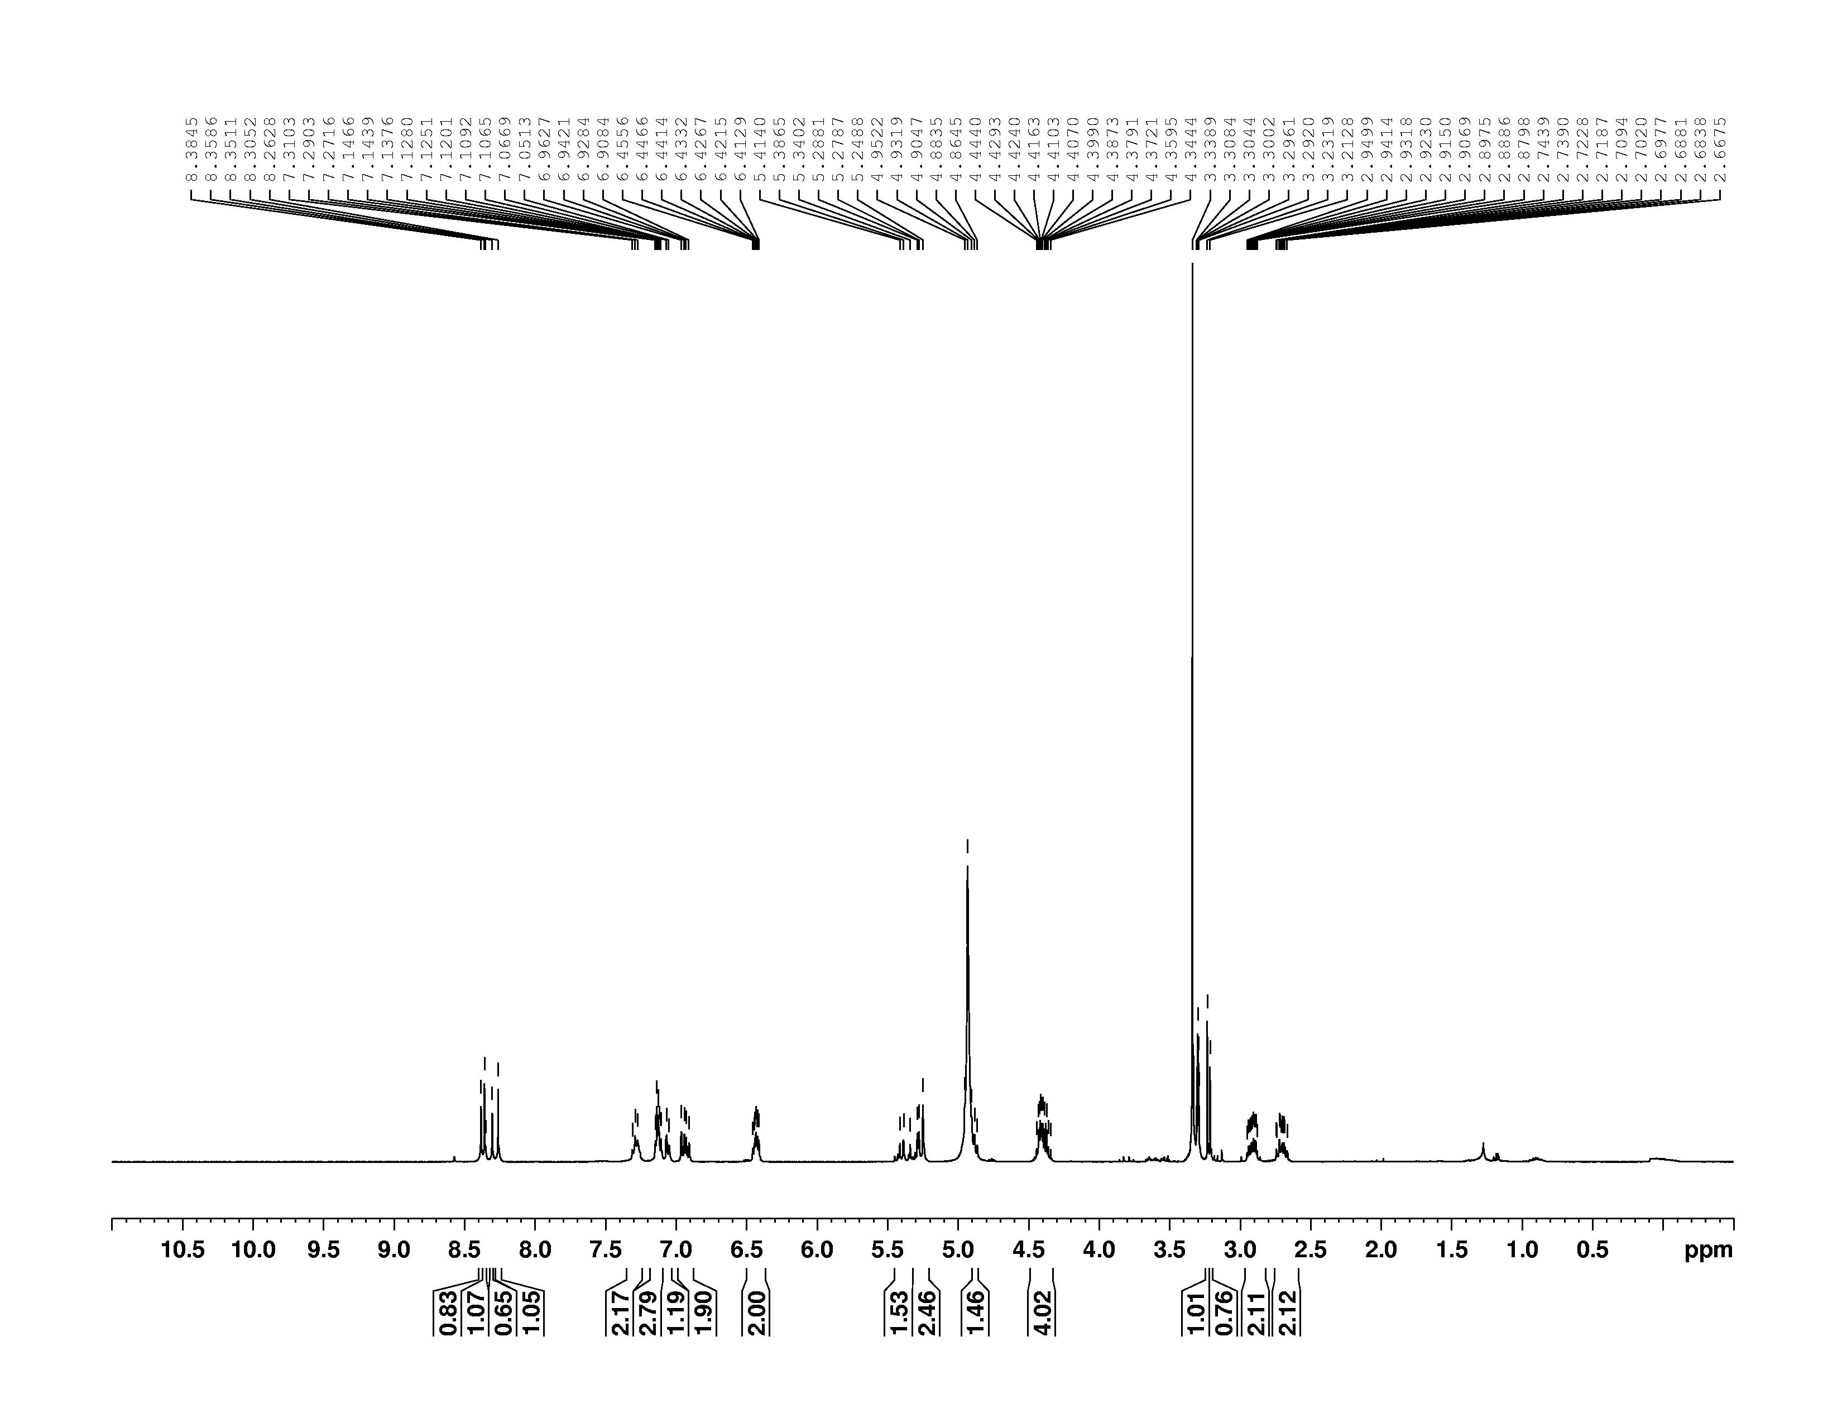

**Figure S7**. 13C NMR spectrum (100 MHz, methanol-*d*4) of EdAP (**3**).

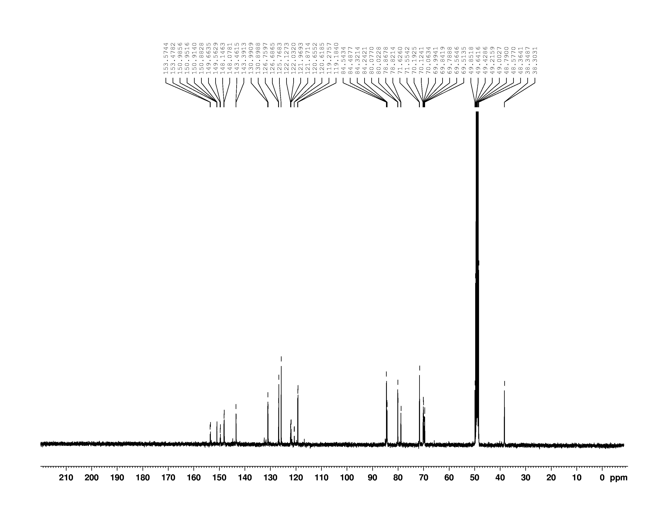

**Figure S8.** 1H NMR spectrum (400 MHz, chloroform-*d*) of compound **21**.

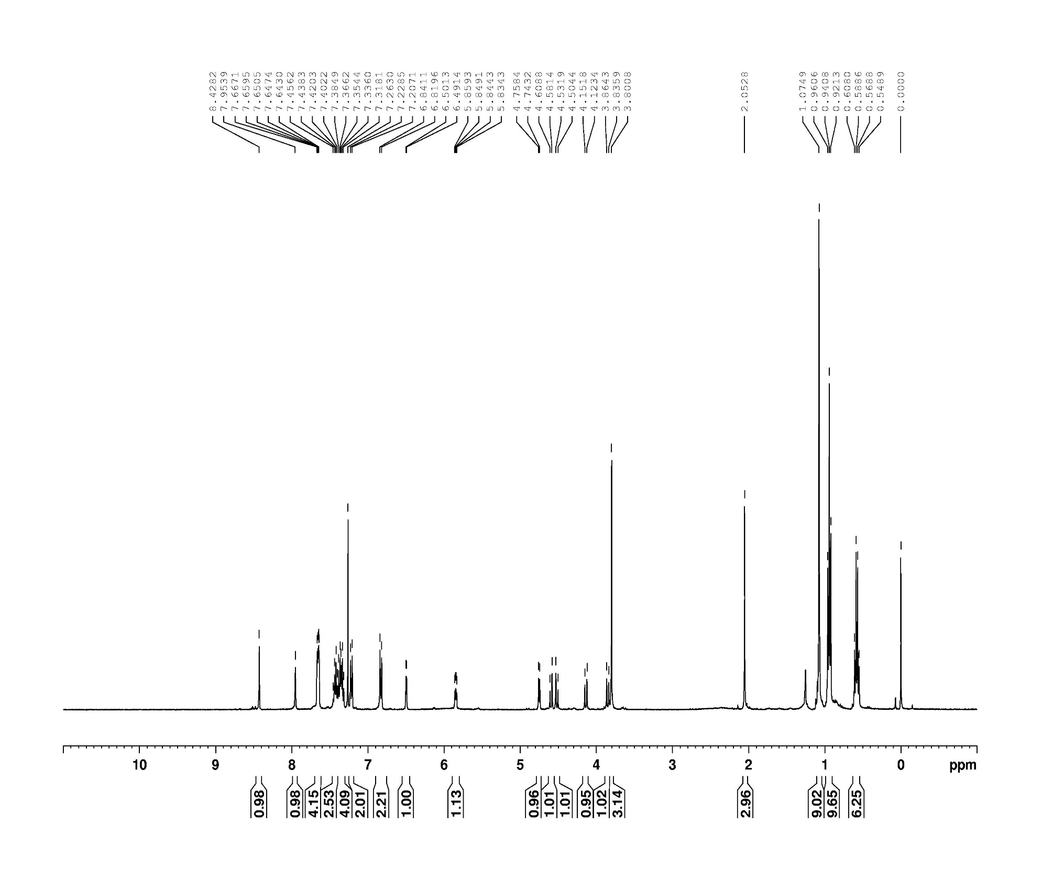

**Figure S9.** 13C NMR spectrum (100 MHz, chloroform-*d*) of compound **21**.

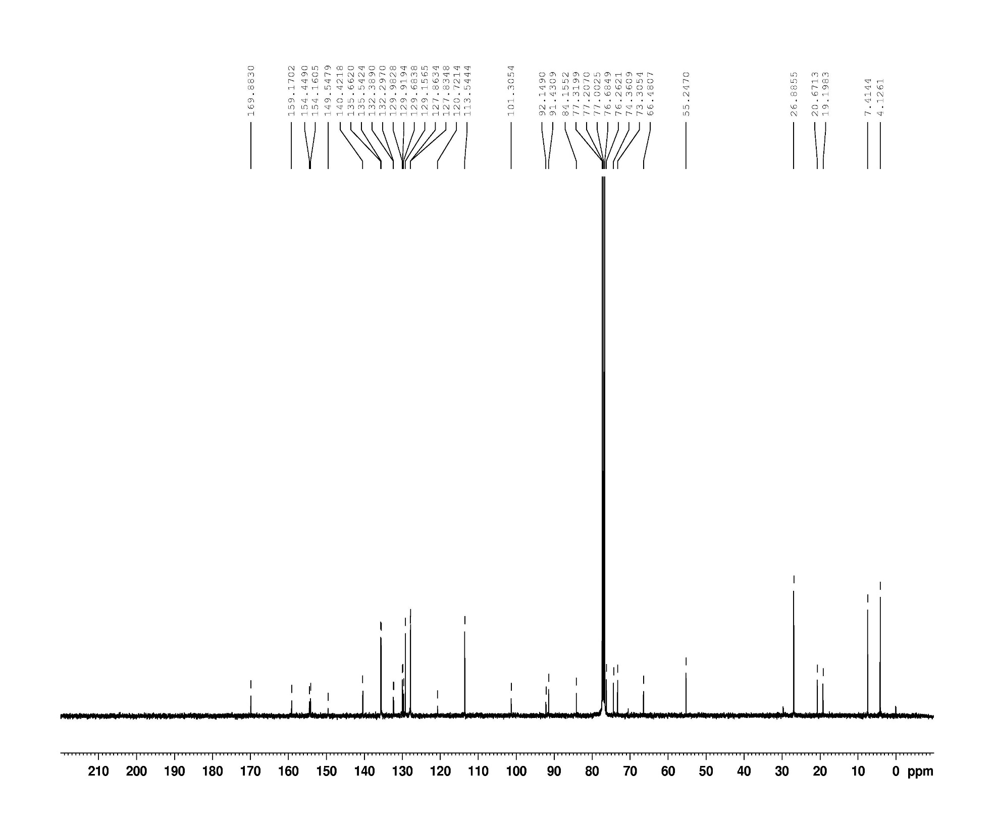

**Figure S10.** Amagnified view of HMBC spectrum of compound **21**.

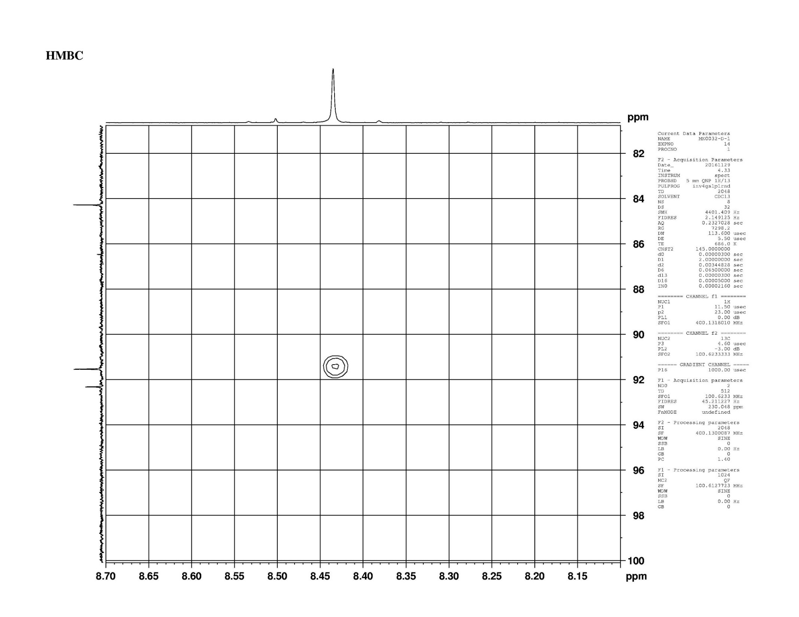



C-1ʹ

H-2



C-4ʹ

**Figure S11.** 1H NMR spectrum (400 MHz, chloroform-*d*) of compound **25**.

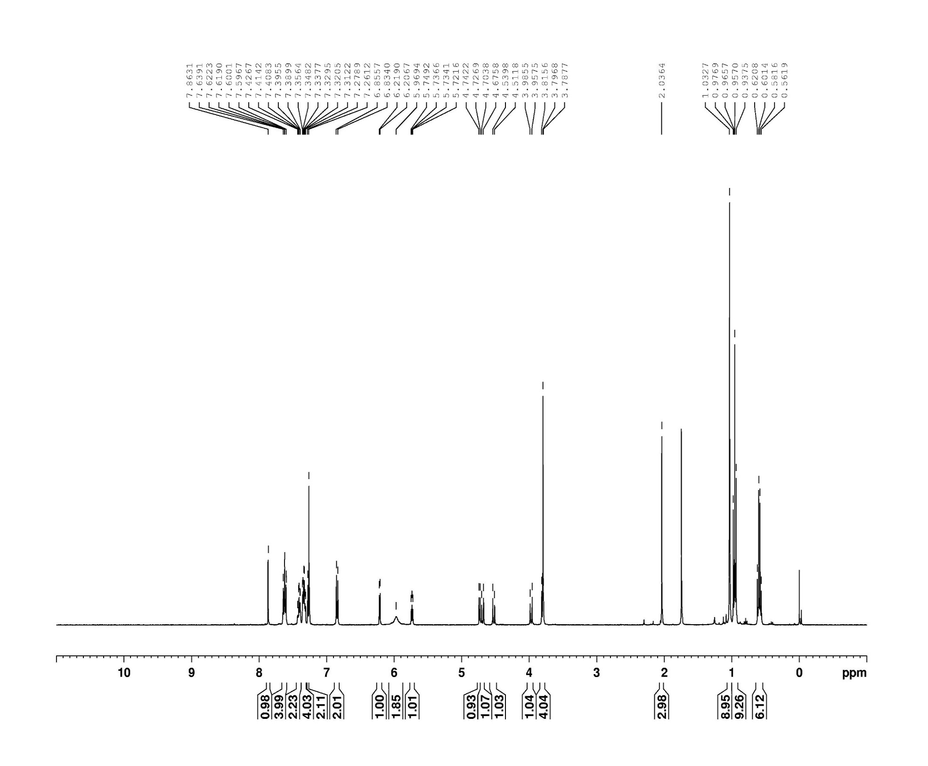

**Figure S12.** 13C NMR spectrum (100 MHz, chloroform-*d*) of compound **25**.

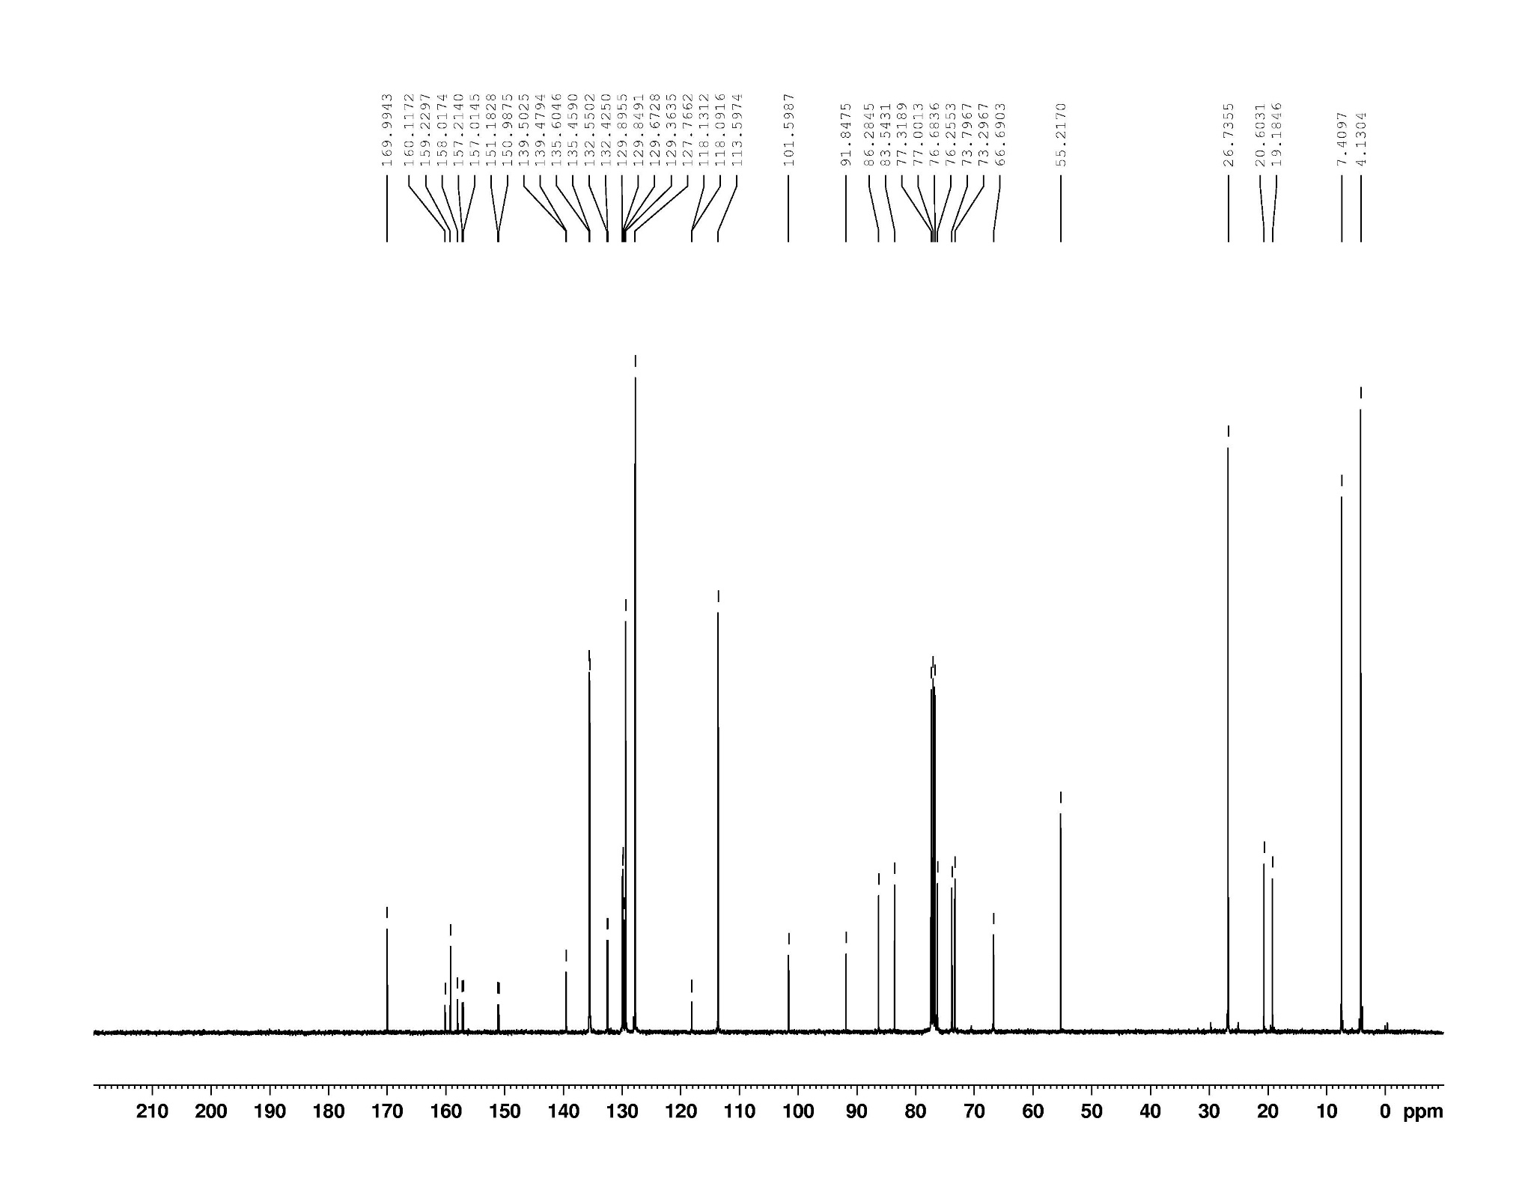

**Figure S13.** 1H NMR spectrum (400 MHz, chloroform-*d*) of compound **26**.

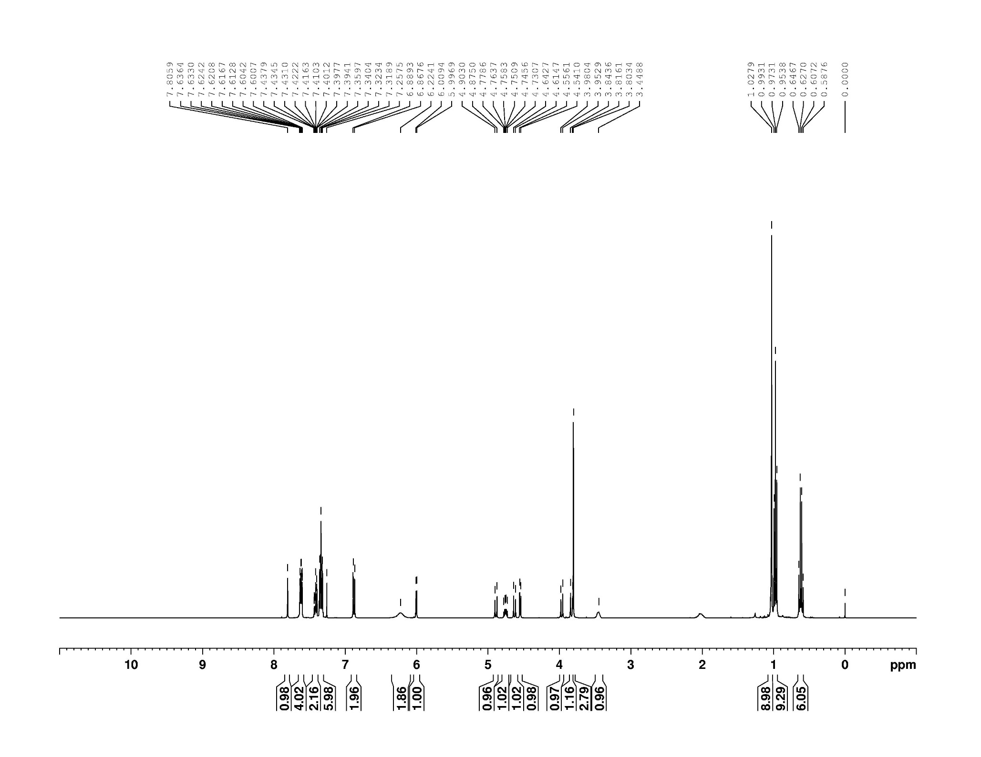

**Figure S14.** 13C NMR spectrum (100 MHz, chloroform-*d*) of compound **26**.

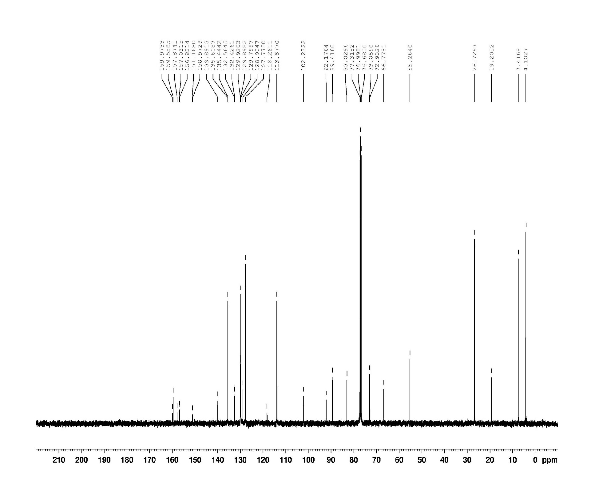

**Figure S15.** 1H NMR spectrum (400 MHz, chloroform-*d*) of compound **27**.

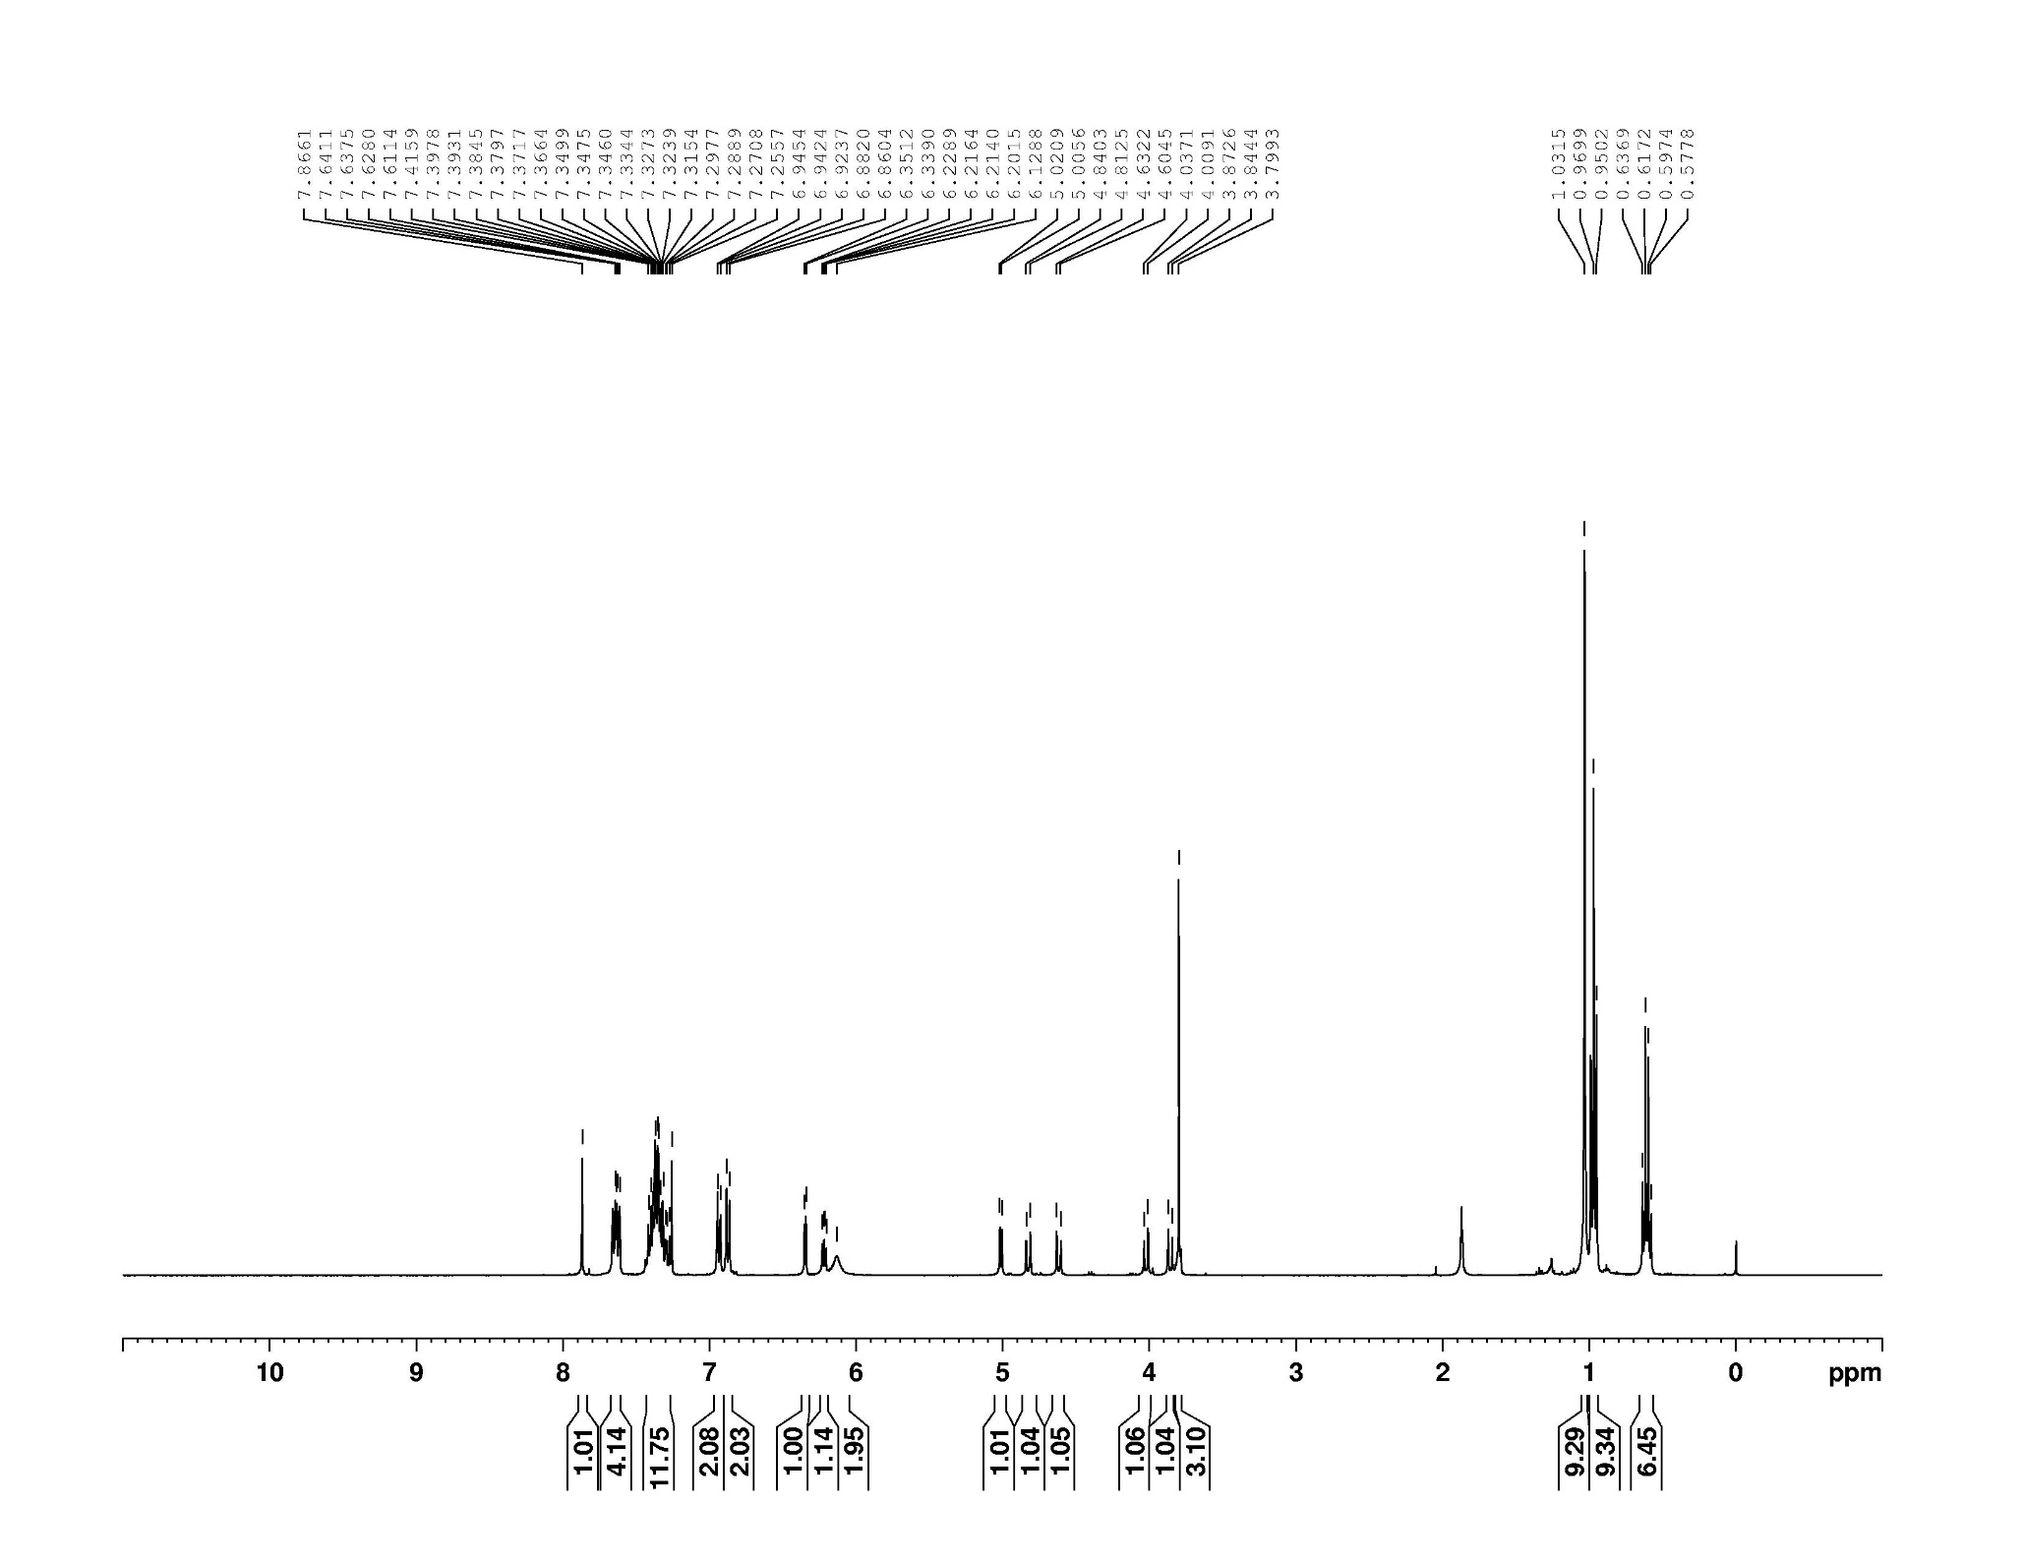

**Figure S16.** 13C NMR spectrum (100 MHz, chloroform-*d*) of compound **27**.

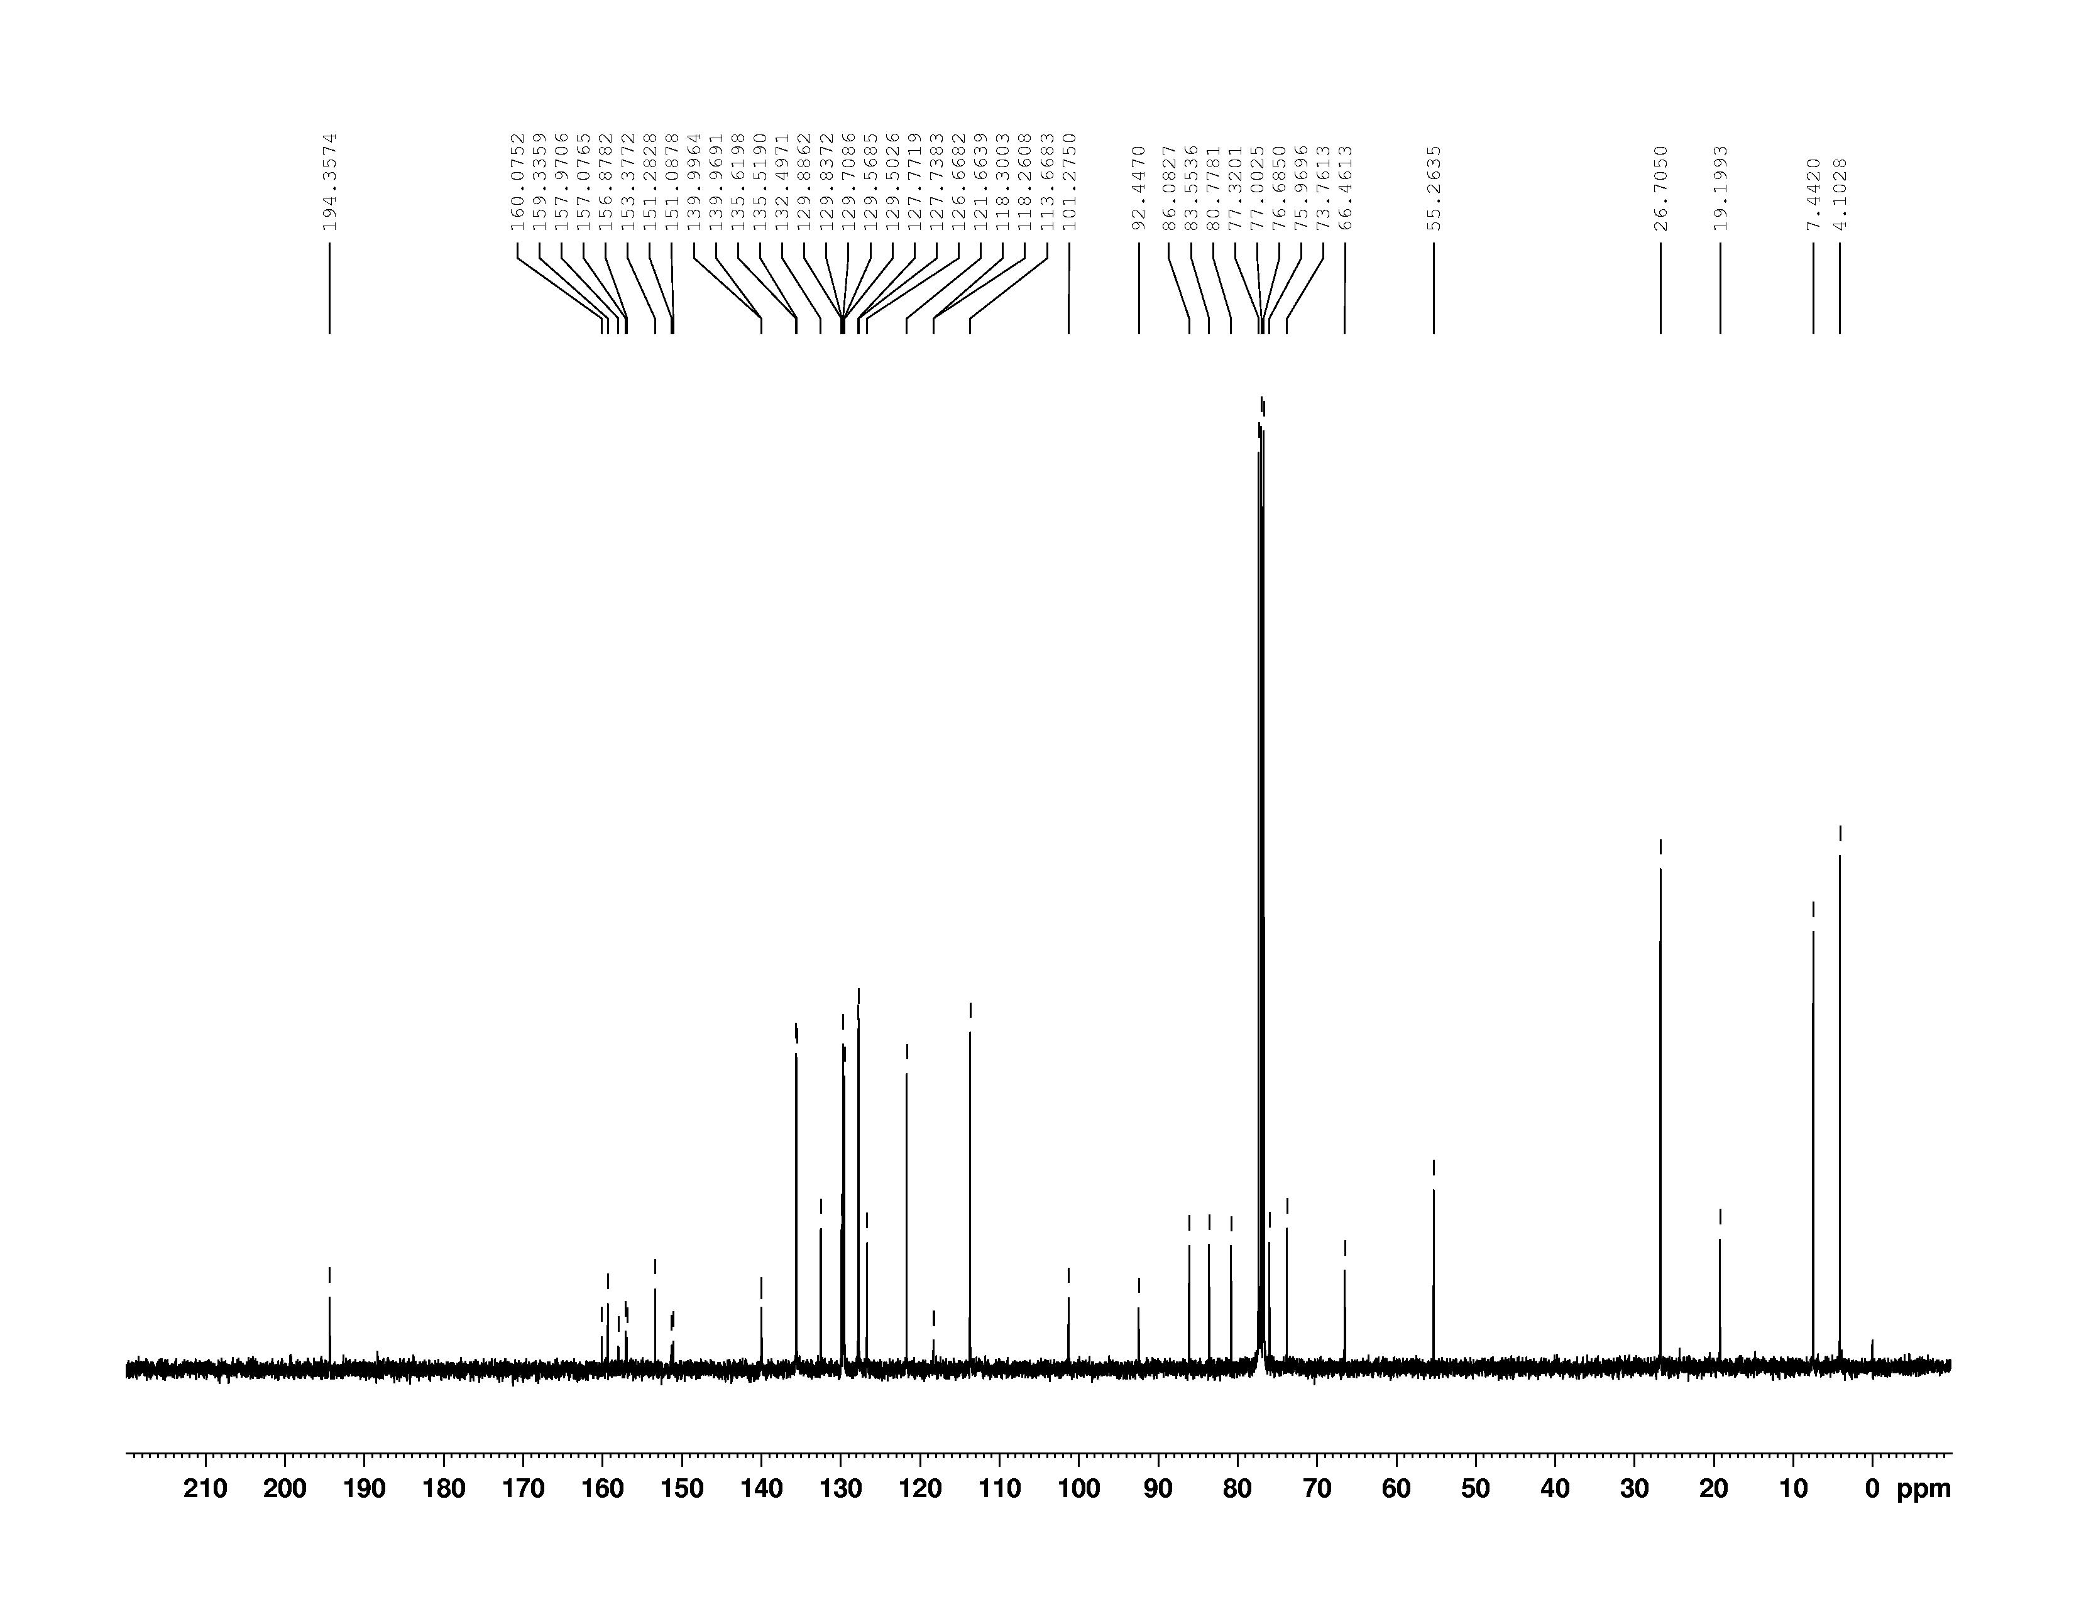

**Figure S17.** 1H NMR spectrum (400 MHz, chloroform-*d*) of compound **28**.

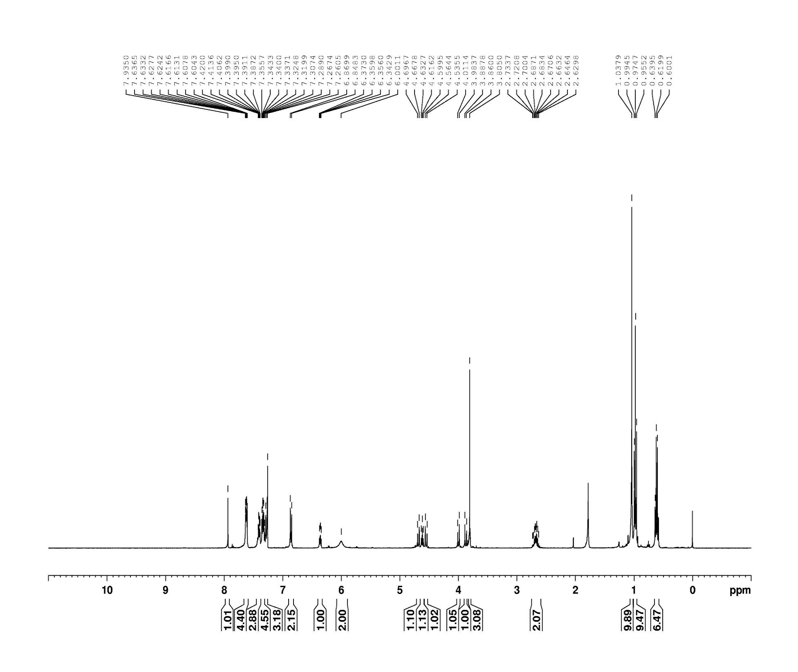

**Figure S18.** 13C NMR spectrum (100 MHz, chloroform-*d*) of compound **28**.

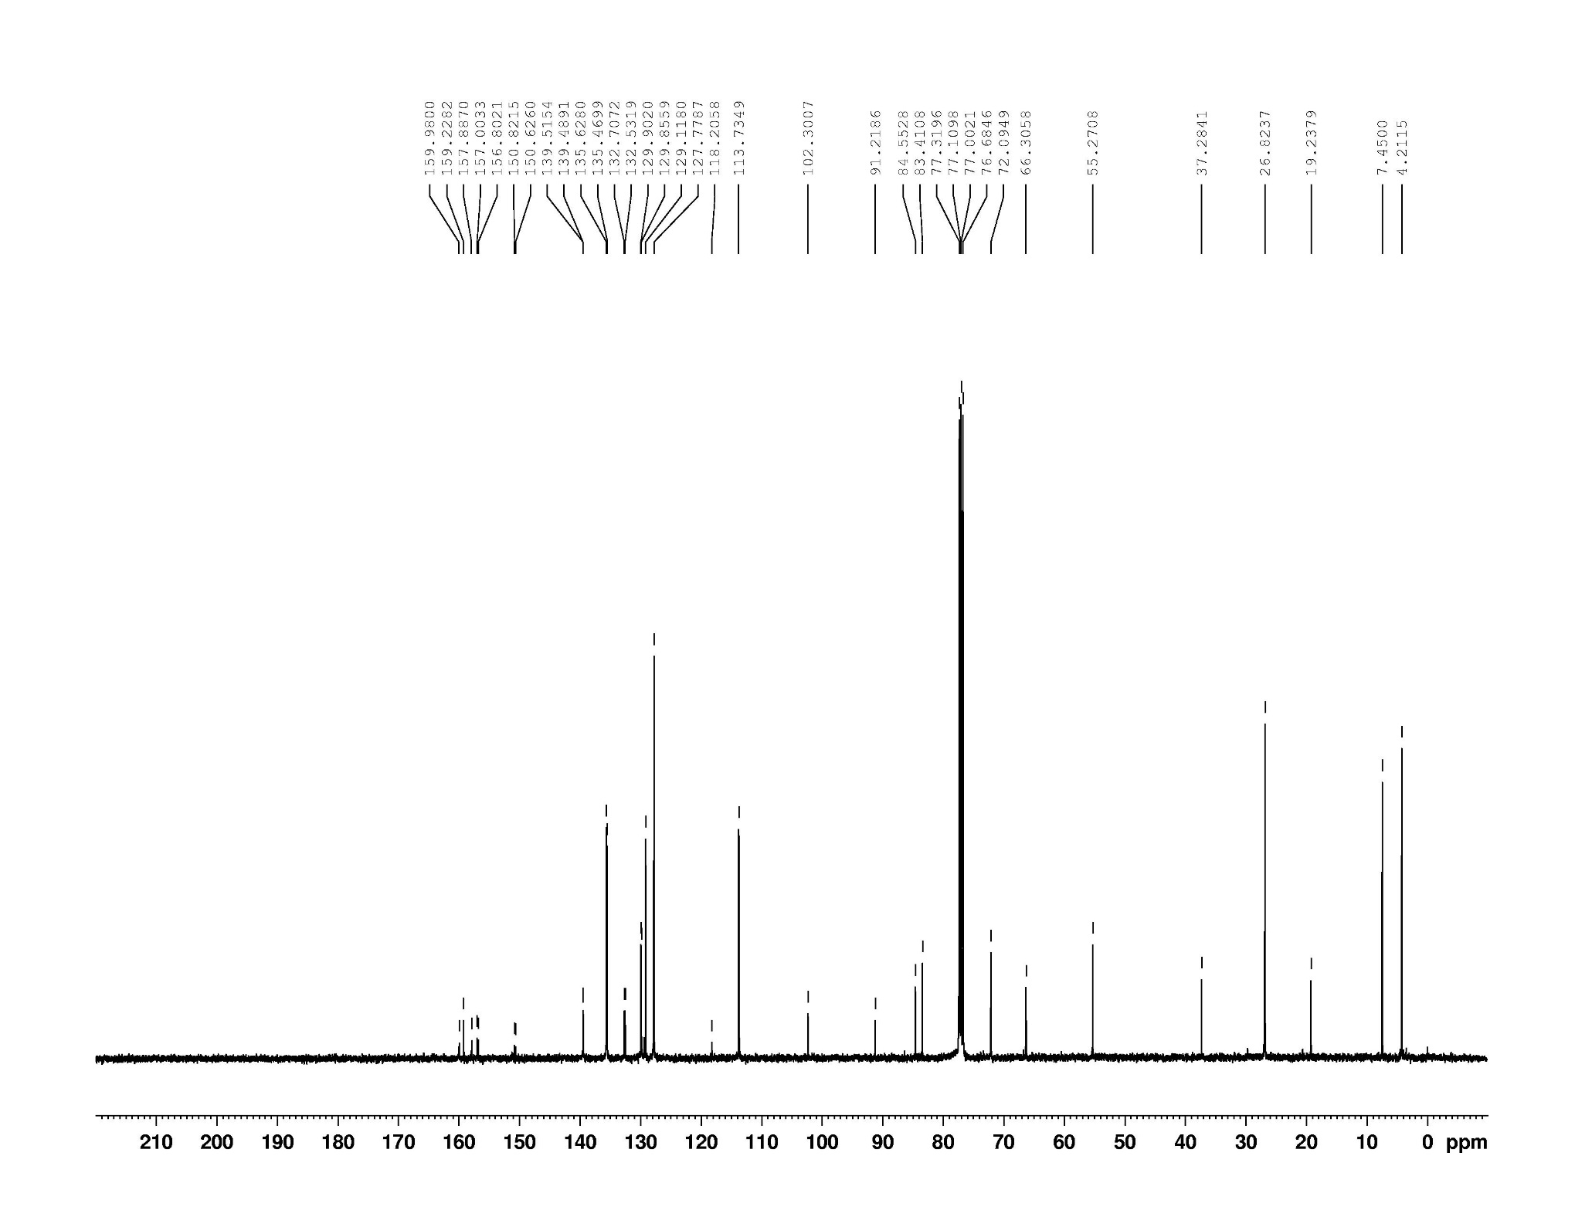

**Figure S19.** 1H NMR spectrum (400 MHz, methanol-*d*4) of compound **29**.

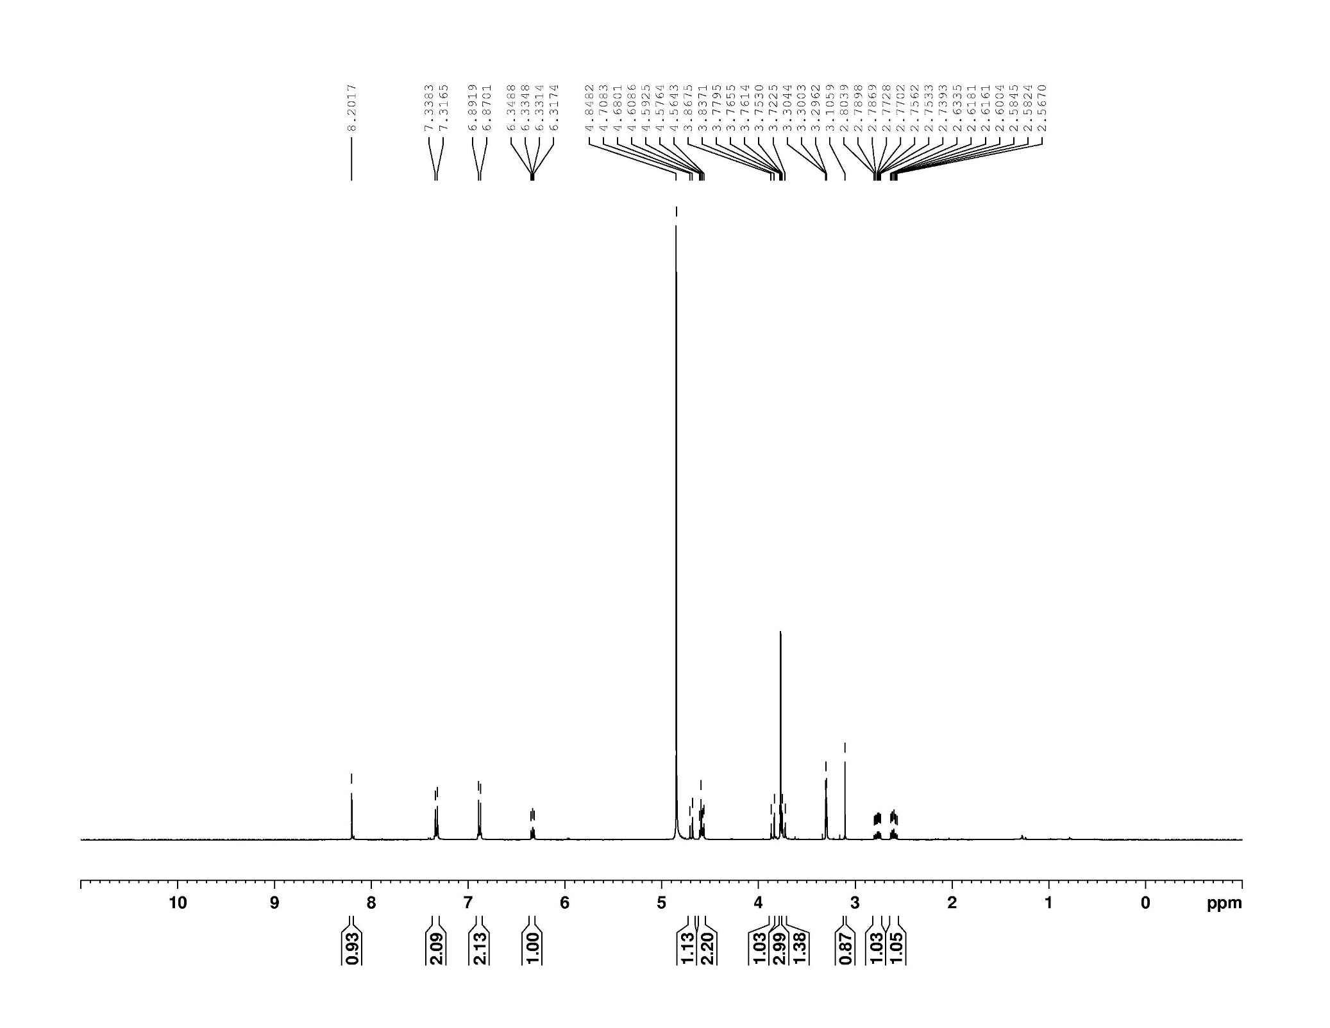

**Figure S20.** 13C NMR spectrum (100 MHz, chloroform-*d*) of compound **29**.

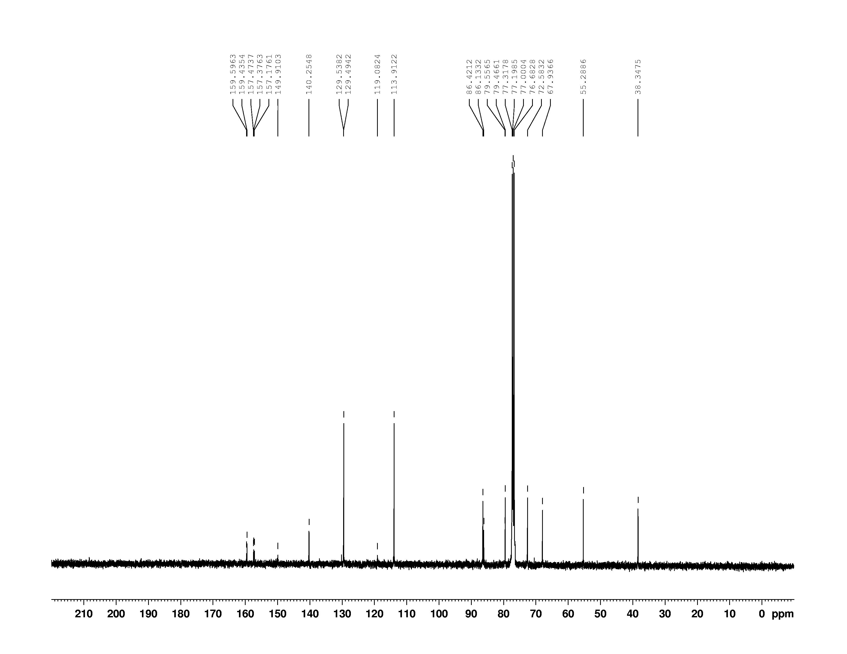

**Figure S21.** Effect of EdA on the replication of HBV.

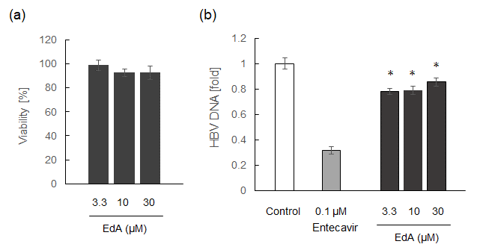

(a) Cytotoxicity of EdP against Hep38.7-Tet cells after six days was determined by XTT assay [S1]. Gray bar, various concentrations of EdA. The viability of vehicle-treated control cells was defined as 100%. (b) Anti-HBV activity was evaluated by real-time PCR quantifying HBV DNA in the culture supernatant of Hep38.7-Tet cells treated with the indicated compounds for six days [S2]. White bar, control, 0.3% DMSO; Light gray bar, 0.1 μM entecavir [S3]; Gray bar, various concentrations of EdA. The data indicate the means ± SD of five samples from an experiment. Statistical significance was determined by Student's *t* test (*, *p* < 0.05).

Reference

[S1] Roehm NW, Rodgers GH, Hatfield SM, et al. An improved colorimetric assay for cell proliferation and viability utilizing the tetrazolium salt XTT. J Immunol Methods. 1991;142:257–265.

[S2] Ogura N, Watashi K, Noguchi T, et al. Formation of covalently closed circular DNA in Hep38.7-Tet cells, a tetracycline inducible hepatitis B virus expression cell line. Biochem Biophys Res Commun. 2014;452:315–321.

[S3] Keating GM, Entecavir: a review of its use in the treatment of chronic hepatitis B in patients with decompensated liver disease. Drugs. 2011;71:2511–2529.