Supplementary materials
Vanstreels, R. E. T., Pichegru, L., Pfaff, M. C., Snyman, A., Dyer, B., Parsons, N. J., Roberts, D. G., Ludynia, K., Makhado, A., and Pistorius, P. A. Ingestion of seashells and anthropogenic debris by African penguins (Spheniscus demersus). Emu – Austral Ornithology.

Figure S1. Geographic distribution of the islands (black circles) and mainland colonies (white circles) from where African penguin stomach contents were sampled.

Figure S2. Frequency of the presence of seashells in the stomach samples from live adult African penguins in relation to the island and month in which the samples were obtained. The months of the primary (dark grey) and secondary incubation peaks (light grey) in each region are highlighted.

Figure S3. Reproductive tract of a female African penguin whose stomach contained seashells (case 7), showing a fully developed and active ovary (distended blood vessels, presence of follicles > 5 mm; thin arrow) and oviduct (enlarged lumen and thickened walls; thick arrow).

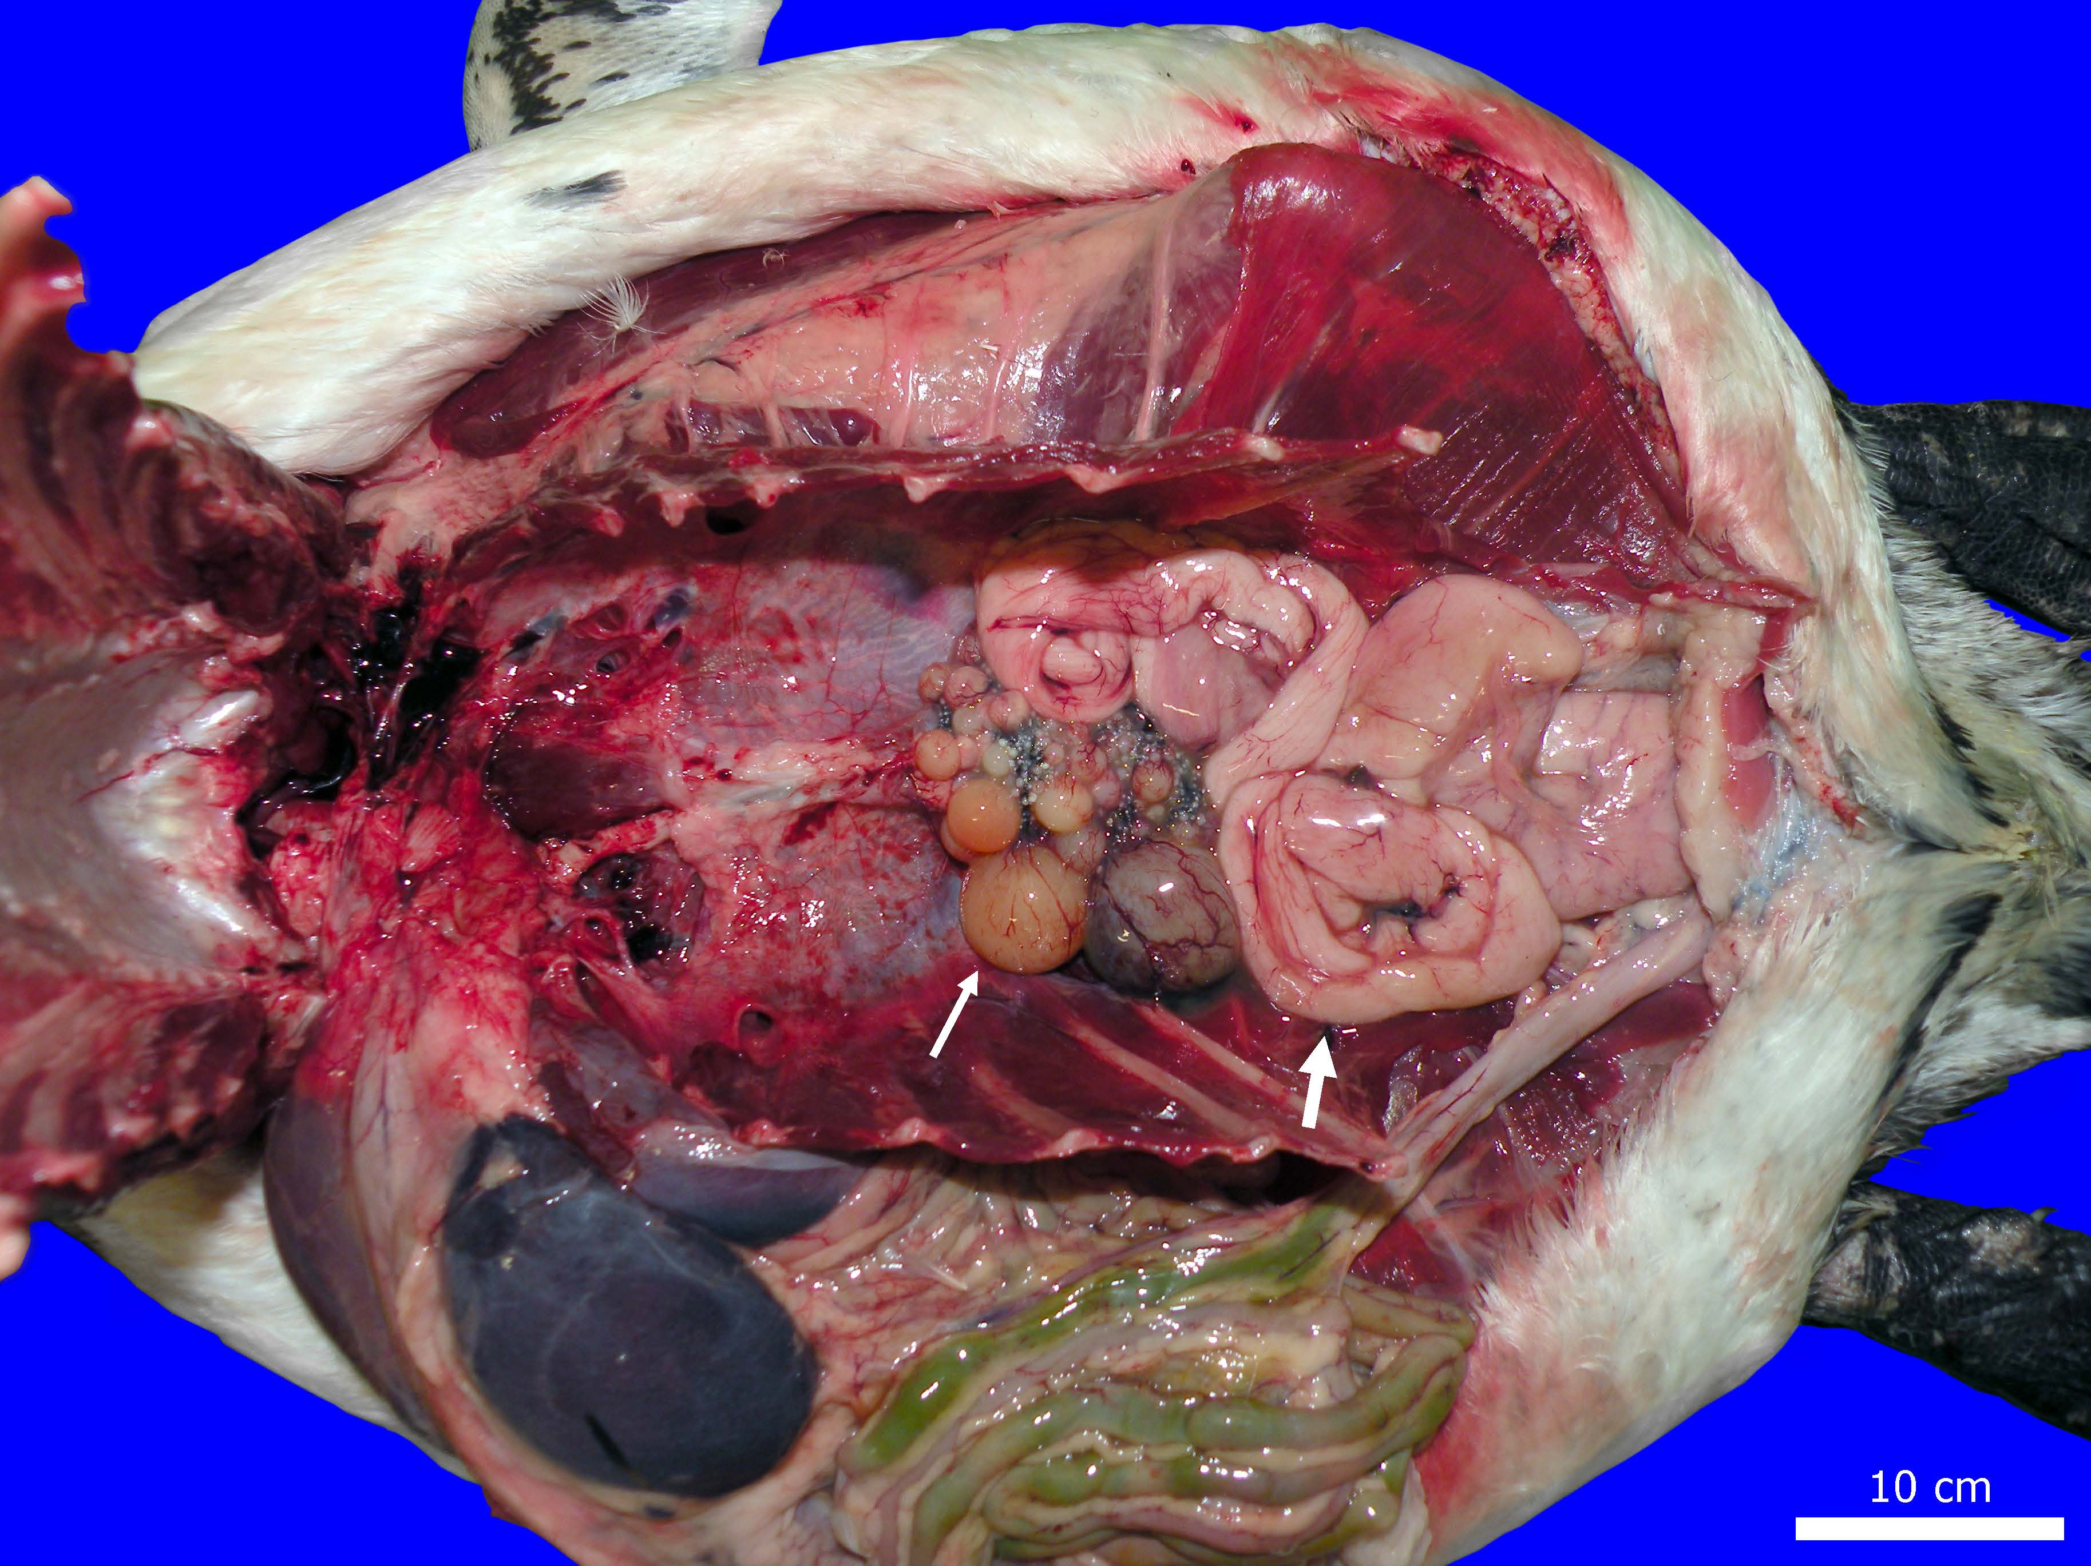
Figure S4. Hard items found in the stomach of adult female African penguins. Legend: (A) Turbo sarmaticus, (B) Aulacomya atra, (C) Dinoplax gigas, (D) Venus verrucosa, (E) unidentified mussel fragment, (F) unidentified periwinkle, (G) unidentified limpet, (H) unidentified barnacle, (I) unidentified oyster, (J) unidentified whelk, (K) unidentified bryozoan, (L) hard plastic fragment, (M) unidentified tellin/clam fragments, (N) rocks, (O) Atactodea striata, (P) Limaria tuberculata.

Figure S5. Stomach contents of an adult female African penguin (case 6) comprising a variety of eroded seashell fragments, a sharp glass shard (white asterisk), a plastic fragment (black asterisk), and squid beaks (black arrow).

Table S1. Number of fragments of seashells and debris identified in stomach samples from adult female African penguins.

 | Case 1*  (St Croix, May 2012) | Case 2*  (St Croix, May 2012) | Case 3**  (Dassen,  Oct 2017) | Case 4**  (Boulders,  Mar 2018) | Case 5**  (Stony Point,  Apr 2018) | Case 6*  (Stony Point, Jun 2016) | Case 7**  (Boulders, Dec 2016)
Mollusca
Bivalvia
Atactodea striata | 1 | - | - | - | - | - | -
Aulacomya atra | - | - | 6 | - | - | - | 6
Limaria tuberculata | 1 | - | - | - | - | - | -
Venus verrucosa | - | 2 | - | - | 1 | - | -
Unidentified oyster | - | 1 | - | - | - | 3 | 1
Unidentified mussel | 1 | 8 | 15 | 5 | - | 2 | 14
Unidentified tellin/clam | 6 | - | - | 10 | 4 | 4 | 17
Gastropoda
Turbo sarmaticus | - | - | - | - | - | - | 1
Unidentified limpet | 1 | - | - | 1 | - | - | -
Unidentified periwinkle | - | - | - | - | - | 1 | 1
Unidentified whelk | - | - | - | 1 | - | - | -
Polyplacophora
Dinoplax gigas | - | - | - | - | - | - | 1
Crustacea
Unidentified sessile barnacle | - | 1 | 2 | 2 | - | - | 2
Bryozoa
Unidentified bryozoan | - | 1 | - | - | 1 | - | -
Unidentified organism
Eroded shell fragment | - | 22 | 10 | 18 | 16 | - | 12
Other hard items
Rocks | - | 1 | - | 5 | - | - | -
Plastic | - | - | - | 1 | - | 1 | -
Glass | - | - | - | - | - | 1 | -
Notes: * Identified from photographs; ** Identified from frozen stomach content samples.

