The HO₄H → O₃ + H₂O Reaction Catalyzed by Acidic, Neutral and Basic Catalysts in the Troposphere
Tianlei Zhang ^{a,c,∗}, Xiujuan Bi^{a,#}, Mingjie Wen^{a,c,#}, Shuai Liuª, Guang Chaiª, Zhaopeng Zengª, Rui Wangª, Wenliang Wang^{b,*},Bo Long^{d,*}
ª Institute of Theoretical and Computational Chemistry, Shaanxi Key Laboratory of Catalysis, School of Chemical & Environment Science, Shaanxi University of Technology, Hanzhong, Shaanxi 723001, P. R. China
^{b} Key Laboratory for Macromolecular Science of Shaanxi Province, School of Chemistry & Chemical Engineering, Shaanxi Normal University, Xi’an, Shaanxi 710062, P. R. China
^{c} Shanghai Key Laboratory of Molecular Catalysis and Innovative Materials, Fudan University, Shanghai 200433, P. R. China
^{d} School of Materials Science and Engineering, Guizhou Minzu University, Guiyang, Guizhou 550025, P. R. China
S. NO | Caption
1 | Figure S1 Schematic energy diagrams of the HO₄H → H₂O + O₃ reaction without catalysts at the CCSD(T)-F12a/cc-pVDZ-F12//M06-2X/6-311+G(3d,2p) level, including the zero-point energy correction (kcalmol⁻¹)
2 | Figure S2 Schematic representation of hydrogen abstraction of HO₄H → O₃ + H₂O (A) under isolated conditions and (B–H) assisted by various catalysts (B: H₂O, C: (H₂O)₂, D: NH₃, E: NH₃H₂O, F: H₂ONH₃, G: HCOOH and H: H₂SO₄)
3 | Figure S3 The geometrical structures of the optimized the reactants, intermediates, transition states and products for the X (X = H₂O, (H₂O)₂, NH₃, NH₃H₂O, H₂ONH₃, HCOOH and H₂SO₄) catalyzed HO₄H → H₂O + O₃ reaction at the M06-2X/6-311+G(3d,2p) level of theory
4 | Table S1 Zero point energy (ZPE/(kcal⋅mol⁻¹)), relative energies (ΔE and Δ(E + ZPE)/(kcal⋅mol⁻¹)), enthalpies (ΔH(298)/(kcal⋅mol⁻¹)), entropy (S(298)/(cal⋅mol⁻¹⋅K⁻¹)), free energies (ΔG(298)/(kcal⋅mol⁻¹)) , <S²> and T₁ of all species for the HO₄H + X reaction at the CCSD(T)-F12a/cc-pVDZ-F12//M06-2X/ 6-311+G(3d,2p) level of theory (X = H₂O, (H₂O)₂, NH₃, NH₃H₂O, H₂ONH₃, HCOOH and H₂SO₄)
5 | Table S2 The binding energies (∆Eª, 0 K), energy barriers (∆E^{b}, 0 K), and reaction energies (∆E^{c},0 K) of the HO₄H → H₂O + O₃ reaction at different theoretical methods with zero-point correction involved and mean unsigned error (MUE^{d}) (in kcal mol⁻¹)
6 | Table S3 Concentrations of all the catalysts (in molecule⋅cm⁻³) within temperature range of 280 K – 320 K at 0 km altitude
7 | Table S4 Calculated rate constants (molecule⁻¹⋅cm³⋅s⁻¹) in presence of catalyst X (X = H₂O, (H₂O)₂, NH₃, NH₃H₂O, H₂ONH₃, HCOOH and H₂SO₄) using the results obtained from CCSD(T)-F12a/ cc-pVDZ-F12//M06-2X/6-311+G(3d,2p) level of theory
8 | Table S5 Effective rate constants (s⁻¹) for all the catalysts within temperature range of 280 K – 320 K at 0 km altitude using catalyst X (X = H₂O, (H₂O)₂, NH₃, NH₃H₂O, H₂ONH₃, HCOOH and H₂SO₄) concentrations given in Table S3
9 | Figure S4 The results of IRC calculations of all transition state for HO₄H → O₃ + H₂O reaction with catalyst X (X = H₂O, (H₂O)₂, NH₃, NH₃H₂O, H₂ONH₃, HCOOH and H₂SO₄)

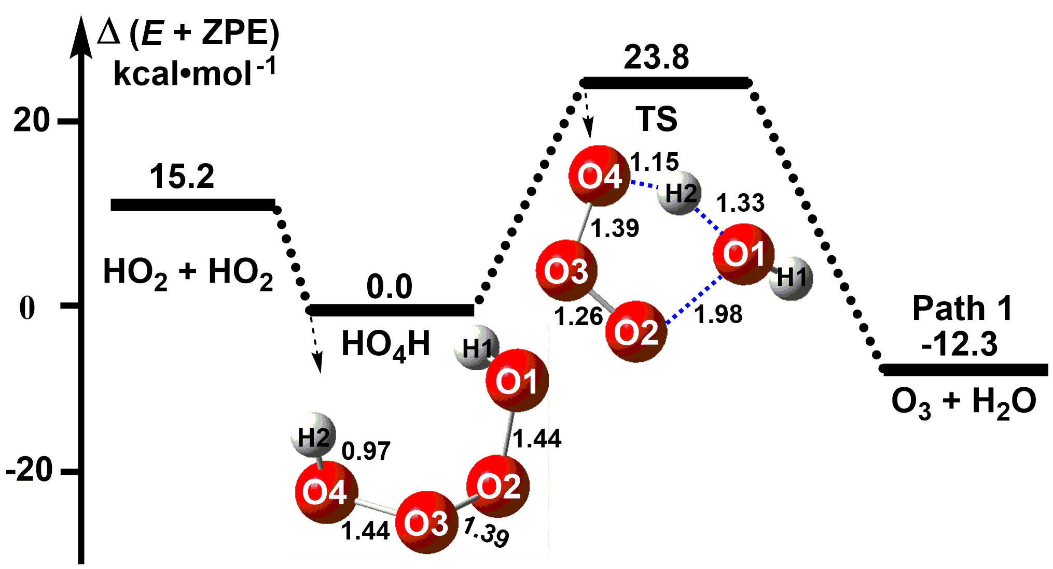
Figure S1 Schematic energy diagrams of the HO₄H → H₂O + O₃ reaction without catalysts at the CCSD(T)-F12a/cc-pVDZ-F12//M06-2X/6-311+G(3d,2p) level, including the zero-point energy correction (kcalmol⁻¹)
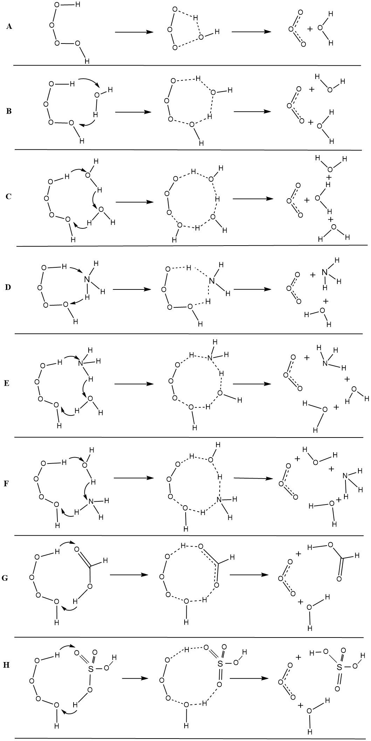
Figure S2 Schematic representation of hydrogen abstraction of HO₄H → O₃ + H₂O (A) under isolated conditions and (B–H) assisted by various catalysts (B: H₂O, C: (H₂O)₂, D: NH₃, E: NH₃H₂O, F: H₂ONH₃, G: HCOOH and H: H₂SO₄)
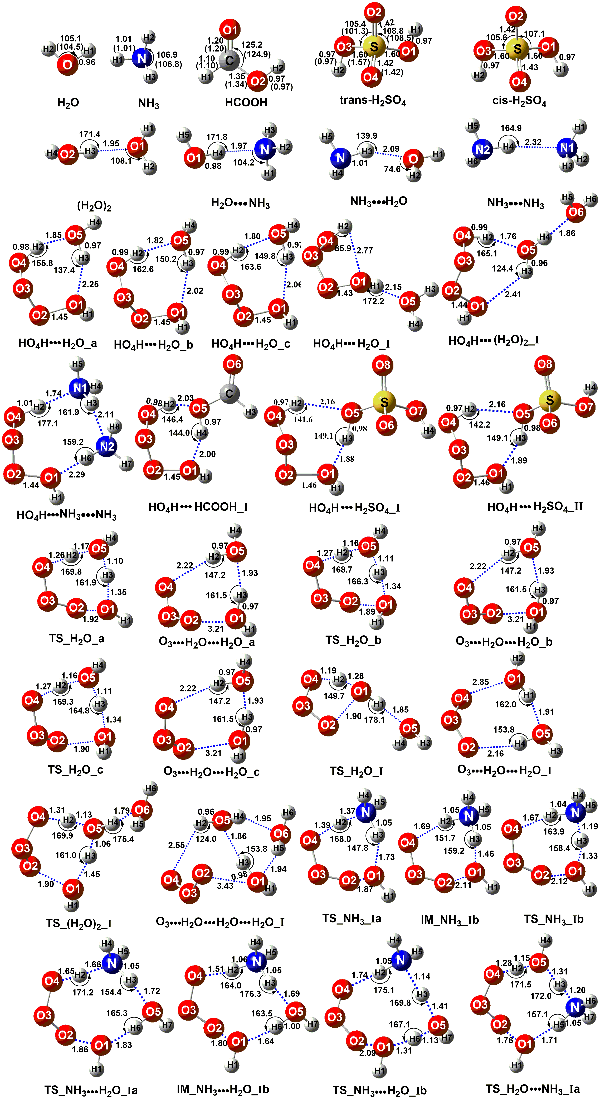
Figure S3 The geometrical structures of the optimized the reactants, intermediates, transition states and products for the X (X = H₂O, (H₂O)₂, NH₃, NH₃H₂O, H₂ONH₃, HCOOH and H₂SO₄) catalyzed HO₄H → H₂O + O₃ reaction at the M06-2X/6-311+G(3d,2p) level of theory
Table S1 Zero point energy (ZPE/(kcal⋅mol⁻¹)), relative energies (ΔE and Δ(E + ZPE)/(kcal⋅mol⁻¹)), enthalpies (ΔH(298)/(kcal⋅mol⁻¹)), entropy (S(298)/(cal⋅mol⁻¹⋅K⁻¹)), free energies (ΔG(298)/(kcal⋅mol⁻¹)) , <S²> and T₁ of all species for the HO₄H + X reaction at the CCSD(T)-F12a/cc-pVDZ-F12//M06-2X/ 6-311+G(3d,2p) level of theory (X = H₂O, (H₂O)₂, NH₃, NH₃H₂O, H₂ONH₃, HCOOH and H₂SO₄)
Catalyst | System | ZPE | S | △E | △(E + ZPE) | △H | △G | <S²> | T₁
Nake  Reaction | HO₂ + HO₂ | 18.5 | 109.2 | 18.6 | 15.2 | 16.5 | 4.2 | 0.750, 0.750 | 0.029, 0.029
 | HO₄H | 21.9 | 67.6 | 0.0 | 0.0 | 0.0 | 0.0 | 0.000 | 0.020
 | TS | 18.5 | 65.6 | 27.2 | 23.8 | 23.6 | 24.2 | 0.000 | 0.020
 | O₃ + H₂O | 18.1 | 101.9 | -8.5 | -12.3 | -10.7 | -21.0 | 0.000, 0.000 | 0.020, 0.011
Nake Reaction_I | HO₂ + HO₂ | 18.5 | 109.2 | 18.0 | 14.2 | 14.2 | 3.1 | 0.750, 0.750 | 0.029, 0.029
 | HO₄H_I | 22.3 | 67.6 | 0.0 | 0.0 | 0.0 | 0.0 | 0.000 | 0.020
 | TS_I | 19.2 | 65.1 | 30.4 | 27.3 | 26.9 | 27.6 | 0.000 | 0.020
 | O₃ + H₂O | 18.7 | 101.7 | -7.1 | -10.7 | -9.3 | -19.5 | 0.000, 0.000 | 0.020, 0.011
H₂O | HO₂ + HO₂ + H₂O | 32.0 | 154.2 | 17.3 | 13.3 | 14.7 | 2.3 | 0.750, 0.750, 0.000 | 0.029, 0.029, 0.011
 | HO₄H + H₂O | 36.0 | 112.5 | 0.0 | 0.0 | 0.0 | 0.0 | 0.000, 0.000 | 0.020, 0.011
 | HO₄HH₂O | 38.1 | 80.3 | -11.6 | -9.5 | -10.3 | -0.7 | 0.000 | 0.018
 | TS_H₂O | 34.0 | 74.7 | 15.0 | 12.9 | 11.4 | 22.6 | 0.000 | 0.016
 | O₃H₂OH₂O | 36.0 | 93.5 | -19.9 | -19.9 | -19.4 | -13.7 | 0.000 | 0.020
 | O₃ + (H₂O)₂ | 34.3 | 125.5 | -14.9 | -16.7 | -15.8 | -19.7 | 0.000, 0.000 | 0.020, 0.011
H₂O_a | HO₂ + HO₂ + H₂O | 31.3 | 154.2 | 17.3 | 13.3 | 14.7 | 2.3 | 0.750, 0.750, 0.000 | 0.029, 0.029, 0.011
 | HO₄H + H₂O | 35.6 | 112.5 | 0.0 | 0.0 | 0.0 | 0.0 | 0.000, 0.000 | 0.020, 0.011
 | HO₄HH₂O_a | 36.8 | 81.0 | -9.7 | -7.1 | -7.8 | 1.6 | 0.000 | 0.018
 | TS_H₂O_a | 33.4 | 75.1 | 17.6 | 14.1 | 14.3 | 23.4 | 0.000 | 0.019
 | O₃H₂OH₂O_a | 34.9 | 94.2 | -19.2 | -19.2 | -19.3 | -14.9 | 0.000 | 0.020
 | O₃ + (H₂O)₂ | 33.7 | 126.7 | -14.3 | -17.6 | -16.6 | -20.3 | 0.000, 0.000 | 0.020, 0.011
H₂O_b | HO₂ + HO₂ + H₂O | 31.3 | 154.2 | 17.3 | 13.3 | 14.7 | 2.3 | 0.750, 0.750, 0.000 | 0.029, 0.029, 0.011
 | HO₄H + H₂O | 35.6 | 112.5 | 0.0 | 0.0 | 0.0 | 0.0 | 0.000, 0.000 | 0.020, 0.011
 | HO₄HH₂O_b | 37.1 | 82.4 | -9.4 | -6.9 | -7.6 | 1.8 | 0.000 | 0.018
 | TS_H₂O_b | 33.3 | 76.0 | 17.6 | 13.5 | 14.7 | 25.9 | 0.000 | 0.020
 | O₃H₂OH₂O_b | 34.9 | 98.4 | -20.2 | -19.9 | -19.0 | -14.5 | 0.000 | 0.020
 | O₃ + (H₂O)₂ | 34.3 | 125.5 | -14.9 | -16.7 | -15.8 | -19.7 | 0.000, 0.000 | 0.020, 0.011
H₂O_c | HO₂ + HO₂ + H₂O | 31.3 | 154.2 | 17.3 | 13.3 | 14.7 | 2.3 | 0.750, 0.750, 0.000 | 0.029, 0.029, 0.011
 | HO₄H + H₂O | 34.6 | 112.5 | 0.0 | 0.0 | 0.0 | 0.0 | 0.000, 0.000 | 0.020, 0.011
 | HO₄HH₂O_c | 37.0 | 82.7 | -9.0 | -6.5 | -7.2 | 2.1 | 0.000 | 0.018
 | TS_H₂O_c | 33.3 | 76.0 | 18.2 | 14.1 | 15.3 | 26.5 | 0.000 | 0.020
 | O₃H₂OH₂O_c | 34.9 | 98.4 | -20.3 | -19.9 | -19.0 | -14.5 | 0.000 | 0.020
 | O₃ + (H₂O)₂ | 34.3 | 125.5 | -14.9 | -16.7 | -15.8 | -19.7 | 0.000, 0.000 | 0.020, 0.011
H₂O_I | HO₂ + HO₂ + H₂O | 31.3 | 154.2 | 17.3 | 13.3 | 14.7 | 2.3 | 0.750, 0.750, 0.000 | 0.029, 0.029, 0.011
 | HO₄H + H₂O | 34.6 | 112.5 | 0.0 | 0.0 | 0.0 | 0.0 | 0.000, 0.000 | 0.020, 0.011
 | HO₄HH₂O_I | 36.4 | 88.5 | -5.2 | -3.4 | -3.79 | 3.8 | 0.000 | 0.018
 | TS_H₂O_I | 33.4 | 87.5 | 20.3 | 16.2 | 18.6 | 26.4 | 0.000 | 0.020
 | O₃H₂OH₂O_I | 34.9 | 98.8 | -19.9 | -19.6 | -18.7 | -14.3 | 0.000 | 0.020
 | O₃ + (H₂O)₂ | 34.3 | 125.5 | -14.9 | -16.7 | -15.8 | -19.7 | 0.000, 0.000 | 0.020, 0.011
(H₂O)₂ | HO₂ + HO₂ + H₂O + H₂O | 45.6 | 199.3 | 22.5 | 16.0 | 18.0 | -0.9 | 0.750, 0.750, 0.000, 0.000 | 0.029, 0.029, 0.011, 0.011
 | HO₄H + (H₂O)₂ | 52.1 | 136.1 | 0.0 | 0.0 | 0.0 | 0.0 | 0.000, 0.000 | 0.020, 0.011
 | HO₄H(H₂O)₂ | 52.8 | 97.3 | -16.4 | -15.6 | -16.2 | -4.6 | 0.000 | 0.017
 | TS_(H₂O)₂ | 48.6 | 87.4 | 11.7 | 8.3 | 6.4 | 20.9 | 0.000 | 0.020
 | O₃H₂OH₂OH₂O | 50.9 | 112.6 | -23.7 | -24.8 | -24.0 | -17.0 | 0.000 | 0.020
 | O₃ + (H₂O)₃ | 51.4 | 135.1 | -20.8 | -21.4 | -21.4 | -21.1 | 0.000, 0.000 | 0.020, 0.011
(H₂O)₂_I | HO₂ + HO₂ + H₂O + H₂O | 44.7 | 199.5 | 20.3 | 14.7 | 16.5 | -1.9 | 0.750, 0.750, 0.000, 0.000 | 0.029, 0.029, 0.011, 0.011
 | HO₄H + (H₂O)₂ | 52.1 | 136.1 | 0.0 | 0.0 | 0.0 | 0.0 | 0.000, 0.000 | 0.020, 0.011
 | HO₄H(H₂O)₂_I | 52.2 | 106.3 | -11.3 | -9.3 | -9.5 | -0.1 | 0.000 | 0.017
 | TS_(H₂O)₂_I | 49.1 | 98.3 | 12.4 | 8.6 | 7.2 | 21.9 | 0.000 | 0.020
 | O₃H₂OH₂OH₂O_I | 51.1 | 113.2 | -24.6 | -21.7 | -22.2 | -15.1 | 0.000 | 0.020
 | O₃ + (H₂O)₃ | 51.4 | 135.1 | -20.8 | -21.4 | -21.4 | -21.1 | 0.000, 0.000 | 0.020, 0.011
NH₃ | HO₂ + HO₂ + NH₃ | 40.2 | 155.1 | 17.3 | 13.3 | 14.7 | 2.3 | 0.750, 0.750, 0.000 | 0.029, 0.029, 0.009
 | HO₄H + NH₃ | 44.2 | 113.4 | 0.0 | 0.0 | 0.0 | 0.0 | 0.000, 0.000 | 0.020, 0.009
 | HO₄HNH₃ | 45.5 | 85.6 | -12.9 | -11.6 | -11.9 | -3.6 | 0.000 | 0.018
 | TS_NH₃ | 43.2 | 77.6 | 11.9 | 10.9 | 9.7 | 20.4 | 0.000 | 0.019
 | O₃NH₃H₂O | 43.6 | 96.8 | -20.5 | -21.1 | -20.2 | -15.3 | 0.000 | 0.020
 | O₃ + H₂ONH₃ | 42.6 | 125.0 | -16.3 | -18.0 | -17.3 | -20.7 | 0.000, 0.000 | 0.020, 0.010
NH₃_I | HO₂ + HO₂ + NH₃ | 40.2 | 155.1 | 17.3 | 13.3 | 14.7 | 2.3 | 0.750, 0.750, 0.000 | 0.029, 0.029, 0.009
 | HO₄H + NH₃ | 44.2 | 113.4 | 0.0 | 0.0 | 0.0 | 0.0 | 0.000, 0.000 | 0.020, 0.009
 | HO₄HNH₃ | 45.5 | 85.6 | -12.9 | -11.6 | -11.9 | -3.6 | 0.000 | 0.018
 | TS_NH₃_Ia | 41.7 | 77.2 | 18.6 | 15.1 | 16.2 | 27.3 | 0.000 | 0.019
 | IM_NH₃_Ib | 44.1 | 78.7 | 12.0 | 10.9 | 10.1 | 20.8 | 0.000 | 0.019
 | TS_NH₃_Ib | 42.2 | 79.8 | 6.9 | 5.5 | 6.3 | 16.8 | 0.000 | 0.018
 | O₃NH₃H₂O | 43.6 | 96.8 | -20.5 | -21.1 | -20.2 | -15.3 | 0.000 | 0.020
 | O₃ + NH₃H₂O | 42.6 | 125.0 | -16.3 | -18.0 | -17.3 | -20.7 | 0.000, 0.000 | 0.020, 0.010
NH₃H₂O | HO₂ + HO₂ + NH₃ + H₂O | 53.8 | 200.3 | 16.1 | 10.9 | 13.1 | -6.0 | 0.750, 0.750, 0.000, 0.000 | 0.029 , 0.029 , 0.009 , 0.011
 | HO₄H + NH₃H₂O | 58.9 | 133.1 | 0.0 | 0.0 | 0.0 | 0.0 | 0.000, 0.000 | 0.020 , 0.010
 | HO₄HNH₃H₂O | 61.3 | 98.9 | -19.2 | -19.1 | -17.8 | -10.1 | 0.000 | 0.020
 | TS_NH₃H₂O | 54.7 | 96.7 | 19.4 | 15.5 | 16.6 | 28.4 | 0.000 | 0.015
 | O₃NH₃H₂OH₂O | 59.6 | 115.3 | -30.3 | -29.9 | -28.4 | -23.5 | 0.000 | 0.020
 | O₃ + NH₃H₂OH₂O | 58.9 | 136.8 | -21.3 | -25.4 | -21.7 | -26.2 | 0.000, 0.000 | 0.020 , 0.011
NH₃H₂O_I | HO₂ + HO₂ + NH₃ + H₂O | 53.8 | 200.3 | 16.1 | 10.9 | 13.1 | -6.0 | 0.750, 0.750, 0.000, 0.000 | 0.029, 0.029, 0.009, 0.011
 | HO₄H + NH₃H₂O | 58.9 | 133.1 | 0.0 | 0.0 | 0.0 | 0.0 | 0.000, 0.000 | 0.020, 0.010
 | HO₄HNH₃H₂O | 61.3 | 98.9 | -19.2 | -19.1 | -17.8 | -10.1 | 0.000 | 0.020
 | TS_NH₃H₂O_Ia | 55.6 | 96.3 | 45.7 | 43.1 | 42.6 | 53.3 | 0.000 | 0.019
 | IM_NH₃H₂O_Ib | 59.9 | 95.3 | 4.3 | 3.3 | 5.2 | 16.1 | 0.000 | 0.020
 | TS_NH₃H₂O_Ib | 57.4 | 92.9 | 1.2 | 0.5 | 0.6 | 10.8 | 0.000 | 0.020
 | O₃NH₃H₂OH₂O | 59.6 | 115.3 | -30.3 | -29.9 | -28.4 | -23.5 | 0.000 | 0.020
 | O₃ + NH₃H₂OH₂O | 58.9 | 136.8 | -21.3 | -25.4 | -21.7 | -26.2 | 0.000, 0.000 | 0.020, 0.011
H₂ONH₃ | HO₂ + HO₂ + H₂O + NH₃ | 53.8 | 200.3 | 20.7 | 15.2 | 16.6 | -0.6 | 0.750, 0.750, 0.000, 0.000 | 0.029, 0.029, 0.009， 0.011
 | HO₄H + H₂ONH₃ | 57.4 | 134.9 | 0.0 | 0.0 | 0.0 | 0.0 | 0.000, 0.000 | 0.020 , 0.010
 | HO₄HH₂ONH₃ | 61.7 | 99.2 | -12.1 | -8.8 | -8.4 | -0.1 | 0.000 | 0.017
 | TS_H₂ONH₃ | 52.5 | 85.5 | 9.6 | 8.9 | 7.9 | 21.0 | 0.000 | 0.020
 | O₃H₂ONH₃H₂O | 59.5 | 117.5 | -25.1 | -24.0 | -21.1 | -15.8 | 0.000 | 0.020
 | O₃ + H₂ONH₃H₂O | 51.6 | 191.0 | -3.8 | -7.3 | -6.3 | -21.0 | 0.000, 0.000 | 0.020, 0.011
H₂ONH₃_I | HO₂ + HO₂ + H₂O + NH₃ | 53.8 | 200.3 | 20.7 | 15.2 | 16.6 | -0.6 | 0.750, 0.750, 0.000, 0.000 | 0.029, 0.029, 0.009, 0.011
 | HO₄H + H₂ONH₃ | 57.4 | 134.9 | 0.0 | 0.0 | 0.0 | 0.0 | 0.000, 0.000 | 0.020, 0.010
 | HO₄H H₂ONH₃ | 61.7 | 99.2 | -12.1 | -8.8 | -8.4 | -0.1 | 0.000 | 0.017
 | TS_H₂ONH₃_Ia | 53.5 | 92.1 | 33.8 | 28.9 | 31.1 | 40.6 | 0.000 | 0.016
 | IM_H₂ONH₃_Ib | 58.4 | 90.0 | 13.3 | 14.8 | 14.8 | 28.8 | 0.000 | 0.020
 | TS_H₂ONH₃_Ib | 56.3 | 95.3 | 3.3 | 3.2 | 2.9 | 15.1 | 0.000 | 0.019
 | O₃H₂ONH₃H₂O_I | 58.5 | 117.5 | -25.1 | -24.0 | -21.1 | -15.8 | 0.000 | 0.017
 | O₃ + H₂ONH₃H₂O | 51.6 | 191.0 | -3.8 | -7.3 | -6.3 | -21.0 | 0.000 | 0.020, 0.011
NH₃NH₃ | HO₂ + HO₂ + NH₃ + NH₃ | 58.4 | 199.3 | 16.4 | 11.7 | 12.6 | -1.9 | 0.750, 0.750, 0.000, 0.000 | 0.029, 0.029,0.011, 0.011
 | HO₄H + NH₃NH₃ | 63.2 | 140.4 | 0.0 | 0.0 | 0.0 | 0.0 | 0.000, 0.000 | 0.020, 0.009
 | HO₄HNH₃NH₃ | 65.1 | 101.4 | -15.4 | -16.9 | -15.6 | -2.4 | 0.000 | 0.017
 | TS_NH₃NH₃ | 62.4 | 85.8 | 42.0 | 35.7 | 33.3 | 51.6 | 0.000 | 0.020
 | O₃NH₃NH₃H₂O | 64.7 | 122.5 | -21.3 | -20.0 | -19.3 | -16.1 | 0.000 | 0.019
 | O₃ + NH₃NH₃H₂O | 63.5 | 140.6 | -20.8 | -21.4 | -21.3 | -20.8 | 0.000, 0.000 | 0.020, 0.010
HCOOH | HO₂ + HO₂ + HCOOH | 40.1 | 168.4 | 17.3 | 13.3 | 14.7 | 2.3 | 0.750, 0.750, 0.000 | 0.029, 0.029, 0.017
 | HO₄H + HCOOH | 44.1 | 126.7 | 0.0 | 0.0 | 0.0 | 0.0 | 0.000, 0.000 | 0.020, 0.017
 | HO₄HHCOOH | 45.2 | 88.4 | -15.3 | -14.1 | -14.4 | -3.0 | 0.000 | 0.019
 | TS_HCOOH | 40.3 | 84.0 | 9.3 | 5.5 | 4.7 | 17.4 | 0.000 | 0.020
 | O₃H₂OHCOOH | 43.4 | 99.2 | -21.6 | -22.3 | -21.4 | -13.2 | 0.000 | 0.020
 | O₃ + H₂OHCOOH | 42.6 | 129.8 | -20.3 | -21.9 | -21.3 | -22.2 | 0.000, 0.000 | 0.020, 0.016
HCOOH_I | HO₂ + HO₂ + HCOOH | 40.1 | 168.4 | 17.3 | 13.3 | 14.7 | 2.3 | 0.750, 0.750, 0.000 | 0.029, 0.029, 0.017
 | HO₄H + HCOOH | 44.1 | 126.7 | 0.0 | 0.0 | 0.0 | 0.0 | 0.000, 0.000 | 0.020, 0.017
 | HO₄HHCOOH_I | 45.5 | 94.3 | -2.2 | -5.3 | -5.7 | 1.5 | 0.000 | 0.019
 | TS_HCOOH_I | 39.9 | 87.2 | 20.3 | 16.1 | 16.5 | 27.1 | 0.000 | 0.020
 | O₃H₂OHCOOH_I | 41.5 | 112.7 | -21.6 | -23.4 | -20.8 | -16.2 | 0.000 | 0.020
 | O₃ + H₂OHCOOH_I | 43.9 | 108.6 | -18.9 | -19.7 | -18.9 | -20.6 | 0.000, 0.000 | 0.020, 0.016
H₂SO₄ | HO₂ + HO₂ + H₂SO₄ | 39.2 | 181.6 | 12.3 | 10.0 | 11.2 | 0.3 | 0.750, 0.750, 0.000 | 0.029, 0.029, 0.016
 | HO₄H + H₂SO₄ | 41.1 | 140.8 | 0.0 | 0.0 | 0.0 | 0.0 | 0.000, 0.000 | 0.020, 0.016
 | HO₄HH₂SO₄ | 43.2 | 100.6 | -12.1 | -10.3 | -10.6 | 1.2 | 0.000 | 0.018
 | TS_H₂SO₄ | 38.1 | 95.9 | 2.6 | 2.1 | 1.7 | 13.3 | 0.000 | 0.017
 | O₃H₂OH₂SO₄ | 39.9 | 115.1 | -31.5 | -27.7 | -27.6 | -26.0 | 0.000 | 0.020
 | O₃ + H₂OH₂SO₄ | 39.2 | 174.2 | -26.3 | -26.4 | -25.1 | -25.1 | 0.000, 0.000 | 0.020, 0.015
H₂SO₄_I | HO₂ + HO₂ + H₂SO₄ | 39.2 | 181.6 | 12.3 | 10.0 | 11.2 | 0.3 | 0.750, 0.750, 0.000 | 0.029, 0.029, 0.016
 | HO₄H + H₂SO₄ | 41.1 | 140.8 | 0.0 | 0.0 | 0.0 | 0.0 | 0.000, 0.000 | 0.020, 0.016
 | HO₄HH₂SO₄_I | 41.3 | 110.1 | -5.9 | -4.7 | -4.6 | 2.5 | 0.000 | 0.018
 | TS_H₂SO₄_I | 39.5 | 102.8 | 7.3 | 5.6 | 5.9 | 16.3 | 0.000 | 0.020
 | O₃ H₂OH₂SO₄_I | 40.1 | 123.6 | -27.4 | -27.0 | -26.5 | -14.5 | 0.000 | 0.020
 | O₃ + H₂OH₂SO₄_I | 39.2 | 174.2 | -26.3 | -26.4 | -25.1 | -25.1 | 0.000, 0.000 | 0.020, 0.015
H₂SO₄_II | HO₂ + HO₂ + H₂SO₄ | 42.3 | 181.8 | 15.3 | 11.9 | 13.2 | 1.0 | 0.750, 0.750, 0.000 | 0.029, 0.029, 0.016
 | HO₄H + H₂SO₄ | 45.7 | 139.3 | 0.0 | 0.0 | 0.0 | 0.0 | 0.000, 0.000 | 0.020, 0.016
 | HO₄HH₂SO₄_II | 46.7 | 105.6 | -5.4 | -5.9 | -4.3 | 3.6 | 0.000 | 0.018
 | TS_H₂SO₄_II | 43.8 | 100.7 | 7.6 | 5.8 | 6.4 | 16.8 | 0.000 | 0.020
 | O₃ H₂OH₂SO₄_II | 40.6 | 120.3 | -29.1 | -28.2 | -18.4 | -13.7 | 0.000 | 0.020
 | O₃ + H₂OH₂SO₄_II | 39.2 | 171.2 | -26.3 | -26.4 | -25.1 | -25.1 | 0.000, 0.000 | 0.020, 0.015

Table S2 The binding energies (∆Eª, 0 K), energy barriers (∆E^{b}, 0 K), and reaction energies (∆E^{c},0 K) of the HO₄H → H₂O + O₃ reaction at different theoretical methods with zero-point correction involved and mean unsigned error (MUE^{d}) (in kcal mol⁻¹)
Methods | ∆Eª | ∆E^{b} | ∆E^{c} | MUE^{d}
W3X-l//M06-2X/aug-cc-pVTZ | -14.5 | 7.7 | -28.8 | 0.00
W2X//M06-2X/aug-cc-pVTZ | -14.8 | 9.5 | -27.7 | 1.06
CCSD(T)-F12a/cc-pVDZ-F12//M06-2X/aug-cc-pVTZ | -15.2 | 8.6 | -27.5 | 0.96
ª The binding energies with respect to HO₄H. ^{b} The energy barriers with respect to HO₄H → H₂O + O₃ reaction. ^{c} The reaction barriers with respect to HO₄H → H₂O + O₃ reaction. ^{d} Mean unsigned error averaged over the three previous columns
Table S3 Concentrations of X (X = H₂O, (H₂O)₂, NH₃, NH₃H₂O, H₂ONH₃, HCOOH and H₂SO₄) (in molecule⋅cm⁻³) within temperature range of 280 K – 320 K at 0 km altitude
catalyst |  |  | 280 K | 290 K | 298 K | 300 K | 310 K | 320 K
NH₃ | 0.1 ppbv |  | 2.6×10⁹ | 2.5×10⁹ | 2.5×10⁹ | 2.4×10⁹ | 2.4×10⁹ | 2.3×10⁹
 | 10 ppbv |  | 2.6×10¹¹ | 2.5×10¹¹ | 2.5×10¹¹ | 2.4×10¹¹ | 2.4×10¹¹ | 2.3×10¹¹
 | 2900 ppbv |  | 7.6×10¹³ | 7.3×10¹³ | 7.1×10¹³ | 7.1×10¹³ | 6.9×10¹³ | 6.7×10¹³
NH₃NH₃ | 0.1 ppbv |  | 3.9×10⁻⁴ | 3.4×10⁻⁴ | 3.0×10⁻⁴ | 2.9×10⁻⁴ | 2.6×10⁻⁴ | 2.3×10⁻⁴
 | 10 ppbv |  | 3.93 | 3.38 | 3.02 | 2.93 | 2.57 | 2.28
 | 2900 ppbv |  | 3.3×10⁵ | 2.8×10⁵ | 2.5×10⁵ | 2.5×10⁵ | 2.2×10⁵ | 1.9×10⁵
NH₃H₂O | 20%RH | 0.1 ppbv | 2.4×10⁶ | 3.3×10⁶ | 4.2×10⁶ | 4.4×10⁶ | 5.8×10⁶ | 7.3×10⁶
 |  | 10 ppbv | 2.4×10⁸ | 3.3×10⁰⁸ | 4.2×10⁸ | 4.4×10⁸ | 5.8×10⁸ | 7.3×10⁸
 |  | 2900 ppbv | 6.9×10¹⁰ | 9.5×10¹⁰ | 1.2×10¹¹ | 1.3×10¹¹ | 1.7×10¹¹ | 2.1×10¹¹
 | 100%RH | 0.1 ppbv | 1.2×10⁷ | 1.6×10⁷ | 2.1×10⁷ | 2.2×10⁷ | 2.9×10⁷ | 3.6×10⁷
 |  | 10 ppbv | 1.2×10⁹ | 1.6×10⁹ | 2.1×10⁹ | 2.2×10⁹ | 2.9×10⁹ | 3.6×10⁹
 |  | 2900 ppbv | 3.5×10¹¹ | 4.8×10¹¹ | 6.1×10¹¹ | 6.4×10¹¹ | 8.4×10¹¹ | 1.1×10¹²
H₂ONH₃ | 20%RH | 0.1 ppbv | 1.8×10⁵ | 2.5×10⁵ | 3.3×10⁵ | 3.4×10⁵ | 4.7×10⁵ | 5.1×10⁵
 |  | 10 ppbv | 1.8×10⁷ | 2.5×10⁷ | 3.3×10⁷ | 3.4×10⁷ | 4.6×10⁷ | 5.1×10⁷
 |  | 2900 ppbv | 5.4×10⁹ | 7.4×10⁹ | 9.3×10⁹ | 1.0×10¹⁰ | 1.3×10¹⁰ | 1.5×10¹⁰
 | 100%RH | 0.1 ppbv | 9.2×10⁵ | 1.3×10⁶ | 1.7×10⁶ | 1.7×10⁶ | 2.4×10⁶ | 2.9×10⁶
 |  | 10 ppbv | 9.2×10⁷ | 1.3×10⁸ | 1.7×10⁸ | 1.7×10⁸ | 2.4×10⁸ | 2.9×10⁸
 |  | 2900 ppbv | 2.7×10¹⁰ | 3.7×10¹⁰ | 4.8×10¹⁰ | 5.1×10¹⁰ | 6.9×10¹⁰ | 8.4×10¹⁰
H₂O | 20% RH |  | 5.2×10¹⁶ | 9.6×10¹⁶ | 1.5×10¹⁷ | 1.7×10¹⁷ | 2.9×10¹⁷ | 4.1×10¹⁷
 | 40% RH |  | 1.0×10¹⁷ | 1.9×10¹⁷ | 3.1×10¹⁷ | 3.4×10¹⁷ | 5.8×10¹⁷ | 9.4×10¹⁷
 | 60% RH |  | 1.5×10¹⁷ | 2.9×10¹⁷ | 4.5×10¹⁷ | 5.1×10¹⁷ | 8.8×10¹⁷ | 1.4×10¹⁷
 | 80% RH |  | 2.1×10¹⁷ | 2.9×10¹⁷ | 6.2×10¹⁷ | 6.9×10¹⁷ | 1.2×10¹⁷ | 1.9×10¹⁷
 | 100% RH |  | 2.6×10¹⁷ | 4.8×10¹⁷ | 7.7×10¹⁷ | 8.6×10¹⁷ | 1.5×10¹⁸ | 2.3×10¹⁸
(H₂O)₂ | 20% RH |  | 8.2×10¹² | 2.4×10¹³ | 5.4×10¹³ | 6.5×10¹³ | 1.6×10¹⁴ | 3.7×10¹⁴
 | 40% RH |  | 3.3×10¹³ | 5.0×10¹³ | 2.2×10¹⁴ | 2.6×10¹⁴ | 6.5×10¹⁴ | 1.5×10¹⁵
 | 60% RH |  | 7.4×10¹³ | 2.1×10¹⁴ | 4.9×10¹⁴ | 5.8×10¹⁴ | 1.5×10¹⁵ | 3.3×10¹⁵
 | 80% RH |  | 1.1×10¹⁴ | 3.8×10¹⁴ | 8.7×10¹⁴ | 1.0×10¹⁵ | 2.6×10¹⁵ | 5.9×10¹⁵
 | 100% RH |  | 2.0×10¹⁴ | 5.9×10¹⁴ | 1.4×10¹⁵ | 1.6×10¹⁵ | 4.0×10¹⁵ | 9.2×10¹⁵
HCOOH | 10 ppbv |  | 2.6×10¹¹ | 2.5×10¹¹ | 2.4×10¹¹ | 2.4×10¹¹ | 2.4×10¹¹ | 2.3×10¹¹
 | 0.01 ppbv |  | 2.6×10⁸ | 2.5×10⁸ | 2.4×10⁸ | 2.4×10⁸ | 2.4×10⁸ | 2.3×10⁸
 | 2 ppbv |  | 2.0×10¹⁰ | 1.9×10¹⁰ | 1.9×10¹⁰ | 1.9×10¹⁰ | 1.8×10¹⁰ | 1.8×10¹⁰
H₂SO₄ |  |  | 3.9×10⁸ | 3.8×10⁸ | 3.7×10⁸ | 3.7×10⁸ | 3.6×10⁸ | 3.4×10⁸

Table S4 Calculated rate constants (molecule⁻¹⋅cm³⋅s⁻¹) in presence of catalyst X (X = H₂O, (H₂O)₂, NH₃, NH₃H₂O, H₂ONH₃, HCOOH and H₂SO₄) using the results obtained from CCSD(T)-F12a/ cc-pVDZ-F12//M06-2X/6-311+G(3d,2p) level of theory
Catalyst | Rate Constant | Temperature(K)
 |  | 213 K | 230 K | 259 K | 280 K | 290 K | 298 K | 300 K | 310 K | 320 K
Nake | k_{b} | 1.21×10⁻⁷ | 3.27×10⁻⁷ | 8.95×10⁻⁶ | 3.07×10⁻⁵ | 7.19×10⁻⁵ | 9.19×10⁻⁵ | 2.47×10⁻⁴ | 3.06×10⁻⁴ | 1.47×10⁻³
H₂O | K_{eq} | 5.06×10⁻¹⁷ | 8.94×10⁻¹⁸ | 7.96×10⁻¹⁹ | 1.91×10⁻¹⁹ | 1.04×10⁻¹⁹ | 6.63×10⁻²⁰ | 5.95×10⁻²⁰ | 3.51×10⁻²¹ | 9.52×10⁻²¹
 | k_{uni} | 4.42×10⁻⁹ | 3.79×10⁻⁸ | 1.47×10⁻⁶ | 1.81×10⁻⁵ | 5.59×10⁻⁵ | 1.33×10⁻⁴ | 1.65×10⁻⁴ | 4.61×10⁻⁴ | 2.79×10⁻³
 | k_{b} | 2.23×10⁻²⁵ | 3.39×10⁻²⁵ | 1.17×10⁻²⁴ | 3.46×10⁻²⁴ | 5.83×10⁻²⁴ | 8.83×10⁻²⁴ | 9.79×10⁻²⁴ | 1.62×10⁻²³ | 2.66×10⁻²³
H₂O_a | K_{eq} | 1.66×10⁻¹⁷ | 3.32×10⁻¹⁸ | 3.55×10⁻¹⁹ | 9.50×10⁻²⁰ | 5.44×10⁻²⁰ | 3.59×10⁻²⁰ | 3.25×10⁻²⁰ | 2.00×10⁻²⁰ | 1.28×10⁻²⁰
 | k_{uni} | 2.00×10⁻⁹ | 1.75×10⁻⁸ | 7.12×10⁻⁷ | 8.97×10⁻⁶ | 2.79×10⁻⁵ | 6.67×10⁻⁵ | 8.26×10⁻⁵ | 2.32×10⁻⁴ | 6.22×10⁻⁴
 | k_{b} | 3.31×10⁻²⁶ | 5.82×10⁻²⁶ | 2.53×10⁻²⁵ | 8.52×10⁻²⁵ | 1.52×10⁻²⁴ | 2.39×10⁻²⁴ | 2.68×10⁻²⁴ | 4.66×10⁻²⁴ | 7.96×10⁻²⁴
H₂O_b | K_{eq} | 2.06×10⁻¹⁷ | 3.83×10⁻¹⁸ | 3.67×10⁻¹⁹ | 9.22×10⁻²⁰ | 5.12×10⁻²⁰ | 3.30×10⁻²⁰ | 2.97×10⁻²⁰ | 1.79×10⁻²⁰ | 1.11×10⁻²⁰
 | k_{uni} | 2.05×10⁻⁹ | 2.00×10⁻⁸ | 9.39×10⁻⁷ | 1.27×10⁻⁵ | 4.09×10⁻⁵ | 1.00×10⁻⁴ | 1.25×10⁻⁴ | 3.60×10⁻⁴ | 9.89×10⁻⁴
 | k_{b} | 4.22×10⁻²⁶ | 7.65×10⁻²⁶ | 3.44×10⁻²⁵ | 1.17×10⁻²⁴ | 2.09×10⁻²⁴ | 3.31×10⁻²⁴ | 3.70×10⁻²⁴ | 6.45×10⁻²⁴ | 1.10×10⁻²³
H₂O_c | K_{eq} | 9.86×10⁻¹⁸ | 1.96×10⁻¹⁸ | 2.05×10⁻¹⁹ | 5.45×10⁻²⁰ | 3.10×10⁻²⁰ | 2.03×10⁻²⁰ | 1.84×10⁻²⁰ | 1.13×10⁻²⁰ | 7.16×10⁻²¹
 | k_{uni} | 1.43×10⁻⁹ | 1.31×10⁻⁸ | 5.85×10⁻⁷ | 7.80×10⁻⁶ | 2.51×10⁻⁵ | 6.15×10⁻⁵ | 7.64×10⁻⁵ | 2.21×10⁻⁴ | 6.10×10⁻⁴
 | k_{b} | 1.41×10⁻²⁶ | 2.57×10⁻²⁶ | 1.20×10⁻²⁵ | 4.25×10⁻²⁵ | 7.76×10⁻²⁵ | 1.25×10⁻²⁴ | 1.40×10⁻²⁴ | 2.50×10⁻²⁴ | 4.37×10⁻²⁴
H₂O_I | K_{eq} | 5.05×10⁻²⁰ | 1.82×10⁻²⁰ | 4.42×10⁻²¹ | 1.94×10⁻²¹ | 1.37×10⁻²¹ | 1.05×10⁻²¹ | 9.90×10⁻²² | 7.36×10⁻²² | 5.57×10⁻²²
 | k_{uni} | 1.19×10⁻⁶ | 3.87×10⁻⁶ | 3.88×10⁻⁵ | 2.27×10⁻⁴ | 5.33×10⁻⁴ | 1.05×10⁻³ | 1.24×10⁻³ | 2.85×10⁻³ | 6.45×10⁻³
 | k_{b} | 6.00×10⁻²⁶ | 7.05×10⁻²⁶ | 1.71×10⁻²⁵ | 4.41×10⁻²⁵ | 7.29×10⁻²⁵ | 1.11×10⁻²⁴ | 1.23×10⁻²⁴ | 2.10×10⁻²⁴ | 3.59×10⁻²⁴
(H₂O)₂ | K_{eq} | 1.03×10⁻¹³ | 7.56×10⁻¹⁵ | 1.95×10⁻¹⁶ | 2.22×10⁻¹⁷ | 8.86×10⁻¹⁸ | 4.44×10⁻¹⁸ | 3.76×10⁻¹⁸ | 1.69×10⁻¹⁸ | 7.98×10⁻¹⁹
 | k_{uni} | 5.59×10⁻¹¹ | 7.72×10⁻¹⁰ | 5.44×10⁻⁸ | 8.97×10⁻⁷ | 3.09×10⁻⁶ | 7.91×10⁻⁶ | 9.95×10⁻⁶ | 3.01×10⁻⁵ | 8.60×10⁻⁵
 | k_{b} | 5.77×10⁻²⁴ | 5.84×10⁻²⁴ | 1.06×10⁻²³ | 2.00×10⁻²³ | 2.73×10⁻²³ | 3.51×10⁻²³ | 3.74×10⁻²³ | 5.09×10⁻²³ | 6.86×10⁻²³
(H₂O)₂_I | K_{eq} | 1.50×10⁻¹⁶ | 2.39×10⁻¹⁷ | 1.85×10⁻¹⁸ | 4.07×10⁻¹⁹ | 2.15×10⁻¹⁹ | 1.33×10⁻¹⁹ | 1.18×10⁻¹⁹ | 6.80×10⁻²⁰ | 4.06×10⁻²⁰
 | k_{uni} | 9.57×10⁻⁹ | 2.17×10⁻⁷ | 1.51×10⁻⁵ | 5.29×10⁻⁵ | 1.23×10⁻⁴ | 1.31×10⁻⁴ | 1.63×10⁻⁴ | 3.87×10⁻⁴ | 8.36×10⁻⁴
 | k_{b} | 1.43×10⁻²⁴ | 5.17×10⁻²⁴ | 2.79×10⁻²³ | 2.15×10⁻²³ | 2.65×10⁻²³ | 1.75×10⁻²³ | 1.93×10⁻²³ | 2.63×10⁻²³ | 3.39×10⁻²³
NH₃ | K_{eq} | 1.51×10⁻¹⁴ | 1.98×10⁻¹⁵ | 1.17×10⁻¹⁶ | 2.21×10⁻¹⁷ | 1.09×10⁻¹⁷ | 6.43×10⁻¹⁸ | 5.66×10⁻¹⁸ | 3.07×10⁻¹⁸ | 1.74×10⁻¹⁸
 | k_{uni} | 3.43×10⁻¹³ | 1.73×10⁻¹¹ | 4.20×10⁻⁹ | 1.10×10⁻⁷ | 4.40×10⁻⁷ | 1.25×10⁻⁶ | 1.61×10⁻⁶ | 4.40×10⁻⁶ | 1.38×10⁻⁵
 | k_{b} | 5.18×10⁻²⁷ | 3.42×10⁻²⁶ | 4.92×10⁻²⁵ | 2.43×10⁻²⁴ | 4.80×10⁻²⁴ | 8.04×10⁻²⁴ | 9.10×10⁻²⁴ | 1.35×10⁻²³ | 2.40×10⁻²³
NH₃_I | K_{eq} | 1.51×10⁻¹⁴ | 1.98×10⁻¹⁵ | 1.17×10⁻¹⁶ | 2.21×10⁻¹⁷ | 1.09×10⁻¹⁷ | 6.43×10⁻¹⁸ | 5.65×10⁻¹⁸ | 3.07×10⁻¹⁸ | 1.74×10⁻¹⁸
 | k_{uni} | 3.62×10⁻¹² | 2.55×10⁻¹⁰ | 2.14×10⁻⁹ | 5.66×10⁻⁸ | 2.57×10⁻⁷ | 4.26×10⁻⁷ | 5.42×10⁻⁷ | 8.04×10⁻⁷ | 2.27×10⁻⁶
 | k_{b} | 5.47×10⁻²⁶ | 5.04×10⁻²⁵ | 2.51×10⁻²⁵ | 1.25×10⁻²⁴ | 2.81×10⁻²⁴ | 2.74×10⁻²⁴ | 3.07×10⁻²⁴ | 2.47×10⁻²⁴ | 3.93×10⁻²⁴
NH₃H₂O | K_{eq} | 1.82×10⁻²⁵ | 2.49×10⁻²⁵ | 5.39×10⁻²⁵ | 1.08×10⁻²⁴ | 1.56×10⁻²⁴ | 2.11×10⁻²⁴ | 2.28×10⁻²⁴ | 3.37×10⁻²⁴ | 5.02×10⁻²⁴
 | k_{uni} | 2.44×10⁻¹⁶ | 1.34×10⁻¹⁵ | 2.40×10⁻¹⁴ | 6.12×10⁻¹⁴ | 1.42×10⁻¹³ | 1.62×10⁻¹³ | 2.07×10⁻¹³ | 5.75×10⁻¹³ | 1.55×10⁻¹²
 | k_{b} | 4.45×10⁻⁴¹ | 3.34×10⁻⁴⁰ | 1.30×10⁻³⁸ | 6.62×10⁻³⁸ | 2.23×10⁻³⁷ | 3.43×10⁻³⁷ | 4.71×10⁻³⁷ | 1.94×10⁻³⁶ | 7.79×10⁻³⁶
NH₃H₂O_I | K_{eq} | 9.24×10⁻⁴⁶ | 4.08×10⁻⁴⁵ | 7.47×10⁻⁴⁴ | 7.76×10⁻⁴³ | 2.53×10⁻⁴² | 6.65×10⁻⁴² | 8.49×10⁻⁴² | 2.95×10⁻⁴¹ | 1.05×10⁻⁴⁰
 | k_{uni} | 3.55×10⁻³⁷ | 8.25×10⁻³⁶ | 1.78×10⁻³³ | 2.80×10⁻³² | 1.56×10⁻³¹ | 3.60×10⁻³¹ | 5.47×10⁻³¹ | 3.70×10⁻³⁰ | 2.44×10⁻²⁹
 | k_{b} | 3.28×10⁻⁸² | 3.37×10⁻⁸⁰ | 1.33×10⁻⁷⁶ | 2.18×10⁻⁷⁴ | 3.96×10⁻⁷³ | 2.40×10⁻⁷² | 4.64×10⁻⁷² | 1.09×10⁻⁷⁰ | 2.56×10⁻⁶⁹

To be Continued
Catalyst | Rate Constant | Temperature(K)
 |  | 213 | 230 | 259 | 280 | 290 | 298 | 300 | 310 | 320
H₂ONH₃ | K_{eq} | 1.56×10⁻¹³ | 1.13×10⁻¹⁴ | 2.90×10⁻¹⁶ | 3.30×10⁻¹⁷ | 1.32×10⁻¹⁷ | 6.60×10⁻¹⁸ | 5.58×10⁻¹⁸ | 2.51×10⁻¹⁸ | 1.19×10⁻¹⁸
 | k_{uni} | 8.42×10⁻¹¹ | 1.42×10⁻⁹ | 9.81×10⁻⁸ | 1.24×10⁻⁶ | 4.02×10⁻⁶ | 9.60×10⁻⁶ | 1.20×10⁻⁵ | 3.33×10⁻⁵ | 8.52×10⁻⁵
 | k_{b} | 1.31×10⁻²³ | 1.60×10⁻²³ | 2.84×10⁻²³ | 4.10×10⁻²³ | 5.54×10⁻²³ | 6.34×10⁻²³ | 6.69×10⁻²³ | 8.35×10⁻²³ | 1.01×10⁻²²
H₂ONH₃_I | K_{eq} | 1.56×10⁻¹³ | 1.13×10⁻¹⁴ | 2.90×10⁻¹⁶ | 3.30×10⁻¹⁷ | 1.32×10⁻¹⁷ | 6.60×10⁻¹⁸ | 5.58×10⁻¹⁸ | 2.51×10⁻¹⁸ | 1.19×10⁻¹⁸
 | k_{uni} | 1.16×10⁻²⁶ | 2.78×10⁻²⁵ | 6.19×10⁻²³ | 9.51×10⁻²² | 5.04×10⁻²¹ | 1.08×10⁻²⁰ | 1.59×10⁻²⁰ | 9.22×10⁻²⁰ | 4.88×10⁻¹⁹
 | k_{b} | 1.81×10⁻³⁹ | 3.13×10⁻³⁹ | 1.79×10⁻³⁸ | 3.14×10⁻³⁸ | 6.65×10⁻³⁸ | 7.10×10⁻³⁸ | 8.90×10⁻³⁸ | 2.32×10⁻³⁷ | 5.81×10⁻³⁷
NH₃NH₃ | K_{eq} | 1.49×10⁻¹² | 8.73×10⁻¹⁴ | 1.66×10⁻¹⁵ | 1.58×10⁻¹⁶ | 5.85×10⁻¹⁷ | 2.76×10⁻¹⁷ | 2.31×10⁻¹⁷ | 9.72×10⁻¹⁸ | 4.33×10⁻¹⁸
 | k_{uni} | 1.53×10⁻³³ | 3.51×10⁻³² | 7.40×10⁻³⁰ | 1.16×10⁻²⁸ | 6.39×10⁻²⁸ | 1.45×10⁻²⁷ | 2.19×10⁻²⁷ | 1.42×10⁻²⁶ | 8.75×10⁻²⁶
 | k_{b} | 2.28×10⁻⁴⁵ | 3.06×10⁻⁴⁸ | 1.23×10⁻⁴⁴ | 1.83×10⁻⁴⁴ | 3.74×10⁻⁴⁴ | 4.01×10⁻⁴⁴ | 5.06×10⁻⁴⁴ | 1.38×10⁻⁴³ | 3.79×10⁻⁴³
HCOOH | K_{eq} | 8.08×10⁻¹⁴ | 6.87×10⁻¹⁵ | 2.21×10⁻¹⁶ | 2.90×10⁻¹⁷ | 1.23×10⁻¹⁷ | 6.45×10⁻¹⁸ | 5.52×10⁻¹⁸ | 2.62×10⁻¹⁸ | 1.31×10⁻¹⁸
 | k_{uni} | 1.17×10⁻⁵ | 6.79×10⁻⁵ | 1.42×10⁻³ | 1.16×10⁻² | 3.02×10⁻² | 6.30×10⁻² | 7.55×10⁻² | 1.82×10⁻¹ | 4.20×10⁻¹
 | k_{b} | 9.43×10⁻¹⁹ | 4.67×10⁻¹⁹ | 3.12×10⁻¹⁹ | 3.38×10⁻¹⁹ | 3.71×10⁻¹⁹ | 4.07×10⁻¹⁹ | 4.17×10⁻¹⁹ | 4.76×10⁻¹⁹ | 5.48×10⁻¹⁹
HCOOH_I | K_{eq} | 3.63×10⁻²¹ | 1.28×10⁻²¹ | 3.02×10⁻²² | 1.31×10⁻²² | 9.21×10⁻²³ | 7.09×10⁻²³ | 6.66×10⁻²³ | 4.93×10⁻²³ | 3.73×10⁻²³
 | k_{uni} | 1.14×10⁻⁹ | 7.99×10⁻⁹ | 3.59×10⁻⁷ | 5.79×10⁻⁶ | 2.07×10⁻⁵ | 5.58×10⁻⁵ | 7.12×10⁻⁵ | 2.33×10⁻⁴ | 7.30×10⁻⁴
 | k_{b} | 4.14×10⁻³⁰ | 1.02×10⁻²⁹ | 1.09×10⁻²⁸ | 7.57×10⁻²⁸ | 1.91×10⁻²⁷ | 3.96×10⁻²⁷ | 4.74×10⁻²⁷ | 1.15×10⁻²⁶ | 2.72×10⁻²⁶
H₂SO₄ | K_{eq} | 1.47×10⁻¹³ | 1.27×10⁻¹⁴ | 4.21×10⁻¹⁶ | 5.63×10⁻¹⁷ | 2.41×10⁻¹⁷ | 1.27×10⁻¹⁷ | 1.09×10⁻¹⁷ | 5.22×10⁻¹⁸ | 2.62×10⁻¹⁸
 | k_{uni} | 4.91×10⁻⁴ | 7.54×10⁻³ | 5.00×10⁻¹ | 5.88 | 1.46×10¹ | 2.97×10¹ | 3.55×10¹ | 8.43×10¹ | 1.95×10²
 | k_{b} | 7.21×10⁻¹⁷ | 9.58×10⁻¹⁷ | 2.10×10⁻¹⁶ | 3.31×10⁻¹⁶ | 3.50×10⁻¹⁶ | 3.78×10⁻¹⁶ | 3.87×10⁻¹⁶ | 4.40×10⁻¹⁶ | 5.10×10⁻¹⁶
H₂SO₄_I | K_{eq} | 6.68×10⁻¹⁸ | 1.25×10⁻¹⁸ | 1.23×10⁻¹⁹ | 3.12×10⁻²⁰ | 1.75×10⁻²⁰ | 1.14×10⁻²⁰ | 1.03×10⁻²⁰ | 6.24×10⁻²¹ | 3.92×10⁻²¹
 | k_{uni} | 8.53×10⁻⁵ | 5.53×10⁻⁴ | 1.38×10⁻² | 1.30×10⁻¹ | 3.59×10⁻¹ | 7.87×10⁻¹ | 9.54×10⁻¹ | 2.44 | 5.98
 | k_{b} | 5.70×10⁻²² | 6.93×10⁻²² | 1.70×10⁻²¹ | 4.06×10⁻²¹ | 6.30×10⁻²¹ | 8.97×10⁻²¹ | 9.80×10⁻²¹ | 1.52×10⁻²⁰ | 2.34×10⁻²⁰
H₂SO₄_II | K_{eq} | 3.81×10⁻¹⁸ | 7.80×10⁻¹⁹ | 8.64×10⁻²⁰ | 2.37×10⁻²⁰ | 1.38×10⁻²⁰ | 9.16×10⁻²¹ | 8.30×10⁻²¹ | 5.19×10⁻²¹ | 3.35×10⁻²¹
 | k_{uni} | 1.37×10⁻⁰⁴ | 9.59×10⁻⁴ | 2.66×10⁻² | 2.65×10⁻¹ | 7.49×10⁻¹ | 1.67 | 2.04 | 5.31 | 1.33×10¹
 | k_{b} | 5.22×10⁻²² | 7.48×10⁻²² | 2.30×10⁻²¹ | 6.29×10⁻²¹ | 1.03×10⁻²⁰ | 1.53×10⁻²⁰ | 1.69×10⁻²⁰ | 2.76×10⁻²⁰ | 4.44×10⁻²⁰
Table S5 Effective rate constants (s⁻¹) for all the catalysts within temperature range of 280 K – 320 K at 0 km altitude using catalyst X (X = H₂O, (H₂O)₂, NH₃, NH₃H₂O, H₂ONH₃, HCOOH and H₂SO₄) concentrations given in Table S3
Catalyst | Concentrations. |  | 280 K | 290 K | 298 K | 300 K | 310 K | 320 K
H₂O | 20% RH |  | 1.80×10⁻⁷ | 5.60×10⁻⁷ | 1.32×10⁻⁶ | 1.66×10⁻⁶ | 4.71×10⁻⁶ | 1.09×10⁻⁵
 | 40% RH |  | 3.46×10⁻⁷ | 1.11×10⁻⁶ | 2.74×10⁻⁶ | 3.33×10⁻⁶ | 9.42×10⁻⁶ | 2.50×10⁻⁵
 | 60% RH |  | 5.19×10⁻⁷ | 1.69×10⁻⁶ | 3.97×10⁻⁶ | 4.99×10⁻⁶ | 1.43×10⁻⁵ | 3.72×10⁻⁶
 | 80% RH |  | 7.26×10⁻⁷ | 1.69×10⁻⁶ | 5.47×10⁻⁶ | 6.75×10⁻⁶ | 1.95×10⁻⁶ | 5.05×10⁻⁶
 | 100% RH |  | 8.99×10⁻⁷ | 2.80×10⁻⁶ | 6.80×10⁻⁶ | 8.42×10⁻⁶ | 2.44×10⁻⁵ | 6.11×10⁻⁵
(H₂O)₂ | 20% RH |  | 1.64×10⁻¹⁰ | 6.56×10⁻¹⁰ | 1.90×10⁻⁹ | 2.43×10⁻⁹ | 8.14×10⁻⁹ | 2.54×10⁻⁸
 | 40% RH |  | 6.59×10⁻¹⁰ | 1.37×10⁻⁹ | 7.73×10⁻⁹ | 9.72×10⁻⁹ | 3.31×10⁻⁸ | 1.03×10⁻⁷
 | 60% RH |  | 1.48×10⁻⁹ | 5.74×10⁻⁹ | 1.72×10⁻⁸ | 2.17×10⁻⁸ | 7.63×10⁻⁸ | 2.27×10⁻⁷
 | 80% RH |  | 2.20×10⁻⁹ | 1.04×10⁻⁸ | 3.06×10⁻⁸ | 3.74×10⁻⁸ | 1.32×10⁻⁷ | 4.05×10⁻⁷
 | 100% RH |  | 3.99×10⁻⁹ | 1.61×10⁻⁸ | 4.92×10⁻⁸ | 5.98×10⁻⁸ | 2.03×10⁻⁷ | 6.32×10⁻⁷
NH₃ | 0.1 ppbv |  | 6.32×10⁻¹⁵ | 1.20×10⁻¹⁴ | 2.01×10⁻¹⁴ | 2.18×10⁻¹⁴ | 3.24×10⁻¹⁴ | 5.52×10⁻¹⁴
 | 10 ppbv |  | 6.32×10⁻¹³ | 1.20×10⁻¹² | 2.01×10⁻¹² | 2.18×10⁻¹² | 3.24×10⁻¹² | 5.52×10⁻¹²
 | 2900 ppbv |  | 1.85×10⁻¹⁰ | 3.50×10⁻¹⁰ | 5.71×10⁻¹⁰ | 6.46×10⁻¹⁰ | 9.32×10⁻¹⁰ | 1.61×10⁻⁹
NH₃H₂O | 20%RH | 0.1  ppbv | 1.59×10⁻³¹ | 7.36×10⁻³¹ | 1.44×10⁻³⁰ | 2.07×10⁻³⁰ | 1.12×10⁻²⁹ | 5.68×10⁻²⁹
 |  | 10  ppbv | 1.59×10⁻²⁹ | 7.36×10⁻²⁹ | 1.44×10⁻²⁸ | 2.07×10⁻²⁸ | 1.12×10⁻²⁷ | 5.68×10⁻²⁷
 |  | 2900  ppbv | 4.57×10⁻²⁷ | 2.12×10⁻²⁶ | 4.11×10⁻²⁶ | 6.12×10⁻²⁶ | 3.29×10⁻²⁵ | 1.63×10⁻²⁴
 | 100%RH | 0.1  ppbv | 7.94×10⁻³¹ | 3.57×10⁻³⁰ | 7.20×10⁻³⁰ | 1.04×10⁻²⁹ | 5.62×10⁻²⁹ | 2.80×10⁻²⁸
 |  | 10  ppbv | 7.94×10⁻²⁹ | 3.57×10⁻²⁸ | 7.20×10⁻²⁸ | 1.04×10⁻²⁷ | 5.62×10⁻²⁷ | 2.80×10⁻²⁶
 |  | 2900  ppbv | 2.32×10⁻²⁶ | 1.07×10⁻²⁵ | 2.09×10⁻²⁵ | 3.01×10⁻²⁵ | 1.63×10⁻²⁴ | 8.56×10⁻²⁴
H₂ONH₃ | 20%RH | 0.1  ppbv | 7.51×10⁻¹⁸ | 1.40×10⁻¹⁷ | 2.07×10⁻¹⁷ | 2.27×10⁻¹⁷ | 3.88×10⁻¹⁷ | 5.21×10⁻¹⁷
 |  | 10  ppbv | 7.51×10⁻¹⁶ | 1.40×10⁻¹⁵ | 2.07×10⁻¹⁵ | 2.27×10⁻¹⁵ | 3.88×10⁻¹⁵ | 5.21×10⁻¹⁵
 |  | 2900  ppbv | 2.19×10⁻¹³ | 4.08×10⁻¹³ | 5.86×10⁻¹³ | 6.71×10⁻¹³ | 1.12×10⁻¹² | 1.52×10⁻¹²
 | 100%RH | 0.1  ppbv | 3.75×10⁻¹⁷ | 6.98×10⁻¹⁷ | 1.06×10⁻¹⁶ | 1.15×10⁻¹⁶ | 2.01×10⁻¹⁶ | 2.92×10⁻¹⁶
 |  | 10  ppbv | 3.75×10⁻¹⁵ | 6.98×10⁻¹⁵ | 1.06×10⁻¹⁴ | 1.15×10⁻¹⁴ | 2.01×10⁻¹⁴ | 2.92×10⁻¹⁴
 |  | 2900  ppbv | 1.10×10⁻¹² | 2.04×10⁻¹² | 3.01×10⁻¹² | 3.39×10⁻¹² | 5.77×10⁻¹² | 8.52×10⁻¹²
HCOOH | 10 ppbv |  | 8.78×10⁻⁸ | 9.27×10⁻⁸ | 9.76×10⁻⁸ | 1.00×10⁻⁷ | 1.14×10⁻⁷ | 1.26×10⁻⁷
 | 2 ppbv |  | 6.75×10⁻⁹ | 7.05×10⁻⁹ | 7.73×10⁻⁹ | 7.92×10⁻⁹ | 8.56×10⁻⁹ | 9.86×10⁻⁹
 | 0.01 ppbv |  | 8.78×10⁻¹¹ | 9.27×10⁻¹¹ | 9.76×10⁻¹¹ | 1.00×10⁻¹⁰ | 1.14×10⁻¹⁰ | 1.26×10⁻¹⁰
H₂SO₄ |  |  | 1.29×10⁻⁷ | 1.33×10⁻⁷ | 1.40×10⁻⁷ | 1.43×10⁻⁷ | 1.58×10⁻⁷ | 1.74×10⁻⁷

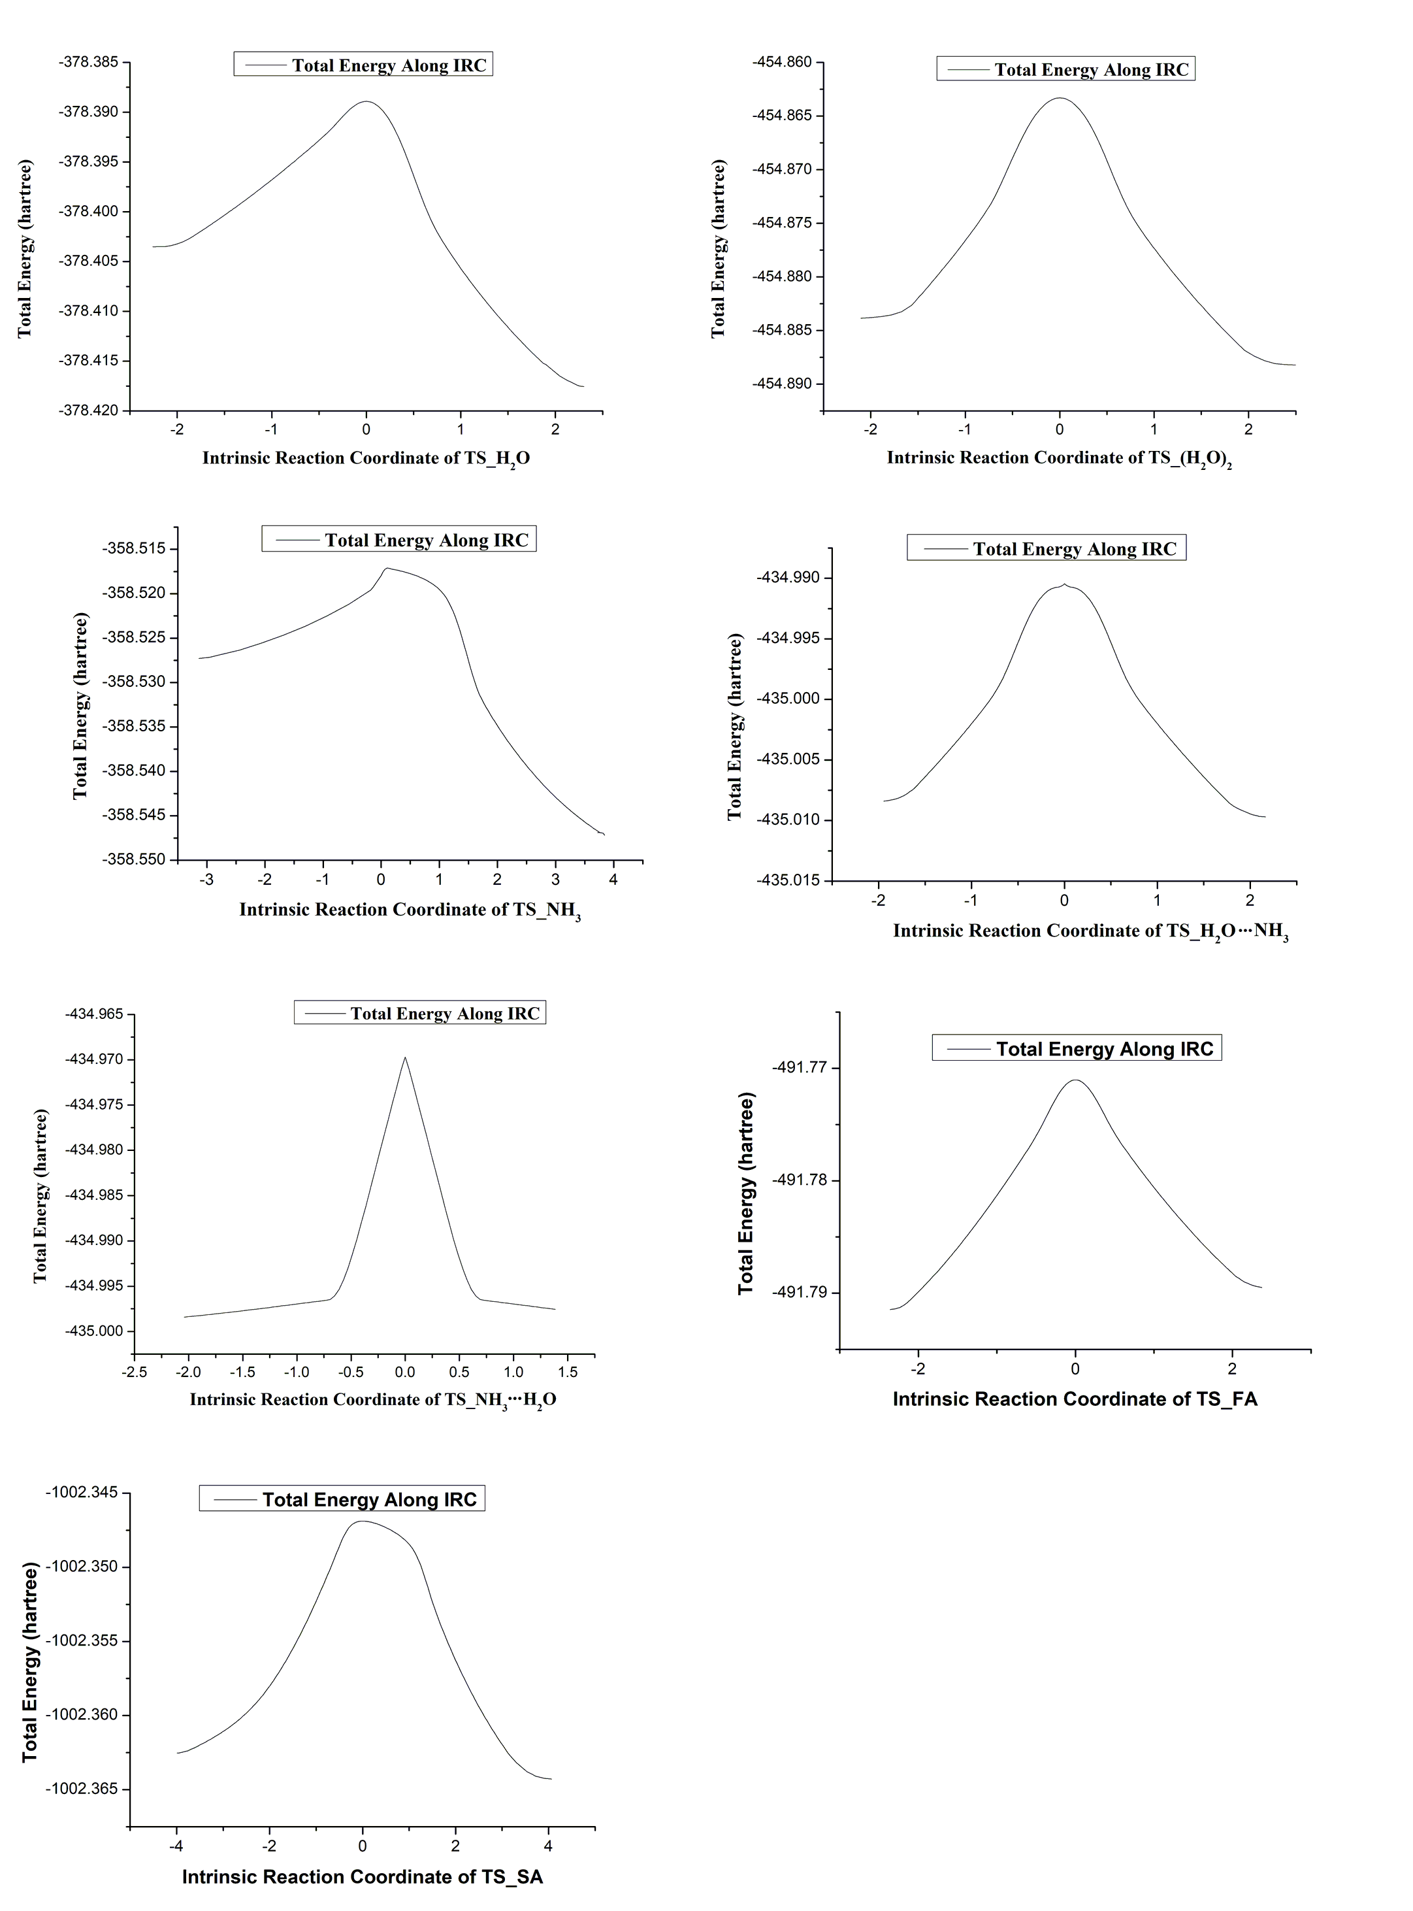
Figure S4 The results of IRC calculations of transition state for HO₄H → O₃ + H₂O reactions with catalyst X (X = H₂O, (H₂O)₂, NH₃, NH₃H₂O, H₂ONH₃, HCOOH and H₂SO₄)

∗ Corresponding Authors. Tel: +86-0916-2641083, Fax: +86-0916-2641083. E-mail: ztianlei88@l63.com (T. L Zhang); wlwang@snnu.edu.cn (W.L Wang); wwwltcommon@sina.com (B. Long) # Xiujuan Bi and Mingjie Wen contributed equally to this work.

