Regioselective Synthesis and biological evaluation of Novel dispiropyrrolidine derivatives Via One-Pot Four-Component Reaction
Subramanya Gopal Hegde ª. Lokesh Koodlur ^{a *}. Manjunatha Narayanarao^{b}
ªDepartment of Studies and Research in Chemistry, Vijayanagara Sri Krishnadevaraya University, Bellary-583105, India.
^{b}East Point College of Engineering and Technology, Visvesvaraya Technological University, Bangalore-560049, India.
* Corresponding author: E: mail: kslokesh@vskub.ac.in
Table of contents

General Information S1

Copies of all NMR Spectra S2-S17

General Information
General. Microwave irradiations were carried out in a Microwave Vials* 0.2-0.5 mL of Biotage Initiator+ at 120ºC, 300W. Reactions were monitored by TLC using 0.25 mm thick Merck plates, silica gel 60 F254. Products were purified by flash column chromatography on silica gel Merck (40-63) μ, 60.08 g/mol). NMR spectra were recorded with a Bruker DRX 400 MHz spectrometer in CDCl3. ¹³C spectra were recorded with 100MHz. The chemical shifts (δ) are given in parts per millions (ppm) relative to tetramethylsilane (TMS) for ¹H and ¹³C nuclei. Conventional abbreviations are used: s = singlet, d = doublet, t = triplet, q = quartet, qn = quintet, m = multiplet, br = broad. Coupling constants (J) are given in Hertz (Hz). Mass spectra were obtained on a GC/MS Saturn 2000 spectrometer. LC/MS were performed on 6410A Series electrospray ionization (ESI).

1',1'',3''-trimethyl-5'-(4-nitrophenyl)-2''H-dispiro[indene-2,2'-pyrrolidine-4',5''-pyrimidine]-1,2'',3,4'',6''(1''H,3''H)-pentaone, (5c)
Pale yellow solid; m.p.: 225–227 °C. ¹H-NMR (400 MHz, DMSO-d6): δ_{H} = 8.03 (m, 4H), 7.98 (dd, J = 12.0 Hz, 1H), 7.82-7.86 (m, 1H), 7.71-7.73 (m, 1H), 7.62-7.66 (m, 1H), 5.50 (s, 1H), 3.04 (s, 3H), 2.98 (d, J = 12.00 Hz, 1H), 2.76 (d, J = 12.00 Hz, 1H), 2.49 (s, 3H), 1.88 (s, 3H). ¹³C NMR (100 MHz, DMSO-d6): δ_{C} = 27.87, 28.84, 33.26, 37.72, 62.95, 63.83, 65.49, 67.78, 73.56, 76.75, 82.23, 122.71, 123.08, 123.36, 123.46, 128.95, 129.55, 132.03, 136.83, 137.08, 137.54, 137.85, 139.46, 140.64, 140.98, 142.87, 147.81, 149.93, 150.06, 150.47, 166.24, 166.36, 167.47, 168.74, 194.92, 196.76, 198.11, 201.72. Calculated MS (ESI) m/z: 476.13, found m/z: 477.21 [M + H+]. Anal. Calcd. For C₂₄H₂₀N₄O₇: C, 60.50; H, 4.23; N, 11.76. Found: C, 60.77; H, 4.56; N, 11.99.
5'-([1,1'-biphenyl]-4-yl)-1',1'',3''-trimethyl-2''H-dispiro[indene-2,2'-pyrrolidine-4',5''-pyrimidine]-1,2'',3,4'',6''(1''H,3''H)-pentaone, (5d)
Pale yellow solid; m.p.: 209–211 °C. ¹H-NMR(400 MHz, DMSO-d6 ): δ_{H} = 8.04-8.09 (m, 4H), 7.65-7.67 (m, 4H), 7.48 (t, J = 16.00 Hz, 2H), 7.36-7.41 (m, 1H), 7.31 (s, 2H), 4.81 (s, 1H), 3.19 (s, 3H), 2.94 (d, J = 12.00 Hz, 1H), 2.77 (d, J = 16.00 Hz, 1H), 2.46 (s, 3H), 1.96 (s, 3H). ¹³C NMR (100 MHz, DMSO-d6): δ_{C} = 28.06, 28.73, 33.22, 37.16, 38.69, 62.93, 73.14, 77.55, 119.06, 119.95, 123.0, 123.29, 127.24, 129.86, 130.42, 136.80, 137.02, 139.55, 141.0, 150.66, 155.66, 156.61, 167.73, 169.10, 198.41, 202.19. Calculated MS (ESI) m/z: 507.18, found m/z: 508.20 [M + H+]. Anal. Calcd. For C₃₀H₂₅N₃O₅: C, 70.99; H, 4.96; N, 8.28. Found: C, 71.35; H, 5.30; N, 8.55.

1',1'',3''-trimethyl-5'-(o-tolyl)-2''H-dispiro[indene-2,2'-pyrrolidine-4',5''-pyrimidine]-1,2'',3,4'',6''(1''H,3''H)-pentaone, (5e)
Pale yellow solid; m.p.: 221–223 °C. ¹H-NMR (400 MHz, DMSO-d6): δ_{H} = 8.01-8.08 (m, 4H), 7.16-7.30 (m, 4H), 5.19 (s, 1H), 3.08 (s, 3H), 2.88 (d, J = 16.00 Hz, 1H), 2.74 (d, J = 16.00 Hz, 1H), 2.49 (s, 3H), 2.13 (s, 1H), 1.82 (s, 3H). ¹³C NMR (100 MHz, DMSO-d6): δ_{C} = 28.00, 28.72, 33.19, 37.74, 62.24, 68.97, 73.11, 117.63, 117.85, 123.08, 123.36, 123.72, 124.30, 124.41, 125.15, 136.87, 137.07, 139.55, 141.02, 146.60, 146.78, 147.76, 147.92, 150.60, 167.48, 168.75, 197.97, 201.91. Calculated MS (ESI) m/z: 445.16, found m/z: 446.20 [M + H+]. Anal. Calcd. For C₂₅H₂₃N₃O₅: C, 67.41; H, 5.20; N, 9.43. Found: C, 67.70; H, 5.44; N, 9.75.
5'-(4-bromophenyl)-1',1'',3''-trimethyl-2''H-dispiro[indene-2,2'-pyrrolidine-4',5''-pyrimidine]-1,2'',3,4'',6''(1''H,3''H)-pentaone, (5f)
Yellow solid; m.p.: 240–242 °C. ¹H-NMR(400 MHz, DMSO-d6 ): δ_{H} = 8.04-8.08 (m, 4H), 7.57 (d, J = 8.00 Hz, 2H), 7.20 (d, J = 12.00 Hz, 2H), 4.74 (s, 1H), 3.16 (s, 3H), 2.90 (d, J = 20.00 Hz, 1H), 2.74 (d, J = 16.00 Hz, 1H), 2.48 (s, 3H), 1.89 (s, 3H). ¹³C NMR (100 MHz, DMSO-d6): δ_{C} = 28.10, 28.71, 33.13, 62.47, 70.30, 73.17, 123.09, 123.35, 124.67, 128.85, 129.76, 130.37, 133.24, 136.80, 137.10, 139.58, 140.89, 149.71, 150.39, 167.97, 168.58, 198.09, 201.47. Calculated MS (ESI) m/z: 509.06, found m/z: 511.25 [M + H+]. Anal. Calcd. For C₂₄H₂₀BrN₃O₅: C, 56.48; H, 3.95; N, 8.23. Found: C, 56.63; H, 4.30; N, 8.55.
5'-(2,3-difluorophenyl)-1',1'',3''-trimethyl-2''H-dispiro[indene-2,2'-pyrrolidine-4',5''-pyrimidine]-1,2'',3,4'',6''(1''H,3''H)-pentaone, (5g)
Pale yellow solid; m.p.: 232–234 °C. ¹H-NMR(400 MHz, DMSO-d6 ): δ_{H} = 8.04-8.06 (m, 4H), 7.44-7.51 (m, 1H), 7.30-7.35 (m, 1H), 7.15 (t, J = 12.00 Hz, 1H), 5.16 (s, 1H), 3.13 (s, 3H), 2.93 (d, J = 12.00 Hz, 1H), 2.80 (d, J = 12.00 Hz, 1H), 2.50 (s, 3H), 1.92 (s, 3H). ¹³C NMR (100 MHz, DMSO-d6): δ_{C} = 27.90, 28.71, 33.23, 37.32, 63.02, 73.39, 77.82, 122.98, 123.27, 126.57, 127.61, 128.91, 134.19, 136.75, 137.0, 139.41, 139.55, 140.76, 140.94, 150.54, 167.76, 169.13, 198.46, 202.05. Calculated MS (ESI) m/z: 467.13, found m/z: 468.25 [M + H+]. Anal. Calcd. For C₂₄H₁₉F₂N₃O₅: C, 61.67; H, 4.10; N, 8.99. Found: C, 61.98; H, 4.42; N, 9.36.
5'-(3-chloro-4-methoxyphenyl)-1',1'',3''-trimethyl-2''H-dispiro[indene-2,2'-pyrrolidine-4',5''-pyrimidine]-1,2'',3,4'',6''(1''H,3''H)-pentaone, (5h)
Pale yellow solid; m.p.: 251–253 °C. ¹H-NMR (400 MHz, DMSO-d6): δ_{H} = 8.02-8.07 (m, 4H), 7.17-7.25 (m, 3H), 4.70 (s, 1H), 3.85 (s, 3H), 3.16 (s, 3H), 2.88 (d, J = 16.00 Hz, 1H), 2.74 (d, J = 16.00 Hz, 1H), 2.49 (s, 3H), 1.89 (s, 3H). ¹³C NMR (100 MHz, DMSO-d6): δ_{C} = 27.88, 28.74, 33.14, 37.38, 62.81, 73.36, 77.20, 122.10, 123.01, 123.29, 131.36, 134.54, 136.77, 137.01, 139.52, 140.93, 150.51, 167.63, 168.95, 198.28, 201.88. Calculated MS (ESI) m/z: 495.12, found m/z: 496.21 [M + H+]. Anal. Calcd. For C₂₅H₂₂ClN₃O₆: C, 60.55; H, 4.47; N, 8.47. Found: C, 60.87; H, 4.80; N, 8.78.
5'-(4-chloro-2-methylphenyl)-1',1'',3''-trimethyl-2''H-dispiro[indene-2,2'-pyrrolidine-4',5''-pyrimidine]-1,2'',3,4'',6''(1''H,3''H)-pentaone, (5i)
Brown solid; m.p.: 220–222 °C. ¹H-NMR (400 MHz, DMSO-d6): δ_{H} = 8.03-8.08 (m, 4H), 7.26-7.33 (m, 3H), 5.14 (s, 1H), 3.09 (s, 3H), 2.88 (d, J = 16.00 Hz, 1H), 2.74 (d, J = 16.00 Hz, 1H), 2.58 (s, 3H), 2.13 (s, 3H), 1.81 (s, 3H). ¹³C NMR (100 MHz, DMSO-d6): δ_{C} = 18.5, 27.8, 28.6, 33.2, 37.3, 38.6, 62.9, 73.3, 78.1, 122.9, 123.28, 128.4, 129.0 135.3, 136.7, 138.1, 139.5, 140.9, 150.5, 167.5, 169.2, 199.5, 202.1. Calculated MS (ESI) m/z: 479.12, found m/z: 480.23 [M + H+]. Anal. Calcd. For C₂₅H₂₂ClN₃O₅: C, 62.57; H, 4.62; N, 8.76. Found: C, 62.90; H, 4.93; N, 8.99.
5'-(4-(4-chlorophenoxy) phenyl)-1',1'',3''-trimethyl-2''H-dispiro[indene-2,2'-pyrrolidine-4',5''-pyrimidine]-1,2'',3,4'',6''(1''H,3''H)-pentaone, (5j)
Yellow solid; m.p.: 239–241 °C. ¹H-NMR (400 MHz, DMSO-d6): δ_{H} = 8.04-8.06 (m, 2H), 8.03 (m, 8H), 7.5 (d, J = 12.00 Hz, 2H), 4.92 (s, 1H), 3.20 (s, 3H), 2.93 (d, J = 12.00 Hz, 1H), 2.80 (d, J = 12.00 Hz, 1H), 2.50 (s, 3H), 1.92 (s, 3H). ¹³C NMR (100 MHz, DMSO-d6): δ_{C} = 27.87, 28.84, 33.26, 37.72, 62.95, 63.83, 65.49, 67.78, 73.56, 76.75, 82.23, 122.71, 123.08, 123.36, 123.46, 128.95, 129.55, 132.03, 136.83, 137.08, 137.54, 137.85, 139.46, 140.64, 140.98, 142.87, 147.81, 149.93, 150.06, 150.47, 166.24, 166.36, 167.47, 168.74, 194.92, 196.76, 198.11, 201.72. Calculated MS (ESI) m/z: 557.14, found m/z: 558.20 [M + H+]. Anal. Calcd. For C₃₀H₂₄ClN₃O₆: C, 64.58; H, 4.34; N, 7.53. Found: C, 64.90; H, 4.66; N, 7.80.
4-(1',1'',3''-trimethyl-1,2'',3,4'',6''-pentaoxo-1,1'',3,3'',4'',6''-hexahydro-2''H-dispiro[indene-2,2'-pyrrolidine-4',5''-pyrimidin]-5'-yl) benzonitrile, (5k)
Pale yellow solid; m.p.: 219–221 °C. ¹H-NMR (400 MHz, DMSO-d6): δ_{H} = 8.04-8.08 (m, 4H), 7.98 (m, 4H), 4.92 (s, 1H), 3.04 (s, 3H), 2.98 (d, J = 12.00 Hz, 1H), 2.76 (d, J = 12.00 Hz, 1H), 2.49 (s, 3H), 1.88 (s, 3H). ¹³C NMR (100 MHz, DMSO-d6): δ_{C} = 29.7, 31.5, 37.3, 48.0, 52.9, 117.7, 118.2, 127.5, 127.9, 128.2, 128.6, 131.5, 131.7, 141.7, 150.2, 154.1, 155.3, 178.4, 197.7, 199.5, 202.1. Calculated MS (ESI) m/z: 456.14, found m/z: 457.21 [M + H+]. Anal. Calcd. For C₂₅H₂₀N₄O₅: C, 65.78; H, 4.42; N, 12.27. Found: C, 66.01; H, 4.62; N, 12.53.
1',1'',3''-trimethyl-5'-(pyridin-4-yl)-2''H-dispiro[indene-2,2'-pyrrolidine-4',5''-pyrimidine]-1,2'',3,4'',6''(1''H,3''H)-pentaone, (5l)
Brown solid; m.p.: 260–262 °C. ¹H-NMR (400 MHz, DMSO-d6): δ_{H} = 8.04-8.08 (m, 4H), 7.57 (d, J = 8.00 Hz, 2H), 7.20 (d, J = 12.00 Hz, 2H), 4.74 (s, 1H), 3.16 (s, 3H), 2.90 (d, J = 20.00 Hz, 1H), 2.74 (d, J = 16.00 Hz, 1H), 2.48 (s, 3H), 1.89 (s, 3H). ¹³C NMR (100 MHz, DMSO-d6): δ_{C} = 28.10, 28.71, 33.13, 62.47, 70.30, 73.17, 123.09, 123.35, 124.67, 128.85, 129.76, 130.37, 133.24, 136.80, 137.10, 139.58, 140.89, 149.71, 150.39, 167.97, 168.58, 198.09, 201.47. Calculated MS (ESI) m/z: 432.14, found m/z: 433.25 [M + H+]. Anal. Calcd. For C₂₃H₂₀N₄O₅: C, 63.88; H, 4.66; N, 12.96. Found: C, 64.15; H, 4.85; N, 13.21.

¹H NMR spectrum of 5a

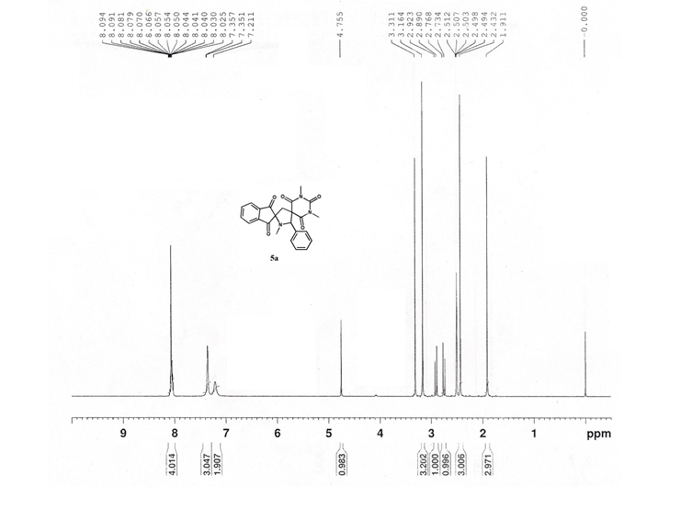

¹³C NMR spectrum of 5a

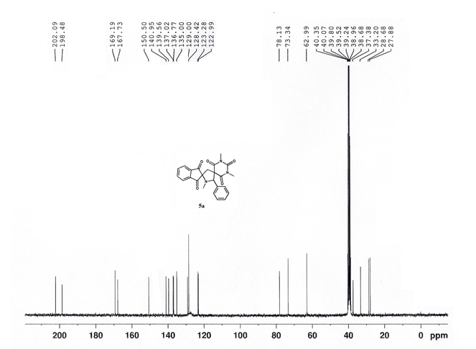

¹H NMR spectrum of 5b
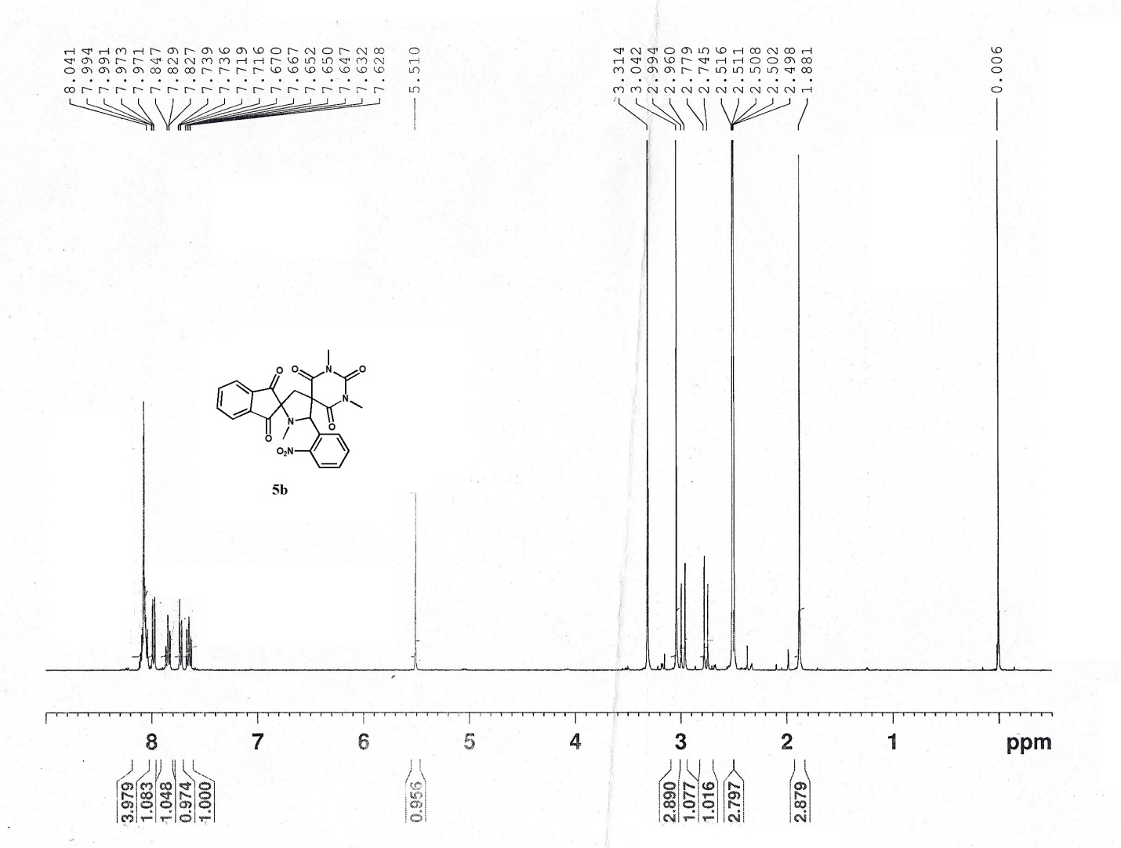

¹³C NMR spectrum of 5b
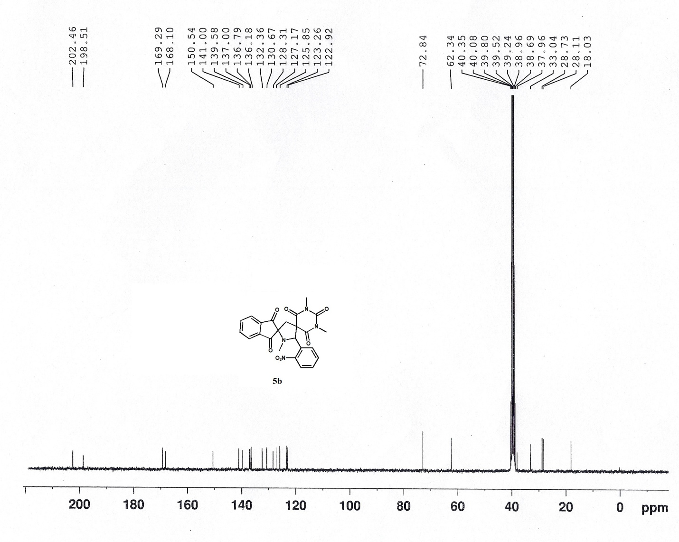

¹H NMR spectrum of 5c

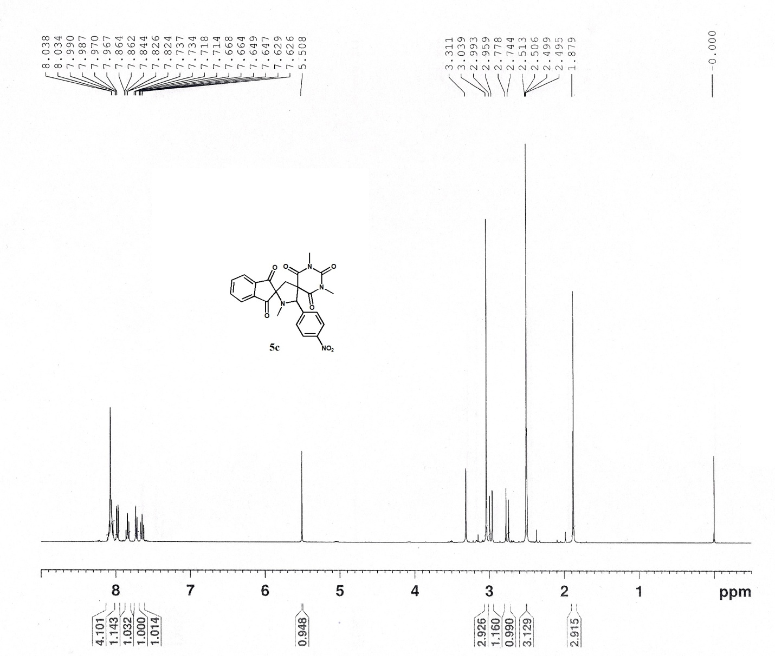

¹³C NMR spectrum of 5c

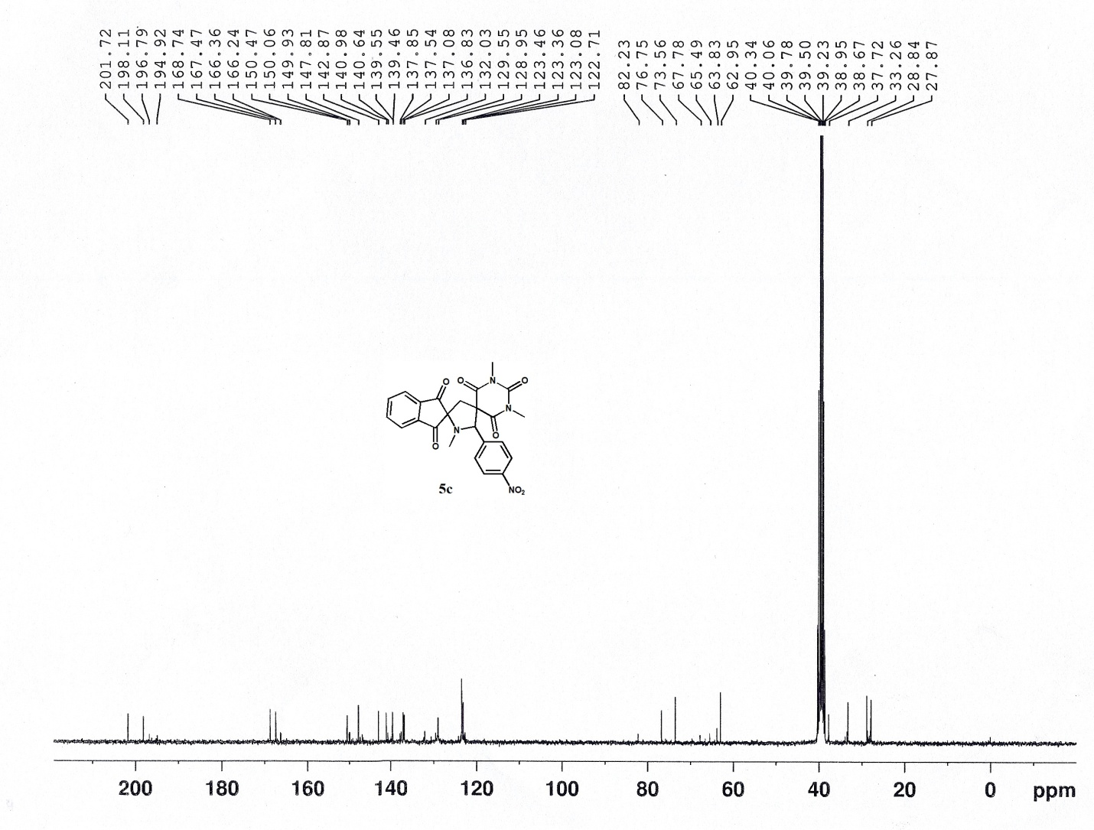

¹H NMR spectrum of 5d
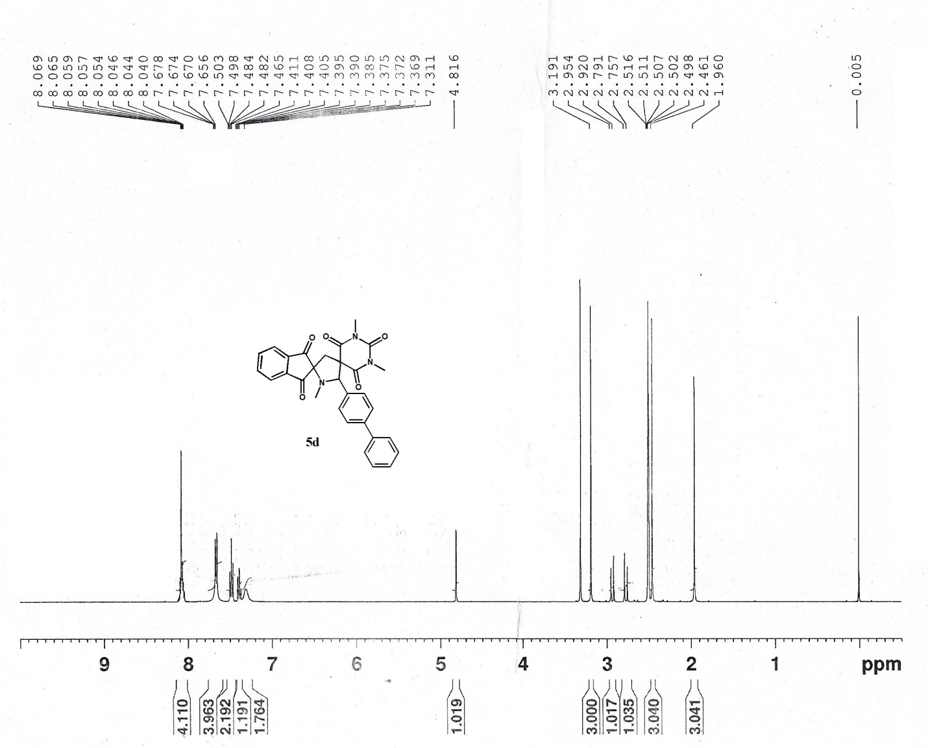

¹³C NMR spectrum of 5d

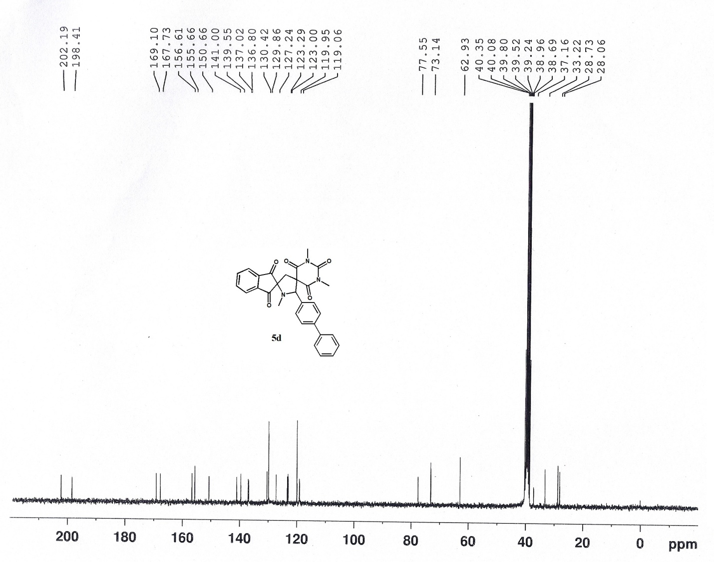

¹H NMR spectrum of 5e
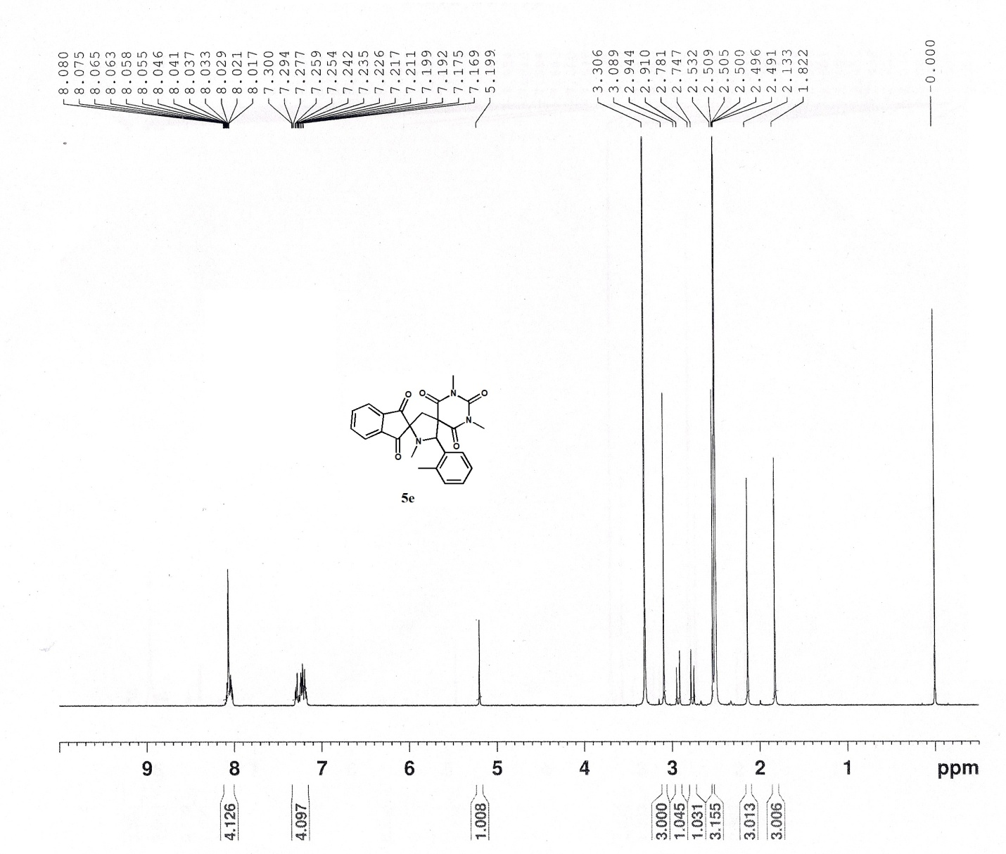

¹³C NMR spectrum of 5e

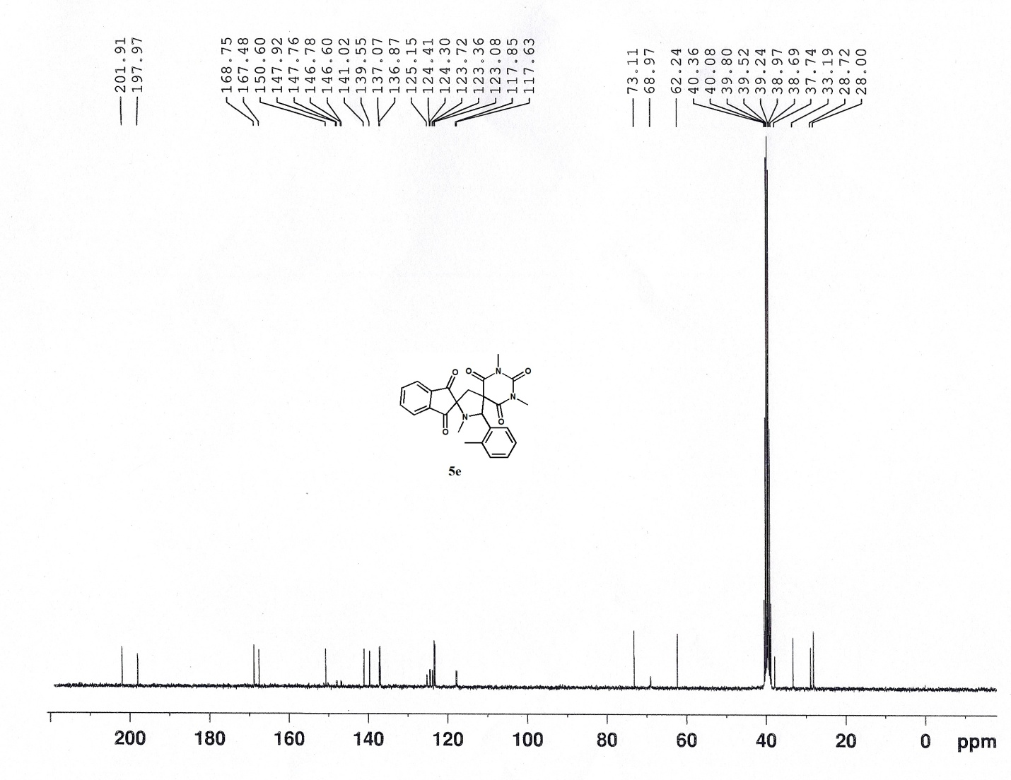

¹H NMR spectrum of 5f

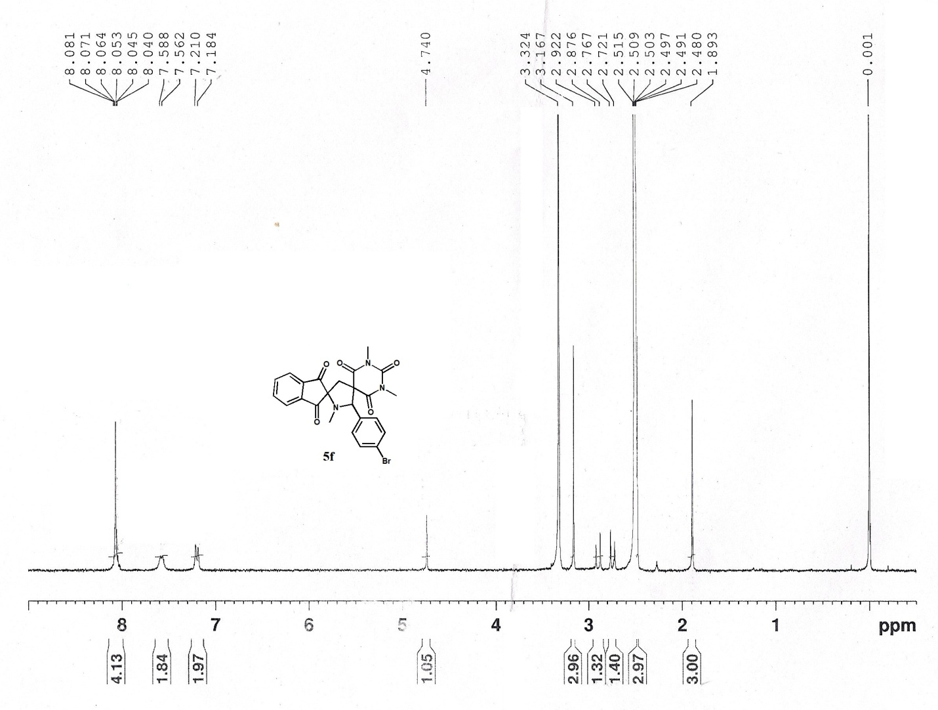

¹³C NMR spectrum of 5f

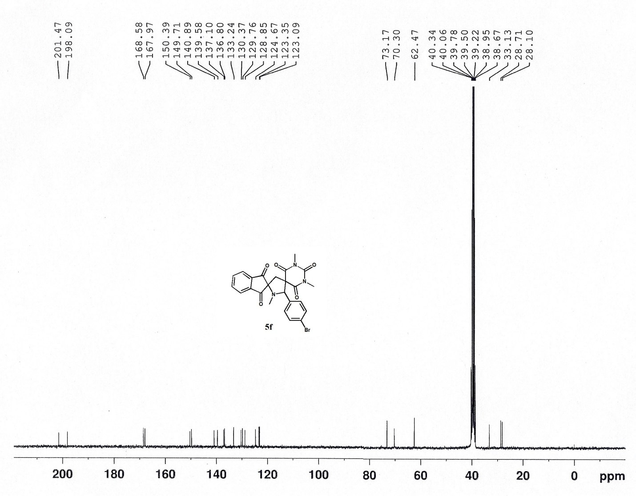

¹H NMR spectrum of 5g

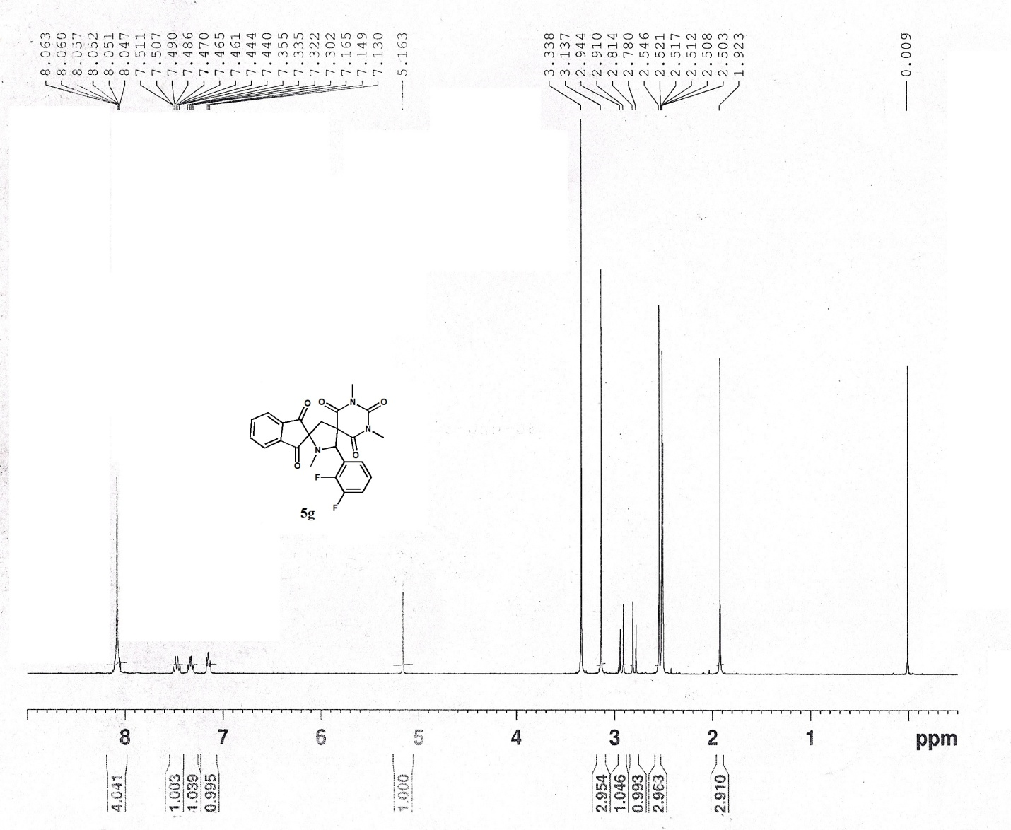

¹³C NMR spectrum of 5g

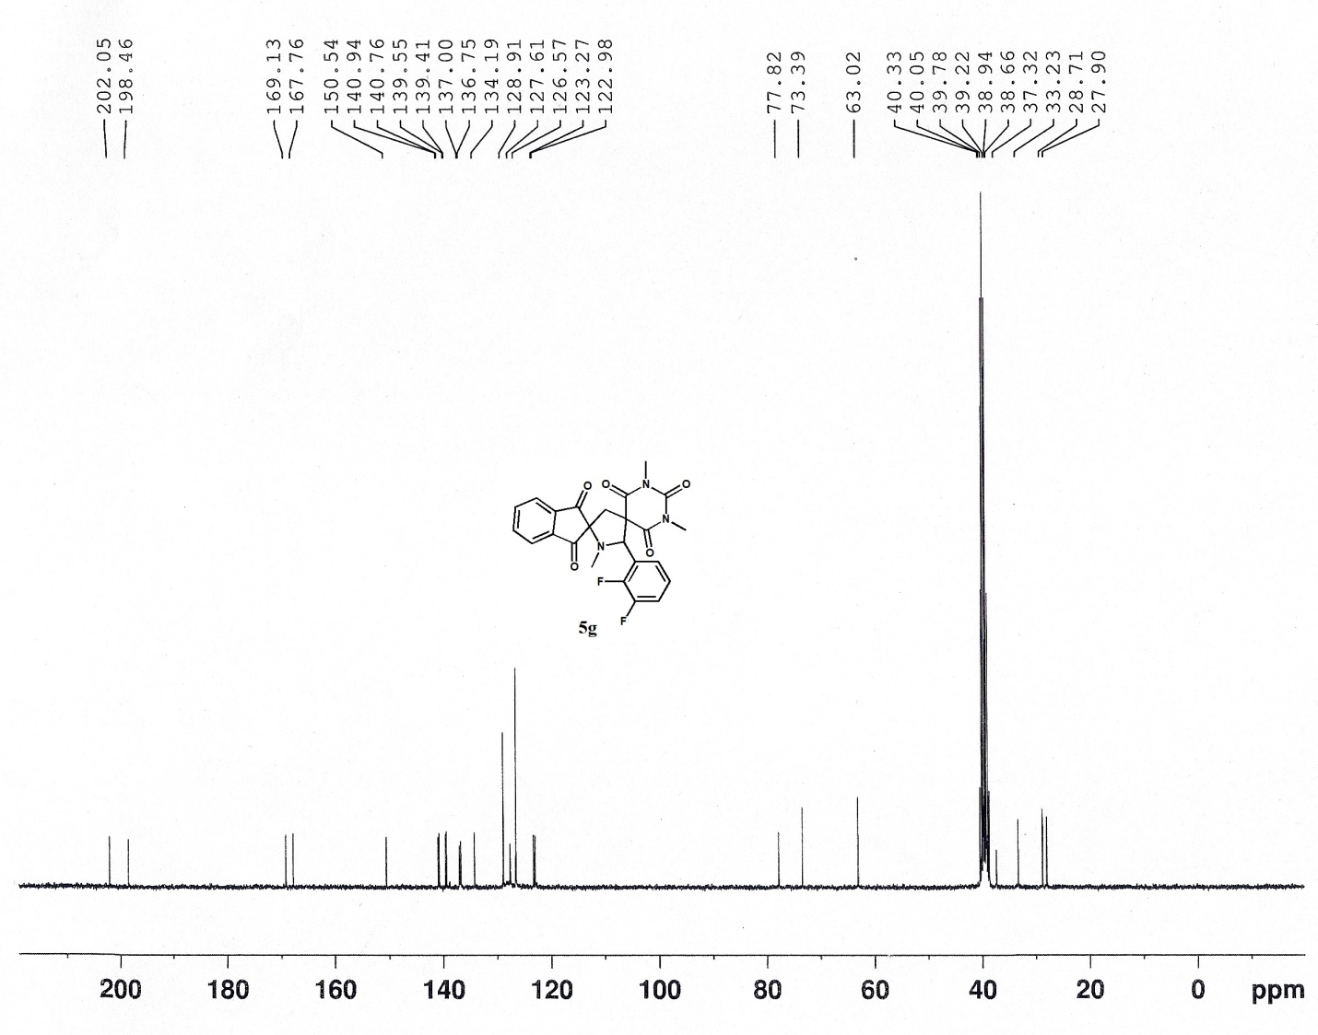

¹H NMR spectrum of 5h

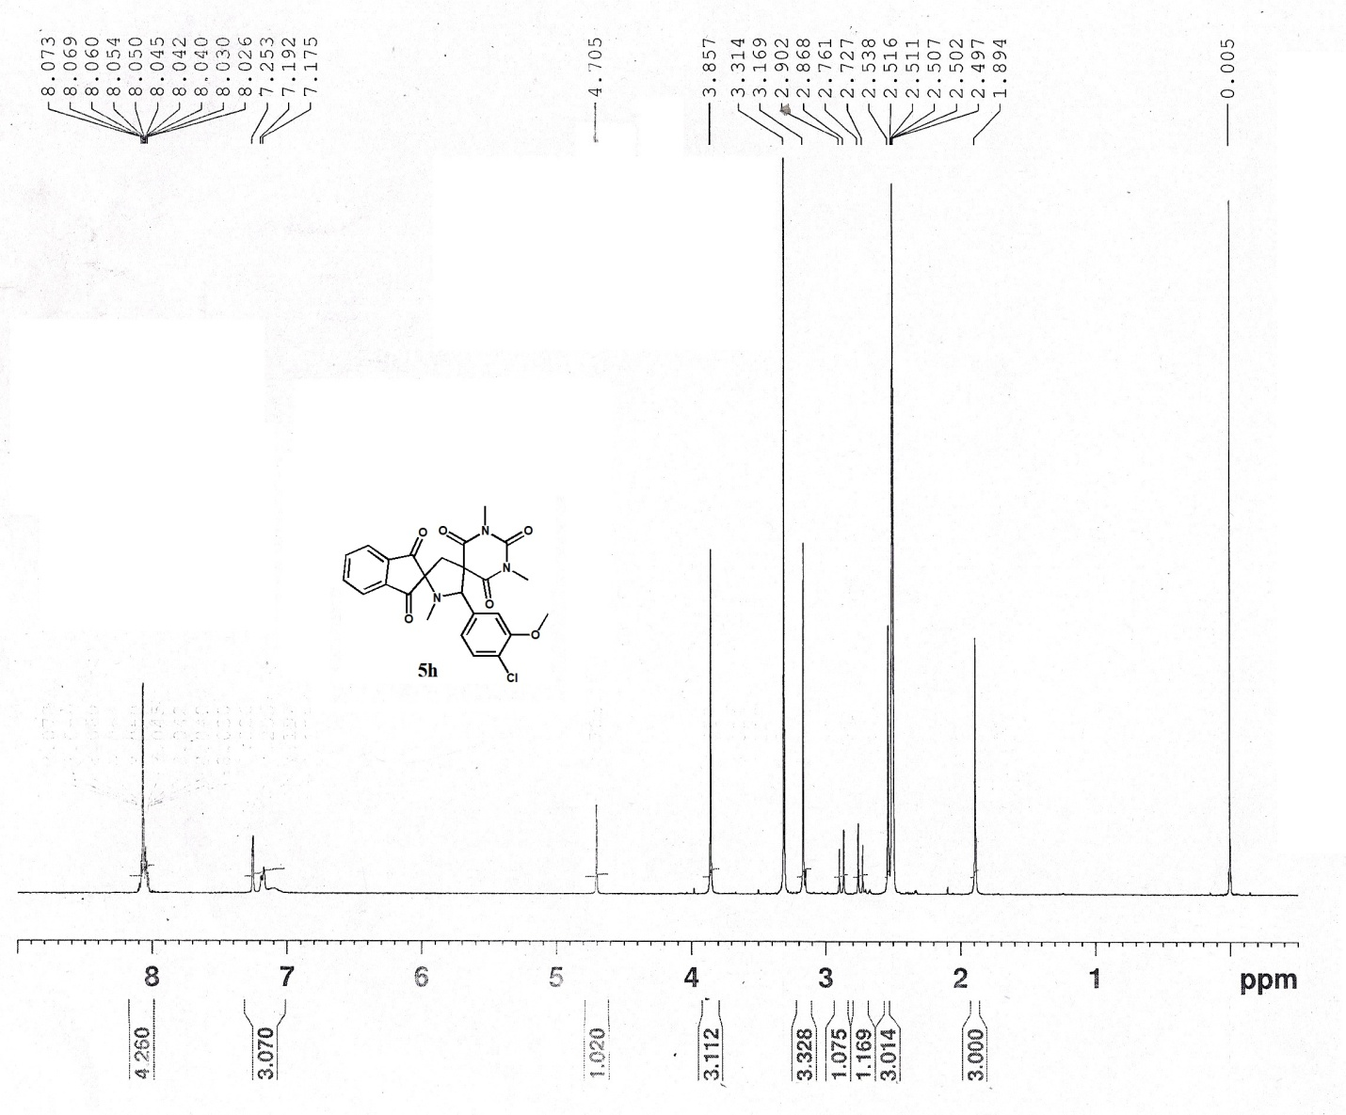

¹³C NMR spectrum of 5h

