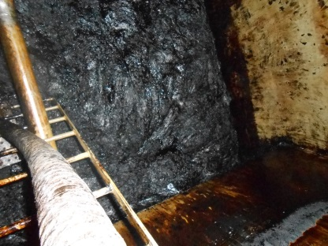 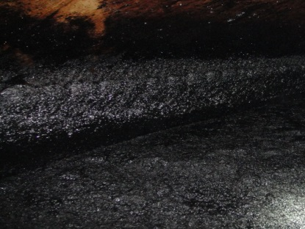

 

Figure S1 The viscous flocs in the treatment tank



Figure S2 The IR spectra of CnDM (a) and PDCnDM (b)

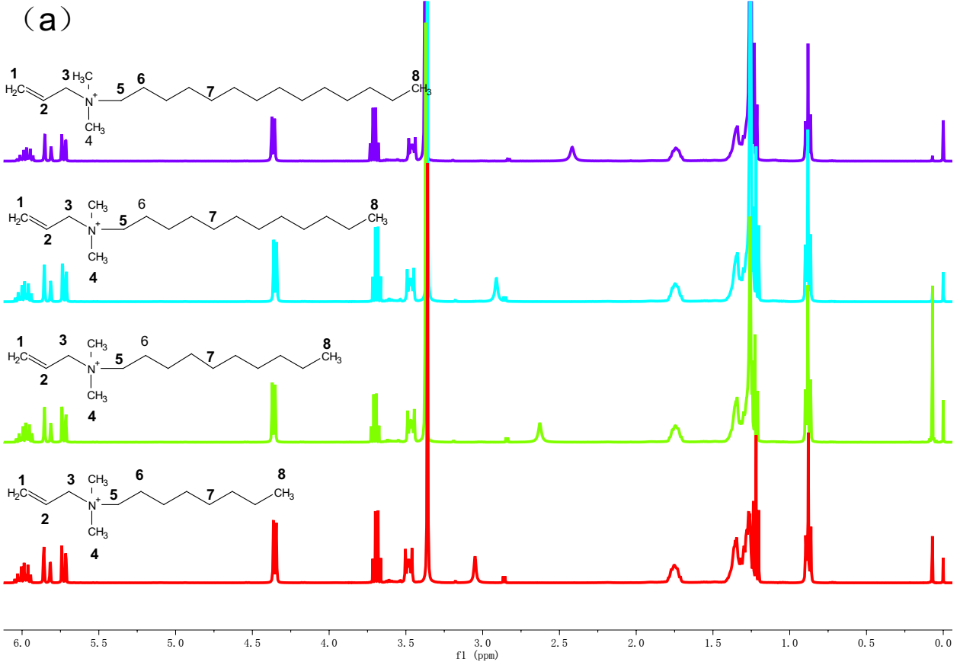 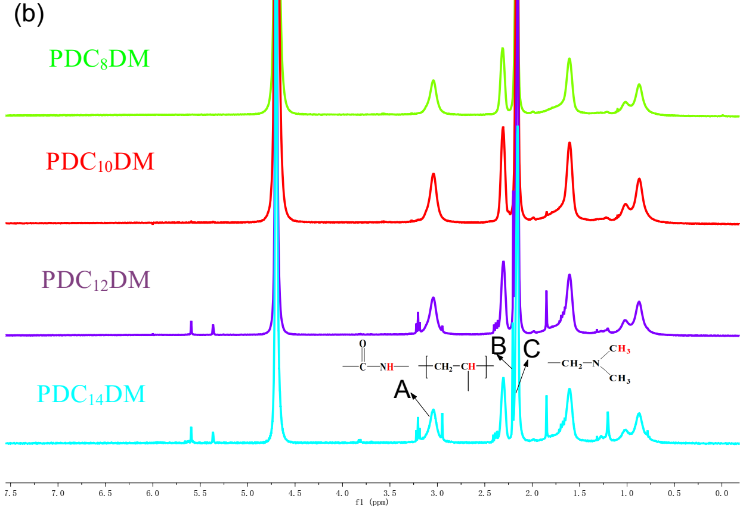

Figure S3 The 1H-NMR spectra of CnDM (a) and PDCnDM (b)



Figure S4 The effect of CnDM type on PDCnDM performance (note: the PDPM is the homopolymer of DMAPMA, flocculant dosage was 250 mg/L )



Figure S5 The effect of monomer concentration on PDC12DM performance (PDC12DM dosage was 250 mg/L )



Figure S6 The effect of mole ratio of C12DM to DMAPMA on PDC12DM performance (PDC12DM dosage was 250 mg/L )



Figure S7 The effect of initiator concentration on PDC12DM performance (PDC12DM dosage was 250 mg/L)



Figure S8 The effect of polymerization temperature on PDC12DM performance (PDC12DM dosage was 250 mg/L)



Figure S9 The effect of polymerization time on PDC12DM performance (PDC12DM dosage was 250 mg/L)

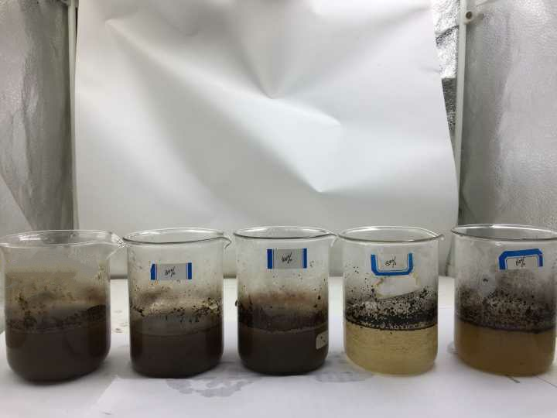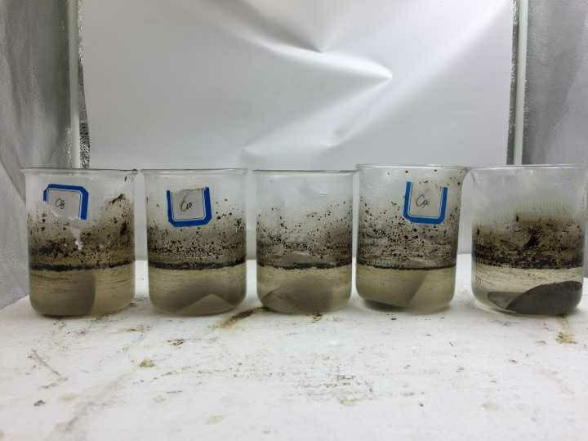

PAM-DAC

PDC12DM

Blank

Figure S10 The photographs of PDC12DM and PAM-DAC (at 250 mg/L) flocculation results



Figure S11 (a)The microscopic morphology of OWPF; (b)The microscopic morphology of flocs