Synthesis of functionalized selenazole derivatives via a three-component condensation of ethyl-2-chloro-3-oxo-butyrate, potassium selenocyanate and hydrazine or hydrazide derivatives
Marziyeh Pourmosaviª, Mohammad H. Mossleminª* and Alireza Hassanabadi ^{b}
ªDepartment of Chemistry, Yazd Branch, Islamic Azad University, Yazd, Iran
^{b}Department of Chemistry, Zahedan Branch, Islamic Azad University, Zahedan, Iran
Email: mhmosslemin@gmail.com

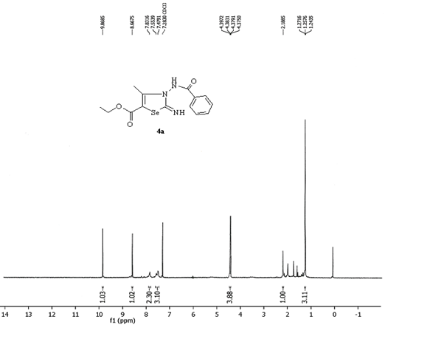
Figure S 1: ¹H NMR of 4a

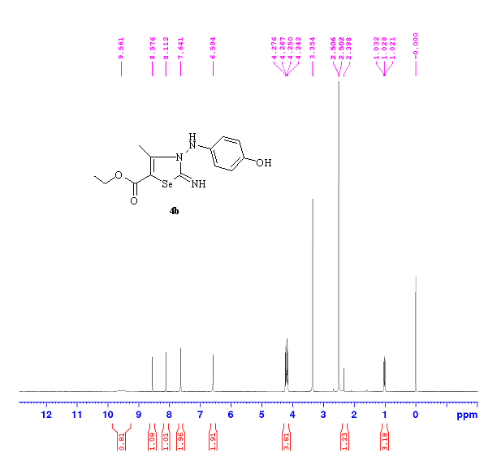
Figure S 2: ¹H NMR of 4b

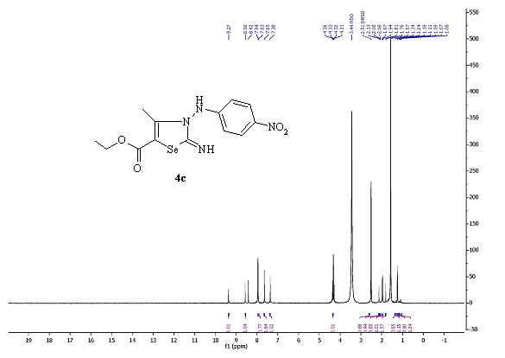
Figure S 3: ¹H NMR of 4c

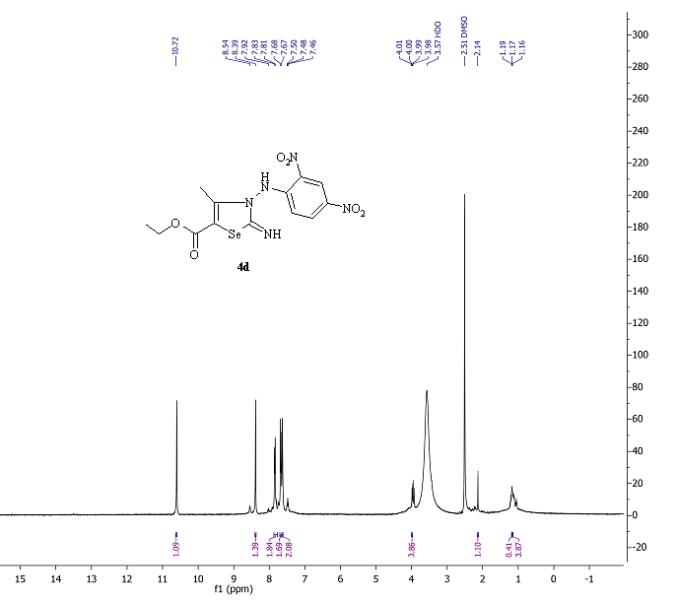
Figure S 4: ¹H NMR of 4d

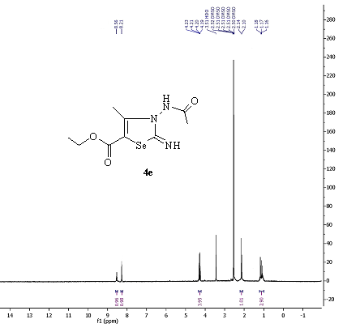
Figure S 5: ¹H NMR of 4e

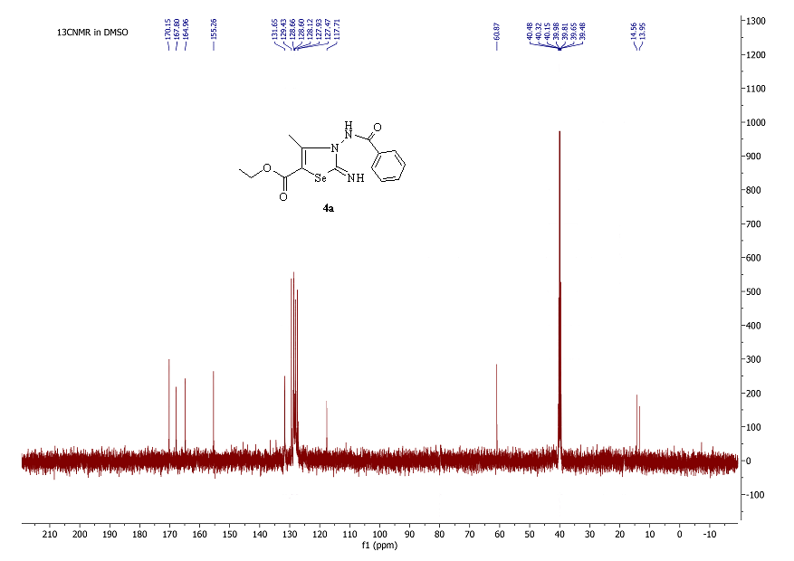

Figure S 6: ¹³C NMR of 4a

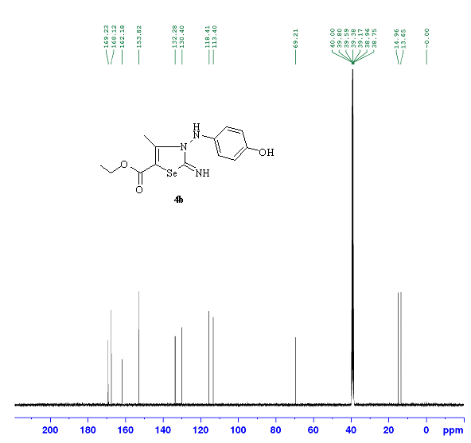
Figure S 7: ¹³C NMR of 4b

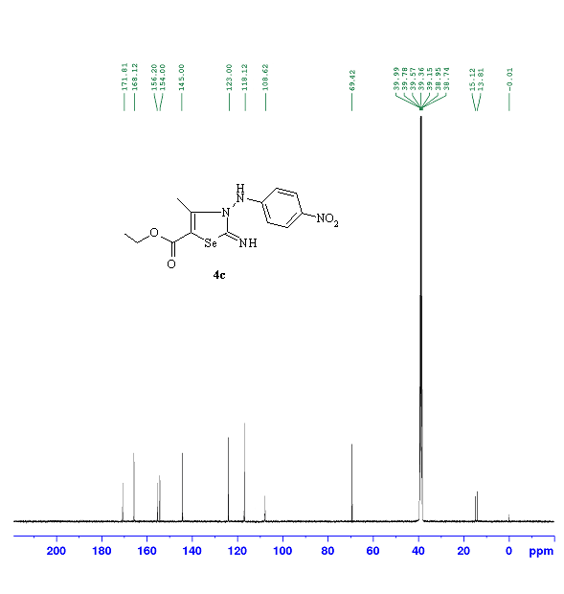
Figure S 8: ¹³C NMR of 4c

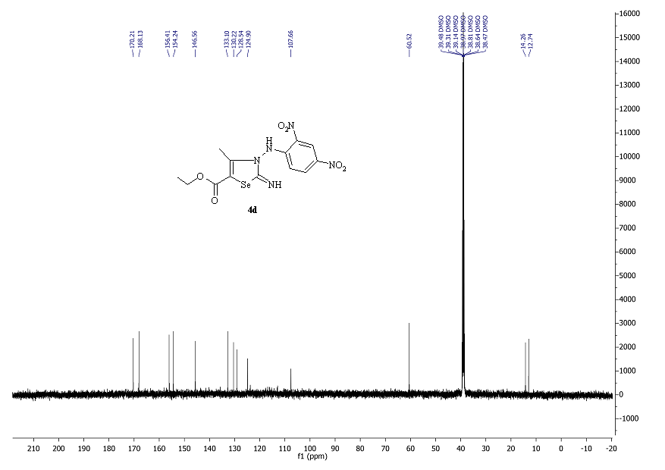

Figure S 9: ¹³C NMR of 4d

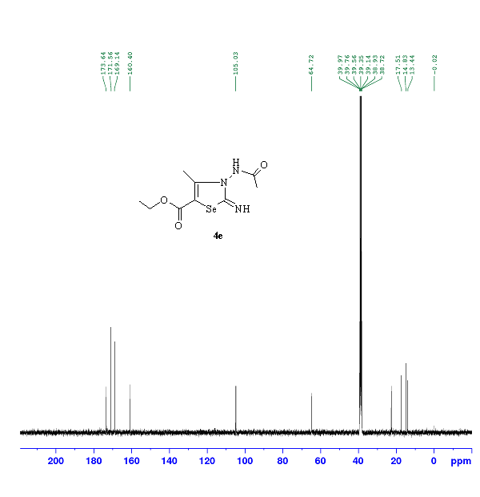
Figure S 10: ¹³C NMR of 4e

