Appendices

Appendix 1: A copy of the questionnaire as displayed to respondents on the custom-built website.

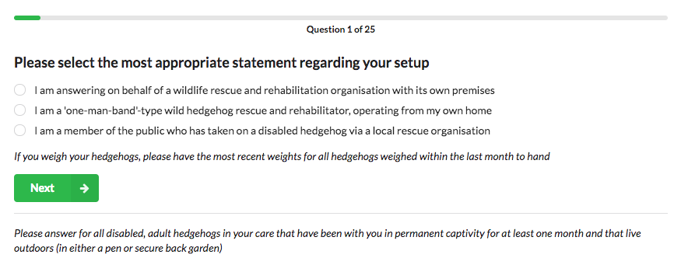

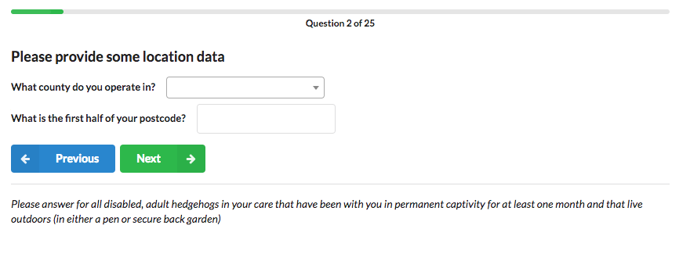

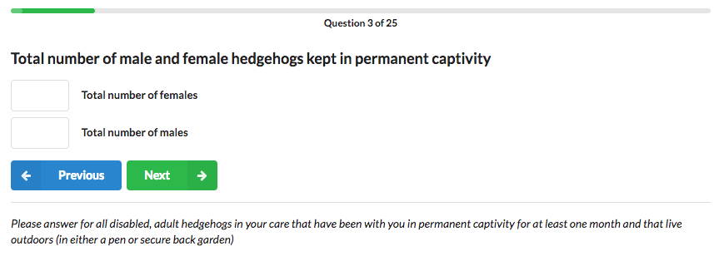

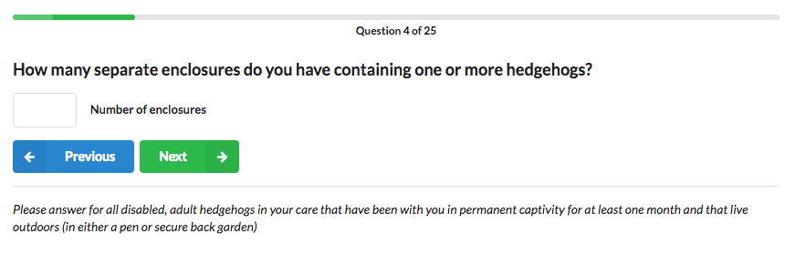

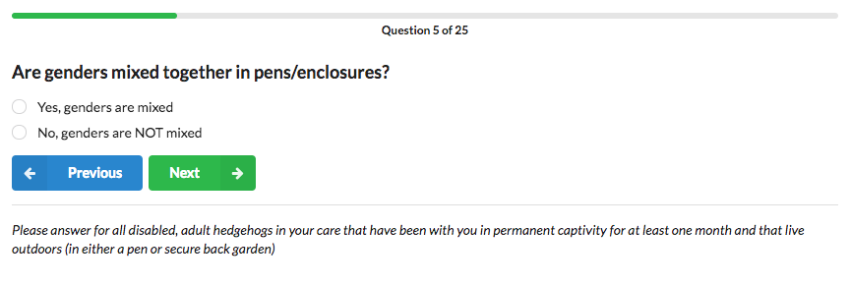

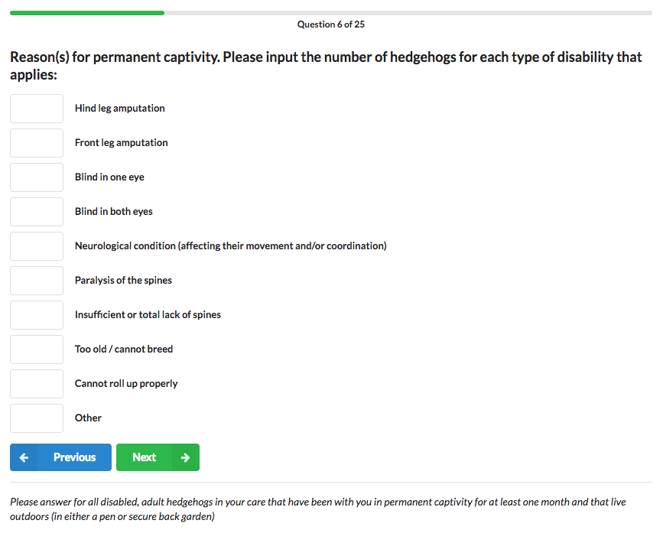

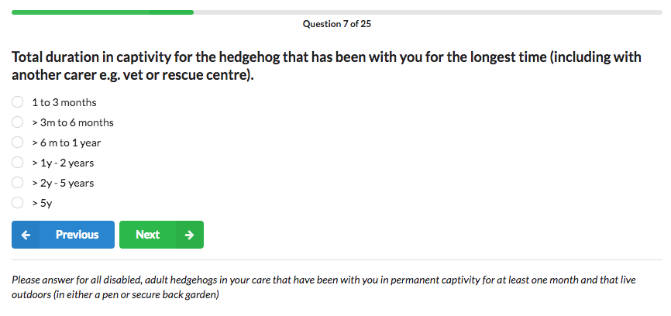

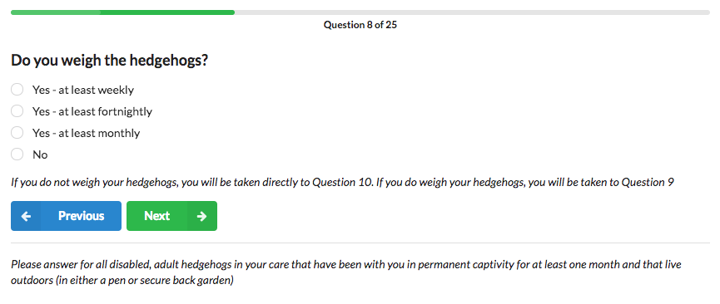

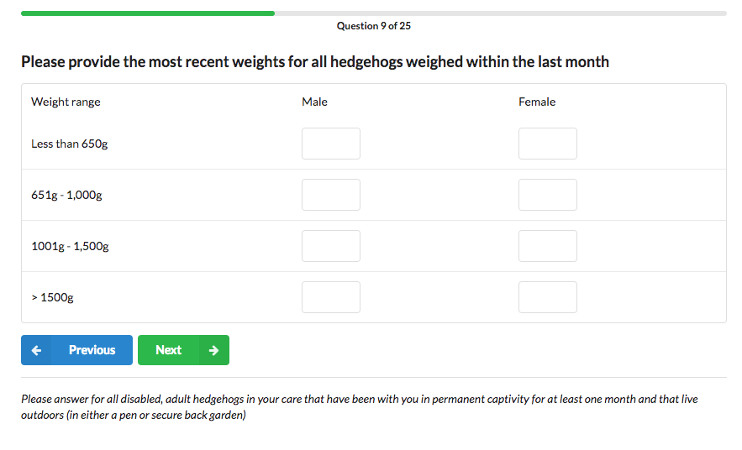

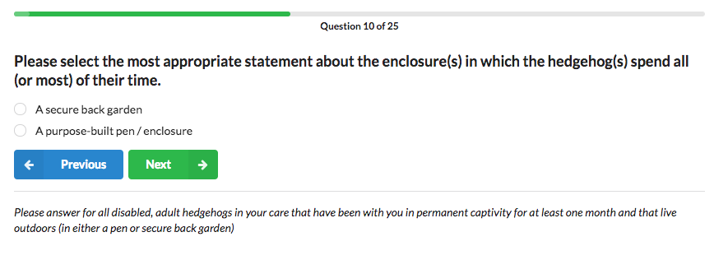

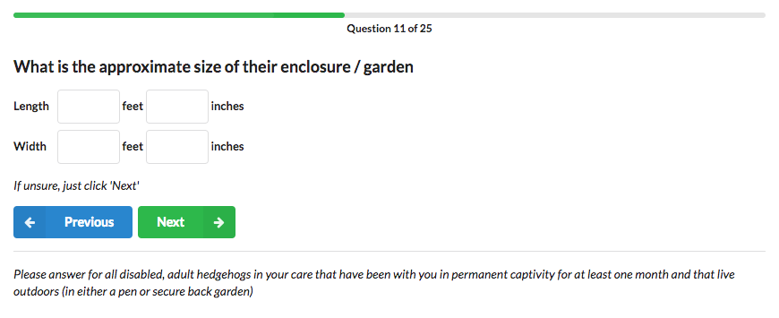

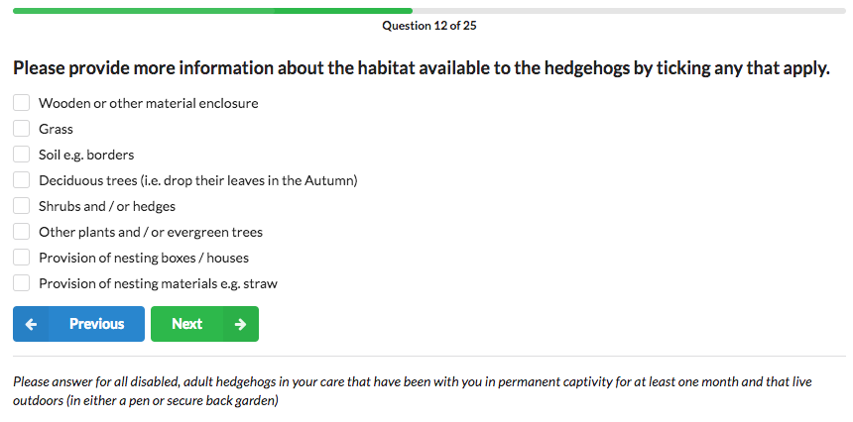

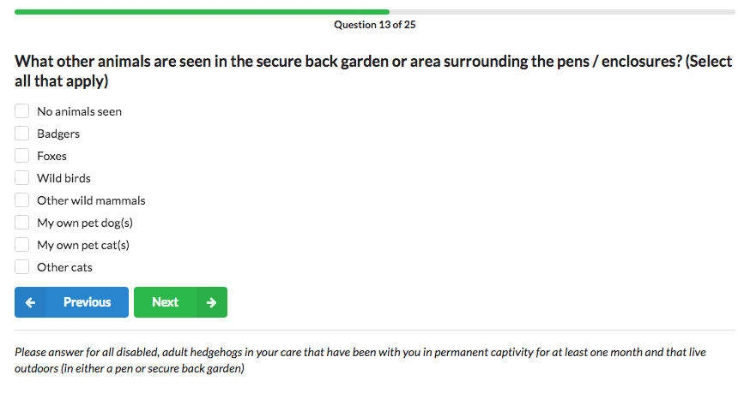

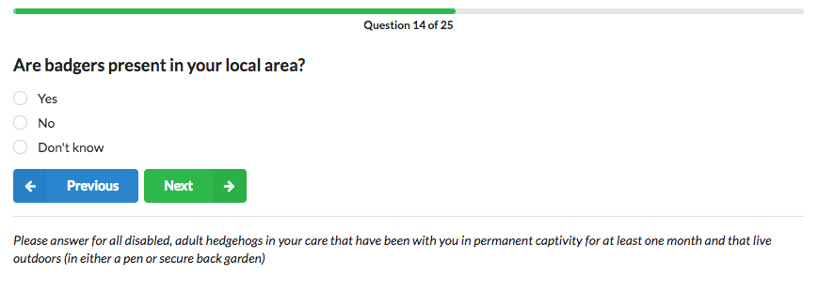

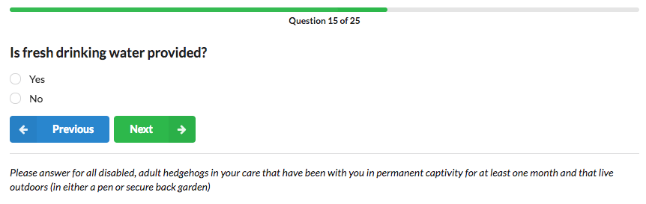

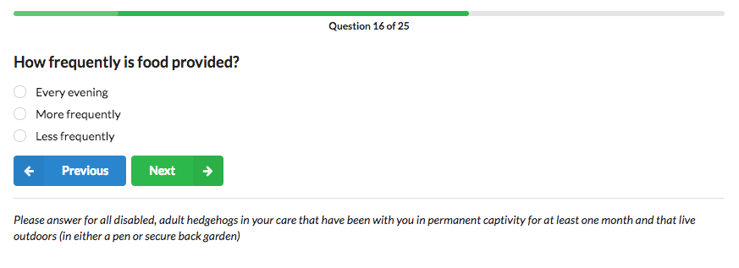

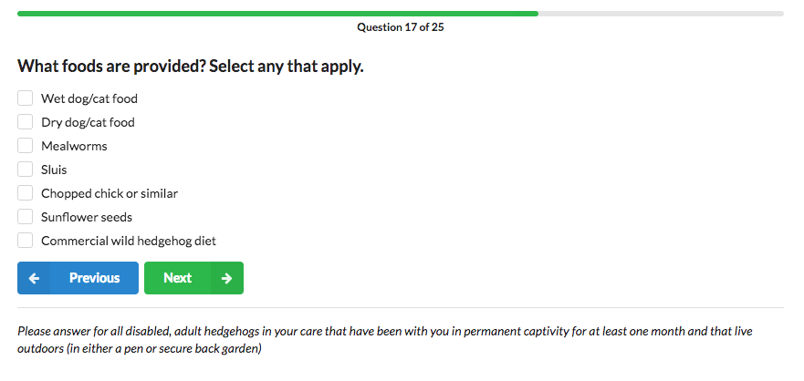

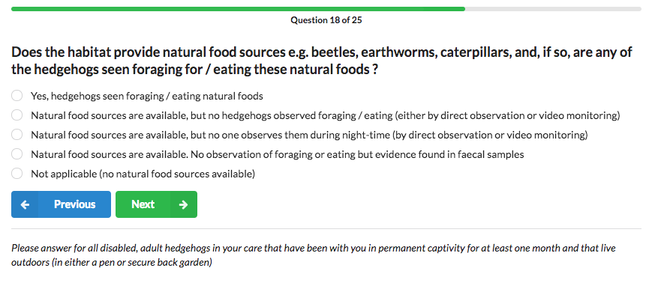

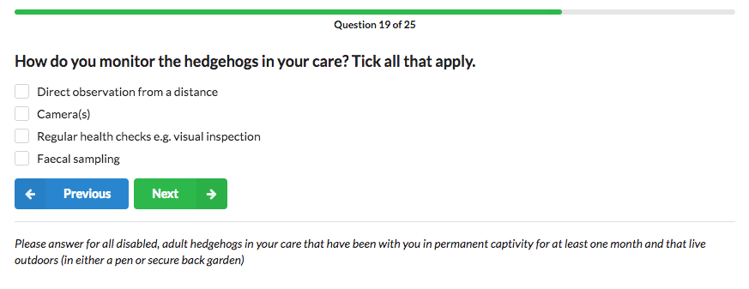

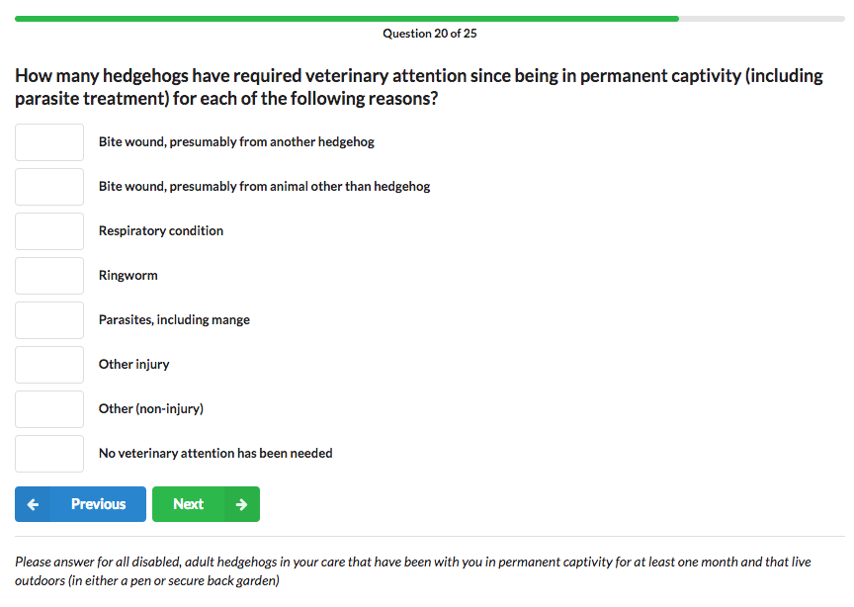

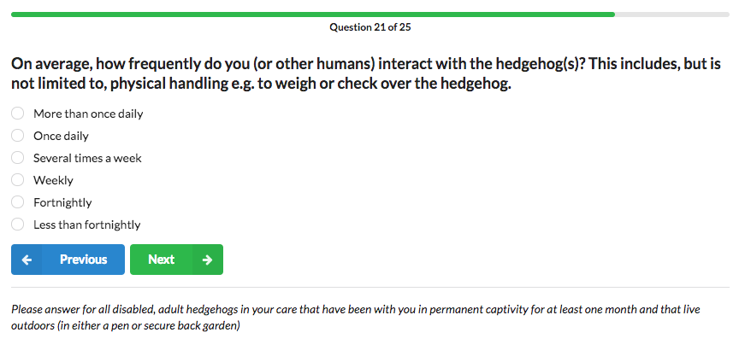

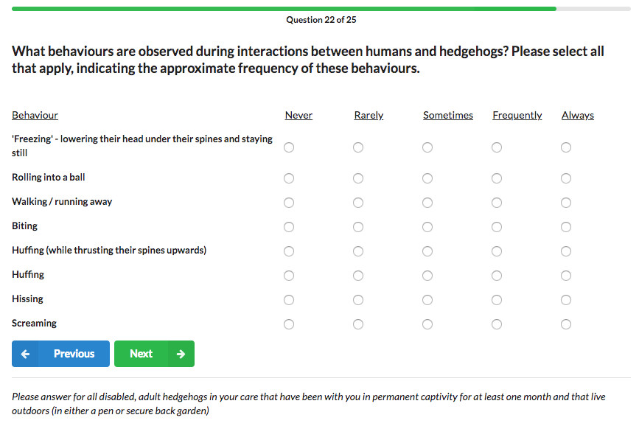

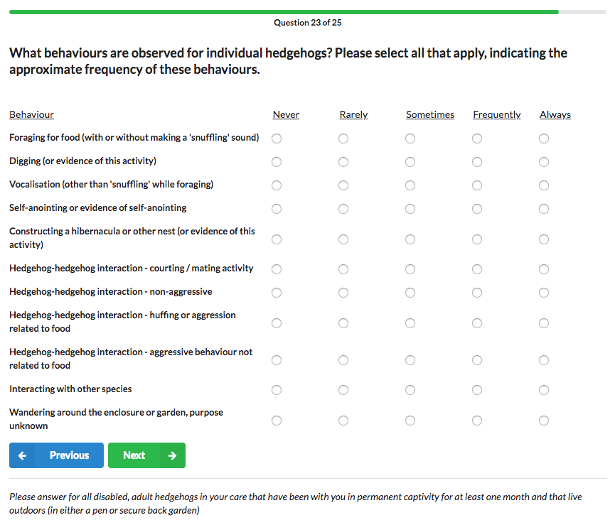

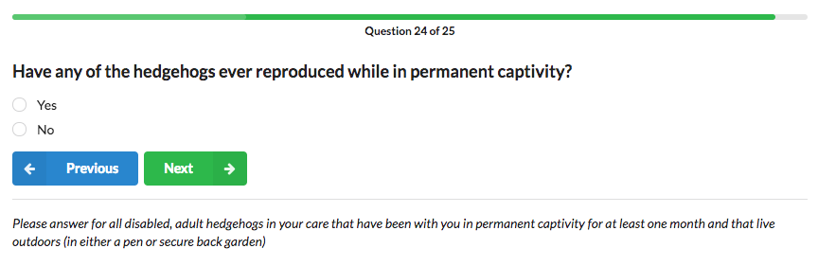

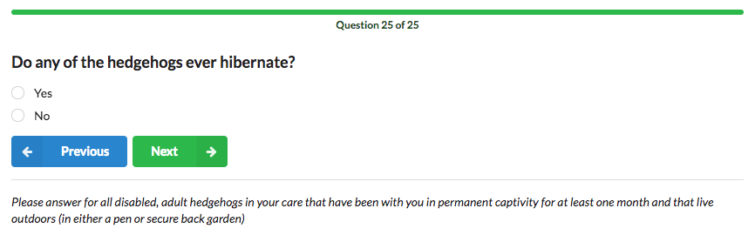

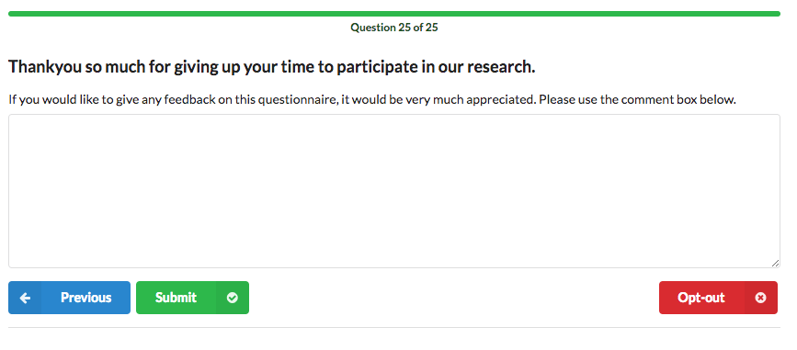
Appendix 2: Ethogram

The ethogram constructed for hedgehog behaviours was split into 3 categories: behaviours observed (i) during interactions with humans (‘Human interaction’); (ii) while not interacting with other animals (‘Individual’); and (iii) during interactions with other animals (‘Interaction (non-human)’).

Behavior | Category | Description
Freezingª | Human interaction | Lowering the head under their spines and staying still, spines erect
Balling^{a, b} | Human interaction | Rolling into a ball
Walking / running away^{a, b} | Human interaction | Walking / running away
Biting^{b} | Human interaction | Biting
Spine-huffingª | Human interaction | Making a ‘huffing’ sound while thrusting their spines upwards
Huffingª | Human interaction | Making a ‘huffing’ sound
Hissingª | Human interaction | Making a ‘hissing’ sound
Screaming^{a, b} | Human interaction | Making a high-pitched sound akin to a scream or a squeal^{b}
Foraging^{b} | Individual | Foraging for food, with or without making a ‘snuffling’ sound
Digging^{b} | Individual | Digging, or evidence of this activity
Vocalizing^{b} | Individual | Vocalization other than the ‘snuffling’ sound made while foraging
Self-anointing^{b} | Individual | Self-anointing (or evidence thereof). This behavior involves a hedgehog using its tongue to flick foamy saliva over their spines (and sometimes their fur)^{b}
Nesting^{b} | Individual | Constructing a hibernacula or other nest (or evidence of this activity)
Wandering | Individual | Wandering around the enclosure or garden with no obvious purpose
Courting / mating^{b} | Interaction (non-human) | Hedgehog-hedgehog: courting / mating activity
Non-aggressive hog-hogª | Interaction (non-human) | Hedgehog-hedgehog: non-aggressive interaction
Food aggression hog-hogª | Interaction (non-human) | Hedgehog-hedgehog: huffing or aggression related to food
Non-food aggression hog-hogª | Interaction (non-human) | Hedgehog-hedgehog: aggressive behaviour not related to food
Other species | Interaction (non-human) | Hedgehog interacting with another species

ª Reeve, 1994

^{b} Morris, 2006

