Supplementary Information

Syntheses, X-ray structure, emission and vibrational spectroscopies, DFT and thermogravimetric studies of two complexes containing the bidentate ligand 5-phenyl-1H-pyrazol-3-yl)methyl) phosphine oxide

RUDY L. LUCK*, JOHN S. MAASS, NICK K. NEWBERRY and MATTHIAS ZELLER

Contents
Figure S1. 1H NMR spectrum of complex 3 in (CD₃)₂SO. 2
Figure S2. TGA for Complex 2 under nitrogen. 3
Figure S3. TGA for Complex 2 under oxygen. 3
Figure S4. TGA for Co(ClO₄)₂•6H₂O under nitrogen. 4
Figure S5. TGA for Complex 3 under nitrogen. 4
Figure S6. Drawing of compound 2 with atoms represented as spheres of arbitrary size (H-white, C-grey, N-blue and O-red) using the GaussView [1] program. 5
Table S1. Atomic coordinates for 2. 5
Figure S7. Uncorrected calculated FTIR (top) and experimental (neat) spectrum of compound 2. 7
Figure S8. Calculated UV-Vis spectrum for 2. 7
Figure S9. UV-vis absorption spectrum of 2 in CH₂Cl₂. 8
Figure S10. Emission spectrum of 2 in CH₂Cl₂. 8
Figure S11. Difference density illustrations as iso-surfaces of complex 2 featuring excited state 9. Red areas indicate values for the different density of -4.575e⁻⁵ and blue are for 4.575e⁺⁵, see scale on top of illustration. 9
Table S2. Excitation energies and oscillator strength for complex 2 9
Figure S12. Drawing of complex 3-THF with atoms represented as spheres of arbitrary size (H-white, C-grey, N-blue and O-red) using the GaussView [1] program. 11
Table S3. Atomic coordinates for 3-THF. 11
Figure S13. Uncorrected calculated FTIR (top) and experimental (neat) spectrum of compound 3-THF. 12
Figure S14. Calculated UV-Vis spectrum for 3-THF. 13
Table S4. Excitation Energies and Oscillator Strengths for 3-THF. 13
Figure S15. Drawing of complex 3 with atoms represented as spheres of arbitrary size (H-white, C-grey, N-blue and O-red) using the GaussView [1] program. 17
Table S5. Atomic coordinates for 3. 17
Figure S16. Uncorrected calculated FTIR (top) and experimental (neat) spectrum of compound 3. 18
Figure S17. Calculated UV-Vis spectrum for 3. 19
Figure S18. UV-vis absorption spectrum of 3 in CH₂Cl₂. 19
Figure S19. Emission spectrum of 3 in CH₂Cl₂. 20
Figure S20. Emission spectrum of solvent CH₂Cl₂. 20
Figure S21. Difference density illustrations as iso-surfaces of complex 3 featuring excited state 1. Red areas indicate values for the different density of -1.630e⁻⁴ and blue are for 1.630e⁺⁴, see scale on top of illustration. 21
Table S6. Excitation Energies and Oscillator Strengths for 3. 21
References 25

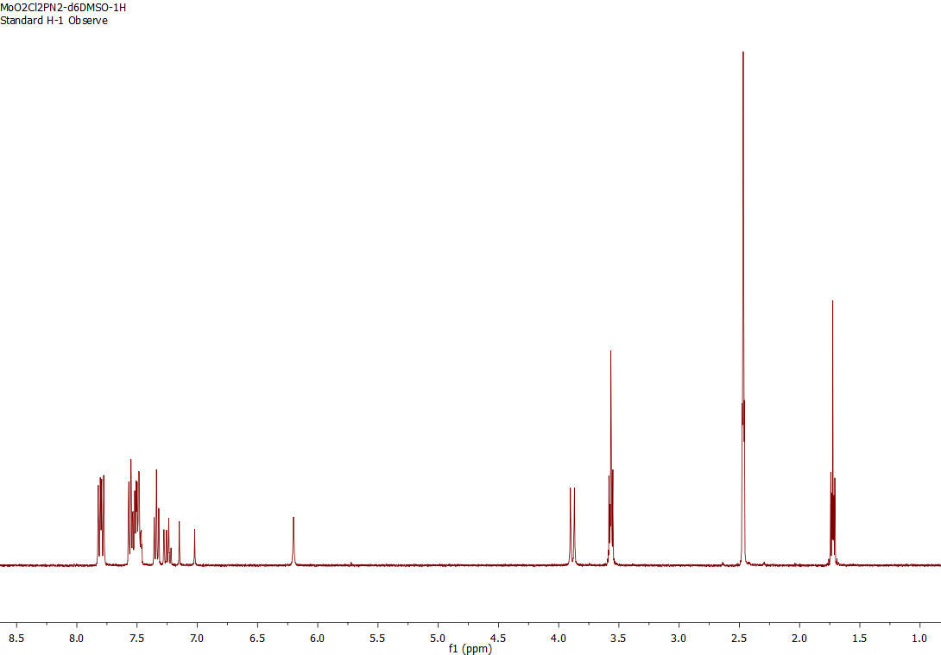

Figure S1. 1H NMR spectrum of complex 3 in (CD₃)₂SO.

[Co((C₆H₅)₂POCH₂(C₃N₂H₂)(C₆H₅))₂(C₄H₈O)₂][ClO₄]₂

Figure S2. TGA for Complex 2 under nitrogen.
[Co((C₆H₅)₂POCH₂(C₃N₂H₂)(C₆H₅))₂(C₄H₈O)₂][ClO₄]₂

Figure S3. TGA for Complex 2 under oxygen.

Figure S4. TGA for Co(ClO₄)₂•6H₂O under nitrogen.

Figure S5. TGA for Complex 3 under nitrogen.

Theoretical Calculations.
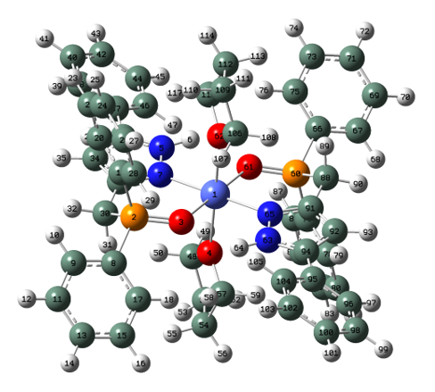

Figure S6. Drawing of compound 2 with atoms represented as spheres of arbitrary size (H-white, C-grey, N-blue and O-red) using the GaussView [1] program.

Table S1. Atomic coordinates for 2.

Row | Symbol | X | Y | Z
1 | Co | -0.01866 | -0.00152 | -0.01933
2 | P | 2.381864 | 2.171229 | 0.512861
3 | O | 1.986164 | 0.717375 | 0.2047
4 | O | 0.011928 | -0.66317 | 2.057006
5 | N | -2.1621 | 2.054374 | 0.533009
6 | H | -2.74216 | 1.309899 | 0.163748
7 | N | -0.84452 | 1.806112 | 0.659961
8 | C | 3.935363 | 2.218087 | 1.450366
9 | C | 4.621876 | 3.425973 | 1.636572
10 | H | 4.260932 | 4.342892 | 1.184861
11 | C | 5.787088 | 3.450705 | 2.396672
12 | H | 6.316373 | 4.38533 | 2.537954
13 | C | 6.276182 | 2.275248 | 2.966651
14 | H | 7.186542 | 2.297669 | 3.554063
15 | C | 5.599555 | 1.071947 | 2.777926
16 | H | 5.981672 | 0.157333 | 3.215399
17 | C | 4.428693 | 1.040827 | 2.023916
18 | H | 3.905391 | 0.105355 | 1.873887
19 | C | 2.628094 | 3.190312 | -0.97049
20 | C | 1.775218 | 4.250399 | -1.30051
21 | H | 0.930355 | 4.50056 | -0.67163
22 | C | 2.009165 | 5.000372 | -2.45164
23 | H | 1.349096 | 5.823128 | -2.69873
24 | C | 3.08853 | 4.695417 | -3.27759
25 | H | 3.270578 | 5.283023 | -4.16965
26 | C | 3.93879 | 3.636766 | -2.95593
27 | H | 4.780779 | 3.400946 | -3.59552
28 | C | 3.71326 | 2.886848 | -1.80672
29 | H | 4.387823 | 2.075585 | -1.55707
30 | C | 1.134653 | 2.982646 | 1.599922
31 | H | 1.259548 | 2.477734 | 2.564059
32 | H | 1.43478 | 4.020441 | 1.756076
33 | C | -0.30621 | 2.915235 | 1.182171
34 | C | -1.30187 | 3.886736 | 1.372098
35 | H | -1.17929 | 4.867952 | 1.799388
36 | C | -2.49444 | 3.299084 | 0.951205
37 | C | -3.86892 | 3.811051 | 0.934979
38 | C | -4.09979 | 5.187253 | 0.794401
39 | H | -3.26232 | 5.864772 | 0.678505
40 | C | -5.39853 | 5.684903 | 0.782175
41 | H | -5.56337 | 6.749999 | 0.670057
42 | C | -6.48395 | 4.818225 | 0.906261
43 | H | -7.49496 | 5.207955 | 0.895522
44 | C | -6.26382 | 3.448942 | 1.048234
45 | H | -7.10259 | 2.771342 | 1.155668
46 | C | -4.96637 | 2.946853 | 1.066578
47 | H | -4.81063 | 1.883914 | 1.21187
48 | C | -0.97879 | -0.28059 | 3.057246
49 | H | -1.96228 | -0.36587 | 2.599071
50 | H | -0.79935 | 0.760532 | 3.339207
51 | C | -0.7488 | -1.22888 | 4.226916
52 | H | -1.29235 | -2.16361 | 4.072885
53 | H | -1.07107 | -0.79389 | 5.173798
54 | C | 0.766053 | -1.46902 | 4.15899
55 | H | 1.306859 | -0.63206 | 4.608596
56 | H | 1.078089 | -2.386 | 4.660063
57 | C | 1.022505 | -1.52586 | 2.656175
58 | H | 2.000308 | -1.14526 | 2.365876
59 | H | 0.88877 | -2.53342 | 2.255457
60 | P | -2.39702 | -2.20216 | -0.49823
61 | O | -2.01673 | -0.73334 | -0.24694
62 | O | -0.03362 | 0.681489 | -2.08609
63 | N | 2.139024 | -2.02907 | -0.59196
64 | H | 2.70917 | -1.26722 | -0.24051
65 | N | 0.814193 | -1.80802 | -0.69511
66 | C | -3.96584 | -2.30522 | -1.40587
67 | C | -4.63511 | -3.52966 | -1.54019
68 | H | -4.25128 | -4.42558 | -1.06582
69 | C | -5.81258 | -3.5983 | -2.27836
70 | H | -6.32833 | -4.54561 | -2.37956
71 | C | -6.33093 | -2.45048 | -2.87807
72 | H | -7.25078 | -2.5072 | -3.44815
73 | C | -5.67094 | -1.23104 | -2.7417
74 | H | -6.07518 | -0.33787 | -3.20299
75 | C | -4.48807 | -1.1563 | -2.00967
76 | H | -3.97662 | -0.20894 | -1.90095
77 | C | -2.60381 | -3.17531 | 1.022278
78 | C | -1.73651 | -4.21922 | 1.366302
79 | H | -0.90043 | -4.48088 | 0.730406
80 | C | -1.94574 | -4.9412 | 2.539913
81 | H | -1.27473 | -5.75196 | 2.796988
82 | C | -3.01441 | -4.62431 | 3.375096
83 | H | -3.17743 | -5.1906 | 4.284469
84 | C | -3.87867 | -3.58138 | 3.039879
85 | H | -4.71284 | -3.33623 | 3.686203
86 | C | -3.67824 | -2.85987 | 1.867982
87 | H | -4.36639 | -2.06341 | 1.608374
88 | C | -1.16064 | -3.03636 | -1.58037
89 | H | -1.31387 | -2.57161 | -2.56043
90 | H | -1.44865 | -4.08384 | -1.68992
91 | C | 0.287647 | -2.9323 | -1.19675
92 | C | 1.298495 | -3.88532 | -1.39838
93 | H | 1.186895 | -4.87287 | -1.81395
94 | C | 2.487134 | -3.2709 | -1.00553
95 | C | 3.870371 | -3.75901 | -1.00941
96 | C | 4.126232 | -5.13085 | -0.86878
97 | H | 3.302014 | -5.82193 | -0.73861
98 | C | 5.43304 | -5.60702 | -0.87445
99 | H | 5.617035 | -6.66893 | -0.76199
100 | C | 6.502057 | -4.72292 | -1.01678
101 | H | 7.519446 | -5.09585 | -1.01987
102 | C | 6.257114 | -3.3579 | -1.15901
103 | H | 7.082841 | -2.66677 | -1.28047
104 | C | 4.95139 | -2.87735 | -1.15944
105 | H | 4.776167 | -1.81762 | -1.30486
106 | C | 0.999495 | 0.341431 | -3.05852
107 | H | 1.96453 | 0.457088 | -2.56918
108 | H | 0.864684 | -0.70255 | -3.35339
109 | C | 0.771569 | 1.291491 | -4.22685
110 | H | 1.27414 | 2.244561 | -4.04697
111 | H | 1.140611 | 0.878474 | -5.16646
112 | C | -0.75291 | 1.472411 | -4.20624
113 | H | -1.24534 | 0.618712 | -4.67945
114 | H | -1.08457 | 2.380728 | -4.71046
115 | C | -1.06003 | 1.506144 | -2.71191
116 | H | -2.03081 | 1.08394 | -2.45645
117 | H | -0.98204 | 2.515643 | -2.30107

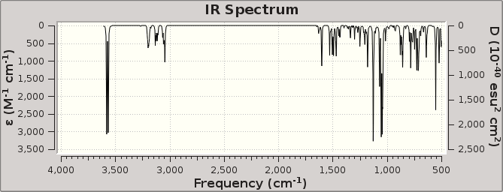
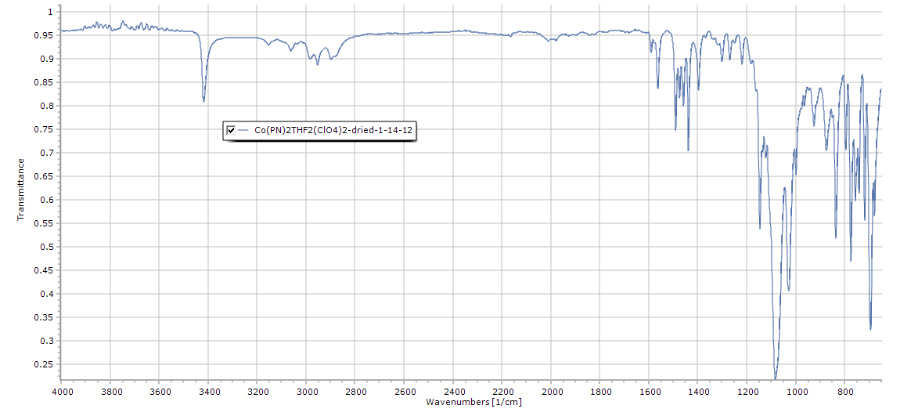

Figure S7. Uncorrected calculated FTIR (top) and experimental (neat) spectrum of compound 2.

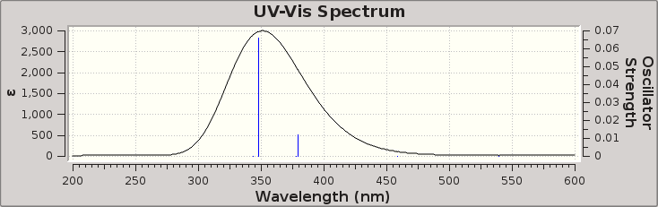

Figure S8. Calculated UV-Vis spectrum for 2.

Figure S9. UV-vis absorption spectrum of 2 in CH₂Cl₂.

Figure S10. Emission spectrum of 2 in CH₂Cl₂.

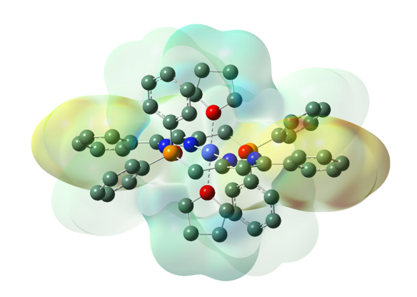

Figure S11. Difference density illustrations as iso-surfaces of complex 2 featuring excited state 9. Red areas indicate values for the different density of -4.575e⁻⁵ and blue are for 4.575e⁺⁵, see scale on top of illustration.

Table S2. Excitation energies and oscillator strength for complex 2

Of the 10 Excited States calculated, numbers 1-6 all had f=0 and are not listed.

Excited State 7: 3.2699 eV 379.17 nm f=0.0120 <S**2>=5.360
235A -> 249A 0.12356
236A -> 239A 0.32756
236A -> 241A 0.16219
237A -> 238A 0.38446
232B -> 249B -0.12313
233B -> 235B 0.51914
233B -> 240B -0.32932
234B -> 237B 0.39114

Excited state symmetry could not be determined.
Excited State 8: 3.2827 eV 377.69 nm f=0.0002 <S**2>=5.472
234A -> 248A -0.12997
235A -> 249A -0.10160
236A -> 238A -0.40323
237A -> 239A -0.35297
237A -> 241A -0.17487
231B -> 248B 0.12869
231B -> 249B -0.10172
232B -> 249B 0.10051
233B -> 237B 0.40190
234B -> 235B 0.42470
234B -> 240B -0.35126

Excited state symmetry could not be determined.
Excited State 9: 3.5607 eV 348.21 nm f=0.0658 <S**2>=4.224
236A -> 239A -0.20267
236A -> 241A -0.10347
237A -> 238A -0.23598
216B -> 235B 0.13146
233B -> 235B 0.82444
233B -> 240B 0.24223
234B -> 237B -0.20855

Excited state symmetry could not be determined.
Excited State 10: 3.6123 eV 343.22 nm f=0.0002 <S**2>=4.116
236A -> 238A 0.19182
237A -> 239A 0.16812
215B -> 235B -0.17587
218B -> 235B -0.18954
222B -> 235B 0.11160
224B -> 235B -0.13338
233B -> 237B -0.18662
234B -> 235B 0.79749
234B -> 240B 0.20793
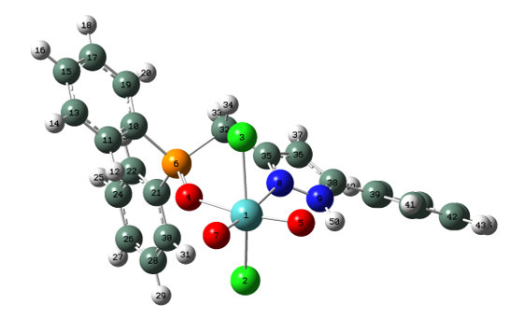

Figure S12. Drawing of complex 3-THF with atoms represented as spheres of arbitrary size (H-white, C-grey, N-blue and O-red) using the GaussView [1] program.

Table S3. Atomic coordinates for 3-THF.

Row | Symbol | X | Y | Z
1 | Mo | 0.086855 | -2.30858 | 0.749534
2 | Cl | -0.77129 | -1.06986 | 2.660818
3 | Cl | 0.971937 | -2.65984 | -1.48426
4 | O | 1.476902 | -0.57469 | 0.69014
5 | O | -1.36859 | -3.19089 | 0.536603
6 | P | 1.781997 | 0.63781 | -0.1834
7 | O | 1.130298 | -3.37055 | 1.578721
8 | N | -1.15585 | -0.55977 | -0.4446
9 | N | -2.4906 | -0.54362 | -0.31526
10 | C | 3.426765 | 0.493876 | -0.93756
11 | C | 4.338673 | -0.37616 | -0.32931
12 | H | 4.033419 | -0.95171 | 0.536218
13 | C | 5.620017 | -0.51439 | -0.85613
14 | H | 6.321668 | -1.19413 | -0.38702
15 | C | 5.993871 | 0.206246 | -1.98897
16 | H | 6.990652 | 0.091935 | -2.39944
17 | C | 5.083847 | 1.065308 | -2.60355
18 | H | 5.368842 | 1.615338 | -3.49295
19 | C | 3.800717 | 1.209403 | -2.08193
20 | H | 3.099119 | 1.868075 | -2.58196
21 | C | 1.711533 | 2.153055 | 0.818682
22 | C | 2.291672 | 3.353573 | 0.387931
23 | H | 2.842074 | 3.399855 | -0.54497
24 | C | 2.185316 | 4.49725 | 1.17351
25 | H | 2.640074 | 5.423406 | 0.841189
26 | C | 1.506905 | 4.446295 | 2.391865
27 | H | 1.430113 | 5.337354 | 3.004791
28 | C | 0.937251 | 3.25125 | 2.824644
29 | H | 0.41661 | 3.207104 | 3.774244
30 | C | 1.036863 | 2.100867 | 2.043656
31 | H | 0.601837 | 1.167419 | 2.380784
32 | C | 0.568747 | 0.803422 | -1.56353
33 | H | 0.652718 | 1.802773 | -1.99488
34 | H | 0.871544 | 0.067799 | -2.31414
35 | C | -0.84245 | 0.540717 | -1.13383
36 | C | -2.00426 | 1.278845 | -1.42361
37 | H | -2.07454 | 2.192261 | -1.99057
38 | C | -3.05887 | 0.54873 | -0.88138
39 | C | -4.50553 | 0.786606 | -0.87866
40 | C | -5.41462 | -0.28136 | -0.85299
41 | H | -5.05418 | -1.30405 | -0.86649
42 | C | -6.78535 | -0.04144 | -0.84558
43 | H | -7.47513 | -0.87728 | -0.82832
44 | C | -7.26955 | 1.265251 | -0.87302
45 | H | -8.33746 | 1.450271 | -0.86976
46 | C | -6.37328 | 2.333077 | -0.90622
47 | H | -6.74268 | 3.35207 | -0.92253
48 | C | -5.00246 | 2.097529 | -0.90515
49 | H | -4.31124 | 2.932288 | -0.9047
50 | H | -2.92089 | -1.27791 | 0.23152

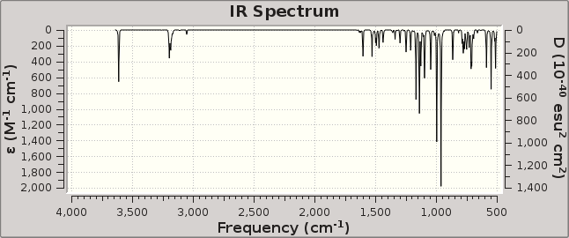

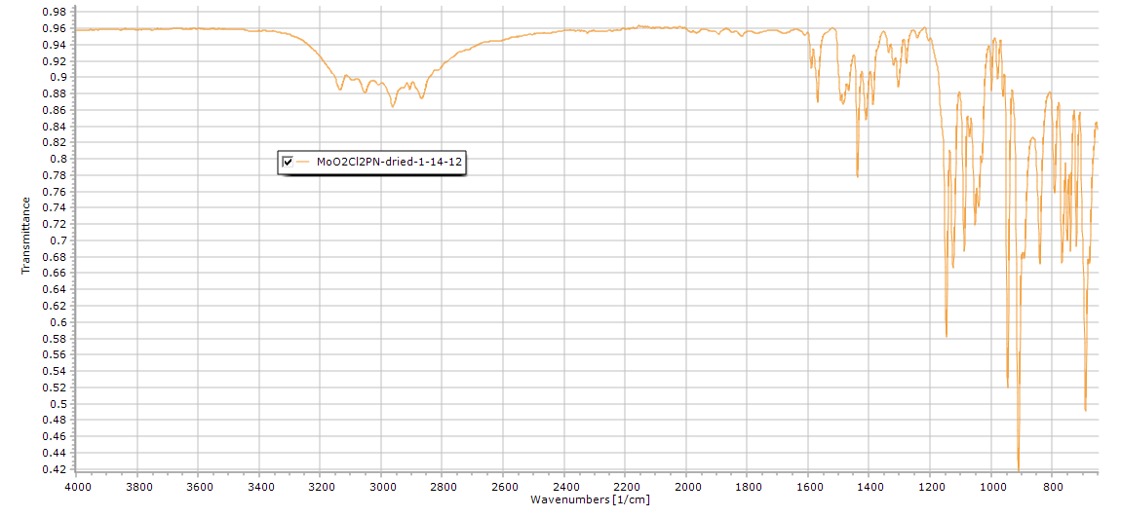

Figure S13. Uncorrected calculated FTIR (top) and experimental (neat) spectrum of compound 3-THF.

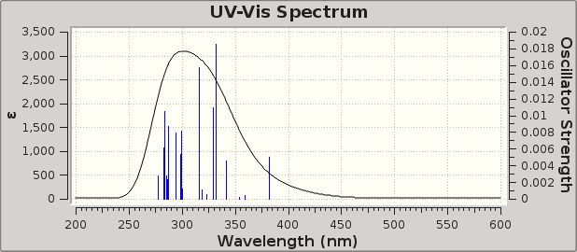

Figure S14. Calculated UV-Vis spectrum for 3-THF.

Table S4. Excitation Energies and Oscillator Strengths for 3-THF.
Excited State 1: Singlet-A 3.2471 eV 381.84 nm f=0.0050 <S**2>=0.000
123 ->127 0.12167
124 ->127 -0.16728
125 ->127 0.16951
126 ->127 0.63847
This state for optimization and/or second-order correction.
Total Energy, E(TD-HF/TD-DFT) = -2513.41919938
Copying the excited state density for this state as the 1-particle RhoCI density.

Excited State 2: Singlet-A 3.4514 eV 359.23 nm f=0.0004 <S**2>=0.000
125 ->127 0.64720
125 ->128 -0.12494
126 ->127 -0.17906

Excited State 3: Singlet-A 3.5023 eV 354.01 nm f=0.0002 <S**2>=0.000
115 ->127 -0.32597
117 ->127 0.28114
118 ->127 -0.12711
120 ->127 0.12828
122 ->127 0.24040
123 ->127 0.32876
124 ->127 0.30449

Excited State 4: Singlet-A 3.6306 eV 341.50 nm f=0.0046 <S**2>=0.000
115 ->127 0.13256
121 ->127 -0.17799
123 ->127 -0.33523
124 ->127 0.49530
126 ->127 0.19683

Excited State 5: Singlet-A 3.7328 eV 332.15 nm f=0.0186 <S**2>=0.000
115 ->128 0.10084
120 ->127 0.12487
124 ->127 0.10330
126 ->128 0.63474

Excited State 6: Singlet-A 3.7609 eV 329.67 nm f=0.0110 <S**2>=0.000
115 ->127 0.24921
120 ->127 0.41889
121 ->127 0.37316
125 ->128 0.11490
126 ->128 -0.14380

Excited State 7: Singlet-A 3.8384 eV 323.01 nm f=0.0006 <S**2>=0.000
115 ->127 0.43593
115 ->128 0.25707
117 ->128 -0.15314
122 ->127 0.13802
122 ->128 -0.11521
123 ->127 0.27149
123 ->128 -0.17953
124 ->128 -0.11762

Excited State 8: Singlet-A 3.8950 eV 318.32 nm f=0.0011 <S**2>=0.000
115 ->127 -0.17057
115 ->128 0.18463
123 ->127 -0.10403
123 ->128 -0.20541
125 ->128 0.57423

Excited State 9: Singlet-A 3.9266 eV 315.75 nm f=0.0157 <S**2>=0.000
115 ->127 -0.19034
115 ->128 0.36534
117 ->128 -0.17443
120 ->127 0.18451
121 ->127 0.16534
123 ->127 -0.15981
123 ->128 -0.13077
124 ->128 -0.11009
125 ->128 -0.29745
126 ->128 -0.11307

Excited State 10: Singlet-A 4.1260 eV 300.49 nm f=0.0012 <S**2>=0.000
116 ->127 -0.19279
117 ->127 0.41534
119 ->127 0.20407
120 ->127 0.27589
121 ->127 -0.18972
123 ->127 -0.17126
124 ->127 -0.25896

Excited State 11: Singlet-A 4.1473 eV 298.95 nm f=0.0082 <S**2>=0.000
114 ->127 -0.10820
119 ->128 -0.12282
120 ->128 0.43022
121 ->128 0.27652
123 ->128 -0.23999
124 ->128 0.27854

Excited State 12: Singlet-A 4.1569 eV 298.26 nm f=0.0054 <S**2>=0.000
114 ->127 -0.21378
116 ->127 0.11526
120 ->128 -0.18988
121 ->128 -0.35946
123 ->128 -0.16387
124 ->128 0.40779
126 ->128 0.11369

Excited State 13: Singlet-A 4.2136 eV 294.24 nm f=0.0079 <S**2>=0.000
123 ->129 0.13524
124 ->129 -0.14728
125 ->129 0.10231
126 ->129 0.64243

Excited State 14: Singlet-A 4.3175 eV 287.17 nm f=0.0087 <S**2>=0.000
114 ->127 0.11022
115 ->128 0.38021
116 ->127 -0.10648
121 ->127 -0.17473
122 ->128 0.19209
123 ->128 0.29609
124 ->128 0.23612
125 ->129 -0.23803

Excited State 15: Singlet-A 4.3318 eV 286.22 nm f=0.0024 <S**2>=0.000
114 ->127 -0.12438
116 ->127 0.11857
119 ->127 0.58812
121 ->127 0.18587
123 ->128 0.10847

Excited State 16: Singlet-A 4.3527 eV 284.84 nm f=0.0028 <S**2>=0.000
117 ->127 -0.26979
118 ->127 0.14080
119 ->127 0.16146
120 ->127 0.27534
121 ->127 -0.34060
123 ->127 0.19035
125 ->129 0.34391

Excited State 17: Singlet-A 4.3664 eV 283.95 nm f=0.0033 <S**2>=0.000
119 ->127 -0.10206
120 ->127 -0.22383
122 ->127 0.46846
123 ->127 -0.22261
125 ->129 0.34356

Excited State 18: Singlet-A 4.3727 eV 283.54 nm f=0.0105 <S**2>=0.000
115 ->128 -0.13048
117 ->127 -0.24402
118 ->127 0.17097
122 ->127 0.39881
123 ->128 -0.17797
125 ->129 -0.36097

Excited State 19: Singlet-A 4.3880 eV 282.55 nm f=0.0061 <S**2>=0.000
113 ->127 -0.11385
114 ->127 0.27748
116 ->127 -0.31403
118 ->127 0.32745
119 ->127 0.21072
120 ->127 -0.13321
121 ->127 0.19691
123 ->127 0.10987
123 ->128 -0.10029
124 ->128 0.12495

Excited State 20: Singlet-A 4.4726 eV 277.21 nm f=0.0028 <S**2>=0.000
114 ->127 -0.21094
116 ->127 0.24946
117 ->127 0.24978
118 ->127 0.53318

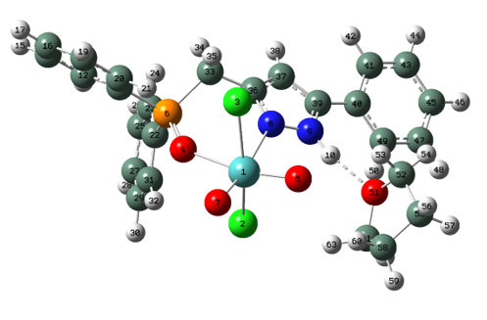

Figure S15. Drawing of complex 3 with atoms represented as spheres of arbitrary size (H-white, C-grey, N-blue and O-red) using the GaussView [1] program.

Table S5. Atomic coordinates for 3.

Row | Symbol | X | Y | Z
1 | Mo | 0.103201 | -2.11335 | 0.260193
2 | Cl | -0.43066 | -1.00032 | 2.349646
3 | Cl | 0.902324 | -2.36761 | -2.03236
4 | O | 1.944797 | -0.88518 | 0.442124
5 | O | -1.50865 | -2.58572 | -0.08158
6 | P | 2.534305 | 0.412901 | -0.10215
7 | O | 0.821416 | -3.51643 | 0.906753
8 | N | -0.60145 | 0.088514 | -0.63169
9 | N | -1.87649 | 0.510649 | -0.5193
10 | H | -2.59628 | -0.12392 | -0.14073
11 | C | 4.221174 | 0.125515 | -0.71609
12 | C | 5.271273 | 1.024325 | -0.49616
13 | H | 5.111051 | 1.926499 | 0.081444
14 | C | 6.539307 | 0.74925 | -1.00411
15 | H | 7.351608 | 1.444835 | -0.82721
16 | C | 6.764044 | -0.42156 | -1.72557
17 | H | 7.752778 | -0.63529 | -2.11569
18 | C | 5.721796 | -1.32381 | -1.93662
19 | H | 5.897458 | -2.24082 | -2.48698
20 | C | 4.45169 | -1.0575 | -1.43353
21 | H | 3.645726 | -1.76694 | -1.58396
22 | C | 2.567005 | 1.709308 | 1.167332
23 | C | 2.740337 | 3.0634 | 0.850313
24 | H | 2.84718 | 3.383698 | -0.18034
25 | C | 2.770062 | 4.017047 | 1.863842
26 | H | 2.900253 | 5.064101 | 1.615613
27 | C | 2.624316 | 3.624272 | 3.19442
28 | H | 2.643155 | 4.369007 | 3.982094
29 | C | 2.443068 | 2.279777 | 3.510954
30 | H | 2.313993 | 1.975275 | 4.54295
31 | C | 2.41317 | 1.319373 | 2.50226
32 | H | 2.243047 | 0.276727 | 2.73901
33 | C | 1.529979 | 1.003049 | -1.52123
34 | H | 1.910685 | 1.966097 | -1.86646
35 | H | 1.698218 | 0.268547 | -2.31448
36 | C | 0.071574 | 1.101046 | -1.1942
37 | C | -0.78696 | 2.18226 | -1.43409
38 | H | -0.52719 | 3.139664 | -1.85385
39 | C | -2.04189 | 1.771091 | -0.99092
40 | C | -3.31817 | 2.497826 | -0.99322
41 | C | -3.51317 | 3.546954 | -1.90531
42 | H | -2.738 | 3.783661 | -2.62469
43 | C | -4.69937 | 4.272815 | -1.91131
44 | H | -4.83288 | 5.077263 | -2.62578
45 | C | -5.71661 | 3.960674 | -1.01002
46 | H | -6.64221 | 4.524934 | -1.01508
47 | C | -5.53559 | 2.916159 | -0.10533
48 | H | -6.32076 | 2.665855 | 0.599162
49 | C | -4.34794 | 2.190066 | -0.09229
50 | H | -4.2271 | 1.378563 | 0.613091
51 | O | -4.09726 | -1.04951 | 0.382264
52 | C | -4.65038 | -1.85642 | -0.6859
53 | H | -3.82642 | -2.21206 | -1.31165
54 | H | -5.31145 | -1.22132 | -1.28004
55 | C | -5.36827 | -3.01779 | 0.000846
56 | H | -5.41181 | -3.90606 | -0.63204
57 | H | -6.39237 | -2.73526 | 0.264321
58 | C | -4.51869 | -3.21804 | 1.265388
59 | H | -5.05774 | -3.72262 | 2.069632
60 | H | -3.61982 | -3.79186 | 1.032319
61 | C | -4.14039 | -1.78407 | 1.634348
62 | H | -4.89874 | -1.31727 | 2.274187
63 | H | -3.16484 | -1.69923 | 2.113033

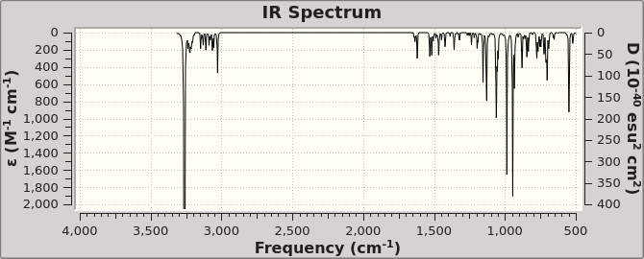

Figure S16. Uncorrected calculated FTIR (top) and experimental (neat) spectrum of compound 3.

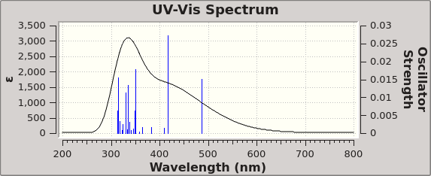

Figure S17. Calculated UV-Vis spectrum for 3.

Figure S18. UV-vis absorption spectrum of 3 in CH₂Cl₂.

Figure S19. Emission spectrum of 3 in CH₂Cl₂.

Figure S20. Emission spectrum of solvent CH₂Cl₂.

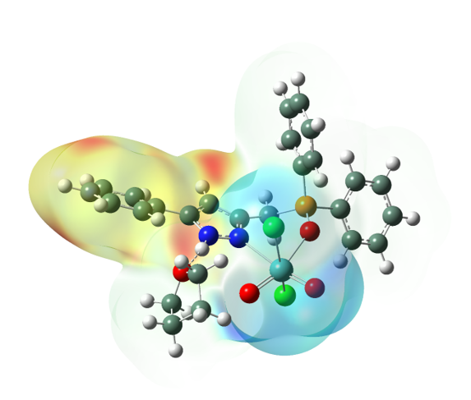

Figure S21. Difference density illustrations as iso-surfaces of complex 3 featuring excited state 1. Red areas indicate values for the different density of -1.630e⁻⁴ and blue are for 1.630e⁺⁴, see scale on top of illustration.

Table S6. Excitation Energies and Oscillator Strengths for 3.

Excited State 1: Singlet-A 2.5491 eV 486.38 nm f=0.0150 <S**2>=0.000
146 ->147 0.69782
This state for optimization and/or second-order correction.
Total Energy, E(TD-HF/TD-DFT) = -2745.81946723
Copying the excited state density for this state as the 1-particle RhoCI density.

Excited State 2: Singlet-A 2.9720 eV 417.18 nm f=0.0273 <S**2>=0.000
146 ->148 0.69826

Excited State 3: Singlet-A 3.0269 eV 409.60 nm f=0.0014 <S**2>=0.000
144 ->147 0.10857
145 ->147 0.68291

Excited State 4: Singlet-A 3.2438 eV 382.22 nm f=0.0016 <S**2>=0.000
139 ->147 0.10870
143 ->147 0.57198
144 ->147 0.36299

Excited State 5: Singlet-A 3.3987 eV 364.80 nm f=0.0018 <S**2>=0.000
138 ->147 0.43782
138 ->148 0.10518
139 ->147 -0.11074
140 ->147 0.10225
141 ->147 0.24170
142 ->147 0.18035
145 ->148 -0.39444

Excited State 6: Singlet-A 3.4649 eV 357.83 nm f=0.0003 <S**2>=0.000
138 ->147 0.28953
141 ->147 0.17741
142 ->147 0.11876
145 ->147 0.14031
145 ->148 0.54863

Excited State 7: Singlet-A 3.5307 eV 351.16 nm f=0.0177 <S**2>=0.000
143 ->147 -0.12292
144 ->147 0.20200
146 ->149 0.65613

Excited State 8: Singlet-A 3.5347 eV 350.76 nm f=0.0025 <S**2>=0.000
143 ->147 -0.31811
144 ->147 0.54582
146 ->149 -0.23116

Excited State 9: Singlet-A 3.5599 eV 348.28 nm f=0.0062 <S**2>=0.000
134 ->147 -0.25364
137 ->147 0.35126
138 ->147 -0.18130
139 ->147 0.16234
142 ->147 0.47008

Excited State 10: Singlet-A 3.5883 eV 345.52 nm f=0.0012 <S**2>=0.000
130 ->147 -0.11303
131 ->147 0.25360
132 ->147 -0.25513
133 ->147 -0.18508
134 ->147 0.18465
135 ->147 0.35829
136 ->147 0.27870
139 ->147 0.12867
143 ->147 -0.13991

Excited State 11: Singlet-A 3.6339 eV 341.19 nm f=0.0008 <S**2>=0.000
134 ->147 -0.15779
137 ->147 0.27830
141 ->147 0.43667
142 ->147 -0.41895

Excited State 12: Singlet-A 3.6619 eV 338.58 nm f=0.0031 <S**2>=0.000
135 ->148 0.10235
136 ->147 -0.12966
137 ->147 0.11875
138 ->148 0.11659
140 ->147 -0.11182
143 ->148 0.52579
144 ->148 0.33012

Excited State 13: Singlet-A 3.6944 eV 335.60 nm f=0.0135 <S**2>=0.000
135 ->147 -0.17235
136 ->147 0.26236
137 ->147 -0.21965
138 ->147 -0.30606
139 ->147 -0.10450
140 ->147 0.30958
141 ->147 0.25667
143 ->147 0.11266
143 ->148 0.14856
144 ->148 0.10547

Excited State 14: Singlet-A 3.7167 eV 333.59 nm f=0.0010 <S**2>=0.000
137 ->147 0.19953
138 ->147 0.12748
140 ->147 0.52823
141 ->147 -0.33481
142 ->147 -0.14809

Excited State 15: Singlet-A 3.7512 eV 330.52 nm f=0.0113 <S**2>=0.000
131 ->147 -0.20081
132 ->147 0.23213
133 ->147 0.11226
134 ->147 -0.12937
136 ->147 0.52577
138 ->147 0.12342
140 ->147 -0.14386

Excited State 16: Singlet-A 3.8175 eV 324.78 nm f=0.0025 <S**2>=0.000
132 ->147 0.10794
137 ->147 -0.21114
139 ->147 0.60557
140 ->147 0.12864

Excited State 17: Singlet-A 3.8500 eV 322.03 nm f=0.0009 <S**2>=0.000
134 ->148 -0.12562
137 ->148 0.18299
138 ->148 0.41386
140 ->148 0.12445
141 ->148 0.30993
142 ->148 0.27591
144 ->148 -0.11529
145 ->148 0.11033

Excited State 18: Singlet-A 3.8980 eV 318.07 nm f=0.0033 <S**2>=0.000
131 ->148 0.20817
132 ->147 0.12888
132 ->148 -0.20030
133 ->148 -0.13580
134 ->148 0.14031
135 ->147 0.36139
135 ->148 0.19463
136 ->148 0.13848
139 ->147 -0.13754
140 ->147 0.17768
144 ->148 -0.18004

Excited State 19: Singlet-A 3.9421 eV 314.51 nm f=0.0155 <S**2>=0.000
131 ->147 -0.17530
131 ->148 -0.20522
132 ->147 0.11042
132 ->148 0.14978
133 ->148 0.11496
134 ->148 -0.10728
135 ->147 0.33580
135 ->148 -0.15446
136 ->147 -0.13084
143 ->148 -0.13205
144 ->148 0.33881

Excited State 20: Singlet-A 3.9547 eV 313.51 nm f=0.0063 <S**2>=0.000
131 ->147 0.10568
131 ->148 0.15468
132 ->148 -0.13121
133 ->148 -0.10736
135 ->147 -0.15277
142 ->148 0.13066
143 ->148 -0.35212
144 ->148 0.44168

References
[1] GaussView, V. 6, R. Dennington, T.A. Keith, J.M. Millam, in, Semichem Inc. Shawnee Mission, KS, 2016.

