Table S1: Bonded parameters for alcohols, fluoroalcohols and fluorotelomer alcohols[1-3].
Bond type | Bond length  (Å) | Angle type | $$θ_{0}$$  (Degrees) | k  (kcal/mol/rad²)
CH_{x}-CH_{y} | 1.54 | CH_{x}-CH₂-CH_{y} | 114.0 | 62.1
CF_{x}-CF_{y} | 1.54 | CH_{y}-CH₂-O | 109.5 | 50.1
CH_{x}-CF_{y} | 1.54 | CH_{x}-O-H | 108.5 | 55.0
CH_{x}-O | 1.43 | CF_{x}-CF₂-CF_{y} | 114.0 | 62.1
CF_{x}-O | 1.43 | CF_{x}-CF₂-O | 109.5 | 62.1
O-H | 0.945 | CF_{x}-O-H | 108.5 | 55.0
O-H (water) | 1.00 | CF_{x}-CH₂-CH_{y} | 114.0 | 62.1
 |  | CF_{x}-CF₂-CH_{y} | 114.0 | 62.1
 |  | CF_{x}-CH₂-O | 109.5 | 62.1
 |  | CH_{x}-CF_{y}-O | 109.5 | 62.1
 |  | H-O-H | 109.47 | Fix

Table S2: Dihedral parameters for alcohols, fluoroalcohols and fluorotelomer alcohols[1-3].
Torsion type | $$n_{i}$$ | $c_{i}$ (kcal/mol) | $δ_{i}$ (Degrees)
CH_{x}-CH₂-CH₂-CH_{y} | 1 | 0.705513 | 0
 | 2 | -0.135507 | 180
 | 3 | 1.572510 | 0
O-CH₂-CH₂-CH_{x} | 1 | 0.350977 | 0
 | 2 | -0.105997 | 180
 | 3 | 1.529998 | 0
H-O-CH₂-CH_{x} | 1 | 0.416952 | 0
 | 2 | -0.057966 | 180
 | 3 | 0.373453 | 0
CF_{x}-CF₂-CF₂-CF_{y} | 1 | 1.588 | 0
 | 2 | -0.6481 | 180
 | 3 | 1.712 | 0
 | 4 | -0.6791 | 180
O-CF₂-CF₂-CF_{x} | 1 | -0.0178 | 0
 | 2 | 0.0836 | 0
 | 3 | 1.6976 | 0
 | 4 | 0.0392 | 0
H-O-CF₂-CF_{x} | 1 | 0.8392 | 0
 | 2 | -0.1096 | 180
 | 3 | 0.6556 | 0
CH₂-CH₂-CF₂-CF_{x} | 1 | 0.8945 | 0
 | 2 | -0.5789 | 180
 | 3 | 1.8605 | 0
 | 4 | -0.1634 | 180
*Optimized dihedral in this work.

Table S2: Continuation of dihedral parameters for alcohols, fluoroalcohols and fluorotelomer alcohols[1-3].
Torsion type | $$n_{i}$$ | $c_{i}$ (kcal/mol) | $δ_{i}$ (Degrees)
CH₂-CF₂-CF₂-CF_{x} | 1 | 1.588 | 0
 | 2 | -0.6481 | 180
 | 3 | 1.712 | 0
 | 4 | -0.6791 | 180
*CH₂-CH₂-CH₂-CF_{x} | 1 | 1.5522 | 0
 | 2 | -0.8265 | 180
 | 3 | 1.4588 | 0
 | 4 | -0.1063 | 180
O-CH₂-CH₂-CF_{x} | 1 | 1.5951 | 0
 | 2 | -1.0807 | 180
 | 3 | 1.6495 | 0
O-CH₂-CF₂-CF_{x} | 1 | -0.0421 | 0
 | 2 | -0.0604 | 180
 | 3 | 2.3476 | 0
*O-CF₂-CF₂-CH_{x} | 1 | -0.2315 | 0
 | 2 | 0.0881 | 180
 | 3 | 2.7794 | 0
 | 4 | 0.1366 | 0
*O-CF₂-CH₂-CH_{x} | 3 | 2.0187 | 0
 | 4 | 0.0800 | 0
H-O-CH₂-CF_{x} | 1 | -0.5760 | 0
 | 2 | 0.9738 | 0
 | 3 | 0.8986 | 0
 | 4 | 0.2396 | 0
*H-O-CF₂-CH_{x} | 1 | 1.793 | 0
 | 2 | 0.6984 | 180
 | 3 | 0.5409 | 0
*Optimized dihedral in this work.

Using the specified $λ$ vectors, initial lambda state, free energy parameters, and free energy calculation frequency in the configuration file, GOMC will output the necessary information for free energy analysis. In addition to the simulation parameters, such as temperature and current lambda value ($λ_{coul}{,λ}_{LJ}$), GOMC will output the total energy of the system, derivative of energy with respect to lambda for coulomb and LJ potential (for TI free energy method), energy difference between current $λ$ vector and all other $λ$ vectors (for free energy perturbation method), and $PV$ term (for NPT ensemble). In Table 2, a sample of free energy data outputted by GOMC is provided.

Table S3: Sample of GOMC free energy data for first 10,000 Monte Carlo Steps of perfluoro-octanol in octanol. The temperature and $λ$ state used in simulation is printed in the first line, while the header of the each column is provided in the second line with energy unit of kJ/mol. The column’s headers from left to right are, the simulation steps, the total energy of the system, energy derivative with respect to $λ$ for coulomb and LJ, the total energy difference evaluated between current lambda state ($λ_{2}$) and all other lambda states ($λ_{0}, λ_{1}, λ_{2}, …, λ_{16}$ in this case), and pressure x volume information for NPT ensemble.
$T=298$ (K) |  | $$λ_{2}=(0.0, 0.2)$$
Steps | $$U_{total}$$ | $$\frac{dU_{coul}}{dλ_{2, coul}}$$ | $$\frac{dU_{LJ}}{dλ_{2, LJ}}$$ | $${∆U}_{2→0}$$ | $${∆U}_{2→1}$$ | $${∆U}_{2→2}$$ | … | $${∆U}_{2→16}$$ | $$PV$$
1000 | -8877.456 | -3.231 | 8.077 | 10.004 | 2.624 | 0.000 | … | 2266.677 | 3.181
2000 | -8835.898 | 2.683 | 110.732 | -0.256 | -4.425 | 0.000 | … | 47079.538 | 3.164
3000 | -8827.969 | 1.666 | 245.945 | -14.514 | -14.142 | 0.000 | … | 19780.139 | 3.188
4000 | -8841.234 | 8.217 | 61.476 | 3.994 | -1.296 | 0.000 | … | 6005.224 | 3.170
5000 | -8830.506 | -5.707 | 127.468 | -1.455 | -5.509 | 0.000 | … | 47112.336 | 3.173
6000 | -8809.501 | -14.851 | 35.057 | 6.910 | 0.617 | 0.000 | … | 1235.585 | 3.183
7000 | -8824.169 | 5.971 | 50.141 | 5.522 | -0.361 | 0.000 | … | 18668.941 | 3.176
8000 | -8814.229 | 2.230 | 9.339 | 9.444 | 2.385 | 0.000 | … | 1126.329 | 3.190
9000 | -8826.988 | 7.380 | 60.722 | 4.220 | -1.148 | 0.000 | … | 13442.642 | 3.172
10000 | -8819.957 | -11.471 | 37.901 | 6.680 | 0.422 | 0.000 | … | 1383.572 | 3.171

Table S4: Comparison of solvation free energies for n-alkanes in 1-octanol at 298 K and 1 atm, calculated with the TraPPE force field[1-3] using TI, MBAR methods, and NPT Gibbs ensemble Monte Carlo (NPT-GEMC) simulations. Number in parenthesis corresponds to statistical uncertainties in the last digit.
Free energy of solvation (${kcal}/{mol}$)
Solute \ Method | MEMC-2[4] | MEMC-3[4] | TI | MBAR | Experiment[5]
n-pentane | -2.42(35) | -2.31(30) | -2.48(5) | -2.42(4) | -2.45
n-hexane | -3.02(35) | -2.94(35) | -3.05(6) | -3.00(5) | -3.01
n-heptane | -3.63(37) | -3.52(41) | -3.79(7) | -3.71(5) | -3.74
n-octane | -4.25(40) | -4.13(39) | -4.36(8) | -4.27(6) | -4.18

Table S5: Predicted free energies of hydration/solvation using TI, BAR, and MBAR method implemented in alchemlyb[6].
Molecule | $ΔG_{C16}$(kcal/mol) |  |  | $ΔG_{1-octanol}$(kcal/mol) |  |  | $ΔG_{water}$(kcal/mol)
 | TI | BAR | MBAR | TI | BAR | MBAR | TI | BAR | MBAR
CH₃(CH₂)₇OH (H8) | -5.14(6) | -5.14(6) | -5.15(5) | -8.8(2) | -8.7(2) | -8.6(2) | -3.1(2) | -2.9(2) | -2.9(2)
CH₃(CH₂)₆CF₂OH (F1H7) | -4.41(7) | -4.35(7) | -4.38(6) | -6.3(2) | -6.1(2) | -6.1(2) | -1.8(3) | -1.7(3) | -1.4(2)
CH₃(CH₂)₅(CF₂)₂OH (F2H6) | -4.29(8) | -4.26(8) | -4.34(6) | -6.0(2) | -5.8(2) | -5.7(2) | -1.3(2) | -1.2(2) | -1.3(2)
CF₃(CF₂)₅(CH2)₂OH (H2F6) | -4.20(8) | -4.16(8) | -4.16(7) | -6.7(3) | -6.8(3) | -7.1(2) | -2.3(3) | -2.0(3) | -1.7(2)
CF₃(CF₂)₆CH₂OH (H1F7) | -4.06(8) | -4.06(8) | -4.10(7) | -6.0(2) | -5.9(2) | -6.0(2) | -1.7(3) | -1.6(3) | -1.6(2)
CF₃(CF₂)₇OH (F8) | -3.38(8) | -3.34(8) | -3.32(7) | -5.3(2) | -5.2(2) | -5.2(2) | 0.3(5) | 0.0(3) | 0.0(3)

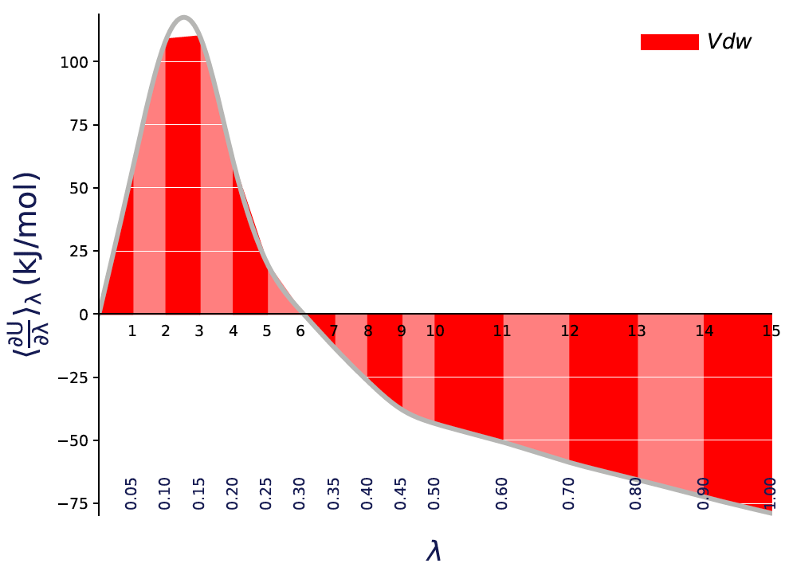
Figure S1: The $〈\frac{dU}{dλ}〉$ versus $λ$ plot for F2H6 solvation free energy in hexadecane, with filled areas indicating free energy estimates from the trapezoid rule, and silver curve indicating interpolation via cubic spline.

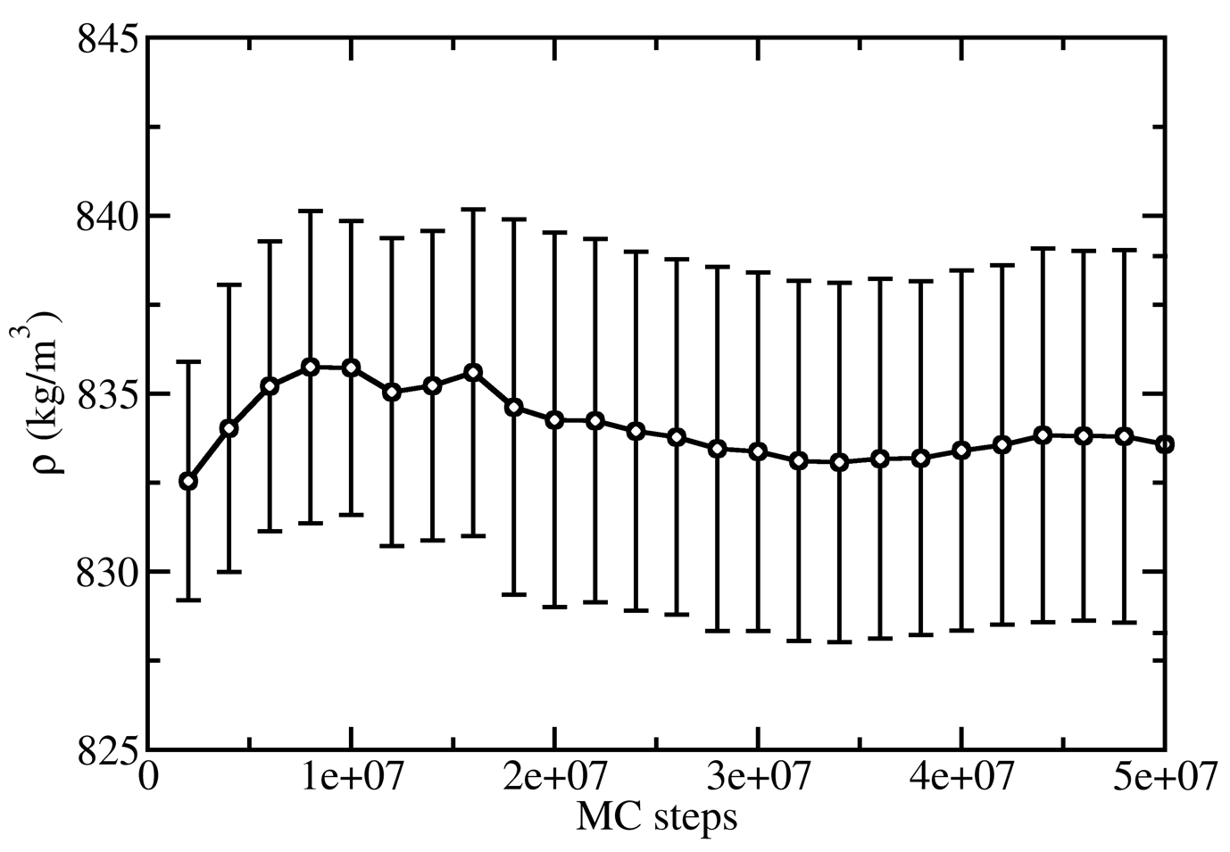
Figure S2: Accumulative average density for perfluorooctanol in 1-octanol.

References:

[1]M. G. Martin and J. I. Siepmann, J Phys Chem B 102 (14), 2569 (1998).
[2]L. Zhang and J. I. Siepmann, J Phys Chem B 109 (7), 2911 (2005).
[3]B. Chen, J. J. Potoff, and J. I. Siepmann, J Phys Chem B 105 (15), 3093 (2001).
[4]M. S. Barhaghi and J. J. Potoff, Fluid Phase Equilibr 486, 106 (2019).
[5]J. B. Li, T. H. Zhu, G. D. Hawkins, P. Winget, D. A. Liotard, C. J. Cramer, and D. G. Truhlar, Theor Chem Acc 103 (1), 9 (1999).
[6]Kenney I. Dotson D., Beckstein O., alchemistry/alchemlyb: Release 0.1.0 (https://doi.org/10.5281/zenodo.583647, 2017).

