Supplementary Appendix
Simulation results
- Misspecification of effect size – Two Experimental Treatment (k=2) and A Control
Effect size scenario 3 ($θ_{1}∈[0, 3], θ_{2}=2$) The behaviour of the five approaches for SSR in this scenario is very similar to that in scenario 2. Therefore we only focus on SSR based on the conditional power approach in the following comparisons. Supplementary Figure 7 shows that the relative performances of the three adaptive designs in this scenario are very similar to that in scenario 2. If no SSR is performed, the power of the FGS design is similar to (when selecting the best treatment) or slightly larger than (when keeping all promising treatments) that of INC design, while the power of FiC is slightly lower. If SSR_{CP} is performed, when selecting the best treatment, all three designs have similar power curves while INC and FGS have much smaller $n_{2}^{*}$. When keeping all promising treatments, the power of FGS are much higher than that of the other two designs. Note that when keeping all promising treatments, the INC and FiC design still cannot reach the targeted 80% power for $θ_{1}<1.5$ even after SSR_{CP}. But it can be seen from Supplementary Figure 8 that the targeted power can be reached for INC and FiC if SSR_{CP, Ob} is performed, with the cost of a larger $n_{2}^{*}$. As $r_{max}$ = 1.5 is enough to achieve the desired power, we do not consider larger values of $r_{max}$ in this scenario. Supplementary Figure 9 compares the difference between the two selection rules. It shows that the power and $n_{2}^{*}$ of the three adaptive designs follow the same pattern as that in scenario 2 (Supplementary Figure 1).

Misspecification of standard deviation (SD)
Supplementary Figure 10 shows the disjunctive power for the scenario $θ_{1}∈[0, 3]$ and $θ_{2}=2$ when the true underlying SD is different from the planned SD. As expected, the power decreases if the true underlying SD is larger than planned, regardless of the design and treatment selection rule used. For example, if the true underlying SD is 7, the power is only around 70% when both treatments have the planned effect size (${θ_{1}=θ}_{2}=2$). Supplementary Figure 11 shows that performing SSR_{CP} can substantially improve the power and the desired 80% power is reached at ${θ_{1}=θ}_{2}=2$. When selecting the best, all three designs have similar power while INC and FGS have smaller $n_{2}^{*}$. When keeping all promising, FGS has the largest power while INC has similar power to that of FiC with a smaller $n_{2}^{*}$.

Different timing (information fraction $t$) for interim analysis
The planned sample size per arm is 152, 144 and 146 for $t=\frac{1}{4}, \frac{1}{2}$ and $\frac{3}{4}$, respectively. Supplementary Figure 12 and 13 demonstrate the impact of the timing for interim analysis on the disjunctive power and average new sample size per arm ($n^{*})$ when $θ_{1}∈[0, 3]$and $θ_{2}=2$. When no SSR is performed, for FGS and INC designs with keeping all promising rule, the timing for interim analysis does not have a significant impact on power, but for other cases it seems the later the interim analysis the higher the power for a fixed value of $θ_{1}$. When SSR_{CP, Ob} is performed, the power increases with the increase of $t$ for a fixed value of $θ_{1}$. FGS design with keeping all promising rule seems to be more robust to the timing of interim analysis than other methods. Even though the power is usually highest at $t=\frac{3}{4}$ among the three information fraction considered here, $n^{*}$ is also the highest. The power curve for $t=\frac{1}{2}$ is close to that for $t=\frac{3}{4}$ while $n^{*}$ is much smaller. Therefore, based on the tradeoff between power and $n^{*}$, $t=\frac{1}{2}$ seems to be a reasonable choice for interim analysis.

Supplementary Table 1. List of abbrevations.
Abbreviation
INC | Adaptive design based on inverse normal combination function
FiC | Adaptive design based on Fisher's combination function
FGS | Flexible group sequential design
SSR | Sample size re-estimation
CP | Conditional power
ESR | Effect size ratio
FWER | Familywise error rate
$$r_{max}$$ | The ratio of maximum sample size allowed per arm to the planned sample size per arm

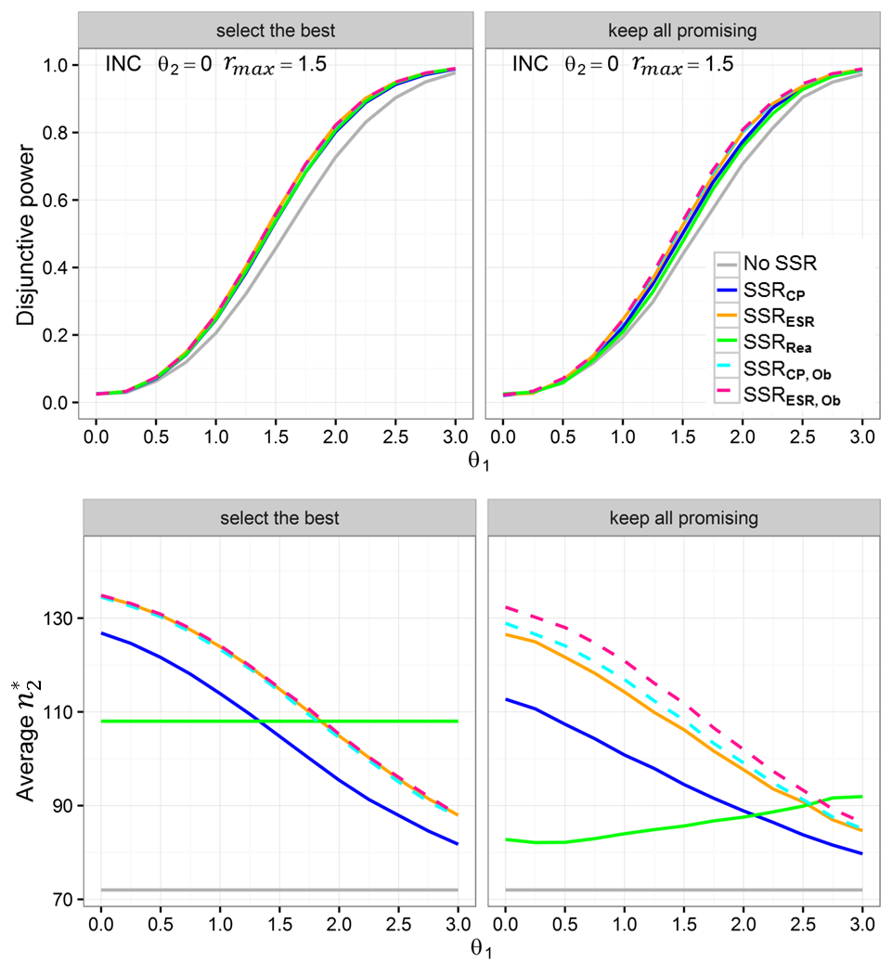
Supplementary Figure 1. Comparison of SSR methods under INC design when $θ_{1}∈[0, 3], θ_{2}=0$

Supplementary Figure 2. Comparison of SSR methods under FiC design when${ θ}_{1}∈[0, 3], θ_{2}=0$

Supplementary Figure 3. Comparison of SSR methods under FGS design when $θ_{1}∈[0, 3], θ_{2}=0$

Supplementary Figure 4. Comparison of two selection rules when $θ_{1}∈[0, 3], θ_{2}=0$

Supplementary Figure 5. Comparison of SSR methods under FGS design when $θ_{1}∈[0, 3], θ_{2}=1.5$

Supplementary Figure 6. Comparison of two selection rules when $θ_{1}∈[0, 3], θ_{2}=1.5$

Supplementary Figure 7. Comparison of three adaptive designs when SSR_{CP} is performed and $θ_{1}∈[0, 3], θ_{2}=2$
Supplementary Figure 8. Comparison of three adaptive designs when SSR_{CP, Ob} is performed and $θ_{1}∈[0, 3], θ_{2}=2$

Supplementary Figure 9. Comparison of two selection rules when $θ_{1}∈[0, 3], θ_{2}=2$

Supplementary Figure 10. Comparison of the power when the true underlying SD were different from the preplanned SD=6

Supplementary Figure 11. Disjunctive power for the three adaptive designs when the true underlying SD is 7

Supplementary Figure 12. The impact of the timing for interim analysis on disjunctive power

Supplementary Figure 13. Average new sample size per arm when using different timing for interim analysis

