Supporting information

SUPERSATURATING DRUG DELIVERY SYSTEM OF FIXED DRUG COMBINATION: SULFAMETHOXAZOLE AND TRIMETHOPRIM

Figure S1. The Stern-Volmer and double logarithm plots of fluorescence quenching of TMT and SLM in presence and absence of Eudragit EPO in aqueous solution.

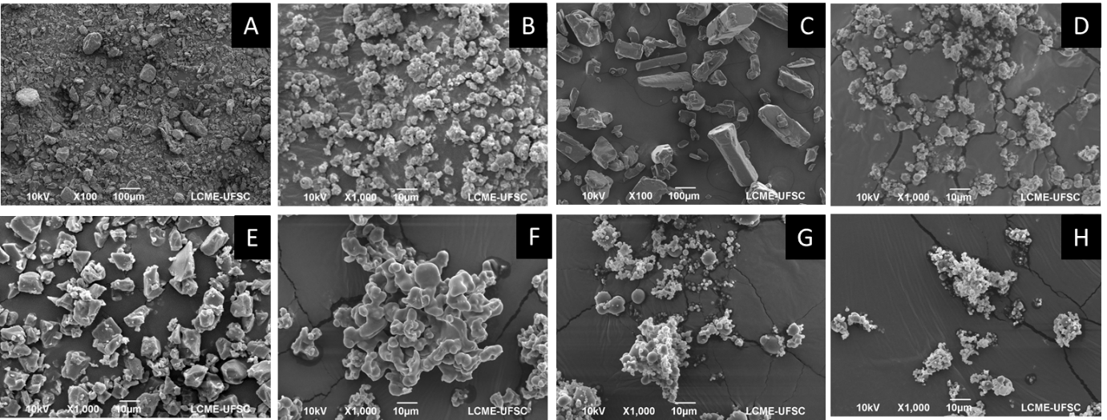
Figure S2. Photomicrographs of crystalline SLM (A), amorphous SLM (B), crystalline TMT (C), amorphous TMT (D), Eudragit EPO (E), Ternary solid dispersion 3:7 drugs-Eudragit EPO (F), 5:5 drugs-Eudragit EPO (G), 7:3 drugs-Eudragit EPO (H).

