Supplementary Material
AsgharZamani *ª, Ahmad PoursattarMarjani *^{b}, Abbas Nikoo^{b}, Mojtaba Heidarpourª and Ahmad Dehghanª
* Corresponding author. Tel.: +98-912-630-1594; fax: +98-4432752746; e-mail: A. Zamani- a.zamani@urmia.ac.ir, A. Poursattar Marjani- a.poursattar@urmia.ac.ir
ª Department of Nanotechnology, Faculty of Science, Urmia University, Urmia 57154, Urmia, Iran
^{b} Department of Chemistry, Faculty of Science, Urmia University, Urmia 57154, Urmia, Iran

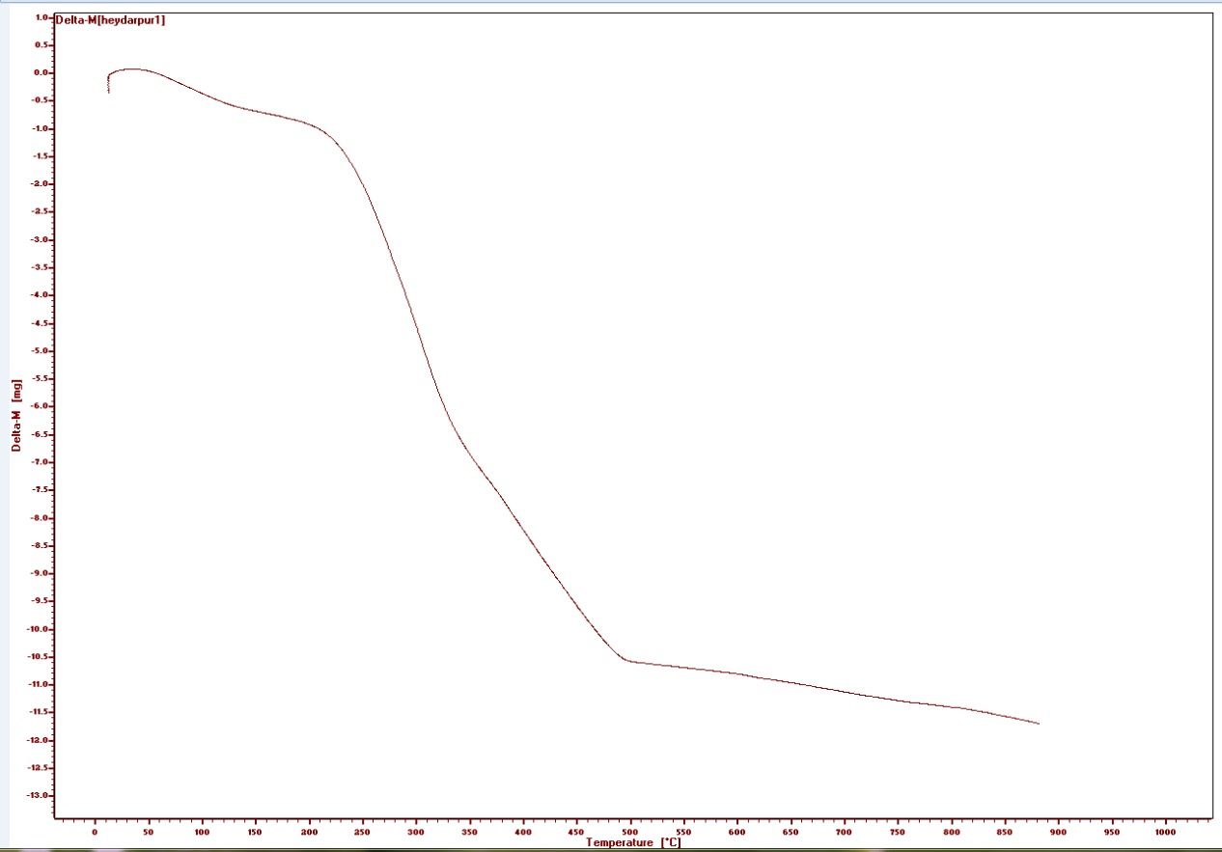

TGA profile of CuNP/WS-1
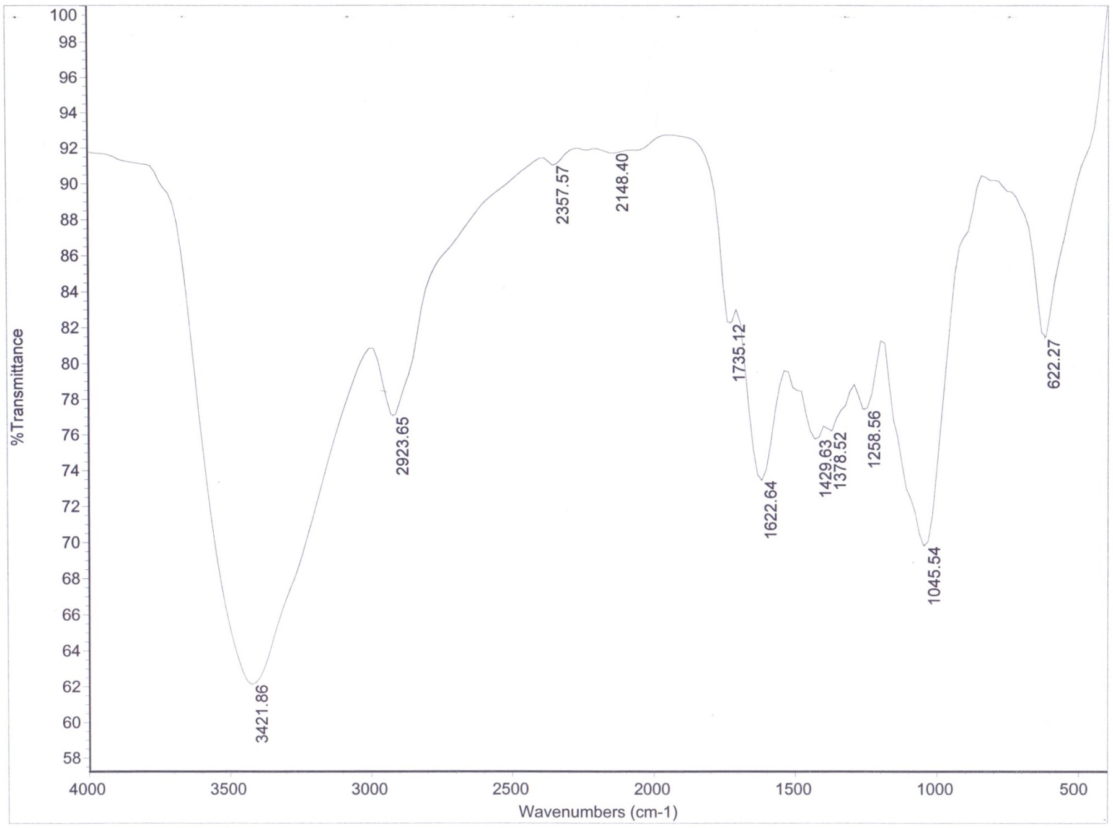

FT-IR spectrum of CuNP/WS-3
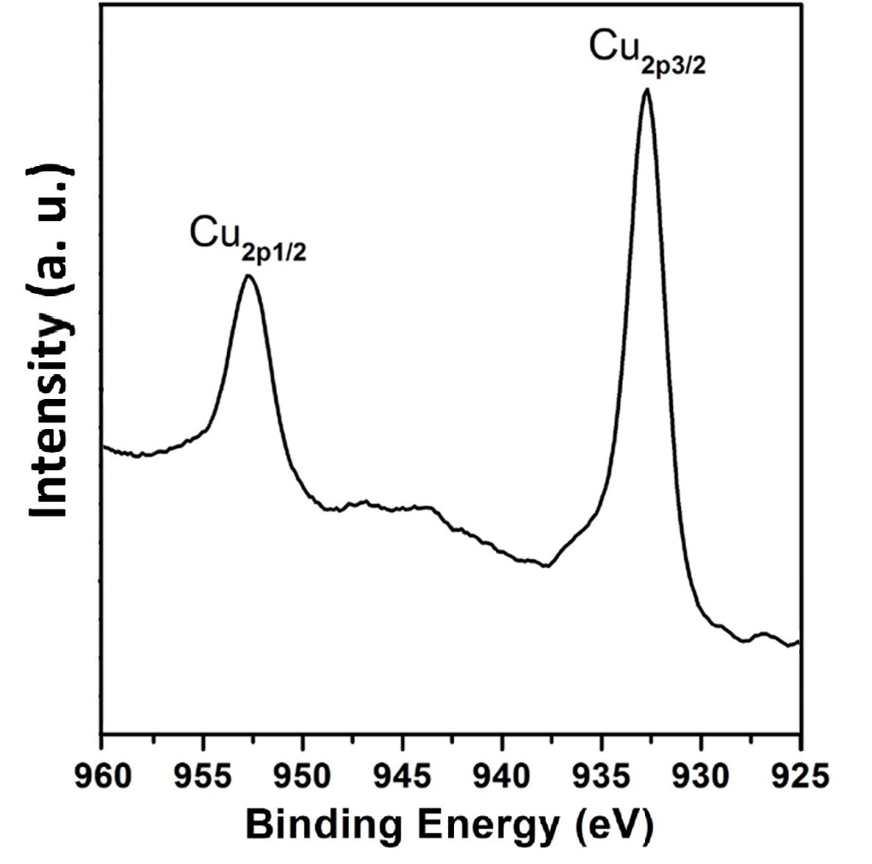

XPS spectrum of CuNP/WS-3

