Supplemental Material
- Sensitivity Analysis on Different Upper Age Limit

To verify the robustness of our key findings to age inclusion criteria, we conducted a sensitivity analysis to determine whether limiting the analysis to those patients younger than 18 years old produced different findings. We found no differences from those in the primary analysis (Figures 1 and 2). Specifically, earlier sequence placement of administering corticosteroids to pediatric asthma patients was positively correlated with better treatment outcomes – shorter length of stay and lower admission rate.

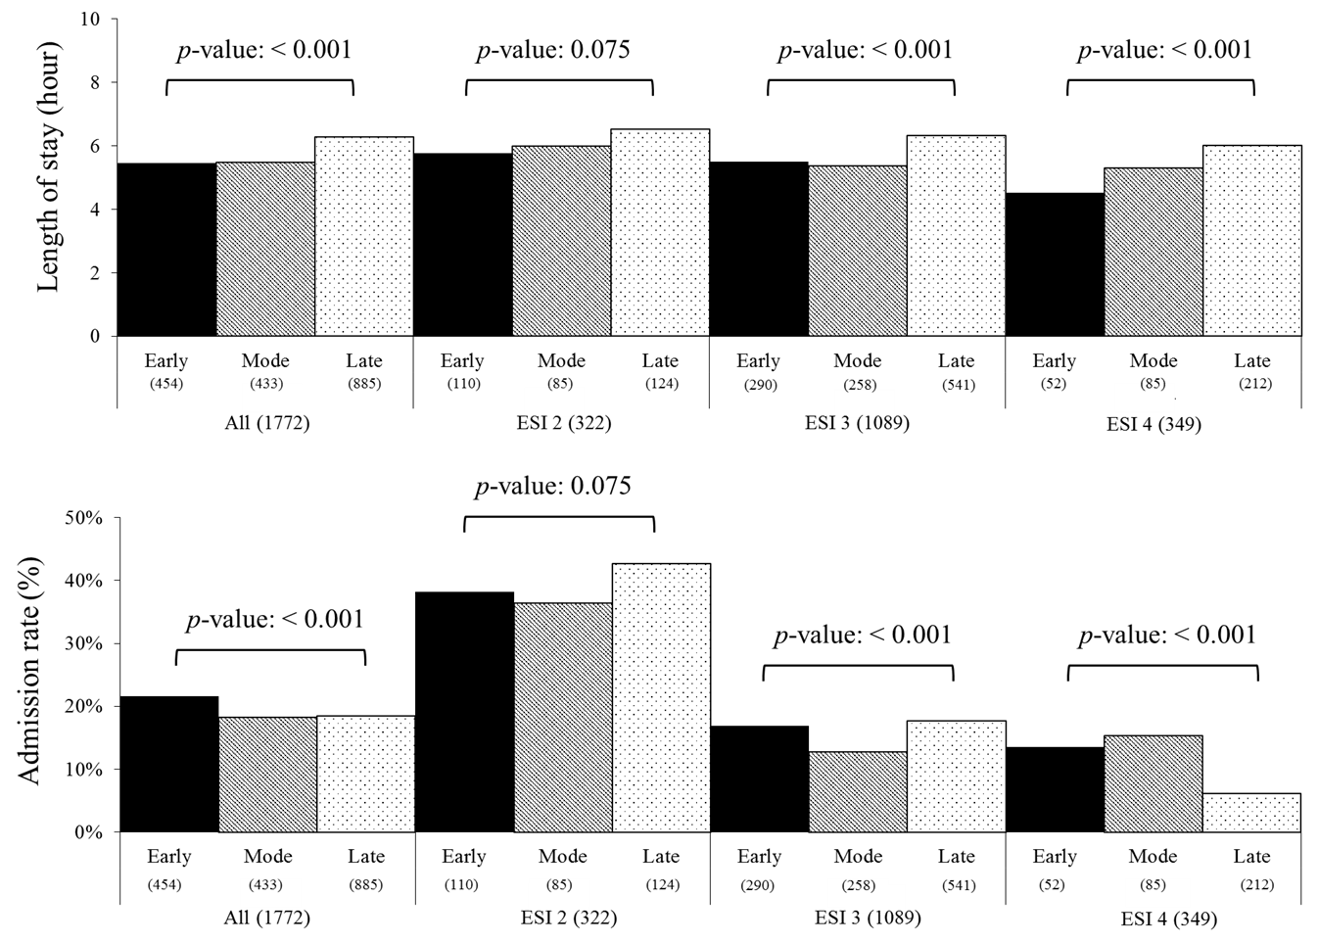
Figure 1. The association between the TTFS and treatment outcomes
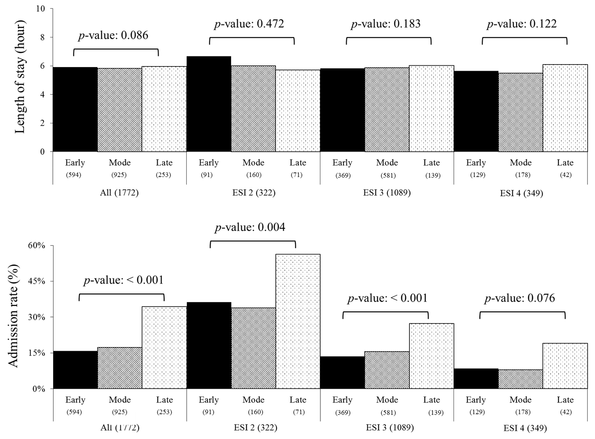
Figure 2. The association between the sequence placement of corticosteroids and treatment outcomes

- Sensitivity Analysis in First Visits Excluding All But One Visit for Patients with Multiple Visits

Because we used a large timeframe (data collected 2009 – 2013), a patient can enter the ED multiple times. To examine the effect of multiple visits by the same patient, we prepared a new dataset. For patients with multiple visits, we randomly selected one visit per patient. After eliminating subsequent encounters, we conducted examined whether multiple encounters (multiple entries per patient) affected our key research findings on the remaining dataset (930 encounter records).
Similar to the primary analysis, there still exists a positive correlation between the earlier placement of corticosteroids and better treatment outcomes (Figures 3 and 4).

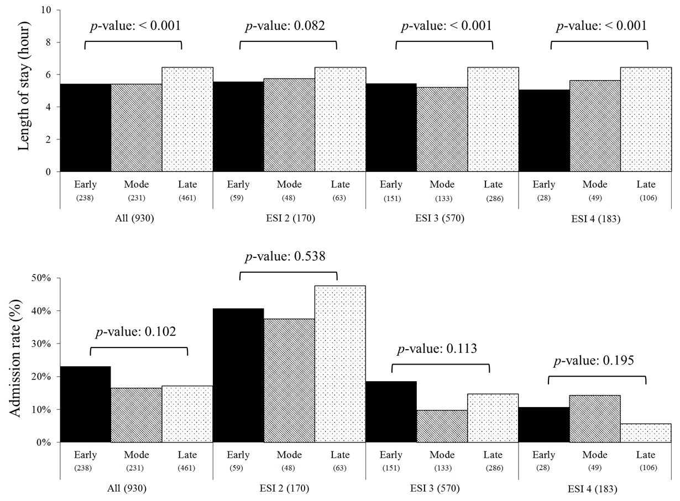
Figure 3. The association between the TTFS and treatment outcomes
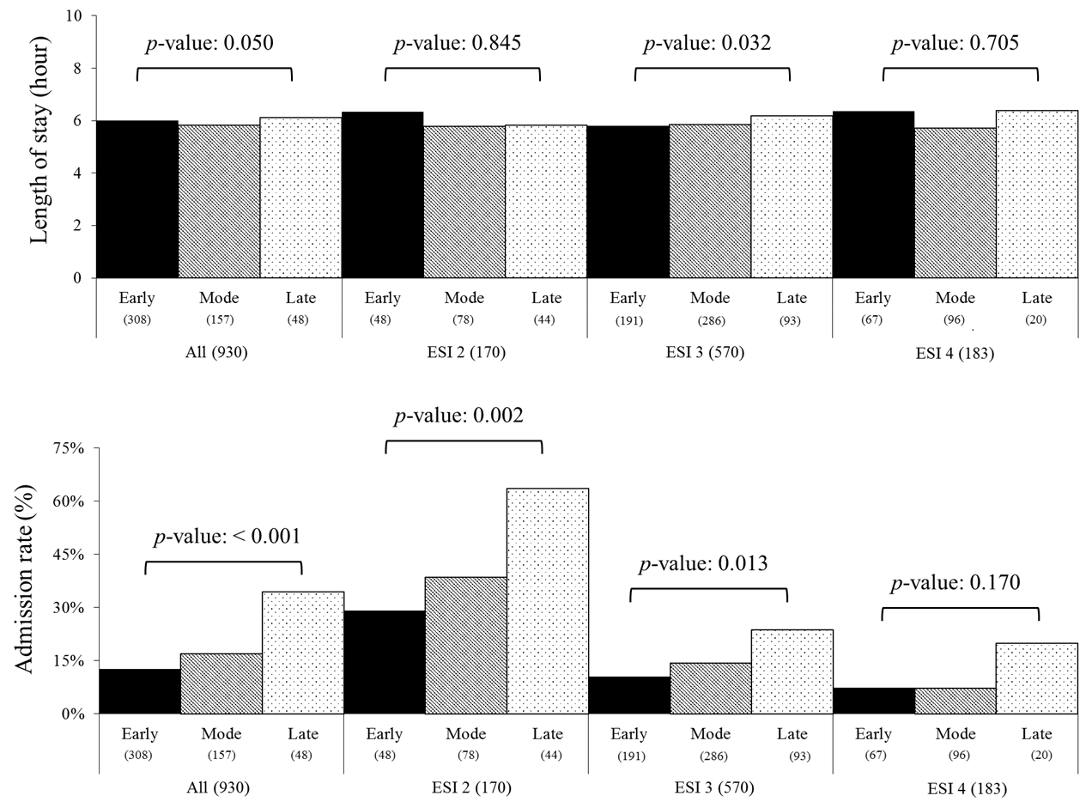
Figure 4. The association between the sequence placement of corticosteroids and treatment outcomes

- Analysis on the group of ESI 1 and 5

We excluded ESI 1 and ESI 5 (the most and the least urgent, respectively) data because of the low counts compared with populations in other ESI levels. Specifically, the number of encounters belonging to ESI 1 and 5 were 13 and 105, respectively. Because encounters in ESI 1 is too small numbers to conduct valid statistical tests, we only included encounters in ESI 5 for the statistical tests to determine if there exists an association between TTFS (or sequence placement) and treatment outcomes. The results are shown as follows:
Table 1 The association between TTFS and treatment outcomes
 | TTFS | N | Length of Stay (Hour) | p-value | Admission rate (%) | p-value
ESI 5 | Early | 5 | 3.260 | < 0.001 | 0.0% | 0.302
 | Mode | 13 | 2.430 |  | 0.0%
 | Late | 32 | 5.161 |  | 12.5%

Table 2 The association between the sequence placement of corticosteroids and treatment outcomes
 | The sequence of corticosteroids | N | Length of Stay (Hour) | p-value | Admission rate (%) | p-value
ESI 5 | Early | 38 | 3.565 | < 0.001 | 0.0% | < 0.001
 | Mode | 10 | 6.278 |  | 40.0%
 | Late | 2 | 7.392 |  | 0.0%

As presented in the Table2, there exists a statistically significant association between the time to first corticosteroid is administered and a shorter length of stay, similar to the results obtained with other groups (ESI 2 – 4). Also, we found a positive correlation between the earlier administration of corticosteroids with patients’ treatment outcomes (length of stay, admission rate; p-value < 0.001).

