Supplementary information

CircDLPAG4/HECTD1 mediates ischemia/reperfusion injury in endothelial cells via ER stress

Authors: Chen, Luo, Chu, Wang, Dai, Zhang, Cheng, Yao, Zhu and Chao

Table of contents

Supplementary Figure S1 2
Supplementary Figure S2 3
Supplementary Figure S3 4
Supplementary Figure S4 5
Supplementary Figure S5 6
Supplementary Figure S6 7
Supplementary Figure S7 8
Supplementary Figure S8 9
Supplementary Table S1 10-11

Supplementary Figure S1
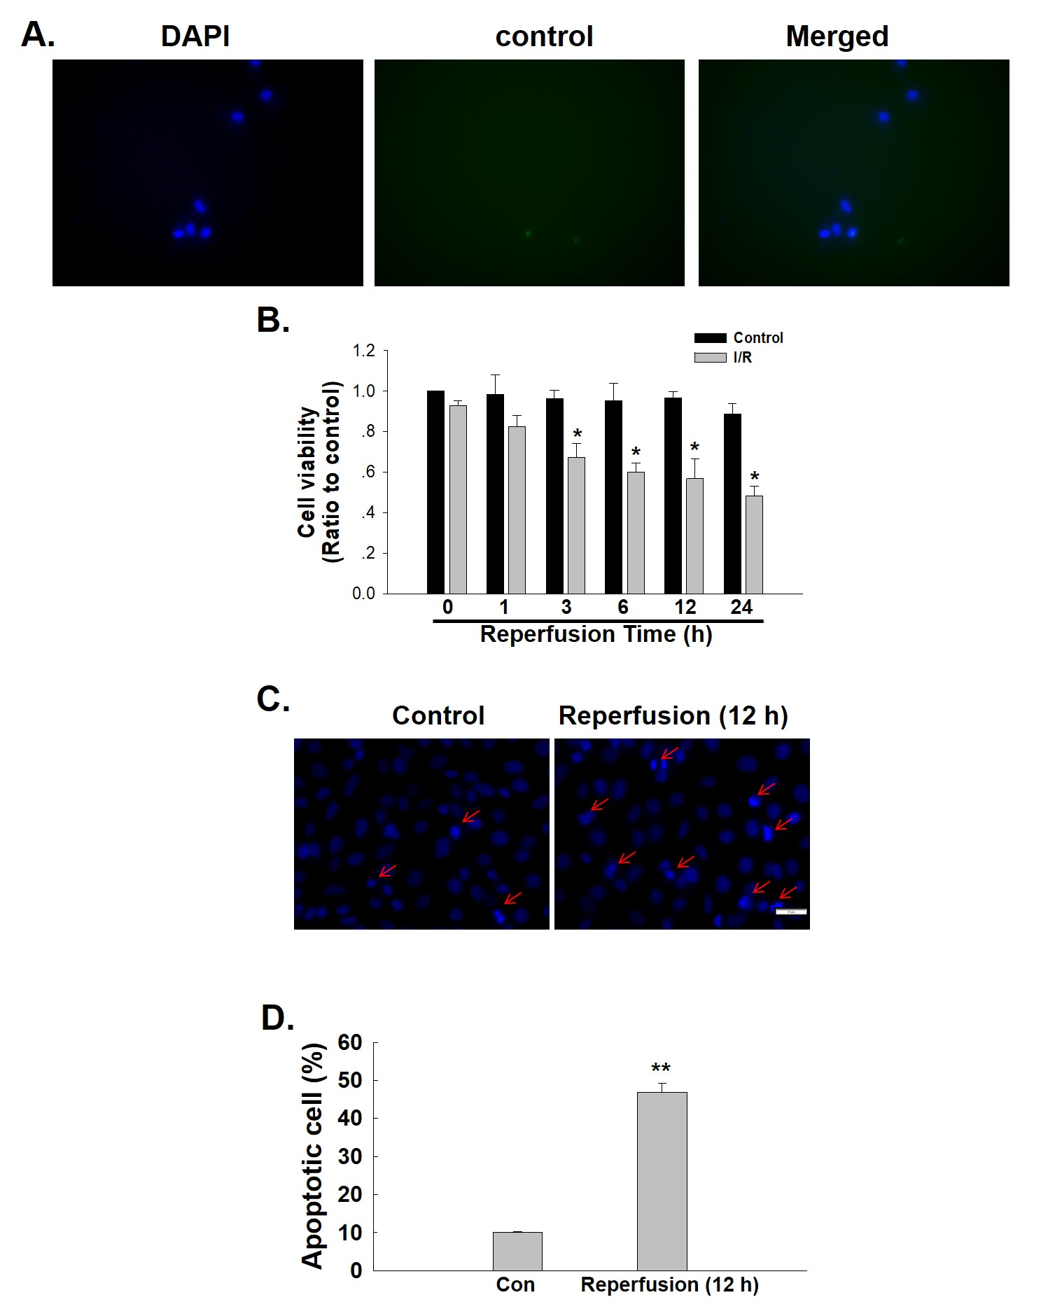
Figure S1. Effect of I/R on cell viability in HUVECs. (A) Representative images of immunocytochemistry without primary antibody as negative control to show the specificity of detection of target proteins. (B) CCK-8 assay results showing an I/R-induced decrease in HUVEC viability. *P < 0.05 vs. the 0 h group, n=5. (C) Representative images of Hoechst 33342 staining of HUVECs after I/R. (D) Hoechst 33342 staining demonstrating the apoptosis induced by I/R; n = 5; **P < 0.01 vs. the control group.
Supplementary Figure S2
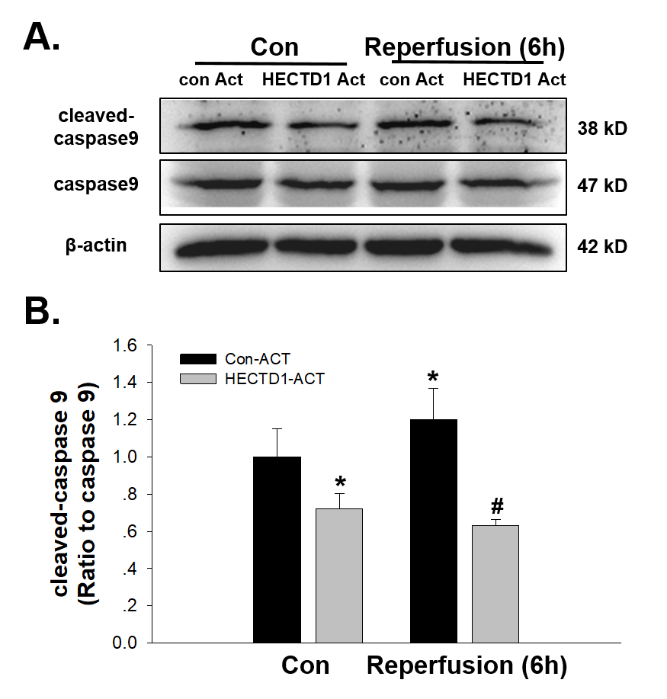
Figure S2. Involvement of HECTD1 in I/R-induced apoptosis in HUVECs. (A) Representative western blot depicting the effect of HECTD1 ACT on caspase-9 protein expression. (B) Densitometric analysis of caspase-9 protein levels from five independent experiments; *P < 0.05 vs. the control group; #P < 0.05 vs. the I/R group.

Supplementary Figure S3
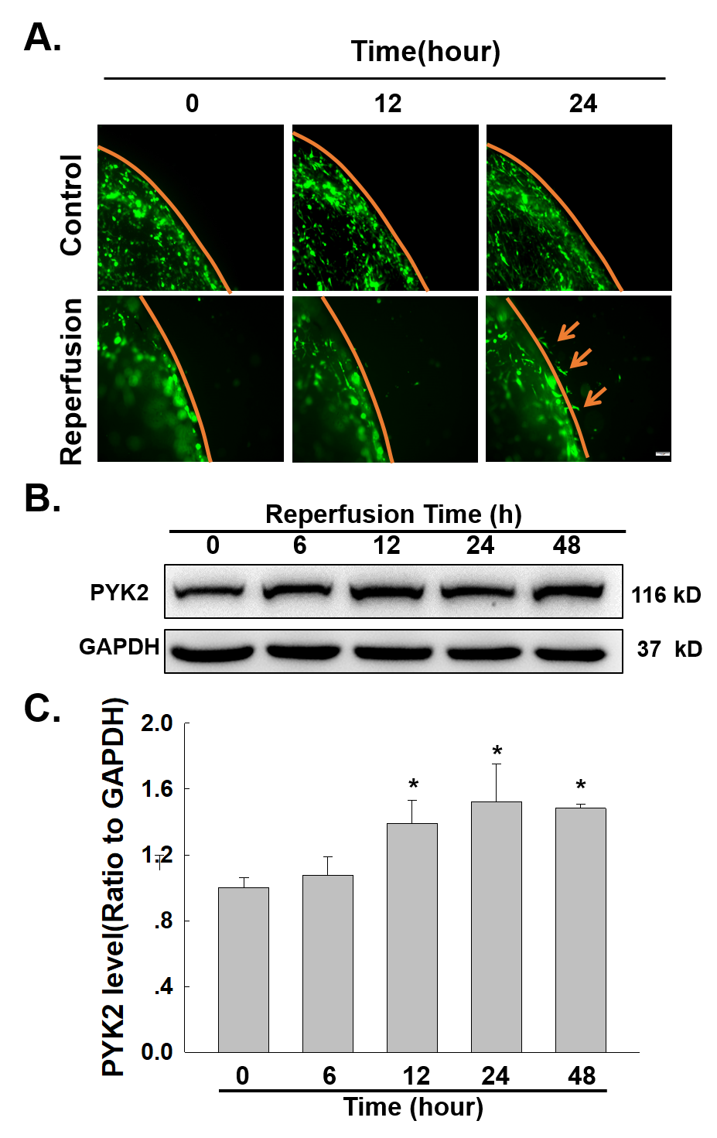
Figure S3. Effect of I/R on cell migration in HUVECs. (A) Representative images from a scratch assay showing the I/R-induced increase in cell migration. (B) Representative western blot showing that I/R induced the expression of PYK2. (C) Densitometric analysis of PYK2 expression from five experiments; *P < 0.05 vs. the 0 h group.

Supplementary Figure S4
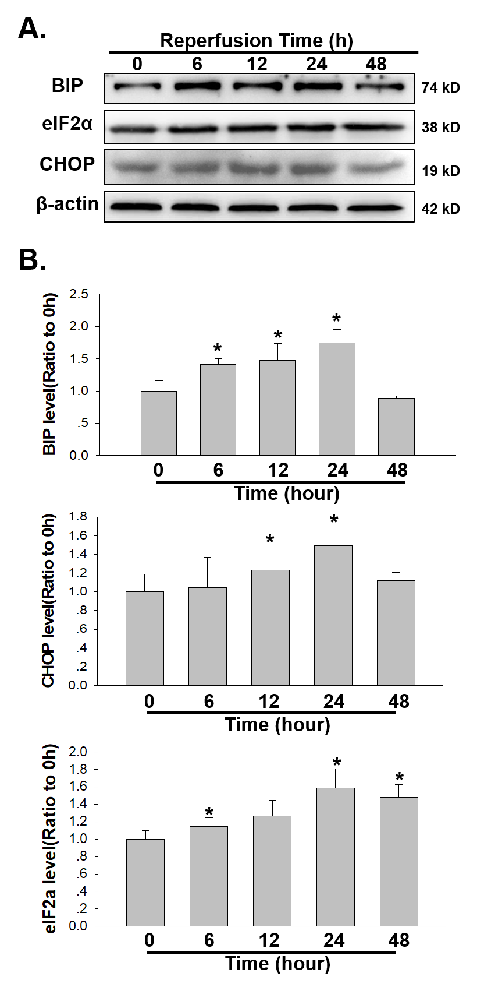
Figure S4. Effect of I/R on ER stress in HUVECs. (A) Representative western blot showing that I/R increased the expression of BIP, eIF2α and CHOP. (B) Densitometric analysis of BIP, eIF2α and CHOP protein levels from five independent experiments; *P < 0.05 vs. the control group.
Supplementary Figure S5
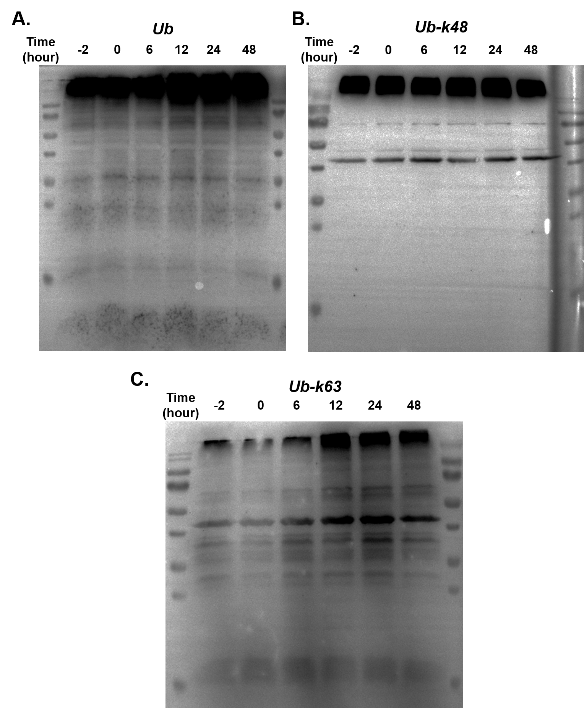
Figure S5. Effect of I/R on ubiquitination in HUVECs. (A) Representative western blot showing the effect of I/R on Ub. (B) Representative western blot showing the effect of I/R on Ub-k48. (C) Representative western blot showing the effect of I/R on Ub-k63.

Supplementary Figure S6
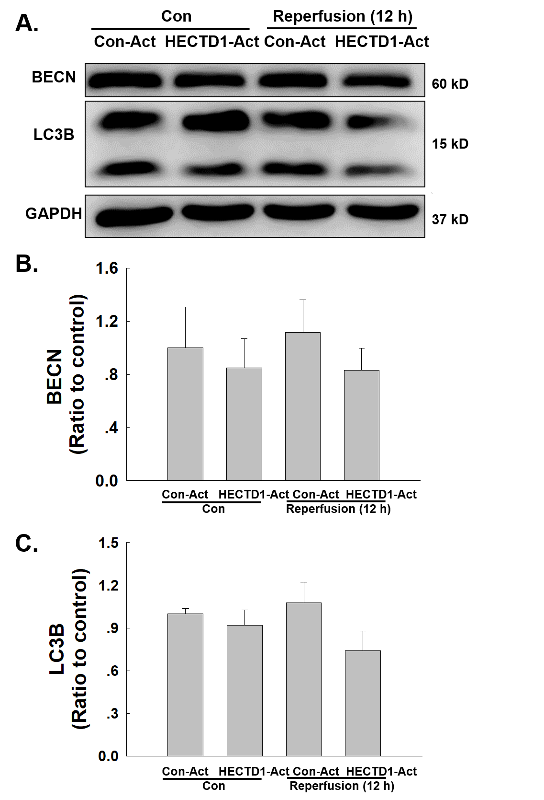
Figure S6. Involvement of HECTD1 in I/R-induced autophagy in HUVECs. (A) Representative western blot depicting the effect of HECTD1 ACT on BECN and LC3B protein expression. Densitometric analysis of BECN (B) and LC3B (C) protein levels from five independent experiments; *P < 0.05 vs. the control group, #P < 0.05 vs. the I/R group.

Supplementary Figure S7
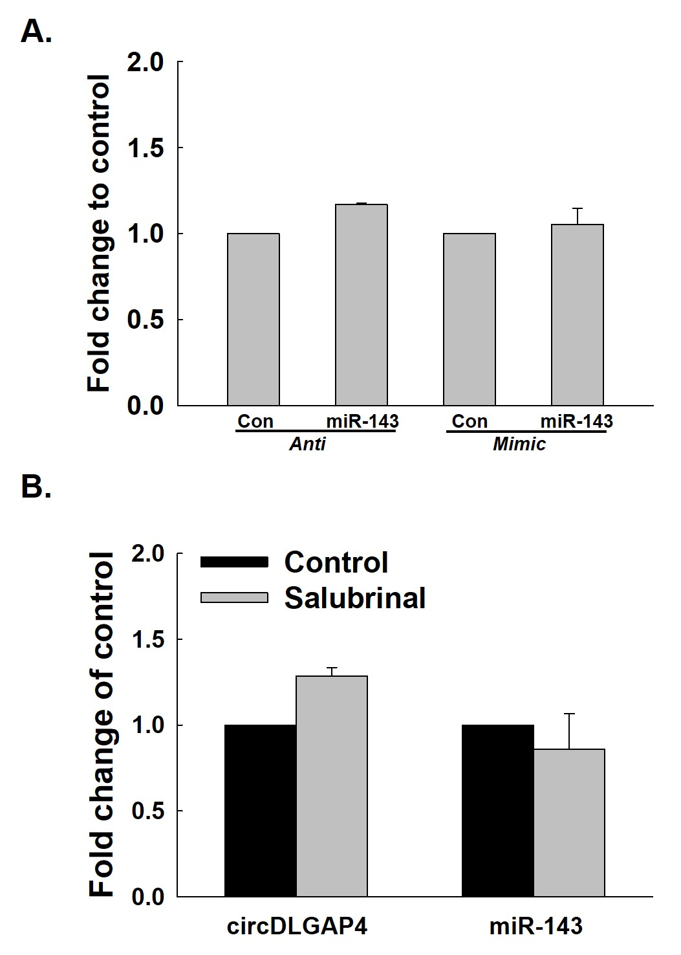
Figure S7. Interaction of ER stress and circDLGAP4/miR143 pathway in HUVECs. (A) As shown in the qRT-PCR analysis, regulation of miR-143 has no effect on circDLGAP4 expression (n=5). (B) As shown in the qRT-PCR analysis, salubrinal pretreatment regulation has no effect on circDLGAP4 and miR-143 expression (n=5).
Supplementary Figure S8
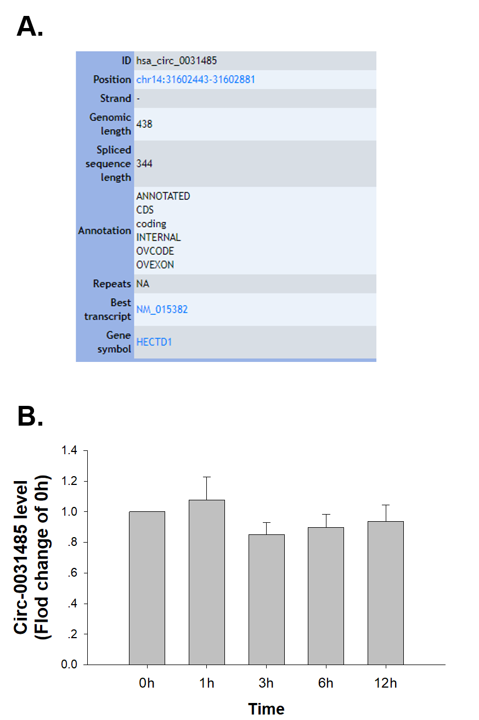
Figure S8. Effect of I/R on circ0031485 in HUVECs. (A) ID number and alias of circ0031485 from the circBase database. (B) As shown in the qRT-PCR analysis, I/R had no effect on circ0031485 expression (n=5).

Supplementary Table S1
Quantitative reverse transcription-polymerase chain reaction (qRT-PCR)
primers and FISH probes
mRNA qPCR primers
Gene | Forward (5′-3′) | Reverse (5′-3′)
GAPDH (human) | ACCATCTTCCAGGAGCGAGAT | GGGCAGAGATGATGACCCTTT
HECTD1 (human) | ACGGTTGTACGCAAGGTTGA | GGCGCTCTCTCATGATCTCC
Non-coding RNA qPCR primers
Name | Forward (5′-3′) | Reverse (5′-3′)
hsa_circ_0060180 | CGAGACGGCTACTGGTTCCT | GCTTTGAAGTGGTGCGTGG
FISH probes
Non-coding RNA | Sequence
hsa_circ_0060180  (biotin-labeled FISH probe) | 5′-AAAACTAGGCATGATGAACCTTCTTCAGAGAGGTT-3′
miR-143 (DIG-labeled FISH probe) | 5′-GAGCTACAGTGCTTCATCTCA-3′
The primers specific for the mature miR-143 and RNU6-6P/RNU6B snRNA were purchased from RiboBio.

