SUPPLEMENTAL ONLINE MATERIAL
Study flow chart
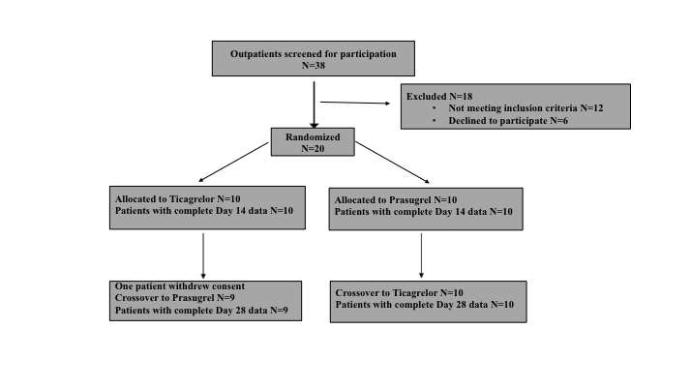

Table. Baseline characteristics of patients.
 | Allocated to  Prasugrel➔  Ticagrelor | Allocated to  Ticagrelor➔  Prasugrel
 | N=10 | N=10 | P
Age | 61 ± 6.4 | 68.6 ± 5.3 | 0.01
Male gender | 8 (80) | 8 (80) | 1.00
BMI (kg/m2) | 29.6 ± 7.1 | 28.6 ± 4.7 | 0.71
Hyperlipidemia | 8 (80) | 9 (90) | 1.00
Hypertension | 5 (50) | 7 (70) | 0.65
Diabetes mellitus | 5 (50) | 3 (30) | 0.65
Smoking | 9 (90) | 4 (40) | 0.06
Multivessel CAD | 6 (60) | 8 (80) | 0.62
2nd Prior MI | 0 (0) | 1 (10) | 1.00
Peripheral arterial disease | 1 (10) | 0 (0) | 1.00
FHCAD | 0 (0) | 2 (20) | 0.47
Treatment
Statins | 8 (80) | 10 (100) | 0.47
Proton Pump Inhibitors | 3 (30) | 3 (30) | 1.00
B-blockers | 8 (80) | 9 (90) | 1.00
Calcium Channel Blockers | 3 (30) | 2 (20) | 1.00
ACE/ATII inhibitors | 6 (60) | 5 (50) | 1.00
Diuretics | 1 (10) | 3 (30) | 0.58
Laboratory evaluation
Hematocrit (%) | 41 (4.4) | 41.2 (1.6) | 0.06
eGFR* (mL/min/1.73m²) | 81 (20) | 71 (18) | 0.52
LDL (mg/dl) | 85.9 (35.9) | 62.9 (18.2) | 0.25
Platelets (x 1000/mm³) | 250.8 (65.5) | 218.1 (43.3) | 0.31
PR at baseline (PRU) | 238.4 ± 50 | 259.6 ± 36 | 0.29
BASE | 201 (29) | 207 (10) | 0.51
Data are expressed as mean (±SD) for normally continuous variables, as median (interquartile range) for skewed variables and as frequency (%) for categorical variables. ACE, angiotensin converting enzyme; ATII, angiotensin II; BMI, body mass index; CAD, coronary artery disease; FHCAD, Family history of CAD; eGFR, estimated glomerular filtration rate; LDL, low-density lipoprotein; MI, myocardial infraction; PR, platelet reactivity; PRU= P2Y₁₂ reaction units.
*using the CKD-EPI formula

Individual PR values according to treatment

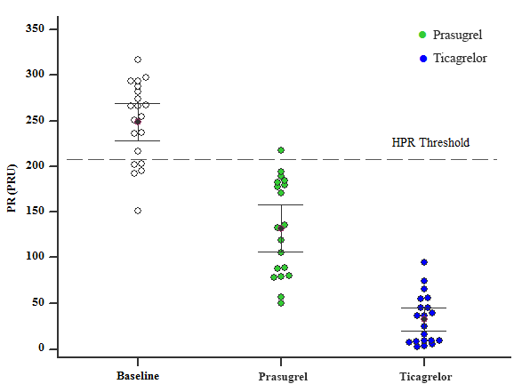

HPR, high platelet reactivity; PR, platelet reactivity; PRU, P2Y₁₂ reaction units. Median, interquartile range are shown.

