Electronic Supplementary Information for
A convenient synthesis of 2,5-diaroyl-4-hydroxy cyclopent-2-enones incorporating aromatic and heteroaromatic moieties
Aswathy L. Balachandran,ª Athira C. S,^{b} Ani Deepthi*ª and Jayasree E. Gª
ªDepartment of Chemistry, University of Kerala, Kariavattom, Thiruvananthapuram – 695581, Kerala, India
^{b}Chemical Sciences and Technology Division, CSIR-National Institute for Interdisciplinary Science and Technology (CSIR-NIIST), Thiruvananthapuram – 695019, Kerala, India

Email: anideepthi@gmail.com

Sl No: | Contents | Figure | Page No:
1 | Synthetic details |  | 3-9
2 | ¹H NMR spectrum of compound 3a | 1 | 10
3 | ¹³C NMR spectrum of compound 3a | 2 | 10
4 | ¹H NMR spectrum of compound 3h | 3 | 11
5 | ¹³C NMR spectrum of compound 3h | 4 | 11
6 | ¹H NMR spectrum of compound 3b | 5 | 12
7 | ¹³C NMR spectrum of compound 3b | 6 | 12
8 | ¹H NMR spectrum of compound 3c | 7 | 13
9 | ¹³C NMR spectrum of compound 3c | 8 | 13
10 | ¹H NMR spectrum of compound 3d | 9 | 14
11 | ¹³C NMR spectrum of compound 3d | 10 | 14
12 | ¹H NMR spectrum of compound 3e | 11 | 15
13 | ¹³C NMR spectrum of compound 3e | 12 | 15
14 | ¹H NMR spectrum of compound 3i | 13 | 16
15 | ¹³C NMR spectrum of compound 3i | 14 | 16
16 | ¹H NMR spectrum of compound 3j | 15 | 17
17 | ¹³C NMR spectrum of compound 3j | 16 | 17
18 | ¹H NMR spectrum of compound 3k | 17 | 18
19 | ¹³C NMR spectrum of compound 3k | 18 | 18
20 | ¹H NMR spectrum of compound 3l | 19 | 19
21 | ¹³C NMR spectrum of compound 3l | 20 | 19
22 | ¹H NMR spectrum of compound 5 | 21 | 20
23 | ¹³C NMR spectrum of compound 5 | 22 | 20
24 | ¹H NMR spectrum of compound 6 | 23 | 21
25 | ¹³C NMR spectrum of compound 6 | 24 | 21
26 | ¹H NMR spectrum of compound 7 | 25 | 22
27 | ¹³C NMR spectrum of compound 7 | 26 | 22

General Experimental Conditions
1,5-Diphenyl-pentane-1,3,5-trione, 4,4’-dibromobenzil, 4,4’-dimethoxybenzil, 4,4’-dimethylbenzil, 3,3’-dimethoxy-2-chloro-benzil, 2,2’-pyridil, furil and butane-2,3-dione were commercially purchased from Sigma Aldrich. Benzil and 2,2’ thenil were purchased from Alfa Aesar. All other 1,2-dicarbonyl compounds were synthesized following the literature procedure. All solvents including HPLC grade were purchased from Spectrochem Pvt. Ltd. Hexane and ethyl acetate were distilled prior to use. Analytical thin layer chromatography was performed on silica gel coated on aluminium sheets and was monitored using UV light of wavelength 366 nm. Gravity column chromatography was performed using 100-200 mesh silica gel and mixtures of hexane and ethyl acetate were used for elution. Melting points were recorded on Analab ThermoCal50 melting point apparatus. NMR spectra were recorded on a Bruker AVANCE III HD 400 MHz spectrometer. Chemical shifts are reported relative to TMS as the internal standard. IR spectra were recorded on an Agilent Cary 630 FTIR spectrometer. Mass spectra were recorded under ESI/HRMS using JEOL JMS 600H mass spectrometer. The purity of the samples was ascertained using PE 2400 series II CHNS Analyser. Absorption spectra were recorded on a Perkin Elmer UV/Vis Lambda 365 spectrometer. Fluorescence spectra were recorded on a JASCO FP-8300 spectrofluorimeter. Computational calculations were done using Gaussian 09 program package.
Experimental procedure for the synthesis of 2,5-dibenzoyl-4-hydroxy-3,4-diphenyl-cyclopent-2-enone (3a)
To a stirred solution of sodium hydroxide (15 mg, 0.38 mmol) in methanol (5 mL), 1,5-diphenyl-pentane-1,3,5-trione 1 (50 mg, 0.187 mmol) was added and the stirring was continued at room temperature for 10 minutes. Benzil 2a (39 mg, 0.187 mmol) was added to the mixture in one portion and the mixture was allowed to stir for a total of 8 hours. The resulting precipitate was filtered and dried in vacuum. This salt was suspended in a separatory funnel in H₂O and CH₂Cl₂. Aqueous HCl was added and the mixture is shaken until the solid dissolved. The layers were separated and the aqueous phase was extracted with CH₂Cl₂. The organic layers were combined and dried over Na₂SO₄ and concentrated under reduced pressure. The residue obtained was subjected to column chromatography using silica gel 100-200 mesh and hexane-EtOAc as solvent system. Elution with 10:90 ethyl acetate: hexane afforded the product as a pale yellow powder (yield: 68%, recovered yield: 82%; mp: 317-320 ℃ ).
IR (v cm⁻¹): 3445, 3052, 1702, 1687, 1648, 1592, 1442, 1325 cm⁻¹; ¹H NMR (400 MHz, CDCl₃) δ (ppm): 7.14-8.05 (m, 20H), 5.42 (s, 1H, exchangeable with D₂O), 5.04 (s, 1H); ¹³C NMR (100 MHz, CDCl₃) δ (ppm): 196.5, 194.7, 173.7, 140.4, 134.5, 134.2, 131.3, 131.0, 130.9, 130.8, 130.0, 130.0, 129.8, 129.5, 129.4, 129.2, 129.1, 129.0, 128.9, 128.8, 128.8, 128.7, 128.4, 128.1, 128.0, 127.7, 127.4, 125.8, 124.9, 82.9, 69.8; HRMS (ESI): m/z calcd. for [C₃₁H₂₂O₄ + Na]: 481.1416, Found: 481.1420; Anal. Calcd (%) for C₃₁H₂₂O₄: C, 81.21; H, 4.84; Found: C, 81.28; H, 4.89.
Experimental procedure for the synthesis of 2,5-dibenzoyl-4-hydroxy-3,4-di-thiophen-2-yl-cyclopent-2-enone (3h)
To a stirred solution of sodium hydroxide (15 mg, 0.38 mmol) in methanol (5 mL), 1,5-diphenyl-pentane-1,3,5-trione 1 (50 mg, 0.187 mmol) was added and the stirring was continued at room temperature for 10 minutes. 2,2'-Thenil 2h (41 mg, 0.187 mmol) was added to the mixture in one portion and the mixture was allowed to stir for a total of 8 hours. The resulting mixture was taken in a separating funnel and H₂O and CH₂Cl₂ was added. Aqueous HCl was then added and the mixture was shaken. The layers were separated. The organic phase were combined and dried over anhydrous Na₂SO₄ and concentrated under reduced pressure. Obtained residue was subjected to column chromatography using silica gel 100-200 mesh and hexane-EtOAc as solvent system. Elution with 10:90 ethyl acetate:hexane afforded the product as a pale yellow powder (yield: 64%, recovered yield: 85%; mp: 324-327 ℃).
IR (v cm⁻¹): 3271, 2954, 2913, 1706, 1684, 1657, 1590, 1445, 1363, 1255; ¹H NMR (400 MHz, CDCl₃) δ (ppm): 6.89-8.06 (m, 16H), 5.74 (s, 1H, exchangeable with D₂O), 5.06 (s, 1H); ¹³C NMR (100 MHz, CDCl₃) δ (ppm): 196.7, 193.5, 171.2, 140.8, 139.3, 139.0, 136.3, 134.0, 133.7, 131.0, 130.3, 129.5, 129.3, 129.1, 128.9, 128.8, 128.7, 128.4, 128.2, 128.0, 127.8, 127.6, 127.3, 127.2, 126.0, 88.3, 71.0; HRMS (ESI): m/z calcd. for [C₂₇H₁₈O₄S₂ +Na]: 493.0544, Found: 493.0544; Anal. Calcd (%) for C₂₇H₁₈O₄S₂: C, 68.92; H, 3.86, S, 13.63; Found: C, 68.95; H, 3.80, S, 13.69.
General procedure for the synthesis of compounds 3a-3m
To a stirred solution of sodium hydroxide (15 mg, 0.38 mmol, 2 equiv.) in methanol (5 mL), 1,5-diphenyl-pentane-1,3,5-trione 1 (50 mg, 0.187 mmol, 1 equiv.) was added and the stirring was continued at room temperature for 10 minutes. Diones (2a-2m) (0.187 mmol, 1 equiv.) was added to the mixture in one portion and the mixture was allowed to stir for 8 hours. The resulting mixture was taken in a separating funnel and H₂O and CH₂Cl₂ was added. Aqueous HCl was then added and the mixture was shaken. The layers were separated. The organic layers were combined and dried over anhydrous Na₂SO₄ and concentrated under reduced pressure. Obtained residue was purified by column chromatography using silica gel 100-200 mesh and hexane-EtOAc as solvent system.
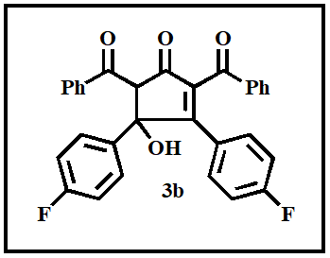
2,5-Dibenzoyl-3,4-bis-(4-fluoro-phenyl)-4-hydroxy-cyclopent-2-enone (3b)
Yellow viscous oil (Elution 10:90 ethyl acetate: hexane); yield: 58% (recovered yield: 83%).
IR (v cm⁻¹): 3356, 2939, 1713, 1698, 1661, 1505, 1408, 1263 cm⁻¹; ¹H NMR (400 MHz, CDCl₃) δ (ppm): 6.69-8.02 (m, 18H), 5.60 (s, 1H), 4.90 (s, 1H); ¹³C NMR (100 MHz, CDCl₃) δ (ppm): 196.6, 194.1 171.9, 140.1, 138.0, 136.1, 135.7, 134.7, 134.5, 134.0, 133.6, 132.5, 132.4, 131.4, 131.3, 131.2, 130.1, 129.8, 129.5, 129.4, 129.3, 129.0, 128.8, 128.5, 128.4, 127.8, 126.8, 126.8, 126.7, 82.6, 69.3; HRMS (ESI): m/z calcd. for [C₃₁H₂₀F₂O₄ + Na]: 517.1227, Found: 517.1230.
2,5-Dibenzoyl-3,4-bis-(4-bromo-phenyl)-4-hydroxy-cyclopent-2-enone (3c)
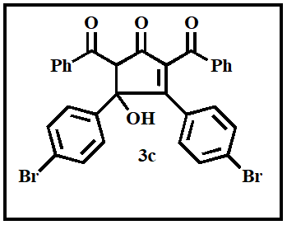
Yellow viscous oil (Elution 10:90 ethyl acetate: hexane); yield: 58% (recovered yield: 74%).
IR (v cm⁻¹): 3397, 2917, 1732, 1700, 1684, 1486, 1397, 1251 cm⁻¹; ¹H NMR (400 MHz, CDCl₃) δ (ppm): 7.0-8.10 (m, 18H), 3.62 (s, 1H), 3.34 (s, 1H); ¹³C NMR (100 MHz, CDCl₃) δ (ppm): 194.7, 193.4, 168.2, 139.9, 139.3, 139.2, 136.9, 136.7, 136.3, 132.3, 132.2, 131.6, 131.6, 131.5, 131.1, 130.2, 130.0, 129.8, 128.9, 128.8, 128.7, 128.6, 128.6, 128.5, 128.4, 128.1, 128.0, 122.2, 121.1, 88.2, 69.3; HRMS (ESI): m/z calcd. for [C₃₁H₂₀Br₂O₄ + Na]: 636.9626, Found: 636.9628.
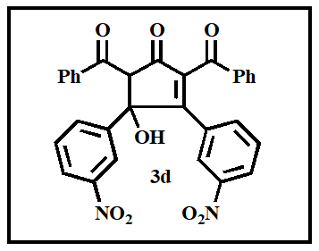
2,5-Dibenzoyl-4-hydroxy-3,4-bis-(3-nitro-phenyl)-cyclopent-2-enone (3d)
Yellow viscous oil (Elution 10:90 ethyl acetate: hexane); yield: 60% (recovered yield: 82%).
IR (v cm⁻¹): 3397, 2917, 1717, 1705, 1661, 1523, 1445, 1263 cm⁻¹; ¹H NMR (400 MHz, DMSO) δ (ppm): 7.24-8.62 (m, 22H), 8.46 (s, 1H), 3.17 (s, 1H); ¹³C NMR (100 MHz, DMSO) δ (ppm): 197.5, 193.2, 173.1, 140.0, 138.6, 135.8, 135.7, 134.0, 133.9, 132.6, 131.1, 130.0, 129.5, 129.5, 129.4, 129.3, 129.1, 128.8, 128.7, 128.6, 128.4, 128.4, 128.3, 128.2, 128.1, 128.0, 127.7, 127.6, 127.0, 82.9, 66.2; HRMS (ESI): m/z calcd. for [C₃₁H₂₀N₂O₈ + Na]: 571.1117, Found: 571.1112.
2,5-Dibenzoyl-3-(2-chloro-3-methoxy-phenyl)-4-hydroxy-4-(3-methoxy-phenyl) cyclopent-2-enone (3e)
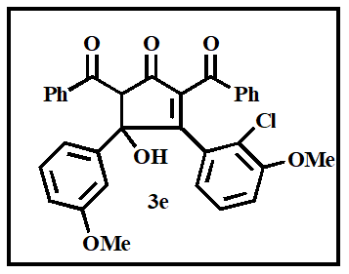
Yellow viscous oil (Elution 10:90 ethyl acetate: hexane); yield: 25% (recovered yield: 49%).
IR (v cm⁻¹): 3354, 2918, 1715, 1704, 1636, 1592, 1415, 1250 cm⁻¹; ¹H NMR (400 MHz, CDCl₃) δ (ppm): 6.40-7.75 (m, 22H), 5.59 (s, 1H), 4.92 (s, 1H), 3.31 (s, 3H), 3.25 (s, 3H); ¹³C NMR (100 MHz, CDCl₃) δ (ppm): 199.4, 193.0, 166.9, 162.2, 159.2, 141.7, 138.5, 138.1, 130.6, 130.5, 129.4, 129.3, 129.0, 128.9, 128.7, 128.7, 128.6, 128.5, 127.5, 127.2, 126.1, 120.8, 118.4, 118.1, 117.9, 116.7, 114.3, 113.5, 111.5, 87.9, 68.9, 55.1, 50.6; HRMS (ESI): m/z calcd. for [C₃₃H₂₅ClO₆ + Na]: 575.1237, Found: 575.1239.
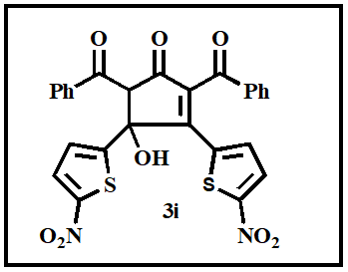
2,5-Dibenzoyl-4-hydroxy-3,4-bis-(5-nitro-thiophen-2-yl)-cyclopent-2-enone (3i)
Yellow viscous oil (Elution 15:85 ethyl acetate: hexane); yield: 59% (recovered yield: 78%).
IR (v cm⁻¹): 3304, 3099, 2917, 2846, 1732, 1693, 1657 cm⁻¹; ¹H NMR (400 MHz, DMSO) δ (ppm): 6.22-8.02 (m, 14 H), 8.62 (s, 1H), 3.17 (s, 1H); ¹³C NMR (100 MHz, DMSO) δ (ppm): 191.1, 187.6, 169.7, 144.1, 142.8, 142.4, 140.8, 140.6, 136.9, 136.7, 133.8, 133.4, 131.2, 131.1, 130.7, 130.5, 130.0, 129.5, 129.2, 129.0, 128.9, 128.7, 128.1, 127.9, 127.1, 83.7, 69.7; HRMS (ESI): m/z calcd. for [C₂₇H₁₆N₂O₈S₂ + Na]: 583.0246, Found: 583.0243.
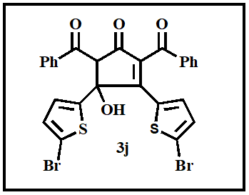
2,5-Dibenzoyl-3,4-bis-(5-bromo-thiophen-2-yl)-4-hydroxy-cyclopent-2-enone (3j)
Yellow viscous oil (Elution 10:90 ethyl acetate: hexane); yield: 55% (recovered yield: 73%).
IR (v cm⁻¹): 3464, 3088, 2920, 2850, 2354, 1732, 1700, 1662 cm⁻¹; ¹H NMR (400 MHz, CDCl₃) δ (ppm): 6.52-8.03 (m, 14 H), 6.30 (s, 1H), 5.27 (s, 1H); ¹³C NMR (100 MHz, CDCl₃) δ (ppm): 195.4, 195.1, 174.1, 148.4, 142.8, 142.7, 142.4, 137.2, 137.1, 130.4, 130.3, 129.0, 128.1, 125.0, 125.0, 124.9, 124.5, 124.2, 123.3, 123.3, 122.8, 122.4, 121.7, 121.6, 84.1, 63.3; HRMS (ESI): m/z calcd. for [C₂₇H₁₆Br₂O₄S₂ + Na]: 648.8754, Found: 648.8759.

2,5-Dibenzoyl-4-hydroxy-3,4-di-pyridin-2-yl-cyclopent-2-enone (3k)
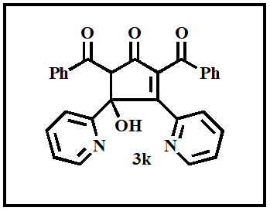
Yellow viscous oil (Elution 10:90 ethyl acetate: hexane); yield: 59% (recovered yield: 75%).
IR (v cm⁻¹): 3267, 3051, 2924, 1717, 1700, 1665 cm⁻¹; ¹H NMR (400 MHz, CDCl₃) δ (ppm): 6.89-8.55 (m, 18 H), 5.75 (s, 1H), 4.94 (s, 1H); ¹³C NMR (100 MHz, CDCl₃) δ (ppm): 195.1, 194.9, 176.0, 165.3, 162.3, 158.9, 158.8, 148.2, 142.3, 141.9, 137.4, 130.3, 130.2, 129.6, 128.6, 125.0, 125.0, 124.7, 122.8, 122.7, 121.8, 121.6, 115.6, 115.6, 110.9, 110.7, 108.5, 87.9, 69.3; HRMS (ESI): m/z calcd. for [C₂₉H₂₀N₂O₄ + Na]: 483.1321, Found: 483.1318.
2,5-Dibenzoyl-3,4-di-furan-2-yl-4-hydroxy-cyclopent-2-enone (3l)
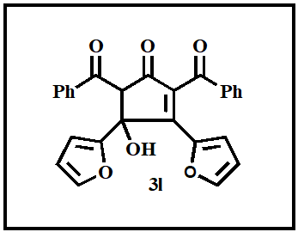
Yellow viscous oil (Elution 15:85 ethyl acetate: hexane); yield: 58% (recovered yield: 77%).
IR (v cm⁻¹): 3435, 3058, 2917, 2850, 1710, 1685, 1665, 1613, 1490, 1255 cm⁻¹; ¹H NMR (400 MHz, CDCl₃) δ (ppm): 6.32-8.14 (m, 16 H), 6.11 (s, 1H), 4.94 (s, 1H); ¹³C NMR (100 MHz, CDCl₃) δ (ppm): 195.7, 191.9, 170.1, 142.9, 139.2, 138.4, 136.3, 136.0, 134.7, 134.5, 133.9, 130.1, 130.0, 129.2, 128.7, 128.7, 128.5, 128.4, 127.7, 124.4, 123.9, 120.6, 119.1, 118.4, 114.0, 78.6, 65.3; HRMS (ESI): m/z calcd. for [C₂₇H₁₈O₆ + Na]: 461.1001, Found: 461.1008.
Experimental procedure for the synthesis of compound 5
To a stirred solution of sodium hydroxide (15 mg, 0.38 mmol) in methanol (5 mL), 1,5-Di-pyridin-2-yl-pentane-1,3,5-trione 4 (50 mg, 0.187 mmol) was added and the stirring was continued at room temperature for 10 minutes. Benzil 2a (0.187 mmol) was added to the mixture in one portion and the mixture was allowed to stir for 8 hours. The resulting mixture was taken in a separating funnel and H₂O and CH₂Cl₂ was added. Aqueous HCl was then added and the mixture was shaken. The layers were separated. The organic layers were combined and dried over anhydrous Na₂SO₄ and concentrated under reduced pressure. Obtained residue was subjected to column chromatography using silica gel 100-200 mesh and hexane-EtOAc as solvent system.

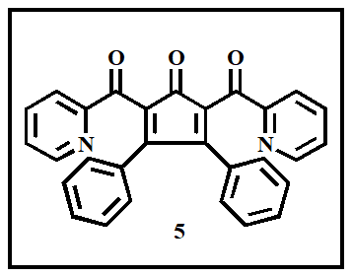
Diphenyl-2,5-bis-(pyridine-2-carbonyl)-cyclopenta-2,4-dienone (5)
Yellow viscous oil (Elution 10:90 ethyl acetate: hexane); yield: 65% (recovered yield: 81%).
IR (v cm⁻¹): 3021, 2949, 1716, 1658, 1661, 1585, 1428, 1274 cm⁻¹; ¹H NMR (400 MHz, CDCl₃) δ (ppm): 7.22-8.67 (m, 18H); ¹³C NMR (100 MHz, CDCl₃) δ (ppm): 198.2, 191.2, 188.0, 156.5, 153.4, 148.7, 137.2, 136.0, 134.8, 133.3, 130.8, 130.3, 129.1, 128.9, 128.7, 128.7, 128.6, 128.5, 128.2, 127.5, 127.2, 123.1, 120.0; HRMS (ESI): m/z calcd. for [C₂₉H₁₈N₂O₃ + Na]: 465.1215, Found: 465.1213.
General procedure for the synthesis of compounds 6 and 7
To a stirred solution of 2,5-dibenzoyl-4-hydroxy-3,4-diphenyl-cyclopent-2-enone 3a or 2,5-Dibenzoyl-4-hydroxy-3,4-di-thiophen-2-yl-cyclopent-2-enone 3h (50 mg) in methanol (5 mL), 5-6 drops of Con H₂SO₄ was added, and the mixture was refluxed for 6 hours. The resulting mixture after cooling was taken in a separating funnel, H₂O and CH₂Cl₂ was added and shaken well. The layers were separated. The organic layers were combined and dried over anhydrous Na₂SO₄ and concentrated under reduced pressure. Obtained residue was subjected to column chromatography using silica gel 100-200 mesh and hexane-EtOAc as solvent system.
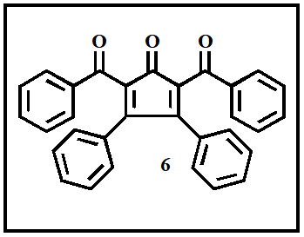
2,5-Dibenzoyl-3,4-diphenyl-cyclopenta-2,4-dienone (6)
Yellow solid (Elution 10:90 ethyl acetate: hexane); yield: 62% (recovered yield: 85%); mp: 305-308 ℃.
IR (v cm⁻¹): 3011, 2987, 2870, 1718, 1655, 1659, 1602, 1450, 1235 cm⁻¹; ¹H NMR (400 MHz, DMSO) δ (ppm): 7.0-7.88 (m, 20 H); ¹³C NMR (100 MHz, DMSO) δ (ppm): 198.4, 181.1, 180.2, 154.9, 148.1, 145.7, 142.2, 137.2, 134.0, 133.9, 129.6, 129.4, 129.2, 129.1, 128.9, 128.3, 128.1, 127.5, 126.7, 125.8, 125.6, 115.1; Anal. Calcd (%) for C₃₁H₂₀O₃: C, 84.53; H, 4.58; Found: C, 84.50; H, 4.61.
2,5-Dibenzoyl-3,4-di-thiophen-2-yl-cyclopenta-2,4-dienone (7)
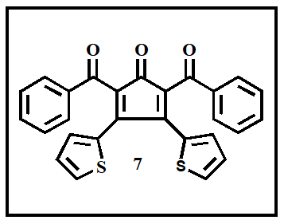
Yellow solid (Elution 10:90 ethyl acetate: hexane); yield: 60% (recovered yield: 81%); mp: 310-313 ℃.
IR (v cm⁻¹): 3014, 2967, 2853, 1717, 1660, 1665, 1612, 1425, 1259; ¹H NMR (400 MHz, CDCl₃) δ (ppm): 6.75-8.02 (m, 16 H); ¹³C NMR (100 MHz, CDCl₃) δ (ppm): 196.0, 173.8, 171.1, 147.2, 135.7, 135.2, 134.7, 134.5, 134.1, 132.0, 130.1, 129.4, 129.3, 129.1, 129.0, 128.8, 128.0, 127.9, 127.5, 126.0, 124.0; Anal. Cald (%) for C₂₇H₁₆O₃S₂: C, 71.66; H, 3.56; S, 14.17; Found: C, 71.63; H, 3.55; S, 14.20.

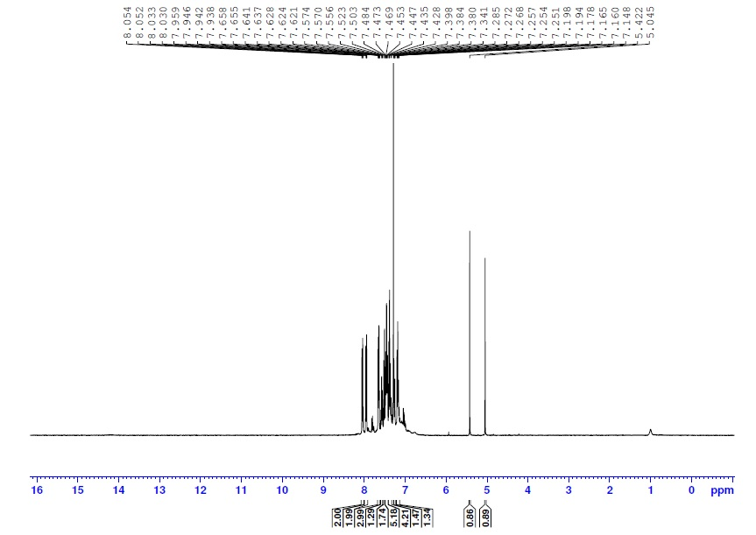
Figure 1: ¹H NMR spectrum of compound 3a

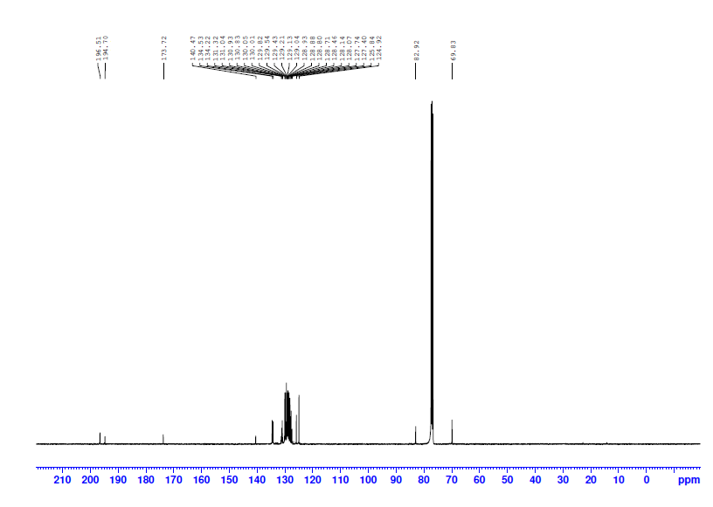
Figure 2: ¹³C NMR spectrum of compound 3a
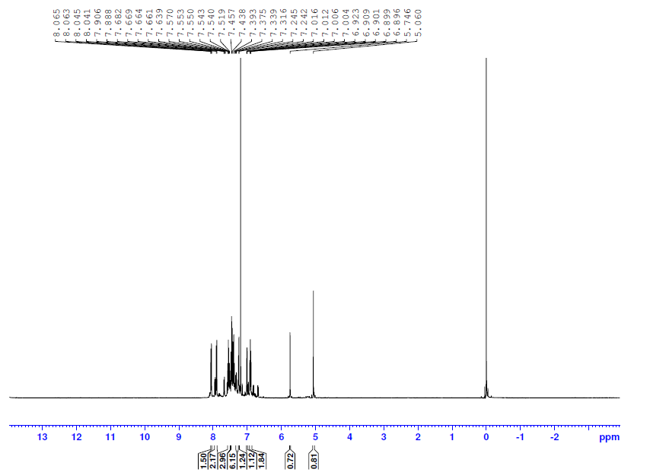
Figure 3: ¹H NMR spectrum of compound 3h
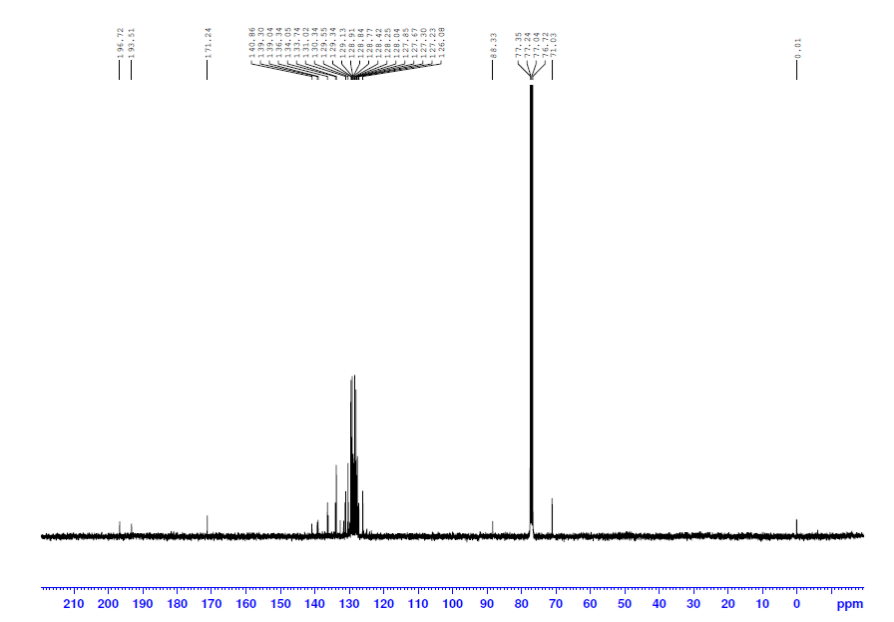
Figure 4: ¹³C NMR spectrum of compound 3h
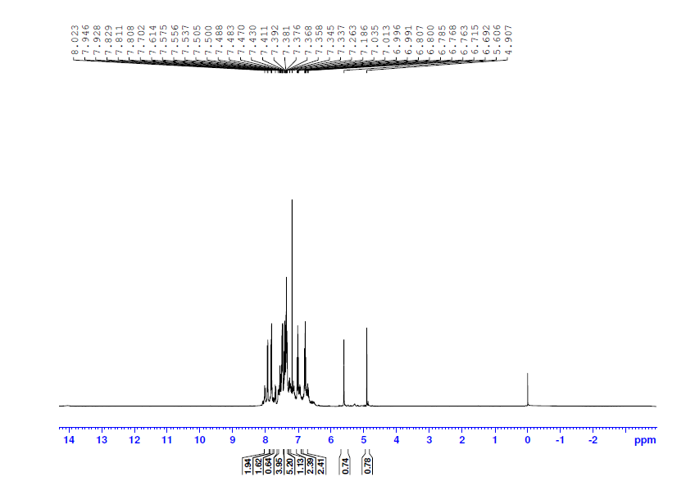
Figure 5: ¹H NMR spectrum of compound 3b
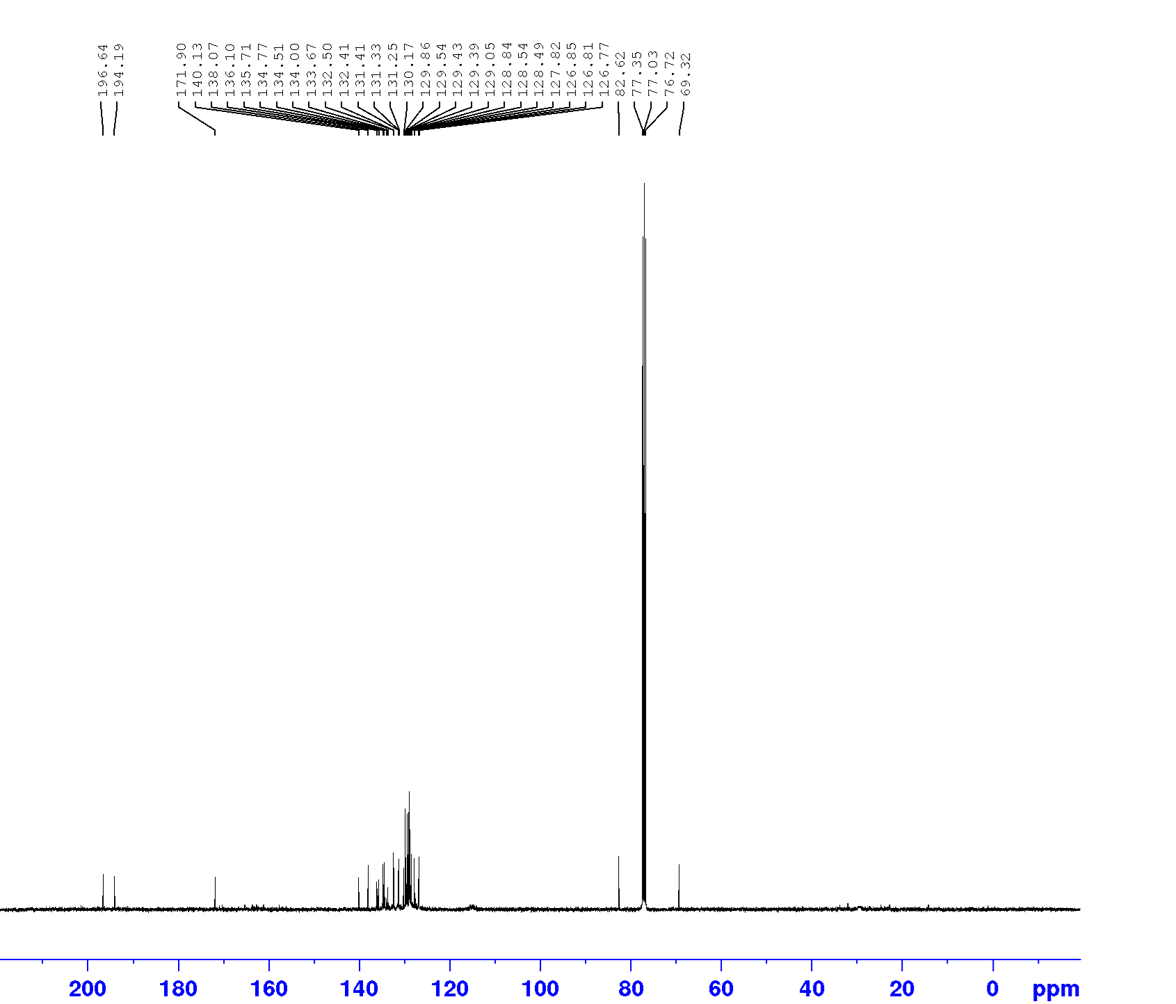
Figure 6: ¹³C NMR spectrum of compound 3b
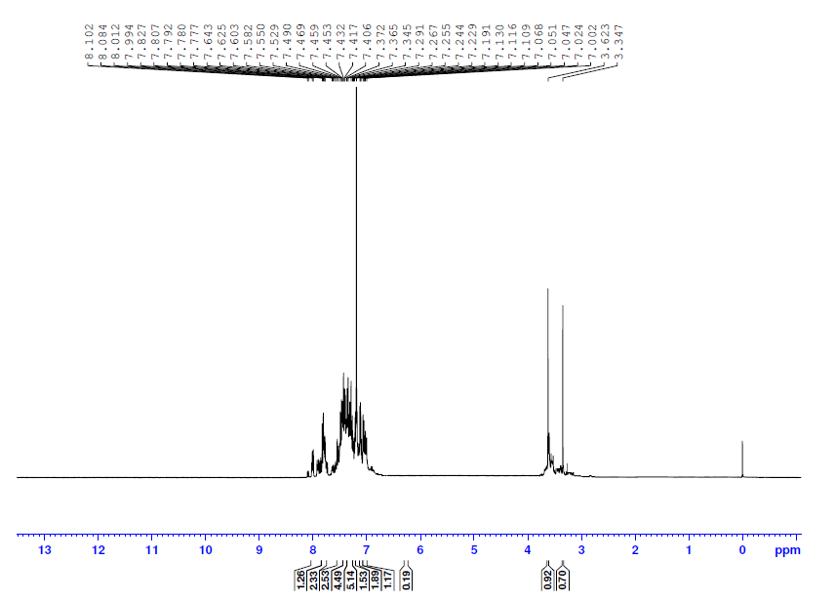Figure 7: ¹H NMR spectrum of compound 3c
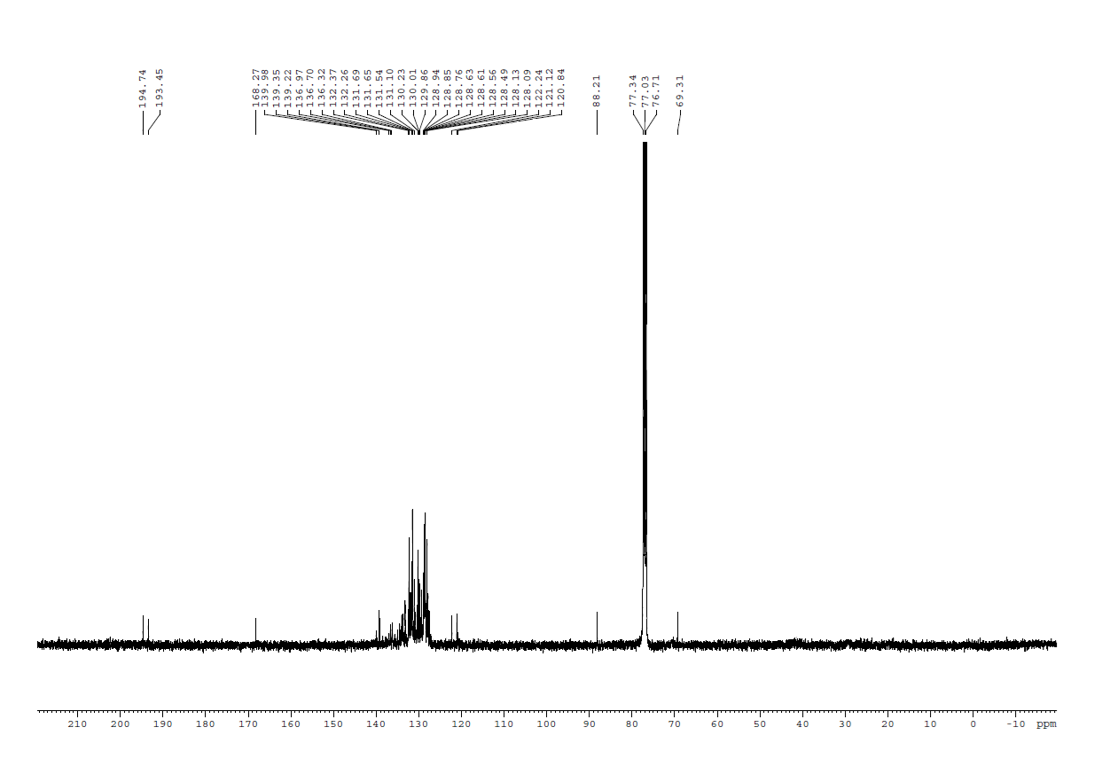Figure 8: ¹³C NMR spectrum of compound 3c
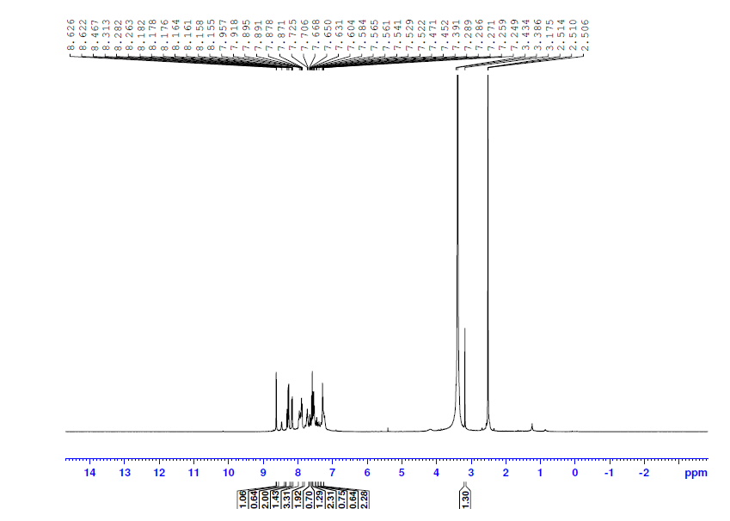
Figure 9: ¹H NMR spectrum of compound 3d
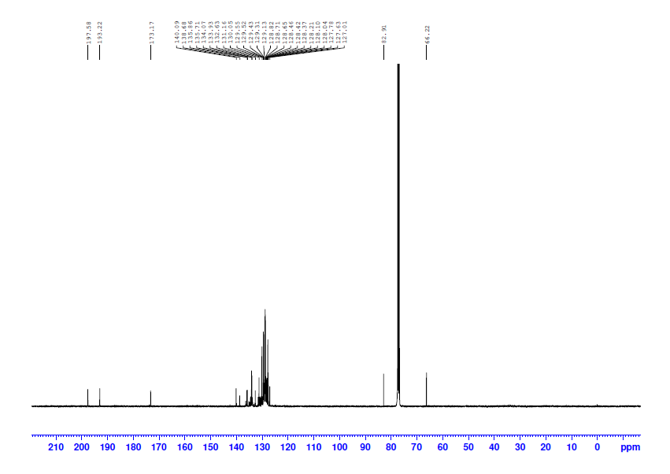
Figure 10: ¹³C NMR spectrum of compound 3d
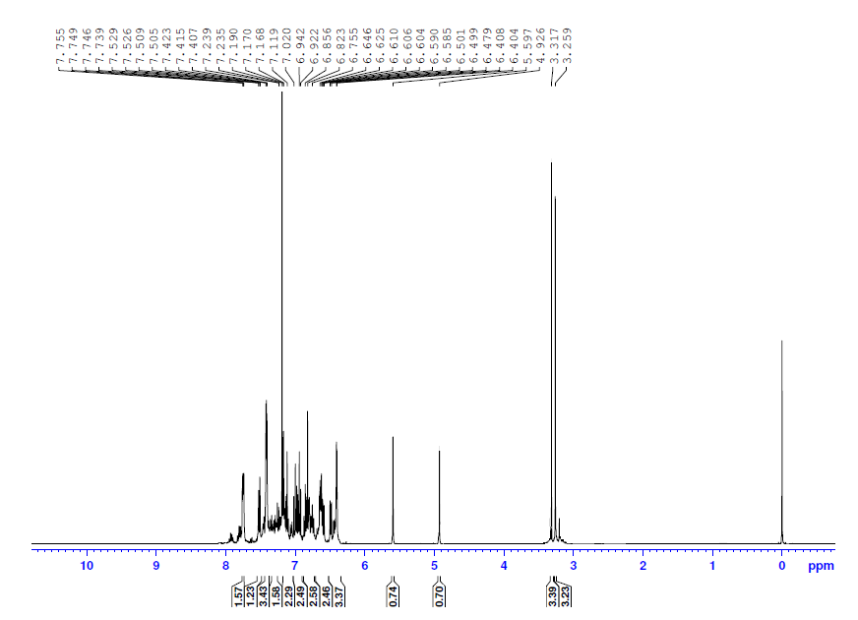
Figure 11: ¹H NMR spectrum of compound 3e
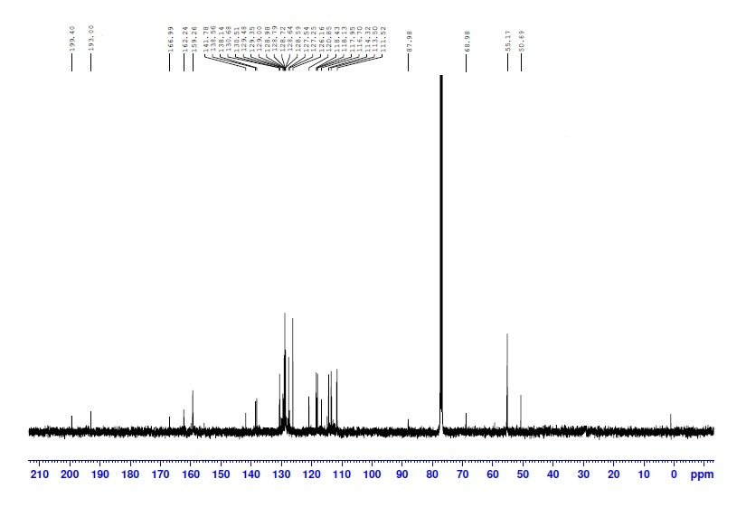
Figure 12: ¹³C NMR spectrum of compound 3e
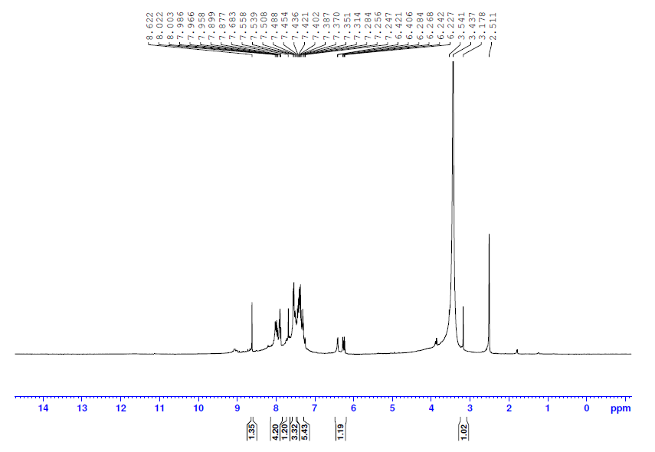
Figure 13: ¹H NMR spectrum of compound 3i
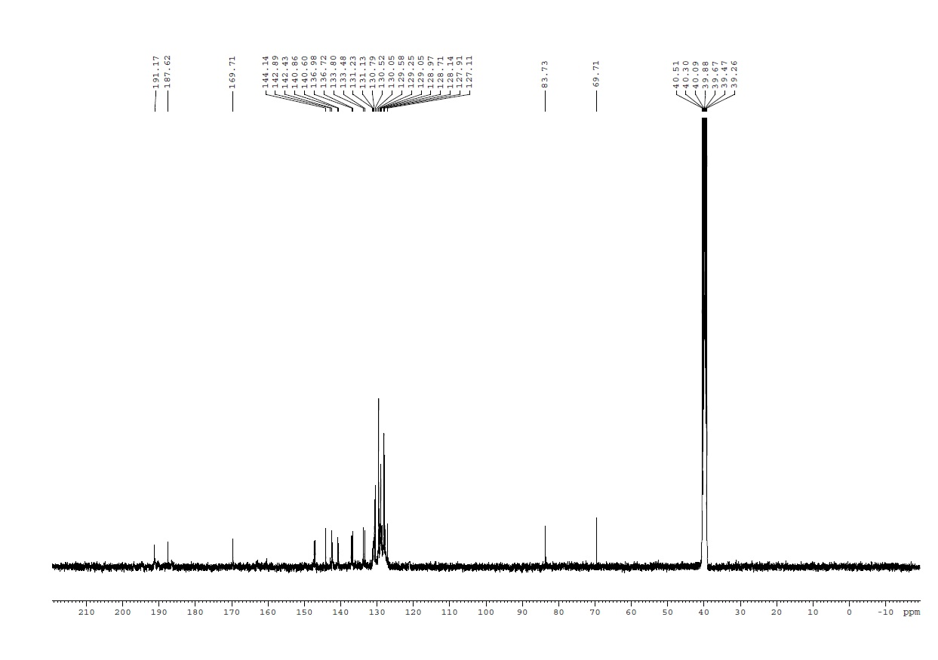
Figure 14: ¹³C NMR spectrum of compound 3i
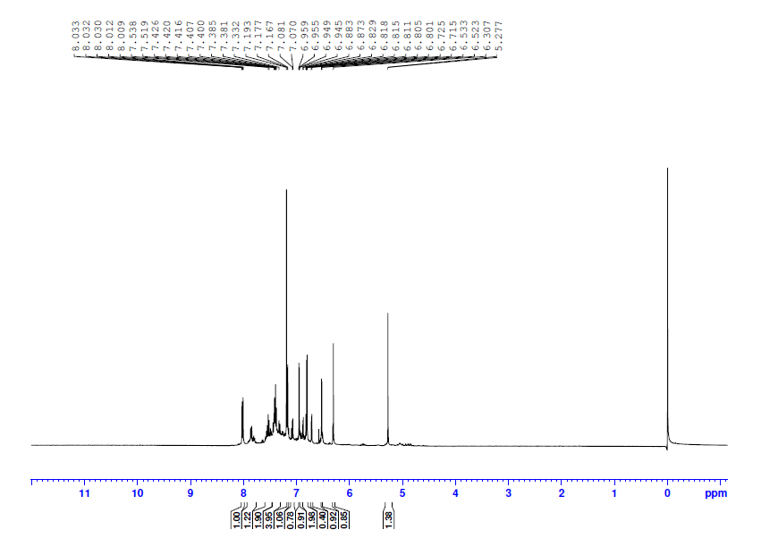
Figure 15: ¹H NMR spectrum of compound 3j
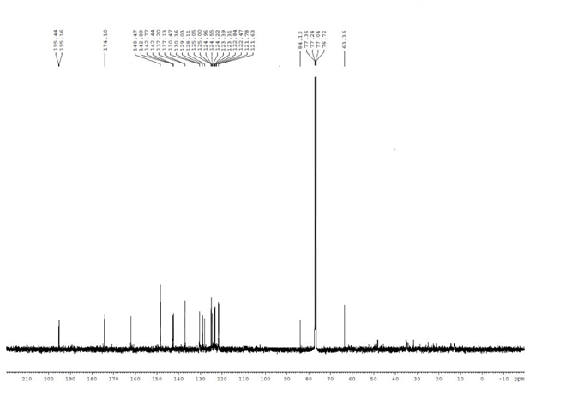Figure 16: ¹³C NMR spectrum of compound 3j
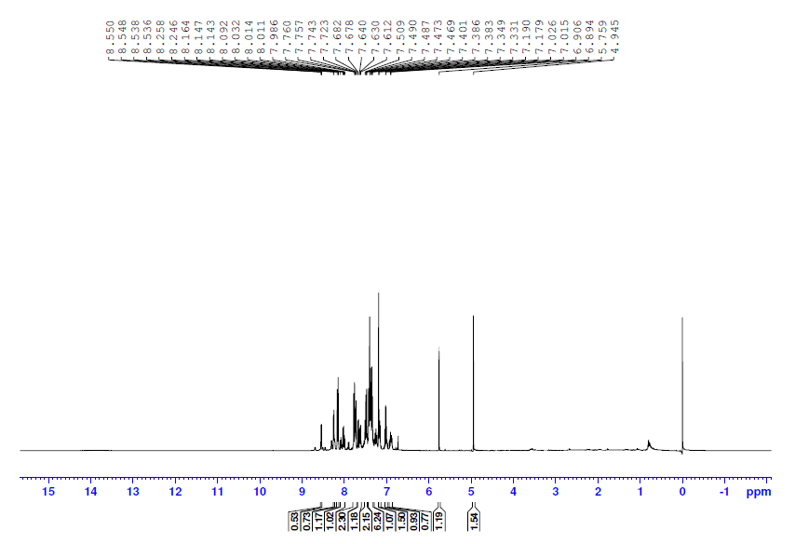
Figure 17: ¹H NMR spectrum of compound 3k
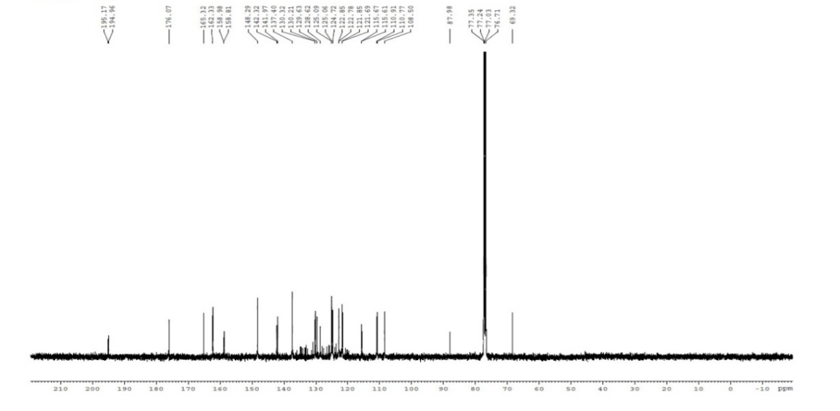
Figure 18: ¹³C NMR spectrum of compound 3k
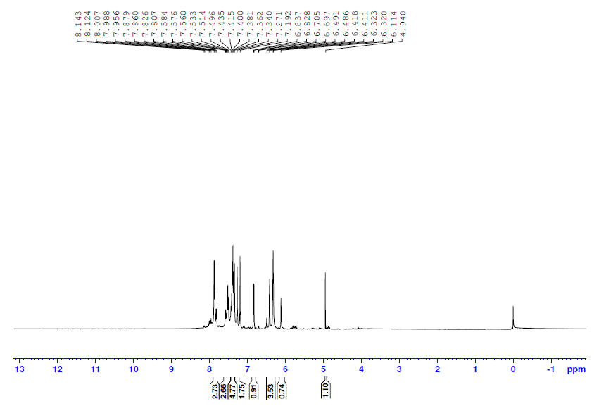
Figure 19: ¹H NMR spectrum of compound 3l
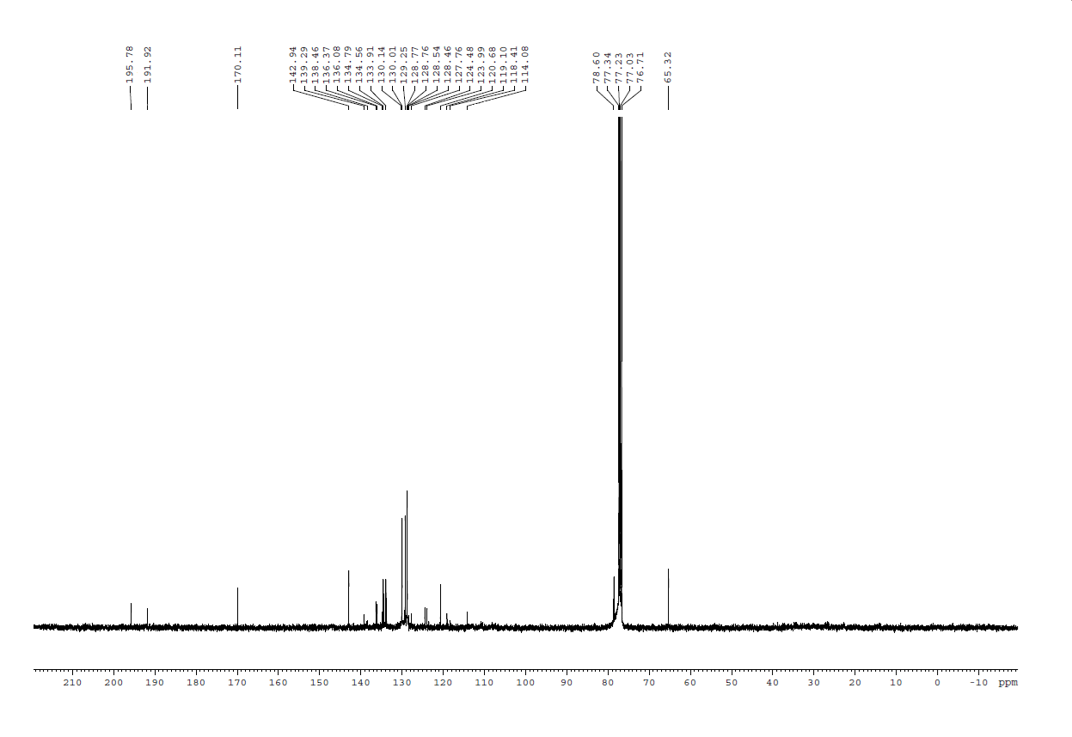Figure 20: ¹³C NMR spectrum of compound 3l
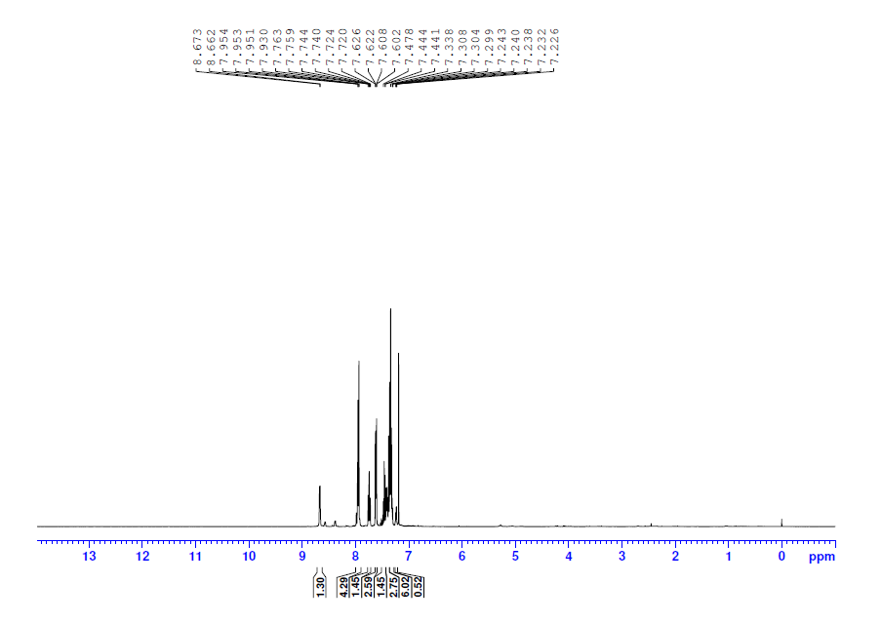
Figure 21: ¹H NMR spectrum of compound 5
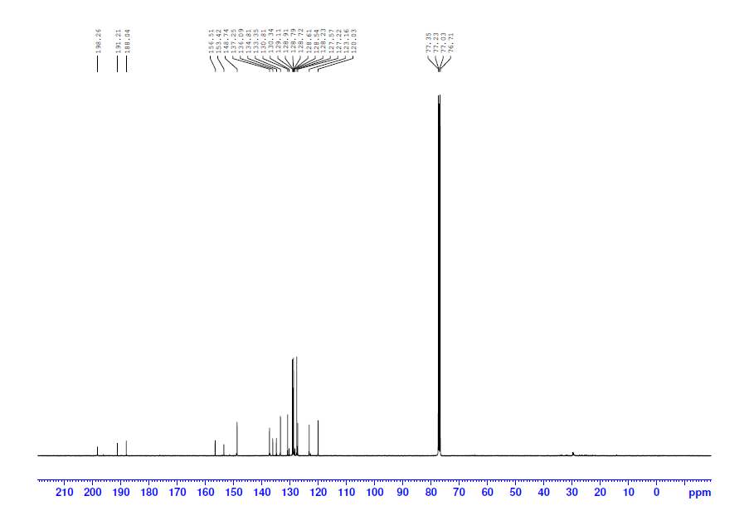
Figure 22: ¹³C NMR spectrum of compound 5
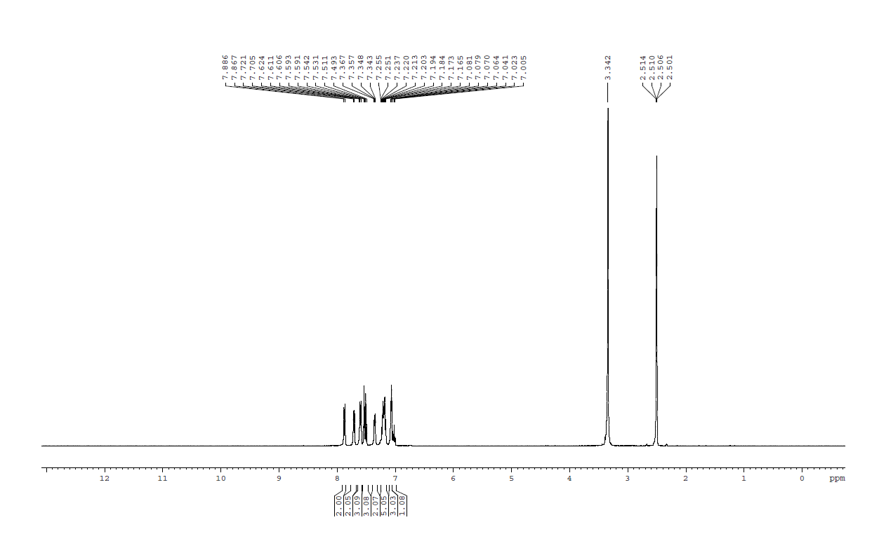Figure 23: ¹H NMR spectrum of compound 6
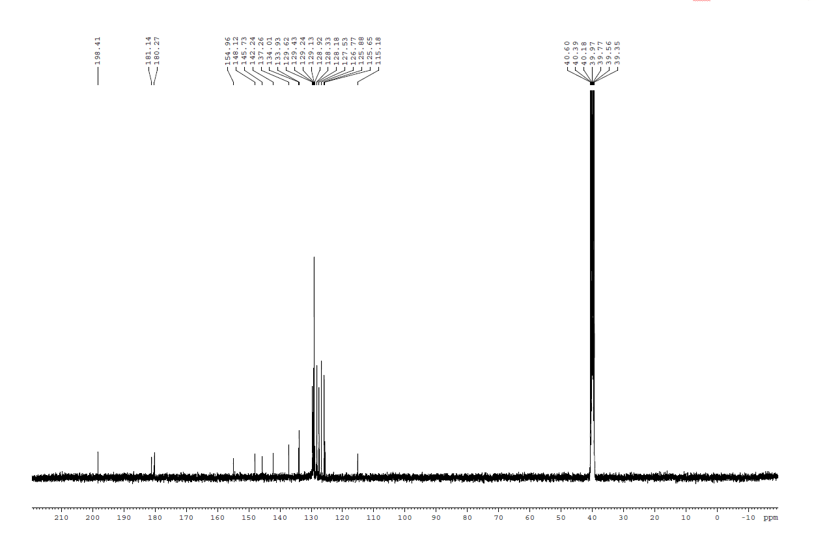
Figure 24: ¹³C NMR spectrum of compound 6
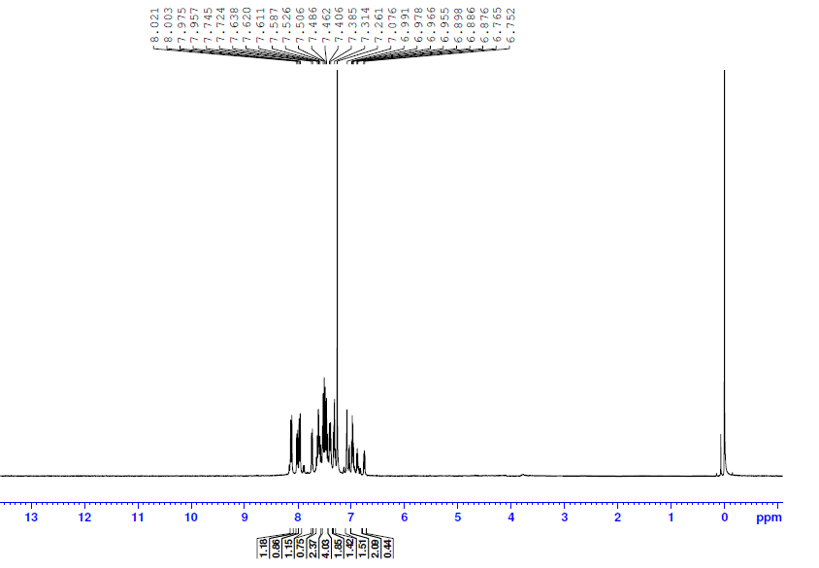
Figure 25: ¹H NMR spectrum of compound 7
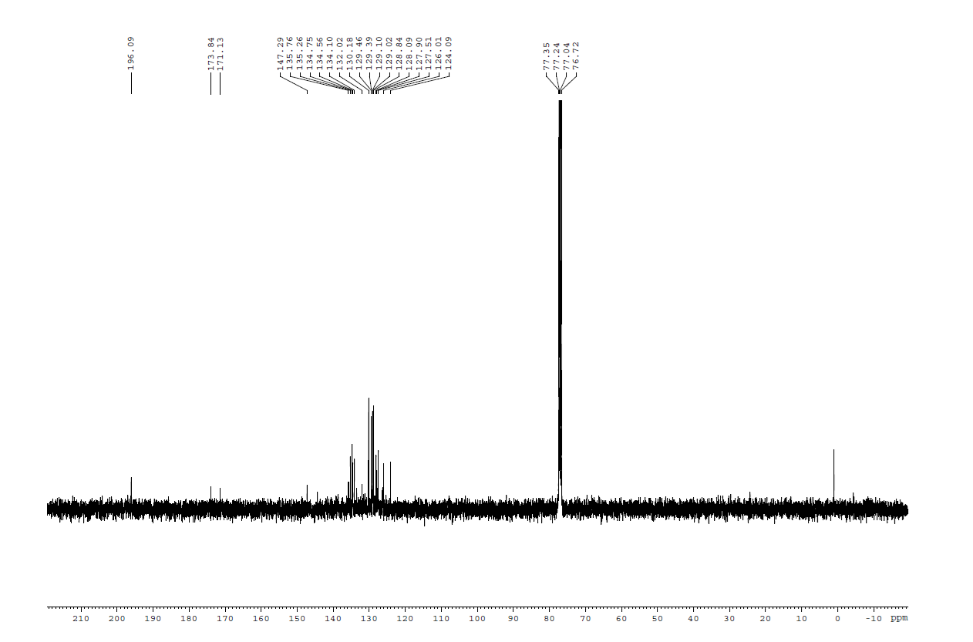
Figure 26: ¹³C NMR spectrum of compound 7

