A convenient synthesis and crystal structure of disubstituted 1,2,3-triazoles having ether functionality
Raj Luxmiª , C. P. Kaushik^{a,} *, Devinder Kumarª, Krishan Kumarª, Ashima Pahwaª, Jyoti Sangwanª, Manisha Chahalª

ªDepartment of Chemistry, Guru Jambheshwar University of Science & Technology, Hisar, Haryana-125001, India

* Corresponding author. Tel.: +91 1662 263152; fax: +91 1662 276240.
E-mail address: kaushikcp@gmail.com (C.P. Kaushik).

Experimental
The chemicals were purchased from Alfa-Aesar, Sigma-Aldrich and used without further puriﬁcation. Thin layer chromatography was used to monitor the progress of the reactions and visualized by UV light. Melting points were determined by capillary method and are uncorrected. IR spectra were recorded on a SHIMAZDU AFFINITY-I FT-IR spectrophotometer using KBr powder and the values are expressed in cm⁻¹. The ¹H NMR and ¹³C NMR spectra of the synthesized compounds were recorded at 400 MHz and 100 MHz, respectively, using Bruker Avance II 400 MHz NMR spectrometer in DMSO-d₆ solvent, and the chemical shifts were expressed in δ and coupling constants (J) in Hz. Splitting patterns were indicated as s: singlet, d: doublet, t: triplet, m: multiplet. HRMS were obtained using Waters Micromass Q-Tof Micro (ESI) spectrophotometer and values were quoted in m/z.

Procedure for synthesis of ether linked 1,4-disubstituted 1,2,3-triazoles
General procedure for synthesis of 1-substituted-4-(prop-2-yn-1-yloxy)benzene (3a-3c)^{[34]}: To the solution of 4-substituted phenols (1a-1c) (1.0 mmol) in dimethylformamide, propargyl bromide (2) (1.5 mmol) was added in the presence of potassium carbonate (2.0 mmol) at 25-35 °C with continuous stirring for 5-7 h. After the completion of reaction, dilute hydrochloric acid was added to reaction mixture and the product was extracted with the ethyl acetate. The organic layer was washed with brine solution and dried by using anhydrous sodium sulphate and evaporated the solvent under reduced pressure to get desired terminal alkynes (3a-3c).
General procedure for synthesis of aromatic azides^{[35]} (5a-5c): To the stirred cool solution of aminophenol (4a-4c) (1.0 mmol) in dichloromethane in a round bottomed flask, 6N hydrochloric acid was added. Further, a saturated solution of sodium nitrite (3.0 mmol) in water was added in small portions to the reaction contents. After half an hour, aqueous solution of sodium azide (3.0 mmol) was added in a drop wise manner to the reaction mixture at 0 °C. After the complete addition the reaction mixture was stirred for 2 h. The progress of the reaction was monitored by TLC. The product was extracted by using dichloromethane and organic layer was washed with sodium carbonate, dried with anhydrous sodium sulphate and evaporated the solvent to get the aromatic azides (5a-5c).
General procedure for synthesis of substituted azides (7a-7f): To the solution of azidophenol (5a-5c) (1.0 mmol) in dimethylformamide, (bromomethyl)benzene (6a)/ (2-bromoethyl)benzene (6b) (1.0 mmol) was added in the presence of potassium carbonate ((2.0 mmol) as base at room temperature with continuous stirring for 5-6 h. Thereafter ice cold water poured into the reaction mixture to precipitate solid. The solid product (7a-7f) was ﬁltered, washed with cool water.
General procedure for the synthesis of ether linked 1,4-disubstituted 1,2,3-triazoles (8a-8z₁): Ether linked 1,4-disubstituted 1,2,3-triazoles were synthesized by one pot click reaction of azide (5a-5c, 7a-7f) and terminal alkynes (3a-3c). To get the desired product, to a stirred solution of azide (5a-5c, 7a-7f) (1.0 mmol) and alkyne (3a-3c) (1.0 mmol) in dimethylformamide, copper sulphate pentahydrate (0.2 mmol) and sodium ascorbate (0.5 mmol) were added. The reaction mixture was stirred at room temperature for 4-7 h at 30-40 °C. After completion of reaction, ice cold water was added to reaction mixture. Product was precipitated, filtered and washed with ammonia solution. Crude product was dissolved in ethyl acetate and precipitated out by hexane, which was filtered and dried to get pure product in good yield.
Characterization of 1,4-disubstituted 1,2,3-triazoles (8a-8z₁)
2-(4-(Phenoxymethyl)-1H-1,2,3-triazol-1-yl)phenol (8a) Appearance: White solid; Yield: 86% ; m.p.: 152‒154 ºC; FTIR (KBr): 3362 (OH, str.), 3128 (C-H str., triazole ring), 3075 (C-H str., aromatic ring), 2937 (C-H str., aliphatic), 1580, 1477 (C=C str., aromatic ring), 1244, 1017 (C-O str., ether); ¹H NMR (400 MHz, DMSO-d₆): δ 5.23 (s, 2H, OCH₂), 6.95-7.14 (m, 5H, ArH), 7.31-7.36 (m, 3H, ArH), 7.61 (d, 1H, ArH, J = 8.0 Hz), 8.60 (s, 1H, CH-triazole), 10.59 (s, 1H, OH); ¹³C NMR (100 MHz, DMSO-d₆): δ 61.3 (OCH₂), 115.2, 117.5, 120.0 (C₅ triazole), 121.3, 124.9, 125.74, 126.71, 130.0, 130.7, 142.9 (C₄ triazole), 150.2, 158.6; HRMS (m/z) calculated for C₁₅H₁₃N₃O₂ [M+H]⁺: 268.1008, found: 268.1082.
3-(4-(Phenoxymethyl)-1H-1,2,3-triazol-1-yl)phenol (8b) Appearance: White solid; Yield: 90%; m.p.: 118‒120 ºC; FTIR (KBr): 3369 (OH, str.), 3125 (C-H str., triazole ring), 3070 (C-H str., aromatic ring), 2931 (C-H str., aliphatic), 1582, 1477 (C=C str., aromatic ring), 1232, 1015 (C-O str., ether); ¹H NMR (400 MHz, DMSO-d₆): δ 5.22 (s, 2H, OCH₂), 6.90 (d, 1H, ArH, J = 8.0 Hz), 6.97 (t, 1H, ArH, J = 8.0 Hz), 7.06 (d, 2H, ArH, J = 8.0 Hz), 7.30-7.41 (m, 5H, ArH), 8.89 (s, 1H, CH-triazole), 10.06 (s, 1H, OH); ¹³C NMR (100 MHz, DMSO-d₆): δ 60.7 (OCH₂), 106.9, 110.4, 114.6, 115.6, 120.9 (C₅ triazole), 122.7, 129.5, 130.7, 137.4, 143.7 (C₄ triazole), 157.9, 158.4; HRMS (m/z) calculated for C₁₅H₁₃N₃O₂ [M+H]⁺: 268.1008, found: 268.1081.
4-(4-(Phenoxymethyl)-1H-1,2,3-triazol-1-yl)phenol (8c) Appearance: White solid; Yield: 86%; m.p.: 94‒96 ºC; FTIR (KBr): 3374 (OH, str.), 3128 (C-H str., triazole ring), 3062 (C-H str., aromatic ring), 2937 (C-H str., aliphatic), 1600, 1475 (C=C str., aromatic ring), 1244, 1060 (C-O str., ether); ¹H NMR (400 MHz, DMSO-d₆): δ 5.21 (s, 2H, OCH₂), 6.99-6.93 (m, 3H, ArH), 7.07 (d, 2H, ArH, J = 8.0 Hz,), 7.32 (t, 2H, ArH, J = 8.0 Hz), 7.68 (d, 2H, ArH, J = 8.0 Hz), 8.76 (s, 1H, CH-triazole), 9.96 (s, 1H, OH); ¹³C NMR (100 MHz, DMSO-d₆): δ 61.4 (OCH₂), 115.2, 116.5, 121.4, 122.5 (C₅ triazole), 123.2, 129.2, 130.0, 144.0 (C₄ triazole), 158.3, 158.5; HRMS (m/z) calculated for C₁₅H₁₃N₃O₂ [M+H]⁺: 268.1008, found: 268.1081.
1-(2-(Benzyloxy)phenyl)-4-(phenoxymethyl)-1H-1,2,3-triazole (8d): Appearance: White solid; Yield: 93%: ; m.p.: 140‒142 ºC; FTIR (KBr): 3172 (C-H str., triazole ring), 3061 (C-H str., aromatic ring), 2941 (C-H str., aliphatic), 1589, 1465 (C=C str., aromatic ring), 1240, 1012 (C-O str., ether); ¹H NMR (400 MHz, DMSO-d₆): δ 5.22 (s, 2H, OCH₂), 5.25 (s, 2H, OCH₂), 6.97 (t, 1H, ArH, J = 8.0 Hz), 7.06 (d, 1H, ArH, J = 8.0 Hz), 7.17 (t, 1H, ArH, J = 8.0 Hz), 7.29-7.41 (m, 9H, ArH), 7.52 (d, 1H, ArH, J = 8.0 Hz), 7.66 (d, 1H, ArH, J = 8.0 Hz), 8.63 (s, 1H, CH-triazole); ¹³C NMR (100 MHz, DMSO-d₆): δ 60.8, 69.9 (OCH₂), 114.3, 114.6, 120.8 (C₅ triazole), 121.1, 125.9, 126.5, 127.2, 127.8, 128.3, 129.4, 130.6, 142.5 (C₄ triazole), 150.6, 157.9; HRMS (m/z) calculated for C₂₂H₁₉N₃O₂ [M+H]⁺: 358.1477, found: 358.1549.
1-(3-(Benzyloxy)phenyl)-4-(phenoxymethyl)-1H-1,2,3-triazole (8e): Appearance: White solid; Yield: 84%; m.p.: 146‒148 ºC; FTIR (KBr): 3156 (C-H str., triazole ring), 3068 (C-H str., aromatic ring), 2939 (C-H str., aliphatic), 1576, 1465 (C=C str., aromatic ring), 1234, 1018 (C-O str., ether); ¹H NMR (400 MHz, DMSO-d₆): δ 5.23-5.24 (m, 4H), 6.96-7.10 (m, 4H, ArH), 7.31-7.53 (m, 9H, ArH), 7.61 (s, 1H, ArH), 8.99 (s, 1H, CH-triazole). ¹³C NMR (100 MHz, DMSO-d₆): δ 61.4, 70.2 (OCH₂), 107.1, 114.4, 115.7, 121.2 (C₅ triazole), 121.4, 123.4, 128.2, 128.3, 128.6, 128.8, 128.9, 130.0, 131.4, 137.1, 138.1, 144.4 (C₄ triazole), 158.5, 159.8; HRMS (m/z) calculated for C₂₂H₁₉N₃O₂ [M+H]⁺: 358.1477, found: 358.1548.
1-(4-(Benzyloxy)phenyl)-4-(phenoxymethyl)-1H-1,2,3-triazole (8f): Appearance: White solid; Yield: 79% ; m.p.: 162‒165 ºC; FTIR (KBr): 3172 (C-H str., triazole ring), 3061 (C-H str., aromatic ring), 2941 (C-H str., aliphatic), 1558, 1465 (C=C str., aromatic ring), 1240, 1012 (C-O str., ether); ¹H NMR (400 MHz, DMSO-d₆): δ 5.20-5.22 (4H), 6.97 (t, 1H, ArH, J = 8.0 Hz), 7.08 (d, 2H, ArH, J = 8.0 Hz), 7.22-7.37 (m, 5H, ArH), 7.42 (t, 2H, ArH, J = 8.0 Hz), 7.49 (d, 2H, ArH, J = 8.0 Hz), 7.82 (d, 2H, ArH, J = 8 Hz), 8.85 (s, 1H, CH-triazole); ¹³C NMR (100 MHz, DMSO-d₆): δ 61.4, 70.1 (OCH₂), 115.2, 116.3, 121.4 (C₅ triazole), 122.3, 123.3, 128.2, 128.4, 129.0, 130.0, 130.6, 137.2, 144.2 (C₄ triazole), 158.5, 158.9; HRMS (m/z) calculated for C₂₂H₁₉N₃O₂ [M+H]⁺: 358.1477, found: 358.1549.
1-(2-Phenethoxyphenyl)-4-(phenoxymethyl)-1H-1,2,3-triazole (8g): Appearance: White solid; Yield: 93%; m.p.: 112‒114 ºC; FTIR (KBr): 3167 (C-H str., triazole ring), 3045 (C-H str., aromatic ring), 2932 (C-H str., aliphatic), 1575, 1444 (C=C str., aromatic ring), 1247, 1021 (C-O str., ether); ¹H NMR (400 MHz, DMSO-d₆): δ 3.20 (t, 2H, J = 8.0 Hz), 4.26 (t, 2H, J = 8.0 Hz, OCH₂), 5.22 (s, 2H, OCH₂), 6.97-7.00 (m, 1H, ArH), 7.06 (d, 1H, ArH, J = 8.0 Hz), 7.17 (t, 1H, ArH, J = 8.0 Hz), 7.28-7.40 (m, 9H, ArH), 7.52 (d, 1H, ArH, J = 8.0 Hz), 7.66 (d, 1H, ArH, J = 8.0 Hz), 8.63 (s, 1H, CH-triazole); ¹³C NMR (100 MHz, DMSO-d₆): δ 36.7 (CH₂), 60.8, 67.9 (OCH₂), 114.3, 114.6, 121.1, 120.8 (C₅ triazole), 125.9, 126.5, 127.2, 127.8, 128.3, 129.4, 130.6, 142.5 (C₄ triazole), 150.6, 157.9; HRMS (m/z) calculated for C₂₃H₂₁N₃O₂ [M+H]⁺: 372.1634, found: 372.2008.
1-(3-Phenethoxyphenyl)-4-(phenoxymethyl)-1H-1,2,3-triazole (8h): Appearance: White solid; Yield: 84%; m.p.: 154‒157 ºC; FTIR (KBr): 3172 (C-H str., triazole ring), 3061 (C-H str., aromatic ring), 2941 (C-H str., aliphatic), 1558, 1465 (C=C str., aromatic ring), 1243, 1018 (C-O str., ether); ¹H NMR (400 MHz, DMSO-d₆): δ 3.22 (t, J = 8.0 Hz, 2H) 4.24 (t, J = 8.0 Hz, 2H, OCH₂), 5.23 (s, 2H, OCH₂), 6.96-7.10 (m, 4H, ArH), 7.31-7.53 (m, 9H, ArH), 7.61 (s, 1H, ArH), 8.99 (s, 1H, CH-triazole); ¹³C NMR (100 MHz, DMSO-d₆): δ 36.5 (CH₂), 61.4, 67.7 (OCH₂), 107.1, 114.4, 115.7, 121.2 (C₅ triazole), 121.4, 123.3, 128.2, 128.3, 128.7, 128.9, 129.0, 130.0, 131.4, 137.1, 138.1, 144.4 (C₄ triazole), 158.5, 159.8; HRMS (m/z) calculated for C₂₃H₂₁N₃O₂ [M+H]⁺: 372. 1634, found: 372.2004.
1-(4-Phenethoxyphenyl)-4-(phenoxymethyl)-1H-1,2,3-triazole (8i): Appearance: White solid; Yield: 79%; m.p.: 120‒122 ºC; FTIR (KBr): 3184 (C-H str., triazole ring), 3053 (C-H str., aromatic ring), 2949 (C-H str., aliphatic), 1598, 1477 (C=C str., aromatic ring), 1228, 1015 (C-O str., ether); ¹H NMR (400 MHz, DMSO-d₆): δ 3.22 (t, 2H, J = 8.0 Hz), 4.24 (t, 2H, J = 8.0 Hz, OCH₂), 5.22 (s, 2H, OCH₂), 6.97 (t, 1H, ArH, J = 8.0 Hz), 7.08 (d, 2H, ArH, J = 8.0 Hz), 7.22-7.37 (m, 5H, ArH), 7.42 (t, 2H, ArH, J = 8.0 Hz), 7.51 (d, 2H, ArH, J = 8.0 Hz), 7.82 (d, 2H, J = 8.0 Hz), 8.85 (s, 1H, CH-triazole); ¹³C NMR (100 MHz, DMSO-d₆): δ 36.5 (CH₂), 61.4, 67.7 (OCH₂), 115.2, 116.3, 121.4 (C₅ triazole), 122.3, 123.3, 128.2, 128.4, 128.9, 130.0, 130.6, 137.2, 144.2 (C₄ triazole), 158.5, 158.9; HRMS (m/z) calculated for C₂₃H₂₁N₃O₂ [M+H]⁺: 372.1634, found: 372.2008.
2-(4-((p-Tolyloxy)methyl)-1H-1,2,3-triazol-1-yl)phenol (8j): Appearance: White solid; Yield: 92% ; m.p.: 160‒162 ºC; FTIR (KBr): 3365 (OH, str.), 3165 (C-H str., triazole ring), 3066 (C-H str., aromatic ring), 2972 (C-H str., aliphatic), 1600, 1471 (C=C str., aromatic ring), 1238, 1033 (C-O str., ether); ¹H NMR (400 MHz, DMSO-d₆): δ 2.25 (s, 3H, CH₃), 5.18 (s, 2H, OCH₂), 6.96-6.98 (m, 3H, ArH), 7.10-7.13 (m, 3H, ArH), 7.35 (d, 1H, ArH, J = 8.0 Hz), 7.61 (d, 1H, ArH, J = 8.0 Hz,), 8.58 (s, 1H, CH-triazole), 10.62 (s, 1H, OH); ¹³C NMR (100 MHz, DMSO-d₆): δ 20.5 (CH₃), 61.4 (OCH₂), 115.0, 117.6, 120.0 (C₅ triazole), 124.9, 125.7, 126.6, 129.9, 130.3, 143.2 (C₄ triazole), 150.2, 156.6; HRMS (m/z) calculated for C₁₆H₁₅N₃O₂ [M+H]⁺: 282.1164, found: 282.1192.
3-(4-((p-Tolyloxy)methyl)-1H-1,2,3-triazol-1-yl)phenol (8k): Appearance: White solid; Yield: 84%; m.p.: 136‒138 ºC; FTIR (KBr): 3372 (OH, str.), 3149 (C-H str., triazole ring), 3078 (C-H str., aromatic ring), 2932 (C-H str., aliphatic), 1597, 1456 (C=C str., aromatic ring), 1234, 1062 (C-O str., ether); ¹H NMR (400 MHz, DMSO-d₆): δ 2.24 (s, 3H, CH₃) 5.17 (s, 2H, OCH₂), 6.89 (d, 1H, ArH, J = 8.0 Hz), 6.96 (d, 2H, ArH, J = 8.0 Hz), 7.12 (d, 2H, ArH, J = 8.0 Hz), 7.32 (d, 2H, ArH, J = 8.0 Hz), 7.38 (t, 1H, ArH, J = 8.0 Hz), 8.88 (s, 1H, CH-triazole), 10.05 (s, 1H, OH); ¹³C NMR (100 MHz, DMSO-d₆): δ 20.6 (CH₃), 61.4 (OCH₂), 107.5, 111.0, 115.0, 116.2, 123.2 (C₅ triazole), 130.1, 130.3, 131.2, 138.0, 144.3 (C₄ triazole), 156.3, 158.9; HRMS (m/z) calculated for C₁₆H₁₅N₃O₂ [M+H]⁺: 282.1164, found: 282.1237
4-(4-((p-Tolyloxy)methyl)-1H-1,2,3-triazol-1-yl)phenol (8l): Appearance: White solid; Yield: 88%; m.p.: 150‒152 ºC; FTIR (KBr): 3375 (OH, str.), 3140 (C-H str., triazole ring), 3078 (C-H str., aromatic ring), 2939 (C-H str., aliphatic), 1602, 1483 (C=C str., aromatic ring), 1246, 1016 (C-O str., ether); ¹H NMR (400 MHz, DMSO-d₆): δ 2.24 (s, 3H, CH₃), 5.16 (s, 2H, OCH₂), 6.95-7.11 (m, 6H, ArH), 7.68 (s, 2H, ArH), 8.76 (s, 1H, CH-triazole), 9.95 (s, 1H, OH); ¹³C NMR (100 MHz, DMSO-d₆): δ 20.5 (CH₃), 61.5 (OCH₂), 115.0, 116.5, 122.5 (C₅ triazole), 123.1, 129.2, 130.1, 130.3, 144.3 (C₄ triazole), 156.4, 158.3; HRMS (m/z) calculated for C₁₆H₁₅N₃O₂ [M+H]⁺: 282.1164, found: 282.1230.
1-(2-(Benzyloxy)phenyl)-4-((p-tolyloxy)methyl)-1H-1,2,3-triazole (8m): Appearance: White solid; Yield: 89% ; m.p.: 168‒170 ºC; FTIR (KBr): 3172 (C-H str., triazole ring), 3059 (C-H str., aromatic ring), 2945 (C-H str., aliphatic), 1587, 1471 (C=C str., aromatic ring), 1242, 1014 (C-O str., ether); ¹H NMR (400 MHz, DMSO-d₆): δ 2.24 (s, 3H, CH₃), 5.18 (s, 2H, OCH₂), 5.25 (s, 2H, OCH₂), 6.94 (d, 2H, J = 8.0 Hz, ArH), 7.09-7.19 (m, 3H, ArH), 7.31-7.41 (m, 6H, ArH), 7.52 (t, 1H, ArH, J = 8.0 Hz), 7.66 (d, 1H, ArH, J = 8.0 Hz), 8.60 (s, 1H, CH-triazole); ¹³C NMR (100 MHz, DMSO-d₆): δ 20.6 (CH₃), 61.4, 70.5 (OCH₂), 114.9, 115.1, 121.7 (C₅ triazole), 127.0, 127.8, 128.4, 128.9, 130.3, 136.8, 143.2 (C₄ triazole), 151.2, 156.4. HRMS (m/z) calculated for C₂₃H₂₁N₃O₂ [M+H]⁺: 372.1634, found: 372.1706.
1-(3-(Benzyloxy)phenyl)-4-((p-tolyloxy)methyl)-1H-1,2,3-triazole(8n): Appearance: White solid; Yield: 84% ; m.p.: 154‒156 ºC; FTIR (KBr): 3159 (C-H str., triazole ring), 3061 (C-H str., aromatic ring), 2941 (C-H str., aliphatic), 1579, 1465 (C=C str., aromatic ring), 1235, 1017 (C-O str., ether); ¹H NMR (400 MHz, DMSO-d₆): δ 2.24 (s, 3H, CH₃) 5.19 (s, 2H, OCH₂), 5.22 (s, 2H, OCH₂), 6.96 (d, 2H, ArH, J = 8.0 Hz), 7.12 (m, 3H, ArH), 7.33-7.37 (m, 3H, ArH), 7.40-7.52 (m, 4H, ArH), 7.60 (s, 1H, ArH), 8.96 (s, 1H, CH-triazole); ¹³C NMR (100 MHz, DMSO-d₆): δ 20.6 (CH₃), 61.6, 70.2 (OCH₂), 107.1, 115.1, 115.6, 123.3 (C₅ triazole), 128.3, 128.5, 128.9, 130.3, 137.0, 138.0, 144.5 (C₄ triazole), 156.3, 159.7; HRMS (m/z) calculated for C₂₃H₂₁N₃O₂ [M+H]⁺: 372.1634, found: 372.1706.
1-(4-(Benzyloxy)phenyl)-4-((p-tolyloxy)methyl)-1H-1,2,3-triazole (8o): Appearance: white solid; Yield: 90%; m.p.: 118‒121 ºC; FTIR (KBr): 3126 (C-H str., triazole ring), 3082 (C-H str., aromatic ring), 2935 (C-H str., aliphatic), 1589, 1452 (C=C str., aromatic ring), 1242, 1010 (C-O str., ether); ¹H NMR (400 MHz, DMSO-d₆): δ 2.24 (s, 3H, CH₃) 5.17 (s, 2H), 5.20 (s, 2H), 6.96 (d, 2H, J = 8.0 Hz, ArH), 7.11 (d, 2H, J = 8.0 Hz, ArH), 7.23 (d, 2H, ArH, J = 12 Hz), 7.35-7.42 (m, 3H, ArH), 7.49 (d, 2H, ArH, J = 8.0 Hz), 7.82 (d, 2H, ArH, J = 12 Hz), 8.83 (s, 1H, CH-triazole); ¹³C NMR (100 MHz, DMSO-d₆): δ 20.6 (CH₃), 61.5, 70.1 (OCH₂), 115.0, 116.3, 122.3 (C₅ triazole), 123.2, 128.2, 128.4, 128.9, 130.1, 130.3, 137.2, 144.3 (C₄ triazole), 156.4, 158.8; HRMS (m/z) calculated for C₂₃H₂₁N₃O₂ [M+H]⁺: 372.1634, found: 372.1702.
1-(2-Phenethoxyphenyl)-4-((p-tolyloxy)methyl)-1H-1,2,3-triazole(8p): Appearance: White solid; Yield: 89% ; m.p.: 146‒148 ºC; FTIR (KBr): 3152 (C-H str., triazole ring), 3059 (C-H str., aromatic ring), 2936 (C-H str., aliphatic), 1586, 1456 (C=C str., aromatic ring), 1238, 1016 (C-O str., ether); ¹H NMR (400 MHz, DMSO-d₆): δ 2.24 (s, 3H, CH₃), 3.26 (t, 2H, J = 8.0 Hz), 4.67 (t, 2H, J = 8.0 Hz, OCH₂), 5.18 (s, 2H, OCH₂), 6.94 (d, 2H, ArH, J = 8.0 Hz), 7.09-7.16 (m, 3H, ArH), 7.33-7.41 (m, 6H, ArH), 7.52 (d, 1H, ArH, J = 8.0 Hz), 7.66 (d, 1H, ArH, J = 8.0 Hz), 8.60 (s, 1H, CH-triazole); ¹³C NMR (100 MHz, DMSO-d₆): δ 20.6 (CH₃), 36.7 (CH₂), 61.4, 67.7 (OCH₂), 114.9, 115.1, 121.7 (C₅ triazole), 127.0, 127.8, 128.4, 128.9, 130.3, 136.8, 143.2 (C₄ triazole), 151.2, 156.4; HRMS (m/z) calculated for C₂₄H₂₃N₃O₂ [M+H]⁺: 386.1790, found: 386.1876.
1-(3-Phenethoxyphenyl)-4-((p-tolyloxy)methyl)-1H-1,2,3-triazole (8q): Appearance: White solid; Yield: 84%; m.p.: 182‒184 ºC; FTIR (KBr): 3172 (C-H str., triazole ring), 3045 (C-H str., aromatic ring), 2939 (C-H str., aliphatic), 1577, 1463 (C=C str., aromatic ring), 1236, 1011 (C-O str., ether); ¹H NMR (400 MHz, DMSO-d₆): δ 2.24 (s, 3H, CH₃), 3.26 (t, 2H, J = 8.0 Hz), 4.67 (t, 2H, J = 8.0 Hz, OCH₂), 5.19 (s, 2H, OCH₂), 6.89 (d, 1H, ArH, J = 8.0 Hz), 6.96 (d, 2H, ArH, J = 8.0 Hz), 7.12 (m, 3H, ArH), 7.33-7.37 (m, 3H, ArH), 7.40-7.52 (m, 4H, ArH), 7.61 (s, 1H, ArH), 8.98 (s, 1H, CH-triazole); ¹³C NMR (100 MHz, DMSO-d₆): δ 20.6 (CH₃), 36.7 (CH₂), 61.6, 67.7 (OCH₂), 107.1, 115.1, 115.7, 123.3 (C₅ triazole), 128.3, 128.5, 128.9, 130.3, 137.0, 138.0, 144.5 (C₅ triazole), 156.3, 159.7. HRMS (m/z) calculated for C₂₄H₂₃N₃O₂ [M+H]⁺: 386.1790, found: 386.1876.
1-(4-Phenethoxyphenyl)-4-((p-tolyloxy)methyl)-1H-1,2,3-triazole (8r): Appearance: white solid; Yield: 90%; m.p.: 168‒170 ºC; FTIR (KBr): 3172 (C-H str., triazole ring), 3061 (C-H str., aromatic ring), 2941 (C-H str., aliphatic), 1558, 1465 (C=C str., aromatic ring), 1240, 1012 (C-O str., ether); ¹H NMR (400 MHz, DMSO): δ 2.24 (s, 3H, CH₃), 3.26 (t, 2H, J = 8.0 Hz), 4.67 (t, 2H, J = 8.0 Hz, OCH₂), 5.17 (s, 2H, OCH₂), 6.96 (d, 2H, ArH, J = 8.0 Hz), 7.11 (d, 2H, ArH), 7.22 (d, 2H, ArH), 7.35-7.45 (m, 5H, ArH), 7.82 (d, 2H, ArH, J = 12 Hz), 8.83 (s, 1H, CH-triazole); ¹³C NMR (100 MHz, DMSO): δ 20.6 (CH₃), 36.7 (CH₂), 61.6, 67.7 (OCH₂), 115.0, 116.3, 122.3 (C₅ triazole), 123.2, 128.2, 128.4, 128.9, 130.1, 130.3, 137.2, 144.3 (C₄ triazole), 156.4, 158.9; HRMS (m/z) calculated for C₂₄H₂₃N₃O₂ [M+H]⁺: 386.1790, found: 386.1870.
2-(4-((4-Nitrophenoxy)methyl)-1H-1,2,3-triazol-1-yl)phenol (8s): Appearance: white solid; Yield: 94%; m.p.: 184‒186 ºC; FTIR (KBr): 3362 (OH, str.), 3176 (C-H str., triazole ring), 3082 (C-H str., aromatic ring), 2974 (C-H str., aliphatic), 1595, 1475 (C=C str., aromatic ring), 1508 (N-O asym. str., NO₂), 1350 (N-O sym. str., NO₂), 1240, 1001 (C-O str., ether); ¹H NMR (400 MHz, DMSO-d₆): δ 5.42 (s, 2H, OCH₂) 7.00 (t, 1H, ArH, J = 8.0 Hz), 7.12 (d, 1H, ArH, J = 8.0 Hz), 7.32-7.38 (m, 3H, ArH), 7.61 (d, 1H, ArH, J = 8.0 Hz), 8.25 (d, 2H, ArH, J = 8.0 Hz), 8.67 (s, 1H, CH-triazole), 10.59 (s, 1H, OH); ¹³C NMR (100 MHz, DMSO-d₆): δ 62.3 (OCH₂), 115.8, 117.5, 120.0 (C₅ triazole), 124.9, 125.7, 126.3, 127.2, 130.8, 141.5, 141.9 (C₄ triazole), 150.2, 163.8. HRMS (m/z) calculated for C₁₅H₁₂N₄O₄ [M+H]⁺: 313.0859, found: 313.0930.
3-(4-((4-Nitrophenoxy)methyl)-1H-1,2,3-triazol-1-yl)phenol (8t): Appearance: white solid; Yield: 89%; m.p.: 148‒150 ºC; FTIR (KBr): 3365 (OH, str.), 3172 (C-H str., triazole ring), 3081 (C-H str., aromatic ring), 2941 (C-H str., aliphatic), 1589, 1465 (C=C str., aromatic ring), 1513 (N-O asym. str., NO₂), 1348 (N-O sym. str., NO₂), 1240, 1012 (C-O str., ether); ¹H NMR (400 MHz, DMSO-d₆): δ 5.41 (s, 2H, OCH₂), 6.90 (d, 1H, ArH, J = 8.0 Hz), 7.30-7.41 (m, 5H, ArH), 8.25 (d, 2H, ArH, J = 12 Hz), 8.94 (s, 1H, CH-triazole), 10.07 (s, 1H, OH); ¹³C NMR (100 MHz, DMSO-d₆): δ 62.3 (OCH₂), 107.6, 111.0, 115.9, 116.3, 123.7 (C₅ triazole), 126.4, 131.3, 137.9, 141.6, 143.3 (C₄ triazole), 159.0, 163.6; HRMS (m/z) calculated for C₁₅H₁₂N₄O₄ [M+H]⁺: 313.0859, found: 313.0930.
4-(4-((4-Nitrophenoxy)methyl)-1H-1,2,3-triazol-1-yl)phenol (8u): Appearance: yellow solid; Yield: 84%; m.p.: 150‒152 ºC; FTIR (KBr): 3380 (OH, str.), 3159 (C-H str., triazole ring), 3088 (C-H str., aromatic ring), 2947 (C-H str., aliphatic), 1597, 1475 (C=C str., aromatic ring), 1519 (N-O asym. str., NO₂), 1342 (N-O sym. str., NO₂), 1251, 1015 (C-O str., ether); ¹H NMR (400 MHz, DMSO): δ 5.40 (s, 2H, OCH₂), 6.95 (d, 2H, ArH, J = 8.0 Hz), 7.31 (d, 2H, ArH, J = 8.0 Hz), 7.67 (d, 2H, ArH, J = 8.0 Hz), 8.24 (d, 2H, ArH, J = 8.0 Hz), 8.81 (s, 1H, CH-triazole), 9.97 (s, 1H, OH); ¹³C NMR (100 MHz, DMSO): δ 62.4 (OCH₂), 115.9, 116.5, 122.6 (C₅ triazole), 123.6, 126.4, 129.1, 141.6, 143.0 (C₄ triazole), 158.4, 163.7; HRMS (m/z) calculated for C₁₅H₁₂N₄O₄ [M+H]⁺: 313.0859, found: 313.0931.
1-(2-(Benzyloxy)phenyl)-4-((4-nitrophenoxy)methyl)-1H-1,2,3-triazole (8v): Appearance: white solid; Yield: 87%; m.p.: 104‒106 ºC; FTIR (KBr): 3186 (C-H str., triazole ring), 3086 (C-H str., aromatic ring), 2939 (C-H str., aliphatic), 1597, 1456 (C=C str., aromatic ring), 1514 (N-O asymm. str., NO₂), 1348 (N-O symm. str., NO₂), 1267, 1014 (C-O str., ether); ¹H NMR (400 MHz, DMSO-d₆): δ 5.24 (s, 2H, OCH₂), 5.42 (s, 2H, OCH₂), 7.15 (t, 1H, J = 8.0 Hz, ArH), 7.38-7.42 (m, 8H, ArH), 7.53 (t, 1H, ArH, J = 8.0 Hz), 7.66 (d, 1H, ArH, J = 8.0 Hz), 8.22 (d, 2H, ArH, J = 8.0 Hz), 8.69 (s, 1H, CH-triazole); ¹³C NMR (100 MHz, DMSO-d₆): δ 62.3, 70.6 (OCH₂), 114.9, 115.8, 121.7 (C₅ triazole), 126.3, 126.5, 127.5, 127.8, 128.4, 128.9, 136.8, 141.6, 142.1 (C₄ triazole), 151.2, 163.7; HRMS (m/z) calculated for C₂₂H₁₈N₄O₄ [M+H]⁺: 403.1328, found: 403.1411.
1-(3-(Benzyloxy)phenyl)-4-((4-nitrophenoxy)methyl)-1H-1,2,3-triazole (8w): Appearance: white solid; Yield: 90%; m.p.: 162‒164 ºC; FTIR (KBr): 3183 (C-H str., triazole ring), 3076 (C-H str., aromatic ring), 2941 (C-H str., aliphatic), 1558, 1465 (C=C str., aromatic ring), 1514 (N-O asym. str., NO₂), 1350 (N-O sym. str., NO₂), 1240, 1012 (C-O str., ether); ¹H NMR (400 MHz, DMSO-d₆): δ 5.22 (s, 2H, OCH₂), 5.43 (s, 2H, OCH₂), 7.13-7.19 (m, 1H, ArH), 7.30-7.38 (m, 3H, ArH), 7.42 (t, 2H, ArH, J = 8.0 Hz), 7.48-7.54 (m, 4H, ArH), 7.60 (s, 1H, ArH), 8.24 (d, 2H, ArH, J = 8.0 Hz), 9.02 (s, 1H, C-H triazole). ¹³C NMR (100 MHz, DMSO-d₆): δ 62.4, 70.2 (OCH₂), 107.3, 112.9, 115.8, 115.9, 123.8 (C₅ triazole), 126.4, 128.3, 128.5, 129.0, 131.4, 137.1, 138.0, 141.7, 143.4 (C₄ triazole), 159.8, 163.7; HRMS (m/z) calculated for C₂₂H₁₈N₄O₄ [M+H]⁺: 403.1328, found: 403.1409
1-(4-(Benzyloxy)phenyl)-4-((4-nitrophenoxy)methyl)-1H-1,2,3-triazole (8x): Appearance: white solid; Yield: 92%; m.p.: 150‒152 ºC; FTIR (KBr): 3170 (C-H str., triazole ring), 3082 (C-H str., aromatic ring), 2980 (C-H str., aliphatic), 1591, 1454 (C=C str., aromatic ring), 1512 (N-O asym. str., NO₂), 1338 (N-O sym. str., NO₂), 1253, 1033 (C-O str., ether); ¹H NMR (400 MHz, DMSO-d₆): δ 5.20 (s, 2H, OCH₂), 5.41 (s, 2H, OCH₂), 7.23 (d, 2H, ArH, J = 8.0 Hz), 7.30-7.44 (m, 5H, ArH), 7.49 (d, 2H, ArH J = 8.0 Hz), 7.82 (d, 2H, ArH, J = 8.0 Hz), 8.24 (d, 2H, ArH, J = 8.0 Hz), 8.89 (s, 1H, CH-triazole); ¹³C NMR (100 MHz, DMSO-d₆): δ 62.4, 70.1 (OCH₂), 115.9, 116.3, 122.4 (C₅ triazole), 123.7, 126.4, 128.2, 128.4, 128.9, 130.5, 137.1, 141.6, 143.2 (C₄ triazole), 158.9, 163.7; HRMS (m/z) calculated for C₂₂H₁₈N₄O₄ [M+H]⁺: 403.1328, found: 403.1409.
4-((4-Nitrophenoxy)methyl)-1-(2-phenethoxyphenyl)-1H-1,2,3-triazole (8y): Appearance: white solid; Yield: 87%; m.p.: 162‒164 ºC; FTIR (KBr): 3178 (C-H str., triazole ring), 3065 (C-H str., aromatic ring), 2939 (C-H str., aliphatic), 1576, 1455 (C=C str., aromatic ring), 1512 (N-O asym. str., NO₂), 1348 (N-O sym. str., NO₂), 1238, 1017 (C-O str., ether); ¹H NMR (400 MHz, DMSO-d₆): δ 3.20 (t, 2H, J = 8.0 Hz) 4.60 (t, 2H, J = 8.0 Hz, OCH₂), 5.42 (s, 2H, OCH₂), 7.17 (t, 1H, ArH, J = 8.0 Hz), 7.28-7.44 (m, 8H, ArH), 7.53 (t, 1H, ArH, J = 8.0 Hz), 7.66 (d, 1H, ArH, J = 8.0 Hz), 8.22 (d, 2H, ArH, J = 8.0 Hz), 8.69 (s, 1H, CH-triazole); ¹³C NMR (100 MHz, DMSO-d₆): δ 36.7 (CH₂), 62.3, 67.7 (OCH₂), 114.9, 115.8, 121.7 (C₅ triazole), 126.3, 126.5, 127.5, 127.8, 128.4, 128.9, 136.8, 141.6, 142.1 (C₄ triazole), 151.2, 163.7; HRMS (m/z) calculated for C₂₃H₂₀N₄O₄ [M+H]⁺: 417.1485, found: 417.1566.
4-((4-Nitrophenoxy)methyl)-1-(3-phenethoxyphenyl)-1H-1,2,3-triazole (8z): Appearance: white solid; Yield: 90%; m.p.: 149‒152 ºC; FTIR (KBr): 3186 (C-H str., triazole ring), 3056 (C-H str., aromatic ring), 2938 (C-H str., aliphatic), 1576, 1454 (C=C str., aromatic ring), 1508 (N-O asym. str., NO₂), 1350 (N-O sym. str., NO₂), 1237, 1018 (C-O str., ether); ¹H NMR (400 MHz, DMSO-d₆): δ 3.20 (t, 2H, J = 8.0 Hz), 4.60 (t, 2H J = 8.0 Hz, OCH₂), 5.43 (s, 2H, OCH₂), 7.13-7.19 (m, 1H, ArH), 7.30-7.38 (m, 3H, ArH), 7.42 (t, 2H, ArH, J = 8.0 Hz), 7.48-7.54 (m, 4H, ArH), 7.60 (s, 1H, ArH), 8.24 (d, 2H, ArH, J = 8.0 Hz), 9.02 (s, 1H, C-H triazole); ¹³C NMR (100 MHz, DMSO-d₆): δ 36.7 (CH₂), 62.3, 67.7 (OCH₂), 107.3, 112.9, 115.8, 115.9, 123.8 (C₅ triazole), 126.4, 128.3, 128.5, 128.9, 131.4, 137.1, 138.0, 141.6, 143.4 (C₄ triazole), 159.8, 163.7; HRMS (m/z) calculated for C₂₃H₂₀N₄O₄ [M+H]⁺: 417.1485, found: 417.1566.
4-((4-Nitrophenoxy)methyl)-1-(4-phenethoxyphenyl)-1H-1,2,3-triazole (8z₁): Appearance: white solid; Yield: 92%; m.p.: 184‒186 ºC; FTIR (KBr): 3174 (C-H str., triazole ring), 3070 (C-H str., aromatic ring), 2969 (C-H str., aliphatic), 1538, 1475 (C=C str., aromatic ring), 1512 (N-O asym. str., NO₂), 1345 (N-O sym. str., NO₂), 1244, 1016 (C-O str., ether); ¹H NMR (400 MHz, DMSO-d₆) δ 3.20 (t, 2H, J = 8.0 Hz), 4.60 (t, 2H, J = 8.0 Hz, OCH₂), 5.41 (s, 2H, OCH₂), 7.23 (d, 2H, ArH, J = 8.0 Hz), 7.31-7.44 (m, 5H, ArH), 7.49 (d, 2H, ArH, J = 8.0 Hz), 7.82 (d, 2H, ArH, J = 8.0 Hz), 8.25 (d, 2H, ArH, J = 8.0 Hz), 8.89 (s, 1H, CH-triazole); ¹³C NMR (100 MHz, DMSO-d₆): δ 36.7 (CH₂), 62.4, 68.1 (OCH₂), 115.9, 116.3, 122.4 (C₅ triazole), 123.7, 126.4, 128.2, 128.4, 128.9, 130.5, 137.1, 141.6, 143.2 (C₄ triazole), 158.9, 163.7; HRMS (m/z) calculated for C₂₃H₂₀N₄O₄ [M+H]⁺: 417.1485, found: 417.1560.
Single X-ray Crystallography
Single crystals of compounds 8c and 8f were selected and determined on a SuperNova, Single source at offset, Titan diffractometer. The crystal was kept at 293 K during data collection. Using Olex2, the structure was solved with the ShelXT^{[36]} structure solution program using Direct Methods and refined with the ShelXL^{[37]} refinement package using Least Squares minimization.

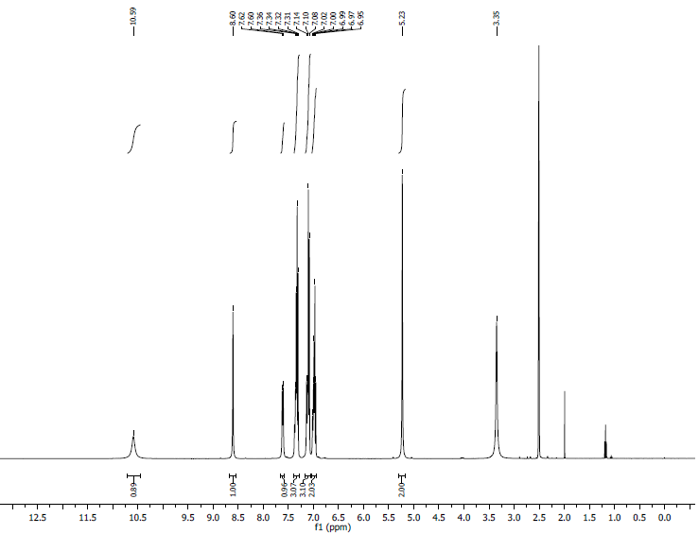
¹H NMR Spectra: 8a

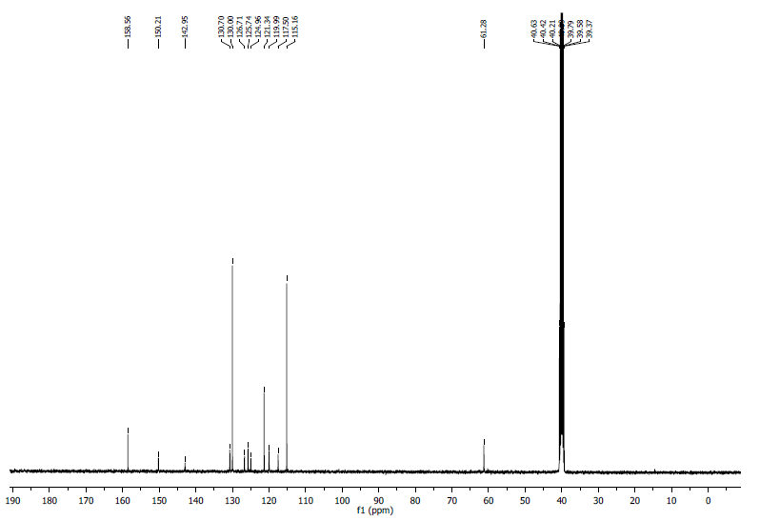
¹³C NMR spectra: 8a

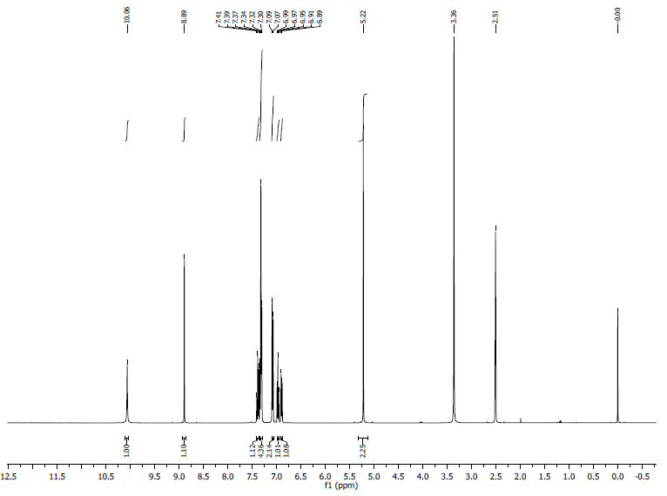
¹H NMR Spectra: 8b

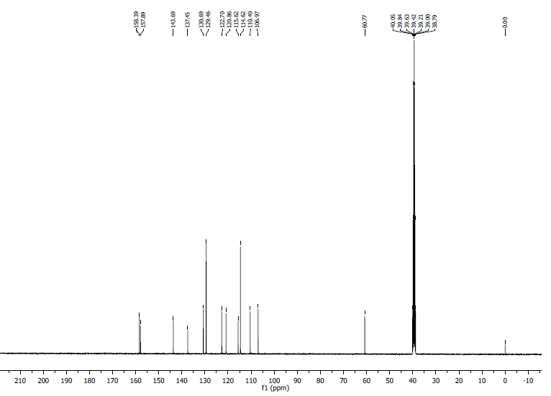
¹³C NMR Spectra: 8b

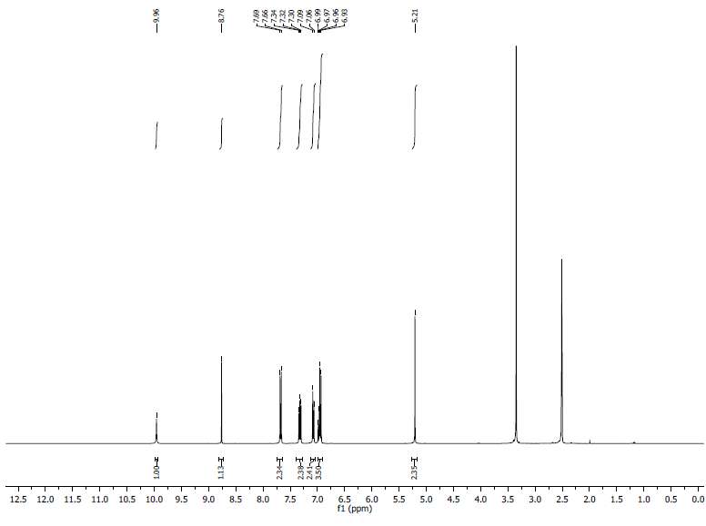

¹H NMR Spectra: 8c

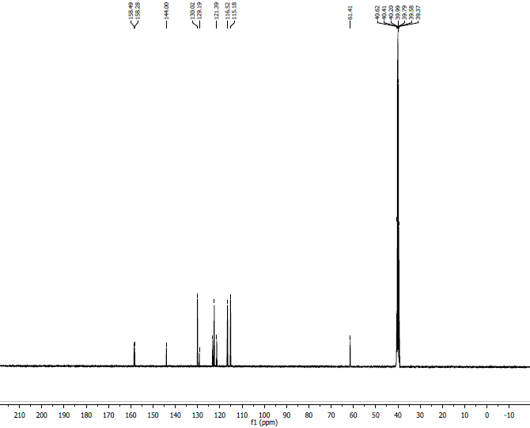
¹³C NMR Spectra: 8c

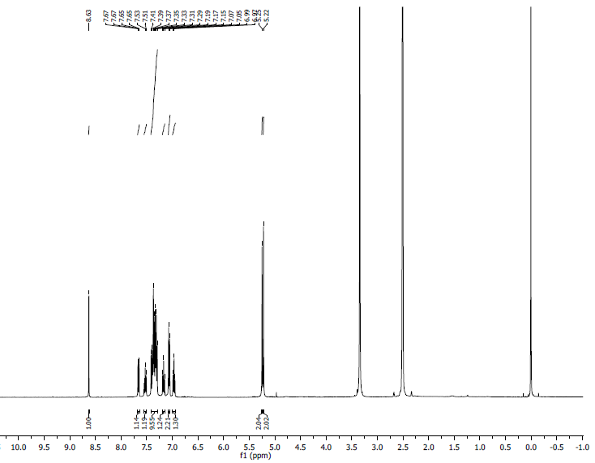

¹H NMR Spectra: 8d

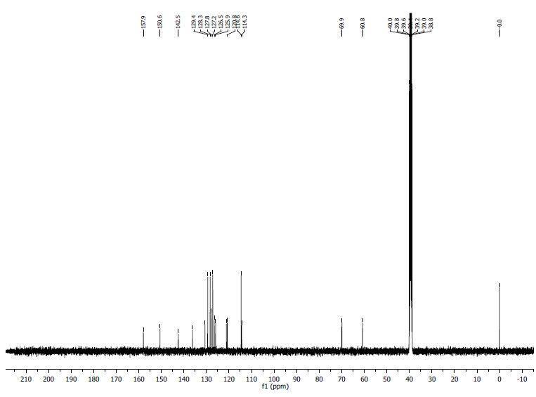
¹³C NMR Spectra: 8d

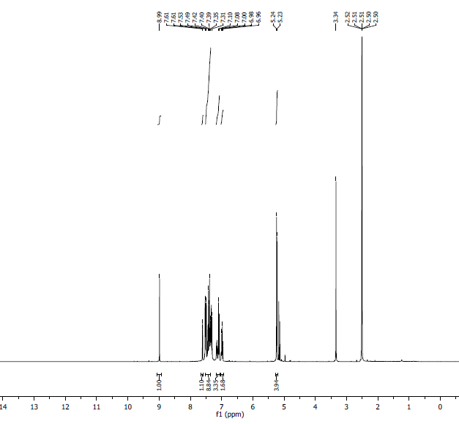

¹H NMR Spectra: 8e

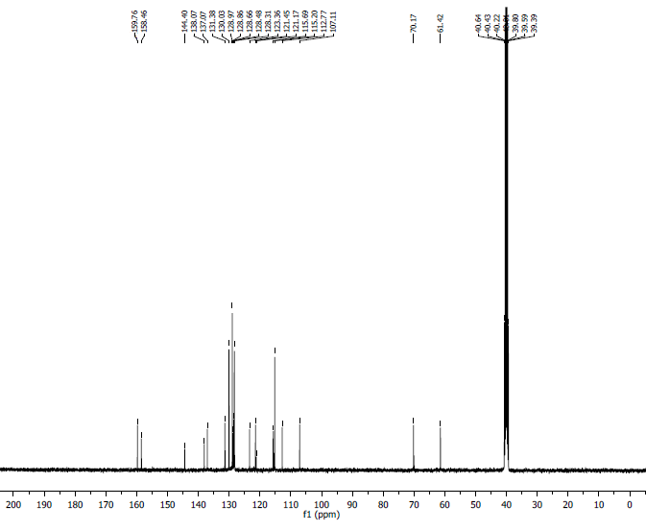

¹³C NMR Spectra: 8e

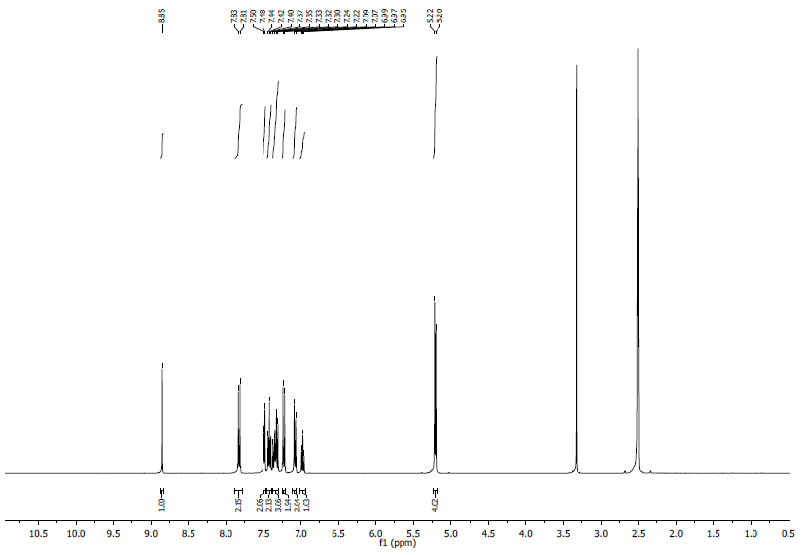

¹H NMR Spectra: 8f
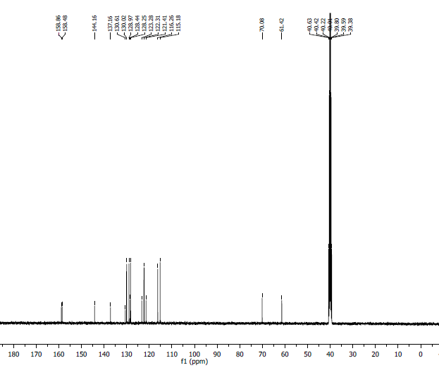
¹³C NMR Spectra: 8f
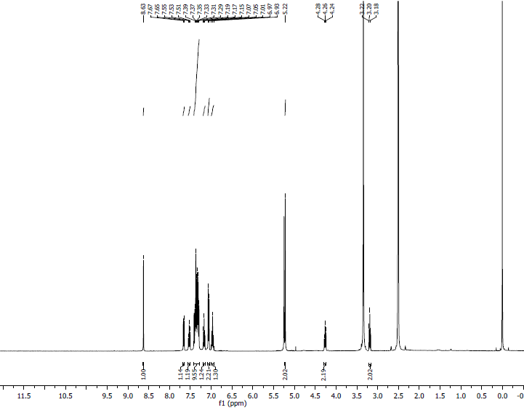
¹H NMR Spectra: 8g
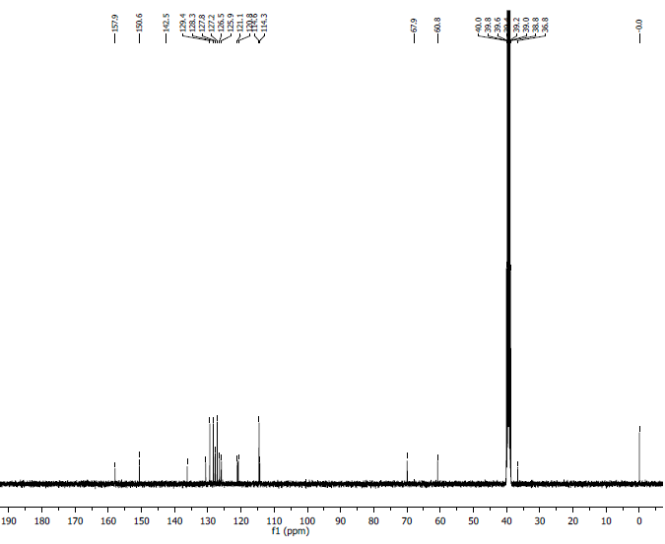
¹³C NMR Spectra: 8g

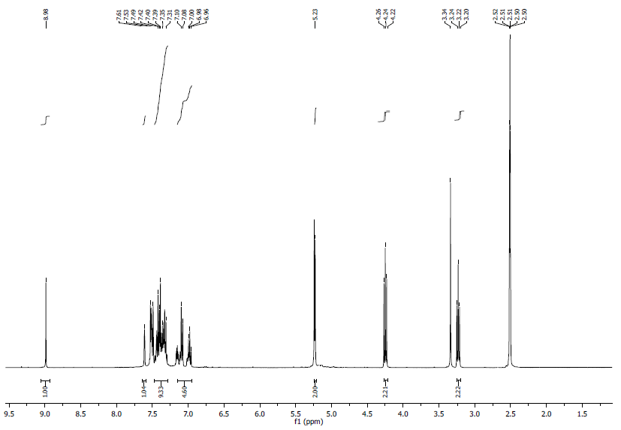
¹H NMR Spectra: 8h
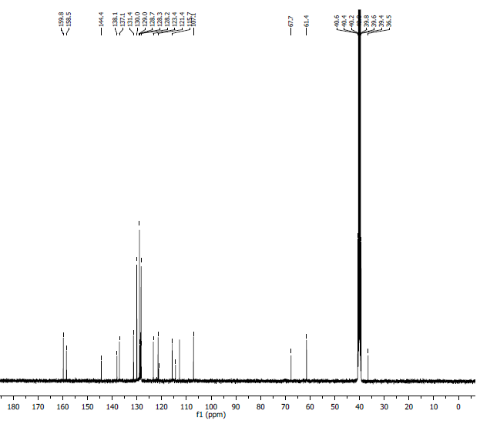
¹³C NMR Spectra: 8h
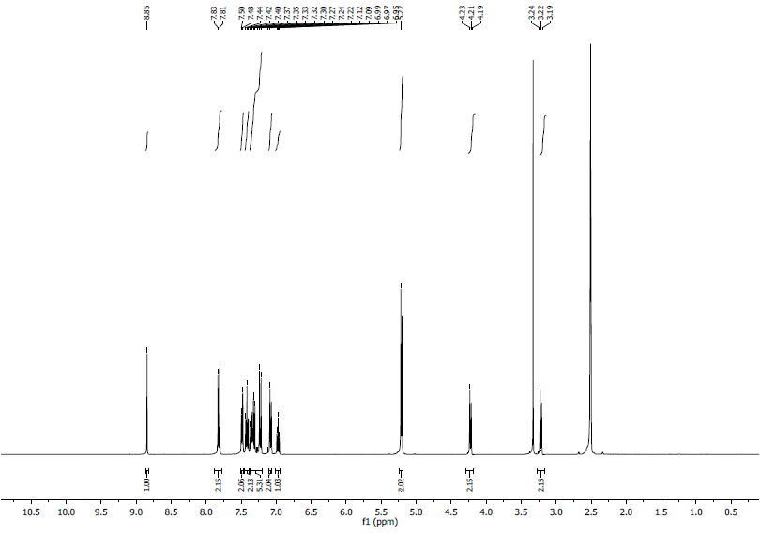
¹H NMR Spectra: 8i
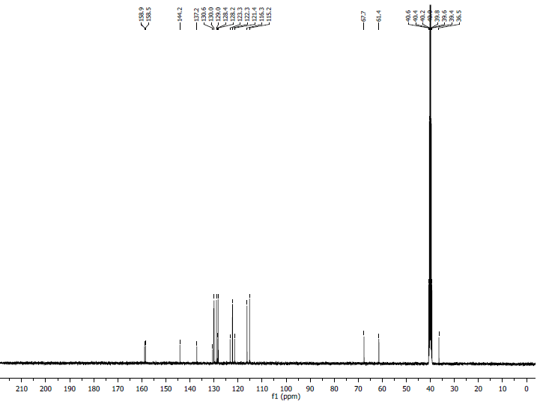
¹³C NMR Spectra: 8i

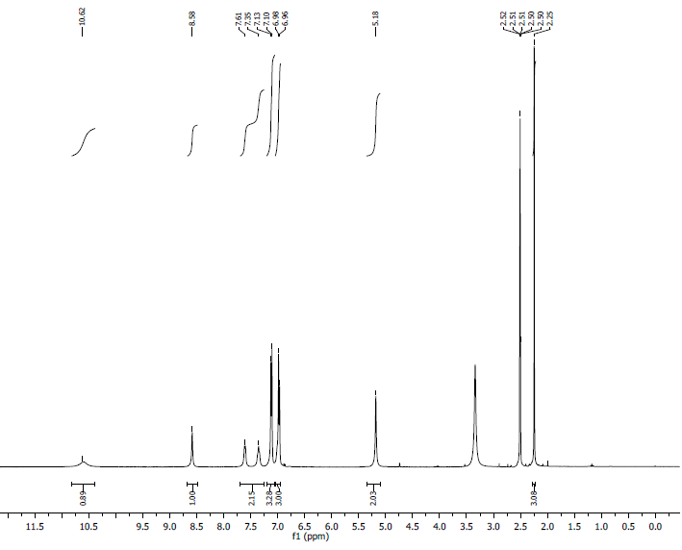
¹H NMR Spectra: 8j
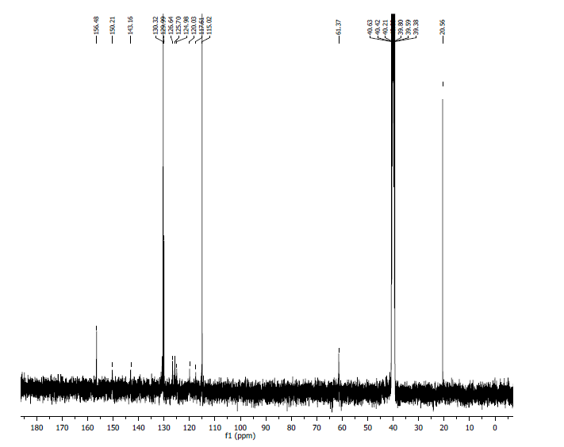

¹³C NMR Spectra: 8j

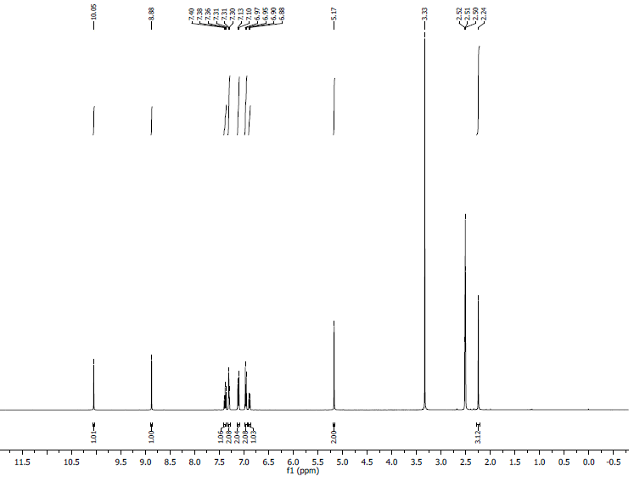
¹H NMR Spectra: 8k
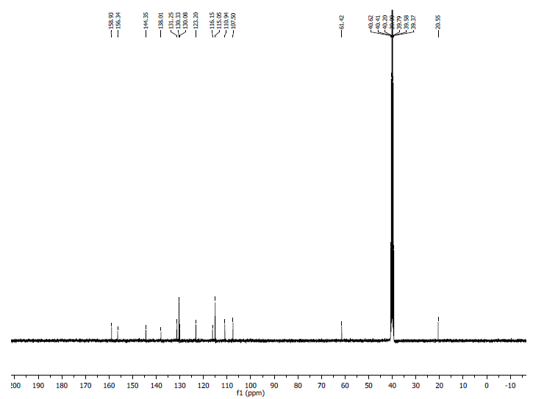
¹³C NMR Spectra: 8k
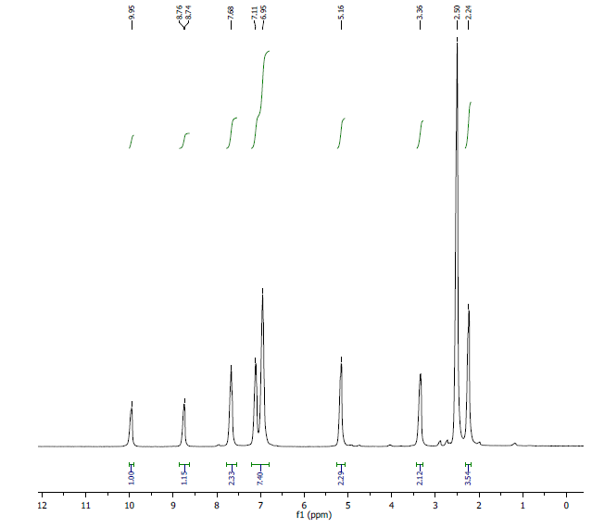
¹H NMR Spectra: 8l
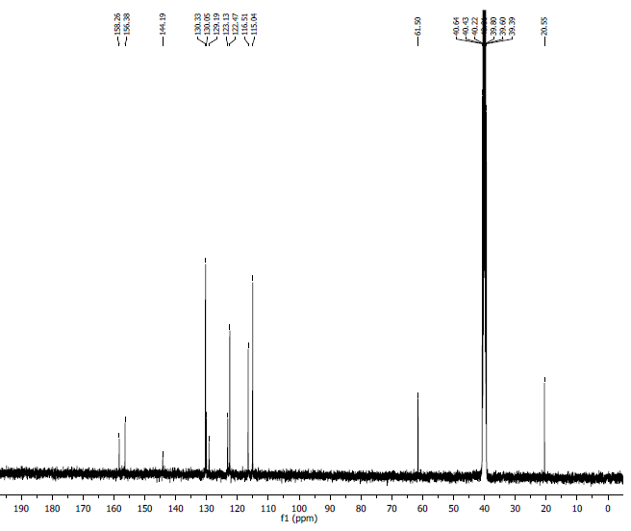
¹³C NMR Spectra: 8l
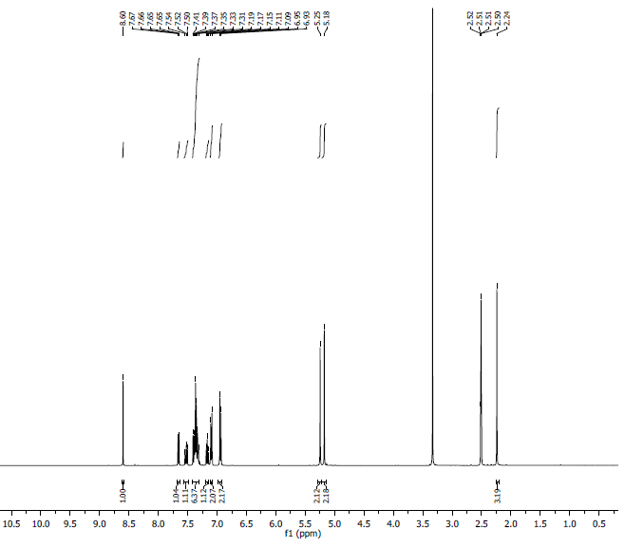
¹H NMR Spectra: 8m
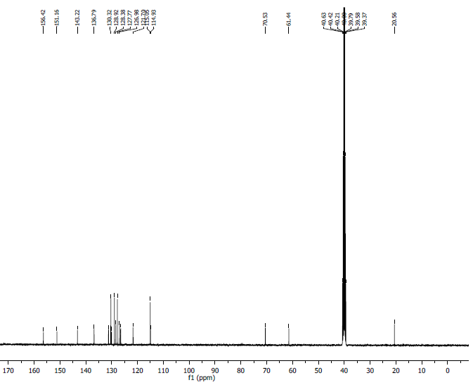

¹³C NMR Spectra: 8m

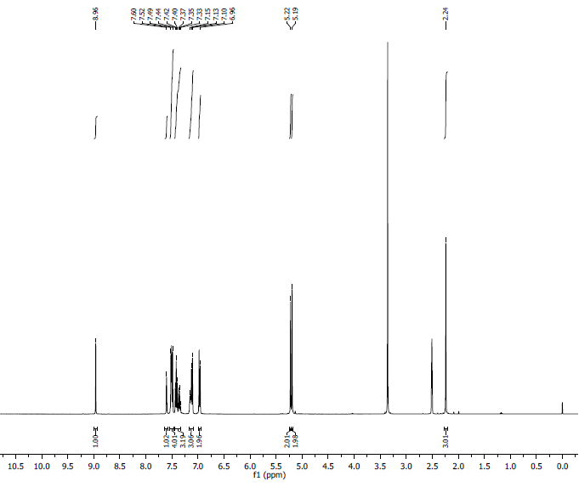
¹H NMR Spectra: 8n

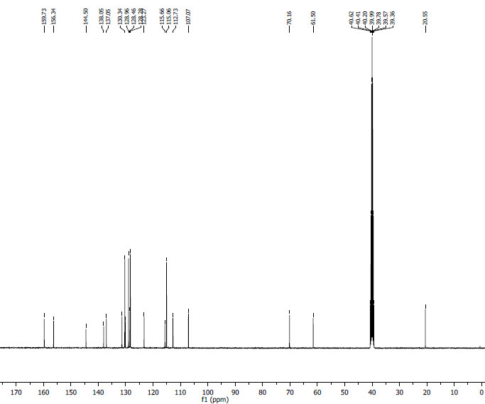
¹³C NMR Spectra: 8n

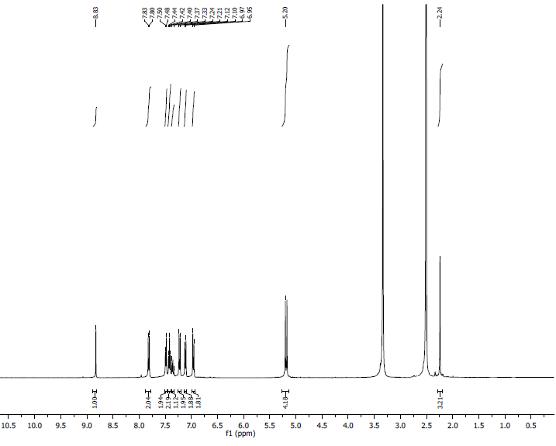
¹H NMR Spectra: 8o
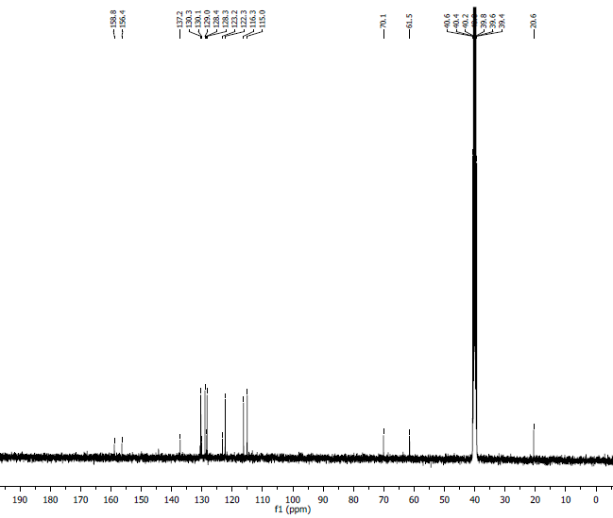
¹³C NMR Spectra: 8o
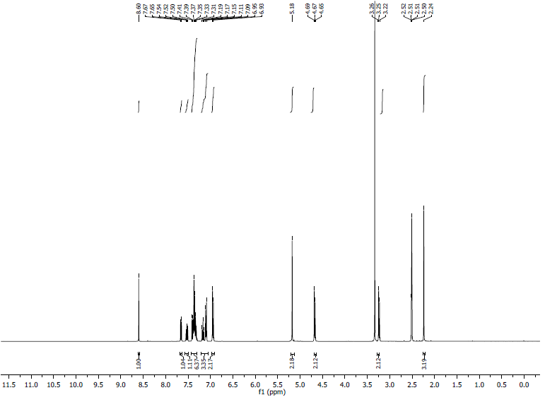
¹H NMR Spectra: 8p
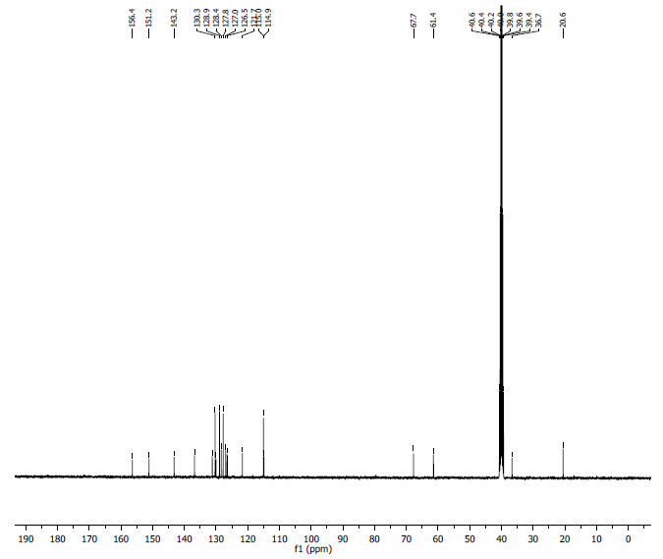
¹³C NMR Spectra: 8p

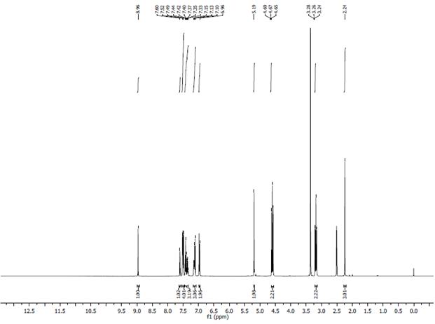
¹H NMR Spectra: 8q
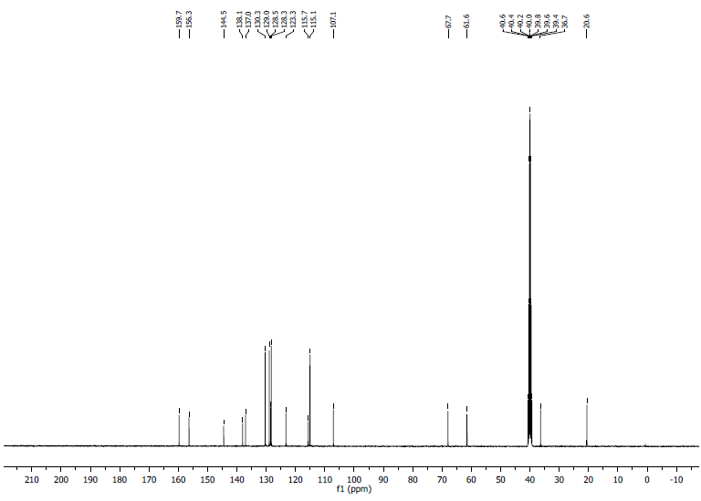
¹³C NMR Spectra: 8q

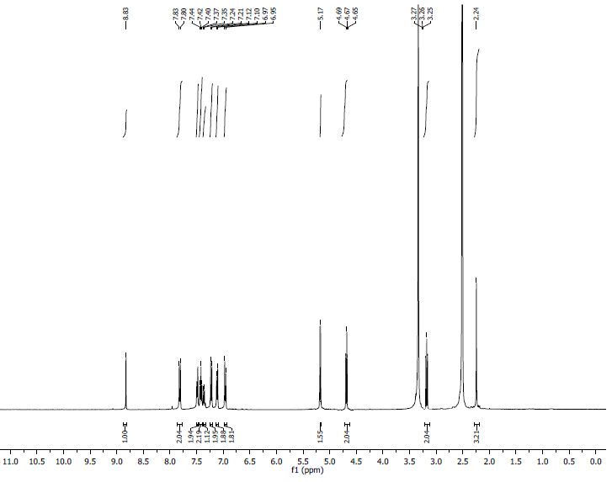
¹H NMR Spectra: 8r
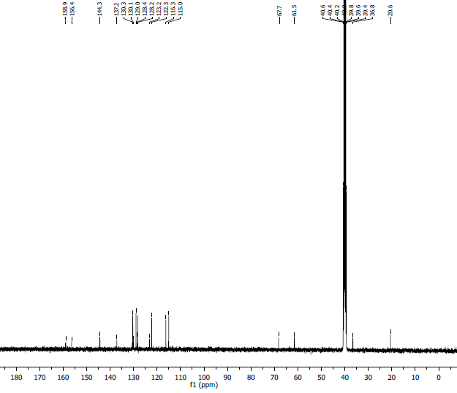

¹³C NMR Spectra: 8r

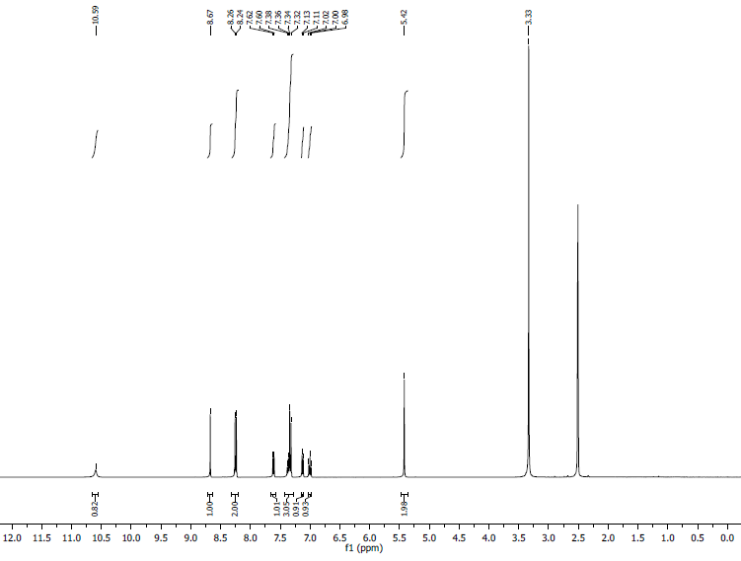
¹H NMR Spectra: 8s
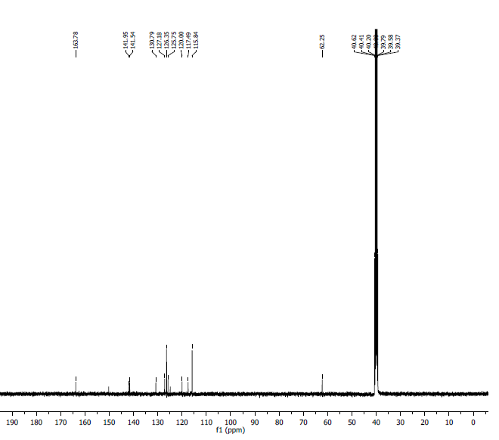
¹³C NMR Spectra: 8s
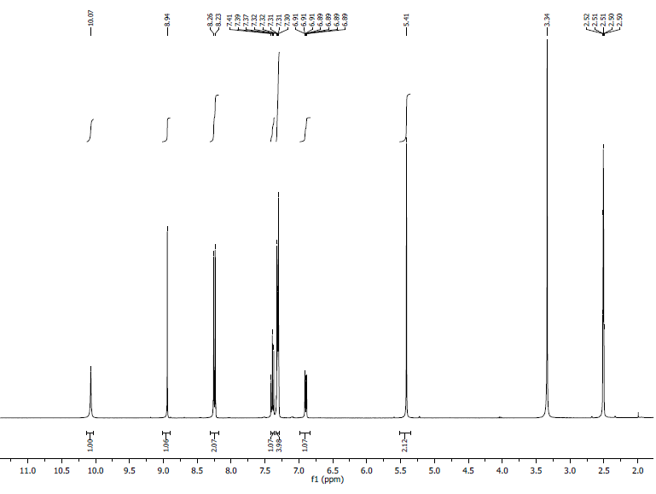
¹H NMR Spectra: 8t
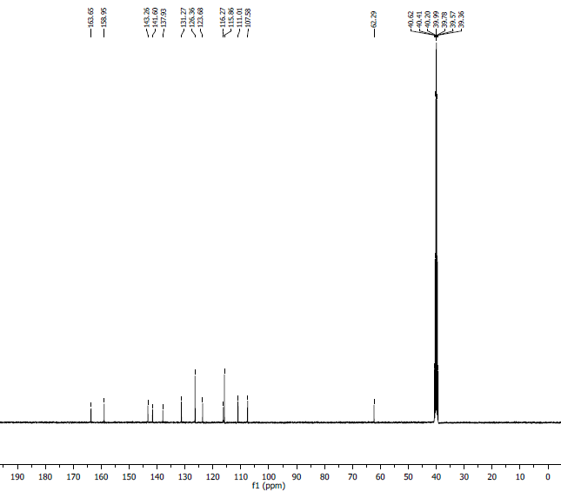
¹³C NMR Spectra: 8t

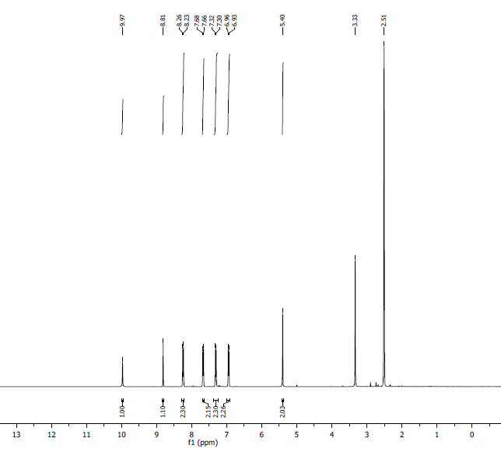
¹H NMR Spectra: 8u
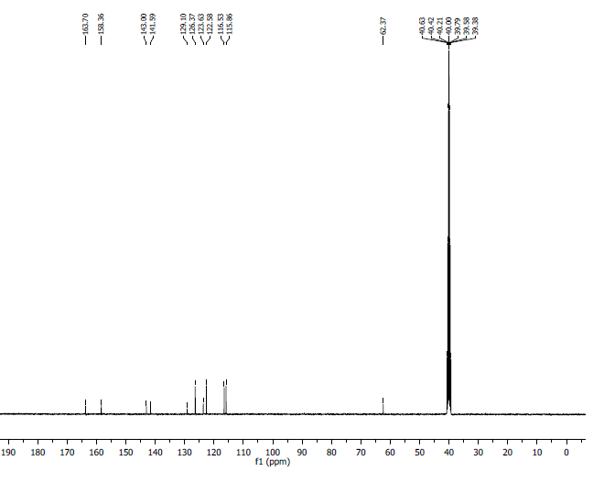
¹³C NMR Spectra: 8u
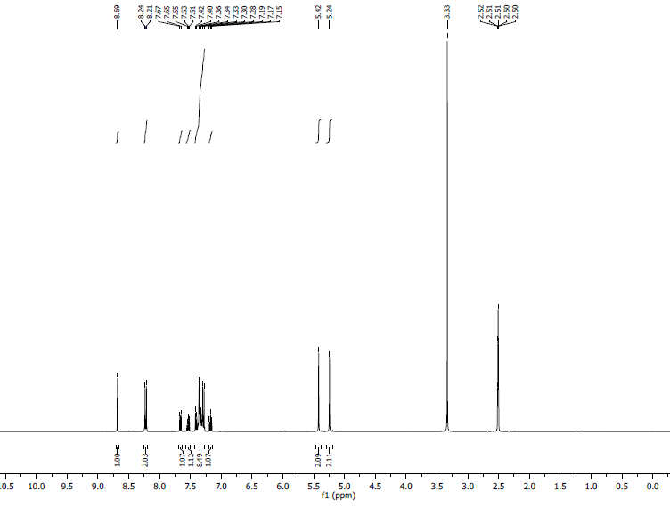
¹H NMR Spectra: 8v

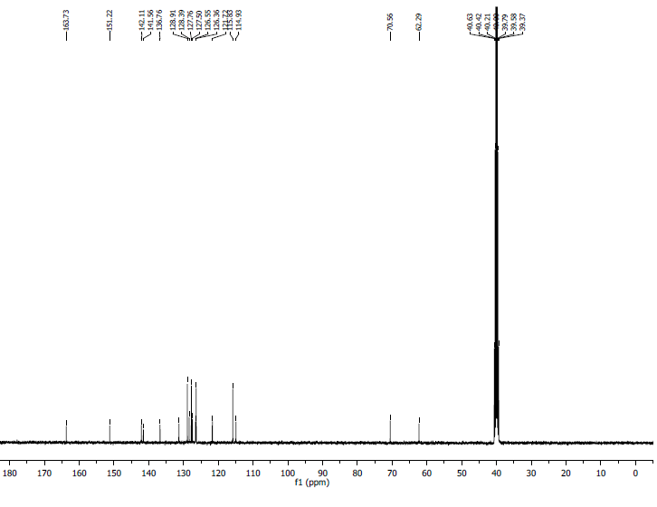
¹³C NMR Spectra: 8v
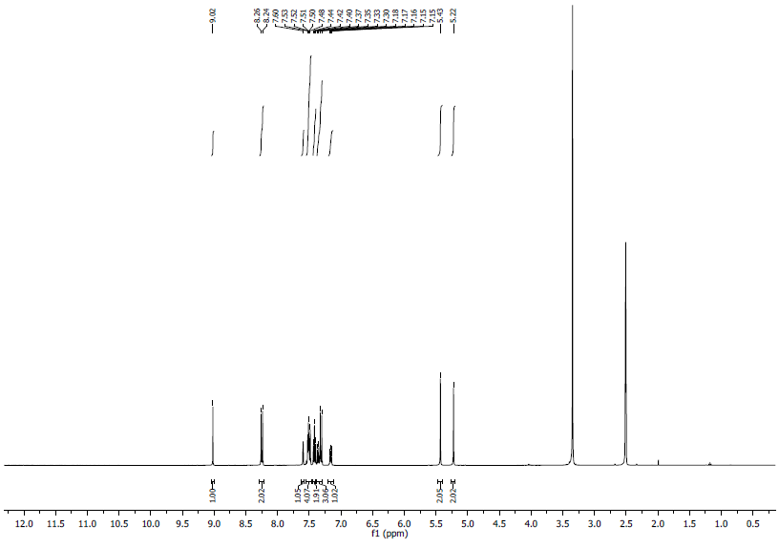
¹H NMR Spectra: 8w
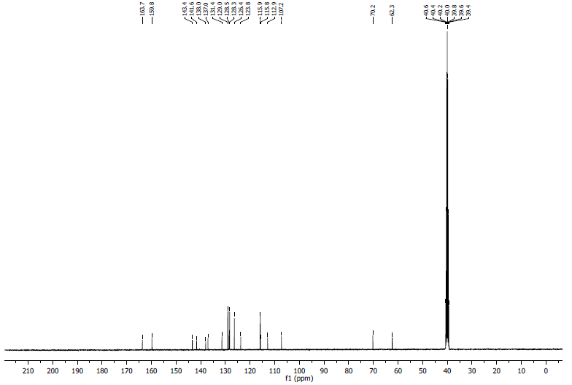
¹³C NMR Spectra: 8w
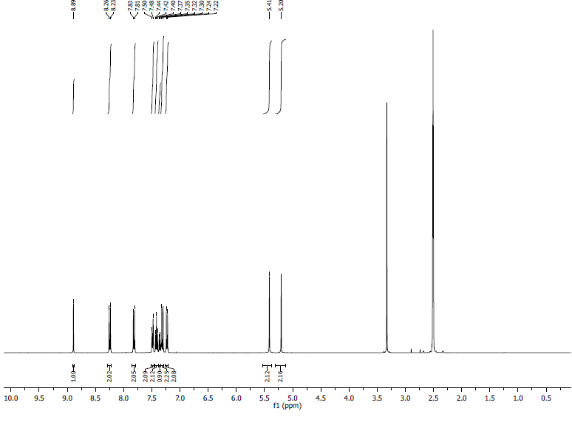
¹H NMR Spectra: 8x
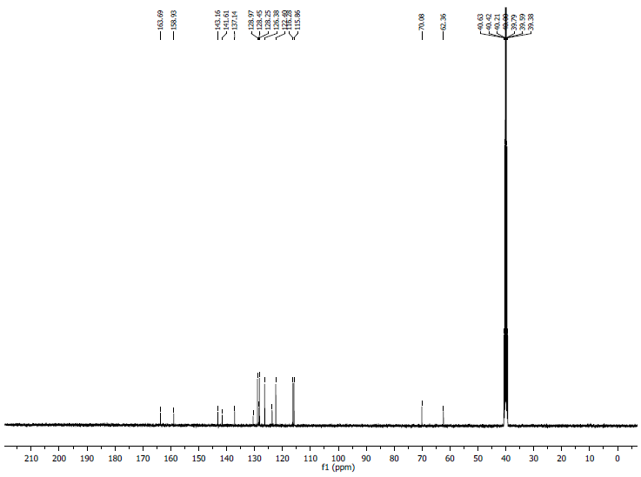
¹³C NMR Spectra: 8x
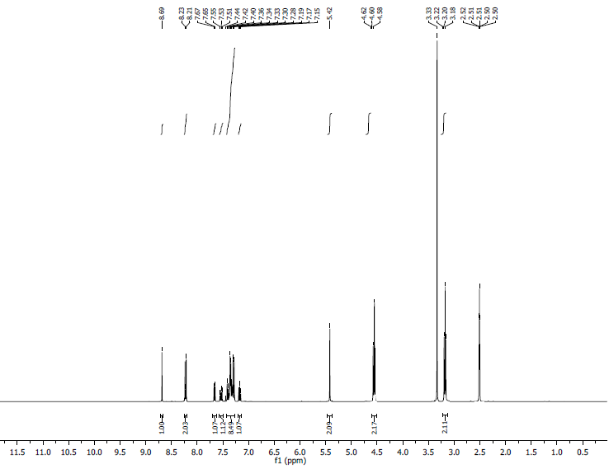
¹H NMR Spectra: 8y

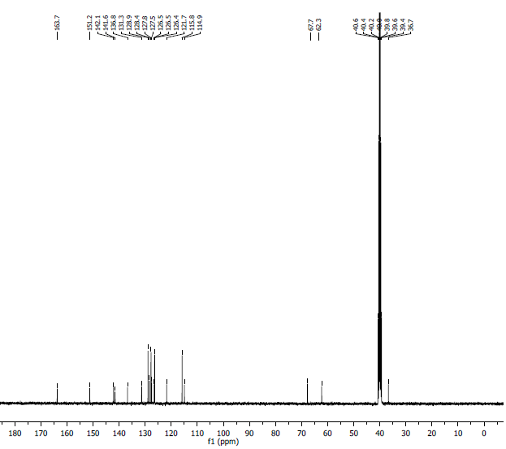
¹³C NMR Spectra: 8y
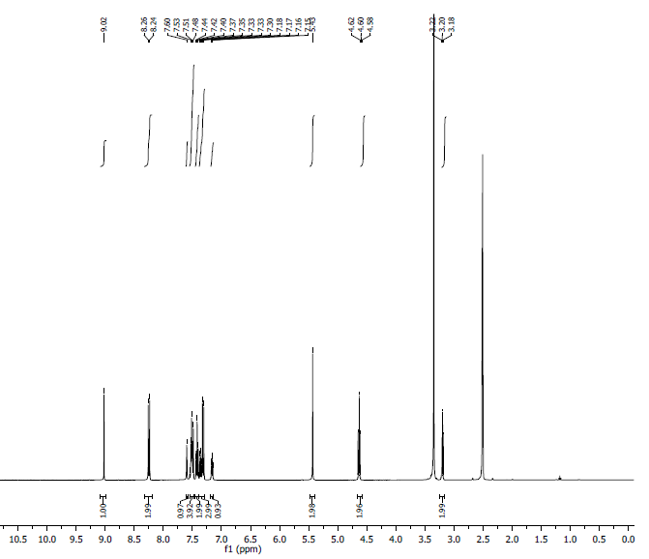
¹H NMR Spectra: 8z
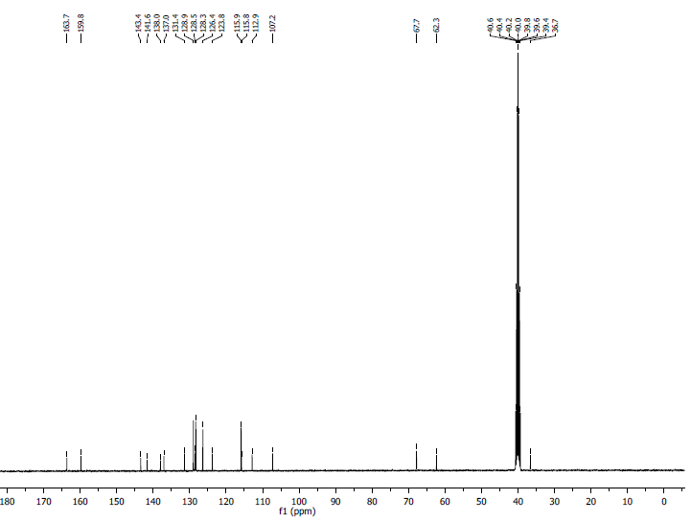
¹³C NMR Spectra: 8z
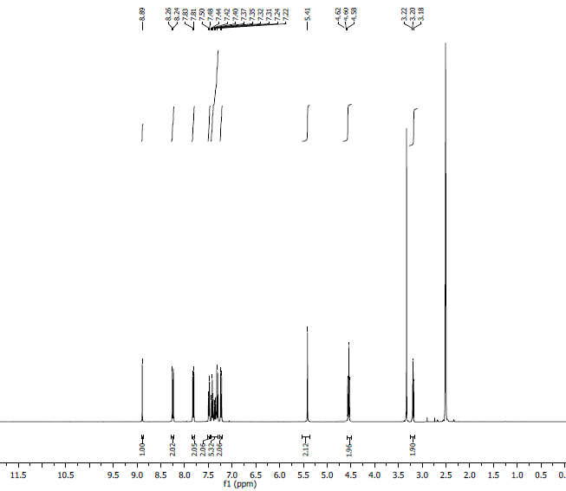
¹H NMR Spectra: 8z₁
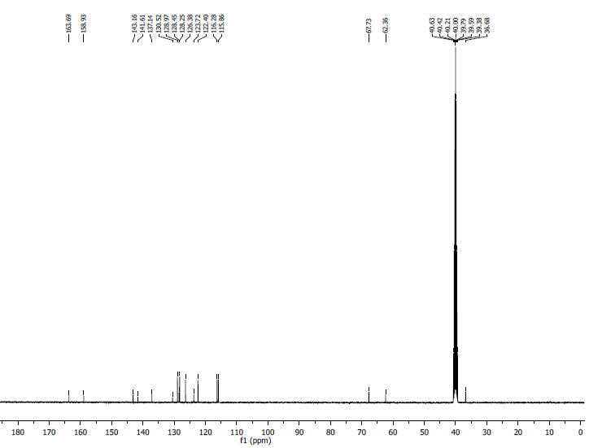
¹³C NMR Spectra: 8z₁

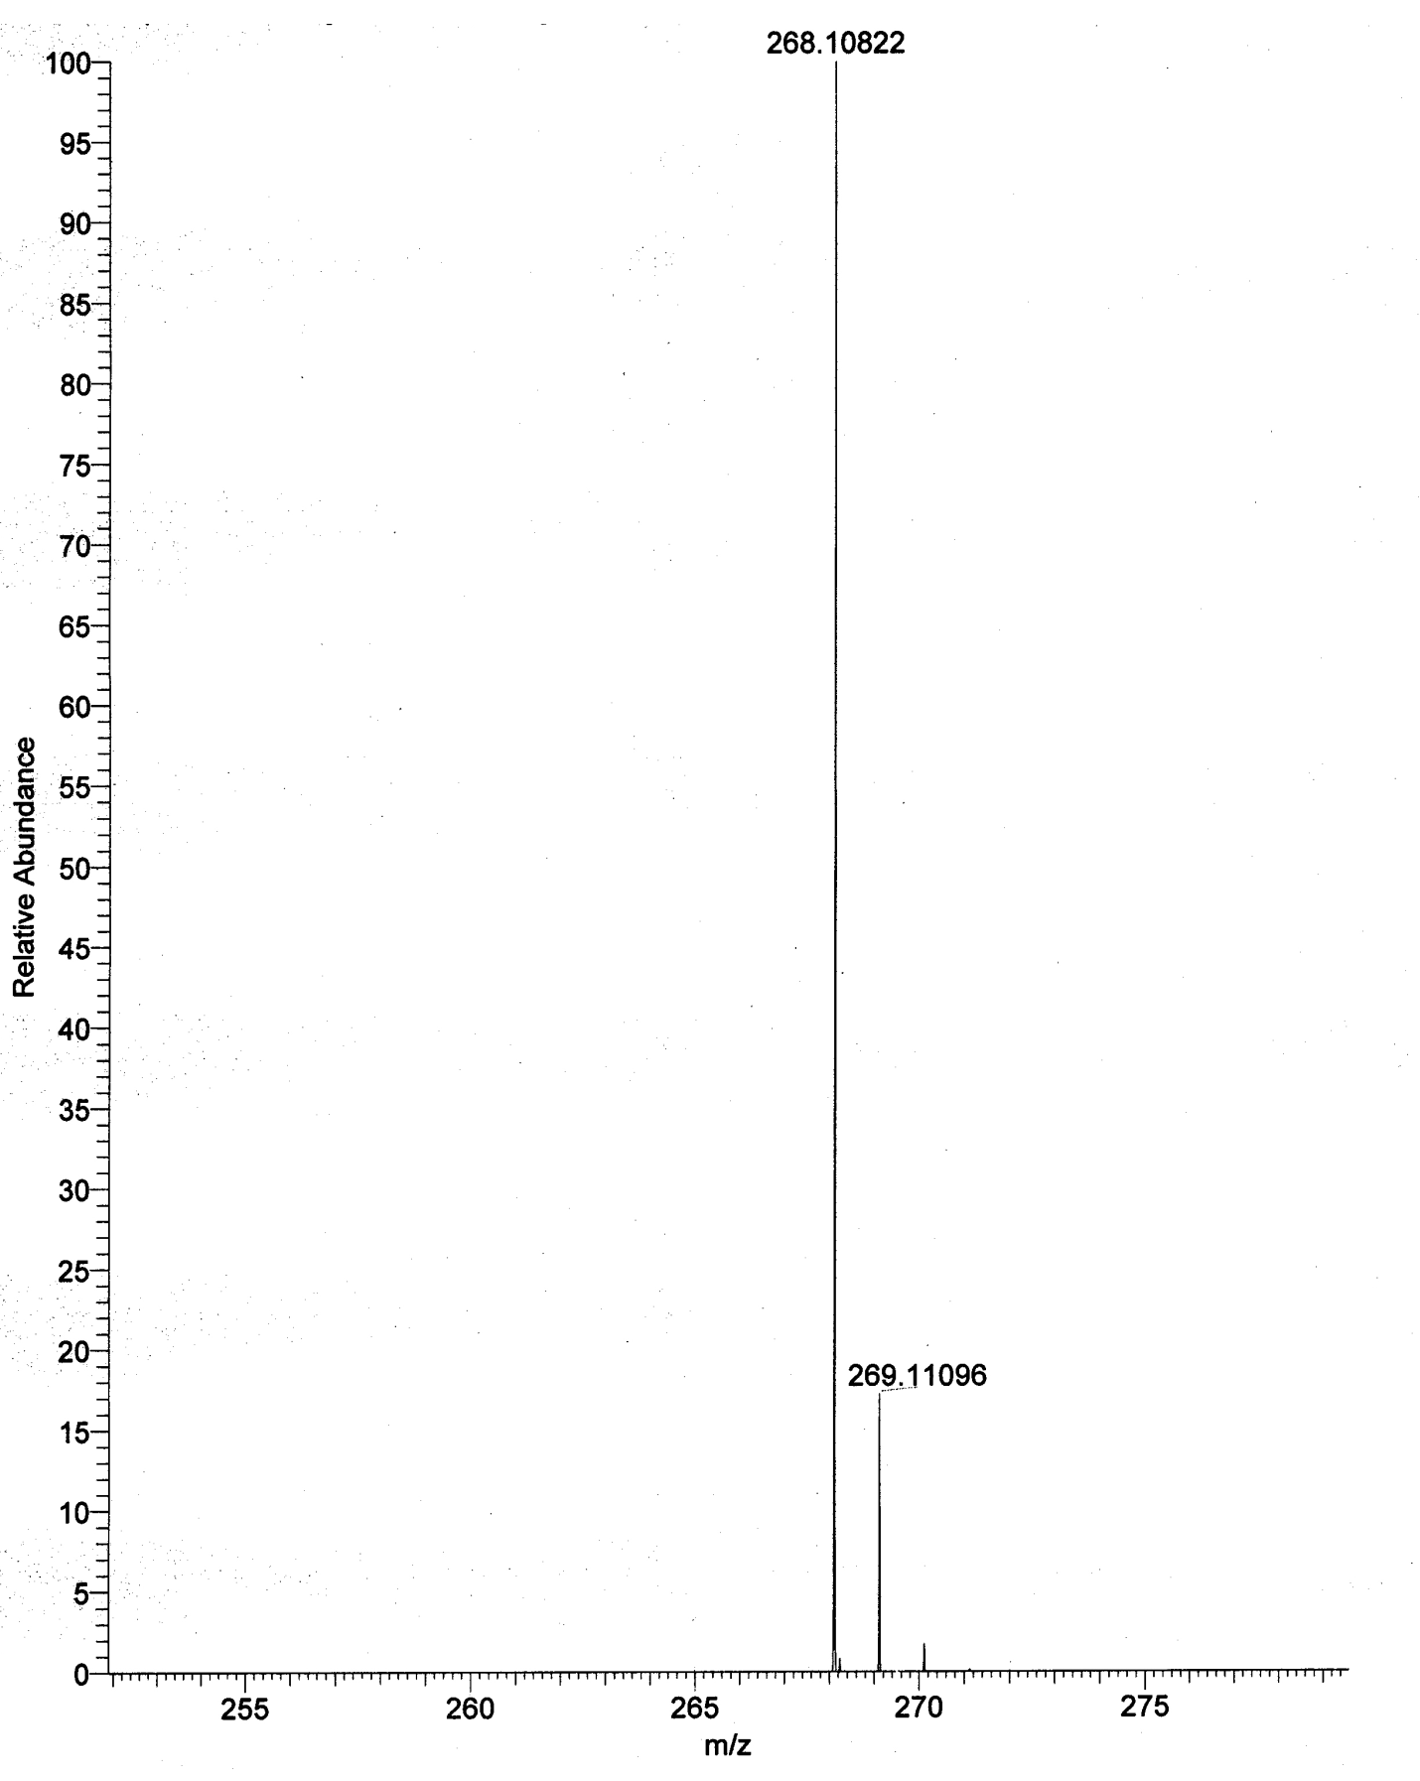
HRMS: 8a
HRMS: 8b

HRMS: 8c
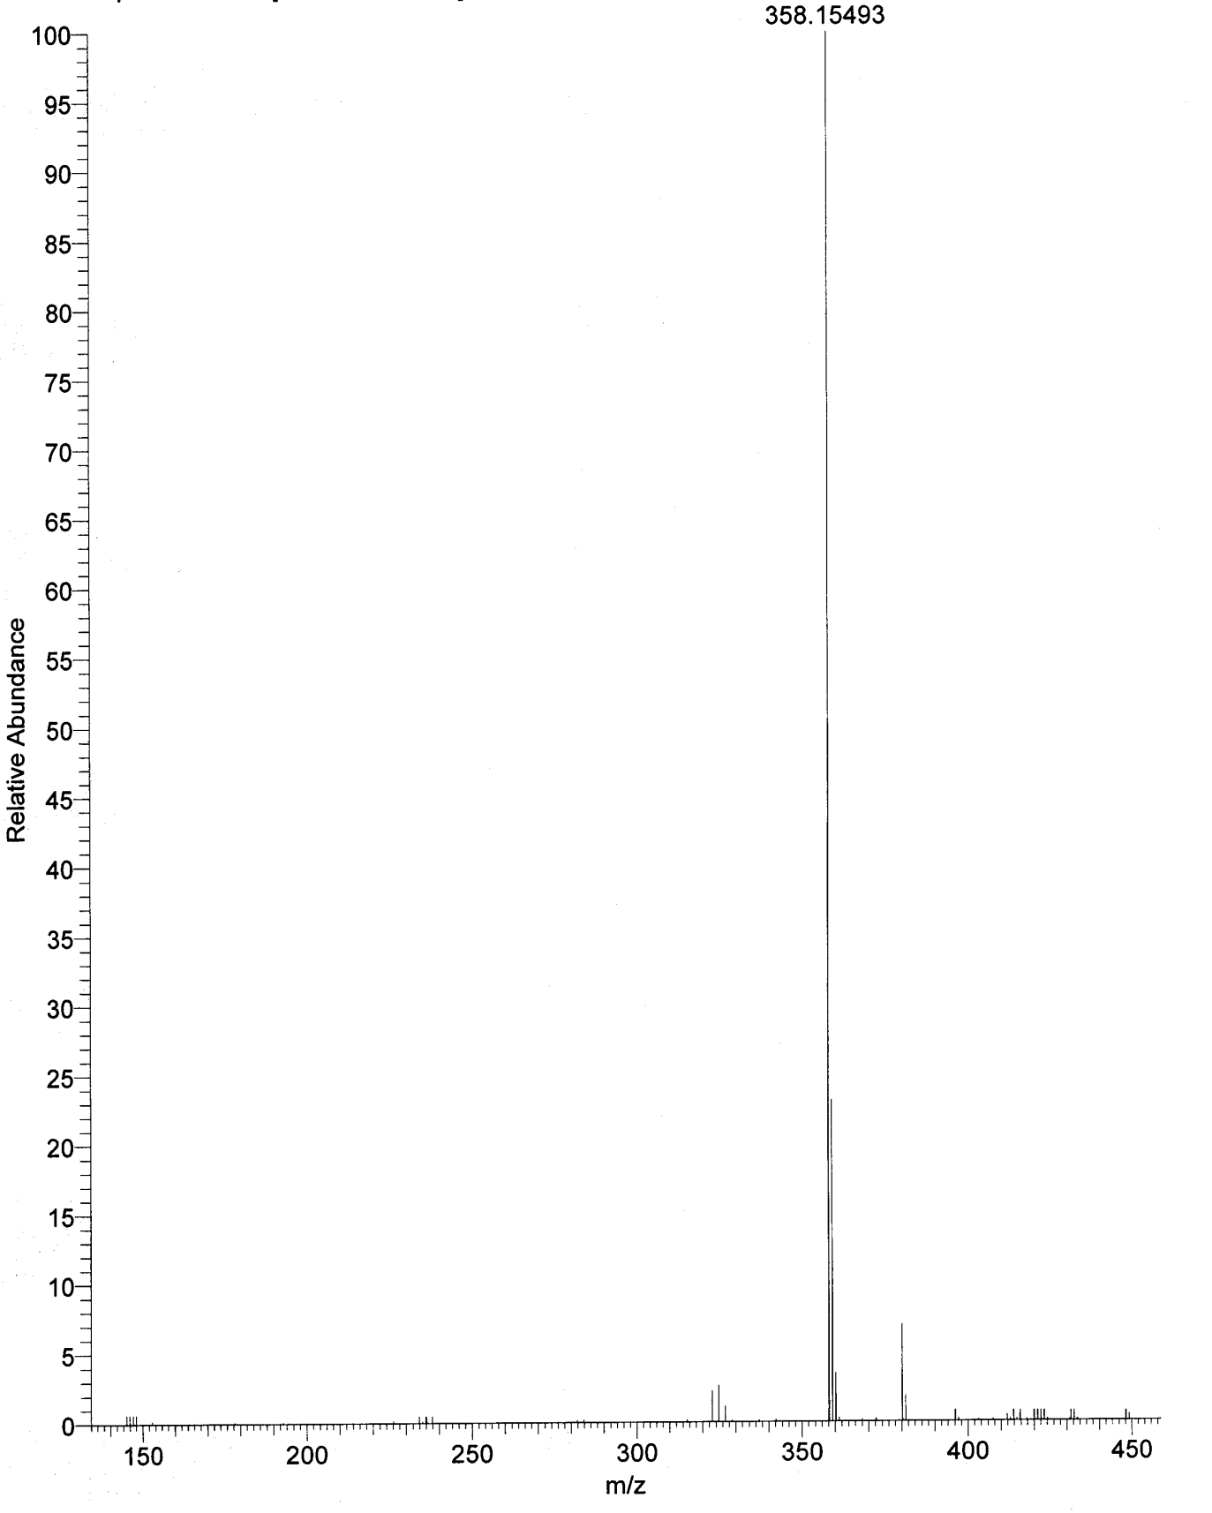
HRMS: 8d

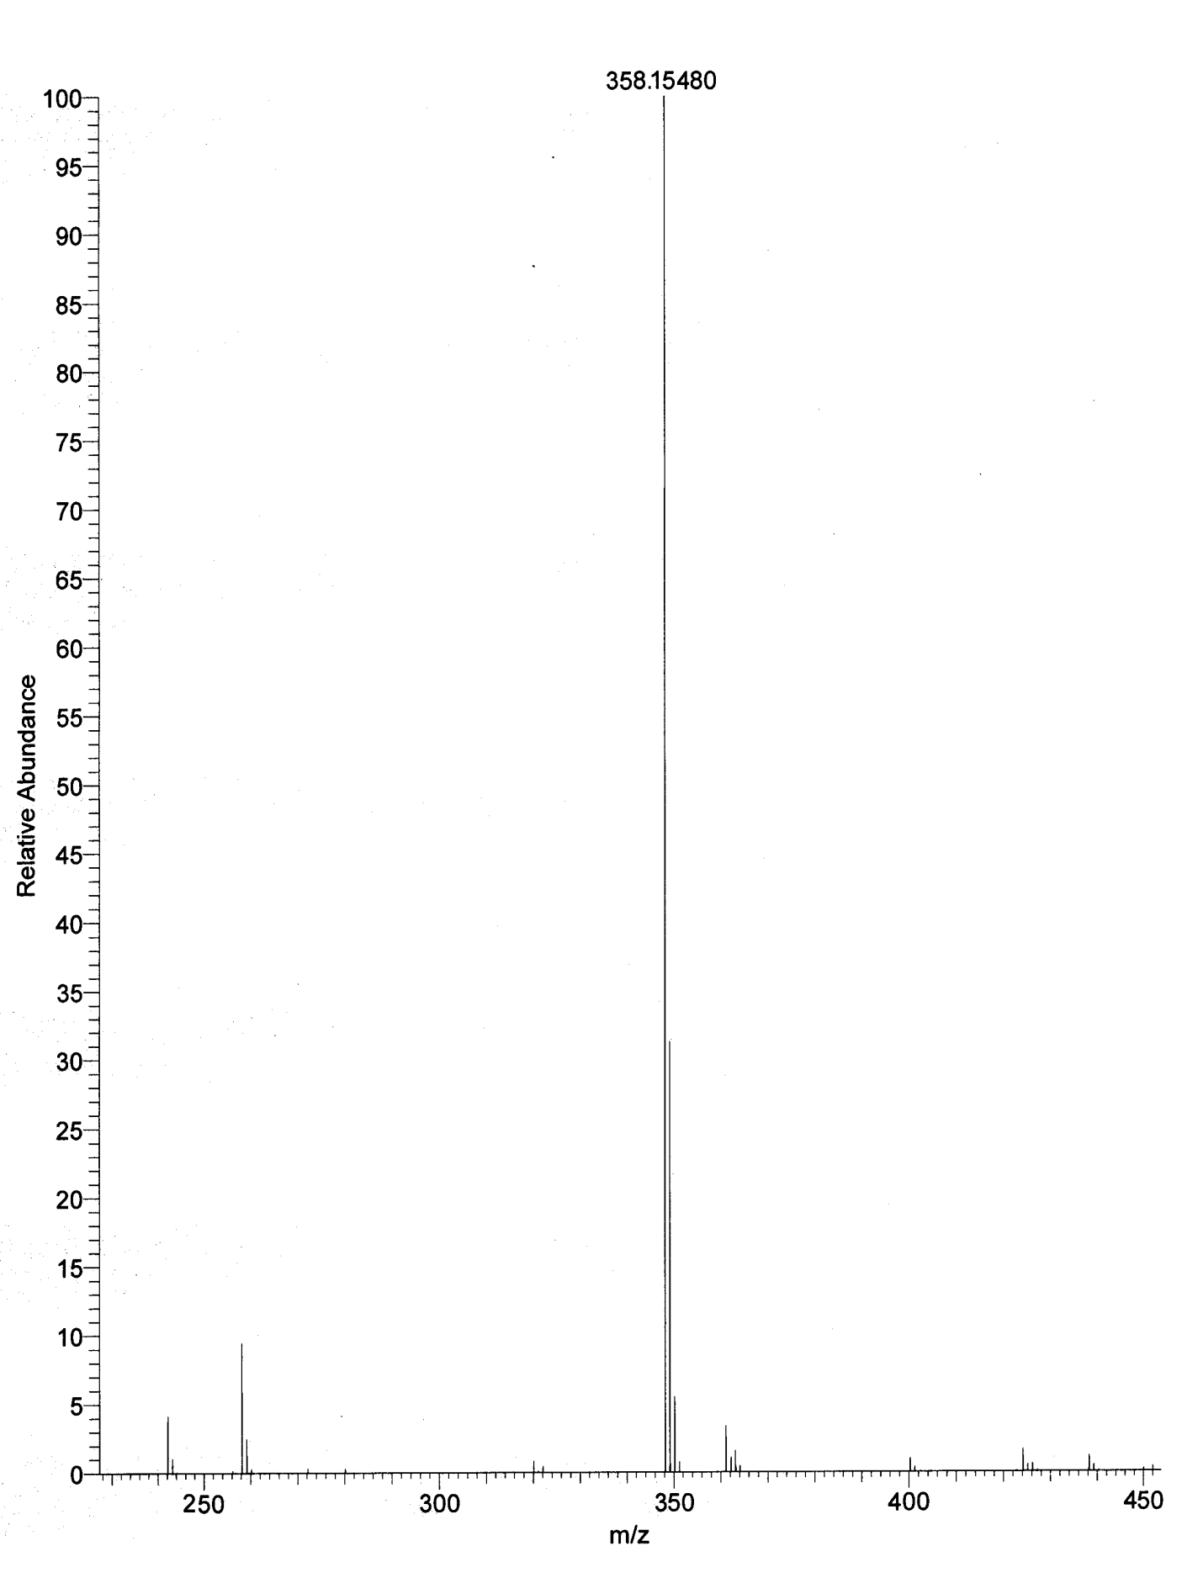
HRMS: 8e

HRMS: 8f
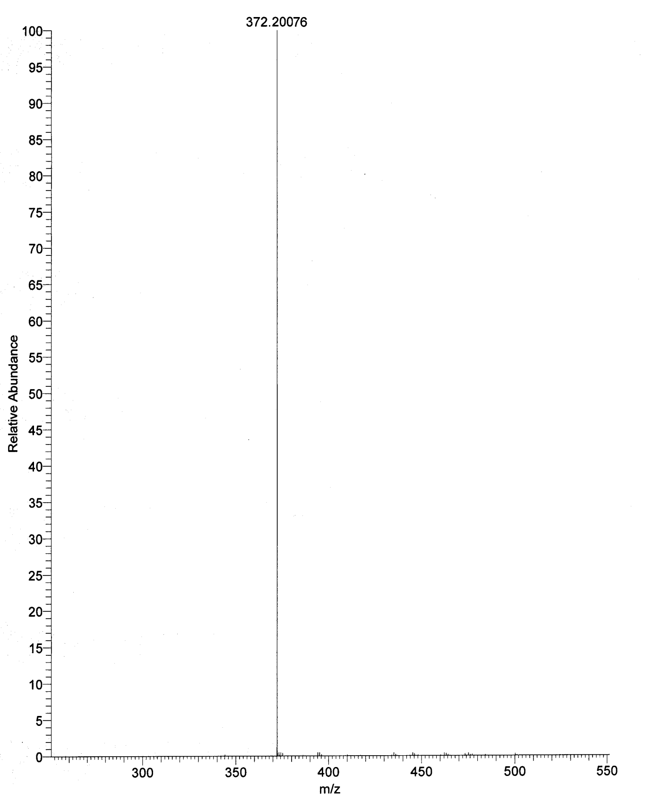
HRMS: 8g

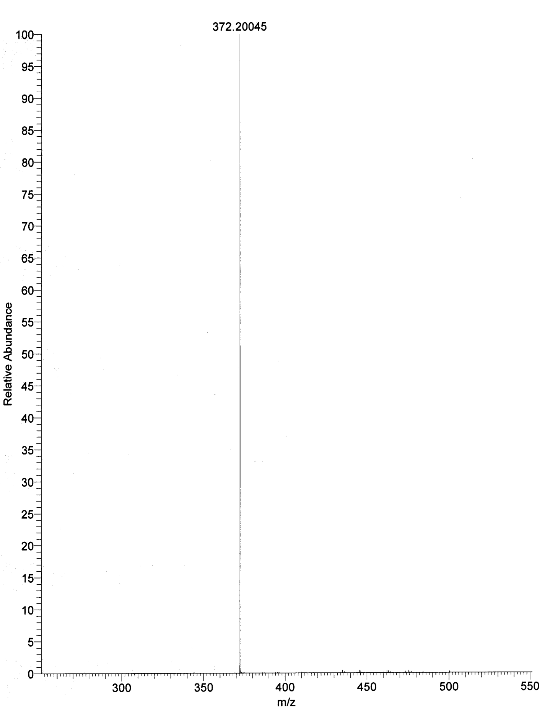
HRMS: 8h
HRMS: 8i
HRMS: 8j
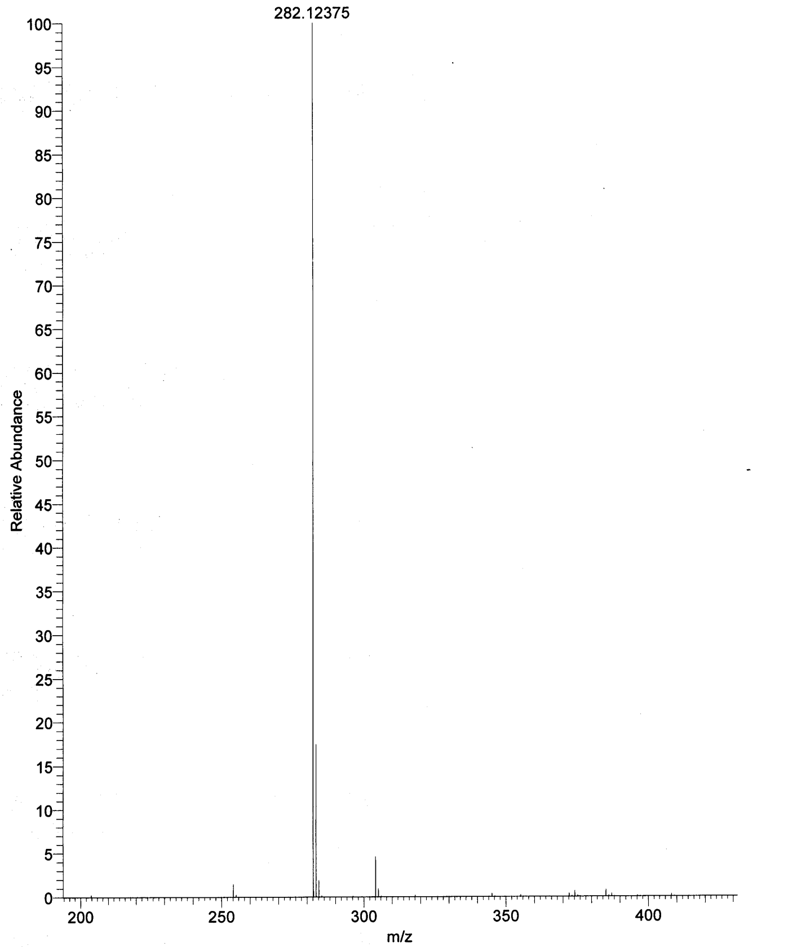
HRMS: 8k
HRMS: 8l
HRMS: 8m

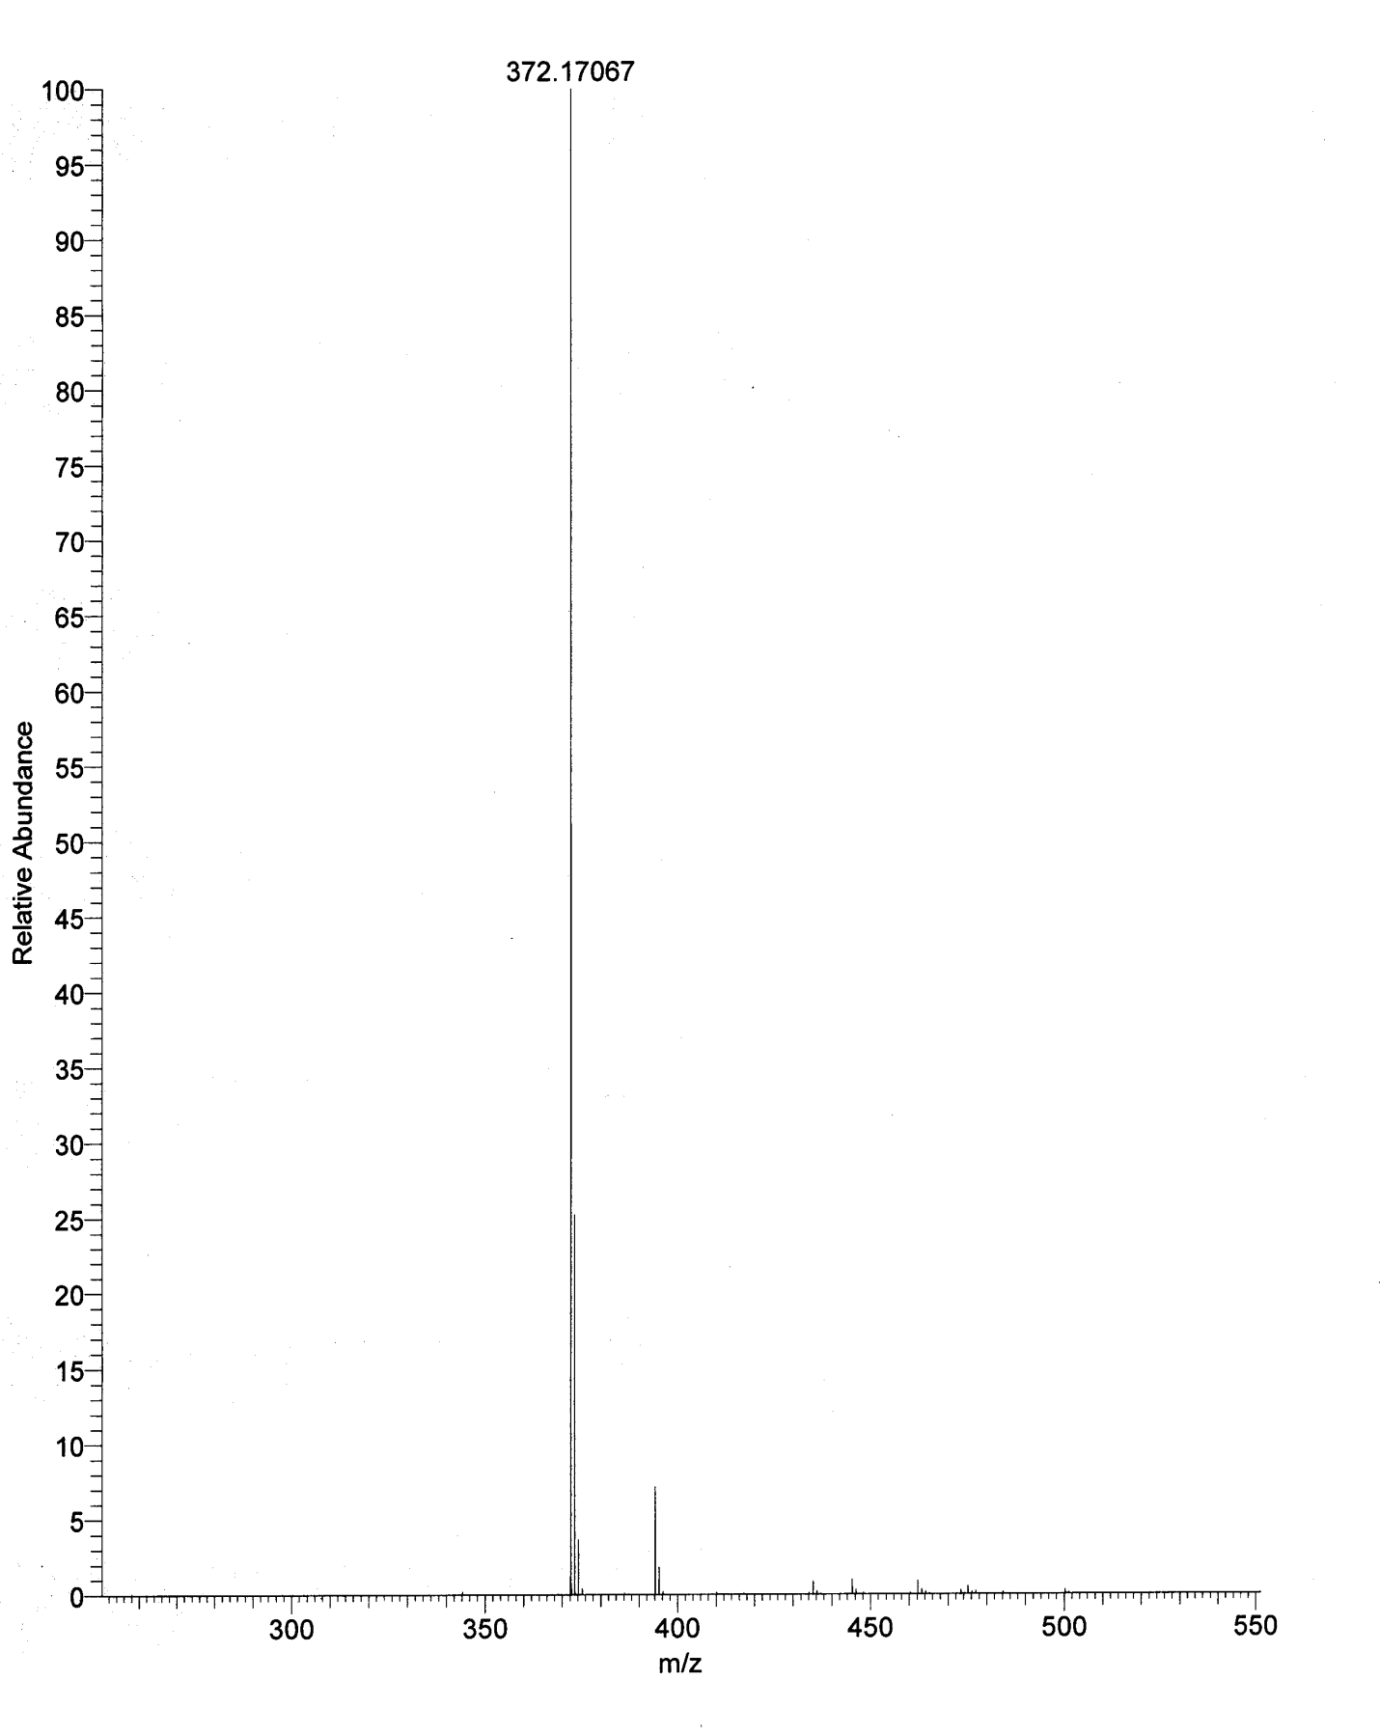
HRMS: 8n

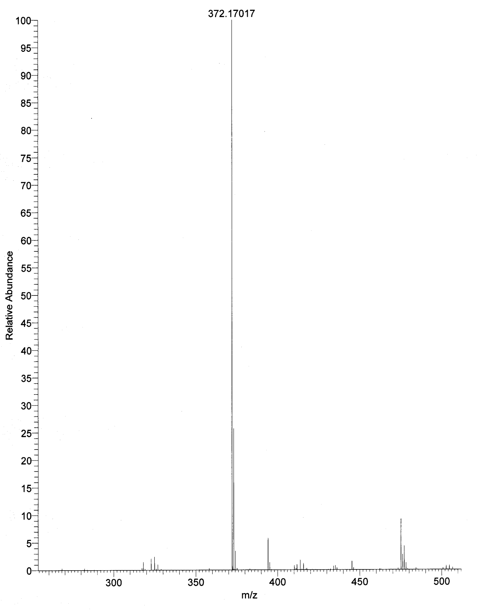
HRMS: 8o
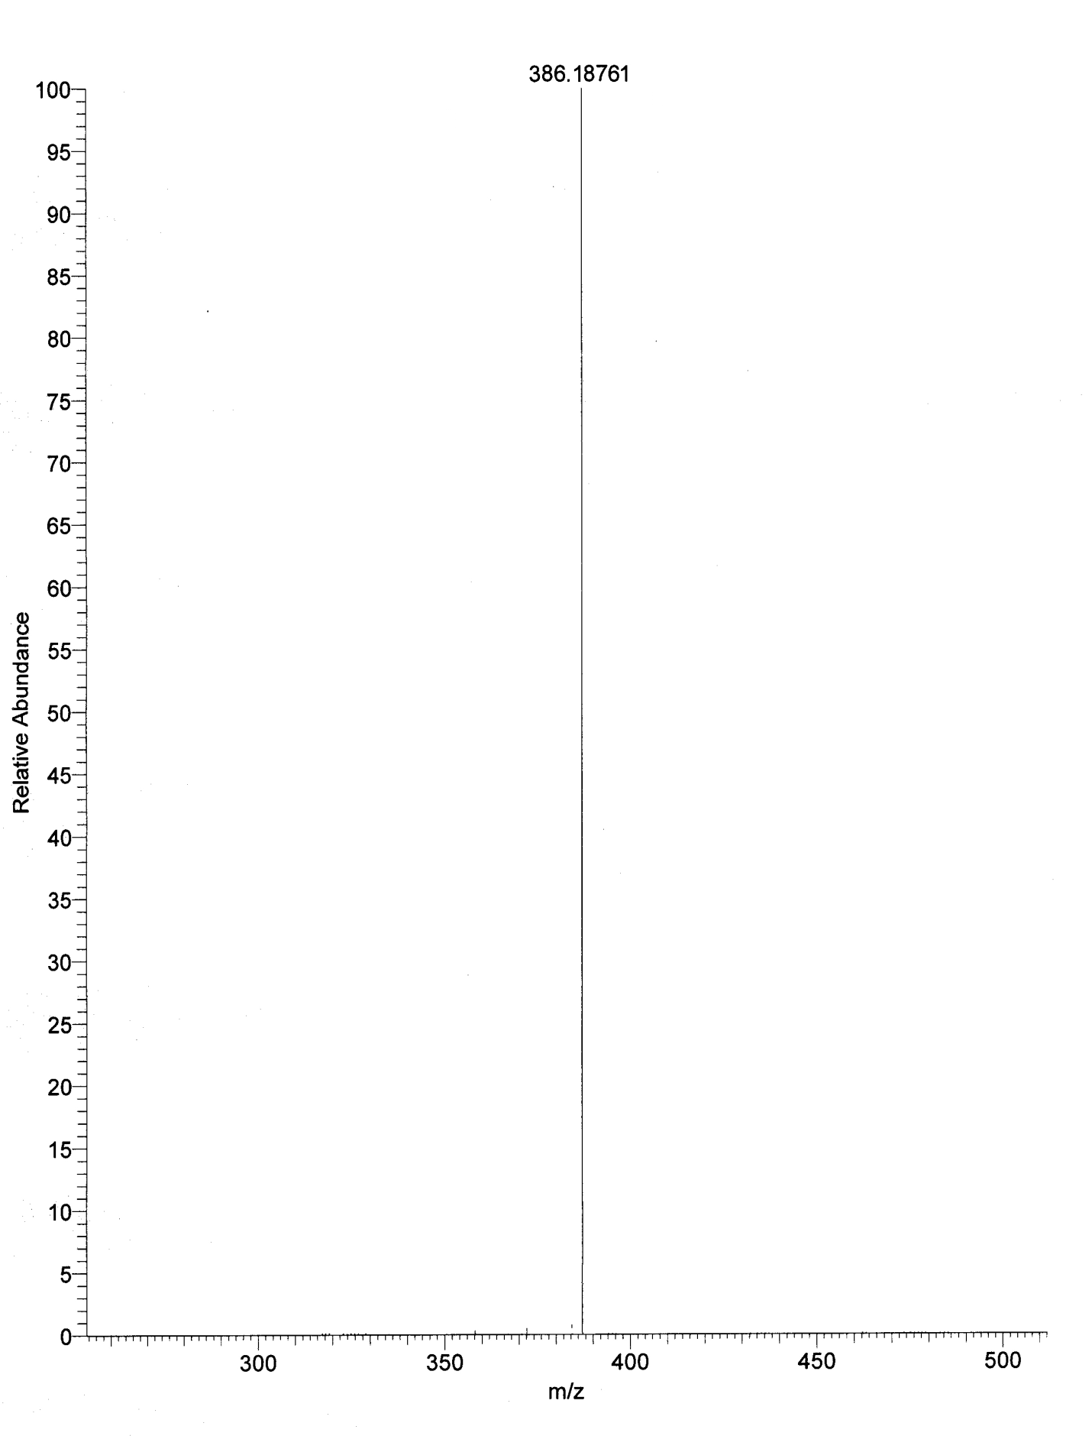
HRMS: 8p

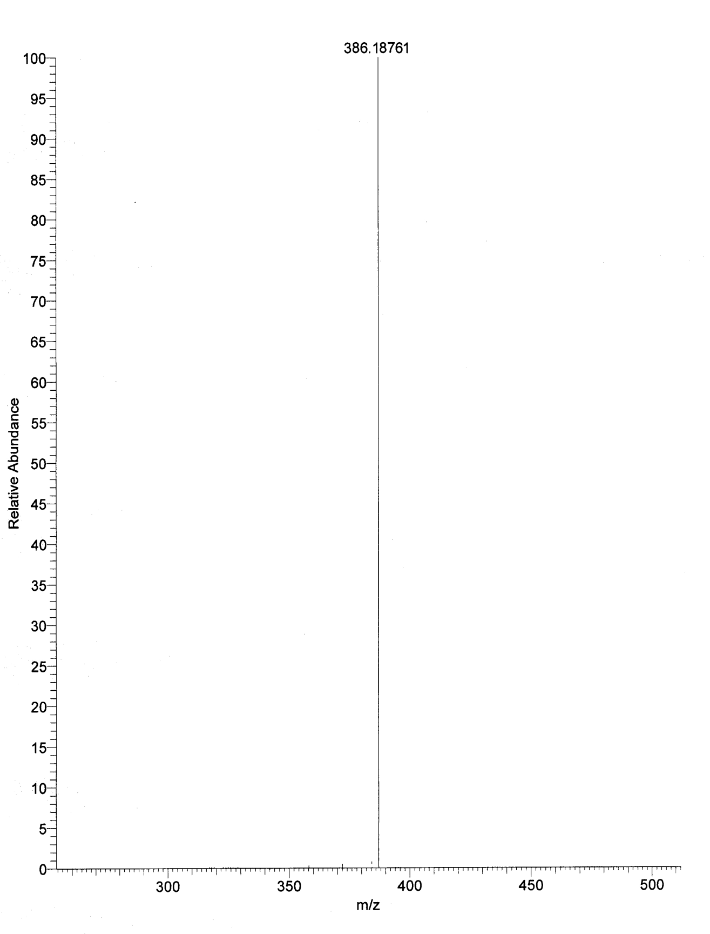
HRMS: 8q
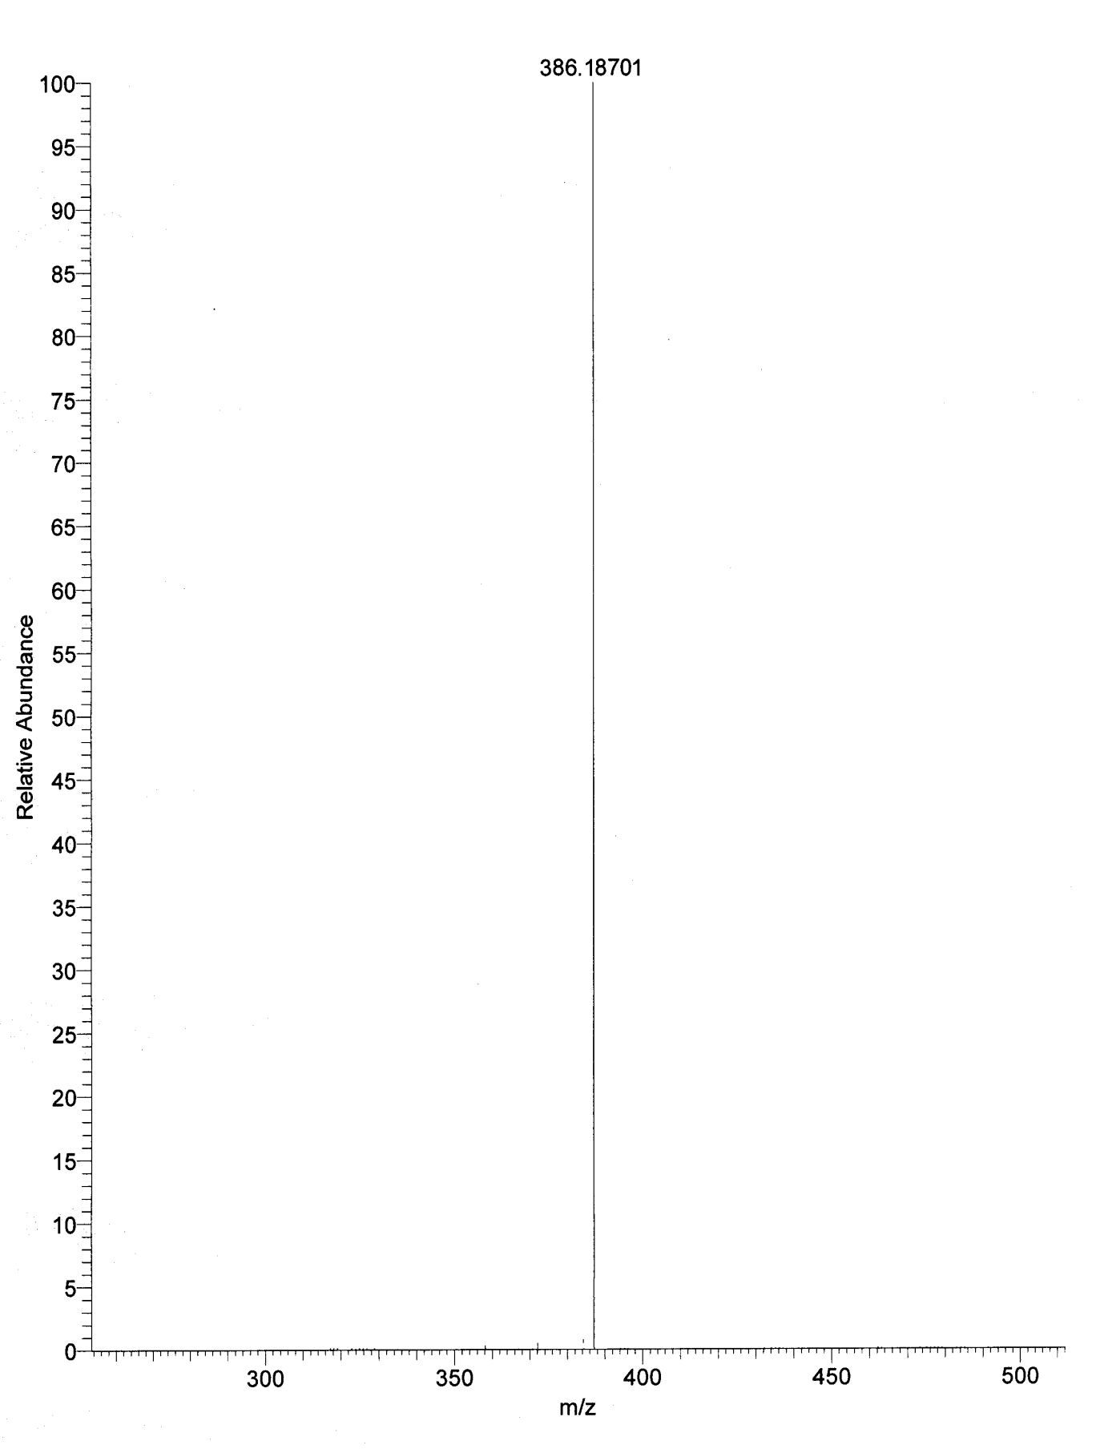
HRMS: 8r

HRMS: 8s
HRMS: 8t
HRMS: 8u
HRMS: 8v
HRMS: 8w
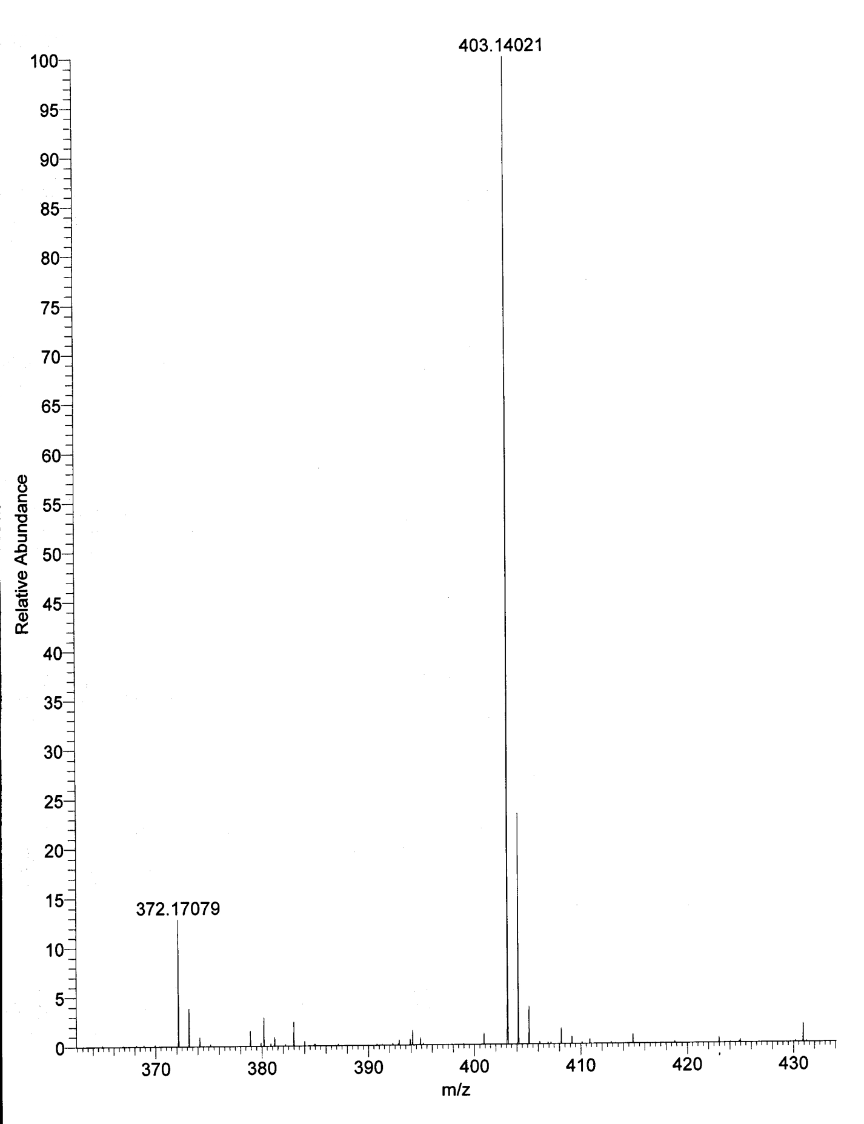
HRMS: 8x
HRMS: 8y
HRMS: 8z

HRMS: 8z₁

