Supporting information
Table of contents

1. Experimental section 2
1.1. Synthesis of acetophenones 3
1.2. Synthesis of ketals 4
1.3. Synthesis of 2-(2-methyl-1,3-dioxolan-2-yl)benzenesulfonyl chlorides 7
1.4. The synthesis of the heterocyclic core 13
1.5. N(2)-Alkylation 23
1.6. Reduction of C=N double bond 26
1.7. N(3)-Alkylation 31
2. NMR spectra 35
3. Detailed NMR study for structure elucidation 103
4. DFT study on the conformers of 20a 121
5. References 123

- Experimental section

Melting points were determined using either a Leica Galen III or an SRS OptiMelt melting point apparatus. IR spectra were obtained on a Bruker ALPHA or VECTOR22 FT-IR spectrometer in KBr pellets or as a film. ¹H NMR and ¹³C NMR spectra were recorded at 22 °C on a Varian Gemini 200 (200/50 MHz), a Bruker Avance III 400 (400/100 MHz) or a Bruker Avance III HD 600 (600/150 MHz) spectrometer equipped with Prodigy cryo-probehead. CDCl₃ or DMSO-d₆ were used as solvents and tetramethylsilane (TMS) as the internal standard. Chemical shifts are given on the δ-scale and coupling constants (J) in Hz, respectively. The pulse programs were taken from the Bruker software library (TopSpin 3.5). Elemental analyses were performed on a Vario EL III Model CHN or on an Elementar Vario MICRO cube CHNS elemental analyzer, the chlorine and sulfur content were determined by titration. A Waters Acquity UPLC equipment coupled with a Thermo Scientific LTQ XL iontrap MS was used to obtain mass spectroscopic data. High resolution mass spectra were recorded on a micromass GCT or on a Bruker O-TOF MAXIS Impact mass spectrometer coupled with a Dionex Ultimate 3000 RS system with a diode array detector. The reactions were followed by analytical thin layer chromatography on silica gel 60 F₂₅₄ and HPLC-MS on a Shimadzu LC-20 HPLC utilizing a SPD-M20A diode array detector and LCMS-2020 spectrometer. All unspecified reagents were purchased from commercial sources. Pd/C stands for Selcat Q palladium on charcoal catalyst (10 w/w%). Microwave-assisted reactions were carried out in a Milestone Microsynth T640 reactor.
  - Synthesis of acetophenones
1-(3,4-Dichlorophenyl)ethan-1-one¹
To a suspension of 1,2-dichlorobenzene (182 mL, 238 g, 1.62 mol) and anhydrous aluminum chloride (308 g, 2.31 mol) acetyl chloride (109 mL, 121 g, 1.54 mol) was added dropwise over a period of 10 min at 55 °C. The mixture was stirred at 120 °C for an hour. Then it was poured into ice-water (2.5 kg), the resulting product was filtered and washed with water and hexane. Yield: 229 g (79%). ¹H NMR (400 MHz, CDCl₃): δ 8.03 (1H, d, J=2.0 Hz), 7.78 (1H, dd, J = 8.3, 2.0 Hz), 7.55 (1H, d, J= 8.4 Hz), 2.60 (3H, s). ¹³C NMR (100 MHz, CDCl₃): δ 195.7, 137.7, 136.6, 133.3, 130.7, 130.3, 127.3, 26.6. IR (KBr, cm⁻¹): 3093, 1685, 1377, 1252, 830.
1-(3-Chloro-4-methoxyphenyl)ethan-1-one, according to literature method²
To a suspension of 2-chloroanisole (5.00 g, 35.1 mmol) and anhydrous aluminium chloride (14.0 g, 105 mmol) in CH₂Cl₂ (150 mL) was added acetyl chloride (8.33 g, 7.5 mL,106 mmol) at 0 °C. The mixture was stirred for 2 h at this temperature, then poured into ice water, and extracted with CH₂Cl₂ (20 mL). The organic layer was washed with saturated aqueous NaHCO₃ (2×20 mL) and brine (20 mL), then dried over anhydrous MgSO₄, and concentrated under reduced pressure. Yield: 6.37 g (98%). ¹H NMR (400 MHz, CDCl₃): δ 8.00 (1H, d, J=2.2 Hz), 7.87 (1H, dd, J=8.6, 2.2 Hz), 6.97 (1H, d, J=8.3 Hz), 3.97 (3H, s), 2.56 (3H, s).
2-Bromo-4-methoxyacetophenone, according to literature method³
A mixture of 3-bromoanisole (52.0 g, 34.9 mL, 278 mmol), anhydrous aluminium chloride (51.9 g, 389 mmol) and 280 mL of dry CH₂Cl₂ was cooled below 5 °C, and acetyl chloride (30.6 g, 27.5 mL, 389 mmol) was added dropwise over a period of 20 min. The mixture was stirred at room temperature overnight, then poured into 350 g of ice-water containing 55 mL of concentrated HCl. The organic phase was separated, and the aqueous layer was washed with CH₂Cl₂ (3×40 mL). The combined organic phase was washed with H₂O (3×27 mL), 10% aqueous NaOH (3×27 mL), H₂O (3×20 mL), and brine (3×20 mL), dried over MgSO₄, and the solvent was removed in vacuo. The residue was distilled (T_{bath}=103–108 °C, p=0.33 mbar) to give crude 27.4 g (59%) as a colorless oil. ¹H NMR (400 MHz, CDCl₃): δ 7.60 (1H, d, J=8.6 Hz), 7.16 (1H, d, J=2.5 Hz), 6.88 (1H, dd, J=8.7, 2.5 Hz), 3.84 (3H, s), 2.64 (3H, s). ¹³C NMR (100 MHz, CDCl₃): δ 199.1, 161.9, 132.7, 131.6, 121.3, 119.5, 113.10, 55.7, 30.0. IR (KBr, cm⁻¹): 1689, 1597, 1253, 1231, 1031.
  - Synthesis of ketals
It is based on our previously published method.⁴
2-(3,4-Dichlorophenyl)-2-methyl-1,3-dioxolane (2a)⁵
A solution of 1-(3,4-dichlorophenyl)ethan-1-one (34.5 g, 183 mmol), ethylene glycol (51 mL, 56.8 g, 915 mmol) and PTSA×H₂O (1.04 g, 5.49 mmol) in toluene (240 mL) was refluxed (boiling temperature: 118–120 °C) in a Dean-Stark apparatus in a microwave reactor under irradiation with a constant 450 W for 3 h. The aqueous phase was separated, and the organic phase was washed with aqueous sodium hydrogen carbonate solution (5%, 300 mL) and water (300 mL), dried over MgSO₄ and evaporated to give 2a as a brown oil (40.94 g, 96%). ¹H NMR (CDCl₃, 400 MHz) δ 7.58 (1H, d, J=2.0 Hz), 7.41 (1H, d, J=8.3 Hz), 7.32 (1H, dd, J=8.3, 2.0 Hz), 4.09–3.99 (2H, m), 3.81–3.71 (2H, m), 1.62 (3H, s). ¹³C NMR (CDCl₃, 100 MHz) δ 143.9, 132.3, 131.8, 130.2, 127.5, 124.8, 107.8, 64.5 (2C), 27.4. IR (film, cm^{–1}): 2990, 2890, 1469, 1232, 1204, 1040, 1030.

2-(4-Chlorophenyl)-2-methyl-1,3-dioxolane (2b)⁵
The title compound was prepared similarly to 2a starting from 1-(4-chlorophenyl)ethan-1-one (92.8 g, 600 mmol). Yield: 116 g (98%), colorless oil. ¹H NMR (CDCl₃, 400 MHz) δ 7.44–7.39 (2H, m), 7.33–7.28 (2H, m), 4.09–3.98 (2H, m), 3.81–3.72 (2H, m), 1.63 (3H, s). ¹³C NMR (CDCl₃, 100 MHz) δ 141.9, 133.7, 128.3 (2C), 126.8 (2C), 108.4, 64.5 (2C), 27.5. IR (film, cm^{–1}): 2985, 2885, 1485, 1373, 1092, 821.
2-(3-Chlorophenyl)-2-methyl-1,3-dioxolane (2c)⁴
The title compound was prepared similarly to 2a starting from 1-(3-chlorophenyl)ethan-1-one (100 g, 647 mmol). Yield: 121 g (94%), yellow oil. ¹H NMR (CDCl₃, 400 MHz) δ 7.49–7.47 (1H, m), 7.39–7.31 (1H, m), 7.28–7.23 (2H, m), 4.07–3.98 (2H, m), 3.81–3.71 (2H, m), 1.63 (3H, s). ¹³C NMR (CDCl₃, 100 MHz) δ 145.6, 134.1, 129.5, 127.9, 125.5, 123.4, 108.1, 64.4 (2C), 27.4. IR (film, cm^{–1}): 2990, 2889, 1374, 1202, 1040.
2-(3-Chloro-4-methoxyphenyl)-2-methyl-1,3-dioxolane (2d)⁶
The title compound was prepared similarly to 2a starting from 1-(3-chloro-4-methoxyphenyl)ethan-1-one (34.5 g, 187 mmol). Yield: 40.1 g (96%), brown oil. ¹H NMR (CDCl₃, 400 MHz) δ 7.49 (1H, d, J=2.2 Hz), 7.33 (1H, dd, J=8.5, 2.2 Hz), 6.89 (1H, d, J=8.5 Hz), 4.08–3.98 (2H, m), 3.90 (3H, s), 3.82–3.72 (2H, m), 1.63 (3H, s). ¹³C NMR (CDCl₃, 150 MHz) δ 154.5, 136.6, 127.4, 124.7, 122.1, 111.6, 108.1, 64.4 (2C), 56.1, 27.6. IR (film, cm^{–1}): 2988, 2891, 1499, 1261, 1039.
2-(3-Methoxyphenyl)-2-methyl-1,3-dioxolane (2e)⁷
The title compound was prepared similarly to 2a starting from 1-(3-methoxyphenyl)ethan-1-one (50.0 g, 333 mmol). Yield: 60.2 g (93%), colorless oil. ¹H NMR (CDCl₃, 400 MHz) δ 7.26 (1H, t, J = 7.9 Hz), 7.09–7.03 (2H, m), 6.83 (1H, ddd, J = 8.2, 2.6, 0.9 Hz), 4.07–3.98 (2H, m), 3.86–3.74 (5H, m), 1.65 (3H, s). ¹³C NMR (CDCl₃, 100 MHz) δ 159.5, 145.0, 129.2, 117.6, 113.3, 110.8, 108.6, 64.4 (2C), 55.2, 27.5. IR (film, cm^{–1}): 2990, 2889, 1485, 1270, 1040. HRMS (EI) calculated for C₁₁H₁₄O₃ 194.0943, found 194.0955. Anal. calcd. for C₁₁H₁₄O₃ (194.23): C 68.02, H 7.27%. Found: C 68.05, H 6.99%.
2-(3,4-Dimethoxyphenyl)-2-methyl-1,3-dioxolane (2f)⁶
A solution of 1-(3,4-dimethoxyphenyl)ethan-1-one (84.3 g, 0.47 mol), ethylene glycol (130 mL, 145.6 g, 2.35 mol), trimethyl orthoformate (155 mL, 150.4 g, 1.42 mol) and para-toluenesulfonic acid monohydrate (3.56 g, 18.7 mmol) in tert-butyl methyl ether (390 mL) was stirred at room temperature for 20 h. The reaction mixture was washed with aqueous sodium hydrogen carbonate solution (5 w/w%, 250 mL), water (500 mL) and brine (400 mL). The organic phase was dried over MgSO4 and the solvent was evaporated to give 104.5 g of the crude product, which was distilled (T_{bath}=165 °C, p<3.8×10^{–2} mbar) to give 2f (79.8 g, 76%) as a colorless oil. ¹H NMR (CDCl₃, 600 MHz) δ 7.04 (1H, dd, J = 8.2, 2.0 Hz), 7.00 (1H, d, J = 2.0 Hz), 6.84 (1H, d, J = 8.3 Hz), 4.07–4.01 (2H, m), 3.90 (3H, s), 3.88 (3H, s), 3.83–3.78 (2H, m), 1.66 (3H, s). ¹³C NMR (CDCl₃, 150 MHz) δ 148.7, 148.5, 135.9, 117.4, 110.6, 108.7, 108.5, 64.4 (2C), 55.9, 27.7 (one carbon signal not resolved). IR (film, cm^{–1}): 1512, 1265, 1030.

2-(2-Bromophenyl)-2-methyl-1,3-dioxolane (13a)⁸
The title compound was prepared similarly to 2a starting from 1-(2-bromophenyl)ethan-1-one (50.0 g, 252 mmol). Yield: 60.0 g (98%), light yellow oil. ¹H NMR (CDCl₃, 400 MHz) δ 7.67 (1H, dd, J= 7.8, 1.7 Hz), 7.59 (1H, dd, J= 7.9, 1.1 Hz), 7.28 (1H, td, J= 7.7, 1.2 Hz), 7.13 (1H, td, J= 7.7, 1.8 Hz), 4.11–4.01 (2H, m), 3.81–3.71 (2H, m), 1.81 (3H, s). ¹³C NMR (CDCl₃, 100 MHz) δ 141.0, 134.9, 129.4, 127.9, 127.1, 120.5, 108.7, 64.2 (2C), 25.0. IR (film, cm^{–1}): 2988, 2888, 1373, 1199, 759.
2-(2-Bromo-4-methoxyphenyl)-2-methyl-1,3-dioxolane (13b)³
The title compound was prepared similarly to 2a starting from 1-(2-bromo-4-methoxyphenyl)ethan-1-one (31.0 g, 135 mmol). Yield: 34.8 g (94%), yellow oil. ¹H NMR (CDCl₃, 400 MHz) δ 7.56 (1H, d, J= 8.7 Hz), 7.15 (1H, d, J= 2.6Hz), 6.81 (1H, dd, J= 8.7, 2.6 Hz), 4.10–4.00 (2H, m), 3.80 (3H, s), 3.78–3.73 (2H, m), 1.79 (3H, s). ¹³C NMR (CDCl₃, 100 MHz) δ 159.5, 133.1, 128.6, 120.8, 120.1, 112.6, 108.6, 64.1 (2C), 55.5, 25.5. IR (film, cm^{–1}): 3386, 2889, 1601, 1487, 1240, 1039.
  - Synthesis of 2-(2-methyl-1,3-dioxolan-2-yl)benzenesulfonyl chlorides
It is based on our previously published method.⁵
2,3-Dichloro-6-(2-methyl-1,3-dioxolan-2-yl)benzenesulfonyl chloride (5a)⁵
Butyllithium (70 mL of a 2.5 M solution in hexane, 175 mmol) was added over a period of 40 min to a solution of 2a (30.7 g, 132 mmol) in dry THF (133 mL) under argon at −78 °C and the mixture was stirred for 2 h at this temperature. The resulting suspension was added to a stirred solution of sulfur dioxide (25.3 g, 396 mmol) in dry THF (63 mL) cooled to −78 °C. The mixture was stirred at ambient temperature for 2 h. After having left overnight, hexane (350 mL) was added and the solid product was filtered to give the corresponding crude lithium sulfinate (39.9 g), the H–SO₂Li substitution was checked with ¹H NMR.
Sulfuryl chloride (16.0 mL, 26.7 g, 198 mmol) in hexane (175 mL) was added dropwise over a period of 20 min to the suspension of the lithium sulfinate (35.0 g, 116 mmol) in hexane (500 mL) at 0–5 °C. After stirring at this temperature for 2 h, the crystalline product was filtered and washed with hexane and water to give 5a as colorless crystals (33.3 g, two steps overall 87%), mp 99–100 °C (ethanol). R_{f} (hexane/EtOAc 7:3): 0.77. ¹H NMR (CDCl₃, 400 MHz) δ 7.89 (1H, d, J = 8.7 Hz), 7.73 (1H, d, J = 8.7 Hz), 4.11–4.01 (2H, m), 3.67–3.56 (2H, m), 1.99 (3H, s). ¹³C NMR (CDCl₃, 100 MHz) δ 146.3, 143.0, 136.6, 134.9, 133.6, 128.0, 109.6, 64.4 (2C), 27.0. IR (KBr, cm^{–1}): 2992, 2912, 1374, 1190, 1028.
5-Chloro-2-(2-methyl-1,3-dioxolan-2-yl)benzenesulfonyl chloride (5b)⁵
Butyllithium (151 mL of a 2.5 M solution in hexane, 376 mmol) was added over a period of 12 min to a solution of 2b (57.5 g, 289 mmol) in dry THF (280 mL) under argon at −78 °C and the mixture was stirred for 2 h at −10–(−5) °C. The resulting suspension was added to a stirred solution of sulfur dioxide (55.5 g, 867 mmol) in dry THF (130 mL) cooled to −78 °C. The mixture was stirred at ambient temperature for 2 h. After having left overnight, hexane (500 mL) was added and the solid product was filtered to give the corresponding crude lithium sulfinate (77.6 g), the H–SO₂Li substitution was checked with ¹H NMR.
Sulfuryl chloride (37.5 mL, 26.7 g, 198 mmol) in hexane (250 mL) was added dropwise over a period of 30 min to the suspension of the lithium sulfinate (70.47 g, 262 mmol) in hexane (1100 mL) at −30–(−20) °C. After stirring at this temperature for 30 min, the crystalline product was filtered and washed with hexane and water to give 5b as colorless crystals (52.4 g, two steps overall 67%), mp 117–118 °C (iPrOH). R_{f} (hexane/EtOAc 7:3): 0.77. ¹H NMR (CDCl₃, 400 MHz) δ 8.24 (1H, d, J = 2.1 Hz), 7.85 (1H, d, J = 8.7 Hz), 7.65 (1H, dd, J = 8.7, 2.1 Hz), 4.16–4.09 (2H, m), 3.82–3.75 (2H, m), 1.88 (3H, s). ¹³C NMR (CDCl₃, 150 MHz) δ 143.7, 142.0, 135.1, 135.0, 130.9, 130.8, 108.6, 64.6 (2C), 27.8. IR (KBr, cm^{–1}): 3106, 2986, 1390, 1187, 1028, 592. Due to hydrolitic instability, further analysis was not performed.
2-Chloro-6-(2-methyl-1,3-dioxolan-2-yl)benzenesulfonyl chloride (5c)
Butyllithium (121 mL of a 2.5 M solution in hexane, 302 mmol) was added over a period of 35 min to a solution of 2c (46.1 g, 232 mmol) in dry THF (150 mL) under argon at −78 °C and the mixture was stirred for 3 h at −75 °C. The resulting suspension was added to a stirred solution of sulfur dioxide (52.0 g, 812 mmol) in dry THF (160 mL) cooled to −78 °C. The mixture was stirred at ambient temperature for 2 h. After having left overnight, the solvent was partially evaporated, hexane–THF mixture (140 mL, 13:1) was added. the precipitated product was filtered, washed with hexane (3×70 mL) to give the corresponding crude lithium sulfinate (68.0 g), the H–SO₂Li substitution was checked with ¹H NMR.
Sulfuryl chloride (36.3 mL, 60.6 g, 449 mmol) in hexane (220 mL) was added dropwise over a period of 25 min to the suspension of the lithium sulfinate (67.7 g, corrected to 231 mmol) in hexane (700 mL) at −30 °C. After stirring at this temperature for 30 min, the crystalline product was filtered and washed with hexane and water to give 5c as colorless crystals (52.0 g, two steps overall 75%). An analytical sample was recrystallized from iPrOH to give colorless crystals, mp 106–108 °C. R_{f} (hexane/EtOAc 1:1): 0.74. ¹H NMR (CDCl₃, 400 MHz) δ 7.84 (1H, dd, J = 7.6, 1.8 Hz), 7.59 (1H, dd, J = 7.9, 1.8 Hz), 7.54 (1H, t, J = 7.8 Hz), 4.11–4.19 (2H, m), 3.68–3.56 (2H, m), 2.00 (3H, s). ¹³C NMR (CDCl₃, 100 MHz) δ 147.7, 141.2, 135.5, 134.3, 133.3, 127.9, 109.7, 64.3 (2C), 27.2. IR (KBr, cm^{–1}): 2900, 1374, 1191, 1034, 581. Anal. calcd. for C₁₀H₁₀Cl₂O₄S (297.16): C 40.42, H 3.39, Cl 23.86, S 10.79%. Found: C 40.59, H 3.39, Cl 23.47, S 10.68%.

2-Chloro-3-methoxy-6-(2-methyl-1,3-dioxolan-2-yl)benzenesulfonyl chloride (5d)
Butyllithium (15.9 mL of a 2.5 M solution in hexane, 39.9 mmol) was added over a period of 10 min to a solution of 2d (7.01 g, 30.7 mmol) in dry THF (30 mL) under argon at −78 °C and the mixture was stirred for 3 h at this temperature. The resulting suspension was added to a stirred solution of sulfur dioxide (7.85 g, 122 mmol) in dry (15 mL) cooled to −78 °C. The mixture was stirred at ambient temperature for 4 h. After having left overnight, hexane was added and the solid product was filtered to give the corresponding crude lithium sulfinate (9.20 g), the H–SO₂Li substitution was checked with ¹H NMR.
Sulfuryl chloride (3.8 mL, 6.3 g, 46.6 mmol) in hexane (55 mL) was added dropwise over a period of 10 min to the suspension of the lithium sulfinate (9.28 g, 31.1 mmol) in hexane (140 mL) at −30 °C. After stirring at this temperature for 30 min, the crystalline product was filtered and washed with hexane and water to give 5d as colorless crystals (10.2 g, two steps overall 100%), mp 100–105 °C (hexane). R_{f} (hexane/EtOAc 1:1): 0.70. ¹H NMR (CDCl₃, 400 MHz) δ 7.80 (1H, d, J= 8.9 Hz), 7.18 (1H, d, J= 8.9 Hz), 4.08–4.01 (2H, m), 3.98 (3H, s), 3.65–3.53 (2H, m), 1.98 (3H, s). ¹³C NMR (CDCl₃, 100 MHz) δ 156.4, 142.3, 137.9, 127.9, 124.5, 116.1, 109.6, 64.2 (2C), 57.0, 27.3. IR (KBr, cm^{–1}): 3424, 1640, 1377, 1193, 1031, 573. Due to hydrolitic instability, further analysis was not performed.
2-Methoxy-6-(2-methyl-1,3-dioxolan-2-yl)benzenesulfonyl chloride (5e)
Butyllithium (20 mL of a 2.5 M solution in hexane, 50 mmol) was added to a solution of 2-(3-methoxyphenyl)-2-methyl-1,3-dioxolane 2e (7.18 g, 37 mmol) in diethylether (60 mL) under argon at 0–5 °C and the mixture was stirred for 4 h at this temperature. The resulting suspension was added to a stirred solution of sulfur dioxide (9.90 g, 155 mmol) in THF (37 mL) cooled to −78 °C. The mixture was stirred at ambient temperature for 1 h and the solid product was filtered to give the corresponding crude lithium sulfinate (8.94 g, 92%).
Sulfuryl chloride (4.85 mL, 8.10 g, 60 mol) in hexane (68 mL) was added dropwise to the suspension of the corresponding crude lithium sulfinate (8.94 g, 34 mmol) in hexane (145 mL) at −5 °C. After stirring at 0 °C for 1 h, the solvent was evaporated, ice-water (100 mL) was added to the residue and the mixture was stirred for 30 min. The crystalline product was filtered to give 5e (9.16 g, two steps overall 85%) as colorless crystals, mp 115–122 °C (diethyl ether). R_{f} (hexane/EtOAc 7:3): 0.58. ¹H NMR (CDCl₃, 400 MHz) δ 7.58 (1H, d, J = 8.1 Hz), 7.45 (1H, dd, J = 8.0, 1.2 Hz), 7.12 (1H, dd, J = 8.3, 1.1 Hz), 4.14–3.97 (5H, m), 3.68–3.53 (2H, m), 1.98 (3H, s). ¹³C NMR 159.2, 145.8, 135.3, 132.1, 120.5, 114.0, 109.3, 64.2 (2C), 57.1, 26.7. IR (KBr, cm^{–1}): 1578, 1368, 1182, 1030, 581. Anal. calcd. for C₁₁H₁₃Cl₂O₅S (292.74): C 45.13, H 4.48, Cl 12.11, S 10.95%. Found: C 44.73, H 4.55, Cl 11.89, S 10.86%.
2,3-Dimethoxy-6-(2-methyl-1,3-dioxolan-2-yl)benzenesulfonyl chloride (5f)
Butyllithium (97 mL of a 2.5 M solution in hexane, 242 mmol) was added over a period of 15 min to a solution of 2f (41.7 g, 186 mmol) in diethylether (200 mL) under argon at −78 °C and the mixture was stirred for 3 h at −10 °C. The resulting suspension was added to a stirred solution of sulfur dioxide (47.6 g, 744 mmol) in diethylether (80 mL) cooled to −78 °C. The mixture was stirred at ambient temperature for 2 h. After having left overnight, the solvent was evaporated, then hexane (500 mL) was added and the solid product was filtered to give the corresponding crude lithium sulfinate (55.5 g), the H–SO₂Li substitution was checked with ¹H NMR.
Sulfuryl chloride (14.0 mL, 23.4 g, 173 mmol) in hexane (75 mL) was added dropwise over a period of 10 min to the suspension of the lithium sulfinate (28.6 g, corrected to 96 mmol) in hexane (300 mL) at −30 °C. After stirring at this temperature for 1.5 h, the crystalline product was filtered and washed with hexane and water to give 5f as pink crystals (25.1 g, two steps overall 81%), mp 81–83 °C (iPrOH). R_{f} (hexane/EtOAc 1:1): 0.75. ¹H NMR (CDCl₃, 400 MHz) δ 7.55 (1H, d, J= 8.8 Hz), 7.15 (1H, d, J= 8.9 Hz), 4.06 (3H, s), 4.05–4.00 (2H, m), 3.94 (3H, s), 3.67–3.50 (2H, m), 1.96 (3H, s). ¹³C NMR (CDCl₃, 100 MHz): 153.8, 149.6, 137.6, 135.4, 123.3, 117.0, 109.1, 64.2 (2C), 62.1, 56.3, 27.2. Due to hydrolitic instability, further analysis could not have been performed.
2-(2-Methyl-1,3-dioxolan-2-yl)benzenesulfonyl chloride (5g)
Butyllithium (151 mL of a 2.5 M solution in hexane, 376 mmol) was added over a period of 12 min to a solution of 13a (57.5 g, 289 mmol) in dry THF (280 mL) under argon at −78 °C and the mixture was stirred for 2 h at −10–(−5) °C. The resulting suspension was added to a stirred solution of sulfur dioxide (55.5 g, 867 mmol) in dry THF (130 mL) cooled to −78 °C. The mixture was stirred at ambient temperature for 2 h. After having left overnight, hexane (500 mL) was added and the solid product was filtered to give the corresponding crude lithium sulfinate (77.6 g), the H–SO₂Li substitution was checked with ¹H NMR.
Sulfuryl chloride (15.4 mL, 25.7 g, 191 mmol) in hexane (125 mL) was added dropwise over a period of 10 min to the suspension of the lithium sulfinate (26.2 g, 112 mmol) in hexane (450 mL) at −30 °C. After stirring at this temperature for 30 min, the crystalline product was filtered and washed with hexane and water to give 5g as colorless crystals (29.6 g, two steps overall 91%), mp 65–68 °C (iPrOH). R_{f} (hexane/EtOAc 7:3): 0.56. ¹H NMR (CDCl₃, 400 MHz) δ 8.27 (1H, dd, J = 8.2, 1.3 Hz), 7.90 (1H, dd, J = 7.8, 1.4 Hz), 7.70 (1H, td, J = 7.4, 1.3 Hz), 7.55 (1H, td, J = 8.0, 1.4 Hz), 4.18–4.03 (2H, m), 3.88–3.70 (2H, m), 1.91 (3H, s). ¹³C NMR (CDCl₃, 100 MHz) δ 143.5, 142.9, 135.2, 131.1, 129.4, 129.2, 108.8, 64.6 (2C), 27.8. IR (KBr, cm^{–1}): 3416, 1699, 1690, 1362, 1203, 1181, 1029. Due to hydrolitic instability, further analysis was not performed.
5-Methoxy-2-(2-methyl-1,3-dioxolan-2-yl)benzenesulfonyl chloride (5h)
Butyllithium (54 mL of a 2.5 M solution in hexane, 134 mmol) was added over a period of 10 min to a solution of 13b (28.7 g, 103 mmol) in diethylether (170 mL) under argon at −78 °C and the mixture was stirred for 4 h at this temperature. The resulting suspension was added to a stirred solution of sulfur dioxide (25.7 g, 402 mmol) in diethylether (85 mL) cooled to −78 °C. The mixture was stirred at ambient temperature for 2 h. After having left overnight, hexane (150 mL) was added and the solid product was filtered to give the corresponding crude lithium sulfinate (28.3 g), the H–SO₂Li substitution was checked with ¹H NMR.
Sulfuryl chloride (14.4 mL, 24.1 g, 179 mmol) in hexane (100 mL) was added dropwise over a period of 10 min to the suspension of the lithium sulfinate (27.8 g, corrected to 101 mmol) in hexane (400 mL) at −30 °C. After stirring at this temperature for 75 min, the crystalline product was filtered and washed with hexane and water to give 5h as red crystals (19.95 g, two steps overall 68%). An analytical sample was recrystallized from iPrOH to give colorless crystals, mp 59–60 °C (iPrOH). R_{f} (hexane/EtOAc 1:1): 0.88. ¹H NMR (CDCl₃, 600 MHz) δ 7.79 (1H, d, J = 8.7 Hz), 7.74 (1H, d, J = 2.6 Hz), 7.19 (1H, dd, J = 8.7, 2.6 Hz), 4.14–4.07 (2H, m), 3.90 (3H, s), 3.81–3.75 (2H, m), 1.88 (3H, s). ¹³C NMR (CDCl₃, 150 MHz) δ 159.4, 143.4, 134.9, 130.7, 120.6, 115.9, 108.7, 64.5 (2C), 55.9, 27.9. IR (KBr, cm^{–1}): 3424, 2986, 1601, 1370, 1182, 1026. Due to hydrolitic instability, further analysis was not performed.
  - The synthesis of the heterocyclic core
6-Acetyl-2,3-dichlorobenzenesulfonyl chloride (14a)
Kieselgel (32.7 g) was suspended in chloroform (650 mL) and conc. sulfuric acid (98%, 10.9 mL) was added. The suspension thus formed was stirred at room temperature for 10 min, then 5a (31.1 g, 94 mmol) was added. The reaction mixture was stirred at room temperature for 4 h, filtered, the filtrate washed with 5% aqueous solution of NaHCO₃ (700 mL) and water (700 mL), dried over MgSO₄, and the solvent was evaporated in vacuo to give an orange oil (26.0 g, 97%). An analytical sample was recrystallized from EtOH to give colorless crystals, mp 66–68 °C. R_{f} (hexane/EtOAc 7:3): 0.62. ¹H NMR (CDCl₃, 400 MHz) δ 7.86 (1H, d, J = 8.2 Hz), 7.20 (1H, d, J = 8.2 Hz), 2.58 (3H, s). ¹³C (CDCl₃, 100 MHz) δ 198.5, 143.3, 138.8, 137.5, 136.4, 132.7, 125.2, 31.8. IR (KBr, cm^{–1}) 1708, 1380, 1174, 598, 564. Anal. calcd. for C₈H₅Cl₃O₃S (287.55): C 33.41, H 1.75, Cl 37.00, S 11.15%. Found: C 33.30, H 1.75, Cl 36.73, S 11.05%.
2-Acetyl-5-chlorobenzenesulfonyl chloride (14b)
The title compound was prepared similarly to 14a starting from 5b (5.00 g, 16.8 mmol). Yield: 3.40 g (80%) yellow oil. ¹H NMR (CDCl₃, 400 MHz) δ 8.10 (1H, d, J = 2.0 Hz), 7.76 (1H, dd, J = 8.1, 2.0 Hz), 7.42 (1H, d, J = 8.1 Hz), 2.65 (3H, s). Due to hydrolitic instability, further analysis was not performed. The product was subjected to the next step in short time.
2-Acetyl-6-chlorobenzenesulfonyl chloride (14c)
The title compound was prepared similarly to 14a starting from 5c (5.00 g, 16.8 mmol). Yield: 4.06 g (95%), colorless crystals, mp 55–56 °C (ethanol). R_{f} (hexane/EtOAc 1:1): 0.60. ¹H NMR (CDCl₃, 600 MHz) δ 7.71–7.67 (2H, m), 7.25 (1H, dd, J =8.9, 2.2 Hz), 2.60 (3H, s). ¹³C NMR (CDCl₃, 150 MHz) δ 199.6, 145.1, 137.1, 135.9, 134.3, 133.5, 125.0, 31.8. IR (KBr, cm^{–1}): 3064, 2900, 2905, 1720, 1566, 1441, 1382, 1374, 1191. Anal. calcd. for C₈H₆Cl₂O₃S (253.11): C 37.96, H 2.39, Cl 28.01, S 12.67%. Found: C 38.13, H 2.41, Cl 27.62, S 12.75%.
6-Acetyl-2-chloro-3-methoxybenzenesulfonyl chloride (14d)
The title compound was prepared similarly to 14a starting from 5d (1.00 g, 3.1 mmol). Yield: 0.75 g (87%), colorless crystals, mp 66–67 °C (iPrOH). R_{f} (hexane/EtOAc 1:1): 0.62. ¹H NMR (CDCl₃, 400 MHz) δ 7.27 (1H, d, J = 8.5 Hz), 7.22 (1H, d, J = 8.5 Hz), 4.01 (3H, s), 2.56 (3H, s). ¹³C NMR (CDCl₃, 100 MHz) δ 199.6, 157.3, 138.5, 136.5, 125.5, 123.2, 117.3, 57.2, 32.2. IR (KBr, cm^{–1}): 3098, 2948, 2846, 1710, 1583, 1474, 1382. Anal. calcd. for C₉H₈Cl₂O₄S (283.13): C 38.18, H 2.85, Cl 25.05, S 11.32%. Found: C 38.46, H 2.78, Cl 25.14, S 11.09%.
2-Acetyl-6-methoxybenzenesulfonyl chloride (14e)
The title compound was prepared similarly to 14a, starting from 5e (3.00 g, 10.3 mmol). Yield: 2.20 g (86%), colorless crystals, mp 123–125 °C (diethyl ether). R_{f} (hexane/EtOAc 7:3): 0.23. ¹H NMR (CDCl₃, 600 MHz) δ 7.71 (1H, dd, J=8.5, 7.5 Hz), 7.18 (1H, dd, J=8.5, 1.0 Hz), 6.85 (1H, dd, J=7.5, 1.0 Hz), 4.09 (3H, s), 2.57 (3H, s). ¹³C NMR (CDCl₃, 150 MHz) δ 200.6, 157.9, 144.4, 137.3, 127.6, 117.7, 113.9, 57.1, 31.9. IR (KBr, cm⁻¹) 3007, 2960, 1706, 1572, 1473, 1385, 1354, 1288, 1179. Anal. calcd. for C₉H₉ClO₄S (248.69): C 43.46, H 3.65, Cl 14.26, S 12.89%. Found: C 43.33, H 3.66, Cl 14.11, S 12.76%.
6-Acetyl-2,3-dimethoxybenzenesulfonyl chloride (14f)
The title compound was prepared similarly to 14a starting from 5f, (5.00 g, 15.5 mol). Yield: 4.31 g (99%), colorless crystals, mp 60–61 °C (iPrOH). R_{f} (hexane/EtOAc 1:1): 0.55. ¹H NMR (CDCl₃, 400 MHz) δ 7.24 (1H, d, J=8.5 Hz), 6.99 (1H, d, J=8.5 Hz), 4.10 (3H, s), 3.97 (3H, s), 2.54 (3H, s). ¹³C NMR (CDCl₃, 100 MHz) δ 200.4, 154.5, 148.2, 135.0, 134.0, 121.2, 118.5, 62.0, 56.5, 32.1. IR (KBr, cm⁻¹) 2957, 1709, 1489, 1368, 1273, 825, 568. Due to hydrolitic instability, further analysis was not performed.
N'-[2,3-Dichloro-6-(2-methyl-1,3-dioxolan-2-yl)benzenesulfonyl]acetohydrazide (15a)
Acetohydrazide (4.47 g, 60 mmol) was added to a stirred suspension of 5a (5.00 g, 15.1 mmol) in iPrOH (42 mL) at ambient temperature. After stirring at this temperature for 2 h, the solvent was evaporated, then ice–water (100 g) was added to the residue and the product was filtered to give 15a as colorless crystals (5.40 g, 97%), mp 132–133 °C (acetonitrile). R_{f} (hexane/EtOAc 7:3): 0.25. ¹H NMR (CDCl₃, 400 MHz) major rotamer: δ 8.56 (1H, s), 8.34 (1H, s), 7.75 (1H, d, J = 8.6 Hz), 7.61 (1H, d, J = 8.6 Hz), 4.09–3.78 (4H, m), 1.99 (3H, s), 1.96 (3H, s), minor rotamer (present in 6 mol%): 7.88 (0.06H, br s), 3.65 (0.14H, br s), 2.30 (0.19H, s). ¹³C NMR (CDCl₃, 100 MHz) major rotamer: δ 168.8, 147.3, 139.1, 135.7, 133.8, 133.1, 127.6, 110.8, 64.9 (2C), 27.9, 20.2, minor rotamer: 128.6, 64.3, 26.9, 20.0. IR (KBr, cm^{–1}): 3292, 3181, 1685, 1374, 1173, 1042, 590. HRMS (ESI): calculated for C₁₂H₁₃N₂O₅SCl₂ [M-H]⁻ 366.9922, found 366.9939.
N'-[5-Chloro-2-(2-methyl-1,3-dioxolan-2-yl)benzenesulfonyl]acetohydrazide (15b)
The title compound was prepared similarly to 15a starting from 5b (5.00 g, 16.8 mmol). Yield: 5.50 g (98%), colorless crystals, mp 134–135 °C (acetonitrile). R_{f} (hexane/EtOAc 7:3): 0.22. ¹H NMR (CDCl₃, 400 MHz) major rotamer: δ 8.63 (1H, d, J = 6.9 Hz), 7.97 (1H, d, J = 2.2 Hz), 7.86 (1H, d, J = 6.8 Hz), 7.80 (1H, d, J = 8.5 Hz), 7.55 (1H, dd, J = 8.5, 2.3 Hz), 4.19–3.99 (4H, m), 1.89 (3H, s), 1.87 (3H, s), minor rotamer (present in 7 mol%): 8.17 (0.07H, d, J =2.3 Hz), 7.60 (0.1H, dd, J =2.3 Hz), 7.41 (0.07H, br s), 3.93-3.87 (0.18H, m), 2.30 (0.24H, s). ¹³C NMR (CDCl₃, 100 MHz) major rotamer: δ 167.8, 142.3, 136.7, 133.8, 133.7, 131.4, 129.5, 109.7, 65.4 (2C), 28.2, 20.5, minor rotamer: 64.8, 27.4, 20.0. IR (KBr, cm^{–1}): 3349, 1695, 1332, 1169, 1040, 678. HRMS (ESI): calculated for C₁₂H₁₃N₂O₅SCl [M-H]⁻ 333.0312, found 333.0318.
N'-[2-Chloro-6-(2-methyl-1,3-dioxolan-2-yl)benzenesulfonyl]acetohydrazide (15c)
The title compound was prepared similarly to 15a starting from 5c (5.00 g, 16.8 mmol). Yield: 4.95 g (88%), colorless crystals, mp 117–120 °C (iPrOH, decomp.). R_{f} (hexane/EtOAc 1:1): 0.25. ¹H NMR (CDCl₃, 400 MHz) major rotamer: δ 8.55 (1H, d, J = 6.8 Hz), 8.39 (1H, d, J = 6.8 Hz), 7.81 (1H, dd, J = 7.7, 1.6 Hz), 7.50–7.36 (2H, m), 4.14–3.78 (4H, m), 2.00 (3H, s), 1.96 (3H, s), minor rotamer (present in 6 mol%): 8.05 (0.04H, dd, J=8.0, 1.5 Hz), 7.66 (0.07H, t J=7.6 Hz), 7.58 (0.08 H, dd, J=8.0, 1.5 Hz), 7.52 (0.09H, dd, J=8.0, 1.5 Hz), 7.31 (0.06H, t, J=8.0 Hz), 7.19 (0.05H, dd, J=7.5, 1.5 Hz), 3.67-3.63 (0.24H, m), 2.30 (0.20H, s). ¹³C NMR (CDCl₃, 100 MHz) major rotamer: δ 168.5, 1458.7, 136.1, 135.2, 133.1, 132.7, 127.3, 110.9, 64.9 (2C), 28.1, 20.2; minor rotamer: 149.0, 134.2, 133.4, 133.3, 129.6, 128.7, 128.6, 128.3, 124.5, 110.2, 64.3, 27.10, 20.0. IR (KBr, cm^{–1}): 3307, 1699, 1346, 1183, 1040, 619. HRMS (ESI): calculated for C₁₂H₁₃N₂O₅SCl [M-H]⁻ 333.0312, found 333.0324.
N'-[2-Chloro-3-methoxy-6-(2-methyl-1,3-dioxolan-2-yl)benzenesulfonyl]acetohydrazide (15d)
The title compound was prepared similarly to 15a starting from 5d (5.00 g, 15.3 mmol). Yield: 5.58 g (53%), colorless crystals, mp 128–129 °C (acetonitrile). R_{f} (hexane/EtOAc 1:1): 0.22. ¹H NMR (CDCl₃, 400 MHz) major rotamer: δ 8.60 (1H, d, J = 6.9 Hz), 8.15 (1H, d, J = 6.8 Hz), 7.77 (1H, d, J = 8.9 Hz), 7.06 (1H, d, J = 9.0 Hz), 4.06–3.82 (7H, m), 1.99 (3H, s), 1.94 (3H, s); minor rotamer (present in 10 mol%): 7.81 (0.07H, s), 7.10 (0.07H, s), 7.01 (0.1H, br s), 3.65-3.59 (0.21H, m), 2.28 (0.29H, s). ¹³C NMR (CDCl₃, 100 MHz) major rotamer: δ 168.4, 155.6, 139.3, 137.7, 127.4, 124.3, 114.9, 110.9, 64.8 (2C), 56.7, 28.2, 20.3; minor rotamer: 128.8, 115.1, 110.0, 64.1, 27.1, 20.0. IR (KBr, cm^{–1}): 3296, 3213, 1689, 1352, 1182, 593. HRMS (ESI): calculated for C₁₃H₁₆N₂O₆SCl [M-H]⁻ 363.0418, found 363.0409.
N'-[2-Methoxy-6-(2-methyl-1,3-dioxolan-2-yl)benzenesulfonyl]acetohydrazide (15e)
The title compound was prepared similarly to 15a starting from 2-methoxy-6-(2-methyl-1,3-dioxolan-2-yl)benzenesulfonyl chloride 5e (3.00 g, 1.71 mmol). Yield: 1.76 g (52%), colorless crystals, mp 130–131 °C (EtOAc). R_{f} (hexane/EtOAc 7:3): 0.28. ¹H NMR (CDCl₃, 400 MHz) major rotamer: δ 8.89 (1H, d, J = 7.2 Hz), 8.32 (1H, d, J = 7.1 Hz), 7.56–7.44 (1H, m), 7.44–7.36 (1H, m), 7.13–6.96 (1H, m), 4.09 (3H, s), 4.07–3.94 (2H, m), 3.70–3.55 (2H, m), 1.95 (3H, s), 1.88 (3H, s); minor rotamer (present in 19 mol%): 7.60 (0.21H, br s), 3.73 (0.08H, br s), 2.26 (0.55H, s). ¹³C NMR (CDCl₃, 100 MHz) major rotamer: δ 167.8, 158.2, 146.0, 125.9, 120.4, 112.6, 109.2, 64.1 (2C), 57.0, 26.8, 20.4; minor rotamer: 176.7, 155.4, 147.7, 133.9, 124.6, 122.1, 121.8, 109.4, 64.0, 57.3, 26.6, 20.1. IR (KBr, cm^{–1}): 3355, 1680, 1386, 1175, 1035. HRMS (ESI): calculated for C₁₂H₁₃N₂O₅SCl [M-H]⁻ 329.0807, found 329.0815.
N'-[2,3-Dimethoxy-6-(2-methyl-1,3-dioxolan-2-yl)benzenesulfonyl]acetohydrazide (15f)
The title compound was prepared similarly to 15a starting from 2,3-dimethoxy-6-(2-methyl-1,3-dioxolan-2-yl)benzenesulfonyl chloride 5f (5.00 g, 15.5 mmol). Yield: 4.77 g (85%), colorless crystals, mp 128–129 °C (iPrOH). R_{f} (hexane/EtOAc 1:1): 0.16. ¹H NMR (CDCl₃, 400 MHz) major rotamer: δ 8.78 (1H, d, J = 6.7 Hz), 8.21 (1H, d, J = 6.6 Hz), 7.50 (1H, d, J = 8.9 Hz), 7.05 (1H, d, J = 8.9 Hz), 4.05–3.99 (5H, m), 3.92 (3H, s), 3.73–3.66 (2H, m), 1.91 (3H, s), 1.89 (3H, s); minor rotamer (present in 29 mol%): 7.69 (0.28H, br s), 7.60 (0.28H, d, J =8.8Hz), 7.12 (0.29H, d, J =8.8 Hz), 6.76 (0.27H, br s), 3.97 (1H, s), 3.93 (1H, s), 3.66–3.60 (0.56H, m), 2.25 (0.89H, s). ¹³C NMR (CDCl₃, 100 MHz) major rotamer: δ 168.2, 152.9, 135.1, 133.3, 123.3, 115.6, 109.08, 64.16 (2C), 62.1, 56.06, 27.2, 20.3(two carbon signals not resolved); minor rotamer: 176.2, 146.1, 137.3, 130.6, 124.8, 115.9, 64.1, 62.6, 56.1, 26.8, 20.0. IR (KBr, cm^{–1}): 3278, 3231, 2986, 1672, 1482, 1349, 1175, 1015, 602. HRMS (ESI): calculated for C₁₄H₁₉N₂O₇S [M-H]⁻ 359.0906, found 359.0913.
N'-[2-(2-Methyl-1,3-dioxolan-2-yl)benzenesulfonyl]acetohydrazide (15g)
The title compound was prepared similarly to 15a starting from 2-(2-methyl-1,3-dioxolan-2-yl)benzenesulfonyl chloride 5g (6.00 g, 22.8 mmol). Yield: 5.40 g (78%), colorless crystals, mp 120–123 °C (acetonitrile). R_{f} (hexane/EtOAc 7:3): 0.24. ¹H NMR (CDCl₃, 400 MHz) major rotamer: δ 8.63 (1H, d, J = 7.1 Hz), 8.12 (1H, d, J = 7.1 Hz), 7.97 (1H, dd, J = 7.9, 1.3 Hz), 7.86 (1H, dd, J = 7.9, 1.3 Hz), 7.59 (1H, td, J = 7.5, 1.4 Hz), 7.39 (1H, td, J = 7.8, 1.4 Hz), 4.17–4.04 (4H, m), 1.92 (3H, s), 1.83 (3H, s); minor rotamer (present in 10 mol%): 8.19 (0.1H, dd, J =7.9, 1.5 Hz), 7.53 (0.1H, td, J =7.9, 1.5Hz), 7.45 (0.1H, br s), 3.93-3.86 (0.2H, m), 2.28 (0.3H, s). ¹³C NMR (CDCl₃, 100 MHz) major rotamer: δ 167.7, 143.9, 134.8, 133.9, 131.7, 127.76, 127.84, 109.9, 65.3 (2C), 28.3, 20.4; minor rotamer: 177.1, 143.0, 134.3, 133.5, 128.7, 128.5, 64.7, 27.5, 19.9. IR (KBr, cm^{–1}): 3340, 3258, 1694, 1339, 1191, 1037. HRMS (ESI): calculated for C₁₂H₁₅N₂O₅SCl [M-H]⁻ 299.0702, found 299.0718.
N'-[5-Methoxy-2-(2-methyl-1,3-dioxolan-2-yl)benzenesulfonyl]acetohydrazide (15h)
The title compound was prepared similarly to 15a starting from 5-methoxy-2-(2-methyl-1,3-dioxolan-2-yl)benzenesulfonyl chloride 5h (500 mg, 1.71 mmol). Yield: 527 mg (93%), colorless crystals, mp 109–111 °C (iPrOH). R_{f} (hexane/EtOAc 1:1): 0.21. ¹H NMR (CDCl₃, 400 MHz) major rotamer: δ 8.67 (1H, d, J = 7.0 Hz), 8.10 (1H, d, J = 7.0 Hz), 7.76 (1H, d, J = 8.7 Hz), 7.51 (1H, d, J = 2.7 Hz), 7.06 (1H, dd, J = 8.7, 2.7 Hz), 4.20–3.98 (4H, m), 3.84 (3H, s), 1.89 (3H, s), 1.86 (3H, s); minor rotamer (present in 12 mol%): 7.91 (0.12H, br s), 7.79 (0.08H, overlapped), 7.68 (0.12H, d, J =2.8 Hz), 7.29 (0.12H, br s), 7.10 (0.08H, d, J =2.8Hz), 3.93-3.87 (0.33H, m), 2.28 (0.37H, s). ¹³C NMR (CDCl₃, 100 MHz) major rotamer: δ 167.7, 158.5, 136.0, 135.5, 129.3, 118.2, 117.7, 109.9, 65.3 (2C), 55.7, 28.4, 20.4; minor rotamer: 176.9, 159.2, 134.4, 134.2, 130.1, 119.0, 119.0, 64.6, 27.6, 19.9. IR (KBr, cm^{–1}): 3210, 1667, 1605, 1382, 1169, 1033. HRMS (ESI): calculated for C₁₂H₁₃N₂O₅SCl [M-H]⁻ 329.0807 found 329.0812.

7,8-Dichloro-4-methyl-2H-1,2,3-benzothiadiazine-1,1-dioxide (8a)⁹
Method 1: Hydrazine monohydrate (22.6 mL, 23.3 g, 466 mmol) was added dropwise at 10–15 °C over a period of 15 min to the solution of 14a (32.1 g, 77.6 mmol) in tetrahydrofuran (330 mL). The reaction mixture was refluxed for 4 h. Thereafter the mixture is poured into water (290 mL), then cc. HCl (29 mL) was added, the layers were separated, the aqueous phase was extracted with EtOAc (2×100 mL), the organic layers were combined, dried over MgSO₄ and evaporated. The residue was filtered from hexane–EtOAc 10:1 (100 mL) to give 18.5 g (90%) as colorless crystals, mp 217–219 °C (ethanol). R_{f} (hexane/EtOAc 1:1): 0.60. ¹H NMR (DMSO-d₆, 400 MHz): δ 12.45 (1H, br s), 8.15 (1H, d, J=8.7 Hz), 7.86 (1H, d, J=8.7 Hz), 2.47 (3H, s). ¹³C NMR (DMSO-d₆, 400 MHz): δ 148.5, 136.2, 134.0, 133.4, 128.5, 128.0, 125.3, 20.3.
Method 2: A suspension of 15a (5.00 g, 13.5 mmol) in aqueous solution of hydrochloric acid (10%, 45 mL) was stirred at 85 °C for 2 h. Then the reaction mixture was cooled to room temperature, filtered, washed with water to give 8a (3.55 g, 99%), identical with compound obtained via Method 1.
7-Chloro-4-methyl-2H-1,2,3-benzothiadiazine-1,1-dioxide (8b)⁹
Method 1: Hydrazine monohydrate (29.0 mL, 29.9 g, 597 mmol) was added dropwise at 10–20 °C over a period of 5 min to the solution of 14b (24.2 g, 95.5 mmol) in tetrahydrofuran (450 ml). The reaction mixture was heated at its boiling point for 4 h. Thereafter the mixture is poured into water (290 g), and it was extracted with EtOAc (3×100 mL), the organic layers were combined, dried over MgSO₄ and evaporated. The residue was filtered from hexane–EtOAc 10:1 (90 mL) to give 15.3 g (69%) as colorless crystals, mp 187–189 °C (iPrOH). R_{f} (hexane/EtOAc 1:1): 0.71. ¹H NMR (DMSO-d₆, 400 MHz): δ 12.28 (1H, br s), 8.05 (1H, d, J=2.0 Hz), 7.98 (1H, dd, J=8.6, 2.1 Hz), 7.92 (1H, d, J=8.6 Hz), 2.49 (3H, s). ¹³C NMR (DMSO-d₆, 100 MHz): δ 148.3, 136.9, 134.7, 133.2, 129.6, 126.4, 120.0, 19.8.
Method 2: The title compound was prepared similarly similarly to 8a starting from 15b (4.00 g, 11.9 mmol) to give 8b (1.37 g, 50%), identical with compound obtained via Method 1.
8-Chloro-4-methyl-2H-1,2,3-benzothiadiazine-1,1-dioxide (8c)⁹
Method 1: The title compound was prepared similarly to 8b starting from 14c (1.50 g, 5.93 mmol). Yield: 0.81 g (59%), colorless crystals, mp 206–207 °C (iPrOH). R_{f} (hexane/EtOAc 1:1): 0.64. ¹H NMR (DMSO-d₆, 400 MHz): δ 12.24 (1H, br s), 7.96–7.83 (3H, m), 2.47 (3H, s). ¹³C NMR (DMSO-d₆, 100 MHz): δ 148.8, 134.3, 133.9, 131.8, 130.1, 126.9, 126.8, 20.4.
Method 2: The title compound was prepared similarly to 8a starting from 15c (48.8 g, 146 mmol) to give 8c (32.3 g, 91%), identical with compound obtained via Method 1.
8-Chloro-7-methoxy-4-methyl-2H-1,2,3-benzothiadiazine-1,1-dioxide (8d)⁹
Method 1: The title compound was prepared similarly to 8a starting from 14d (640 mg, 2.26 mmol). Yield: 456 mg (78%), colorless crystals, mp 227–229 °C (acetonitrile). R_{f} (hexane/EtOAc 1:1): 0.25. ¹H NMR (DMSO-d₆, 600 MHz): δ 11.96 (1H, s), 7.85 (1H, d, J = 8.9 Hz), 7.61 (1H, d, J = 9.0 Hz), 4.02 (3H, s), 2.43 (3H, s). ¹³C NMR (DMSO-d₆, 150 MHz): 157.3, 149.2, 133.5, 128.5, 122.0, 116.2, 114.8, 57.5, 20.4.
Method 2: The title compound was prepared similarly to 8a starting from 15d (2.00 g, 5.48 mmol) to give 8d (1.33 g, 93%), identical with compound obtained via Method 1.

8-Methoxy-4-methyl-2H-1,2,3-benzothiadiazine-1,1-dioxide (8e)⁹
Method 1: The title compound was prepared similarly to 8a starting from 2-acetyl-6-methoxybenzenesulfonyl chloride 14e (15.9 g, 63.8 mmol). Yield: 13.7 g (95%), colorless crystals, mp 194–197 °C (methanol). R_{f} (hexane/EtOAc 1:1): 0.27. ¹H NMR (DMSO-d₆, 400 MHz): δ 11.78 (1H, s), 7.80 (1H, t, J = 8.2 Hz), 7.48 (1H, d, J = 8.4 Hz), 7.37 (1H, d, J = 7.9 Hz), 3.95 (3H, s), 2.42 (3H, s). ¹³C NMR (DMSO-d₆, 100 MHz): δ 154.4, 148.0, 134.1, 129.5, 122.6, 118.9, 115.7, 56.8, 20.4.
Method 2: The title compound was prepared similarly to 8a starting from 15e (1.50 g, 4.54 mmol) to give 8e (0.92 g, 90%), identical with compound obtained via Method 1.
7,8-Dimethoxy-4-methyl-2H-1,2,3-benzothiadiazine-1,1-dioxide (8f)⁹
The title compound was prepared similarly to 8b starting from 14f (3.07 g, 11.0 mol), with the exception that the product was partially precipitated from water, filtered off and later on unified with the product obtained after extraction. Yield: 2.93 g (100%), colorless crystals, mp 238–240 °C (acetonitrile). R_{f} (hexane/EtOAc 1:1): 0.28. ¹H NMR (DMSO-d₆, 400 MHz): δ 11.59 (1H, br s), 7.58 (1H, d, J=8.9 Hz), 7.52 (1H, d, J=8.9 Hz), 3.97 (3H, s), 3.87 (3H, s), 2.39 (3H, s). ¹³C NMR (DMSO-d₆, 100 MHz): δ 155.1, 148.5, 142.6, 129.0, 124.4, 121.3, 116.8, 61.5, 56.7, 20.1. IR (KBr, cm⁻¹): 3219, 1499, 1318, 1131, 1040. Anal. calcd. for C₁₀H₁₂N₂O₄S (256.28): C 46.87, H 4.72, N 10.93, S 12.51%. Found: C 46.87, H 4.53, N 11.08, S 12.64%.
Method 2: The title compound was prepared similarly to 8a starting from 15f (3.01 g, 8.35 mmol) to give 2.20 g crude product which was recrystallized from 35 ml acetonitrile resulting 8f (1.24 g, 58%), identical with compound obtained via Method 1.

4-Methyl-2H-1,2,3-benzothiadiazine-1,1-dioxide (8g)^{9,10}
Method 2: The title compound was prepared similarly to 8a starting from 15g (1.50 g, 5.00 mmol). Yield: 0.51 g (52%), colorless crystals, mp 183–185 °C (iPrOH). R_{f} (hexane/EtOAc 1:1): 0.67. ¹H NMR (DMSO-d₆, 400 MHz): δ 12.07 (1H, br s), 8.02–7.95 (3H, m), 7.94–7.85 (1H, m), 2.49 (3H, s). ¹³C NMR (DMSO-d₆, 100 MHz): δ 148.7, 133.6, 133.1, 132.7, 127.8, 127.2, 120.1, 19.8.
7-Methoxy-4-methyl-2H-1,2,3-benzothiadiazine-1,1-dixide (8h)⁹
Method 2: The title compound was prepared similarly to 8a starting from 15h (900 mg, 2.72 mmol). Yield: 125 mg (20%), colorless crystals, mp 174–176 °C (methanol). R_{f} (hexane/EtOAc 1:1): 0.40. ¹H NMR (DMSO-d₆, 400 MHz): 11.88 (1H, s), 7.84 (1H, d, J=8.6 Hz), 7.51–7.26 (2H, m), 3.95 (3H, s), 2.44 (3H, s). ¹³C NMR (DMSO-d₆, 100 MHz): 161.8, 148.6, 135.4, 129.5, 120.9, 119.7, 103.6, 56.4, 19.8. IR (KBr, cm⁻¹): 3255, 1610, 1498, 1162, 1148. Anal. calcd. for C₉H₁₀N₂O₃S (226.26): C 47.78, H 4.46, N 12.38, S 14.17%. Found: C 48.03, H 4.51, N 12.26, S 14.08%.
  - N(2)-Alkylation
7,8-Dichloro-2,4-dimethyl-1,2,3-benzothiadiazine 1,1-dioxide (16a)⁹
To a stirred solution of 8a (3.98 g, 15.0 mmol) in DMF (60 mL) was added t-BuOK (3.37 g, 30.0 mmol) at 10 °C. The mixture was stirred for 10 min, then MeI (2.80 mL, 6.39 g, 45.0 mmol) was added dropwise at 10 °C. The mixture was stirred for additional 12 h at 25 °C. Then it was poured into ice–water (330 g), the crude product was filtered and crystallized from acetonitrile (60 mL) to give 16a as colorless crystals (3.14 g, 75%). ¹H NMR (DMSO-d₆, 600 MHz): δ 8.20 (1H, d, J=8.7 Hz), 7.92 (1H, d, J=8.7 Hz), 3.44 (3H, s), 2.50 (3H, br s). ¹³C NMR (DMSO-d₆, 150 MHz): δ 148.9, 136.8, 134.8, 132.2, 128.6, 128.2, 125.7, 35.9, 20.5.
7,8-Dichloro-2-ethyl-4-methyl-1,2,3-benzothiadiazine 1,1-dioxide (16b)
To a stirred solution of 8a (1.06 g, 4.00 mmol) in DMF (14 mL) was added t-BuOK (0.90 g, 8.00 mmol) at 10 °C. The mixture was stirred for 10 min, then EtI (0.97 mL, 1.87 g, 12.00 mmol) was added dropwise at 10 °C. The mixture was stirred for additional 3 h at 25 °C. Then it was poured into ice–water (50 g) and the precipitate was filtered to give 16b (1.03 g, 87%) as beige crystals, mp 145–147 °C (EtOH). R_{f} (hexane/EtOAc 7:3): 0.69. ¹H NMR (CDCl₃, 600 MHz): δ 7.97 (1H, d, J=8.6 Hz), 7.50 (1H, d, J=8.6 Hz), 3.97 (2H, q, J=7.2 Hz), 2.51 (3H, s), 1.43 (3H, t, J=7.2 Hz). ¹³C NMR (CDCl₃, 150 MHz): δ 147.2, 137.5, 133.3, 133.1, 128.8, 127.6, 125.4, 44.8, 20.6, 14.8. IR (KBr, cm^{–1}): 1355, 1157. HRMS (ESI): calculated for C₁₀H₁₁Cl₂N₂O₂S [M+H]⁺ 292.9914, found 292.9913.
2-Benzyl-7,8-dichloro-4-methyl-1,2,3-benzothiadiazine 1,1-dioxide (16c)
To a stirred solution of 8a (530 mg, 2.00 mmol) in DMF (7.0 mL) was added t-BuOK (449 mg, 4.00 mmol) at 10 °C. The mixture was stirred for 10 min, then BnBr (713 µL, 1026 mg, 6.00 mmol) was added dropwise at 10 °C. The mixture was stirred for additional 2 h at 25 °C. Then it was poured into ice–water (35 g), extracted with CH₂Cl₂ (3×20 mL), the unified organic layer was washed with water (2×20 mL), dried over MgSO₄ and evaporated. The crude product was crystallized from acetonitrile (3 mL) to give 16c (345 mg, 49%) as colorless crystals, mp 133–134 °C (EtOH). R_{f} (hexane/EtOAc 7:3): 0.54. ¹H NMR (CDCl₃, 600 MHz): δ 7.78 (1H, d, J=8.6 Hz), 7.46 (1H, d, J=8.6 Hz), 7.43-7.40 (2H, m), 7.35-7.27 (3H, m), 5.06 (2H, s), 2.46 (3H, s). ¹³C NMR (CDCl₃, 150 MHz): δ 147.5, 137.6, 136.0, 133.4, 133.3, 128.8 (2C), 128.8, 128.5 (2C), 128.0, 127.8, 125.5, 52.7, 20.7. IR (KBr, cm^{–1}): 1312, 1152. HRMS (ESI): calculated for C₁₅H₁₃Cl₂N₂O₂S [M+H]⁺ 355.0069, found 355.0062.
7-Chloro-2,4-dimethyl-1,2,3-benzothiadiazine 1,1-dioxide (16d)⁹
The title compound was prepared similarly to 16a starting from 8b (2.30 g, 9.97 mmol). Reaction time: 2 h. The crude product was crystallized from EtOH (15 mL). Yield: 1.20 g (49%), colorless crystals. ¹H NMR (DMSO-d₆, 600 MHz): δ 7.98 (1H, d, J=2.1 Hz), 7.71 (1H, dd, J=8.6, 2.1Hz), 7.59 (1H, d, J=8.6 Hz), 3.54 (3H, s), 2.51 (3H, s). ¹³C NMR (DMSO-d₆, 150 MHz): δ 147.6, 137.9, 133.8, 132.9, 127.6, 126.8, 121.5, 35.3, 20.0.
8-Chloro-2,4-dimethyl-1,2,3-benzothiadiazine 1,1-dioxide (16e)
The title compound was prepared similarly to 16c starting from 8c (2.30 g, 9.97 mmol) and MeI (374 µL, 851 mg, 6.00 mmol). Reaction time: 2 h. Yield: 441 mg (90%), colorless crystals, mp 142–144 °C (EtOH). R_{f} (hexane/EtOAc 7:3): 0.36. ¹H NMR (CDCl₃, 600 MHz): δ 7.74-7.60 (2H, m), 7.55 (1H, d, J=7.6 Hz), 3.55 (3H, s), 2.50 (3H, s). ¹³C NMR (CDCl₃, 150 MHz): δ 147.6, 134.0, 132.8, 131.2, 130.8, 129.3, 125.0, 35.8, 20.7. IR (KBr, cm^{–1}): 1333, 1171. HRMS (ESI): calculated for C₉H₁₀ClN₂O₂S [M+H]⁺ 245.0146, found 245.0141.
8-Methoxy-2,4-dimethyl-1,2,3-benzothiadiazine 1,1-dioxide (16f)
To a stirred solution of 8e (453 mg, 2.00 mmol) in DMF (7.0 mL) was added t-BuOK (449 mg, 4.00 mmol) at 10 °C. The mixture was stirred for 10 min, then MeI (374 µL, 852 mg, 6.00 mmol) was added dropwise at 10 °C. The mixture was stirred for additional 3 h at 25 °C. Then it was poured into ice–water (30 g), extracted with CH₂Cl₂ (2×15 mL), the unified organic layer was washed with water (1×15 mL) and brine (1×15 mL), dried over MgSO₄ and evaporated. Yield: 360 mg (75%), colorless crystals, mp 106–107 °C (EtOH). R_{f} (hexane/EtOAc 1:1): 0.53. ¹H NMR (DMSO-d₆, 600 MHz): δ 7.65 (1H, t, J=8.3 Hz), 7.21-7.15 (2H, m), 4.01 (3H, s), 3.52 (3H, s), 2.46 (3H, s). ¹³C NMR (DMSO-d₆, 150 MHz): δ 155.3, 147.2, 133.7, 130.5, 121.6, 118.0, 114.4, 56.6, 35.4, 20.6. IR (KBr, cm^{–1}): 1321, 1179. HRMS (ESI): calculated for C₁₀H₁₅N₂O₃S [M+H]⁺ 243.0797, found 243.0797.
  - Reduction of C=N double bond
7,8-Dichloro-2,4-dimethyl-3,4-dihydro-1,2,3-benzothiadiazine 1,1-dioxide (17a)¹²
To a solution of 16a, (3.80 g, 13.6 mmol) in a mixture of CH₂Cl₂ (30 mL) and TFA (13.5 mL, 20.18 g, 177.0 mmol) was added in small portions NaBH₄ (515 mg, 13.6 mmol) under inert atmosphere at 0–5 °C over a period of 30 min. The mixture was stirred for additional 3.5 h at this temperature. Then it was poured into ice–water (250 g), alkalinized with NaOH solution (40 w/w%, 18 mL), extracted with CH₂Cl₂ (3×80 mL), the unified organic layer was washed with water (3×80 mL), dried over MgSO₄ and evaporated to give 17a (3.68 g, 96%) as colorless crystals. ¹H NMR (DMSO-d₆, 600 MHz): δ 7.88 (1H, d, J=8.6 Hz), 7.52 (1H, d, J=8.6 Hz), 6.20 (1H, br s), 4.46 (1H, q, J=6.5 Hz), 2.92 (3H, s), 1.33 (3H, d, J=6.5 Hz). ¹³C NMR (DMSO-d₆, 150 MHz): δ 143.2, 134.4, 133.4, 132.1, 128.5, 127.9, 46.8, 35.8, 19.5.
7,8-Dichloro-2-ethyl-4-methyl-3,4-dihydro-1,2,3-benzothiadiazine 1,1-dioxide (17b)¹²
The title compound was prepared similarly to 17a starting from 16b (586 mg, 2.00 mmol). Yield: 480 mg (81%), colorless crystals. ¹H NMR (DMSO-d₆, 600 MHz): δ 7.86 (1H, d, J=8.5 Hz), 7.48 (1H, d, J=8.5 Hz), 6.22 (1H, d, J=3.2 Hz), 4.43 (1H, br s), 3.41-3.30 (1H, m), 3.09 (1H, qd, J=13.8, 7.1 Hz), 1.36 (3H, d, J=6.8 Hz), 1.19 (3H, t, J=7.1 Hz). ¹³C NMR (DMSO-d₆, 150 MHz): δ 144.1, 135.2, 133.3, 131.9, 128.1, 127.9, 48.2, 41.6, 19.9, 12.5.
2-Benzyl-7,8-dichloro-4-methyl-3,4-dihydro-1,2,3-benzothiadiazine 1,1-dioxide (17c)
The title compound was prepared similarly to 17a starting from 16c (300 mg, 0.85 mmol). The amount of NaBH₄ was increased to 1.5 eq (48 mg, 1.23 mmol). Reaction time: 5 h. Yield: 263 mg (87%), colorless crystals, mp 96–98 °C (EtOH). R_{f} (hexane/EtOAc 7:3): 0.69. ¹H NMR (DMSO-d₆, 600 MHz): δ 7.88 (1H, d, J=8.5 Hz), 7.48 (1H, d, J=8.5 Hz), 7.43-7.35 (4H, m), 7.34-7.29 (1H, m), 6.24 (1H, br s), 4.52 (1H, d, J=14.6 Hz), 4.38 (1H, br s), 4.30 (1H, d, J=14.6 Hz), 1.21 (3H, d, J=6.3 Hz). ¹³C NMR (DMSO-d₆, 150 MHz): δ 144.1, 136.1, 135.4, 133.4, 132.0 (2C), 129.1 (2C), 128.5 (2C), 128.0, 127.8, 51.2, 48.9, 19.9. IR (KBr, cm^{–1}): 3323, 1341, 1153. HRMS (ESI): calculated for C₁₅H₁₅Cl₂N₂O₂S [M+H]⁺ 357.0226, found 357.0229.
7-Chloro-2,4-dimethyl-3,4-dihydro-1,2,3-benzothiadiazine 1,1-dioxide (17d)
The title compound was prepared similarly to 17a starting from 16d (489 mg, 2.00 mmol). The amount of NaBH₄ was increased to 1.5 eq (113 mg, 3.00 mmol). Reaction time: 2 h. Yield: 340 mg (69%), colorless crystals which oxidize upon storage in air. ¹H NMR (DMSO-d₆, 600 MHz): δ 7.83 (1H, d, J=2.3 Hz), 7.69 (1H, dd, J=8.5, 2.3 Hz), 7.51 (1H, d, J=8.5 Hz), 6.10 (1H, br s), 4.37 (1H, q, J=6.8 Hz), 2.85 (3H, s), 1.36 (3H, d, J=6.8 Hz). ¹³C NMR (DMSO-d₆, 150 MHz): δ 140.6, 135.8, 132.6, 132.3, 129.5, 123.6, 47.8, 35.4, 19.6. IR (KBr, cm^{–1}): 3318, 1325, 1163. HRMS (ESI): calculated for C₉H₁₂ClN₂O₂S [M+H]⁺ 247.0303, found 247.0302.
8-Chloro-2,4-dimethyl-3,4-dihydro-1,2,3-benzothiadiazine 1,1-dioxide (17e)¹²
The title compound was prepared similarly to 17a starting from 16e (300 mg, 1.23 mmol). Reaction time: 2 h. Yield: 211 mg (70%), colorless crystals. ¹H NMR (DMSO-d₆, 600 MHz): δ 7.58 (1H, t, J=7.9 Hz), 7.55 (1H, d, J=7.9 Hz), 7.45 (1H, d, J=7.9 Hz), 6.13 (1H, d, J=3.9 Hz), 4.48-4.38 (1H, m), 2.90 (3H, s), 1.34 (3H, d, J=6.6 Hz). ¹³C NMR (DMSO-d₆, 150 MHz): δ 144.7, 133.1, 132.5, 130.3, 129.9, 126.4, 47.4, 35.6, 19.8.
8-Methoxy-2,4-dimethyl-3,4-dihydro-1,2,3-benzothiadiazine 1,1-dioxide (17f)
The title compound was prepared similarly to 17a starting from 16f (481 mg, 2.00mmol). Yield: 403 mg (83%), colorless crystals, mp 135–137 °C (EtOH). R_{f} (hexane/EtOAc 1:1): 0.53. ¹H NMR (DMSO-d₆, 600 MHz): δ 7.52 (1H, t, J=8.1 Hz), 7.09 (1H, d, J=8.4 Hz), 6.97 (1H, d, J=7.9 Hz), 5.58 (1H, d, J=4.4 Hz), 4.36-4.26 (1H, m), 3.87 (3H, s), 2.83 (3H, s), 1.31 (3H, d, J=6.8 Hz). ¹³C NMR (DMSO-d₆, 150 MHz): δ 156.9, 143.9, 133.3, 123.0, 118.7, 111.1, 56.6, 47.5, 35.3, 19.8. IR (KBr, cm^{–1}): 3262, 1303, 1083. HRMS (ESI): calculated for C₁₀H₁₅N₂O₃S [M+H]⁺ 243.0797, found 243.0797.
7,8-Dichloro-4-methyl-3,4-dihydro-2H-1,2,3-benzothiadiazine 1,1-dioxide (18a)^{11,12}
To a solution of 8a (5.18 g, 19.5 mmol) in a mixture of CH₂Cl₂ (28 mL) and trifluoroacetic acid (TFA, 19.5 mL, 29.11 g, 254.0 mmol) was added in small portions NaBH₄ (739 mg, 19.5 mmol) under inert atmosphere at 0–5 °C over a period of 70 min. The mixture was stirred for additional 5 h at this temperature. The reaction mixture was poured onto ice-water (150 g), the precipitated product was filtered off to give 18a (5.04 g, 97%) as colorless crystals. ¹H NMR (DMSO-d₆, 600 MHz): δ 8.79 (1H, br s), 7.84 (1H, d, J=8.5 Hz), 7.48 (1H, d, J=8.5 Hz), 6.10 (1H, br s), 4.26 (1H, br s), 1.34 (3H, d, J=6.7 Hz). ¹³C NMR (DMSO-d₆, 150 MHz): δ 143.6, 136.9, 133.0, 131.7, 128.2, 127.8, 52.6, 19.0.
7-Chloro-4-methyl-3,4-dihydro-2H-1,2,3-benzothiadiazine 1,1-dioxide (18b)¹²
The title compound was prepared similarly to 18a starting from 8b (4.51 g, 19.5 mmol). Yield: 3.82 g (84%), colorless crystals. ¹H NMR (DMSO-d₆, 400 MHz): δ 8.68 (1H, s), 7.78 (1H, d, J= 2.3 Hz), 7.64 (1H, dd, J=8.5, 2.3 Hz), 7.48 (1H, d, J=8.5 Hz), 6.01 (1H, br s), 4.22 (1H, q, J= 6.8 Hz), 1.35 (3H, d, J= 6.8 Hz). ¹³C NMR (DMSO-d₆, 100 MHz): δ 140.5, 138.3, 132.0, 131.9, 129.4, 123.3, 51.4, 19.0.
8-Chloro-4-methyl-3,4-dihydro-2H-1,2,3-benzothiadiazine 1,1-dioxide (18c)¹²
The title compound was prepared similarly to 18a starting from 8c (7.35 g, 31.9 mmol). Reaction time: 2 h. Yield: 6.60 g (89%), colorless crystals. ¹H NMR (DMSO-d₆, 400 MHz): δ 8.64 (1H, s), 7.57–7.48 (2H, m), 7.45–7.39 (1H, m), 6.00 (1H, br s), 4.26 (1H, q, J=6.7 Hz), 1.35 (3H, d, J= 6.7 Hz). ¹³C NMR (DMSO-d₆, 100 MHz): δ 144.9, 134.9, 132.6, 130.0, 129.4, 126.2, 52.5, 19.2.
8-Chloro-7-methoxy-4-methyl-3,4-dihydro-2H-1,2,3-benzothiadiazine 1,1-dioxide (18d)¹²
The title compound was prepared similarly to 18a starting from 8d (1.00 g, 3.84 mmol). Reaction time: 3.5 h. Yield: 0.90 g (89%), colorless crystals. ¹H NMR (DMSO-d₆, 600 MHz): δ 8.59 (1H, s), 7.39 (1H, d, J=8.9 Hz), 7.35 (1H, d, J=8.9 Hz), 5.94 (1H, br s), 4.20 (1H, br s), 3.90 (3H, s), 1.31 (3H, d, J=6.5 Hz). ¹³C NMR (DMSO-d₆, 150 MHz): δ 153.9, 135.9, 135.5, 126.9, 118.1, 115.8, 56.9, 52.2, 19.2.
8-Methoxy-4-methyl-3,4-dihydro-2H-1,2,3-benzothiadiazine 1,1-dioxide (18e)¹²
The title compound was prepared similarly to 18a starting from 8e (4.00 g, 17.7 mmol). Yield: 3.87 g (96%), colorless crystals. ¹H NMR (DMSO-d₆, 400 MHz): δ 8.27 (1H, s), 7.48 (1H, t, J=8.2 Hz), 7.07 (1H, d, J=8.4 Hz), 6.95 (1H, d, J=8.0 Hz), 5.73 (1H, br s), 4.16 (1H, q, J=6.5 Hz), 3.86 (3H, s), 1.31 (3H, d, J=6.5 Hz). ¹³C NMR (DMSO-d₆, 100 MHz): δ 156.5, 143.8, 132.8, 125.5, 118.6, 110.8, 56.5, 52.0, 19.1.
7,8-Dimethoxy-4-methyl-3,4-dihydro-2H-1,2,3-benzothiadiazine 1,1-dioxide (18f)¹²
The title compound was prepared similarly to 18a starting from 8f (1.00 g, 3.90 mmol). Reaction time: 2.5 h. Yield: 808 g (80%), colorless crystals. ¹H NMR (DMSO-d₆, 400 MHz): δ 8.28 (1H, s), 7.26 (1H, d, J=8.5 Hz), 7.09 (1H, d, J=8.5 Hz), 5.78 (1H, s), 4.12 (1H, br s), 3.85 (3H, s), 3.82 (3H, s), 1.29 (3H, d, J=6.2 Hz). ¹³C NMR (DMSO-d₆, 100 MHz): δ 151.2, 145.5, 134.5, 131.5, 122.3, 116.5, 60.8, 56.3, 51.6, 19.0.
4-Methyl-3,4-dihydro-2H-1,2,3-benzothiadiazine 1,1-dioxide (18g)¹²
A mixture of 8g (2.00 g, 10.2 mmol), THF (40 mL), AcOH (4.0 mL) and Pd/C (10 m/m%, 200 mg) was hydrogenated at 10 bar H₂ pressure at 25 °C for 3.5 h. Then an additional proportion of Pd/C (100 mg) was added and the reaction was continued for 1.5 h at 25 °C. The reaction mixture was filtered through celite and the solvent was evaporated. Yield: 1.99 g (98%), colorless crystals. ¹H NMR (DMSO-d₆, 400 MHz): δ 8.52 (1H, d J=2.3 Hz), 7.73 (1H, dd, J=7.8, 1.3 Hz), 7.56 (1H, td, J=7.8, 1.3 Hz), 7.46-7.40 (2H, m), 5.92 (1H, t, J=3.0 Hz), 4.23 (1H, m), 1.35 (3H, d, J=6.8 Hz). ¹³C NMR (DMSO-d₆, 100 MHz): δ 141.5, 136.8, 131.9, 127.5, 126.9, 123.7, 51.6, 19.1.
  - N(3)-Alkylation
Preparation of compounds 19a–c was conducted similarly to published procedures to give identical products.¹²
7,8-Dichloro-3,4-Dimethyl-3,4-dihydro-1,2,3-benzothiadiazine 1,1-dioxide (19a)¹²
A mixture of 18a (4.80 g, 18.0 mmol), THF (150 mL), paraformaldehyde (4.00 g, 133 mmol), AcOH (4.5 mL) and Pd/C (2.00 g) was hydrogenated at 10 bar H₂ at 25 °C for 24 h. Then the catalyst was filtered off, the solvent was removed in vacuo, and the residue was recrystallized from EtOH twice (100 mL and 55 mL) to give 19a (1.47 g, 29%) as colorless crystals. R_{f} (EtOH/cc. ammonia 10:1): 0.58. ¹H NMR (CDCl₃, 200 MHz): δ 7.55 (1H, d, J=8.4 Hz), 7.10 (1H, dd, J=8.4, 0.7 Hz), 5.87 (1H, s), 4.05 (1H, q, J=6.6 Hz), 2.79 (3H, s), 1.44 (3H, d, J=6.6 Hz). ¹³C NMR (CDCl₃, 50 MHz): δ 141.4, 136.0, 133.6, 132.8, 126.3, 58.5, 43.0, 12.9.
7,8-Dichloro-3-ethyl-4-methyl-3,4-dihydro-1,2,3-benzothiadiazine 1,1-dioxide (19b)¹²
A mixture of 18a (3.00 g, 11.2 mmol), THF (100 mL), acetaldehyde (3.00 mL, 2.34 g, 53.1 mmol), AcOH (1.0 mL) and Pd/C (0.80 g) was hydrogenated at 5 bar H₂ at 25 °C for 24 h, and it was continued for 6 h with an additional portion of Pd/C (0.50 g). Then the catalyst was filtered off, the solvent was removed in vacuo, and the residue was recrystallized from a mixture of hexane–EtOAc (3:5, 40 mL) to give 19b (1.60 g, 48%) as colorless crystals. R_{f} (EtOH/cc. ammonia 10:1): 0.40. ¹H NMR (CDCl₃, 400 MHz): δ 7.54 (1H, d, J=8.4 Hz), 7.09 (1H, dd, J=8.4, 0.4 Hz), 5.77 (1H, s), 4.17 (1H, q, J=6.9 Hz), 3.00–2.90 (1H, m), 2.83–2.74 (1H, m), 1.42 (3H, d, J=6.9 Hz), 1.25 (3H, t, J=7.1 Hz). ¹³C NMR (CDCl₃, 100 MHz): δ 142.8, 137.3, 134.6, 133.8, 131.6, 127.5, 59.3, 50.1, 13.6, 12.9.
7,8-Dichloro-4-methyl-3-propyl-3,4-dihydro-1,2,3-benzothiadiazine 1,1-dioxide (19c)¹²
A mixture of 18a (3.00 g, 11.2 mmol), THF (150 mL), propionaldehyde (3.00 mL, 2.40 g, 41.3 mmol), AcOH (1.0 mL) and Pd/C (1.00 g) was hydrogenated at 10 bar H₂ at 25 °C for 24 h, and it was continued for 24 h with an additional portion of Pd/C (0.50 g). Then the catalyst was filtered off, the solvent was removed in vacuo, and the residue was recrystallized from a mixture of hexane–EtOAc (1:1, 50 mL), subjected to chromatographical purification (SiO₂, hexane–EtOAc) and filtered from hexane to give 19c (1.30 g, 37%) as colorless crystals. R_{f} (EtOH/cc. ammonia 10:1): 0.49. ¹H NMR (CDCl₃, 400 MHz): δ 7.54 (1H, d, J=8.4 Hz), 7.09 (1H, dd, J=8.4, 0.6 Hz), 5.81 (1H, s), 4.13 (1H, q, J=6.9 Hz), 2.91–2.83 (1H, m), 2.66–2.58 (1H, m), 1.74–1.64 (2H, m), 1.42 (3H, d, J=7.0 Hz), 0.97 (3H, t, J=7.4 Hz). ¹³C NMR (CDCl₃, 100 MHz): δ 141.8, 136.1, 133.5, 132.7, 130.4, 126.4, 58.6, 56.4, 19.8, 12.5, 11.3.
3,4-Dimethyl-3,4-dihydro-1,2,3-benzothiadiazine 1,1-dioxide (19d)
A mixture of 18f (149 mg, 0.75 mmol), THF (7.5 mL), paraformaldehyde (169 mg, 5.63 mmol), AcOH (386 µL) and Pd/C (75 mg) was hydrogenated at 12.5 bar H₂ at 25 °C for 22 h. Then the reaction mixture was filtered through celite, the solvent was evaporated and the residue was purified by flash chromatography (SiO₂, hexane–EtOAc) to give 19d (96 mg, 60%) as a colorless solid. R_{f} (hexane/EtOAc 1:1): 0.58. ¹H NMR (DMSO-d₆, 600 MHz): δ 8.52 (1H, s), 7.73 (1H, dd, J=7.8, 1.3 Hz), 7.58 (1H, td, J=7.8, 1.3 Hz), 7.48-7.43 (2H, m), 4.10 (1H, q, J=6.8 Hz), 2.66 (3H, s), 1.38 (3H, d, J=6.8 Hz). ¹³C NMR (DMSO-d₆, 150 MHz): δ 141.0, 136.3, 132.1, 127.8, 127.7, 123.7, 58.2, 43.1, 15.0. IR (KBr, cm^{–1}): 3185, 1318, 1174. HRMS (ESI): calculated for C₉H₁₃N₂O₂S [M+H]⁺ 213.0692, found 213.0697.
7,8-Dichloro-2,3,4-trimethyl-3,4-dihydro-1,2,3-benzothiadiazine 1,1-dioxide (20a)¹²
A mixture of 17a (200 mg, 0.71 mmol), THF (6.0 mL), paraformaldehyde (160 mg, 5.34 mmol), AcOH (164 µL) and Pd/C (40 mg) was hydrogenated at 10 bar H₂ at 25 °C for 2 h. The catalyst was filtered off, the solvent was evaporated and the residue was crystallized from water (5 mL) to give 20a (186 mg, 89%) as colorless crystals. ¹H NMR (DMSO-d₆, 600 MHz): δ 7.89 (1H, d, J=8.6 Hz), 7.59 (1H, d, J=8.6 Hz), 4.22 (1H, q, J=6.6 Hz), 2.76 (3H, br s), 2.73 (3H, s), 1.39 (3H, d, J=6.6 Hz). ¹³C NMR (DMSO-d₆, 150 MHz): δ 142.1, 133.8, 133.4, 132.2, 128.7, 128.5, 53.6, 39.7, 28.2, 20.2.
7,8-Dichloro-3-ethyl-2,4-dimethyl-3,4-dihydro-1,2,3-benzothiadiazine 1,1-dioxide (20b)
A mixture of 17a (200 mg, 0.71 mmol), THF (6.0 mL), acetaldehyde (235 mg, 5.34 mmol) and Pd/C (40 mg) was hydrogenated at 15 bar H₂ at 25 °C for 2.5 h. The catalyst was filtered off, the solvent was evaporated and the residue was crystallized from water to give 20b (172 mg, 78%) as off-white crystals, mp 109–110 °C (EtOH). R_{f} (hexane/EtOAc 7:3): 0.36. ¹H NMR (DMSO-d₆, 400 MHz, 335 K): δ 7.83 (1H, d, J=8.6 Hz), 7.52 (1H, d, J=8.6 Hz), 4.29 (1H, q, J=6.6 Hz), 3.12-3.04 (1H, m), 2.89-2.80 (1H, m), 2.78 (3H, br s), 1.42 (3H, d J=6.6 Hz), 1.11 (3H, d, J=7.0 Hz). ¹³C NMR (DMSO-d₆, 100 MHz, 335 K): δ 142.2, 134.3, 132.9, 131.9, 128.4, 128.0, 53.5, 43.6, 30.0, 20.1, 12.1. ¹H NMR (DMSO-d₆, 600 MHz): δ 7.88 (1H, d, J=8.6 Hz), 7.59 (1H, b), 4.29 (1H, q, J=6.7 Hz), 3.11 (1H, br s), 3.00-2.60 (4H, br s), 1.41 (3H, br s), 1.10 (3H, t, J=7.0 Hz). ¹³C NMR (DMSO-d₆, 150 MHz): δ 142.5, 134.2, 133.3, 132.1, 128.7, 128.5, 52.7, 42.6, 27.4, 20.3, 12.4. IR (KBr, cm^{–1}): 1342, 1154. HRMS (ESI): calculated for C₁₁H₁₅Cl₂N₂O₃S [M+H]⁺ 309.0226, found 309.0222.
8-Methoxy-2,3,4-trimethyl-3,4-dihydro-1,2,3-benzothiadiazine 1,1-dioxide (20c)
A mixture of 17f (200 mg, 0.83 mmol), THF (6.0 mL), paraformaldehyde (186 mg, 6.19 mmol), AcOH (189 µL) and Pd/C (40 mg) was hydrogenated at 15 bar H₂ at 25 °C for 3.5 h. The catalyst was filtered off, the solvent was evaporated, the residue was treated with water (5 mL), extracted with EtOAc (3×15 mL), dried over MgSO₄, evaporated and purified via flash chromatography (SiO₂, hexane:EtOAc) to give 20c (45 mg, 21 %) as colorless crystals, decomp ca. 72 °C. R_{f} (hexane/EtOAc 7:3): 0.18. ¹HNMR (DMSO-d₆, 400 MHz, 325 K): δ 7.53 (1H, t, J=8.1 Hz), 7.10 (1H, d, J=8.4 Hz), 7.00 (1H, d, J=7.9 Hz), 4.07 (1H, q, J=6.6 Hz), 3.87 (3H, s), 2.71 (3H, s), 2.70 (3H, s), 1.37 (3H, d, J=6.6 Hz DEPTQ (DMSO-d₆, 100 MHz, 325 K): δ 156.9, 152.4, 142.1, 133.0, 119.2, 111.2, 56.4, 54.2, 39.1, 28.8, 20.4. ). ¹HNMR (DMSO-d₆, 600 MHz): δ 7.54 (1H, t, J=8.2 Hz), 7.11 (1H, d, J=8.4 Hz), 7.04 (1H, d, J=7.9 Hz), 4.07 (1H, q, J=6.6 Hz), 3.87 (3H, s), 2.69 (6H, br s), 1.36 (3H, d, J=6.6 Hz). DEPTQ (DMSO-d₆, 150 MHz): δ 157.0, 142.2, 133.4, 122.2, 119.4, 111.1, 56.5, 40.2, 20.6 (two carbon signals not resolved). IR (KBr, cm^{–1}): 1577. 1336, 1159. HRMS (ESI): calculated for C₁₁H₁₅Cl₂N₂O₃S [M+H]⁺ 257.0954, found 257.0958.

- NMR spectra
1-(3,4-Dichlorophenyl)ethan-1-one, ¹H and ¹³C NMR (400/100 MHz), CDCl₃
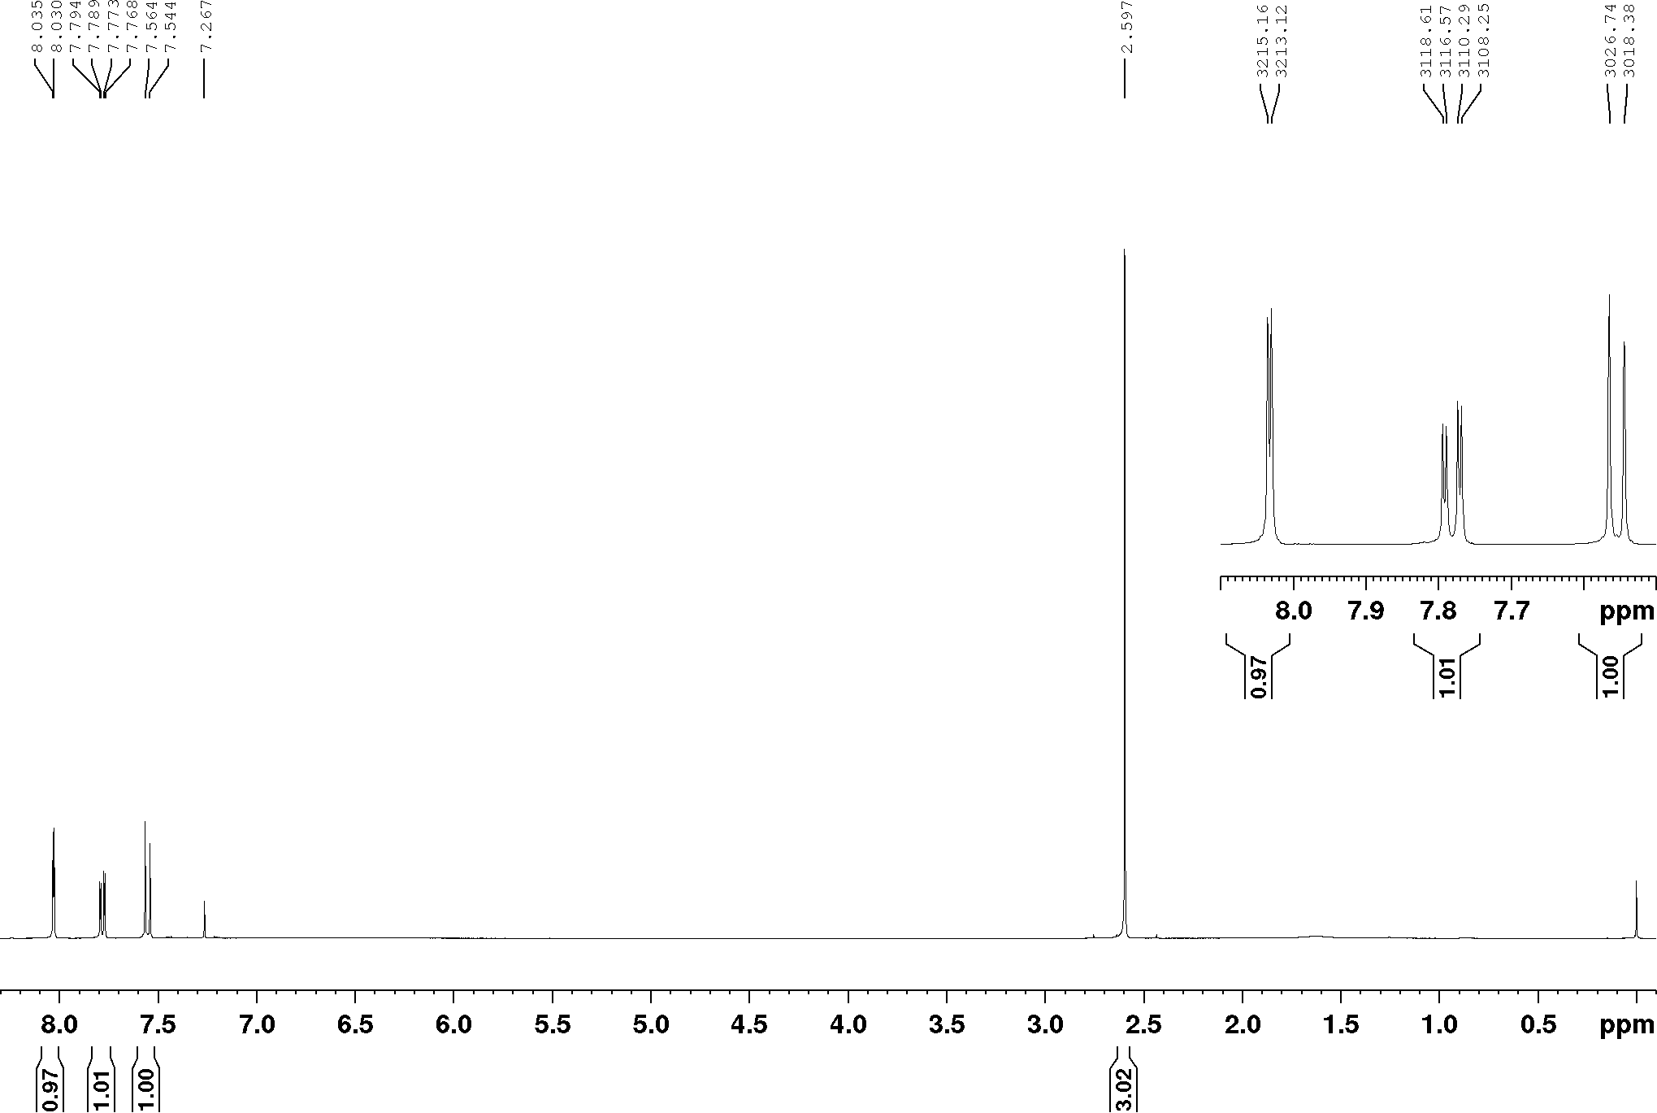
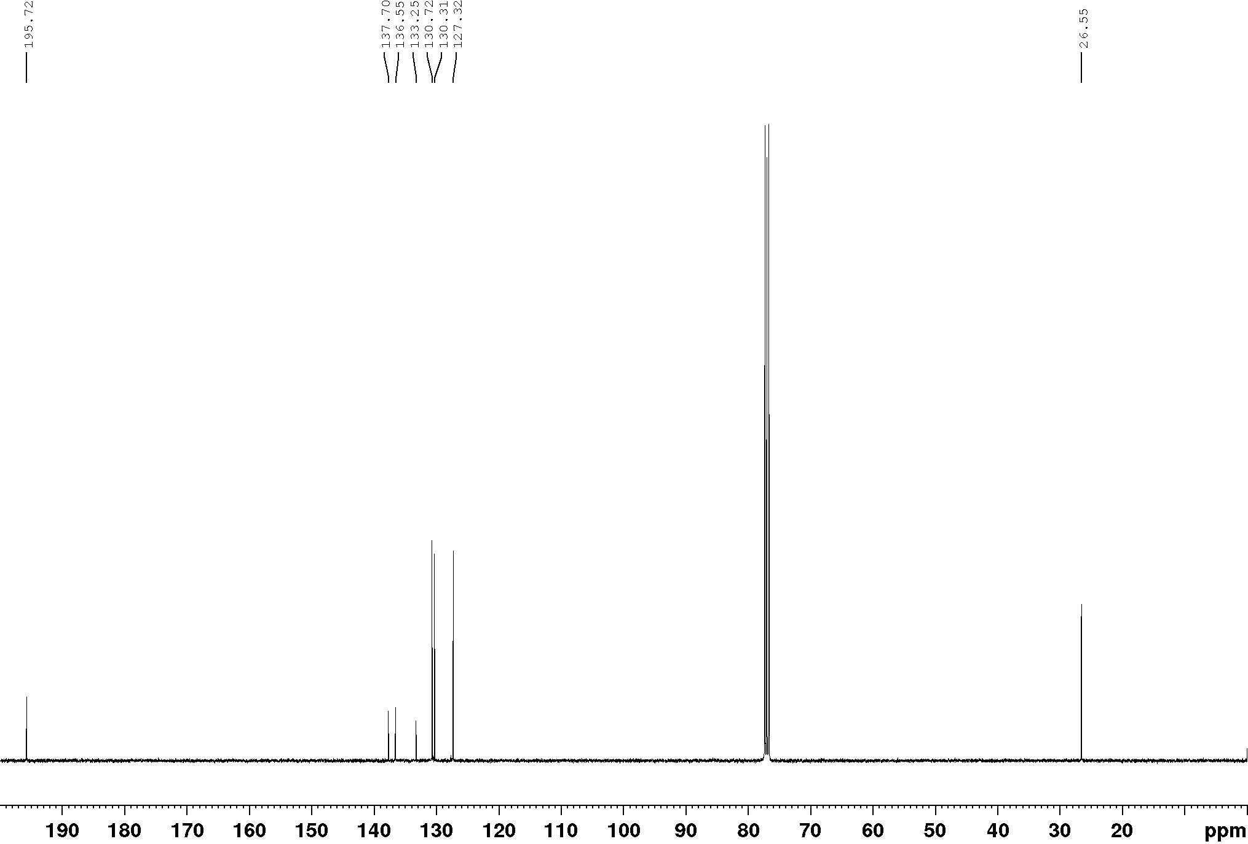
1-(3-Chloro-4-methoxyphenyl)ethan-1-one, ¹H NMR (400 MHz), CDCl₃
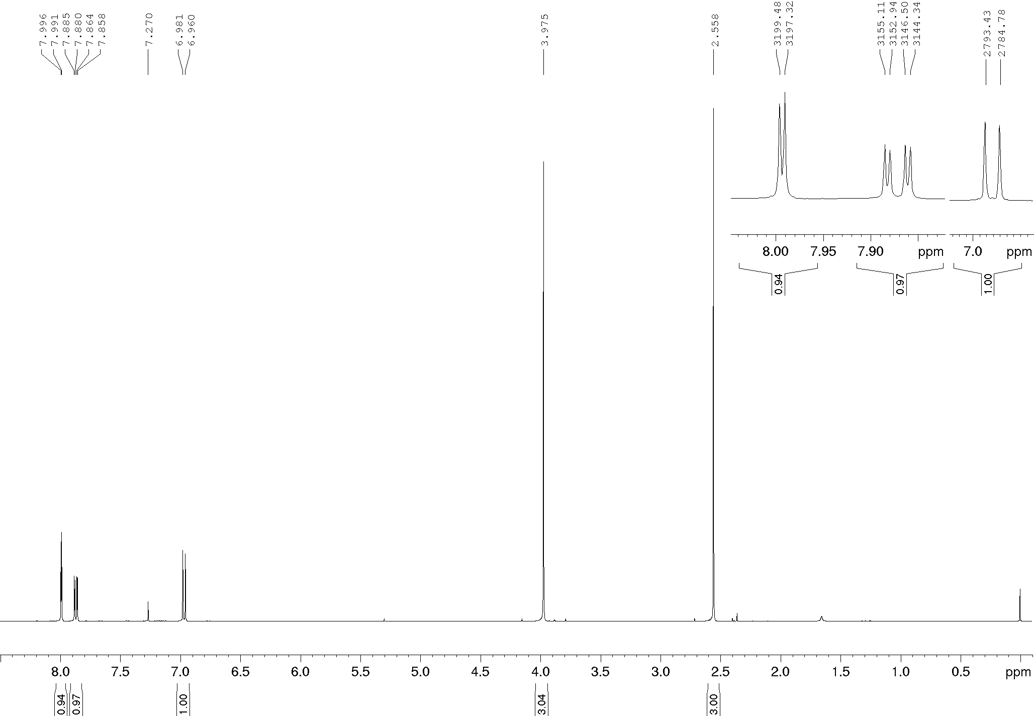

2-Bromo-4-methoxyacetophenone, ¹H and ¹³C NMR (400/100 MHz), CDCl₃
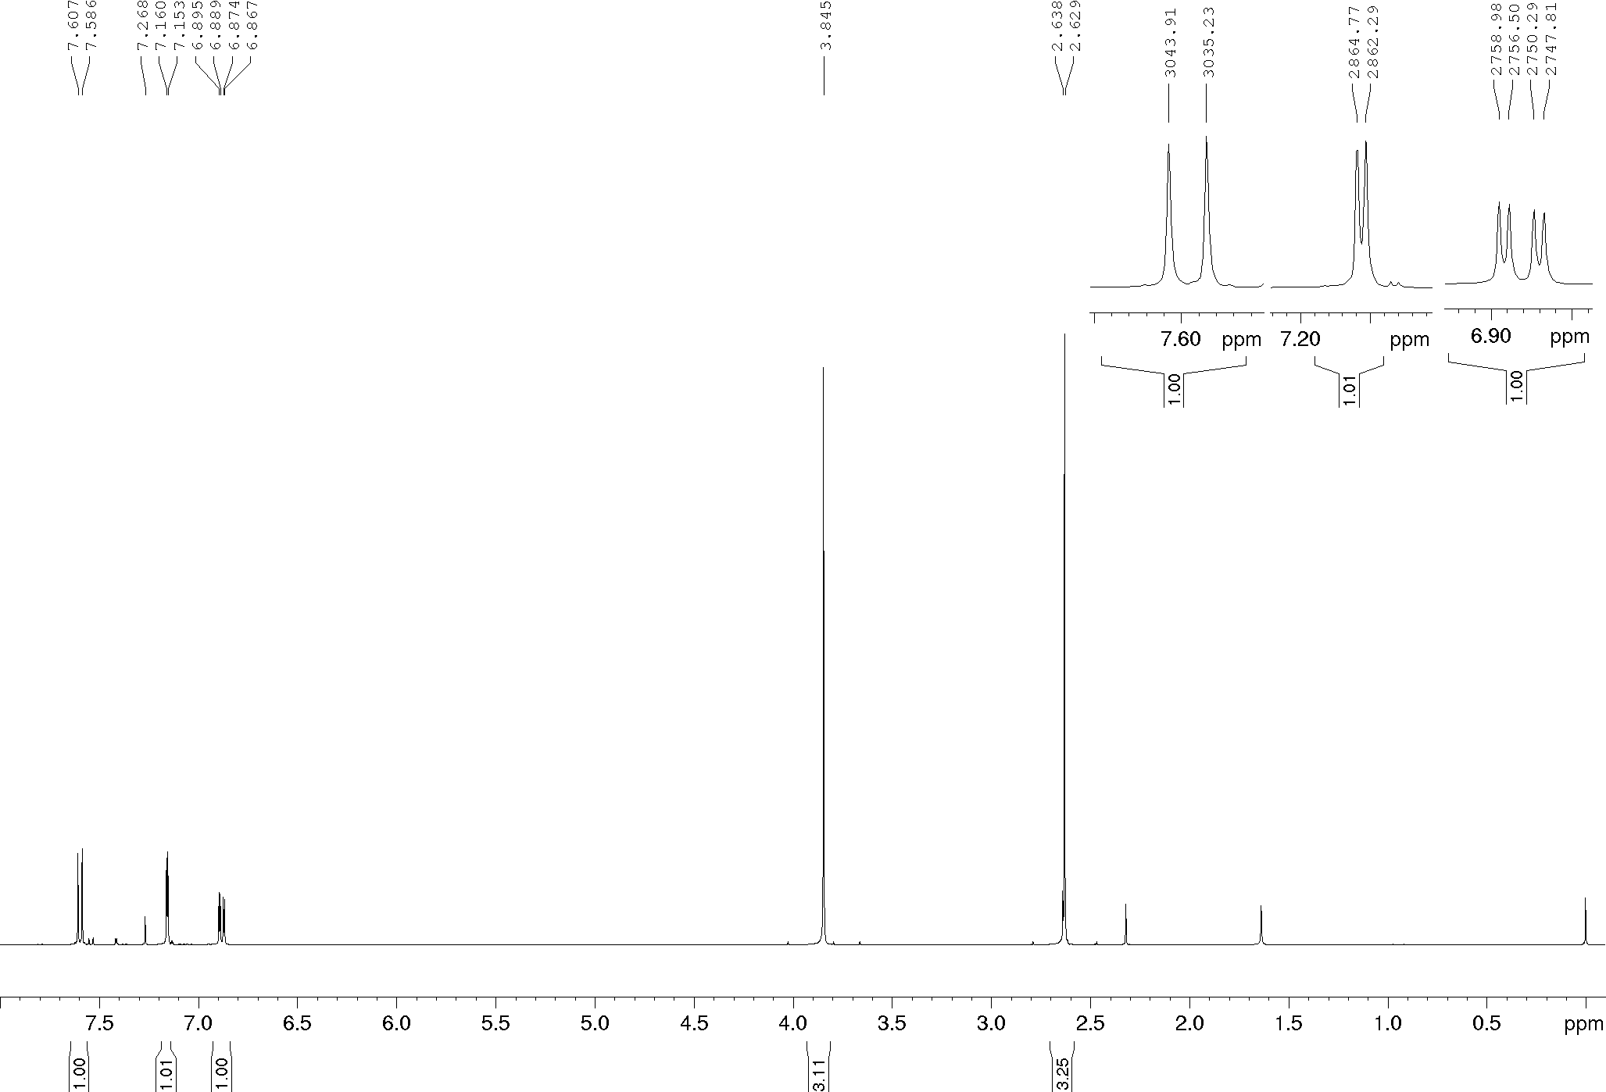
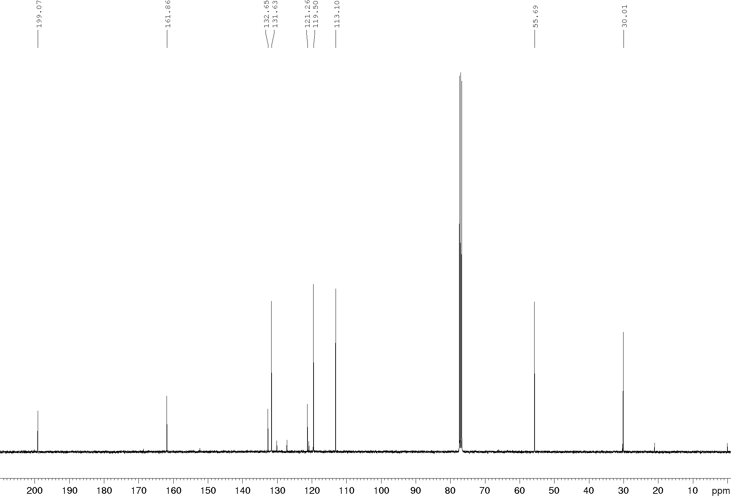

Compound 2a, ¹H and ¹³C NMR (400/100 MHz), CDCl₃
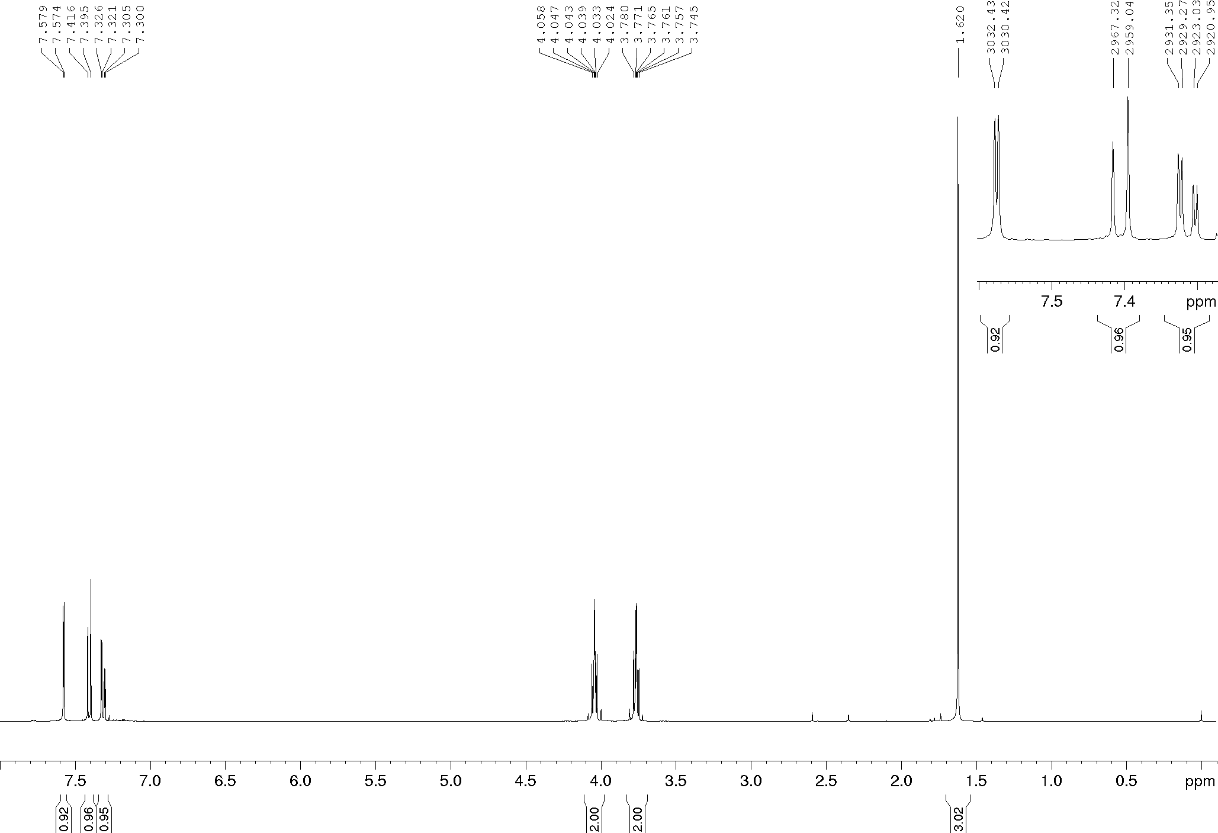
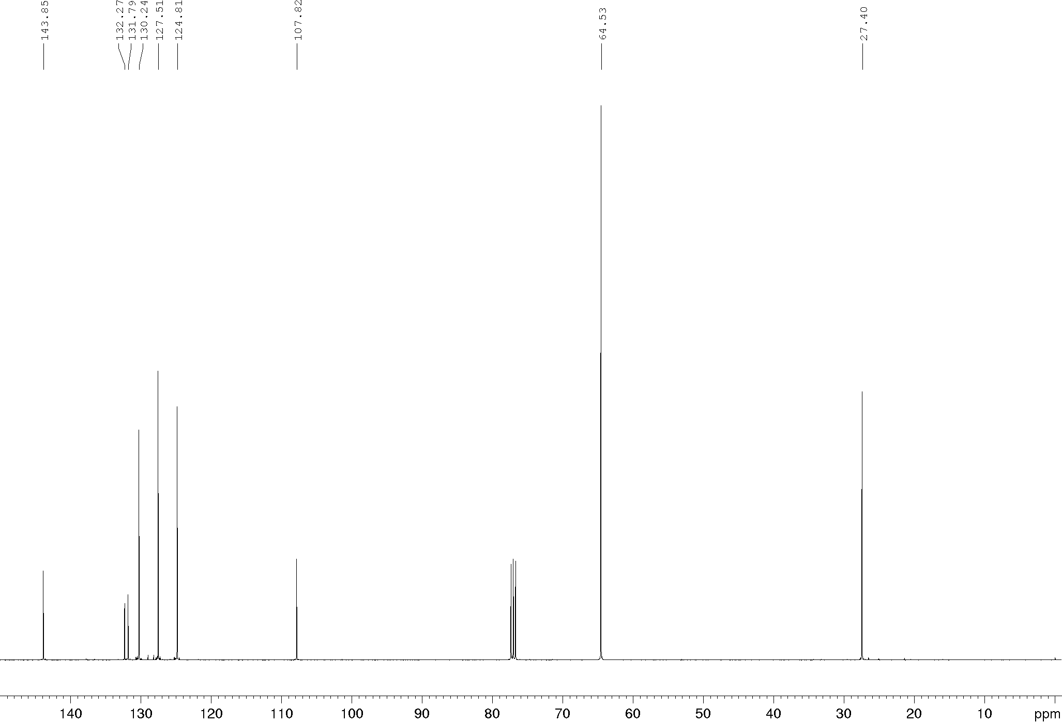
Compound 2b, ¹H and ¹³C NMR (400/100 MHz), CDCl₃
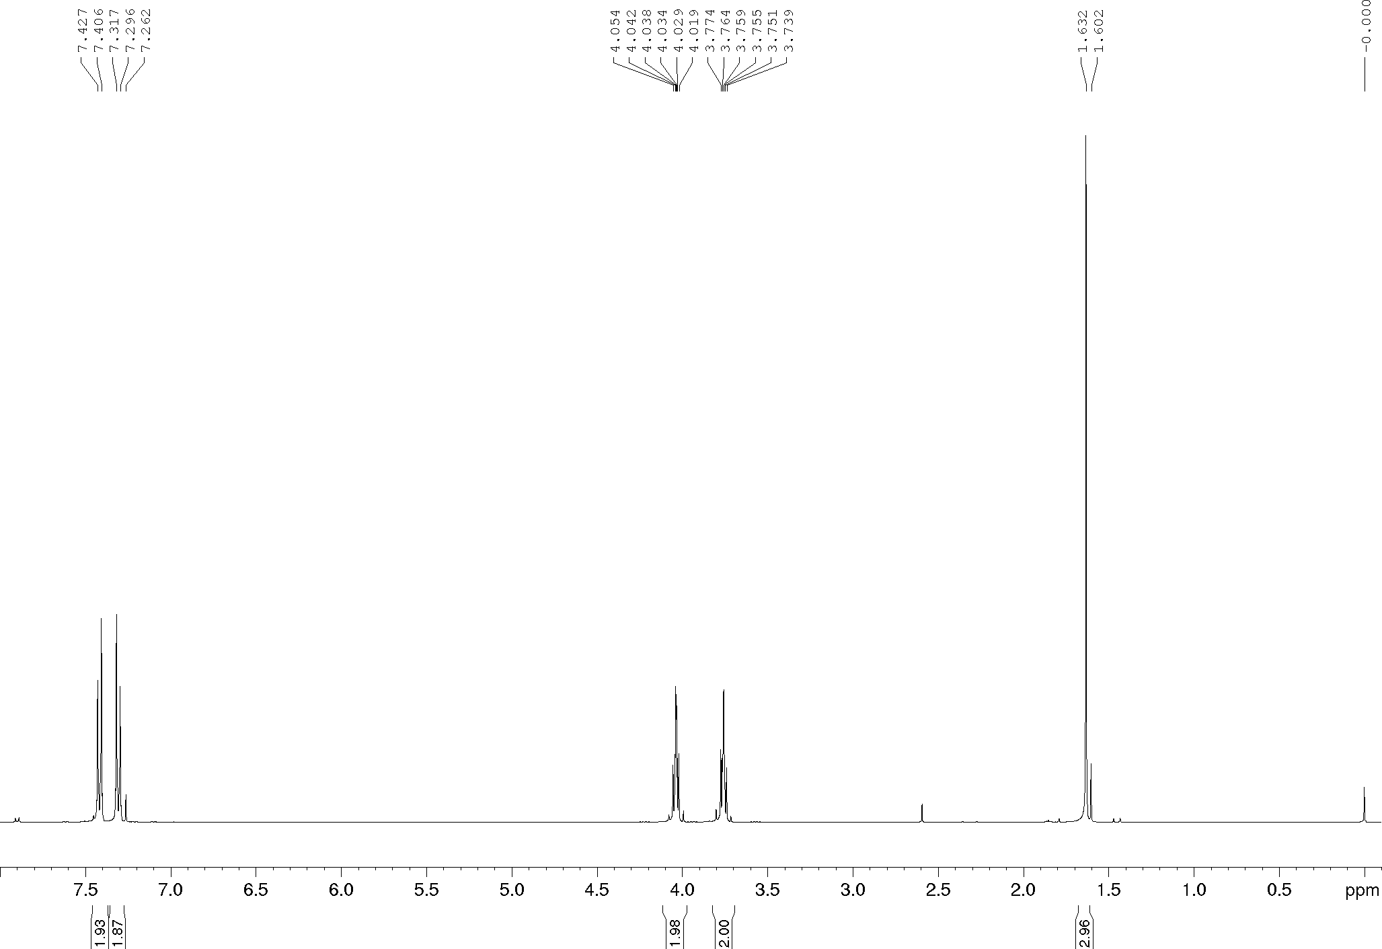
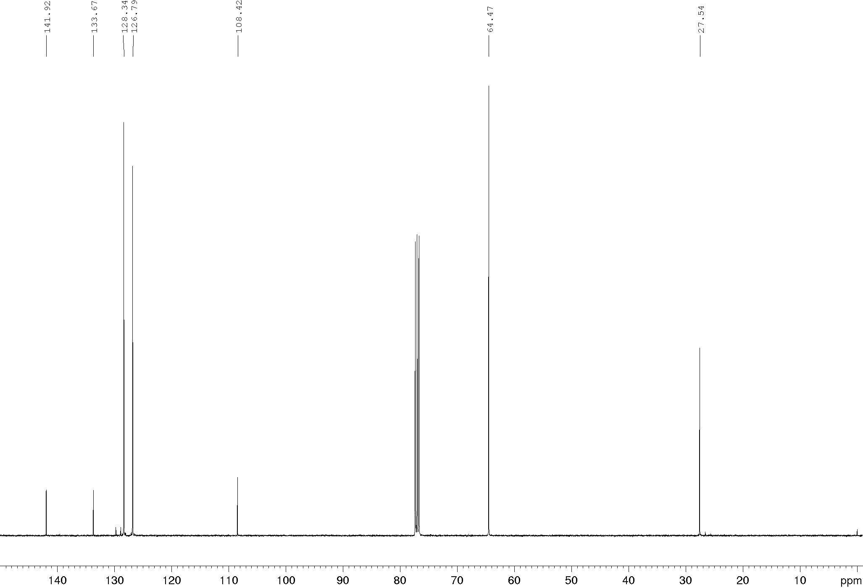
Compound 2c, ¹H and ¹³C NMR (400/100 MHz), CDCl₃
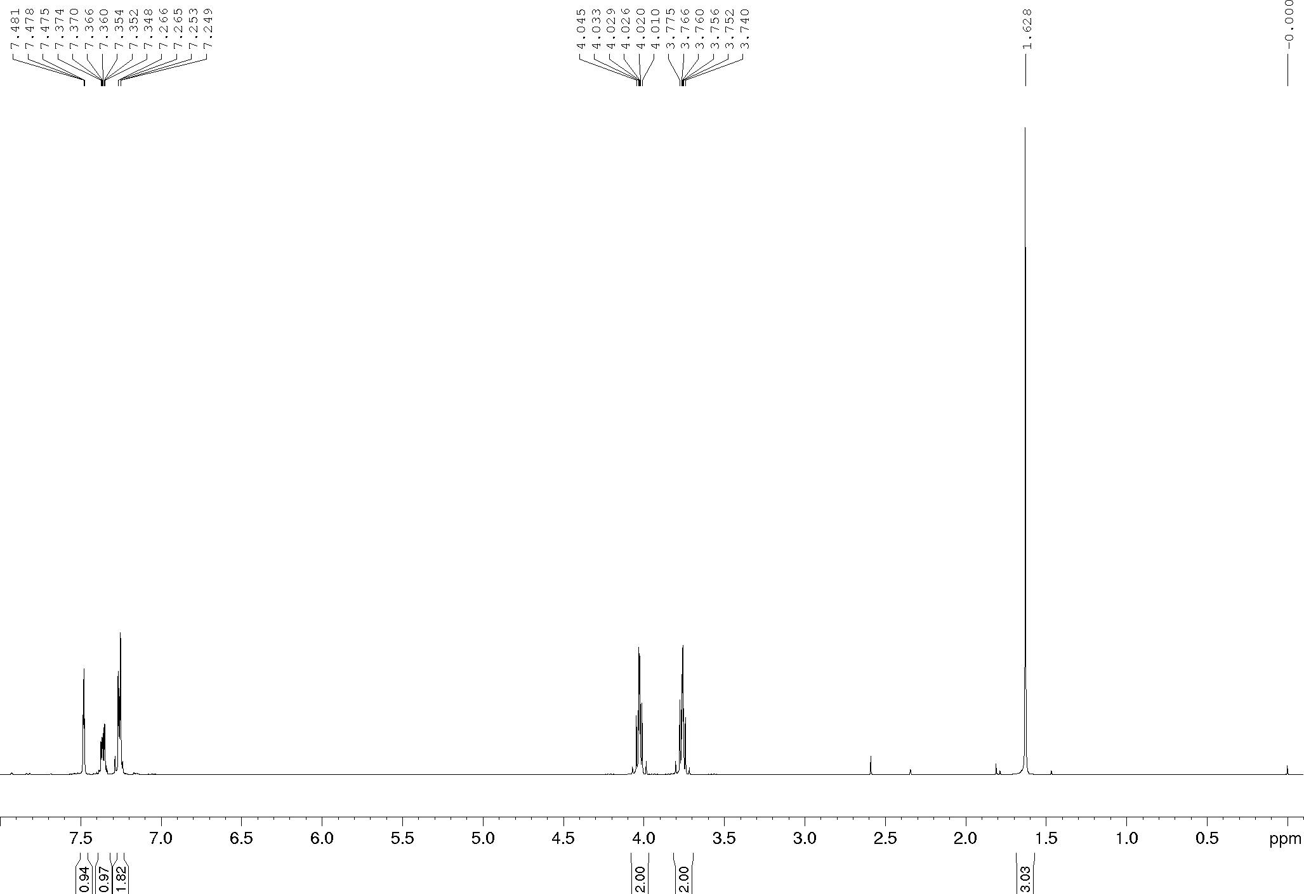
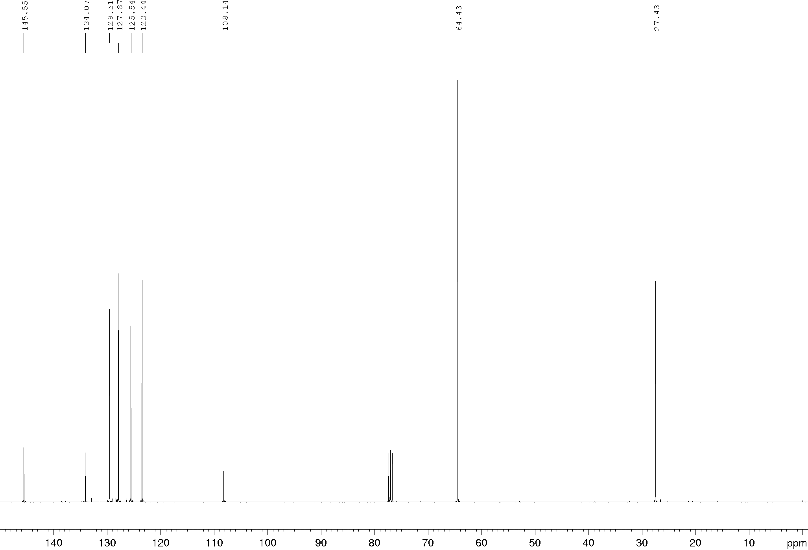
Compound 2d, ¹H and ¹³C NMR (600/150 MHz), CDCl₃
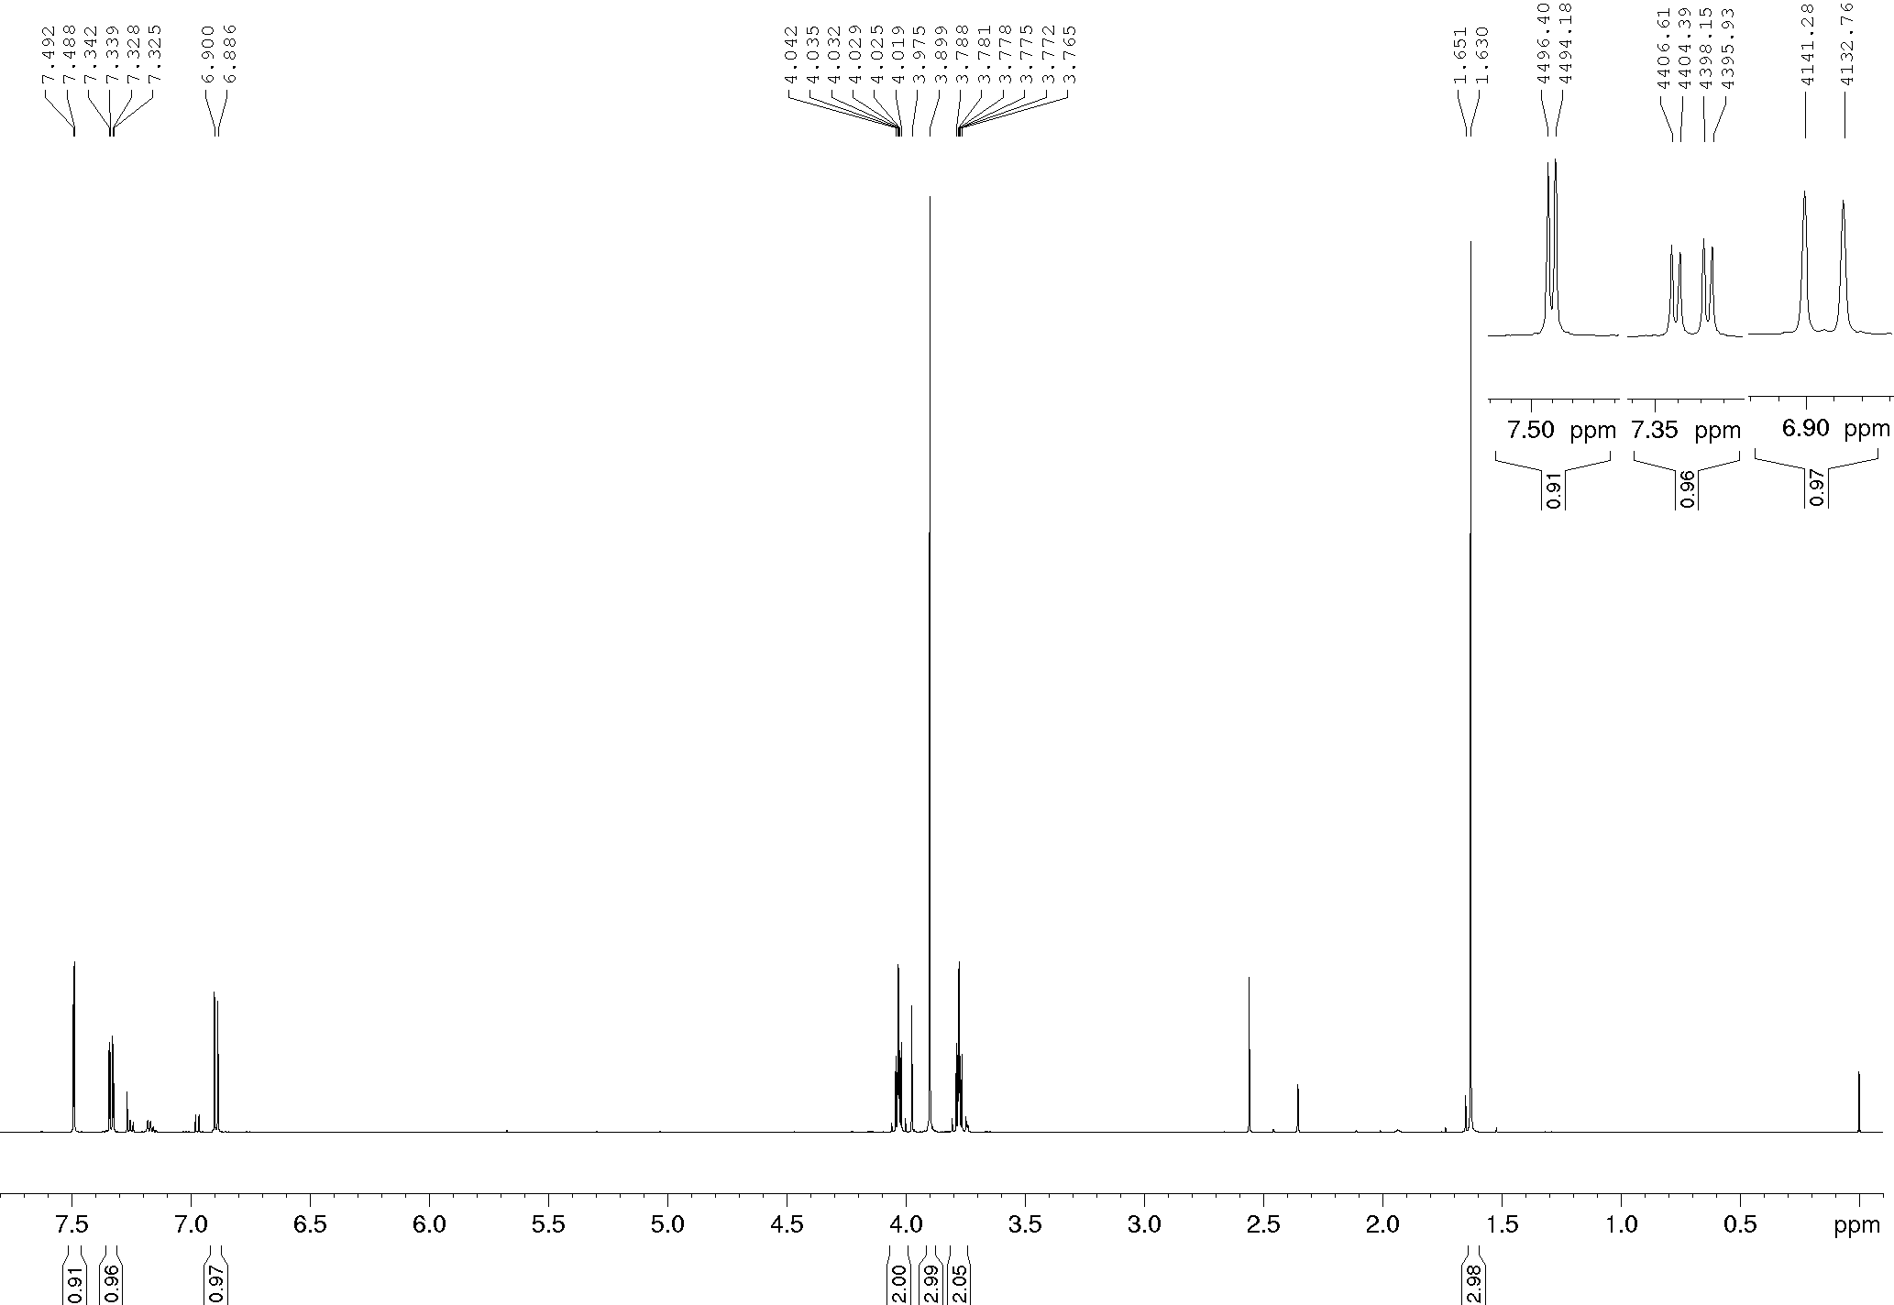
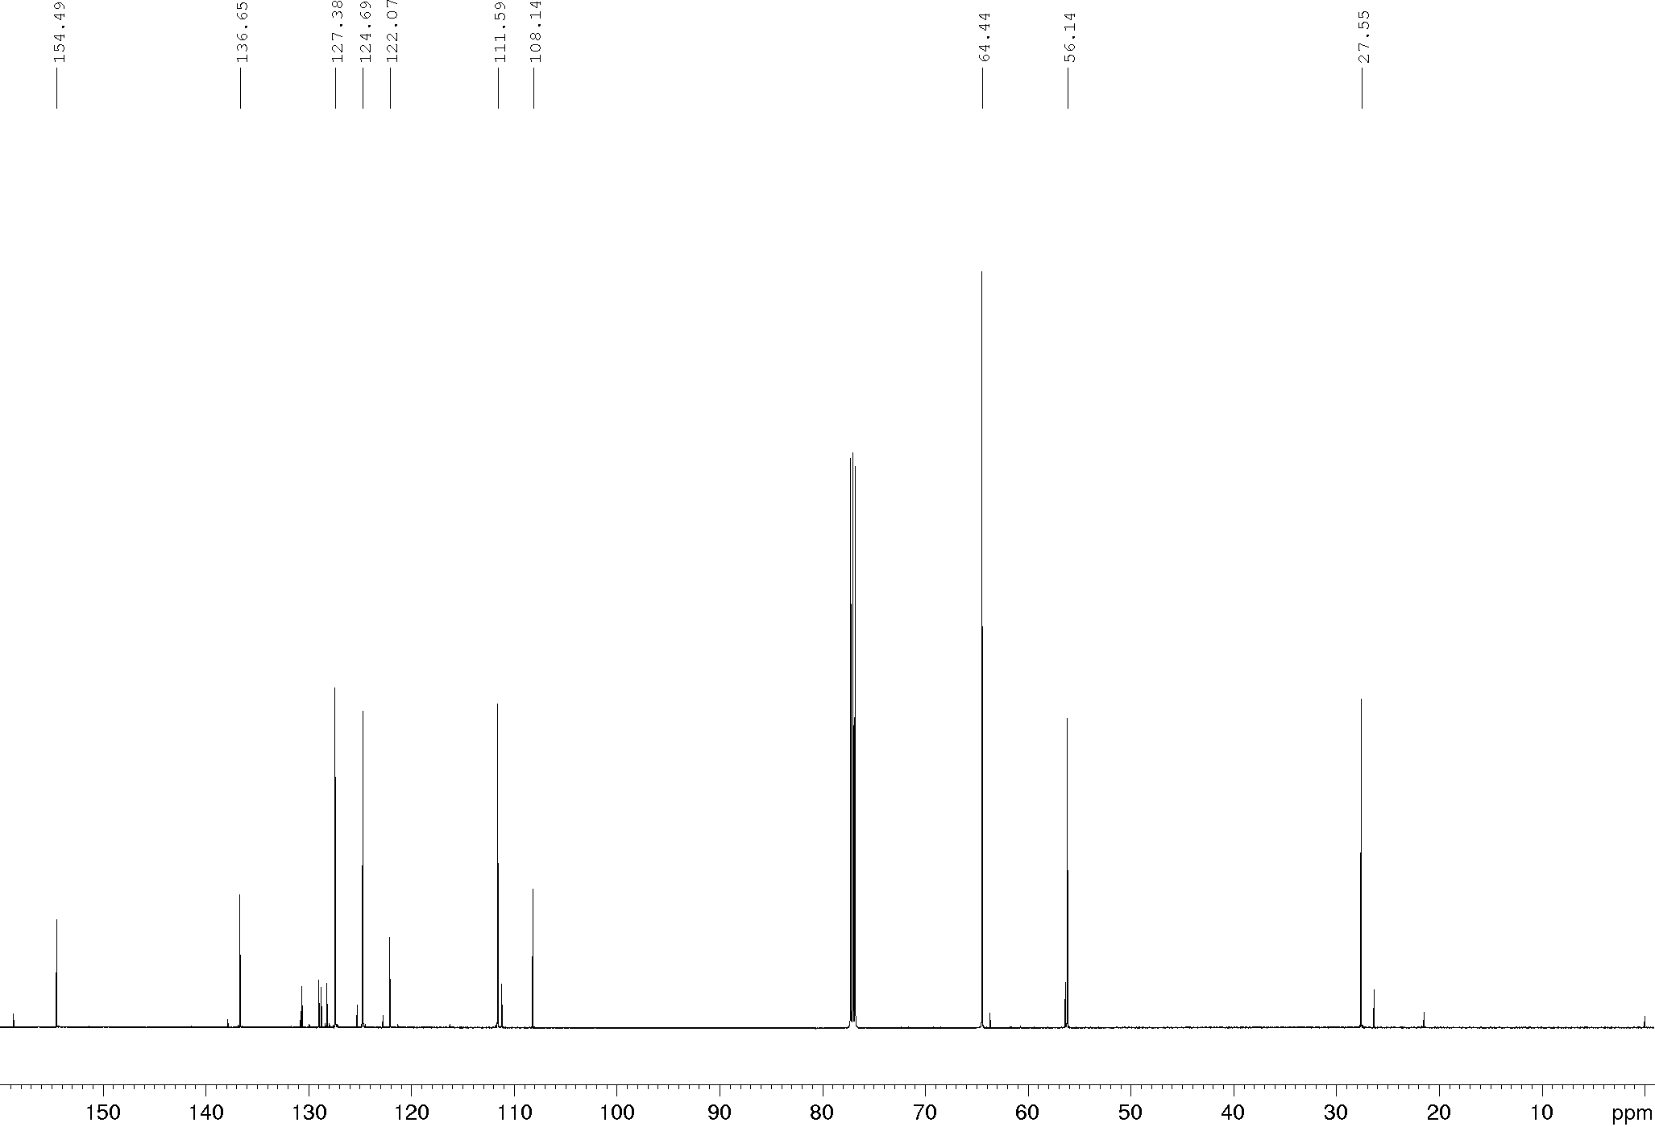
Compound 2e, ¹H and ¹³C NMR (400/100 MHz), CDCl₃
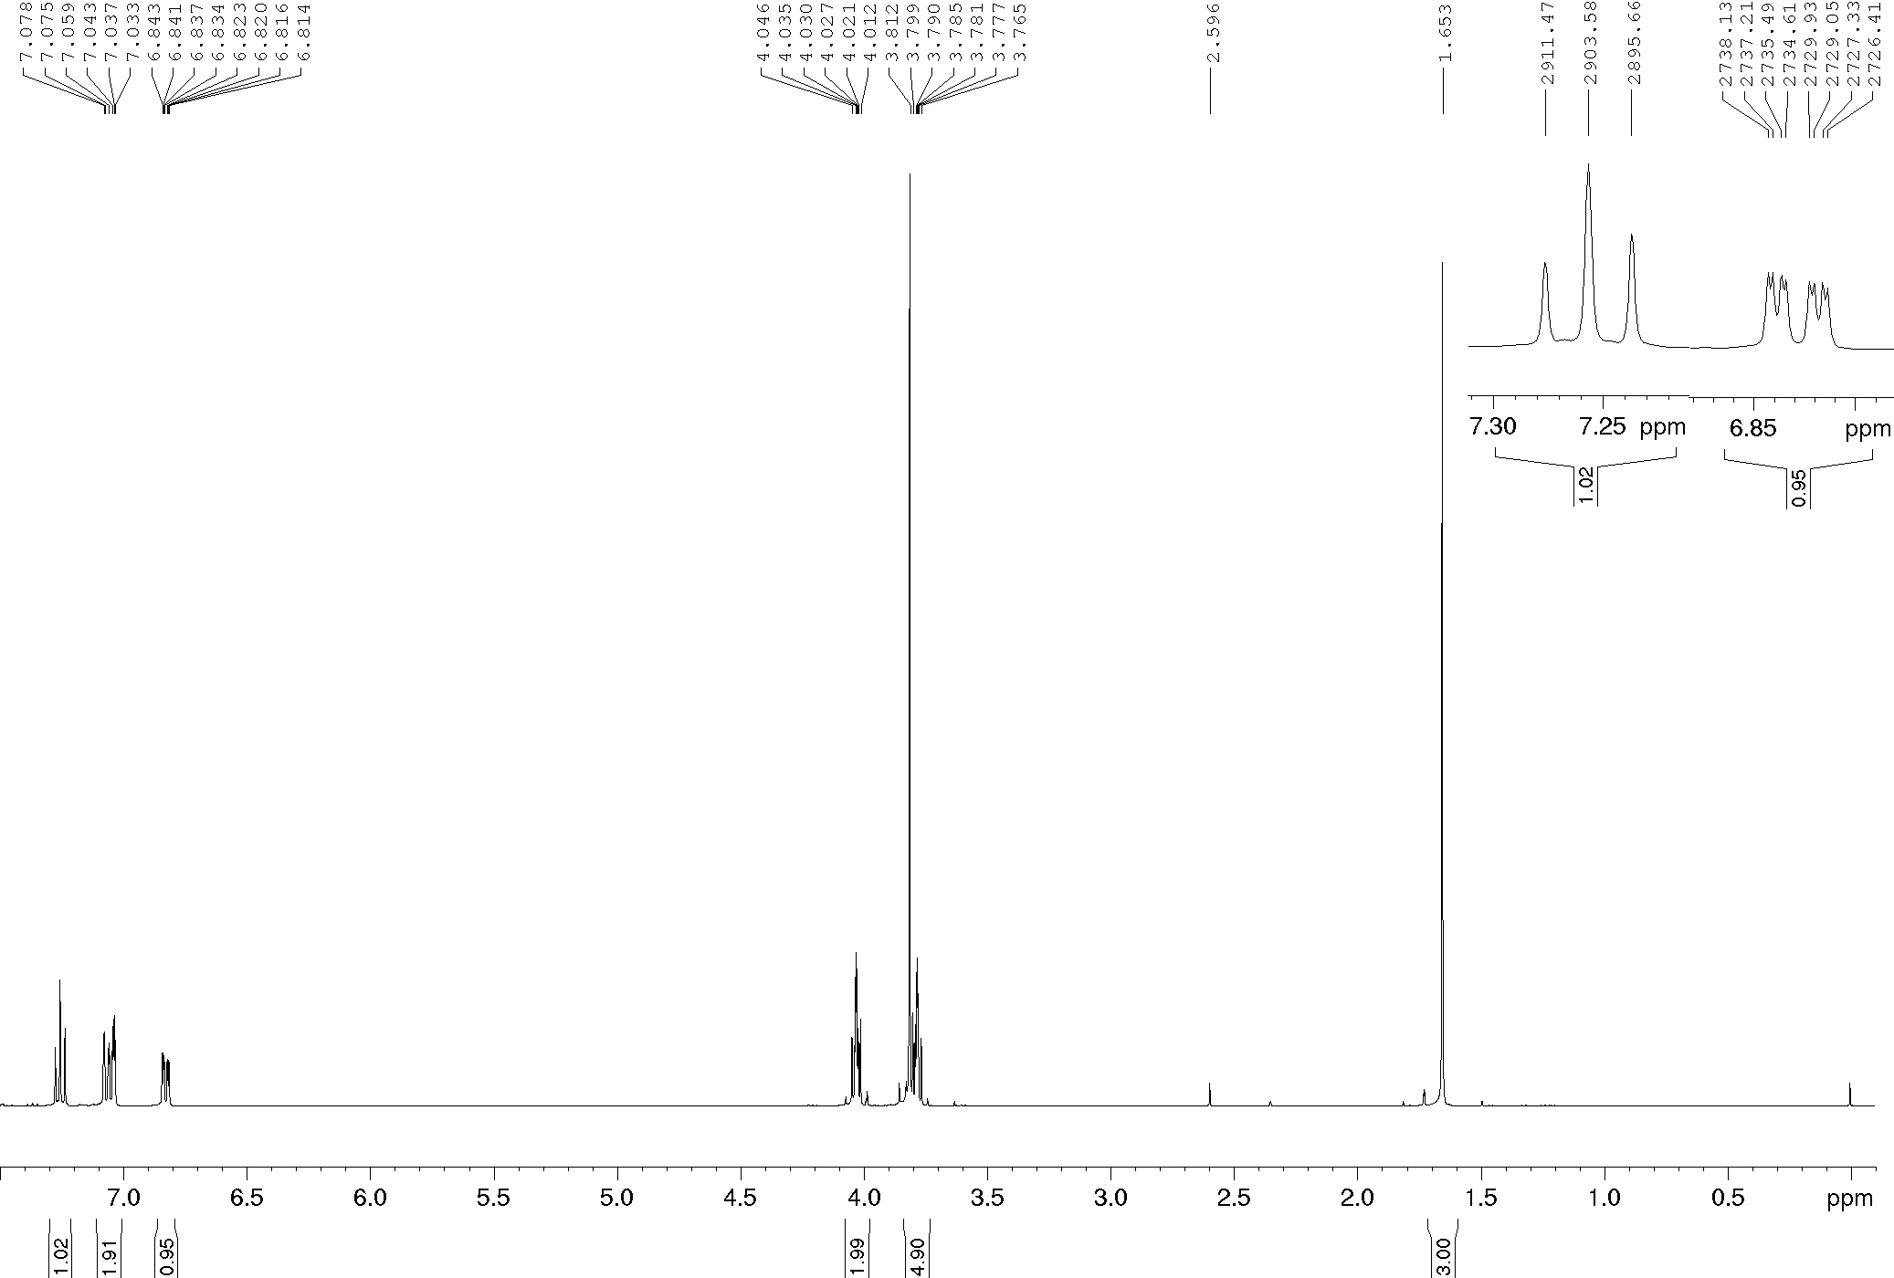
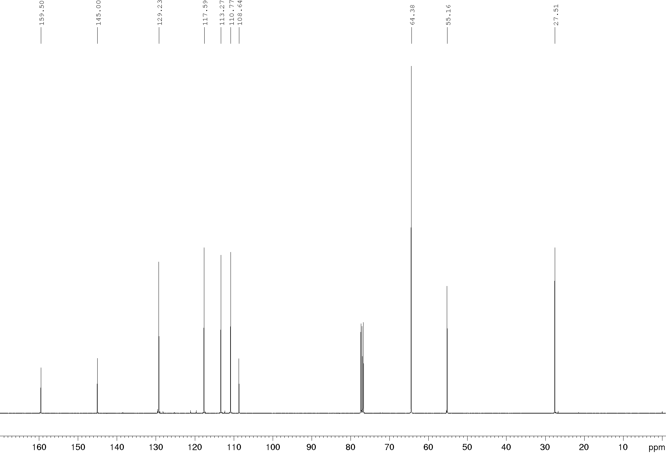
Compound 2f, ¹H and ¹³C NMR (600/150 MHz), CDCl₃
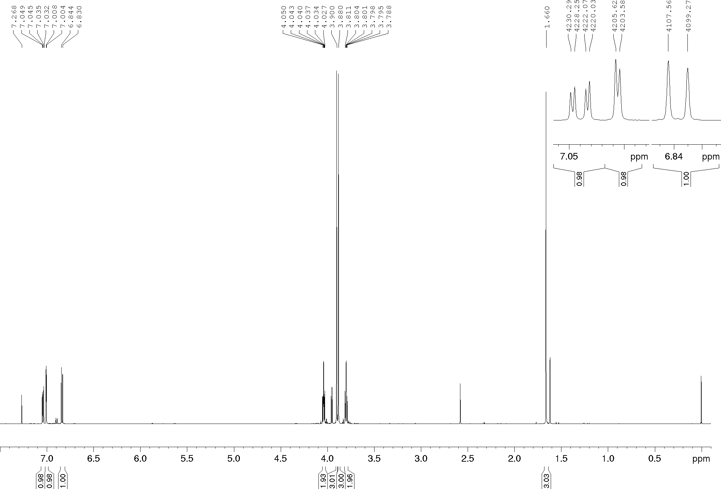
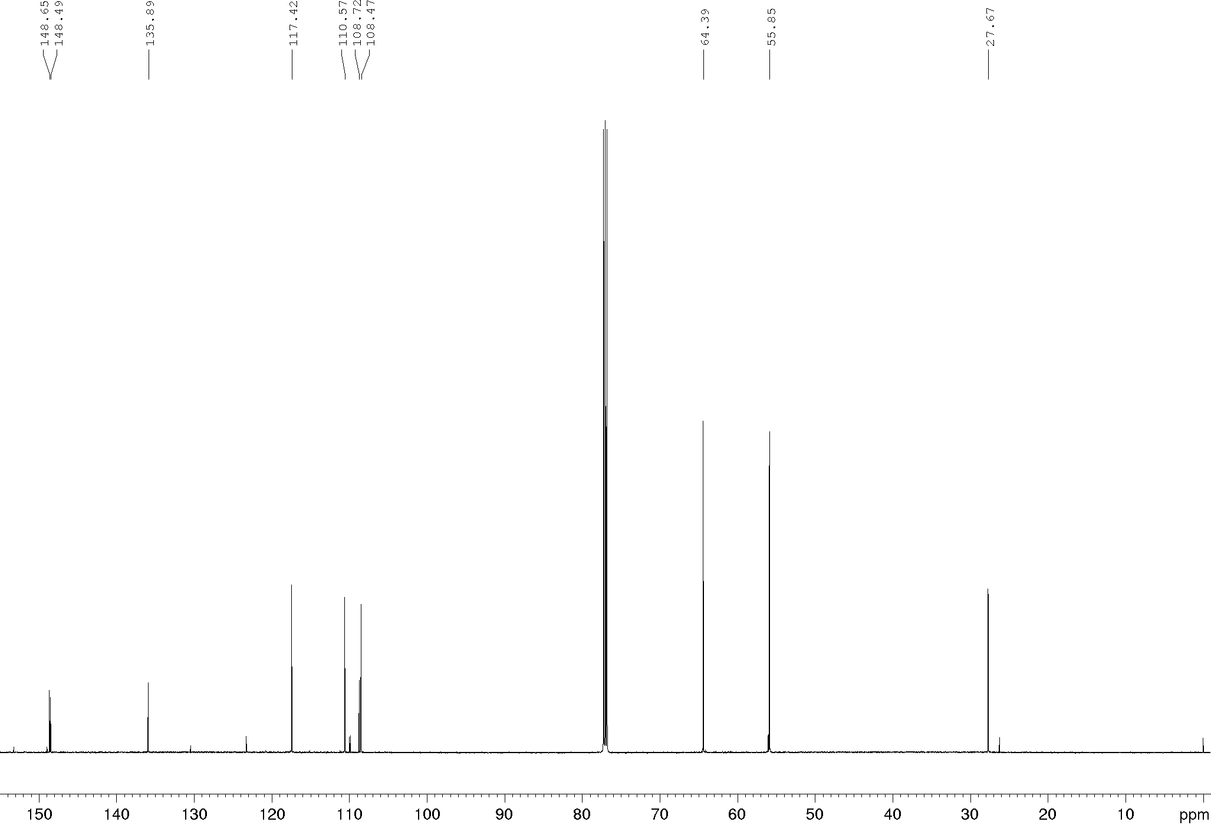
Compound 13a, ¹H and ¹³C NMR (400/100 MHz), CDCl₃
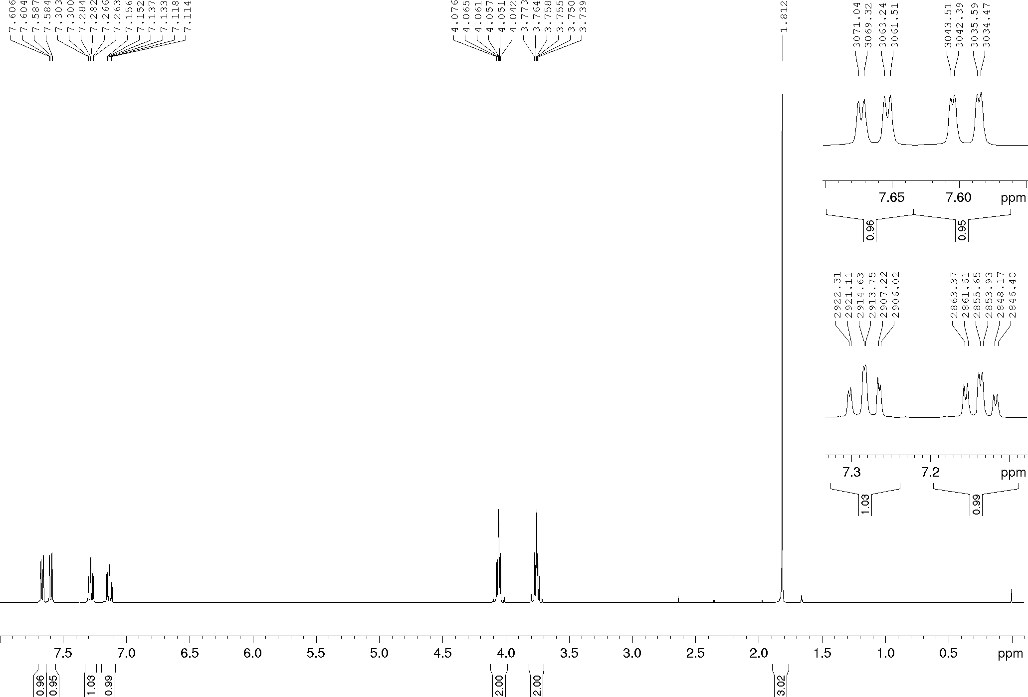
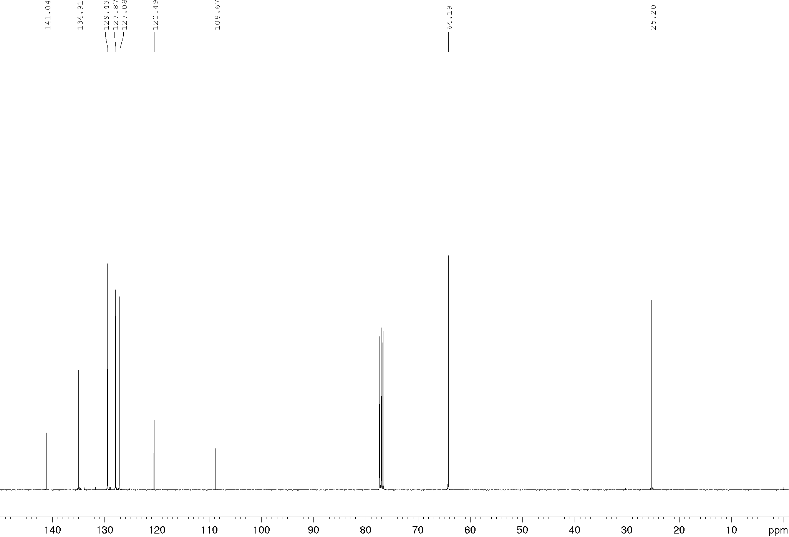
Compound 13b, ¹H and ¹³C NMR (400/100 MHz), CDCl₃
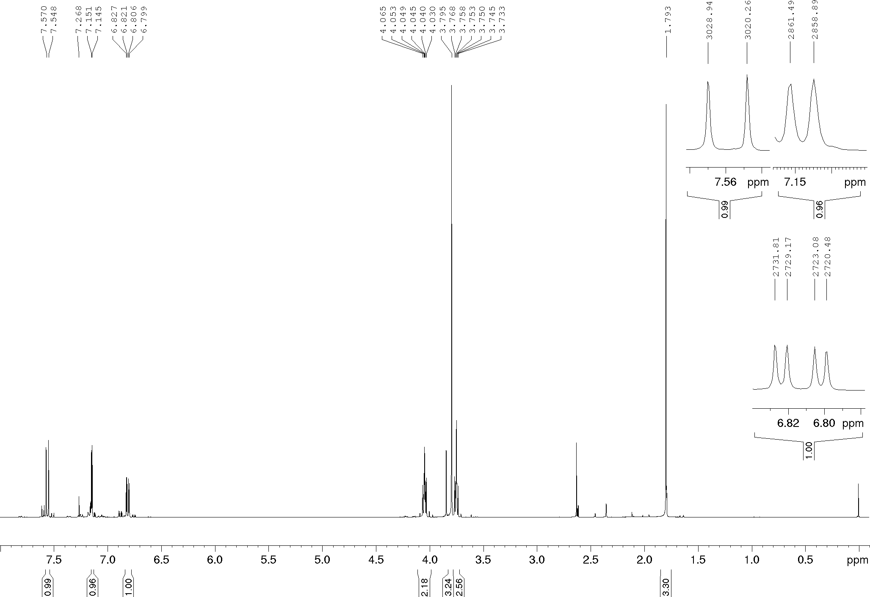
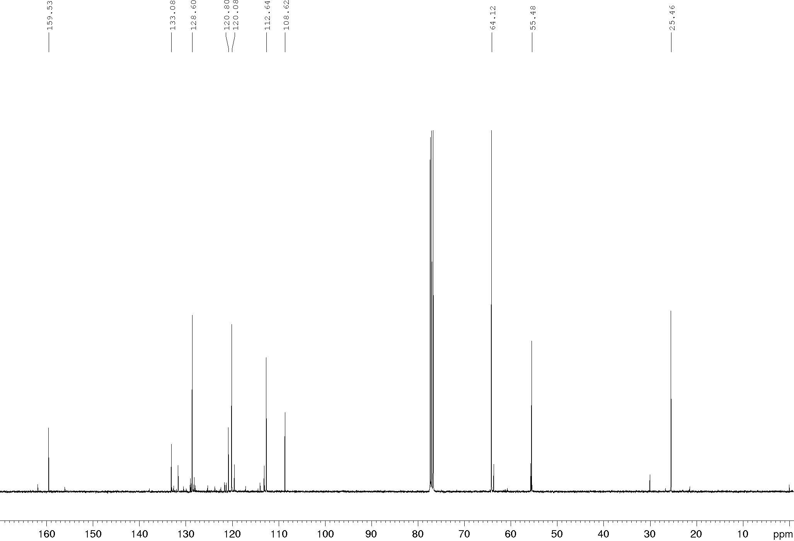

Compound 5a, ¹H and ¹³C NMR (400/100 MHz), CDCl₃
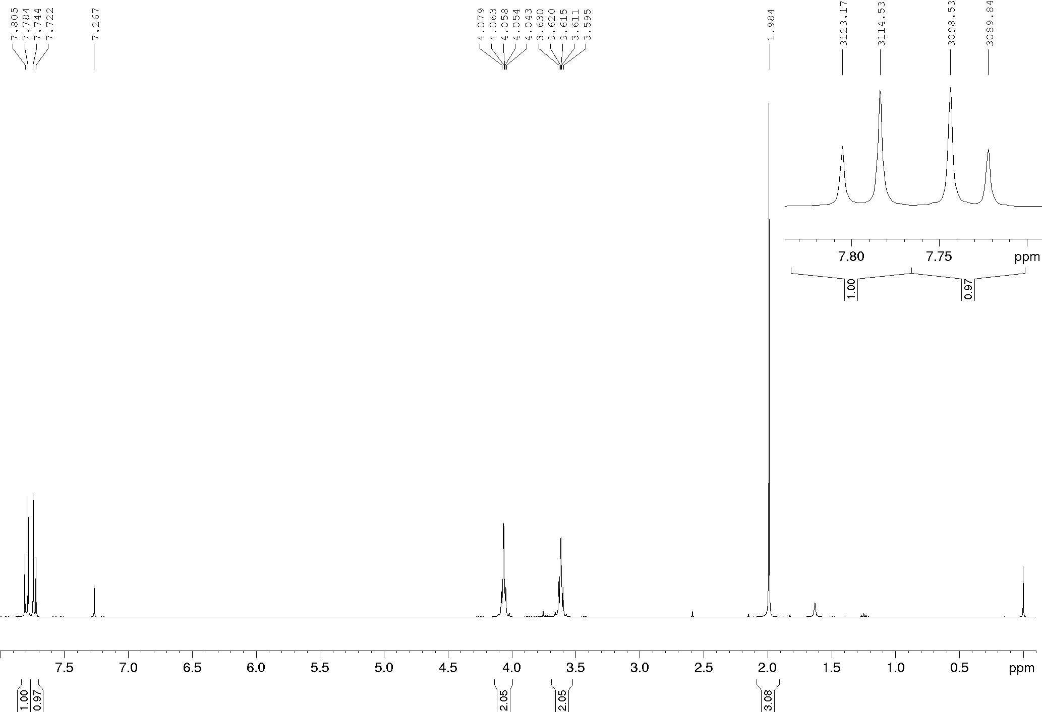
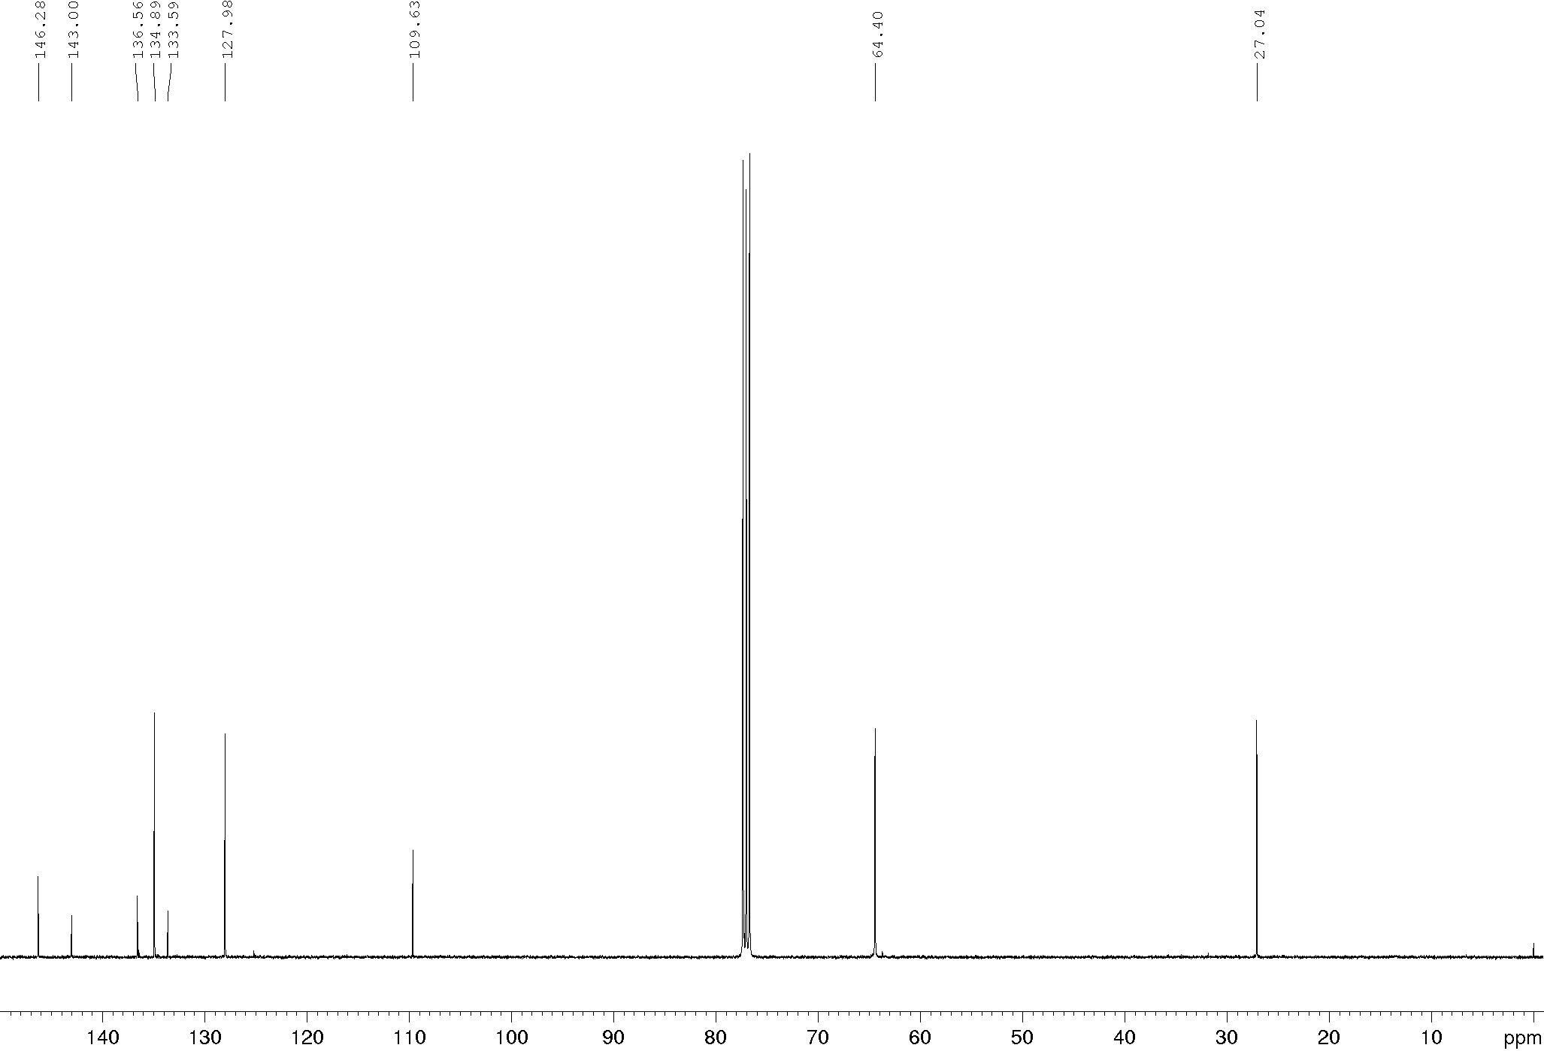
Compound 5b, ¹H and ¹³C NMR (600/150 MHz), CDCl₃
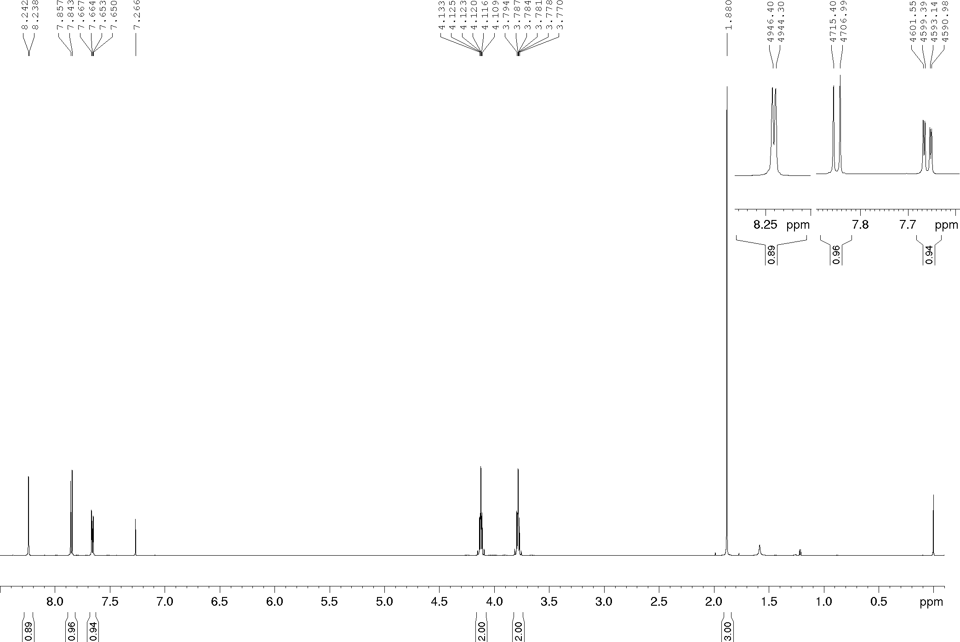
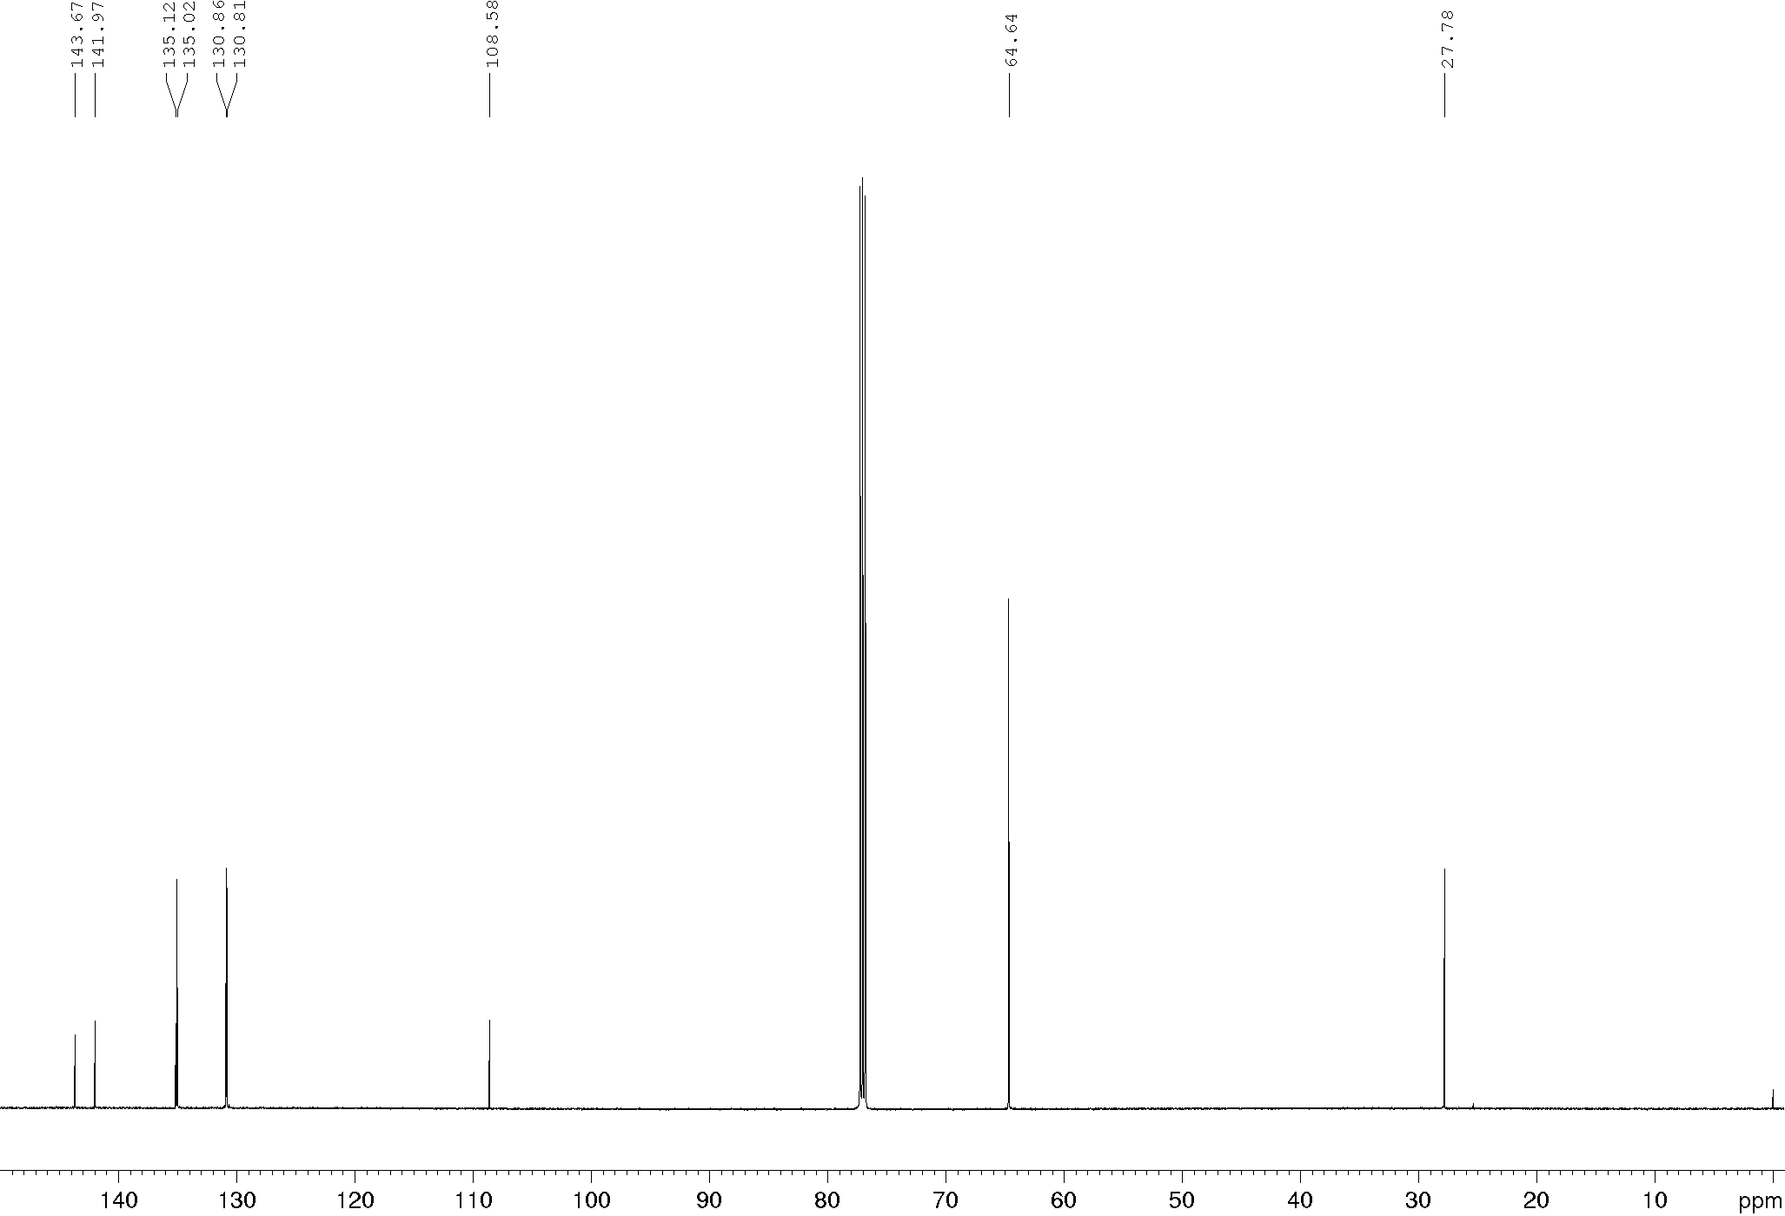
Compound 5c, ¹H and ¹³C NMR (400/100 MHz), CDCl₃
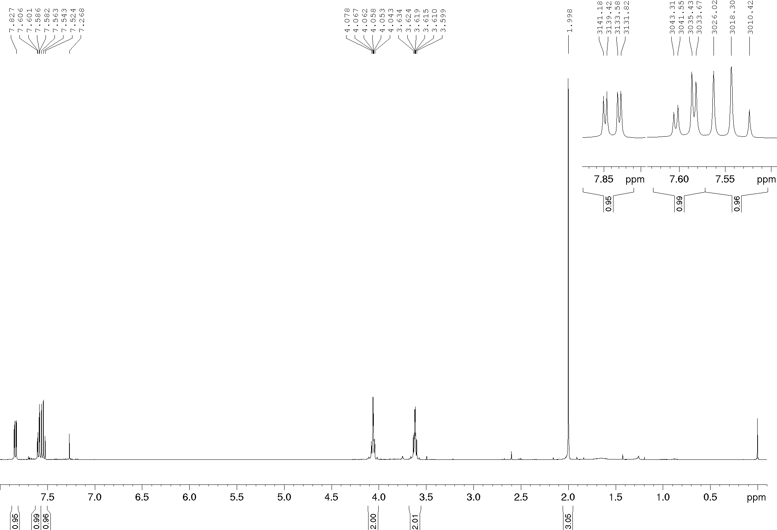
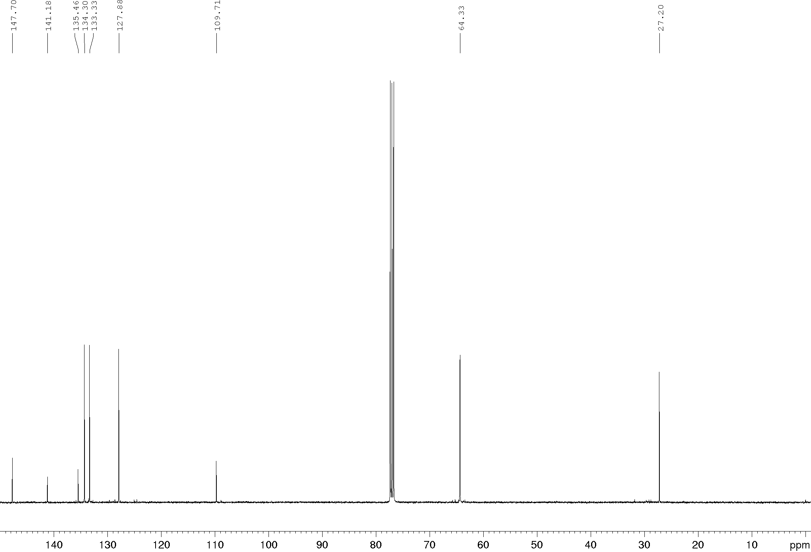
Compound 5d, ¹H and ¹³C NMR (400/100 MHz), CDCl₃
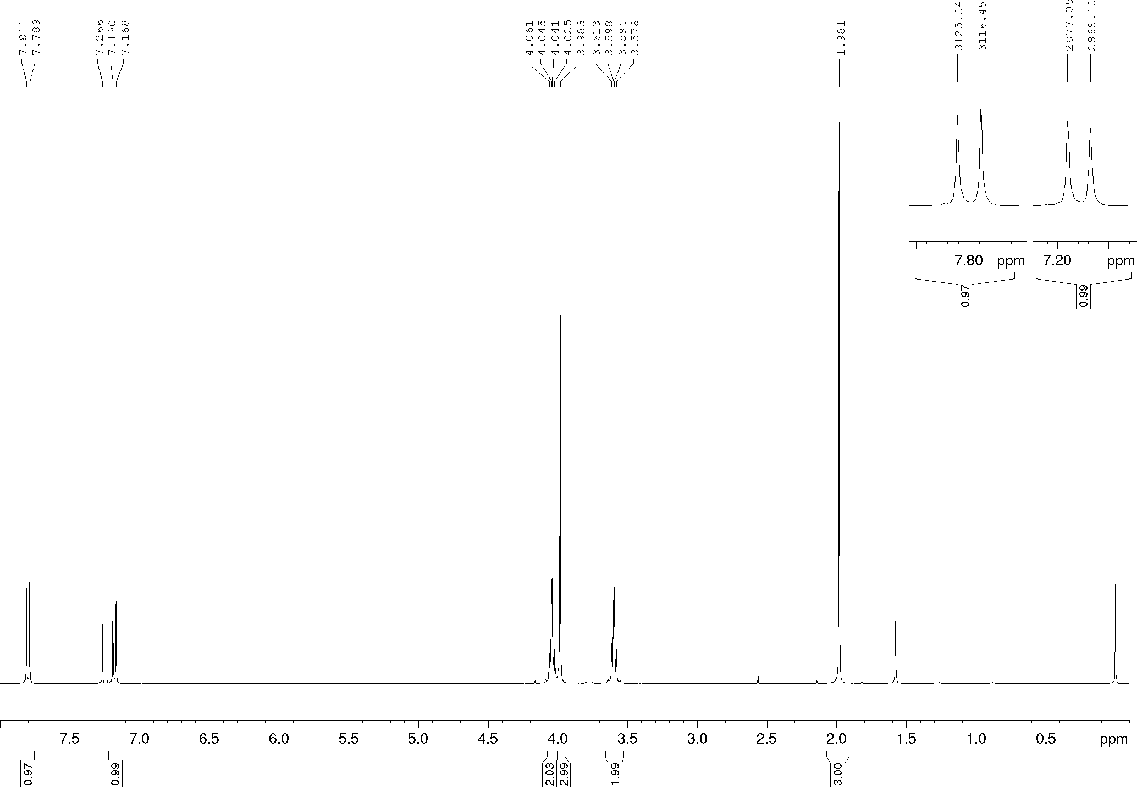
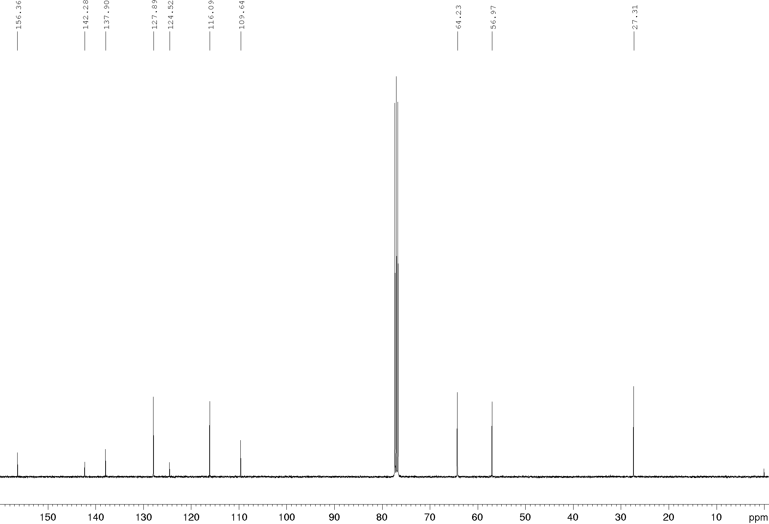
Compound 5e, ¹H and ¹³C NMR (400/100 MHz), CDCl₃
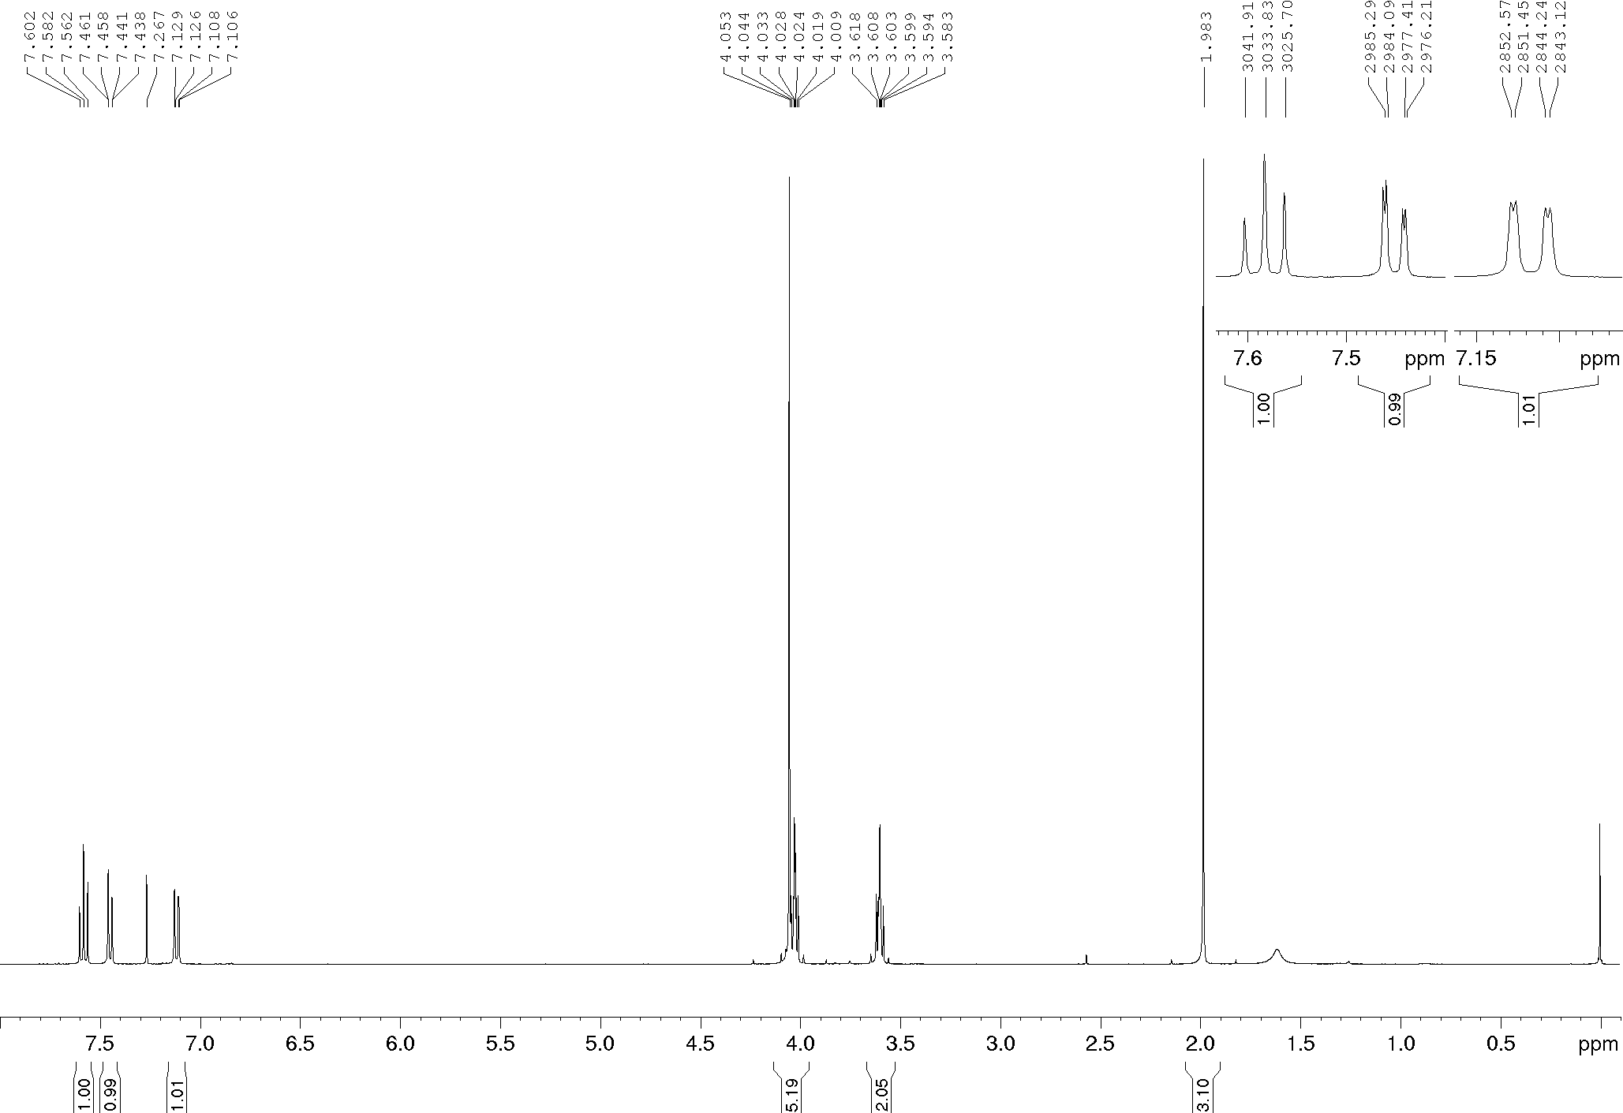
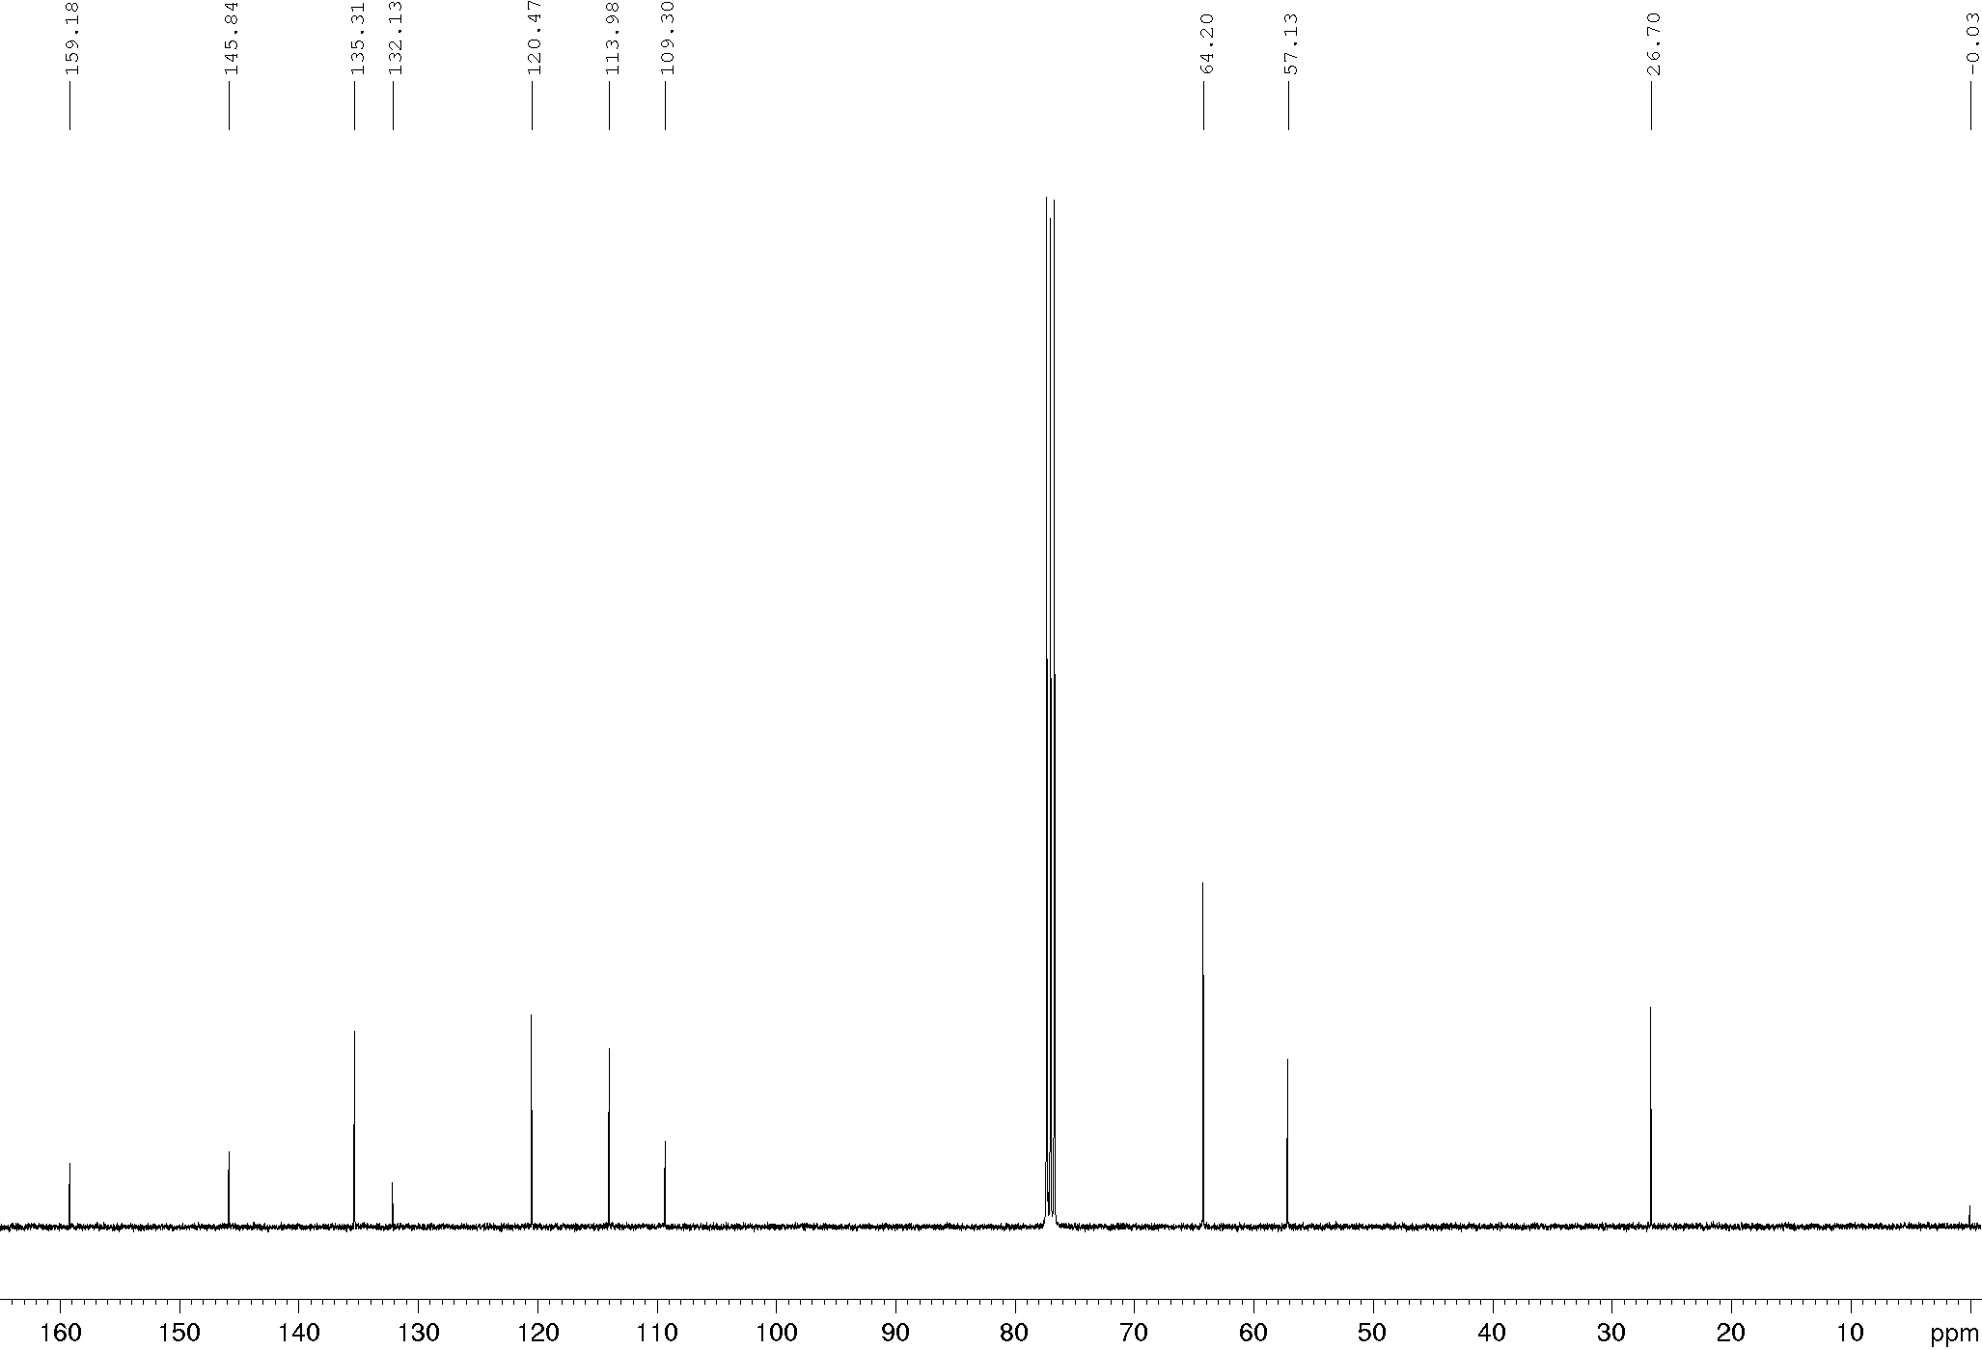
Compound 5f, ¹H and ¹³C NMR (400/100 MHz), CDCl₃
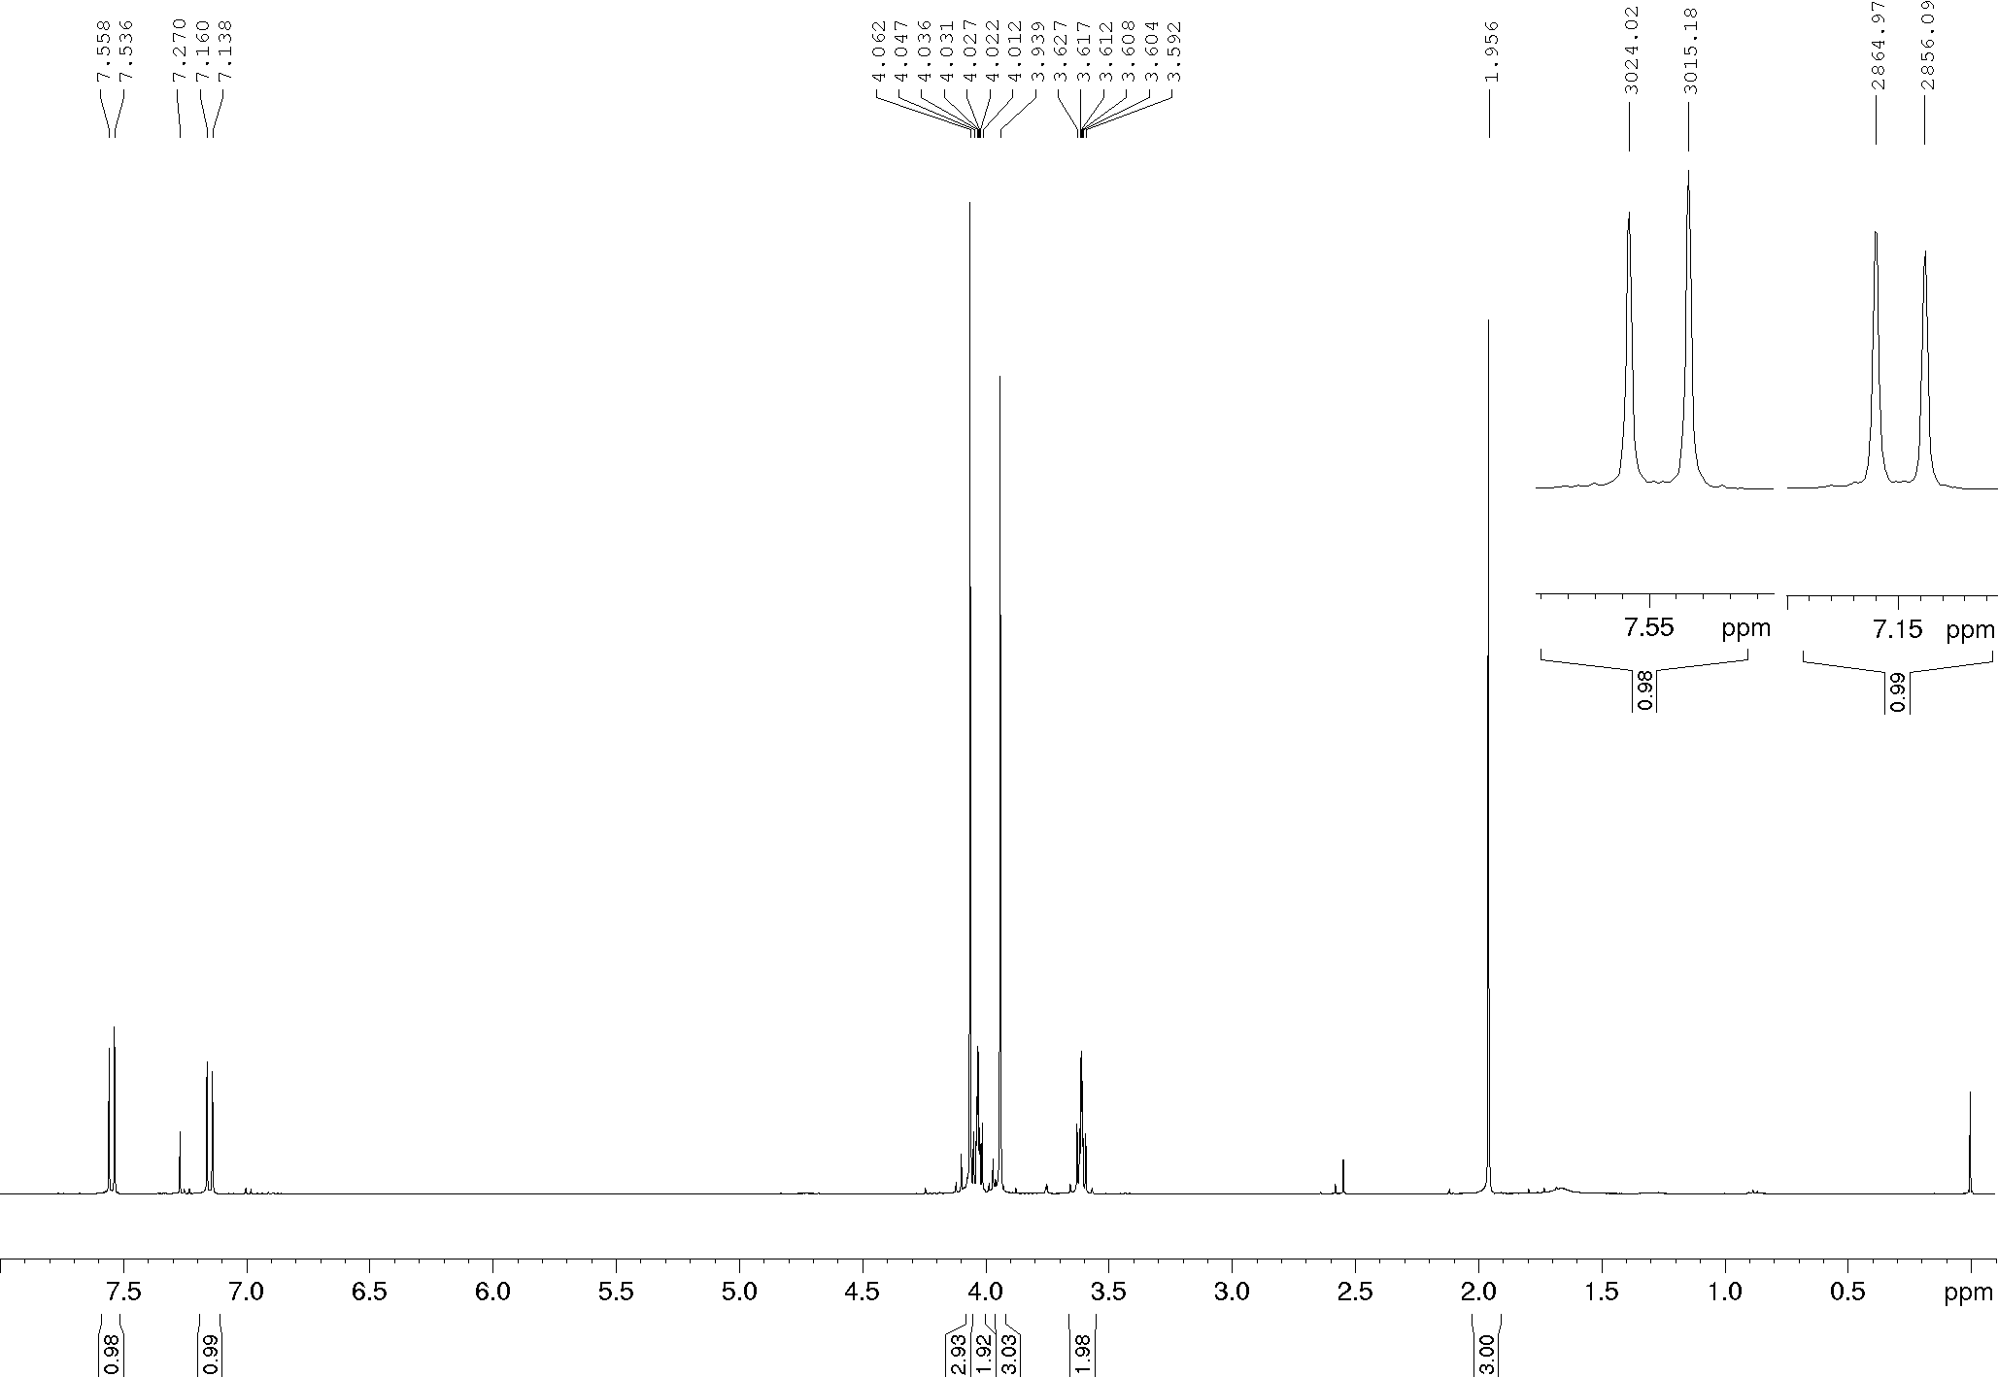
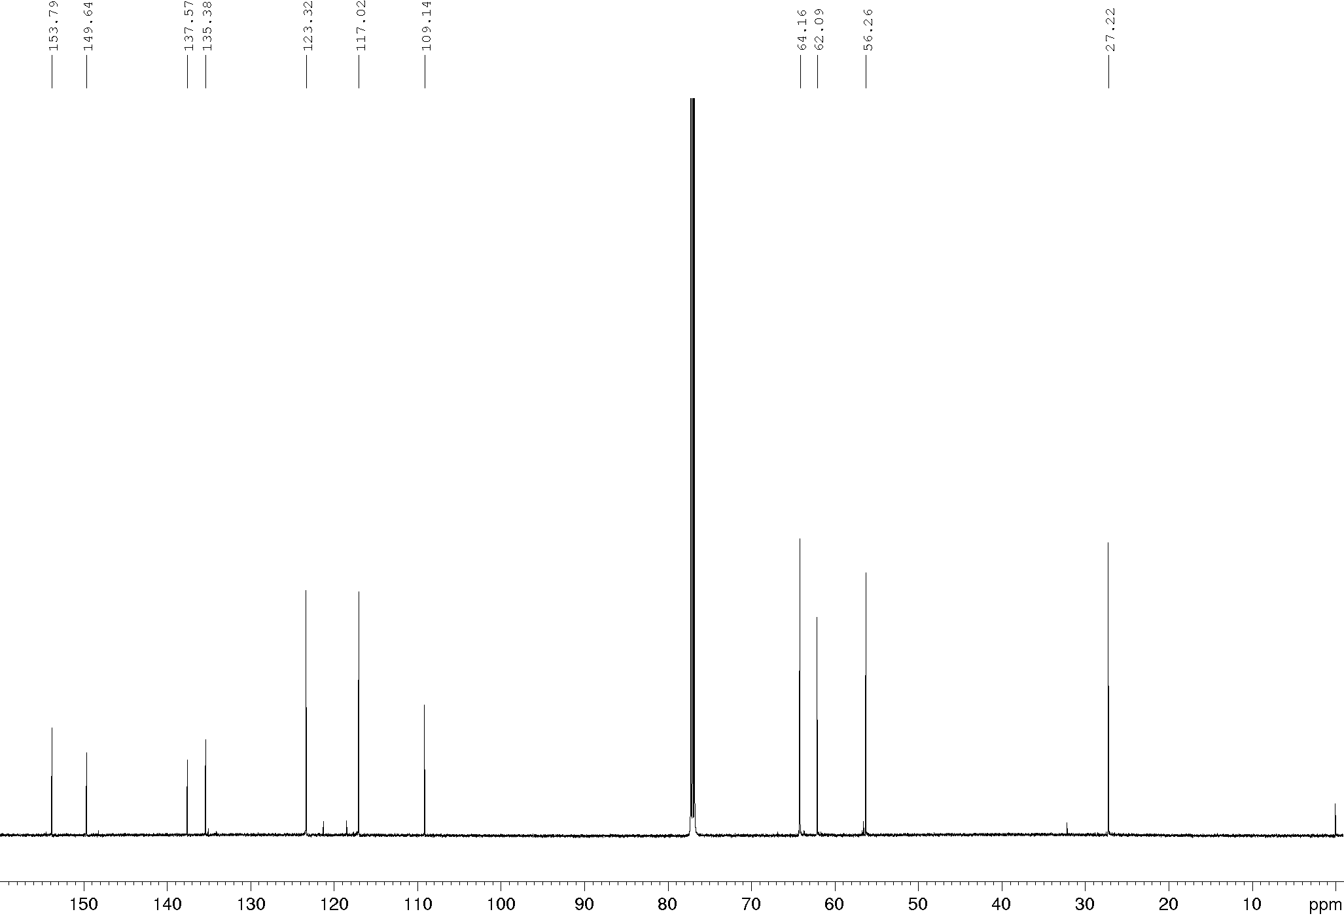
Compound 5g, ¹H and ¹³C NMR (400/100 MHz), CDCl₃
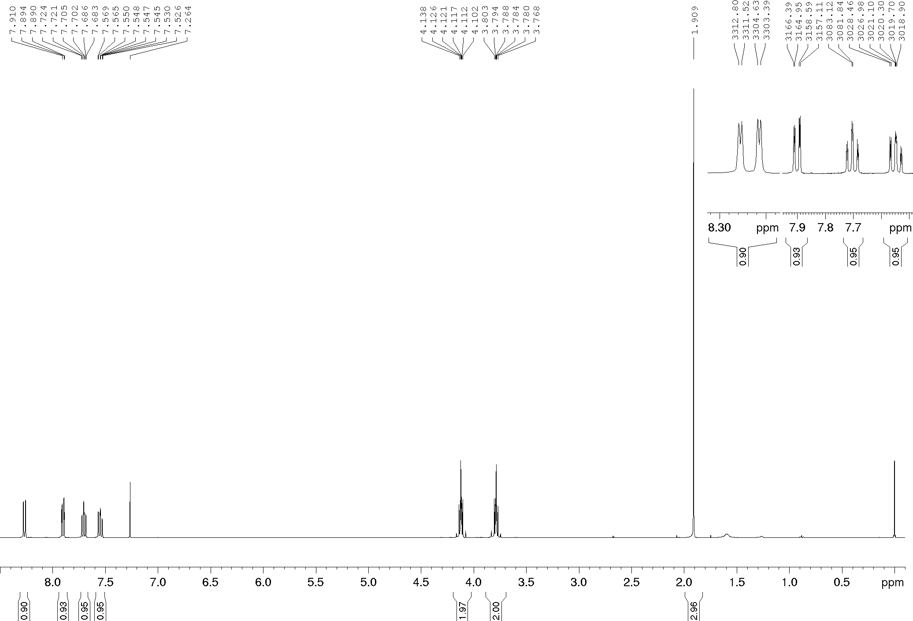
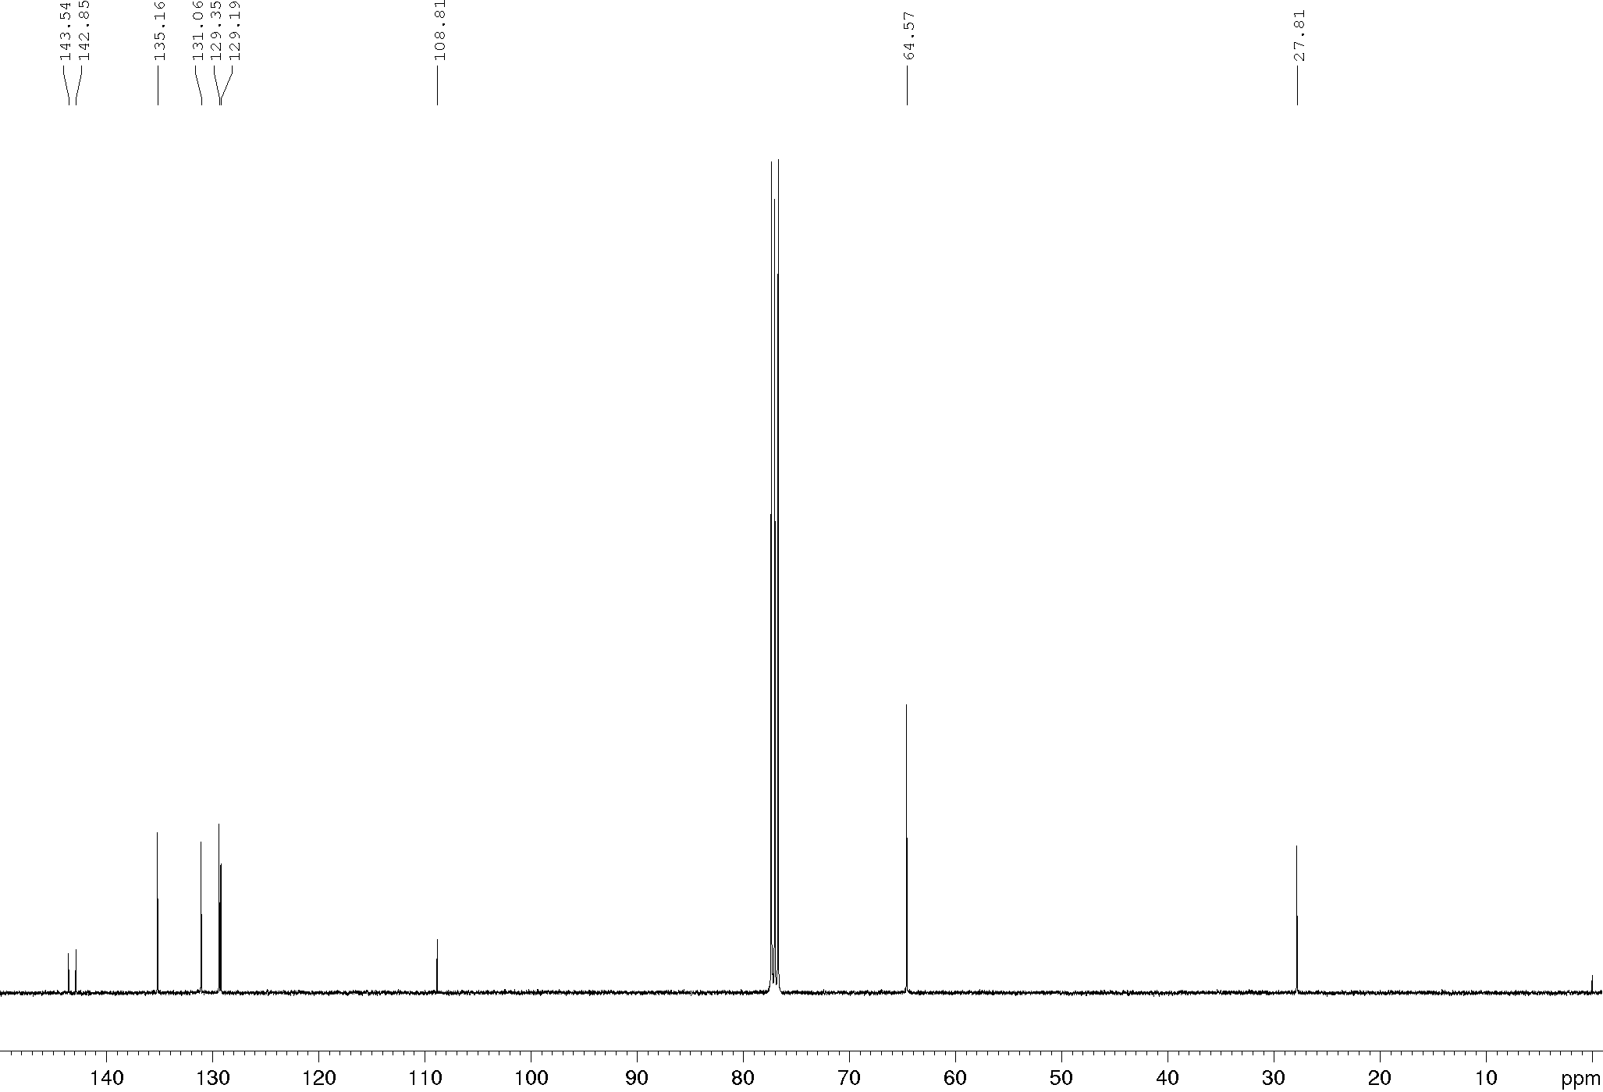
Compound 5h, ¹H and ¹³C NMR (600/150 MHz), CDCl₃
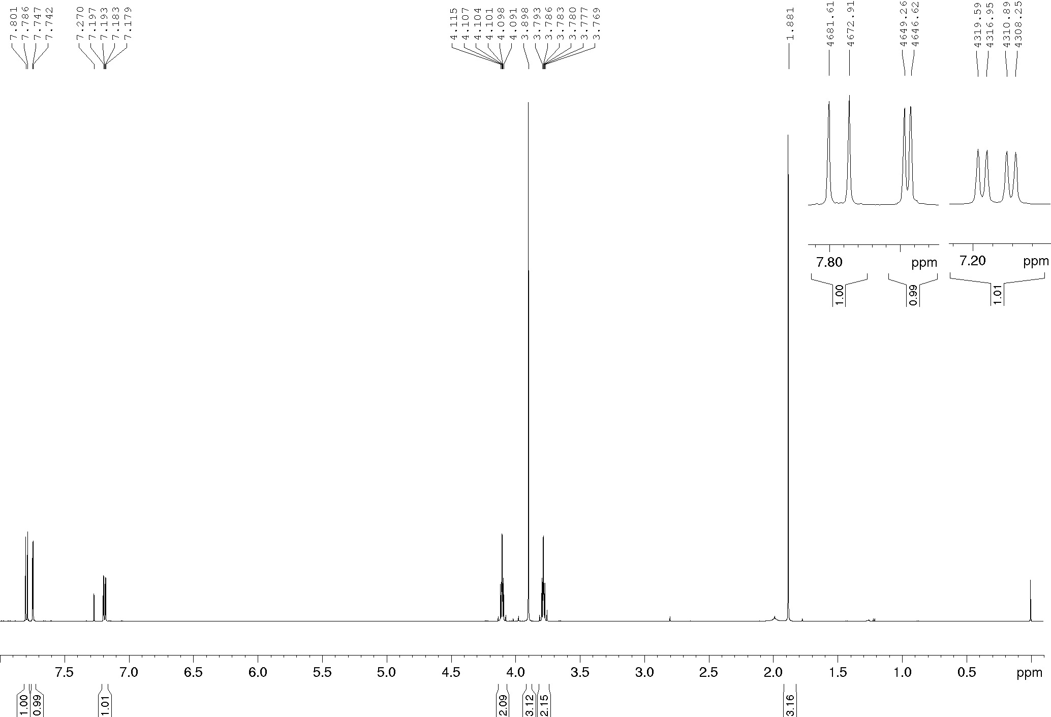
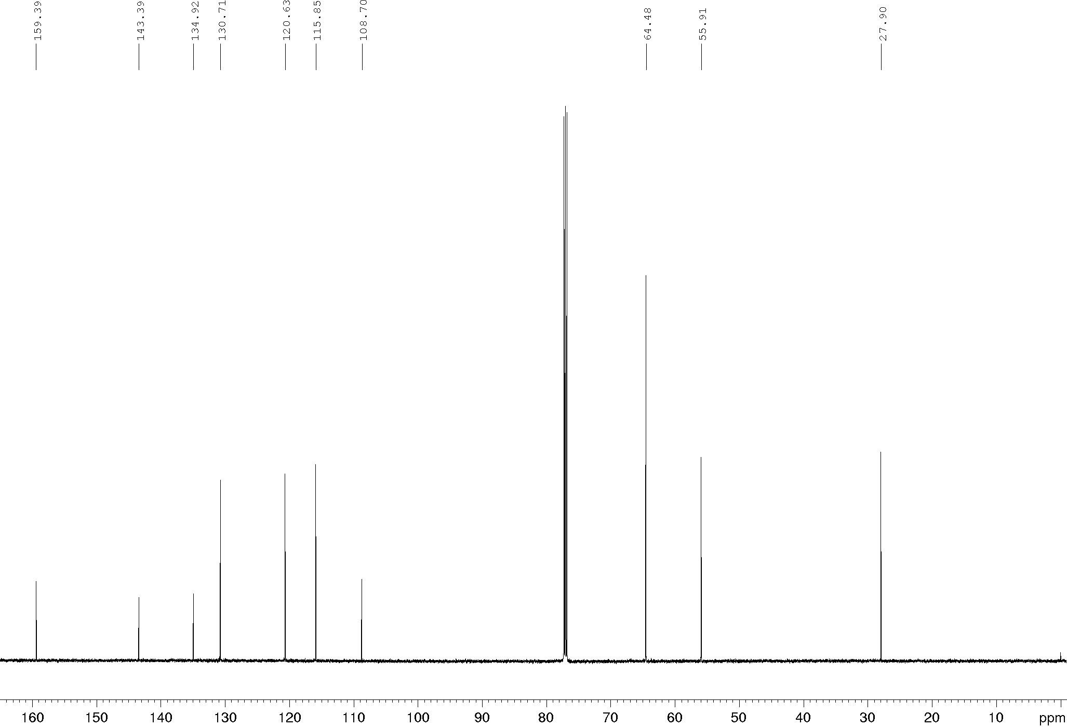

Compound 14a, ¹H and ¹³C NMR (400/100 MHz), CDCl₃
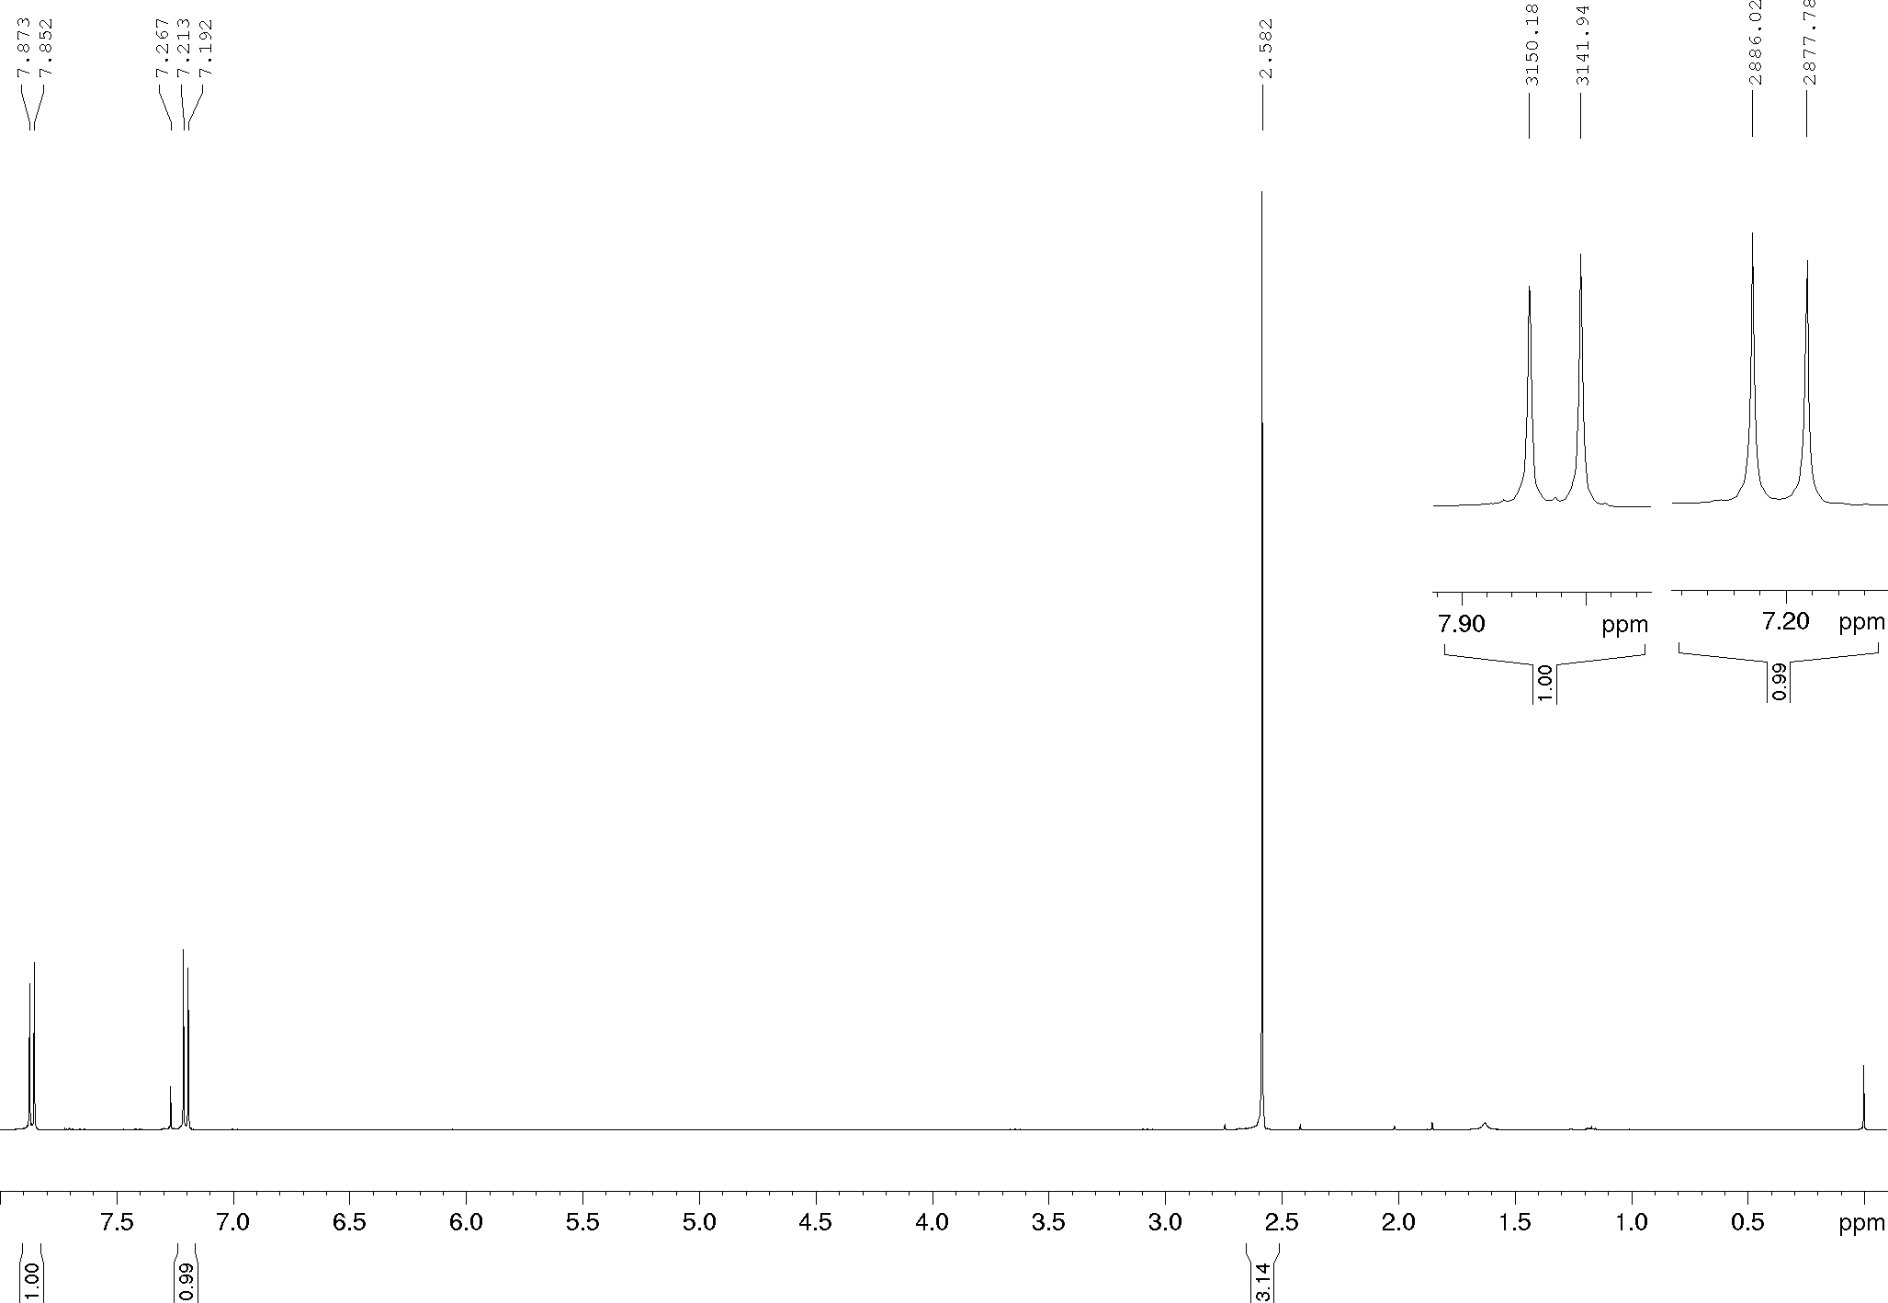
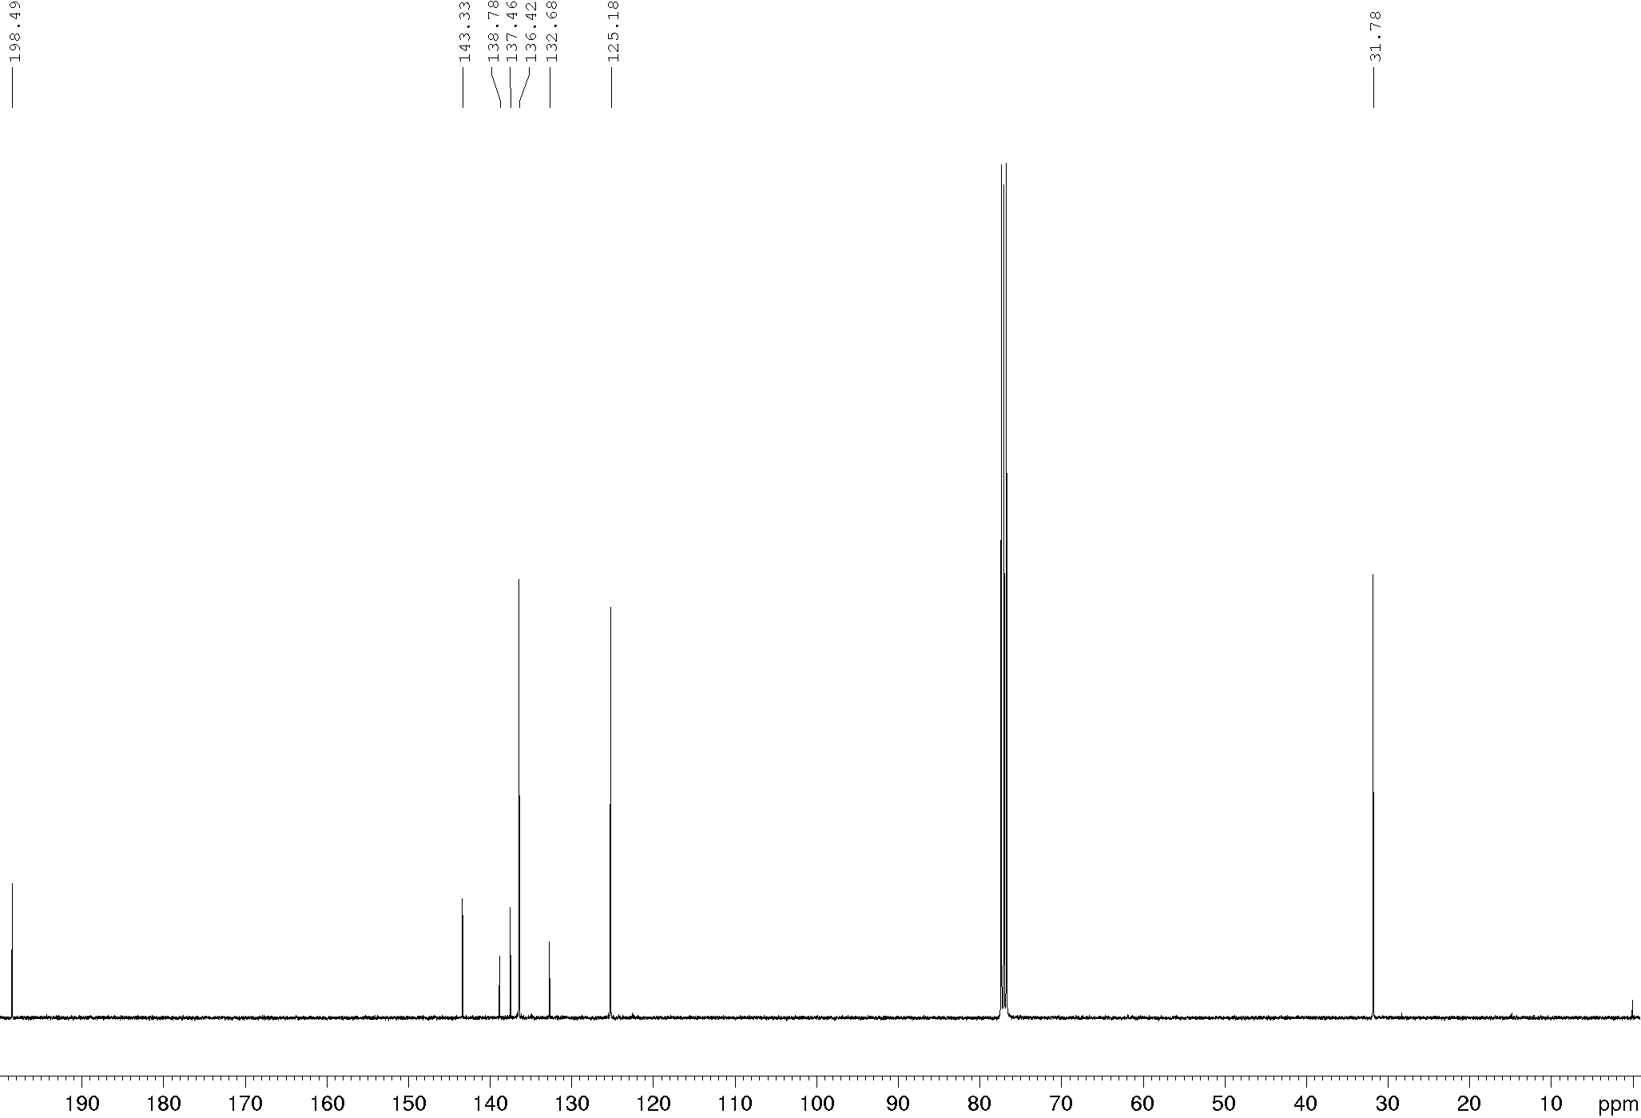
Compound 14b, ¹H NMR (400/100 MHz), CDCl₃
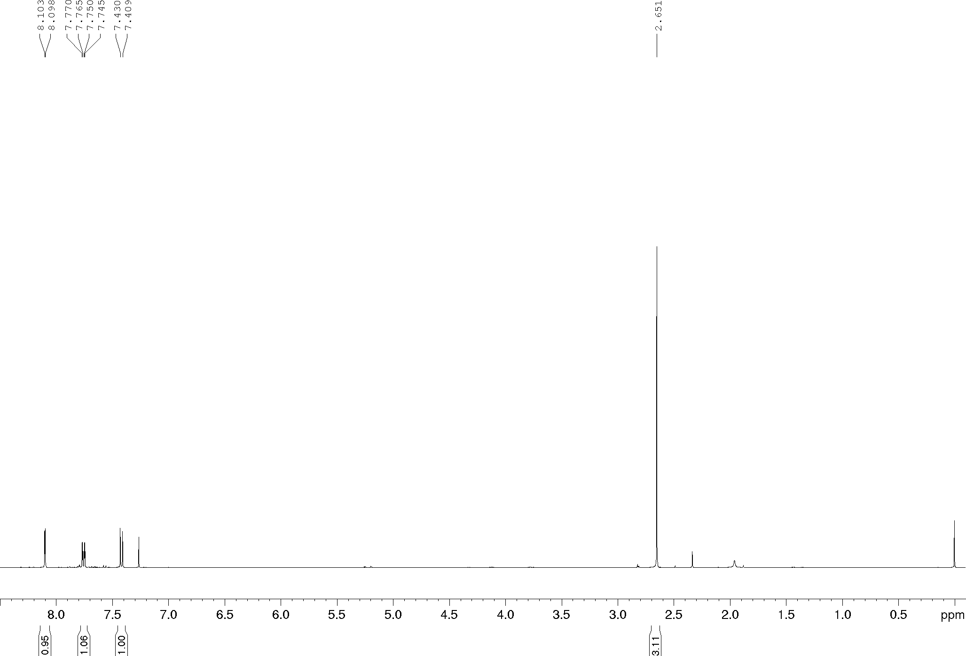

Compound 14c, ¹H and ¹³C NMR (600/150 MHz), CDCl₃
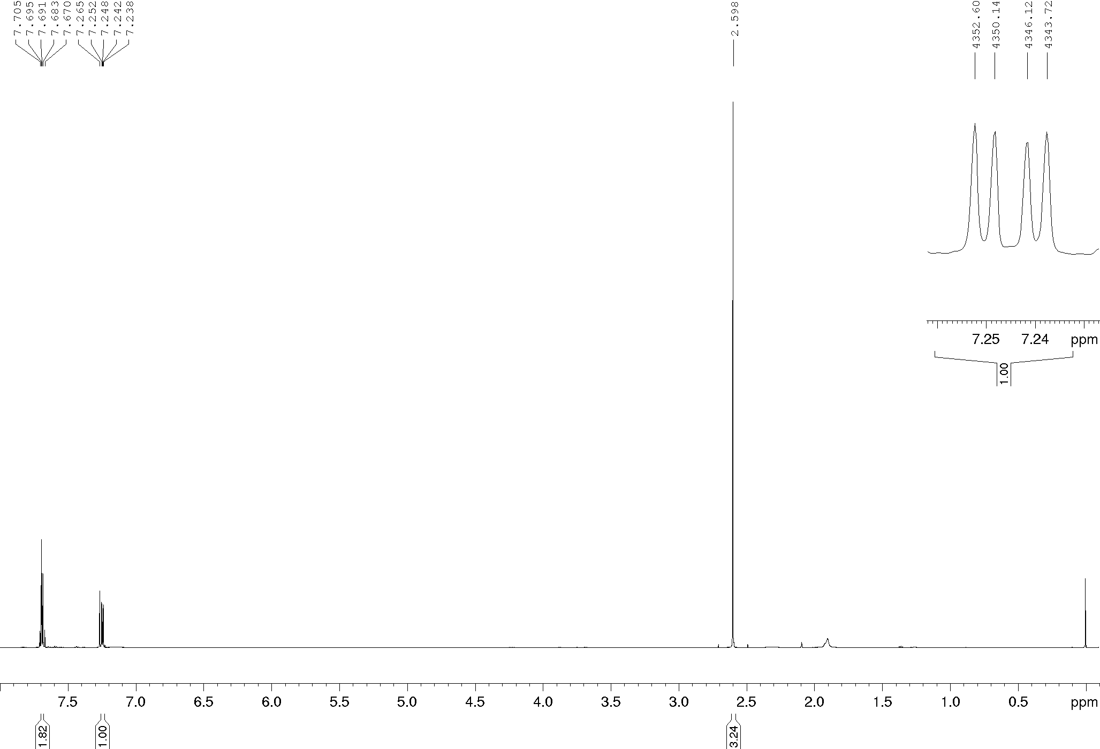
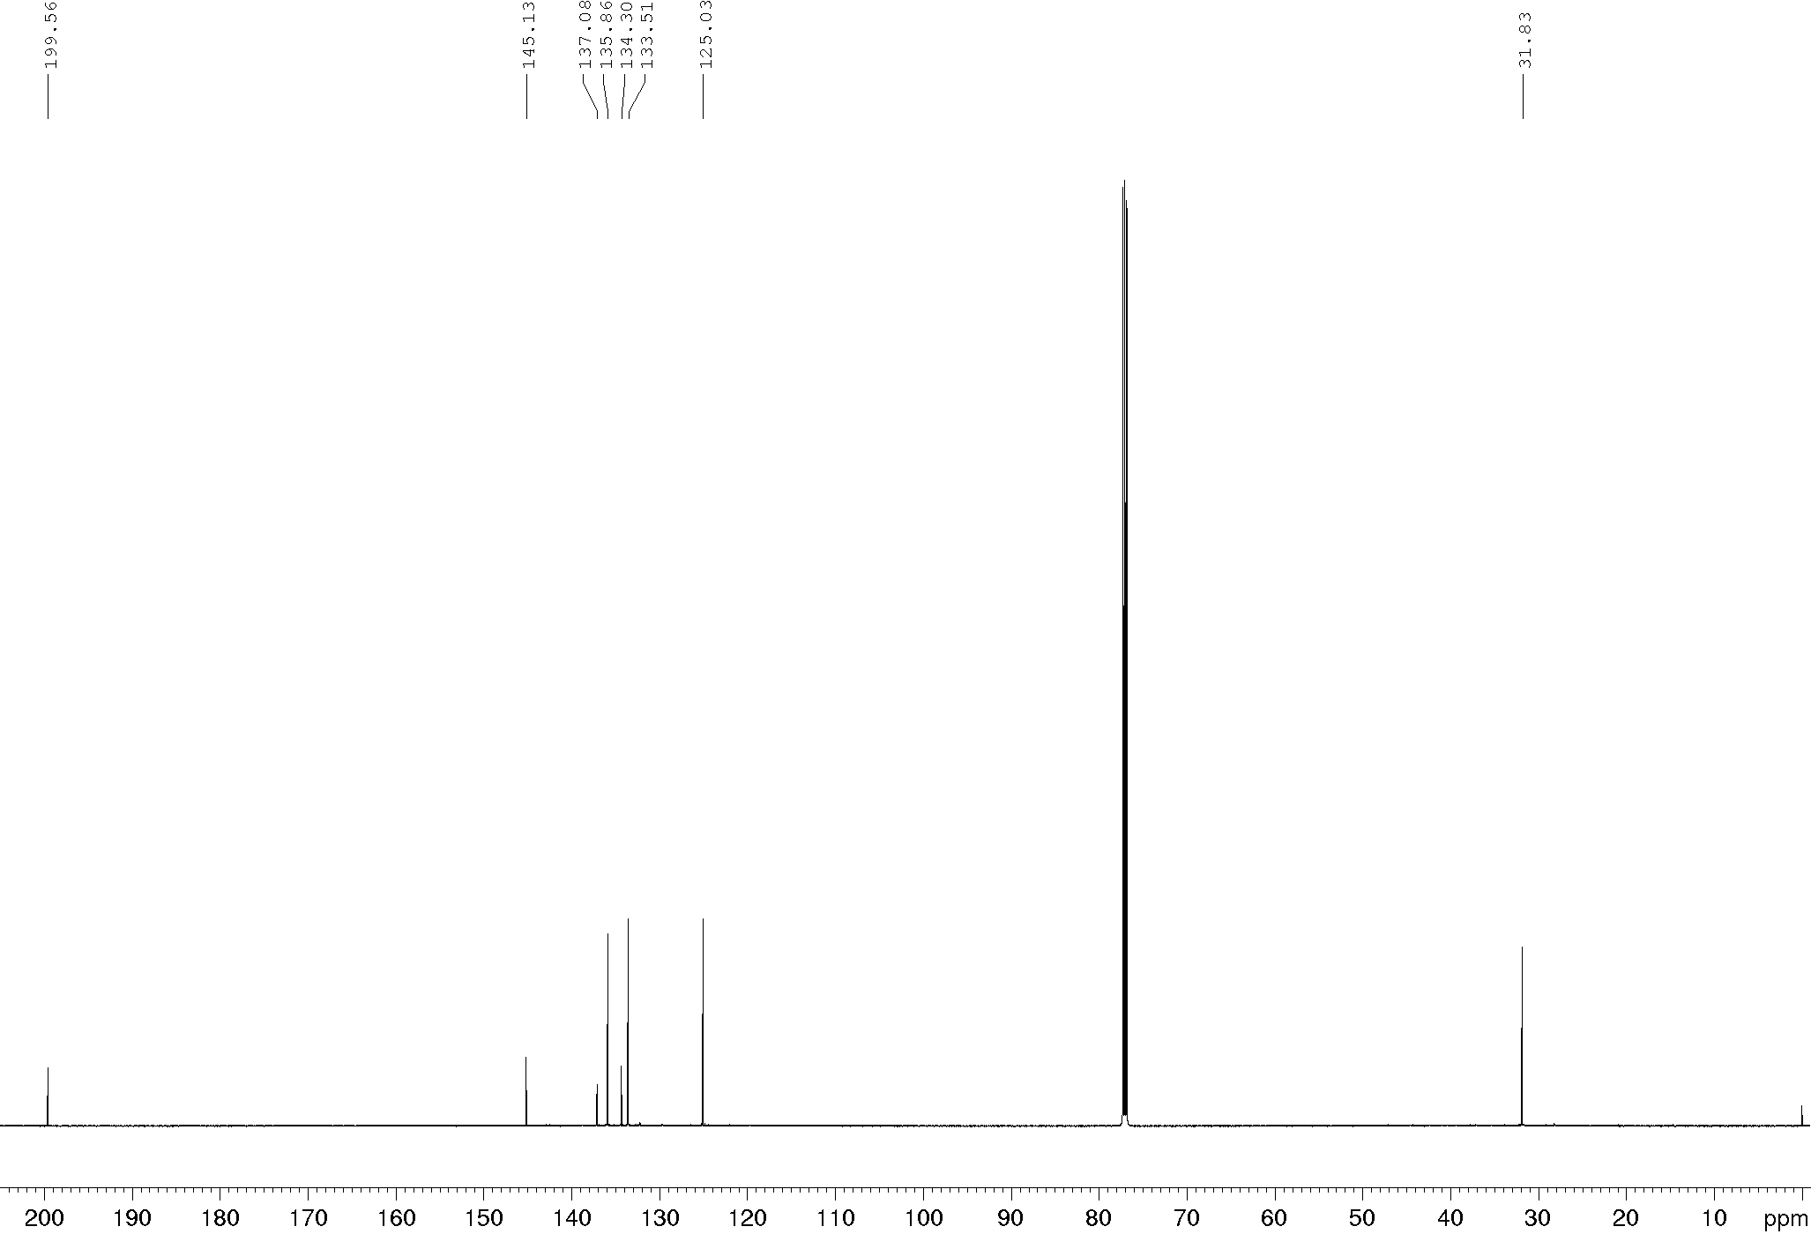
Compound 14d, ¹H and ¹³C NMR (400/100 MHz), CDCl₃
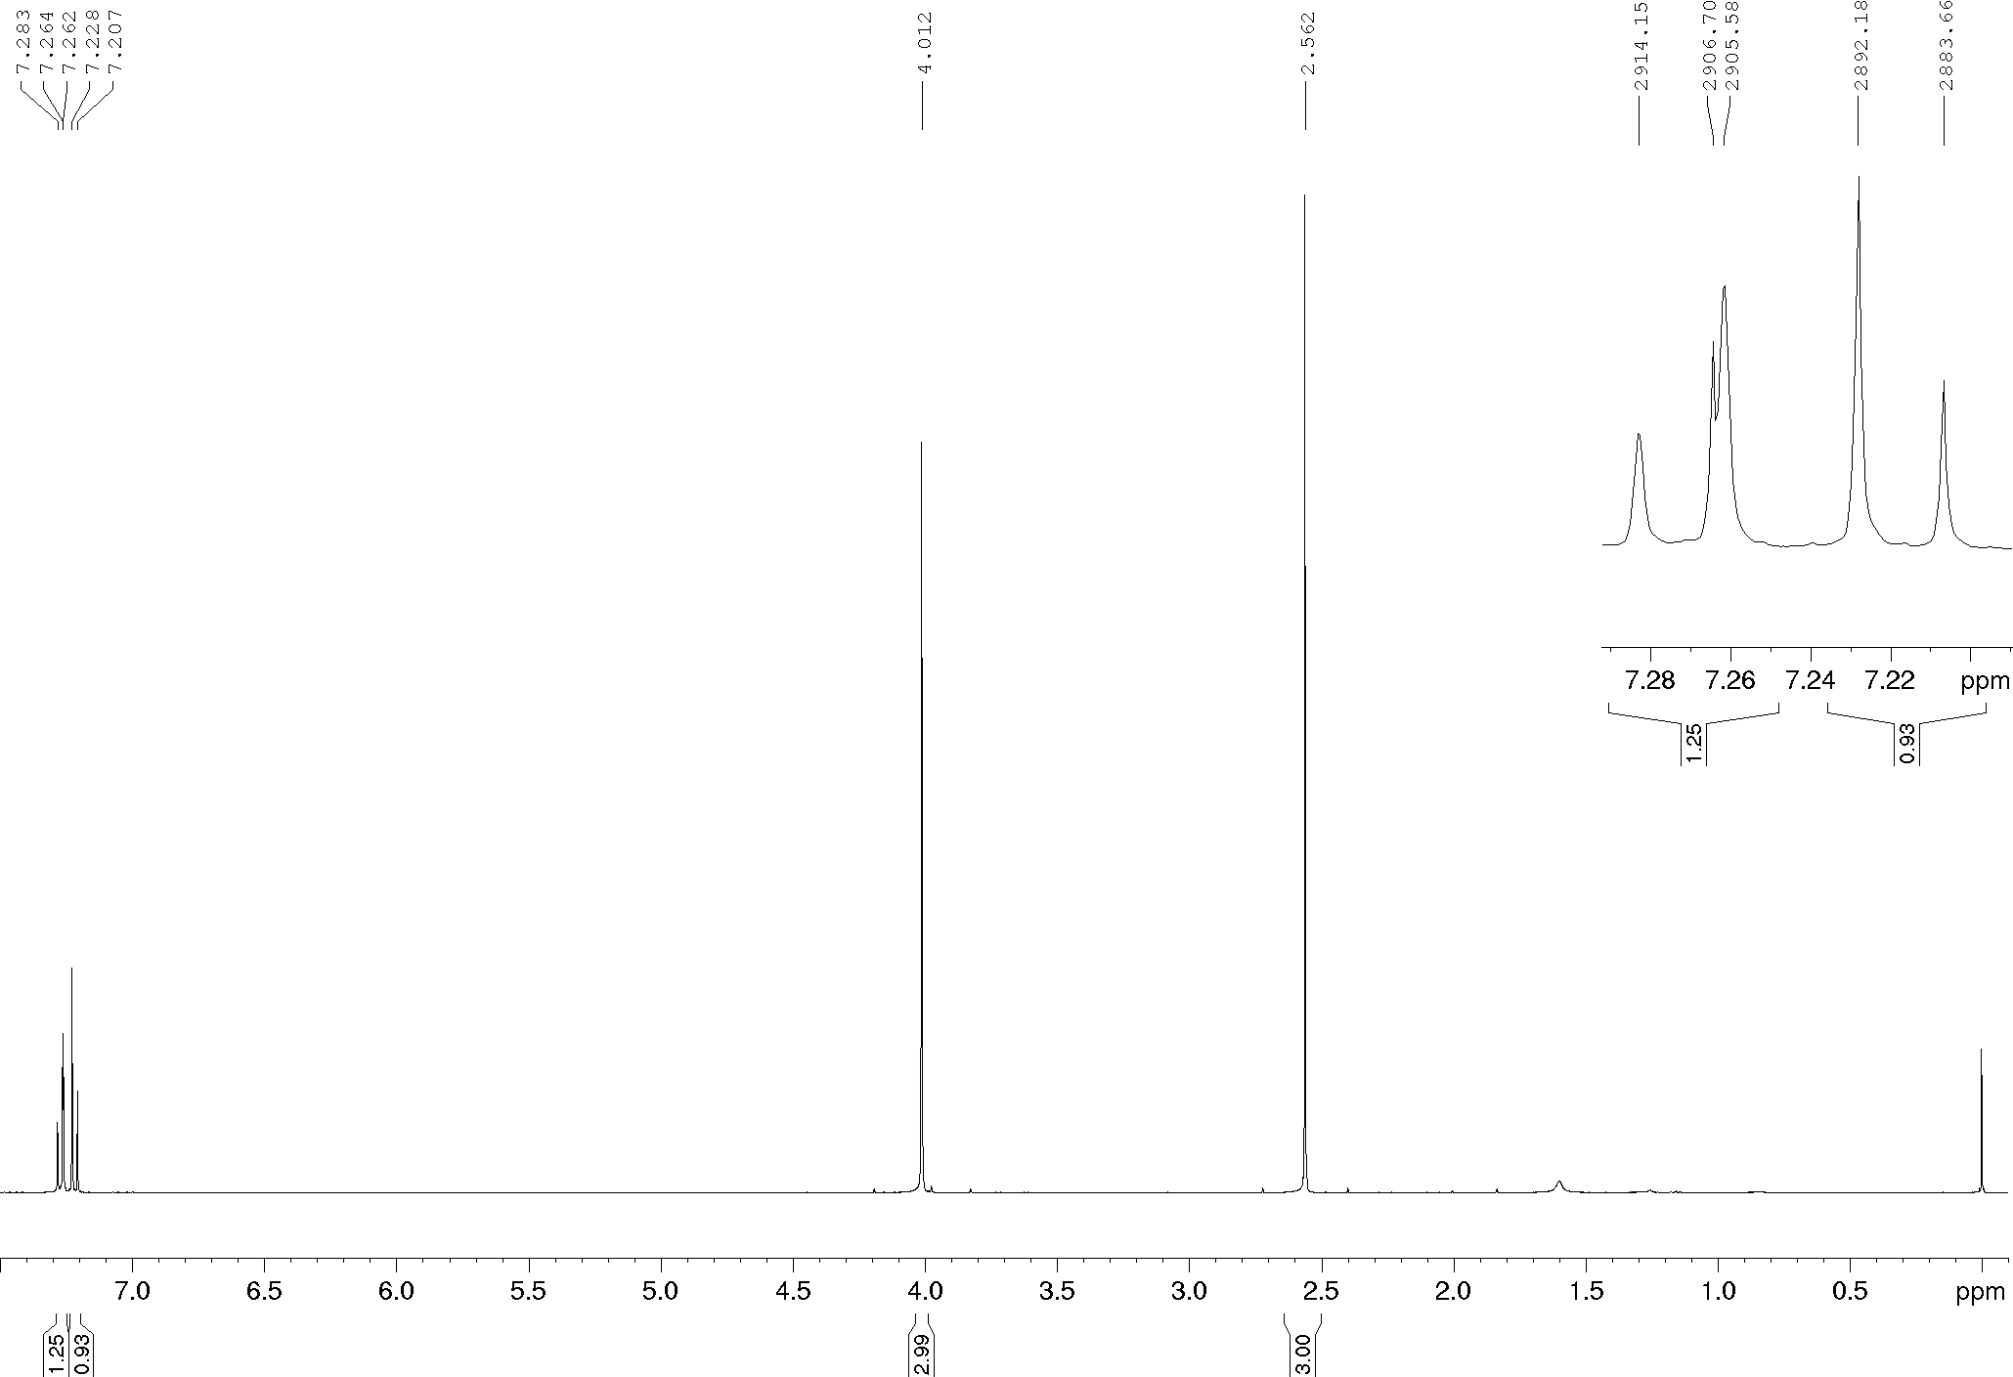
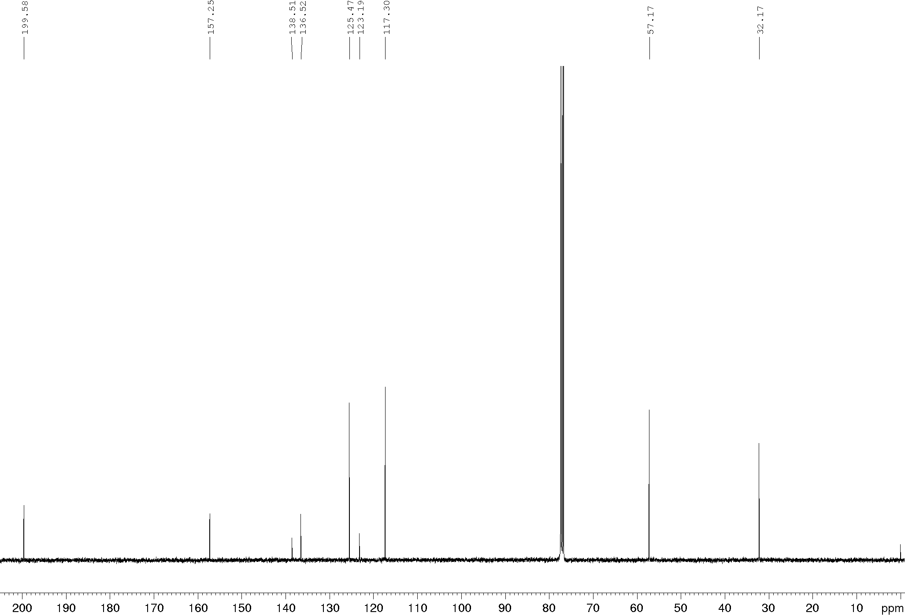
Compound 14e, ¹H and ¹³C NMR (600/150 MHz), CDCl₃
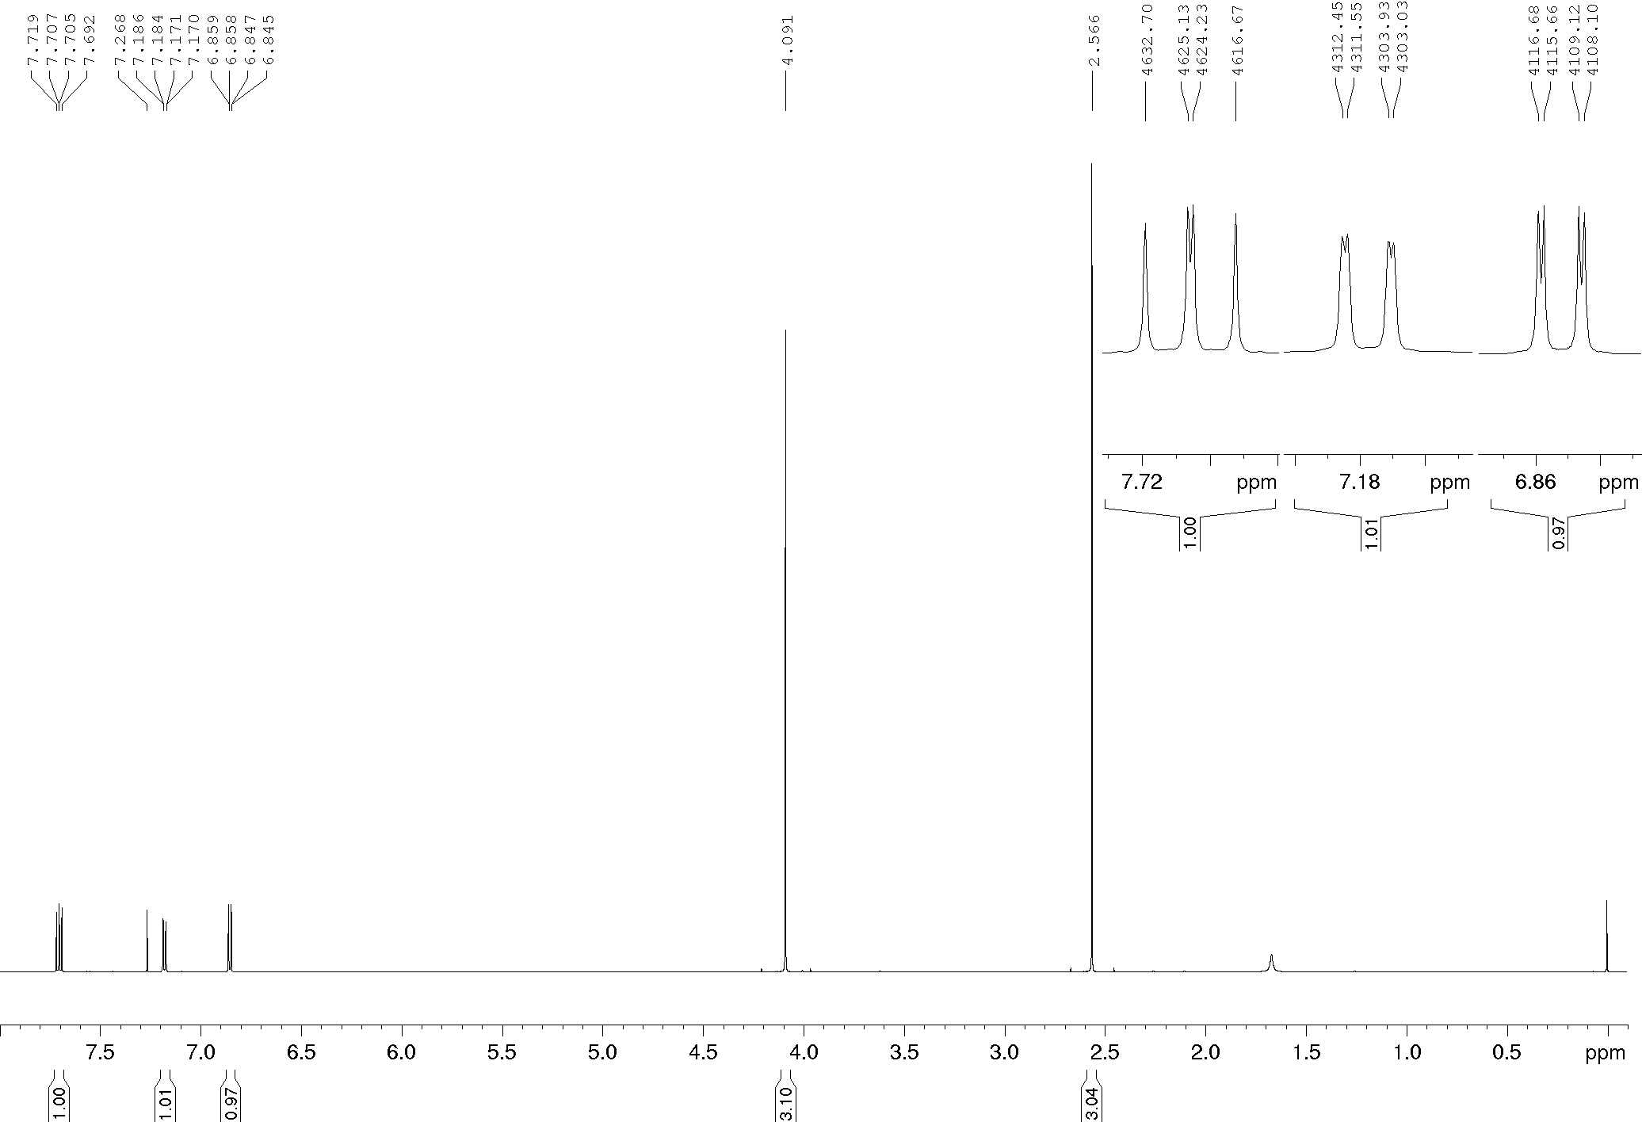
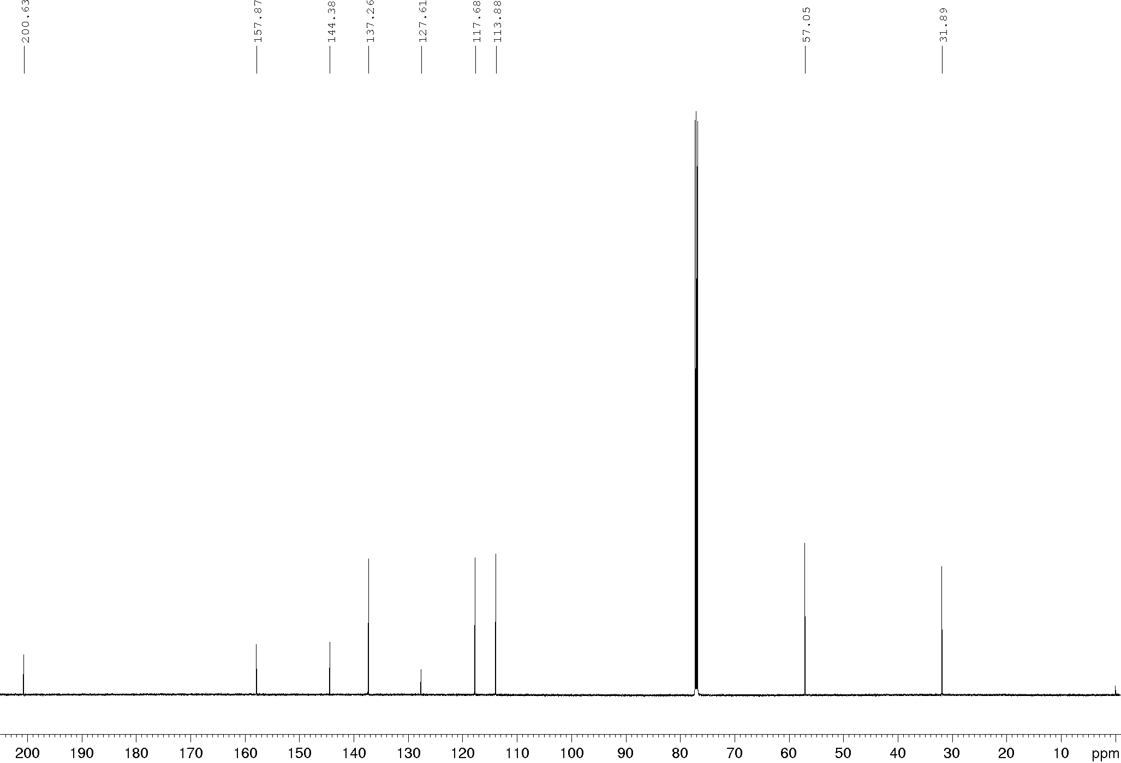
Compound 14f, ¹H and ¹³C NMR (400/100 MHz), CDCl₃
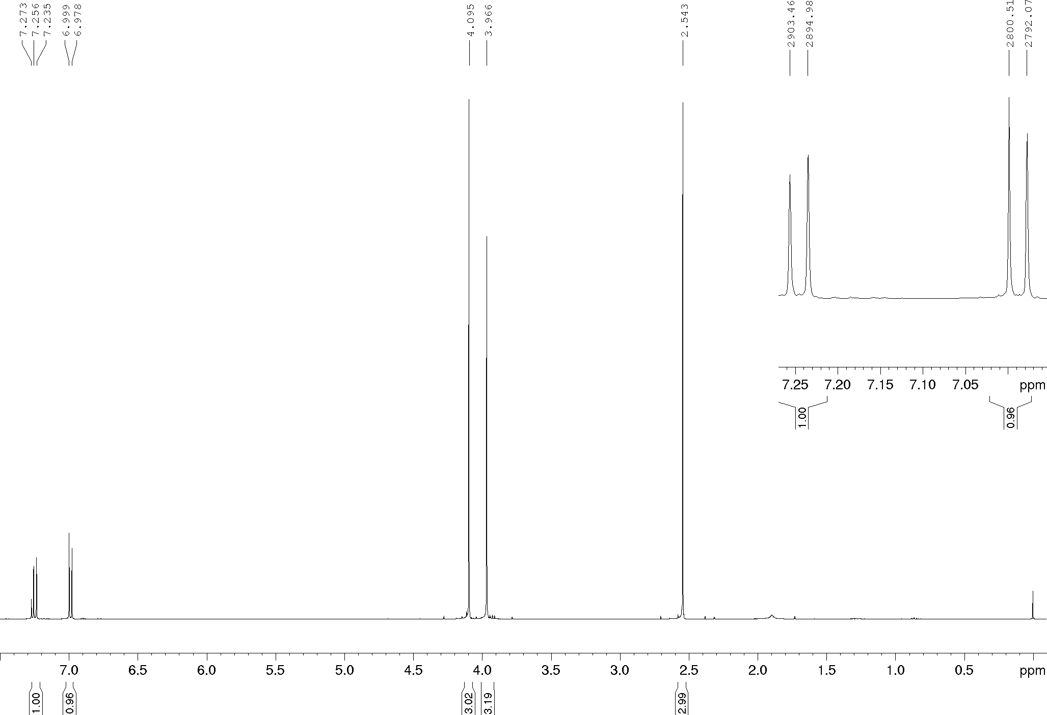
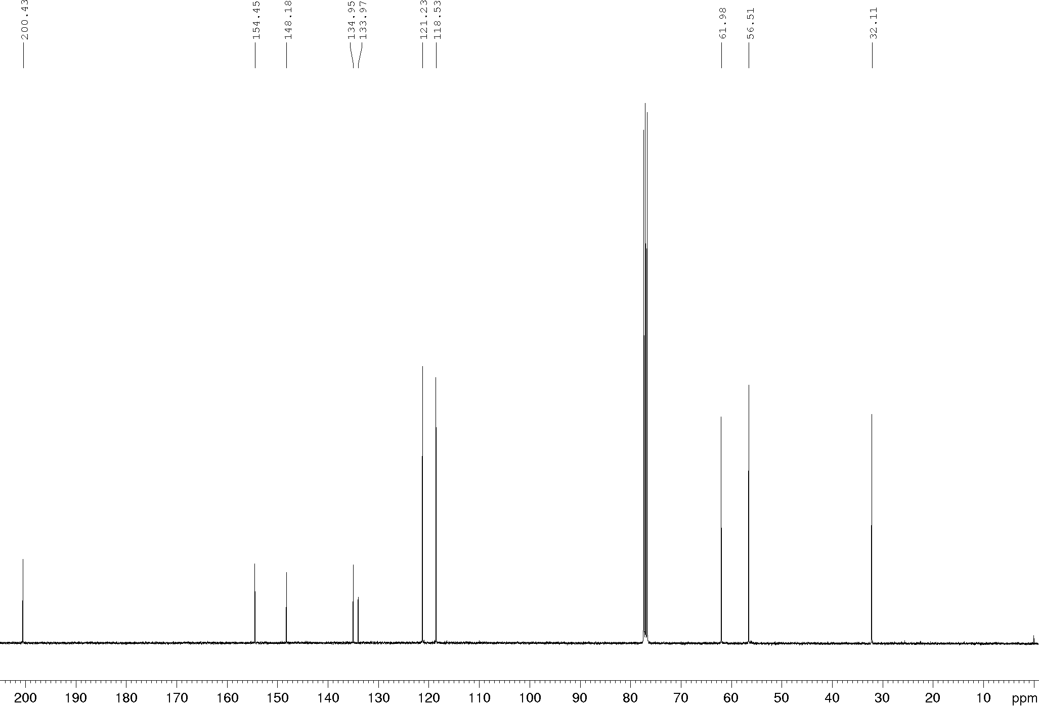
Compound 15a, ¹H and ¹³C NMR (400/100 MHz), CDCl₃
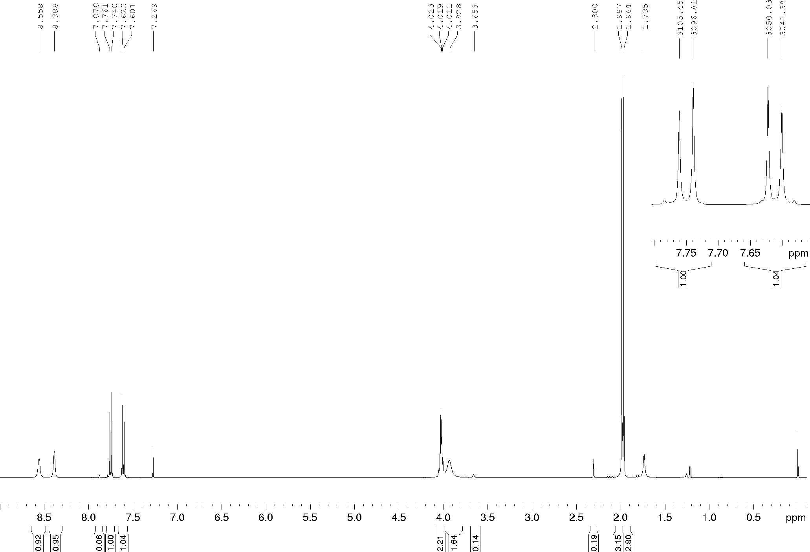
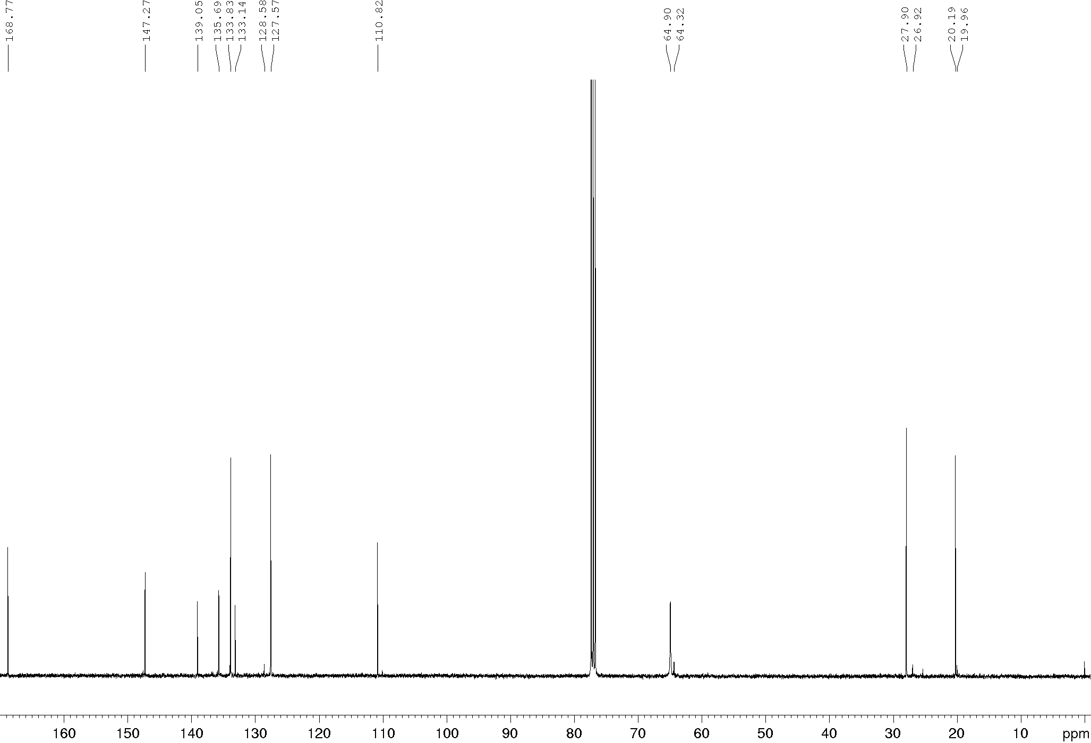
Compound 15b, ¹H and ¹³C NMR (400/100 MHz), CDCl₃
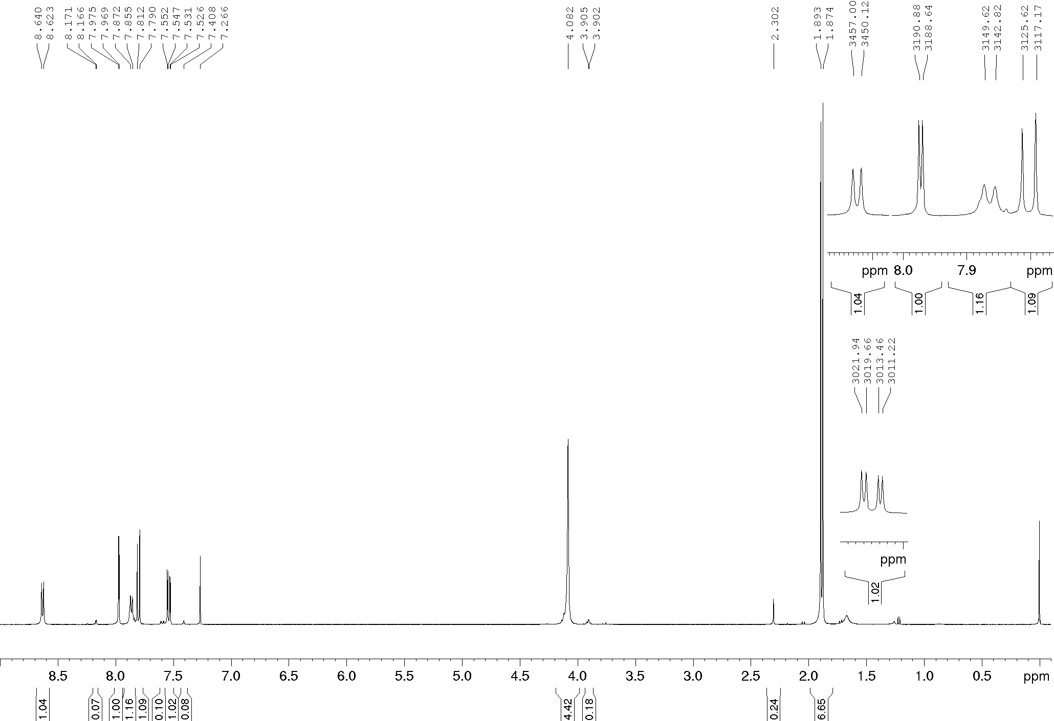
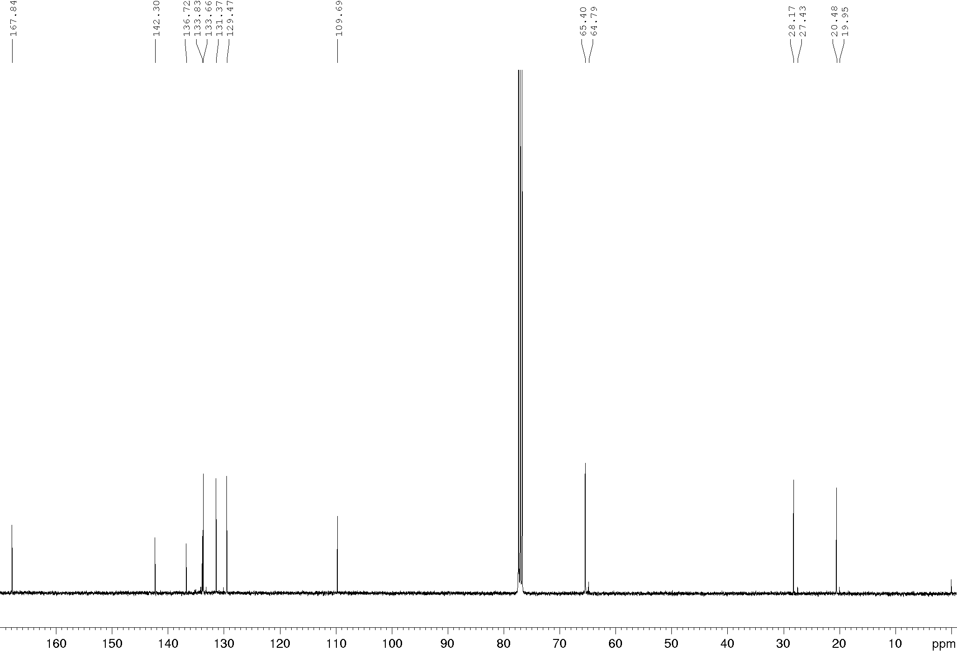
Compound 15c, ¹H and ¹³C NMR (400/100 MHz), CDCl₃
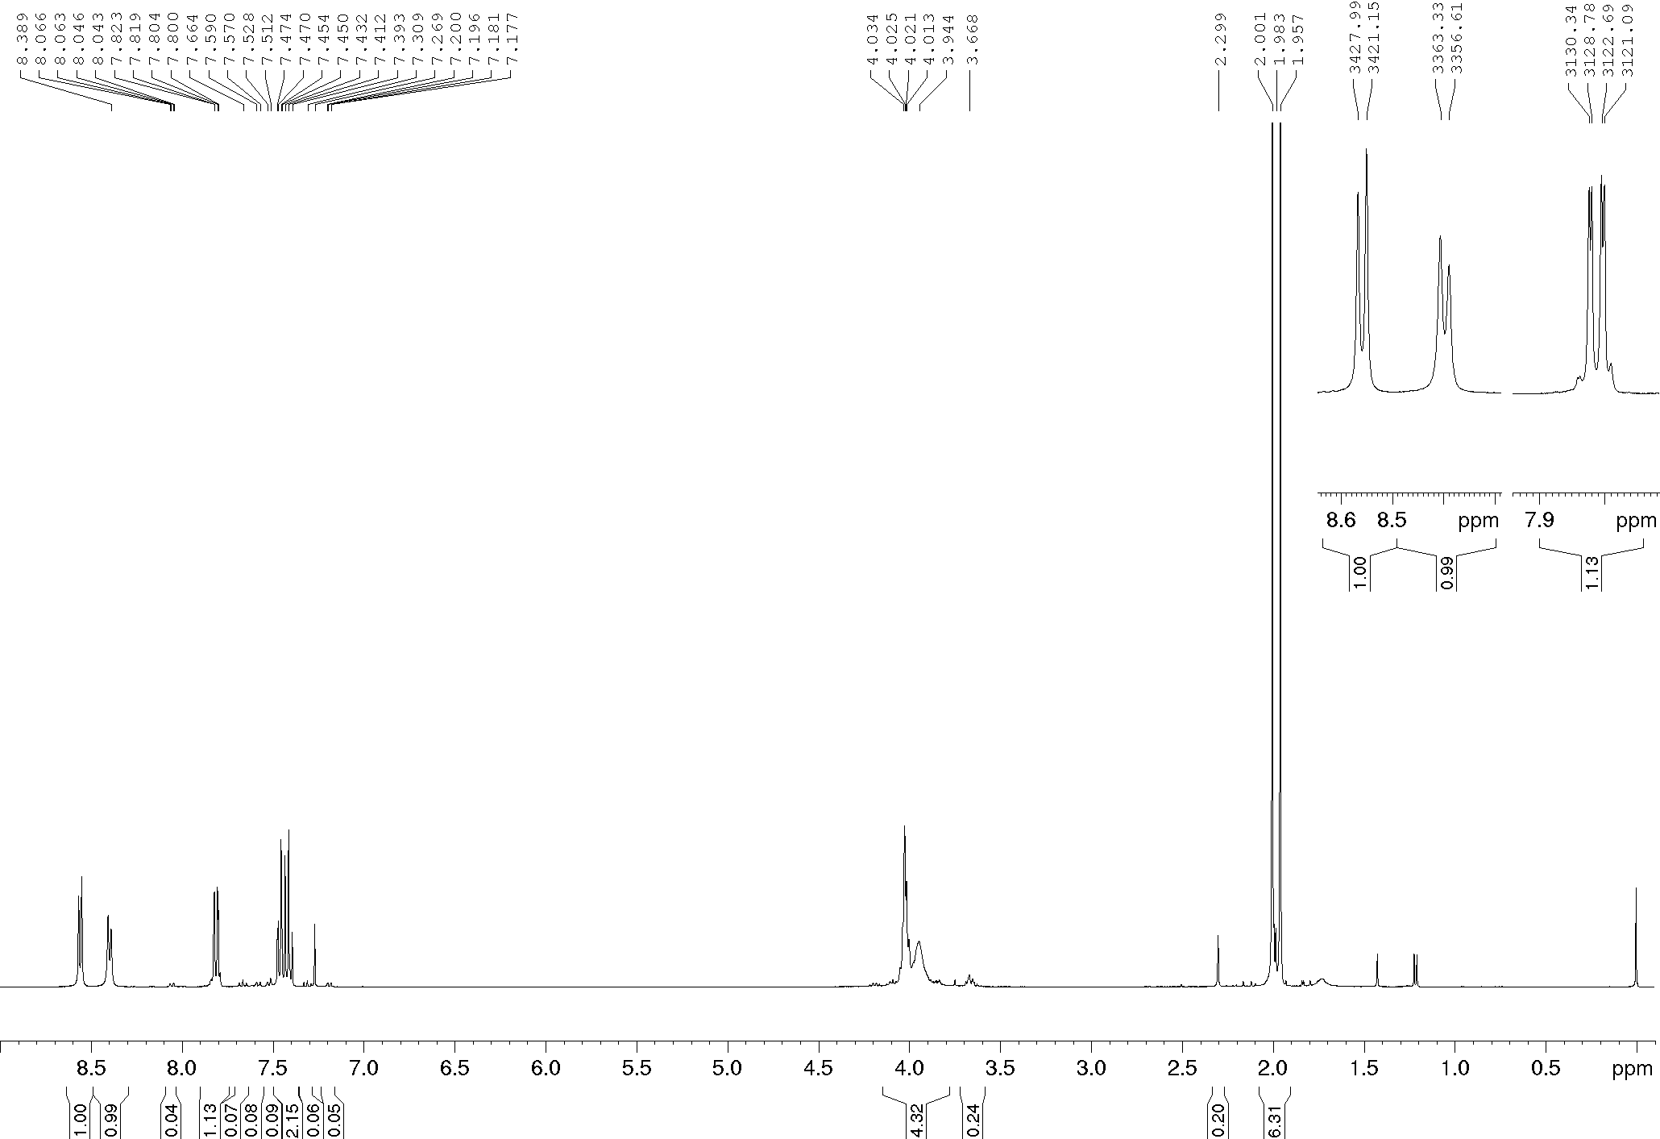
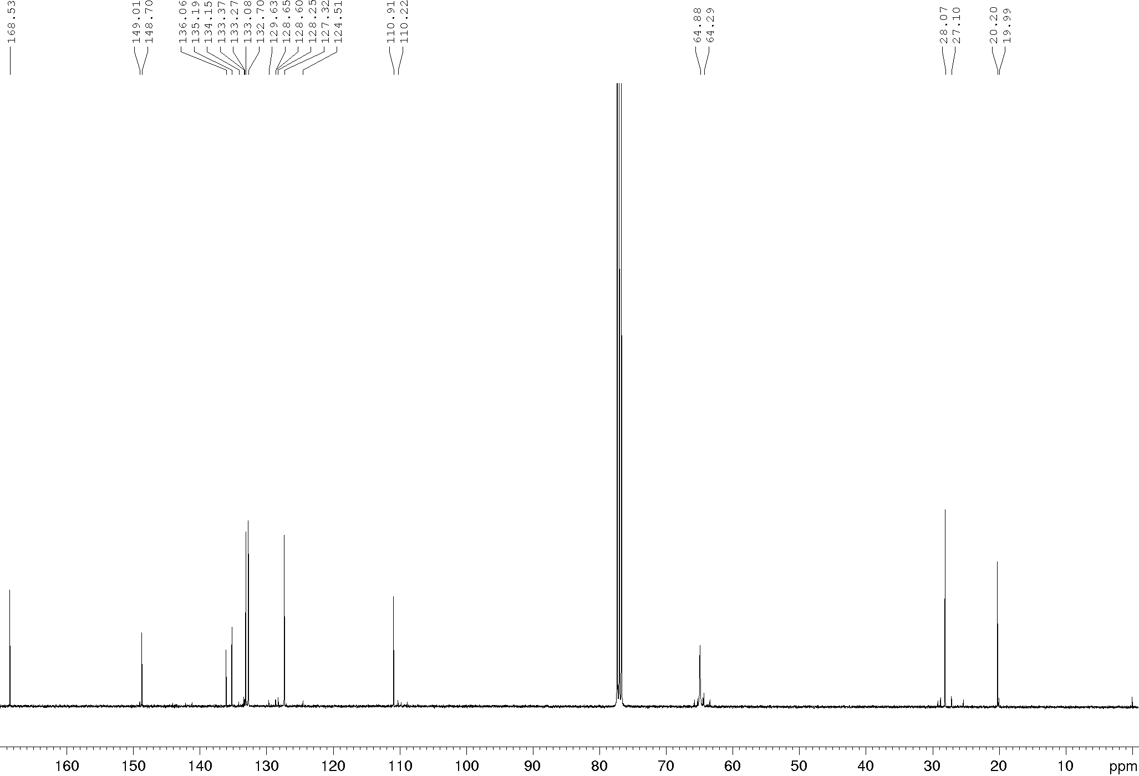
Compound 15d, ¹H and ¹³C NMR (400/100 MHz), CDCl₃
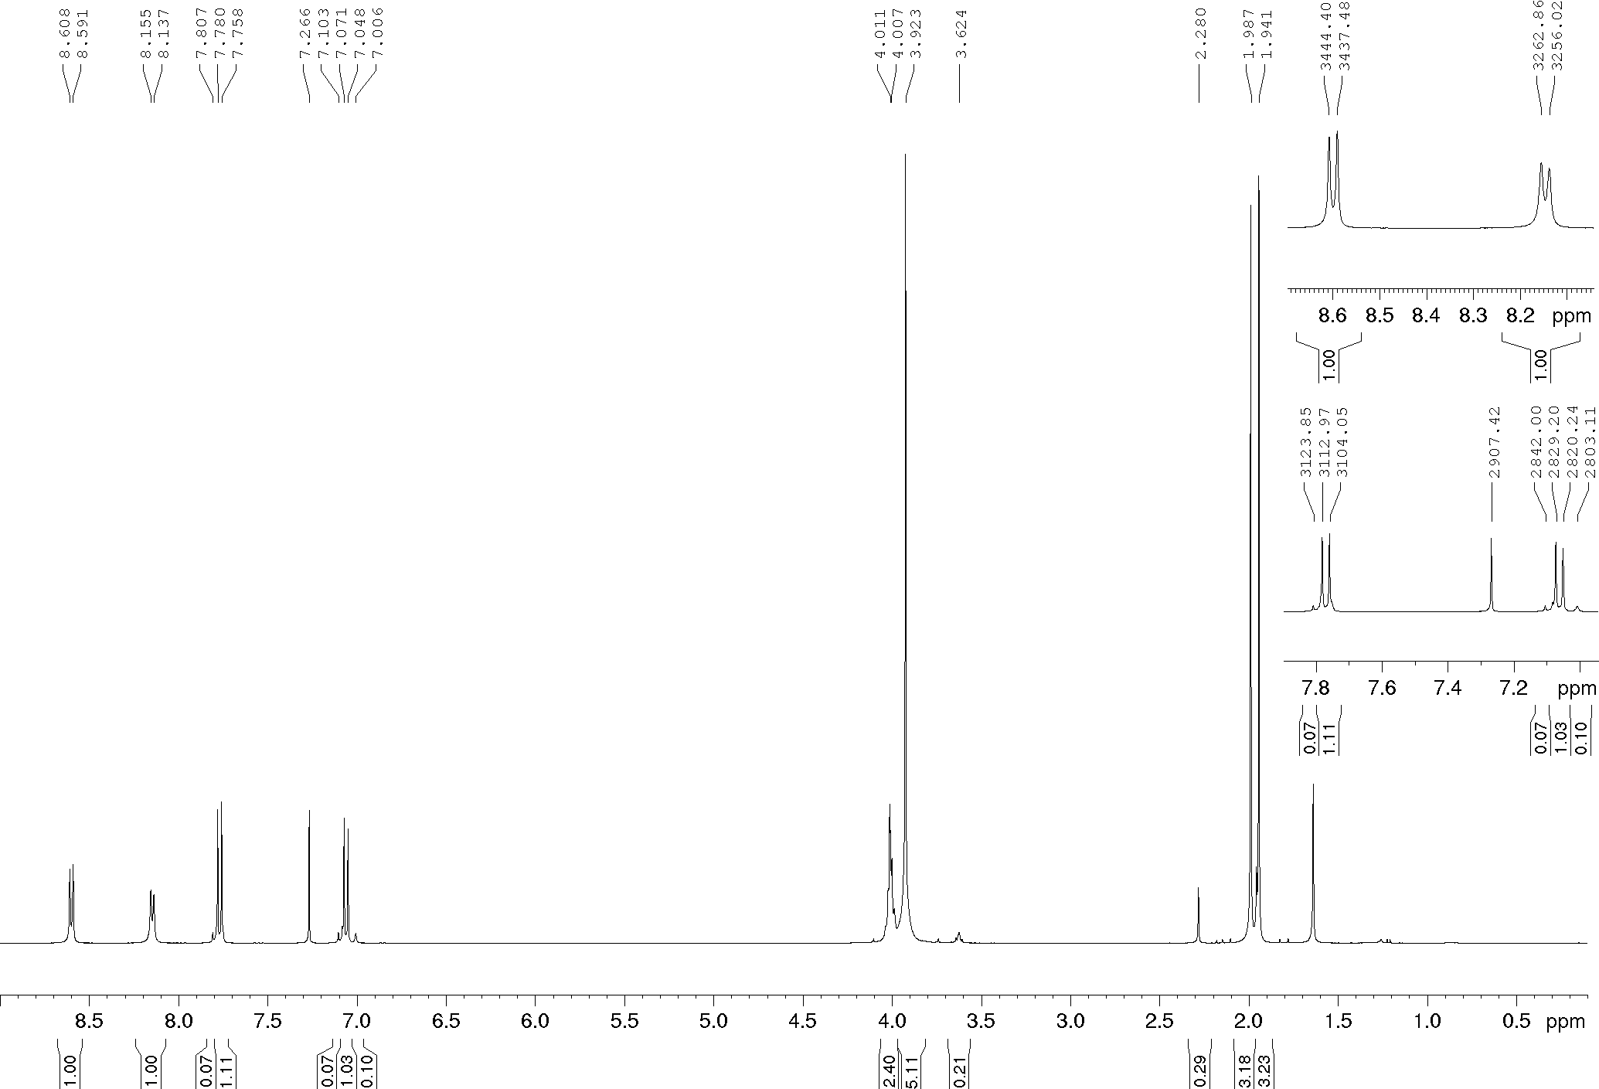
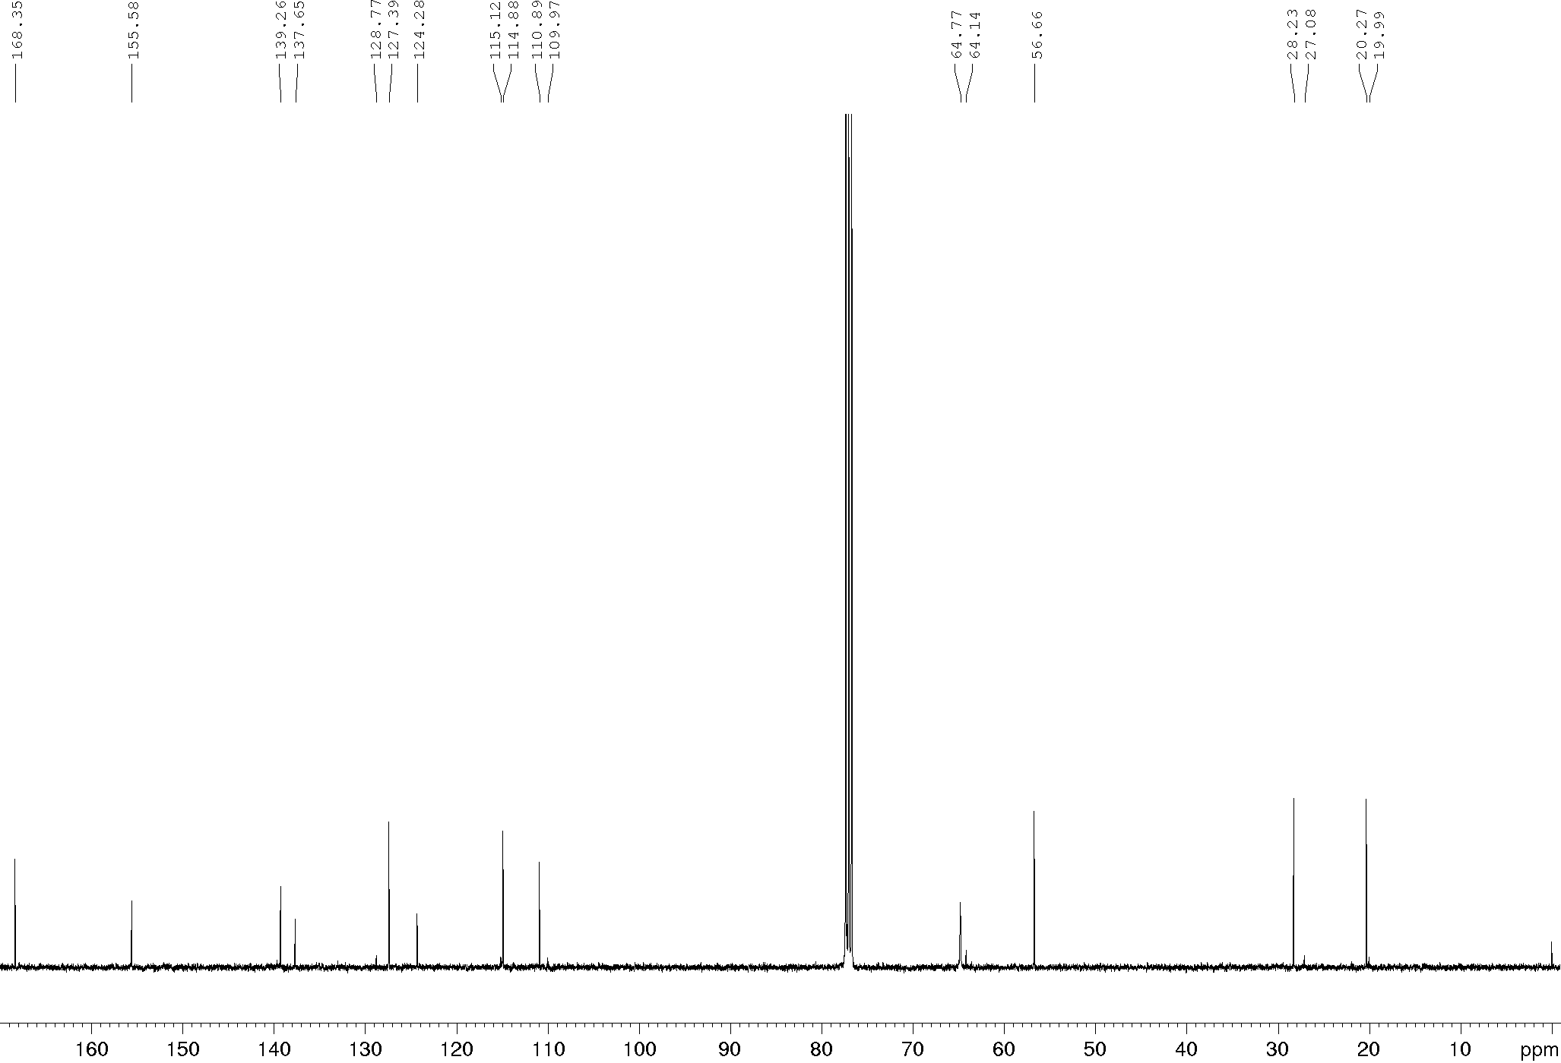
Compound 15e, ¹H and ¹³C NMR (400/100 MHz), CDCl₃
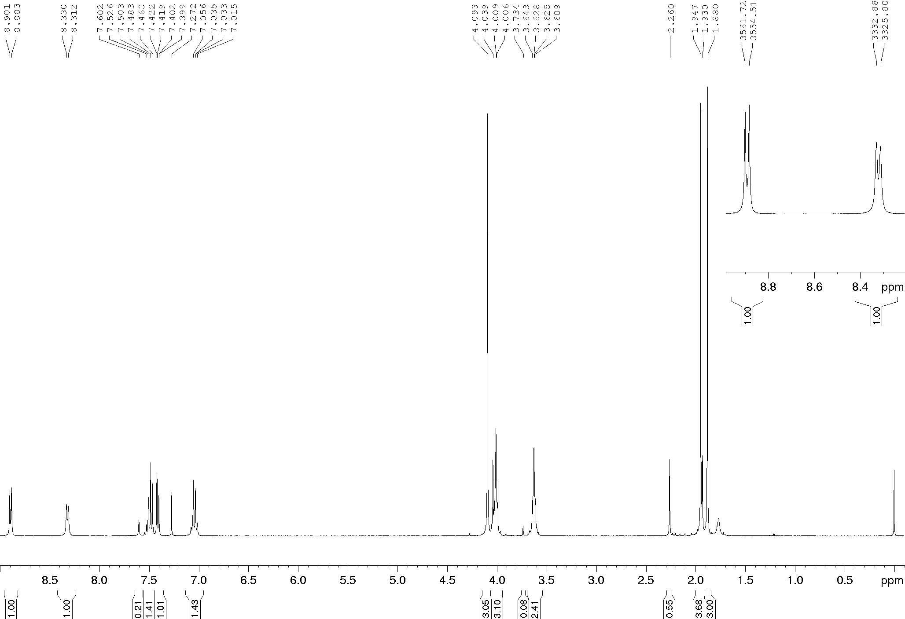
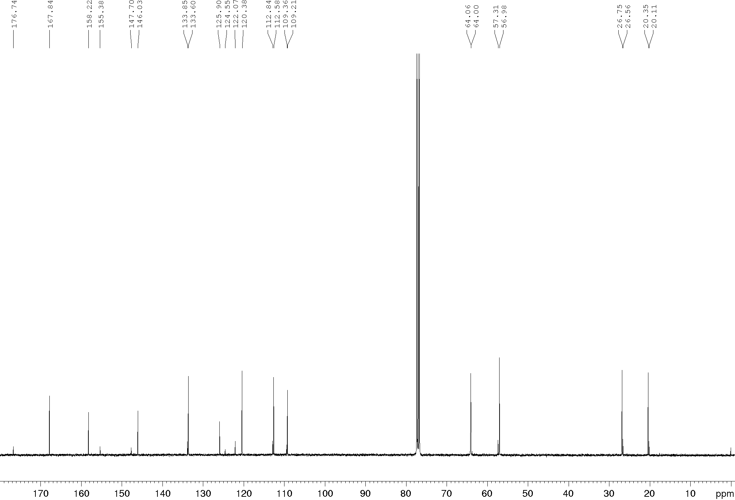
Compound 15f, ¹H and ¹³C NMR (400/100 MHz), CDCl₃
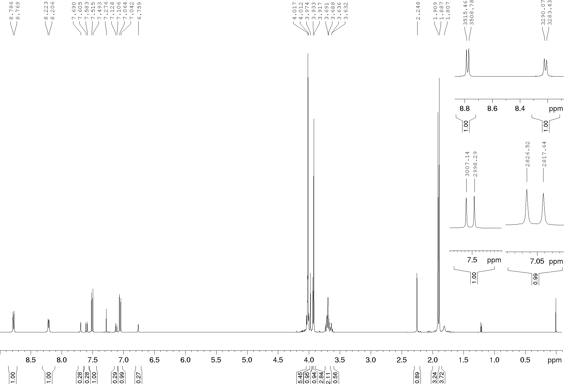
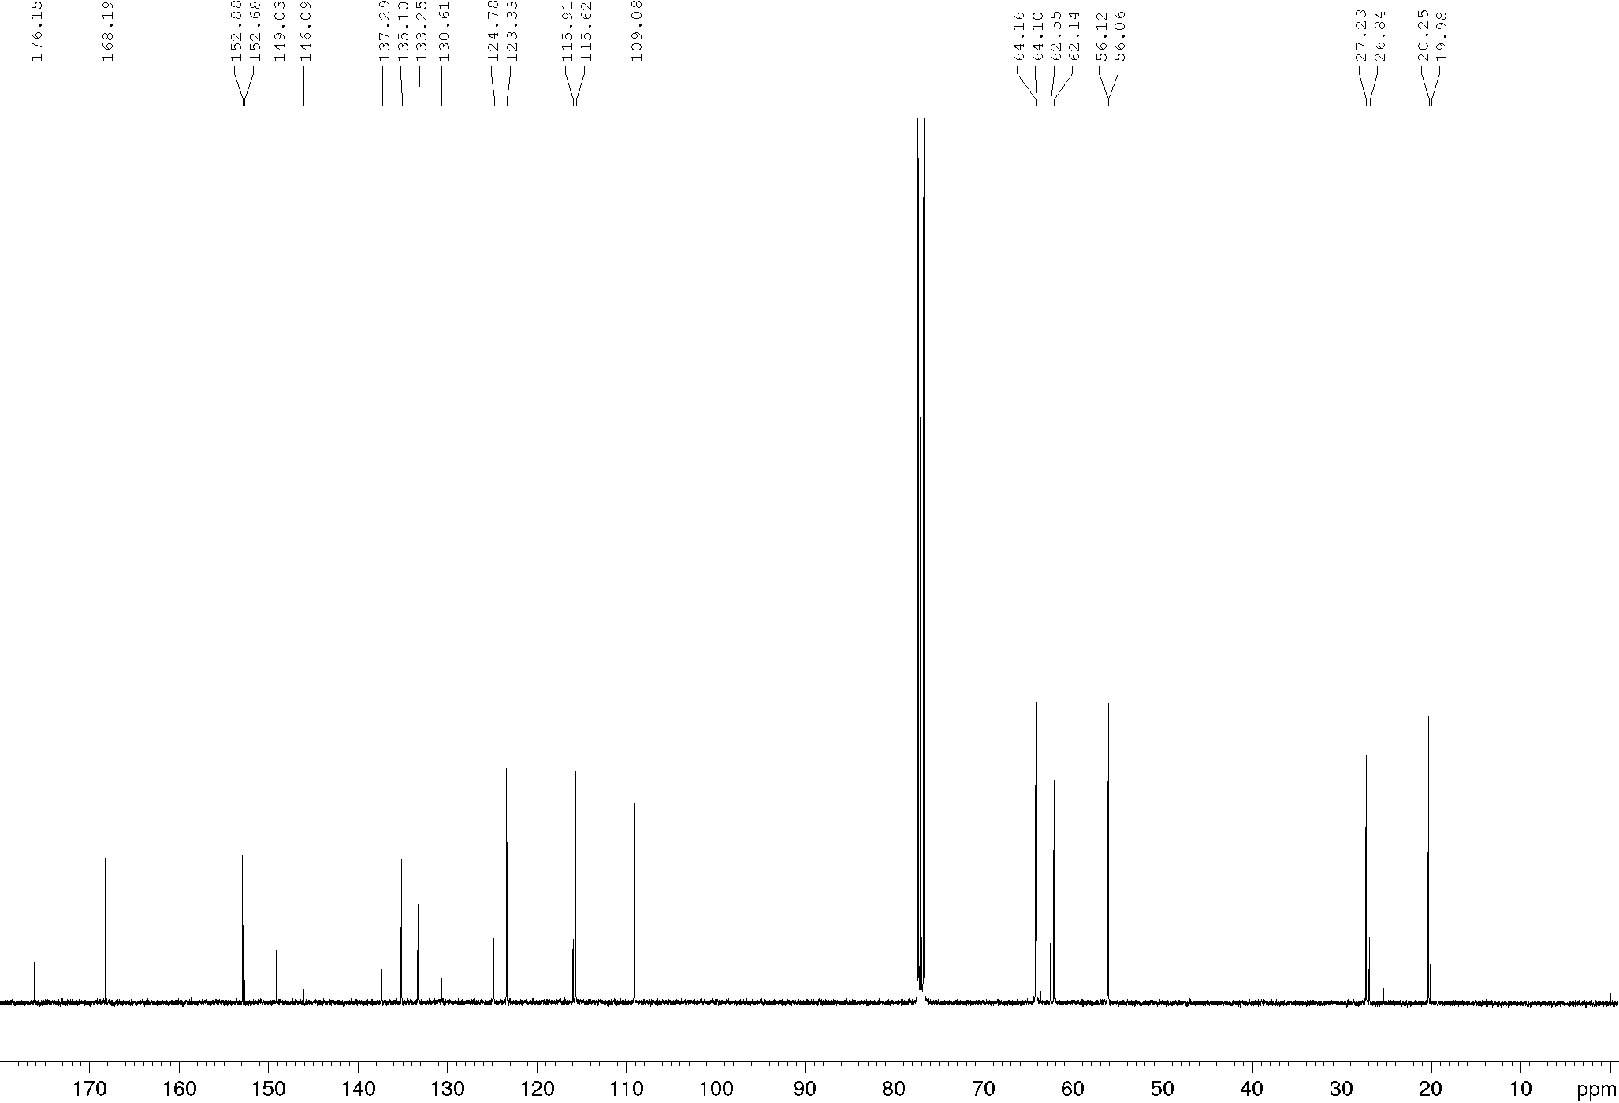
Compound 15g, ¹H and ¹³C NMR (400/100 MHz), CDCl₃
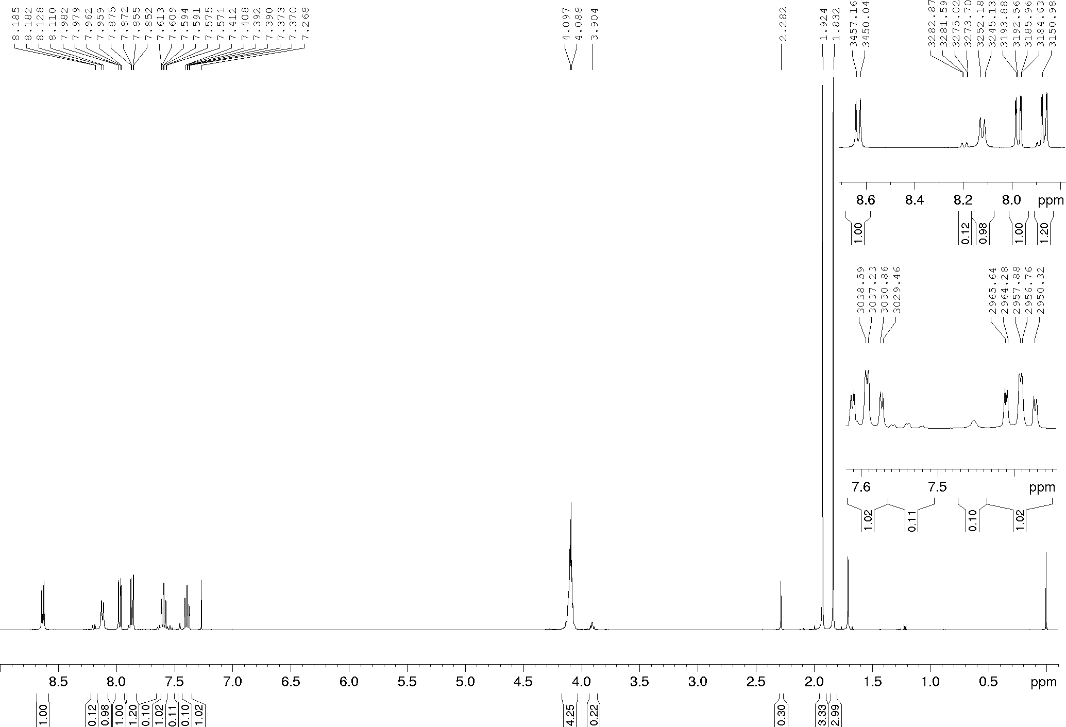
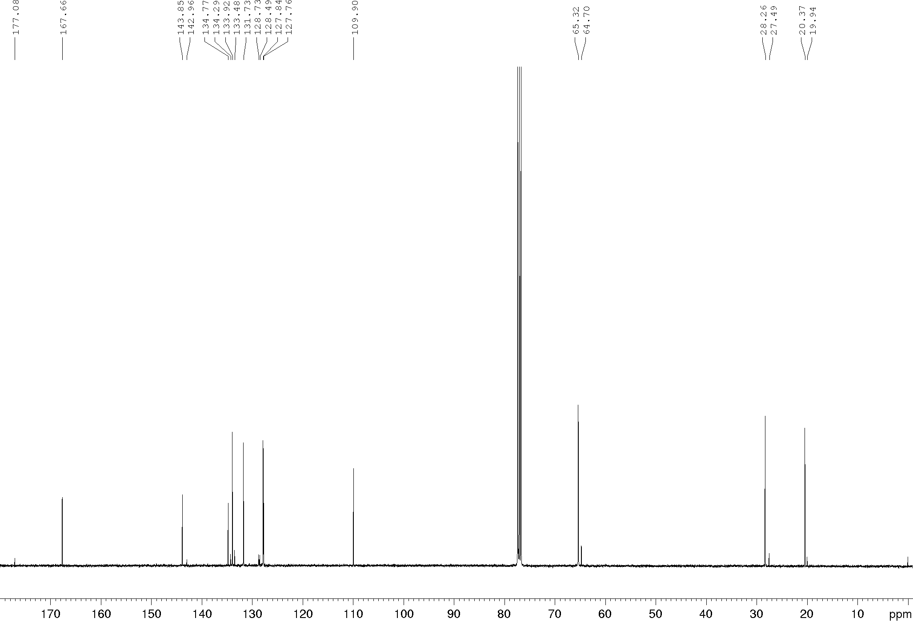
Compound 15h, ¹H and ¹³C NMR (400/100 MHz), CDCl₃
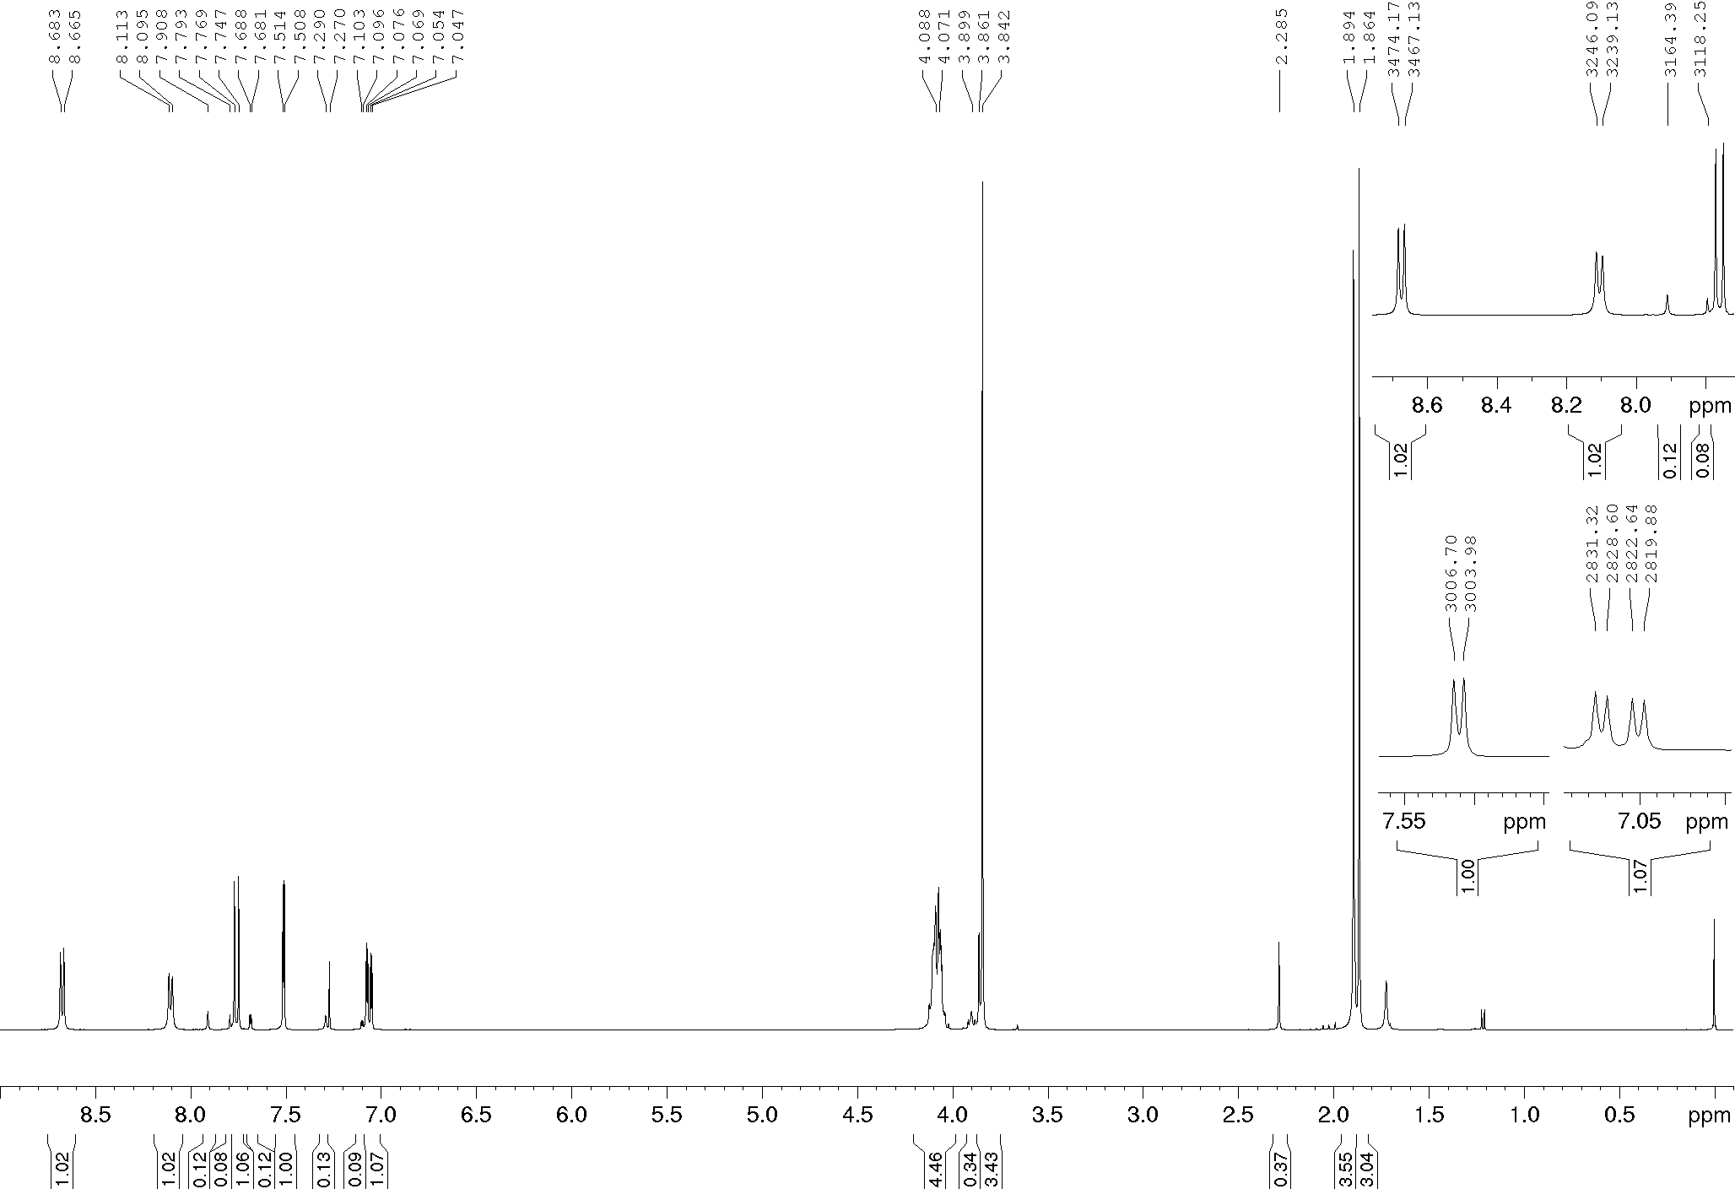
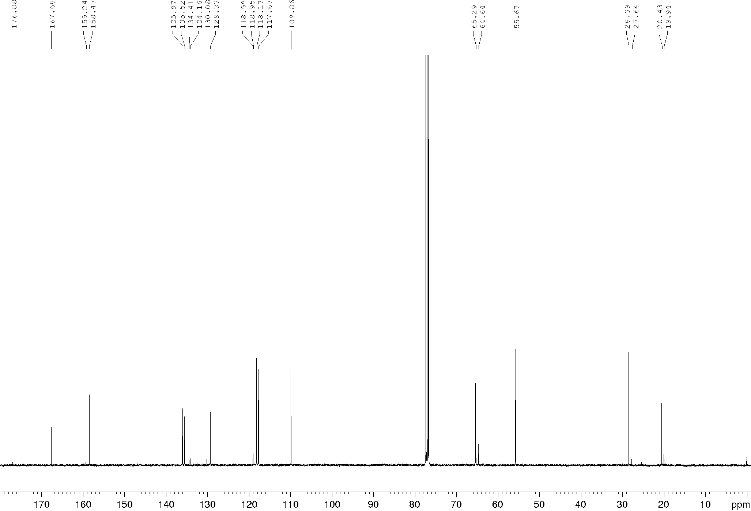
Compound 8a, ¹H and ¹³C NMR (400/100 MHz), DMSO-d₆
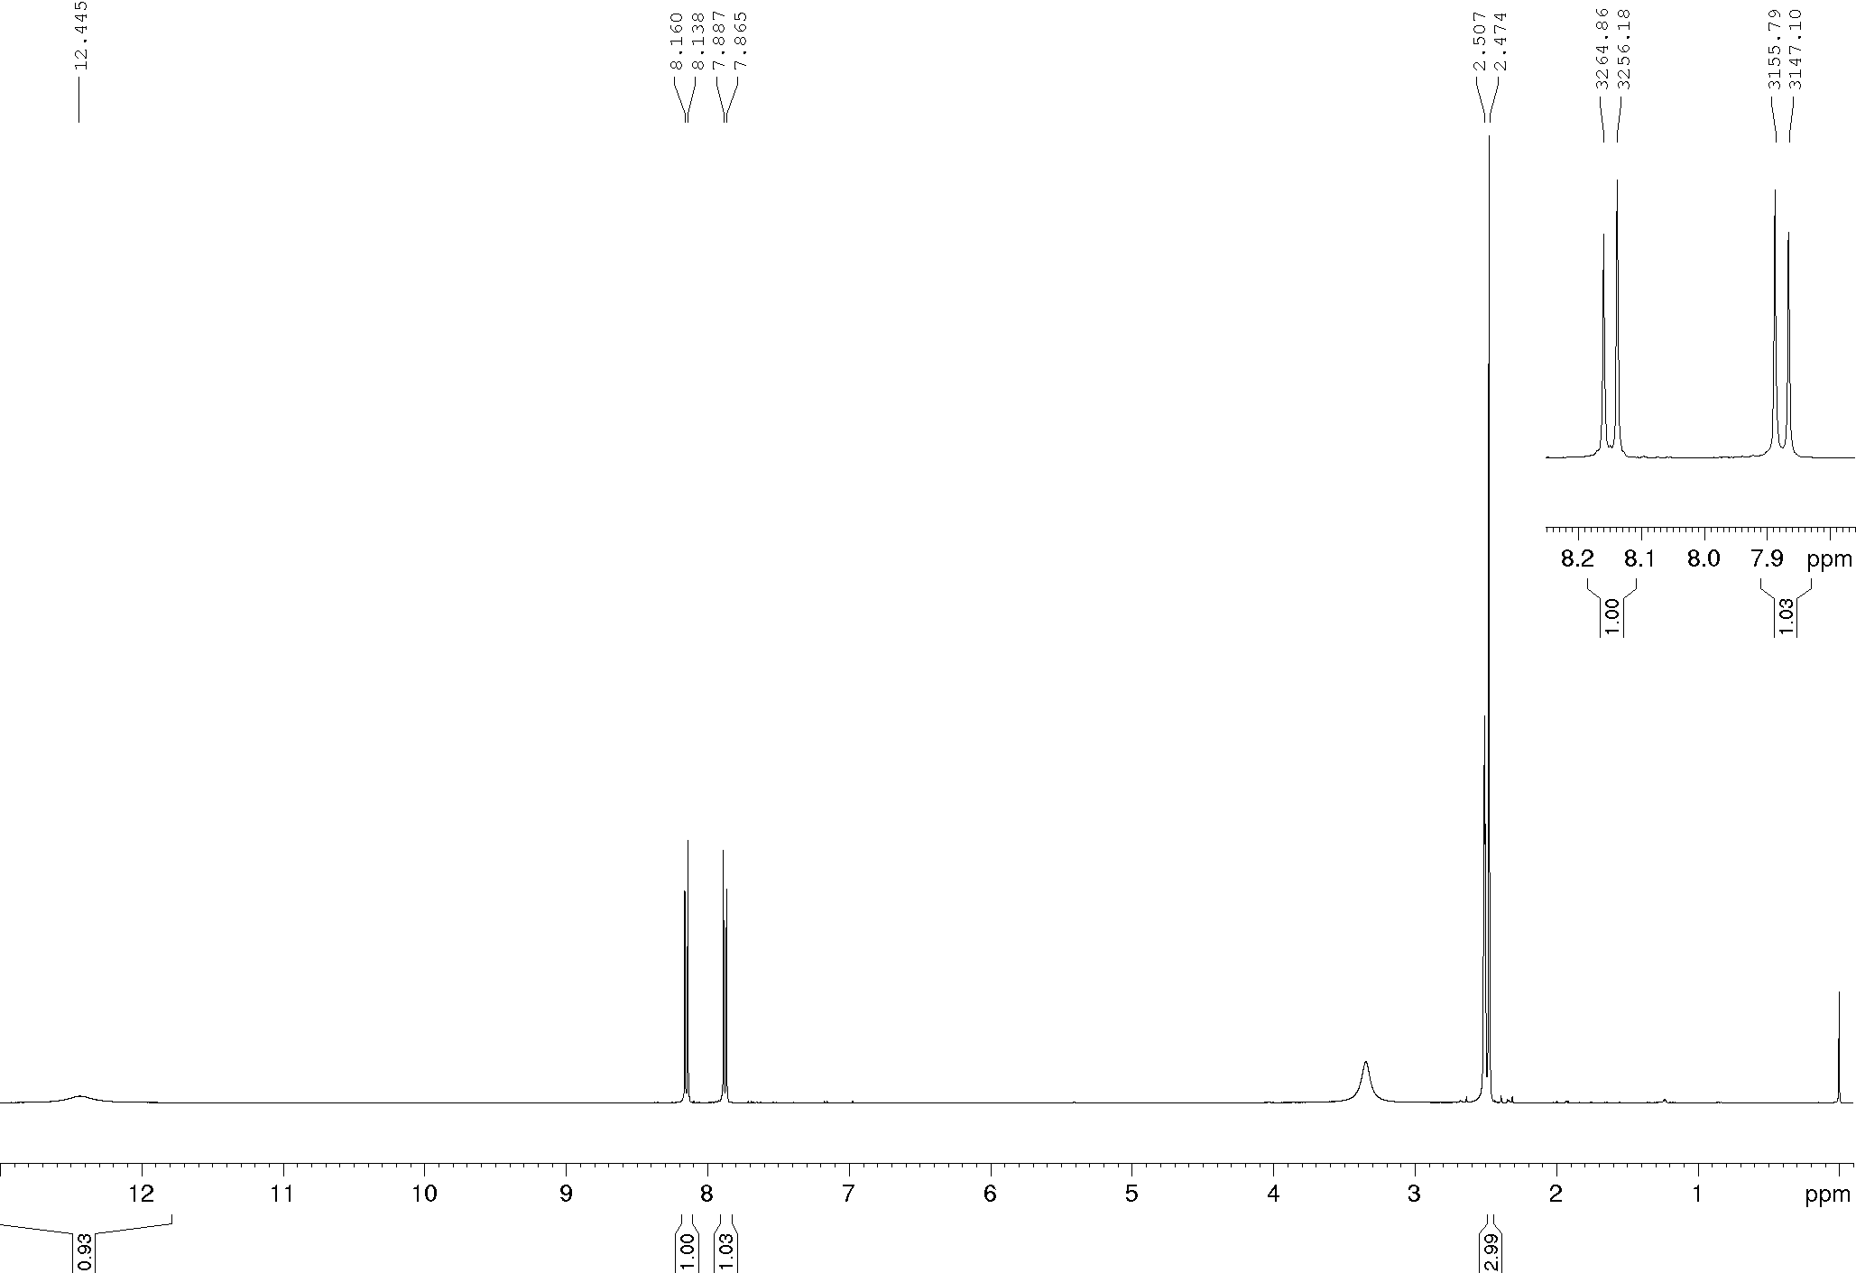
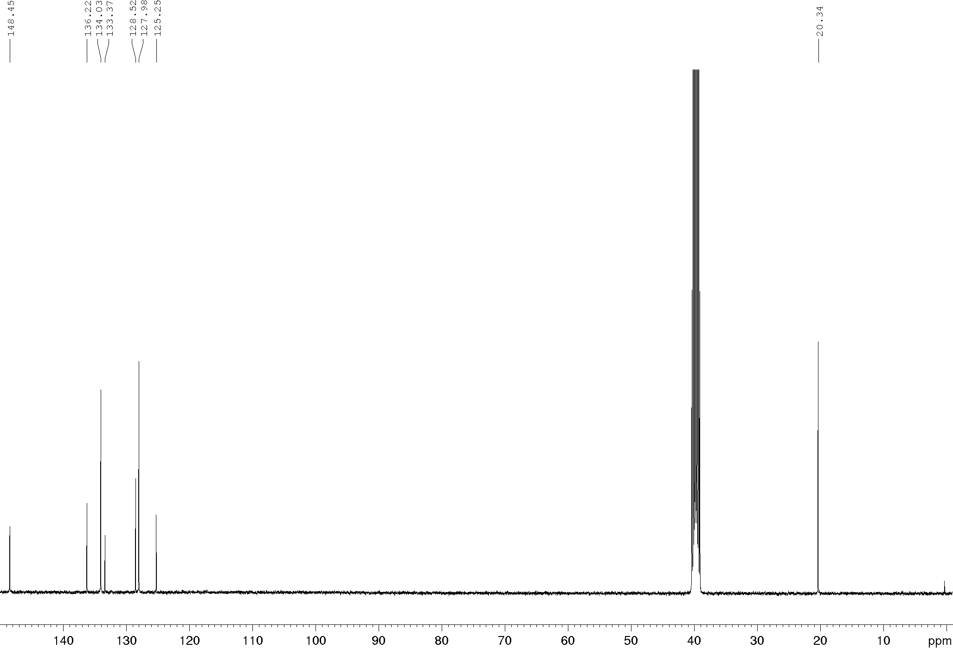
Compound 8b, ¹H and ¹³C NMR (400/100 MHz), DMSO-d₆
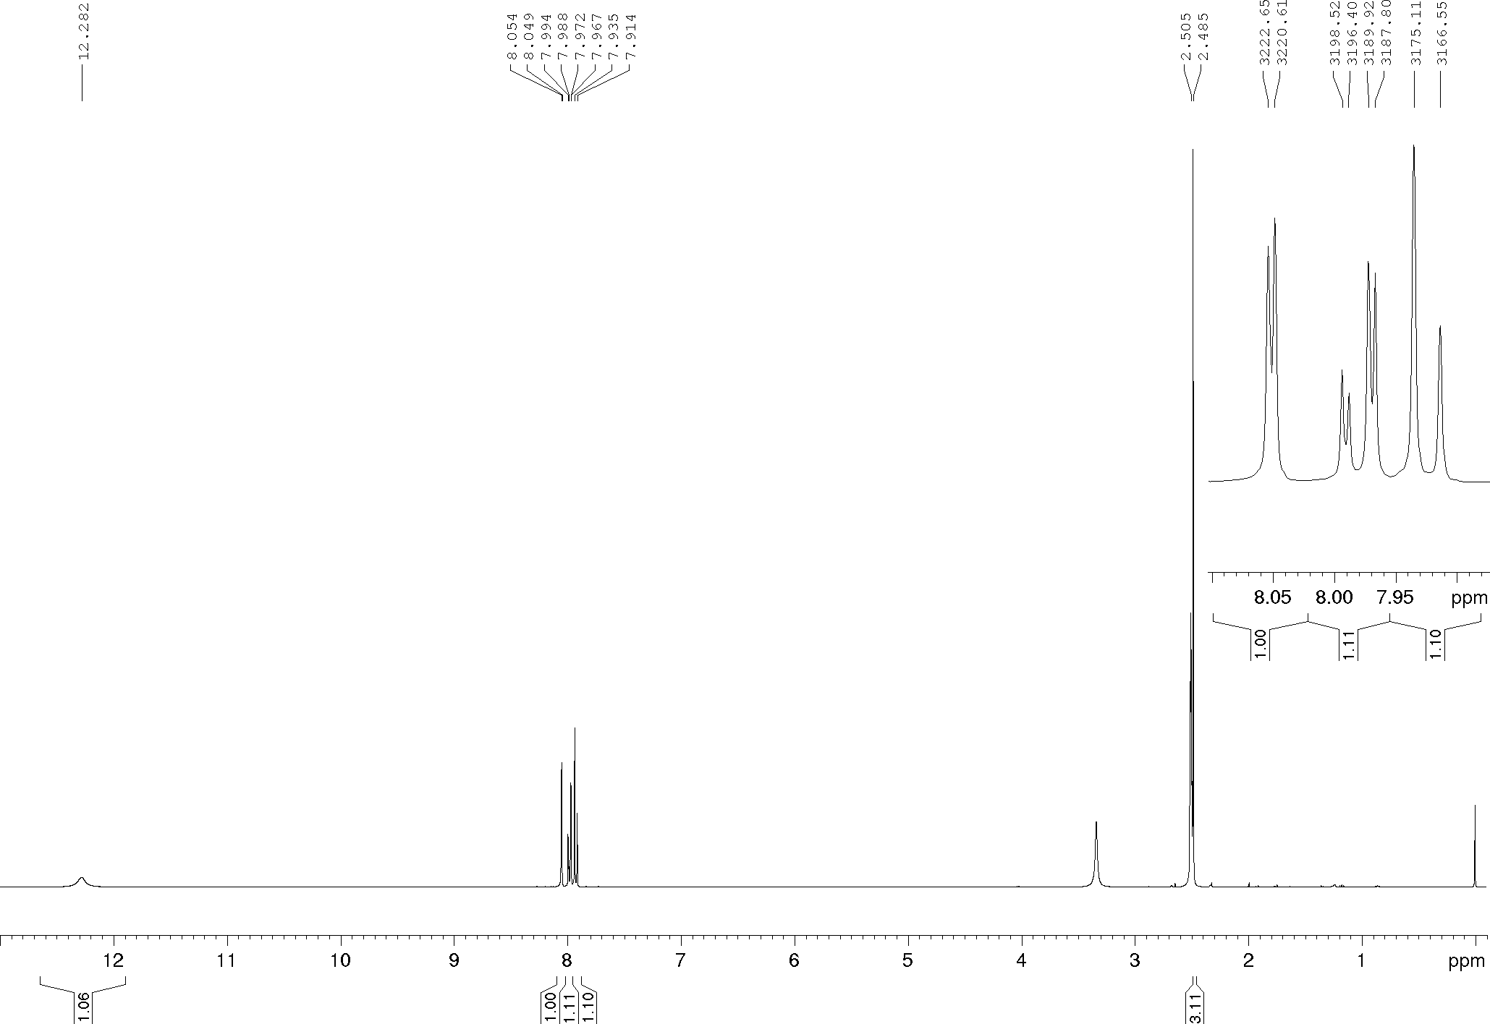
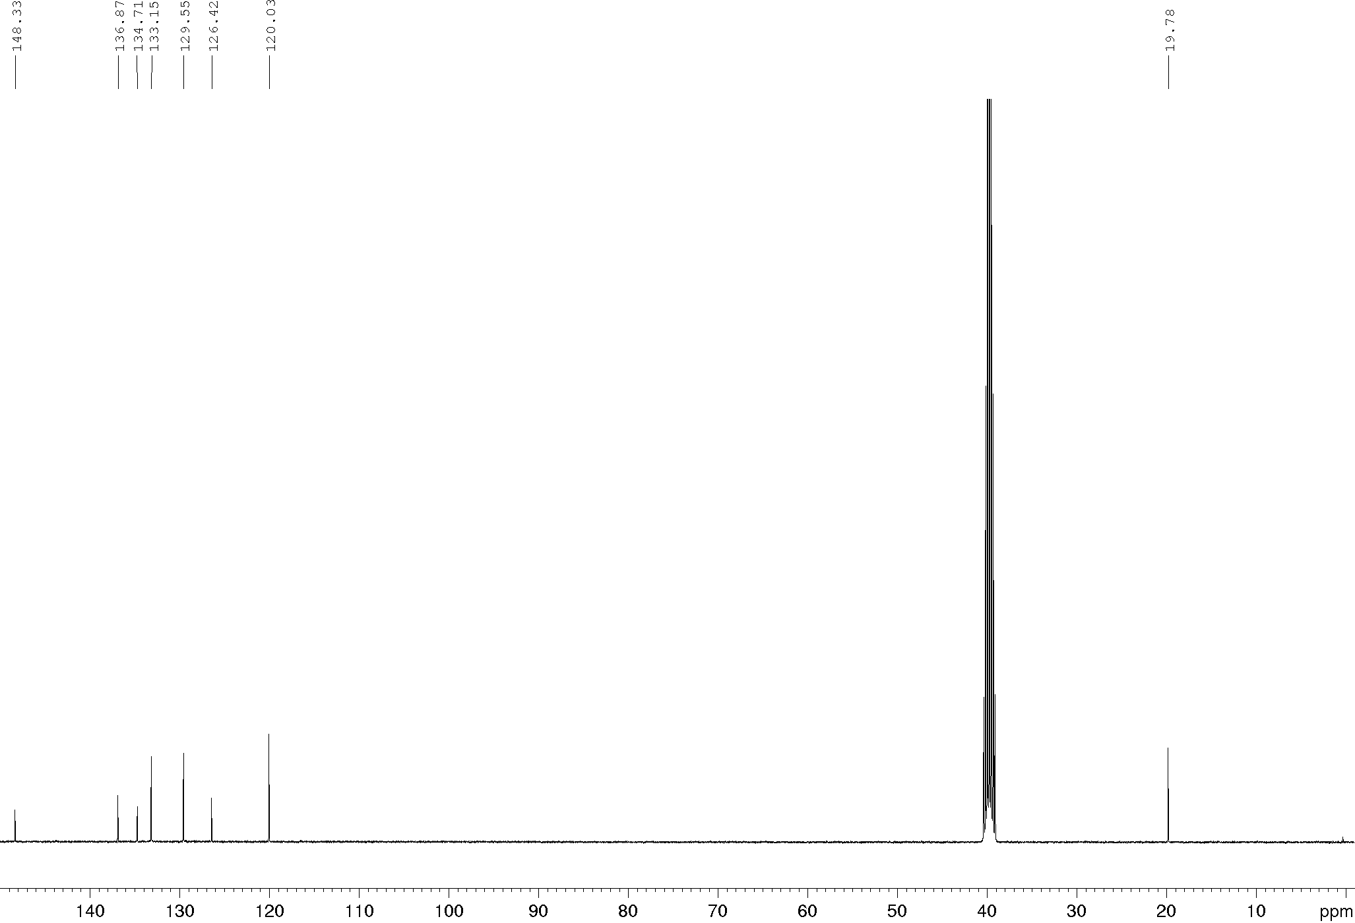
Compound 8c, ¹H and ¹³C NMR (400/100 MHz), DMSO-d₆
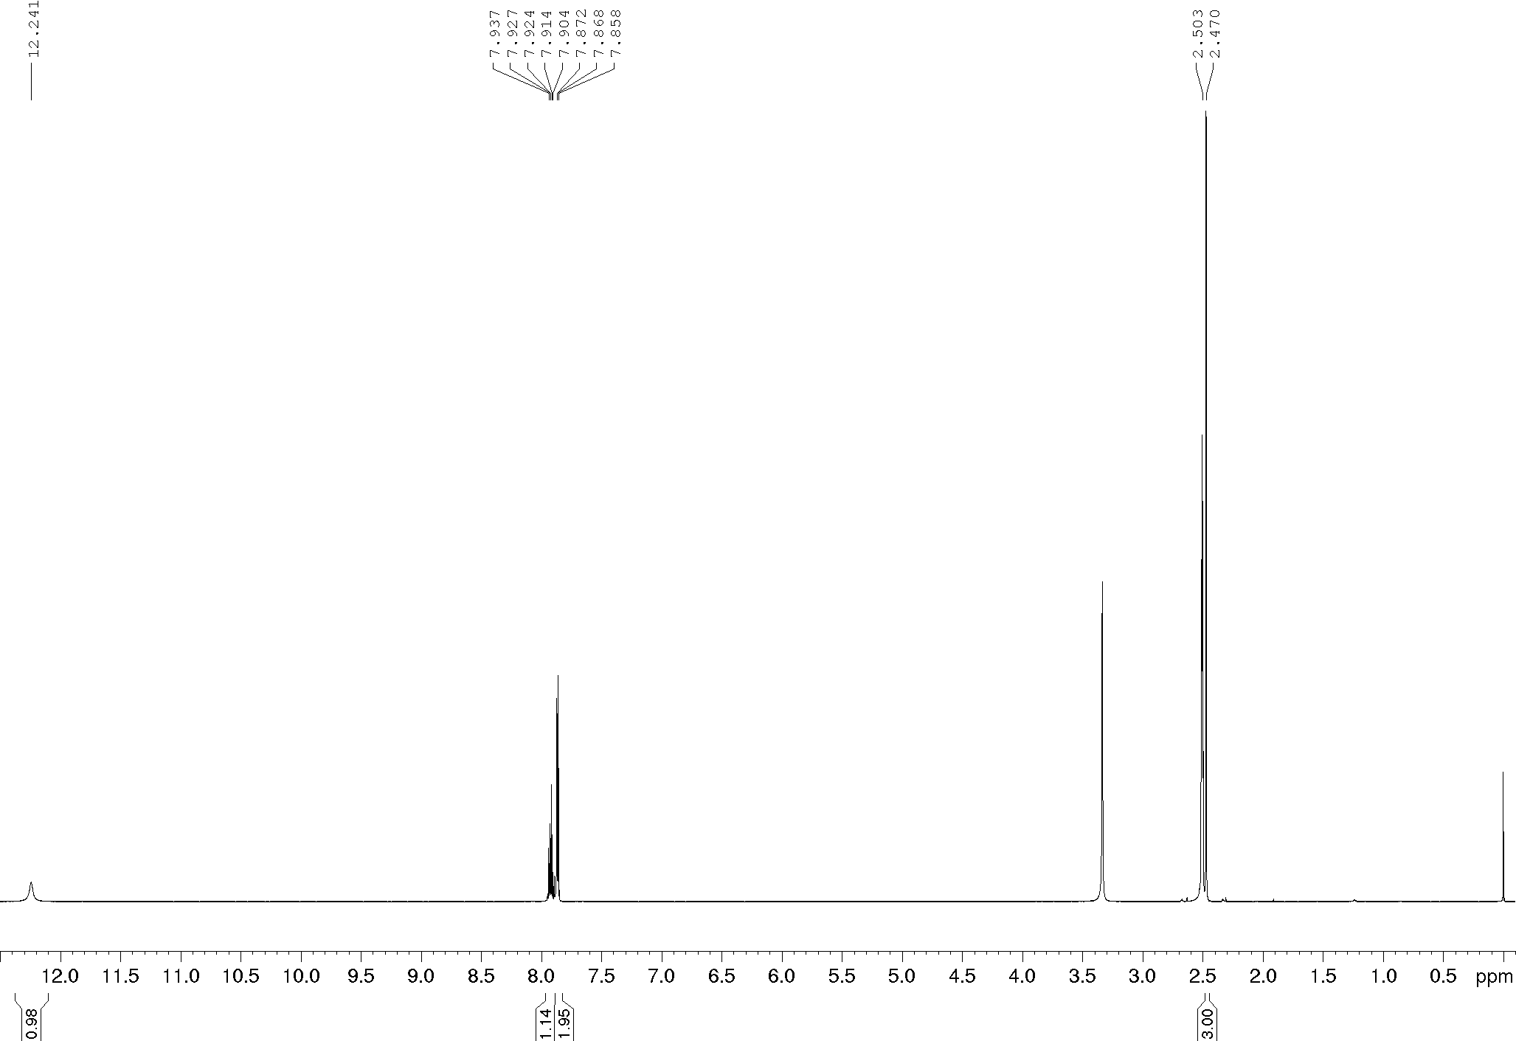
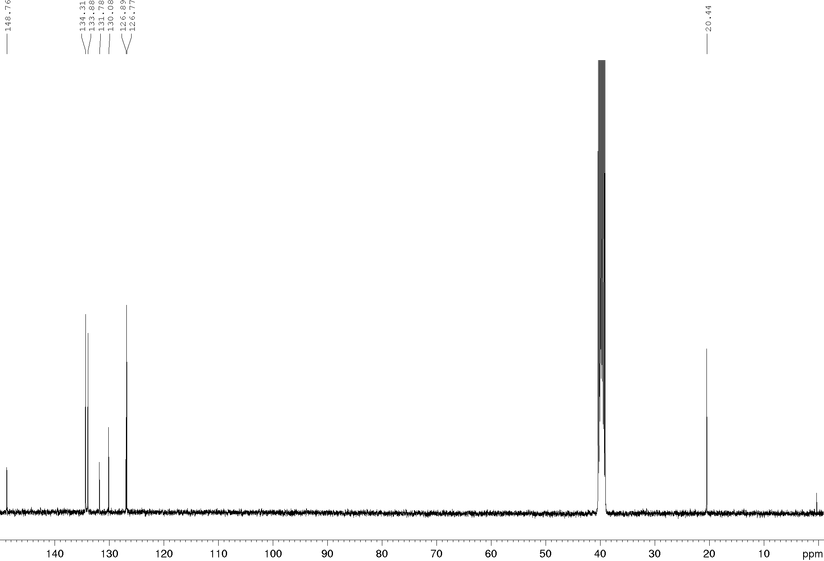
Compound 8d, ¹H and ¹³C NMR (600/150 MHz), DMSO-d₆
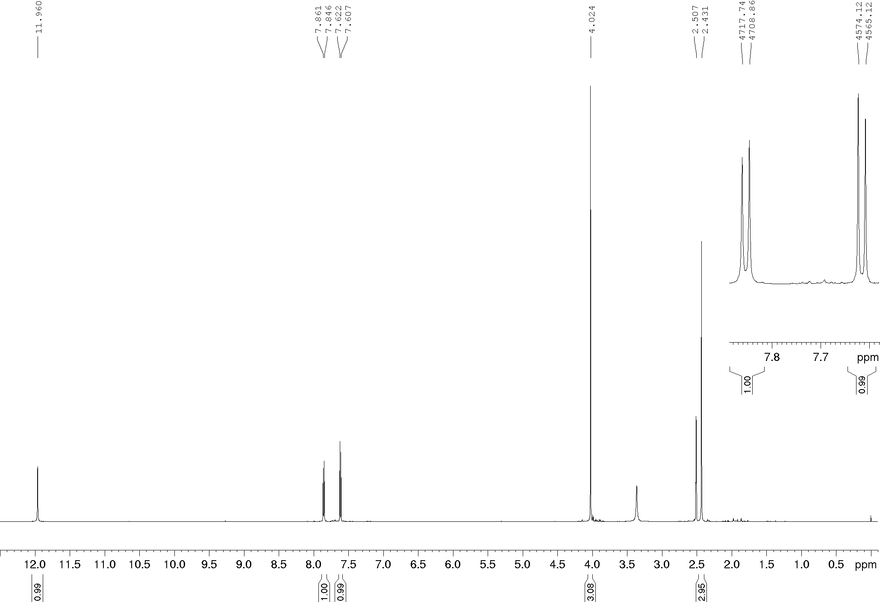
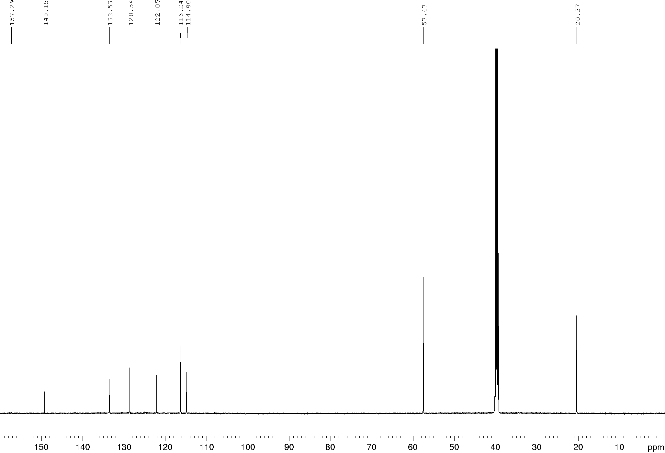
Compound 8e, ¹H and ¹³C NMR (400/100 MHz), DMSO-d₆
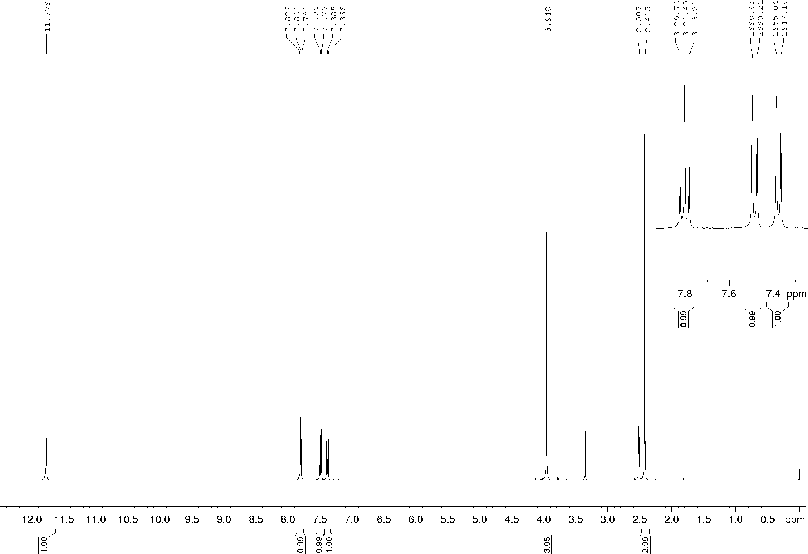
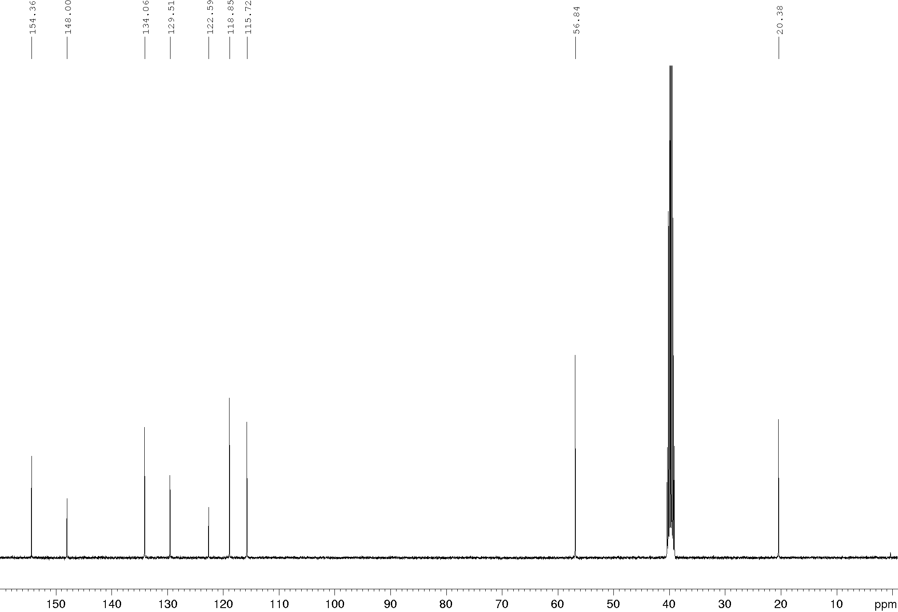
Compound 8f, ¹H and ¹³C NMR (400/100 MHz), DMSO-d₆
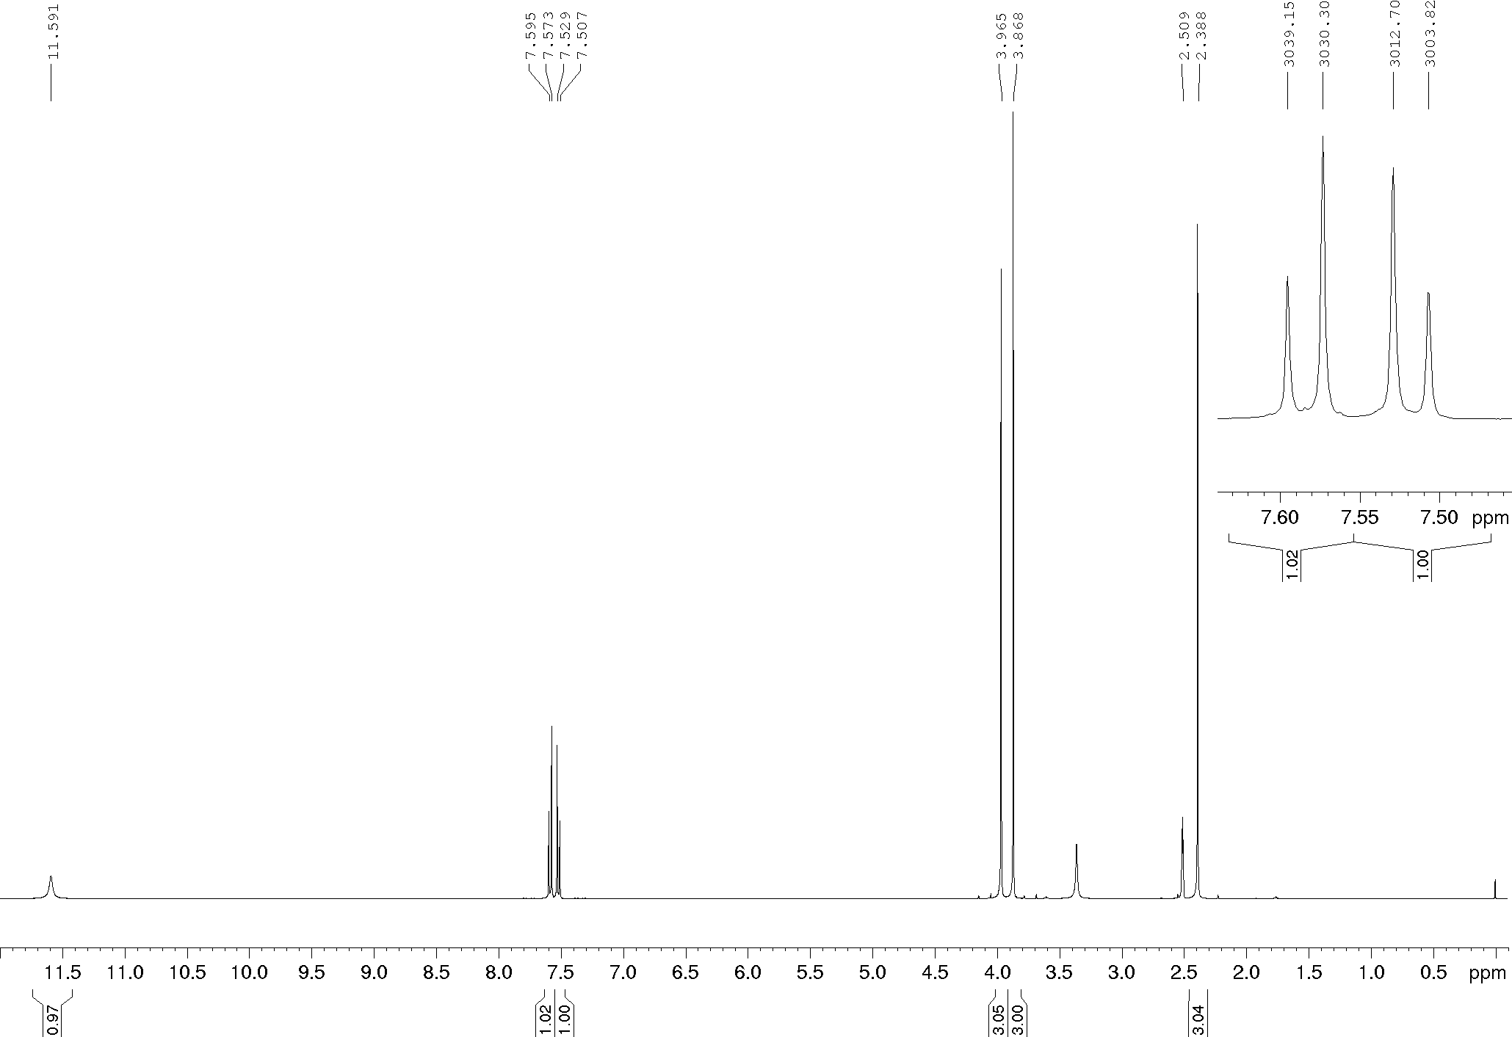
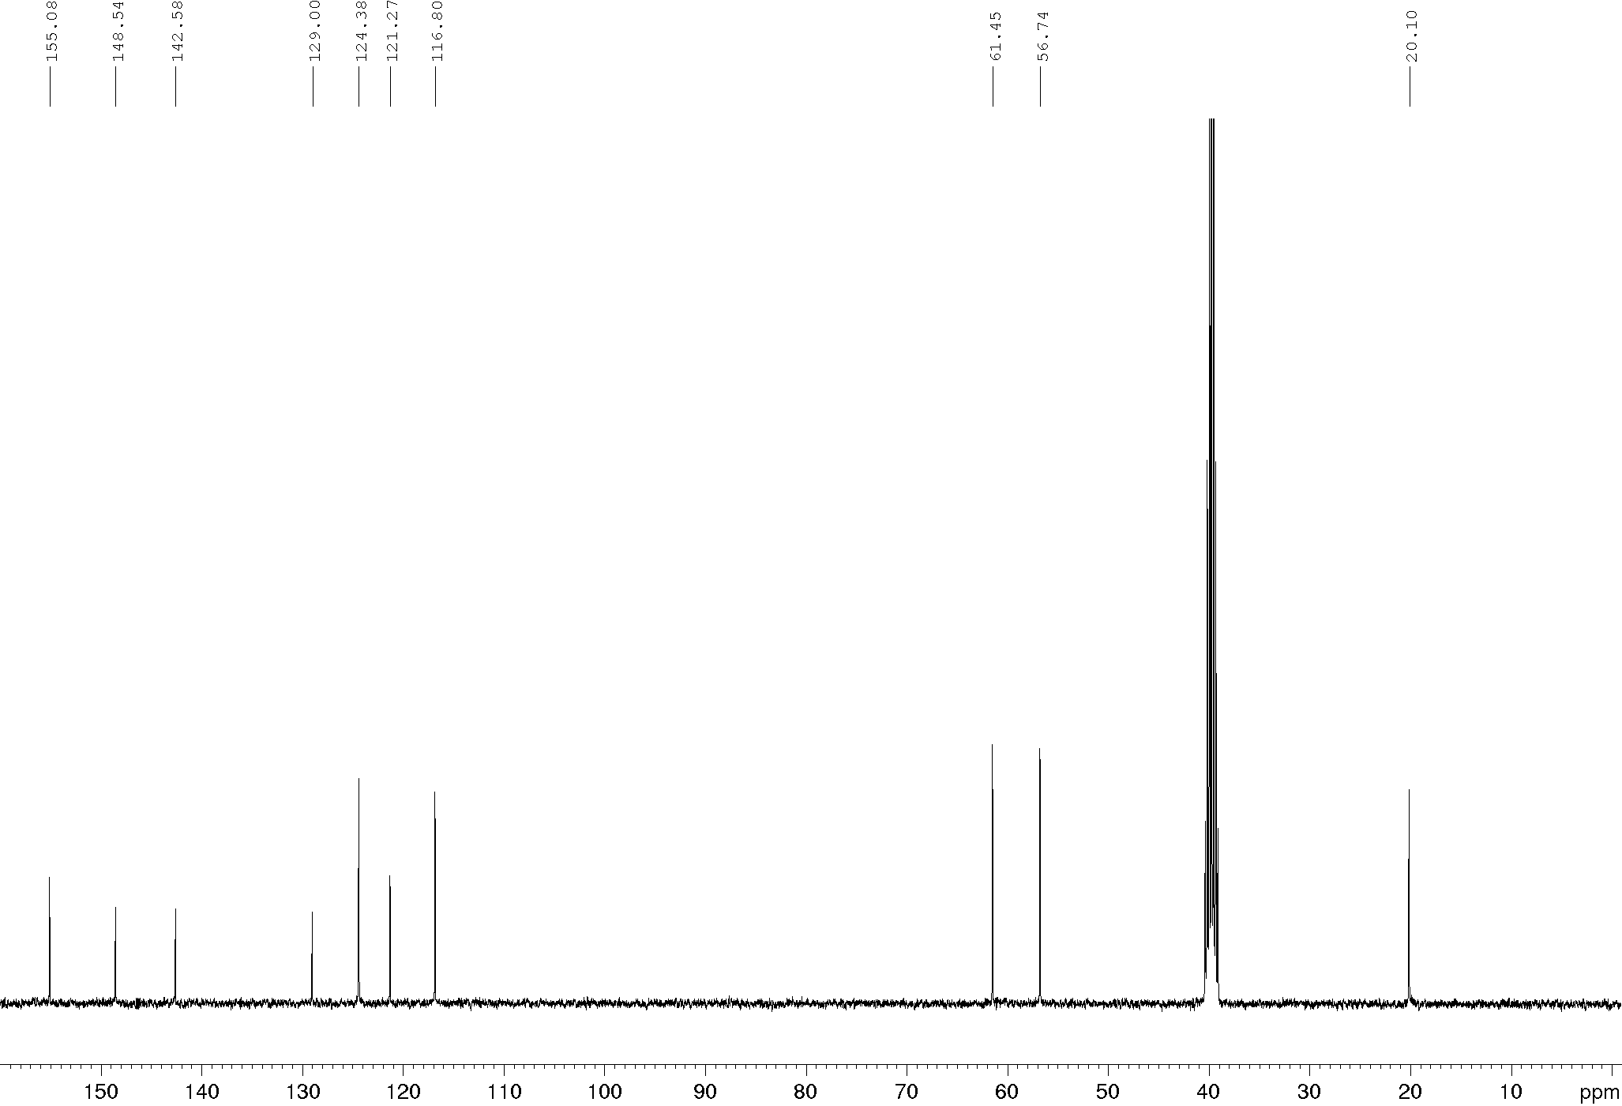
Compound 8g, ¹H and ¹³C NMR (400/100 MHz), DMSO-d₆
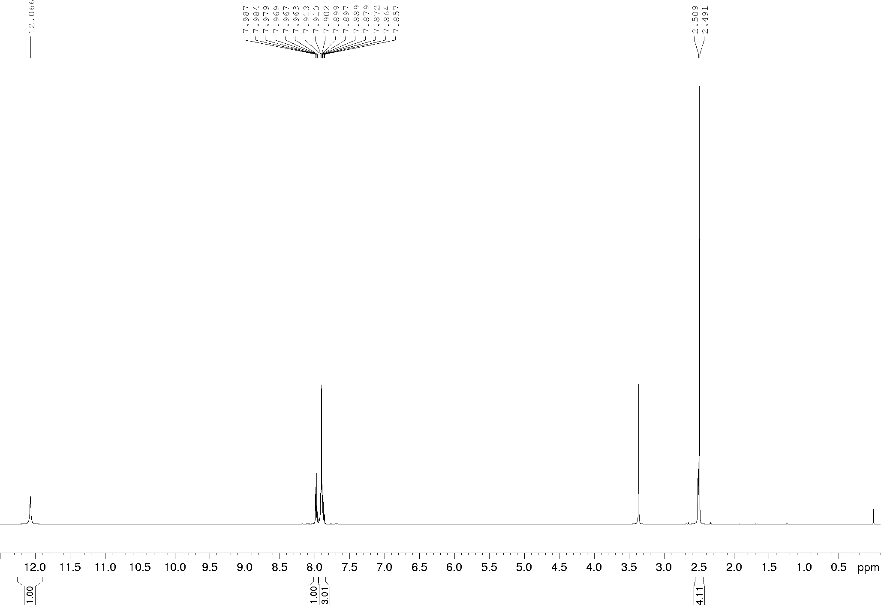
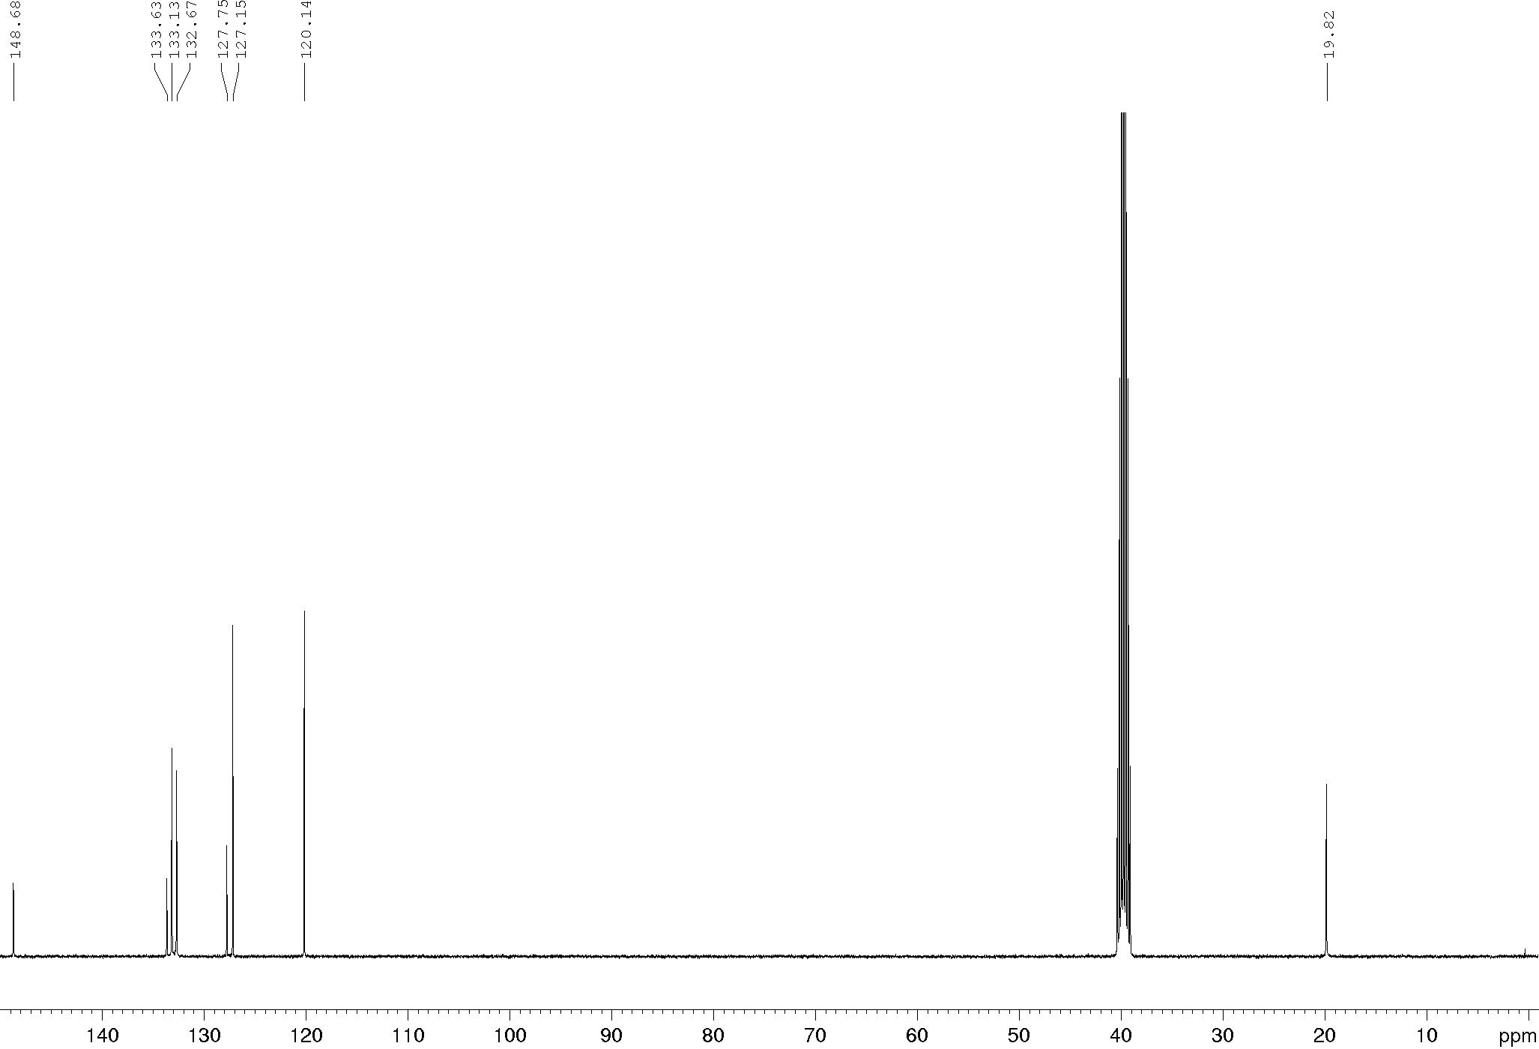
Compound 8h, ¹H and ¹³C NMR (400/100 MHz), DMSO-d₆
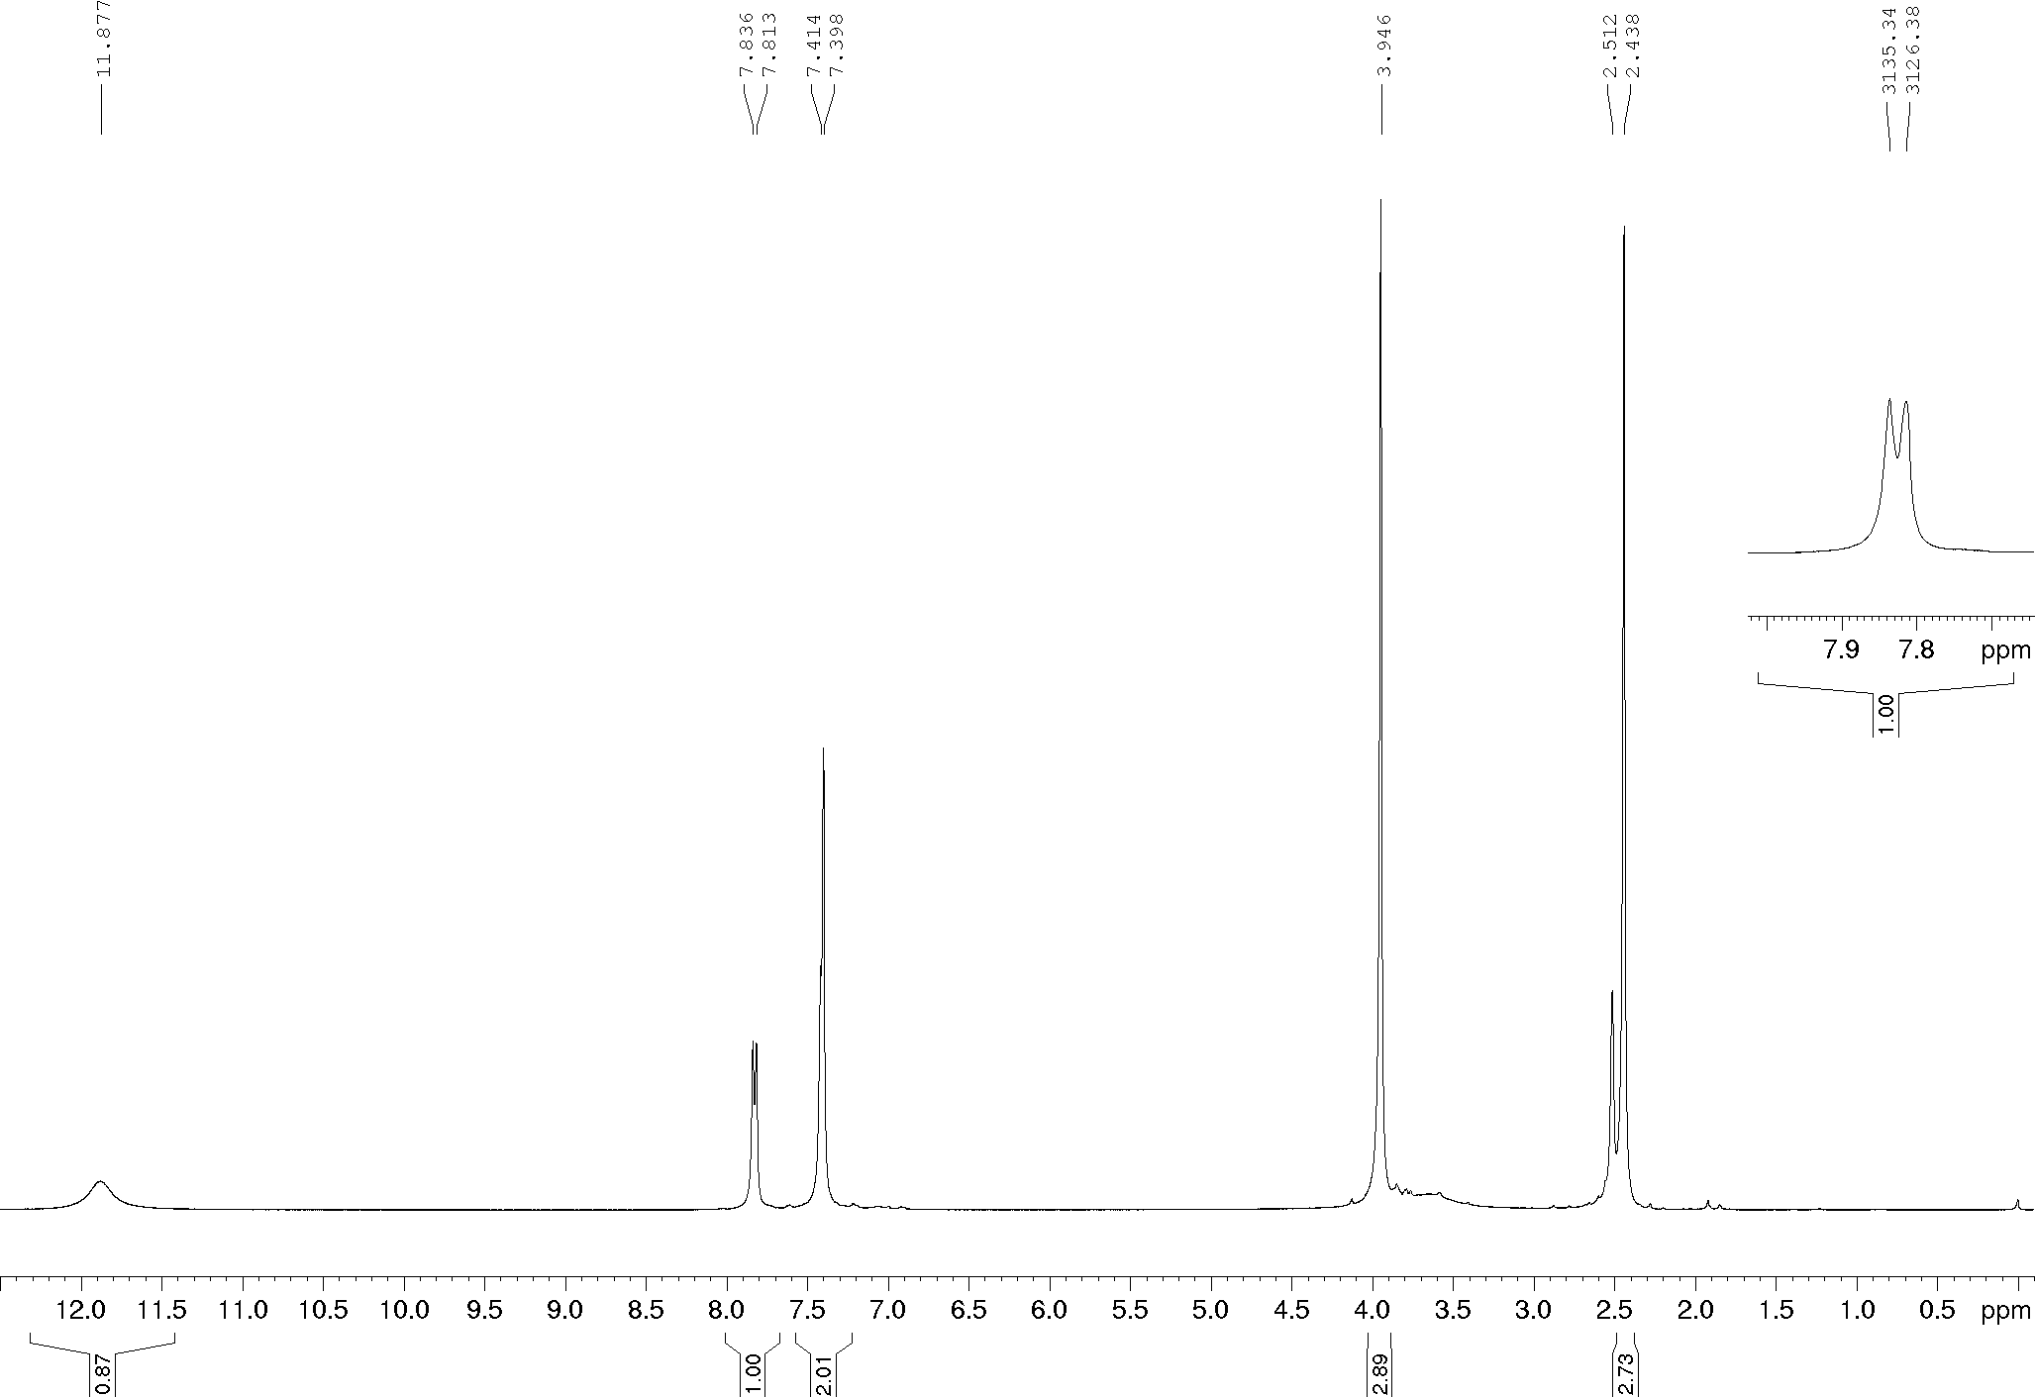
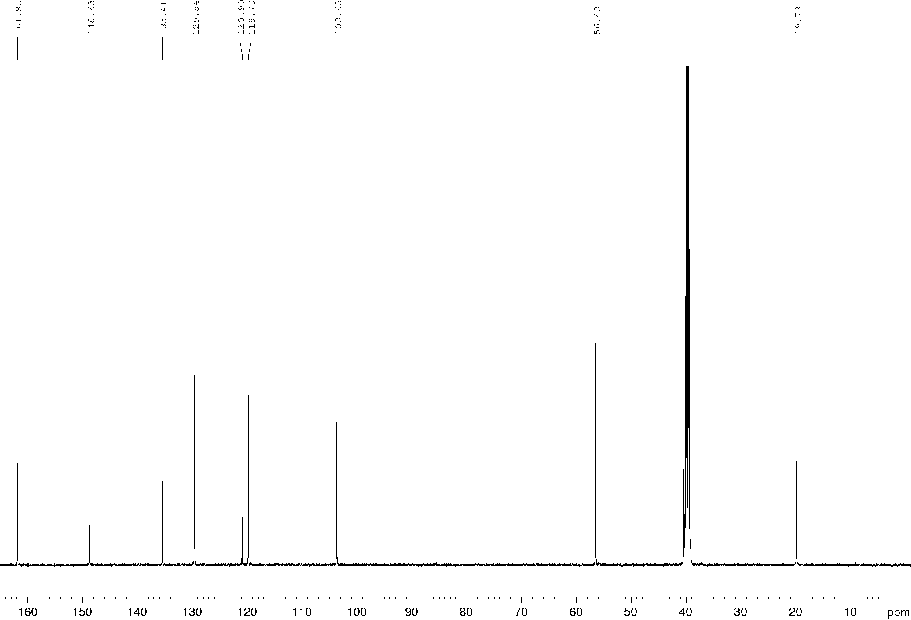
Compound 16a, ¹H and ¹³C NMR (600/150 MHz), DMSO-d₆
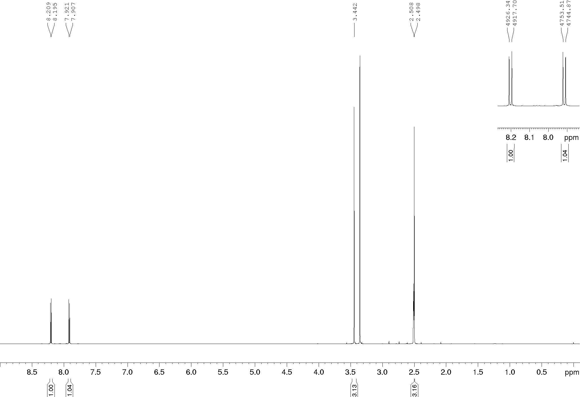
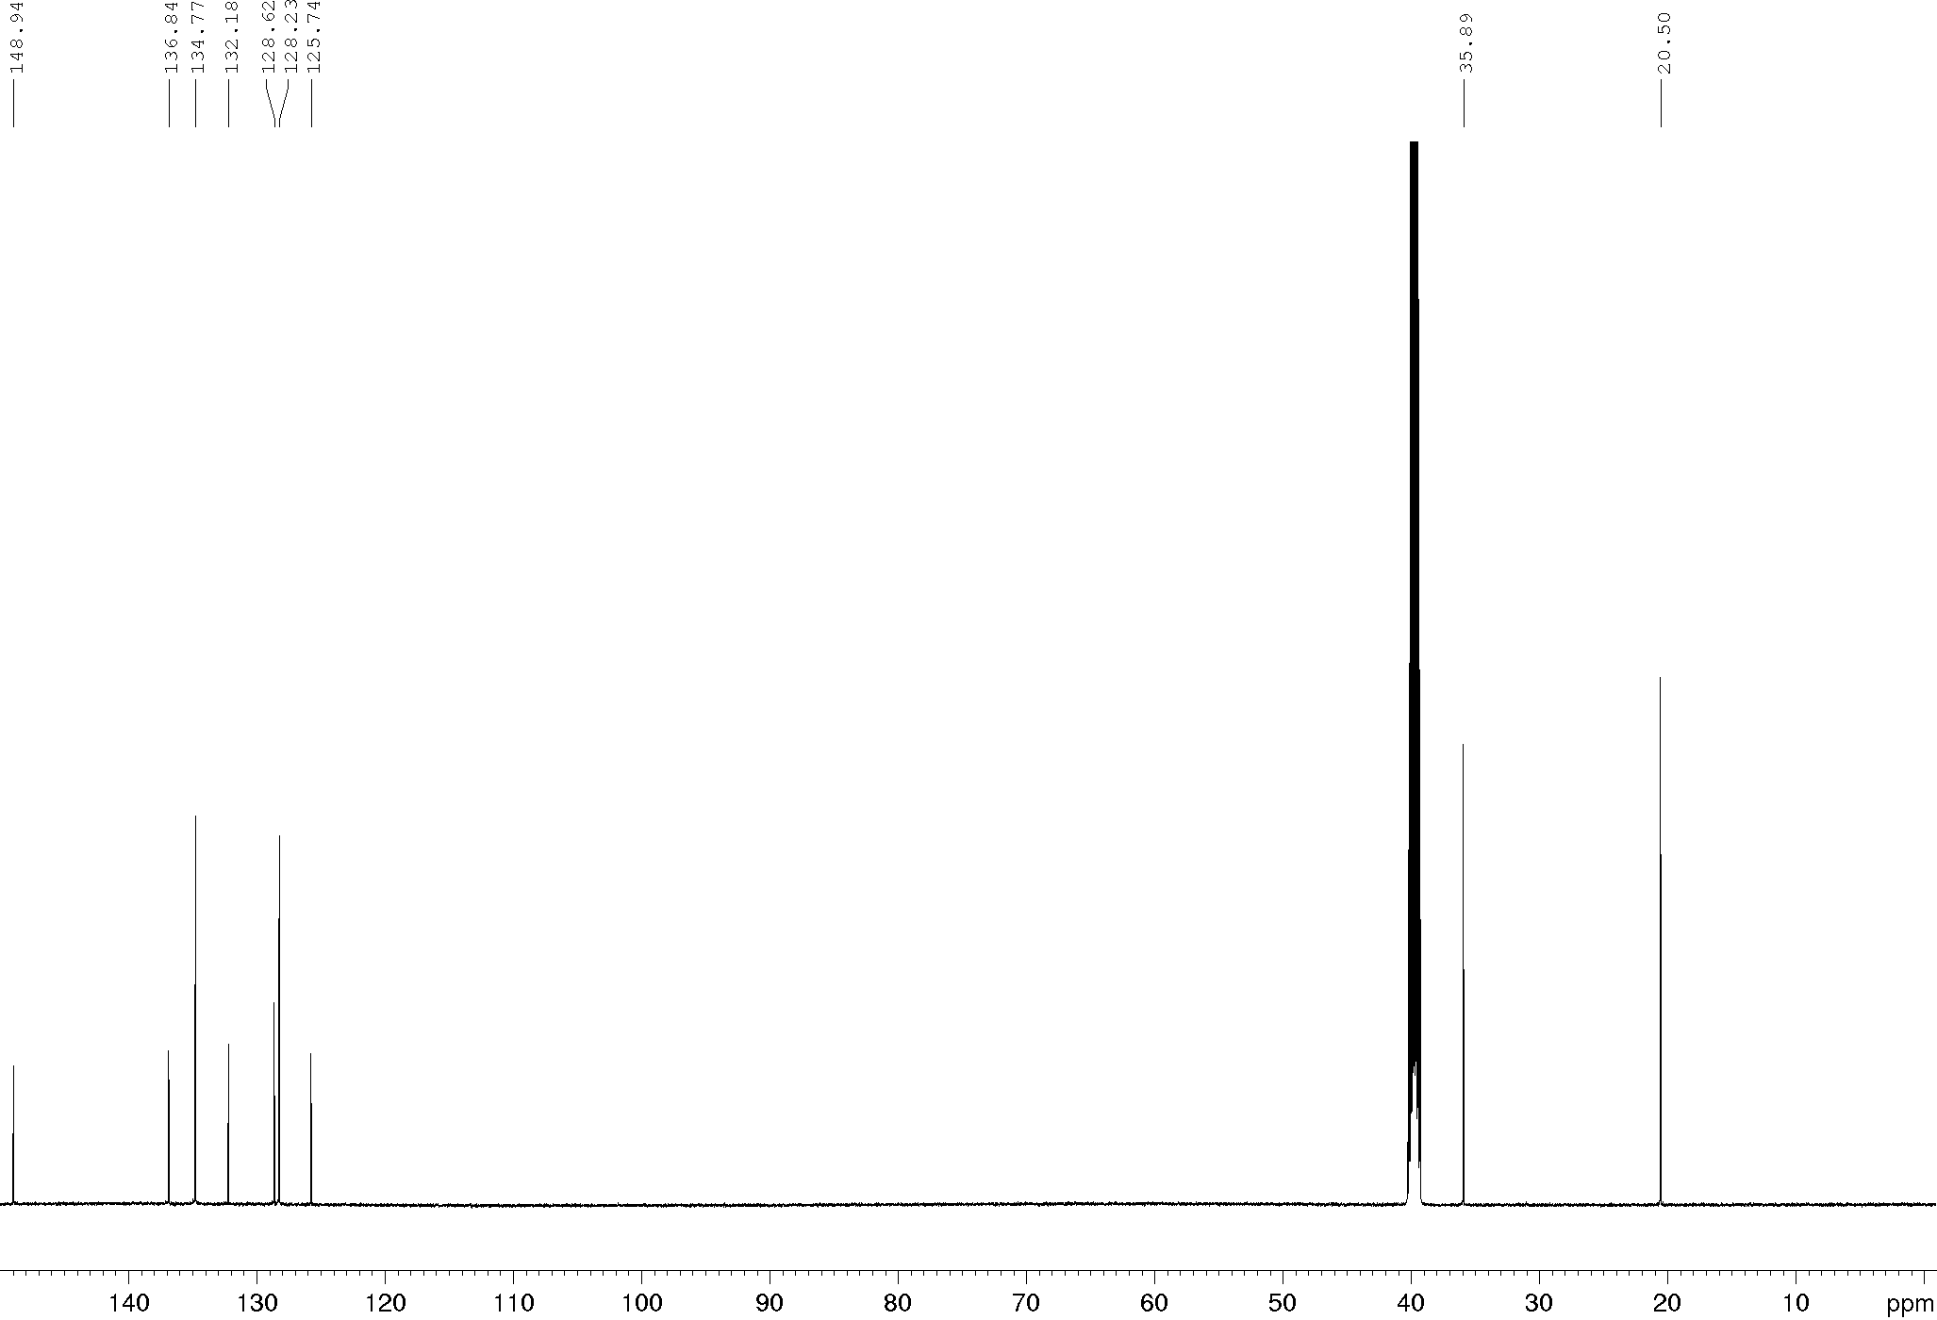
Compound 16b, ¹H and ¹³C NMR (600/150 MHz), CDCl₃
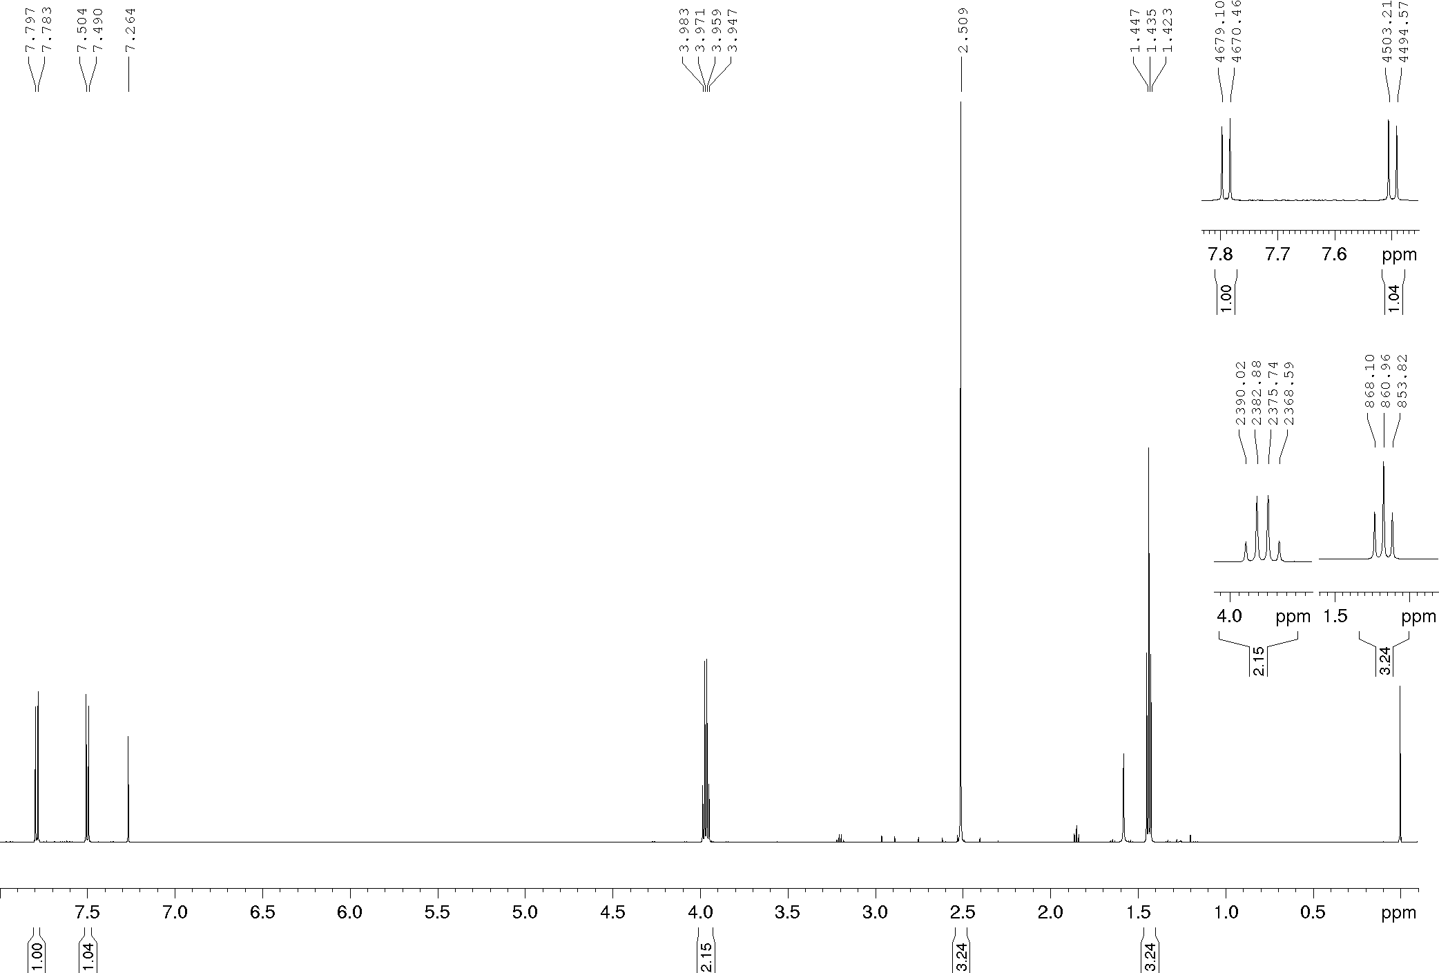
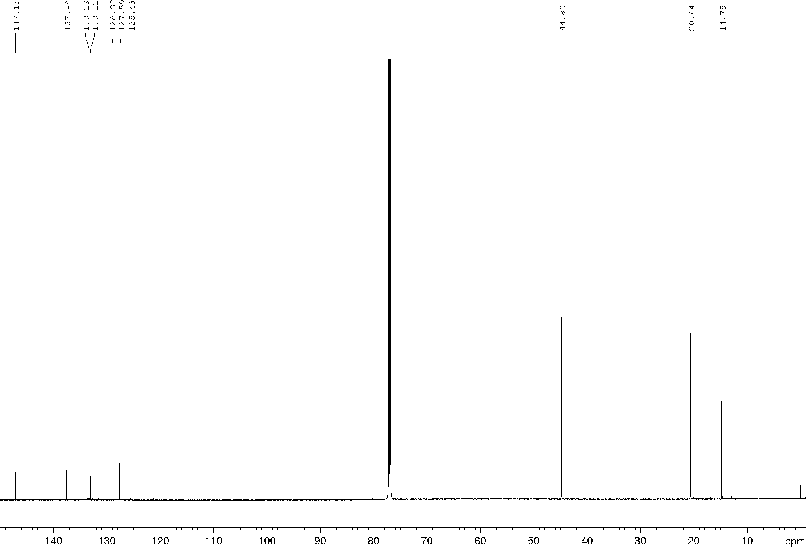
Compound 16c, ¹H and ¹³C NMR (600/150 MHz), CDCl₃
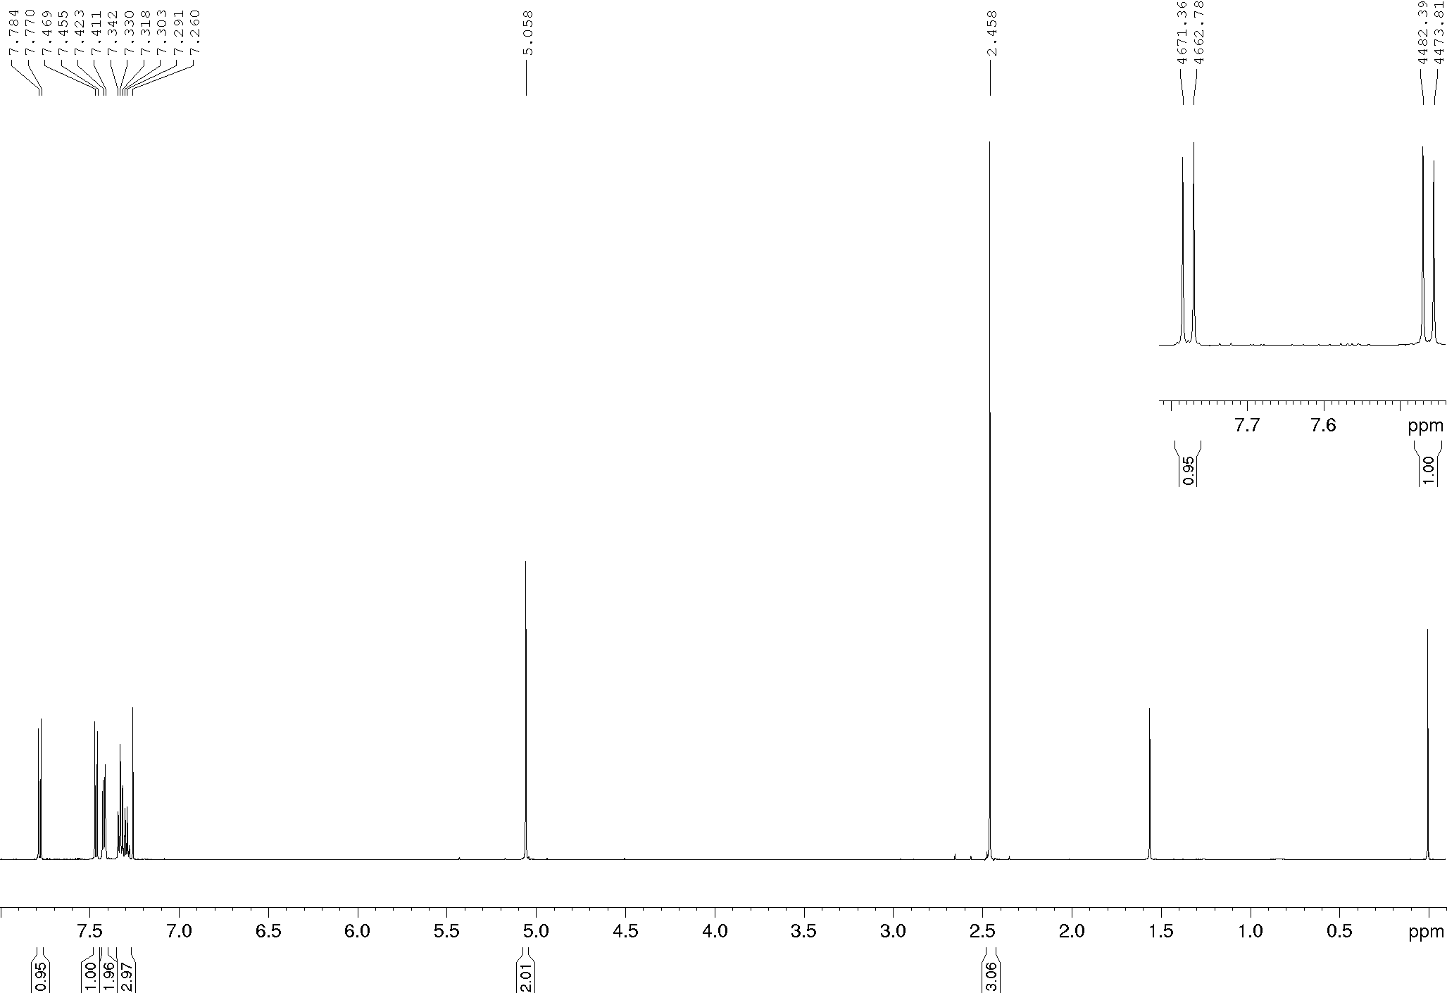
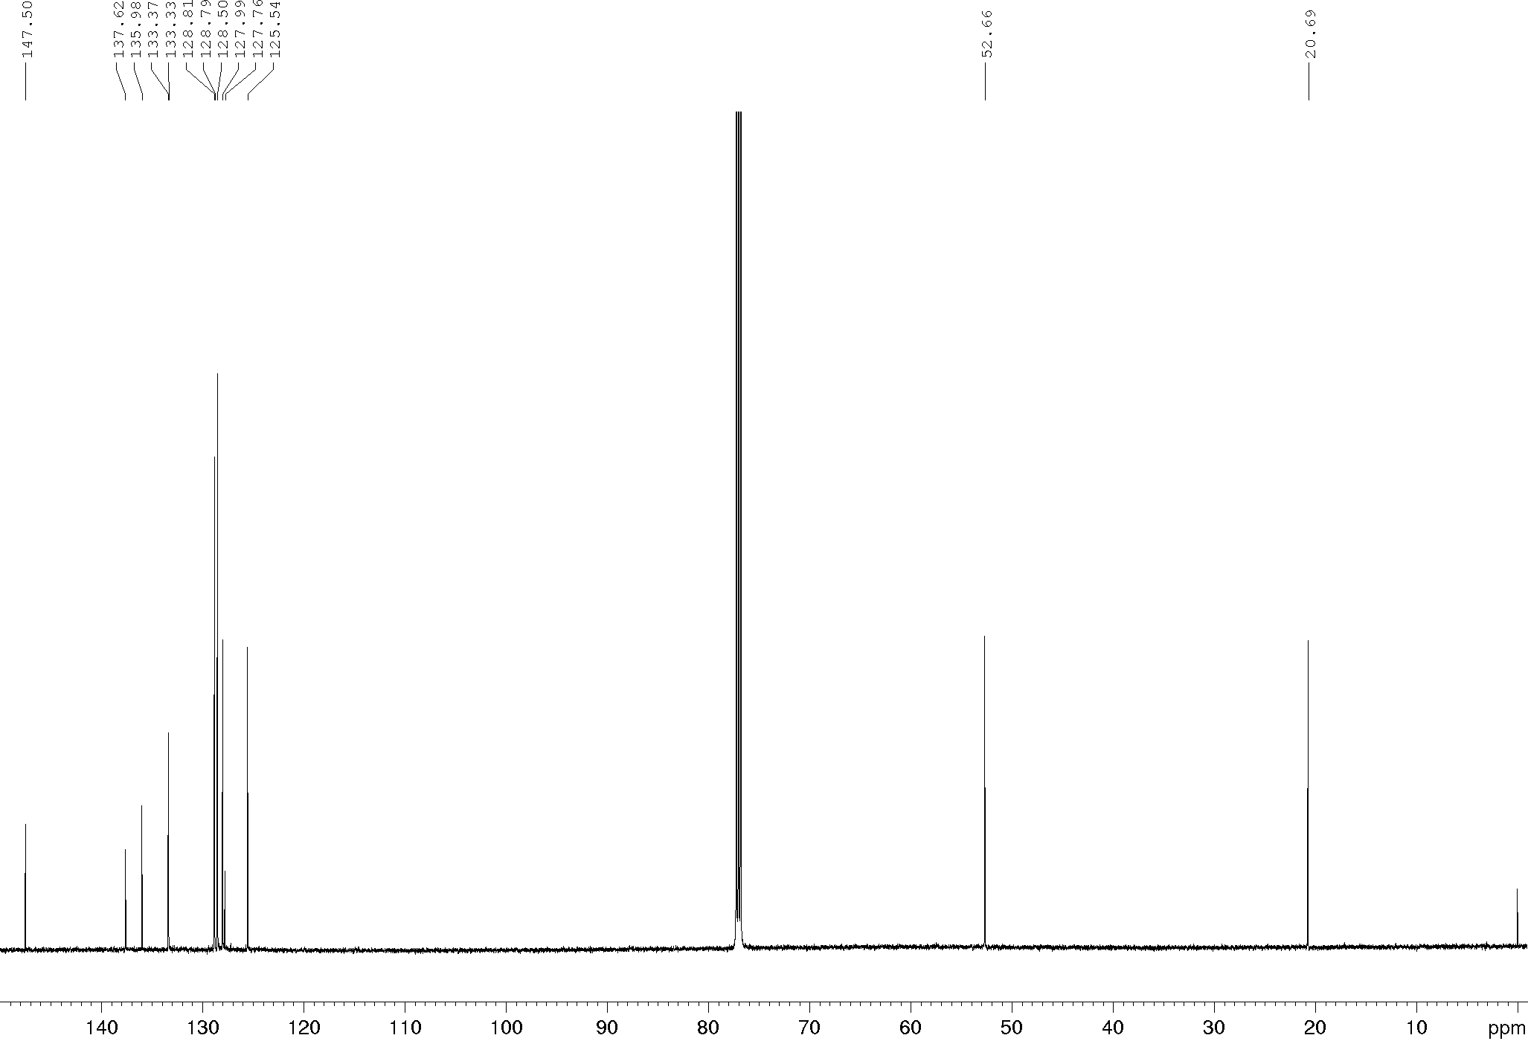
Compound 16d, ¹H and ¹³C NMR (600/150 MHz), DMSO-d₆
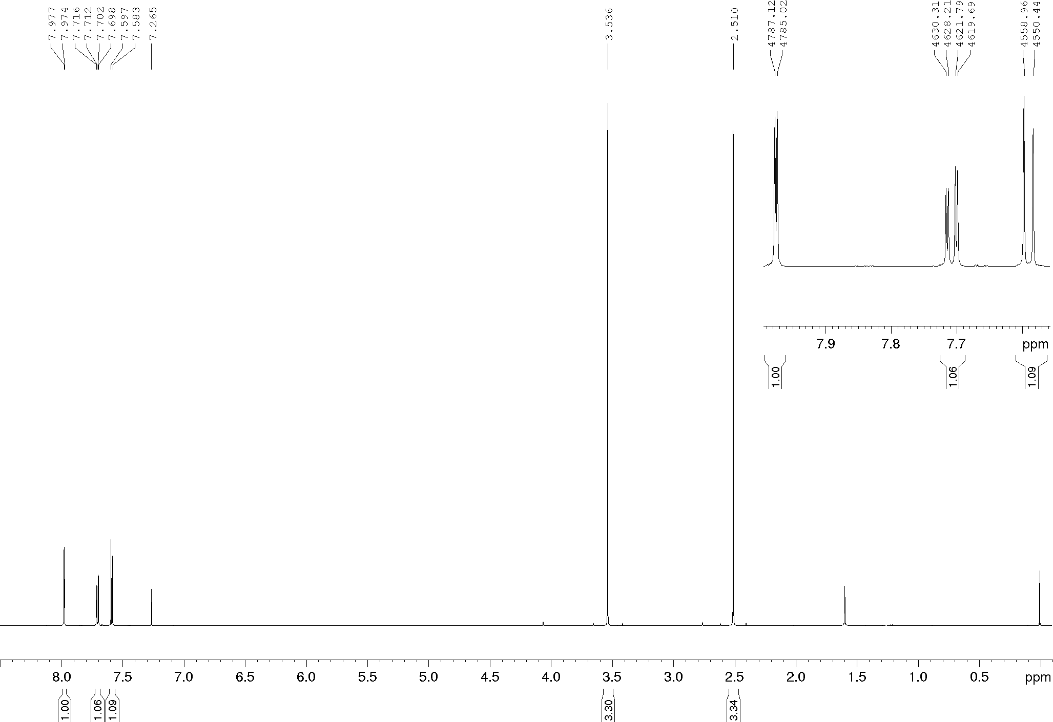
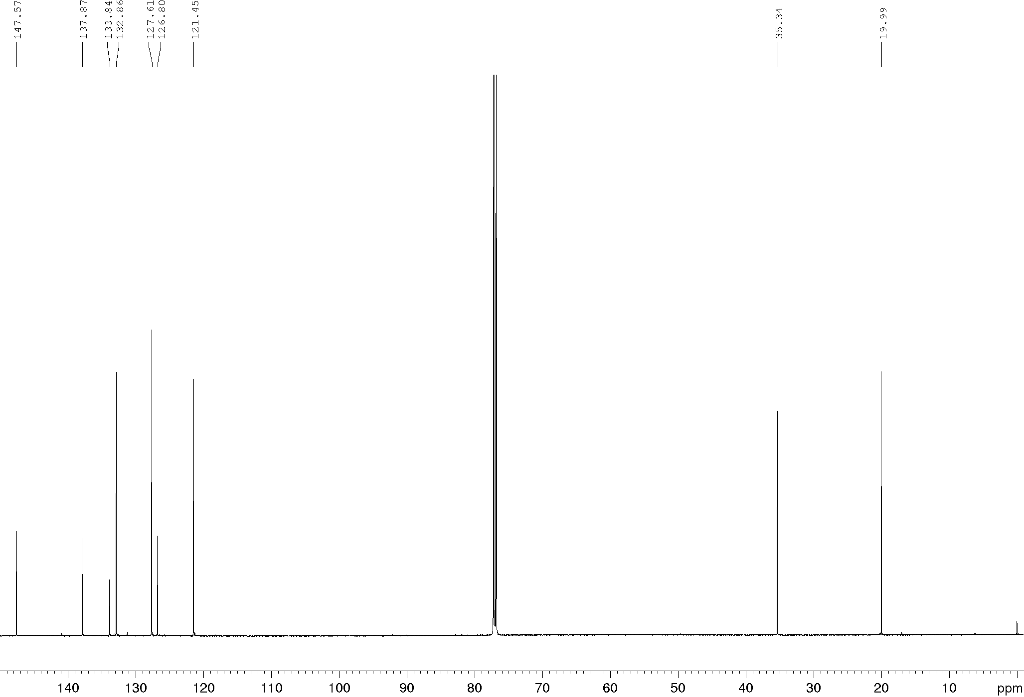
Compound 16e, ¹H and ¹³C NMR (600/150 MHz), DMSO-d₆
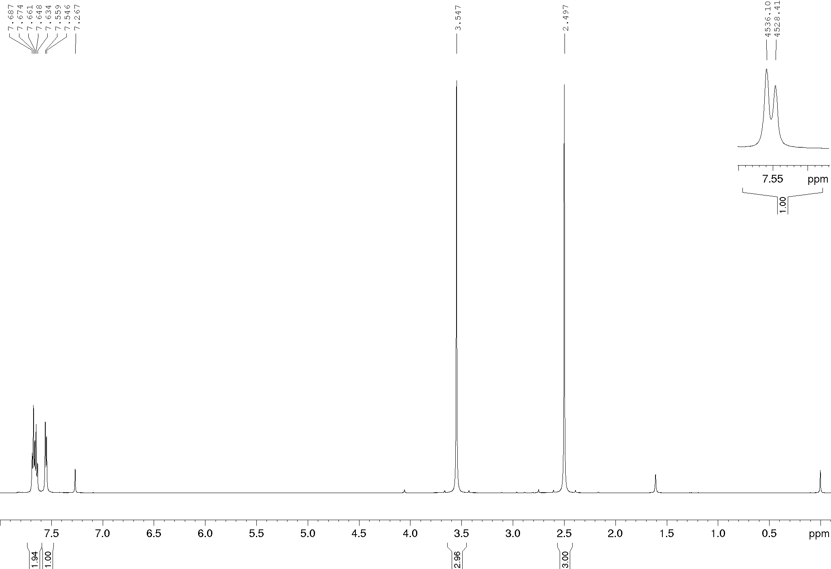
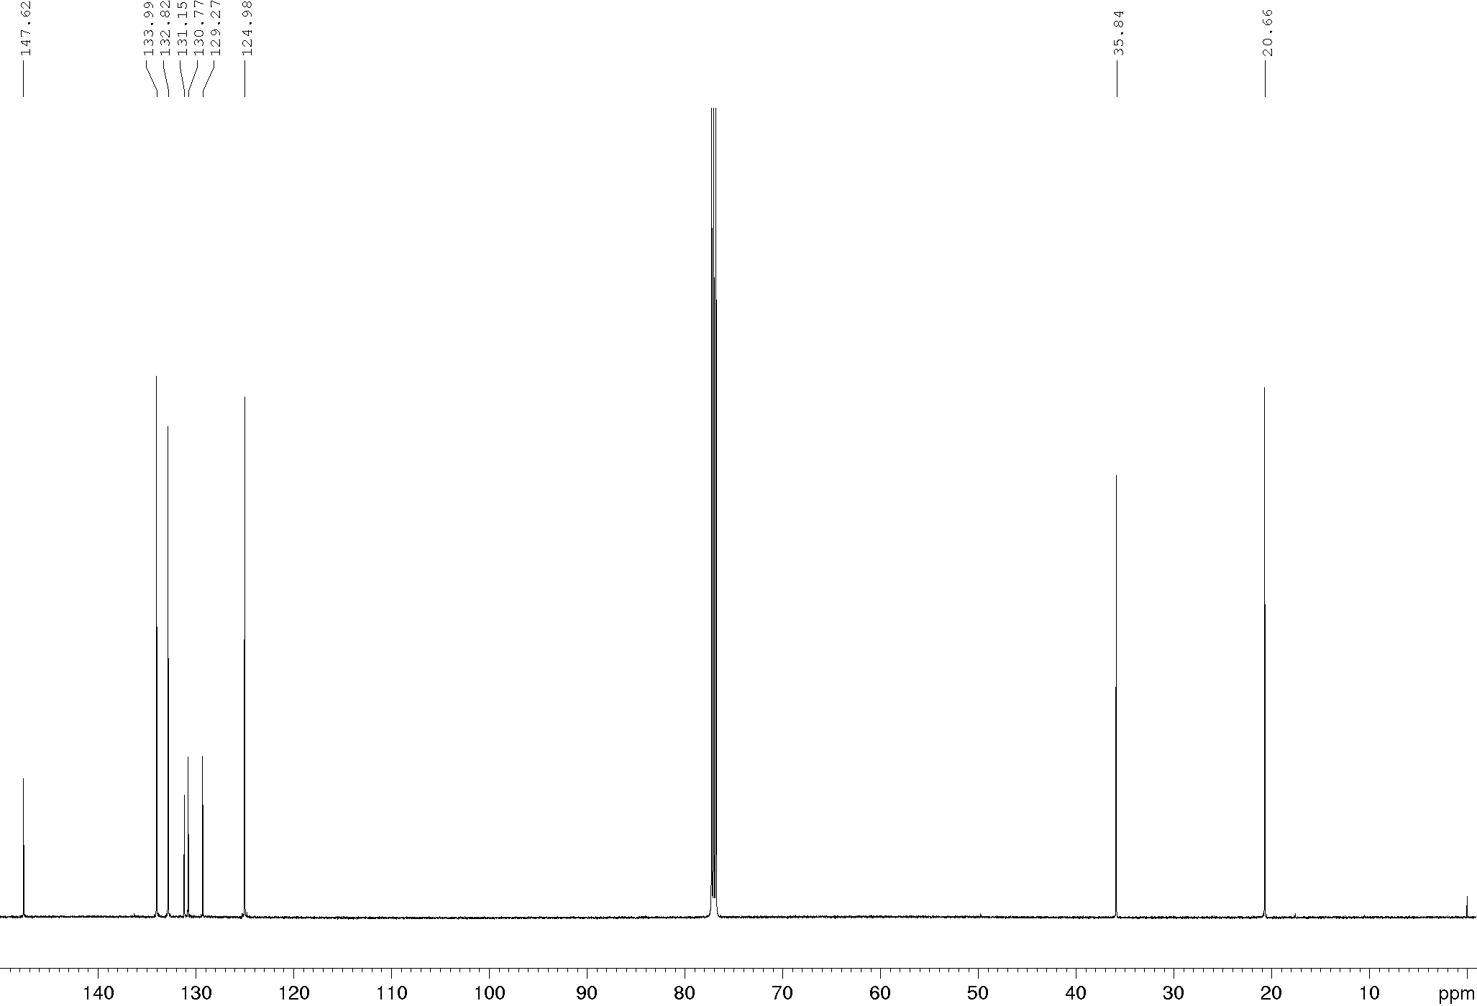
Compound 16e, ¹H and ¹³C NMR (600/150 MHz), DMSO-d₆
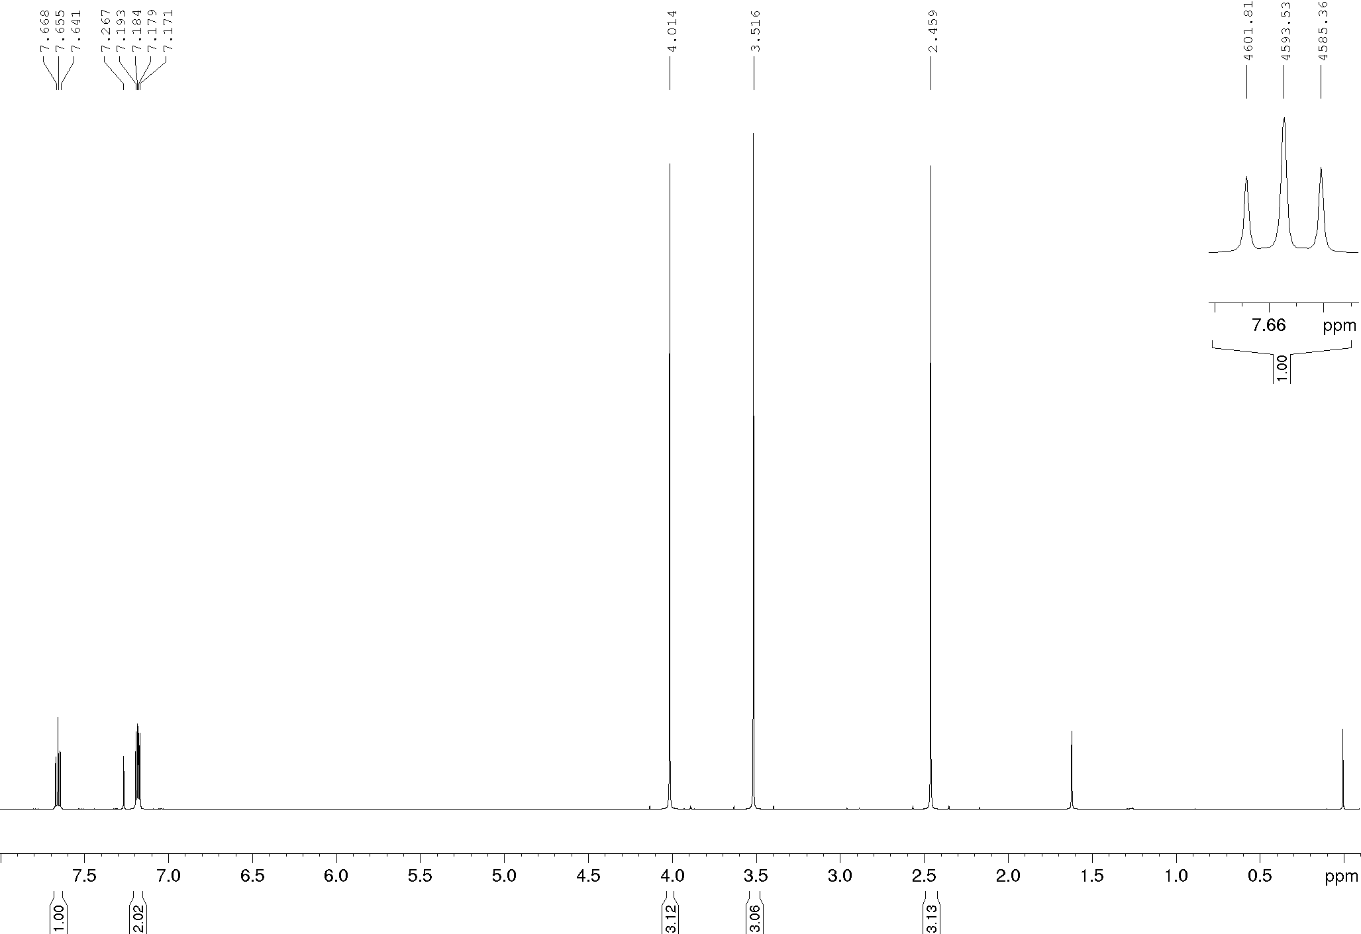
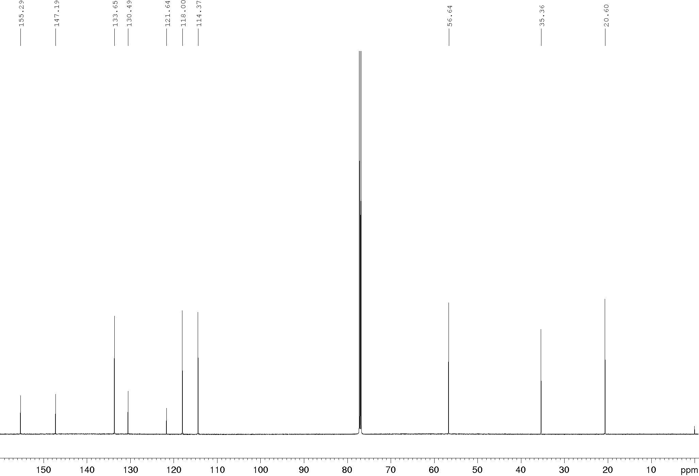
Compound 17a, ¹H and ¹³C NMR (600/150 MHz), DMSO-d₆
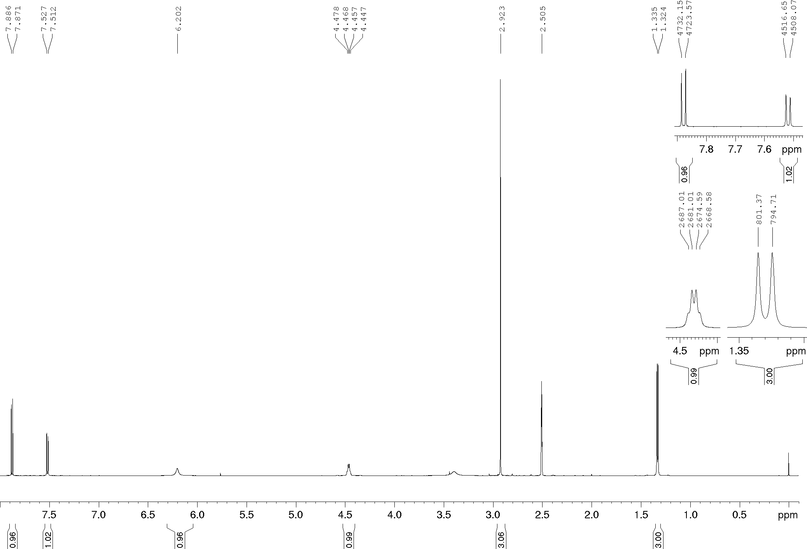
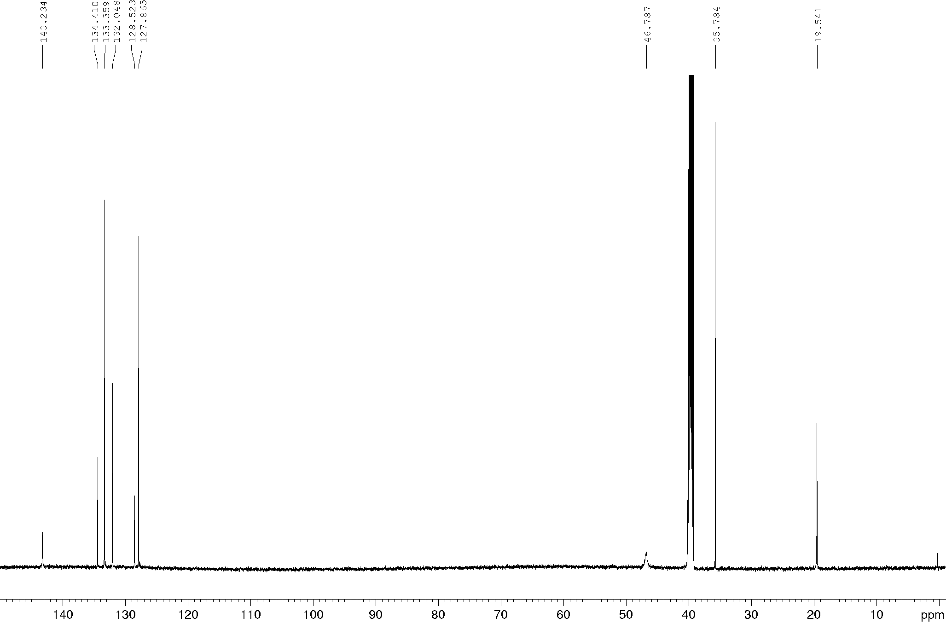
Compound 17b, ¹H and ¹³C NMR (600/150 MHz), DMSO-d₆
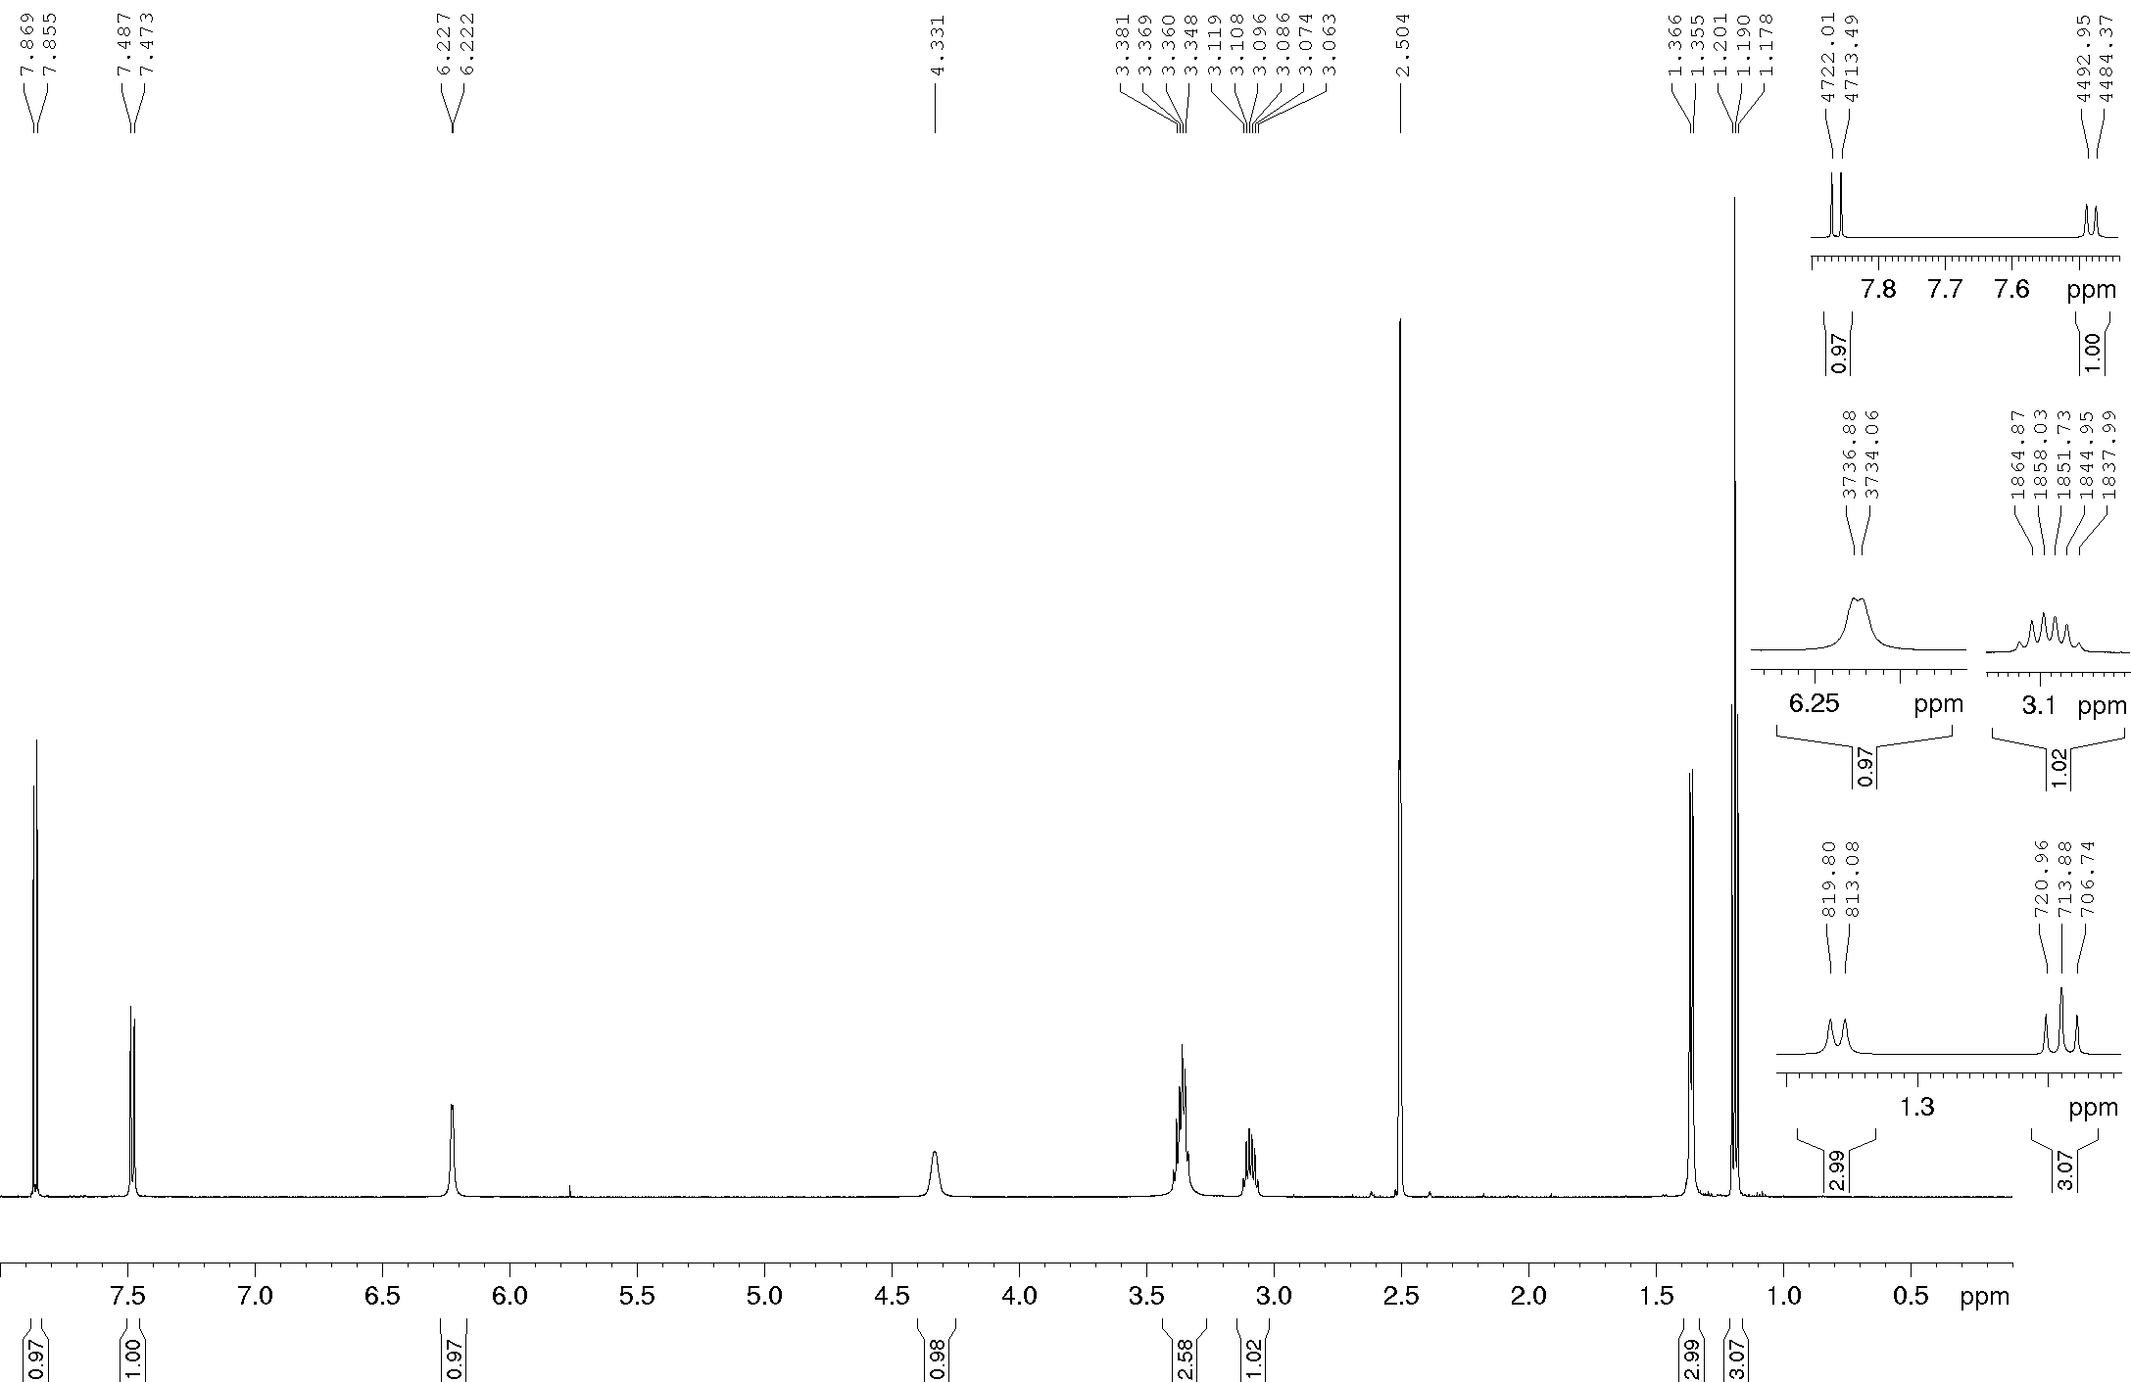
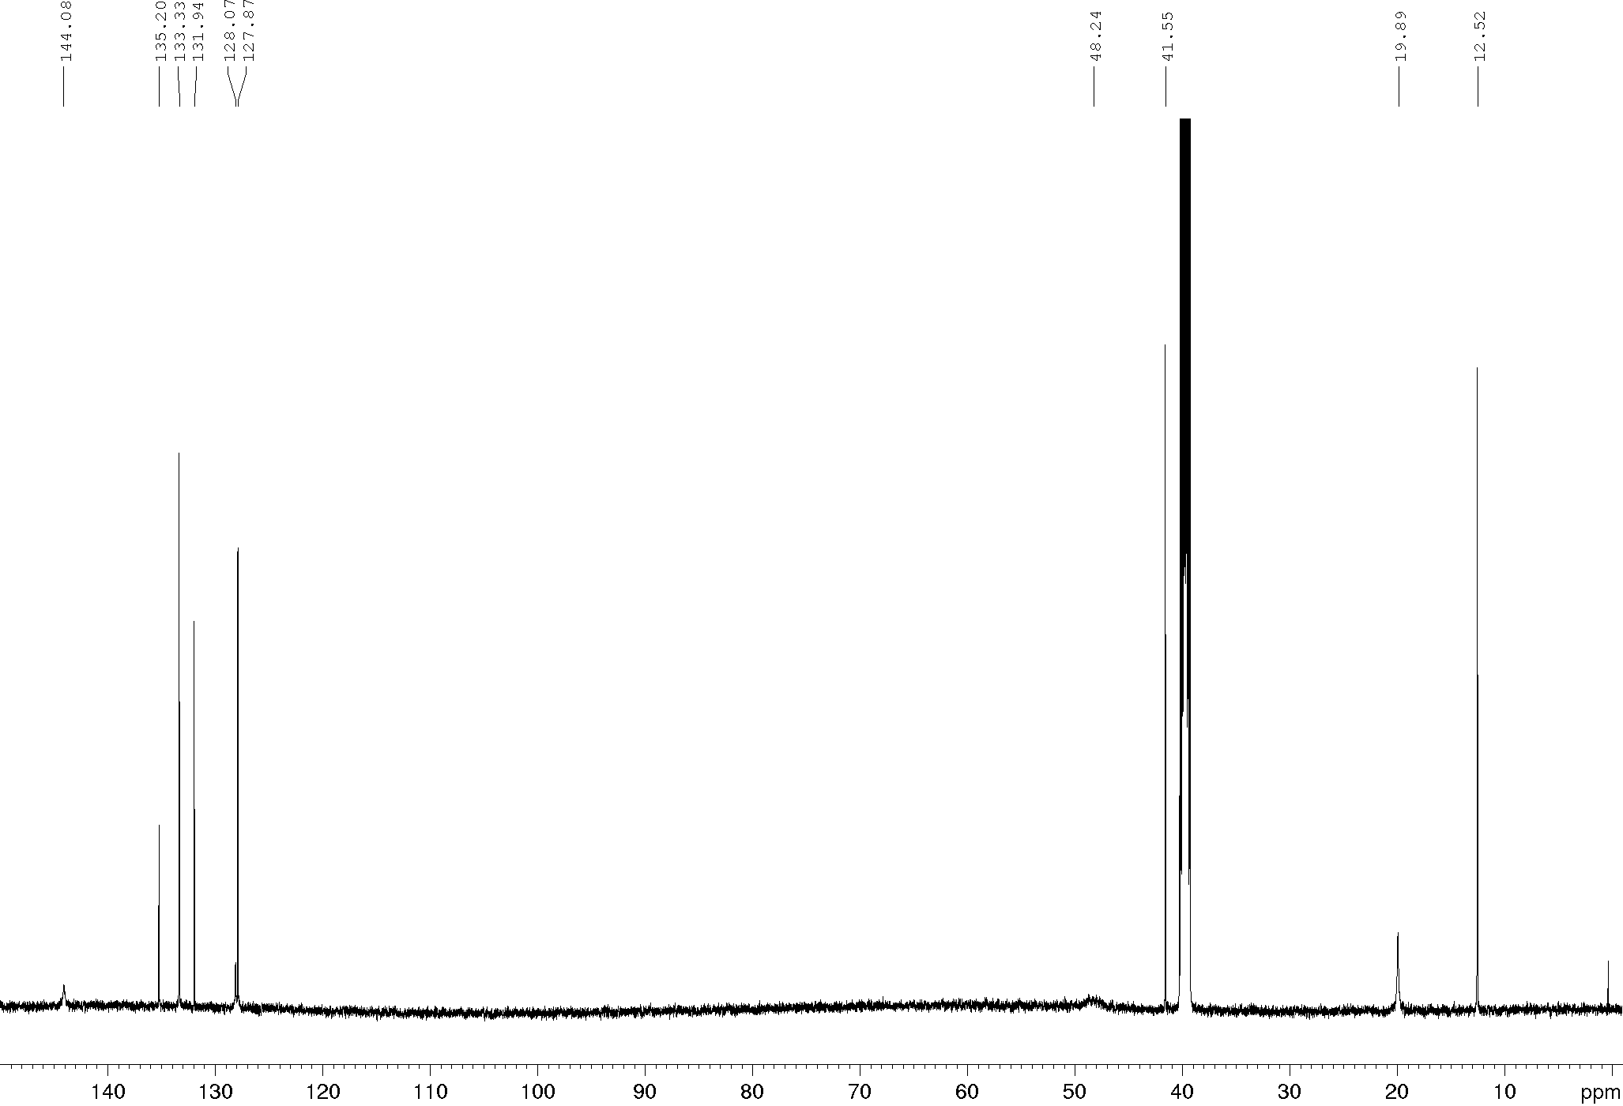
Compound 17c, ¹H and ¹³C NMR (600/150 MHz), DMSO-d₆
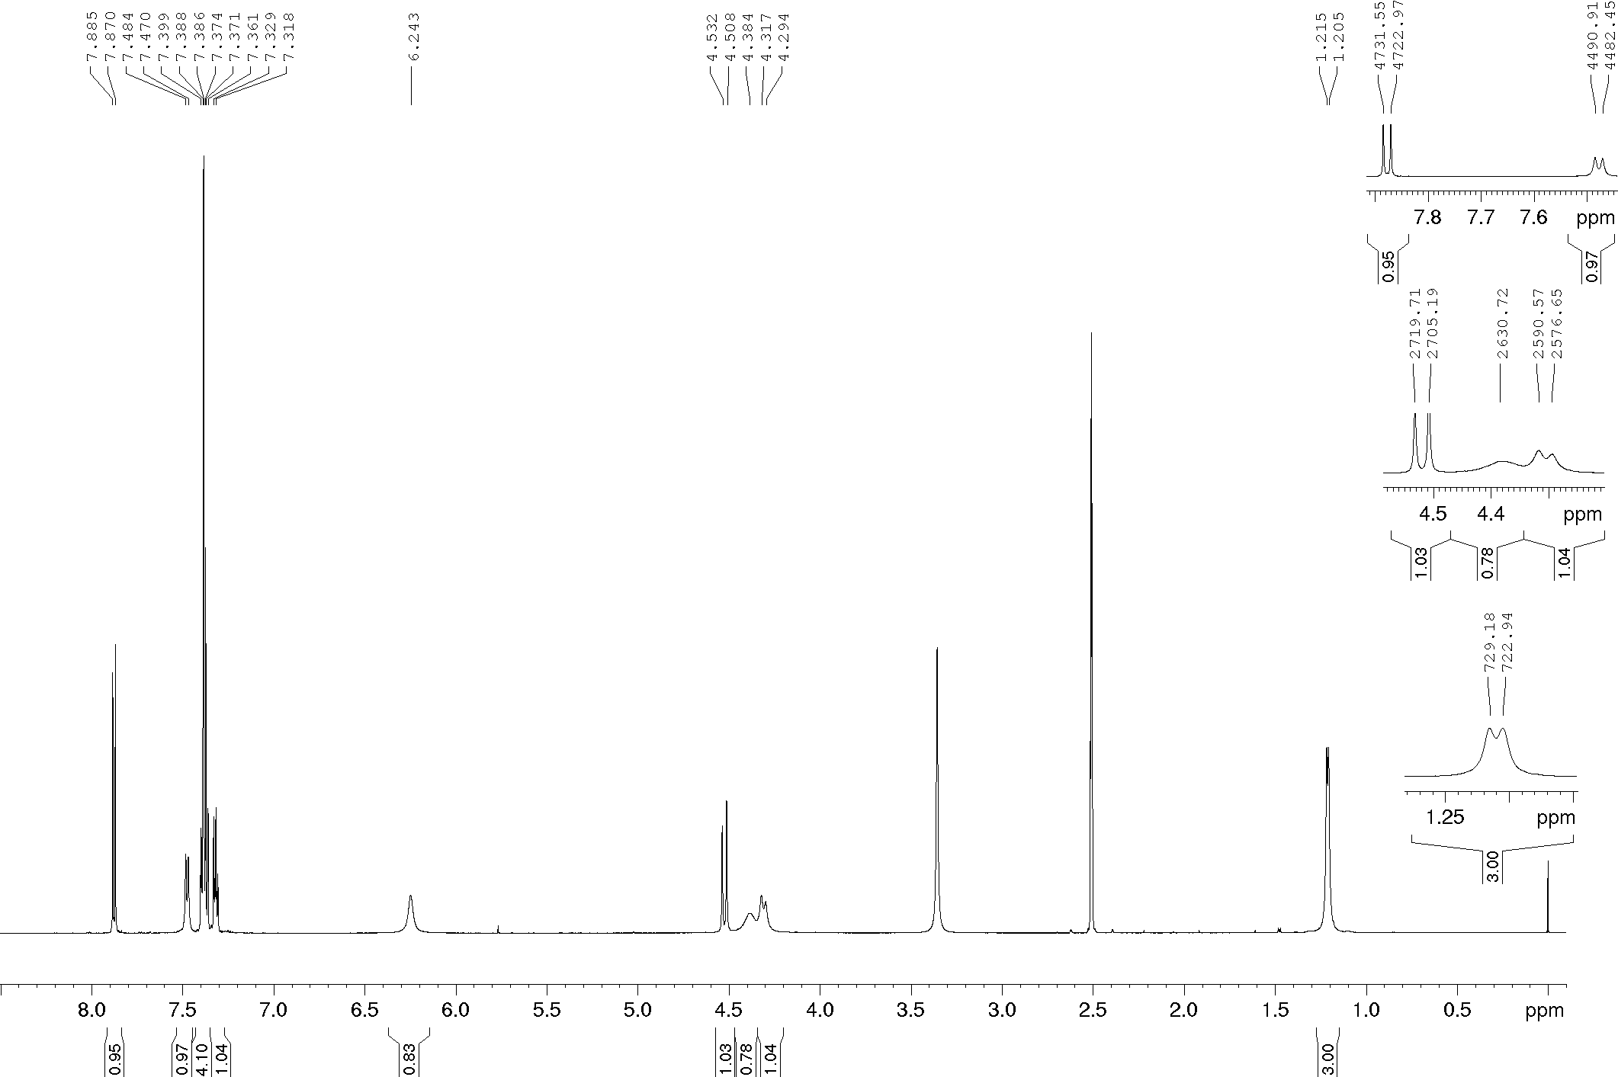
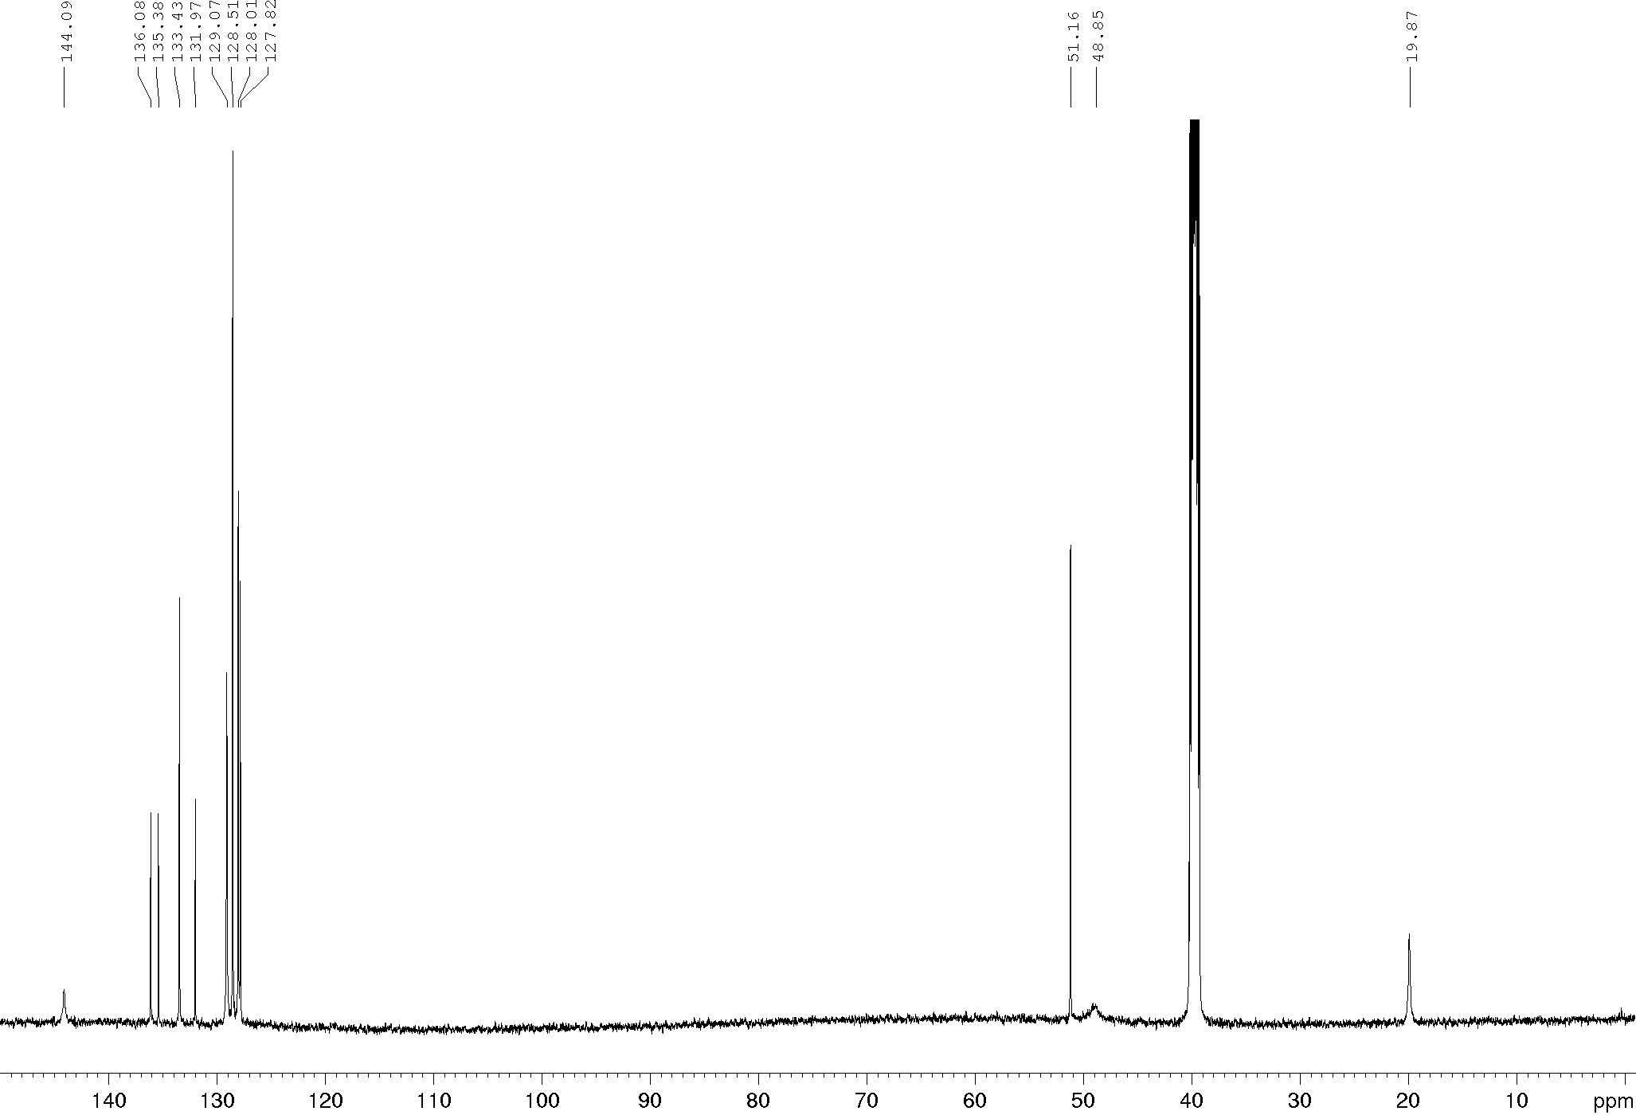
Compound 17d, ¹H and ¹³C NMR (600/150 MHz), DMSO-d₆
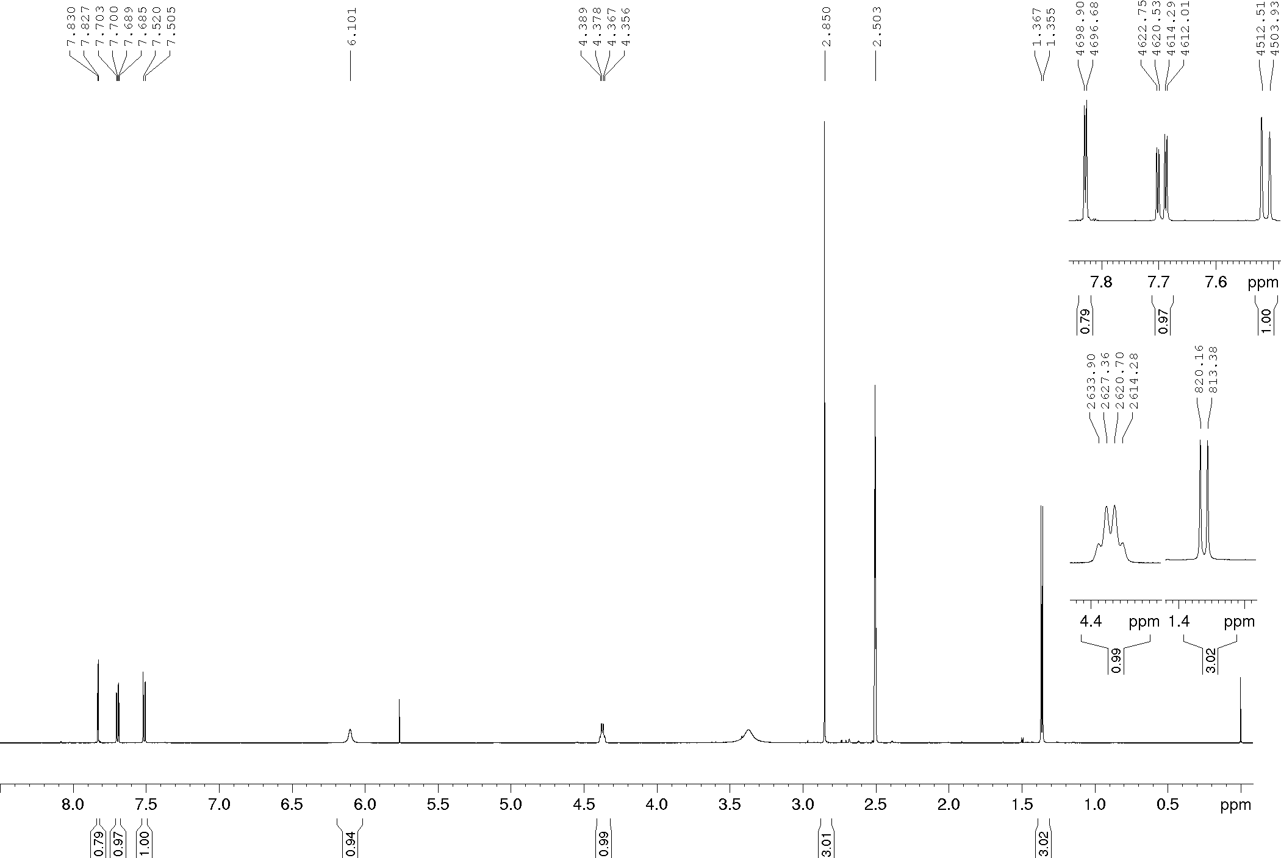
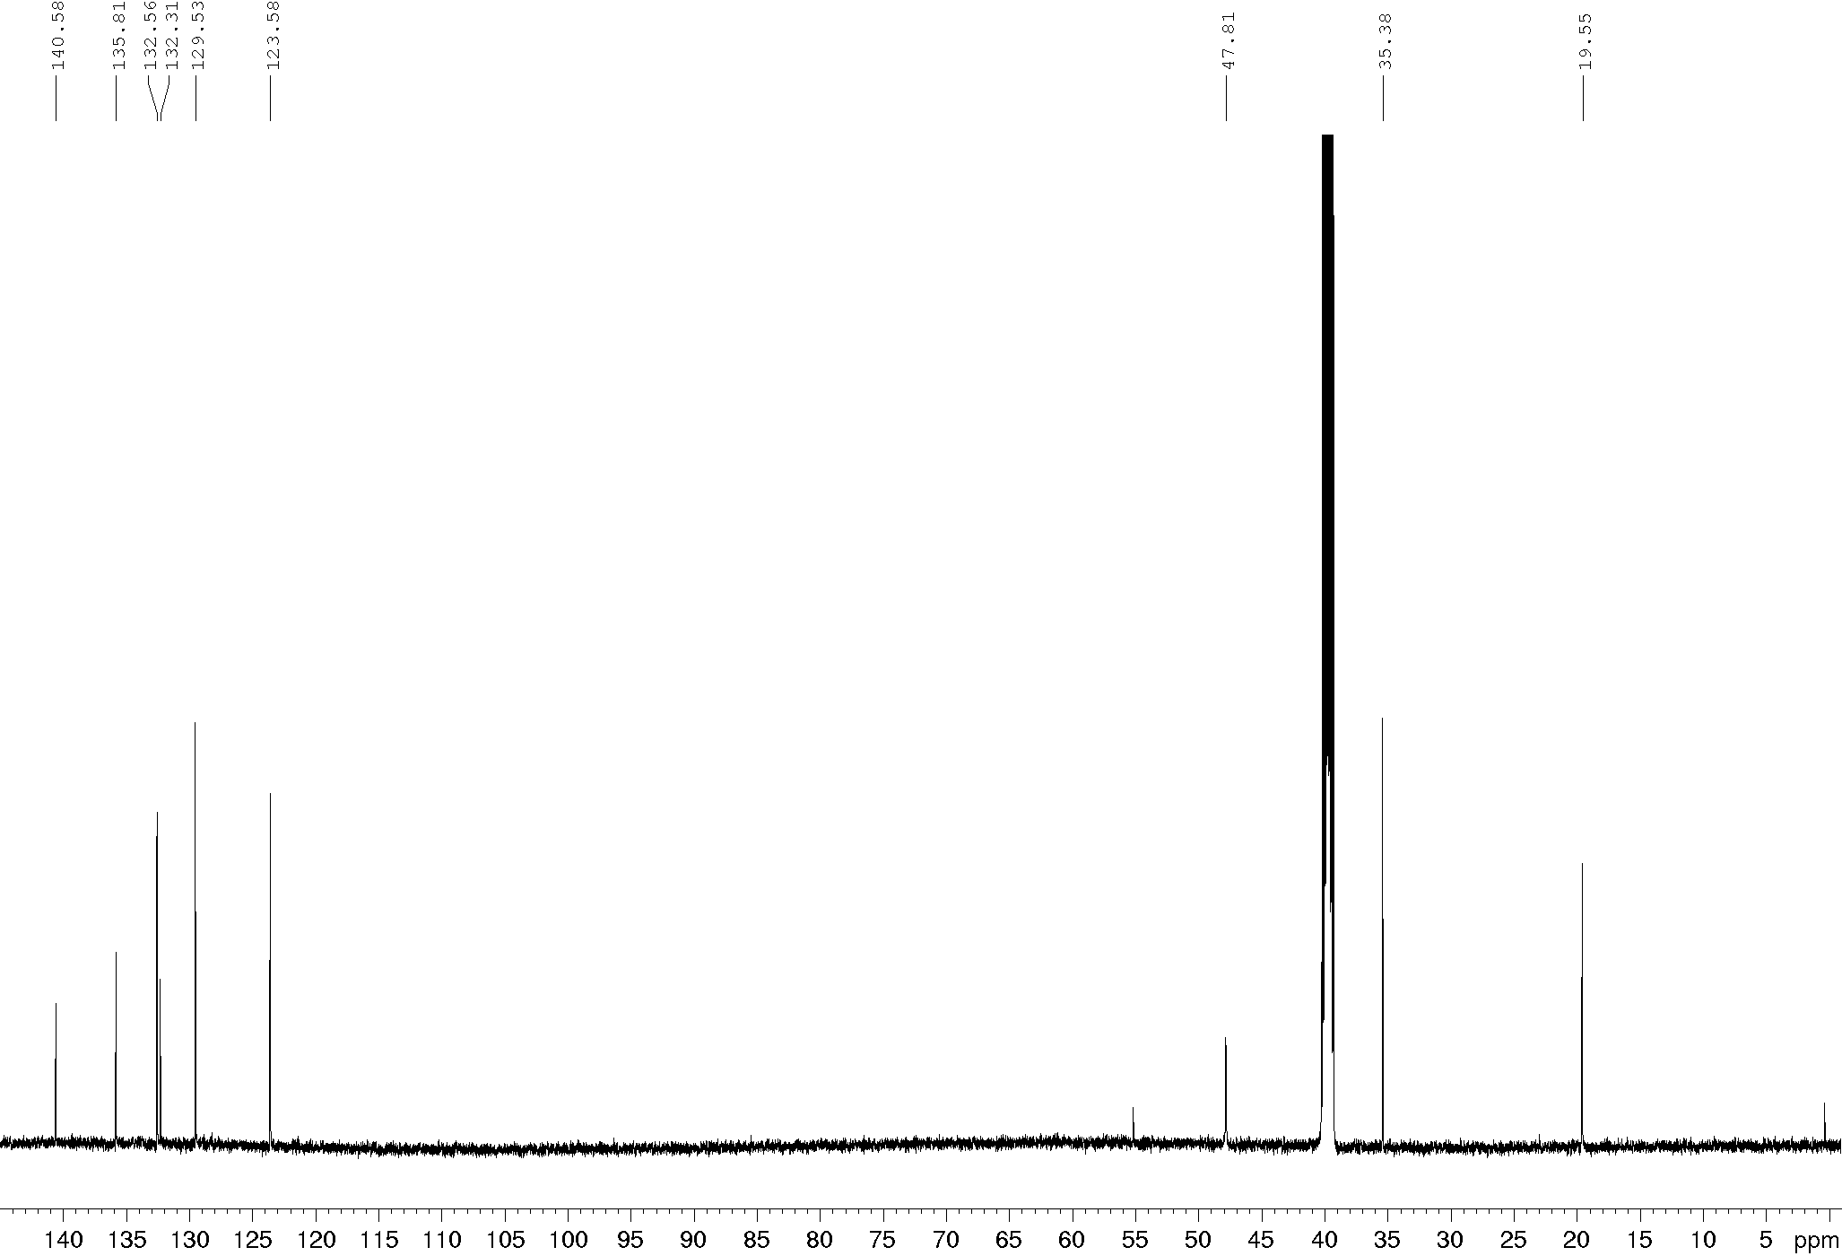
Compound 17e, ¹H and ¹³C NMR (600/150 MHz), DMSO-d₆
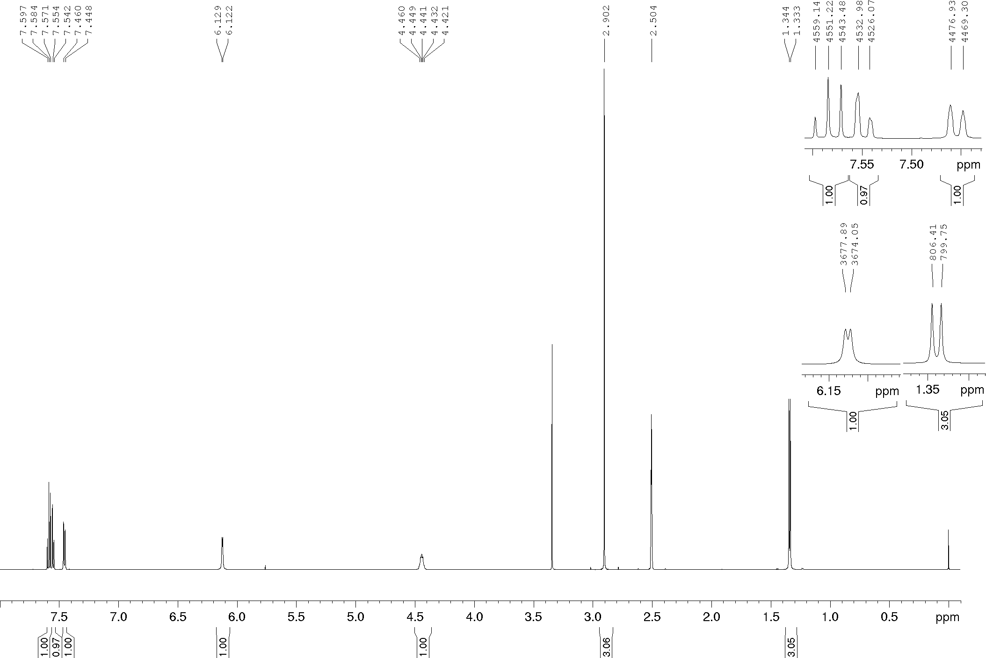
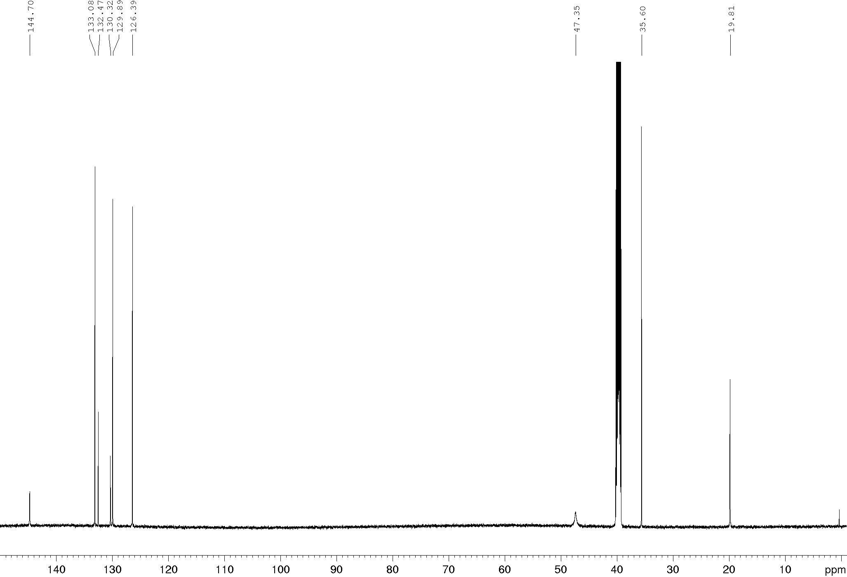
Compound 17f, ¹H and ¹³C NMR (600/150 MHz), DMSO-d₆
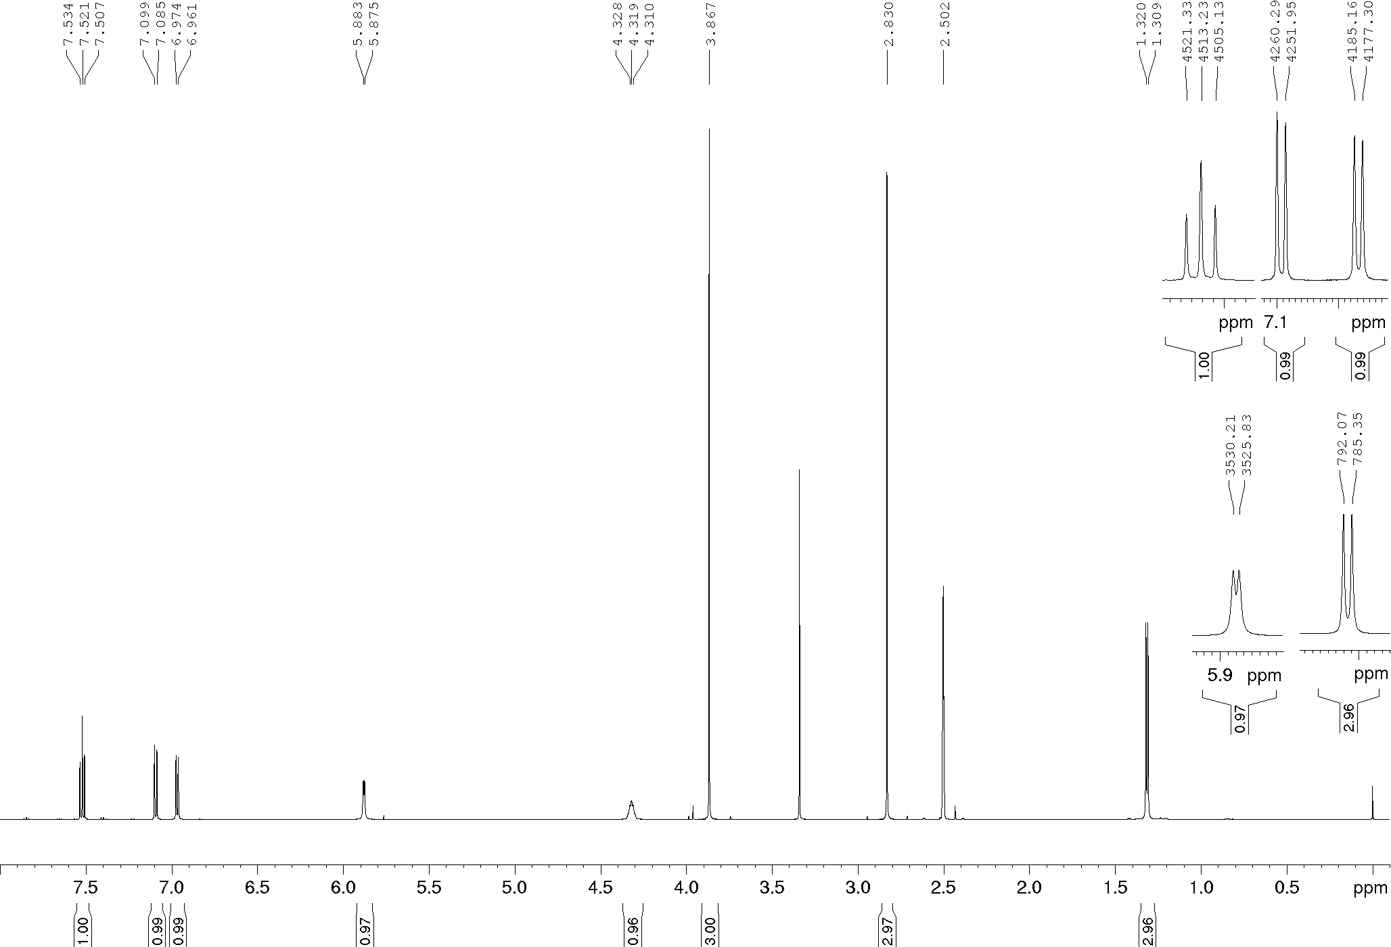
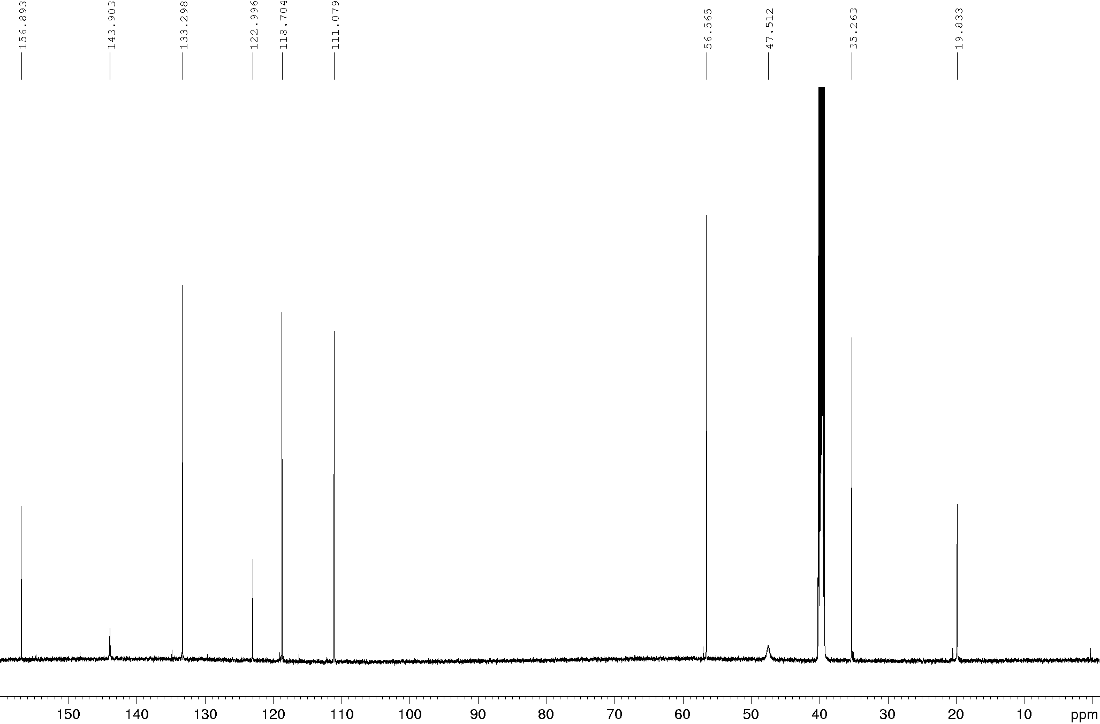

Compound 18a, ¹H and ¹³C NMR (600/150 MHz), DMSO-d₆
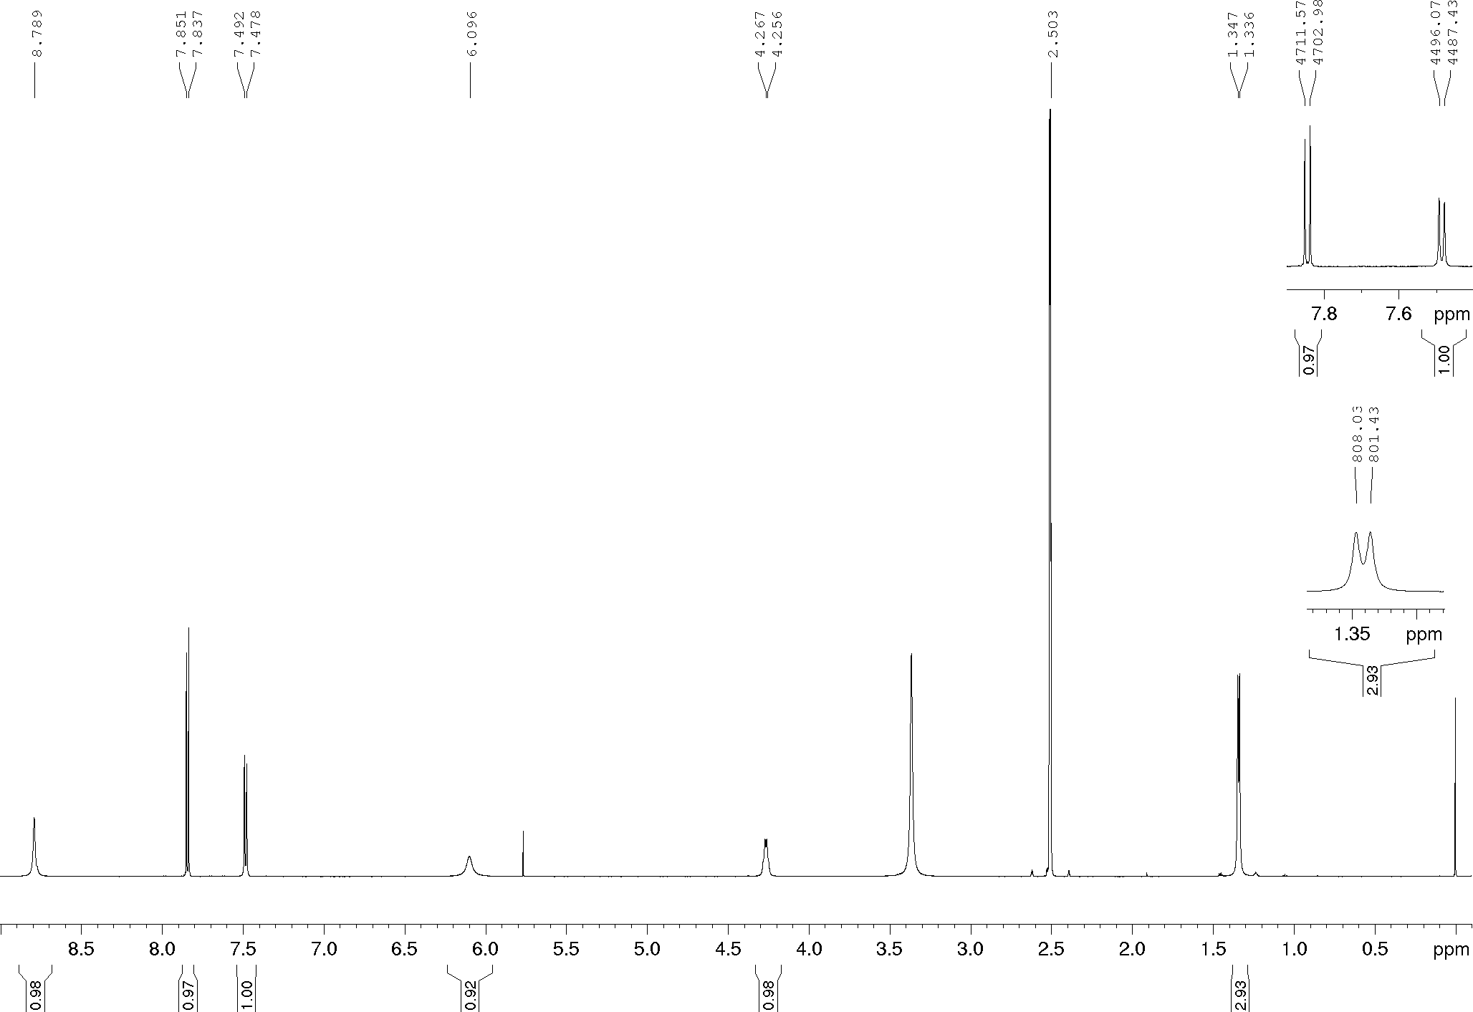
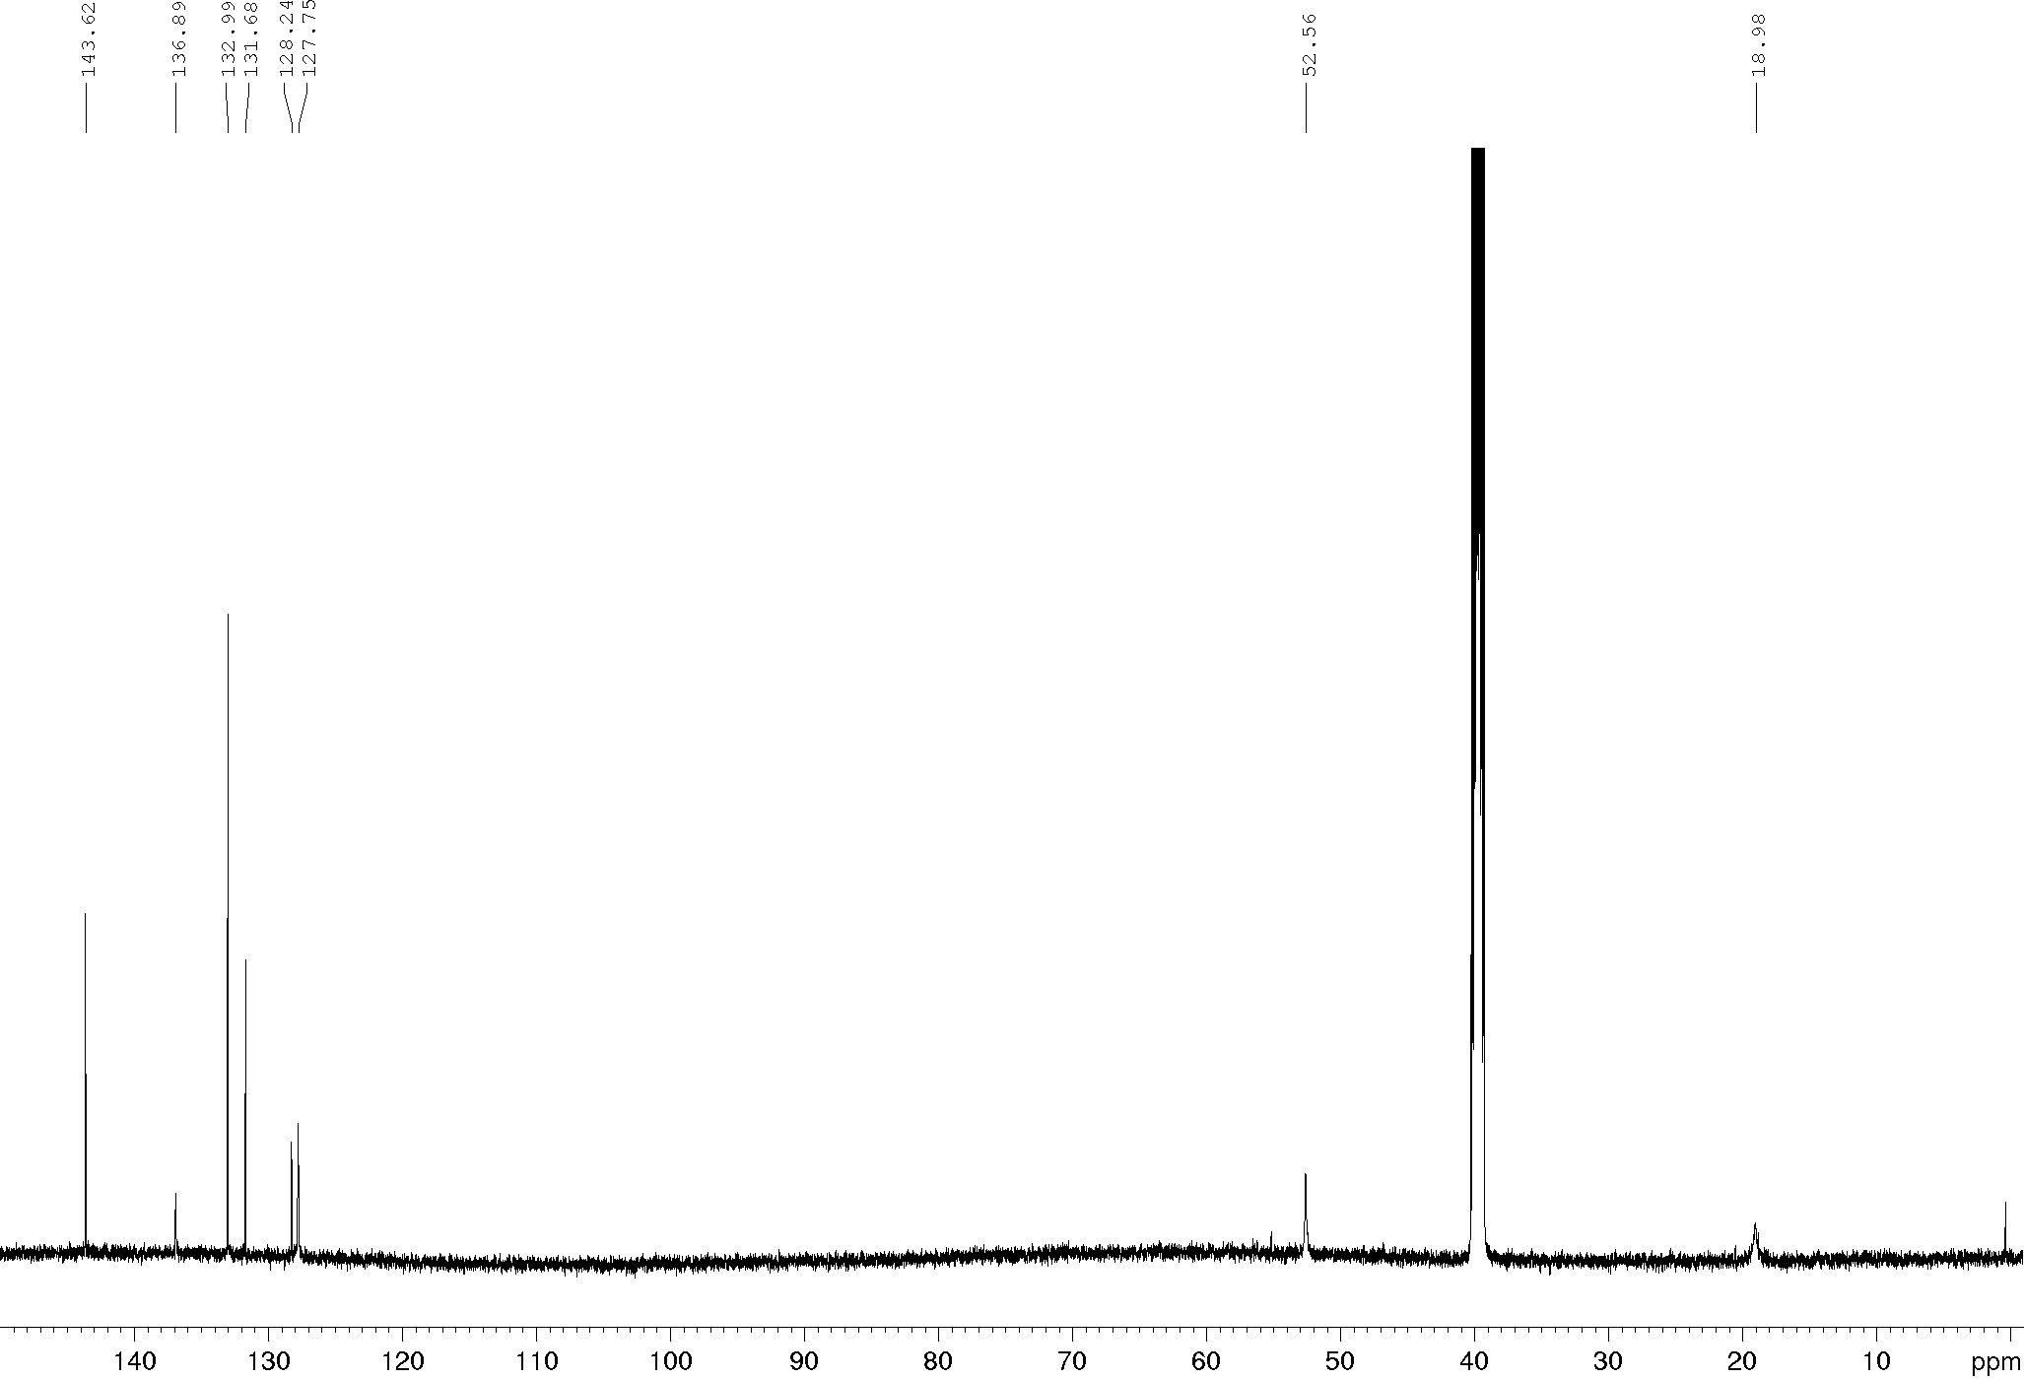
Compound 18b, ¹H and ¹³C NMR (400/100 MHz), DMSO-d₆
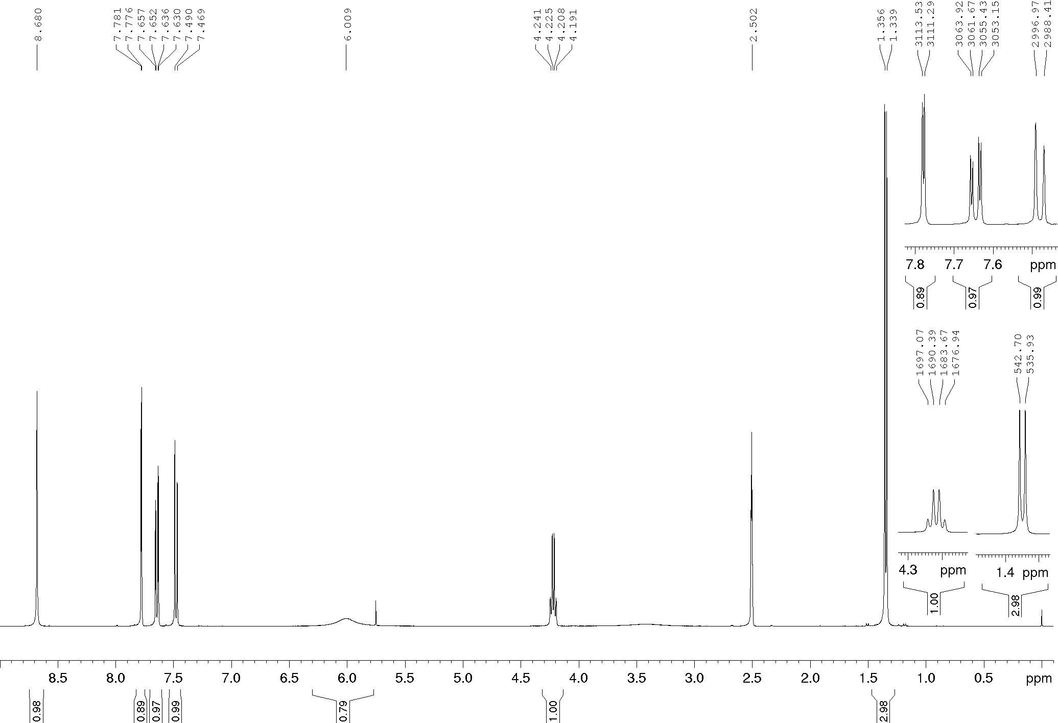
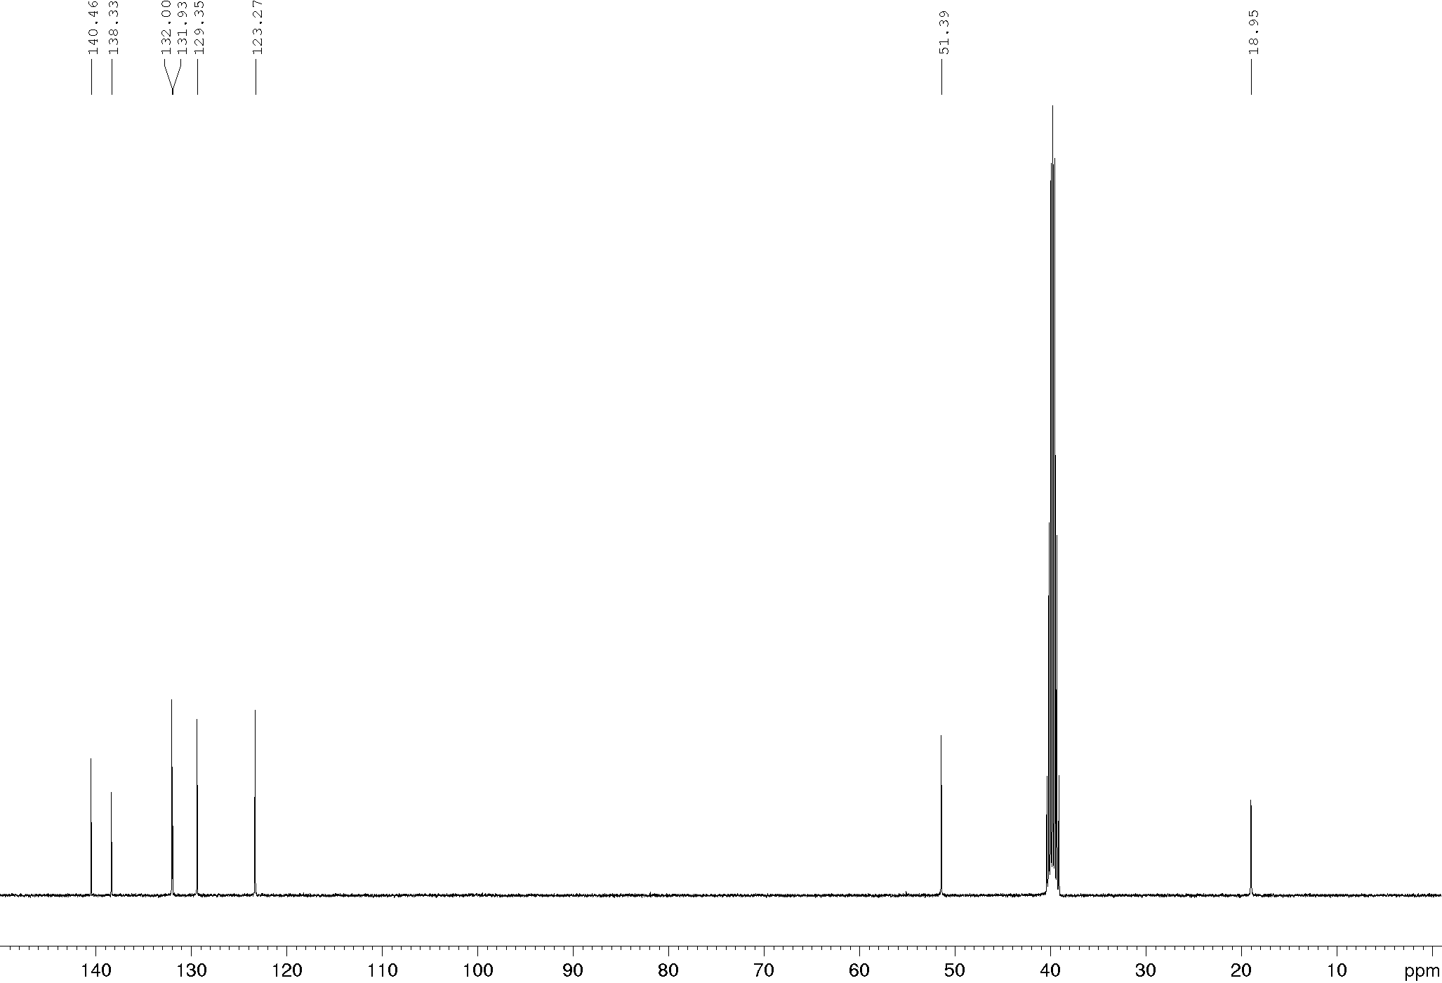
Compound 18c, ¹H and ¹³C NMR (400/100 MHz), DMSO-d₆
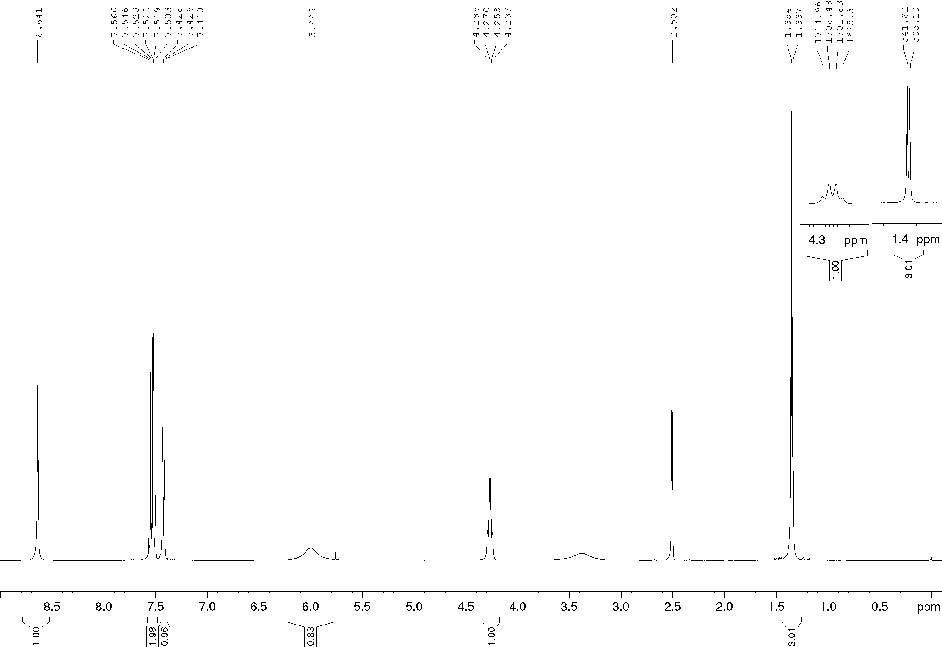
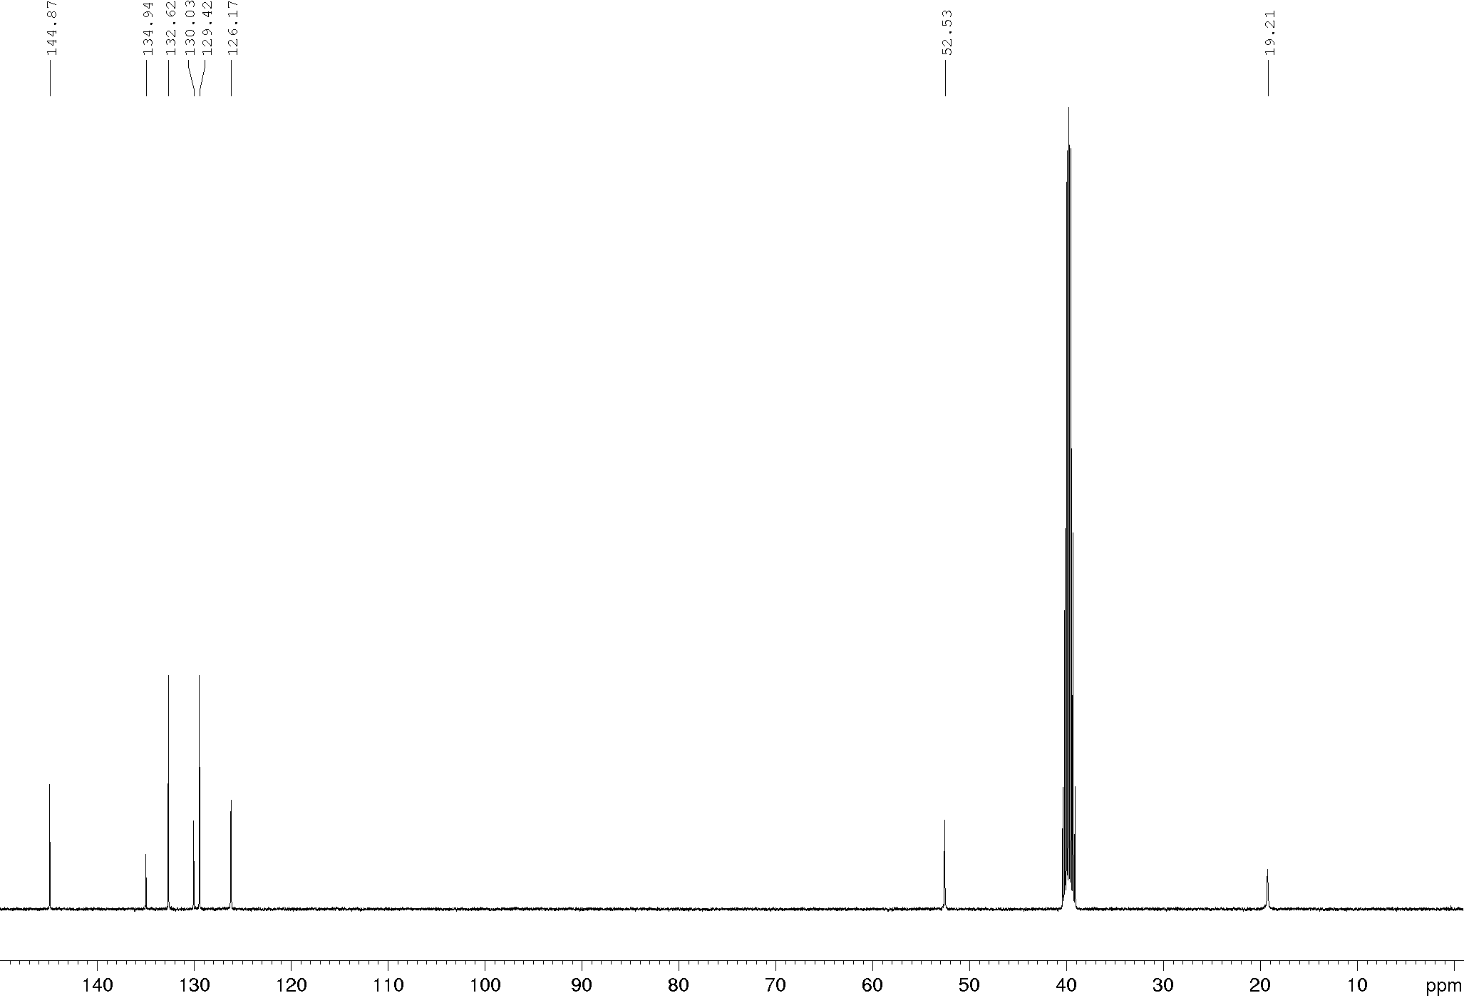
Compound 18d, ¹H and ¹³C NMR (600/150 MHz), DMSO-d₆
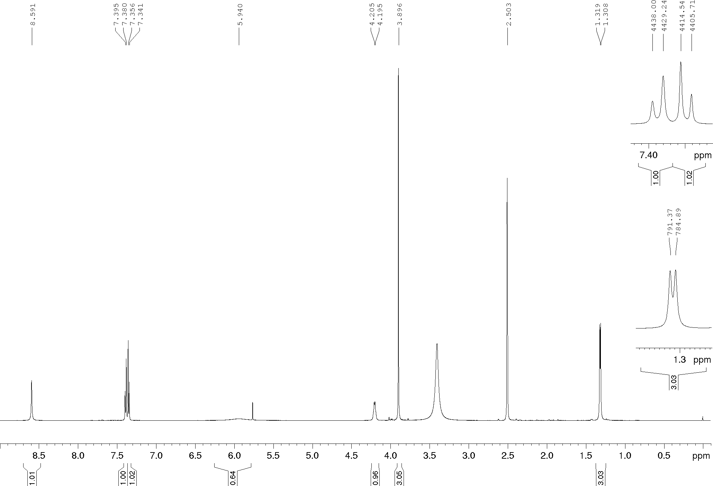
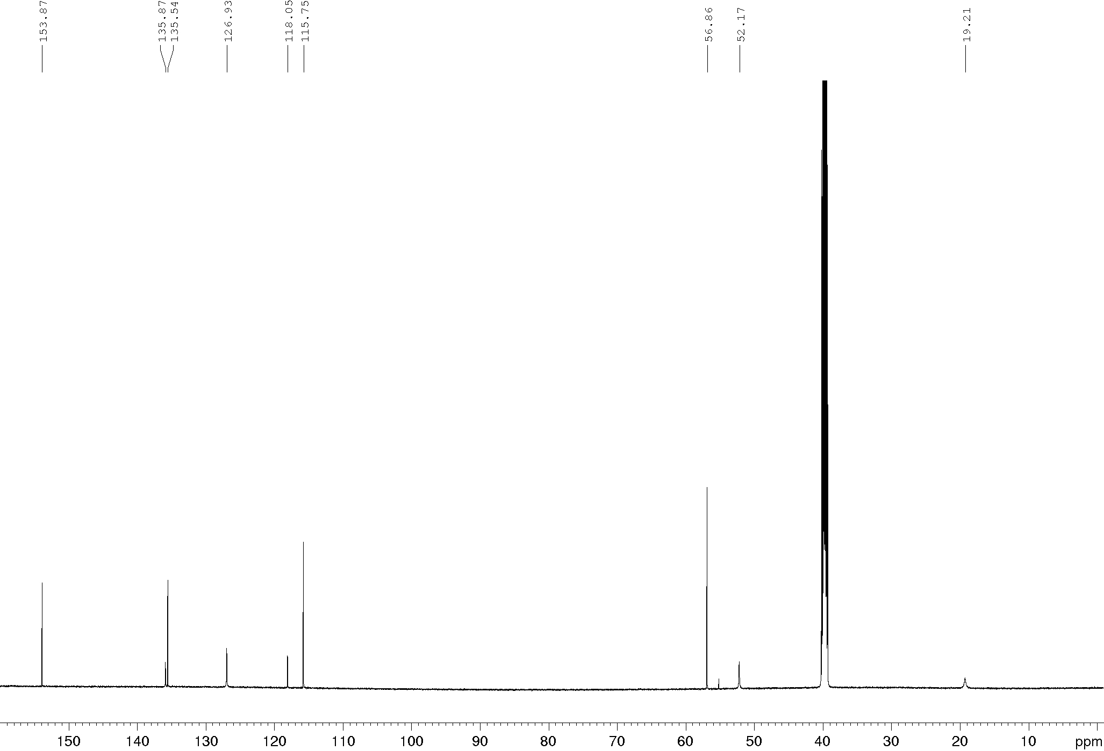
Compound 18e, ¹H and ¹³C NMR (400/100 MHz), DMSO-d₆
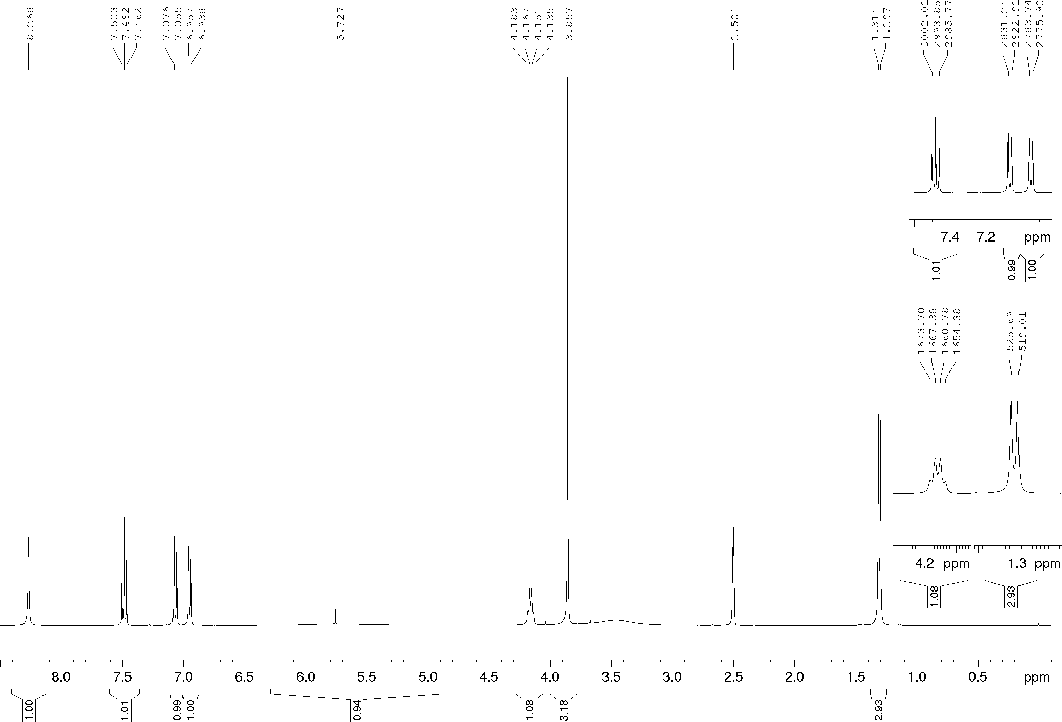
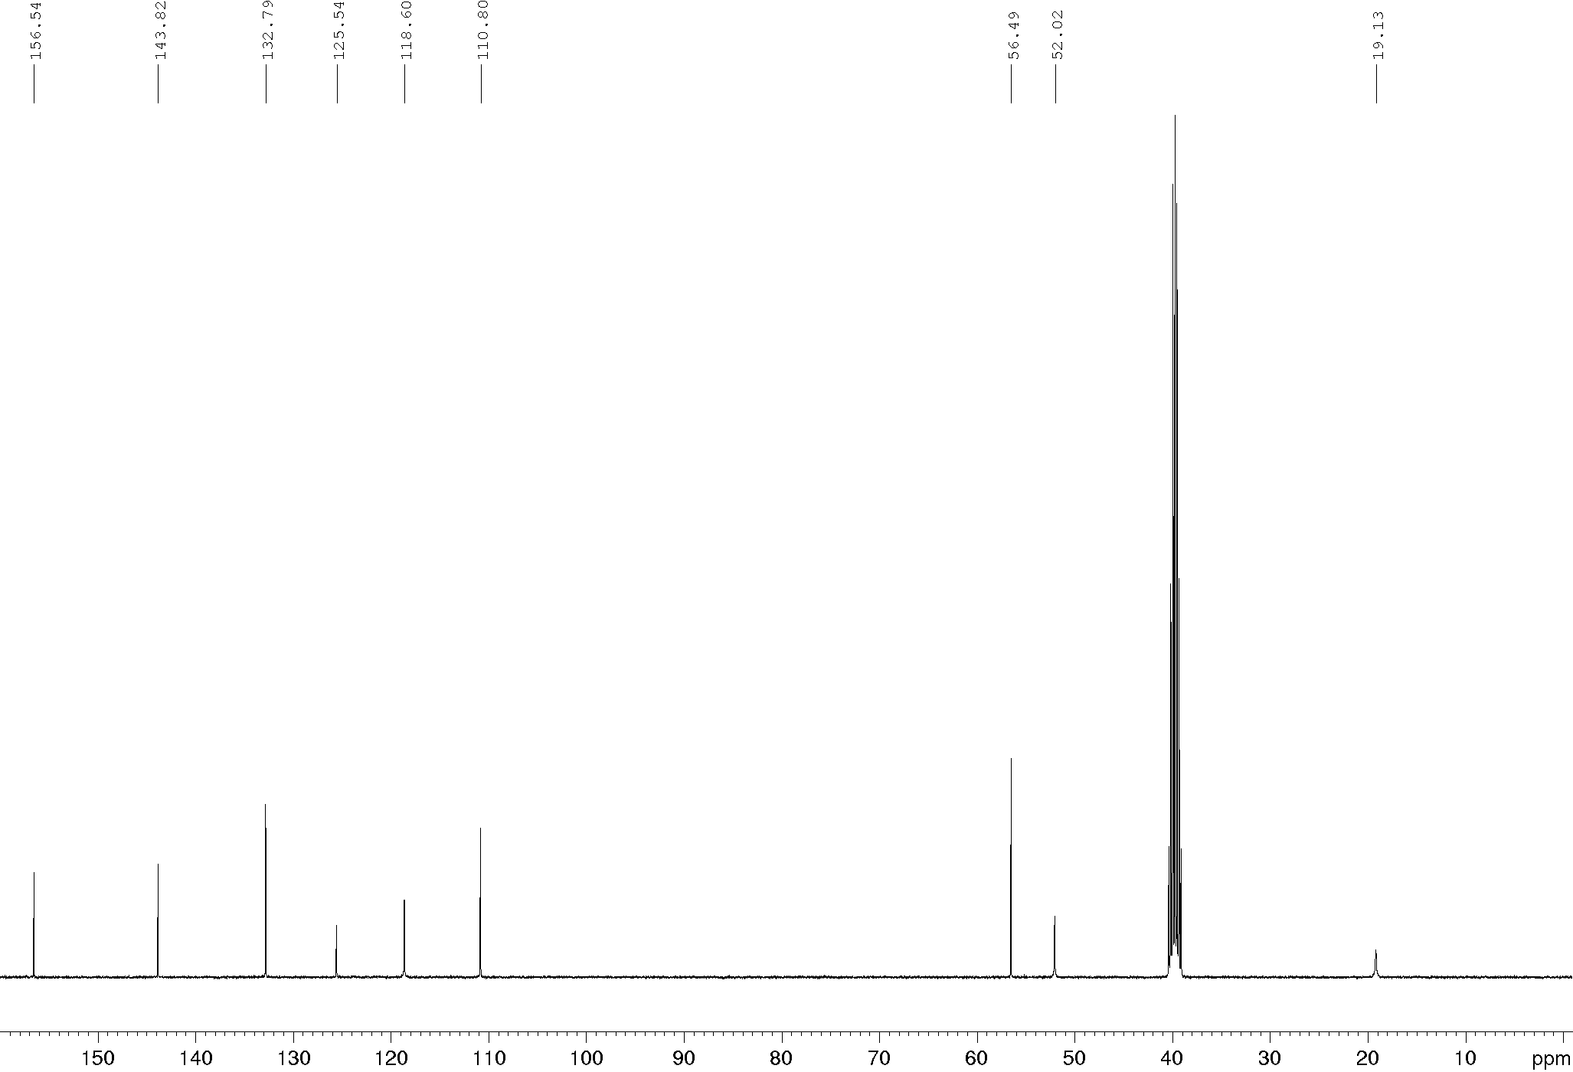
Compound 18f, ¹H and ¹³C NMR (400/100 MHz), DMSO-d₆
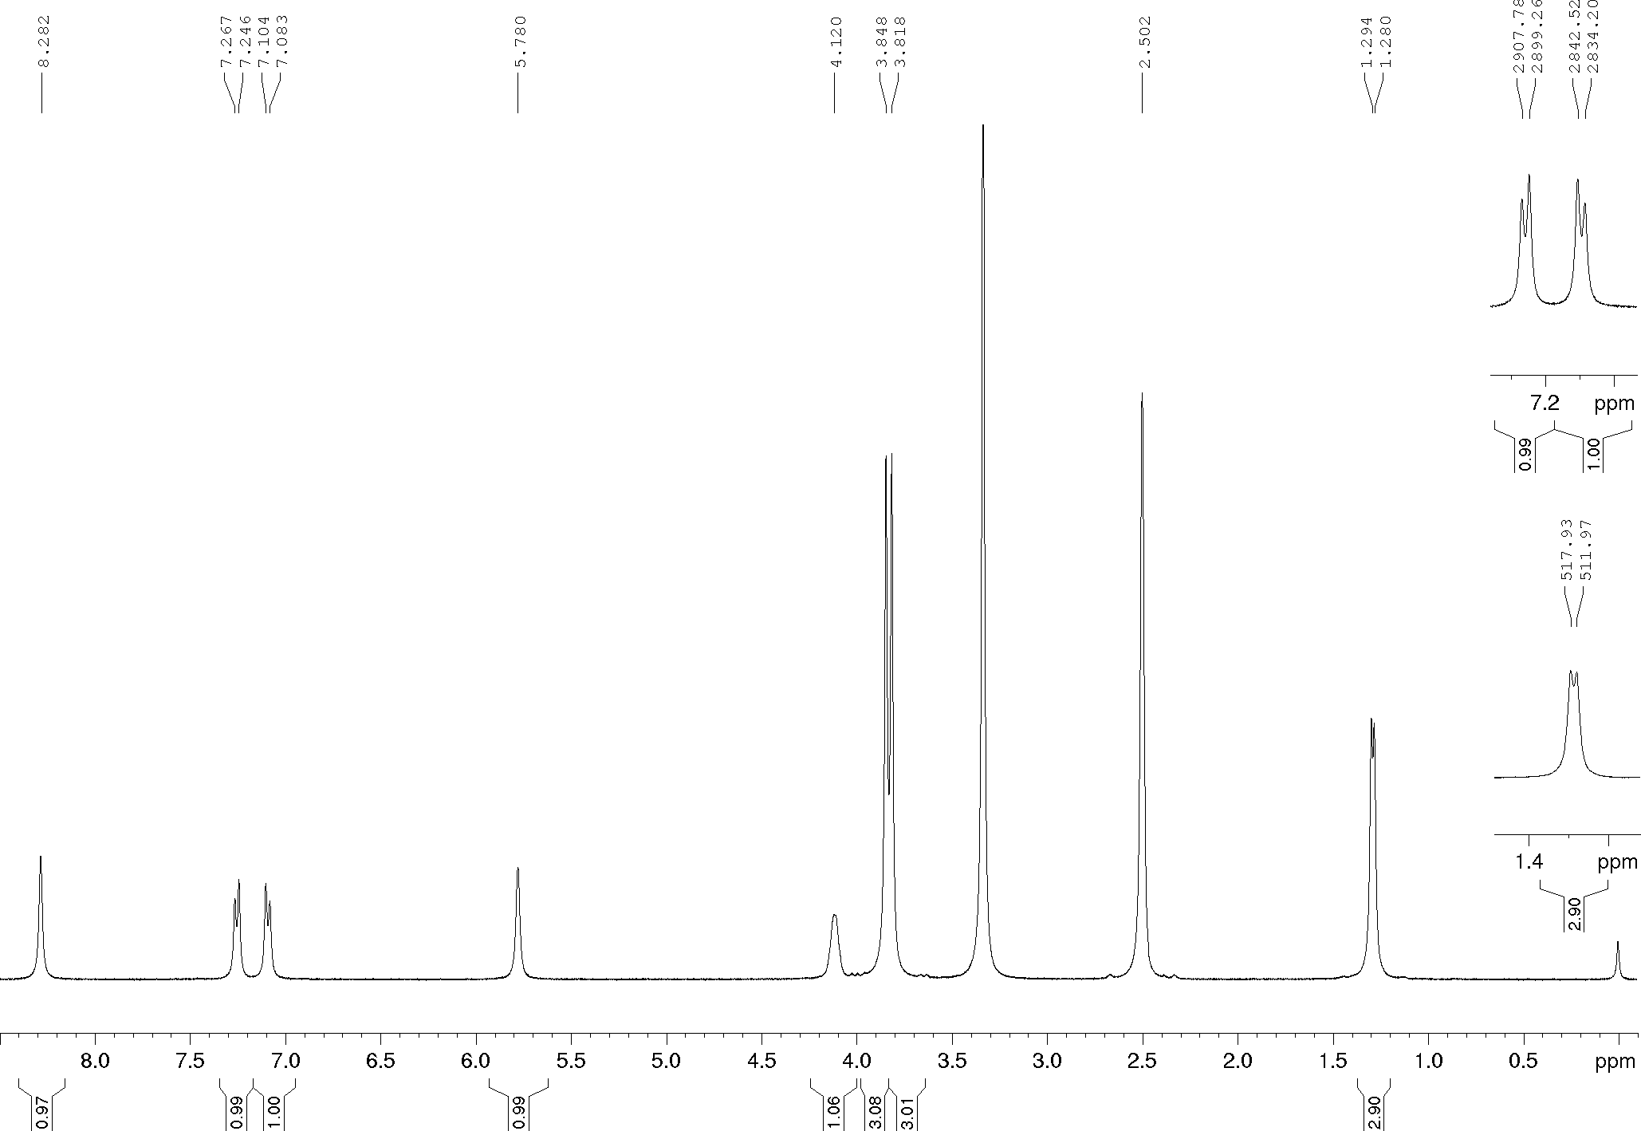
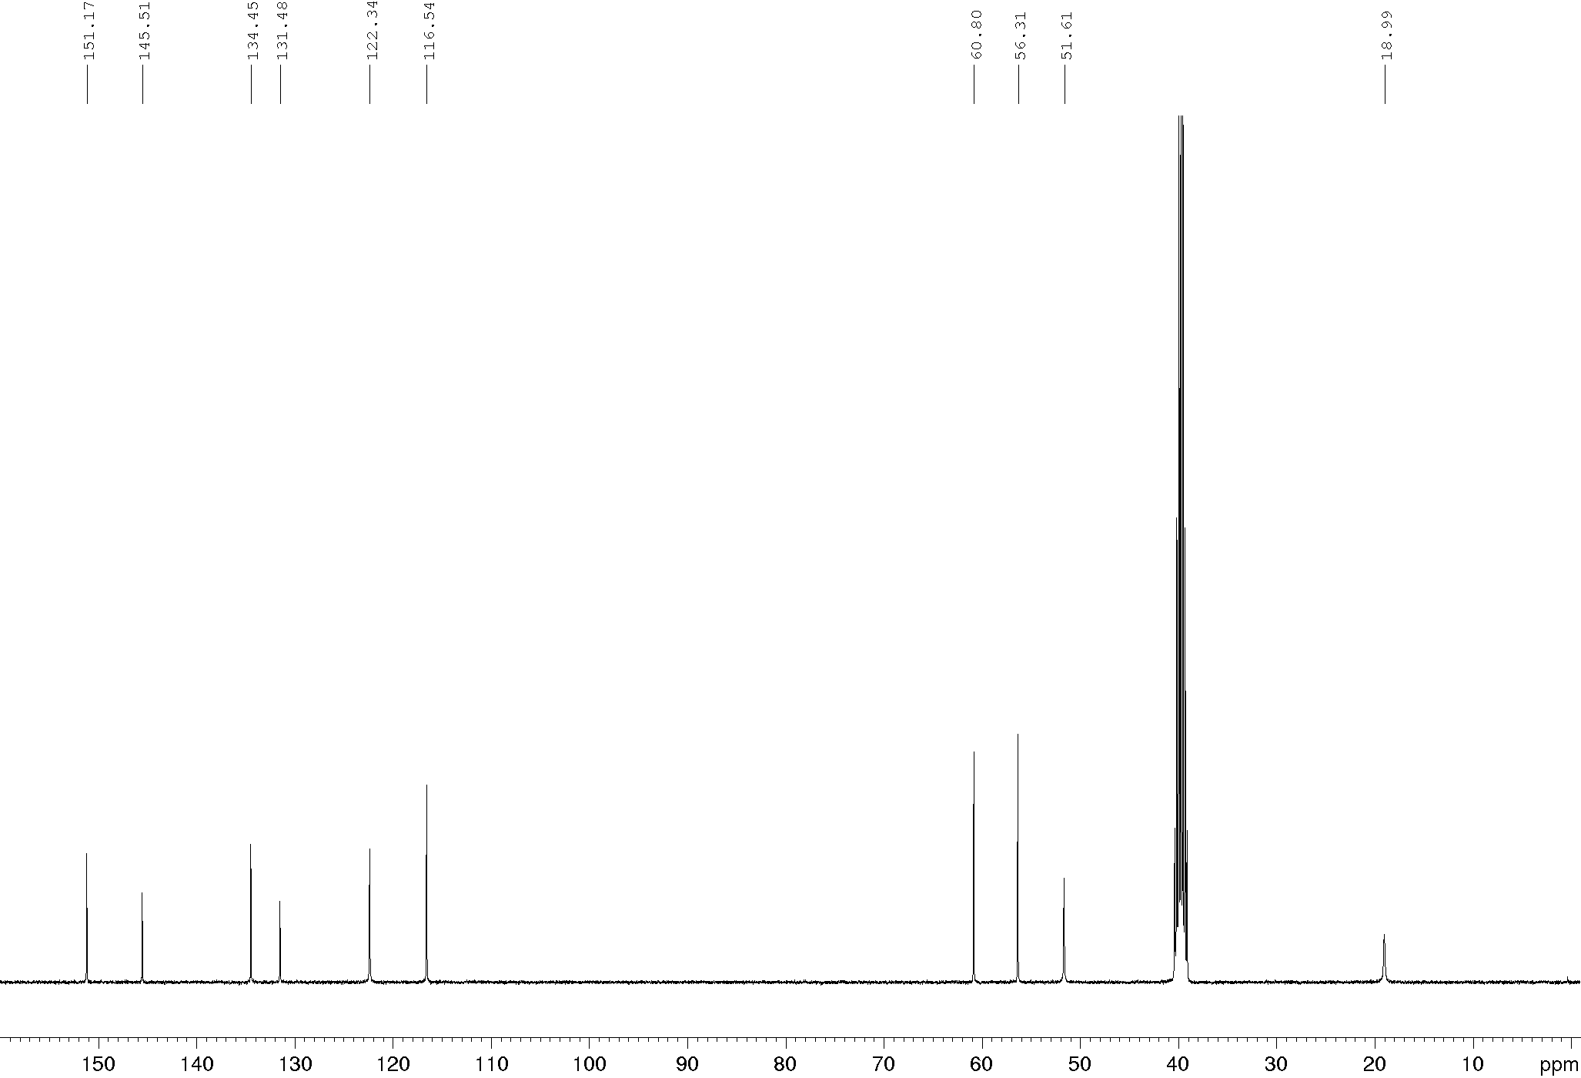
Compound 18g, ¹H and ¹³C NMR (400/100 MHz), DMSO-d₆
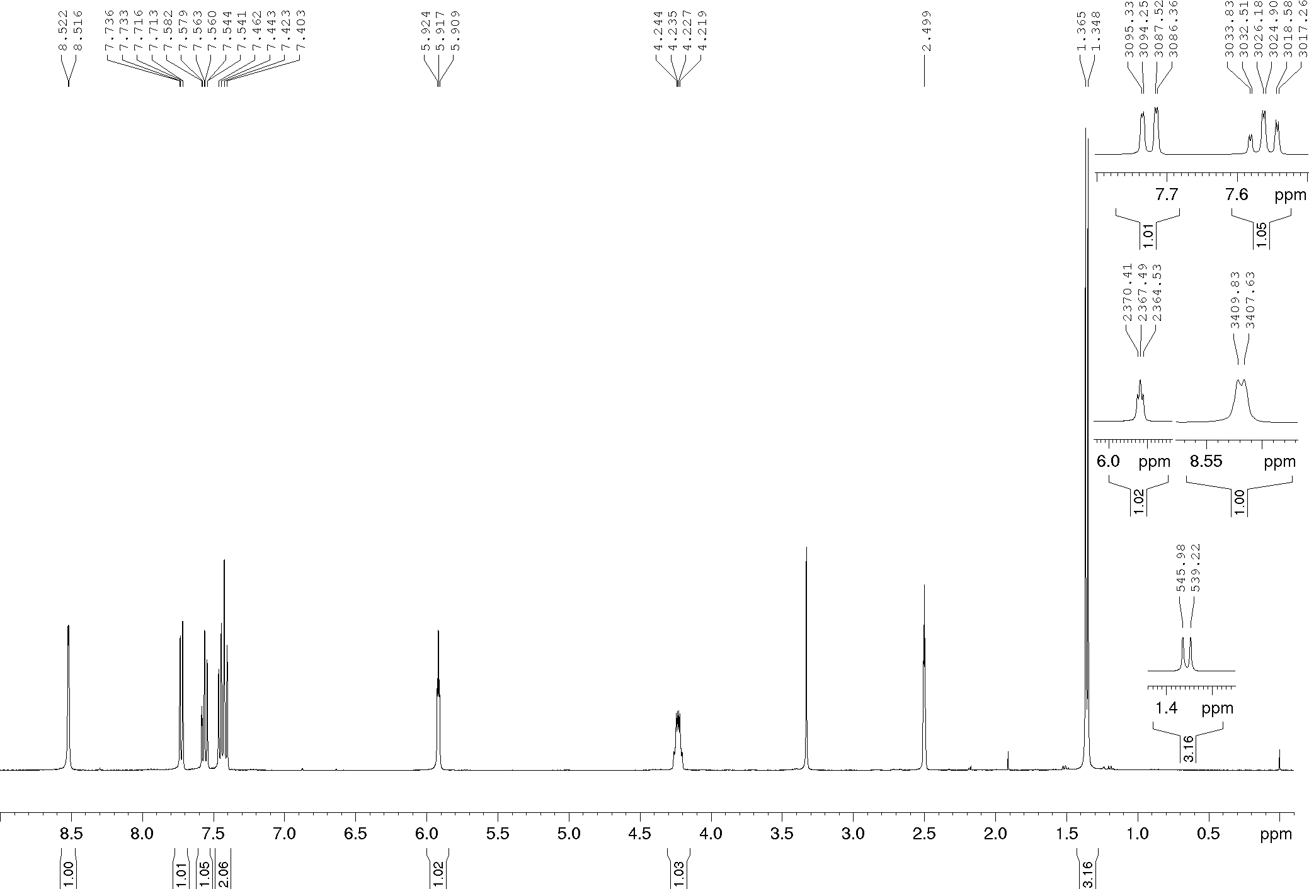
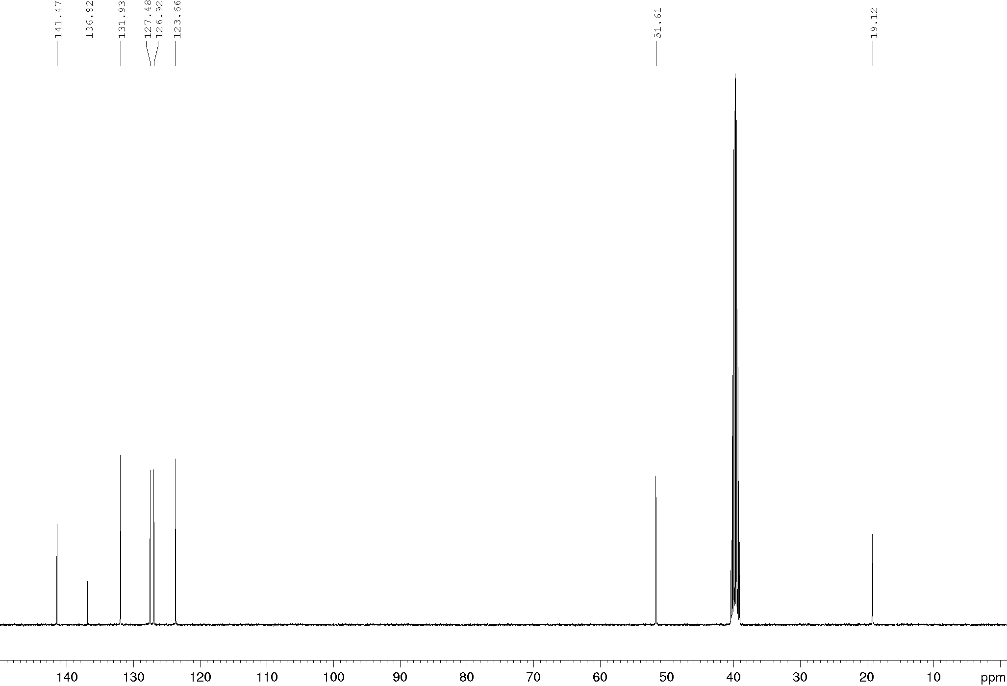
Compound 19d, ¹H and ¹³C NMR (600/150 MHz), DMSO-d₆
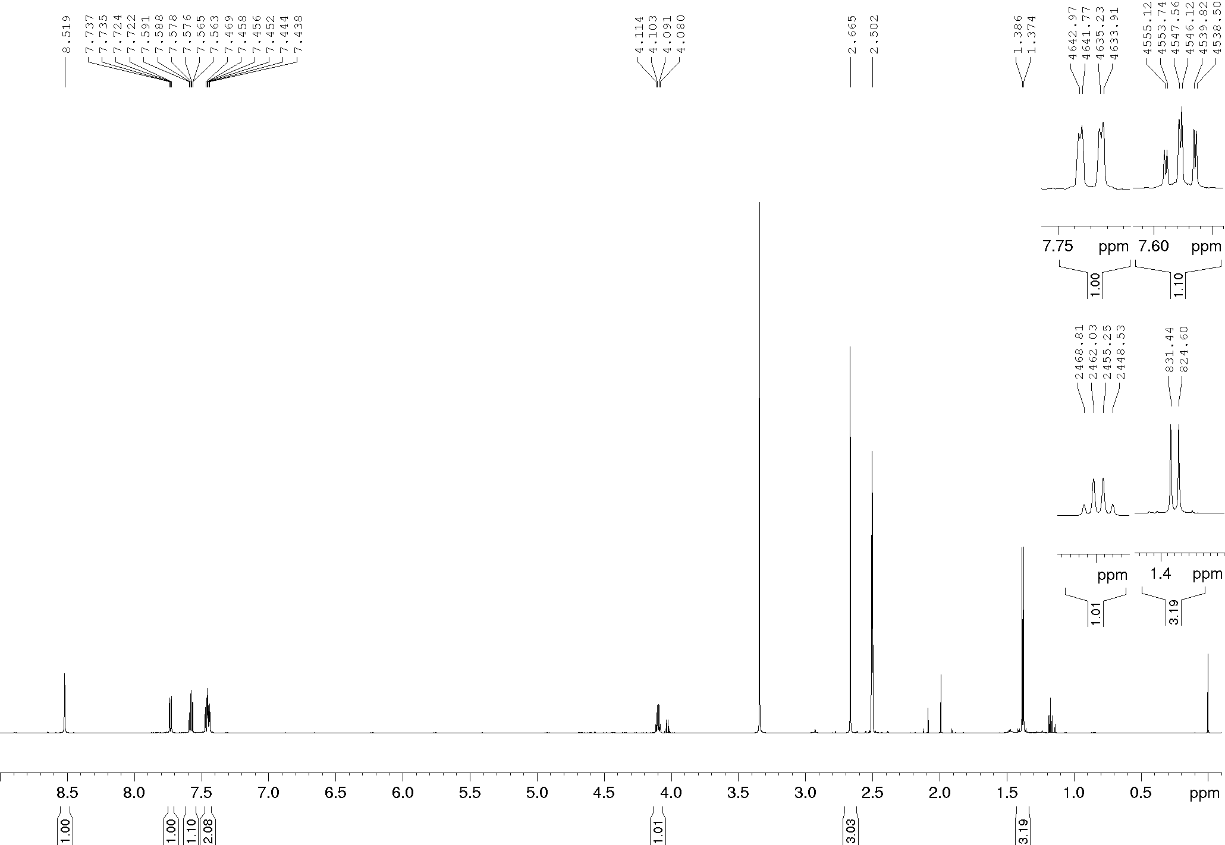
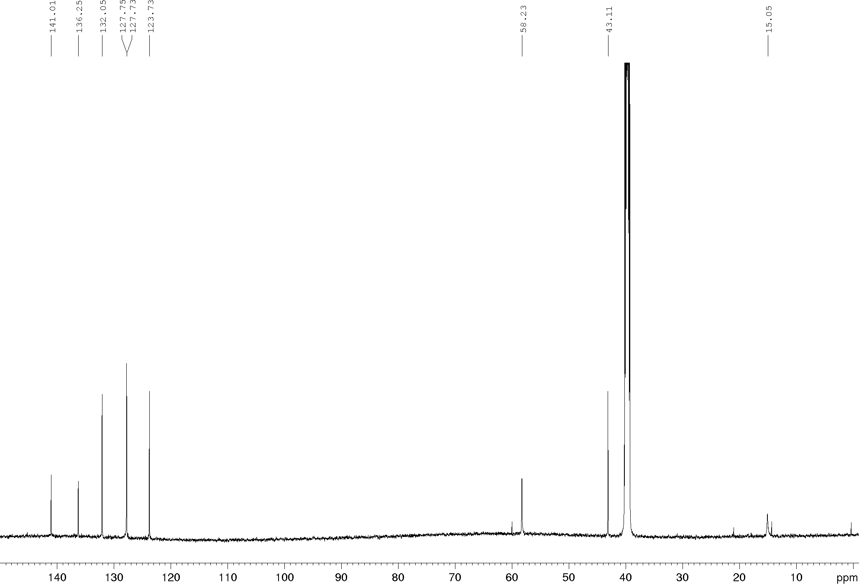

Compound 20a, ¹H and ¹³C NMR, DMSO-d₆
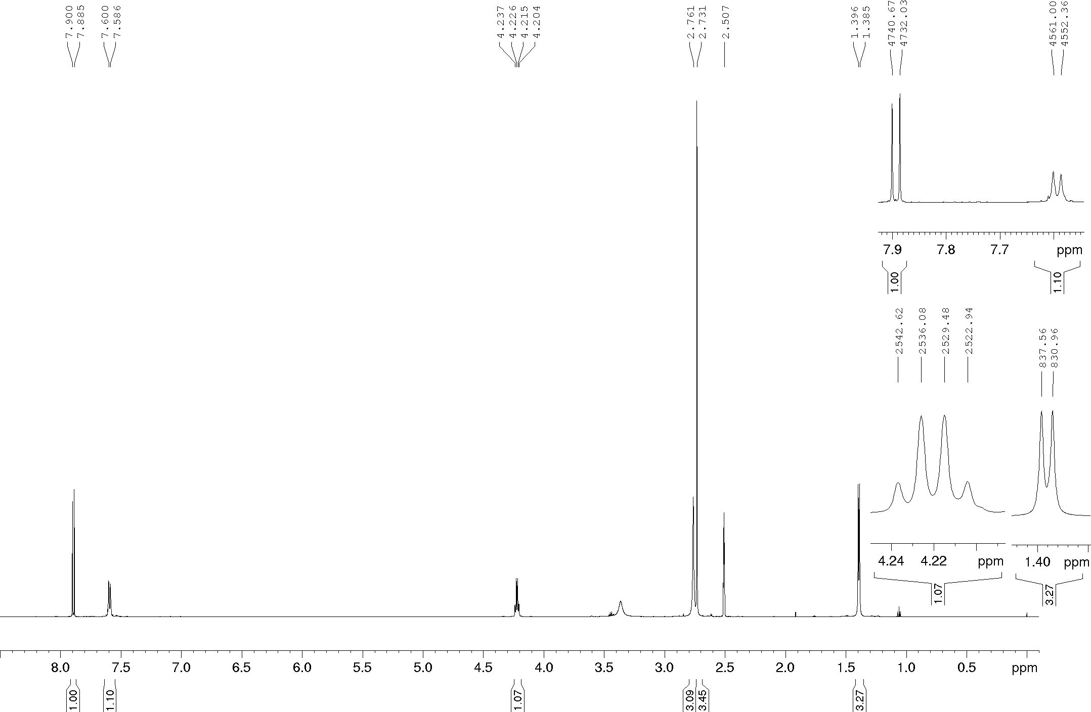
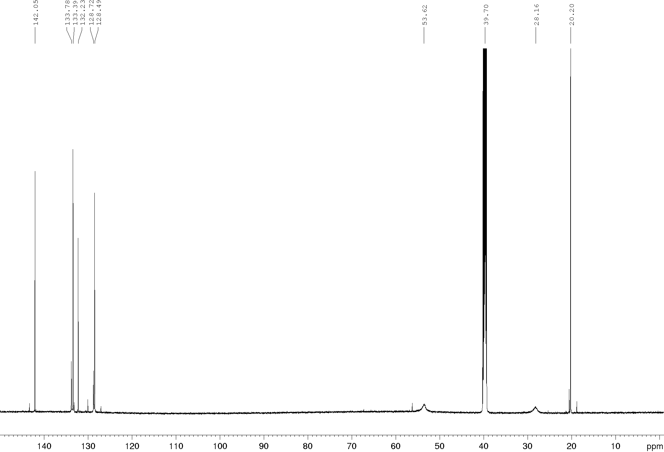
Compound 20a, DEPTQ (600 MHz), DMSO-d₆
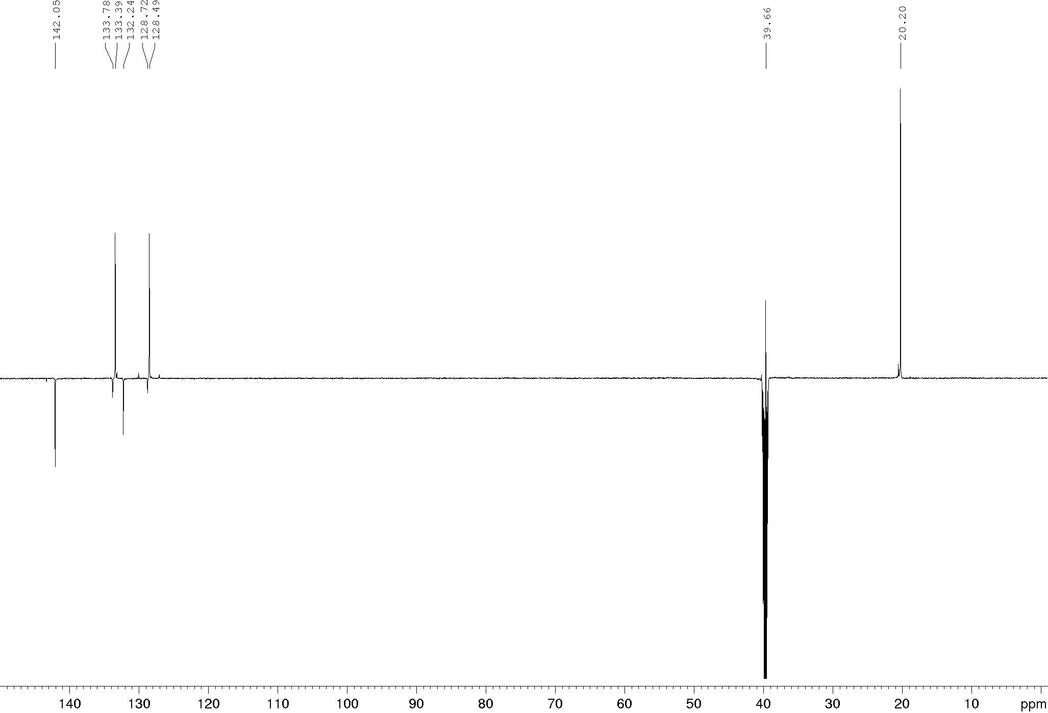

Compound 20b, ¹H and ¹³C NMR (400/100 MHz, 335 K), DMSO-d₆
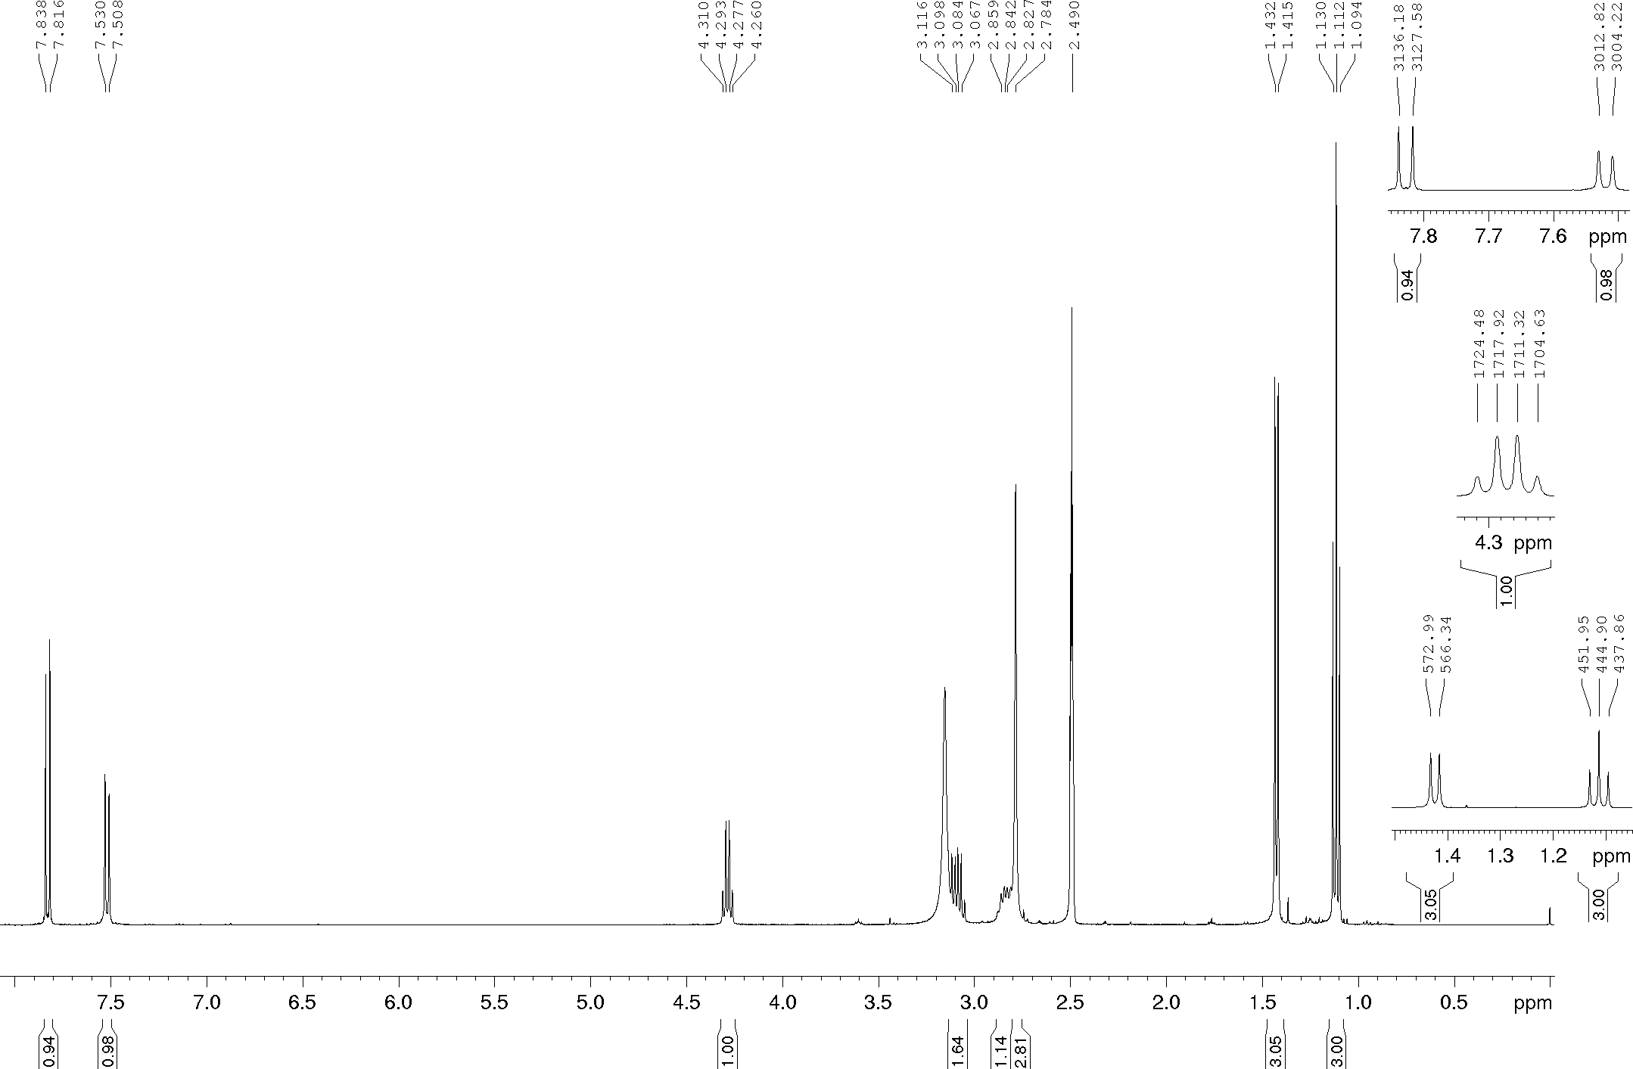
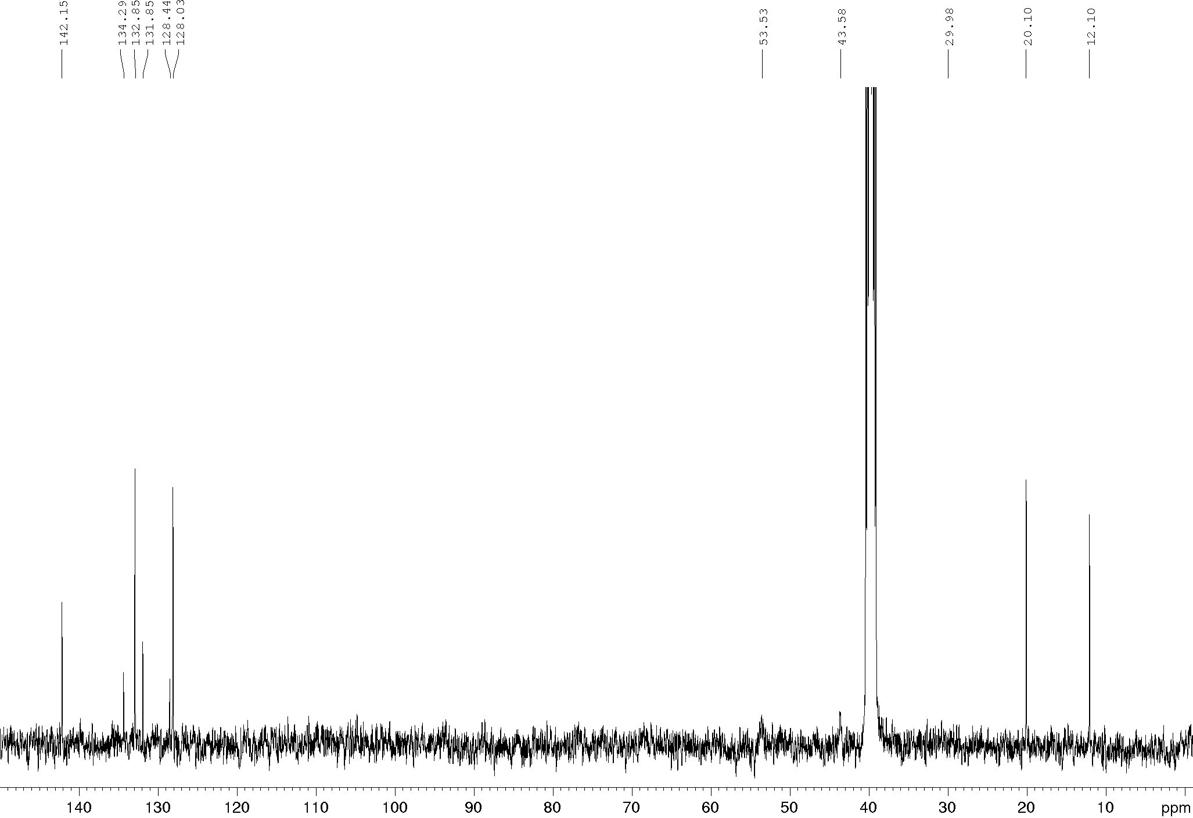
Compound 20b, HSQC (400/100 MHz, 335 K), DMSO-d₆
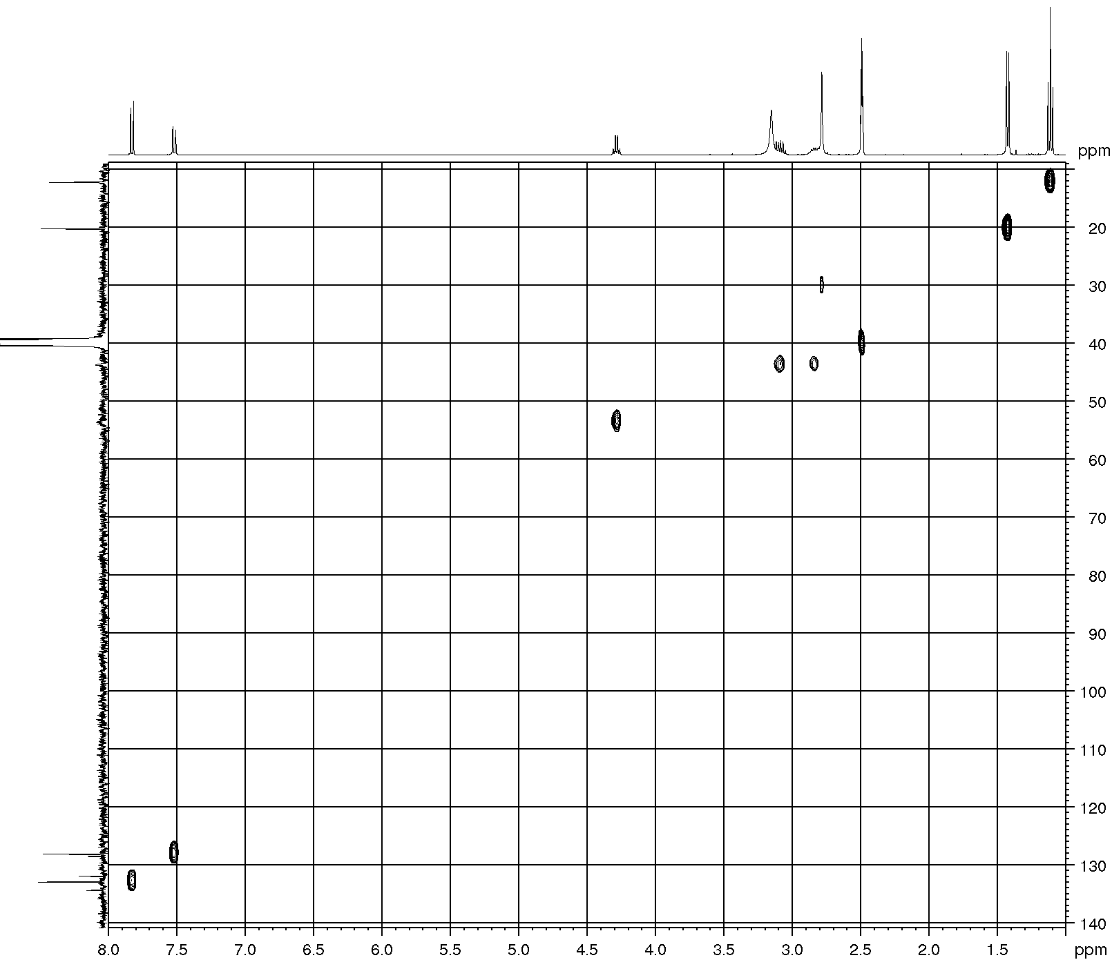

Compound 20b, ¹H and ¹³C NMR (600/150 MHz), DMSO-d₆
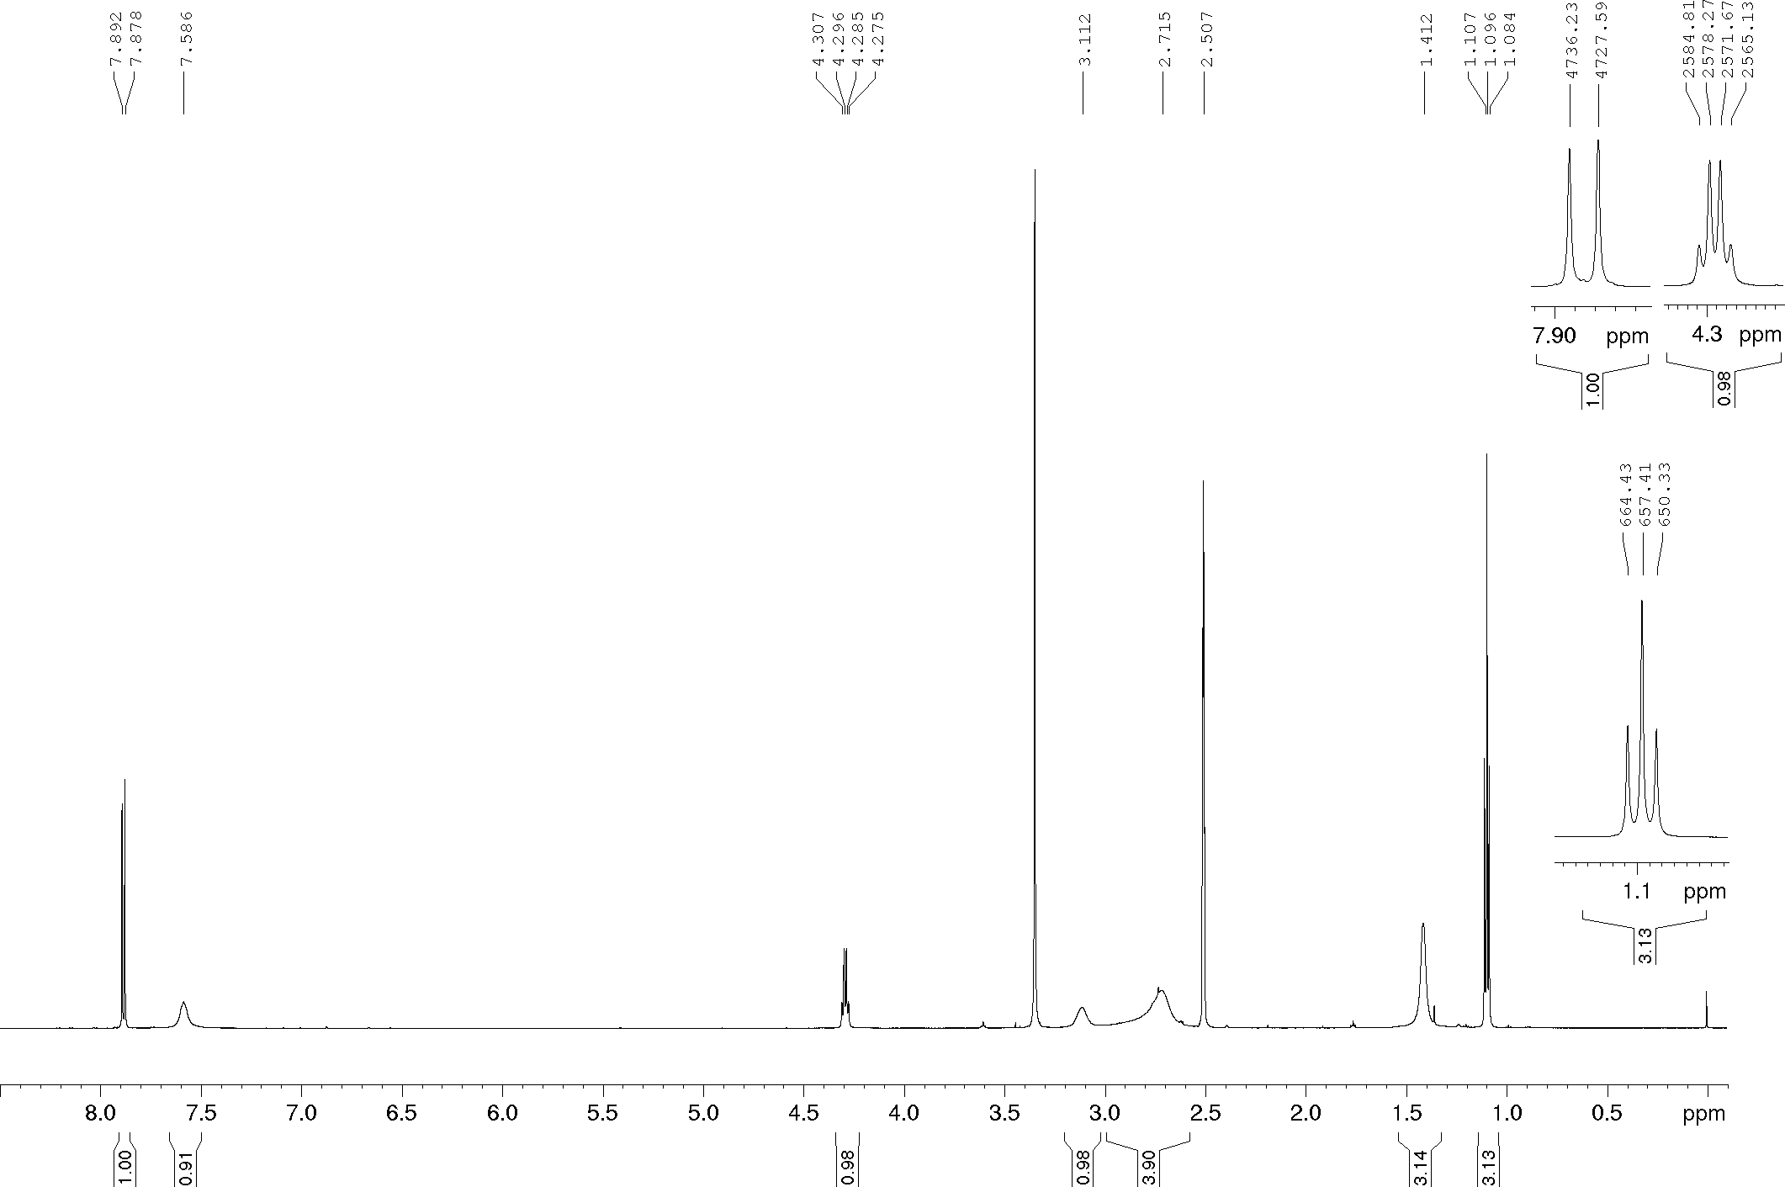
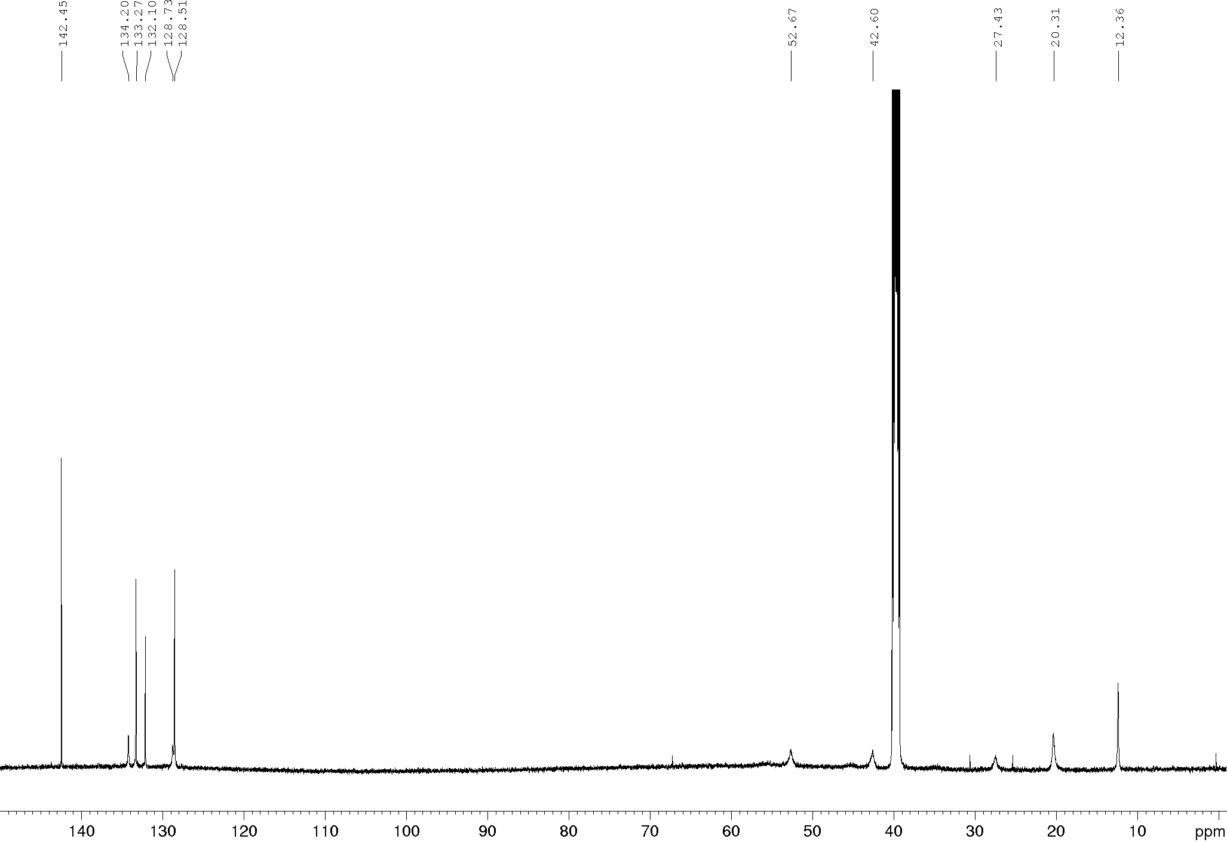
Compound 20c, ¹H and DEPTQ NMR (400/100 MHz, 325 K), DMSO-d₆
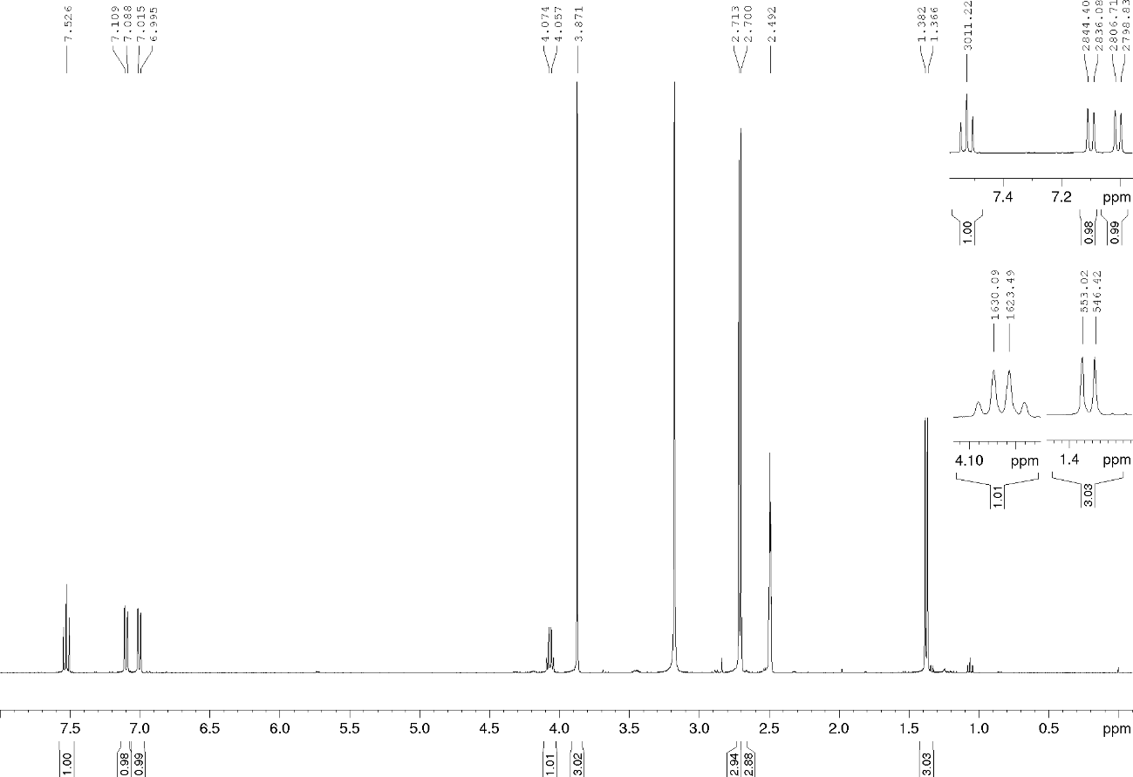
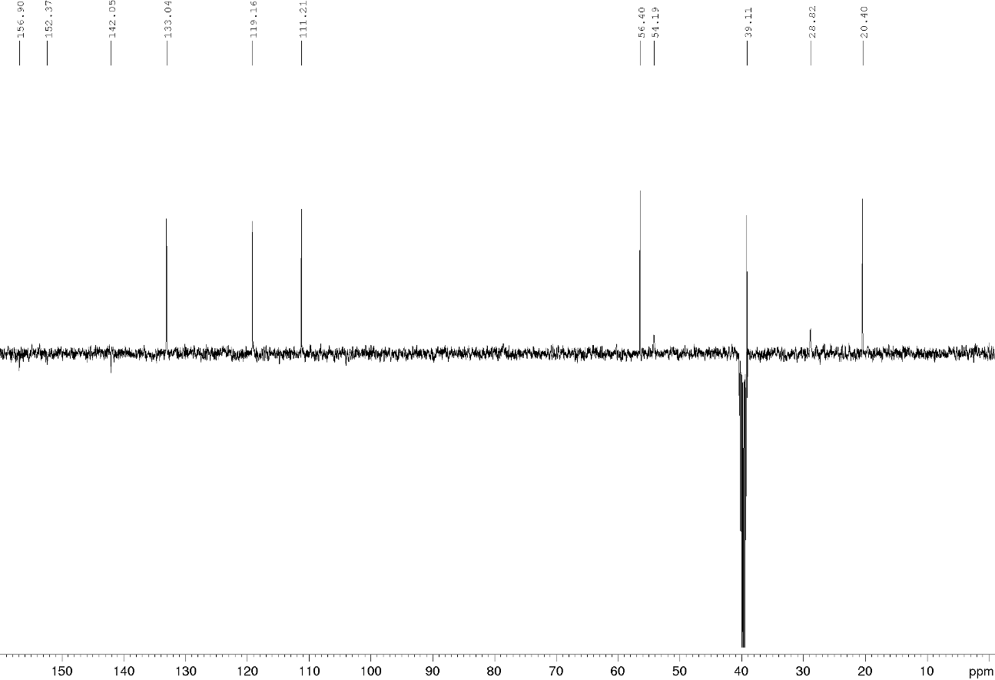
Compound 20c, ¹H and DEPTQ NMR (600/150 MHz), DMSO-d₆
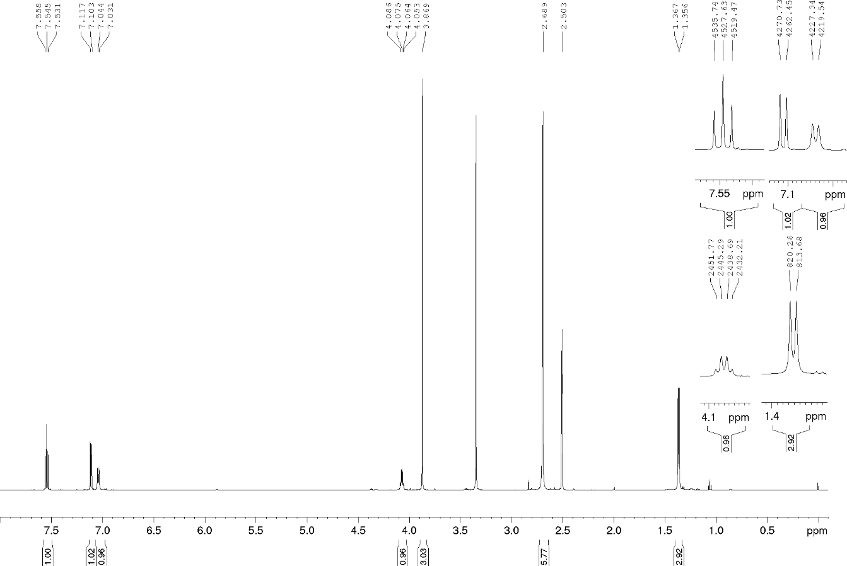
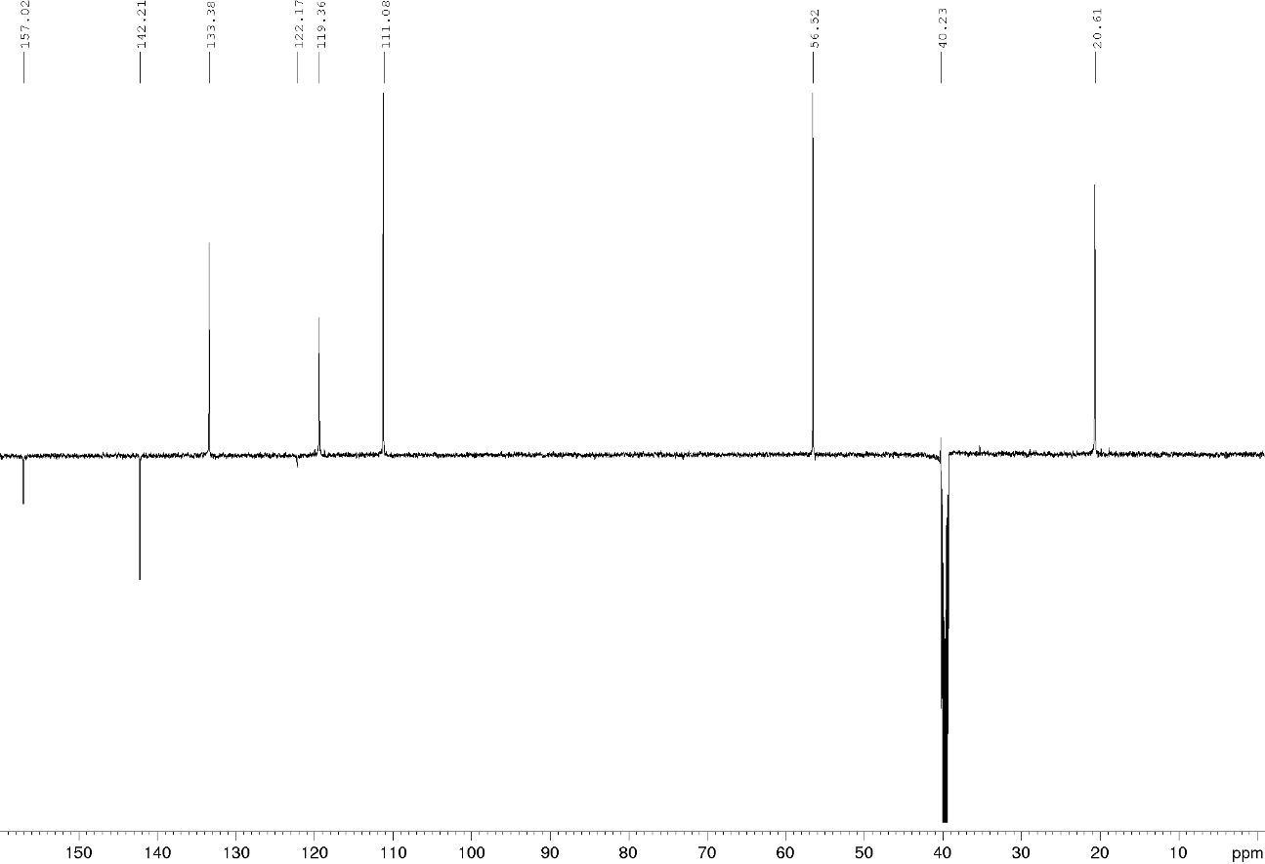

- Detailed NMR study for structure elucidation
Compound 17a, ¹H and HSQC
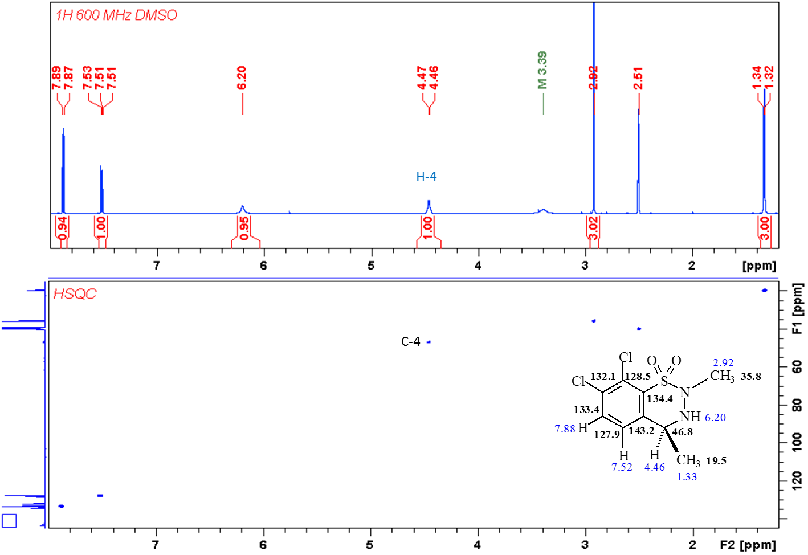
Compound 17a, ¹³C and HMBC
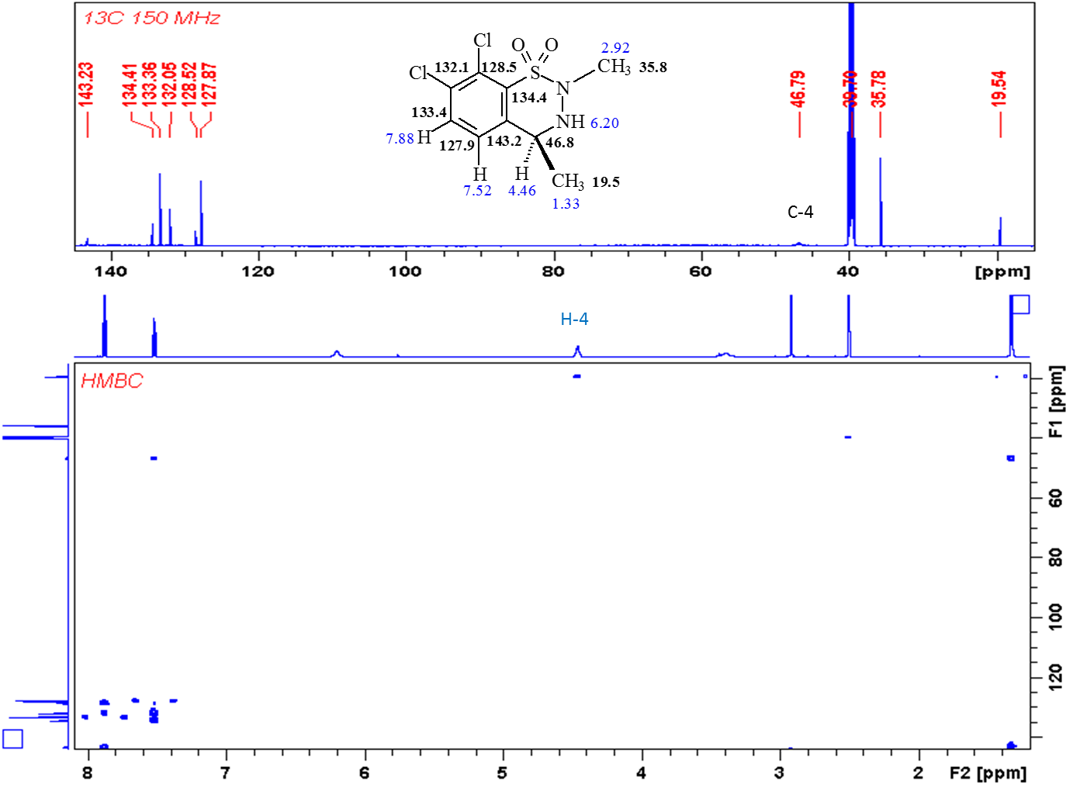
Compound 17b, ¹H and HSQC
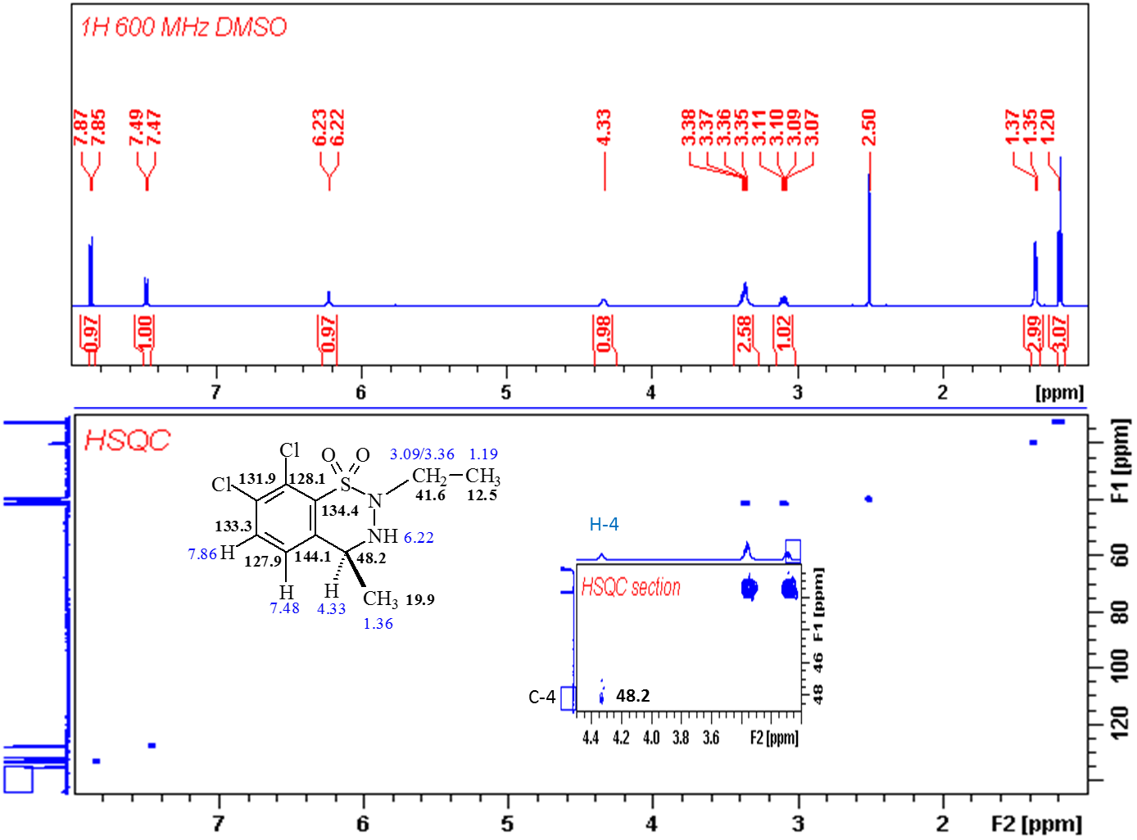
Compound 17b, ¹³C and HMBC
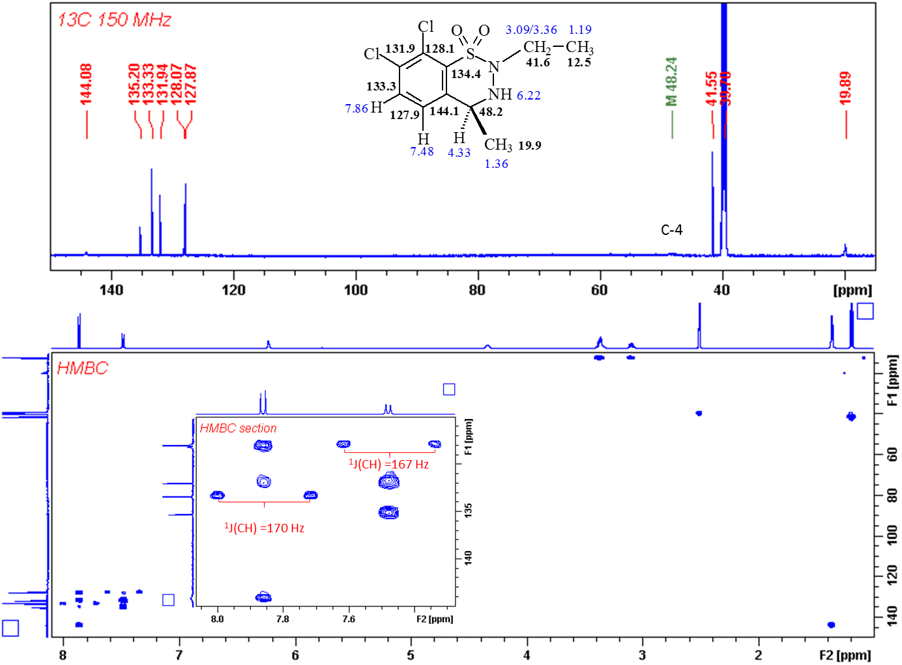
Compound 17d, ¹H and HSQC
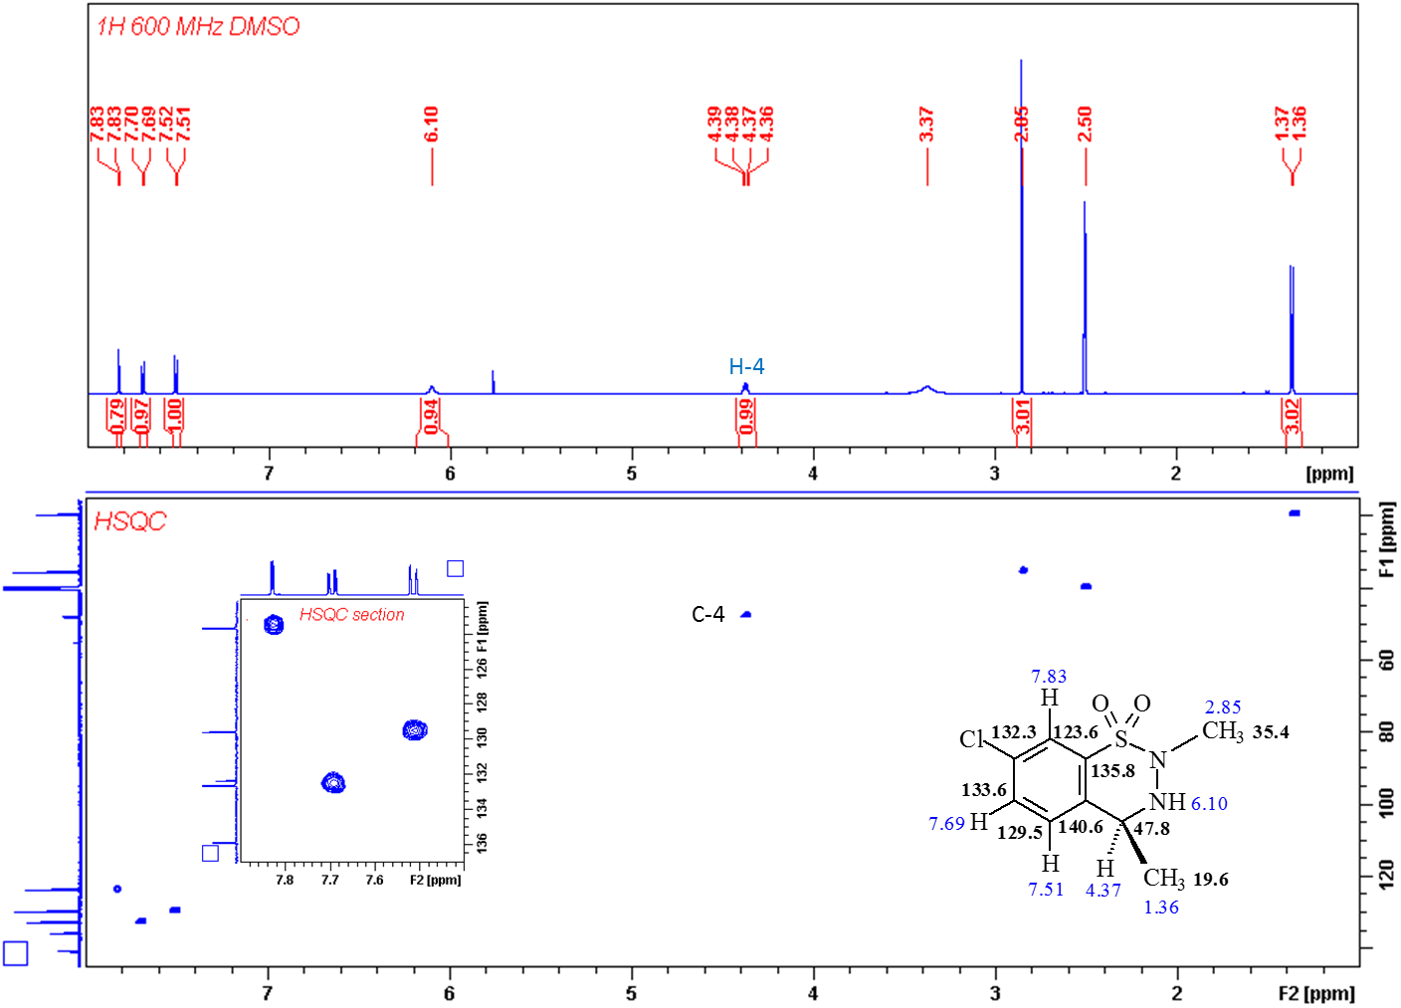
Compound 17d, ¹³C and HMBC
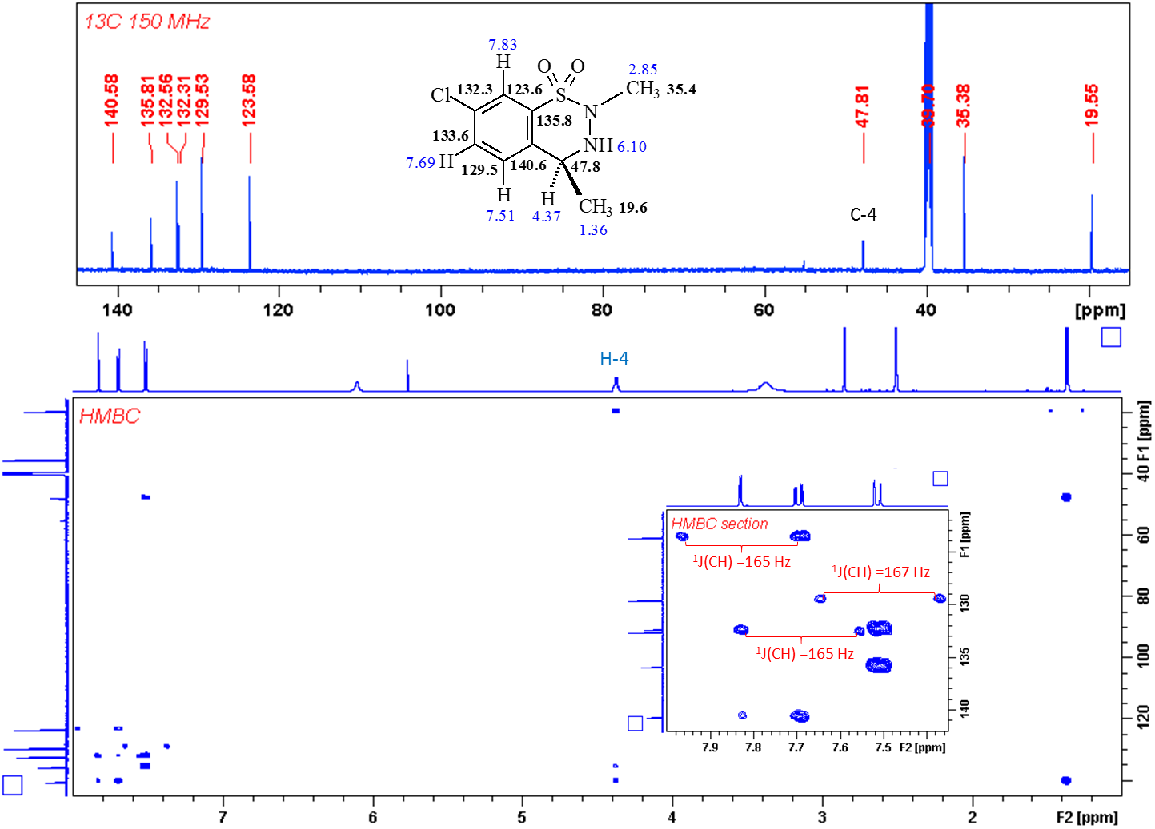
Compound 17e, ¹H and HSQC
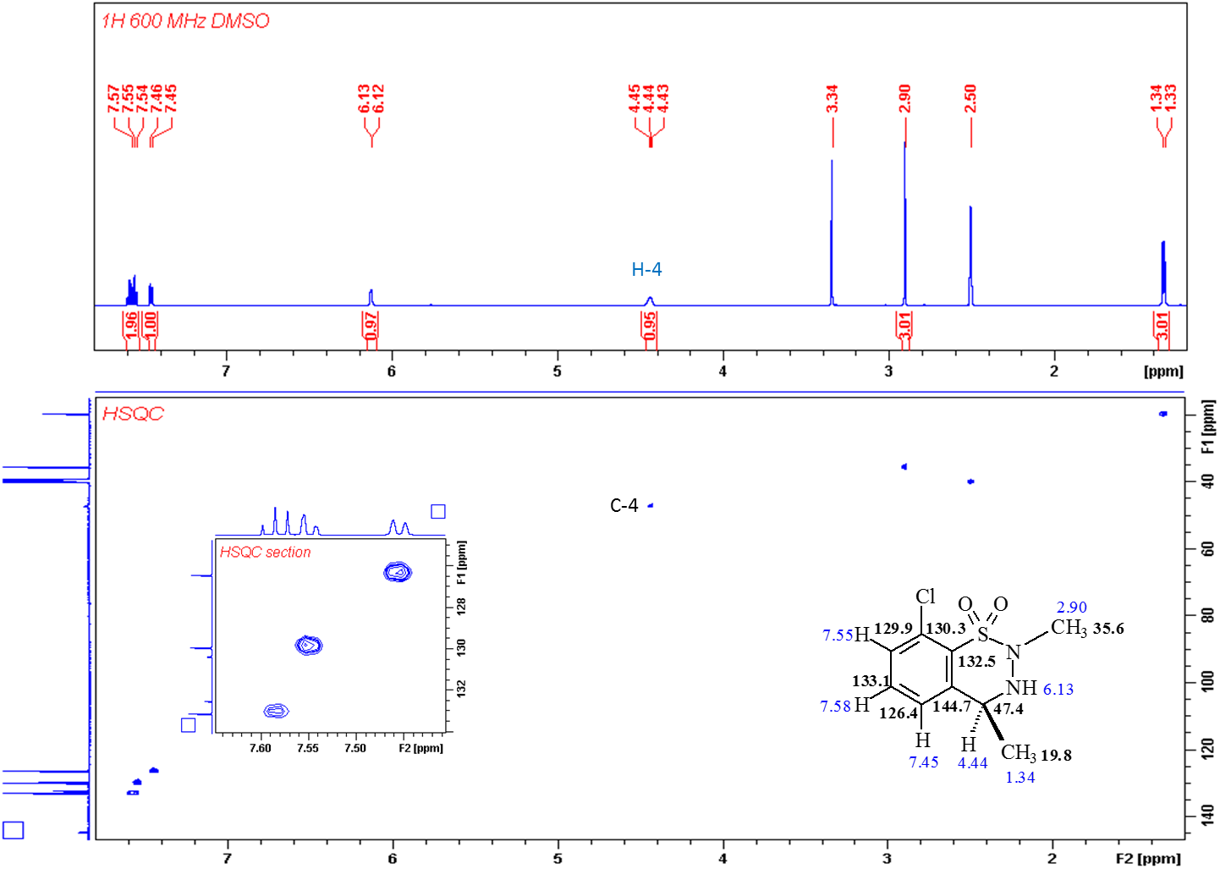
Compound 17e, ¹³C and HMBC
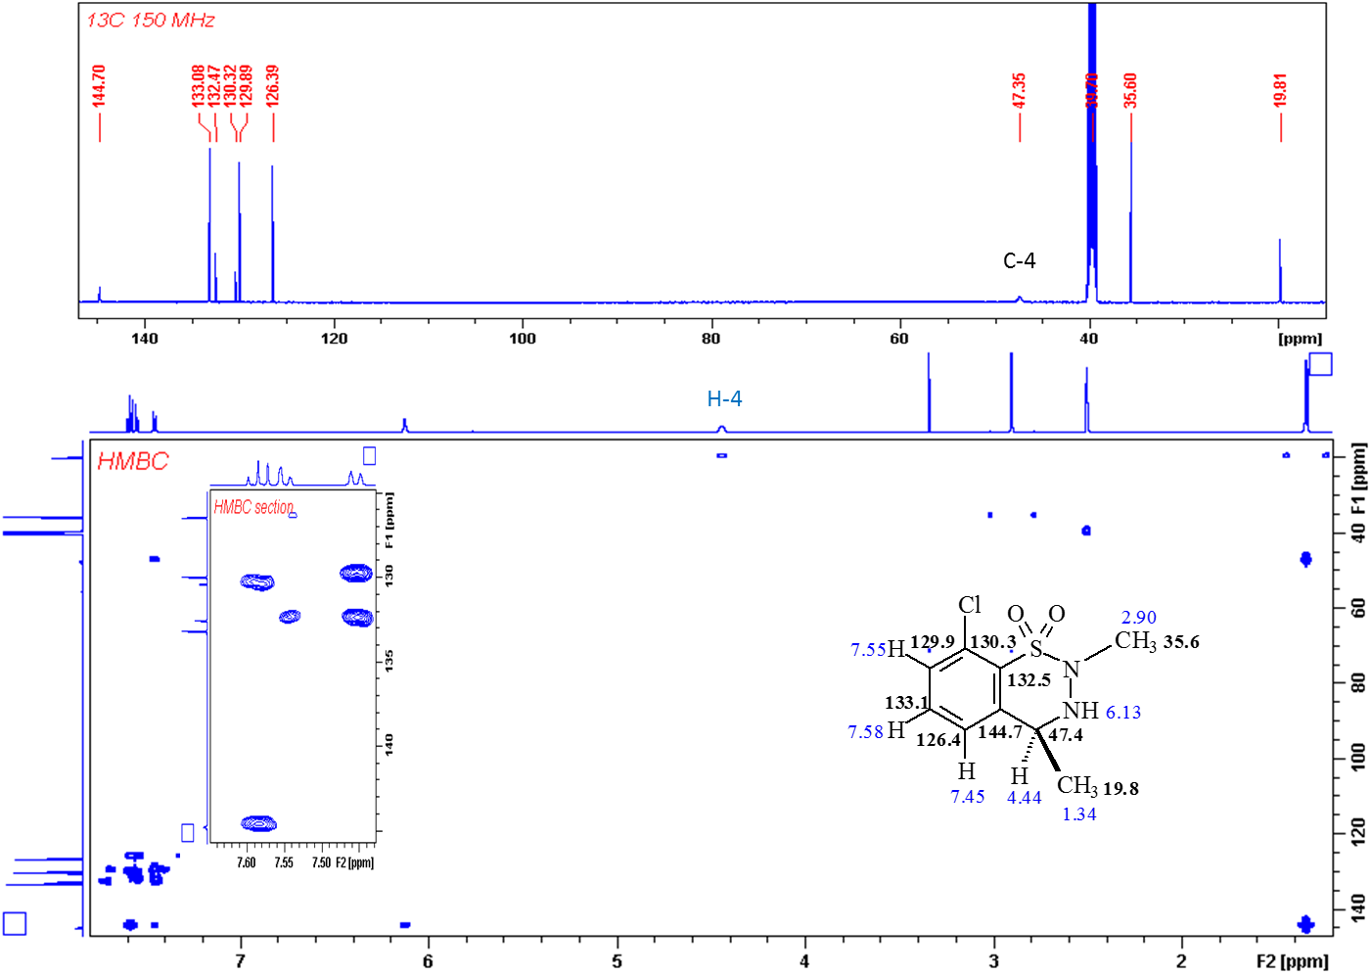
Compound 17f, ¹H and HSQC
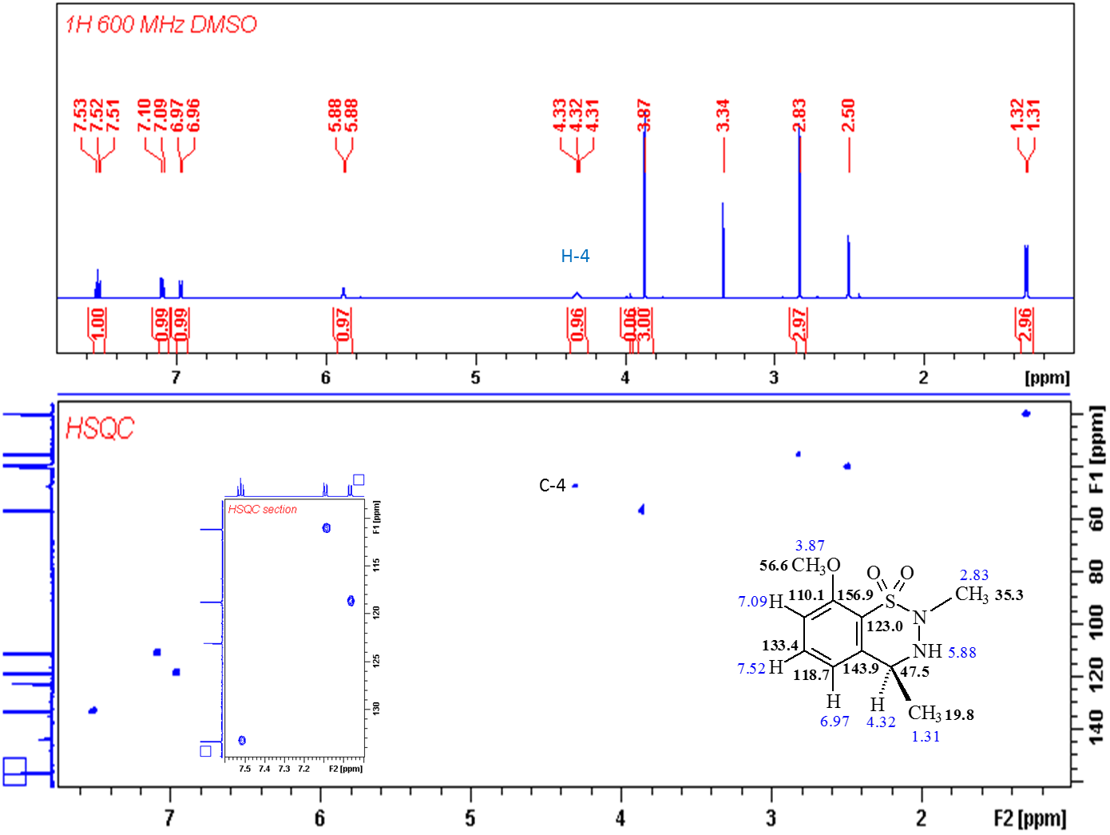
Compound 17f, ¹³C and HMBC
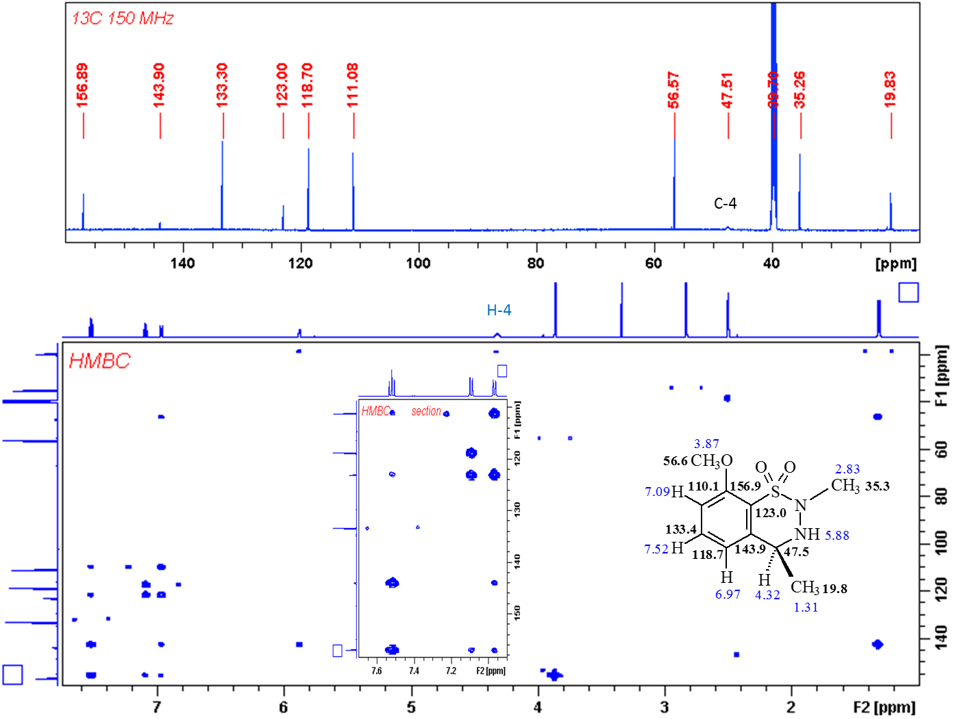
Compound 18a, ¹H, DEPTQ and ¹³C
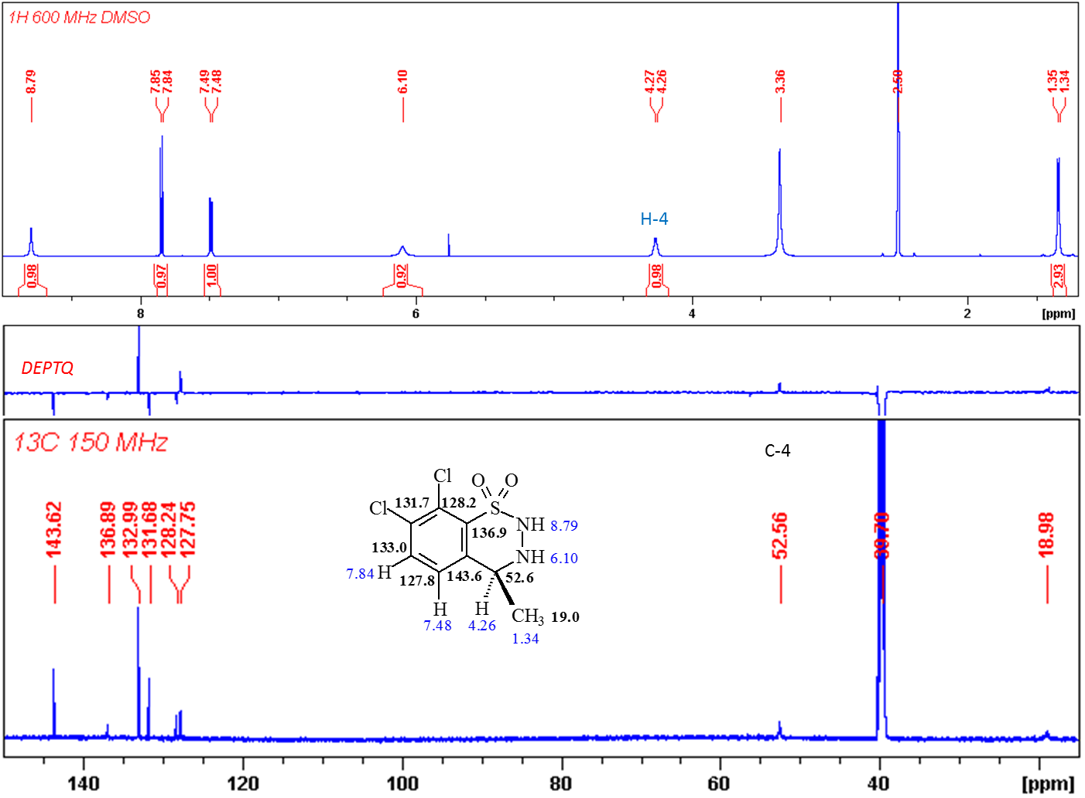
Compound 19d, ¹H and HSQC
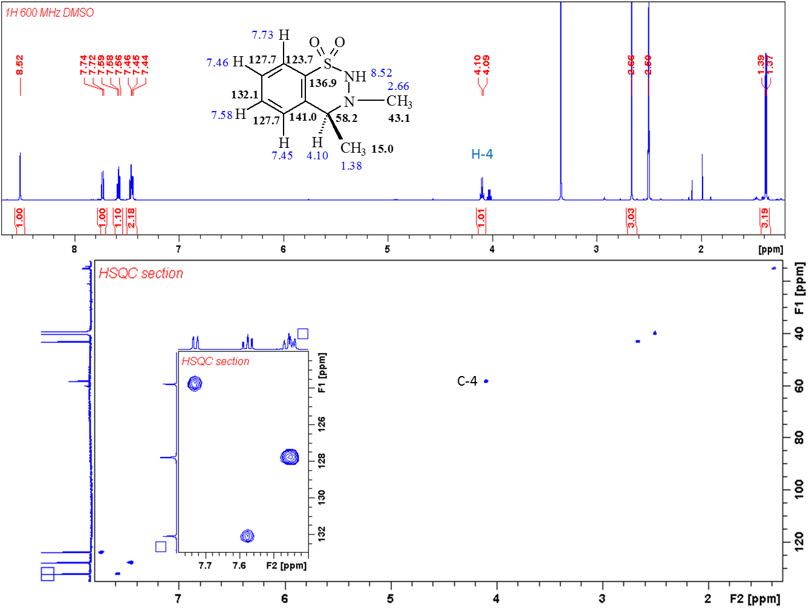
Compound 19d, ¹³C and HMBC
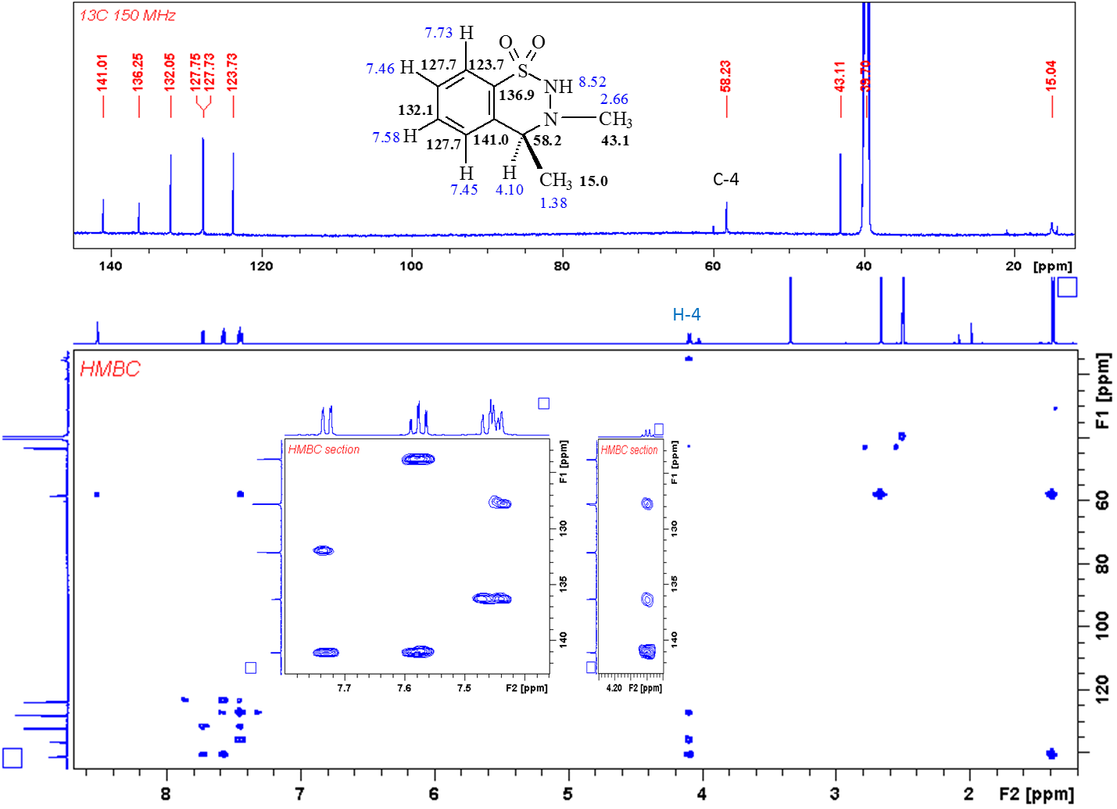
Compound 20a, ¹H and HSQC
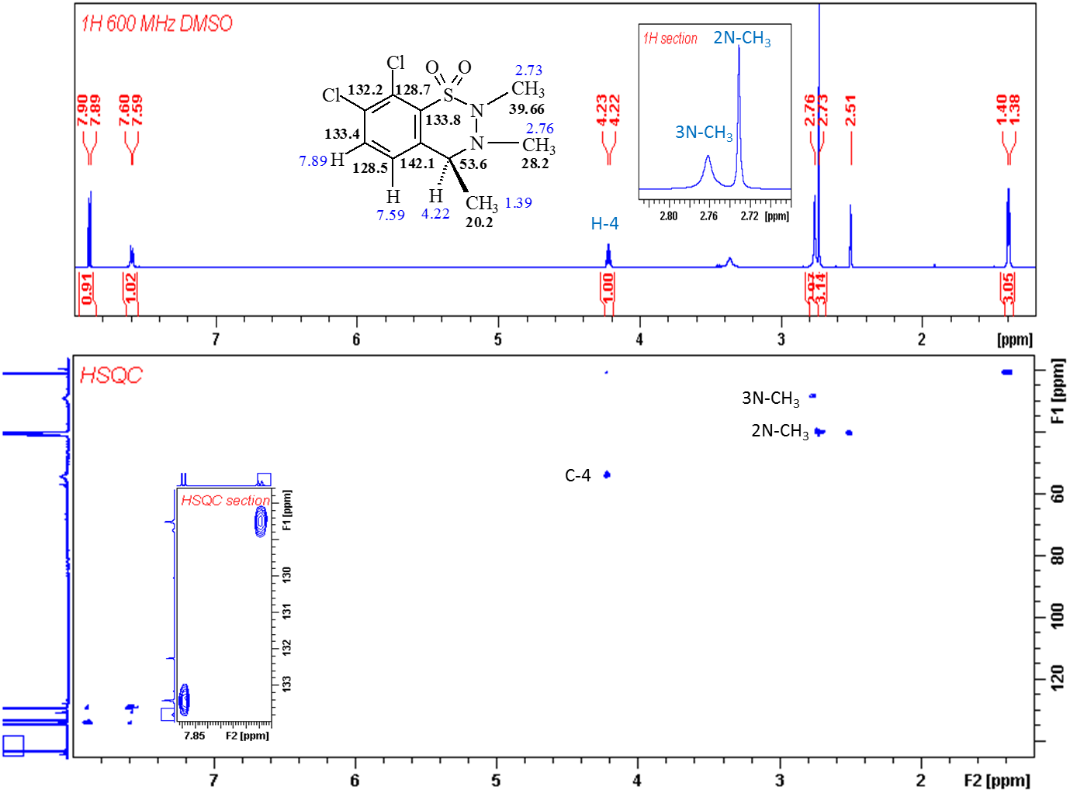
Compound 20a, DEPTQ, ¹³C and HMBC
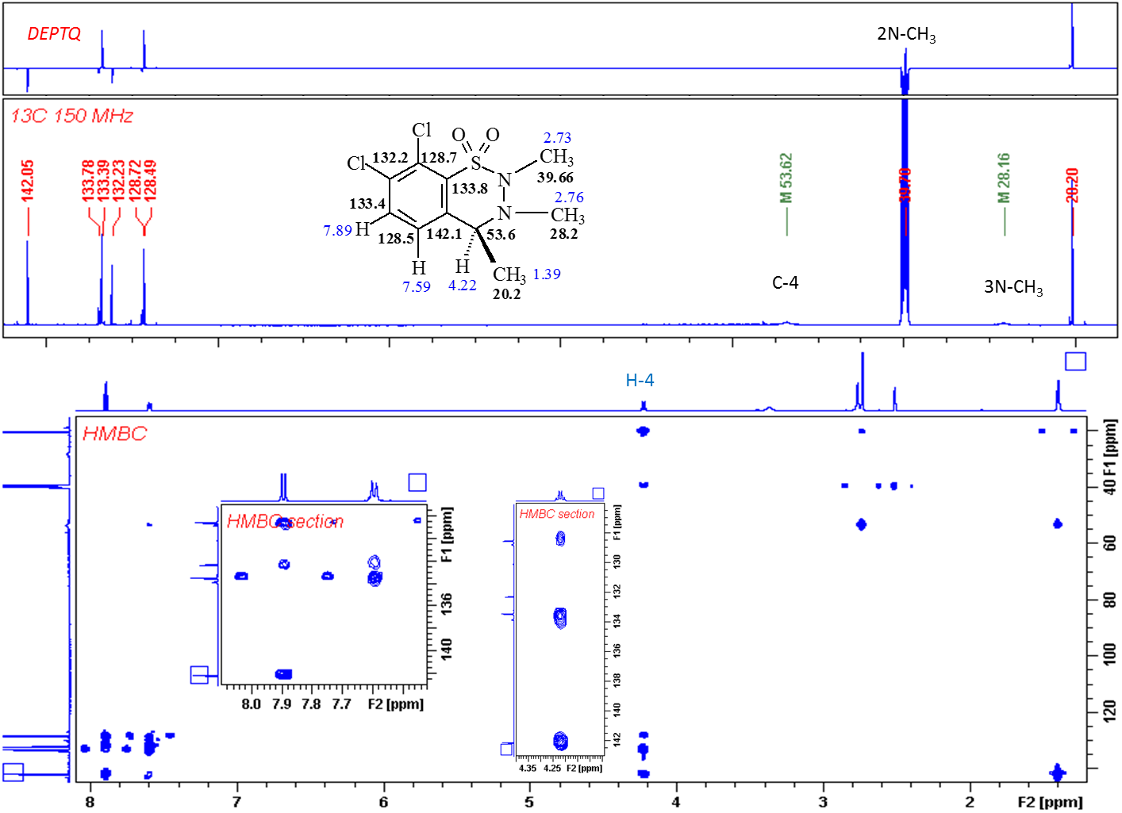
Compound 20c, ¹H and HSQC (22 °C)
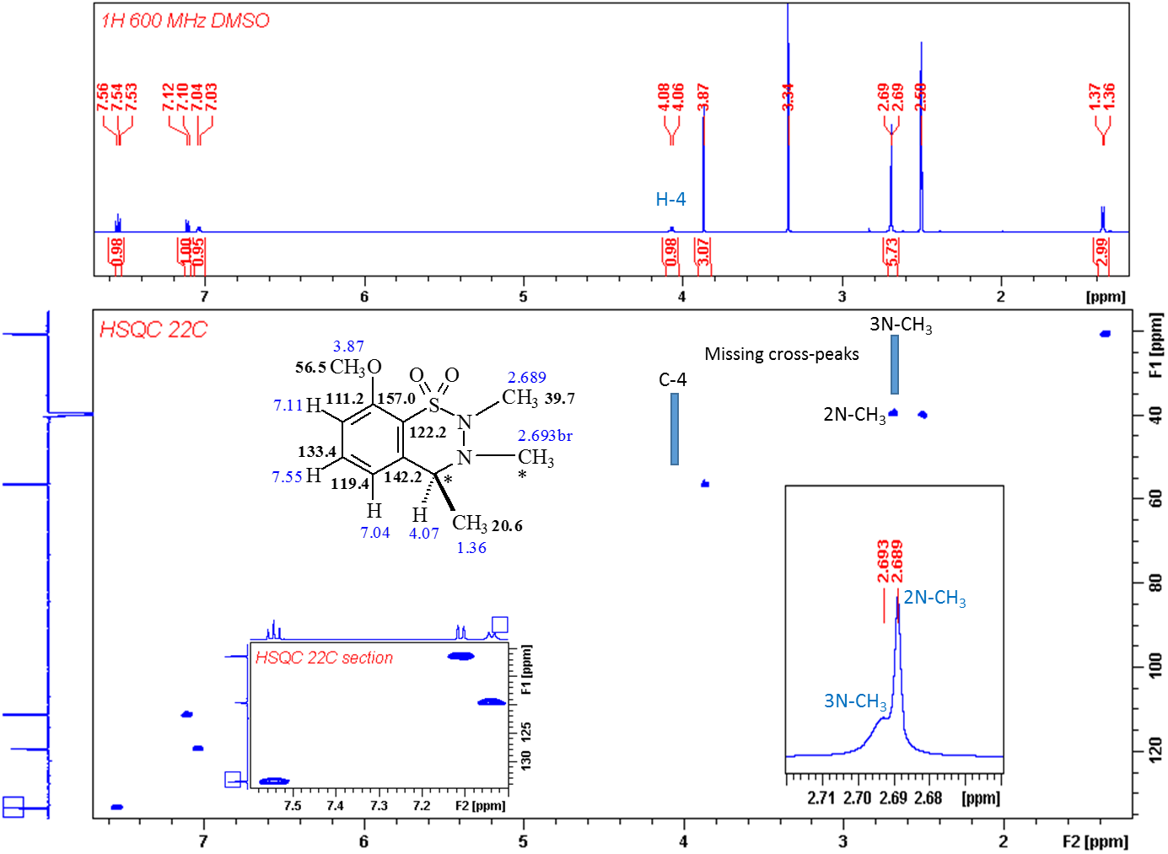
Compound 20c, DEPTQ and HMBC (22 °C)
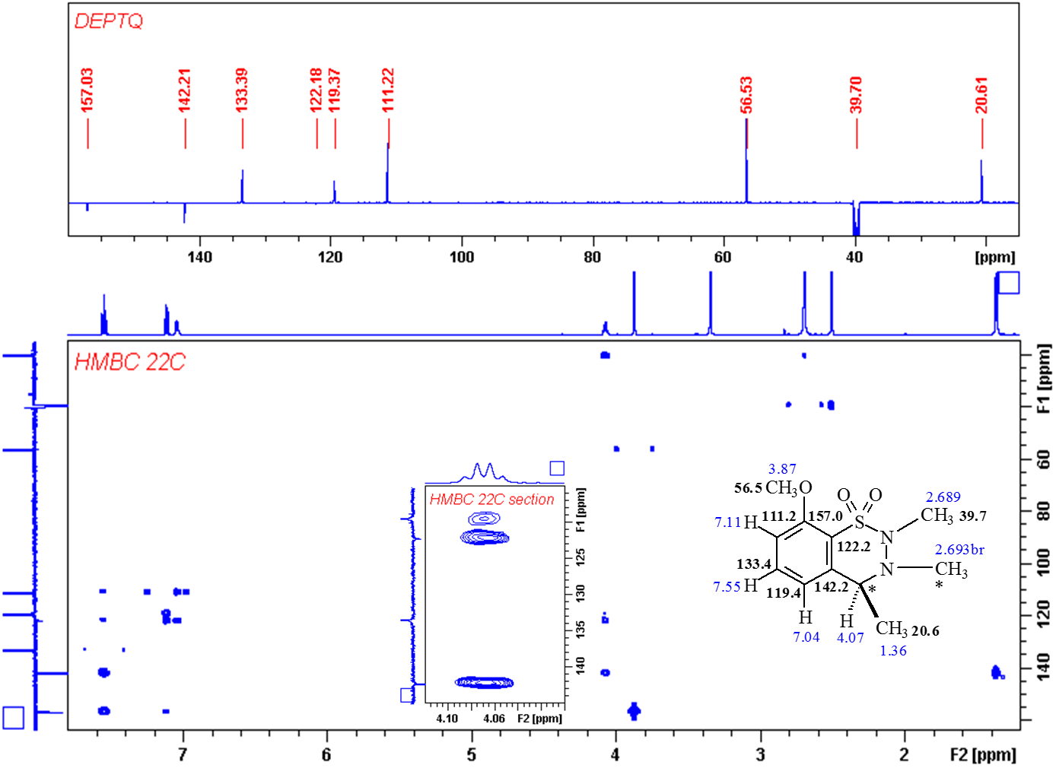
Compound 20c, DEPTQ, ¹H and HSQC (52 °C)
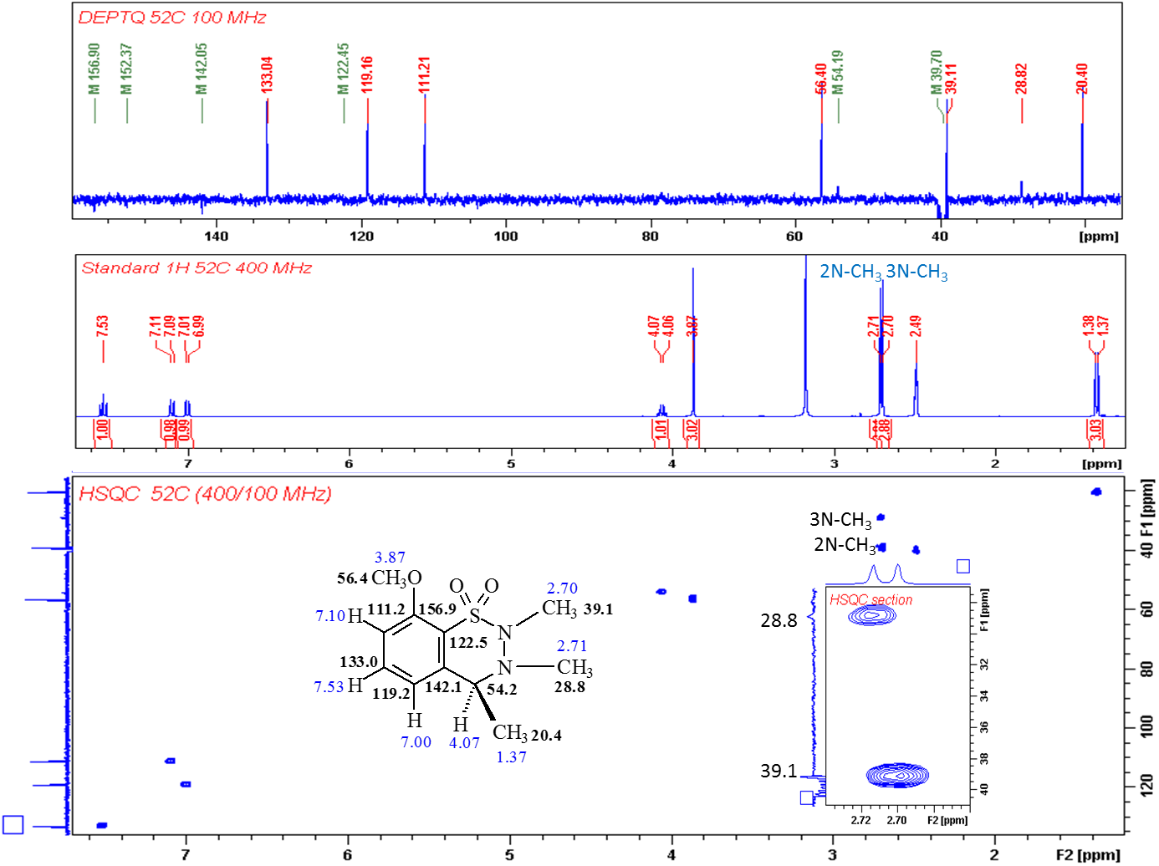

- DFT study on the conformers of 20a

To obtain the optimized geometries of the conformers of 20a, DFT calculations were performed with Gaussian 09 software package¹³ at B3LYP/6-31G level of theory in gas phase. The CYLview software was used for visualization.

Minor conformer
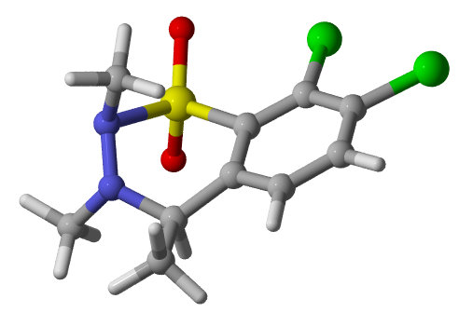
Predominant conformer

Minor conformer
E = -1966.3141002 Ha
G = -1966.146238 Ha
C 0.009561 -0.287949 0.076298
C 0.093759 -0.068842 1.462969
C 1.390910 0.062197 2.016263
C 2.535781 0.063557 1.213671
C 2.403513 -0.136161 -0.164371
C 1.146472 -0.327935 -0.728250
S 1.487114 0.110409 3.926526
N -0.185394 -1.100626 4.185278
N -1.217149 -0.400680 3.660896
C -1.204954 0.147035 2.254779
C -2.481845 -0.321324 1.535822
O 2.869798 -0.562403 4.476009
O 1.022098 1.619515 4.388380
C 0.143892 -2.402199 3.559034
C -1.939966 0.436711 4.642454
Cl 4.171965 0.375075 1.899180
Cl 3.837228 -0.138682 -1.268864
H 1.058745 -0.492013 -1.794908
H -0.954967 -0.417968 -0.394070
H 0.120106 -2.411450 2.463813
H 1.135399 -2.692198 3.913300
H -0.592467 -3.116438 3.939439
H -2.962909 0.595150 4.288393
H -1.966562 -0.108701 5.584805
H -1.438090 1.398514 4.789267
H -3.338345 -0.201496 2.203906
H -2.682964 0.270474 0.637698
H -2.416540 -1.378969 1.261946
H -1.263475 1.238515 2.392206
Predominant conformer
E = -1966.3169407 Ha
G = -1966.149464 Ha
C 0.000000 0.000000 0.000000
C 0.000000 0.000000 1.531697
C 1.137708 0.000000 2.352509
S 2.814660 0.174947 1.563915
N 2.273151 0.957307 -0.020475
N 1.320384 0.180496 -0.625678
C 1.051119 -0.145336 3.738107
C -0.200989 -0.218604 4.334421
C -1.349399 -0.176155 3.552643
C -1.245954 -0.075446 2.173045
Cl 2.518990 -0.282394 4.737761
Cl -0.381721 -0.389137 6.105225
O 3.724741 1.255560 2.353944
O 3.389338 -1.293255 1.188727
C 1.980668 2.386721 0.178722
C 1.815996 -0.871086 -1.516115
H -0.722854 0.708287 -0.431059
H -2.318085 -0.240828 4.031245
H -2.151434 -0.079807 1.580242
H 1.096152 2.570701 0.802689
H 2.852244 2.839775 0.648899
H 1.827684 2.809967 -0.814235
H 1.090506 -1.026561 -2.320392
H 2.755030 -0.523260 -1.942962
H 1.998249 -1.812061 -0.985846
C -0.414350 -1.337569 -0.376461
H -0.439202 -1.417795 -1.462217
H 0.291827 -2.062845 0.025050
H -1.406864 -1.536628 0.025050

- References
(1) Liu, W.; Wang, H.; Li, C. J. Org. Lett. 2016, 18, 2184.
(2) Watanabe, N.; Kabasawa, Y.; Takase, Y.; Matsukura, M.; Miyazaki, K.; Ishihara, H.; Kodama, K.; Adachi, H. J. Med. Chem. 1998, 41, 3367.
(3) Hu, B.; Xing, S.; Ren, J.; Wang, Z. Tetrahedron 2010, 66, 5671.
(4) Lukács, G.; Porcs-Makkay, M.; Komáromi, A.; Simig, G. Arkivoc 2008, iii, 17.
(5) Lukács, G.; Porcs-Makkay, M.; Simig, G. Tetrahedron Lett. 2003, 44, 3211.
(6) Nyulasi, B.; Németh, A.; Porcs-Makkay, M.; Kupai, J.; Lukács, G.; Simig, G.; Volk, B. Tetrahedron 2017, 73, 298.
(7) Pinder, A. R.; Smith, H. J. Chem. Soc. 1954, 113.
(8) Pilgrim, B. S.; Gatland, A. E.; McTernan, C. T.; Procopiou, P. A.; Donohoe, T. J. Org. Lett. 2013, 15, 6190.
(9) Porcs-Makkay, M.; Lukács, G.; Kapus, G.; Gacsályi, I.; Simig, G.; Lévay, G.; Mezei, T.; Vegh, M.; Kertész, S.; Barkoczy, J.; Leveleki, C.; Harsing, L. G. WO 2008020255 PCT Intern. Pat. Appl.; Chem. Abstr. 2008, 148, 262627.
(10) Kacem, Y.; Hassine, B. Ben. Tetrahedron Lett. 2013, 54, 4023.
(11) Porcs-Makkay, M.; Gyűjtő, I.; Simig, G.; Volk, B. Tetrahedron 2016, 72, 8463.
(12) Porcs-Makkay, M.; Lukács, G.; Kapus, G.; Gacsályi, I.; Simig, G.; Lévay, G.; Mezei, T.; Végh, M.; Kertész, S.; Barkóczy, J.; Leveleki, C.; Hársing, L. WO 2008020256 PCT Intern. Pat. Appl.; Chem. Abstr. 2008, 148, 262626.
(13) Gaussian 09, Revision B.01, Frisch, M. J.; Trucks, G. W.; Schlegel, H. B.; Scuseria, G. E.; Robb, M. A.; Cheeseman, J. R.; Scalmani, G.; Barone, V.; Mennucci, B.; Petersson, G. A.; Nakatsuji, H.; Caricato, M.; Li, X.; Hratchian, H. P.; Izmaylov, A. F.; Bloino, J.; Zheng, G.; Sonnenberg, J. L.; Hada, M.; Ehara, M.; Toyota, K.; Fukuda, R.; Hasegawa, J.; Ishida, M.; Nakajima, T.; Honda, Y.; Kitao, O.; Nakai, H.; Vreven, T.; Montgomery Jr., J. A.; Peralta, J. E.; Ogliaro, F.; Bearpark, M.; Heyd, J. J.; Brothers, E.; Kudin, K. N.; Staroverov, V. N.; Keith, T.; Kobayashi, R.; Normand, J.; Raghavachari, K.; Rendell, A.; Burant, J. C.; Iyengar, S. S.; Tomasi, J.; Cossi, M.; Rega, N.; Millam, J. M.; Klene, M.; Knox, J. E.; Cross, J. B.; Bakken, V.; Adamo, C.; Jaramillo, J.; Gomperts, R.; Stratmann, R. E.; Yazyev, O.; Austin, A. J.; Cammi, R.; Pomelli, C.; Ochterski, J. W.; Martin, R. L.; Morokuma, K.; Zakrzewski, V. G.; Voth, G. A.; Salvador, P.; Dannenberg, J. J.; Dapprich, S.; Daniels, A. D.; Farkas, Ö.; Foresman, J. B.; Ortiz, J. V.; Cioslowski, J.; Fox, D. J. Gaussian, Inc., Wallingford CT, 2010.

