SUPPLEMENTARY INFORMATION
Supplementary Figures S1-S3
Supplementary File S1
Supplementary Tables S1-S4
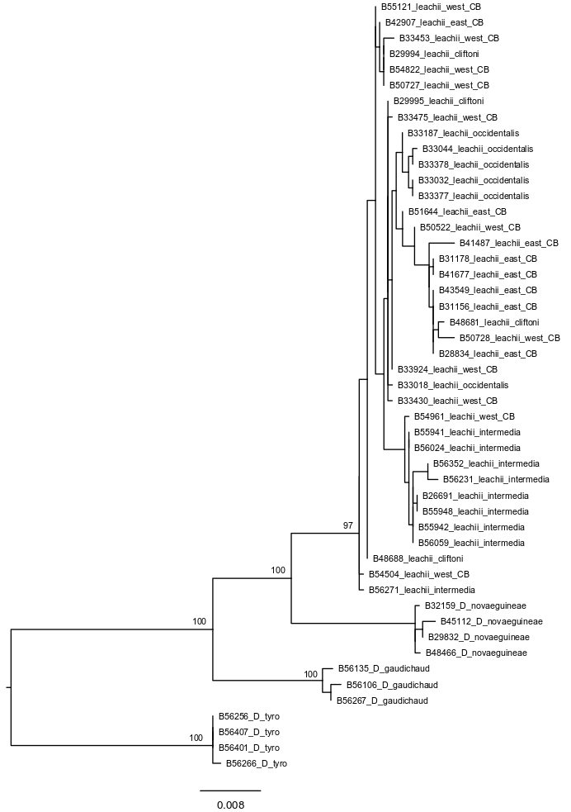
Supplementary Figure S1: Maximum likelihood phylogram (RAxML) showing relationships of 49 individual samples based on DNA sequence data from four gene regions (ND2, 20454, FIB_BI7, TGFB2). Labels show ANWC accession number followed by species/subspecies designation. Labels for nominal subspecies D. l. leachii indicate position east or west of Carpentarian Barrier (CB).

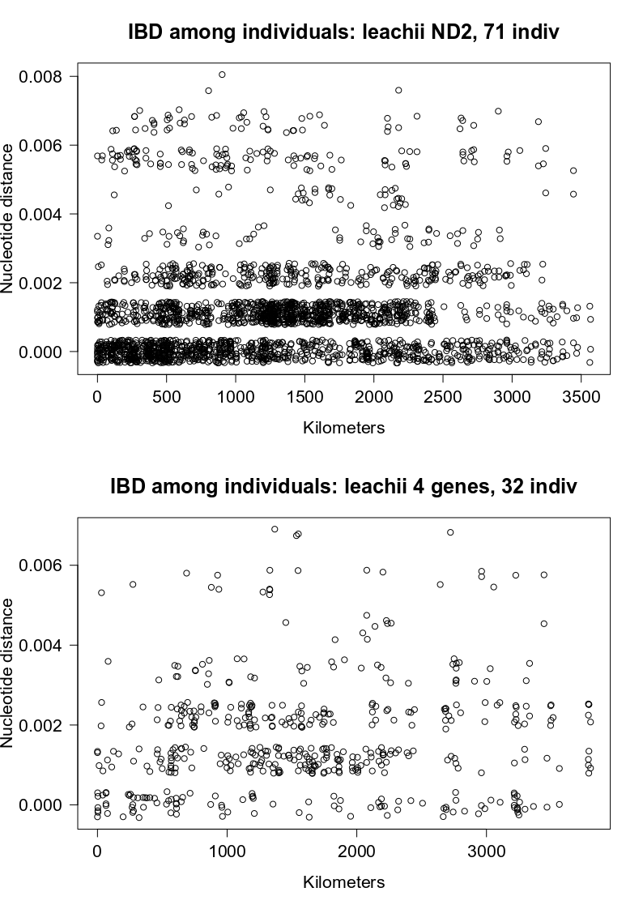
Supplementary Figure S2: Isolation-by-distance (IBD) analyses. Pairwise scatterplot of nucleotide p-distance against geographic distance for 71 individuals based on ND2 data (upper panel), and for 32 individuals where genetic data was a concatenated alignment of four genes (lower panel).

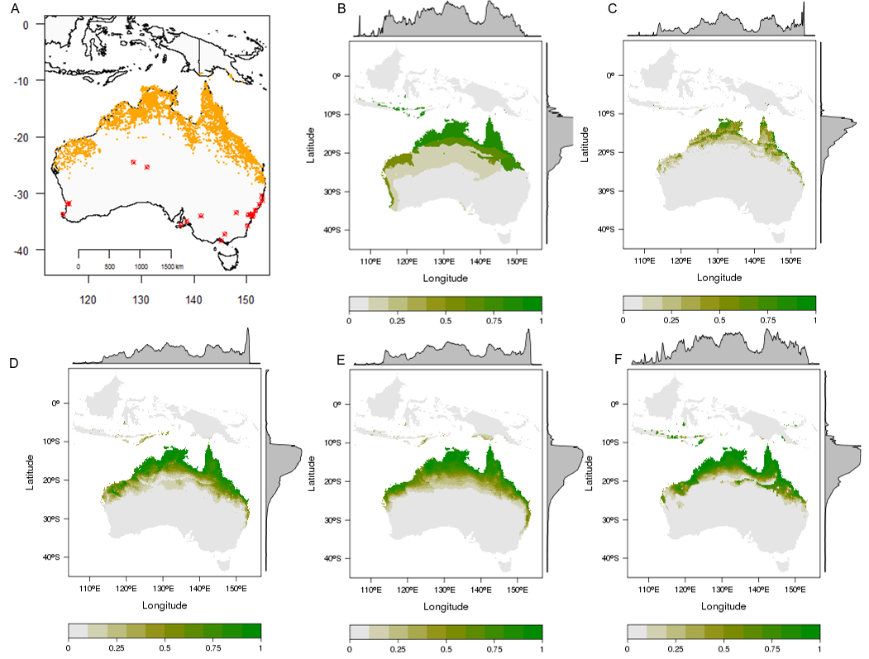
Supplementary Figure S3: Current day projections for five species distribution model (SDM) algorithms for Dacelo leachii. A. Orange points show distribution records used for SDMs (data from Atlas of Living Australia). Red points highlight distribution records outside normal range excluded from analysis. B. Classification Tree Analysis projection. C. Maxent projection. D. Multivariate Adaptive Regression Splines projection. E. Generalized Linear Model projection. F. Artificial Neural Network projection. Grey density plotted along top and right margins represent average probability of occurrence by longitude (x-axis) and latitude (y-axis).

Supplementary File S1: R script used to create Figure 3
##R script by D. J. Schmidt
##for Dorrington et al. 'Phylogeography of the blue-winged kookaburra
##Dacelo leachii across tropical northern Australia and New Guinea'
##This script investigates the effect of dividing a sample of geopositioned
##DNA sequences into two groups where the dividing line between the two
##groups is randomly selected from across a longitudinal range.

##Two files are required:
##1) DNA sequences in fasta format
##2) Latitude and longitude coordinates in CSV format.
## -Specifically the CSV file has three columns:
## -column 1 = "code", sample code corresponding to DNA sequence name in fasta file
## -column 2 = "long", longitide of sample in decimal degrees
## -column 3 = "lat", latidute of sample in decimal degrees
##
## Example:
## code long lat
## B28618 141.5847 -16.45170
## B28834 145.2300 -15.53140
## B29455 139.3900 -17.72720
##

library(pegas)

dna <- read.dna("ND2_leac_east_west.fasta", format="fasta",skip=0, as.matrix=TRUE)
coords <- read.csv("leachii_long_lat_ND2_east_west.csv", header=TRUE, sep=",", quote="", dec=".")

dist_matrix <- dist.dna(dna, "N")

west.limit <- quantile(coords$long, 0.1)
#set western and east limits for AMOVA dividing line as 10th & 90th percentile of longitude values

east.limit <- quantile(coords$long, 0.9)
long.set <- data.frame(coords$long)
#store longitude values as dataframe as we'll be adding a column of non-numeric values (factors for AMOVA groups) during the loop

output <- matrix(ncol=3, nrow=100)
#initialise matrix to store output of loop

start.time <- proc.time()

for (i in 1:100) {
long.div <- runif(1, west.limit, east.limit)
#set longitudinal dividing line for AMOVA as random numeric value between east and west limits

long.set$grp <- ifelse(long.set$coords.long >= long.div, x <- "east", x <- "west")
# evaluate each longitude value as east or west of dividing line and add result to new column called grp which then use as factors in AMOVA

amova.groups <- factor(long.set$grp)

result <- pegas::amova(dist_matrix~amova.groups, is.squared = TRUE)
# AMOVA call to pegas

sigma2.ap <- result$varcomp[1,1]
# extract among group variance

sigma2.wp <- result$varcomp[2,1]
# extract within group variance

phi_st <- sigma2.ap/(sigma2.ap + sigma2.wp)
#phi_st formula

output[i,1] <- phi_st
# write output to matrix
output[i,2] <- result$varcomp[1,2]

output[i,3] <- long.div
}
proc.time() - start.time
output

plot(output[,3], output[,1])

Supplementary Table S1. Voucher specimen information for 97 kookaburra samples included in genetic analyses.
ANWC Voucher code | Species | Subspecies | Region | Locality | Latitude | Longitude
B56106 | Dacelo gaudichaud |  | Papua New Guinea | Bensbach Lodge | -8.85101 | 141.24799
B56135 | Dacelo gaudichaud |  | Papua New Guinea | Bensbach Lodge | -8.85101 | 141.24799
B56267 | Dacelo gaudichaud |  | Papua New Guinea | left bank Morehead river, Morehead | -8.71205 | 141.64272
B56202 | Dacelo tyro |  | Papua New Guinea | Thou, Bensbach River | -8.78841 | 141.20567
B56256 | Dacelo tyro |  | Papua New Guinea | Morehead/ Suki road | -8.58917 | 141.74752
B56265 | Dacelo tyro |  | Papua New Guinea | left bank Morehead river, Morehead | -8.71205 | 141.64272
B56266 | Dacelo tyro |  | Papua New Guinea | left bank Morehead river, Morehead | -8.71205 | 141.64272
B56401 | Dacelo tyro |  | Papua New Guinea | Wando patrol post | -8.85101 | 141.24799
B56407 | Dacelo tyro |  | Papua New Guinea | Bensbach Village | -8.8 | 141
B29832 | Dacelo novaeguineae |  | Australia: Qld | Mission River, ca 10.3 km NE of Weipa, Cape York Peninsula | -12.5556 | 141.9222
B32159 | Dacelo novaeguineae |  | Australia: Qld | Sandy Creek, 8 km NW of Laura, Cape York Peninsula | -15.5314 | 144.3847
B45112 | Dacelo novaeguineae |  | Australia: SA | 5 km W of Bool Lagoon, SW of Naracoorte | -37.15 | 140.6333
B48466 | Dacelo novaeguineae |  | Australia: SA | 14 km N of Wangary, SW Eyre Peninsula | -34.4439 | 135.4556
B26691_E009 | Dacelo leachii | intermedia | Papua New Guinea | Port Moresby District (Moitaka), Central Province (40m) | -9.43 | 147.21
B55941 | Dacelo leachii | intermedia | Papua New Guinea | 4.5 km W of Agevairu, on Hisiu Road | -9.02211 | 146.77823
B55942 | Dacelo leachii | intermedia | Papua New Guinea | 4.5 km W of Agevairu, on Hisiu Road | -9.02211 | 146.77823
B55948 | Dacelo leachii | intermedia | Papua New Guinea | 4.5 km W of Agevairu, on Hisiu Road | -9.02211 | 146.77823
B56024 | Dacelo leachii | intermedia | Papua New Guinea | 3.5 km NW of Agevairu, 90 km NW of Port Moresby | -8.99921 | 146.79308
B56059 | Dacelo leachii | intermedia | Papua New Guinea | 3 km NNW of Agevairu, 90 km NW of Port Moresby | -8.99887 | 146.80368
B56127 | Dacelo leachii | intermedia | Papua New Guinea | Bensbach Airstrip | -8.85469 | 141.25822
B56231 | Dacelo leachii | intermedia | Papua New Guinea | Bensbach/Morehead Rd | -8.78196 | 141.34428
B56271 | Dacelo leachii | intermedia | Papua New Guinea | South of Morehead on road to Mibini | -8.77699 | 141.63367
B56352 | Dacelo leachii | intermedia | Papua New Guinea | Bensbach Lodge environs | -8.85101 | 141.24799
B28618 | Dacelo leachii | leachii | Australia: Qld | Bayswater Waterhole, Inkerman Station, SW Cape York Peninsula | -16.4517 | 141.5847
B28834 | Dacelo leachii | leachii | Australia: Qld | ca 7 km SSW of Cooktown | -15.5314 | 145.23
B28911 | Dacelo leachii | leachii | Australia: Qld | Staaten River, Inkerman Station, Sw Cape York Peninsula | -16.45 | 141.5833
B29455 | Dacelo leachii | leachii | Australia: Qld | Horseshoe Lagoon, Escott Station, W of Burketown | -17.7272 | 139.39
B29584 | Dacelo leachii | leachii | Australia: Qld | Walker Creek Crossing, Karumba/Normanton Road | -17.4722 | 141.1922
B29585 | Dacelo leachii | leachii | Australia: Qld | Walker Creek Crossing, Karumba/Normanton Road | -17.4722 | 141.1922
B29994 | Dacelo leachii | cervina | Australia: NT | Koolpinyah Station, E of Darwin | -12.3978 | 131.1908
B29995 | Dacelo leachii | cervina | Australia: NT | Koolpinyah Station, E of Darwin | -12.3997 | 131.1936
B31156 | Dacelo leachii | leachii | Australia: Qld | 3 km ENE of Mt Ossa On Seaforth Road, N of Mackay | -20.9464 | 148.855
B31157 | Dacelo leachii | leachii | Australia: Qld | 8 km ENE of Mt Ossa On Seaforth Road, N of Mackay | -20.9225 | 148.9167
B31178 | Dacelo leachii | leachii | Australia: Qld | Maiden Creek, Bruce Highway, 42 km N of Bowen | -19.9322 | 147.8672
B31235 | Dacelo leachii | leachii | Australia: Qld | Mt Alma Road, 3.9 km NE of Home Hill | -19.7272 | 147.5039
B31236 | Dacelo leachii | leachii | Australia: Qld | Mt Alma Road, 3.9 km NE of Home Hill | -19.7272 | 147.5039
B31283 | Dacelo leachii | leachii | Australia: Qld | Killymoon Creek, ca 24 km S of Townsville | -19.3928 | 146.9942
B31340 | Dacelo leachii | leachii | Australia: Qld | Bruce Highway, 9 km S of Cardwell | -18.3269 | 146.045
B31409 | Dacelo leachii | leachii | Australia: Qld | 1 km W of Daintree | -16.2581 | 145.315
B31461 | Dacelo leachii | leachii | Australia: Qld | ca 7 km SSW of Cooktown | -15.5314 | 145.23
B31588 | Dacelo leachii | leachii | Australia: Qld | 3 km E of Mt Garnet | -17.6906 | 145.1531
B32157 | Dacelo leachii | leachii | Australia: Qld | Battle Creek, 10.2 km WNW of Mt Carbine | -16.5069 | 145.0397
B32173 | Dacelo leachii | leachii | Australia: Qld | 52 km N of Musgrave, Cape York Peninsula | -14.3953 | 143.3625
B33018 | Dacelo leachii | occidentalis | Australia: WA | Fortescue River, Roy Hill Station | -22.6439 | 119.9669
B33032 | Dacelo leachii | occidentalis | Australia: WA | 124 km N of Mt Newman on road to Marble Bar | -22.3931 | 119.9747
B33033 | Dacelo leachii | occidentalis | Australia: WA | 124 km N of Mt Newman on road to Marble Bar | -22.3931 | 119.9747
B33044 | Dacelo leachii | occidentalis | Australia: WA | De Grey River, Near De Grey Station Entrance | -20.2956 | 119.2367
B33187 | Dacelo leachii | occidentalis | Australia: WA | Hardey River, Rocklea Station, ca 48 km NW of Paraburdoo | -22.9406 | 117.3889
B33377 | Dacelo leachii | occidentalis | Australia: WA | Gascoyne River, ca 2 km E of Gascoyne Junction | -25.0444 | 115.2306
B33378 | Dacelo leachii | occidentalis | Australia: WA | Gascoyne River, ca 2 km E of Gascoyne Junction | -25.0444 | 115.2306
B33430 | Dacelo leachii | leachii | Australia: NT | ca 45 km ESE of Katherine | -14.4631 | 132.6408
B33453 | Dacelo leachii | leachii | Australia: NT | Bullo River Station, ca 80 km W of Timber Creek | -15.6169 | 129.6697
B33468 | Dacelo leachii | leachii | Australia: NT | Bullo River Station, ca 80 km W of Timber Creek | -15.6658 | 129.64
B33475 | Dacelo leachii | leachii | Australia: NT | E Baines River, Auvergne Station, ca 45 km W of Timber Creek | -15.6306 | 130.0103
B33923 | Dacelo leachii | leachii | Australia: NT | Big Knob Waterhole, Bullo River, Bullo River Station | -15.7019 | 129.6381
B33924 | Dacelo leachii | leachii | Australia: NT | Big Knob Waterhole, Bullo River, Bullo River Station | -15.7019 | 129.6381
B34193 | Dacelo leachii | leachii | Australia: Qld | ca 23 km SE of Edward River on road to Kowanyama | -14.9714 | 141.79
B41487 | Dacelo leachii | leachii | Australia: Qld | Road into Cathu Forestry Camp, NW of Mackay | -20.8167 | 148.5917
B41488 | Dacelo leachii | leachii | Australia: Qld | Road into Cathu Forestry Camp, NW of Mackay | -20.8167 | 148.5917
B41676 | Dacelo leachii | leachii | Australia: Qld | SW of Normanton, 32 km along road to Normanton | -17.875 | 140.8333
B41677 | Dacelo leachii | leachii | Australia: Qld | SW of Normanton, 32 km along road to Normanton | -17.875 | 140.8333
B42895 | Dacelo leachii | leachii | Australia: Qld | Eastern McIlwraith Range Lowlands, Cape York Peninsula | -13.8444 | 143.4611
B42907 | Dacelo leachii | leachii | Australia: Qld | Eastern McIlwraith Range Lowlands, Cape York Peninsula | -13.8917 | 143.5861
B43060 | Dacelo leachii | leachii | Australia: Qld | Eastern McIlwraith Range Lowlands, Cape York Peninsula | -13.8861 | 143.5833
B43549 | Dacelo leachii | leachii | Australia: Qld | Shoalwater Bay Army Training Reserve, N of Rockhampton | -22.7417 | 150.2361
B43761 | Dacelo leachii | leachii | Australia: Qld | Shoalwater Bay Army Training Reserve, N of Rockhampton | -22.7583 | 150.2917
B48059 | Dacelo leachii | leachii | Australia: Qld | Bayswater Waterhole, Inkerman Station, SW Cape York Peninsula | -16.3889 | 141.5328
B48545 | Dacelo leachii | cervina | Australia: NT | Taracumbi Falls, 22 km S of Snake Bay, Melville Island | -11.6039 | 130.7125
B48681 | Dacelo leachii | cervina | Australia: NT | 4 km W of Goose Creek (Andranangoo), Melville Island | -11.5342 | 130.8803
B48462 | Dacelo leachii | cervina | Australia: NT | 17 km N of Pickertaramoor, Melville Island | -11.7692 | 130.9953
B48688 | Dacelo leachii | cervina | Australia: NT | Pickertaramoor Forestry Camp, Melville Island | -11.7692 | 130.89
B48761 | Dacelo leachii | cervina | Australia: NT | ca 18 km SE of Pickertaramoor, Melville Island | -11.8858 | 130.9203
B50522 | Dacelo leachii | leachii | Australia: WA | Wellare Bridge Area, Yeeda Station, ca 35 km S of Derby | -17.7086 | 123.6261
B50523 | Dacelo leachii | leachii | Australia: WA | Wellare Bridge Area, Yeeda Station, ca 35 km S of Derby | -17.7086 | 123.6261
B50635 | Dacelo leachii | leachii | Australia: WA | 14.5 km E of Yeeda Station Homestead, ca 15 km S of Derby | -17.6686 | 123.5653
B50727 | Dacelo leachii | leachii | Australia: WA | Collins Lagoon area, ca 73 km E of Broome | -17.7742 | 122.8544
B50728 | Dacelo leachii | leachii | Australia: WA | Collins Lagoon area, ca73 km E of Broome | -17.7742 | 122.8544
B51032 | Dacelo leachii | leachii | Australia: WA | Ord River, ca 25 km N of Kununurra | -15.5333 | 128.6333
B51466 | Dacelo leachii | leachii | Australia: Qld | Kalpowar Station, Princess Charlotte Bay, Cape York Peninsula | -14.6244 | 144.245
B51614 | Dacelo leachii | leachii | Australia: Qld | Kowanyama Region, South Mitchell River, Cape York Peninsula | -15.4367 | 141.7181
B51644 | Dacelo leachii | leachii | Australia: Qld | Kowanyama Region, South Mitchell River, Cape York Peninsula | -15.5558 | 141.7994
B51645 | Dacelo leachii | leachii | Australia: Qld | Kowanyama Region, South Mitchell River, Cape York Peninsula | -15.5558 | 141.7994
B51661 | Dacelo leachii | leachii | Australia: Qld | Kowanyama Region, South Mitchell River, Cape York Peninsula | -15.5558 | 141.7994
B54504 | Dacelo leachii | leachii | Australia: NT | 8 Mile Waterhole, McArthur River, 57 km SW of Borroloola | -16.503 | 136.447
B54646 | Dacelo leachii | leachii | Australia: NT | 21 km SSE of Mt McMinn Station Homestead, W of Roper Bar | -14.8260 | 134.4180
B54822 | Dacelo leachii | leachii | Australia: NT | 20km ENE of Maryfield Station Homestead | -15.787 | 133.578
B54960 | Dacelo leachii | leachii | Australia: WA | Ivanhoe Station, Mantinea Flat, 1 km S of Ord River, 5 km SSW of House Roof Hill | -15.6014 | 128.4906
B54961 | Dacelo leachii | leachii | Australia: WA | Ivanhoe Station, Mantinea Flat, 1 km S of Ord River, 5 km SSW of House Roof Hill | -15.6014 | 128.4906
B55094 | Dacelo leachii | leachii | Australia: WA | 7 km SE of Home Valley Station Homestead, Gibb River Road, Pentecost River | -15.7749 | 127.8641
B55121 | Dacelo leachii | leachii | Australia: WA | Speewah Yards, 53km SW of Doon Doon Roadhouse, Great Northern Hwy | -16.4484 | 127.9609
B56697 | Dacelo leachii | leachii | Australia: WA | "Frank Wise Institute", WA Ag Dept Research Stn, 17.7 km N Kununurra | -15.6556 | 128.71523
B56698 | Dacelo leachii | leachii | Australia: WA | "Frank Wise Institute", WA Ag Dept Research Stn, 17.7 km N Kununurra | -15.6556 | 128.71523
B57145 | Dacelo leachii | leachii | Australia: Qld | Bamaga airport 8 km SE Bamaga | -10.9407 | 142.44616
B57258 | Dacelo leachii | leachii | Australia: Qld | Upper reaches Dulhunty River ca 66 km NE Weipa | -11.8996 | 142.1871
B57343 | Dacelo leachii | leachii | Australia: Qld | Merluna Station (Boyds Lagoon) 68 km SE Weipa | -13.1188 | 142.35109
B57457 | Dacelo leachii | leachii | Australia: Qld | Holroyd/Pretender R (Holroyd R Stn) 104 km SW Coen | -14.3639 | 142.44409
B57543 | Dacelo leachii | leachii | Australia: Qld | Mitchell R (Highbury Stn) 179 km NW Chillagoe | -16.3468 | 143.05797

Supplementary Table S2. Genbank Accession numbers for the four gene regions.
ANWC Voucher code | Species | Subspecies | ND2 | 20454 | FIB_BI7 | TGFB2
B56106 | Dacelo gaudichaud |  | MK116641 | MK116756 | MK116769 | MK116820
B56135 | Dacelo gaudichaud |  | MK116643 | MK116757 | MK116768 | MK116821
B56267 | Dacelo gaudichaud |  | MK116649 | MK116758 | MK116767 | MK116819
B56202 | Dacelo tyro |  | MK116644 |  | MK116770 | MK116826
B56256 | Dacelo tyro |  | MK116646 | MK116759 | MK116771 | MK116822
B56265 | Dacelo tyro |  | MK116647 |  | MK116772
B56266 | Dacelo tyro |  | MK116648 | MK116760 | MK116773 | MK116823
B56401 | Dacelo tyro |  | MK116652 | MK116761 | MK116774 | MK116824
B56407 | Dacelo tyro |  | MK116653 | MK116762 | MK116775 | MK116825
B29832 | Dacelo novaeguineae |  | MK116622 | MK116763 | MK116777 | MK116827
B32159 | Dacelo novaeguineae |  | MK116626 | MK116764 | MK116776 | MK116828
B45112 | Dacelo novaeguineae |  | MK116667 | MK116765 | MK116778 | MK116829
B48466 | Dacelo novaeguineae |  | MK116631 | MK116766 | MK116779 | MK116830
B26691_E009 | Dacelo leachii | intermedia | MK116666 | MK116715 | MK116818 | MK116868
B55941 | Dacelo leachii | intermedia | MK116636 | MK116748 | MK116809
B55942 | Dacelo leachii | intermedia | MK116637 | MK116749 | MK116810 | MK116860
B55948 | Dacelo leachii | intermedia | MK116638 | MK116755 | MK116811 | MK116861
B56024 | Dacelo leachii | intermedia | MK116639 | MK116750 | MK116812 | MK116862
B56059 | Dacelo leachii | intermedia | MK116640 | MK116751 | MK116813 | MK116863
B56127 | Dacelo leachii | intermedia | MK116642 | MK116752 | MK116814 | MK116864
B56231 | Dacelo leachii | intermedia | MK116645 | MK116753 | MK116815 | MK116865
B56271 | Dacelo leachii | intermedia | MK116650 | MK116754 | MK116816 | MK116866
B56352 | Dacelo leachii | intermedia | MK116651 |  | MK116817 | MK116867
B28618 | Dacelo leachii | leachii | MK116673
B28834 | Dacelo leachii | leachii | MK116621 | MK116716 | MK116799 | MK116851
B28911 | Dacelo leachii | leachii |  | MK116717 | MK116800 | MK116852
B29455 | Dacelo leachii | leachii | MK116674
B29584 | Dacelo leachii | leachii | MK116675
B29585 | Dacelo leachii | leachii | MK116676
B29994 | Dacelo leachii | cervina | MK116623 | MK116718 | MK116780 | MK116831
B29995 | Dacelo leachii | cervina | MK116671 | MK116719 | MK116781 | MK116832
B31156 | Dacelo leachii | leachii | MK116624 | MK116720 | MK116801 | MK116853
B31157 | Dacelo leachii | leachii | MK116677
B31178 | Dacelo leachii | leachii | MK116625 | MK116721 | MK116802 | MK116854
B31235 | Dacelo leachii | leachii | MK116678
B31236 | Dacelo leachii | leachii | MK116679
B31283 | Dacelo leachii | leachii | MK116680
B31340 | Dacelo leachii | leachii | MK116681
B31409 | Dacelo leachii | leachii | MK116682
B31461 | Dacelo leachii | leachii | MK116683
B31588 | Dacelo leachii | leachii |  | MK116722 | MK116803
B32157 | Dacelo leachii | leachii | MK116684
B32173 | Dacelo leachii | leachii | MK116685
B33018 | Dacelo leachii | occidentalis | MK116672 | MK116723 | MK116783 | MK116835
B33032 | Dacelo leachii | occidentalis | MK116668 | MK116724 | MK116784 | MK116836
B33033 | Dacelo leachii | occidentalis |  | MK116725 | MK116785
B33044 | Dacelo leachii | occidentalis | MK116661 | MK116726 | MK116786 | MK116837
B33187 | Dacelo leachii | occidentalis | MK116686 | MK116727 | MK116787 | MK116838
B33377 | Dacelo leachii | occidentalis | MK116687 | MK116728 | MK116788 | MK116839
B33378 | Dacelo leachii | occidentalis | MK116627 | MK116729 | MK116789 | MK116840
B33430 | Dacelo leachii | leachii | MK116669 | MK116730 | MK116790 | MK116841
B33453 | Dacelo leachii | leachii | MK116688 | MK116731 | MK116791
B33468 | Dacelo leachii | leachii | MK116689
B33475 | Dacelo leachii | leachii | MK116663 | MK116732 | MK116792 | MK116843
B33923 | Dacelo leachii | leachii | MK116690
B33924 | Dacelo leachii | leachii | MK116691 | MK116733 | MK116793 | MK116842
B34193 | Dacelo leachii | leachii | MK116692
B41487 | Dacelo leachii | leachii | MK116628 | MK116734 | MK116804 | MK116855
B41488 | Dacelo leachii | leachii | MK116693
B41676 | Dacelo leachii | leachii | MK116694
B41677 | Dacelo leachii | leachii | MK116695 | MK116735 | MK116805 | MK116856
B42895 | Dacelo leachii | leachii | MK116696
B42907 | Dacelo leachii | leachii | MK116629 | MK116736 | MK116806 | MK116857
B43060 | Dacelo leachii | leachii | MK116697
B43549 | Dacelo leachii | leachii | MK116630 | MK116737 | MK116807 | MK116858
B43761 | Dacelo leachii | leachii | MK116698
B48059 | Dacelo leachii | leachii | MK116699
B48545 | Dacelo leachii | cervina | MK116701
B48681 | Dacelo leachii | cervina | MK116702 | MK116738 |  | MK116833
B48462 | Dacelo leachii | cervina | MK116700
B48688 | Dacelo leachii | cervina | MK116670 | MK116739 | MK116782 | MK116834
B48761 | Dacelo leachii | cervina | MK116703
B50522 | Dacelo leachii | leachii | MK116662 | MK116740 | MK116795 | MK116844
B50523 | Dacelo leachii | leachii | MK116704
B50635 | Dacelo leachii | leachii | MK116705
B50727 | Dacelo leachii | leachii | MK116706 | MK116741 |  | MK116845
B50728 | Dacelo leachii | leachii | MK116632 | MK116742 | MK116794 | MK116846
B51032 | Dacelo leachii | leachii | MK116707
B51466 | Dacelo leachii | leachii | MK116708
B51614 | Dacelo leachii | leachii | MK116709
B51644 | Dacelo leachii | leachii | MK116665 | MK116743 | MK116808 | MK116859
B51645 | Dacelo leachii | leachii | MK116710
B51661 | Dacelo leachii | leachii | MK116711
B54504 | Dacelo leachii | leachii | MK116633 | MK116744 | MK116796 | MK116847
B54646 | Dacelo leachii | leachii | MK116712
B54822 | Dacelo leachii | leachii | MK116634 | MK116745 |  | MK116848
B54960 | Dacelo leachii | leachii | MK116713
B54961 | Dacelo leachii | leachii | MK116635 | MK116746 | MK116797 | MK116849
B55094 | Dacelo leachii | leachii | MK116714
B55121 | Dacelo leachii | leachii | MK116664 | MK116747 | MK116798 | MK116850
B56697 | Dacelo leachii | leachii | MK116654
B56698 | Dacelo leachii | leachii | MK116655
B57145 | Dacelo leachii | leachii | MK116656
B57258 | Dacelo leachii | leachii | MK116657
B57343 | Dacelo leachii | leachii | MK116658
B57457 | Dacelo leachii | leachii | MK116659
B57543 | Dacelo leachii | leachii | MK116660

Supplementary Table S3. Worldclim bioclimatic variables used in the species distribution modelling of Dacelo leachii.
bio1 = Mean annual temperature
bio4 = Temperature seasonality (standard deviation *100)
bio5 = Max temperature of warmest month
bio8 = Mean temperature of the wettest quarter
bio9 = Mean temperature of driest quarter
bio10 = Mean temperature of warmest quarter
bio12 = Total (annual) precipitation
bio15 = Precipitation seasonality (coefficient of variation)
bio16 = Precipitation of wettest quarter
bio17 = Precipitation of driest quarter
bio18 = Precipitation of warmest quarter
bio19 = Precipitation of Coldest Quarter

Supplementary Table S4. Configuration settings used in the BCCVL to run a species distribution model for Dacelo leachii. In terms of absence data settings, no true absence data was available to use as input into the SDMs. Therefore pseudo-absence points were generated for the experiments. The pseudo-absence strategy (configuration option) used was ‘random’, and the absence-presence ratio was 1. The number of background points chosen to configure Maxent with was 10,000. Since only once source of non-species (i.e. climate and environmental) data was chosen as predictor variables, there was no need to scale the input data to a common resolution. Geographic constraints for the experiments, within which the model extracts data for the purposes of training, were derived from a polygon drawn on a map which included the area delimiting the extent of the occurrence records. Default settings were used for all configuration options for each algorithm utilised for this study within the BCCVL. Table A1 lists all configuration settings used for all the algorithms used in this study. For the climate change experiment (the species distribution model run with WorldClim climate data from the Last Glacial Maximum, 22,000 years ago), the threshold used for each SDM was derived from the ‘maximize TPR+TNR’ strategy (i.e. True Positive Rate + True Negative Rate, which is the default setting in the BCCVL). This was different for each algorithm: 0.251 for ANN, 0.597 for CTA, 0.130 for Maxent, 0.485 for GLM and 0.340 for MARS). By default, the projection that results from a climate change experiment in the BCCVL is constrained to the same area as the source (input) current climate SDM. The BCCVL results also include an unconstrained projected distribution, to allow for the expansion of the modelled distribution under different past or future climate scenarios. The algorithms used to construct species distribution models for Dacelo leachii, the list of configurable options in the BCCVL for these algorithms, and the default settings for those configuration options, as implemented in the BCCVL.
Algorithm | Configurable options* | Default
Maximum Entropy model (MaxEnt) | 1) Weighted response weights | 0.5
 | 2) Maximum number of iterations | 1
 | 3) Linear/quadratic/product/ threshold/hinge feature thresholds | Yes
 | 4) Product Feature thresholds | 80
 | 5) Quadratic feature threshold | 10
 | 6) Hinge feature threshold | 15
 | 7-11) Regularisation options:  - threshold feature regularization  - categorical feature regularization  - linear/quadratic/product feature regularization’  - hinge feature regularization  - Regularization multiplier | 1
 | 12) Prevalence | 0.5
Classification Tree Analysis (CTA) | 1) Weighted response weights | 0.5
 | 2) Cross-validation folds | 10
 | 3) Minimum bucket | 1
 | 4) Minimum split | 20
 | 5) Complexity parameter | 0.01
 | 6) Maximum depth | 30
Generalised Linear Model (GLM) | 1) Weighted response weights | 0.5
 | 2) Type | quadratic
 | 3) Interaction level | 1
 | 4) Test | AIC
Artificial Neural Network (ANN) | 1) Weighted response weights | Null
 | 2) NbCV | 5
Multivariate Adaptive Regression Splines (MARS) | 1) Degree | 1
 | 2) NK (max. no. of terms) | Null
 | 3) Penalty | 2
 | 4) Thresh | 0.001
 | 5) Prune | True
 | 6) Weighted response weights | 0.5
 | 7) Resampling | 0

