Appendix A. Supplementary Material
Efficient Biosorption of Pb(II) on Pteris vittata L. from Aqueous Solution Using Pulsed Plate Column Technique
Smruthi Prabhuª, Govindan Srinikethanª, Smitha Hegde^{b,*}
ª Department of Chemical Engineering, National Institute of Technology Karnataka, Surathkal, Mangaluru- 575 025, India
^{b} Nitte University Center for Science Education and Research (NUCSER), Paneer Campus, Deralakatte, Mangaluru- 575 018, India
^{b,*} Corresponding author. Email address: smitha.hegde@nitte.edu.in
Telephone number: +91 9886036077
Number of texts: 2 sections, 9 sub-sections
Number of tables: 6
Number of figures: 6
CONTENT
Text S1 Supplementary information for Materials and Methods
Text S1.1 Pb(II) biosorption and desorption study
Text S1.2 Pulsed- plate column
Text S1.3 Kinetic and Isotherm models
Text S1.4 Characterization of Pteris vittata L. pinnae-based biosorbent
Text S1.5 Proximate analysis of the biosorbents
Text S1.6 Statistical Analysis
Text S2 Supplementary information for Results and Discussion
Text S2.1 Determination of equilibrium contact time
Text S2.2 Detailed discussion on pteridophyte-based sorbents
Text S2.3 Evaluation of Pulsed Plate Column experimental data
Table S1 Characteristics of powdered and pelletized biosorbent
Table S2 Games-Howell Multiple Comparisons for metal uptake efficiency at different metal concentrations
Table S3 Sorption of lead at randomly selected metal to dosage ratios
Table S4 Intra-particle diffusion constants for Pb(II) ion uptake by pelletized biosorbent at dosage 10, 15 and 20 mg/L
Table S5 Parameters of Pseudo-second order kinetic model for the sorption of Pb(II) on the powdered and pelletized biosorbents
Table S6 Comparison of maximum Pb(II) sorption capacity of untreated-Pteris vittata L. pinnae powder with other pteridophyte-based sorbents
Fig. S1 Schematic of a compression system: (a) the manual press, (b) die of the pellet press and (c) representative pelleting set-up. Dimensions: It includes a cylindrical die (with a diameter of 12 mm, length of 34 mm and 13 mm in the presence of the pedestal) and a press (11.88 mm in diameter)
Fig. S2 Amount of Pb(II) ion biosorbed versus time
Fig. S3 Effect of sorbate to sorbent dosage ratio on Pb(II) sorption. Particle size= 150 to ≤300 μm, Contact time=120 min, Temperature= 30 °C, pH =5
Fig. S4 Uptake of Pb(II) by the pelletized biosorbent at varied initial Pb(II) concentrations. Means that do not share a letter are significantly different
Fig. S5 SEM micrograph of Pteris vittata L. pellets with corn starch binder
Fig. S6 ATR- FTIR spectra peak frequencies and corresponding possible functional groups of Pteris vittata L. pinnae powder and pellets before (1 and 3) and after lead adsorption (2 and 4)
Text S1 Supplementary information for Materials and Methods
Text S1.1 Pb(II) biosorption and desorption study
The lead [Pb(II)] solutions were prepared in deionized water using Pb(NO₃)₂ (Merck Life Science Pvt. Ltd., Mumbai, India). The best-operating conditions were determined from the batch studies. 1g/L adsorbent dosage was contacted with the lead solution taken in stoppered Erlenmeyer flasks (250 mL) and agitated at 150 rpm in an electrically thermostatic reciprocating shaker (Scigenics Biotech Orbitek, Chennai, India) unless otherwise mentioned. To determine the effect of individual aforementioned parameters, all other parameters except it were kept constant. Post the experiments, contents of the flasks were filtered through a Whatman filter paper and the filtrate was then analyzed for the residual Pb(II) concentrations. A GBC 932 plus flame atomic absorption spectrometer equipped with deuterium lamp background correction, was used to determine the Pb(II) concentrations of the liquid samples at a wavelength, 261.4 nm.
The biosorbent from the most efficient desorbing agent was separated, washed with deionized water and dried. The adsorbate-free biosorbent was once more introduced into 100 mg/L lead solution for the next adsorption-desorption cycle. Calculations were made as mentioned elsewhere.^{[1]}

Text S1.2 Pulsed- plate column
The column is made of a vertical Perspex tube of 6.8 cm inner diameter, 7.4 cm outer diameter and 62 cm height. It consists of a stack of three perforated brass plates with a plate spacing of 3.2 cm mounted on a central shaft. Each plate consisted of holes, 2 mm in diameter. The frequency of pulsation was controlled using a variable voltage speed regulator and the amplitude of pulsation was set by changing the position of the crankshaft in the slider/ crankshaft arrangement. This arrangement allows the pulsation of the plate-stack at required amplitude and frequency. The column inlet and outlet was through a port at 7.7 cm and 37.8 cm, respectively from the bottom of the column. The working volume of the column was 1 L.
Text S1.3 Kinetic and Isotherm models
Kinetic studies
The kinetics experimental data was obtained from the equilibrium time studies. It was calculated by contacting 0.1 g of the powdered biosorbent and 10 g of pelletized biosorbent with 100 mg/L Pb(II) solution of pH 5 at 30 °C. Aliquots of solution were taken every 15 minutes for the first two hours and then every 60 min up to 360 min.
The linearized Pseudo-first order kinetic model is given by Eq. (1).
$ln({q_{e}-q_{t})=lnq_{e}-tK_{pl}}$ (1)
Where q_{e} and q_{t} (mg/g) are the adsorption capacities at equilibrium and time t (min), respectively. K_{pl} (min⁻¹) is the pseudo-first-order rate constant for the kinetic model.
The linearized Pseudo-second order kinetic model is given by Eq. (2).
$t/{q_{t}=1/{{{kq}_{e}}^{2}+t/{q_{e}}}}$ (2)
Where t (min) is time, q_{t} (mg/g) is the uptake capacity at t and k (g mg⁻¹min⁻¹) shows the equilibrium rate constant of pseudo-second order adsorption, q_{e} the amount adsorbed (mg/g) at equilibrium. $kq_{e}^{2}$ (mg/(g·min)), initial adsorption rate.
The Intra-particle diffusion model is of major interest as the adsorption rate in most of the liquid systems is determined by internal diffusion. Adsorption may be controlled by one or more stages such as liquid film diffusion, macro-, meso- and micro-pore diffusion constitutes the various stages.^{[2]} The model is given by Eq. (3).^{[3]}
$q_{t}=K_{id}t^{0.5}+$C (3)
Where K_{id}, the intra-particle diffusion rate constant (mgg⁻¹min^{-1/2}) is the slope obtained from the plot of q_{t} versus t^{0.5}. The intercept of the plot, C (mgg⁻¹) is a constant that describes the thickness of the boundary layer and gives an idea on its effect.^{[4]}
Isotherm studies
In the present study, the adsorption isotherms were determined by varying the metal ion concentrations. Langmuir model assumes monolayer and finite adsorption. A dimensionless constant known as the separation factor (R_{L}) was determined to interpret the sorption type. Separation factor (R_{L}) is given by the equation: 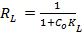, where C_{o} is the highest initial metal ion concentration (mg/L) and K_{L} is the Langmuir constant (L/mg). When, R_{L}> 1: unfavourable; R_{L}< 0: unfavourable; R_{L} = 1: favourable (linear); 0 <R_{L}< 1: favourable; R_{L}= 0: irreversible sorption.
Freundlich model does not restrict to monolayer and uniform adsorption. The adsorption is found to be infinite with the increase in the adsorbate concentration. The linear form of the model is given by Eq. (4).
$logQ_{e}=logk_{f}+\frac{1}{n}\log{C_{e}}$ (4)
Where q_{e} is the amount of metal adsorbed (mg/g), C_{e} is the equilibrium concentration of the metal (mg/L). The plot, log C_{e} versus logq_{e} is considered for the Freundlich model and is linear. k_{f} and n are the Freundlich constants that are calculated from the intercept and slope of the graph respectively. If Freundlich constant (1/n) is close to zero the nature of adsorption is assumed to be heterogeneous, if below unity the nature of adsorption is chemisorption or if the value is above unity, co-operative adsorption is assumed to be the nature of adsorption.^{[5]}
Text S1.4 Characterization of Pteris vittata L. pinnae-based biosorbent
Scanning Electron Microscope and Energy Dispersive X-Ray Analysis
The SEM analysis of the native and the pelletized biosorbent was accomplished using JSM-7600F Field Emission Gun-Scanning electron microscope. The surface characteristics of the powdered and the pelletized biomass were compared. Samples were previously assembled on an aluminium holder using carbon tape and sputtered with a thin layer of gold to improve their conductivity. Finally, the prepared samples were introduced into the microscope chamber with a high vacuum.
The elemental analysis of the native biosorbent was done by the using SEM-EDX. The changes in the elemental composition after metal loading on the biosorbent were studied.
ATR- FTIR analysis
To identify the functional groups, ATR-FTIR (Brucker Eco-ATR) spectrum of the native and the pelletized biosorbent, before and after its introduction to the metal solution was ascertained. Pre-weighed amount of the sample was analysed to avoid any discrepancy in the results.

Text S1.5 Proximate analysis of the biosorbents
Proximate analysis of both the forms of biosorbent was done according to ASTM D2867-09 for moisture content, ASTM E1755-01 for ash content, ASTM D5832-98 for volatile matter and ASTM E1756-08 for total solids in the biomass. Ultimate analysis i.e., C, H, N and O (C= 44.55%, H= 5.803%, N= 2.35% and O= 27.28%) of the biosorbent was analyzed using an elemental analyzer (Thermo Finnigan FLASH EA 1112 Series, Italy). The loose bulk density of the powdered biosorbent was determined according to ASTM D7481-09.
Text S1.6 Statistical Analysis
Data gathered were subjected to Shapiro-Wilk Test of Normality. Based on the Normality test, one-way analysis of variance (ANOVA) at 5% level of significance was applied to determine if there were any statistically significant differences between the means of the independent groups. Since the sample size was small, one-way ANOVA option, Welch’s ANOVA was applied to determine the significant difference. Upon validation of all the assumptions, intergroup mean values were compared using Post Hoc Tukey’s Test. If the assumption of equal variance (Levene Test) was violated, Games-Howell test was applied to the data for multiple comparisons. Statistical Package for the Social Sciences (SPSS) for Windows software was used for statistical analysis.
Text S2 Supplementary information for Results and Discussion
Text S2.1 Determination of equilibrium contact time
Equilibrium time was determined by contacting 0.1 g of the biosorbent with 100 mL of 100 mg/L lead solution of pH 5. Aliquots of solution were taken every 10 minutes for the first two hours. Care was taken such that the final volume of the solution did not reduce more than 5% of the initial volume.
Text S2.2 Detailed discussion on pteridophyte-based sorbents
Although Azolla filiculoides, H₂O or MgCl₂ treated and activated form shows higher metal uptake, it is attributed to its algal association in addition to being treated.^{[6, 7]} The wide distribution of Pteris vittata L. in the Indian subcontinent increases its potential to be used as a biosorbent due to the unrestricted availability of the biomass as compared to habitat-specific Azolla filiculoides. Pteris vittata L. pinnae powder shows good metal uptake capacity in its pristine form but the Pb(II) removal per gram of the biosorbent reduced during pelleting. The sorption capacity of the pristine biomass can be further improved by subjecting it to activation or chemical modification.^{[8]}
Text S2.3 Evaluation of Pulsed Plate Column experimental data
Breakthrough curves (C_{t}/C_{i} vs. time, t) were obtained from the data generated by the Pulsed Plate column experiments. The various parameters associated with the column studies were analysed using the following equations.
The maximum Pb(II) adsorption capacity of the biosorbent in the column, q_{total} in mg for a given inlet concentration of Pb(II) and flow rate is given by Eq. (5).
$q_{total}=\frac{Q}{1000}\int_{t=0}^{t=t_{total}}{C_{t}dt}$ (5)
Where C_{t} is the adsorbed Pb(II) concentration (mg/L) at time, t and Q is the volumetric flow rate (mL/min).
Total amount of Pb(II) sent to the column (in mg) was obtained using Eq. (6).
$M_{total}= \frac{QC_{i}t_{total}}{1000}$ (6)
Where C_{i} is the inlet Pb(II) concentration (mg/L) and t_{total} is the total time the column is operated.
The metal uptake by the biosorbent in the column was determined by using Eq. (7).
$q=\frac{Q\left(C_{i}-C_{t}\right)t}{m}$ (7)
Where Q is the volumetric flow rate (L/h), C_{i} is the initial Pb(II) concentration, C_{t} is the Pb(II) concentration at time, t and m is the biosorbent mass.
Pb(II) removal efficiency (%) of the column is given by the ratio of the maximum Pb(II) adsorption capacity of the biosorbent in the column, q_{total} to the total amount of Pb(II) sent to the column, as shown in Eq. (8).
$Total removal \%= \frac{q_{total}}{M_{total}}×100$ (8)

Table S1 Characteristics of powdered and pelletized biosorbent
Biosorbent type |  | Native powdered biosorbent | Pelletized biosorbent
Proximate  Analysis  (Wt %) | Moisture | 1.67± 0.29 | 2.70± 0.17
 | Ash | 13.46± 1.66 | 8.22± 0.20
 | Volatile matter | 85.83± 1.97 | 89.20± 1.00
Total solids |  | 98.33± 0.29 | 97.44± 0.29
Bulk density (kg/m³) |  | 185.33± 3.51 | 508.94- 777.42

Table S2 Games-Howell Multiple Comparisons for metal uptake efficiency at different metal concentrations
Comparison of metal uptake |  | Mean Difference | Sig. | Comparison of metal uptake | Mean Difference | Sig.
100 | 150 | 14.25* | .006 | 100 | -43.70* | .022
 | 200 | 31.13* | .001 | 150 | -29.45 | .058
 | 250 | 37.65* | .000 | 200 | -12.57 | .261
 | 300 | 43.70* | .022 | 300 250 | -6.057 | .704
 | 350 | 46.63* | .000 | 350 | 2.93 | .971
 | 400 | 41.88* | .001 | 400 | -1.82 | .997
 | 450 | 47.78* | .000 | 450 | 4.07 | .900
150 | 100 | -14.25* | .006 | 100 | -46.63* | .000
 | 200 | 16.88* | .024 | 150 | -32.38* | .000
 | 250 | 23.39* | .000 | 200 | -15.50* | .024
 | 300 | 29.45 | .058 | 350 250 | -8.99* | .002
 | 350 | 32.38* | .000 | 300 | -2.93 | .971
 | 400 | 27.63* | .000 | 400 | -4.75* | .013
 | 450 | 33.52* | .000 | 450 | 1.14 | .775
200 | 100 | -31.13* | .001 | 100 | -41.88* | .001
 | 150 | -16.88* | .024 | 150 | -27.63* | .000
 | 250 | 6.51 | .157 | 200 | -10.75 | .066
 | 300 | 12.57 | .261 | 400 250 | -4.23* | .033
 | 350 | 15.50* | .024 | 300 | 1.82 | .997
 | 400 | 10.75 | .066 | 350 | 4.75* | .013
 | 450 | 16.64* | .014 | 450 | 5.90* | .031
250 | 100 | -37.65* | .000 | 100 | -47.78* | .000
 | 150 | -23.39* | .000 | 150 | -33.52* | .000
 | 200 | -6.51 | .157 | 200 | -16.64* | .014
 | 300 | 6.06 | .704 | 450 250 | -10.13* | .002
 | 350 | 8.99* | .002 | 300 | -4.07 | .900
 | 400 | 4.23* | .033 | 350 | -1.14 | .775
 | 450 | 10.13* | .002 | 400 | -5.89* | .031
Table S3 Sorption of lead at randomly selected metal to dosage ratios
Initial metal concentration (mg/L) | Dosage (g/L) | Metal to dosage ratio (g/g) | Metal uptake (mg/g) | SD
100 | 2.00 | 0.05 | 47.14 | 2.99
150 | 3.00 |  | 39.89
200 | 4.00 |  | 44.33
250 | 5.00 |  | 44.38
100 | 1.00 | 0.10 | 85.84 | 5.80
150 | 1.50 |  | 79.04
200 | 2.00 |  | 75.66
250 | 2.50 |  | 72.18
100 | 0.75 | 0.13 | 108.01 | 11.00
150 | 1.13 |  | 97.39
200 | 1.50 |  | 89.44
250 | 1.88 |  | 82.32
*Table S4 Intra-particle diffusion constants for Pb(II) ion uptake by pelletized biosorbent at dosage 10, 15 and 20 mg/L
K_{id1} (mgg⁻¹min^{-1/2}) |  |  | C₁ |  |  | K_{id2} (mgg⁻¹min^{-1/2}) |  |  | C₂
10 mg/L | 15 mg/L | 20 mg/L | 10 mg/L | 15 mg/L | 20 mg/L | 10 mg/L | 15 mg/L | 20 mg/L | 10 mg/L | 15 mg/L | 20 mg/L
0.08 | 0.07 | 0.05 | 5.25 | 0.42 | 0.71 | 0.04 | 0.00 | 0.00 | 3.09 | 5.50 | 4.60
*K_{id1} and C₁ represent the macropore and mesopore diffusion. K_{id2} and C₂ represent the micropore diffusion stage.
It is evident upon comparing the K_{id} values for the macropore and micropore diffusion stages that micropore diffusion is the rate determining step as the constants, K_{id2} (micropore diffusion constant) were lower than those for the K_{id1} (macropore diffusion constant). Both, K_{id1}and K_{id2} constants were in the following order: 10> 15> 20 mg/L. Lower the K_{id} value, slower is the diffusion process. Hence internal diffusion of Pb(II) was fast at pellet dosage of 10 mg/L and slowest at 20 mg/L. Thus, justifying the trend obtained for Pb(II) uptake at various pellet dosages. The effect of boundary layer is greater at the micropore diffusion stage (C₂) than at the macropore stage (C₁) as C₂> C₁.
Table S5 Parameters of Pseudo-second order kinetic model for the sorption of Pb(II) on the powdered and pelletized biosorbents
q_{e}(mg/g) | Theoretical q_{e} (mg/g) | R²
POWDERED Pteris vittata L. BASED BIOSORBENT
85.32 | 90.90 | 0.997
PELLETIZED Pteris vittata L. BASED BIOSORBENT
9.59 | 10.42 | 0.995
Table S6 Comparison of maximum Pb(II) sorption capacity of untreated-Pteris vittata L. pinnae powder with other pteridophyte-based sorbents
Adsorbent | Maximum Biosorption Capacity (mg/g) | Reference
Pristine Pteris vittata L. pellets | 8.40 | Present study
Acrostichum aureum L | 28.57 | Soniya and Krishnakumar^{[9]}
Tree fern | 40.00 | Ho et al.^{[10]}
Pteris vittata L.  HNO₃ treated | 51.55 | Prabhu et al.^{[8]}
Pteris vittata L.  CaCl₂ treated | 90.91 | Prabhu et al.^{[8]}
Pteris vittata L. pinnae powder (pristine) | 125.00 | Present Study
Pteris vittata L.  NaOH treated | 133.33 | Prabhu et al.^{[8]}
Azolla filiculoides (dry)  H₂O or MgCl₂ treated | 228.00 | Ganji et al.^{[6]}
Azolla filiculoides (Activated) | 271.00 | Khosravi et al.^{[7]}

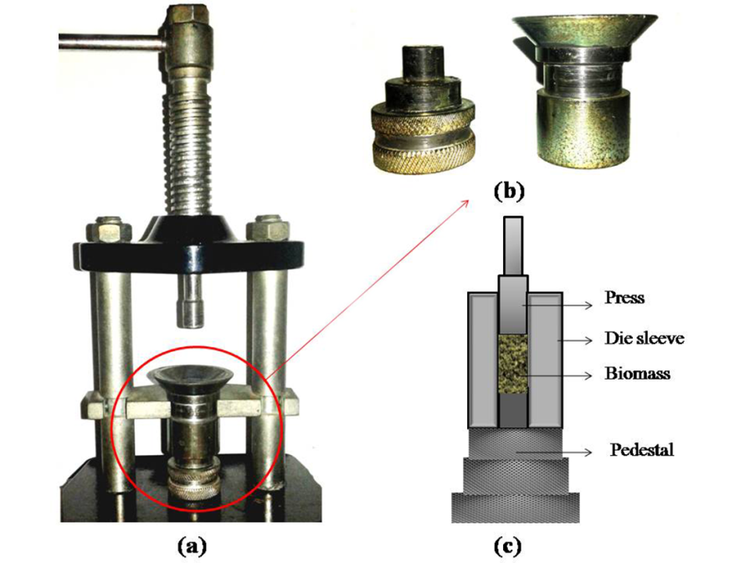
Fig. S1 Schematic of a compression system: (a) the manual press, (b) die of the pellet press and (c) representative pelleting set-up. Dimensions: It includes a cylindrical die (with a diameter of 12 mm, length of 34 mm and 13 mm in the presence of the pedestal) and a press (11.88 mm in diameter)

Fig. S2 Amount of Pb(II) ion biosorbed versus time

Fig. S3 Effect of sorbate to sorbent dosage ratio on Pb(II) sorption. Particle size= 150 to ≤300 μm, Contact time=120 min, Temperature= 30 °C, pH =5
Fig. S4 Uptake of Pb(II) by the pelletized biosorbent at varied initial Pb(II) concentrations. Means that do not share a letter are significantly different
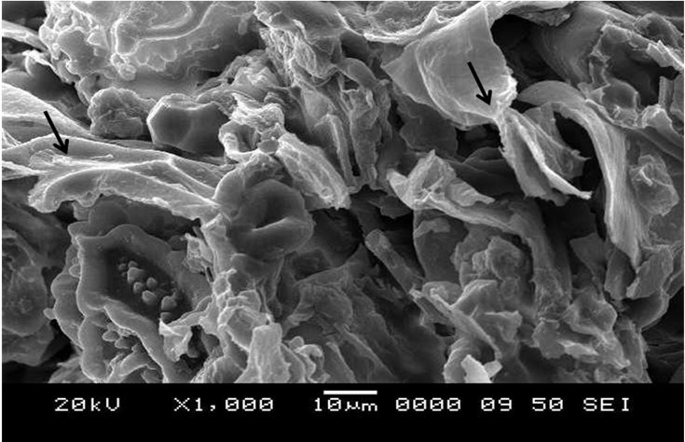
Fig. S5 SEM micrograph of Pteris vittata L. pellets with corn starch binder
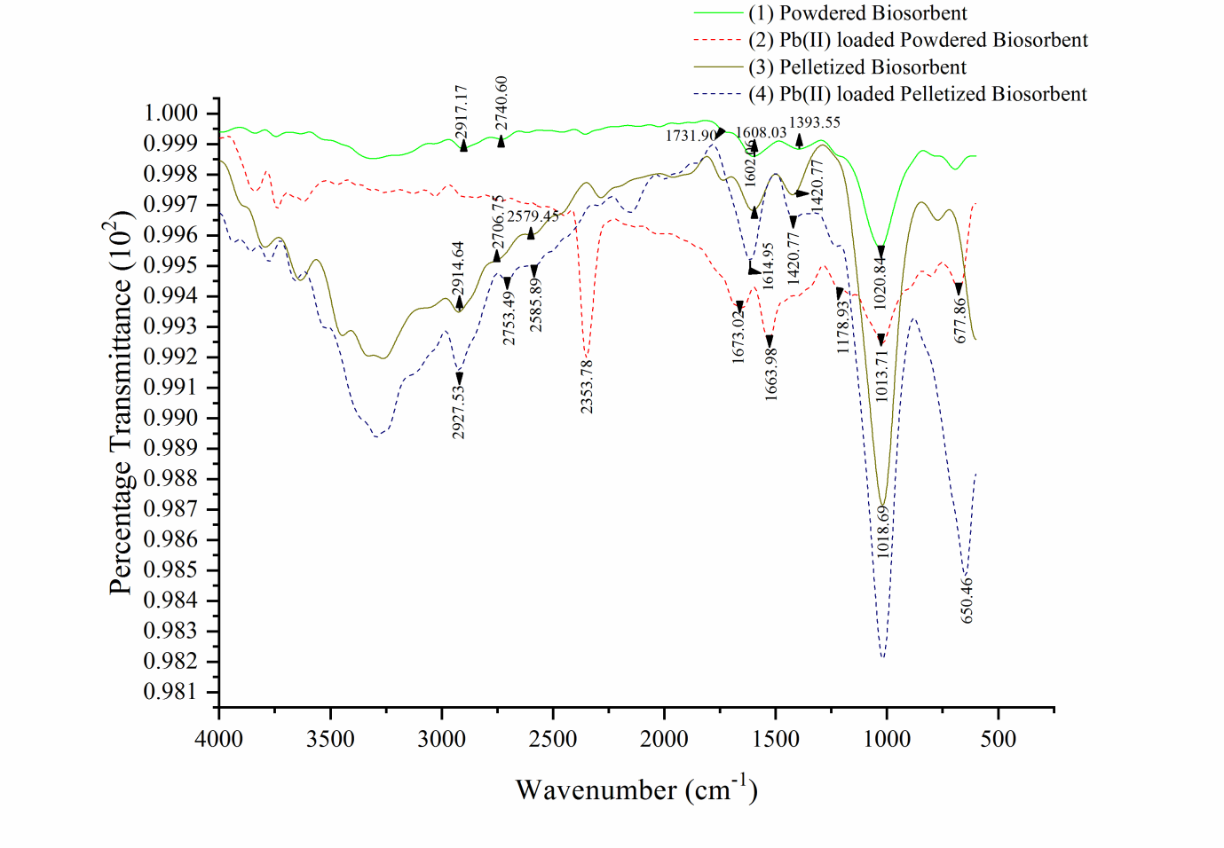
Fig. S6 ATR- FTIR spectra peak frequencies and corresponding possible functional groups of Pteris vittata L. pinnae powder and pellets before (1 and 3) and after lead adsorption (2 and 4)
References
- Mata, Y.N.; Blázquez, M.L.; Ballester, A.; González, F.; Muñoz, J.A. (2010) Studies on sorption, desorption, regeneration and reuse of sugar- beet pectin gels for heavy metal removal. J. Hazard. Mater., 178: 243-248.
- Fierro, V.; Torné-Fernández, V.; Montané, D.; Celzard, A. (2008) Adsorption of phenol onto activated carbons having different textural and surface properties. Microporous Mesoporous Mater 111:276-284.
- Tarawou, T.; Young, E. (2015) Intraparticle and Liquid film diffusion studies on the adsorption of Cu²⁺ and Pb²⁺ ions from aqueous solution using powdered cocoa pod (Theobroma cacao). IRJET, 2: 236-243.
- Tsibranska, I.; Hristova, E. (2011) Comparison of different kinetic models for adsorption of heavy metals onto activated carbon from apricot stones. Bulg. Chem. Commun., 43: 370-377.
- Foo, K.Y.; Hameed, B.H. (2009) Insights into the modeling of adsorption isotherm systems. Chem. Eng. J., 156: 2-10.
- Ganji, M.T., Khosravi, M.; Rakhshaee, R. (2005) Biosorption of Pb, Cd, Cu and Zn from the wastewater by treated Azolla filiculoides with H₂O₂/ MgCl₂. Int. J. Environ. Sci. Technol., 1: 265-271.
- Khosravi, M.; Rakhshaee, R.; Ganji, M.T. (2005) Pre- treatment process of Azolla filiculoides to removal Pb(II), Cd(II), Ni(II) and Zn(II) from aqueous solution in the batch and fixed- bed reactors. J. Hazard. Mater., 127: 228-237.
- Prabhu, S.G.; Srinikethan, G.; Hegde, S. (2018) Surface treated Pteris vittata L. pinnae powder used as an efficient biosorbent of Pb(II), Cd(II) and Cr(VI) from aqueous solution. Int. J. Phytoremediation, 20: 947-956.
- Soniya, L.; Krishnakumar, G. (2015) Biosorption of heavy metals from aqueous solution using Mangrove fern Acrostichum aureum L. leaf biomass as a sorbent. Int. Res. J. Environ. Sci., 4: 25-31.
- Ho, Y.S.; Chiu, W.T.; Hsu, C.S.; Huang, C.T. (2004) Sorption of lead ions from aqueous solution using tree fern as a sorbent. Hydrometallurgy, 73: 55-61.

