Surporting Information
No. | Content | Pages
S1 | ¹H NMR spectrum of S1 | 2
S2 | ESI-MS spectrum of S1 | 3
S3 | Visual color changes of S1 in different HEPES–DMSO buffer solutions | 4
S4 | Linear plot of S1 (20 μM) against CN⁻ in HEPES–DMSO (1:9, V/V, pH = 7.0) for calculating detection limit of CN⁻. | 5
S5 | The resulting titration curve of S1 with CN⁻ in HEPES–DMSO (2:8, V/V, pH = 7.0) (Inset: the result of the Hill plot analysis) | 6
S6 | Linear plot of S1 (20 μM) against CN⁻ in HEPES–DMSO (2:8, V/V, pH = 7.0) for calculating detection limit of CN⁻. | 7
S7 | The resulting titration curve of S1 with CN⁻ in HEPES–DMSO (3:7, V/V, pH = 7.0) (Inset: the result of the Hill plot analysis) | 8
S8 | Linear plot of S1 (20 μM) against CN⁻ in HEPES–DMSO (3:7, V/V, pH = 7.0) for calculating detection limit of CN⁻. | 9
S9 | The resulting titration curve of S1 with CN⁻ in HEPES–DMSO (4:6, V/V, pH = 7.0) (Inset: the result of the Hill plot analysis). | 10
S10 | Linear plot of S1 (20 μM) against CN⁻ in HEPES–DMSO (4:6, V/V, pH = 7.0) for calculating detection limit of CN⁻. | 11
S11 | The resulting titration curve of S1 with CN⁻ in HEPES–DMSO (1:1, V/V, pH = 7.0) (Inset: the result of the Hill plot analysis). | 12
S12 | Linear plot of S1 (20 μM) against CN⁻ in HEPES–DMSO (1:1, V/V, pH = 7.0) for calculating detection limit of CN⁻. | 13
S13 | Jobs’ plot of S1 with CN⁻. | 14
S14 | ESI-MS spectrum of S1 after the addtion of excess of CN⁻. | 15
S15 | Effect of time (from 0 to 30 minutes) on the UV-vis spectra. | 16
S16 | Effect of pH (from 3 to13) on the UV-vis spectra for S1 (20 μM). | 17
S17 | Labels of C, H, O, N atoms in optimized structure of S1. | 18
Table S1 | Representative interatomic distance. | 18
Table S1 | Correlative calculation results of different species. | 18

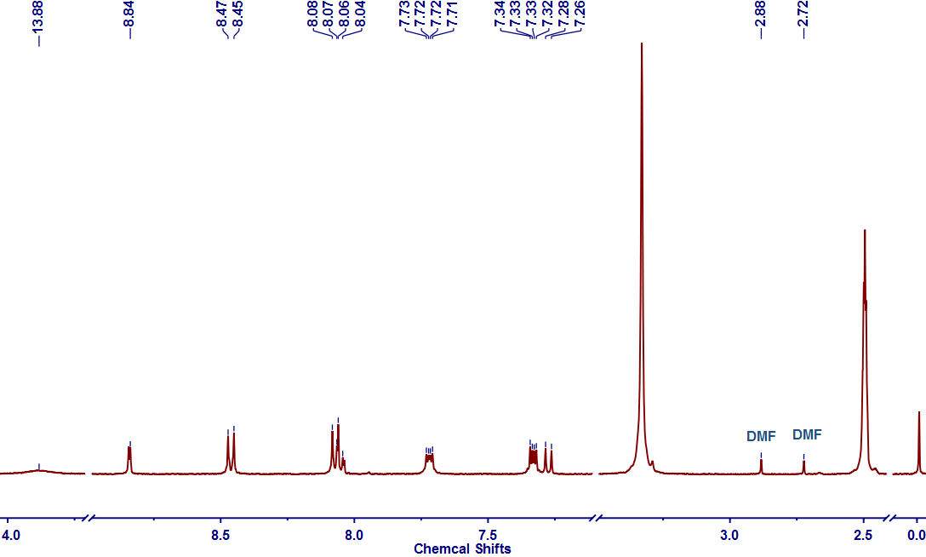
Figure S1. ¹H NMR spectrum of S1 in DMSO-d₆.
In Figure S1, the signals of 2.72 and 2.88 ppm colud be assigned to the solvent impurities of dimethylformamide (DMF). In our experiments, the dimethyl sulfoxide (DMSO) was used as the polar solvent. DMF is also a polar solvent, which is always used for the investigation of sensing behavior ^{[1]}, and there isn’t much difference among λ_{max} of sensor in DMSO or DMF solvent. That is, the negative effects generated from the traces of DMF can be ignored.

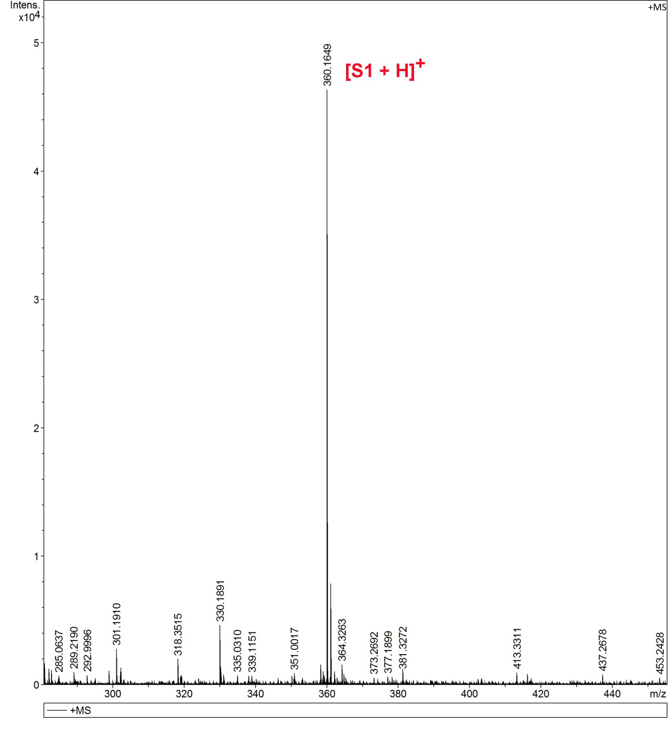
Figure S2. ESI-MS spectrum of S1, calc. for C₁₉H₁₄N₅O₃ , 360.1097, found: 360.1649.
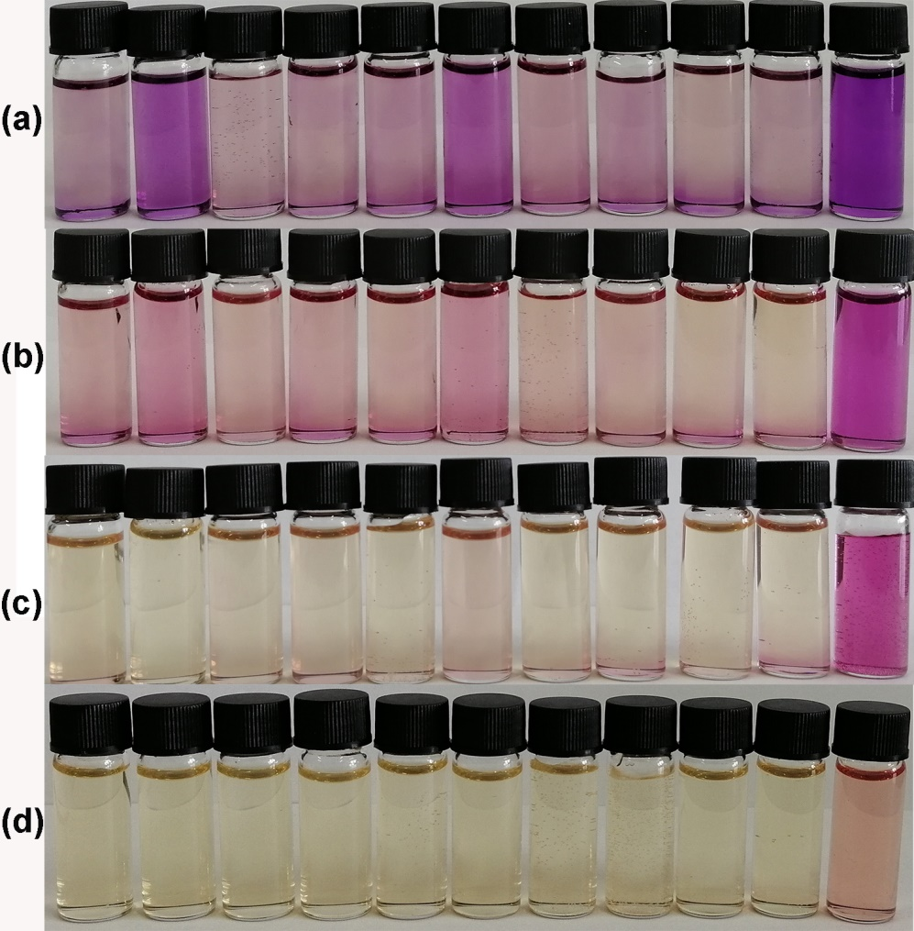
Figure S3. Visual color changes of S1 (20 μM) in (a) HEPES–DMSO (1:9, V/V, pH = 7.0); (b) HEPES–DMSO (2:8, V/V, pH = 7.0); (c) HEPES–DMSO (3:7, V/V, pH = 7.0); (d) HEPES–DMSO (1:1, V/V, pH = 7.0) (v/v) after addition of 10 equiv. corresponding anions (F⁻, Cl⁻, Br⁻, I⁻, AcO⁻, H₂PO₄⁻, ClO₄⁻, HSO₄⁻, SCN⁻ and CN⁻, respectively).
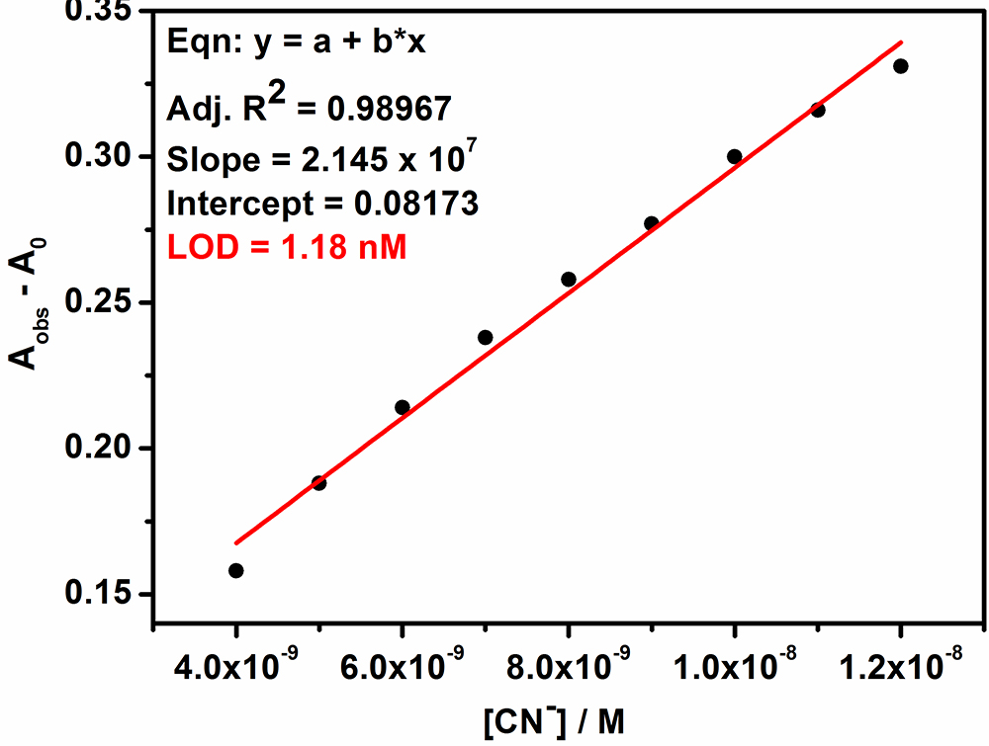
Figure S4. Linear plot of S1 (20 μM) against CN⁻ ( 0 – 1.2 × 10⁻⁸ M) in HEPES–DMSO (1:9, V/V, pH = 7.0) for calculating detection limit of CN⁻.
SD = $\sqrt{{\sum{{(A-A1)}^{2}}}/{(N-1)}}$ = 0.008412
LOD = 3 × SD / Slope = 3 × 0.008412/ (2.145 × 10⁷) = 1.18 × 10⁻⁹ M

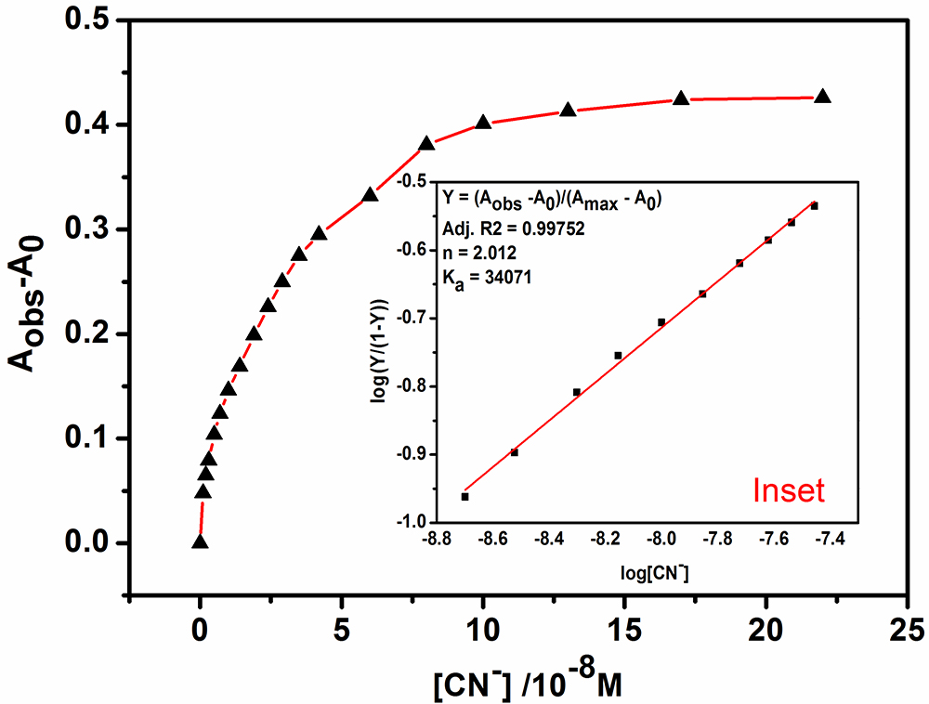
Figure S5. The resulting titration curve of S1 with CN⁻ in HEPES–DMSO (2:8, V/V, pH = 7.0) (Inset: the result of the Hill plot analysis)

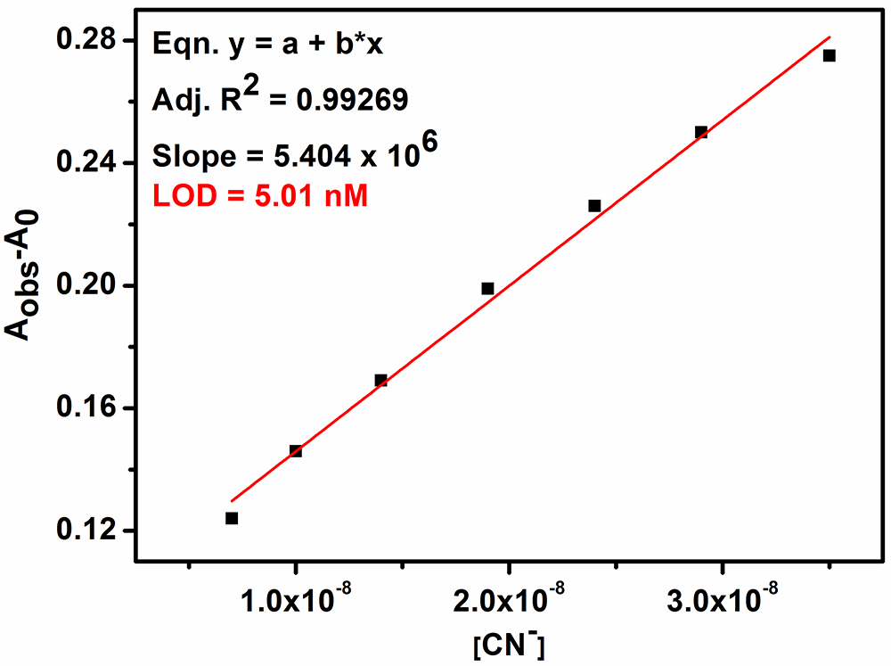
Figure S6. Linear plot of S1 (20 μM) against CN⁻ ( 0 – 3.5 × 10⁻⁸ M) in HEPES–DMSO (2:8, V/V, pH = 7.0) for calculating detection limit of CN⁻.
SD = $\sqrt{{\sum{{(A-A1)}^{2}}}/{(N-1)}}$ = 0.009018
LOD = 3 × SD / Slope = 3 × 0.009018/ (5.404 × 10⁶) = 5.01 × 10⁻⁹ M
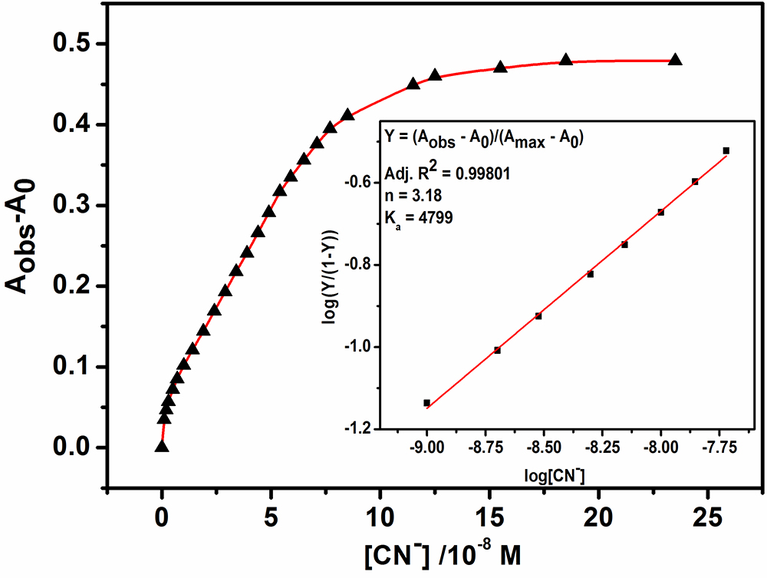
Figure S7. The resulting titration curve of S1 with CN⁻ in HEPES–DMSO (3:7, V/V, pH = 7.0) (Inset: the result of the Hill plot analysis)

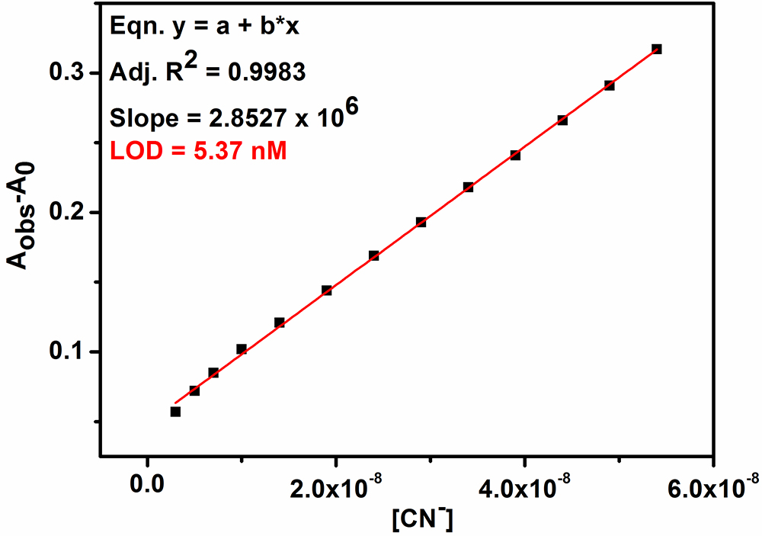
Figure S8. Linear plot of S1 (20 μM) against CN⁻ ( 0 – 5.4 × 10⁻⁸ M) in HEPES–DMSO (3:7, V/V, pH = 7.0) for calculating detection limit of CN⁻.
SD = $\sqrt{{\sum{{(A-A1)}^{2}}}/{(N-1)}}$ = 0.005106
LOD = 3 × SD / Slope = 3 × 0.005106/ (2.8527 × 10⁶ ) = 5.37 × 10⁻⁹ M

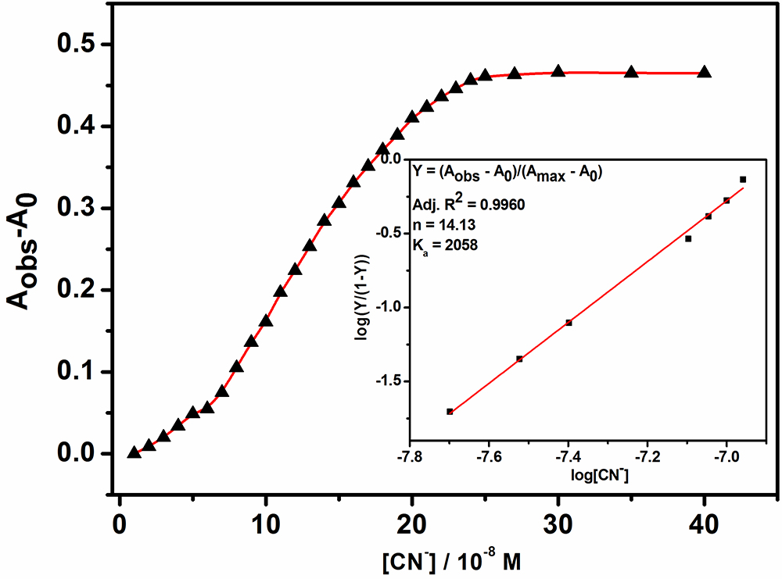
Figure S9. The resulting titration curve of S1 with CN⁻ in HEPES–DMSO (4:6, V/V, pH = 7.0) (Inset: the result of the Hill plot analysis).

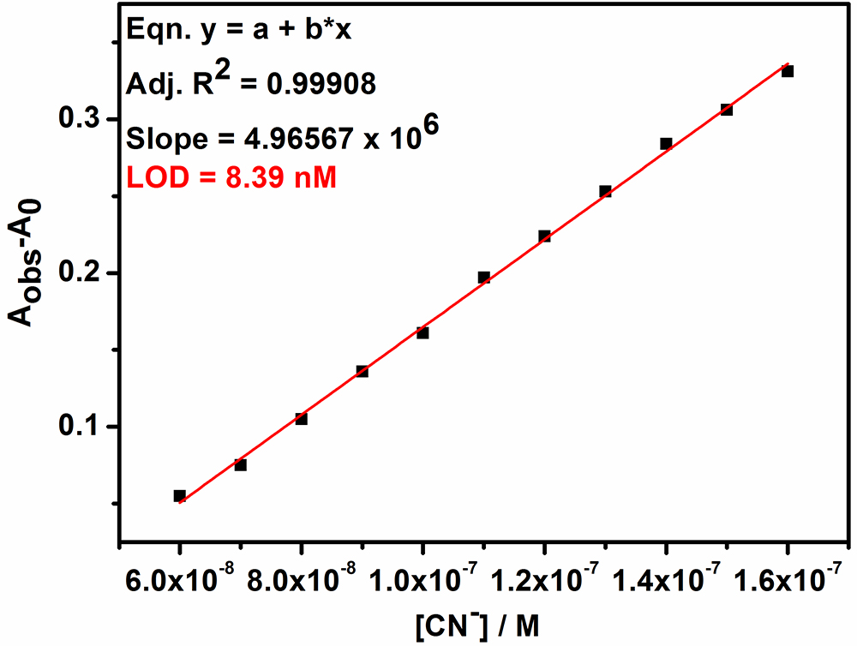
Figure S10. Linear plot of S1 (20 μM) against CN⁻ ( 0 – 5.4 × 10⁻⁸ M) in HEPES–DMSO (4:6, V/V, pH = 7.0) for calculating detection limit of CN⁻.
SD = $\sqrt{{\sum{{(A-A1)}^{2}}}/{(N-1)}}$ = 0.013895
LOD = 3 × SD / Slope = 3 × 0.013895/ (4.96567 × 10⁶) = 8.39 × 10⁻⁹ M
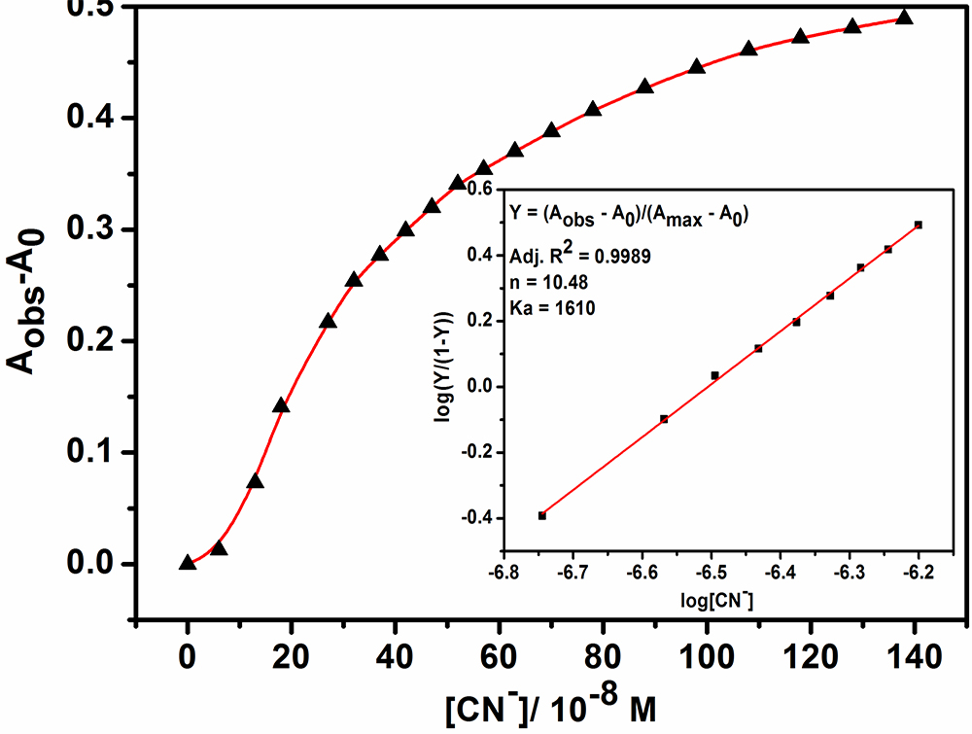
Figure S11. The resulting titration curve of S1 with CN⁻ in HEPES–DMSO (1:1, V/V, pH = 7.0) (Inset: the result of the Hill plot analysis).

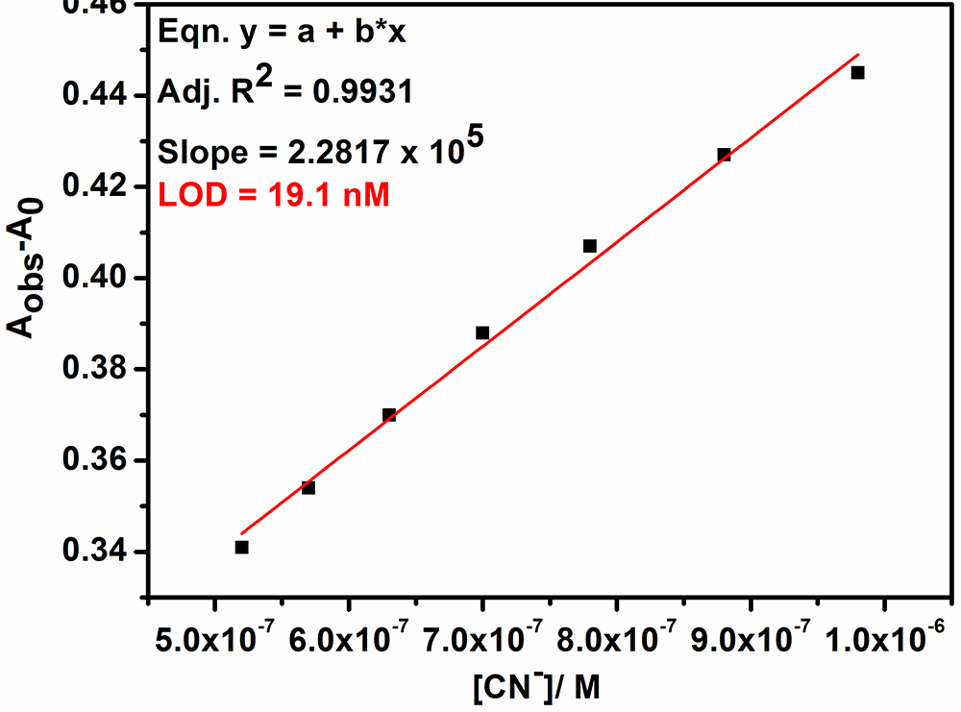
Figure S12. Linear plot of S1 (20 μM) against CN⁻ ( 0 – 5.4 × 10⁻⁸ M) in HEPES–DMSO (1:1, V/V, pH = 7.0) for calculating detection limit of CN⁻.
SD = $\sqrt{{\sum{{(A-A1)}^{2}}}/{(N-1)}}$ = 0.00145
LOD = 3 × SD / Slope = 3 × 0.00145/ (2.2817 × 10⁵) = 19.1 × 10⁻⁹ M

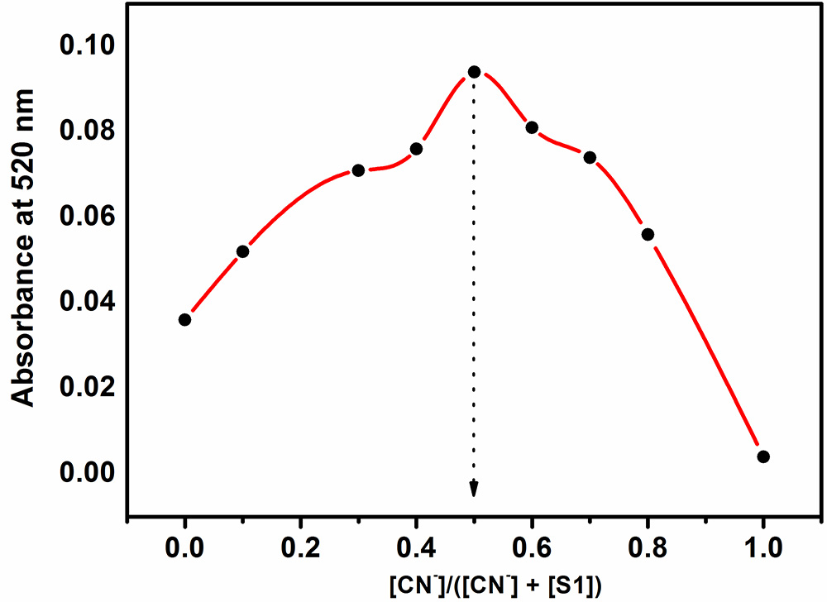
Figure S13. Jobs’ plot of S1 with CN⁻ ([S1 + CN⁻] = 20 μM) in HEPES–DMSO (4:6, V/V, pH = 7.0) shows 1:1 stoichiometry.
Figure S14. ESI-MS spectrum of S1 after the addtion of excess of CN⁻ (m/z: calcd for C₁₉H₁₂N₅O₃ : 358.0940 [S1 - H⁺]⁻; found: 358.1638).

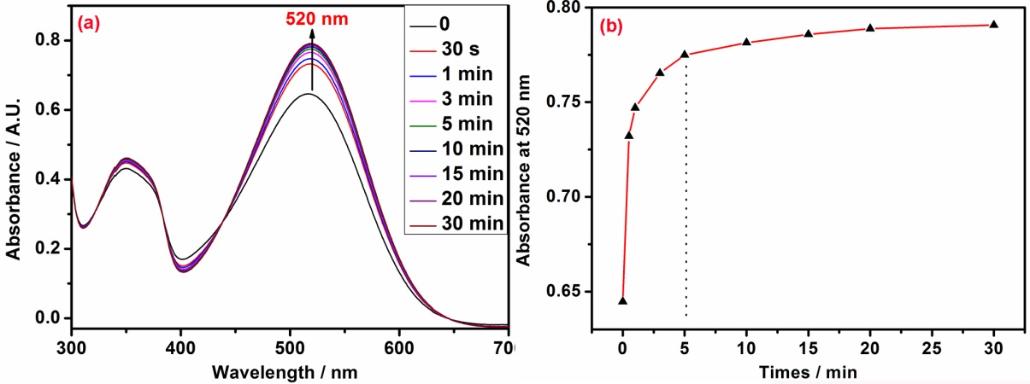
Figure S15. Effect of time (from 0 to 30 minutes) on the UV-vis spectra (a) and on the absorbance at 520 nm (b) for S1 (20 μM) in HEPES–DMSO (4:6, V/V, pH = 7.0) (V/V) solution after addtion of 10 equiv. CN⁻.

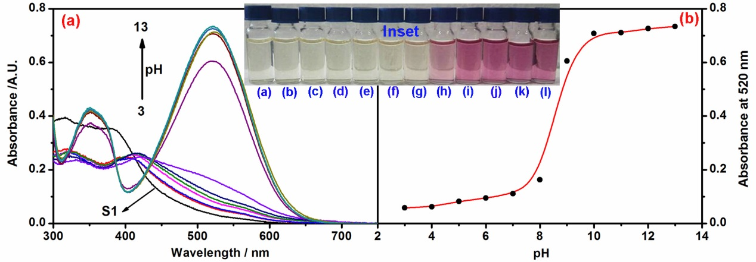
Figure S16. (a) Effect of pH (from 3 to13) on the UV-vis spectra for S1 (20 μM) in 40% H₂O-60% DMSO (V/V) solution, pH values were controlled by the HEPES solution; (b) the change curve of S1 with different pH values (Inset: color change of S1 at different pH values, (a) S1 only, from (b) to (l) pH value is 3 to 13, respectively).

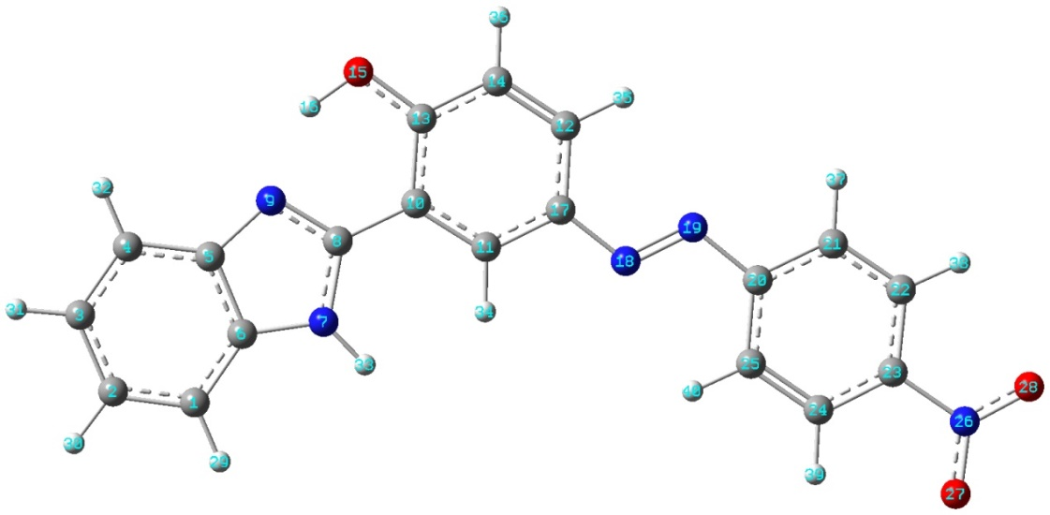
Figure S17. Labels of C, H, O, N atoms in optimized structure of S1.
Table S1 representative interatomic distance
SN | O₁₅-H₁₆ | C₁₃-O₁₅ | C₈-C₁₀ | C₈-N₉ | C₈-N₇ | C₈-N₉ | N₇-H₃₃ | H₁₆-N₉
S1 | 0.9980 | 1.3296 | 1.4561 | 1.3234 | 1.3744 | 1.4240 | 1.0063 | 1.7020

Table S2 Correlative calculation results of different species
SN | E | H | G | S | HOMO | LUMO | Δ_{E}ª | Δ_{E}ª
units | a.u. | a.u. | a.u. | cal/(mol‧K) | eV | eV | kJ/mol | eV
CN⁻ | -92.8616 | -92.8583 | -92.8806 | 47.019
HCN | -93.4356 | -93.4321 | -93.4549 | 48.043
S1 | -1231.19 | -1231.17 | -1231.24 | 156.91 | -6.24 | -3.15 | 297.99 | 3.09
S1-H | -1230.67 | -1230.65 | -1230.72 | 156.94 | -2.37 | -0.12 | 217.01 | 2.25
a: Δ_{E} = Δ_{(LUMO-HOMO)}

Reference
[1] Balamurugan, G.; Velmathi, S. Anal. Methods 2016, 8, 1705-1710.

