Appendix - Supplementary Material

Volatile sulfide compounds (VSCs) and ammonia emission characteristics and odor contribution in the process of municipal sludge composting

Zhao Shan^{1,2,3}, Yang Xiaofang^{1,*}, Zhang Weijun ⁴, Jiang Chang³, Wang Dongsheng^{1,2,*}
1. Research Center for Eco-Environmental Sciences, Chinese Academy of Sciences, Beijing 100085, China;
2. University of Chinese Academy of Sciences, Beijing 100049, China;
3. Research and Development Center, Beijing Drainage Group Co., Ltd, Beijing 100124, China;
4. School of Environmental Studies, China University of Geosciences, Wuhan 430074, Hubei, China

The appendix contains 3 Figures and 1 Table.
Figures:
Figure A1. Flow chart of the sludge aerobic composting process.
Figure A2. Sampling points of NH₃ and VSCs in the sludge treatment workshops.
Figure A3. The sketch of the static chamber of sludge composting
Figures:
Table R1. Method detection limits and R2 of calibration curves of VSCs

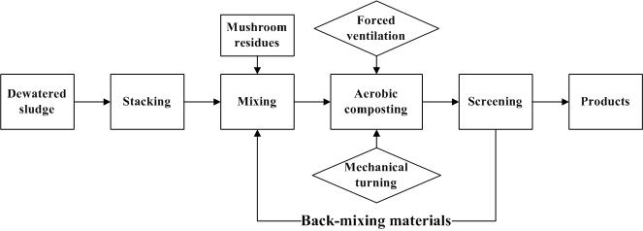
Figure A1. Flow chart of the sludge aerobic composting process.

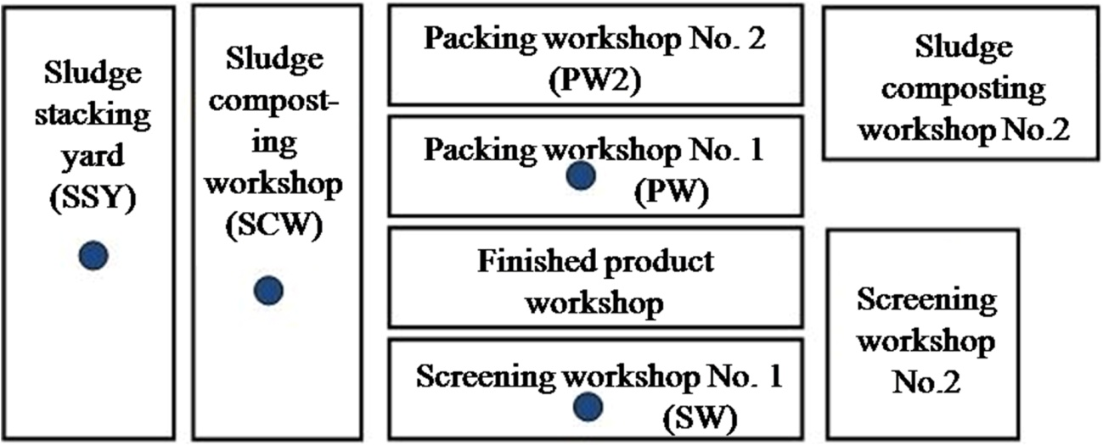
Figure A2. Sampling points of NH₃ and VSCs in the sludge treatment workshops.
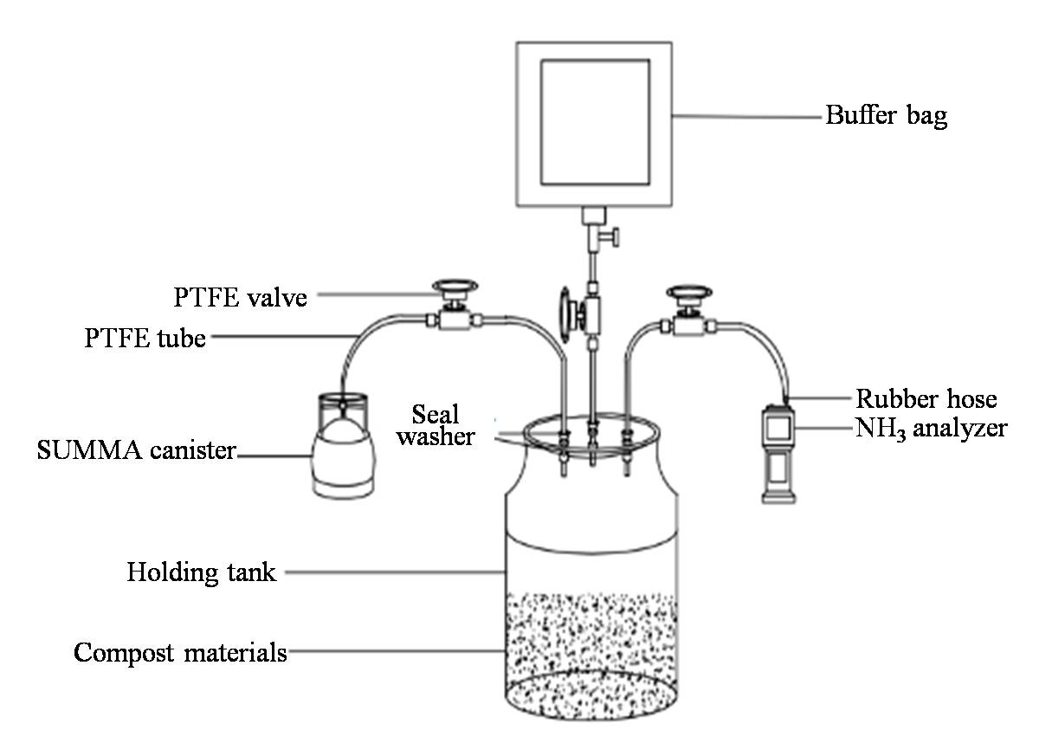
Figure A3. The sketch of the static chamber of sludge composting.
Table:
Table A1. Method detection limits and R² of calibration curves of VSCs
VSCs | Detection limits (μg·m⁻³) | Calibration curves R²
H₂S | 0.189 | R²=0.9999, p<0.01
MT | 0.144 | R²=0.9999, p<0.01
DMS | 0.048 | R²=0.9998, p<0.01
CS₂ | 0.028 | R²=0.9433, p<0.01
DMDS | 0.037 | R²=0.9998, p<0.01

