Improving the Accuracy of Emission Inventories with a Machine-Learning Approach and Investigating Transferability across Cities

Supplemental Information

Ran Tu
PhD Candidate, University of Toronto
ran.tu@mail.utoronto.ca

An Wang
PhD Candidate, University of Toronto
ananan.wang@mail.utoronto.ca

Marianne Hatzopoulou (Corresponding Author)
Associate Professor, Civil and Mineral Engineering, University of Toronto
35 St George Street, Toronto, ON M5S 1A4
PHONE: 416-978-0864, FAX: 416-978-6813
marianne.hatzopoulou@utoronto.ca

1- Development of traffic simulation
Traffic data used for training and testing CLEVER were generated from AIMSUN hybrid simulation [1]. The hybrid simulation is able to aggregate traffic data such as average speed and density for each link over the entire simulated network, and generate second-by-second driving profiles in selected microsimulation areas. Since each of the subnetworks (City of Toronto, Mississauga, and Ajax) does not encompass the entire Greater Toronto Area (GTA), traffic demand of these three areas was retrieved by “OD traversal” function in AIMSUN [2] based on the GTA OD data. As illustrated in Figure A, the gray box represents each subnetwork, and demand of the entire region (shown as the circle) can be categorized into five groups: out-out, out-in-out, in-out, out-in, and in-in. OD traversal function summarizes the total number of trips that cross the boundary of the subnetwork (in-out, out-in, out-in-out), or happen inside the boundary (in-in).
The process of microscopic simulation is called “time-based”. Time moves based on a time step, and intervening movements like speed, and lane changing, are considered for each vehicle, while the vehicle moves by the distance determined for that time step. As such, a vehicle’s instantaneous speed and acceleration in each time step can be recorded by microscopic simulation. In contrast, mesoscopic simulation in AIMSUN is “event-based”, which means traffic data are obtained after a certain event like a vehicle passing one link [3]. Aggregate traffic data are then summarized out of these event-based records.

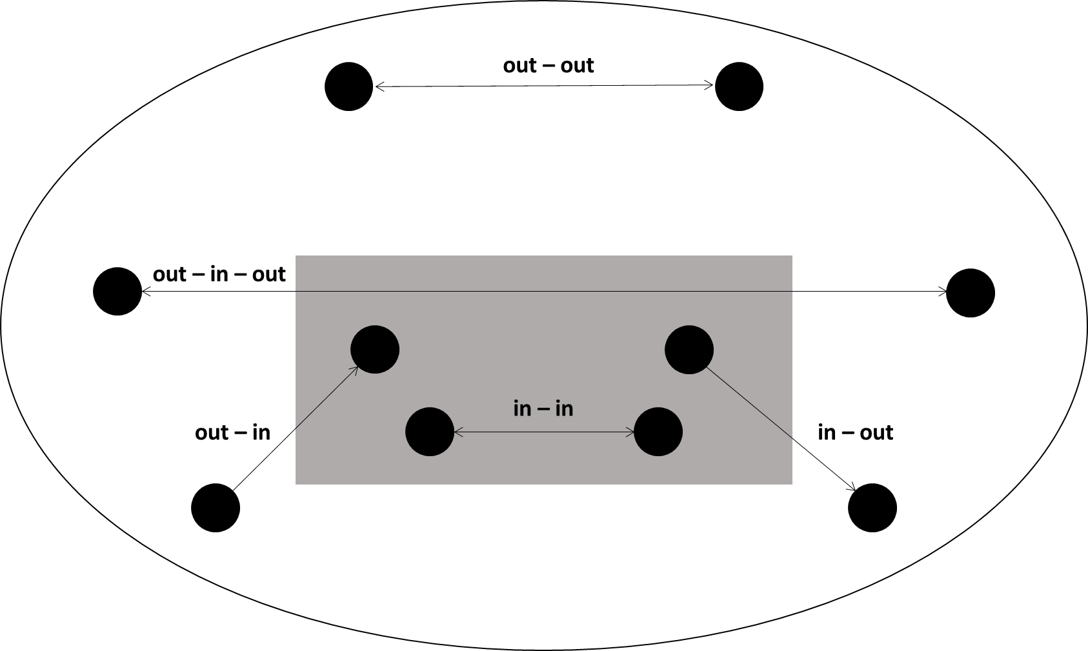
Figure A Relationship between trips and subnetwork

2- Calibration of traffic simulation
Network parameters of the AIMSUN simulation model were calibrated with hourly average speed and traffic volume aggregated from loop detector data on major highways of the GTA. Parameters such as road capacity, jam density, traffic demand, and traffic signals were adjusted to reach the minimal calibration criterion GEH, defined the following equation.
$$GEH=\sqrt{\frac{2{\left(M-C\right)}^{2}}{M+C}}$$
Where M represents simulated traffic flow, and C represents observed traffic flow.
Figure B presents the calibrated speeds and volumes, and as a result, the average GEH after calibration was 13.6 (down from 20). More details on the network calibration can be found in [4].
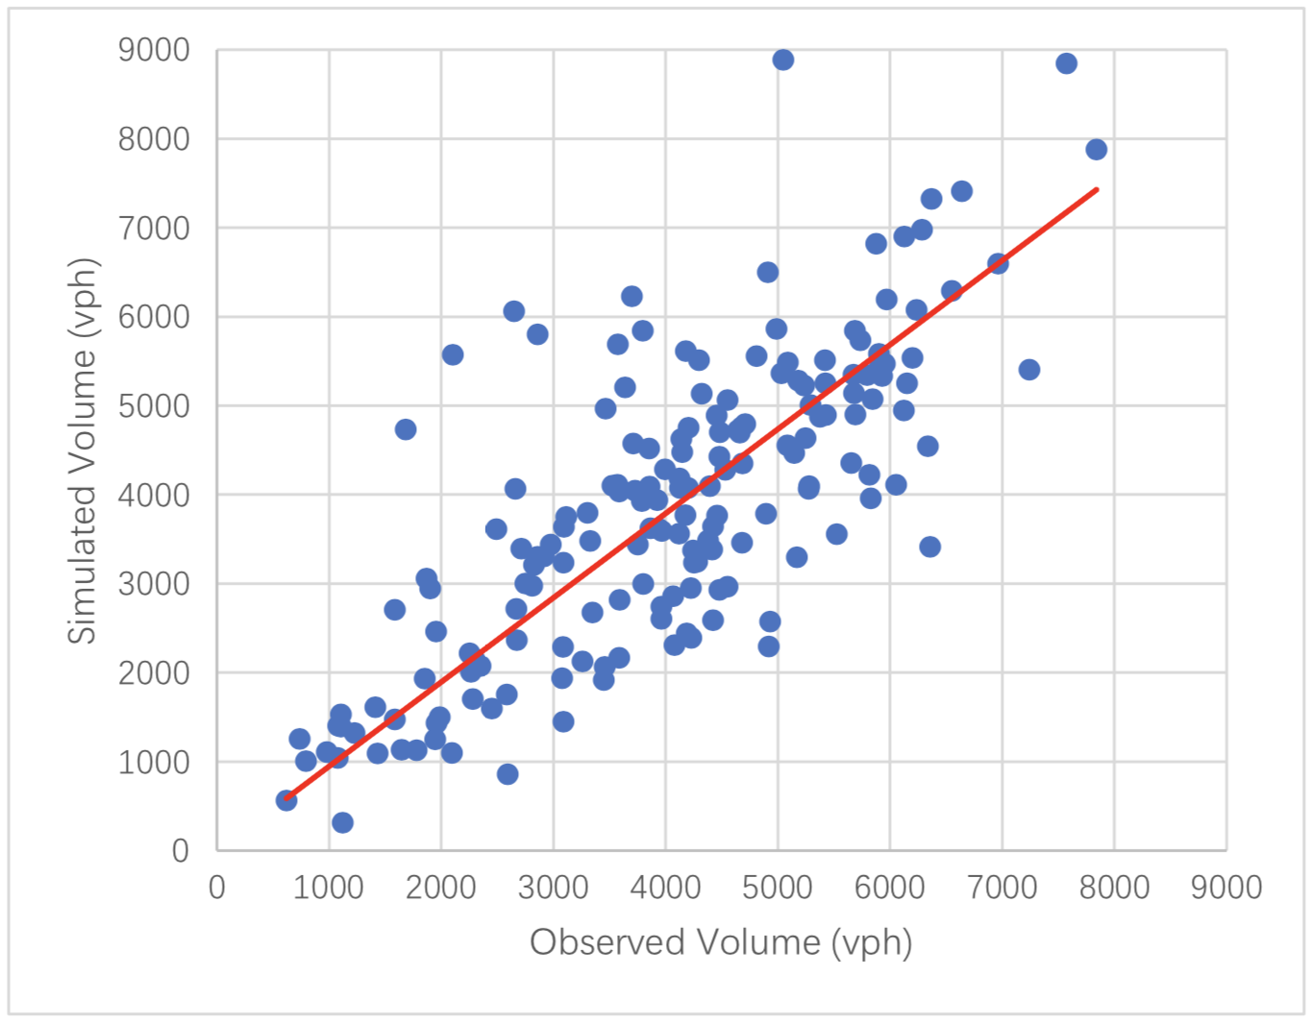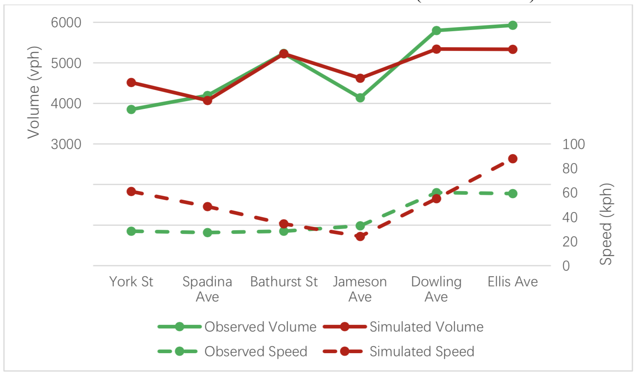
a | b
Figure B. Model validation results: a) Observed vs. simulated traffic volumes; and b) Observed vs. simulated volumes and speeds over the Gardiner expressway

The microscopic simulation in AIMSUN hybrid model was validated against instantaneous speeds recorded by a roadside radar at a major arterial, College Street in downtown Toronto. Speed distributions of the radar data and micro-simulated speed profiles at the same location were compared. The simulation showed similar mean speed value to the radar data with no significant difference at 95% CI. The comparison is presented in Figure C [5].
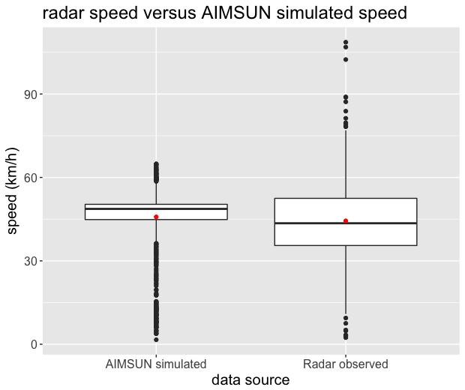
Figure C. Observed vs. simulated speed distributions at one arterial link in the GTA (the horizontal line inside the box represents the median value of speed, and the red dot represents the mean value of speed)

3. Calculation of vehicle specific power
The vehicle specific power (VSP calculation) is illustrated in the following equation [6]:
$$P_{v, t}=\frac{Av_{t}+Bv_{t}^{2}+Cv_{t}^{3}+mv_{t}a_{t}}{m}$$
Where:
$P_{v, t}$is the vehicle specific power (VSP);
$v_{t}$ is the speed at time t (m/s);
$a_{t}$is the acceleration at time t (m/s²);
m is the mass of the vehicle, usually referred as “weight” (Mg);
A, B and C are track-road coefficients, representing rolling resistance, rotational resistance and aerodynamic drag, in unit kW-sec/m, kW-sec²/m² and kW-sec³/m ³.

References
[1] AIMSUN, “Hybrid Simulator - Aimsun (Version 8.2) Help.” AIMSUN, 2017.
[2] AIMSUN, “Estimation of Traversal OD Matrices - Aimsun (Version 8.2) Help.” AIMSUN, 2017.
[3] AIMSUN, “Simulation Process - Aimsun (Version 8.2) Help.”, 2017.
[4] I. Kamel, A. Shalaby, and B. Abdulhai, “Simulation-Based Dynamic Traffic and Transit Assignment Model for the Greater Toronto Area,” in 97th Transportation Research Board Annual Meeting, 2018.
[5] R. Tu, I. Kamel, A. Wang, B. Abdulhai, and M. Hatzopoulou, “Development of a hybrid modelling approach for the generation of an urban on-road transportation emission inventory,” Transp. Res. Part D Transp. Environ., vol. 62, pp. 604–618, 2018.
[6] U.S. Environmental Protection Agency, “Exhaust Emission Rates for Light-Duty On-road Vehicles in MOVES2014, Final Report,” 2015.

