Supplemental File

Hydrogen production through the cooperation of a catalyst synthesized in ethanol medium and the effect of the plasma
¹Mehmet Sait İZGİ, ¹Erhan ONAT, ²Hilal ÇELIK KAZICI, ^{1*}Ömer ŞAHİN

¹Department of Chemical Engineering, Faculty of Engineering and Architecture, Siirt University, 56100 Siirt, Turkey
E-mail: saitizgi@siirt.edu.tr
sahinomer2011@gmail.com

erhanonat@gmail.com
²Department of Chemical Engineering, Faculty of Engineering, Van Yüzüncü Yıl University, 65080 Van, Turkey
hilalkazici@yyu.edu.tr

*Corresponding Author: E-mail: sahinomer2011@gmail.com
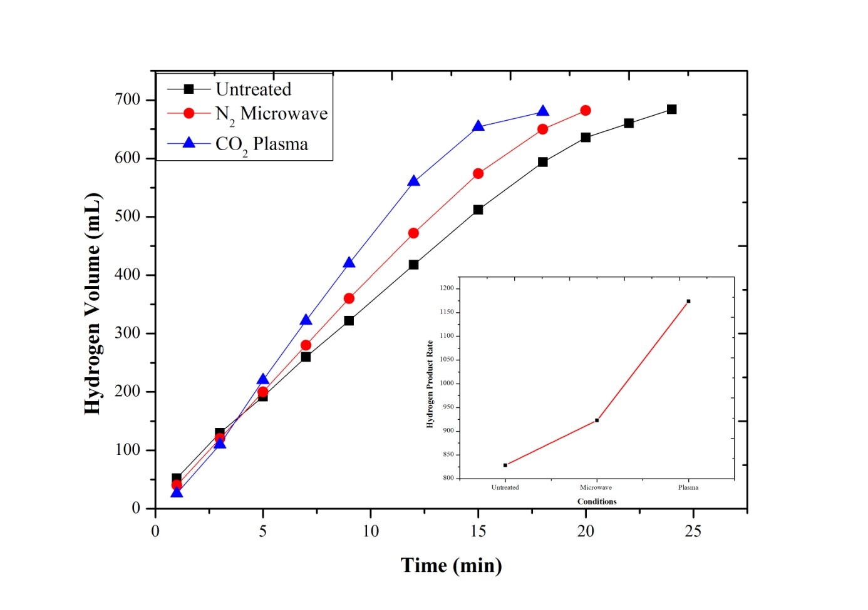
Figure S1 Comparison of the effect of the plasma and microwave mediums of the Ni-B catalyst synthesized in ethanol medium on the hydrolysis of NaBH₄ (30 ºC, 2.5% NaBH₄, 10 mL solution, 50 mg catalyst, 10% NaOH)

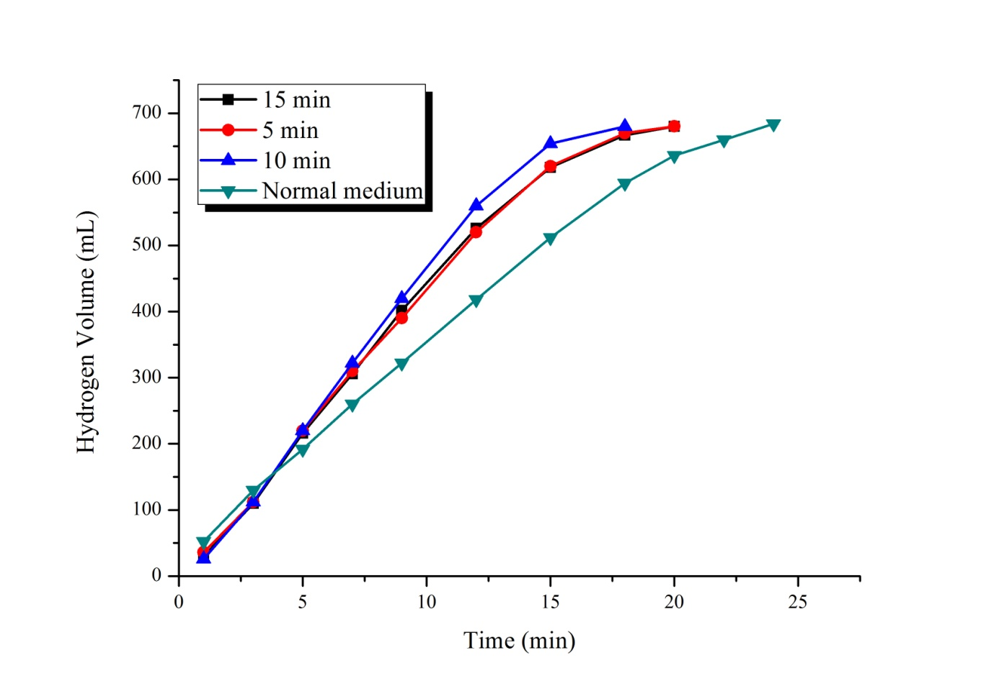
Figure S2 The effect of different holding times of the Ni-B catalyst synthesized in ethanol medium on the NaBH₄ hydrolysis in the plasma medium and the presence of CO₂ (30 ºC, 2.5% NaBH₄, 10 mL solution, 50 mg catalyst, 10% NaOH)

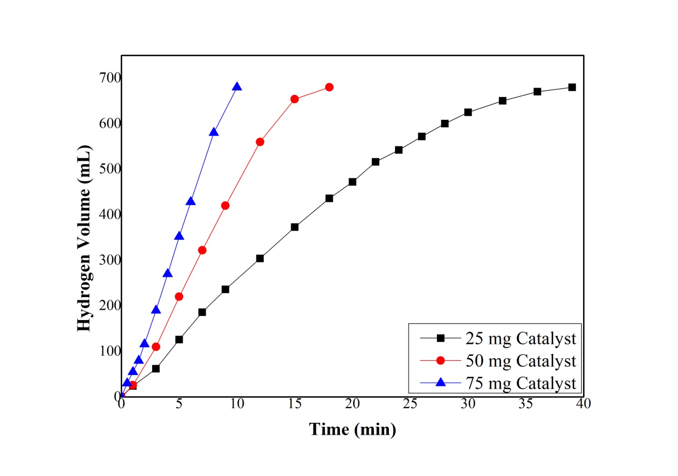
Figure S3 The effect of different amounts of the Ni-B catalysts synthesized in ethanol medium on NaBH₄ hydrolysis in the plasma medium and the presence of CO₂ within 10 minutes (30 ºC, 2.5% NaBH₄, 10 mL solution, 10% NaOH)

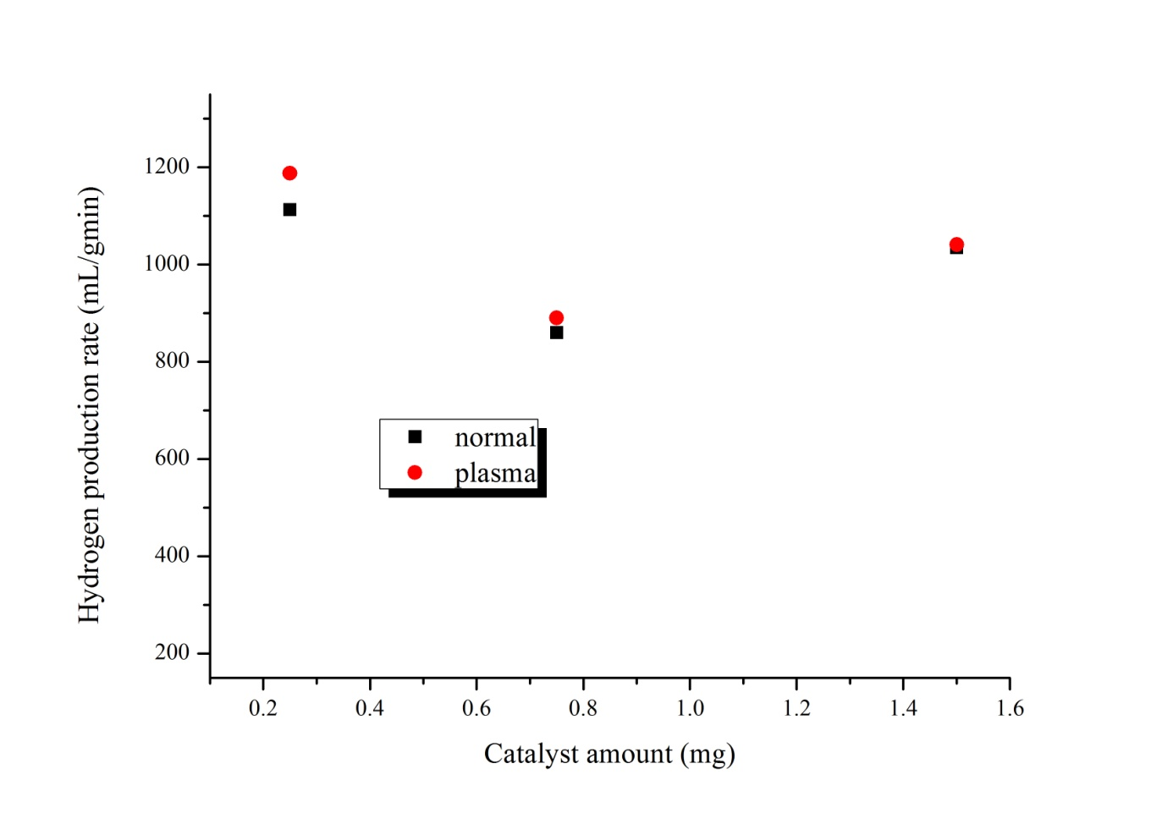
Figure S4 The effect of different amounts of the Ni-B catalyst synthesized in ethanol medium on hydrogen production rate in ethanol medium and presence of CO₂ within 10 minutes (30 ºC, 2.5% NaBH₄, 10 mL solution, 10% NaOH)

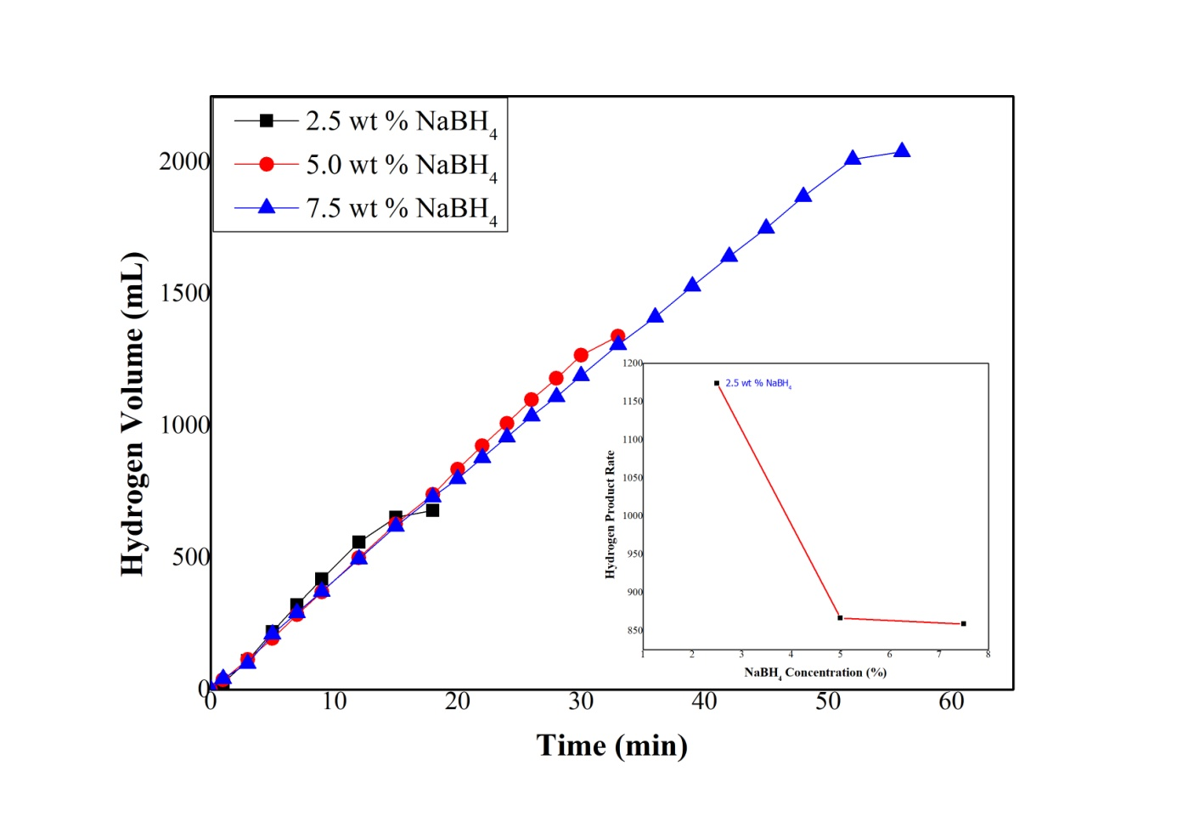
Figure S5 The effect of the Ni-B catalyst synthesized in ethanol medium on NaBH₄ hydrolysis in the presence of plasma medium for 10 minutes and CO₂ for 10 minutes (30 ºC, 10 mL solution, 50 mg catalyst, %10 NaOH)

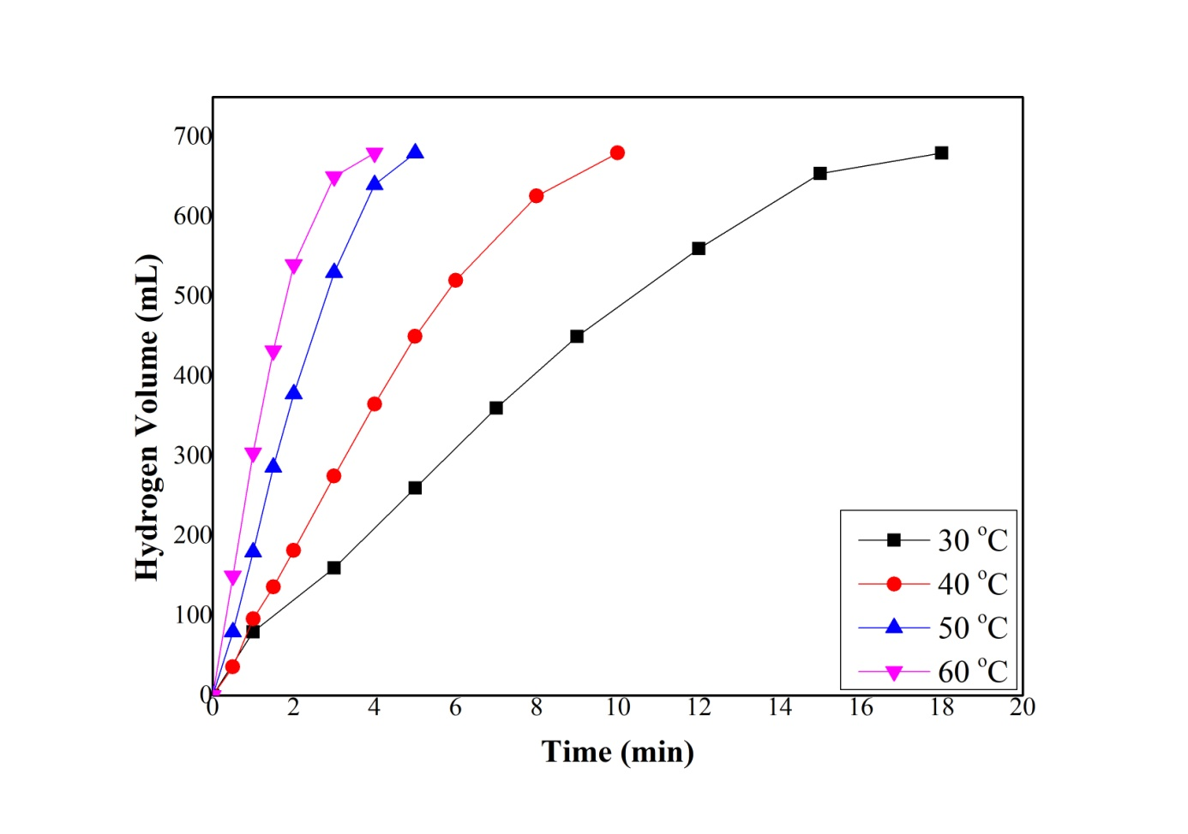
Figure S6 Effect of different temperatures of the Ni-B catalysts synthesized in ethanol medium on NaBH₄ hydrolysis (10 mL solution, 2.5% NaBH₄, 50 mg catalyst, 10% NaOH)

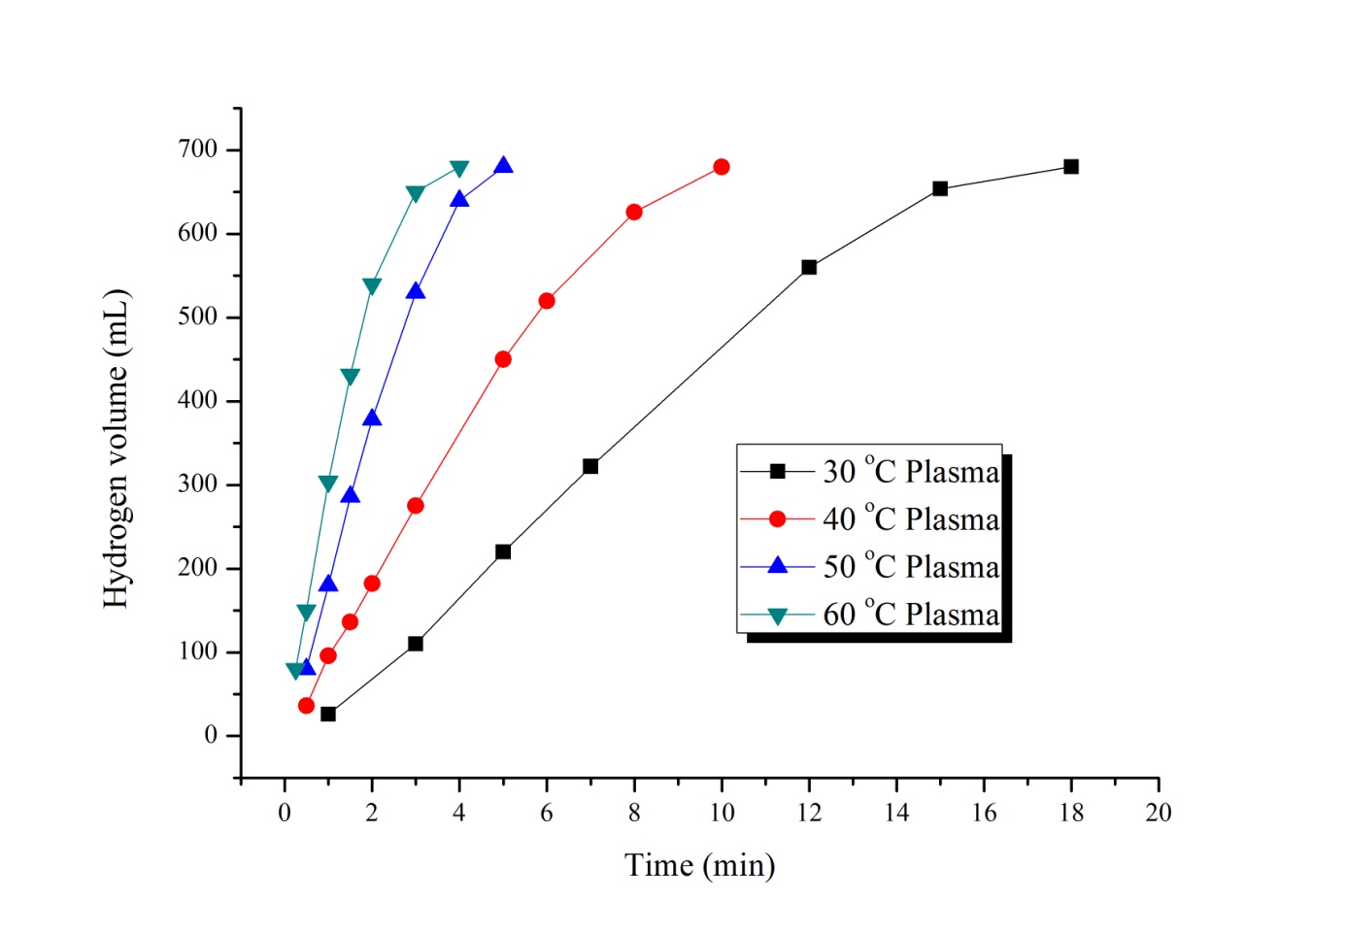
Figure S7 Effects of different temperatures of the Ni-B catalysts synthesized in ethanol medium on the NaBH₄ hydrolysis in the presence of plasma and CO₂ (10 mL solution, 2.5% NaBH₄, 50 mg catalyst, 10% NaOH)

Table S1. Kinetic parameters and hydrogen production rates of hydrolysis reaction at different temperatures

Temperature (ºC) | Reaction speed degree (n) | The reaction speed constant (k) | Hydrogen production rate (mL/g_{cat} dk) | R²
30 | 0.33 | 0.001061 | 1041 | 0.998066
40 | 0.33 | 0.001719 | 2125 | 0.993744
50 | 0.33 | 0.003782 | 4390 | 0.998763
60 | 0.33 | 0.005236 | 7134 | 0.988073

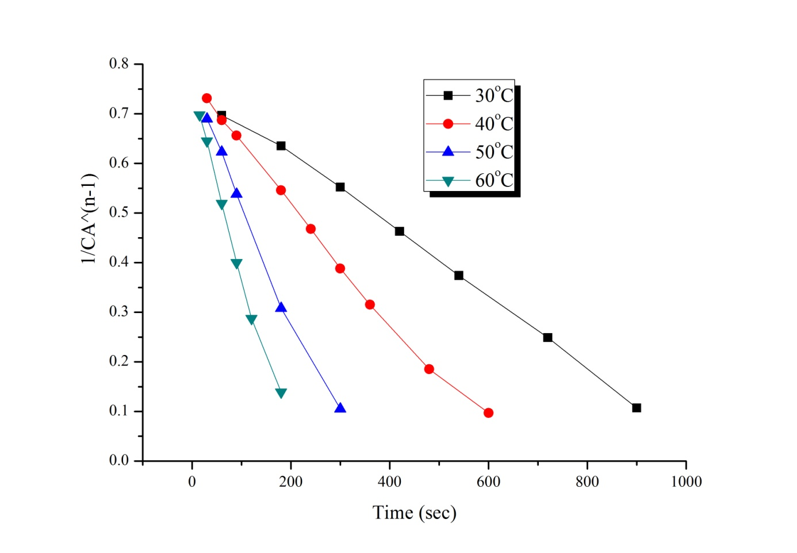

Figure S8 The reaction kinetics of the Ni-B catalysts synthesized in the plasma and ethanol medium at different temperatures in the presence of CO₂ (10 mL solution, 2.5% NaBH₄, 50 mg catalyst, 10% NaOH)

Table S2 Comparison of the catalytic performance of various catalysts for the hydrolysis of NaBH₄
Catalysts | Method |  | Temp.  (ºC) |  | Ea  (kJ/mol) | Max. hydrogen  production rate (mL/g_{cat} dk) | Ref.
Co/Al₂O₃ |  | Chemical reduction |  | 30 | 32.63 | 220 | (Ye et al. 2007)
Co₂B |  | Chemical reduction |  | 20 | - | 468.3 | (Liu BH et al. 2006)
Ni₂B |  | Chemical reduction |  | 20 | - | 18.3 | (Liu BH et al. 2006)
Ni-Ru/50WX8 |  | Electroless deposition |  | - | 52.7 | 400 | (Liu CH et al. 2009)
Co-Ni-Mo-P/γ  -Al₂O₃ |  | Electroless deposition |  | 90 | 52.4 | 10125 | (Wang LN et al. 2016)
Ni-Co-B |  | Chemical reduction |  | 575 | 62 | 2608 | (Ingersoll et al. 2007)
Co-Ni-P/Cu sheet |  | Electroless plating |  | 78 | 53.5 | 2172.4 | (Wang Y et al. 2017)
Ni-B |  | Chemical reduction |  | 60 | 46.83 | 7134 | This work

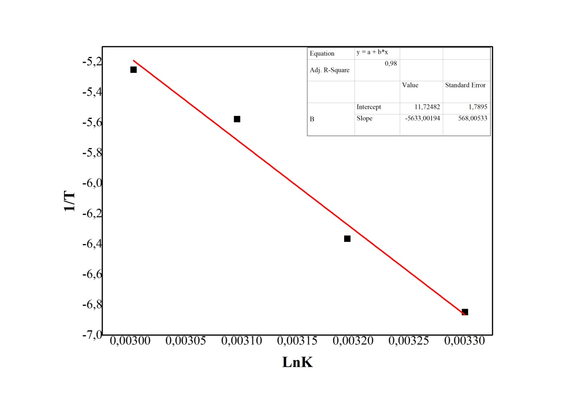
Figure S9 Arrhenius equation according to the “n” degree of the Ni-B catalyst synthesized in ethanol medium

