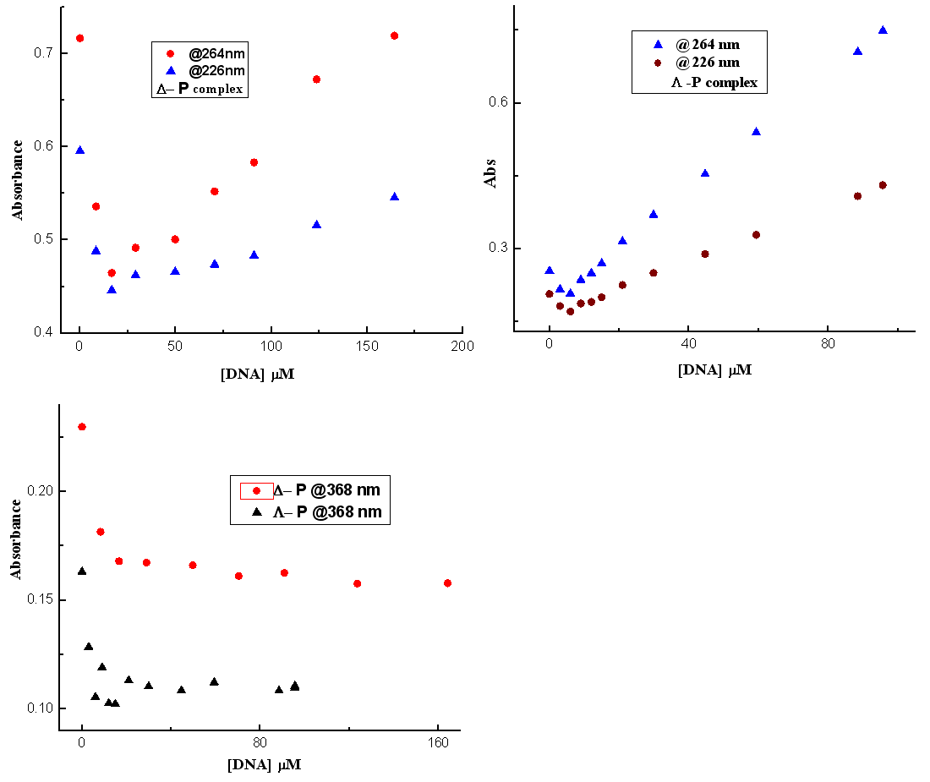
Fig. S1. The absorbance of Δ&Λ- P complexes at a fix wavelength against the DNA concentration.

Fig. S2: Absorbance of corresponding concentration of two sets of B& P-enantiomers for comparison aims; [DNA]=118µM

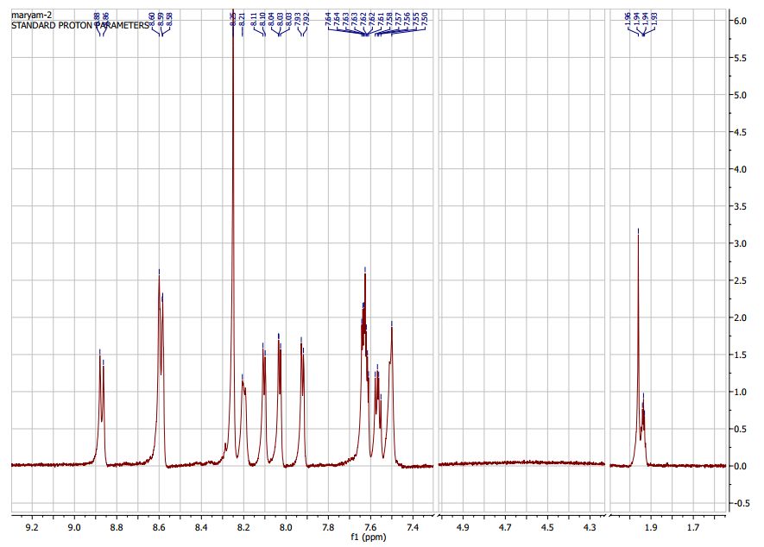
The NMR of B-complex

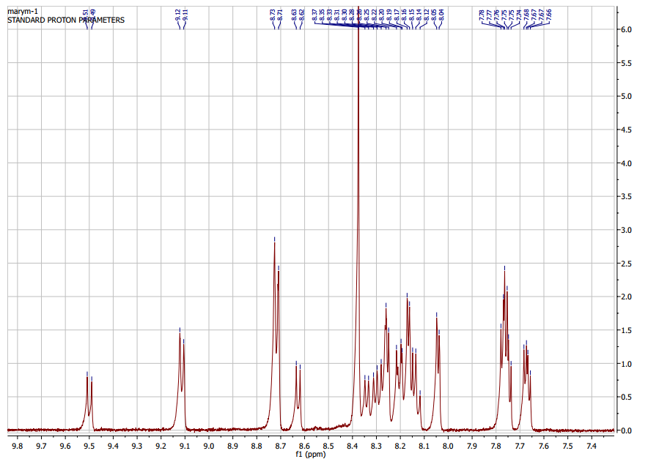
The NMR of P-complex

CD Spectra

Fig. S3. CD Spectra of Enantiomers of P-complex (b1-b2) and B-complex (a1-a2) in different mole ratios with a fix concentration of DNA (as shown the ratio on the figure; 0.05 & 0.1) and variation on the bands.

Induced Circular Dichroism Spectra (ICD)

Fig. S4. ICD spectra (obtained by subtracting the free metal complex spectra from the ct-DNA plus metal complex CD spectra) DNA concentration (120 µM) for both enantiomers was constant while concentration of complex was varying and CD spectra were recorded on two mole ratios.

