APPENDIX 1
The following description was summarized from Mogiardini et al. 2013. To calculate the similarity between two curves, the multiple-value metrics (MPC metrics) which are implemented in RSVPP treats the magnitude and phase of the curve independently. Two different metrics called M components for the magnitude of the curve and P components for the phase of the curve are joined together to form a comprehensive metric or C. The P component should be sensitive to the differences in phasing but not in magnitude. Conversely, the M component should be sensitive to differences in magnitude but insensitive in differences in phase. A value of zero indicates the two curves are identical.

Name | Magnitude | Phase | Comprehensive
Sprague & Geers | $$M_{GSG}=\sqrt{\frac{\sum{c_{i}^{2}}}{\sum{m_{i}^{2}}}}-1$$ | $$P_{SG}=\frac{1}{π}\cos^{-1}\frac{\sum{c_{i}m_{i}}}{\sqrt{\sum{c_{i}^{2}}\sum{m_{i}^{2}}}}$$ | $$\sqrt{M_{SG}^{2}+P_{SG}^{2}}$$

Reference:
Mongiardini M, Ray MH, Plaxico CA. Development of a programme for the quantitative comparison of a pair of curves. Int. J. Comput. Appl. Technol. 2013;46(2):128.

APPENDIX 2
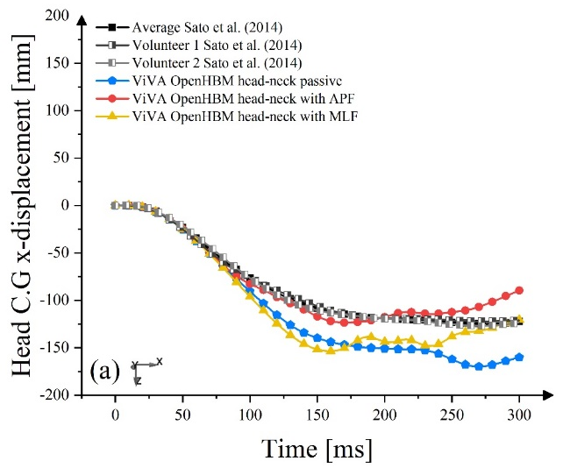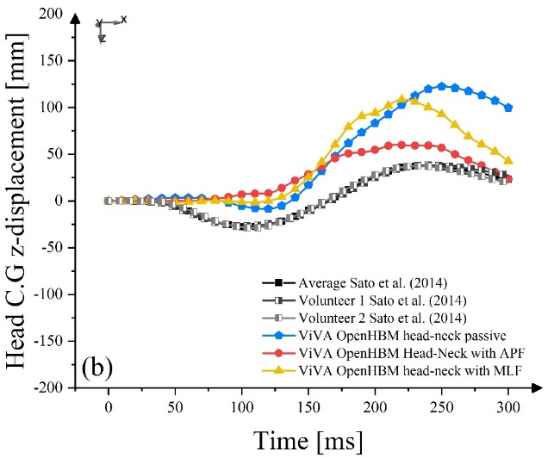
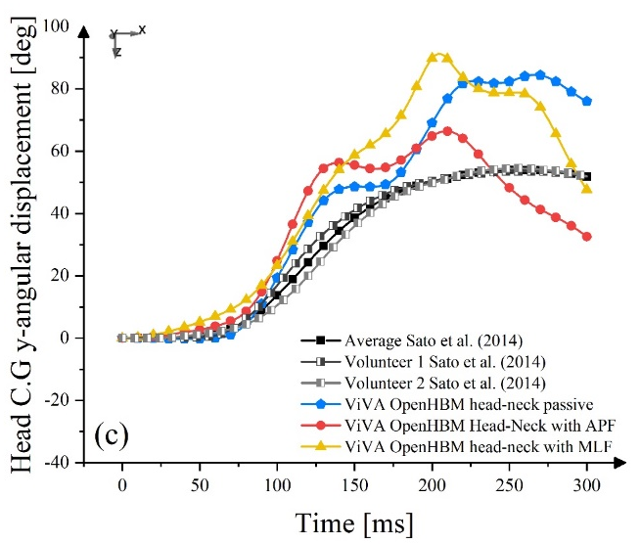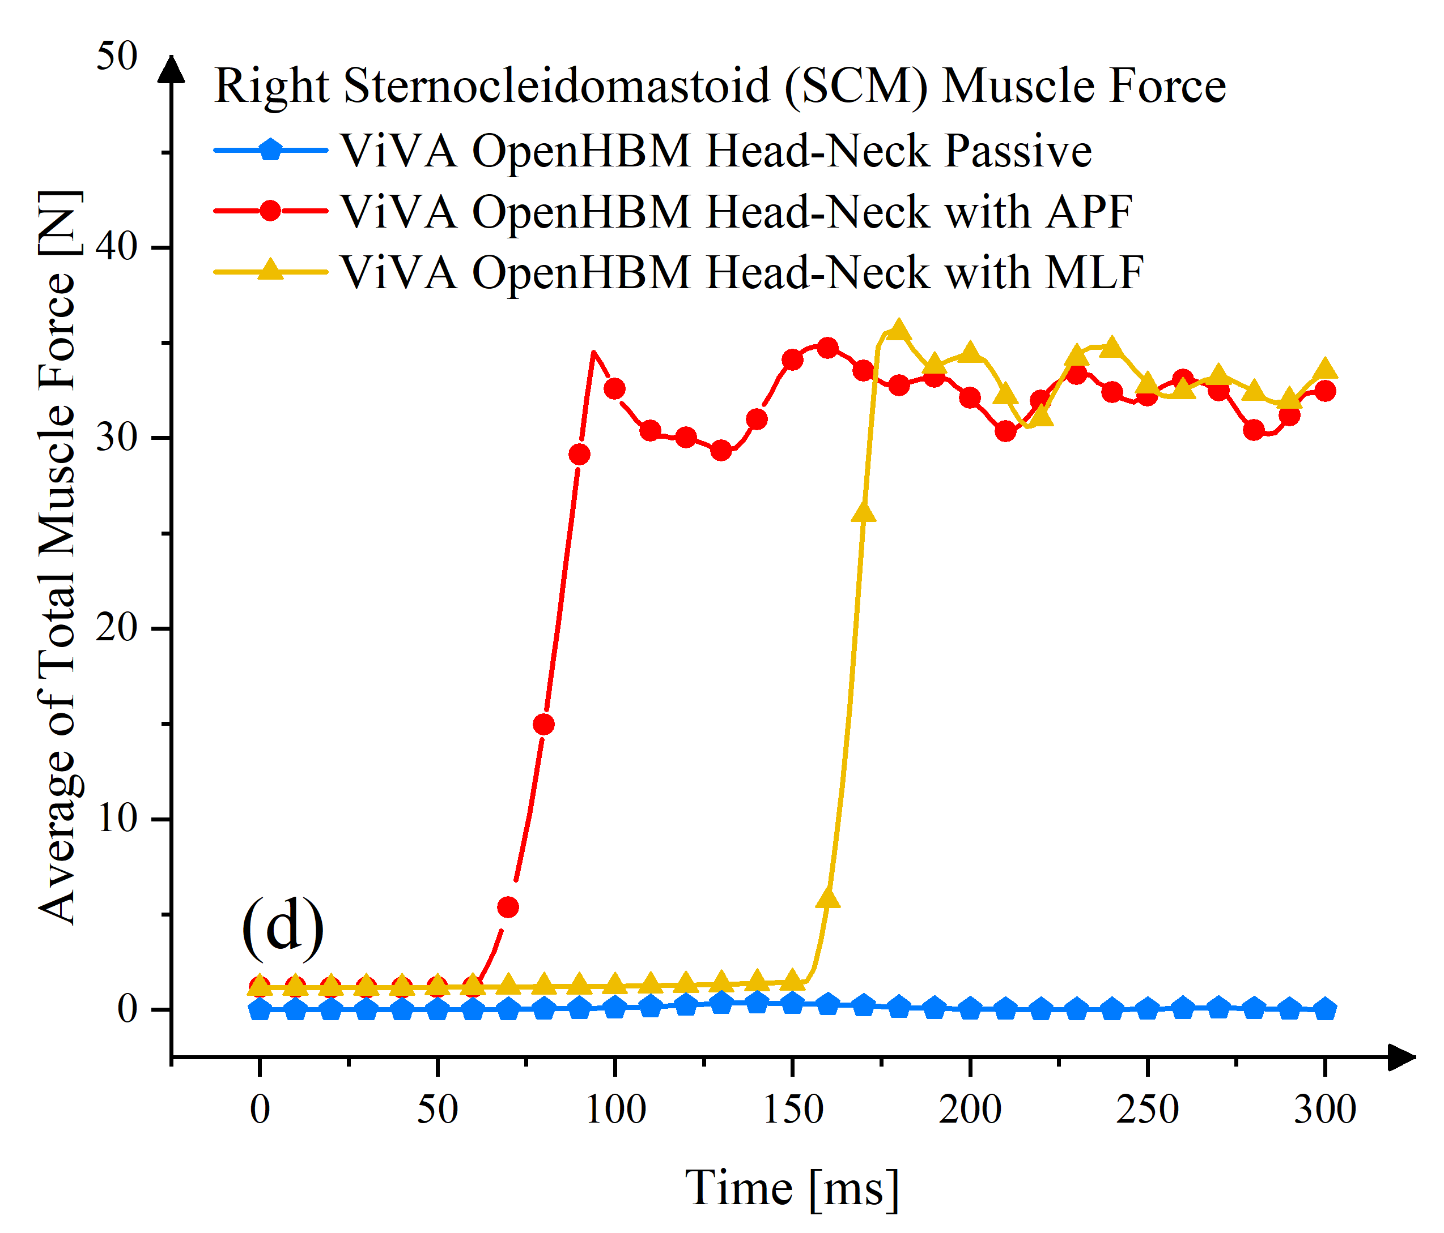
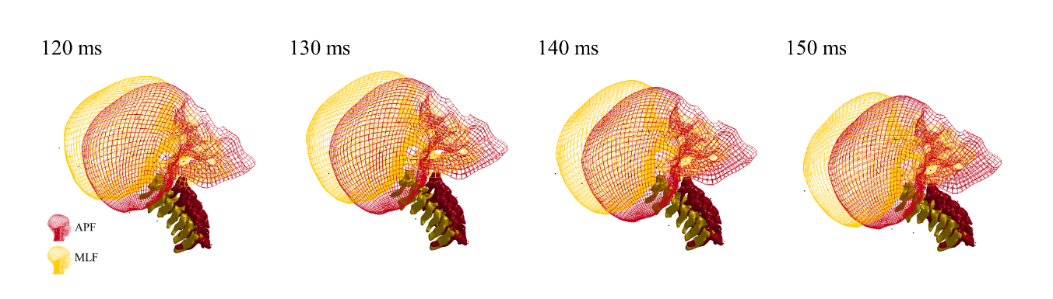
Figure A1. Head kinematics from simulation models and volunteer tests. (a) Head C.G x-linear displacement; (b) Head C.G z-linear displacement; (c) Head C.G y-angular displacement; (d) Sternocleidomastoid (SCM) muscle force; (e) Buckling in cervical spine of the model with APF controller caused by muscle tension. The lower position of the head of the model with APF controller relative to the model with MLF controller illustrates how the local cervical spine buckling changes the kinematics.

