Supplementary Figure 1. Probabilistic bias analysis on the association between male military personnel and incidence of motor neuron disease for confounding by smoking
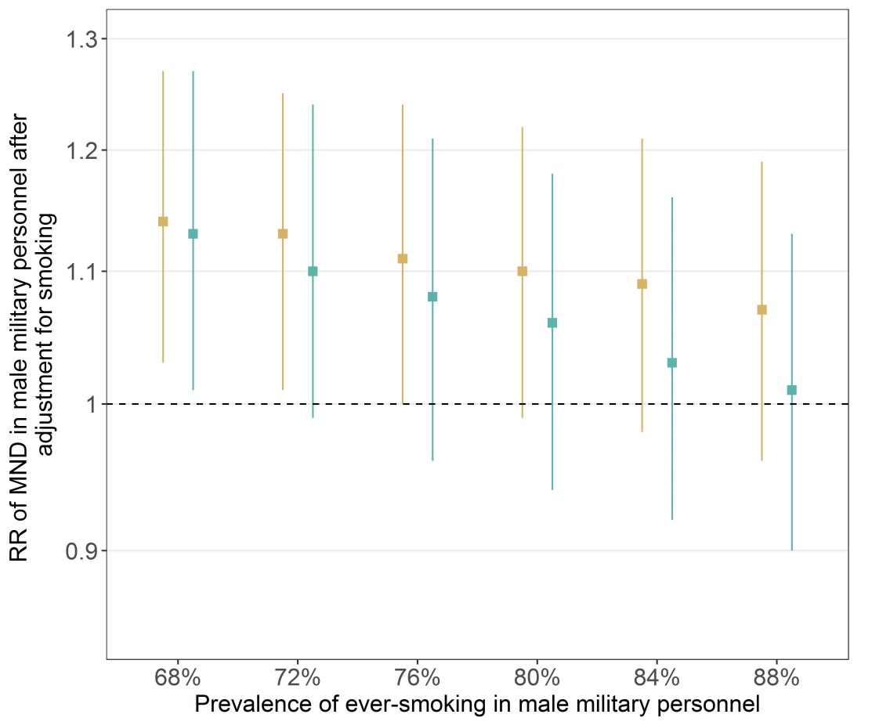

Probabilistic bias analysis was carried out for the association between male military personnel and MND (RR=1.16; 95% CI=1.05-1.29). We specified prior knowledge on three parameters:

- the association between ever-smoking and MND: either RR=1.42 (■) (Wang et al., 2011) or OR=2.0 (■) (Nelson et al., 2000).

- the prevalence of ever-smoking in men ≥50y from the general population: we used data from the French ESPS health survey (Célant et al., 2017) that included 2,518 CNAMTS male members ≥50y in whom the prevalence of ever-smoking was 64%. We used a uniform distribution between 59% and 69%.

- the prevalence of ever-smoking in men ≥50y from the military population: data from the same survey included 60 CNMSS male members ≥50y in whom the prevalence of ever-smoking was 67%. Because the prevalence of ever smoking in military personnel was based on a small number of subjects and may be imprecise, we considered a larger difference in prevalence of ever-smoking between the two groups by allowing prevalence of ever-smoking to increase in military men from 68% to 88% by 4% steps and using a uniform distribution centered on each ever-smoking prevalence with a range of 5 point.

