Supplemental Information
to the article:
Chemical and microphysical properties of wind-blown dust near an actively retreating glacier in Yukon, Canada
Jill Bachelder¹, Marie Cadieux², Carolyn Liu-Kang¹, Pérrine Lambert¹, Alexane Filoche¹, Juliana Aparecida Galhardi¹, Madjid Hadioui¹, Amélie Chaput², Marie-Pierre Bastien-Thibault², Kevin J. Wilkinson¹, James King², and Patrick L. Hayes¹
Departments of Chemistry¹ and Geography², Université de Montréal, Montréal, Canada

- Photos of dust emissions from the sampled site

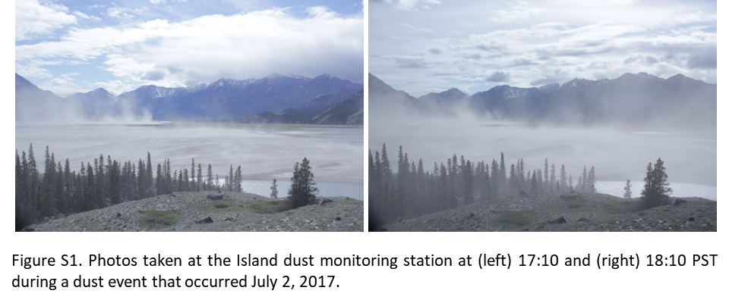

- Down Valley site meteorological equipment specifications

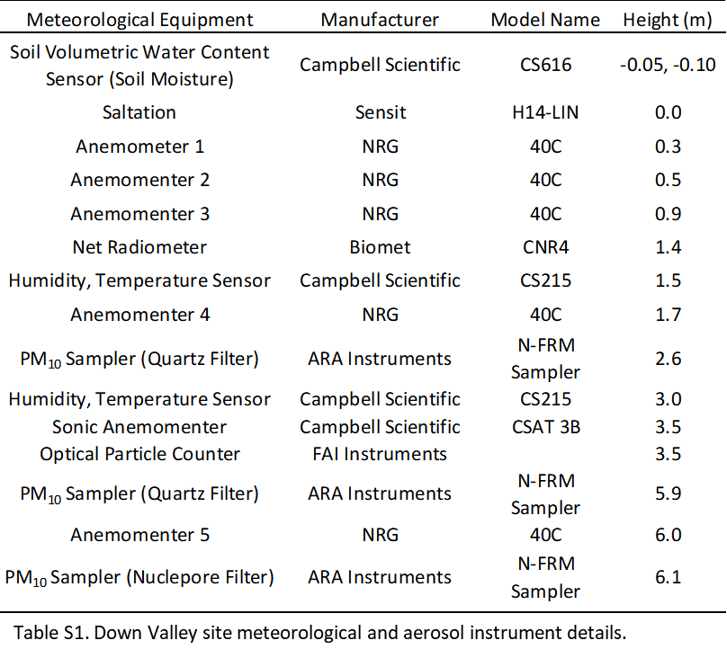

- Quality control and data analysis for aerosol sampling instruments

The level of contamination introduced during the handling and transport of the filter samples was determined through analysis of the field blanks for all four air samplers deployed in the field. The average mass on the field blanks was 0.11 mg ± 0.07 mg. The maximum mass of particulate matter recorded on a filter blank was 0.21 mg (found in a blank collected from the 6 m sampler at the DV site), which could introduce an over-estimation of no more than 10 µg/m³ into the monitoring of a 24 hr period; this is more than an order of magnitude lower than the typical 24 hr mass concentration recorded by these instruments, and is thus a negligible contribution. Moreover, ICP-MS analysis of field blanks indicated negligible metal concentrations as compared to filter samples, also demonstrating the limited contamination introduced to the filters (see Results and Discussion). For all gravimetric and ICP-MS analyses, measurements were blank-subtracted to account for any contamination.

To assess the accuracy of our OPC measurements, an averaged PM₁₀ mass concentration was calculated from the measured particle size distribution for the same periods sampled by our mini-vol samplers at the Down Valley site (Gillies and Berkofsky 2004). An assumed particle density of 2.6 g cm⁻³ was used for this calculation, in accordance with the generally accepted density of mineral dust particles provided in the literature (Tegen and Fung 1994, Yang et al. 2009). The daily mass concentration calculated from the OPC data was well correlated with the mass concentrations determined via gravimetric analysis of both the 6 m and 2 m quartz filters, with R² values of 0.963 and 0.918, respectively. We then used the gravimetric data from the Down Valley site 6 m and 2 m samplers to estimate the daily ambient mass concentration of PM₁₀ at the height of the OPC (4.5 m), using the method of Gillies and Berkofsky (2004). The comparison of the estimated values and OPC output gave an R² value of 0.98 and a slope of 1.13 (Supplemental Information, Figure 2); as the ideal slope should be 1.00, we found this to be an acceptable indicator of the validity of the OPC data.

Furthermore, analysis of the variation in particle size distribution with wind speed showed no sampling error due to wind speed-induced biases in the OPC data. In addition, no correction for the refractive index of mineral dust particles was used to modify the OPC data output. This was justified by the fact that clay minerals, which SEM/EDS analysis indicated make up a large portion of ambient PM₁₀ at the Down Valley site (see Results and Discussion), typically have refractive indices that fall in the range of 1.47 to 1.68 (Mukherjee 2013). This range includes the refractive index of polystyrene latex spheres (PSL) (Smart and Willis 1967), which were used to calibrate the OPC by the manufacturer. As a result, it was assumed that the difference between the refractive index of the mineral dust sampled and that of the PSL calibration standard had a negligible effect on the particle sizing data provided by the OPC.
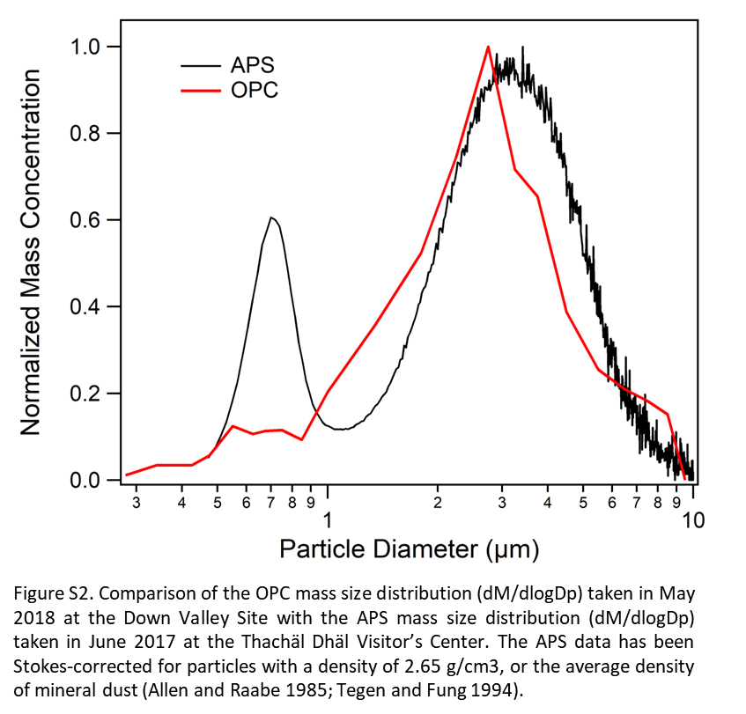

- Comparison of OPC data from May 2018 and APS data from June 2017
An aerodynamic particle sizer (APS) sampled ambient air outside the Thachäl Dhäl Visitor’s Center from June 13 to June 21, 2017. The instrument was operated at a flow rate of 5 LPM ± 0.2 LPM, with samples taken every minute. The data from the APS indicated the only clear dust event that occurred during the June 2017 sampling period took place from 12:00 to 15:00 on June 19. We applied a Stokes correction to the average particle size distribution measured during this period. The purpose of the Stokes correction was to account for the error introduced into the particle sizing due to deviations of particle densities from the densities of the polystyrene latex particles used by the instrument supplier to calibrate the instrument; these particles have a density of 1.05 g/cm³, while typical values of the density of mineral dust have been shown to be 2.65 g/cm³(Tegen and Fung 1994, Allen and Raabe 1985). The resulting size distribution of the measured aerodynamic diameters are provided in Figure S2. The maximum of this distribution lies at 3.87 µm, which compares well with the maximum optical diameter measured by the OPC in May 2018, which was 3.25 µm.

- Calculation of 10-min resolution PM₁₀ at the Down Valley site

Due to the high correlation between the results of the gravimetric analysis of filters from the Down Valley site and the 24 hr calculated OPC data, we calculated the interpolation equation relating the gravimetric and OPC data. The interpolation equations and R² values for this analysis can be found in the Supplemental Information section (Figure 3). This analysis allowed us to obtain data at two different heights with a 5-minute timescale.

- SEM/EDS spectra
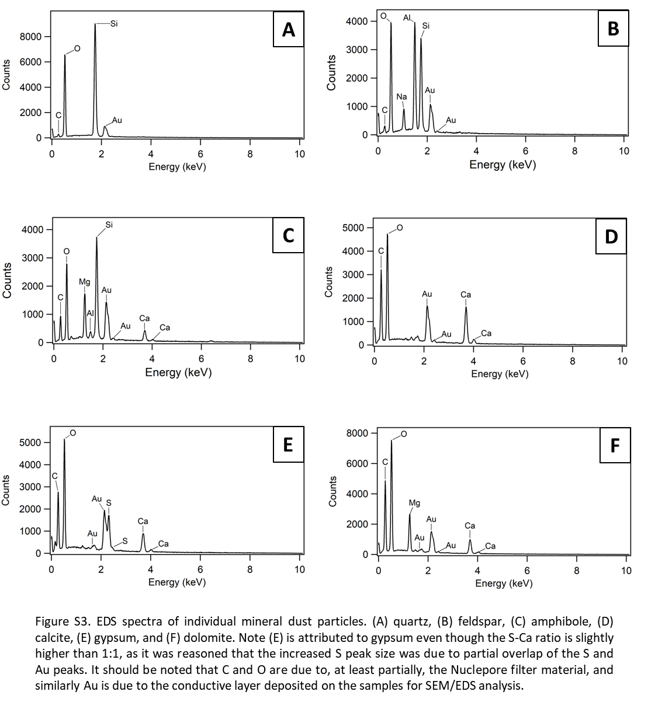
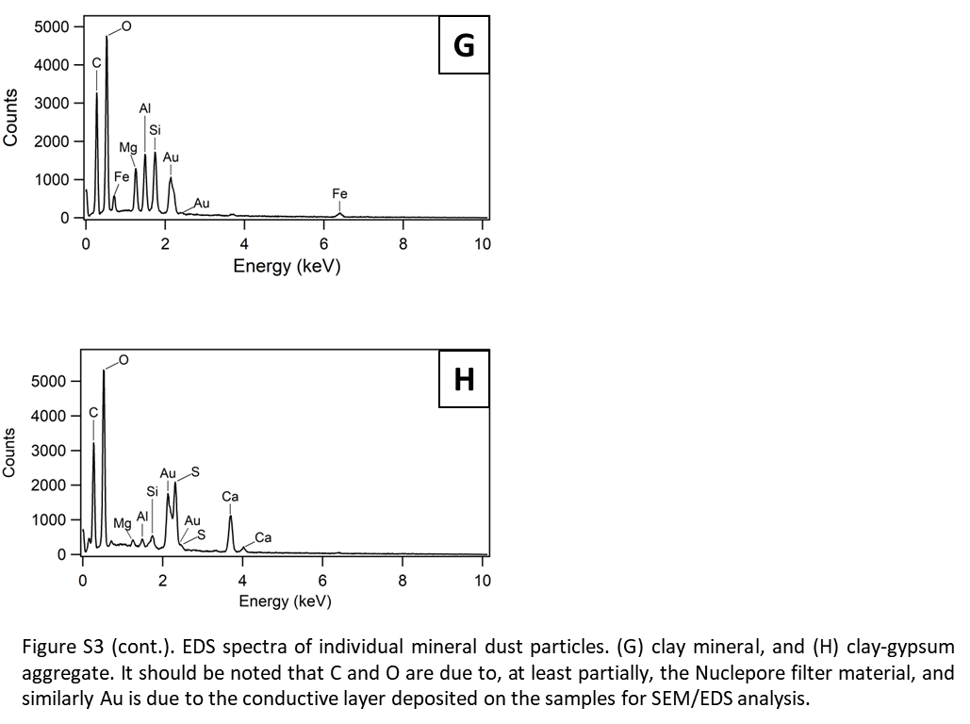

- Method evaluation results for ICP-MS analysis of elemental composition
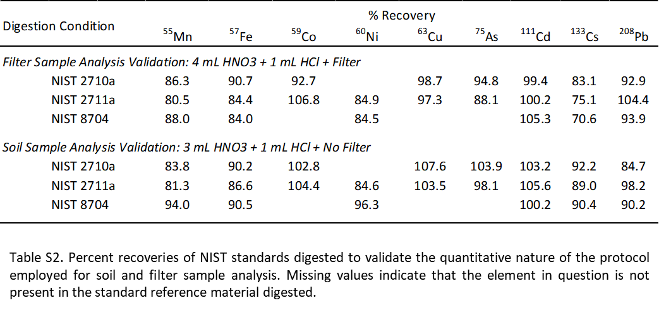
As our protocol modified Method 3051a, special care was taken to validate the procedure used in this study. Validation tests for the filter sample digestion protocol were completed by digesting 25 mg of a NIST standard together with a quartz filter, using the acid mixture 4 mL HNO₃/1 mL HCl. Soil samples were analyzed using only 3 mL HNO₃/1 mL HCl; the reduction in acid volume was due to the absence of the quartz filter, as this reduces the total sample mass by 0.14 g. Thus, this procedure was validated by digesting 25 mg of NIST standard using the acid mixture 3 mL HNO₃/1 mL HCl. Three standards supplied by NIST were used for the validation tests: Montana I Soil with Highly Elevated Trace Element Concentrations (NIST 2710a), Montana II Soil with Moderately Elevated Trace Element Concentrations (NIST 2711a), and Buffalo River Sediment (NIST 8704).

The percent recoveries of the NIST standards subjected to the digestion conditions used to digest soil and filter samples are provided in the Supplemental Information section (Table S2). For both soil and filter samples, the percent recoveries of these metals fell within an acceptable range of 80 to 110 %. Furthermore, analysis of filter blanks obtained in the field showed negligible concentrations of the metals quantified. The results of the field blank limit of detection (LOD), calculated as three times the standard deviation of the blank divided by the slope of the calibration curve, compared to the concentrations found in select filter samples can be found in Table S3.
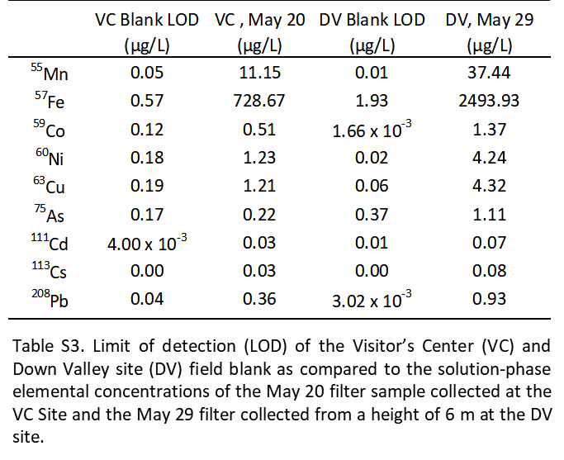
There are several advantages to the technique we have employed, as we have avoided the use of highly hazardous materials, such as HF, which is typically used to digest samples of low mass (e.g. less than 50 mg). Furthermore, we have extracted several key elements that are crucial to the characterization of dust emitted from the Ä’äy Chù Valley, notably Fe and As. However, as neither HNO₃ nor HNO₃/HCl can completely digest the aluminosilicate matrix, there were several important metals that we were not able to quantitatively extract from our samples. These include Na, Mg, Al, K, and Ca, all of which can impact primary ecological productivity and can be related to the mineralogy of air and soil samples through the calculation of elemental ratios. Future work will focus on expanding the number of elements quantified in samples collected in the Ä’äy Chù Valley.

- ICP-MS analysis results
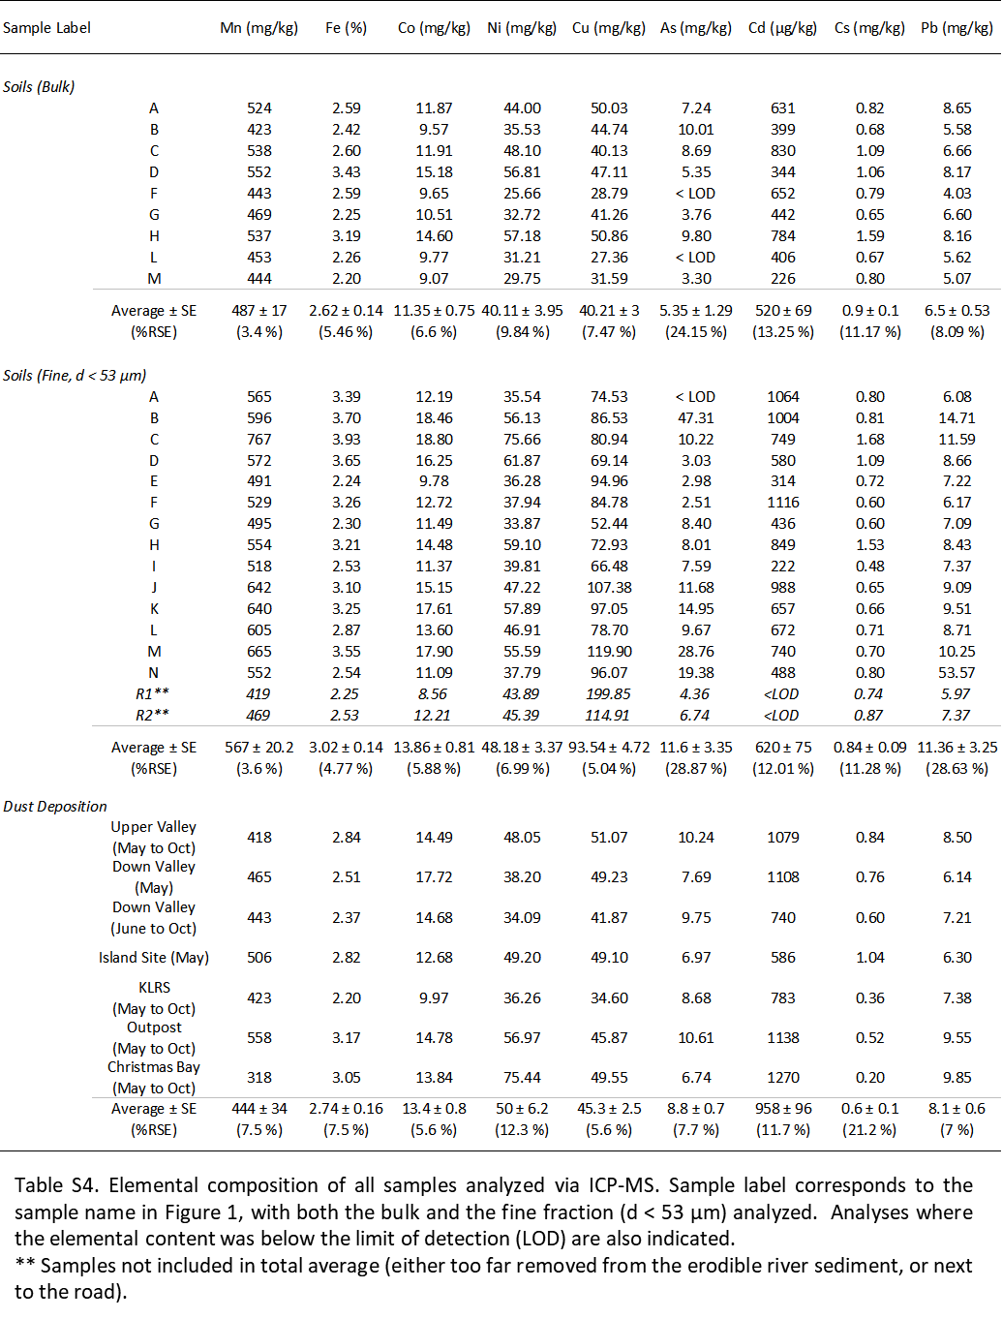
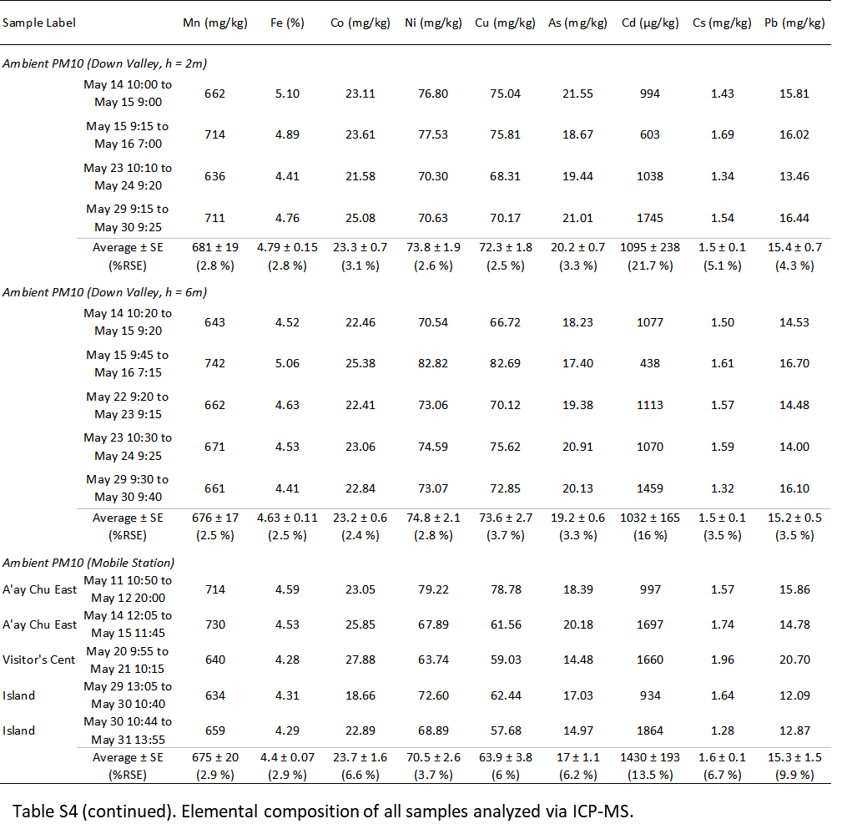

- SEM/EDS analysis of soil

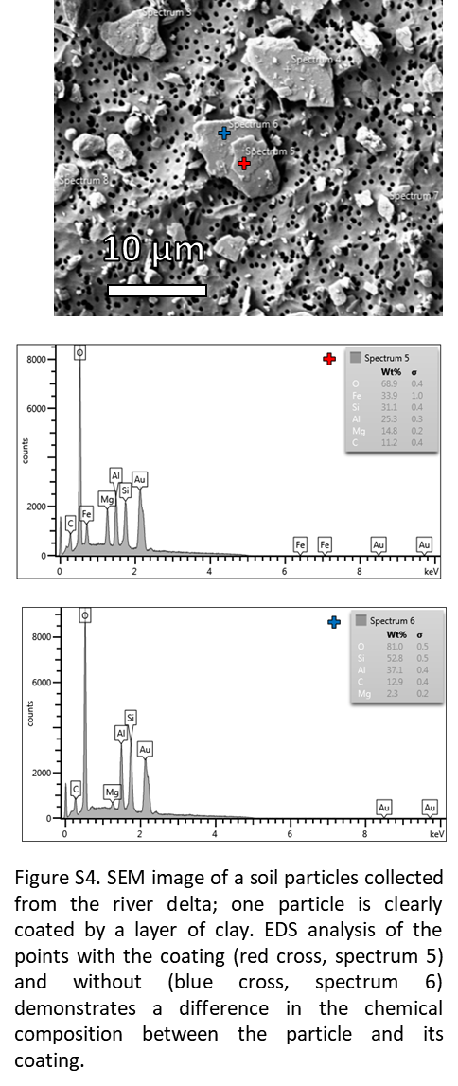

- Coulter counter analysis of deposition and fine soils
Both soil and deposition samples were sieved to select the size fraction smaller than 53 µm in diameter. This fraction of the soils was then analyzed by a Coulter counter using a 100 µm aperture, in order to obtain the size distribution of the particles in these samples. The fine fractions of two soil samples were analyzed (Samples G and H), as well as the June to August 2018 deposition collected at the Down Valley site.

- Calculation of the size-resolved threshold velocity for particle entrainment

The size-resolved threshold wind velocity for dust emission was calculated using the method employed by Ginoux et al. when parameterizing vertical aerosol flux for the Global Ozone Chemistry Aerosol Radiation and Transport (GOCART) chemical transport model (Ginoux et al. 2001). Equation (S1) gives this parameterization, where u_{t} is the threshold velocity, A is a dimensionless parameter of 6.5, $Φ$ is the particle diameter, g is acceleration due to gravity, ρ_{a} is air density, ρ_{p} is particle density, and w is soil moisture. Note that this equation is only valid for soil moisture values less than 0.5; the typical soil moisture measured during our campaign was 0.05, which is well below this limit.

u_{t} = A$\sqrt{Φg\frac{ρ_{a}- ρ_{p}}{ρ_{a}}}$ (1.2 + 0.2log₁₀ w) (S1)

- Comparison of vertical aerosol flux and saltation measurements
We have compared the output of our SENSIT horizontal mass flux monitor with the ambient concentrations of PM₁₀ obtained through our gravimetric analysis and OPC data and have provided two examples of this comparison performed on May 19 and 24 (Figure 12). The 10-min resolved PM₁₀ concentrations at 6 m and 2 m were extrapolated based on the OPC data (Figure 3). The results show very little correlation between the SENSIT data and ambient dust, with dust observed almost the entire 24 hr period on both days and very little horizontal mass flux recorded. While these are just two examples pulled from the entirety of our sampling period, there were no dust events that occurred which showed correlation between horizontal mass flux and ambient PM₁₀.

References
Allen, M. D., and O. G. Raabe. 1985. Slip Correction Measurements of Spherical Solid Aerosol Particles in an Improved Millikan Apparatus. Aerosol Sci Technol 4 (3): 269-286. doi.org/10.1080/02786828508959055
Gillies, J. A., and L. Berkofsky. 2004. Eolian suspension above the saltation layer, the concentration profile. J Sediment Res 74 (2), 176-183. doi.org/10.1306/091303740176
Ginoux, P., M. Chin, I. Tegen, J. M. Prospero, B. Holben, O. Dubovik, and S.-J. Lin. 2001. Sources and distributions of dust aerosols simulated with the GOCART model. J Geophys Res-Atmos 106 (D17), 20255-20273. doi.org/10.1029/2000JD000053
Mukherjee, S. 2013. The science of clays: Applications in Industry, Engineering and Environment. Dordrecht, NL: Springer; New Delhi, IN: Capital Publishing.
Smart, C., and E. Willis. 1967. Determination of refractive indices of polystyrene latices by light scattering. J Colloid Interf Sci 25 (4): 577-583. doi.org/10.1016/0021-9797(67)90071-9
Tegen, I., and I. Fung. 1994. Modeling of mineral dust in the atmosphere: Sources, transport, and optical thickness. Geophys Res 99 (D11), 22897-22914. doi.org/10.1029/94JD01928
Yang, M., S.G. Howell, J. Zhuang, and B. J. Huebert. 2009. Attribution of aerosol light absorption to black carbon, brown carbon, and dust in China – interpretations of atmospheric measurements during EAST-AIRE. Atmos Chem Phys 9 (6): 2035-2050. doi.org/10.5194/acp-9-2035-2009

