Electronic Supplementary file
for the Research Paper
“Optimization of process parameters in elucidating the adsorption mechanism of Gallic acid on activated carbon prepared from date stones”

List of Supplementary Figure captions

Fig. S1. Energy dispersive analysis spectrum of DSAC.
Fig. S2. Fourier Transform Infrared Spectroscopy (FTIR) of DSAC.
Fig. S3. X-ray diffraction of DSAC.
Fig. S4. The effect of pH on the adsorption of gallic acid onto DSAC. Mass of sorbent = 0.1 g, V_{solution}= 150 mL, C₀(GA) = 0.1 g/L, time = 360 min, T = 298K, 180 rpm.
Fig. S5.Curves pH_{final} = f (pH_{initial}) for determining the point of zero charge (pH_{pzc}) of DSAC.
Fig. S6. Effect of ionic strength (NaCl) on the adsorption of GA. V_{solution}= 150 mL, C₀(GA) = 0.1 g/L, time = 360 min, pH = 4.5, T = 298 K, 180 rpm.
Fig. S7.Van’t Hoff plot for GA adsorption onto DSAC. m(AC) = 0.1g; V_{Solution}= 150 mL; C₀(GA)= 0.1 g/L; t = 360 min; 180 rpm; pH = 4.5.

Fig. S1

Fig. S2

Fig.S3

Fig. S4

Fig. S5

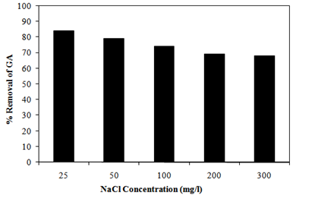
Fig. S6

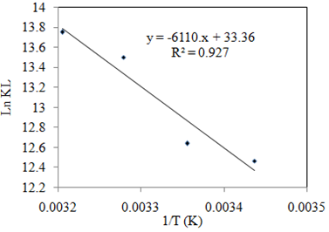

Fig. S7

