Distribution of missing data from questionnaires

 | All participants | Intervention | Control | Difference | P-value
Randomized | 54 | 27 | 27 | NA | NA
Questions answered at baseline (%) | 58.32 | 54.3 | 62.3 | -8.04 | 0.46
Questions answered at discharge (%) | 41.16 | 39.62 | 42.7 | -3.07 | 0.58
Total answered questions (%) | 49.74 | 46.96 | 52.52 | -5.56 | 0.37
There is no statistically significant difference in percentage of answered questions compering patients randomized to control or intervention. For both groups more questions were answered at discharge compared to baseline (admission).

Floor plan of room

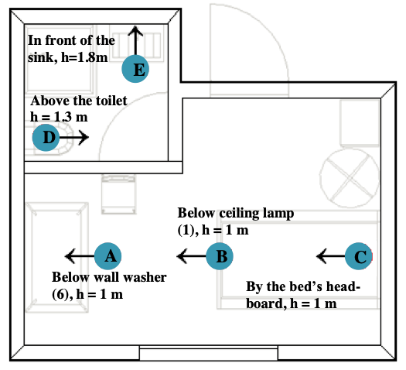

Floor plan of room with indications of measurement points, hight and direction for the Konica Minolta Illuminance Spectrophotometer CL-500A, which measures radiant power in watt per square metre for wavelengths in the visual spectrum (lux). At each point (A, B, C, D and E) we conducted two measurements, one with the spectrophotometer oriented vertically, and one horizontally in the direction indicated by the arrows.
Radiant power in circadian potent wavelengths (melanopic lux)
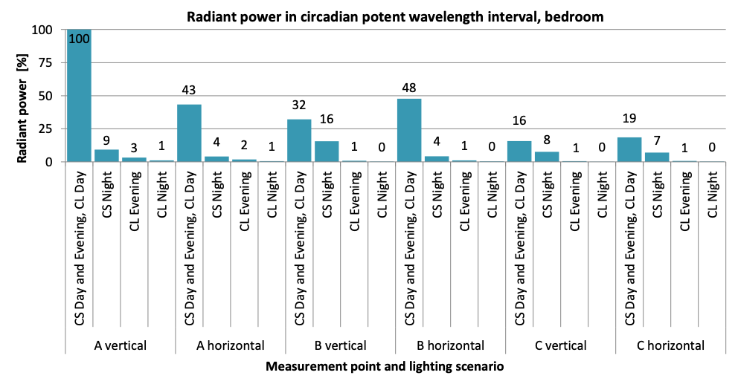

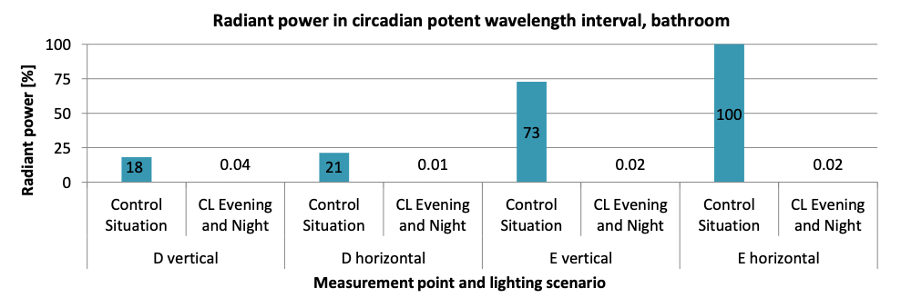

All measurements are stated as a percentage of the highest radiant power in the circadian potent wavelength spectrum (melanopic lux) measured vertically at point A during day time for main room, and at point E for bathroom. CS is ‘control’ and CL ‘intervention’. The bottom chart presents measurements from the bathroom. Day is 10am - 7pm, evening is 7pm - 11pm and night is 11pm to 7am. Measurements confirm that intervention rooms are effectively free from circadian potent blut wavelengths in evening and night time.

Illuminance in bathroom

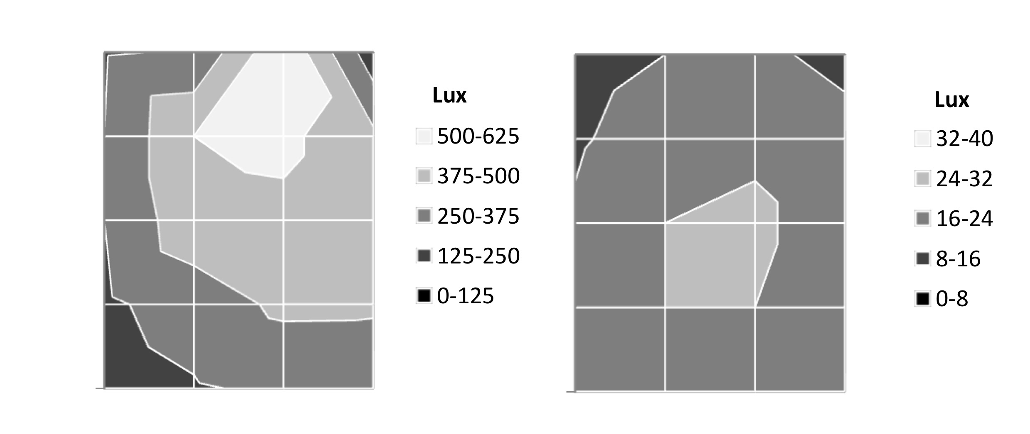

The illuminance levels in the rooms (bathroom, this page, and main room, next page) were measured in different lighting scenarios with daylight excluded from the room. All measurements were made using a TESTO 540 lux meter one metre above floor level. All measurements are presented in lux and according to floor plan in figure 1. The distance between grid lines is 0,5 metres. The reading lamp (light source no. 3, figure 1) is turned off. On the image to the left the lamp above the mirror “Mirror lamp” (Jakobsson Kleemann T124 with an Osram Lumilux HO 24W/830 T5 fluorescent light) is on and the centrally placed LED “Downlight II” (Solar Light IP21 13W) is off. This corresponds to control all day and intervention 7am - 7pm. On the image on the right the “Mirror lamp” is off and the “Downlight II” is on, which corresponds to intervention in evening and night time (7pm - 7am).

Illuminance in room (continued from previous page)

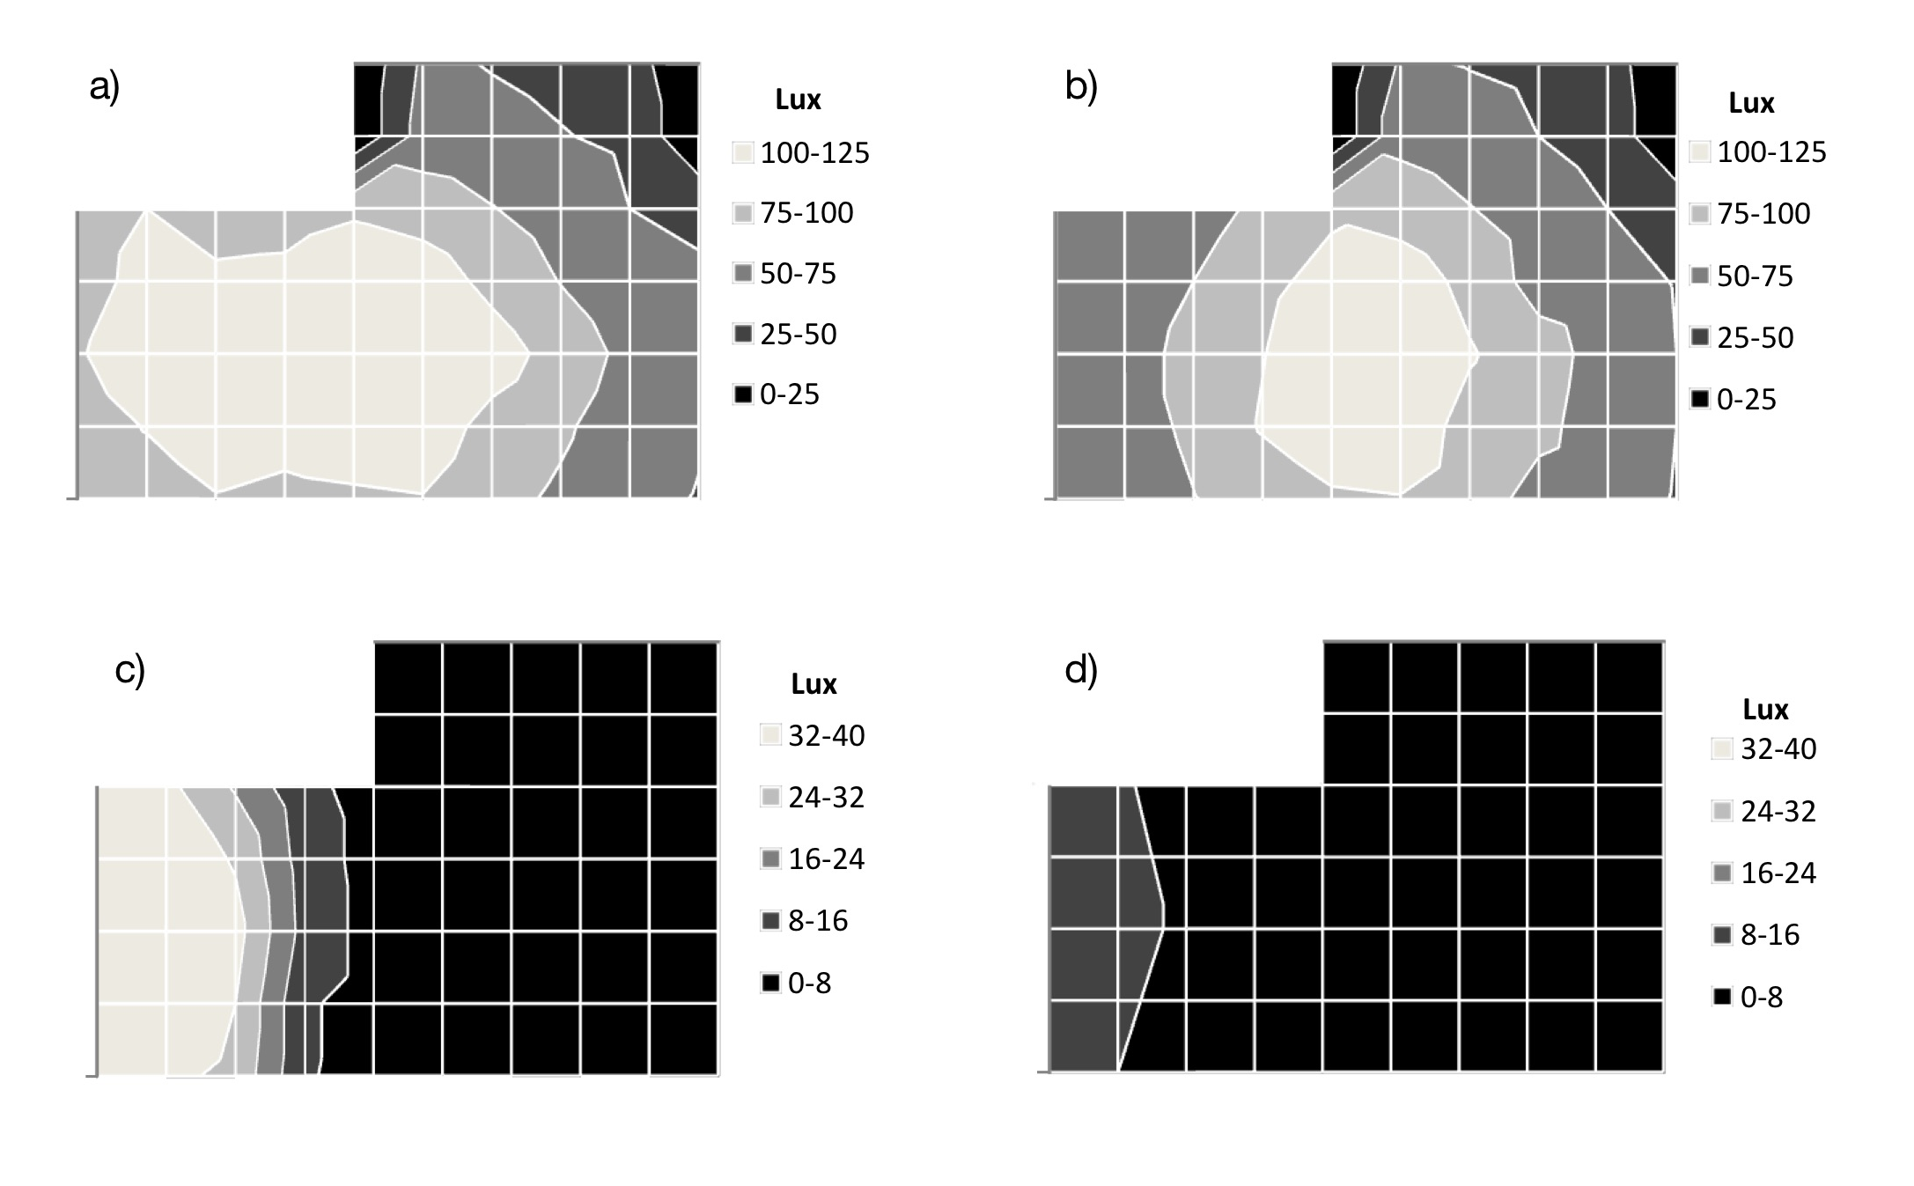

On image a) the centrally placed LED in main room Downlight I (Marlin Opaline 2055 with an Osram Dulux D 26W 827 light bulb) and LED above the desk top Wall washer (Wall Washer version 9) are on. On image b) the Downlight I is on and Wall washer is off. Both scenarios correspond to control all day and intervention 10am to 7pm. On image c) the Downlight I is off and Wall washer emits 295lm from red channel, 303lm from green channel and turned off on blue and white channels (low lux, no blue). This correponds to intervention from 7pm to 7am. In image d) the Downlight I is off and the Wall washer emits 41lm from the red channel, 43lm from green and 0 from blue and white channels (very low lux, no blue). This corresponds to intervention between 11pm to 7am.
Floor plan of the ward
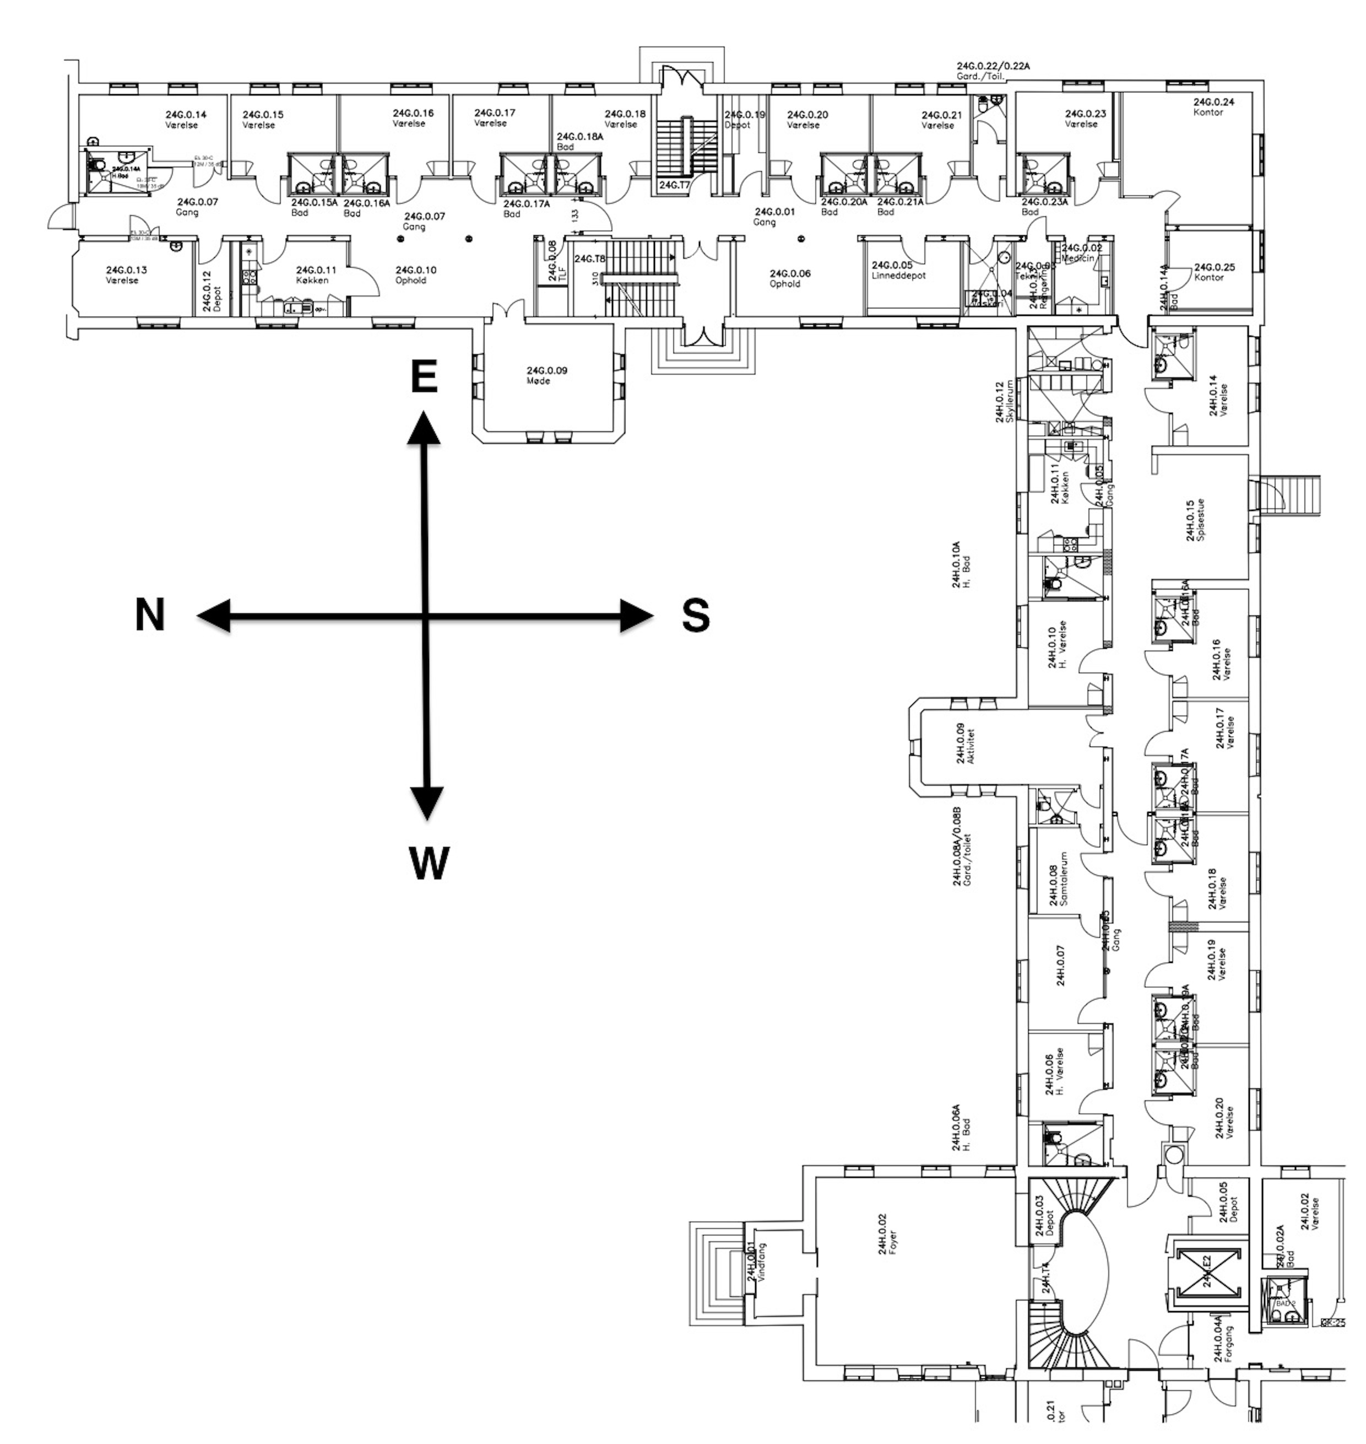

There are 17 beds or rooms ‘Værelser’ in the ward, two with windows facing north, six facing south, eight facing east, and one facing west. ‘Spiserum’ denotes dining room, ‘opholdsstue’ is living room, ‘kontor’ is staff office, ‘køkken’ is patient kitchens, and ‘møde’ is staff meeting room.

Lighting network

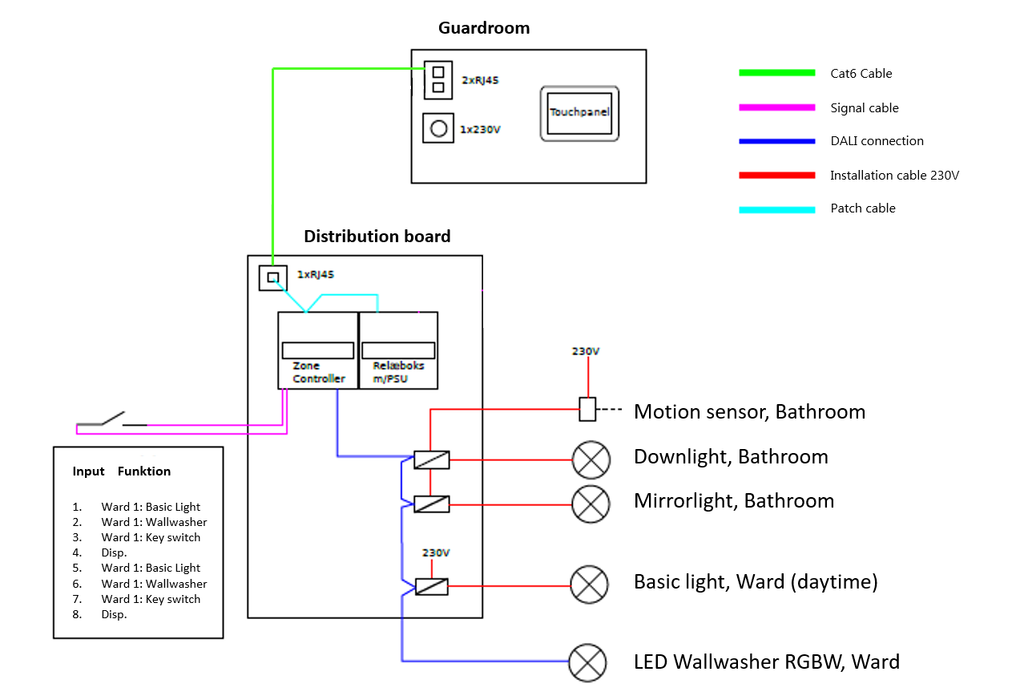

A schematic drawing of the advanced lighting system in the ward. In the staff office “Guardroom” there is a Touch Controller “Touchpanel” (product no. 40020006), which is a wall-mounted tablet with Android platform to control the lighting settings in each of the 17 patient rooms. The Touch Controller is connected to a System Controller “Distribution board” (product no. 70000001), which is a general server that contains software to communicate the commands from the Touch Controller to the Zone Controllers (product no. 70010049), which are local servers placed in each room that control the main light sources and integrate with information from motion sensors. All products are delivered by Moto Muto Aps.

Season of admission by month compared for patients in treatment (blue color) and patients in control (red color).

Photo of the inpatient ward taken from park side on September 22, 2016, 07.56 pm. Below the tree crown there are two windows; one with yellow light (control room) and one with red light (intervention room).

