Supplementary Online Content

Bi WG, Emami E, Luo ZC, Santamaria C, Wei, SQ. Effect of periodontal treatment in pregnancy on perinatal outcomes: a systematic review and meta-analysis

Appendix 1. Literature search strategy

Appendix 2. Assessment of bias risk of the included randomized controlled trials

Appendix 3 The funnel plot for the primary outcome of perinatal mortality

Appendix 4 Association between periodontal treatment in pregnancy and gestational age at birth (weeks)

Appendix 1. Literature search strategy

#1 - ("pregnancy"[MeSH Terms] OR "pregnancy"[All Fields] OR "gestation"[All Fields]) OR ("pregnant women"[MeSH Terms] OR "pregnant women"[All Fields] OR "pregnant woman"[All Fields] OR "pregnancy"[All Fields] OR "pregnancies"[All Fields]) OR ("gravidity"[MeSH Terms] OR "gravidity"[All Fields]) OR ("gravidity"[MeSH Terms] OR "gravidity"[All Fields] OR "gravidities"[All Fields]) OR ("gravidity"[MeSH Terms] OR "gravidity"[All Fields] OR "pregnant"[All Fields]) OR pregnants[All Fields]

#2 - ("periodontitis"[MeSH Terms] OR "periodontitis"[All Fields]) OR "periodontal disease"[All Fields] OR "periodontal therapy"[All Fields] OR "periodontal treatment"[All Fields] OR "scaling and root planing"[All Fields] OR "periodontal intervention"[All Fields] OR "dental scaling"[All Fields] OR "root planing"[All Fields] OR "subgingival curettage"[All Fields] OR "root scaling"[All Fields] OR "subgingival scaling"[All Fields] OR "supragingival Scaling"[All Fields] OR "periodontal therapeutics"[All Fields] OR (periodontal[All Fields] AND ("therapeutics"[MeSH Terms] OR "therapeutics"[All Fields] OR "attachment loss, periodontal"[All Fields] OR "loss, periodontal attachment"[All Fields] OR "periodontal debridement"[All Fields] OR ("periodontal debridement"[MeSH Terms] OR ("periodontal"[All Fields] AND "debridement"[All Fields])

#3 - ("pregnancy outcome"[MeSH Terms] OR ("pregnancy"[All Fields] AND "outcome"[All Fields]) OR "pregnancy outcome"[All Fields] OR ("outcome"[All Fields] AND "pregnancy"[All Fields])) OR (perinatal mortality [All Fields] OR "still birth"[MeSH Terms] OR "neonatal death"[All Fields]) OR (premature[All Fields] OR "premature birth"[MeSH Terms] OR "premature birth"[All Fields] OR preterm[All Fields] OR "preterm birth"[All Fields] OR "obstetric labor, premature"[MeSH Terms] OR "infant, premature"[MeSH Terms] OR ("infant, premature"[MeSH Terms] OR ("infant"[All Fields] AND "premature"[All Fields]) OR "premature infant"[All Fields] OR "prematurity"[All Fields]) OR "infant, birth weight"[MeSH Terms] OR "birth weight"[All Fields] OR "preterm delivery"[All Fields] OR ("pre-eclampsia"[MeSH Terms] OR "pre-eclampsia"[All Fields] OR ("pre"[All Fields] AND "eclampsia"[All Fields]) OR "pre eclampsia"[All Fields]) OR "pre eclampsia"[All Fields] OR ("pre-eclampsia"[MeSH Terms] OR "pre-eclampsia"[All Fields] OR "preeclampsia"[All Fields]) OR "gestational diabetes"[All Fields] OR "complication, pregnancy"[All Fields] OR "pregnancy complication"[All Fields] OR "complications, pregnancy"[All Fields]

#4 - (#1 AND #2 AND #3)

Appendix 2. Assessment of bias risk of the included randomized controlled trials
Study | Sequence generation | Allocation concealment | Blinding of participants and personnel | Blinding of outcome assessment | Incomplete outcome data | Selective outcome data | Other sources of bias
Farrell 2003 | Low | Unclear | High | Low | High | High | Unclear
Herrera 2009 | Low | Low | High | Unclear | Low | Low | Low
Jeffcoat 2003 | Low | Low | Low | Low | Low | Low | Low
Jeffcoat 2011 | Low | Low | Low | Low | Low | Low | Low
Khairnar 2015 | Unclear | Low | High | Low | Low | Low | Low
Lopez 2002 | Low | Unclear | High | Low | Low | Low | Unclear
Lopez 2005 | Low | Unclear | High | Low | Low | Low | Unclear
Macones 2010 | Low | Low | Low | Low | Low | Low | Low
Michalowicz 2006 | Low | Low | Low | Low | Low | Low | Low
Newnham 2009 | Low | Low | Low | Low | Low | Low | Low
Novak 2009 | Low | Low | High | Unclear | Low | Low | Unclear
Offenbacher 2006 | Unclear | Unclear | High | Low | Low | Low | Unclear
Offenbacher 2009 | Low | Low | Low | Low | High | Low | Low
Oliveira 2011 | Unclear | Low | High | Low | Low | Low | Unclear
Pirie 2013 | Low | Low | High | Unclear | Low | Low | Unclear
Radnai 2009 | Low | Low | High | Low | Low | Low | Low
Sadatmansouri 2006 | Unclear | Unclear | High | Unclear | Low | Low | Unclear
Sant’ana 2010 | Unclear | Unclear | High | Unclear | Low | Low | Unclear
Tarannum 2007 | Low | Low | High | Unclear | Low | Low | Unclear
Weidlich 2013 | Low | Low | High | Unclear | Low | Low | Unclear

Appendix 3 The funnel plot for the primary outcome of perinatal mortality

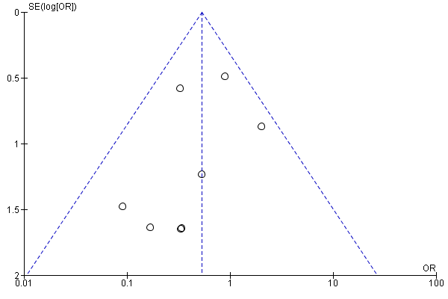

Appendix 4 Association between periodontal treatment in pregnancy and gestational age at birth (weeks)
