**Supplementary file**

**All Equations used in the present study:**

$Bulk density \left(\frac{g}{cm3}\right)=\frac{oven dry wt. of soil}{volume} eq.1$

$$Maximum water holding capacity of soil \left(\%\right)=\frac{(M3-M2-M4) }{(M2-M1) }×100 eq. 2$$

Here:

* Mass of filter paper + Keen’s box = M1 g
* Mass of dry soil + Keen’s box = M2 g
* Mass of soil after saturation + Keen’s box = M3 g
* Mass of dry soil = (M2-M1) g
* Mass of water absorbed by the soil = (M3-M2) g
* Mass of water absorbed by the filter paper = M4 g
* Mass of water absorbed by the soil = (M3-M2-M4) g

Volatile matter, ash and moisture content were analysed by using the American Society for Testing and Materials ASTM (D1762-84) method. Fixed-carbon content was calculated by subtracting volatile matter and ash content from the total dry weight of biochar. Energy Dispersive X-Ray Analysis (EDX) is an X-Ray technique which was used to identify the elemental composition of *Prosopis juliflora* biochar.35

Here, B= sample weight (grams) after drying at 105⁰C

C= sample in grams after drying at 950°C

$$Ash content \left(\%\right)=\frac{D}{B}×100 eq. 7$$

Here, B= sample in grams after drying at 105⁰C

D= residues in grams

Fixed carbon (%) = 100% - (volatile matter % + ash content %) eq.8

$Moisture \left(\%\right)=\frac{\left(A-B\right)}{A}×100 eq. 9$

Here, A= air-dry sample weight in grams

B= sample in grams after drying at 105⁰C

* ***Proximate and ultimate analysis of biochar***

The proximate and ultimate/elemental compositions of biochar sample prepared at 450⁰C are shown in Table 4 (This data set is already published).35 Volatile matter, ash and moisture content were analysed by using the American Society for Testing and Materials ASTM (D1762-84) method. Fixed-carbon content was calculated by subtracting volatile matter and ash content from the total dry weight of biochar.

**Table 5. Proximate and Ultimate analysis of biochar derived from *Prosopis juliflora* biomass.**

|  |  |  |
| --- | --- | --- |
| **Sr. No.** | **Constituents** | **PJBC** |
| **Proximate Analysis**  1. | Moisture (%) | 0.5 |
| 2. | Volatile Matter (%) | 11.01 |
| 3. | Ash content (%) | 5.2 |
| 4.  **Ultimate Analysis** | Fixed carbon (%) | 83.29 |
| 5. | Hydrogen (%) | 1.01 |
| 6. | Sulfur (%) | 0.13 |
| 7. | Oxygen (%) | 14.51 |
| 8. | Nitrogen (%) | 1.07 |

* **Optimization of extraction procedure and choice of extraction solvent**

Extraction efficiency of PAHs was significantly depends on the affinity of extraction solvent. To achieve better extraction efficiency of PAHs from environmental samples (soil, plant and water) the samples were first analysed with 2 solvents having wide polarity range like n-hexane and toluene. The extraction efficiency of PAHs expressed as a percentage determined from both extraction solvent are given in Table 6.

**Table 6. The extraction efficiencies of PAHs analysed**.

|  |  |  |  |  |  |  |  |  |  |  |  |  |  |  |
| --- | --- | --- | --- | --- | --- | --- | --- | --- | --- | --- | --- | --- | --- | --- |
| |  |  |  | | --- | --- | --- | | PAHs | Extraction efficiencies ± RSD (%) | | | n-hexane | Toluene | |  |  |  | | Naphthalene | ND | 66.39 ±0.26 | | Phenanthrene | 52 ±2 | 74.36 ±0.39 | |

* **Sample preparation for PAHs analysis**

The 2g sample was transferred into a glass beaker and 20-30 ml extraction solvent (toluene) was added to it. Samples were sonicated by using probe sonicator for 30 min at 30-40 duty cycles. The same procedure was followed 2-3 times by adding toluene for all samples. After that high-speed centrifuge MPW-350R was used at 4000 rpm for 15 min, the sample was filtered by using Whatman filter-paper No.1, pore size 11 µm. Silica gel for chromatography 60-120 mm mesh size glass column was used to filter-out the colored samples to make it colorless. Collect the whole extract in amber glass GC-vials. Finally, extract volume were reduced to 1-2 ml by allowing solvent evaporation with the help of rotator distillation unit at 100°C for approximately 45 min followed by GC-FID for PAHs analysis.

* **Reagents and Standards for PAH analysis**

The Poly-aromatic hydrocarbons analyzed in the present study were naphthalene and phenanthrene. An intermediate standard set of the solution was developed by transferring the equal dose of both naphthalene and phenanthrene (0.1 g to 25 ml) volumetric flask and dissolved in toluene. The final concentration prepared was 4000 ppm. A set of calibration standard solution of 1, 0.5 and 0.1 ppm was prepared from the standard working solution and used to fortify soil and plant samples. Toluene was HPLC grade and silica gel for chromatography 60-120 mm mesh size was purchased from Loba chemicals. The ultrapure Milli-Q water was used in the present study. Naphthalene and phenanthrene standard chemicals were purchased from Sigma-Aldrich.

* **GC-FID conditions**

The analysis of PAHs was carried out by GC (Varian-450, 2700 Mitchell drive, Walnut Creek, CA 94598-1675/USA) equipped with a flame ionised detector (FID) and an automatic split-splitless injector model. The column used for separation was 30 m × 0.53 mm, Id BPX 5, 1.5 (Serial no. 741901).

GC-FID operating conditions were as follows:

Injector port temperature= 280°C,

Nitrogen as carrier gas at a flow-rate = 1.2 ml/min.

Pulsed splitless mode (pulsed pressure 45 psi= 310 kPa for 1.5 min).

Column temperature = 140°C for 3 min, then programmed at 6°C/min to 250°C; increased to 300°C at a rate of 10°C/min and held for 5 min.

The total analysis time was 42 min and the equilibration time was 2 min. A 1µl volume was injected to the injector. Make-up (Nitrogen) flow rate 28 ml/min; combustion (Hydrogen) flow rate 30ml/min and combustion (Air) flow rate 30 ml/min were programmed.

* **Analytical characteristics of standards by gas chromatography**

Linear calibration curve was obtained by using four-point standards ranged from 0.1, 0.5 and 1 ppm. The linear graph plotted std. conc. v/s chromatographic area whose, R²=0.999 for phenanthrene and R² = 0.997 for naphthalene. 2g of dried, sieved soil (2 mm sieve) and 3g of plant sample was dissolved in 20 ml and 30 ml toluene respectively, used for the extraction of PAHs. PAHs were analysed by GC-FID. Representative GC-FID chromatogram of naphthalene and phenantharene analysed in a *Prosopis juliflora* biochar sample Fig 5. Both naphthalene and phenanthrene were satisfactory separated with adequate sensitivity.

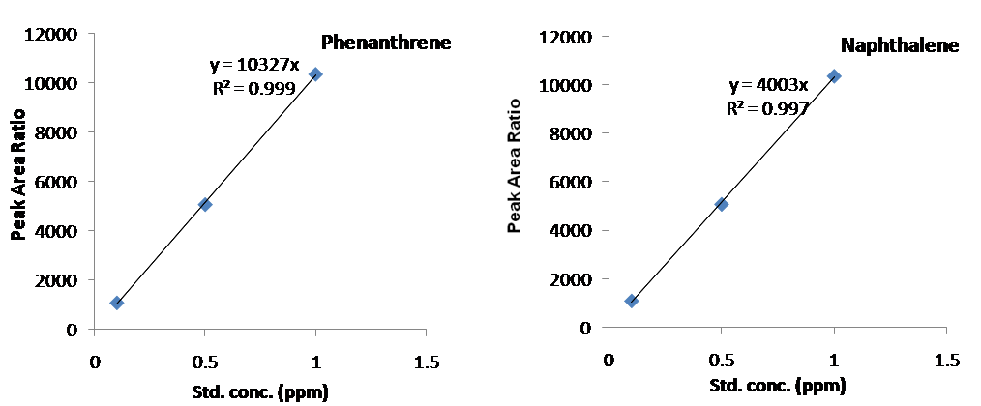

**Figure 4. Represents the standard peaks of Phenanthrene & Naphthalene (Conc. v/s peak area).**



**Figure 5. Representative GC-FID chromatogram of naphthalene and phenantharene analysed in a *Prosopis juliflora* biochar sample.**