Supplement materials
Figures
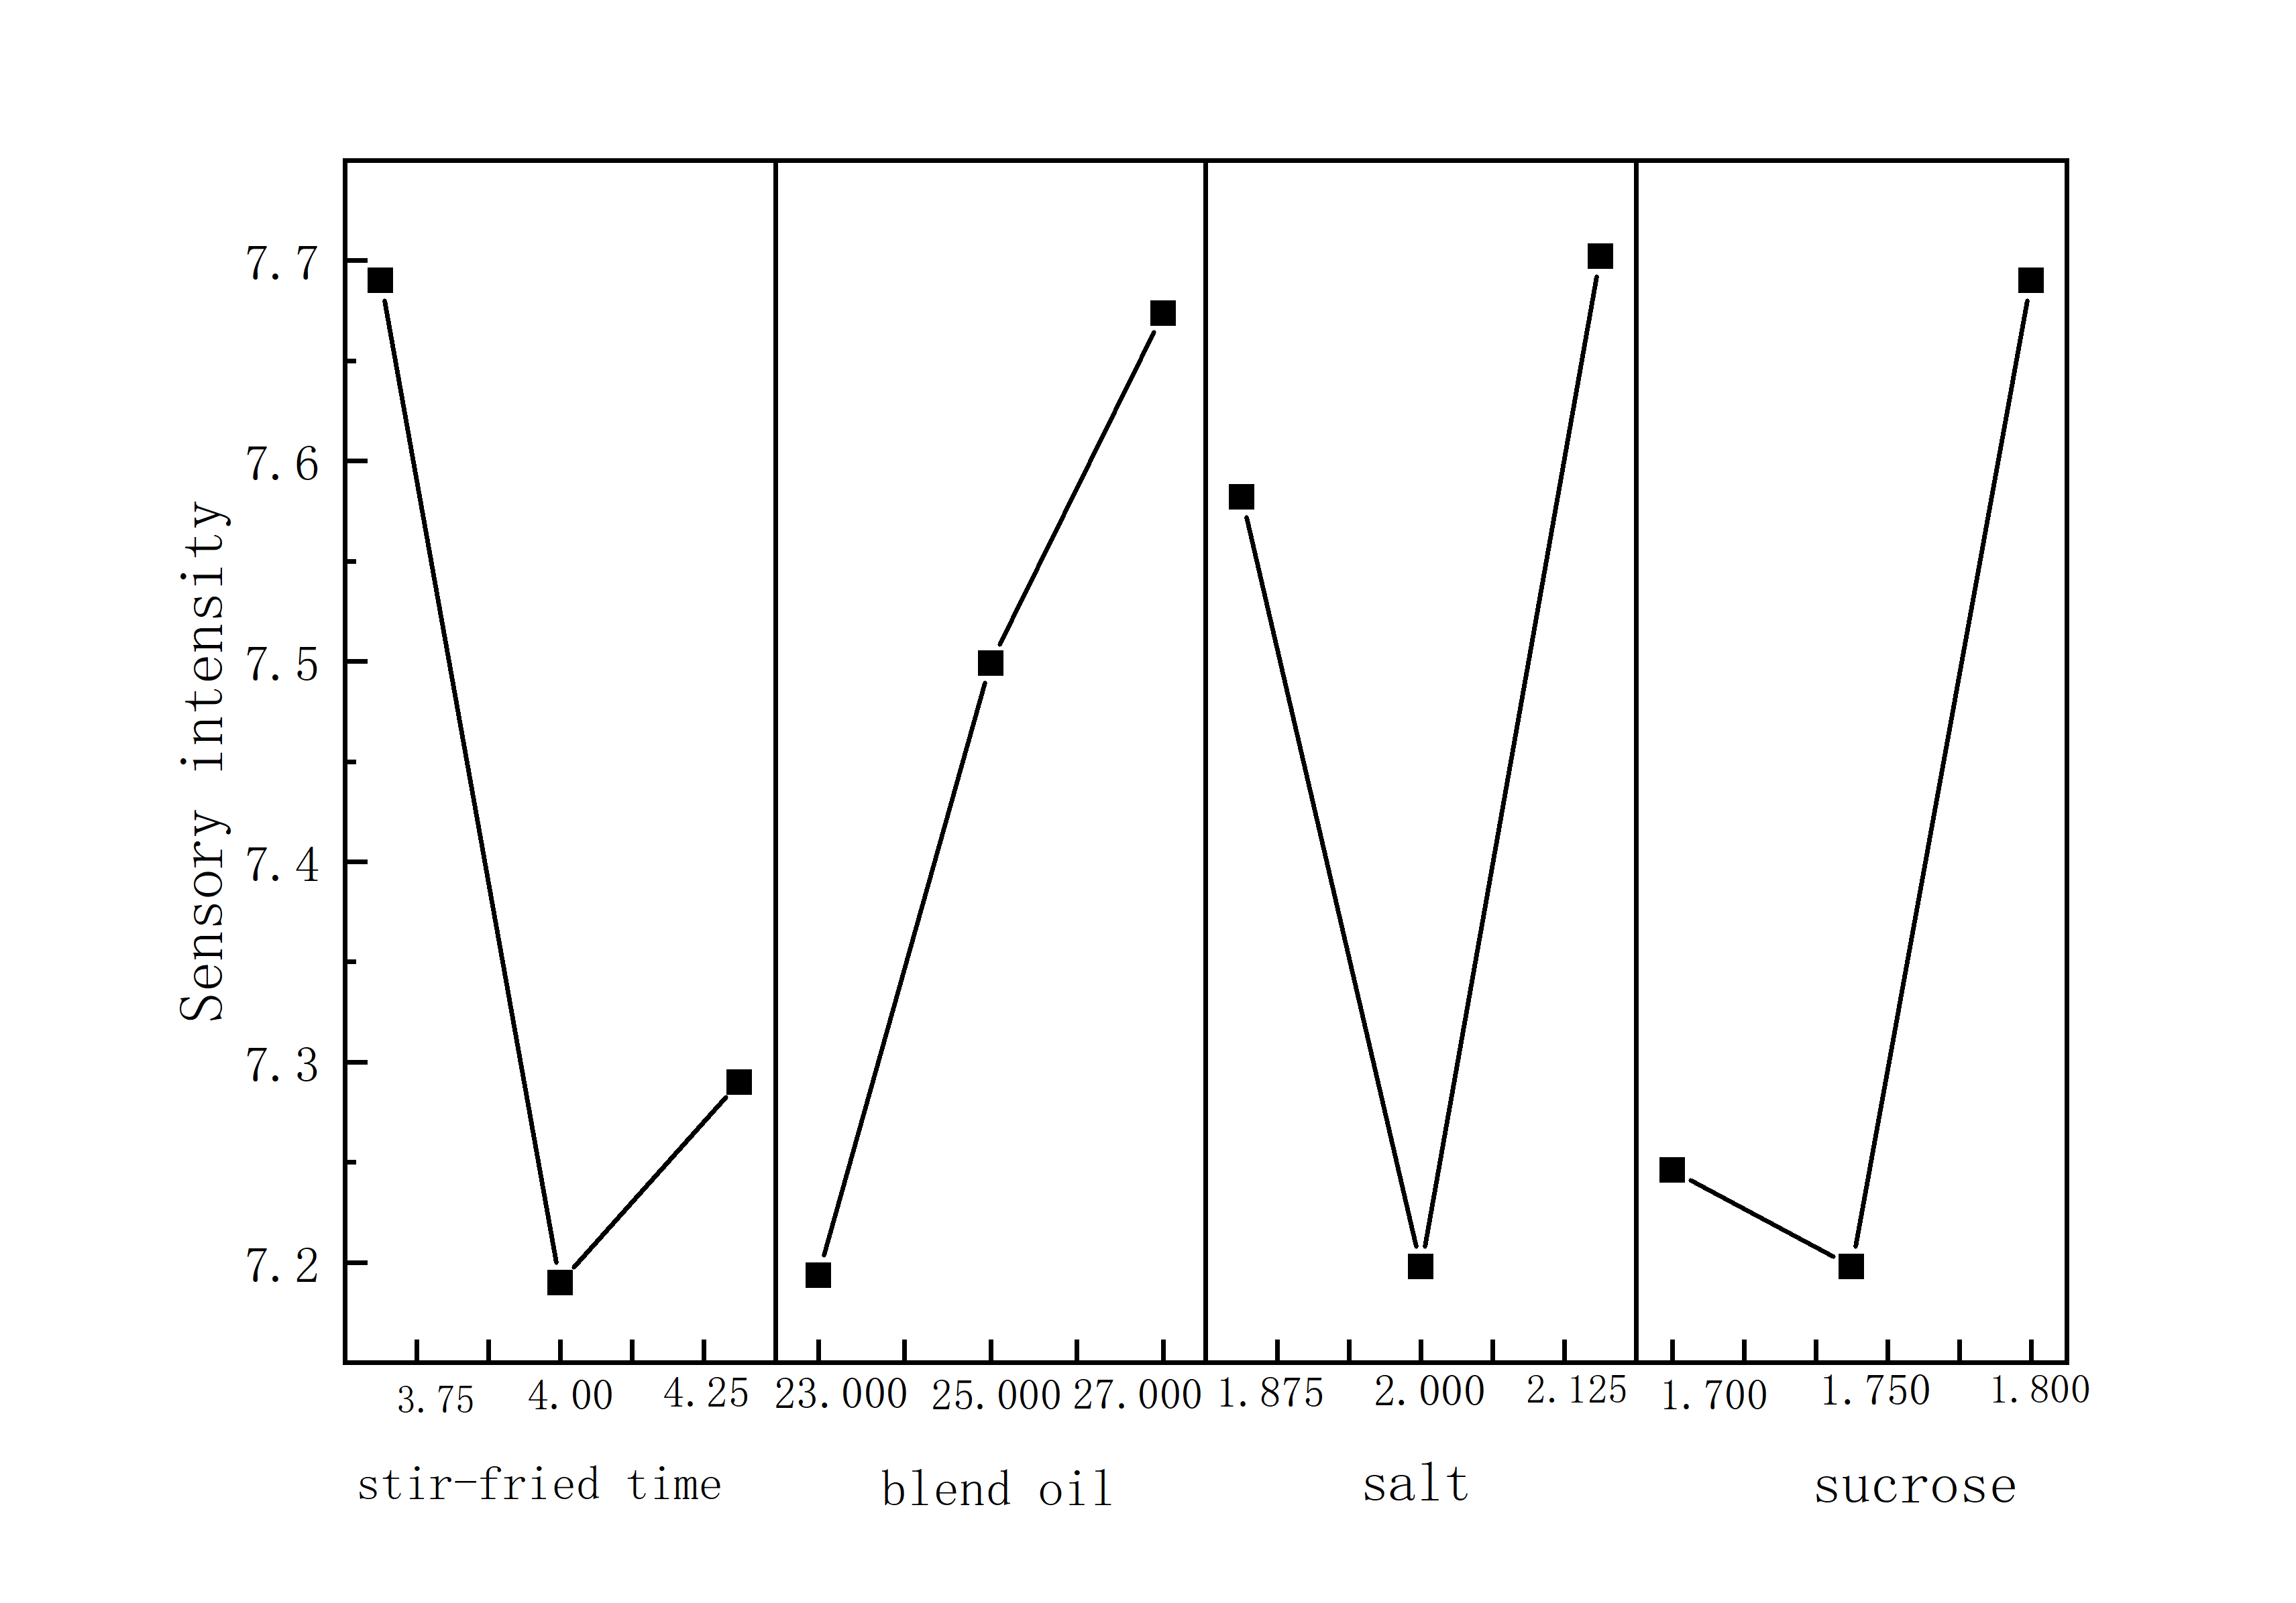
Fig.F1 Response graph for the mean values of each factor.(L₉(3⁴))

A  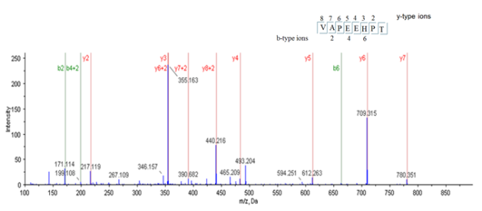 | B  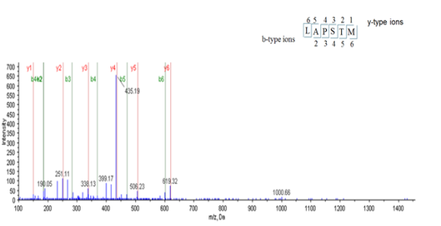
C  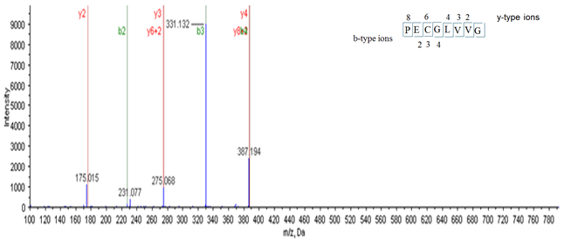 | D  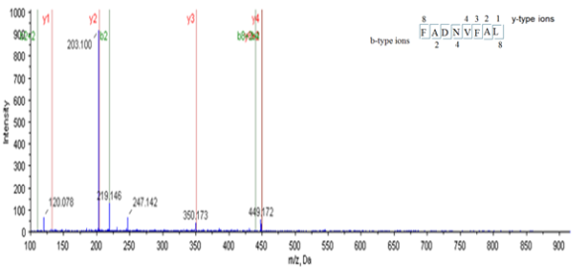
E
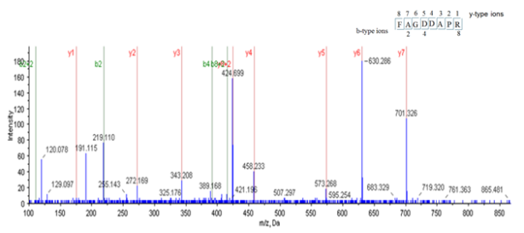

Fig.F2 MS/MS spectra of purified peptides (A: the peptides from S1M2-Ⅰ, B and C: the peptides from S1M2-Ⅱ, D: the peptides from S2M2-Ⅰ, E: the peptides from S2M2-Ⅱ; the b and y represented the ions generated from peptides.).

Tables
Table T1 L₉(3⁴) orthogonal array of the orthogonal experiment method.
Experiment order | Parameter level
 | (A) | (B) | (C) | (D)
1 | 1 | 1 | 1 | 1
2 | 1 | 2 | 2 | 2
3 | 1 | 3 | 3 | 3
4 | 2 | 1 | 2 | 3
5 | 2 | 2 | 3 | 1
6 | 2 | 3 | 1 | 2
7 | 3 | 1 | 3 | 2
8 | 3 | 2 | 1 | 3
9 | 3 | 3 | 2 | 1

Table T2 Parameters and levels of the L₉(3⁴) orthogonal experiment method.
Parameters | Level 1 | Level 2 | Level 3
(A) Time(min) | 3.75 | 4.00 | 4.25
(B) Oil(g) | 23.000 | 25.000 | 27.000
(C) Salt(g) | 1.875 | 2.000 | 2.125
(D) Sucrose(g) | 1.700 | 1.750 | 1.800

