Supplementary information
Synthesis and crystal structure of bis(morpholino dithiocarbamato) Cd(II) complex and its use as precursor for CdS using different capping agents

Lebogang L. R. Mphahlele and Peter A. Ajibade*
School of Chemistry and Physics, University of KwaZulu-Natal, Private Bag X01, Scottsville, Pietermaritzburg, 3209 South Africa

Figure S1: IR spectra of morpholine ligand (L) and corresponding Cd(II) complex (C).

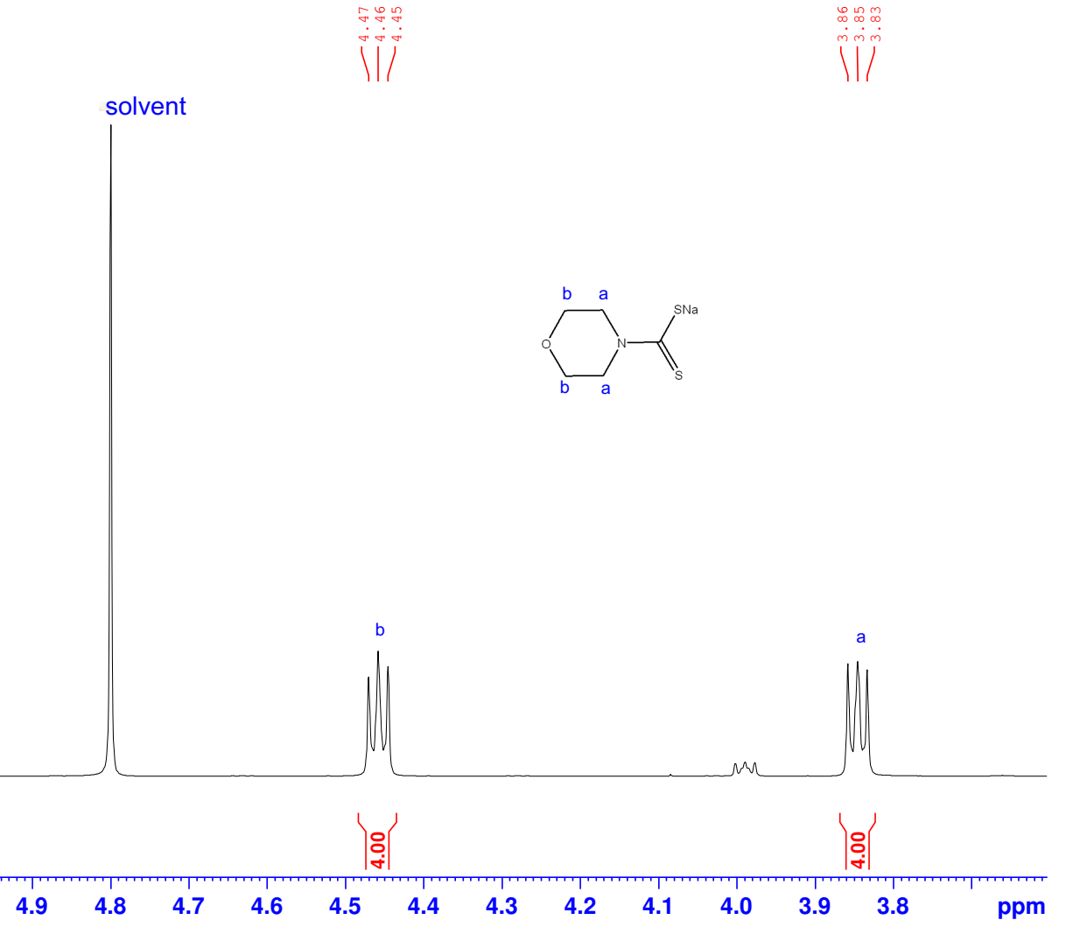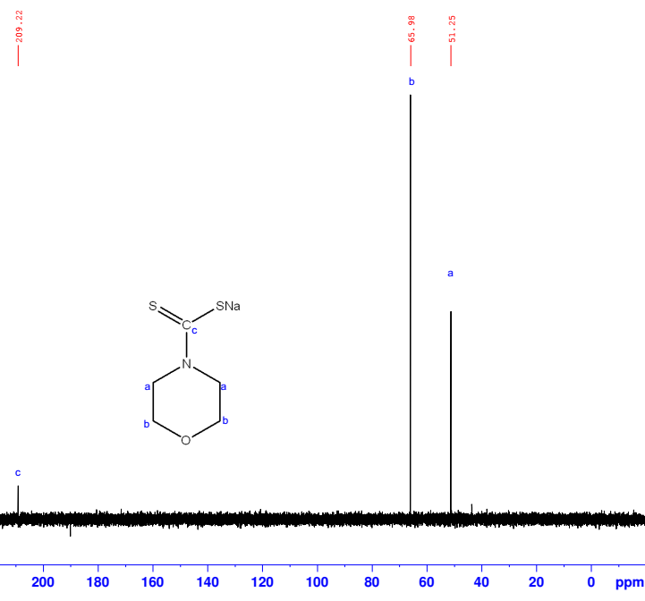

Figure S2: ¹H & ¹³C NMR spectra of morpholine DTC ligand (L)

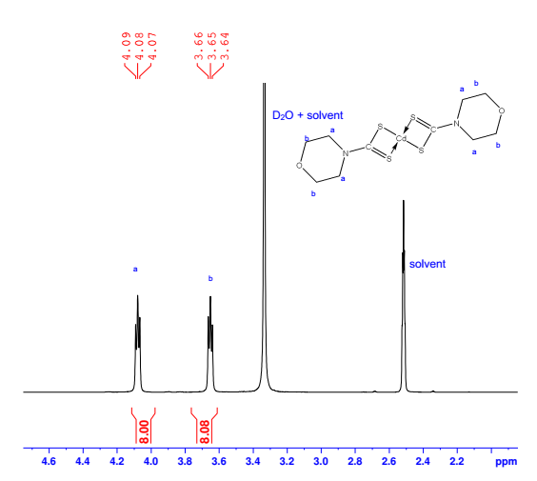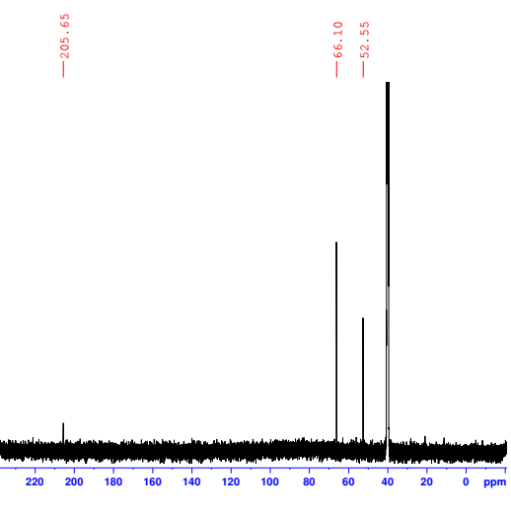
Figure S3: ¹H & ¹³C NMR spectra of Cd(II)L DTC complex (C)

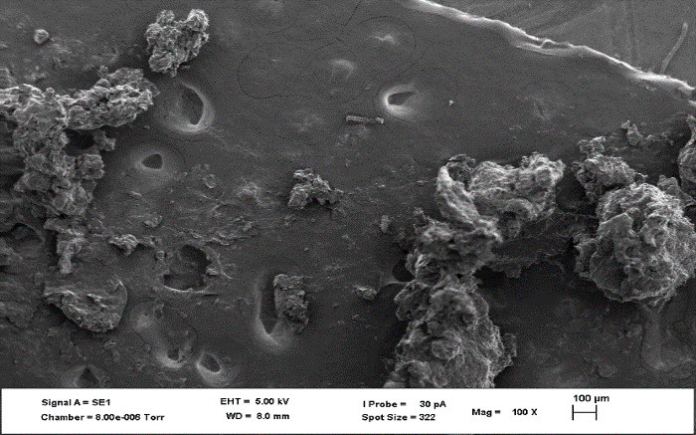 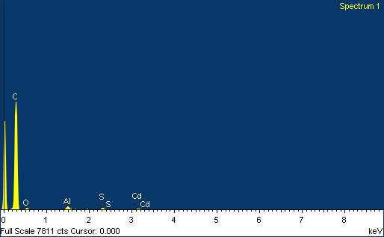(a)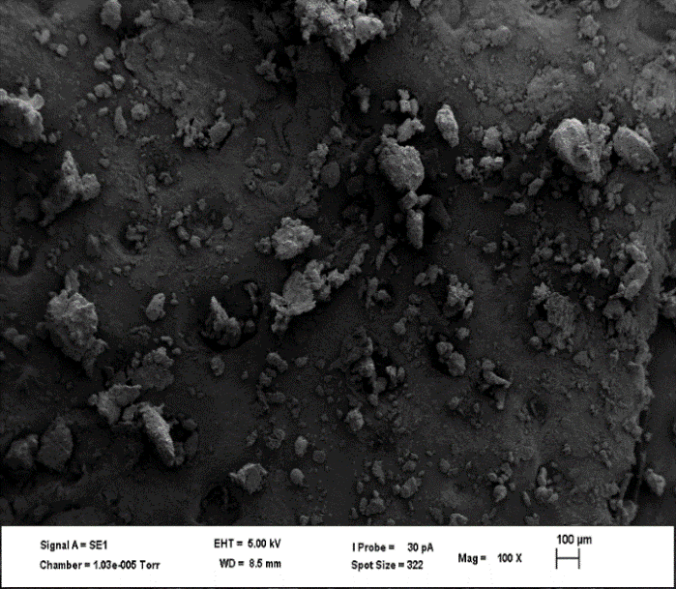 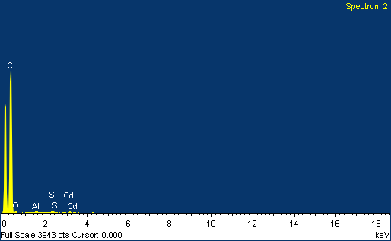(b)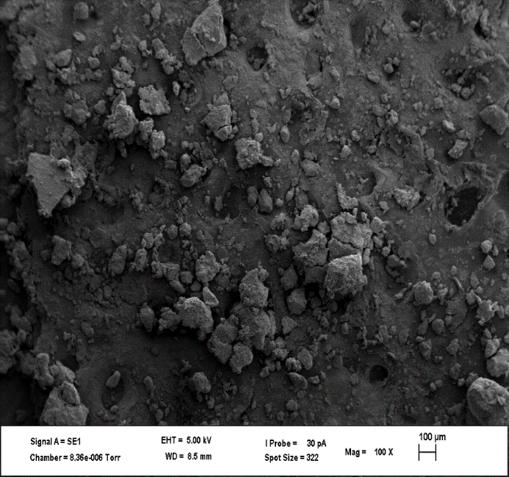 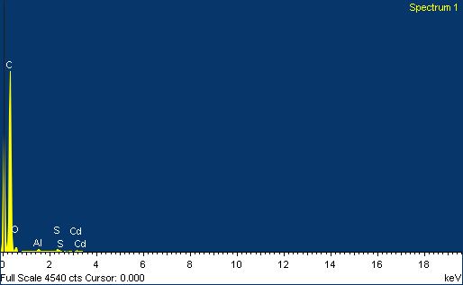(C)
Figure S4: SEM micrographs and EDS spectra of as-prepared (OLM, HDA, and ODA) CdS nanoparticles

