Supplementary materials
Inverse Vulcanization of Sulfur with Vinylic POSS
Rafał Anyszka,ª٭ Marcin Kozanecki,^{b} Anna Czaderna,^{b} Magdalena Olejniczak,^{b} Jan Sielski,^{c} Mariusz Siciński,ª Mateusz Imiela,ª Jakub Wręczycki,ª Dominik Pietrzak,ª Tomasz Gozdek,ª Michał Okraska,ª Małgorzata Iwona Szynkowska^{d}, Piotr Malinowski^{d} and Dariusz M. Bieliński,ª
^{a.} Institute of Polymer and Dye Technology, Lodz University of Technology, Stefanowskiego 12/16, 90-924 Lodz, Poland. ٭E-mail: rafal.anyszka@p.lodz.pl
^{b.} Department of Molecular Physics, Lodz University of Technology, Zeromskiego 116, 90-924 Lodz, Poland.
^{c.} Department of Molecular Engineering, Lodz University of Technology, Wolczanska 213, 90-924-Lodz, Poland.
^{d.} Institute of General and Ecological Chemistry, Lodz University of Technology, Zeromskiego 116, 90-924 Lodz, Poland.

Experimental

Materials
Octavinyl silsesquioxane (OL1170 – Vinyl POSS Cage Mixture) of >97 % purity was originated from HybridPlastics Inc (US) and used as received. Sulfur of >99,95 % purity was purchased from Siarkopol S. A. (Poland). Carbon disulphide (CS₂) of ≥ 99 % purity was purchased from Sigma-Aldrich (US).

Methods
Preparation of the hybrid copolymer: 8.998 g of the sulfur along with 0.997 g of the POSS were placed in a laboratory boron glass beaker of 100 ml volume. The beaker with the substrates was immersed in silicone oil bath, placed on electric heating plate, equipped with a magnetic stirrer and a thermocouple. The thermocouple was immersed in the silicone oil. The substrates were heated up to 130 °C and mixed with magnetic stirrer 8 hour/day during 7 days (Figure S1). After 7 of synthesis viscosity of the composition was so high that magnetic stirrer was unable to efficient mixing anymore. Afterwards, visibly homogenous part of the composition was removed for further analysis (Figure S2).

Unreacted sulfur extraction: A single piece of the copolymer of 127 mg was placed in 30 ml of CS₂ for one week in order to remove unreacted sulfur and investigate the solubility of the copolymer. Mass of the sample was measured before and after the immersion by analytical balance AS.160.X2 (Radwag). After the test mass of the sample decreased to 31 mg showing that the sample contains 24.4 % of the copolymer and 75.6 % of unreacted free sulfur.

Unreacted POSS extraction: A single piece of the copolymer of 31 mg was placed in 30 ml of cloroform for one day in order to remove unreacted POSS. Mass of the sample was measured before and after the immersion by analytical balance AS.160.X2 (Radwag). After the test mass of the sample was still equal to 31 mg showing that all the used POSS is chemically bonded to sulfur.

a)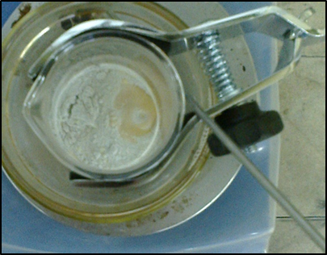 b)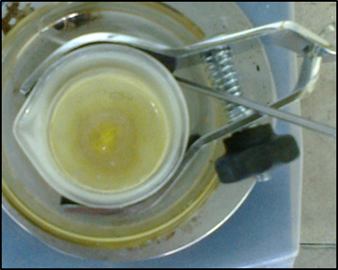 c)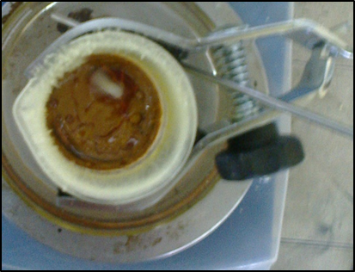
Figure S1. Images of the substrates after 1 hour (a), 1 day (b) and 7 days (c) of reaction.

Figure S2. Images of the poly(S-r-POSS) sample piece used for testing under various magnifications.

Analytical instrumentation: The absorption spectra in the middle infrared region, from 525 cm⁻¹ to 4000 cm⁻¹, were collected using Nicolet Fourier-Transform iS50 (Thermo Scientific) spectrometer equipped with a KBr beam splitter and a mercury cadmium telluride (MCT) detector cooled with liquid nitrogen. The spectra were recorded with a resolution of 2 cm⁻¹ and with an average of 256 scans per spectrum. The attenuated total reflectance (ATR) accessory with a diamond crystal was applied. The Raman spectra in the 50 and 3500 cm⁻¹ range were acquired using Jobin-Yvon T64000 triple grating Raman spectrometer with Ar laser of 514.5 nm as excitation line and with a CCD camera as a detector. The spectral resolution was below 1 cm⁻¹. The powder samples were placed directly onto the microscope stage and the laser beam was focused on the surface of the sample. The x50 long-distance microscope objective (N.A.=0.65) offered lateral spatial resolution below 1 µm. The laser power on a surface of the sample was estimated to be 2-4 mW. Data acquisition time was selected individually for each material. All measurements were performed at (20.0 ± 1.0)˚C.
Scanning Electron Microscope (SEM) Quanta FEI200F equipped with X-ray elemental analyser (EDX) Oxford Instruments X-Max 50 was utilized for the sample micromorphology analysis. The depth of the EDX measurement was ~500 nm. Due to nonconductive character of the sample SEM analysis was carried out under low pressure nitrogen atmosphere in order to prevent the sample surface from overcharging by electrons. Elemental weight composition of the sample was calculated as an average value from 11 measurements, excluding counts for nitrogen.
Differential scanning calorimeter (DSC) Netzch DSC 204 along with thermogravimetric analyser (TG) Netzch TG 209 used with Netzch TASC 414/3A controller were used for thermal properties analysis of synthesized copolymer. DSC analysis were performed under nitrogen or synthetic air atmosphere in temperature range from -70 ºC to 500 ºC. The samples (14.9 mg under nitrogen; 12.2 mg under synthetic air) were tested with heating rate of 5, 10 and 20 ºC/min and gas flow rate of 22 ml/min. TG analysis were performed under nitrogen atmosphere with gas flow rate of 16 ml/min and heating rate of 2, 4, 6 of 8 °C/min. Mass of the tested samples were: 12.2 mg for 2 ºC/min, 13.8 mg for 4 °C/min, 14.0 mg for 6 °C/min and 14.1 mg for 8 °C/min measurements. To calculate activation energy of the copolymer thermal decomposition the Flynn-Wall-Ozawa method was used. At constant conversion (decomposition) degree (α), the plot consisting of logβ (β – heating rate) versus 1/T made of the data from several measurements at different heating rates should representing a straight line, which slope indicates the activation energy of thermal decomposition, using the following eq. 1.

𝑠𝑙𝑜𝑝𝑒 = d(logβ)/d(1T) = 0.4567ER (1)

Where E is the activation energy and R is the gas constant (8.314 J/molK). To apply this model heating rates of 2, 4, 6, and 8 °C/min were chosen and measurement were made for conversion rates (α) of 0.1, 0.2, 0.3, 0.4, 0.5, 0.6, 0.7, 0.8 and 0.9.
SEM-EDX analysis of the samples previously tested by means of DSC method was done using Hitachi S-4700 electron scanning microscope equipped with X-ray analyser, operating with accelerating voltage of 25 kV.

Results

The unmodified spectrum of sulfur in the middle IR region is performed on the Figure S2. The baseline was subtracted from ‘rare’ spectrum. After the normalization to the integrated area, the spectrum was smooth using 20 point filter.

Figure S3. ATR FT-IR spectra of sulfur.

Figure S4. SEM picture of the poly(S-r-POSS) copolymer cross-section analysed by EDS technique (Figure S4).

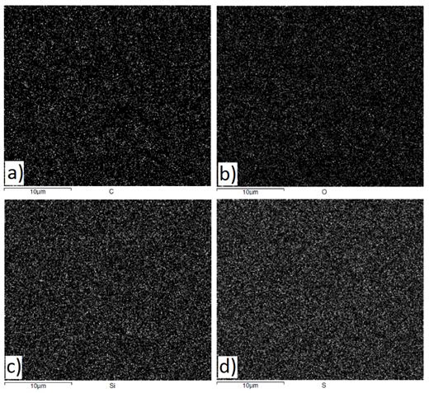
Figure S5. EDS maps of carbon a), oxygen b), silicon c) and sulfur d) distribution on the surface of the Poly(S-r-POSS) copolymer cross-section.

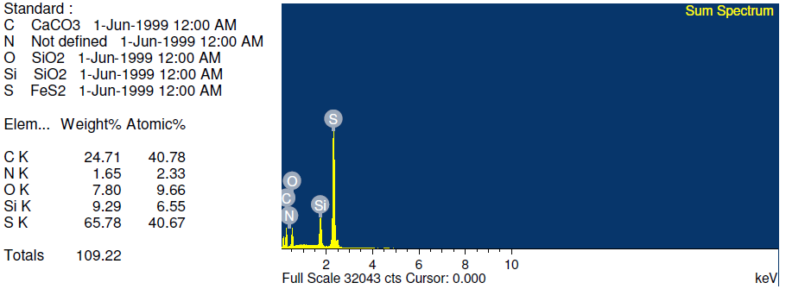
Figure S6. An example of EDX analysis results for one measurement.

Description | Content of elements (% wg)
Element | C | O | Si | S | H
EDS measurement | 23.53 ± 2.59 | 6.93 ± 1.14 | 7.48 ± 0.80 | 62.07 ± 3.71 | -
Calculated | 3.03 | 3.02 | 3.54 | 90.03 | 0.38
Table S1. EDS measured and calculated content of structural elements of Poly(S-r-POSS)

Figure S7. SEM pictures of the poly(S-r-POSS) copolymer surface under various magnifications before the extraction of unreacted sulfur.

Figure S8. SEM pictures of the poly(S-r-POSS) copolymer surface under various magnifications after the extraction of unreacted sulfur.
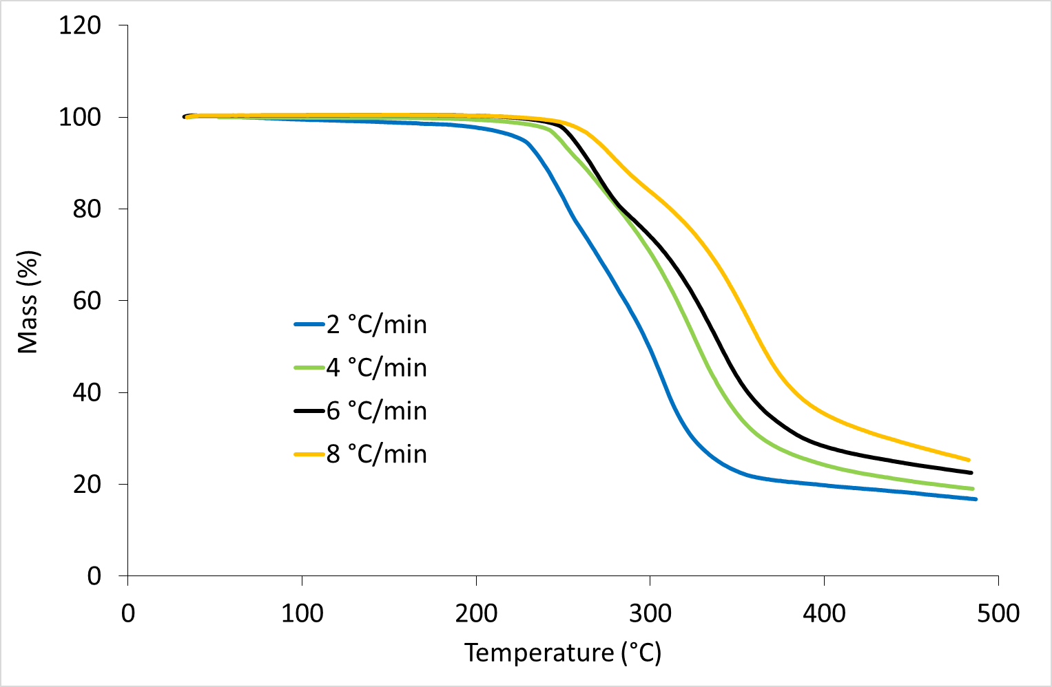
Figure S9. Thermogravimetric analysis of the Poly(S-r-POSS) samples under nitrogen atmosphere and various heating rates.

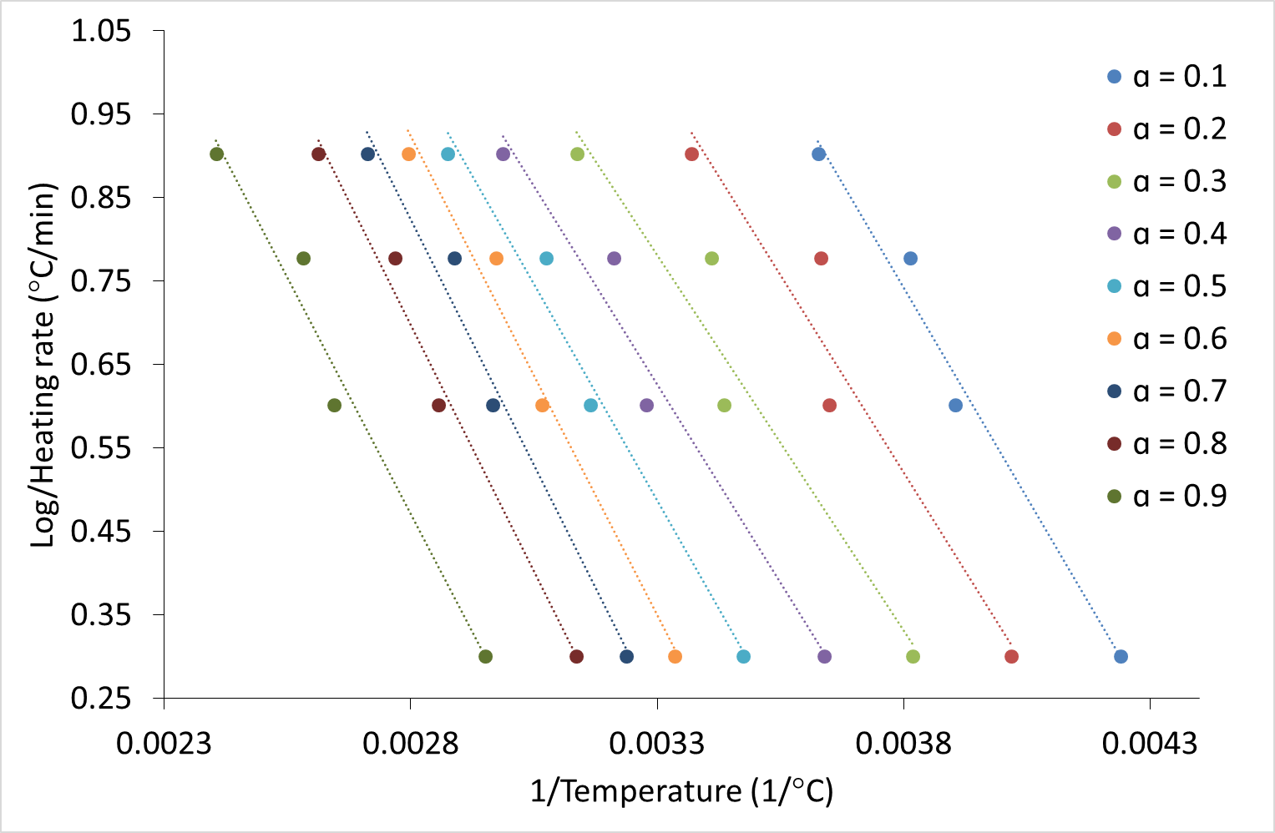
Figure S10. Plots exhibiting Flynn-Wall-Ozawa approach toward estimation of decomposition energy of Poly(S-r-POSS) samples.

Figure S11. SEM picture of the Poly(S-r-POSS) sample residue after DCS analysis under nitrogen atmosphere (magnification x300).
Figure S12. SEM picture of the Poly(S-r-POSS) sample residue after DCS analysis under nitrogen atmosphere (magnification x1000).

Figure S13. SEM picture of the Poly(S-r-POSS) sample residue after DCS analysis under synthetic air atmosphere (magnification x300).

Figure S14. SEM picture of the Poly(S-r-POSS) sample residue after DCS analysis under synthetic air atmosphere (magnification x1000).

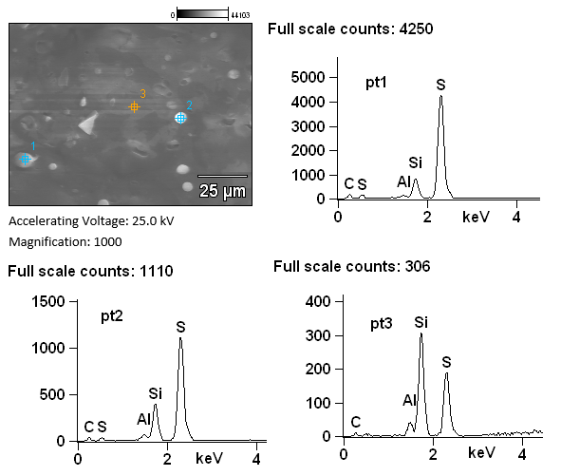
Figure S15. EDX analysis results of specific spots on the Poly(S-r-POSS) sample residue after DCS analysis under nitrogen atmosphere.
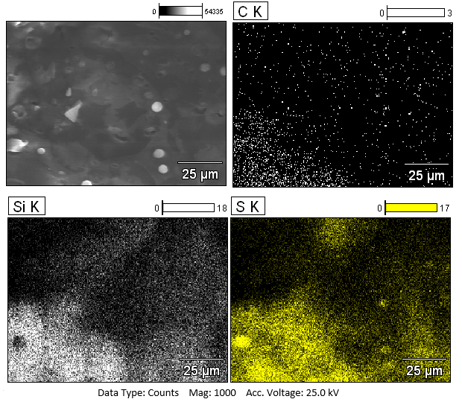
Figure S16. SEM picture and EDX mapping results of the Poly(S-r-POSS) sample residue after DCS analysis under nitrogen atmosphere.

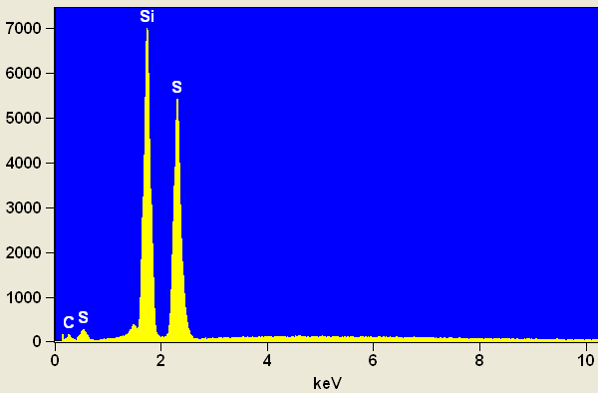
Figure S17. EDX analysis results of the Poly(S-r-POSS) sample residue after DCS analysis under nitrogen atmosphere.

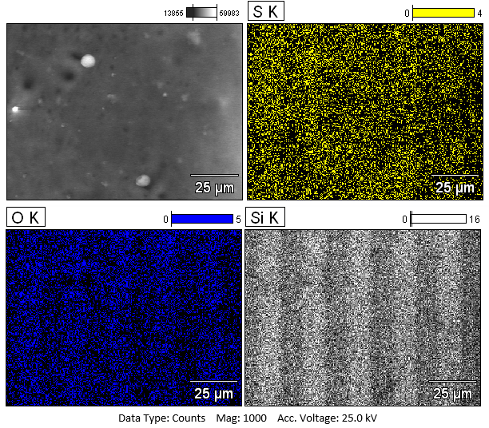
Figure S18. SEM picture and EDX mapping results of the Poly(S-r-POSS) sample residue after DCS analysis under synthetic air atmosphere.
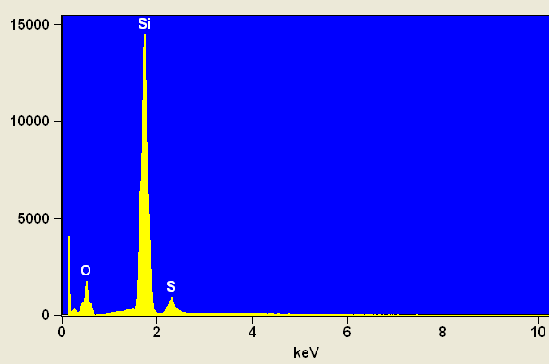
Figure S19. EDX analysis results of the Poly(S-r-POSS) sample residue after DCS analysis under synthetic air atmosphere.

