Efficacy of an ambulance ventilation system in reducing EMS worker exposure to airborne particles from a patient cough simulator

Online Supplemental Materials

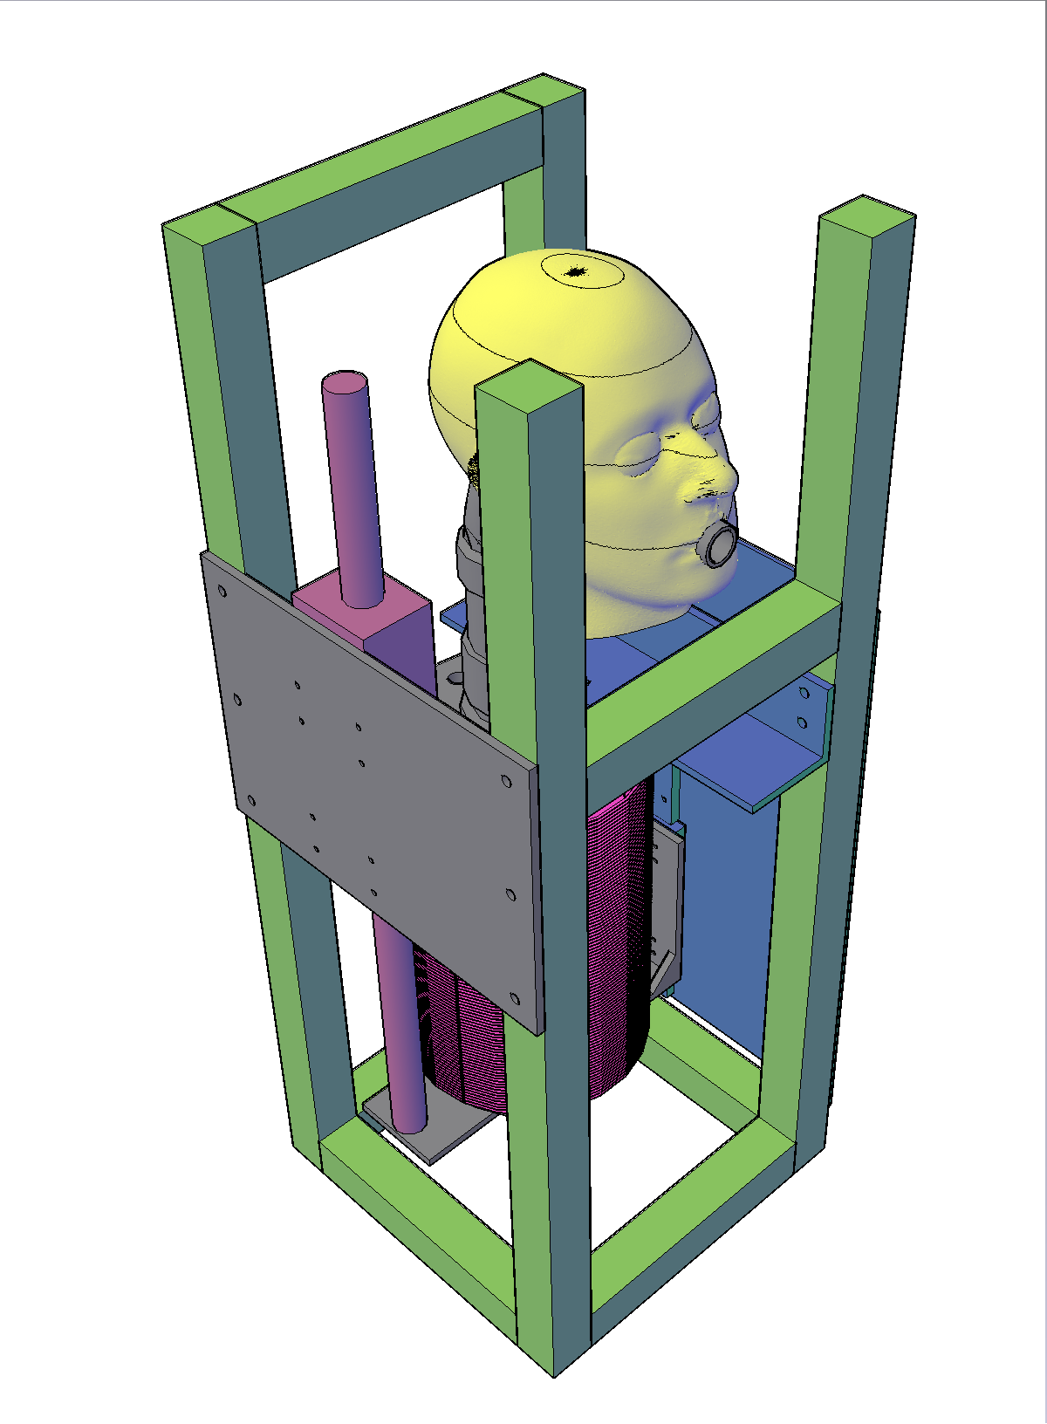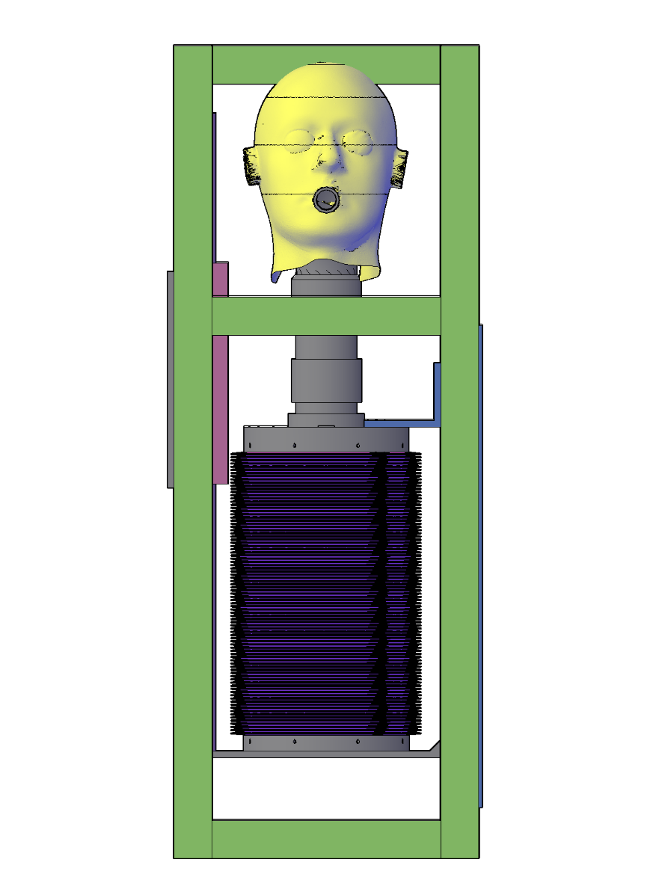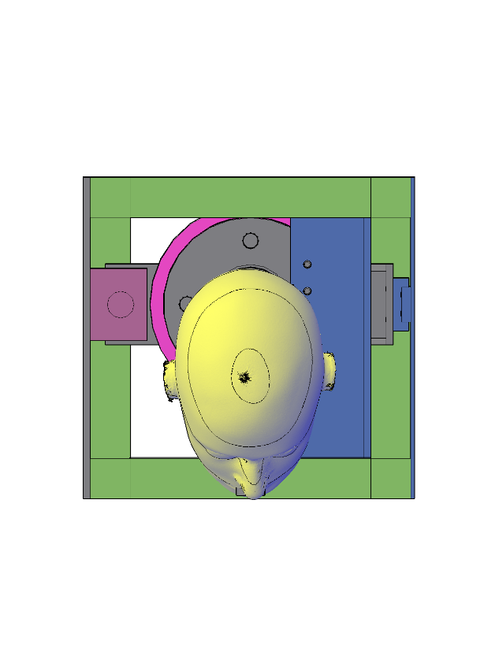

32”

(81.3 cm)

25 ½”

(64.8 cm)

12”

(5.1 cm)

12”

(5.1 cm)

Bellows

Linear

motor

Mouth

(cough

outlet)

Guide

rail

Figure S1: NIOSH cough aerosol simulator. The simulator produces a cough with a volume of 4.2 liters and a peak flow rate of 11 liters/second.

# Cough aerosol simulator output



Figure S2: The size distribution of the cough aerosol generated by the simulator is shown for the 28% KCl solution with the cot angle at 30°. The histogram shows the volume concentration of the aerosol expelled by the cough simulator in each of 28 size bins for aerosol particles from 0.3 to 20 µm in diameter. At this angle, the cough aerosol had a volume geometric mean particle diameter of 2.6 µm, a geometric standard deviation of 1.7, and a total aerosol volume concentration of 202 µL/m3 of air for particles between 0.3 and 3 µm in diameter. The size distribution of the cough aerosol output was similar at the other cot angles, but the concentration of the cough aerosol was 7% higher at 0° and 14% lower at 60° compared to 30°, as shown in Table S1 below.



Figure S3: The cough aerosol output with the MHBSS used as a suspending media for the influenza virus had a volume geometric mean of 1.5 µm, a geometric standard deviation of 1.6, and a total aerosol volume concentration of 947 µL/m3 of air for particles between 0.3 and 3 µm in diameter, indicating that the MHBSS cough aerosol was composed of smaller particles on average than the 28% KCl aerosol, and had a markedly higher concentration.

Table S1: Characteristics of the cough aerosol output from the NIOSH cough aerosol simulator. Results are the mean and standard deviation (in parentheses) from six trials at each angle for the 28% KCl, and twelve trials for the MHBSS.

|  |  |  |  |  |  |
| --- | --- | --- | --- | --- | --- |
| *Cot angle* | *Aerosol medium* | *Volume concentration of cough aerosol (µL/m3)* | *Volume concentration of cough aerosol between 0.3 and 3 µm (µL/m3)* | *Volume geometric mean diameter of aerosol (µm)* | *Volume geometric standard deviation* |
| 0° | 28% KCl | 376 (40) | 216 (28) | 2.68 (0.06) | 1.76 (0.02) |
| 30° | 28% KCl | 346 (40) | 202 (22) | 2.65 (0.06) | 1.72 (0.03) |
| 60° | 28% KCl | 286 (18) | 173 (10) | 2.58 (0.03) | 1.70 (0.02) |
| 30° | MHBSS | 1013 (145) | 947 (140) | 1.51 (0.04) | 1.59 (0.06) |

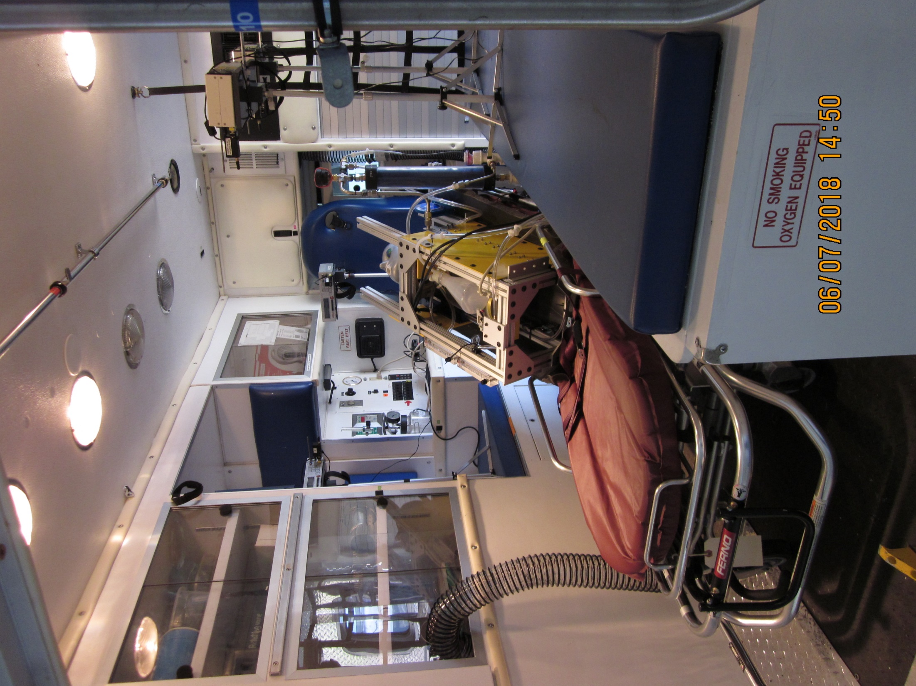

OPC 1

OPC 2

OPC 3

(behind

OPC 4)

OPC 4

Cough

simulator

Patient cot

Hose to

HEPA

blower

Figure S4: Experimental set-up. The NIOSH cough simulator is shown on the patient cot at a 30° angle with 4 optical particle counters (OPCs) in positions 1-4. The yellow circles mark the inlets for each OPC.

Diffusion drier

<-Aeroneb nebulizer

Bench seat

Control panel

Seat

Seat

C:\Users\wdl7\AppData\Local\Microsoft\Windows\INetCache\Content.Word\AKC_60_Pos1_TotalVol.emf



Figure S5: Aerosol volume concentration over time at position 1 with the cot at 0°, 30° and 60°. The aerosol volume concentration is the total volume of KCl aerosol particles from 0.3 to 3 µm in diameter per m3 of air. Because the output from the cough aerosol simulator changes with the cot angle, the volume concentrations at 0° were divided by 1.067 and the 60° concentrations by 0.858 to normalize them to the 30° cot angle results. ACH is compartment air changes/hour. Each line is the mean of four experiments.

C:\Users\wdl7\AppData\Local\Microsoft\Windows\INetCache\Content.Word\AKC_60_Pos2_TotalVol.emf



Figure S6: Aerosol volume concentration over time at position 2 with the cot at 0°, 30° and 60°.

C:\Users\wdl7\AppData\Local\Microsoft\Windows\INetCache\Content.Word\AKC_60_Pos4_TotalVol.emf



Figure S7: Aerosol volume concentration over time at position 4 with the cot at 0°, 30° and 60°.



Figure S8: Aerosol volume concentration over time at position 3 with the cot at 0° and 30°.



Figure S8: Aerosol volume concentration over time at position 5 with the cot at 60°.

 

Figure S9: Mean concentration at each position and cot angle for different ACH levels. This figure shows the same data as in Figure 3, but with the groups showing the results for each cot angle rather than each ACH. Only data from positions 1, 2 and 4 are shown since those were the only positions used for all cot angles. At 0 ACH, some differences can be seen at different cot angles, but at 5 and 12 ACH the results are similar for each cot angle.

 

Figure S10: Mean of the concentrations at all positions combined (that is, the overall mean concentration inside the patient compartment) at each cot angle and ACH.

 

Figure S11: Overall mean concentration at each cot angle and ACH relative to the mean concentration at 0 ACH with the cot at 0°.

# Aerosol volume concentration vs. number concentration for bioaerosols

In this paper, the aerosol concentration data are reported in units of volume concentration (total **volume** of aerosol particles per unit volume of air) rather than number concentration (total **number** of aerosol particles per unit volume of air). The reason is that the volume concentration provides a better description of the number of airborne microorganisms than does the number concentration. Here is an explanation.

Let us assume that we have a liquid media containing a uniform concentration of microorganisms, and that we use the media to produce an aerosol. Let us also assume that the microorganisms are small enough that we can ignore their size relative to the size of the aerosol particles. In this case, the number of microorganisms in each aerosol particle would be directly proportional to the volume of that particle, which is proportional to the cube of the particle diameter:

$N_{microorg}= C_{microorg}V_{part}= C_{microorg}\frac{π}{6}{d_{part}}^{3}$ (S1)

Where:

Nmicroorg = number of microorganisms per particle

Cmicroorg = concentration of microorganisms in suspending media, in number of microorganisms/μm3

Vpart = volume of particle in μm3

dpart = particle diameter in μm

As an example, a 3 μm particle has a diameter 10 times larger than a 0.3 μm particle and therefore has 1000 times the volume (103). Thus, in this model, a 3 μm particle would contain 1000 times as many microorganisms as a 0.3 μm particle. (For simplicity, all of the calculations here are in μm and μm3. In the paper, the aerosol volume concentrations are given in μL/m3, where 1 μL = 109 μm3).

Now suppose that our liquid media has a uniform microorganism concentration of 1000 microorganisms/μm3 of media. Let’s use this media to produce two aerosol clouds: Aerosol Cloud A contains 500 aerosol particles with a diameter of 0.306 μm in 1 m3 of air, and Aerosol Cloud B contains 500 aerosol particles with a diameter of 3.06 μm in 1 m3 of air. In this case, Aerosol Cloud A and Aerosol Cloud B have the same aerosol particle number concentration—500 particles/m3 of air. However, because the volume of a 0.306 μm particle is 0.015 μm3 while the volume of a 3 μm particle is 15 μm3, the total volume of the aerosol particles in Aerosol Cloud A is 500 x 0.015 μm3 = 7.5 μm3, while the total volume of the aerosol particles in Aerosol Cloud B is 500 x 15 μm3 = 7500 μm3. Thus, Aerosol Cloud A has a volume concentration of 7.5 μm3/m3 of air, while Aerosol Cloud B has a volume concentration of 7500 μm3/m3 of air.

Next, let’s calculate how many microorganisms are contained in each aerosol cloud. Since Aerosol Cloud A has a total particle volume of 7.5 μm3, it contains 7.5 μm3 x 1000 microorganisms/μm3 = 7500 microorganisms. Since Aerosol Cloud B has a total particle volume of 7500 μm3, it contains 7500 μm3 x 1000 microorganisms/μm3 = 7,500,000 microorganisms.

Aerosol Cloud A

Aerosol particle size: 0.306 μm

Number of particles: 500

Volume of each aerosol particle: 0.015 μm3

Total volume of all aerosol particles: 7.5 μm3

Number of microorganisms in aerosol cloud: 7500

Aerosol Cloud B

Aerosol particle size: 3.06 μm

Number of particles: 500

Volume of each aerosol particle: 15 μm3

Total volume of all aerosol particles: 7500 μm3

Number of microorganisms in aerosol cloud: 7,500,000

Notice the relationships between the number concentrations, volume concentrations, and number of microorganisms in each aerosol cloud. Aerosol Cloud A and Aerosol Cloud B have the same aerosol number concentration. However, the volume concentration and the number of microorganisms are both 1000 times greater for Aerosol Cloud B than for Aerosol Cloud A. Thus, the number of microorganisms is proportional to the volume concentration in the two aerosol clouds, while it is not proportional to the number concentration. This is the reason that volume concentration is used in the paper.

Equation S1 is a simplified model of the relationship between aerosol particle volume and the number of microorganisms in the particle. This relationship becomes more complex when the concentration of the microorganisms in the suspending media is low or when size of the microorganism approaches the size of the aerosol particle, because some aerosol particles will contain one or more microorganisms while others will contain none. Raabe (1968) has an analysis of the statistical distribution of microspheres in aerosol droplets that is produced when an aqueous solution of microspheres in water is aerosolized, and the principles in his analysis apply here as well. Raabe’s analysis is also discussed in Chen et al. (2011).

Some researchers have experimentally examined the relationship between the number of microorganisms and aerosol particle diameter in sub-micrometer aerosols. The theoretical relationship between the number of microorganisms and particle diameter in Equation S1 above is a power-law relationship with a coefficient of 3 (that is, the number of microorganisms is proportional to dpart3). Zuo et al. (2013) aerosolized four different viruses and compared particle size and count to the total number of virions for aerosol particles from 100 to 400 nm in diameter. They found that the best-fit power law coefficients ranged from 3.28 to 4.95. The authors suggest that this may be in part because the particles were separated using a differential mobility analyzer and that larger particles with multiple charges may have been inadvertently collected along with the smaller single-charged particles in each particle size bin. They also suggest that the composition of the suspending media may be a factor. Walls et al. (2016) aerosolized MS2 bacteriophage and studied particles from 45 nm to 300 nm. They found a power law coefficient of 2.64 for infectious MS2. Pan et al. (2019) aerosolized MS2 bacteriophage in three different types of suspending media and found power law coefficients of 3.07 for total MS2 in deionized water, 2.40 in beef extract solution, and 3.44 in artificial saliva. They also presented a model showing how factors such as partitioning the virus toward the surface of the media or agglomeration of the virus could affect the power law coefficient. Thus, the experimental data support the theoretical result that the number of microorganisms in an aerosol particle is proportional to the particle volume, but suggest that other factors may play a role as well and may affect the power coefficient.

## References

Chen, BT, RA Fletcher and YS Cheng (2011). Calibration of Aerosol Instruments. In: *Aerosol Measurement: Principles, Techniques, and Applications*. P. Kulkarni, P. A. Baron and K. Willeke. Hoboken, NJ, John Wiley & Sons: 449-478.

Pan, M, L Carol, JA Lednicky, A Eiguren-Fernandez, S Hering, ZH Fan and CY Wu (2019). Determination of the distribution of infectious viruses in aerosol particles using water-based condensational growth technology and a bacteriophage MS2 model. *Aerosol Sci Technol* 53(5): 583-593.

Raabe, OG (1968). The dilution of monodisperse suspensions for aerosolization. *Am Ind Hyg Assoc J* 29(5): 439-43.

Walls, HJ, DS Ensor, LA Harvey, JH Kim, RT Chartier, SV Hering, SR Spielman and GS Lewis (2016). Generation and sampling of nanoscale infectious viral aerosols. *Aerosol Sci Technol* 50(8): 802-811.

Zuo, Z, TH Kuehn, H Verma, S Kumar, SM Goyal, J Appert, PC Raynor, S Ge and DYH Pui (2013). Association of Airborne Virus Infectivity and Survivability with its Carrier Particle Size. *Aerosol Sci Technol* 47(4): 373-382.

# Predicted vs. actual effect of ventilation rate on aerosol concentration

For a simple first-order theoretical analysis of the expected effects of the ventilation system on the aerosol concentration in the patient compartment, let us assume that the air in the compartment is continuously well-mixed (that is, the aerosol concentration is the same everywhere in the compartment). Let us also assume that the losses due to particle settling are small compared to losses due to the ventilation system over the 15-minute experiment time interval for the 0.3 to 3 μm particles that we are examining.

If the compartment has an initial concentration of CI and an air change rate of k, then the concentration at time t is

$$C\left(t\right)=C_{I} e^{-kt}$$

In our case, we will express t in hours and k in air changes/hour. For t = 0.25 hours (15 minutes) and k = 5 ACH, we find that C(t)/CI = 0.287. This means that the filtration system would be expected to reduce the particle concentration at all locations to 29% of the initial concentration after 15 minutes. Similarly, if t = 0.25 and k = 12 ACH, then C(t)/CI = 0.050, indicating that with 12 air changes/hour, we would expect to see the concentration fall to 5% of the initial value after 15 minutes.

The mean aerosol concentration Cmean to which the worker is exposed over time interval T is found by integrating C(t) over T:

$$C_{mean}= \frac{\int_{0}^{T}{C_{I} e^{-kt}}}{T}$$

$$C_{mean}= \frac{C_{I}}{T} \int_{0}^{T}{e^{-kt}}$$

$$C_{mean}= -\frac{C_{I}}{kT} \left[e^{-kT}- e^{-k0}\right]$$

$$C_{mean}= \frac{C_{I}}{kT} \left[e^{-k0}- e^{-kT}\right]$$

$$C_{mean}= \frac{C_{I}}{kT} \left[1- e^{-kT}\right]$$

If k = 5 ACH and T = 0.25 hours, then kT = 1.25 and Cmean = 0.571 CI.

If k = 12 ACH and T = 0.25 hours, then kT = 3 and Cmean = 0.317 CI.

Now let us compare these calculations to the experimental results. If we average the experimental volume concentration results from the OPCs for all positions and cot angles for each air change rate, we find that the mean concentration at 5 ACH is 66% of the 0 ACH mean (SD 19%), and the mean concentration at 12 ACH is 32% of the 0 ACH mean (SD 9%), which is close to the predicted results. Similarly, if we average the influenza test results for both positions, we find that the mean concentration at 5 ACH is 65% of the 0 ACH mean (SD 25%), and the mean concentration at 12 ACH is 36% of the 0 ACH mean (SD 20%), which again is close to the predicted results.

A discussion of the measurement of air change rates and concentrations using a variety of techniques can be found in: Grieve, PW (1991). “Measuring Ventilation Using Tracer-Gases”. Bruel & Kjaer, Denmark, available online at <https://innova.lumasenseinc.com/manuals/booklets/>.

# Experimental data

|  |  |  |  |  |  |  |  |  |
| --- | --- | --- | --- | --- | --- | --- | --- | --- |
| Experiments with coughs produced using 28% KCl in the Collison nebulizer | | | | | |  |  |  |
| Each experimental condition (cot angle and air changes/hour (ACH)) was repeated 4 times with the optical particle counters | | | | | | | | |
| rotated among the positions. | | |  |  |  |  |  |  |
| Note that, when the cot angle was 0 or 30 degrees, positions 1-4 were used | | | | | |  |  |  |
| and when the cot angle was 60 degrees, positions 1-2 and 4-5 were used. | | | | | |  |  |  |
| The normalization factor accounts for differences in aerosol output from the cough simulator at different cot angles | | | | | | | |  |
|  |  |  |  |  |  |  |  |  |
|  |  |  |  |  |  | Mean |  | Normalized |
|  |  |  |  |  |  | Aerosol |  | mean |
|  |  |  | Instrument |  | Air changes/hour | Concentration | Normalization | concentration |
|  | Experiment # | Instrument S/N | Position | Cot Angle | ACH | (uL/liter of air) | Factor | (uL/m^3) |
|  | AKC001 | 34 | 1 | 0 | 0 | 27.81433905 | 1.067311205 | 2.61E-02 |
|  | AKC001 | 45 | 2 | 0 | 0 | 29.05523006 | 1.067311205 | 2.72E-02 |
|  | AKC001 | 44 | 3 | 0 | 0 | 22.47963878 | 1.067311205 | 2.11E-02 |
|  | AKC001 | 24 | 4 | 0 | 0 | 23.51703992 | 1.067311205 | 2.20E-02 |
|  | AKC002 | 45 | 1 | 0 | 0 | 19.06686899 | 1.067311205 | 1.79E-02 |
|  | AKC002 | 44 | 2 | 0 | 0 | 24.25374112 | 1.067311205 | 2.27E-02 |
|  | AKC002 | 24 | 3 | 0 | 0 | 16.82050396 | 1.067311205 | 1.58E-02 |
|  | AKC002 | 34 | 4 | 0 | 0 | 21.69343442 | 1.067311205 | 2.03E-02 |
|  | AKC003 | 44 | 1 | 0 | 0 | 22.85325601 | 1.067311205 | 2.14E-02 |
|  | AKC003 | 24 | 2 | 0 | 0 | 34.7637828 | 1.067311205 | 3.26E-02 |
|  | AKC003 | 34 | 3 | 0 | 0 | 20.49301867 | 1.067311205 | 1.92E-02 |
|  | AKC003 | 45 | 4 | 0 | 0 | 28.20951045 | 1.067311205 | 2.64E-02 |
|  | AKC004 | 24 | 1 | 0 | 0 | 24.04826253 | 1.067311205 | 2.25E-02 |
|  | AKC004 | 34 | 2 | 0 | 0 | 30.9428124 | 1.067311205 | 2.90E-02 |
|  | AKC004 | 45 | 3 | 0 | 0 | 23.85346761 | 1.067311205 | 2.23E-02 |
|  | AKC004 | 44 | 4 | 0 | 0 | 23.5762496 | 1.067311205 | 2.21E-02 |
|  | AKC005 | 34 | 1 | 0 | 5 | 14.65969309 | 1.067311205 | 1.37E-02 |
|  | AKC005 | 45 | 2 | 0 | 5 | 14.54603951 | 1.067311205 | 1.36E-02 |
|  | AKC005 | 44 | 3 | 0 | 5 | 12.96223115 | 1.067311205 | 1.21E-02 |
|  | AKC005 | 24 | 4 | 0 | 5 | 14.6814251 | 1.067311205 | 1.38E-02 |
|  | AKC006 | 45 | 1 | 0 | 5 | 15.03493717 | 1.067311205 | 1.41E-02 |
|  | AKC006 | 44 | 2 | 0 | 5 | 14.87713238 | 1.067311205 | 1.39E-02 |
|  | AKC006 | 24 | 3 | 0 | 5 | 16.6677227 | 1.067311205 | 1.56E-02 |
|  | AKC006 | 34 | 4 | 0 | 5 | 15.73662827 | 1.067311205 | 1.47E-02 |
|  | AKC007 | 44 | 1 | 0 | 5 | 14.66330555 | 1.067311205 | 1.37E-02 |
|  | AKC007 | 24 | 2 | 0 | 5 | 19.57899554 | 1.067311205 | 1.83E-02 |
|  | AKC007 | 34 | 3 | 0 | 5 | 16.10422716 | 1.067311205 | 1.51E-02 |
|  | AKC007 | 45 | 4 | 0 | 5 | 14.04626472 | 1.067311205 | 1.32E-02 |
|  | AKC008 | 24 | 1 | 0 | 5 | 15.51730335 | 1.067311205 | 1.45E-02 |
|  | AKC008 | 34 | 2 | 0 | 5 | 17.14429777 | 1.067311205 | 1.61E-02 |
|  | AKC008 | 45 | 3 | 0 | 5 | 15.21468129 | 1.067311205 | 1.43E-02 |
|  | AKC008 | 44 | 4 | 0 | 5 | 15.17917794 | 1.067311205 | 1.42E-02 |
|  | AKC009 | 34 | 1 | 0 | 12 | 7.63386722 | 1.067311205 | 7.15E-03 |
|  | AKC009 | 45 | 2 | 0 | 12 | 7.54581966 | 1.067311205 | 7.07E-03 |
|  | AKC009 | 44 | 3 | 0 | 12 | 6.35240257 | 1.067311205 | 5.95E-03 |
|  | AKC009 | 24 | 4 | 0 | 12 | 7.25564682 | 1.067311205 | 6.80E-03 |
|  | AKC010 | 45 | 1 | 0 | 12 | 7.03504601 | 1.067311205 | 6.59E-03 |
|  | AKC010 | 44 | 2 | 0 | 12 | 7.48774221 | 1.067311205 | 7.02E-03 |
|  | AKC010 | 24 | 3 | 0 | 12 | 7.31132609 | 1.067311205 | 6.85E-03 |
|  | AKC010 | 34 | 4 | 0 | 12 | 7.1853861 | 1.067311205 | 6.73E-03 |
|  | AKC011 | 44 | 1 | 0 | 12 | 7.52148615 | 1.067311205 | 7.05E-03 |
|  | AKC011 | 24 | 2 | 0 | 12 | 9.0301219 | 1.067311205 | 8.46E-03 |
|  | AKC011 | 34 | 3 | 0 | 12 | 7.62726495 | 1.067311205 | 7.15E-03 |
|  | AKC011 | 45 | 4 | 0 | 12 | 6.83429334 | 1.067311205 | 6.40E-03 |
|  | AKC012 | 24 | 1 | 0 | 12 | 8.22596422 | 1.067311205 | 7.71E-03 |
|  | AKC012 | 34 | 2 | 0 | 12 | 8.9516751 | 1.067311205 | 8.39E-03 |
|  | AKC012 | 45 | 3 | 0 | 12 | 7.08875017 | 1.067311205 | 6.64E-03 |
|  | AKC012 | 44 | 4 | 0 | 12 | 6.57810422 | 1.067311205 | 6.16E-03 |
|  | AKC013 | 34 | 1 | 30 | 0 | 32.81387758 | 1 | 3.28E-02 |
|  | AKC013 | 45 | 2 | 30 | 0 | 13.7098732 | 1 | 1.37E-02 |
|  | AKC013 | 44 | 3 | 30 | 0 | 25.99427027 | 1 | 2.60E-02 |
|  | AKC013 | 24 | 4 | 30 | 0 | 34.44620891 | 1 | 3.44E-02 |
|  | AKC014 | 45 | 1 | 30 | 0 | 25.88061219 | 1 | 2.59E-02 |
|  | AKC014 | 44 | 2 | 30 | 0 | 13.02543807 | 1 | 1.30E-02 |
|  | AKC014 | 24 | 3 | 30 | 0 | 26.0699938 | 1 | 2.61E-02 |
|  | AKC014 | 34 | 4 | 30 | 0 | 30.61530407 | 1 | 3.06E-02 |
|  | AKC015 | 44 | 1 | 30 | 0 | 17.9586727 | 1 | 1.80E-02 |
|  | AKC015 | 24 | 2 | 30 | 0 | 15.48351225 | 1 | 1.55E-02 |
|  | AKC015 | 34 | 3 | 30 | 0 | 20.1183869 | 1 | 2.01E-02 |
|  | AKC015 | 45 | 4 | 30 | 0 | 21.62415974 | 1 | 2.16E-02 |
|  | AKC016 | 24 | 1 | 30 | 0 | 26.08145987 | 1 | 2.61E-02 |
|  | AKC016 | 34 | 2 | 30 | 0 | 18.2253558 | 1 | 1.82E-02 |
|  | AKC016 | 45 | 3 | 30 | 0 | 16.91844233 | 1 | 1.69E-02 |
|  | AKC016 | 44 | 4 | 30 | 0 | 29.74713069 | 1 | 2.97E-02 |
|  | AKC017 | 34 | 1 | 30 | 5 | 13.91952039 | 1 | 1.39E-02 |
|  | AKC017 | 45 | 2 | 30 | 5 | 13.67705654 | 1 | 1.37E-02 |
|  | AKC017 | 44 | 3 | 30 | 5 | 12.49818939 | 1 | 1.25E-02 |
|  | AKC017 | 24 | 4 | 30 | 5 | 15.20207896 | 1 | 1.52E-02 |
|  | AKC018 | 45 | 1 | 30 | 5 | 12.44225782 | 1 | 1.24E-02 |
|  | AKC018 | 44 | 2 | 30 | 5 | 14.28404608 | 1 | 1.43E-02 |
|  | AKC018 | 24 | 3 | 30 | 5 | 14.02944822 | 1 | 1.40E-02 |
|  | AKC018 | 34 | 4 | 30 | 5 | 13.16574038 | 1 | 1.32E-02 |
|  | AKC019 | 44 | 1 | 30 | 5 | 12.90461722 | 1 | 1.29E-02 |
|  | AKC019 | 24 | 2 | 30 | 5 | 15.58895974 | 1 | 1.56E-02 |
|  | AKC019 | 34 | 3 | 30 | 5 | 14.87990456 | 1 | 1.49E-02 |
|  | AKC019 | 45 | 4 | 30 | 5 | 12.86682163 | 1 | 1.29E-02 |
|  | AKC020 | 24 | 1 | 30 | 5 | 14.50989875 | 1 | 1.45E-02 |
|  | AKC020 | 34 | 2 | 30 | 5 | 16.94864042 | 1 | 1.69E-02 |
|  | AKC020 | 45 | 3 | 30 | 5 | 14.60310127 | 1 | 1.46E-02 |
|  | AKC020 | 44 | 4 | 30 | 5 | 12.96657409 | 1 | 1.30E-02 |
|  | AKC021 | 34 | 1 | 30 | 12 | 6.72830693 | 1 | 6.73E-03 |
|  | AKC021 | 45 | 2 | 30 | 12 | 5.83963477 | 1 | 5.84E-03 |
|  | AKC021 | 44 | 3 | 30 | 12 | 5.49492014 | 1 | 5.49E-03 |
|  | AKC021 | 24 | 4 | 30 | 12 | 6.21397833 | 1 | 6.21E-03 |
|  | AKC022 | 45 | 1 | 30 | 12 | 6.57704635 | 1 | 6.58E-03 |
|  | AKC022 | 44 | 2 | 30 | 12 | 6.13429489 | 1 | 6.13E-03 |
|  | AKC022 | 24 | 3 | 30 | 12 | 6.93192121 | 1 | 6.93E-03 |
|  | AKC022 | 34 | 4 | 30 | 12 | 6.71001719 | 1 | 6.71E-03 |
|  | AKC023 | 44 | 1 | 30 | 12 | 6.47176939 | 1 | 6.47E-03 |
|  | AKC023 | 24 | 2 | 30 | 12 | 6.87332936 | 1 | 6.87E-03 |
|  | AKC023 | 34 | 3 | 30 | 12 | 7.11919948 | 1 | 7.12E-03 |
|  | AKC023 | 45 | 4 | 30 | 12 | 6.07023453 | 1 | 6.07E-03 |
|  | AKC024 | 24 | 1 | 30 | 12 | 7.45994928 | 1 | 7.46E-03 |
|  | AKC024 | 34 | 2 | 30 | 12 | 7.09498985 | 1 | 7.09E-03 |
|  | AKC024 | 45 | 3 | 30 | 12 | 6.28048896 | 1 | 6.28E-03 |
|  | AKC024 | 44 | 4 | 30 | 12 | 6.20499556 | 1 | 6.20E-03 |
|  | AKC025 | 34 | 1 | 60 | 0 | 15.43393363 | 0.85816518 | 1.80E-02 |
|  | AKC025 | 45 | 2 | 60 | 0 | 11.6495921 | 0.85816518 | 1.36E-02 |
|  | AKC025 | 44 | 4 | 60 | 0 | 14.66617091 | 0.85816518 | 1.71E-02 |
|  | AKC025 | 24 | 5 | 60 | 0 | 18.42475527 | 0.85816518 | 2.15E-02 |
|  | AKC026 | 45 | 1 | 60 | 0 | 12.55257725 | 0.85816518 | 1.46E-02 |
|  | AKC026 | 44 | 2 | 60 | 0 | 11.33243998 | 0.85816518 | 1.32E-02 |
|  | AKC026 | 24 | 4 | 60 | 0 | 13.22924769 | 0.85816518 | 1.54E-02 |
|  | AKC026 | 34 | 5 | 60 | 0 | 16.91428718 | 0.85816518 | 1.97E-02 |
|  | AKC027 | 44 | 1 | 60 | 0 | 10.31963729 | 0.85816518 | 1.20E-02 |
|  | AKC027 | 24 | 2 | 60 | 0 | 12.9255502 | 0.85816518 | 1.51E-02 |
|  | AKC027 | 34 | 4 | 60 | 0 | 14.42738332 | 0.85816518 | 1.68E-02 |
|  | AKC027 | 45 | 5 | 60 | 0 | 15.00327965 | 0.85816518 | 1.75E-02 |
|  | AKC028 | 24 | 1 | 60 | 0 | 15.20187483 | 0.85816518 | 1.77E-02 |
|  | AKC028 | 34 | 2 | 60 | 0 | 13.6095889 | 0.85816518 | 1.59E-02 |
|  | AKC028 | 45 | 4 | 60 | 0 | 16.5039968 | 0.85816518 | 1.92E-02 |
|  | AKC028 | 44 | 5 | 60 | 0 | 21.5330893 | 0.85816518 | 2.51E-02 |
|  | AKC029 | 34 | 1 | 60 | 5 | 12.15310381 | 0.85816518 | 1.42E-02 |
|  | AKC029 | 45 | 2 | 60 | 5 | 13.13541929 | 0.85816518 | 1.53E-02 |
|  | AKC029 | 44 | 4 | 60 | 5 | 9.98964581 | 0.85816518 | 1.16E-02 |
|  | AKC029 | 24 | 5 | 60 | 5 | 11.15227203 | 0.85816518 | 1.30E-02 |
|  | AKC030 | 45 | 1 | 60 | 5 | 11.32856535 | 0.85816518 | 1.32E-02 |
|  | AKC030 | 44 | 2 | 60 | 5 | 12.33085766 | 0.85816518 | 1.44E-02 |
|  | AKC030 | 24 | 4 | 60 | 5 | 11.19967523 | 0.85816518 | 1.31E-02 |
|  | AKC030 | 34 | 5 | 60 | 5 | 11.27098024 | 0.85816518 | 1.31E-02 |
|  | AKC031 | 44 | 1 | 60 | 5 | 10.88240059 | 0.85816518 | 1.27E-02 |
|  | AKC031 | 24 | 2 | 60 | 5 | 12.95364507 | 0.85816518 | 1.51E-02 |
|  | AKC031 | 34 | 4 | 60 | 5 | 11.24787646 | 0.85816518 | 1.31E-02 |
|  | AKC031 | 45 | 5 | 60 | 5 | 10.1258415 | 0.85816518 | 1.18E-02 |
|  | AKC032 | 24 | 1 | 60 | 5 | 11.55519149 | 0.85816518 | 1.35E-02 |
|  | AKC032 | 34 | 2 | 60 | 5 | 11.24344334 | 0.85816518 | 1.31E-02 |
|  | AKC032 | 45 | 4 | 60 | 5 | 9.54096993 | 0.85816518 | 1.11E-02 |
|  | AKC032 | 44 | 5 | 60 | 5 | 9.13903425 | 0.85816518 | 1.06E-02 |
|  | AKC033 | 34 | 1 | 60 | 12 | 6.36247142 | 0.85816518 | 7.41E-03 |
|  | AKC033 | 45 | 2 | 60 | 12 | 5.79163378 | 0.85816518 | 6.75E-03 |
|  | AKC033 | 44 | 4 | 60 | 12 | 5.3470014 | 0.85816518 | 6.23E-03 |
|  | AKC033 | 24 | 5 | 60 | 12 | 5.83521359 | 0.85816518 | 6.80E-03 |
|  | AKC034 | 45 | 1 | 60 | 12 | 5.09747421 | 0.85816518 | 5.94E-03 |
|  | AKC034 | 44 | 2 | 60 | 12 | 4.81218723 | 0.85816518 | 5.61E-03 |
|  | AKC034 | 24 | 4 | 60 | 12 | 5.46984972 | 0.85816518 | 6.37E-03 |
|  | AKC034 | 34 | 5 | 60 | 12 | 5.20238239 | 0.85816518 | 6.06E-03 |
|  | AKC035 | 44 | 1 | 60 | 12 | 6.20622436 | 0.85816518 | 7.23E-03 |
|  | AKC035 | 24 | 2 | 60 | 12 | 7.00944441 | 0.85816518 | 8.17E-03 |
|  | AKC035 | 34 | 4 | 60 | 12 | 6.43305556 | 0.85816518 | 7.50E-03 |
|  | AKC035 | 45 | 5 | 60 | 12 | 5.73066747 | 0.85816518 | 6.68E-03 |
|  | AKC036 | 24 | 1 | 60 | 12 | 6.63970419 | 0.85816518 | 7.74E-03 |
|  | AKC036 | 34 | 2 | 60 | 12 | 6.39297097 | 0.85816518 | 7.45E-03 |
|  | AKC036 | 45 | 4 | 60 | 12 | 5.85521322 | 0.85816518 | 6.82E-03 |
|  | AKC036 | 44 | 5 | 60 | 12 | 5.8832601 | 0.85816518 | 6.86E-03 |

|  |  |  |  |  |  |
| --- | --- | --- | --- | --- | --- |
| Experiments with coughs produced using influenza virus in MHBSS with Aeroneb nebulizer | | | | | |
| In these experiments, the cough simulator coughed an aerosol containing influenza virus into the compartment | | | | | |
| and the aerosolized virus was collected at two positons using SKC BioSamplers for 15 minutes after the cough. | | | | | |
| M1 copies is the number copies of the influenza M1 gene detected in the sample by PCR | | | | | |
|  |  |  |  |  |  |
|  | Volume of air collected (m^3) |  | 0.1875 |  |  |
| Experiment # | Patient | ACH | Position | M1 copies | M1 copies/m^3 air |
|  | cot angle |  |  |  |  |
| AIC001 | 30° | 0 | P1 | 5.87E+04 | 3.13E+05 |
| AIC001 | 30° | 0 | P4 | 4.90E+04 | 2.61E+05 |
| AIC002 | 30° | 0 | P1 | 5.72E+04 | 3.05E+05 |
| AIC002 | 30° | 0 | P4 | 6.70E+04 | 3.58E+05 |
| AIC003 | 30° | 0 | P1 | 7.08E+04 | 3.78E+05 |
| AIC003 | 30° | 0 | P4 | 8.94E+04 | 4.77E+05 |
| AIC004 | 30° | 5 | P1 | 4.65E+04 | 2.48E+05 |
| AIC004 | 30° | 5 | P4 | 2.23E+04 | 1.19E+05 |
| AIC005 | 30° | 5 | P1 | 5.45E+04 | 2.91E+05 |
| AIC005 | 30° | 5 | P4 | 4.68E+04 | 2.50E+05 |
| AIC010 | 30° | 5 | P1 | 3.08E+04 | 1.65E+05 |
| AIC010 | 30° | 5 | P4 | 5.43E+04 | 2.90E+05 |
| AIC007 | 30° | 12 | P1 | 2.93E+04 | 1.56E+05 |
| AIC007 | 30° | 12 | P4 | 1.70E+04 | 9.04E+04 |
| AIC008 | 30° | 12 | P1 | 2.34E+04 | 1.25E+05 |
| AIC008 | 30° | 12 | P4 | 2.25E+04 | 1.20E+05 |
| AIC009 | 30° | 12 | P1 | 2.71E+04 | 1.45E+05 |
| AIC009 | 30° | 12 | P4 | 2.05E+04 | 1.09E+05 |

**SAS Analysis of experimental data**

**Results for Position 1:**

The Mixed Procedure

Model Information

Data Set WORK.NEW

Dependent Variable logConc

Covariance Structure Diagonal

Estimation Method REML

Residual Variance Method Profile

Fixed Effects SE Method Model-Based

Degrees of Freedom Method Residual

Class Level Information

Class Levels Values

ACH 3 0 5 12

Cot\_Angle 3 0 30 60

Position 1 1

Dimensions

Covariance Parameters 1

Columns in X 16

Columns in Z 0

Subjects 1

Max Obs per Subject 36

Number of Observations

Number of Observations Read 36

Number of Observations Used 36

Number of Observations Not Used 0

Covariance Parameter Estimates

Cov Parm Estimate

Residual 0.01688

Fit Statistics

-2 Res Log Likelihood -21.1

AIC (Smaller is Better) -19.1

AICC (Smaller is Better) -18.9

BIC (Smaller is Better) -17.8

The SAS System

The Mixed Procedure

Type 3 Tests of Fixed Effects

Num Den

Effect DF DF F Value Pr > F

Cot\_Angle 2 27 4.96 0.0147

ACH 2 27 207.15 <.0001

ACH\*Cot\_Angle 4 27 5.20 0.0031

Least Squares Means

Standard

Effect ACH Cot\_Angle Estimate Error DF t Value Pr > |t| Alpha

ACH\*Cot\_Angle 0 0 -9.1351 0.06496 27 -140.63 <.0001 0.05

ACH\*Cot\_Angle 0 30 -8.9922 0.06496 27 -138.43 <.0001 0.05

ACH\*Cot\_Angle 0 60 -9.4822 0.06496 27 -145.98 <.0001 0.05

ACH\*Cot\_Angle 5 0 -9.5751 0.06496 27 -147.41 <.0001 0.05

ACH\*Cot\_Angle 5 30 -9.6189 0.06496 27 -148.08 <.0001 0.05

ACH\*Cot\_Angle 5 60 -9.6229 0.06496 27 -148.14 <.0001 0.05

ACH\*Cot\_Angle 12 0 -10.2536 0.06496 27 -157.85 <.0001 0.05

ACH\*Cot\_Angle 12 30 -10.2989 0.06496 27 -158.55 <.0001 0.05

ACH\*Cot\_Angle 12 60 -10.2632 0.06496 27 -158.00 <.0001 0.05

The SAS System

The Mixed Procedure

Differences of Least Squares Means

Effect ACH Cot\_Angle ACH Cot\_Angle Adjustment Adj P Alpha Lower Upper

ACH\*Cot\_Angle 0 0 0 30 Tukey 0.8194 0.05 -0.3314 0.04560

ACH\*Cot\_Angle 0 0 0 60 Tukey 0.0192 0.05 0.1586 0.5356

ACH\*Cot\_Angle 0 0 5 0 Tukey 0.0015 0.05 0.2515 0.6285

ACH\*Cot\_Angle 0 0 5 30 Tukey 0.0004 0.05 0.2953 0.6723

ACH\*Cot\_Angle 0 0 5 60 Tukey 0.0004 0.05 0.2993 0.6763

ACH\*Cot\_Angle 0 0 12 0 Tukey <.0001 0.05 0.9300 1.3070

ACH\*Cot\_Angle 0 0 12 30 Tukey <.0001 0.05 0.9753 1.3523

ACH\*Cot\_Angle 0 0 12 60 Tukey <.0001 0.05 0.9396 1.3166

ACH\*Cot\_Angle 0 30 0 60 Tukey 0.0004 0.05 0.3015 0.6785

ACH\*Cot\_Angle 0 30 5 0 Tukey <.0001 0.05 0.3944 0.7713

ACH\*Cot\_Angle 0 30 5 30 Tukey <.0001 0.05 0.4382 0.8152

ACH\*Cot\_Angle 0 30 5 60 Tukey <.0001 0.05 0.4422 0.8191

ACH\*Cot\_Angle 0 30 12 0 Tukey <.0001 0.05 1.0729 1.4499

ACH\*Cot\_Angle 0 30 12 30 Tukey <.0001 0.05 1.1182 1.4952

ACH\*Cot\_Angle 0 30 12 60 Tukey <.0001 0.05 1.0825 1.4595

ACH\*Cot\_Angle 0 60 5 0 Tukey 0.9814 0.05 -0.09559 0.2814

ACH\*Cot\_Angle 0 60 5 30 Tukey 0.8511 0.05 -0.05174 0.3252

ACH\*Cot\_Angle 0 60 5 60 Tukey 0.8311 0.05 -0.04780 0.3292

ACH\*Cot\_Angle 0 60 12 0 Tukey <.0001 0.05 0.5830 0.9599

ACH\*Cot\_Angle 0 60 12 30 Tukey <.0001 0.05 0.6282 1.0052

ACH\*Cot\_Angle 0 60 12 60 Tukey <.0001 0.05 0.5926 0.9695

ACH\*Cot\_Angle 5 0 5 30 Tukey 0.9999 0.05 -0.1446 0.2323

ACH\*Cot\_Angle 5 0 5 60 Tukey 0.9998 0.05 -0.1407 0.2363

ACH\*Cot\_Angle 5 0 12 0 Tukey <.0001 0.05 0.4901 0.8670

ACH\*Cot\_Angle 5 0 12 30 Tukey <.0001 0.05 0.5353 0.9123

ACH\*Cot\_Angle 5 0 12 60 Tukey <.0001 0.05 0.4997 0.8766

ACH\*Cot\_Angle 5 30 5 60 Tukey 1.0000 0.05 -0.1845 0.1924

ACH\*Cot\_Angle 5 30 12 0 Tukey <.0001 0.05 0.4462 0.8232

ACH\*Cot\_Angle 5 30 12 30 Tukey <.0001 0.05 0.4915 0.8685

ACH\*Cot\_Angle 5 30 12 60 Tukey <.0001 0.05 0.4558 0.8328

ACH\*Cot\_Angle 5 60 12 0 Tukey <.0001 0.05 0.4423 0.8192

ACH\*Cot\_Angle 5 60 12 30 Tukey <.0001 0.05 0.4875 0.8645

ACH\*Cot\_Angle 5 60 12 60 Tukey <.0001 0.05 0.4519 0.8288

ACH\*Cot\_Angle 12 0 12 30 Tukey 0.9999 0.05 -0.1432 0.2338

ACH\*Cot\_Angle 12 0 12 60 Tukey 1.0000 0.05 -0.1789 0.1981

ACH\*Cot\_Angle 12 30 12 60 Tukey 1.0000 0.05 -0.2242 0.1528

Differences of Least Squares Means

Adj Adj

Effect ACH Cot\_Angle ACH Cot\_Angle Lower Upper

ACH\*Cot\_Angle 0 0 0 30 -0.4520 0.1662

ACH\*Cot\_Angle 0 0 0 60 0.03798 0.6562

ACH\*Cot\_Angle 0 0 5 0 0.1309 0.7491

ACH\*Cot\_Angle 0 0 5 30 0.1747 0.7929

ACH\*Cot\_Angle 0 0 5 60 0.1787 0.7969

ACH\*Cot\_Angle 0 0 12 0 0.8094 1.4276

ACH\*Cot\_Angle 0 0 12 30 0.8547 1.4729

ACH\*Cot\_Angle 0 0 12 60 0.8190 1.4372

ACH\*Cot\_Angle 0 30 0 60 0.1809 0.7991

ACH\*Cot\_Angle 0 30 5 0 0.2738 0.8920

ACH\*Cot\_Angle 0 30 5 30 0.3176 0.9358

ACH\*Cot\_Angle 0 30 5 60 0.3216 0.9397

ACH\*Cot\_Angle 0 30 12 0 0.9523 1.5705

ACH\*Cot\_Angle 0 30 12 30 0.9976 1.6158

ACH\*Cot\_Angle 0 30 12 60 0.9619 1.5801

ACH\*Cot\_Angle 0 60 5 0 -0.2162 0.4020

ACH\*Cot\_Angle 0 60 5 30 -0.1723 0.4458

ACH\*Cot\_Angle 0 60 5 60 -0.1684 0.4498

ACH\*Cot\_Angle 0 60 12 0 0.4624 1.0805

ACH\*Cot\_Angle 0 60 12 30 0.5076 1.1258

ACH\*Cot\_Angle 0 60 12 60 0.4720 1.0901

ACH\*Cot\_Angle 5 0 5 30 -0.2652 0.3529

ACH\*Cot\_Angle 5 0 5 60 -0.2613 0.3569

ACH\*Cot\_Angle 5 0 12 0 0.3695 0.9876

ACH\*Cot\_Angle 5 0 12 30 0.4147 1.0329

ACH\*Cot\_Angle 5 0 12 60 0.3791 0.9972

ACH\*Cot\_Angle 5 30 5 60 -0.3051 0.3130

ACH\*Cot\_Angle 5 30 12 0 0.3256 0.9438

ACH\*Cot\_Angle 5 30 12 30 0.3709 0.9891

ACH\*Cot\_Angle 5 30 12 60 0.3352 0.9534

ACH\*Cot\_Angle 5 60 12 0 0.3217 0.9399

ACH\*Cot\_Angle 5 60 12 30 0.3669 0.9851

ACH\*Cot\_Angle 5 60 12 60 0.3313 0.9494

ACH\*Cot\_Angle 12 0 12 30 -0.2638 0.3544

ACH\*Cot\_Angle 12 0 12 60 -0.2995 0.3187

ACH\*Cot\_Angle 12 30 12 60 -0.3448 0.2734

**Results for Position 2:**

The Mixed Procedure

Model Information

Data Set WORK.NEW

Dependent Variable logConc

Covariance Structure Diagonal

Estimation Method REML

Residual Variance Method Profile

Fixed Effects SE Method Model-Based

Degrees of Freedom Method Residual

Class Level Information

Class Levels Values

ACH 3 0 5 12

Cot\_Angle 3 0 30 60

Position 1 2

Dimensions

Covariance Parameters 1

Columns in X 16

Columns in Z 0

Subjects 1

Max Obs per Subject 36

Number of Observations

Number of Observations Read 36

Number of Observations Used 36

Number of Observations Not Used 0

Covariance Parameter Estimates

Cov Parm Estimate

Residual 0.01451

Fit Statistics

-2 Res Log Likelihood -25.2

AIC (Smaller is Better) -23.2

AICC (Smaller is Better) -23.0

BIC (Smaller is Better) -21.9

The SAS System

The Mixed Procedure

Type 3 Tests of Fixed Effects

Num Den

Effect DF DF F Value Pr > F

Cot\_Angle 2 27 20.36 <.0001

ACH 2 27 208.51 <.0001

ACH\*Cot\_Angle 4 27 9.50 <.0001

Least Squares Means

Standard

Effect ACH Cot\_Angle Estimate Error DF t Value Pr > |t| Alpha

ACH\*Cot\_Angle 0 0 -8.8962 0.06023 27 -147.70 <.0001 0.05

ACH\*Cot\_Angle 0 30 -9.5087 0.06023 27 -157.87 <.0001 0.05

ACH\*Cot\_Angle 0 60 -9.5494 0.06023 27 -158.55 <.0001 0.05

ACH\*Cot\_Angle 5 0 -9.4825 0.06023 27 -157.44 <.0001 0.05

ACH\*Cot\_Angle 5 30 -9.5027 0.06023 27 -157.77 <.0001 0.05

ACH\*Cot\_Angle 5 60 -9.5455 0.06023 27 -158.48 <.0001 0.05

ACH\*Cot\_Angle 12 0 -10.1741 0.06023 27 -168.92 <.0001 0.05

ACH\*Cot\_Angle 12 30 -10.3492 0.06023 27 -171.83 <.0001 0.05

ACH\*Cot\_Angle 12 60 -10.2802 0.06023 27 -170.68 <.0001 0.05

Least Squares Means

Effect ACH Cot\_Angle Lower Upper

ACH\*Cot\_Angle 0 0 -9.0197 -8.7726

ACH\*Cot\_Angle 0 30 -9.6323 -9.3852

ACH\*Cot\_Angle 0 60 -9.6730 -9.4259

ACH\*Cot\_Angle 5 0 -9.6060 -9.3589

ACH\*Cot\_Angle 5 30 -9.6263 -9.3792

ACH\*Cot\_Angle 5 60 -9.6691 -9.4220

ACH\*Cot\_Angle 12 0 -10.2977 -10.0505

ACH\*Cot\_Angle 12 30 -10.4728 -10.2257

ACH\*Cot\_Angle 12 60 -10.4038 -10.1566

Differences of Least Squares Means

Effect ACH Cot\_Angle ACH Cot\_Angle Adjustment Adj P Alpha Lower Upper

ACH\*Cot\_Angle 0 0 0 30 Tukey <.0001 0.05 0.4378 0.7873

ACH\*Cot\_Angle 0 0 0 60 Tukey <.0001 0.05 0.4785 0.8281

ACH\*Cot\_Angle 0 0 5 0 Tukey <.0001 0.05 0.4115 0.7611

ACH\*Cot\_Angle 0 0 5 30 Tukey <.0001 0.05 0.4318 0.7813

ACH\*Cot\_Angle 0 0 5 60 Tukey <.0001 0.05 0.4746 0.8241

ACH\*Cot\_Angle 0 0 12 0 Tukey <.0001 0.05 1.1032 1.4527

ACH\*Cot\_Angle 0 0 12 30 Tukey <.0001 0.05 1.2783 1.6279

ACH\*Cot\_Angle 0 0 12 60 Tukey <.0001 0.05 1.2092 1.5588

ACH\*Cot\_Angle 0 30 0 60 Tukey 0.9999 0.05 -0.1341 0.2155

ACH\*Cot\_Angle 0 30 5 0 Tukey 1.0000 0.05 -0.2010 0.1485

ACH\*Cot\_Angle 0 30 5 30 Tukey 1.0000 0.05 -0.1808 0.1688

ACH\*Cot\_Angle 0 30 5 60 Tukey 1.0000 0.05 -0.1380 0.2116

ACH\*Cot\_Angle 0 30 12 0 Tukey <.0001 0.05 0.4906 0.8402

ACH\*Cot\_Angle 0 30 12 30 Tukey <.0001 0.05 0.6657 1.0153

ACH\*Cot\_Angle 0 30 12 60 Tukey <.0001 0.05 0.5967 0.9462

ACH\*Cot\_Angle 0 60 5 0 Tukey 0.9964 0.05 -0.2418 0.1078

ACH\*Cot\_Angle 0 60 5 30 Tukey 0.9997 0.05 -0.2215 0.1281

ACH\*Cot\_Angle 0 60 5 60 Tukey 1.0000 0.05 -0.1787 0.1709

ACH\*Cot\_Angle 0 60 12 0 Tukey <.0001 0.05 0.4499 0.7994

ACH\*Cot\_Angle 0 60 12 30 Tukey <.0001 0.05 0.6250 0.9746

ACH\*Cot\_Angle 0 60 12 60 Tukey <.0001 0.05 0.5560 0.9055

ACH\*Cot\_Angle 5 0 5 30 Tukey 1.0000 0.05 -0.1545 0.1950

ACH\*Cot\_Angle 5 0 5 60 Tukey 0.9976 0.05 -0.1117 0.2378

ACH\*Cot\_Angle 5 0 12 0 Tukey <.0001 0.05 0.5169 0.8664

ACH\*Cot\_Angle 5 0 12 30 Tukey <.0001 0.05 0.6920 1.0415

ACH\*Cot\_Angle 5 0 12 60 Tukey <.0001 0.05 0.6229 0.9725

ACH\*Cot\_Angle 5 30 5 60 Tukey 0.9999 0.05 -0.1320 0.2176

ACH\*Cot\_Angle 5 30 12 0 Tukey <.0001 0.05 0.4966 0.8462

ACH\*Cot\_Angle 5 30 12 30 Tukey <.0001 0.05 0.6717 1.0213

ACH\*Cot\_Angle 5 30 12 60 Tukey <.0001 0.05 0.6027 0.9522

ACH\*Cot\_Angle 5 60 12 0 Tukey <.0001 0.05 0.4538 0.8034

ACH\*Cot\_Angle 5 60 12 30 Tukey <.0001 0.05 0.6289 0.9785

ACH\*Cot\_Angle 5 60 12 60 Tukey <.0001 0.05 0.5599 0.9094

ACH\*Cot\_Angle 12 0 12 30 Tukey 0.5210 0.05 0.000351 0.3499

ACH\*Cot\_Angle 12 0 12 60 Tukey 0.9384 0.05 -0.06871 0.2808

ACH\*Cot\_Angle 12 30 12 60 Tukey 0.9955 0.05 -0.2438 0.1057

Differences of Least Squares Means

Adj Adj

Effect ACH Cot\_Angle ACH Cot\_Angle Lower Upper

ACH\*Cot\_Angle 0 0 0 30 0.3260 0.8992

ACH\*Cot\_Angle 0 0 0 60 0.3667 0.9399

ACH\*Cot\_Angle 0 0 5 0 0.2997 0.8729

ACH\*Cot\_Angle 0 0 5 30 0.3200 0.8932

ACH\*Cot\_Angle 0 0 5 60 0.3628 0.9360

ACH\*Cot\_Angle 0 0 12 0 0.9914 1.5646

ACH\*Cot\_Angle 0 0 12 30 1.1665 1.7397

ACH\*Cot\_Angle 0 0 12 60 1.0974 1.6706

ACH\*Cot\_Angle 0 30 0 60 -0.2459 0.3273

ACH\*Cot\_Angle 0 30 5 0 -0.3129 0.2603

ACH\*Cot\_Angle 0 30 5 30 -0.2926 0.2806

ACH\*Cot\_Angle 0 30 5 60 -0.2498 0.3234

ACH\*Cot\_Angle 0 30 12 0 0.3788 0.9520

ACH\*Cot\_Angle 0 30 12 30 0.5539 1.1271

ACH\*Cot\_Angle 0 30 12 60 0.4848 1.0580

ACH\*Cot\_Angle 0 60 5 0 -0.3536 0.2196

ACH\*Cot\_Angle 0 60 5 30 -0.3333 0.2399

ACH\*Cot\_Angle 0 60 5 60 -0.2905 0.2827

ACH\*Cot\_Angle 0 60 12 0 0.3381 0.9113

ACH\*Cot\_Angle 0 60 12 30 0.5132 1.0864

ACH\*Cot\_Angle 0 60 12 60 0.4441 1.0173

ACH\*Cot\_Angle 5 0 5 30 -0.2663 0.3069

ACH\*Cot\_Angle 5 0 5 60 -0.2235 0.3497

ACH\*Cot\_Angle 5 0 12 0 0.4050 0.9783

ACH\*Cot\_Angle 5 0 12 30 0.5802 1.1534

ACH\*Cot\_Angle 5 0 12 60 0.5111 1.0843

ACH\*Cot\_Angle 5 30 5 60 -0.2438 0.3294

ACH\*Cot\_Angle 5 30 12 0 0.3848 0.9580

ACH\*Cot\_Angle 5 30 12 30 0.5599 1.1331

ACH\*Cot\_Angle 5 30 12 60 0.4908 1.0640

ACH\*Cot\_Angle 5 60 12 0 0.3420 0.9152

ACH\*Cot\_Angle 5 60 12 30 0.5171 1.0903

ACH\*Cot\_Angle 5 60 12 60 0.4480 1.0212

ACH\*Cot\_Angle 12 0 12 30 -0.1115 0.4617

ACH\*Cot\_Angle 12 0 12 60 -0.1805 0.3927

ACH\*Cot\_Angle 12 30 12 60 -0.3557 0.2175

**Results for Position 3:**

The Mixed Procedure

Model Information

Data Set WORK.NEW

Dependent Variable logConc

Covariance Structure Diagonal

Estimation Method REML

Residual Variance Method Profile

Fixed Effects SE Method Model-Based

Degrees of Freedom Method Residual

Class Level Information

Class Levels Values

ACH 3 0 5 12

Cot\_Angle 2 0 30

Position 1 3

Dimensions

Covariance Parameters 1

Columns in X 12

Columns in Z 0

Subjects 1

Max Obs per Subject 24

Number of Observations

Number of Observations Read 24

Number of Observations Used 24

Number of Observations Not Used 0

Covariance Parameter Estimates

Cov Parm Estimate

Residual 0.01771

Fit Statistics

-2 Res Log Likelihood -13.2

AIC (Smaller is Better) -11.2

AICC (Smaller is Better) -11.0

BIC (Smaller is Better) -10.3

The Mixed Procedure

Type 3 Tests of Fixed Effects

Num Den

Effect DF DF F Value Pr > F

Cot\_Angle 1 18 0.19 0.6661

ACH 2 18 155.26 <.0001

ACH\*Cot\_Angle 2 18 0.80 0.4656

Least Squares Means

Standard

Effect ACH Cot\_Angle Estimate Error DF t Value Pr > |t| Alpha

ACH\*Cot\_Angle 0 0 -9.2490 0.06654 18 -139.00 <.0001 0.05

ACH\*Cot\_Angle 0 30 -9.1285 0.06654 18 -137.19 <.0001 0.05

ACH\*Cot\_Angle 5 0 -9.5616 0.06654 18 -143.70 <.0001 0.05

ACH\*Cot\_Angle 5 30 -9.5786 0.06654 18 -143.96 <.0001 0.05

ACH\*Cot\_Angle 12 0 -10.3237 0.06654 18 -155.15 <.0001 0.05

ACH\*Cot\_Angle 12 30 -10.3556 0.06654 18 -155.63 <.0001 0.05

Least Squares Means

Effect ACH Cot\_Angle Lower Upper

ACH\*Cot\_Angle 0 0 -9.3888 -9.1092

ACH\*Cot\_Angle 0 30 -9.2683 -8.9887

ACH\*Cot\_Angle 5 0 -9.7014 -9.4218

ACH\*Cot\_Angle 5 30 -9.7184 -9.4388

ACH\*Cot\_Angle 12 0 -10.4634 -10.1839

ACH\*Cot\_Angle 12 30 -10.4954 -10.2158

The SAS System 09:10 Monday, August 5, 2019 26

The Mixed Procedure

Differences of Least Squares Means

Effect ACH Cot\_Angle ACH Cot\_Angle Adjustment Adj P Alpha Lower Upper

ACH\*Cot\_Angle 0 0 0 30 Tukey 0.7914 0.05 -0.3182 0.07718

ACH\*Cot\_Angle 0 0 5 0 Tukey 0.0375 0.05 0.1149 0.5103

ACH\*Cot\_Angle 0 0 5 30 Tukey 0.0260 0.05 0.1320 0.5274

ACH\*Cot\_Angle 0 0 12 0 Tukey <.0001 0.05 0.8770 1.2724

ACH\*Cot\_Angle 0 0 12 30 Tukey <.0001 0.05 0.9089 1.3043

ACH\*Cot\_Angle 0 30 5 0 Tukey 0.0026 0.05 0.2354 0.6308

ACH\*Cot\_Angle 0 30 5 30 Tukey 0.0018 0.05 0.2525 0.6479

ACH\*Cot\_Angle 0 30 12 0 Tukey <.0001 0.05 0.9975 1.3929

ACH\*Cot\_Angle 0 30 12 30 Tukey <.0001 0.05 1.0294 1.4248

ACH\*Cot\_Angle 5 0 5 30 Tukey 1.0000 0.05 -0.1806 0.2148

ACH\*Cot\_Angle 5 0 12 0 Tukey <.0001 0.05 0.5644 0.9598

ACH\*Cot\_Angle 5 0 12 30 Tukey <.0001 0.05 0.5963 0.9917

ACH\*Cot\_Angle 5 30 12 0 Tukey <.0001 0.05 0.5473 0.9427

ACH\*Cot\_Angle 5 30 12 30 Tukey <.0001 0.05 0.5793 0.9746

ACH\*Cot\_Angle 12 0 12 30 Tukey 0.9993 0.05 -0.1658 0.2296

Differences of Least Squares Means

Adj Adj

Effect ACH Cot\_Angle ACH Cot\_Angle Lower Upper

ACH\*Cot\_Angle 0 0 0 30 -0.4196 0.1785

ACH\*Cot\_Angle 0 0 5 0 0.01354 0.6116

ACH\*Cot\_Angle 0 0 5 30 0.03061 0.6287

ACH\*Cot\_Angle 0 0 12 0 0.7756 1.3737

ACH\*Cot\_Angle 0 0 12 30 0.8076 1.4057

ACH\*Cot\_Angle 0 30 5 0 0.1341 0.7322

ACH\*Cot\_Angle 0 30 5 30 0.1511 0.7492

ACH\*Cot\_Angle 0 30 12 0 0.8961 1.4942

ACH\*Cot\_Angle 0 30 12 30 0.9281 1.5262

ACH\*Cot\_Angle 5 0 5 30 -0.2820 0.3161

ACH\*Cot\_Angle 5 0 12 0 0.4630 1.0611

ACH\*Cot\_Angle 5 0 12 30 0.4950 1.0931

ACH\*Cot\_Angle 5 30 12 0 0.4460 1.0441

ACH\*Cot\_Angle 5 30 12 30 0.4779 1.0760

ACH\*Cot\_Angle 12 0 12 30 -0.2671 0.3310

**Results for Position 4:**

The Mixed Procedure

Model Information

Data Set WORK.NEW

Dependent Variable logConc

Covariance Structure Diagonal

Estimation Method REML

Residual Variance Method Profile

Fixed Effects SE Method Model-Based

Degrees of Freedom Method Residual

Class Level Information

Class Levels Values

ACH 3 0 5 12

Cot\_Angle 3 0 30 60

Position 1 4

Dimensions

Covariance Parameters 1

Columns in X 16

Columns in Z 0

Subjects 1

Max Obs per Subject 36

Number of Observations

Number of Observations Read 36

Number of Observations Used 36

Number of Observations Not Used 0

Covariance Parameter Estimates

Cov Parm Estimate

Residual 0.009615

Fit Statistics

-2 Res Log Likelihood -36.3

AIC (Smaller is Better) -34.3

AICC (Smaller is Better) -34.1

BIC (Smaller is Better) -33.0

Type 3 Tests of Fixed Effects

Num Den

Effect DF DF F Value Pr > F

Cot\_Angle 2 27 11.29 0.0003

ACH 2 27 476.82 <.0001

ACH\*Cot\_Angle 4 27 9.62 <.0001

Least Squares Means

Standard

Effect ACH Cot\_Angle Estimate Error DF t Value Pr > |t| Alpha

ACH\*Cot\_Angle 0 0 -9.0971 0.04903 27 -185.55 <.0001 0.05

ACH\*Cot\_Angle 0 30 -8.8588 0.04903 27 -180.69 <.0001 0.05

ACH\*Cot\_Angle 0 60 -9.3775 0.04903 27 -191.27 <.0001 0.05

ACH\*Cot\_Angle 5 0 -9.5796 0.04903 27 -195.39 <.0001 0.05

ACH\*Cot\_Angle 5 30 -9.6116 0.04903 27 -196.05 <.0001 0.05

ACH\*Cot\_Angle 5 60 -9.7144 0.04903 27 -198.14 <.0001 0.05

ACH\*Cot\_Angle 12 0 -10.3409 0.04903 27 -210.92 <.0001 0.05

ACH\*Cot\_Angle 12 30 -10.3759 0.04903 27 -211.64 <.0001 0.05

ACH\*Cot\_Angle 12 60 -10.3115 0.04903 27 -210.32 <.0001 0.05

Least Squares Means

Effect ACH Cot\_Angle Lower Upper

ACH\*Cot\_Angle 0 0 -9.1977 -8.9965

ACH\*Cot\_Angle 0 30 -8.9594 -8.7582

ACH\*Cot\_Angle 0 60 -9.4781 -9.2769

ACH\*Cot\_Angle 5 0 -9.6802 -9.4790

ACH\*Cot\_Angle 5 30 -9.7122 -9.5110

ACH\*Cot\_Angle 5 60 -9.8150 -9.6138

ACH\*Cot\_Angle 12 0 -10.4415 -10.2403

ACH\*Cot\_Angle 12 30 -10.4764 -10.2753

ACH\*Cot\_Angle 12 60 -10.4121 -10.2109

Differences of Least Squares Means

Effect ACH Cot\_Angle ACH Cot\_Angle Adjustment Adj P Alpha Lower Upper

ACH\*Cot\_Angle 0 0 0 30 Tukey 0.0424 0.05 -0.3806 -0.09608

ACH\*Cot\_Angle 0 0 0 60 Tukey 0.0101 0.05 0.1381 0.4226

ACH\*Cot\_Angle 0 0 5 0 Tukey <.0001 0.05 0.3402 0.6247

ACH\*Cot\_Angle 0 0 5 30 Tukey <.0001 0.05 0.3722 0.6568

ACH\*Cot\_Angle 0 0 5 60 Tukey <.0001 0.05 0.4750 0.7595

ACH\*Cot\_Angle 0 0 12 0 Tukey <.0001 0.05 1.1015 1.3860

ACH\*Cot\_Angle 0 0 12 30 Tukey <.0001 0.05 1.1365 1.4210

ACH\*Cot\_Angle 0 0 12 60 Tukey <.0001 0.05 1.0722 1.3567

ACH\*Cot\_Angle 0 30 0 60 Tukey <.0001 0.05 0.3765 0.6610

ACH\*Cot\_Angle 0 30 5 0 Tukey <.0001 0.05 0.5785 0.8631

ACH\*Cot\_Angle 0 30 5 30 Tukey <.0001 0.05 0.6106 0.8951

ACH\*Cot\_Angle 0 30 5 60 Tukey <.0001 0.05 0.7133 0.9979

ACH\*Cot\_Angle 0 30 12 0 Tukey <.0001 0.05 1.3399 1.6244

ACH\*Cot\_Angle 0 30 12 30 Tukey <.0001 0.05 1.3748 1.6593

ACH\*Cot\_Angle 0 30 12 60 Tukey <.0001 0.05 1.3105 1.5950

ACH\*Cot\_Angle 0 60 5 0 Tukey 0.1295 0.05 0.05980 0.3443

ACH\*Cot\_Angle 0 60 5 30 Tukey 0.0487 0.05 0.09185 0.3764

ACH\*Cot\_Angle 0 60 5 60 Tukey 0.0013 0.05 0.1946 0.4791

ACH\*Cot\_Angle 0 60 12 0 Tukey <.0001 0.05 0.8211 1.1057

ACH\*Cot\_Angle 0 60 12 30 Tukey <.0001 0.05 0.8561 1.1406

ACH\*Cot\_Angle 0 60 12 60 Tukey <.0001 0.05 0.7918 1.0763

ACH\*Cot\_Angle 5 0 5 30 Tukey 0.9999 0.05 -0.1102 0.1743

ACH\*Cot\_Angle 5 0 5 60 Tukey 0.5914 0.05 -0.00745 0.2771

ACH\*Cot\_Angle 5 0 12 0 Tukey <.0001 0.05 0.6191 0.9036

ACH\*Cot\_Angle 5 0 12 30 Tukey <.0001 0.05 0.6540 0.9385

ACH\*Cot\_Angle 5 0 12 60 Tukey <.0001 0.05 0.5897 0.8742

ACH\*Cot\_Angle 5 30 5 60 Tukey 0.8540 0.05 -0.03950 0.2450

ACH\*Cot\_Angle 5 30 12 0 Tukey <.0001 0.05 0.5870 0.8715

ACH\*Cot\_Angle 5 30 12 30 Tukey <.0001 0.05 0.6220 0.9065

ACH\*Cot\_Angle 5 30 12 60 Tukey <.0001 0.05 0.5577 0.8422

ACH\*Cot\_Angle 5 60 12 0 Tukey <.0001 0.05 0.4843 0.7688

ACH\*Cot\_Angle 5 60 12 30 Tukey <.0001 0.05 0.5192 0.8037

ACH\*Cot\_Angle 5 60 12 60 Tukey <.0001 0.05 0.4549 0.7394

ACH\*Cot\_Angle 12 0 12 30 Tukey 0.9999 0.05 -0.1073 0.1772

ACH\*Cot\_Angle 12 0 12 60 Tukey 1.0000 0.05 -0.1716 0.1129

ACH\*Cot\_Angle 12 30 12 60 Tukey 0.9892 0.05 -0.2066 0.07795

Differences of Least Squares Means

Adj Adj

Effect ACH Cot\_Angle ACH Cot\_Angle Lower Upper

ACH\*Cot\_Angle 0 0 0 30 -0.4716 -0.00505

ACH\*Cot\_Angle 0 0 0 60 0.04709 0.5137

ACH\*Cot\_Angle 0 0 5 0 0.2492 0.7157

ACH\*Cot\_Angle 0 0 5 30 0.2812 0.7478

ACH\*Cot\_Angle 0 0 5 60 0.3840 0.8505

ACH\*Cot\_Angle 0 0 12 0 1.0105 1.4771

ACH\*Cot\_Angle 0 0 12 30 1.0454 1.5120

ACH\*Cot\_Angle 0 0 12 60 0.9811 1.4477

ACH\*Cot\_Angle 0 30 0 60 0.2854 0.7520

ACH\*Cot\_Angle 0 30 5 0 0.4875 0.9541

ACH\*Cot\_Angle 0 30 5 30 0.5196 0.9861

ACH\*Cot\_Angle 0 30 5 60 0.6223 1.0889

ACH\*Cot\_Angle 0 30 12 0 1.2488 1.7154

ACH\*Cot\_Angle 0 30 12 30 1.2838 1.7504

ACH\*Cot\_Angle 0 30 12 60 1.2195 1.6861

ACH\*Cot\_Angle 0 60 5 0 -0.03123 0.4354

ACH\*Cot\_Angle 0 60 5 30 0.000825 0.4674

ACH\*Cot\_Angle 0 60 5 60 0.1036 0.5702

ACH\*Cot\_Angle 0 60 12 0 0.7301 1.1967

ACH\*Cot\_Angle 0 60 12 30 0.7651 1.2316

ACH\*Cot\_Angle 0 60 12 60 0.7007 1.1673

ACH\*Cot\_Angle 5 0 5 30 -0.2012 0.2653

ACH\*Cot\_Angle 5 0 5 60 -0.09848 0.3681

ACH\*Cot\_Angle 5 0 12 0 0.5280 0.9946

ACH\*Cot\_Angle 5 0 12 30 0.5630 1.0296

ACH\*Cot\_Angle 5 0 12 60 0.4987 0.9653

ACH\*Cot\_Angle 5 30 5 60 -0.1305 0.3360

ACH\*Cot\_Angle 5 30 12 0 0.4960 0.9626

ACH\*Cot\_Angle 5 30 12 30 0.5309 0.9975

ACH\*Cot\_Angle 5 30 12 60 0.4666 0.9332

ACH\*Cot\_Angle 5 60 12 0 0.3932 0.8598

ACH\*Cot\_Angle 5 60 12 30 0.4282 0.8948

ACH\*Cot\_Angle 5 60 12 60 0.3639 0.8305

ACH\*Cot\_Angle 12 0 12 30 -0.1983 0.2682

ACH\*Cot\_Angle 12 0 12 60 -0.2627 0.2039

ACH\*Cot\_Angle 12 30 12 60 -0.2976 0.1690

**Results for Position 5 are not displayed because there is only one level of cot angle (60°) for that position.**