**Supplementary Materials**

**Peramivir Binding Affinity with Influenza A Neuraminidase and Research on Its Mutations Using an Induced-Fit Docking Approach**

Viet-Khoa Tran-Nguyen 1,a, Minh-Tri Le 1,2,a,*, Thanh-Dao Tran1, Van-Dat Truong 1, and Khac-Minh Thai 1,*

1. Department of Medicinal Chemistry, Faculty of Pharmacy, University of Medicine and Pharmacy at Ho Chi Minh City, 41 Dinh Tien Hoang St., Dist. 1, Ho Chi Minh City 700000, Vietnam;
2. School of Medicine, Vietnam National University Ho Chi Minh City, Linh Trung Ward, Thu Duc Dist., Ho Chi Minh City 700000, Vietnam;

[vktrannguyen@unistra.fr](mailto:vktrannguyen@unistra.fr), [khoatnv1993@gmail.com](mailto:khoatnv1993@gmail.com) (V.-K. T.-N.); [tranthanhdao@uphcm.edu.vn](mailto:tranthanhdao@uphcm.edu.vn) (T.-D. T.); [leminhtri1099@gmail.com](mailto:leminhtri1099@gmail.com) (M.-T. L.); [dattv@ump.edu.vn](mailto:dattv@ump.edu.vn) (V.-D. T.)

a V.-K. T.-N. and M.-T. L. contributed equally to this work and are co-first authors.

**\*** Correspondence: [thaikhacminh@ump.edu.vn](mailto:thaikhacminh@ump.edu.vn); [thaikhacminh@gmail.com](mailto:thaikhacminh@gmail.com) (K.-M. T.); [leminhtri1099@gmail.com](mailto:leminhtri1099@gmail.com) (M.-T. L.).

**Table S1.** All mutations that can happen to each of 20 amino acids in nature. 2

**Table S2.** Docking scores (in kJ.mol-1) and PIDS values of 8 subtypes of influenza A neuraminidase from NA1 to NA9, excluding NA6. 3

**Table S3.** All relevant information regarding 200 compounds from 6 scaffolds featured in this study: name code, 2D structure, IC50 (nM), docking scores with 3 important *in silico* mutated versions of NA6 (kJ.mol-1). 12

**Figure S1.** 2D peramivir-neuraminidase interaction schemes of 9 subtypes from NA1 to NA9.

56

**Table S1.** All relevant information regarding 200 compounds from 6 scaffolds featured in this study: name code, 2D structure, IC50 (nM), docking scores with 3 important *in silico* mutated versions of NA6 (kJ.mol-1).

Docking score ≤ -40 kJ.mol-1.

Docking score > -40 kJ.mol-1 or docking with wild type NA.

IC50 (nM) values were recorded from biological assays using wild type influenza A virus.

N/I: IC50 value was not indicated, but inhibitory activity against influenza A was observed.

**Benzoic acid scaffold (22 compounds)**

|  |  |  |  |  |  |  |
| --- | --- | --- | --- | --- | --- | --- |
| **Name code** | **2D structure** | **IC50 (nM)** | **1W21 (NA6)** | | | |
| **Wild type** | **R378Q** | **R378K** | **R378L** |
| BMC-2003-11-1465-17 |  | 4677351.413 | -41.397 | -27.577 | -27.024 | -24.974 |
| BMC-2003-11-1465-18 |  | 2089296.131 | -41.098 | -23.504 | -22.640 | -17.171 |
| BMC-2003-11-1465-19 |  | 75857.7575 | -59.145 | -40.744 | -30.597 | -23.807 |
| BMC-2003-11-1465-20 |  | 1659586.907 | -42.962 | -29.123 | -29.023 | -28.807 |
| BMC-2003-11-1465-21 |  | 812830.5162 | -53.656 | -33.154 | -31.933 | -29.350 |
| BMC-2003-11-1465-25 |  | 234422.8815 | -55.832 | -39.143 | -26.918 | -27.667 |
| CMC-2012-7-1527-46 |  | 750000 – 1000000  (NA2) | -41.248 | -27.398 | -23.730 | -27.152 |
| CMC-2012-7-1527-47 |  | > 10000000  (NA2) | -44.350 | -26.858 | -26.594 | -26.566 |
| CMC-2012-7-1527-48 |  | > 10000000  (NA2) | -45.843 | -28.254 | -28.091 | -27.320 |
| CMC-2012-7-1527-49 |  | 20000  (H3N2) | -57.538 | -31.751 | -33.914 | -30.401 |
| CMC-2012-7-1527-50 |  | > 100000  (H3N2) | -35.110 | -29.733 | -31.931 | -29.434 |
| CMC-2012-7-1527-53 |  | N/I | -51.049 | -35.185 | -28.342 | -17.841 |
| CMC-2012-7-1527-54 |  | N/I | -42.782 | -26.908 | -24.411 | -14.959 |
| CMC-2012-7-1527-55 |  | N/I | -50.688 | -30.660 | -27.942 | -27.782 |
| CMC-2012-7-1527-56 |  | 32 | -68.015 | -47.053 | -46.558 | -47.352 |
| JMC-1999-42-2332-8 |  | 250000  (NA9) | -55.942 | -42.746 | -41.356 | -37.489 |
| JMC-1999-42-2332-9 |  | 20000  (NA9) | -53.154 | -36.318 | -36.299 | -33.639 |
| JMC-1999-42-2332-10 |  | 2600000  (NA9) | -58.088 | -38.296 | -42.860 | -37.231 |
| JMC-1999-42-2332-11 |  | 760000  (NA9) | -47.131 | -31.091 | -30.819 | -31.021 |
| JMC-1999-42-2332-12 |  | 5000  (NA9) | -58.496 | -34.209 | -40.274 | -33.779 |
| JMC-1999-42-2332-13 |  | 222000  (NA9) | -43.529 | -24.628 | -23.393 | -19.238 |
| JMC-1999-42-2332-14 |  | 48  (NA9) | -46.112 | -32.278 | -25.756 | -15.643 |

**Cyclohexene scaffold (46 compounds)**

|  |  |  |  |  |  |  |
| --- | --- | --- | --- | --- | --- | --- |
| **Name code** | **2D structure** | **IC50 (nM)** | **1W21 (NA6)** | | | |
| **Wild type** | **R378Q** | **R378K** | **R378L** |
| AVR-2013-100-698-1a |  | 1.35 – 47.29  (H1N1) | -31.618 | -25.630 | -25.754 | -27.142 |
| AVR-2013-100-698-1b |  | 0.76 – 5.2  (H1N1) | -45.089 | -29.654 | -30.025 | -27.916 |
| AVR-2013-100-698-1c |  | 1.16 – 13.18  (H1N1) | -44.082 | -28.143 | -28.098 | -27.951 |
| AVR-2013-100-698-1d |  | 87 – 431  (H1N1) | -39.463 | -26.702 | -28.218 | -24.343 |
| AVR-2013-100-698-1e |  | 0.16 – 1.311  (H1N1, H3N2) | -44.916 | -26.995 | -27.015 | -27.833 |
| AVR-2013-100-698-1f |  | 0.09 – 0.759  (H1N1, H3N2) | -46.108 | -27.285 | -28.519 | -27.348 |
| AVR-2013-100-698-1g |  | 0.12 – 1.078  (H1N1, H3N2) | -44.347 | -28.012 | -27.886 | -27.783 |
| AVR-2013-100-698-1h |  | 1.17 – 5.31  (H1N1) | -43.123 | -26.770 | -26.307 | -26.519 |
| AVR-2013-100-698-1i |  | > 746.1  (H1N1) | -38.295 | -21.321 | -23.565 | -21.390 |
| AVR-2013-100-698-1j |  | > 1000  (H1N1) | -21.487 | -19.232 | -22.815 | -18.249 |
| AVR-2013-100-698-1k |  | > 1000  (H1N1) | -20.651 | -23.013 | -22.253 | -22.958 |
| AVR-2013-100-698-1l |  | > 1000  (H1N1) | -35.086 | -20.015 | -22.781 | -19.927 |
| AVR-2013-100-698-1m |  | 31.8 – 130.55  (H1N1) | -33.747 | -27.528 | -27.809 | -29.422 |
| AVR-2013-100-698-1n |  | 279.4 – 869.4  (H1N1) | -43.924 | -34.023 | -32.103 | -33.101 |
| AVR-2013-100-698-1o |  | 0.99 – 4.93  (H1N1) | -47.340 | -30.106 | -30.050 | -28.726 |
| AVR-2013-100-698-1p |  | 115.8 – 162.4  (H1N1) | -44.611 | -31.359 | -31.103 | -29.094 |
| AVR-2013-100-698-1q |  | > 384.6  (H1N1) | -30.415 | -30.877 | -30.863 | -17.220 |
| AVR-2013-100-698-1r |  | 108.6 – 351.5  (H1N1) | -45.863 | -20.266 | -27.612 | -20.416 |
| BMCL-1997-7-1837-1a |  | 1  (H1N1) | -45.431 | -19.215 | -21.401 | -22.862 |
| BMCL-1997-7-1837-4 |  | 2000  (H1N1) | -35.945 | -23.205 | -25.311 | -22.759 |
| BMCL-1997-7-1837-5 |  | 225  (H1N1) | -20.744 | -27.938 | -26.669 | -27.855 |
| BMCL-1997-7-1837-6 |  | 2200  (H1N1) | -37.996 | -25.512 | -28.204 | -28.194 |
| BMCL-1997-7-1837-7 |  | 22  (H1N1) | -33.126 | -23.026 | -26.692 | -19.043 |
| BMCL-1997-7-1837-8 |  | 60  (H1N1) | -32.515 | -28.334 | -30.847 | -28.503 |
| BMCL-1997-7-1837-9 |  | 530  (H1N1) | -26.728 | -23.930 | -28.356 | -27.517 |
| BMCL-1998-8-3321-3a |  | 65  (H1N1) | -44.336 | -27.161 | -24.937 | -28.082 |
| BMCL-1998-8-3321-3c |  | 6  (H1N1) | -30.999 | -18.933 | -23.611 | -26.377 |
| BMCL-1998-8-3321-3d |  | 100  (H1N1) | -25.467 | -28.304 | -29.521 | -28.168 |
| BMCL-1998-8-3321-3e |  | 200  (H1N1) | -37.289 | -18.049 | -22.164 | -22.740 |
| BMCL-1998-8-3321-3f |  | 90  (H1N1) | -40.118 | -18.030 | -20.753 | -21.825 |
| BMCL-1998-8-3321-3g |  | 85  (H1N1) | -35.429 | -21.498 | -23.996 | -21.971 |
| BMCL-1998-8-3321-3h |  | 12  (H1N1) | -34.381 | -24.757 | -24.710 | -25.236 |
| BMCL-1998-8-3321-3i |  | 200  (H1N1) | -27.722 | -26.753 | -26.035 | -26.207 |
| BMCL-1998-8-3321-3j |  | 11  (H1N1) | -35.516 | -24.141 | -26.633 | -28.687 |
| BMCL-1998-8-3321-3k |  | 2700  (H1N1) | -24.351 | -22.563 | -27.825 | -20.636 |
| BMCL-1998-8-3321-3l |  | 6400  (H1N1) | -24.805 | -22.570 | -28.073 | -22.568 |
| BMCL-1998-8-3321-3m |  | 4000  (H1N1) | -27.047 | -26.080 | -27.368 | -26.983 |
| JMC-1998-41-2451-31 |  | 6300 | -39.614 | -27.258 | -21.912 | -25.680 |
| JMC-1998-41-2451-32 |  | 3700 | -48.104 | -20.125 | -24.353 | -21.927 |
| JMC-1998-41-2451-33 |  | 2000 | -39.847 | -25.463 | -26.556 | -28.928 |
| JMC-1998-41-2451-34 |  | 180 | -36.355 | -28.129 | -28.610 | -28.101 |
| JMC-1998-41-2451-35 |  | 300 | -31.780 | -21.719 | -25.032 | -21.269 |
| JMC-1998-41-2451-42 |  | 200 | -46.862 | -19.838 | -22.217 | -25.253 |
| JMC-1998-41-2451-43 |  | 10 | -32.136 | -21.161 | -25.223 | -19.224 |
| JMC-1998-41-2451-45 |  | 1 | -35.449 | -22.447 | -26.642 | -25.472 |
| JMC-1998-41-2451-52 |  | 620 | -41.150 | -25.999 | -26.246 | -25.520 |

**Cyclopentane scaffold (28 compounds)**

|  |  |  |  |  |  |  |
| --- | --- | --- | --- | --- | --- | --- |
| **Name code** | **2D structure** | **IC50 (nM)** | **1W21 (NA6)** | | | |
| **Wild type** | **R378Q** | **R378K** | **R378L** |
| BMC-2003-11-1465-3 |  | 363.0781 | -51.777 | -35.743 | -35.331 | -35.913 |
| BMC-2003-11-1465-5 |  | 14791.0839 | -50.574 | -35.214 | -34.932 | -35.865 |
| CMC-2012-7-1527-39 |  | 15 – 80 | -55.504 | -37.246 | -39.979 | -33.452 |
| CMC-2012-7-1527-40 |  | 15 – 80 | -53.855 | -42.818 | -40.682 | -42.727 |
| CMC-2012-7-1527-41 |  | 15 – 80 | -54.700 | -29.509 | -39.851 | -29.782 |
| JMC-2004-47-1919-14a |  | 330 | -48.295 | -33.309 | -32.701 | -32.890 |
| JMC-2004-47-1919-14b |  | 1340 | -40.234 | -32.368 | -32.923 | -35.662 |
| JMC-2004-47-1919-14c |  | 720 | -57.989 | -41.408 | -42.077 | -41.323 |
| JMC-2004-47-1919-14d |  | 9900 | -48.382 | -31.482 | -30.317 | -29.426 |
| JMC-2004-47-1919-14e |  | 410 | -38.978 | -28.456 | -33.625 | -33.003 |
| JMC-2004-47-1919-14f |  | 80 | -44.652 | -29.669 | -28.266 | -29.213 |
| JMC-2004-47-1919-14g |  | 3200 | -37.992 | -31.427 | -30.399 | -30.522 |
| JMC-2004-47-1919-14h |  | 8400 | -58.563 | -39.698 | -35.333 | -40.568 |
| JMC-2004-47-1919-14i |  | 8700 | -41.109 | -28.738 | -27.106 | -31.051 |
| JMC-2004-47-1919-14j |  | 1800 | -42.105 | -26.918 | -28.100 | -29.125 |
| JMC-2004-47-1919-14k |  | 6400 | -47.237 | -31.145 | -33.352 | -33.393 |
| JMC-2004-47-1919-15a |  | 940 | -47.131 | -31.233 | -26.248 | -33.503 |
| JMC-2004-47-1919-15b |  | 3210 | -46.331 | -31.731 | -31.402 | -33.041 |
| JMC-2004-47-1919-15c |  | 650 | -45.102 | -27.547 | -27.230 | -34.282 |
| JMC-2004-47-1919-15d |  | 2400 | -46.214 | -29.372 | -31.279 | -26.731 |
| JMC-2004-47-1919-15f |  | 8000 | -42.551 | -33.499 | -31.736 | -24.441 |
| JMC-2004-47-1919-15g |  | 15 | -41.956 | -27.116 | -27.005 | -27.215 |
| JMC-2004-47-1919-15h |  | 130 | -50.783 | -37.314 | -30.307 | -33.505 |
| JMC-2004-47-1919-15i |  | 430 | -43.541 | -25.099 | -26.038 | -25.127 |
| JMC-2004-47-1919-15j |  | 670 | -44.700 | -33.079 | -25.890 | -29.710 |
| JMC-2004-47-1919-15k |  | 720 | -45.754 | -31.898 | -31.947 | -31.776 |
| JMC-2004-47-1919-15l |  | 200 | -45.052 | -33.690 | -29.724 | -29.031 |
| JMC-2004-47-1919-15m |  | 60 | -49.646 | -34.121 | -29.505 | -29.108 |

**Dihydropyran scaffold (73 compounds)**

|  |  |  |  |  |  |  |
| --- | --- | --- | --- | --- | --- | --- |
| **Name code** | **2D structure** | **IC50 (nM)** | **1W21 (NA6)** | | | |
| **Wild type** | **R378Q** | **R378K** | **R378L** |
| JMC-1998-41-787-4a |  | > 390000 | -36.347 | -38.680 | -39.434 | -43.339 |
| JMC-1998-41-787-4b |  | 420000 | -30.119 | -30.578 | -32.321 | -33.825 |
| JMC-1998-41-787-4c |  | > 480000 | -46.045 | -35.950 | -37.047 | -33.756 |
| JMC-1998-41-787-4d |  | 19000 | -44.321 | -27.347 | -30.941 | -32.865 |
| JMC-1998-41-787-4e |  | 2400 | -32.992 | -28.332 | -25.554 | -27.868 |
| JMC-1998-41-787-4f |  | 180 | -34.215 | -26.266 | -28.949 | -30.287 |
| JMC-1998-41-787-4g |  | 12 | -40.774 | -25.774 | -27.884 | -26.102 |
| JMC-1998-41-787-4h |  | 6 | -48.462 | -27.973 | -25.941 | -27.288 |
| JMC-1998-41-787-4i |  | 450 | -31.499 | -23.486 | -20.966 | -21.025 |
| JMC-1998-41-787-4j |  | 3 | -29.730 | -27.522 | -25.608 | -22.766 |
| JMC-1998-41-787-4k |  | 40 | -46.334 | -32.781 | -32.735 | -32.618 |
| JMC-1998-41-787-4l |  | 19000 | -30.673 | -28.636 | -29.197 | -27.120 |
| JMC-1998-41-787-4m |  | 3 | -42.395 | -25.925 | -27.809 | -28.004 |
| JMC-1998-41-787-4n |  | 4 | -38.698 | -24.063 | -26.678 | -24.142 |
| JMC-1998-41-787-4o |  | 4200 | -29.570 | -28.235 | -23.769 | -25.735 |
| JMC-1998-41-787-4p |  | 2 | -29.710 | -27.500 | -21.710 | -24.006 |
| JMC-1998-41-787-4q |  | 18 | -31.556 | -25.246 | -23.451 | -25.307 |
| JMC-1998-41-787-4r |  | 23 | -33.688 | -20.066 | -23.572 | -22.787 |
| JMC-1998-41-787-4s |  | 12000 | -40.271 | -29.929 | -31.742 | -29.710 |
| JMC-1998-41-787-4t |  | 320 | -43.341 | -29.053 | -28.960 | -32.107 |
| JMC-1998-41-787-4u |  | 5 | -40.613 | -27.517 | -26.931 | -29.205 |
| JMC-1998-41-787-4v |  | 130000 | -46.806 | -30.290 | -31.388 | -26.903 |
| JMC-1998-41-787-4w |  | 19000 | -45.249 | -38.639 | -35.471 | -38.337 |
| JMC-1998-41-787-4x |  | > 300000 | -33.877 | -29.489 | -22.984 | -26.059 |
| JMC-1998-41-787-4y |  | 9 | -41.372 | -35.105 | -37.137 | -35.889 |
| JMC-1998-41-787-4z |  | 12 | -43.256 | -30.659 | -34.844 | -29.116 |
| JMC-1998-41-787-4aa |  | 14 | -41.951 | -25.764 | -28.548 | -26.290 |
| JMC-1998-41-787-4ab |  | 8 | -39.820 | -29.273 | -30.218 | -28.434 |
| JMC-1998-41-787-4ac |  | 47000 | -46.477 | -30.114 | -33.523 | -30.985 |
| JMC-1998-41-787-4ad |  | 46 | -29.565 | -29.344 | -23.725 | -24.484 |
| JMC-1998-41-787-4ae |  | 3000 | -34.914 | -28.808 | -24.034 | -26.148 |
| JMC-1998-41-787-4af |  | 8 | -31.110 | -32.136 | -30.812 | -32.225 |
| JMC-1998-41-787-4ag |  | 9 | -42.656 | -29.400 | -28.263 | -29.889 |
| JMC-1998-41-787-4ah |  | 5 | -28.860 | -24.561 | -24.462 | -29.038 |
| JMC-1998-41-787-4ai |  | 3 | -37.535 | -30.007 | -28.624 | -29.676 |
| JMC-1998-41-787-4aj |  | 2 | -35.558 | -27.026 | -28.508 | -28.003 |
| JMC-1998-41-787-4ak |  | 6 | -38.781 | -25.920 | -23.721 | -27.150 |
| JMC-1998-41-787-4al |  | 12 | -38.925 | -25.387 | -24.885 | -25.402 |
| JMC-1998-41-787-4am |  | 270 | -18.362 | -29.161 | -18.859 | -20.509 |
| JMC-1998-41-787-4an |  | 9 | -35.319 | -30.312 | -23.935 | -24.879 |
| JMC-1998-41-787-4ao |  | 2 | -27.812 | -24.178 | -24.284 | -25.846 |
| JMC-1998-41-787-4ap |  | 2900 | -32.935 | -29.917 | -29.674 | -30.498 |
| JMC-1998-41-787-4aq |  | 310 | -44.704 | -28.353 | -30.559 | -32.301 |
| JMC-1998-41-787-4ar |  | 5 | -41.734 | -29.383 | -28.389 | -30.224 |
| JMC-1998-41-787-4as |  | 110 | -43.621 | -26.371 | -30.266 | -30.068 |
| JMC-1998-41-787-4at |  | 110 | -43.467 | -30.239 | -31.878 | -29.849 |
| JMC-1998-41-787-4au |  | 290 | -32.311 | -26.770 | -23.814 | -25.590 |
| JMC-1998-41-787-5a |  | 20000 | -54.380 | -41.119 | -40.842 | -38.163 |
| JMC-1998-41-787-5b |  | N/I | -54.536 | -34.894 | -38.649 | -40.202 |
| JMC-1998-41-787-5c |  | N/I | -59.672 | -42.887 | -44.185 | -44.282 |
| JMC-1998-41-787-5d |  | 500 | -48.450 | -31.750 | -34.642 | -31.411 |
| JMC-1998-41-787-5e |  | 25 | -48.842 | -33.494 | -36.296 | -35.559 |
| JMC-1998-41-787-5f |  | 4 | -47.053 | -32.721 | -34.339 | -31.964 |
| JMC-1998-41-787-5g |  | 2 | -53.641 | -33.473 | -35.992 | -36.365 |
| JMC-1998-41-787-5h |  | N/I | -52.805 | -39.284 | -37.289 | -37.423 |
| JMC-1998-41-787-5i |  | N/I | -48.651 | -23.353 | -31.782 | -31.926 |
| JMC-1998-41-787-5j |  | 1 | -48.151 | -30.548 | -29.959 | -23.716 |
| JMC-1998-41-787-5k |  | N/I | -58.051 | -36.163 | -37.625 | -40.440 |
| JMC-1998-41-787-5l |  | N/I | -55.612 | -31.911 | -29.650 | -30.742 |
| JMC-1998-41-787-5m |  | N/I | -49.949 | -25.716 | -33.921 | -33.612 |
| JMC-1998-41-787-5n |  | N/I | -50.352 | -28.596 | -33.452 | -39.048 |
| JMC-1998-41-787-5o |  | N/I | -51.922 | -33.797 | -31.861 | -29.174 |
| JMC-1998-41-787-5p |  | 5 | -50.548 | -31.744 | -32.674 | -37.577 |
| JMC-1998-41-787-5q |  | N/I | -51.417 | -31.333 | -33.356 | -33.608 |
| JMC-1998-41-787-5r |  | 7 | -44.364 | -27.255 | -30.119 | -32.441 |
| JMC-1998-41-787-5s |  | N/I | -50.290 | -36.022 | -31.863 | -37.511 |
| JMC-1998-41-787-5t |  | N/I | -51.289 | -31.340 | -33.167 | -37.335 |
| JMC-1998-41-787-5u |  | N/I | -52.545 | -29.812 | -35.270 | -38.498 |
| JMC-1998-41-787-5v |  | N/I | -46.749 | -40.006 | -42.812 | -43.840 |
| JMC-1998-41-787-5w |  | N/I | -58.760 | -37.991 | -43.045 | -45.556 |
| JMC-1998-41-787-5x |  | N/I | -50.678 | -43.820 | -24.474 | -30.620 |
| JMC-1998-41-787-5y |  | N/I | -53.530 | -36.792 | -29.642 | -30.023 |
| JMC-1998-41-787-5z |  | N/I | -43.802 | -28.965 | -26.540 | -31.021 |

**Pyrrolidine scaffold (20 compounds)**

|  |  |  |  |  |  |  |
| --- | --- | --- | --- | --- | --- | --- |
| **Name code** | **2D structure** | **IC50 (nM)** | **1W21 (NA6)** | | | |
| **Wild type** | **R378Q** | **R378K** | **R378L** |
| BMC-2003-11-1465-6 |  | 741.3102 | -46.011 | -30.311 | -31.009 | -30.257 |
| BMC-2003-11-1465-7 |  | 16218.1010 | -47.053 | -34.260 | -31.670 | -34.070 |
| BMC-2003-11-1465-8 |  | 173780.0829 | -48.406 | -34.569 | -32.150 | -34.499 |
| BMCL-2005-15-125-1 |  | 1.2 | -44.214 | -26.715 | -29.946 | -31.089 |
| CMC-2012-7-1527-43 |  | 15 – 80 | -44.098 | -28.126 | -31.145 | -34.482 |
| JMC-2001-44-1192-10a |  | 22000 | -43.938 | -30.792 | -29.509 | -27.724 |
| JMC-2001-44-1192-10b |  | 25000 | -46.099 | -31.162 | -29.093 | -31.120 |
| JMC-2001-44-1192-10e |  | 1600 | -47.043 | -31.571 | -33.182 | -34.036 |
| JMC-2001-44-1192-10f |  | 4000 | -49.636 | -33.689 | -35.773 | -34.346 |
| JMC-2001-44-1192-10h |  | 21000 | -49.361 | -33.413 | -34.035 | -34.102 |
| JMC-2001-44-1192-10i |  | 2100 | -49.050 | -36.510 | -35.720 | -37.095 |
| JMC-2001-44-1192-10j |  | 2000 | -43.064 | -30.405 | -29.452 | -31.943 |
| JMC-2001-44-1192-10k |  | 19000 | -51.654 | -39.160 | -37.305 | -39.545 |
| JMC-2001-44-1192-10l |  | 1300 | -55.721 | -40.278 | -40.867 | -40.510 |
| JMC-2001-44-1192-10m |  | 46000 | -59.655 | -44.593 | -42.514 | -49.598 |
| JMC-2001-44-1192-20a |  | 7500 | -47.028 | -29.753 | -29.105 | -30.379 |
| JMC-2001-44-1192-20b |  | 16000 | -46.125 | -30.675 | -34.481 | -29.630 |
| JMC-2001-44-1192-20c |  | 96000 | -47.097 | -34.098 | -35.015 | -33.711 |
| JMC-2001-44-1192-20e |  | 280 | -46.457 | -30.344 | -35.592 | -32.283 |
| JMC-2001-44-1192-20f |  | 130000 | -49.772 | -33.146 | -33.039 | -32.708 |

**Tetrahydrofuran scaffold (11 compounds)**

|  |  |  |  |  |  |  |
| --- | --- | --- | --- | --- | --- | --- |
| **Name code** | **2D structure** | **IC50 (nM)** | **1W21 (NA6)** | | | |
| **Wild type** | **R378Q** | **R378K** | **R378L** |
| BMCL-2005-15-125-5 |  | N/I | -11.102 | -12.845 | -10.790 | -12.290 |
| BMCL-2005-15-125-6 |  | N/I | -12.577 | -12.898 | -11.667 | -12.085 |
| BMCL-2005-15-125-7 |  | N/I | -11.817 | -15.197 | -10.620 | -11.574 |
| BMCL-2005-15-125-8 |  | N/I | -15.657 | -17.340 | -12.246 | -15.152 |
| BMCL-2005-15-125-9 |  | 410 | -37.727 | -23.923 | -24.088 | -23.186 |
| BMCL-2005-15-125-10 |  | N/I | -10.201 | -12.923 | -10.424 | -11.706 |
| BMCL-2005-15-125-11 |  | N/I | -41.842 | -18.461 | -15.481 | -14.714 |
| BMCL-2005-15-125-12 |  | N/I | -14.173 | -14.827 | -11.313 | -14.845 |
| BMCL-2005-15-125-13 |  | N/I | -18.354 | -20.294 | -21.033 | -23.219 |
| BMCL-2005-15-125-14 |  | 580 | -44.737 | -28.538 | -27.032 | -30.325 |
| CMC-2012-7-1527-38 |  | 15 – 80 | -45.253 | -32.934 | -29.589 | -30.058 |

**Table S2.** All mutations that can happen to each of 20 amino acids in nature.

|  |  |  |  |  |  |  |  |  |  |  |  |  |  |  |  |  |  |  |  |  |
| --- | --- | --- | --- | --- | --- | --- | --- | --- | --- | --- | --- | --- | --- | --- | --- | --- | --- | --- | --- | --- |
|  | **Ala** | **Arg** | **Asn** | **Asp** | **Cys** | **Gln** | **Glu** | **Gly** | **His** | **Ile** | **Leu** | **Lys** | **Met** | **Phe** | **Pro** | **Ser** | **Thr** | **Trp** | **Tyr** | **Val** |
| **Ala** |  |  |  |  |  |  |  |  |  |  |  |  |  |  |  |  |  |  |  |  |
| **Arg** |  |  |  |  |  |  |  |  |  |  |  |  |  |  |  |  |  |  |  |  |
| **Asn** |  |  |  |  |  |  |  |  |  |  |  |  |  |  |  |  |  |  |  |  |
| **Asp** |  |  |  |  |  |  |  |  |  |  |  |  |  |  |  |  |  |  |  |  |
| **Cys** |  |  |  |  |  |  |  |  |  |  |  |  |  |  |  |  |  |  |  |  |
| **Gln** |  |  |  |  |  |  |  |  |  |  |  |  |  |  |  |  |  |  |  |  |
| **Glu** |  |  |  |  |  |  |  |  |  |  |  |  |  |  |  |  |  |  |  |  |
| **Gly** |  |  |  |  |  |  |  |  |  |  |  |  |  |  |  |  |  |  |  |  |
| **His** |  |  |  |  |  |  |  |  |  |  |  |  |  |  |  |  |  |  |  |  |
| **Ile** |  |  |  |  |  |  |  |  |  |  |  |  |  |  |  |  |  |  |  |  |
| **Leu** |  |  |  |  |  |  |  |  |  |  |  |  |  |  |  |  |  |  |  |  |
| **Lys** |  |  |  |  |  |  |  |  |  |  |  |  |  |  |  |  |  |  |  |  |
| **Met** |  |  |  |  |  |  |  |  |  |  |  |  |  |  |  |  |  |  |  |  |
| **Phe** |  |  |  |  |  |  |  |  |  |  |  |  |  |  |  |  |  |  |  |  |
| **Pro** |  |  |  |  |  |  |  |  |  |  |  |  |  |  |  |  |  |  |  |  |
| **Ser** |  |  |  |  |  |  |  |  |  |  |  |  |  |  |  |  |  |  |  |  |
| **Thr** |  |  |  |  |  |  |  |  |  |  |  |  |  |  |  |  |  |  |  |  |
| **Trp** |  |  |  |  |  |  |  |  |  |  |  |  |  |  |  |  |  |  |  |  |
| **Tyr** |  |  |  |  |  |  |  |  |  |  |  |  |  |  |  |  |  |  |  |  |
| **Val** |  |  |  |  |  |  |  |  |  |  |  |  |  |  |  |  |  |  |  |  |

Frequently occurring point mutations investigated in this study

Silent mutations

Other irrelevant mutations

**Table S3.** Docking scores (in kJ.mol-1) and PIDS values of 9 subtypes of influenza A neuraminidase from NA1 to NA9.

The space occupied by each mutation is colored according to the corresponding PIDS value as follows:

PIDS < 0%

0% ≤ PIDS < 10%

10% ≤ PIDS < 20%

20% ≤ PIDS < 30%

30% ≤ PIDS < 40%

40% ≤ PIDS < 50%

PIDS ≥ 50%

Silent mutations are colored in black (not investigated in this study). All other irrelevant mutations are colored in gray.

The number in the brackets next to the PDB code of each subtype is the docking score (in kJ.mol-1) obtained with the corresponding wild type NA version.

Neuraminidase NA1: **4B7J (-56.397)**

|  |  |  |  |  |  |  |  |
| --- | --- | --- | --- | --- | --- | --- | --- |
|  | **Arg118** | **Asp151** | **Arg152** | **Trp179** | **Glu228** | **Arg293** | **Arg368** |
| **Ala (A)** |  | -52.092  7.63% |  |  | -47.315  16.10% |  |  |
| **Arg (R)** |  |  |  | -50.898  9.75% |  |  |  |
| **Asn (N)** |  | -51.353  8.94% |  |  |  |  |  |
| **Asp (D)** |  |  |  |  | -61.868  -9.70% |  |  |
| **Cys (C)** | -45.635  19.08% |  | -49.255  12.66% | -52.364  7.15% |  | -44.964  20.27% | -39.721  29.57% |
| **Gln (Q)** | -46.449  17.64% |  | -50.140  11.09% |  | -51.299  9.04% | -46.215  18.05% | -43.937  22.09% |
| **Glu (E)** |  | -54.566  3.25% |  |  |  |  |  |
| **Gly (G)** | -47.862  15.13% | -52.277  7.31% | -52.423  7.05% | -47.774  15.29% | -50.091  11.18% | -43.549  22.78% | -45.042  20.13% |
| **His (H)** | -48.040  14.82% | -57.486  -1.93% | -52.414  7.06% |  |  | -42.366  24.88% | -42.365  24.88% |
| **Ile (I)** | -49.470  12.28% |  | -52.689  6.57% |  |  | -45.470  19.37% | -39.586  29.81% |
| **Leu (L)** | -45.445  19.42% |  | -52.971  6.07% | -52.695  6.56% |  | -45.429  19.45% | -37.940  32.73% |
| **Lys (K)** | -44.342  21.37% |  | -53.219  5.63% |  | -61.885  -9.73% | -44.581  20.95% | -40.511  28.17% |
| **Met (M)** | -46.862  16.91% |  | -53.756  4.68% |  |  | -47.603  15.59% | -36.370  35.51% |
| **Phe (F)** |  |  |  |  |  |  |  |
| **Pro (P)** | -47.698  15.42% |  | -52.476  6.95% |  |  | -44.541  21.02% | -37.452  33.59% |
| **Ser (S)** | -44.364  21.34% |  | -49.641  11.98% | -49.800  11.70% |  | -44.007  21.97% | -43.344  23.14% |
| **Thr (T)** | -42.600  24.46% |  | -49.844  11.62% |  |  | -44.685  20.77% | -38.141  32.37% |
| **Trp (W)** | -45.187  19.88% |  | -51.649  8.42% |  |  | -41.467  26.47% | -43.509  22.85% |
| **Tyr (Y)** |  | -53.045  5.94% |  |  |  |  |  |
| **Val (V)** |  | -52.591  6.75% |  |  | -49.324  12.54% |  |  |

Neuraminidase NA2: **4K1I (-53.286)**

|  |  |  |  |  |  |  |
| --- | --- | --- | --- | --- | --- | --- |
|  | **Arg118** | **Asp151** | **Glu227** | **Glu277** | **Arg292** | **Arg371** |
| **Ala (A)** |  | -50.049  6.08% | -49.109  7.84% | -52.588  1.31% |  |  |
| **Arg (R)** |  |  |  |  |  |  |
| **Asn (N)** |  | -54.101  -1.53% |  |  |  |  |
| **Asp (D)** |  |  | -47.964  9.99% | -49.951  6.26% |  |  |
| **Cys (C)** | -47.208  11.41% |  |  |  | -44.807  15.91% | -44.652  16.20% |
| **Gln (Q)** | -47.685  10.51% |  | -50.579  5.08% | -56.194  -5.46% | -42.524  20.20% | -41.052  22.96% |
| **Glu (E)** |  | -54.235  -1.78% |  |  |  |  |
| **Gly (G)** | -49.209  7.65% | -48.116  9.70% | -46.855  12.07% | -49.751  6.63% | -44.846  15.84% | -42.916  19.46% |
| **His (H)** | -49.093  7.87% | -50.787  4.69% |  |  | -41.726  21.69% | -39.059  26.70% |
| **Ile (I)** | -45.585  14.45% |  |  |  | -45.611  14.40% | -42.447  20.34% |
| **Leu (L)** | -41.260  22.57% |  |  |  | -45.774  14.10% | -43.565  18.24% |
| **Lys (K)** | -46.566  12.61% |  | -45.371  14.85% | -48.597  8.80% | -45.763  14.12% | -42.377  20.47% |
| **Met (M)** | -47.586  10.70% |  |  |  | -45.682  14.27% | -43.488  18.39% |
| **Phe (F)** |  |  |  |  |  |  |
| **Pro (P)** | -47.281  11.27% |  |  |  | -46.794  12.18% | -42.432  20.37% |
| **Ser (S)** | -48.551  8.89% |  |  |  | -41.667  21.81% | -40.869  23.30% |
| **Thr (T)** | -45.828  14.00% |  |  |  | -43.850  17.71% | -36.717  31.09% |
| **Trp (W)** | -49.697  6.74% |  |  |  | -46.466  12.80% | -44.212  17.03% |
| **Tyr (Y)** |  | -51.294  3.74% |  |  |  |  |
| **Val (V)** |  | -48.989  8.06% | -44.774  15.97% | -53.555  -0.51% |  |  |

Neuraminidase NA3: **4HZX (-52.751)**

|  |  |  |  |  |  |
| --- | --- | --- | --- | --- | --- |
|  | **Arg118** | **Asp151** | **Glu277** | **Arg292** | **Arg371** |
| **Ala (A)** |  | -50.494  4.28% | -51.889  1.63% |  |  |
| **Arg (R)** |  |  |  |  |  |
| **Asn (N)** |  | -56.815  -7.71% |  |  |  |
| **Asp (D)** |  |  | -50.408  4.44% |  |  |
| **Cys (C)** | -41.992  20.40% |  |  | -48.999  7.11% | -34.862  33.91% |
| **Gln (Q)** | -42.419  19.59% |  | -49.050  7.02% | -48.511  8.04% | -37.816  28.31% |
| **Glu (E)** |  | -48.850  7.39% |  |  |  |
| **Gly (G)** | -41.475  21.37% | -52.039  1.35% | -47.389  10.17% | -44.116  16.37% | -34.903  33.84% |
| **His (H)** | -41.991  20.40% | -49.449  6.26% |  | -44.327  15.97% | -41.238  21.82% |
| **Ile (I)** | -44.882  14.92% |  |  | -44.103  16.39% | -37.573  28.77% |
| **Leu (L)** | -43.533  17.47% |  |  | -46.612  11.64% | -37.833  28.28% |
| **Lys (K)** | -47.557  9.85% |  | -45.092  14.52% | -47.786  9.41% | -35.397  32.90% |
| **Met (M)** | -43.807  16.96% |  |  | -44.739  15.19% | -37.328  29.24% |
| **Phe (F)** |  |  |  |  |  |
| **Pro (P)** | -47.469  10.01% |  |  | -45.753  13.27% | -34.999  33.65% |
| **Ser (S)** | -47.861  9.27% |  |  | -44.117  16.37% | -41.093  22.10% |
| **Thr (T)** | -42.887  18.70% |  |  | -44.678  15.30% | -38.319  27.36% |
| **Trp (W)** | -48.161  8.70% |  |  | -43.719  17.12% | -38.793  26.46% |
| **Tyr (Y)** |  | -52.600  0.29% |  |  |  |
| **Val (V)** |  | -50.114  5.00% | -52.706  0.08% |  |  |

Neuraminidase NA4: **2HTV** with binding site marked by peramivir **(-54.924)**

|  |  |  |  |  |  |  |  |
| --- | --- | --- | --- | --- | --- | --- | --- |
|  | **Arg118** | **Glu119** | **Asp151** | **Arg156** | **Arg292** | **Arg371** | **Tyr406** |
| **Ala (A)** |  | -53.982  1.71% | -48.509  11.68% |  |  |  |  |
| **Arg (R)** |  |  |  |  |  |  |  |
| **Asn (N)** |  |  | -54.276  1.18% |  |  |  | -53.654  2.31% |
| **Asp (D)** |  | -56.748  -3.32% |  |  |  |  | -54.832  0.17% |
| **Cys (C)** | -34.402  37.36% |  |  | -54.472  0.82% | -46.202  15.88% | -40.203  26.80% | -34.653  36.91% |
| **Gln (Q)** | -51.711  5.85% | -55.919  -1.81% |  | -55.554  -1.15% | -50.578  7.91% | -39.768  27.59% |  |
| **Glu (E)** |  |  | -54.765  0.29% |  |  |  |  |
| **Gly (G)** | -51.572  6.10% | -56.081  -2.11% | -44.266  19.41% | -50.139  8.71% | -46.306  15.69% | -38.767  29.42% |  |
| **His (H)** | -50.201  8.60% |  | -46.970  14.48% | -56.748  -3.32% | -47.543  13.44% | -42.709  22.24% | -43.990  19.91% |
| **Ile (I)** | -52.445  4.51% |  |  | -57.000  -3.78% | -44.023  19.85% | -44.579  18.83% |  |
| **Leu (L)** | -51.642  5.97% |  |  | -57.099  -3.96% | -47.860  12.86% | -41.813  23.87% |  |
| **Lys (K)** | -51.664  5.94% | -55.333  -0.74% |  | -56.765  -3.35% | -45.142  17.81% | -42.981  21.75% |  |
| **Met (M)** | -45.912  16.41% |  |  | -51.998  5.33% | -41.820  23.86% | -39.676  27.76% |  |
| **Phe (F)** |  |  |  |  |  |  | -51.763  5.76% |
| **Pro (P)** | -51.555  6.13% |  |  | -56.772  -3.36% | -44.194  19.54% | -39.787  27.56% |  |
| **Ser (S)** | -51.395  6.43% |  |  | -57.031  -3.84% | -47.748  13.06% | -44.453  19.06% | -55.375  -0.82% |
| **Thr (T)** | -50.936  7.26% |  |  | -56.987  -3.76% | -50.542  7.98% | -40.279  26.66% |  |
| **Trp (W)** | -49.403  10.05% |  |  | -54.443  0.88% | -43.124  21.48% | -38.848  29.27% |  |
| **Tyr (Y)** |  |  | -45.612  16.96% |  |  |  |  |
| **Val (V)** |  | -58.397  -6.32% | -56.114  -2.17% |  |  |  |  |

Neuraminidase NA5: **4QN5 (-60.701)**

|  |  |  |  |  |  |  |  |  |
| --- | --- | --- | --- | --- | --- | --- | --- | --- |
|  | **Arg37** | **Asp70** | **Arg71** | **Glu147** | **Glu197** | **Arg212** | **Tyr268** | **Arg292** |
| **Ala (A)** |  | -51.100  15.82% |  | -51.250  15.57% | -47.173  22.29% |  |  |  |
| **Arg (R)** |  |  |  |  |  |  |  |  |
| **Asn (N)** |  | -55.095  9.24% |  |  |  |  | -53.156  12.43% |  |
| **Asp (D)** |  |  |  | -51.348  15.41% | -53.860  11.27% |  | -52.582  13.38% |  |
| **Cys (C)** | -52.149  14.09% |  | -54.392  10.39% |  |  | -52.209  13.99% | -45.727  24.67% | -40.092  33.95% |
| **Gln (Q)** | -51.113  15.80% |  | -52.691  13.20% | -49.789  17.98% | -51.743  14.76% | -45.820  24.52% |  | -41.125  32.25% |
| **Glu (E)** |  | -54.176  10.75% |  |  |  |  |  |  |
| **Gly (G)** | -51.675  14.87% | -50.041  17.56% | -52.505  13.50% | -50.586  16.66% | -47.910  21.07% | -48.568  19.99% |  | -41.056  32.36% |
| **His (H)** | -51.397  15.33% | -55.304  8.89% | -57.621  5.07% |  |  | -41.082  32.32% | -55.320  8.87% | -43.818  27.81% |
| **Ile**  **(I)** | -49.298  18.79% |  | -53.551  11.78% |  |  | -44.517  26.66% |  | -37.267  38.61% |
| **Leu (L)** | -53.858  11.27% |  | -53.386  12.05% |  |  | -43.725  27.97% |  | -38.124  37.19% |
| **Lys (K)** | -53.689  11.55% |  | -55.436  8.67% | -48.468  20.15% | -47.106  22.40% | -44.281  27.05% |  | -36.143  40.46% |
| **Met (M)** | -52.302  13.84% |  | -55.976  7.79% |  |  | -46.002  24.22% |  | -41.238  32.06% |
| **Phe (F)** |  |  |  |  |  |  | -51.908  14.49% |  |
| **Pro (P)** | -53.213  12.34% |  | -55.661  8.30% |  |  | -44.450  26.77% |  | -38.880  35.95% |
| **Ser (S)** | -47.443  21.84% |  | -55.083  9.26% |  |  | -41.681  31.33% | -51.750  14.75% | -38.782  36.11% |
| **Thr (T)** | -51.228  15.61% |  | -54.292  10.56% |  |  | -48.623  19.90% |  | -39.074  35.63% |
| **Trp (W)** | -52.056  14.24% |  | -55.149  9.15% |  |  | -45.397  25.21% |  | -39.448  35.01% |
| **Tyr (Y)** |  | -52.067  14.23% |  |  |  |  |  |  |
| **Val (V)** |  | -54.740  9.82% |  | -53.570  11.75% | -47.906  21.08% |  |  |  |

Neuraminidase NA6: **1W21 (-52.291)**

|  |  |  |  |  |  |  |  |
| --- | --- | --- | --- | --- | --- | --- | --- |
|  | **Arg124** | **Asp157** | **Arg158** | **Trp185** | **Glu284** | **Arg299** | **Arg378** |
| **Ala (A)** |  | -47.148  9.84% |  |  | -48.216  7.79% |  |  |
| **Arg (R)** |  |  |  | -52.955  -1.27% |  |  |  |
| **Asn (N)** |  | -48.901  6.48% |  |  |  |  |  |
| **Asp (D)** |  |  |  |  | -57.911  -10.75% |  |  |
| **Cys (C)** | -44.541  14.82% |  | -43.811  16.22% | -54.165  -3.58% |  | -49.127  6.05% | -28.169  46.13% |
| **Gln (Q)** | -46.219  11.61% |  | -44.584  14.74% |  | -52.101  0.36% | -44.314  15.26% | -26.115  50.06% |
| **Glu (E)** |  | -40.392  22.76% |  |  |  |  |  |
| **Gly (G)** | -42.618  18.50% | -47.630  8.91% | -39.705  24.07% | -53.412  -2.14% | -52.278  0.03% | -49.173  5.96% | -29.229  44.10% |
| **His (H)** | -41.800  20.06% | -50.964  2.54% | -44.057  15.75% |  |  | -44.956  14.03% | -27.796  46.84% |
| **Ile (I)** | -42.763  18.22% |  | -43.042  17.69% |  |  | -46.002  12.03% | -30.099  42.44% |
| **Leu (L)** | -42.688  18.37% |  | -44.531  14.84% | -52.820  -1.01% |  | -48.956  6.38% | -24.163  53.79% |
| **Lys (K)** | -42.207  19.29% |  | -36.618  29.97% |  | -49.499  5.34% | -48.624  7.01% | -25.573  51.09% |
| **Met (M)** | -44.661  14.59% |  | -42.638  18.46% |  |  | -39.683  24.11% | -38.846  25.71% |
| **Phe (F)** |  |  |  |  |  |  |  |
| **Pro (P)** | -46.237  11.58% |  | -41.299  21.02% |  |  | -50.172  4.05% | -33.482  35.97% |
| **Ser (S)** | -46.775  10.55% |  | -44.371  15.15% | -53.373  -2.07% |  | -41.412  20.81% | -29.503  43.58% |
| **Thr (T)** | -42.890  17.98% |  | -42.110  19.47% |  |  | -46.002  12.03% | -30.927  40.86% |
| **Trp (W)** | -43.919  16.01% |  | -48.643  6.98% |  |  | -41.858  19.95% | -33.906  35.16% |
| **Tyr (Y)** |  | -51.128  2.22% |  |  |  |  |  |
| **Val (V)** |  | -52.346  -0.10% |  |  | -53.040  -1.43% |  |  |

Neuraminidase NA7: **4QN7 (-54.633)**

|  |  |  |  |  |  |  |
| --- | --- | --- | --- | --- | --- | --- |
|  | **Arg36** | **Glu37** | **Asp69** | **Glu196** | **Arg211** | **Arg290** |
| **Ala (A)** |  | -43.179  20.97% | -52.244  4.37% | -50.507  7.55% |  |  |
| **Arg (R)** |  |  |  |  |  |  |
| **Asn (N)** |  |  | -53.864  1.41% |  |  |  |
| **Asp (D)** |  | -53.046  2.91% |  | -60.855  -11.39% |  |  |
| **Cys (C)** | -44.218  19.06% |  |  |  | -41.788  23.51% | -48.444  11.33% |
| **Gln (Q)** | -44.212  19.07% | -54.290  0.63% |  | -51.696  5.38% | -42.576  22.07% | -40.155  26.50% |
| **Glu (E)** |  |  | -50.642  7.31% |  |  |  |
| **Gly (G)** | -44.609  18.35% | -56.501  -3.41% | -52.234  4.39% | -50.504  7.56% | -44.337  18.85% | -40.515  25.84% |
| **His (H)** | -45.527  16.67% |  | -49.366  9.64% |  | -44.592  18.38% | -41.207  24.58% |
| **Ile (I)** | -44.359  18.81% |  |  |  | -44.458  18.63% | -39.363  27.95% |
| **Leu (L)** | -44.189  19.12% |  |  |  | -42.957  21.37% | -39.469  27.76% |
| **Lys (K)** | -44.279  18.95% | -53.580  1.93% |  | -59.235  -8.42% | -43.821  19.79% | -39.156  28.33% |
| **Met (M)** | -44.244  19.02% |  |  |  | -48.275  11.64% | -36.250  33.65% |
| **Phe (F)** |  |  |  |  |  |  |
| **Pro (P)** | -45.879  16.02% |  |  |  | -42.810  21.64% | -41.011  24.93% |
| **Ser (S)** | -43.815  19.80% |  |  |  | -46.677  14.56% | -39.418  27.85% |
| **Thr (T)** | -42.419  22.36% |  |  |  | -46.306  15.24% | -41.011  24.93% |
| **Trp (W)** | -44.235  19.03% |  |  |  | -45.977  15.84% | -39.499  27.70% |
| **Tyr (Y)** |  |  | -51.634  5.49% |  |  |  |
| **Val (V)** |  | -54.444  0.35% | -50.605  7.37% | -50.224  8.07% |  |  |

Neuraminidase NA8: **2HTU (-60.288)**

|  |  |  |  |  |  |  |  |  |
| --- | --- | --- | --- | --- | --- | --- | --- | --- |
|  | **Arg118** | **Asp151** | **Arg152** | **Trp180** | **Glu229** | **Arg294** | **Tyr352** | **Arg376** |
| **Ala (A)** |  | -56.814  5.76% |  |  | -56.900  5.62% |  |  |  |
| **Arg (R)** |  |  |  | -66.124  -9.68% |  |  |  |  |
| **Asn (N)** |  | -55.579  7.81% |  |  |  |  | -60.266  0.04% |  |
| **Asp (D)** |  |  |  |  | -60.519  -0.38% |  | -57.174  5.17% |  |
| **Cys (C)** | -47.573  21.09% |  | -60.079  0.35% | -63.993  -6.15% |  | -50.845  15.66% | -56.454  6.36% | -43.714  27.49% |
| **Gln (Q)** | -50.454  16.31% |  | -61.604  -2.18% |  | -63.292  -4.98% | -51.724  14.21% |  | -44.490  26.20% |
| **Glu (E)** |  | -51.141  15.17% |  |  |  |  |  |  |
| **Gly (G)** | -51.602  14.41% | -50.461  16.30% | -60.405  -0.19% | -61.617  -2.20% | -58.334  3.24% | -50.159  16.80% |  | -45.675  24.24% |
| **His (H)** | -51.327  14.86% | -61.517  -2.04% | -55.251  8.36% |  |  | -49.200  18.39% | -60.407  -0.20% | -46.138  23.47% |
| **Ile**  **(I)** | -53.882  10.63% |  | -56.616  6.09% |  |  | -51.334  14.85% |  | -48.818  19.03% |
| **Leu (L)** | -52.908  12.24% |  | -56.241  6.71% | -66.237  -9.87% |  | -51.640  14.34% |  | -44.261  26.58% |
| **Lys (K)** | -51.880  13.95% |  | -60.428  -0.23% |  | -53.478  11.30% | -48.973  18.77% |  | -45.044  25.29% |
| **Met (M)** | -51.395  14.75% |  | -59.858  0.71% |  |  | -53.721  10.89% |  | -51.562  14.47% |
| **Phe (F)** |  |  |  |  |  |  | -55.490  7.96% |  |
| **Pro (P)** | -47.868  20.60% |  | -55.751  7.53% |  |  | -52.198  13.42% |  | -43.924  27.14% |
| **Ser**  **(S)** | -49.584  17.75% |  | -61.196  -1.51% | -64.254  -6.58% |  | -50.296  16.57% | -63.218  -4.86% | -51.011  15.39% |
| **Thr (T)** | -53.187  11.78% |  | -61.314  -1.70% |  |  | -51.392  14.76% |  | -45.153  25.10% |
| **Trp (W)** | -55.847  7.37% |  | -54.775  9.15% |  |  | -50.209  16.72% |  | -44.013  27.00% |
| **Tyr (Y)** |  | -54.263  9.99% |  |  |  |  |  |  |
| **Val (V)** |  | -55.257  8.35% |  |  | -55.002  8.77% |  |  |  |

Neuraminidase NA9: **1F8D (-56.735)**

|  |  |  |  |  |  |  |
| --- | --- | --- | --- | --- | --- | --- |
|  | **Arg118** | **Asp151** | **Glu227** | **Glu277** | **Arg292** | **Arg371** |
| **Ala (A)** |  | -47.829  15.70% | -50.306  11.33% | -61.842  -9.00% |  |  |
| **Arg (R)** |  |  |  |  |  |  |
| **Asn (N)** |  | -45.411  19.96% |  |  |  |  |
| **Asp (D)** |  |  | -54.048  4.74% | -62.498  -10.16% |  |  |
| **Cys (C)** | -52.880  6.79% |  |  |  | -41.922  26.11% | -43.395  23.51% |
| **Gln (Q)** | -50.425  11.12% |  | -47.789  15.77% | -51.980  8.38% | -44.231  22.04% | -45.971  18.97% |
| **Glu (E)** |  | -48.097  15.23% |  |  |  |  |
| **Gly (G)** | -53.389  5.90% | -48.230  14.99% | -54.141  4.57% | -52.420  7.60% | -42.146  25.71% | -45.463  19.87% |
| **His (H)** | -53.617  5.49% | -40.236  29.08% |  |  | -46.323  18.35% | -45.512  19.78% |
| **Ile (I)** | -53.545  5.62% |  |  |  | -45.864  19.16% | -46.270  18.44% |
| **Leu (L)** | -53.017  6.55% |  |  |  | -46.017  18.89% | -43.061  24.10% |
| **Lys (K)** | -53.293  6.07% |  | -46.036  18.86% | -54.806  3.40% | -45.620  19.59% | -41.367  27.09% |
| **Met (M)** | -48.983  13.66% |  |  |  | -44.983  20.71% | -34.105  39.89% |
| **Phe (F)** |  |  |  |  |  |  |
| **Pro (P)** | -47.699  15.93% |  |  |  | -43.104  24.03% | -45.308  20.14% |
| **Ser (S)** | -53.344  5.98% |  |  |  | -46.589  17.88% | -45.493  19.81% |
| **Thr (T)** | -53.630  5.47% |  |  |  | -45.927  19.05% | -43.374  23.55% |
| **Trp (W)** | -53.748  5.26% |  |  |  | -46.860  17.41% | -46.531  17.98% |
| **Tyr (Y)** |  | -47.970  15.45% |  |  |  |  |
| **Val (V)** |  | -49.788  12.24% | -54.302  4.29% | -54.830  3.36% |  |  |

**Table S4.** Residues included in the ligand-binding site of each NA subtype.

|  |  |  |
| --- | --- | --- |
| **Subtype** | **PDB code** | **Residues that constituted the ligand-binding site** |
| NA1 | 4B7J | Arg 118, Glu 119, Asp 151, Arg 152, Arg 156, Trp 179, Ser 180, Arg 223, Arg 225, Glu 228, Ser 247, Glu 277, Glu 278, Arg 293, Asn 295, Gly 345, Arg 368, Tyr 402 |
| NA2 | 4K1I | Arg 118, Glu 119, Asp 151, Arg 152, Arg 156, Trp 178, Ser 179, Ile 222, Arg 224, Glu 227, Ala 246, Glu 276, Glu 277, Arg 292, Asn 294, Gly 348, Arg 371, Tyr 406 |
| NA3 | 4HZX | Arg 118, Glu 119, Asp 151, Arg 152, Arg 156, Trp 178, Ser 179, Ile 222, Arg 224, Glu 227, Ala 246, Glu 276, Glu 277, Arg 292, Asn 294, Gly 348, Arg 371, Tyr 406 |
| NA4 | 2HTV | Val 116, Ile 117, Arg 118, Glu 119, Leu 134, Thr 135, Gln 136, Ala 138, Lys 143, His 144, Ser 145, Asn 146, Gly 147, Thr 148, Val 149, Lys 150, Asp 151, Arg 152, Arg 156, Trp 178, Ser 179, Ile 222, Arg 224, Glu 227, Ser 246, Glu 276, Glu 277, Arg 292, Asn 294, Asn 325, Pro 326, Tyr 347, Gly 348, Glu 369, Ser 370, Arg 371, Trp 403, Ser 404, Tyr 406, Ile 427, Arg 428, Gly 429, Gln 430, Pro 431, Lys 432, Glu 433, Trp 438, Thr 439 |
| NA5 | 4QN5 | Arg 37, Glu 38, Asp 70, Arg 71, Arg 75, Trp 98, Ser 99, Ile 142, Arg 144, Glu 147, Ala 166, Glu 196, Glu 197, Arg 212, Asn 214, Tyr 268, Gly 269, Arg 292, Tyr 326 |
| NA6 | 1W21 | Arg 124, Glu 125, Asp 157, Arg 158, Arg 162, Trp 185, Ser 186, Ile 229, Arg 231, Glu 234, Ala 253, Glu 283, Glu 284, Arg 299, Asn 301, Gly 355, Arg 378, Tyr 412 |
| NA7 | 4QN7 | Arg 36, Glu 37, Asp 69, Arg 70, Arg 74, Trp 97, Ser 98, Ile 141, Arg 143, Glu 146, Ala 165, Glu 195, Glu 196, Arg 211, Asn 213, Gly 267, Arg 290, Tyr 324 |
| NA8 | 2HTU | Arg 118, Glu 119, Leu 134, Asp 151, Arg 152, Arg 156, Trp 180, Ser 181, Ile 224, Arg 226, Glu 229, Ala 248, Glu 278, Glu 279, Arg 294, Tyr 352, Gly 353, Arg 376, Tyr 411 |
| NA9 | 1F8D | Arg 118, Glu 119, Asp 151, Arg 152, Arg 156, Trp 178, Ser 179, Ile 222, Leu 223, Arg 224, Glu 227, Ala 246, Glu 276, Glu 277, Arg 292, Asn 294, Gly 348, Arg 371, Tyr 406 |

The binding site of NA4 was determined by the Site Finder tool of MOE 2008.10. For all other subtypes, the binding site was constituted by all the residues having at least 1 heavy atom within a radius of 5 Angstroms from a heavy atom of the co-crystallized ligand. It is noted that the numbering of residues may vary among PDB entries.

**Figure S1.** 2D peramivir-neuraminidase interaction schemes of 9 subtypes from NA1 to NA9.

**NEURAMINIDASE NA1 (4B7J)**

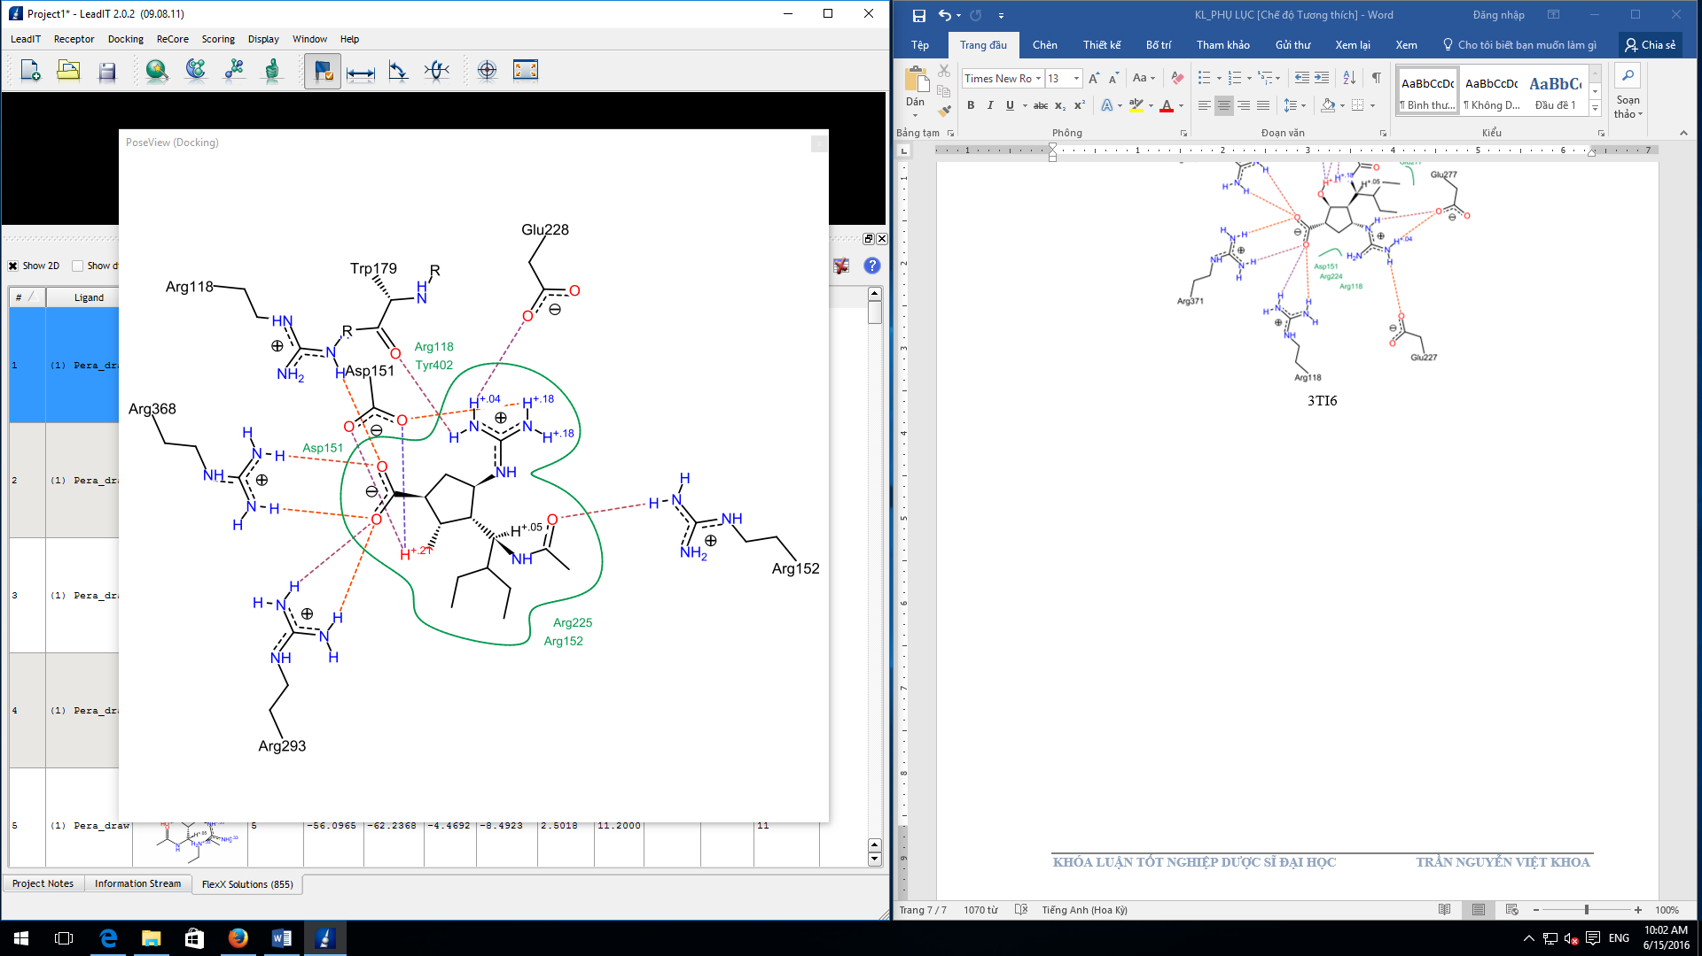

**NEURAMINIDASE NA2 (4K1I)**

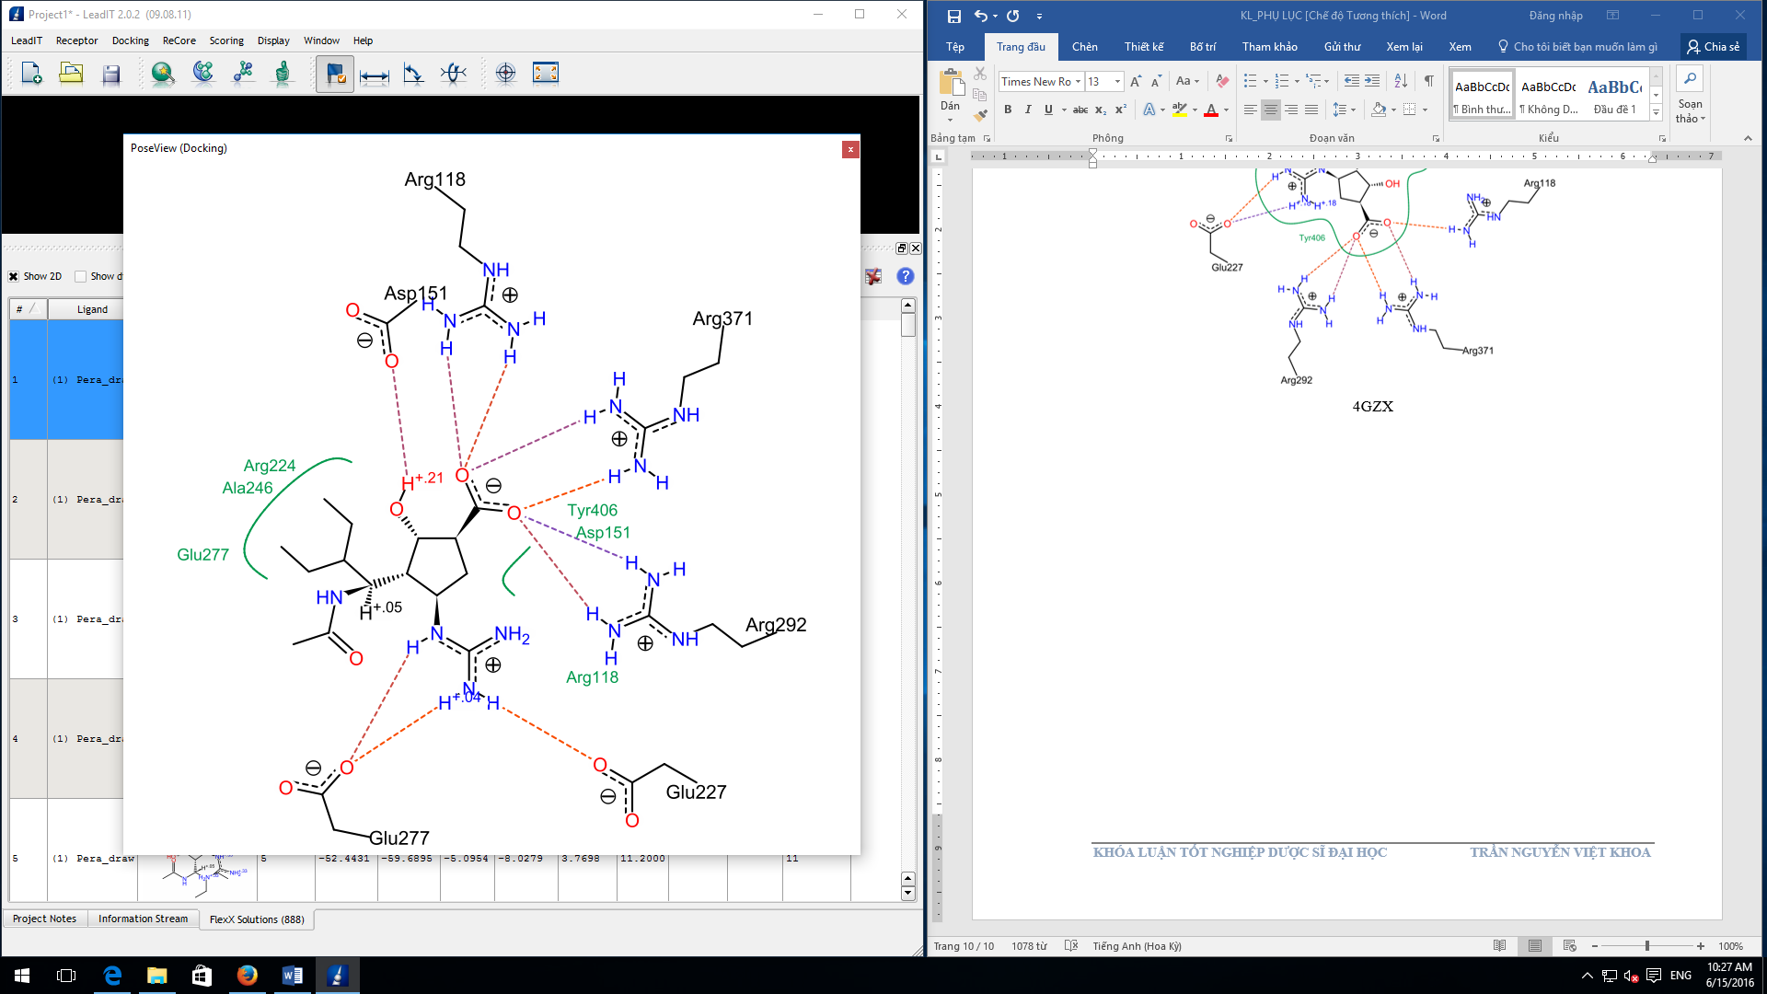

**NEURAMINIDASE NA3 (4HZX)**

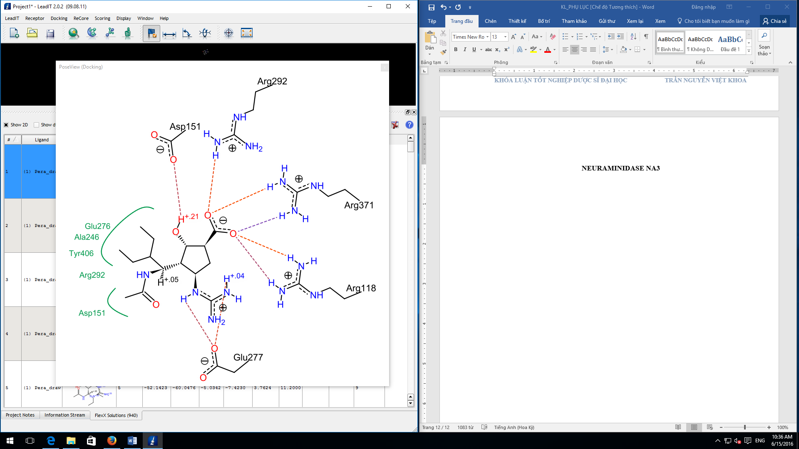

**NEURAMINIDASE NA4 (2HTV)**

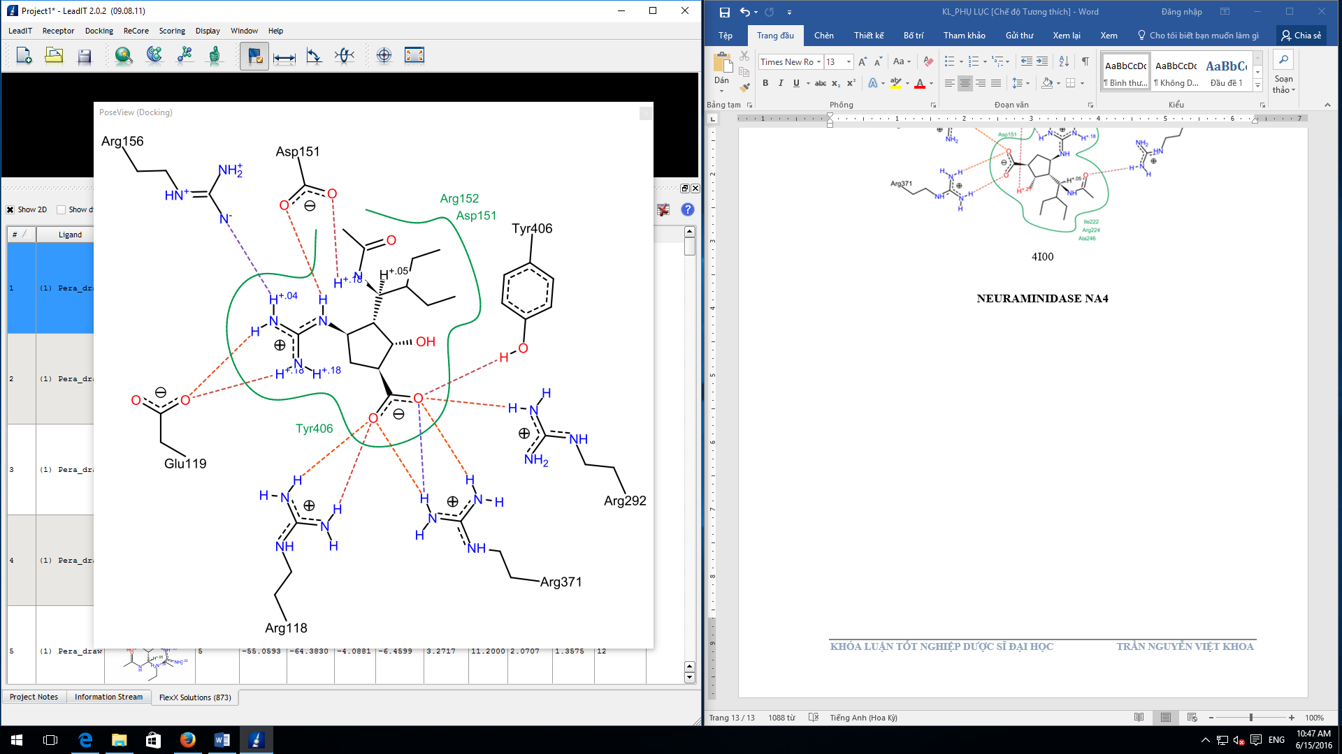

**NEURAMINIDASE NA5 (4QN5)**

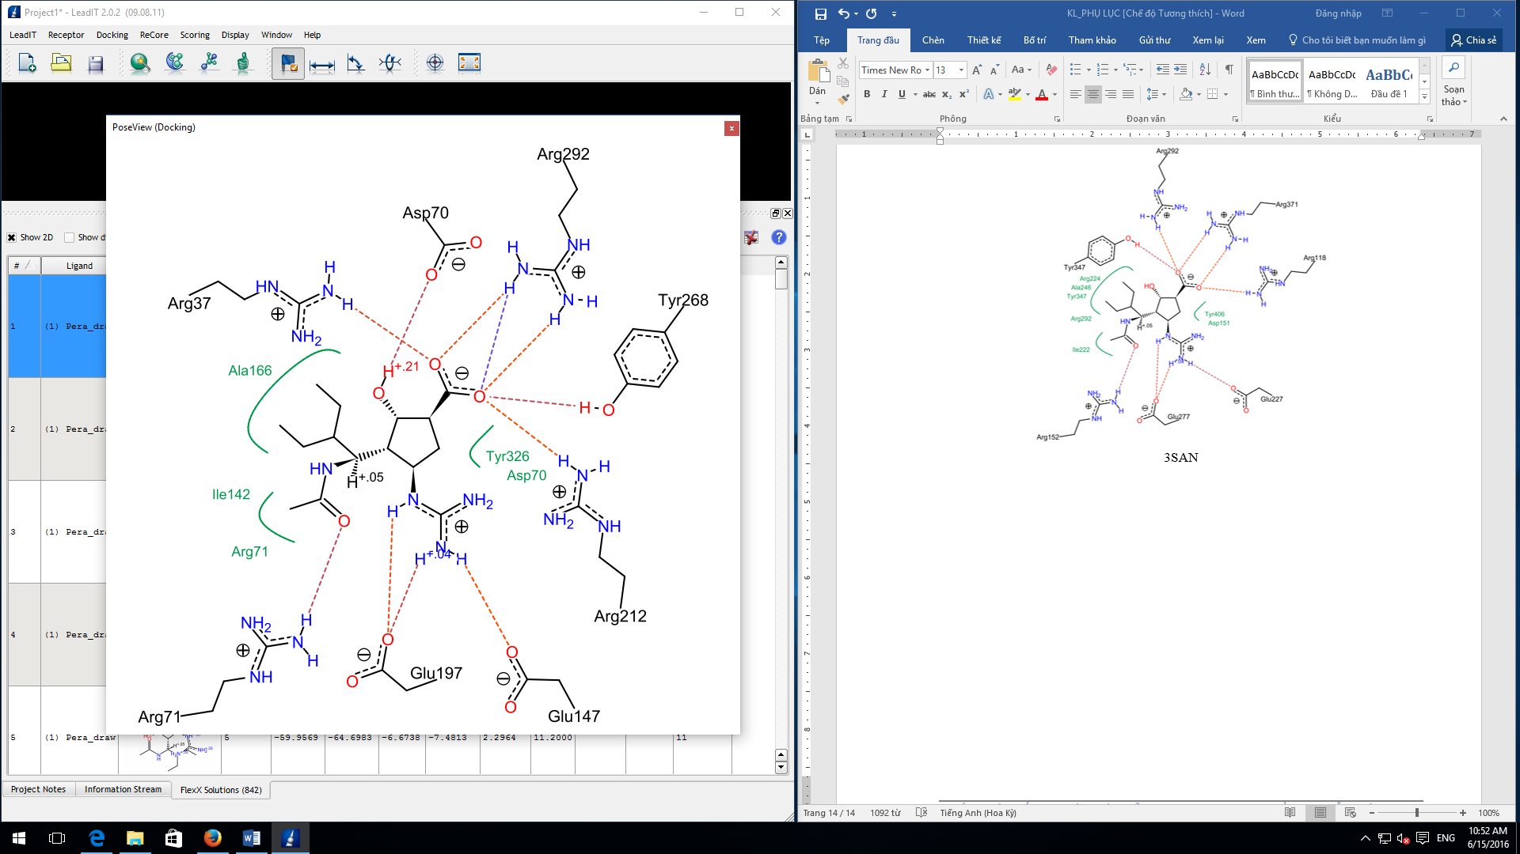

**NEURAMINIDASE NA6 (1W21)**

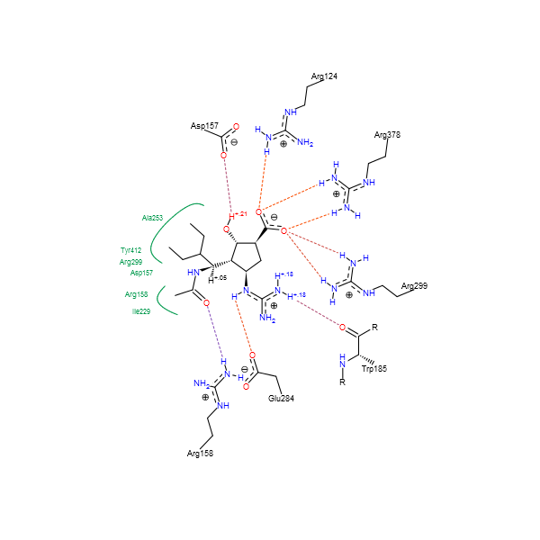

**NEURAMINIDASE NA7 (4QN7)**

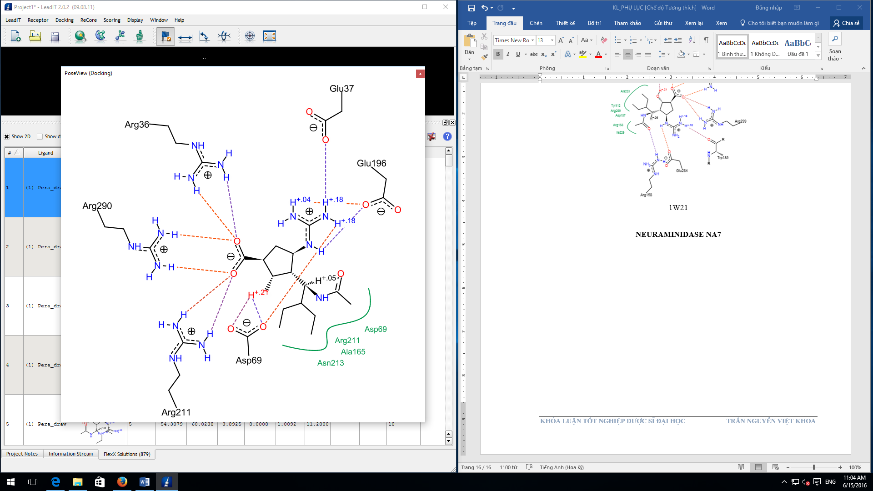

**NEURAMINIDASE NA8 (2HTU)**

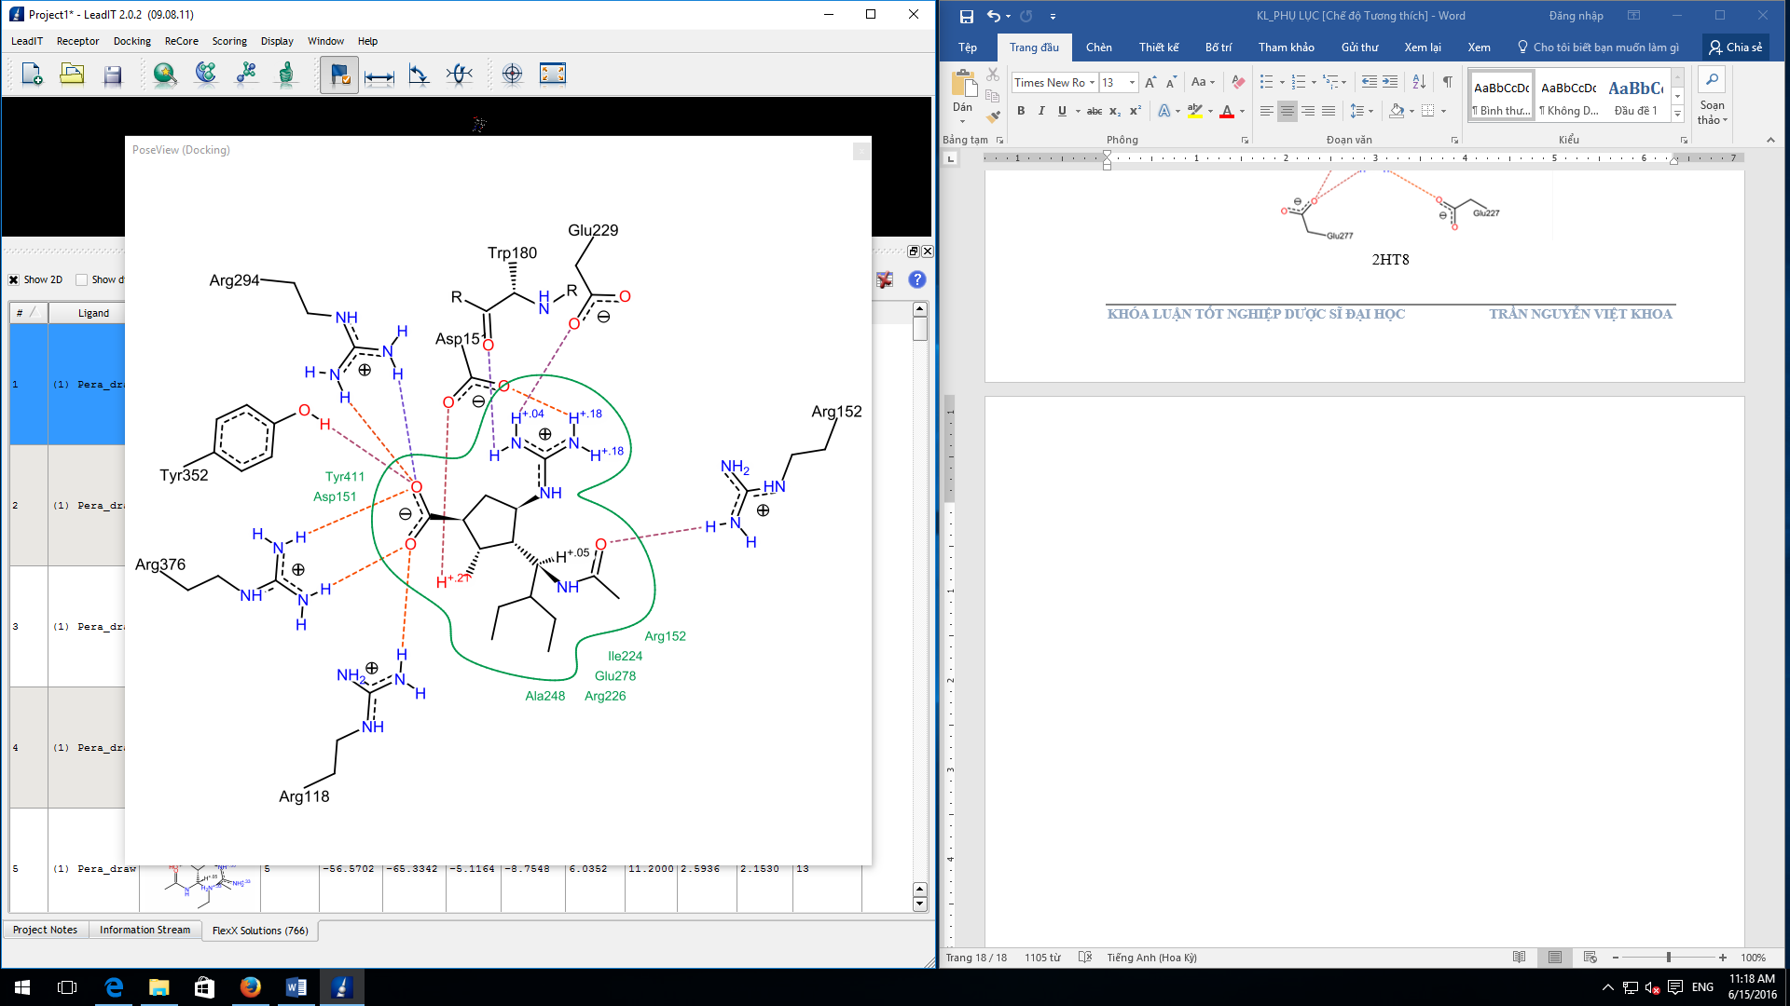

**NEURAMINIDASE NA9 (1F8D)**

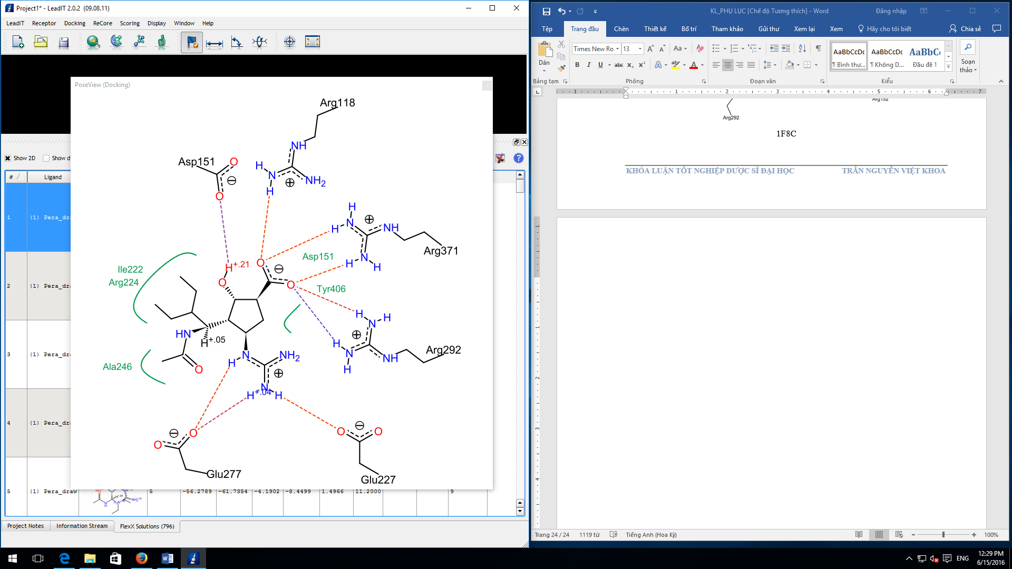

**Figure S2.** Interaction schemes in 2D and 3D between a peramivir molecule and the R378Q, R378K and R378L mutant versions of NA6.

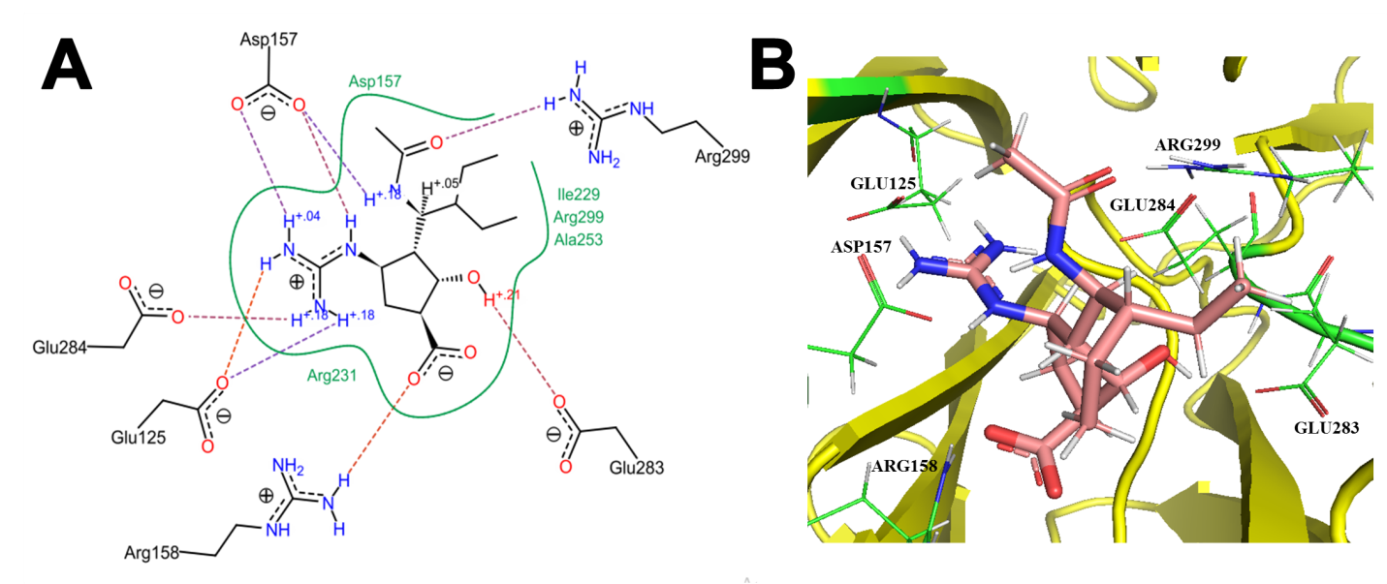

**Figure S2.1.** The interaction schemes in 2D **(A)** and 3D **(B)** of peramivir and the R378Q mutant version of NA6 (PDB ID 1W21). In Figure S2.1B, peramivir is shown as sticks. There were 6 residues in the binding site of neuraminidase that participated in 9 hydrogen bonds with the ligand, including Glu 125, Asp 157, Arg 158, Glu 283, Glu 284, and Arg 299 (all shown as lines, labeled), with an average bond length at 3.0 Å. Besides, Ile 229 and Ala 253 engaged in van der Waals interactions with peramivir. No ligand-protein ionic interaction was observed. The Figure S2.1A was prepared with LeadIT 2.0.2, the Figure S2.1B was prepared with PyMOL.

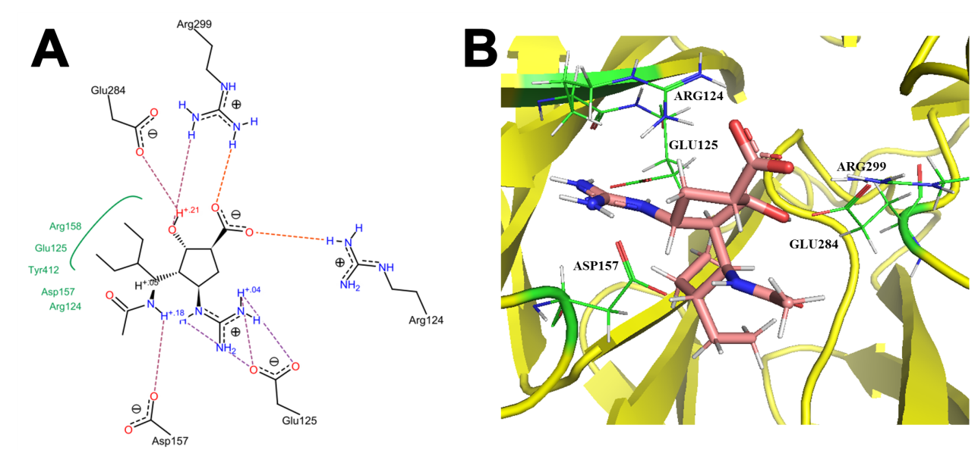

**Figure S2.2.** The interaction schemes in 2D **(A)** and 3D **(B)** of peramivir and the R378K mutant version of NA6 (PDB ID 1W21). In Figure S2.2B, peramivir is shown as sticks. There were 5 residues in the binding site of neuraminidase that participated in 8 hydrogen bonds with the ligand, including Arg 124, Glu 125, Asp 157, Glu 284, and Arg 299 (all shown as lines, labeled), with an average bond length at 3.1 Å. Besides, Tyr 412 engaged in van der Waals interactions with peramivir. No ligand-protein ionic interaction was observed. The Figure S2.2A was prepared with LeadIT 2.0.2, the Figure S2.2B was prepared with PyMOL.

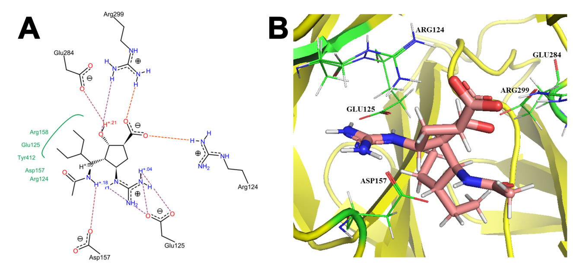

**Figure S2.3.** The interaction schemes in 2D **(A)** and 3D **(B)** of peramivir and the R378L mutant version of NA6 (PDB ID 1W21). In Figure S2.3B, peramivir is shown as sticks. There were 5 residues in the binding site of neuraminidase that participated in 8 hydrogen bonds with the ligand, including Arg 124, Glu 125, Asp 157, Glu 284, and Arg 299 (all shown as lines, labeled), with an average bond length at 3.2 Å. Besides, Tyr 412 engaged in van der Waals interactions with peramivir. No ligand-protein ionic interaction was observed. The Figure S2.3A was prepared with LeadIT 2.0.2, the Figure S2.3B was prepared with PyMOL.