Supplemental online material
Impact of in vitro digestion on gastrointestinal fate and uptake of silver nanoparticles with different surface modifications

Ashraf Abdelkhaliq^{1,2,3}, Meike van der Zande¹, Anna K. Undas¹, Ruud J.B. Peters¹, Ivonne, M.C.M. Rietjens² and Hans Bouwmeester^{2*}

¹ RIKILT - Wageningen Research, P.O. Box 230, 6700 AE, Wageningen, the Netherlands
² Division of Toxicology, Wageningen University, P.O. box 8000, 6700 EA, Wageningen, the Netherlands
³ Food Science and Technology Department, Faculty of Agriculture – Alexandria University, Alexandria, Egypt
* Corresponding author: email: hans.bouwmeester@wur.nl

Keywords: silver nanoparticles, surface chemistry, in vitro digestion, bioavailability, single particle-ICP-MS

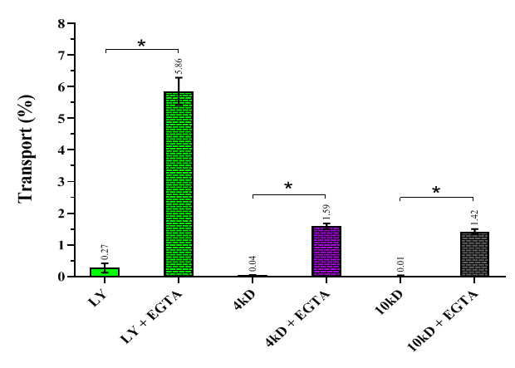
Figure S1: Cell barrier integrity of a Caco-2/HT29-MTX co-culture transwell model expressed as the % transport (mean ± SD) of lucifer yellow (LY), and 4 kDa and 10 kDa FITC-dextrans in presence and absence of EGTA (tight junction disruptor). * Significant difference in transport between presence and absence of EGTA (p < 0.05).

Table S1: The number of particles in pristine and IVD AgNPs suspensions and in the cell fraction
Status | AgNPs | Sample | Concentration (µg/L) | Number of particles ± SD
Pristine | (LA) AgNPs | Suspension | 250 | 5.9 × 10⁶ ± 1.4 × 10⁶
 |  |  | 500 | 9.8 × 10⁶ ± 2.3 × 10⁵
 |  |  | 2500 | 2.7 × 10⁷ ± 1.9 × 10⁶
 |  | Cell fraction | 250 | 1.8 × 10⁵ ± 4.9 × 10⁴
 |  |  | 500 | 3.1 × 10⁵ ± 4.6 × 10⁴
 |  |  | 2500 | 1.3 × 10⁶ ± 5.1 × 10⁵
 | (Cit) AgNPs | Suspension | 250 | 8.1 × 10⁶ ± 1.3 × 10⁶
 |  |  | 500 | 1.4 × 10⁷ ± 2.8 × 10⁶
 |  |  | 2500 | 3.5 × 10⁷ ± 5.0 × 10⁶
 |  | Cell fraction | 250 | 1.3 × 10⁶ ± 1.6 × 10⁵
 |  |  | 500 | 2.6 × 10⁶ ± 1.7 × 10⁵
 |  |  | 2500 | 4.5 × 10⁶ ± 2.3 × 10⁵
IVD | (LA) AgNPs | Suspension | 250 | 3.2 × 10⁵ ± 4.7 × 10⁴
 |  |  | 500 | 7.1 × 10⁵ ± 2.2 × 10⁵
 |  |  | 2500 | 1.9 × 10⁶ ± 4.5 × 10⁵
 |  | Cell fraction | 250 | 2.4 × 10⁵ ± 2.8 × 10⁴
 |  |  | 500 | 4.2 × 10⁵ ± 3.6 × 10⁴
 |  |  | 2500 | 1.3 × 10⁶ ± 1.7 × 10⁵
 | (Cit) AgNPs | Suspension | 250 | 3.0 × 10⁶ ± 7.8 × 10⁵
 |  |  | 500 | 7.4 × 10⁶ ± 2.8 × 10⁵
 |  |  | 2500 | 2.0 × 10⁷ ± 5.8 × 10⁶
 |  | Cell fraction | 250 | 2.1 × 10⁵ ± 2.6 × 10⁴
 |  |  | 500 | 4.4 × 10⁵ ± 6.0 × 10⁴
 |  |  | 2500 | 1.9 × 10⁶ ± 1.8 × 10⁵

