Title: APOE polymorphism in ATTR amyloidosis patients treated with lipid nanoparticle siRNA

Christoph Niemietz, Oksana Nadzemova, Andree Zibert, Hartmut H.-J. Schmidt*
Medizinische Klinik B für Gastroenterologie und Hepatologie, Universitätsklinikum Münster, Münster, Germany

Abbreviations: Ago 2, Argonaute 2; APOE, Apolipoprotein E; ATTR amyloidosis, transthyretin amyloidosis; DLin-MC3-DMA, dilinoleylmethyl-4-dimethylaminobutyrate; ELISA, enzyme-linked immunosorbent assay; EMA, European Medicines Agency; FDA, Food and Drug Administration; HSPG, Heparan Sulfate Proteoglycans; LDLR; low density lipoprotein receptor; LNP, lipid nanoparticle; LRP1, Low Density Lipoprotein Receptor-related Protein 1; RBP, retinol-binding protein; RISC, RNA-induced silencing complex; RT-qPCR, quantitative real-time polymerase chain reaction; siRNA, small interfering RNA; TRBP, TAR RNA binding protein; TTR, transthyretin; VLDL, very low density lipoprotein.

*Correspondence to: Prof. Hartmut H.-J. Schmidt, MD; Medizinische Klinik B für Gastroenterologie und Hepatologie, Universitätsklinikum Münster, Albert-Schweitzer-Campus 1, Gebäude A14, D-48149 Münster, Germany.
Email: hepar@ukmuenster.de
Telephone: +49-251- 83-57935 Fax: +49-251 83-57771
Author Contributions:
Study concept and design: A.Z., H.S. Acquistion of data: C.N., O.N. Analysis and interpretation of data: C.N., O.N., A.Z. Drafting of the manuscript: C.N., A.Z. Critical revision of the manuscript: A.Z., H.S. Study supervision: A.Z., H.S.

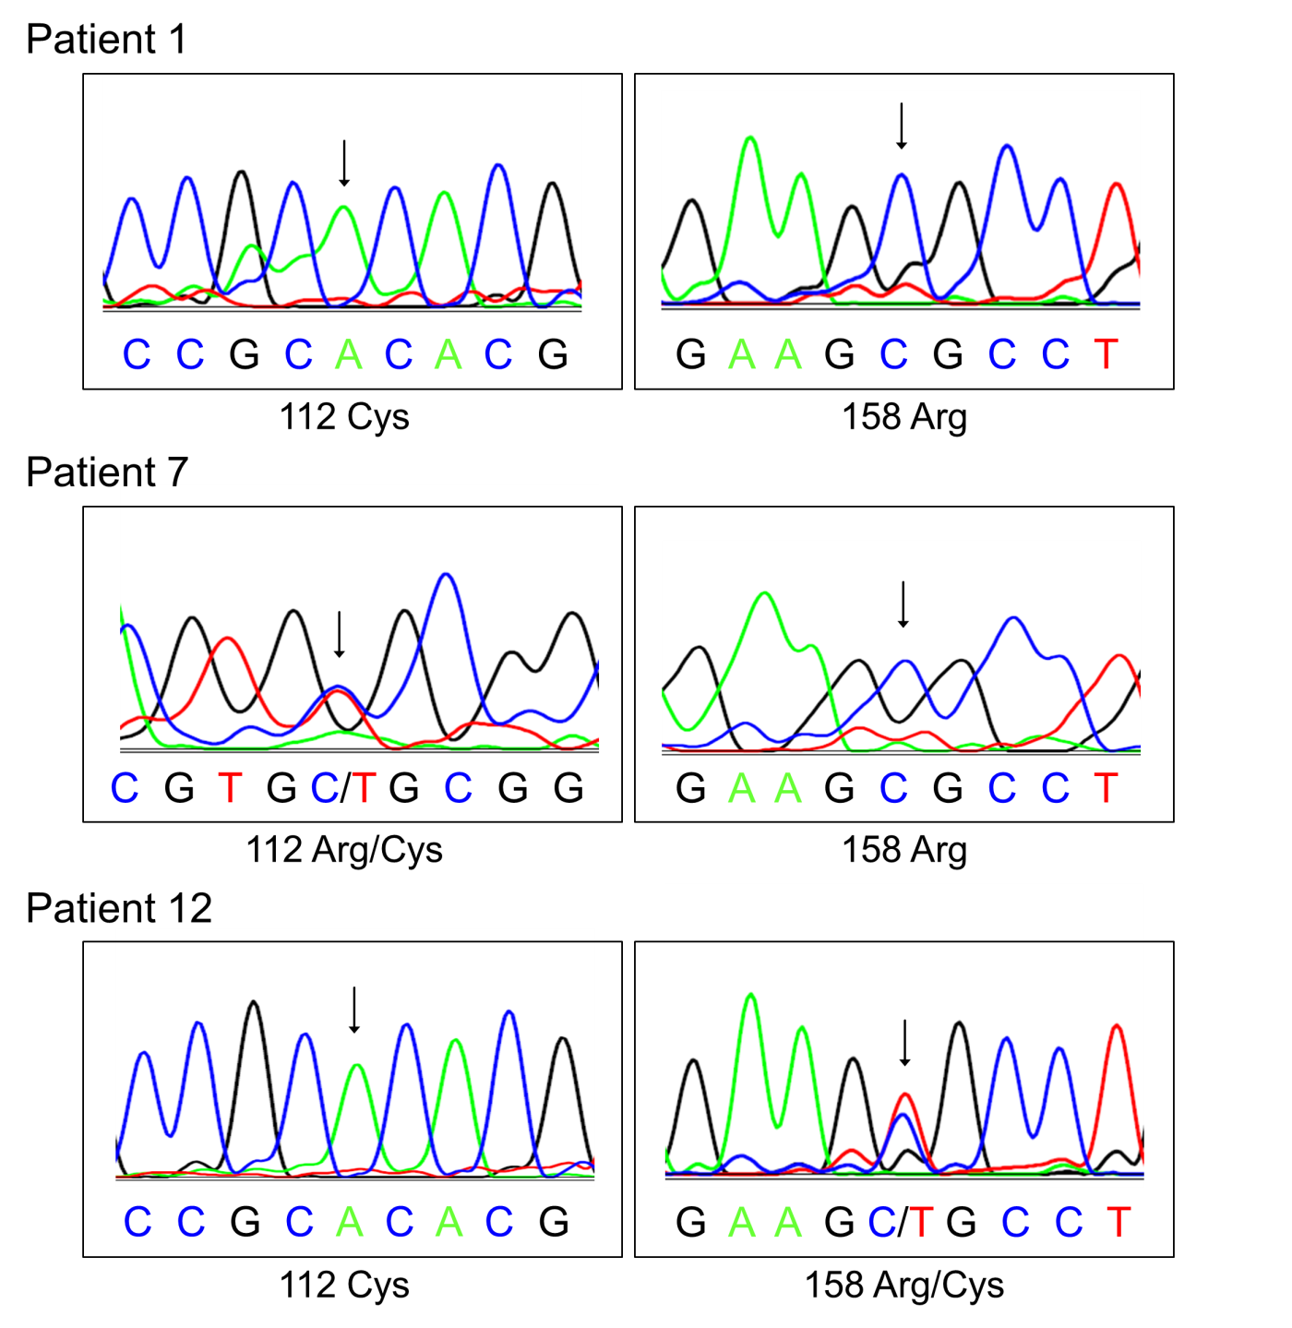
Fig. S1: APOE sequencing results of ATTR amyloidosis patients. DNA sequence histograms of the APO gene corresponding to amino acid positions 112 and 158 are shown. Arrows indicate mutations.

