Title: 5Azacytidine incorporated Polycaprolactone - Gelatin nanoscaffold for cardiomyocyte differentiation
Kerena Rachel, Surajit Pathak, A. Moorthi, Srinivasan Narasimhan, RamachandranMurugesan and Shoba Narayan*
 | PCL-Gelatin (Figure 5a) | PCL-Gelatin-Aza1  (Figure 5b) | PCL-Gelatin- Aza2  (Figure 5c) | Assignments
Wavenumber cm⁻¹ | 2935 | 2935 | 2935 | asymmetric (CH2 stretching),
Wavenumber cm⁻¹ | 2866 | 2853 | 2853 | symmetric CH2  stretching
Wavenumber cm⁻¹ | 1718 | 1713 | 1713 | carbonyl stretching
Wavenumber cm⁻¹ | 1280 | 1230 | 1230 | asymmetric C–O–C stretching
Wavenumber cm⁻¹ | 1098 | 1104 | 1104 | symmetric C-O-C stretching
Wavenumber cm⁻¹ | 1468 | 1462 | 1462 | N–H bending  (amide II)
Faculty of Allied Health Sciences, Chettinad Hospital and Research Institute, Chettinad Academy of Research and Education, Kelambakkam, Tamilnadu, 603103, India

Table S1: Vibrational band assignments of Scaffolds PCL-Gelatin (a), PCL-Gelatin-Aza1 (b), PCL-Gelatin-Aza2 (c)

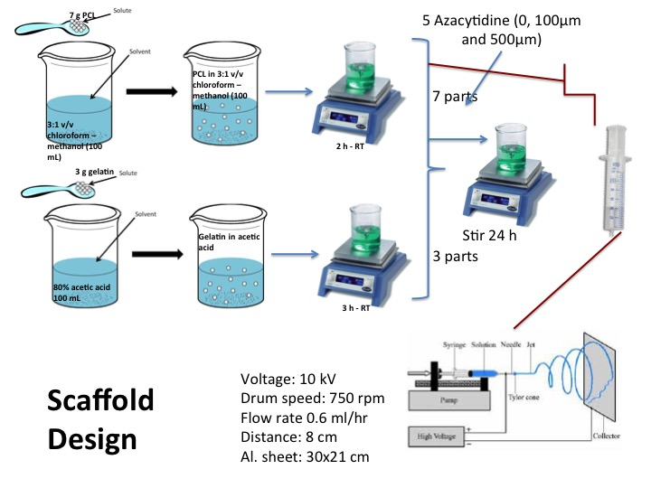
Scheme 1 : Scaffold design

Figure S1 Histogram depicting the variation in fibre width a) PCL-Gelatin, b) PCL-Gelatin-5-Aza1 and c) PCL-Gelatin-5Aza2

