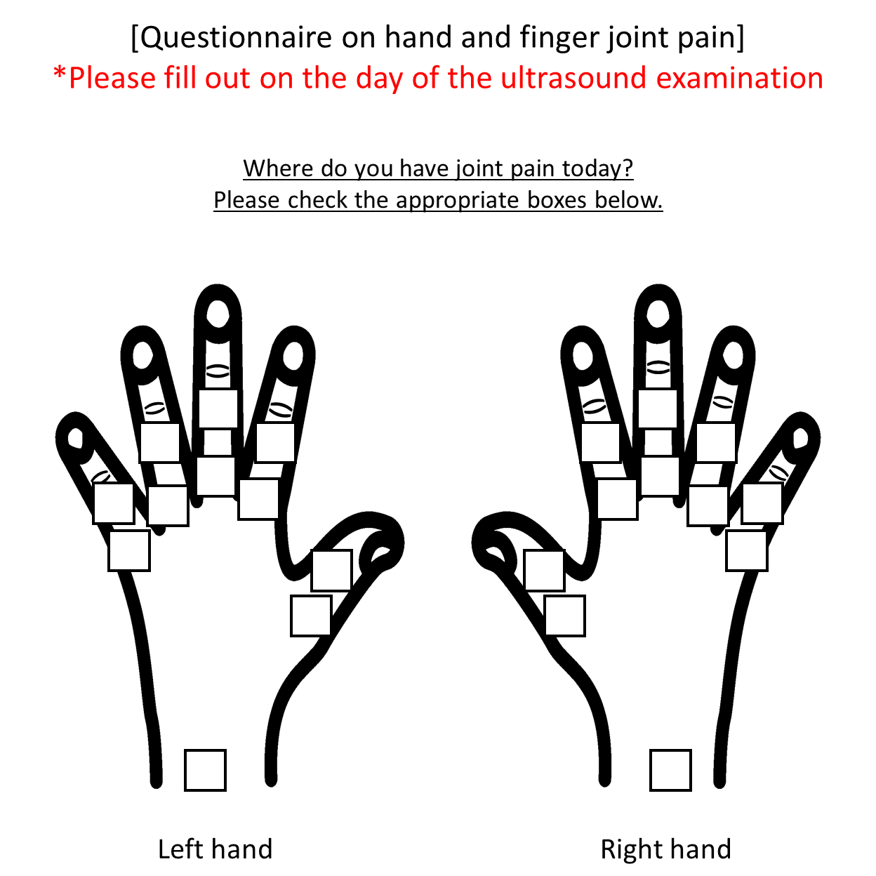

Supplementary figure 1. Questionnaire on subjective symptoms of arthralgia. The original questionnaire was written in Japanese.

Supplementary table 1. Concordance between US findings and subjective symptoms of patients separated by functional disability.

Joints | Functional remission† |  |  | Functional non-remission†
 | n‡ | PABAK |  | n‡ | PABAK
MCP1 Right | 265 | 0.645 |  | 138 | 0.478
Left | 266 | 0.662 |  | 138 | 0.565
MCP2 Right | 265 | 0.404 |  | 136 | 0.118
Left | 266 | 0.496 |  | 134 | 0.358
MCP3 Right | 266 | 0.594 |  | 136 | 0.338
Left | 266 | 0.714 |  | 135 | 0.467
MCP4 Right | 266 | 0.774 |  | 136 | 0.456
Left | 266 | 0.782 |  | 136 | 0.603
MCP5 Right | 266 | 0.767 |  | 136 | 0.412
Left | 266 | 0.805 |  | 136 | 0.647
IP1 Right | 265 | 0.758 |  | 137 | 0.518
Left | 266 | 0.797 |  | 137 | 0.620
PIP2 Right | 265 | 0.721 |  | 136 | 0.618
Left | 266 | 0.774 |  | 137 | 0.620
PIP3 Right | 266 | 0.692 |  | 133 | 0.519
Left | 266 | 0.820 |  | 135 | 0.585
PIP4 Right | 266 | 0.737 |  | 131 | 0.618
Left | 266 | 0.820 |  | 135 | 0.659
PIP5 Right | 266 | 0.797 |  | 135 | 0.630
Left | 266 | 0.850 |  | 134 | 0.716
Wrist Right | 265 | -0.019 |  | 137 | -0.022
Left | 264 | -0.083 |  | 138 | 0.014
†Functional remission: the Health Assessment Questionnaire (HAQ) ≤ 0.5; Functional non-remission: HAQ > 0.5. ‡Joints with deficits in US data were excluded. US: ultrasound; PABAK: prevalence-adjusted bias-adjusted kappa; MCP: metacarpophalangeal; (P)IP: (proximal) interphalangeal.

Supplementary table 2. Concordance between US findings and subjective symptoms of patients separated by the Steinbrocker stage.

Joints | Stage I |  |  | Stage II |  |  | Stage III |  |  | Stage IV
 | n† | PABAK |  | n† | PABAK |  | n† | PABAK |  | n† | PABAK
MCP1 Right | 136 | 0.735 |  | 114 | 0.596 |  | 81 | 0.654 |  | 155 | 0.497
Left | 137 | 0.781 |  | 114 | 0.649 |  | 81 | 0.605 |  | 155 | 0.561
MCP2 Right | 136 | 0.559 |  | 114 | 0.386 |  | 81 | 0.284 |  | 154 | -0.026
Left | 137 | 0.577 |  | 113 | 0.575 |  | 80 | 0.375 |  | 153 | 0.268
MCP3 Right | 136 | 0.779 |  | 114 | 0.579 |  | 81 | 0.407 |  | 155 | 0.329
Left | 137 | 0.883 |  | 114 | 0.737 |  | 80 | 0.550 |  | 154 | 0.377
MCP4 Right | 136 | 0.897 |  | 114 | 0.719 |  | 81 | 0.556 |  | 154 | 0.481
Left | 137 | 0.912 |  | 114 | 0.702 |  | 80 | 0.675 |  | 155 | 0.587
MCP5 Right | 136 | 0.853 |  | 114 | 0.614 |  | 80 | 0.650 |  | 156 | 0.538
Left | 137 | 0.883 |  | 114 | 0.772 |  | 80 | 0.625 |  | 155 | 0.600
IP1 Right | 136 | 0.794 |  | 114 | 0.737 |  | 81 | 0.605 |  | 155 | 0.613
Left | 137 | 0.839 |  | 114 | 0.807 |  | 81 | 0.654 |  | 154 | 0.623
PIP2 Right | 136 | 0.765 |  | 114 | 0.737 |  | 81 | 0.556 |  | 153 | 0.673
Left | 137 | 0.766 |  | 114 | 0.789 |  | 81 | 0.704 |  | 153 | 0.686
PIP3 Right | 136 | 0.735 |  | 114 | 0.649 |  | 81 | 0.580 |  | 150 | 0.600
Left | 137 | 0.796 |  | 114 | 0.772 |  | 80 | 0.675 |  | 152 | 0.724
PIP4 Right | 136 | 0.779 |  | 114 | 0.684 |  | 80 | 0.675 |  | 148 | 0.716
Left | 137 | 0.810 |  | 114 | 0.772 |  | 80 | 0.675 |  | 152 | 0.763
PIP5 Right | 136 | 0.809 |  | 114 | 0.789 |  | 81 | 0.753 |  | 150 | 0.707
Left | 137 | 0.854 |  | 114 | 0.807 |  | 80 | 0.775 |  | 151 | 0.788
Wrist Right | 136 | 0.074 |  | 113 | -0.009 |  | 81 | 0.012 |  | 155 | -0.058
Left | 137 | 0.022 |  | 113 | -0.115 |  | 81 | -0.062 |  | 154 | -0.117
†Joints with deficits in US data were excluded. US: ultrasound; PABAK: prevalence-adjusted bias-adjusted kappa; MCP: metacarpophalangeal; (P)IP: (proximal) interphalangeal.

Supplementary table 3. Concordance between US findings and subjective symptoms of patients separated by anxiety and depression.

Joints | Anxiety† |  |  |  |  |  | Depression†
 | Present† |  |  | Absent† |  |  | Present† |  |  | Absent†
 | n‡ | PABAK |  | n‡ | PABAK |  | n‡ | PABAK |  | n‡ | PABAK
MCP1 Right | 102 | 0.627 |  | 382 | 0.607 |  | 129 | 0.597 |  | 356 | 0.618
Left | 101 | 0.683 |  | 384 | 0.641 |  | 129 | 0.643 |  | 357 | 0.653
MCP2 Right | 102 | 0.333 |  | 381 | 0.270 |  | 129 | 0.318 |  | 355 | 0.273
Left | 99 | 0.475 |  | 382 | 0.435 |  | 127 | 0.465 |  | 355 | 0.437
MCP3 Right | 103 | 0.476 |  | 381 | 0.538 |  | 129 | 0.628 |  | 356 | 0.489
Left | 101 | 0.644 |  | 382 | 0.628 |  | 129 | 0.581 |  | 355 | 0.651
MCP4 Right | 103 | 0.573 |  | 380 | 0.689 |  | 129 | 0.674 |  | 355 | 0.662
Left | 101 | 0.743 |  | 383 | 0.713 |  | 129 | 0.674 |  | 356 | 0.736
MCP5 Right | 102 | 0.529 |  | 382 | 0.696 |  | 128 | 0.609 |  | 357 | 0.681
Left | 101 | 0.644 |  | 383 | 0.744 |  | 129 | 0.721 |  | 356 | 0.725
IP1 Right | 103 | 0.650 |  | 381 | 0.701 |  | 130 | 0.692 |  | 355 | 0.690
Left | 101 | 0.703 |  | 383 | 0.744 |  | 129 | 0.690 |  | 356 | 0.753
PIP2 Right | 101 | 0.564 |  | 381 | 0.732 |  | 129 | 0.705 |  | 354 | 0.695
Left | 100 | 0.660 |  | 383 | 0.755 |  | 128 | 0.813 |  | 356 | 0.708
PIP3 Right | 101 | 0.624 |  | 378 | 0.656 |  | 126 | 0.619 |  | 354 | 0.661
Left | 99 | 0.616 |  | 382 | 0.780 |  | 127 | 0.701 |  | 355 | 0.763
PIP4 Right | 98 | 0.633 |  | 378 | 0.741 |  | 124 | 0.774 |  | 353 | 0.700
Left | 99 | 0.677 |  | 382 | 0.785 |  | 127 | 0.669 |  | 355 | 0.797
PIP5 Right | 100 | 0.660 |  | 379 | 0.789 |  | 126 | 0.794 |  | 354 | 0.751
Left | 99 | 0.697 |  | 381 | 0.837 |  | 127 | 0.795 |  | 354 | 0.814
Wrist Right | 101 | 0.030 |  | 382 | 0.000 |  | 129 | -0.008 |  | 355 | 0.008
Left | 101 | -0.010 |  | 382 | -0.079 |  | 129 | -0.085 |  | 355 | -0.059
†Anxiety and depression were evaluated by the Hospital Anxiety and Depression Scale (HADS-A / HADS-D). Anxiety present: HADS-A ≥ 8; Anxiety absent: HADS-A < 8; Depression present: HADS-D ≥ 8; Depression absent: HADS-D < 8. ‡Joints with deficits in US data were excluded. US: ultrasound; PABAK: prevalence-adjusted bias-adjusted kappa; MCP: metacarpophalangeal; (P)IP: (proximal) interphalangeal.

