Supplementary Information
Fig. 1. FT-IR spectra of [Tmim] [HSO₄]₄

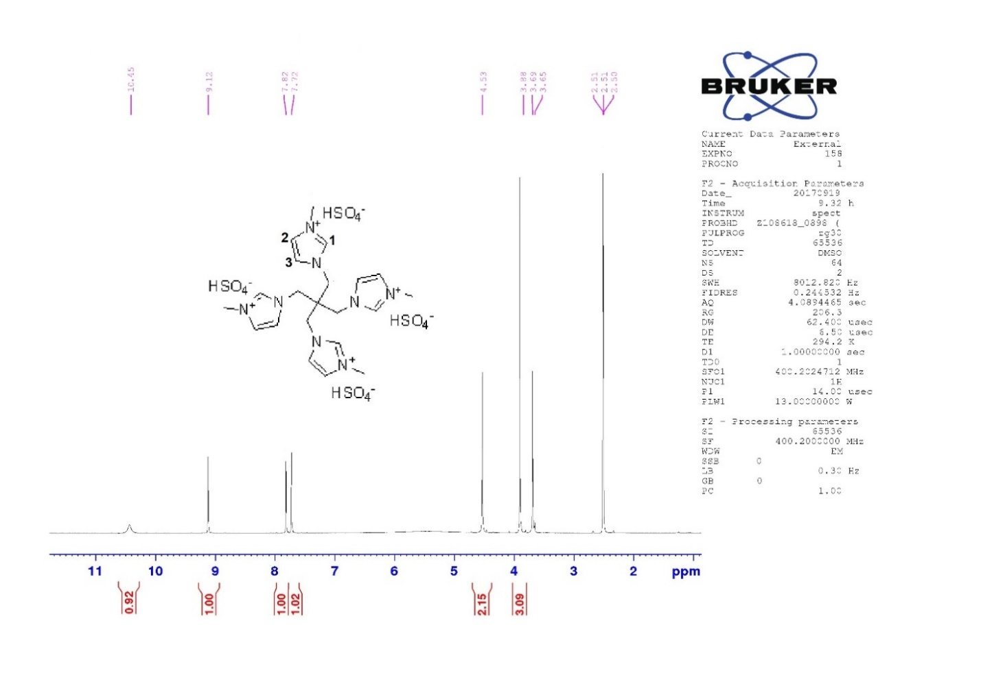
Fig. 2. 400 MHz ¹H NMR spectrum in DMSO of [Tmim] [HSO₄]₄

Fig. 3. 400 MHz ¹³C NMR spectrum in DMSO of [Tmim] [HSO₄]₄

Fig. 4. TGA curve of [Tmim] [HSO₄]₄

